

- Module: International Business Concepts (LCMB7034)

INTERNATIONAL BUSINESS CONCEPTS: A REPORT ON THE INDIAN AGRICULTURAL INDUSTRY

STUDENT NAME= DIPEN PATEL
- STUDENT NUMBER = 2503885
- LECTURER NAME = DR. GLADIUS DAVID KULOTHUNGAN

Executive summary

This report has analysed the Agricultural industry of India with a focus on the rice sector. It highlighted the industry and its economic significances, global competitiveness and major players in it like LT Foods, Bayer Crop Science and Syngenta, among which KRBL Limited has been the key focus of the study. The report results showcase how the industry is contributing to GDP and international trade. Furthermore, through the use of the Porter’s Diamond Model the study highlights that the agricultural sector in India enjoys good natural resources, a considerable size of domestic market, and new support industries though it has structural inefficiencies and policy distortions which are lacking its further growth.
A particular focus on KRBL Limited was given through analysing the PESTLE analysis for the Indian agricultural market and its potential for KRBL for future growth. Regardless of a few challenges, higher export values, solid governmental policy support, increased demand for high quality rice, and others have been key influencing factors for KRBL in the region. However, the long-term growth still depends on high innovation, development of infrastructure, and stable policy systems to increase efficiency over time. The complete Reflective task through Kolb’s reflective cycles have been also been crucial for developing a wider understanding of what has been improved and what areas need still need improvement for enacting future academic writings.
Table of Contents

1. Introduction to the report 5
2. Industry and Country Overview 6
2.1 The Agricultural industry of India 6
2.2 Size, scope and economic validity 7
2.3 Major companies and competitive positioning 8
3. Michael Porter’s Diamond Model of National Advantage 11
4. One of the major foreign MNCs/TNCs operating in the country-industry pair 15
4.1 Political 15
4.2 Economic 17
4.3 Social (Cultural) 19
4.4 Technological 20
4.5 Legal 21
4.6 Environmental 21
5. Conclusion to the report 23
Section 2: Reflection 24
References 27

List of figures

Figure 1: India’s position as a rice exporter in the globe 5
Figure 2: Agricultural industry of India overview 7
Figure 3: Porter’s diamond Model in Indian Agriculture Industry 12
Figure 4: KRBL international presence 17
Figure 5: Financial overview of KRBL as of (31st March 2024) 19
Figure 6: Digital presence of KRBL 20
Figure 7: Environmental highlights of KRBL 22
Figure 8: Kolb’s reflective cycles 24

Section 1: Industry and company analysis

1. Introduction to the report
Agriculture is a key factor supporting the Indian economy and social structure, regardless of major growth in the industrial and service sectors. As argued by Charishma and Singh (2024), agriculture contributes to nearly half of India’s population, making it the key aspect of the economic sector. Being one of the largest producers of agricultural commodities in the world, India has developed its agricultural industry to support livelihoods of a major portion of their population while contributing to national food security. Government reports showcase how the agricultural output has expanded in India as it recorded 40% growth in the past decade (IBEF, 2025). These highlight how it has continuous relevancy in rural development and macroeconomic stabilities. In the wider agricultural context, the rice industry has the highest contribution to India’s economy. This is due to the fact that India has become the largest exporter of rice across the globe, as shown in Figure 1, with nearly 40% of exports (Duggal et al., 2023).
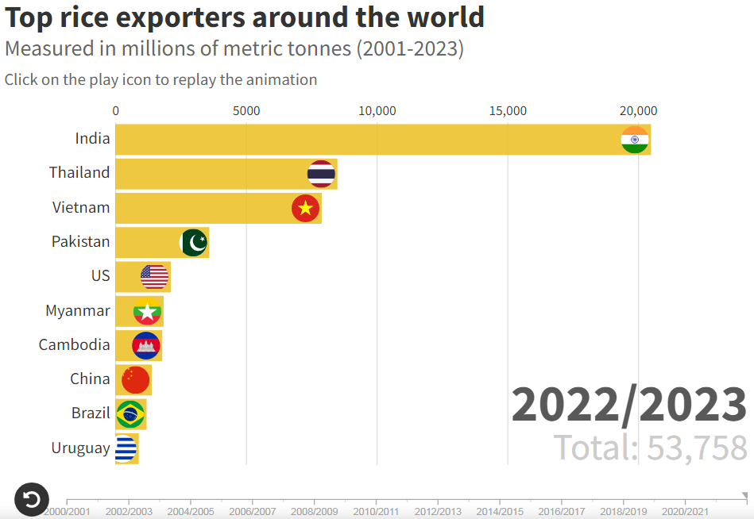

Figure 1: India’s position as a rice exporter in the globe
(Source: Duggal et al., 2023)
The industry not only meets local consumption needs, but also plays a major role in global international trade. This report thus aims to analyse the agricultural industry of India (IBEF, 2025). It will evaluate the structure, competitiveness, and global positioning of the industry while analysing how major companies like KRBL Limited are operating in it. Through the use of developed frameworks like Porter’s Diamond Model, the report aims to provide a detailed understanding of how various factors are impacting the industry performance and future growth potential. A reflection on the learning journey will also support understanding what this research supported in personal and professional development.

2. Industry and Country Overview

2.1 The Agricultural industry of India
Baruah and Mandal, (2025) identified how the agricultural industry of India is a key supporting pillar for the national economy, with consideration to the country’s socio-economic values. Regardless of rapid advancements in the manufacturing and service sector of India, it sustains the livelihoods, support food security, and increases the export value of the region. As identified in Figure 2, the Agricultural industry of India has done exports of over $36 billion (Ibef, 2025). The sector is highly diversified with food grains, livestock, fisheries, and others. In this vast industry, the rise of the sector is a major contributing force to the agricultural industry. Through a consistent supply of Basmati and non-Basmati varieties of rice, India has been among the largest rice exporter from 2012 (Udhayakumar and Karunakaran, 2020). Based on online reports, in the financial year 2024-2025, India exported 20.1 million metric tonnes of rice (Pib, 2025). This is nearly $12.95 billion that reached over 172 countries, showing the strong global food supply chain integration. Recent reports have further showcased how in India, 54.8% of geographical areas are agricultural land as of statistics for 2021-22, showing the solid base of this industry in India (Agriwelfare, 2024).
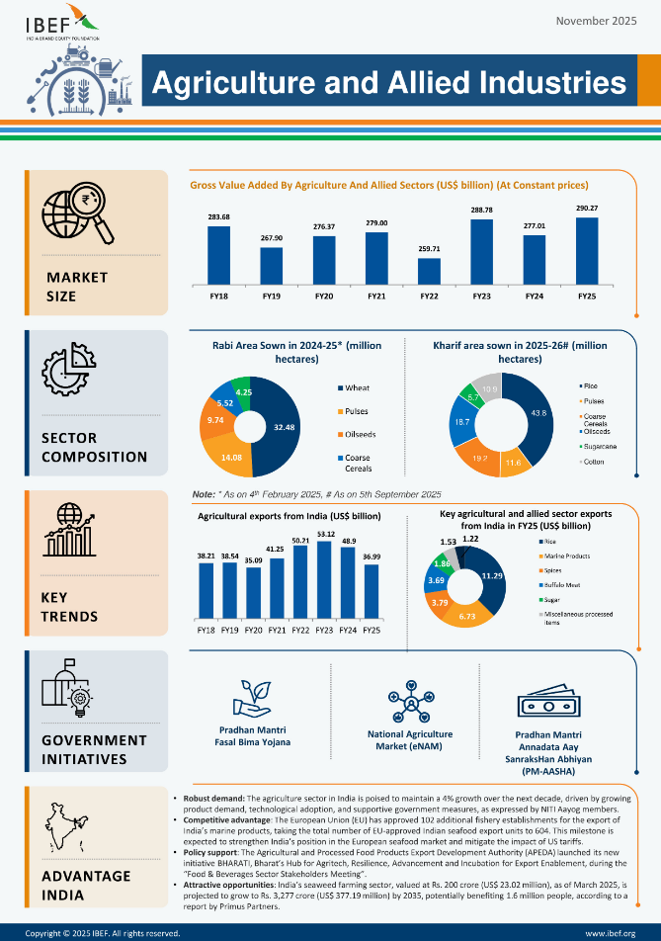

Figure 2: Agricultural industry of India overview
(Source: Ibef, 2025)

2.2 Size, scope and economic validity
The vastness of the agricultural industry of India is wide in terms of both scale and economic contribution. As stated in the report, the agricultural and allied activities are collaboratively contributing to 17.8% of India’s GDP in 2023-24, while also employing a major level of population (Ibef, 2025). This has shown the dual importance of this sector as an e economic force and employment driver. Reports on the industry have highlighted how the foodgrain production has increased its quantity by 216.61 lakh Metric tonnes (LTM) in 2024-25, an increase of 6.5% at an annual rate, as shown in figure 3 (global-agriculture, 2025). The scale of production ensures domestic food security while also allowing surplus for the export markets. The rice segment in the industry has shown an approximate of 8.16% growth, becoming the largest contributor to the industry (global-agriculture, 2025).
The industry is also playing a major role in rural development, supply chain expansion, and industry linkages like logistics, and exporters. The agricultural sector of India is contributing 17.8% for the country’s GDP in 2023-24, and exports reached to $51.86 billion in FY25, with rice leading the category (agricultureinstitute, 2025). These numbers are showing the major potential of the Indian economic sector and its growth opportunities in near future. These also position India to become a dominant player in not only the rice segment, but also the complete global agricultural industry. Competitive pricing, large-scale production, and diverse product offerings are impacting the growth of the industry.

2.3 Major companies and competitive positioning
The Indian rice and complete agricultural industry are filled with major domestic companies and multinational corporations. Among all these, leading domestic players like KRBL Limited are a major one with a reputation of being the largest exporters of basmati rice across the globe. Annual reports, showcase how the company is operating over 80 countries and is known for its key segment of “India Gate” brand allowing it to become a premium position in the basmati segment with strong considerations of branding, quality, and global distribution (krblrice, 2025).
Company | Positioning/ strategy | Key focus/ products | Presence | Revenue | Employees (approximate)
KRBL Limited | One of the leading domestic player and largest exporters of basmati rice across the globe. “India Gate” brand allowing it to gain a premium position in the basmati segment (krblrice, 2025). | Branded rice and Basmati rice | Operating over 80 countries | Rs. 1,19,918 lakhs as of 30.06.2024 (krblrice, 2025). | 3.00k (Markets, 2026)
LT Foods | Another major competitor with premium and popular brands like Daawat (ltfoods, 2025). It is focused on product diversification, including organic and even ready-to eat rice products. It is heavily focused on innovation and value-added products. North America and the Middle East have been key regions of the company’s presence. | Basmati rice, Premium rice brands, Ready-to-eat and organic rice segments. | India, North America and the Middle East are key segments. | Approximately Rs. 8,770 crores as of FY’25 (Ltfoods, 2026). | Over 4000
Kohinoor Foods | Kohinoor Foods has maintained major relevance with a strong presence in the basmati rice segment (kohinoorfoods, 2025). Yet, the company’s market position has fluctuated due to financial issues and restructuring approaches. | Basmati rice, ready-to-eat, packaged foods (kohinoorfoods, 2026). | Over 65 countries | Turn-over of INR 863.93 million (kohinoorfoods, 2025) | Approximately 100 permanent employees
Bayer Crop Science | Major international player who focuses on use of small lands for better harvests and provide solutions for better crop management. The company’s all considering support for allowing the identification of nearby retailers, diagnosis for crop issues and alert options for pests and diseases allows them to rapidly get adopted in the Indian market. These factors contributed to their long-lasting presence of over 130 years (bayer, 2025). | Solutions for better crop management, diagnosis for crop issues and alert options for pests and diseases | Global presence with a keen focus on developing countries (bayer, 2026) | Revenue of INR 56.22bn (Markets, 2026) | 1.17k (Markets, 2026)
Syngenta | It is a major international player that has a major presence in the Indian agricultural sector, especially due to its diverse range of seeds and caring guides offered for the region (syngenta, 2026). The global networks and access to capital are key competitive advantages. | Seeds, caring guides, biological products for agricultural usage. | More than 100 countries (syngentabiologicals, 2025). | $28.8 billion as of FY,24 (Syngenta, 2025). | Over 30,000 (Syngenta, 2026).
Table 1: comparative analysis of five key operating companies
These companies are operating in various commodities and focus on sourcing, processing and global distributions. The competitive landscape is influenced through combining traditional strengths like heritage and long-lasting presence of companies like domestic firms and modern strategies and global networks via international companies (Sharma, 2025). Yet the rising exports and India becoming among the top agricultural industry players is developing potential for the Indian companies to dominate their position in the global agriculture industry while competing properly with multinational players.

3. Michael Porter’s Diamond Model of National Advantage
According to the Diamond model developed by Michael Porters (1990), within a nation some specific elements exist that improve the ability of the country to achieve a global market presence. In this aspect, four core determinants of national competitiveness have been selected which include factor conditions, demand conditions, related and supporting industries along with firm strategy, structure and rivalry. Beyond the four pillars, the theory explains how the government can act to improve a country's position in a globally competitive economic environment which are interrelated with chance aspects. By using this model, the study aims to show that the agricultural sector of India is highly competitive on the global front while it is also limited by structural inefficiencies.
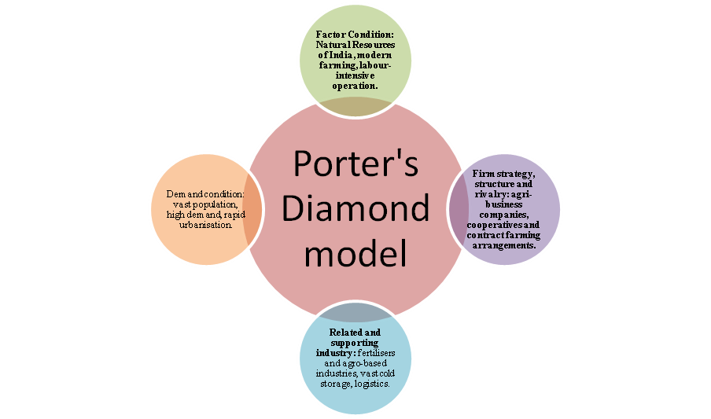

Figure 3: Porter’s diamond Model in Indian Agriculture Industry
(Source: Self-made)
Factor Conditions: Factor condition of this theory is defined as the most important point by Porter, which consists of naturally inherited factors that play an important role to improve the overall success of an industry. India is endowed with high basic factors, which greatly contribute to agricultural competitiveness within the global platform. According to Thakur et al., (2023), the country has more than 156 million hectares of arable land, and recognised as one of the world's leading producers of agricultural products along with second-largest rice producer in the world. These firms are already engaged in sourcing, processing and worldwide distributions of different commodities. These firms have a wide network globally and have access to capital that is one of their competitive advantages over the domestic firms. Accordingly, the competitive environment is shaped by integrating the conventional advantages such as heritage and the long-term existence of companies such as domestic companies and the contemporary approaches and international network by foreign companies. Nevertheless, the growing exports and India emerging as one of the leading agricultural industry participants is creating a prospect of the Indian firms taking over their role in the worldwide food industry and competing adequately with multinational actors.
In addition, the country has favourable agro-climatic conditions, such as monsoon rainfall and fertile alluvial soil in some regions like Punjab, UP and west Bengal that increased productivity and developed global share record 150.18 MT in 2024-25, accounting for over 28% of global output regarding worldwide rice production (PMF IAS, 2026). On the contrary, the industry is still highly vulnerable to climate variability as almost half of the farmland is rain-fed (Mubashir and Bhat, 2021). Furthermore, integration of modern farming approaches by using scientific knowledge within this industry also followed, especially after the green revolution (Thakur et al., 2023). The labour-intensive farming operations are another factor, in which a large rural labour force also offers economic advantages to the industry. However, despite excellent factor endowments, advanced agricultural factors are still underdeveloped in India including mechanisation, storage facilities, and agricultural R&D, which limits productivity and global competitiveness (World Bank, 2023).
Demand condition: The size and nature of the industry’s consumer base are referred to as demand conditions which not only influence product development and innovation but also stimulate differentiation for higher market scale. In this regard, due to the vast population of the country (exceeding 1.46 billion people), favorable domestic demand conditions are an advantage to India that promote quality and quantity improvement. In this regard, the data shows that with a per capita availability of 174.3 kg, food grain output reached 357.73 million tonnes in 2024–25, indicating high levels of consumption (Global Agriculture, 2025). On the contrary, the huge and heterogeneous home market causes a strain of product differentiation. In addition, rapid urbanisation and growth in income level is changing the consumer preference towards protein-rich foods along with the increasing demand for feed and livestock to strengthen overall agricultural competitiveness. As argued by Mubashir and Bhat (2021), despite global demand influencing its competitiveness, national demand growth is still uneven and price-sensitive due to the inconsistent export regulations as well as the existence of a low-income population that is restricting innovation-driven competitiveness.
Related and supporting industry: This factor includes the upstream and downstream industries that promote innovation through idea sharing approaches to strengthen a particular industry. In this regard, the agricultural competitiveness of India is strengthened by extensive related and supportive industries like fertilisers and agro-based industries, in which chemical fertilizers dominated the market with its 83% share in 2025 as a backbone of the country's agricultural system (IMARC Group, 2025). Furthermore, irrigation equipment, logistics and food processing along with the existence of vast cold storage centres in India creating a robust ecosystem to strengthen its growth by managing the harvesting process. As defined by Kumar et al., (2024), agri-tech ecosystem is well established in India that is influencing the fourth agricultural revolution through providing additional steps towards efficiency, integration of precision farming and innovation in the supply chain of the industry. Nonetheless, scarcity of infrastructure, pricing issues and imbalance in its distribution still restricts the efficiency of the entire value chain.
Firm strategy, structure and rivalry: In accordance with the value creation aspect, the interconnected approach in the agricultural supply chain is followed in this industry that thrives its growth from $580 billion to $650 billion (McKinsey & Company, 2025). By evaluating the survey of the Ministry of Agriculture & Farmers Welfare, it has followed that the fragmented structure of this industry is primarily dominated by the 85% small farmers which intensifies the domestic rivalry and limits the economies of scale (Press Information Bureau, 2023). Furthermore, in India, most of the farm activities are conventional, rising involvement of agri-business companies and contract farming arrangements are redefining the industrial strategies towards efficiency and integration in the market. Nevertheless, the rivalry between private players and exporters encourages innovation with processing and branding efficiencies of agricultural products. For instance, KRBL has built strong global brands through leveraging high quality rice production, which have strengthened the international position of Indian agricultural segments (Saha, 2020). Five significant competitors of KRBL Limited in India include LT Foods Limited, Shri Lal Mahal Group, Supple Tek Industries Private Limited, Kohinoor Foods Limited and Mahavir Rice Mills. Out of these, LT Foods Limited (known for its “Daawat” segment) and Kohinoor Foods Limited are analysed to have a long-standing name in the context of premium rice trade. However, Dev (2023) stated that price adjustment mechanisms that are controlled by the government like PM-KISAN, Minimum Support Prices (MSP), also affect the industrial strategies by providing income stability. This may suppress the diversification and innovation within this industry. It is also true that India is an undisputed renowned leader when it comes to the aromatic rice segment, which is led by these top Basmati rice manufacturers.

4. One of the major foreign MNCs/TNCs operating in the country-industry pair
For this particular task of the report, the chosen company is KRBL Limited, which is a major player in the Indian agricultural and rice industry. Maheswari and Kalyan (2020) analysed KRBL with other top market players to identify that KRBL has the highest potential for return, making it a major and dominant player in the industry. With presence in over 90 countries and over 3.75 lac retail outlets, the company is operating at a global scale, regardless of being a domestic one (Krblrice, 2024). The key product categories, like their flagship India Gate line, have allowed them to maintain a strong brand presence in the domestic and international markets also. The company’s strong presence, supply chain complexities, and global market force exposure make it crucial for analysing how these factors can influencer KRBL’s success in India. For this analysis, the PESTLE framework can be used for developing a deeper understanding of the context.

4.1 Political
The Indian political environment plays a major role in impacting the agriculture sector. Government policies for export regulations, food security, and farmer supports can directly impact companies like KRBL. The agricultural policies are often based on food security in consideration with periodic bans or duties on non-basmati rice exports for controlling inflation. In 2022, an export duty of 20% on non-basmati white rice was imposed to reduce prices and ensure availability in the domestic region (Pib, 2023). As identified in the figure below, for companies like KRBL, these polices can change the situation, developing uncertainties. Regardless of Basmati rice being exempt from strict export bans, wider regulatory changes can influence pricing, supply chain, and logistics planning. Furthermore, governmental initiatives like the Pradhan Mantri Kisan Samman Nidhi scheme and investment in rural infrastructures are potentially supporting KRBL through farm productivity enhancements and table raw material supplying (Kumar and Phougat, 2021). Furthermore, the strong diplomatic relations of India with regions like the Middle East are enhancing the export opportunities for basmati rice, especially for KRBL (Youns and Muzaffar, 2025). Thus, the political environment can be identified to be strong enough for offering institutional support for agriculture, yet the polices are unpredictable, developing potential risk factors for the company in the long run.
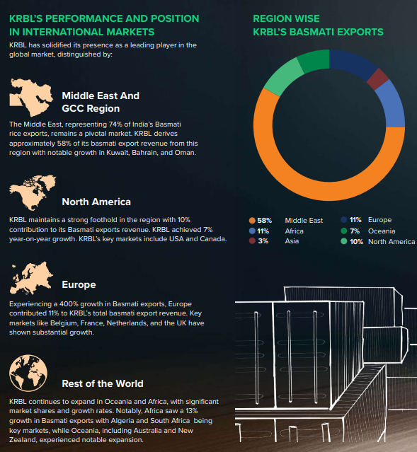

Figure 4: KRBL international presence
(Source: Krblrice, 2024)

4.2 Economic
The economic environment of India is highly favourable for agricultural production due to the availability of a massive labour force and vast land suitable for agriculture. The agriculture and allied sectors, as of 2024, have 54.6% of workforce engagement, and they also account for nearly 18.4% of India’s GVA (agriwelfare, 2024). For companies like KRBL, these developments' key advantage is the low-cost labour and raw materials, allowing for competitive pricing in the global market. The company’s revenue growth by 18% in 2024, as identified in the figure below in the domestic market, also highlights the beneficial sides of the Indian economy, allowing the company to increase its profit margin (Krblrice, 2024). Although, the company’s performance is based on also global economic conditions.
Changes in exchange rates, international demand and inflation can hinder export revenues. Like a global economic slowdown or a reduction of the Indian rupee value can make exports more competitive and reduce demand in key markets of KRBL. Another key contributing factor in this is the changes in agricultural outputs, especially for the monsoon dependency. Based on reports, it can be said that rice production in India is majorly influenced via rainfall and needs optimal levels for better production (Maiti et al., 2024). So, any changes in the rainfall patterns like droughts or floods, can affect the supply, prices, and profit of the company.
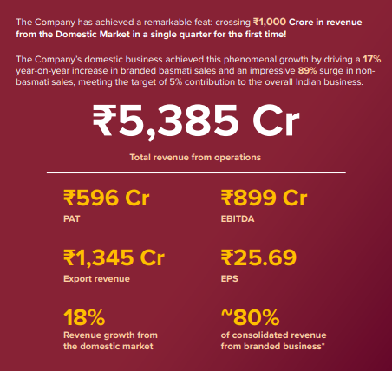

Figure 5: Financial overview of KRBL as of (31st March 2024)
(Source: Krblrice, 2024)

4.3 Social (Cultural)
Cultural factors also play a major role in the success of KRBL in the region. Rice has been a key food source in India and various parts of Asia, and Middle East regions. For example, Saeed et al. (2020) identified Basmati rice as being associated with aroma, premium quality, and a preferred choice in various regions. KRBL has effectively utilised this cultural positioning through considering their India Gate brand, which is considered for its quality, which also made it the number 1 basmati rice not only in India but also a brand across the globe (businessstandard, 2022). The company’s focus on branding and consistent reach to its followers ensures the development of trust among a large number of consumers.
Urbanization and changing consumption trends at domestic level also influence the demand. The growing preference for packaged, branded, and ready-to-cook foods has increased pressure on KRBL for responding through changing its portfolio. India’s consumers also play a major role in being a social influencing factor. Countries with higher Indian populations, like the UAE, and UK are also developing key markets for KRBL. The cultural familiarity with Indian cuisines also allows for stable demand management (Charthakuzhy Raju, 2026). Yet, changes in diets and health consciousness in some markets can develop challenges. According to reports, there is a trend among 53% Indian consumers for taking steps to enhance health and wellness, supporting the previous analysis (Nielseniq, 2025). Consumers are constantly searching for alternatives like brown rice, which can develop challenges for the company in the long term.
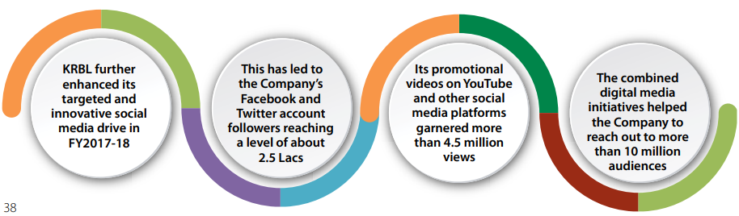

Figure 6: Digital presence of KRBL
(Source: You, 2021)

4.4 Technological
Technology has been advancing rapidly and is becoming also crucial in the agricultural industry. KRBL, being a major player in the industry, has also made major investments like their integrated business model, which includes seed development, farming support, milling, processing, and packaging (KRBL Rice, 2025). Advanced technologies, quality testing tools, and supply chain management approaches are allowing KRBL to maintain its consistency in product quality. Their constant focus on innovation and adapting new technologies also allows them to enhance their operations in exports, farming, and production while reducing risks (Krblrice, 2026). Although technological adaptation in India’s agricultural sector is scattered, with some farmers lacking proper tools and knowledge, it potentially hinders a consistent raw material supply. This develops the need for continuous investment in technologies for adapting to changes and the uneven technological adaptation nature of the region.

4.5 Legal
The legal environment of India is providing opportunities and challenges for KRBL. In this case, one of the most crucial advantages is to maintain the Geographical Indication (GI) status of Basmati rice that provides India with a competitive advantage in various international markets through authenticity (Upreti, 2023). Trade policies and tariffs for countries also influence the import duties and quality of standards for KRBL, and influence the competitiveness in the market. Furthermore, the company needs to align with wider domestic and international regulations, which often include food safety standards, export documentation, quality certificates, and environmental regulations. Alignment with these standards is crucial, especially the ones set by the Food Safety and Standards Authority of India (FSSAI) to ensure proper market access (Aswathy et al., 2024). Challenges with contract farming, land use and farmer relations are also supported through legal frameworks, making them key factors influencing supply chain effectiveness.

4.6 Environmental
Environmental considerations are also crucial and highly relevant in the agricultural industry. Rice cultivation is a water-intensive process with additional concerns for water scarcity and soil degradation being relevant in the Indian region (Savari et al., 2025). For KRBL, environmental issues like constant rainfall, rising temperature and extreme weather conditions can hinder crop production majorly. Thus, sustainability in these approaches is crucial, which made KRBL consider various sustainability practices in their operations (krblrice, 2026). Although proper management of these practices while meeting the rising and shifting demands can develop issues in the company’s growth. The sustainability approaches can also impact the brand perceptions of KRBL in India and even at global scale.
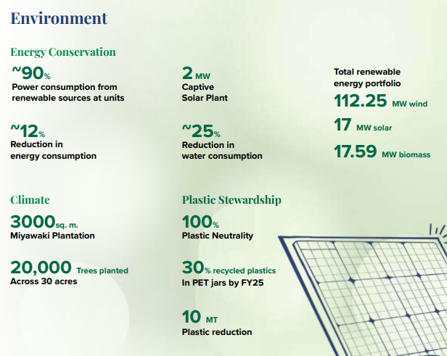

Figure 7: Environmental highlights of KRBL
(Source: Krblrice, 2024)
India’s agricultural and rice industry is still highly attractive for companies like KRBL. The country has significant growth opportunities for a brand like KRBL, which holds major potential in both the domestic and international markets. The country is providing strong natural advantages like favourable climatic conditions and a large labour force with the availability of agricultural land. Production of total food grains increased to 357.73 million tonnes in 2024-25 from 332.30 million tonnes of 2023-24. More significantly, production of rice in India has reached to a record of 150.18 million tonnes, which was 137.82 million tonnes in 2024 (Global Agriculture, 2025). The economic and social trends can be supportive pillars for KRBL for growth in the market. India’s global leadership in rice exports and its presence as a major agricultural provider across the globe also make it a highly profitable and beneficial country of choice. Although the market is having some issues which need appropriate consideration. For example, the policy uncertainty, climate risks, and rising global competition are some aspects which KRBL needs to adapt and develop more flexible approaches to compete in the market and sustain future growth.

5. Conclusion to the report
From the above study it has been concluded that the Indian agricultural industry holds a significant position in the global market due to the natural favourable factors of the country along with strong network and supporting industries. Regardless of its strong position in the global market, providence of high GDP and creates jobs as well as exports that influences world agricultural trade, this industry is a structurally complicated sector of India, striking a balance between a high level of natural advantages and long-standing inefficiencies. In the case of companies such as KRBL, which rely heavily on foreign markets such as the Middle East, and North America, these policies can turn things around and uncertainties are generated. No matter whether Basmati rice will be subjected to strict export prohibitions, more broad-based regulatory adjustments would impact price setting, supply chain, and logistics planning. Besides, there are government programs, such as the Pradhan Mantri Kisan Samman Nidhi program and investments in rural infrastructures that could be benefiting KRBL by boosting the productivity of the farms and by providing the table raw materials.
Furthermore, the analysis based on the application of the Diamond Model by Porter shows that the industry enjoys the advantages of the abundance of the natural resources and competitiveness in the export but the shift in the focus to the growth that is driven by innovation is still uneven due to the structural constraints in terms of fragmented landholdings, poor infrastructure, and evolving policies. In this context, the evaluation of KRBL has concluded the significance of the internationalisation process in which companies can use branding, supply chain integration, and international market orientation as an effective way of succeeding and coping with the challenges of the industry to reach a global consumer base. However, the macro business environment, which is affected by the political, economic, legal and cultural environment, has a long-lasting impact on the operational results that need to be balanced through the strategic evaluation of the organisation as well as the capacity of India to shift towards innovative and sustainable agricultural development.

Section 2: Reflection

This study has developed a wide range of understanding for me, while not only allowing me to improve my skills but also developing new opportunities to consider a situation. To better understand the complete process of the task and what has been the major personal and professional development, the Kolb’s reflective cycle can be used, which covers four key areas, including Concrete experience, reflective observation, abstract conceptualisation and active experimentation (Morris, 2020).
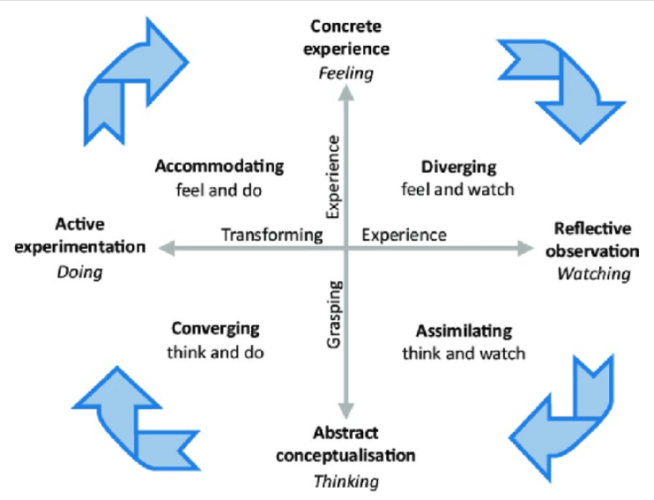

Figure 8: Kolb’s reflective cycles
(Source: Ahmed and Opoku, 2022)
Concrete experience
The completion of this assignment included the development of a detailed industry and company analysis report based on the Indian agricultural sector and a particular focus on KRBL Limited. From the start, I thought the task was simple and straightforward. Yet, as I progressed, I realised that producing an academic report will need more in-depth engagement with the authentic data sources, industry reports, and the company’s reports. I was able to manage various sections with step-by-step process and started with the introduction and then expanded to the overview of the industry. In the gathering of statistical data like GDP contribution, and export values required proper selection of credible and authentic sources like PIB and company annual reports is required. The most challenging part of this complete task for me was properly connecting all the information to develop a meaningful insight. While analysing KRBL Limited and the wider environment, I had to utilise theoretical frameworks like PESTLE and connect them to real-world contexts. I required to shift from my basic understanding and think in a more critical manner. The complete analysis was highly demanding and informative for me, especially for linking theory with the real-world industry approaches.
Reflective observations
For the complete analysis, I felt that I was able to gain all relevant and recent information properly, but the process was not smooth at all times. I often faced issues with managing the content in a structured and academic manner. I tried to shift from my descriptive analysis to a more organised content in a structured and academic tone/. As time passed, I was able to enhance this complete approach through making proper connections among the arguments and data gained. Furthermore, I also became more aware of the cruciality for utilising authentic sources. I tried to utilise all authentic sources to improve the credibility of my report, yet it also increased the time consumed. I also realised that can enhance my academic writing skills. This is mainly due to the fact that some of the parts in this report still feel informal which develops the need for enhancement for clarity and critical nature in my writing skills.
Abstract conceptualisation
Via conducting this assignment, I developed a clear understanding of how theoretical frameworks are utilised in real-world situations. For an example, I shifted my focus from just understanding the concepts like PESTLE or Porter’s Diamond model, to better utilising them to real company context. One of the key concepts I understood has been the idea of industry competitiveness. The Indian agricultural sector seemed to be strong for large scale and global dominance. Although, as more analysis was done, I understood the concept that factors like policy changes, climate risks, and global competition can influence the performances. I also gained understanding of how companies like KRBL can maintain a competitive advantage. This involved wider considerations like branding, quality control, supply chain management, and global marketing positions/. This develops wider strategic management theories in which companies need to consider both internal strengths and external opportunities for ensuring long-term success. I also learned how data can be utilised efficiently to enhance argument supporting. Various statistical evidence, like exporting values a allowed me to improve my writing quality and made it more authentic.
Active experimentation
Based on the complete assignment experience, I can now shed light on various areas in which I need improvement that will support my future assignments. First, I aim to start at an early level and organise all sources in a careful manner to ensure systematic gathering. This will significantly allow me to reduce excess time pressure and ensure in-depth analysis can be done. On the other hand, there is a crucial need for me to improve my existing academic writing skills. I aim to develop crucial and clear arguments while supporting them with relevant analytics database for better quality writing. I will also ensure to maintain a more logical flow like this assignment in my future tasks. Through focusing on enhancing my structured writing skills I can ensure my future assignments will be done in a more academically-appropriate manner. I learned to utilise theoretical frameworks effectively, which I was a little weak with. Instead of considering them as just sections, I can now integrate them more effectively in the analysis. Yet I will focus on enhancing this skill as it still needs more improvements. I will also continuously focus on using authentic and recent sources. This assignment has showcased me the crucial need for credible data usage for effective arguments. In future, I will use more authentic sources for supporting my claims to ensure reliability and validity of the studies. I now feel more prepared for managing similar tasks in future, yet there are still some areas, which I need to improve for efficient delivery and maintenance of study quality.

References
Agricultureinstitute, (2025). Entrepreneurial Marketing in Agriculture: Strategies for Success. Available at: https://agriculture.institute/agripreneurship/entrepreneurial-marketing-agriculture-strategies/ [Accessed on 02.04.2026].
Agriwelfare, (2024). Annual report 2023-24. Available at: https://agriwelfare.gov.in/Documents/AR_English_2023_24.pdf [Accessed on 01.04.2026].
agriwelfare, (2024). DEPARTMENT AT A GLANCE. Available at: https://agriwelfare.gov.in/en/Dept [Accessed on 05.04.2026].
Ahmed, V. and Opoku, A., (2022). Technology supported learning and pedagogy in times of crisis: the case of COVID-19 pandemic. Education and information technologies, 27(1), pp.365-405. https://link.springer.com/content/pdf/10.1007/s10639-021-10706-w.pdf
Aswathy, T., Rajan, S.A., Chitra, N. and Soumya, V.I., (2024). Food Safety Standards Authority of India (FSSAI): A multifaceted approach towards food safety. Agritechpublication. com, pp.1-4. https://www.academia.edu/download/118328389/FSSAI_Sept_2024._Aswathy_S._Anu_Raja.pdf
Baruah, S. and Mandal, R.K., (2025). Crucial Achievements of Indian Agriculture: A Critical Assessment. Journal of Information Systems Engineering and Management, 10, pp.487-97. https://www.researchgate.net/profile/Swapnali-Baruah/publication/391952532_Crucial_Achievements_of_Indian_Agriculture_A_Critical_Assessment/links/682e72706b5a287c30433431/Crucial-Achievements-of-Indian-Agriculture-A-Critical-Assessment.pdf
bayer, (2025). Bayer in India At a Glance. Available at: https://www.bayer.in/sites/bayer_in/files/corporate-brochure-2026-india-1.pdf [Accessed on 02.04.2026].
Bayer (2026). Crop Science. Available at: https://www.bayer.in/en-in/our-businesses/crop-science (Accessed: 18.04.2026).
businessstandard, (2022). Latest study recognizes India Gate as the world's no. 1 basmati rice brand. Available at: https://www.business-standard.com/article/companies/latest-study-recognizes-india-gate-as-the-world-s-no-1-basmati-rice-brand-122102700479_1.html [Accessed on 08.04.2026].
Charishma, K.S. and Singh, R., (2024). Contribution of agriculture sector in exports of India-an economic analysis. Journal of Education (nd). https://www.researchgate.net/profile/Rajender-Singh-11/publication/381291939_CONTRIBUTION_OF_AGRICULTURE_SECTOR_IN_EXPORTS_OF_INDIA-_AN_ECONOMIC_ANALYSIS/links/6665d530a54c5f0b945c3989/CONTRIBUTION-OF-AGRICULTURE-SECTOR-IN-EXPORTS-OF-INDIA-AN-ECONOMIC-ANALYSIS.pdf
Charthakuzhy Raju, L., (2026). An explanatory study on the significance of Indian ready-to-eat frozen snacks in the UK market. https://stud.epsilon.slu.se/21933/1/charthakuzhy-raju-l-20260126.pdf
Dev, K., (2023). Institutional arrangements to enforce the minimum support price (MSP) policy effectively in India: a case study of wheat and paddy production in Punjab. Advances in Research, 24(5), pp.60-70.https://papers.ssrn.com/sol3/Delivery.cfm?abstractid=4467499
Duggal et al., (2023). How reliant is the world on Indian rice exports? Available at: https://www.aljazeera.com/news/2023/9/20/how-reliant-is-the-world-on-indian-rice-exports [Accessed on 30.03.2026].
Global Agriculture, (2025). India’s foodgrain output jumps nearly 8% to 357.73 million tonnes in 2024–25, shows final estimate. Available at: https://www.global-agriculture.com/global-agriculture/indias-foodgrain-output-jumps-nearly-8-to-357-73-million-tonnes-in-2024-25-shows-final-estimate/ (Accessed on 19.03.2026).
global-agriculture, (2025). India’s Foodgrain Output Hits Record 353.96 MMT in 2024–25, Up by 21.66 MMT from Last Year. Available at: https://www.global-agriculture.com/india-region/indias-foodgrain-output-hits-record-353-96-mmt-in-2024-25-up-by-21-66-mmt-from-last-year/ [Accessed on 30.03.2026].
Ibef, (2025). Agriculture in India: Information About Indian Agriculture & Its Importance. Available at: https://www.ibef.org/industry/agriculture-india [Accessed on 25.03.2026].
Ibef, (2025). Growth of Agriculture Industry in India – Infographic. Available at: https://www.ibef.org/industry/agriculture-india/infographicIMARC Group, (2025). Indian fertilizer market: Size, share, trends and forecast by product type, segment, formulation, application, and region, 2026–2034. Available at: https://www.imarcgroup.com/indian-fertilizer-market (Accessed: 19 March 2026).
kohinoorfoods, (2025). Annual report 2024-25. Available at: https://www.kohinoorfoods.in/assets/annual-reports/ANNUAL-REPORT-2025.pdf [Accessed on 28.03.2026].
Kohinoorfoods, (2026). Kohinoor- Global Presence in Over 65+ Countries. Available at: https://www.kohinoorfoods.in/ (Accessed: 17.04.2026).
Krblrice, (2024). Evolving for Tomorrow’s Palate ANNUAL REPORT 2023 – 2024. Available at: https://krblrice.com/wp-content/uploads/2024/08/KRBL-Annual-Report-2024.pdf [Accessed on 27.03.2026].
Krblrice, (2025). Annual report 2024-25. Available at: https://krblrice.com/wp-content/uploads/2025/08/KRBL-Annual-Report-2025.pdf [Accessed on 25.03.2026].
Krblrice, (2025). Q1 FY2025 Financial Results. Available at: https://krblrice.com/wp-content/uploads/2024/08/Q1-FY2025-Financial-Results.pdf (Accessed: 18.04.2026).
Krblrice, (2026). Discover The Essence Of Excellence. Available at: https://krblrice.com/about-us/ [Accessed on 30.03.2026].
krblrice, (2026). SUSTAINABILITY Preserving For Future Generations. Available at: https://krblrice.com/sustainability/ [Accessed on 28.03.2026].
Kumar, D. and Phougat, S., (2021). Analysis of pradhan mantri kisan samman nidhi (PM-kisan) scheme: with special reference to Haryana state. Journal of Global Agriculture and Ecology, 12(2), pp.1-8. https://www.researchgate.net/profile/Malik-11/publication/355162835_Journal_of_Global_Agriculture_and_Ecology_ANALYSIS_OF_PRADHAN_MANTRI_KISAN_SAMMAN_NIDHI_PM-KISAN_SCHEME_WITH_SPECIAL_REFERENCE_TO_HARYANA_STATE/links/61615fdc0bf51d48175bcc3d/Journal-of-Global-Agriculture-and-Ecology-ANALYSIS-OF-PRADHAN-MANTRI-KISAN-SAMMAN-NIDHI-PM-KISAN-SCHEME-WITH-SPECIAL-REFERENCE-TO-HARYANA-STATE.pdf
Kumar, K., Babu, T.R. and Deshmukh, S.S., (2024). Nurturing growth: Agri-startup landscape in India and the challenges ahead. Research on World Agricultural Economy, 5(2), pp.131-149. https://ageconsearch.umn.edu/record/343525/files/RWAE-0502-1073.pdf
ltfoods, (2025). A Billion Dollar Empire. Available at: https://ltfoods.com/ltfoodscms/uploads/article/pdf/article_1764842750.pdf [Accessed on 30.03.2026].
Ltfoods, (2026). Nurturing Goodness isn't just our tagline but our way of life. Available at: https://ltfoods.com/ (Accessed: 18.04.2026).
Maheswari, D.Y. and Kalyan, D.N.B., (2020). A Study on Performance of Equity Stocks in Indian Commodity Market. Available at SSRN 3527924. https://papers.ssrn.com/sol3/Delivery.cfm?abstractid=3527924
Maiti, A., Hasan, M.K., Sannigrahi, S., Bar, S., Chakraborti, S., Mahto, S.S., Chatterjee, S., Pramanik, S., Pilla, F., Auerbach, J. and Sonnentag, O., (2024). Optimal rainfall threshold for monsoon rice production in India varies across space and time. Communications Earth & Environment, 5(1), p.302. https://www.nature.com/articles/s43247-024-01414-7.pdf
Markets, (2026). Bayer Cropscience Ltd. Available at: https://markets.ft.com/data/equities/tearsheet/profile?s=BAYERCROP:NSI (Accessed: 16.04.2026).
Markets, (2026). KRBL Ltd. Available at: https://markets.ft.com/data/equities/tearsheet/profile?s=KRBL:NSI#:~:text=Revenue%20in%20INR%20(TTM)60.15,Fax+91%201%20204060398 (Accessed: 18.04.2026).
McKinsey & Company, (2025). Value creation in Indian agriculture. Available at: https://www.mckinsey.com/industries/agriculture/our-insights/value-creation-in-indian-agriculture (Accessed: 19 March 2026).
Morris, T.H., (2020). Experiential learning–a systematic review and revision of Kolb’s model. Interactive learning environments, 28(8), pp.1064-1077. https://researchspace.bathspa.ac.uk/13077/1/13077.pdf
Mubashir, M. and Bhat, A., (2021). Agriculture and farming community in India: Challenges, problems and possible solutions. In: A. Kumar, S. Mukherjee, D. Thirumaran and S. Mandal (eds.) Indian agriculture, farmer and labour: Issues and reforms. New Delhi: Bharti Publications, pp.1–15. Available at: https://www.researchgate.net/publication/355730895 (Accessed: 01.04.2026).
Nielseniq, (2025). NIQ: Indian Consumers Are Taking Charge of Their Health Through Smarter Food and Tech Choices. Available at: https://nielseniq.com/global/en/news-center/2025/niq-indian-consumers-are-taking-charge-of-their-health-through-smarter-food-and-tech-choices/
Pib, (2023). Centre amends Export Policy of Non Basmati White Rice to ensure adequate domestic availability at reasonable prices. Available at: https://www.pib.gov.in/PressReleasePage.aspx?PRID=1941139&reg=3&lang=2 [Accessed on 02.04.2026].
Pib, (2025). Bharat International Rice Conference (BIRC) 2025 to position India’s Leadership in Global Rice Supply Chain. Available at: https://www.pib.gov.in/PressReleasePage.aspx?PRID=2182209&reg=3&lang=2 [Accessed on 02.04.2026].
PMF IAS, (2026). India becomes the world’s largest rice producer. PMF IAS. Available at: https://www.pmfias.com/india-worlds-largest-rice-producer/ (Accessed: 19.03.2026).
Press Information Bureau, (2023). Union Agriculture Minister says if the small farmers will be empowered, it will boost India’s GDP. Ministry of Agriculture & Farmers Welfare, Government of India. Available at: https://www.pib.gov.in/PressReleasePage.aspx?PRID=1906748 (Accessed: 20.03.2026).
Saeed, I., Mubarik, A., Umar, F. and Aqsa, Y., (2020). Basmati rice cluster feasibility and transformation study. 2020) Cluster Development Based Agriculture Transformation Plan Vision-2025. Project, (131), p.434. https://sawie.net/wp-content/uploads/2025/01/Basmati_Rice_Cluster_Report.pdf
Saha, D., (2020). Economics of the Food Processing Industry. Themes in Economics.https://www.academia.edu/download/88156186/978-981-13-8554-420220701-1-1bcn8wm.pdf [Accessed on 02.04.2026].
Savari, M., Amghani, M.S. and Miladi, H., (2025). Sustainable rice production under water scarcity conditions using drip irrigation: Based on evidence among Iranian farmers. Available at: https://www.sciencedirect.com/science/article/pii/S2590123025025125 [Accessed on 02.04.2026].
Sharma, P. (2025). Top Basmati Rice Manufacturers in India for International Bulk Supply. Available at: https://www.tradologie.com/blogs/top-basmati-rice-manufacturers-in-india-for-international-bulk-supply/ (Accessed: 10.04.2026).
Syngenta, (2025). Syngenta Group reports $28.8 billion sales and $3.9 billion EBITDA in 2024. Available at: https://www.syngentagroup.com/newsroom/2025/fyr-2024 (Accessed: 18.04.2026).
Syngenta, (2026). Seeds. Available at: https://www.syngenta.co.in/seeds [Accessed on 28.03.2026].
Syngenta, (2026). Syngenta About Syngenta. Available at: https://www.syngenta.com/company (Accessed: 17.04.2026).
Syngentabiologicals, (2025). Syngenta strengthens global leadership in agricultural biologicals. Available at: https://www.syngentabiologicals.com/en/media-center/news-press-releases/press-release/corporate/syngenta-strengthens-global-leadership-agricultura/#:~:text=About%20Syngenta,on%20LinkedIn%2C%20Instagram%20&%20X (Accessed: 18.04.2026).
Thakur, R., Sharma, S., Negi, A. and Laishram, C., (2023). Precision farming for Indian agriculture. Just Agriculture, 3(8), Article ID: 76. Available at: https://www.researchgate.net/publication/377974565. (Accessed: 30.03.2026).
Udhayakumar, M. and Karunakaran, K.R., (2020). Growth and Stability of Basmati and Non-basmati Rice Export in India. Current Journal of Applied Science and Technology, 39(40), pp.9-18. http://note.send2pub.com/id/eprint/419/1/Udhayakumar39402020CJAST63657.pdf
Upreti, P.N., (2023). The battle for geographical indication protection of basmati rice: A view from Nepal. IIC-International Review of Intellectual Property and Competition Law, 54(5), pp.710-731. https://link.springer.com/content/pdf/10.1007/s40319-023-01323-w.pdf
You, T., (2021). Company Secretary. Available at: https://stockinsights-in-filings.s3.ap-south-1.amazonaws.com/annual-reports/KRBL-KRBL_Ltd-AnnualReport-FY2018.pdf (Accessed: 29.03.2026).
Youns, E. and Muzaffar, M., (2025). Historical and Diplomatic Relations of India with Saudia Arabia and Iran. Annals of Human and Social Sciences, 6(2), pp.126-136. https://www.ojs.ahss.org.pk/journal/article/download/972/1009

