Turbo tantrum vr postmortem

Name – Alex king
Module code - M6X01898
Module title - SFDM Major Project Stage 1
Course tutor - Richard William Morgan
Submitted in partial fulfilment of the requirements for the degree of BA (Hons) University of Wales Trinity Saint David, Swansea, (18th jan 2019)

Introduction
Turbo Tantram VR is a cross platform 3 player vs one vr player racing game where the main aim is to finish the race and avoid the rampaging Rodd the kidd. Production of the game was split between two teams the tech team and the art team who both split the task between four members. Being part of the art team my roles in the production of the game where as followed –
- to draw concepts for the bedroom that the game would take place in
- draw ideas and concepts for the race track and objects that could appear
- the ui and menus for the game
- design rodd the kidd
- draw concepts of the power ups and icons
- design the look of the hot-rod car
- design the art target/diorama to show at the end of the term

research Evaluation
When researching for the game a more explorative path was taken as much of the game was set in an 80s era setting when creating the look of many of the asset’s real examples of objects and things from that time where looked at. For example, when creating the look of some of the toys that will be around the track actual images of toys and bedrooms from that time where looked at to capture the feeling that this toy could actually be found in a bedroom at the time. Using a more explorative research technique really paid off as being part of the art team required lots of visual research to back up the designs and I would often be looking for examples of objects that fit that time and would need to find out what they looked like with no prior knowledge of their designs.
Technical Research
In regards to the technical side of the research I would go look up websites on how other games designed their art styles, I would interact with the other art team and get their opinions on my designs I would also take into consideration what course tutors would say in regards to the design process as well.
Contextual research
When researching for the game many sources of inspiration where used in regards to the visual style of the game toy story and other animated cartoons where a big influence on my design style, comic books where also an influence as their style of heavy lines and bold colours helped the game stand out when compared to others like it. Probably the biggest influence on the games style that I looked at was the Memphis art movement form the 1980s its use of bold bright colour and insane abstract shapes really helped our designs stand out and also capture that distinct 80s feeling. When looking at the music for the game research on music from the time was undertaken and genres like synth/pop/and punk where a big influence on the game and this as well influenced the art style as more bright intense colours where used in my designs to try and match the music’s feeling. When designing lots of the asset concepts I also tried to go out and find actual examples of them this can be seen with the toys I found of early 1980s wrestling figures that influenced my designs of the toys.

When researching for the game I always aimed to make sure everything I looked at would fit the game but also stay true to the 80s setting I made sure that everything I looked at had evidence to back it up and that that object could really be found in that time if not I would move on and keep looking. Even though I looked at lots of 80s themed objects and things from that time I think I should have branched out and looked at more modern examples to get a wider range of research examples.
Game research
During the process of making my designs I referenced micro machines use of fun mayhem and scale to influence my design of the hot-rod and Rodd the kidd , mean greens was also a big influence on the actual design layout of the room and what types of objects could be found in the area its mechanics of having army men running around directly influenced some of my own power up ideas as they fit in turbo tantrum as well. Zelda the windwaker also heavily inspired my style as its use of cell shading and bold colours helped make assets stand out and also help the vr player see the cars moving more easily on the track. games like jet set radio and Splatoon also influenced the art style with their use of colours but probably my biggest influence was toy box turbo as the game is very similar to the game our team plans on making I played the game to get a feeling for what we should aim for also its use of colour theory in the cars directly influenced my design of the hot rod.

Research conclusion
I feel like the way I researched ideas and concepts was good and I had no problem finding new ideas and ways to solve problems I had but I could have done lots more to get a bigger range of influences. looking back, I think I could have looked at more examples of actual racing games to get a real feeling of how racing games play/work/look I also think I should have looked at more written research on how games work and should feel like. Next time I hope to get a much wider range of research that also includes written evidence. I also think I should spend more time actually playing racing games to get an idea for what they are and how to function and what makes them fun in an art style sense.

Technique evaluation
When it came to the way production was handled the art team split tasks between ourselves and each week we would aim to complete our task on a Monday/Friday basis. Team gantt was used to keep track of task and plan ahead I used this to stay on top of my task and inform the team if I had trouble or needed help with anything this way of work was really good, and I feel like it made me more productive and helped keep me on task more.
Development of Techniques & Skills
Alongside planning my own tasks team gantt was used to keep the entire team updated therefore I feel like I learned more of how planning works on a wider scale and how planning for a project is implemented effectively, frequent meetings with the tech and art sides of the team also meant I had to balance and account for tasks they wanted done by a planned date. I feel like working like this has improved my commutation skills and my ability for planning. Over the course of the project I feel like I have stepped out of my comfort zone and collaborated more this term than last term and I feel like this is due to the feedback I had then of communicating more. Summer and me would also share ideas on how a part of the game would look and we would work on a sort of production line of me coming up with ideas passing them to her and then improving on the idea she gave back I feel like this way of working has helped make the art style more consistent and I have learned more about how collaboration works.
Overall Quality of Work Produced
Overall the quality of the work I have produced this year is far better than last year and I am happy with what I have achieved in the time we have had. I feel that working in teams of just artists have allowed me more freedom to explore and share ideas with the team and have directly helped improve my work. Although I have done much more work and to a better quality this year I also feel like it could be better I still think I am to slow and it takes me some time to get my ideas on paper I feel like if I worker closer with the art team and share more of my ideas they could help me get the ball rolling faster . I also think I should use my time better as I leave things to late and then rush a lot of my work if I just plan better and use my gantt chart more often I feel like the quality would improve next term.
Technique conclusion
Taking everything, I have learned from past years in games design I fell like this year has been a big improvement and feels more like a games design project. I wouldn’t say I have leaned lots this term, but my existing skills have defiantly improved my planning and communication skills are better and I can take what I have leaned into the next term and really give it my all. I know that working closely with and communicating with your team is key to a successful project also I have learned that actually experiencing something is better than just researching about something for example with actually playing a game rather than watching it. Next term I want to focus more on time management and project scope as I feel like there is still room for improving in these areas and the project scale will need to be looked at to make sure I am on track and not over reaching.
Development evaluation
In the team each member had a role they had to fill and each week a deadline was set to keep everyone on track to get a part of the work done. Team gantt and weekly meetings where held to make sure everyone was on track and followed their deadlines this worked well for the most part but later on in the project some problems arose with team members not doing work on time therefore I feel like the planning needs improving next term to make sure this doesn’t happen again.
When producing work, I worked on an iterative design process this meant I would create a bunch of ideas then I would show both teams and get their feedback on them and then I would take what they said and improve on the design to get a final outcome. The reason I worked like this was to make sure that my designs stayed true to the original game idea and I wasn’t just coming up with random things that don’t fit the game/style. Although I also feel like this had a drawback as some of my creative ideas where shot down and I couldn’t be free to experiment with ideas also I fell like working on an iterative design baseis made my work flow slow down and it would take me longer to get my work done. I worked around many of these problems by going back to my gantt chart and planning for immediate deadlines and asking summer and aday if they could take one or two of my designs to draw instead in return I helped them out when they needed it.

Creativity
When planning out the project the team set many goals as we thought the game idea was original and had the ability to be great I spent my weekends and free time exploring ideas and concepts from many sources as I felt that this game could be amazing if I put in the work. I went to shops and local areas that had 80s themed objects to capture evidence and give the game an authentic felling like I have actually taken the time to look at and design objects instead of just using secondary evidence. Just because I think the game is so fun I made the art target/diorama to show people what the game could be I didn’t have to do this, but I did because it’s a genuinely fun game. The setting of the game also inspires me as the 80s retro theme is not explored enough in racing games and I feel like I want to genuinely research about things from that era apply myself to this project.
Relevance to the brief
As the brief was loose with what we could pick for a game I believe turbo tantrum is still close to what the brief asked for but the introduction of the vr element meant that the game had to be designed with that in mind. With no one in the art or tech team having previous knowledge on how to design for vr I personal looked at pre-existing vr games like resident evil 7 to see how I could design the environment around the vr element.
Contribution within a group
As this term required a group change I had to work in a team with new people, but I also had my old team member Felix with me this meant the structure we worked with last year had to change to accommodate summer and Aday. Within the group we gave out task and roles and I had previse experience with art so I was given more a concept design role each week we held team meetings and I went to everyone one. discord was also set up, so I could communicate with the tech team it became evident that the rest of my team was not talking with the tech team and this caused some problems as they couldn’t see what the tech team was doing and vice versa. As a result of this I had to compromise and try and make sure the art team stayed on task and did what the tech team asked for this defiantly has to change next term and the art team needs to talk with the tech team at least ones a day to stay in the loop.
Overall, I feel like the team worked well and did the tasks we set but I also feel like I was alone a lot of the way and my team wouldn’t talk I hope to talk with my team about this more to stay on track next term.
Iterative design practice
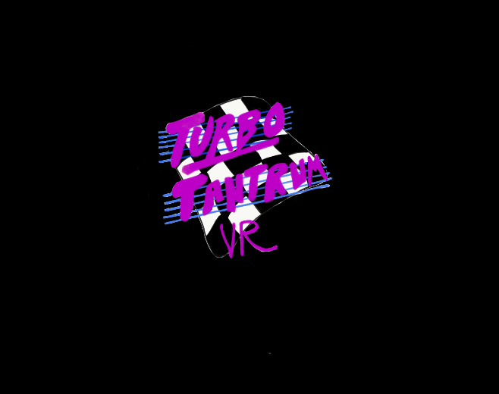
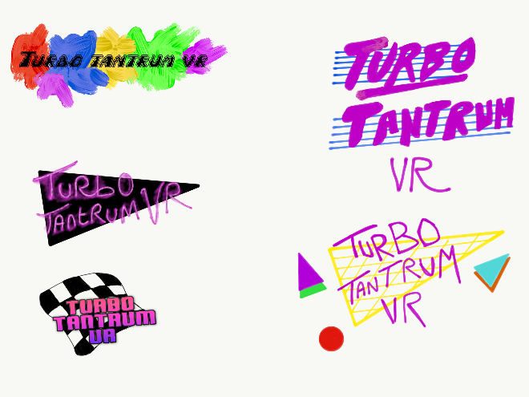

When I made concepts, I would show tech/art team and get their opinions on the design as seen above with the game logo after getting feedback on the logos I made I refined it and came up with a much better logo for the game. I relied on external feedback from my team and Ritch to help find areas I could improve my designs and I feel that this helped me improve my drawing skills rather than just drawing and not bothering to ask about designs and having bad concepts this helped me be self-critical as well and ask myself is this the best I can do.
Time management
As soon as this term started I set up team gantt and also a solo gantt chart as I have previous knowledge of how time management works in a team. I fell like my time management this term is vastly improved over last year as I would use the gantt chart daily to see my goals and deadlines I made a risk assessment taking what Iearned last year to make sure me and my team stayed on task and what they could do if they where in trouble with something as well. I would spend at least 2-3 hours a day researching or drawing concepts for the game and also used my weekends if I was behind in my work. Realistically I set a bit two many goals this term that I should have known I wouldn’t achieve in the timescale I had but after the team decided on making term one a concept stage I felt that many of the goals where achievable and I could stay on task much more effectively.
Development conclusion
Overall, I believe that the development process this term has vastly improved over last year and I have learned from many of my mistakes. The planning was better because of the use of gantt charts and this time I am actually using it instead of box ticking although the problems with the team not talking with each other made lots of problems farther down the line. Taking what I have learned in this term I am going to make sure both teams have meetings weekly and both teams talk more in depth about our ideas and progress updates. I also plan on scaling back on some of the bigger ideas I had for the game now that I understand the scale of the game overall next term I want to plan more effectively and make sure I don’t get overwhelmed with work.
Overall conclusion
This year’s first term has gone very well and is a vast improvement over how things went last year I believe that because my planning is better a direct result is that my work is better, and I have achieved much more in the timescale than I had previously. using class time and self-directed study effectively I believe I have done a better job and have achieved a good quality of work with research/references to back it up. Although I haven’t learned anything new I believe that I have improved on my pre-existing communication and planning skills and my work is better because of it.
The team started of to a rocky start with a new team/members and later on with members not talking with each other but in honesty the team worked well when the time came the communication definitely needs improving next term I plan on setting up Facebook groups/discord chat and making sure everyone has each-others numbers to make sure there is literally no way people can’t talk about things. Also, i think both teams should have a sort of leader that makes sure both teams are in contact and there are no problems that are building up.

