Research Project
The overall aim of the research project is to discover whether or not differentiated tasks have an impact on the engagement of student in relation to the tasks set and to the lesson. In order to achieve this aim clear objective were set:
- Provide differentiated tasks to a class of Key Stage 3 learners.
- Measure the levels of engagement of selected case pupils, during a lesson with multiple differentiated tasks.
- Interview case pupils about the lesson that they have just taken part in, in order to determine their levels of engagement.
- Refine and reproduce a lesson with differentiation based in the findings from the previous lesson.
The purpose of this research is to develop an understanding about differentiated tasks and if they have an impact on engagement for students in relation to the task and the lessons and to improve on our teaching practice to ensure all learners about consistently engaged and improving during a lesson.
The particular focus during this investigation is the direct link to differentiated tasks and pupils engagement. Differentiation was of interest to me because in my school humanity lessons from Year 7 to Year 11 are all made up of mixed ability students. Therefore, differentiation is a daily part of my teaching practice and planning for every lesson. Within my class I have a range of students from MAT to ALN students so in order for a lesson to run smoothly and to have all leaners challenged I needed to create and provide tasks that are differentiated in relation to the learner’s abilities. As a result of this, I was interested to see what effect this has on a leaners engagement during a lesson and see it had a direct link to the engagement levels during a lesson.
Research Context
The research investigation will take place in two comprehensive schools. School A, an English medium school has pupils ranging from 11 -16 years old with approximately 1,105 pupils enrolled. The schools intakes a full range of ability learners with 21.5% of leaners having additional learning needs and 4% of students have a statement for special educational needs. School B has mixed ability classes for all lessons apart from English, Maths and Science with pupils ranging in attainments levels (Esytn, 2017).
School B is an English medium comprehensive school and has pupils age ranging from 11-19 years old. The school has an approximate intake of 1,242 pupil with around 23% of pupils with special educational needs and 4% of pupils statemented (Eystn, 2017).
I conducted my research in school A, as my class was a mixed ability Year 7 History class this meant that the differentiation in tasks were needed to be for a full attainment range, as the class was mixed with MAT students to children with ALN and teaching assistants.
My research partners conducted their research in school B. The class they carried out her investigation with was a top set Year 7 English class. This meant that they differentiated tasks that were provided needed to be set with the higher levels of difficultly that a top set needs in order to be challenged.
I discussed this with my partner about the different types of differentiation that can be incorporated into a lesson and therefore our research question is ‘To what extent do differentiated tasks have an impact on engagement in a Key Stage 3 class’.
Literature Review
Differentiation can be defined by the Department of Educational Skills as:
“….identifying and addressing the different needs, interests and abilities of all learners to give them the best possible chance of achieving their learning goals.” (Standards Unit, Improving differentiation in business education, 2004)
Differentiation is often refeed to as ‘teaching mixed ability’ or ‘teaching mixed level classes’. However, it’s clear that all learners are different in many different ways, not just through their ability. An even more important thing that needs to be considered is what is meant by ability as all students have strengths and weaknesses within their abilities and talents. No class is ever completely homogenous. What needs to be considered is how much we as teachers can meet the needs of the induvial students. Therefore it is vital to teach the students rather than complete a lesson plan. Teachers need to be adaptable to any given situation.
Differentiation isn’t always providing different worksheet for all learning and getting them to work individually or even as pairs as this can come across as uninspiring and stretches the learning too thin. Student come to school and love to interact with one another and quite a lot can be learnt through interaction.
Questioning techniques can also be adapted in order to provide better differentiation. Giving students enough time and space to answer a specific question, asking the question before nomination a student to answer is also a very easy way in which to differentiate types of questioning as it allows pupils to think about the answer. Additionally considering how hard the questions is before selecting a particular student, not choosing a student who would struggle to answer certain questions. Asking different types of questions is a useful methods which can be taken from Bloom’s Mastery and developmental tasks (Bloom’s Taxonomy) (Suleman, 2016).
Nonetheless, within a class of mixed ability students it is essential to be able to provide differentiated work in order for all pupils to have the best chance at learning, regardless of their weaknesses, strengths or abilities. Differentiation is key in order to keep a full class of different learners in the ‘struggle zone’ where there is high challenge and effective learning with low stress (Runeckles, 2018).
Every learner needs to be kept from falling into the comfort or panic zone. However, this can only be done through teacher monitoring the learners and making adjustments to their workload when necessary, thus differentiation. Without this key skill, high achieving learners would be at risk of falling into the comfort zone without their learning ever being stretched and those who are less able would fall into the panic zone as the work would be overloading.
Moreover, planning a lessons with differentiated tasks is always a challenge. There are many thing that need to be considered such as the number of different resources that are need to be made for the lessons and the time that a teacher would need to explain the different tasks to the learners. This can be difficult to instruct with a full class where a selection of learners are going to be carrying out different tasks.
However, successful implementation of differentiated tasks can be achieved when a teacher is well prepared and not bombarding pupils with numerous different sources of information (Runeckles, 2018). Teachers need to be prepared to provide tasks and extra resources available for those who are in need of them and stretch and challenge tasks available for higher attaining student and MAT students that need further challenging.
Overall implementing differentiation is a challenge but one that has had continuous improvement with practise of teaching and getting to known the learners individual needs and talents. This is a practice that can always been developed for the good of the learners.
Lesson Study
The main method used during this research assignment was that of a lesson study. A lesson study is a form of classroom research which focuses on the development of teacher practice knowledge which has been used in Japan since the 1870s (Godfrey, 2018). Lesson Study typically involves groups of teachers collaboratively planning, observing, teaching and analysing the teaching and learning that takes place in the research lessons. Usually a research lesson is designed by teachers/researchers together and then one person will teach the lesson whilst the researches observe it and make notes. The recording made during the lesson will be used to improve the lessons that follow. Researchers record their findings and over a cycle of research lessons the researchers may innovate or refine a pedagogical principle or approach.
Lesson Study has been used successfully in the UK. It was launched by Dr Pete Dudley in 2011 in order to improve teaching techniques and pupil progress in core subjects. Additionally primary and secondary PGCE students in universities have used Lesson Studies to develop broader pedagogic approaches such as assessment for learning (AfL).
During a Lesson Studies a small group of teachers (or even a pair) will:
- Use the data they have gathered from day to day and periodic assessment to agree upon a focus i.e cross curricular responsibilities or differentiated tasks.
- Together as a group teachers/researchers will jointly identify a teaching technique in order to develop or improve upon.
- Identify around three ‘case pupils’ that will be the focus of the investigation. Each pupil should represent a particular group of learners in the class.
- Jointly plan a ‘research lesson’ which studies and develops the effects of the approach under examination.
- Interview the case pupils to gain their insights into the research lesson.
- Reflect on the lessons given and interview carried out in order to understand what went well and what needs to be changed for the future teaching practice.

Teach and jointly observe the research lesson focusing on the case pupils’ learning and progress, using a form of observational tool such as an observation checklist. In order to carry out an observation and observational methods needs to be create or used. The Leuven wellbeing and involvement scale was a tool developed by a team based at the University of Leuven in Belgium under the supervision of Dr Ferre Laeves (Laevers, 2011). This tools was created in order to examine the level of well-being and involvement during a lesson. It’s very useful to observe how well children’s levels of well-being and involvement are during different tasks in a lesson and also how pupils responds to different activities. Even a low level of involvement can be a useful piece of evidence (Laevers, 2011).
Following the lesson a reflection shout take place on what has happened. A reflection involves three processes:
- Experiences something
- Thinking (Reflecting) on the experience
- Learning from the experience
Reflection models of reflective practice allow teachers and researchers to construct a reflection on a much greater depth. From using models of reflective practice such as Gibbs, 1988 and Kolb, 1975 and 1984; there is a reflective learning cycle which enables researchers to observe the event/experience through a cycle which aims to take the leaning into a new experience for the future.
Ethical Considerations
When carrying out a research project such as this, specific ethical considerations need to be taken under advisement prior to the investigation. The British Educational Research Association (BERA) have specific guidelines that need to be followed. Anonymity is considered as a risk to the participant and therefore as an issue of safeguarding and well-being the identity of the participant and the researcher will remain anonymous throughout and after the investigation. (British Educational Association, 2018). Additionally full informed consent must be gained in order for the participant to take part in research not only from the participant themselves but from their parents, under the British Educational Association, 2018 guidelines. Moreover, pupils will have the opportunity to withdraw if they feel uncomfortable or pressure at any given time. Pupils will also have to opportunity to not be involved with the investigation at all if they simply do not want to take part. Participants will be told that they are not under pressure to given specific answers during the interview process. This is the responsibility of the researcher to build a rapport with the particular and ensure that all participants are willing to be involved and have access to withdraw themselves if they so wish.
Lesson Study One
Lesson one was taken place in an English medium comprehensive school during a top set English Year 7 class. The aim of the lesson was to examine a poem using the techniques that the learners have been developing in their English classes since they started to topic of poetry.
Therefore all the pupils were put into groups at the beginning of the lesson biased on levels of attainment within the class. Every groups was given a different poem along the theme of weather. They were instructed to analyse the poem they were given and identify any of the techniques that they recognise from their previous lessons. Pupils with a harder poem were encouraged to use a key so that all the different techniques could be labelled easily
Pupils were then directed to stand up and find someone who had a different poem to them and discuss their poems with one another. They were instructed to explain what their poem was about, what techniques were used and what they thought of the poem. Pupils were then instructed to return to their seats were a people from different groups were asked to share that they have discovered about their poems. Pupils 1, 2 and 3 were the most engaged during this part of the lesson, whilst they were able to communicate their finding with their fellow peers. They were able to use their communication skills to discuss their opinions and thoughts with both their groups, fellow pupils and the teacher when the discussion became open to the class.
Pupil 1 and 2 during the beginning of the lesson during the first task were disengaged from the lesson they were busy but without real concentration and not fully absorbed during the activity. This seemed to consist continuously during this task. However, pupil 3, the higher attaining pupil, was fully engaged during the activity as they seemed challenged and motivated to do their work and absorbed during the lesson. This task took a large portion of the lesson and eventually pupil 1 became slightly more engaged as they was able to engage in a discussion with their group about what they’d discovered. However, pupils 2 and 3 became more disengaged throughout this task as the amount of time given allowed them to disconnect from the activity. Nonetheless, when the task change to standing up and communicating with other pupils, pupils 1, 2 and 3 became more engaged with the activity and were egger to be involved in the lesson. However, with the amount of time given for this activity the pupils conversation managed to off track from the poems which meant their engagement level decreased as they all became distracted.
From this experience we learnt that the pupils enjoyed completing different poems. Through our investigation we understood that by incorporating differentiated poems into the lesson pupils were more engaged as they wanted to know about the other group poems and what was different to their own poem. Pupils seemed the most engaged during the discussion part of the lesson where they were able to discuss with a person who had a different poem. This insures that through differentiation pupils were more engaged using their communication skills.
A modification that we decided to make with the next lesson study was to incorporate multiple tasks during the lesson that would all be differentiated based on the pupil’s attainment. Through multiple shorter tasks within the lesson pupils might be not be inclined to be directed from the lesson. We additionally decided that we would measure the pupil’s engagement levels during every differentiated task they complete rather than have one differentiated task were engagement would be measured.
Another modification that we decided to make was to incorporate a task where pupils would again use their communication skills. Additionally we would also incorporate tasks that use their creative skills and literacy skills. This is so we could measure the engagement levels whilst pupils are using different skills to see whether it had an effect on their engagement. All of these tasks would be differentiated so that every learner can complete them to the best of their ability whilst still achieving the aims of the lesson.
Lesson Study Two
The lessons that I carried out was a history lesson about the Conquest of Wales promoting the question, ‘why was Wales so hard to conquer?’. The leaning objectives for this lessons were:
- To gain knowledge and understanding about the Conquest of Wales.
- To discuss the importance of why Wales was so hard to conquer.
- To work effectively in groups and communicate ideas.
In order to achieve this aim learners completed varied tasks. Firstly they looked a true and false statements on a worksheet, they were instructed to read carefully through the statements are tick whether or not they think the statements were true or false. This required individual working in order for the leaners to gage a basic level of understanding of the subject and it allowed me as a teacher to determine what level their prior knowledge was surrounding this topic.
Next pupils continued with some individual work. They were given a visual open mind diagram. Pupils were intrusted to listen carefully to a story about the Conquest of Wales which was read aloud by the teacher. Whilst they were listening they were to jot down any pictures or words that they visualised as the story was being read. At this point certain learners such as pupil 3 were given a plain visual open mind diagrams such as in image one. However, a few individuals such as pupils 1 and 2 had a differentiated diagram in order to prompt them with ideas. The differentiated diagram, displayed in image two, was given to lower attaining learners and a few selected MAT students (such as pupil 2). Pupil 2 and a few other selected MAT students were given the differentiated worksheet as they are known for previously struggling with creative tasks such as this. They struggle with coming up with the ‘right’ answer during creative tasks and then move from the struggle zone into the panic zone. Therefore with simple prompts they are able to continuously be challenged during these types of tasks but remain free of panicking. All learners were able to complete this task without struggle and all learners were silent and fully engaged during the task. It allowed all learners to fill in their visual open mind diagrams with either pictures of words depending on what they felt the most comfortable doing and it required.
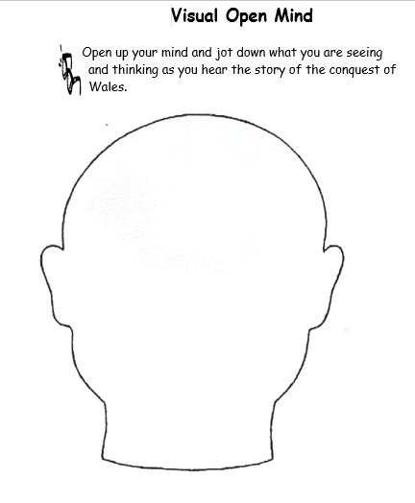
Image One - Visual Open Mind Task Sheet
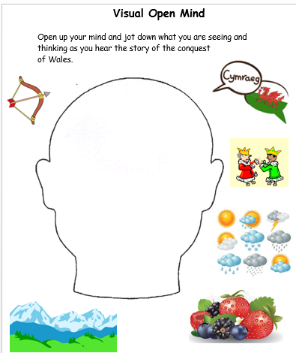
Image Two - Visual Open Mind Task Sheet (differentiated for certain learners)

The next task, task two required the learners to work in pairs. Every pair was given a version of the story that was previous read out loud by the teacher. There were three version of the story, a MAT version which had a lot of detail and a few challenging words which was given to the higher attaining children, a standard version which was the same one that was read aloud to the class in the previous task and a less detailed version that was given to the learners with lower attainment and ALN’s. Pupils were in pairs and were given a certain version of the story depending on their ability. Pupil 2 and their partner receive the MAT version of the story, pupil 3 received the standard version and pupil 1 was given then less detailed story. In their pairs they were instructed to:
- read through their story together and help each other to understand the information
- discuss the reasons why Wales was difficult to conquer
This task was to ensure the further understanding of the Conquest of Wales and to ensure that all the learners fully understood the information that was being presented to them during the lesson. There was a glossary on the back of each story so that pupils could learn the words that might have been new to them or that they didn’t fully understand. This task was essentially more important to pupil 1 as English is a second language to them so this tasks was implemented to make sure they received a full understanding of the information they were begin given. Additionally, due to the fact that English is a second language for pupil 1 it means that during specific tasks such as this where there are a lot of words, engagement levels can be lower than creative tasks such as the first tasks during this lesson.

From the observation it’s clear to see that the levels of engagement from pupil 1, the lower attaining learner, goes from ‘clear signs of involvement and engagement’ to ‘no concentration, starting and daydreaming’ during the reading and writing tasks. Whilst pupils 2 and 3’s level of engagement actually increase.
Image three – story of wales given to high attaining and MAT students such as pupil 2.
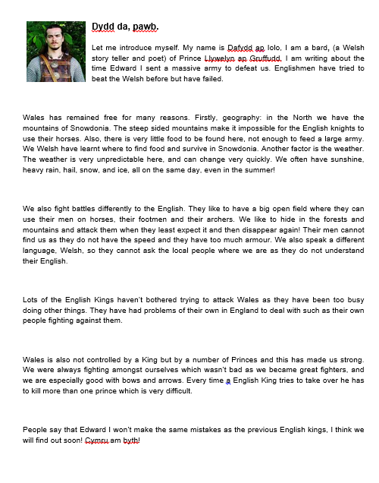
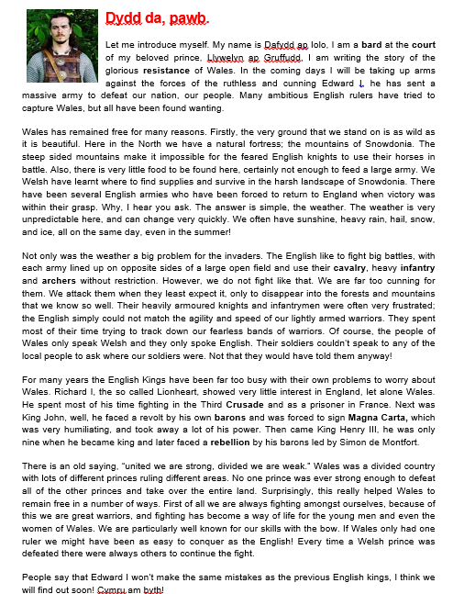
Image four – story of wales given to low attaining students such as pupil 1.
Image five – story of wales given to middle attaining pupils such as pupil 3.

Tasks three, required group work, pupils were instructed to discuss in their group the top eight different reasons as to why Wales was so hard to conquer and then they were to write those eight different reasons onto eight separate post-it-notes. After then had completed this they needed to, as a group, stick-the-post it notes on an A3 piece of paper ranking their reasons from post important to least important. This required the pupils to use their communication skills as they needed to discuss with each other what their eight reasons would be and how important they were. Higher attaining pupils such as pupil 3 were given a plain piece of A3 paper and eight plain post-it-notes, however some pupils such as pupil 2 were given three or four cards as an example for what they could write down in order to prompt their answers. Pupils with lower attainment such as pupil 1 were given a set of 10 answers which they could either pick eight from or could use simply to prompt their learning (Example cards are shown below in image six).
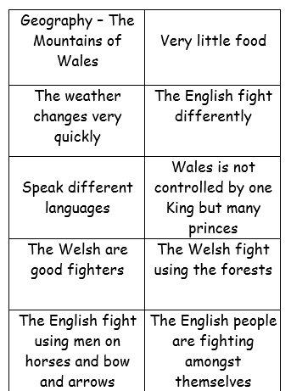
Image six – Example cards for pupils to use to come up with answers for ‘why Wales was so hard to Conquer?’

The engagement of pupils 2 and 3 during these tasks further increase when the tasks moves from reading and writing to a discussion. Pupils 2 and 3’s engagement continuously increases throughout the course of this task to the point where they both ‘cannot be distracted and enjoy being engrossed in the activity’. This could simple be because this task was more discussion based and they were able to communicate their ideas to their groups father then writing them down. However, pupil 1’s engagement level actually decreases during this task with ‘no signs of interest’ and ‘does not appear to be taking part in anything’.
Task 4 as a plenary was to ask certain members of each group to share their most important reason to ‘Why was Wales so hard to Conquer?’ and why they decided that it was the most important reason. During this task all three pupils were fully engaged with ‘clear signs of involvement’. This may have been because pupils from each from were chosen at random to explain what their reasons were. When all three pupils were asked to provide an answer for their groups work they were able to provide a clear and detailed answer with the information that they had learn during the lessons.
From my investigation I can conclude that pupil’s engagement was at a high level during certain tasks during the lesson and whilst all pupils were able to complete the tasks at hand through discussing with their groups. It’s clear that levels of engagement were higher when tasks involved using the skills that they are better in. Many pupils were able to provide feedback from their findings and justifications for their reasoning hence it’s clear that all pupils had not only an understanding of the tasks but hand but also an opinion about the work. This only ensures that the pupils achieve the main aims of the lessons and were able to verbally explain this to me.
In the future I believe that I could have developed the learners understanding further by getting them to discuss their answers with another group and then asked them to reflect on their answers to see if their opinions had been swayed. I think that this would have stretched the pupils learning further as they would have been able to see things from a different point of view. However, I have learnt that through differentiated tasks all learners are able to keep in the ‘struggle zone’ and consistently learn. I feel that my experience was a good experience there I learnt a lot about adapting lessons and resources and knowing the ability of the learners.
Discussion of Research Findings
Throughout the lesson the aim was to ensure all learners were engaged by using differentiated tasks. Therefore certain tasks throughout the lesson had element of differentiation depending on the learners’ attainment levels. All learners completed their tasks either in groups, pairs or as individuals using the resources that they had been provided. When the extra help resources were provided lower attained learners used the resources to enhance their learning and understanding. MAT learners who had a slightly more difficult challenge were able to stretch their learning and use the limited resources that they have been given to complete their tasks.
Additionally we found out that by providing multiple tasks during the lesson with each being differentiated for pupils learning, the levels of engagement are higher than a lesson were there is only one or two tasks as pupils don’t have time to get distracted or to disconnect from the lesson. Furthermore, we also discovered that during creative and communication tasks pupils are more engaged and egger to take part in the lesson. However, time given to do these activities needs to be considered as when pupils are given time to talk they are able to get easily distracted from the activity.
Knowing the learners aided in enhancing their learning because as teachers we are able to provide every learner with the adequate tasks that would keep them in the struggle zone and continuously learning and improving. Without this knowledge lessons would not be able to be adapted and learners wouldn’t be able to improve, therefore some learners would be in the comfort zone and some in the panic zone.
For my class of mixed ability learners, a limitation to providing differentiated tasks would be that there was an emotional incline to provide as much help as possible for all the leaners. However, by scaffolding pupils learning by provided them with the certain level of help that they needed and ensuring that all the learners understood the task at hand meant that the learners had all that they needed to achieve the lesson aims. This means that a productive lesson can take place.
Conclusion
To conclude, from my investigation I can conclude that pupil’s engagement was at a high level and that all pupils were able to complete the tasks at hand whilst discussing with their groups. It was clear that all pupils had not only an understanding of the tasks but hand but also an opinion about the work. Many pupils were able to provide feedback from their findings and justifications for their reasoning.
However, our research has shown that pupil’s engagement levels can be affected when pupils are given tasks that requires skills that are not their strongest. Additionally pupil’s engagement is affected when too much time is given to a particular task as it allows learners not become disconnected with the task and the lesson. This is something that effects many peoples teaching practice and is something that always needs to be evaluated when planning the lesson and when carrying out the lesson because pupils might needed more or less time on a specific task than originally planned. This adaptability is a requirement in every teaching practice.
The data collection methods used where somewhat reliable. However, using two classes where one class was of mixed ability and one class was a set class may not have been the best way to receive constant results as the environment of attainment levels was very different. We believe that this study would have been more accurate if an investigation was carried out on two different mixed ability classes in order to see if differentiation has an impact on pupil’s engagement for a full range of attainted pupils. Also differentiation clearly has a bigger impact when teaching a mixed ability class the whole class has the same lesson aims which they need to meet. Therefore in order to meet the lesson aims, pupils learning need to be scaffold depending on their ability and the help they require. Within a set class pupils attainment is of equal level and thus not much differentiation is require for them to meet the lesson aims. We felt that the sample size of the classes and pupils used for the interview were adequate for our study Nonetheless, differentiation can be adapted to any lessons and can be seen as a positive impact.
Recommendations
This research will help us move our own teaching practice further as we know that differentiated tasks do play an impact on pupil engagement levels during a KS3 lesson when carried out correctly in order to scaffold pupils learning to keep within the ‘struggle zone’ (Hatti, 2011). Furthermore, this investigation taught us that without the differentiated tasks that understanding of the topic may have been limited.
If this research were to be conducted again, I would recommend it to be done in comparison to another class that did not have differentiated tasks as that would be a more adequate way in which to understand the importance of differentiation.
Bibliography

Esytn, 2017. Inspection Report Bishopston Comprehensive School, s.l.: Esytn.
Eystn, 2017. Bishop Gore Comprehensive School Estyn Report, s.l.: Estyn.
Godfrey, D., 2018. A developmental evaluation approach to lesson study. [Online]
Available at: https://moodle.uwtsd.ac.uk/pluginfile.php/289267/mod_resource/content/1/Godfrey%20et%20al.%202019.pdf
[Accessed 3rd Feburary 2020].
Hatti, J., 2011. Visible Learning for Teachers, Abingdon: Routledge.
Laevers, F., 2011. Well-being and Involvement in Care Setting.. Leuven: Leuven University .
Runeckles, C., 2018. Making every history lesson count. Carmarthen: Crown House Publishing .
Suleman, I. H. a. D., 2016. Effect of Bloo,'s Mastery Learning Approch on Students' Academic Achievemnet. Journal of Literatire, langruages and linguistics, Volume 23, pp. 35-43.

Appendix :
Observation of Lesson One (images 1-4)
Observation of Lesson Two (images 4-8)
Lesson Reflection (images 8-9)


