SR333 Sport, diet and disease cover sheet
- Please attach this to the front of your assignment. This should replace the normal College of Engineering cover sheet for this module only. In addition to the normal cover sheet, this version will ask you specific comments on 1) your current targets, 2) a self-assessment of the assignment and 3) teaching material you found beneficial. I will then be able to provide specific feedback based upon the information you include.
Coursework Title: | Nutritional Assessment - Individual Case Study
Module Code: | SR333
Module Title | Sport, diet and disease
Submission Deadline | 26/11/2025
Lecturer | Dr Thomas Love
Student Number | 2357814

By submitting this coursework, I certify that this is all my own work.

Submission date: 26/11/2025

Student signature (initials only) if this is a non-electronic submission: ……………………………………….

SPLD Students
Please tick this box if you are officially recognised by the University as an SPLD student

Current feedback/targets you are working on
- Please list here any areas/targets that have been identified by you (e.g. self) or identified by staff in feedback from previous assignments (e.g. module code SR-???) that you are trying to develop/strengthen in this assignment. Please also indicate how these have been addressed in this new assignment. I will then provide specific feedback on these targets

Self/Module that identified target | Target | How this has been  addressed in this assignment
SR-259  (Human nutrition) | Stay on track with what is expected to be addressed in the assignment, used information from lectures as well as wider reading. | Used knowledge from lecture content and readings to help with the analysis and evaluation of the meal plan.

Self-assessment
- Please identify the strengths and weaknesses of your assignment including a mark for each section (0 – 100%). Specific feedback that aligns with your comments will then be provided in this assignment.

 | Strengths | Weakness | Mark
Introduction | Lots of literature research discussing the demands of marathons. | Started off over the word count and going off track, needed to make sure I was sticking to the brief. | 80%
Analysis of nutritional strategy | Using nutritics, excel and calculations used in the workshop to analyse the meal plan. | I wasn’t sure if my relative nutritional values were correct, I found the hydration part difficult. | 70%
Critical evaluation of nutritional strategy | Comparing the individual’s intake values with the DRV and linking it back to the demands of a marathon runner. | Ensuring I was using the correct guidelines specifically for athletes. | 70%
Designing a new nutritional strategy | Creating a table and inputting data from nutritics. | New food ideas and what nutrients are in each one to meet the guidelines. | 50%
Overall | The structure and layout of my assignment flow nicely. | More detail for the revised meal plan. | 70%

Which teaching/learning method(s) was beneficial for the following areas of the assignment?
- You may have used a variety of teaching/learning methods on this module. Please indicate how helpful each teaching activity was for this assignment using a scale from 0 to 10 (0 = Not helpful, 10 = Extremely helpful). If you did not utilise a teaching activity, please leave blank or insert N/A.

 | Analysis of nutritional strategy | Critical evaluation of nutritional strategy | Designing a new nutritional strategy
Lecture PowerPoint | 4 | 5 | 7
Lecture discussion/scenarios | 7 | 7 | 8
Lecture recording | 10 | 10 | 10
Recommended reading | 5 | 5 | 7
PC Workshop | 10 | 10 | 10
Practical Laboratory | 6 | 4 | 6
Peer Feedback | N/A | N/A | N/A
Online Tests | 10 | 10 | 10
Marking Rubric | 7 | 9 | 9
Office hour | N/A | N/A | N/A
Independent Study | 9 | 7 | 8
Other

If other, please specify: ………………………………………………………………………….

Thank you for taking the time to complete this cover sheet.

Sports Nutrition Case Study

Introduction

Marathon running is a highly demanding endurance sport that requires intense, long-term aerobic effort (Gondko et al., 2024). It mainly uses the muscles of the lower body, del Coso et al. (2017) stated that during each step, the lower limbs can absorb forces between 1.5 to 3 times the athlete’s body weight. This, combined with repetitive use, can lead to exercise-induced muscle damage (del Coso et al., 2017). Prolonged running places significant demands on the respiratory, cardiovascular and musculoskeletal systems to support the body’s high metabolic needs (Mahler & Loke, 1984). Fatigue during endurance exercise has been linked to reduced glycogen availability within active muscles. Following marathon events, runners often exhibit signs of inflammation and muscle fibre damage, emphasising the importance of fibre composition and available energy fuels in endurance performance (Mahler & Loke, 1984). Running a marathon involves months of progressive training, muscle strengthening and dietary planning (Gondko et al., 2024).

Thermoregulation further complicates performance, as continuous muscle activity produces internal heat, environmental conditions can also challenge the body’s ability to maintain a stable temperature (Cheuvront & Haymes, 2001), leading to dehydration, which in turn, reduces blood volume and affects heat loss, compromising performance (del Coso et al., 2017; Cheuvront & Haymes, 2001). Understanding nutritional strategies can directly affect an athlete’s performance and recovery. The correct nutrition is crucial for sustaining energy levels and supporting the physiological and psychological needs during a marathon for success (Fatima et al., 2024; Patnaik, 2024).

This essay aims to critically analyse and evaluate a good club marathon runner’s, Sue, 2-day pre-race and race day nutritional strategy in preparation for her competition, identify the limitations and propose an evidence-based dietary plan designed to enhance her performance.

Analysis and Evaluation

Table 1: Current 2-day pre-race carbohydrate loading plan & Pre-race meal strategy

 | 2-day pre-race carbohydrate loading strategy |  |  |  | Pre-race meal strategy
 | Thursday |  | Friday |  | Saturday
Nutrients | Absolute | Relative | Absolute | Relative | Absolute | Relative
Energy | 2624kcal | - | 2521kcal | - | 1767kcal | -
Carbohydrates | 302g | 5.02g/kg | 391g | 6.43g/kg | 418g | 6.93g/kg
Protein | 160g | 2.66g/kg | 104g | 1.71g/kg | 17g | 0.28g/kg
Fat | 86g | 29.5%EI | 60g | 21.4%EI | 3g | 1.5%EI
Water | 3821g | 3.8L | 4192g | 4.19L | 6017g | 6.02L
Fibre | 49g | - | 71g | - | 15g | -
Sodium | 1593mg | - | 1789mg | - | 8042mg | -
Potassium | 6529mg | - | 6947mg | - | 1061mg | -
Urine osmolality | 530mosmol/kg |  | 495mosmol/kg |  | 490mosmol/kg

Table 2: Glycaemic index - pre-race meal

 | CHO (g) | Contribution to meal CHO | GI | Contribution to meal GI
Wholemeal bread | 28.51 | 0.49 | 74.00 | 36.26
Baked beans | 29.21 | 0.51 | 40.00 | 20.40
Water | 0.00 | 0.00 | 0.00 | 0.00
Total | 57.72 |  |  | 56.66

The glycaemic index (GI) categorises carbohydrate foods according to how much they raise blood glucose levels once consumed (Chiavaroli et al., 2021). Foods are typically defined as low (≤55), moderate (56-69) or high (≥70) on a glucose scale (Chiavaroli et al., 2021). Research has investigated the optimal timings for consuming foods with different GI (OʼReilly et al., 2010). Evidence suggests that low GI meals consumed prior to exercise may elevate endurance capacity and enhance fat oxidation, whereas high GI meals provide more rapid carbohydrate availability for immediate energy needs (OʼReilly et al., 2010).

Table 3: Hydration – during race

Pre-BM (kg) | Post-BM (kg) | Change in BM (kg) | Fluid intake (L) | Urine volume (L) | Sweat loss (L) | Sweat rate (L/hr) | Dehydration (%BM)
60.40 | 61.90 | +1.50 | 6.00 | 0.00 | 4.50 | 1.29 | -2.48
Table 4: Electrolyte loss – during race
Sweat loss (L) | Sweat [Na] (mmol/L) | Sweat Na loss (mmol) | Sweat Na loss (mg)
4.5 | 50 | 225 | 5152.5
 | Sweat [K] (mmol/L) | Sweat K loss (mmol) | Sweat K loss (mg)
4.5 | 4.1 | 18.45 | 721.4
Hydration can be assessed using urine osmolality, with values <700 mosmol/kg indicating euhydration and >900 mosmol/kg indicating hypohydration (ACSM, 2016). Referring to Sue’s urine osmolality, it was lower on race day (490 mosmol/kg) compared to the two previous days, however she appears to be in the euhydration state consistently over the 3 days as seen in table 1. Sweat rates typical range varies between 0.3-2.4 L/h relative to exercise intensity and endurance (ACSM, 2016). During the marathon, Sue’s sweat rate was 1.29 L/hr, leading to a total sweat loss of 4.5L. Her dehydration was calculated at -2.48% body mass, current guidelines recommend that athletes body fluid deficit should not exceed 2% as this can lead to dehydration (ACSM, 2016). However, Sue consumes 750ml of sports drink every 5k, indicating she is attempting to rehydrate throughout.

Current 2-day pre-race strategy

Carbohydrates

Carbohydrates are the body’s main energy source during endurance exercise, many athletes use carbohydrate loading strategies before competition to enhance glycogen storage and delay the onset of fatigue (Fatima et al., 2024). It is recommended that marathon runners engage in carbohydrate loading to enhance their muscle glycogen stores, as these work as a fuel source during prolonged endurance exercise (Burke, 2007). Increased muscle glycogen levels allow athletes to sustain their optimal running pace for an extended period, which can enhance overall performance outcomes (Burke, 2007). Current dietary guidelines recommend that marathon runners should consume 10-12g/kg/d of carbohydrates 36-48 hours prior to competition (ACSM, 2016). However, Sue’s intake falls significantly below these guidelines, only consuming 5.02g/kg on Thursday and 6.43g/kg on Friday. Research by Kirwan et al (1988) and Achten et al (2004), supports the importance of a high carbohydrate diet, illustrating that athletes who combine intense training with inadequate carbohydrate intake experience greater fatigue, while those consuming sufficient carbohydrates maintain performance and feel less tired. Consequently, Sue’s relatively low carbohydrate intake may result in reduced muscle glycogen stores and impaired metabolic recovery, potentially limiting her endurance capacity and overall race performance (Roberts et al., 1988). To improve performance, Sue should focus on increasing her carbohydrate intake during the days leading up to competition. In contrast, research has stated that diets high in fats and low in carbohydrates increase the body’s ability to burn fat and may enhance endurance by reducing reliance on carbohydrates. Although, current studies do not demonstrate benefits for marathon runners to adopt a low-carb diet, as it shows no significant effect on VO₂ max, maximum heart rate or perceived exertion (Cao et al., 2021). Therefore, carbohydrates remain as an essential nutrient for maintaining optimal performance.

Protein

Protein intake plays a crucial role in supporting muscle recovery for endurance athletes (Patnaik, 2024). Prolonged endurance training creates a range of metabolic interferences within skeletal muscle, including the depletion of endogenous energy substrates and structural damage to muscle proteins (Moore et al., 2014). Post-exercise protein intake is essential to restore these substrates and enabling the repair and remodelling of muscle tissue (Moore et al., 2014). Current dietary guidelines recommend that high-intensity endurance athletes should consume between 1.2-2g/kg of protein throughout the day and following exercise (ACSM, 2016). On Thursday, Sue’s protein intake is above this guideline, consuming 2.66g/kg, and remains withing the guideline on Friday, consuming 1.71g/kg. At times, athletes may engage in excessive protein consumption during certain phases of training, though there is limited evidence to suggest that increased protein intake alone enhances performance outcomes or endurance capacity (Witard et al., 2025; Zhao et al., 2024). Protein should not be considered as a replacement for carbohydrates, Sue should acknowledge that optimising the balance between her protein and carbohydrate intake will be more effective in improving her endurance performance than relying on a high protein intake alone (Zhao et al., 2024). Sufficient protein intake enhances muscle protein synthesis, thereby supporting recovery processes and contributing to improved performance (Witard et al., 2025).

Fat

Endurance athletes may benefit from the inclusion of fats in their diet as they also provide a source of energy during prolonged exercise. Unlike carbohydrates, the body can store fat to a larger extent, making fats an essential nutrient for maintaining endurance (Hawley et al., 1998; Pendergast et al., 2000;). Although there has been an increase in interest in a low-carb high-fat dietary approach, excessive fat intake can affect performance in higher intensity exercise (ACSM, 2016; Pendergast et al., 2000). Current guidelines recommend that athletes consume between 20-35% of fat in their diet. On both Thursday and Friday, Sue’s fat intake falls within this range, consuming 29.5%EI and 21.4%EI respectively. Recent evidence supports the adoption of a balanced diet including moderate to high levels of fat, as this enhances fat oxidation without impairing glycogen stores (Pendergast et al., 2000). While Sue’s current fat intake aligns with established dietary guidelines, it is recommended she increases her carbohydrate intake to optimise her energy availability and improve endurance performance.

Fibre

Specific daily fibre recommendations are often overlooked within the nutritional planning of endurance athletes despite their importance (Mancin et al., 2025). Fibre serves many important roles in the diet, contributing to gut health and influencing gastrointestinal comfort, nutrient absorption and overall health (Mancin et al., 2025). With careful dietary planning, endurance athletes can manage their fibre intake to maintain digestive comfort while maximising the nutritional and performance benefits of adequate fibre consumption (Mancin et al., 2025). Current dietary guidelines recommend that adults should be consuming a fibre intake of 30g per day (Hooper et al., 2015). Sue’s fibre intake across the two days significantly exceeds this guideline, consuming 49g on Thursday and 71g on Friday. For endurance athletes, excessive fibre intake can have unintentional nutritional consequences. A study done by Melin et al. (2015) concluded that females who consumed a high fibre, low energy density foods restricted their overall caloric intake. This diet prohibits them from meeting the energy demands needed for an endurance athlete, and results in reduced energy availability. Despite the importance of fibre, it is recommended that Sue moderates her fibre intake to increase endurance capacity.

Water, Sodium and Potassium

Hydration is equally important to prevent a decline in strength, endurance and cognitive function (Patnaik, 2024). Sodium and potassium also play an important role in an endurance athletes diet. Sodium is essential for maintaining fluid balance and supporting normal physiological functions, as well as maintaining exercise performance (Valentine, 2007). During prolonged activity, large amounts of sodium are lost through sweat, emphasising the importance of sodium replacement to help prevent muscle cramps (ACSM, 2016). Potassium’s role in the diet is to maintain electrolyte balance and contributes to overall physical capacity (Baranauskas et al., 2020), making both minerals critical for endurance performance.

Guidelines for water intake are dependent on athletes sweat rate, activity duration and environmental conditions (Patnaik, 2024), however typical guidelines recommend a fluid intake of 1.5 to 3L a day. Sue’s fluid intake exceeds these guidelines as she consumes 3.8L on Thursday and 4.19L on Friday. While this is not an unreasonable amount for an endurance athlete, she should be aware of overhydration risks such as disturbances in electrolyte balance (Kalra, 2023).
UK guidelines recommend an intake of 2400mg of sodium throughout the day (NHS, 2020). On both Thursday and Friday, Sue consumes significantly less than the recommendation, 1593mg and 1789mg respectively. I would suggest that Sue should increase her daily sodium intake as low levels of sodium can reduce blood pressure and increase the risk of developing hypertension (Grillo et al., 2019).
NHS (2020) recommend an intake of 3500mg of potassium daily. Sue’s daily potassium intake is significantly higher than the recommended value, consuming 6529mg on Thursday and 6947mg on Friday. No evidence suggests there are risks for consuming too much potassium within healthy individuals, however people with reduced kidney function can be at risk of developing hyperkalaemia (National Institutes of Health, 2022).

Current pre-race meal

Carbohydrates

Carbohydrate intake 1-4 hours before an event helps to sustain sufficient energy availability for both muscular and neural function (Burke et al., 2011). Consuming carbohydrates at this time supports the replenishment of muscle and liver glycogen stores and enhances endurance performance when combined with prior carbohydrate loading (Burke et al., 2011). Guidelines suggest that athletes should consume 1-4g/kg of carbohydrates in these hours before the event. Sue consumed her pre-race meal 3 hours before her event, aligning with the guidelines, however her carbohydrate intake was 6.93g/kg which significantly exceeds the guidelines. Excessive pre-exercise carbohydrate intake may affect the body’s metabolic function and energy substrate use during exercise (Davitt et al., 2021). I would recommend that Sue should decrease her carbohydrate intake pre-event, although the timing was good.

Protein

Research on pre-exercise protein intake is limited, although some evidence indicates potential benefits. Consuming a protein rich meal prior to exercise may support glycogen resynthesis and metabolism during endurance activity (Cintineo et al., 2018). However, protein alone does not enhance performance, therefore combining protein with carbohydrates has been shown to improve performance by 9% (Cintineo et al., 2018). As mentioned, protein guidelines for pre-events are limited because this nutrient is usually consumed post-event to aid muscle recovery and is dependent on individuals. In a general sense, it is recommended that protein intake should be distributed throughout the day following intense exercise. Consuming around 0.25-3g/kg body weight of protein within the first two hours of recovery has been shown to enhance muscle repair (ACSM, 2016). Sue consumed 0.28g/kg prior to her event, which falls within the guidelines recommendations.

Fat

Including dietary fat in a pre-race meal is important to achieve an appropriate macronutrient balance to support optimal performance (ACSM, 2009). Fat intake should be sufficient, ensuring it compliments carbohydrate intake and does not limit its availability (ACSM, 2009). Additionally, the timing and quantity of fat consumed pre-event should be considered to reduce the chance of gastrointestinal discomfort (ACSM, 2009). Guidelines suggest that fat intake should be kept low to moderate to ensure digestion (ACSM, 2016). Sue consumes an extremely low amount of fats in her pre-race meal (1.5%), almost removing it completely. I would recommend that she increases her fat intake closer to 10-20% as this is low enough to promote digestion but still allows vitamin absorption (ACSM, 2016).

Fibre

General guidelines for fibre intake are 30g a day as there are no direct guidelines specifically for pre-endurance events (Hooper et al., 2015). Sue’s fibre intake for her pre-event meal was 15g which is lower than the recommendation. However, evidence suggests endurance runners may benefit from avoiding a high intake of fibre before competition (Parnell et al., 2020). Fibre slows digestion, which can contribute to gastrointestinal symptoms such as bloating, cramping or stomach pain, potentially affecting comfort and performance (Parnell et al., 2020).

Water, Sodium and Potassium

Athletes are advised to start exercise in a euhydrated state and maintain fluid intake throughout to prevent dehydration (Vieira Potter, 2011). Consuming 400-600ml of fluid 2 to 3 hours prior to exercise supports this, although Sue only drinks 250ml. Dehydration has been shown to impair performance and cause muscle cramps (ACSM, 2016; von Duvillard et al., 2004). Findings suggest that fluids containing carbohydrates and sodium support water retention, maintain plasma volume and delay fatigue (von Duvillard et al., 2004). Athletes exercising longer than an hour are advised to consume 600-1200ml/h of fluid containing carbohydrates and sodium (von Duvillard et al., 2004). However, Sue consumed 6L of high carbohydrate sports drink, exceeding the recommendations and increasing the risk of sodium depletion due to overhydration (von Duvillard et al., 2004).
Athletes with high sweat rates (>1.2L/hr) or prolonged exercise exceeding 2 hours should consume sodium throughout a race (ACSM, 2016), both of which apply to Sue. On race day, she consumed 8042mg of sodium. Additionally, studies found that correct intake of potassium during a marathon lead to better performance outcomes (Roca et al., 2020) and therefore should be consumed during exercise. Her potassium intake on race day was 1061mg.

These findings indicate the need to revise Sue’s current meal plan to improve her overall performance.

Revised meal plan

Table 4: revised meal plan analysis

 | 2-day pre-race carbohydrate loading strategy |  |  |  | Pre-race meal strategy
 | Thursday |  | Friday |  | Saturday
Nutrients | Absolute | Relative | Absolute | Relative | Absolute | Relative
Energy | 3500kcal | - | 3500kcal | - | 1928kcal | -
Carbohydrates | 636g | 10.53g/kg | 636g | 10.53g/kg | 393g | 6.51g/kg
Protein | 142g | 2.35g/kg | 142g | 2.35g/kg | 29g | 0.48g/kg
Fat | 74g | 20.00%EI | 74g | 20.00%EI | 26g | 12.14%EI
Water | 3064g | 3.06L | 3064g | 3.06L | 5302g | 5.32L
Fibre | 34g | - | 34g | - | 5g | -
Sodium | 2844mg | - | 2844mg | - | 5654mg | -
Potassium | 3089mg | - | 3089mg | - | 1305mg | -
Revised 2-day meal plan strategy
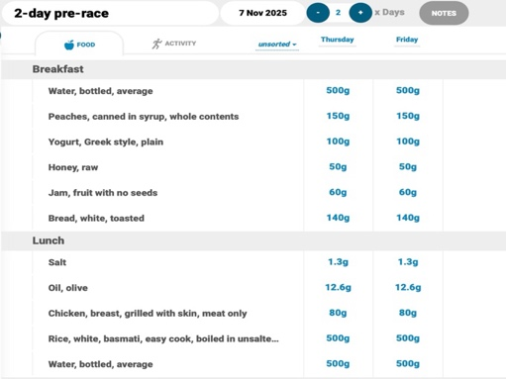
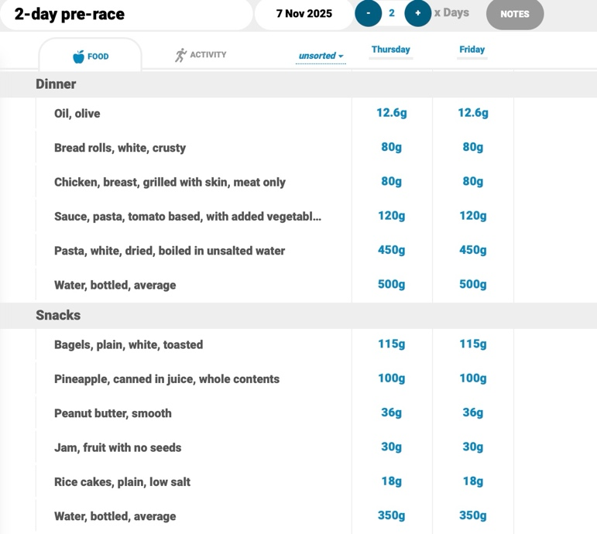

This revised meal plan focuses on carbohydrate loading to enhance her muscle glycogen stores. I recommend Sue follows this exact meal for the 2 days prior to her race as it meets the nutritional guidelines mentioned in the above evaluation and will improve her performance.

Revised race-day meal strategy

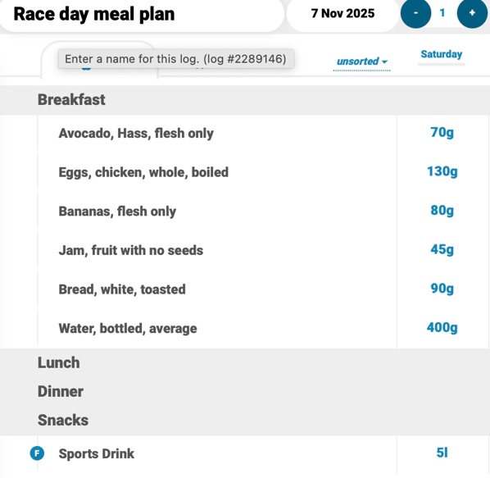

Sue should consume this meal 1-4 hours before her race to sustain energy availability. This revised race day meal plan will ensure optimal performance as it meets the guidelines needed for a marathon runner.

References

- Achten., et al. (2004). Higher dietary carbohydrate content during intensified running training results in better maintenance of performance and mood state. JAP, 96, 1331–1340.
- American College of Sports Medicine. (2009). Nutrition and Athletic Performance. Medicine & Science in Sports & Exercise, 41(3), 709–731. https://doi.org/10.1249/mss.0b013e31890eb86
- American College of Sports Medicine. (2016). Nutrition and Athletic Performance. Medicine & Science in Sports & Exercise, 48(3), 543–568. https://doi.org/10.1249/mss.0000000000000852
- Baranauskas, M., Jablonskienė, V., Abaravičius, J. A., Samsonienė, L., & Stukas, R. (2020). Dietary Acid-Base Balance in High-Performance Athletes. International Journal of Environmental Research and Public Health, 17(15), 5332. https://doi.org/10.3390/ijerph17155332
- Burke, L. M. (2007). Nutrition Strategies for the Marathon. Sports Medicine, 37(4), 344–347. https://doi.org/10.2165/00007256-200737040-00018
- Burke, L. M., Hawley, J. A., Wong, S. H. S., & Jeukendrup, A. E. (2011). Carbohydrates for training and competition. Journal of Sports Sciences, 29 Suppl 1(1), S17-27. https://doi.org/10.1080/02640414.2011.585473
- Cao, J., Lei, S., Wang, X., & Cheng, S. (2021). The Effect of a Ketogenic Low-Carbohydrate, High-Fat Diet on Aerobic Capacity and Exercise Performance in Endurance Athletes: A Systematic Review and Meta-Analysis. Nutrients, 13(8), 2896. https://doi.org/10.3390/nu13082896
- Cheuvront, S. N., & Haymes, E. M. (2001). Thermoregulation and Marathon Running. Sports Medicine, 31(10), 743–762. https://doi.org/10.2165/00007256-200131100-00004
- Chiavaroli, L., Lee, D., Ahmed, A., Cheung, A., Khan, T. A., Blanco, S., Mejia, Mirrahimi, A., Jenkins, D. J. A., Livesey, G., Wolever, T. M. S., Rahelić, D., Kahleová, H., Salas-Salvadó, J., Kendall, C. W. C., & Sievenpiper, J. L. (2021). Effect of low glycaemic index or load dietary patterns on glycaemic control and cardiometabolic risk factors in diabetes: systematic review and meta-analysis of randomised controlled trials. BMJ, 374(8302), n1651. https://doi.org/10.1136/bmj.n1651
- Cintineo, H. P., Arent, M. A., Antonio, J., & Arent, S. M. (2018). Effects of Protein Supplementation on Performance and Recovery in Resistance and Endurance Training. Frontiers in Nutrition, 5(83). https://doi.org/10.3389/fnut.2018.00083
- Davitt, P. M., Saenz, C., Hartman, T., Barone, P., & Estremera, S. (2021). Physiological Impact of a Single Serving Slow Absorption Carbohydrate on Metabolic, Hemodynamic, and Performance Markers in Endurance Athletes During a Bout of Exercise. Journal of Strength and Conditioning Research, 35(5), 1262–1272. https://doi.org/10.1519/jsc.0000000000003968
- del Coso, J., Salinero, J. J., Lara, B., Abián-Vicén, J., Gallo-Salazar, C., & Areces, F. (2017). A comparison of the physiological demands imposed by competing in a half-marathon vs. a marathon. The Journal of Sports Medicine and Physical Fitness, 57(11). https://doi.org/10.23736/s0022-4707.17.07056-6
- Fatima, F., Waheed, S., Asifullah, M. A., Hassan, T., Samo, N. H., & Zamurd, B. (2024). Nutritional Strategies for Optimizing Performance in Endurance Sports: A Case Study of Marathon Runners. International Journal of Biochemistry Research & Review, 33(6), 365–378. https://doi.org/10.9734/ijbcrr/2024/v33i6919
- Gondko, D., Patrycja Dębiec, Roman, J., & Pietrzak, N. (2024). Marathon Health Pitfalls: What Every Runner Needs to Know. Journal of Education Health and Sport, 73, 51692–51692. https://doi.org/10.12775/jehs.2024.73.51692
- Grillo, A., Salvi, L., Coruzzi, P., Salvi, P., & Parati, G. (2019). Sodium Intake and Hypertension. Nutrients, 11(9). https://doi.org/10.3390/nu11091970
- Hawley, J. A., Brouns, F., & Jeukendrup, A. (1998). Strategies to Enhance Fat Utilisation During Exercise. Sports Medicine, 25(4), 241–257. https://doi.org/10.2165/00007256-199825040-00003
- Hooper, B., Spiro, A., & Stanner, S. (2015). 30 g of fibre a day: An achievable recommendation? Nutrition Bulletin, 40(2), 118–129. https://doi.org/10.1111/nbu.12141
- Kalra, D. (2023). Overhydration: A boon or bane. Indian Journal of Pharmacy and Pharmacology, 10(2), 73–75. https://doi.org/10.18231/j.ijpp.2023.017
- Kirwan., et al. (1988). Carbohydrate balance in competitive runners during successive days of intense training. JAP, 65, 2601–2606.
- Mahler, D. A., & Loke, J. (1984). The Physiology of Endurance Exercise: The Marathon. Clinics in Chest Medicine, 5(1), 63–76. https://doi.org/10.1016/S0272-5231(21)00232-X
- Mancin, L., Burke, L. M., & Rollo, I. (2025). Fibre: The Forgotten Carbohydrate in Sports Nutrition Recommendations. Sports Medicine, 55. https://doi.org/10.1007/s40279-024-02167-1
- Melin, A., Tornberg, Å. B., Skouby, S., Møller, S. S., Faber, J., Sundgot-Borgen, J., & Sjödin, A. (2015). Low-energy density and high fiber intake are dietary concerns in female endurance athletes. Scandinavian Journal of Medicine & Science in Sports, 26(9), 1060–1071. https://doi.org/10.1111/sms.12516
- Moore, D. R., Camera, D. M., Areta, J. L., & Hawley, J. A. (2014). Beyond muscle hypertrophy: why dietary protein is important for endurance athletes. Applied Physiology, Nutrition, and Metabolism, 39(9), 987–997.
- National Institutes of Health. (2022, June 2). Office of Dietary Supplements - Potassium. Nih.gov. https://ods.od.nih.gov/factsheets/Potassium-HealthProfessional/
- NHS. (2020, August 3). Vitamins and Minerals. NHS; NHS. https://www.nhs.uk/conditions/vitamins-and-minerals/others/
- OʼReilly, J., Wong, S. H. S., & Chen, Y. (2010). Glycaemic Index, Glycaemic Load and Exercise Performance. Sports Medicine, 40(1), 27–39. https://doi.org/10.2165/11319660-000000000-00000
- Parnell, J. A., Wagner-Jones, K., Madden, R. F., & Erdman, K. A. (2020). Dietary restrictions in endurance runners to mitigate exercise-induced gastrointestinal symptoms. Journal of the International Society of Sports Nutrition, 17(1). https://doi.org/10.1186/s12970-020-00361-w
- Patnaik, L. (2024). The Role of Nutrition in Improving Performance and Recovery for Athletes. South Carolina State University ProQuest Dissertations & Theses, 5.
- Pendergast, D. R., Leddy, J. J., & Venkatraman, J. T. (2000). A perspective on fat intake in athletes. Journal of the American College of Nutrition, 19(3), 345–350. https://doi.org/10.1080/07315724.2000.10718930
- Roberts, K. M., Noble, E. G., Hayden, D. B., & Taylor, A. W. (1988). Simple and complex carbohydrate-rich diets and muscle glycogen content of marathon runners. European Journal of Applied Physiology and Occupational Physiology, 57(1), 70–74. https://doi.org/10.1007/bf00691241
- Roca, E., Nescolarde, L., Brotons, D., Bayes-Genis, A., & Roche, E. (2020). Macronutrient and Mineral Intake Effect on Racing Time and Cardiovascular Health in Non-Elite Marathon Runners. Nutrition, 78(7-8), 110806. https://doi.org/10.1016/j.nut.2020.110806
- Valentine, V. (2007). The Importance of Salt in the Athlete’s Diet. Current Sports Medicine Reports, 6(4), 237–240. https://doi.org/10.1097/01.csmr.0000306477.87713.74
- Vieira Potter, V. J. (2011). Eat Your Water for Health, Sport Performance, and Weight Control. American Journal of Lifestyle Medicine, 5(4), 316–319. https://doi.org/10.1177/1559827611405148
- von Duvillard, S. P., Braun, W. A., Markofski, M., Beneke, R., & Leithäuser, R. (2004). Fluids and hydration in prolonged endurance performance. Nutrition, 20(7-8), 651–656. https://doi.org/10.1016/j.nut.2004.04.011
- Witard, O. C., Hearris, M., & Morgan, P. T. (2025). Protein Nutrition for Endurance Athletes: A Metabolic Focus on Promoting Recovery and Training Adaptation. Sports Medicine, 55(6). https://doi.org/10.1007/s40279-025-02203-8
- Zhao, S., Zhang, H., Xu, Y., Li, J., Du, S., & Ning, Z. (2024). The effect of protein intake on athletic performance: a systematic review and meta-analysis. Frontiers in Nutrition, 11. https://doi.org/10.3389/fnut.2024.1455728

Appendices

Appendix 1 – 2-day pre-race & race day nutritics

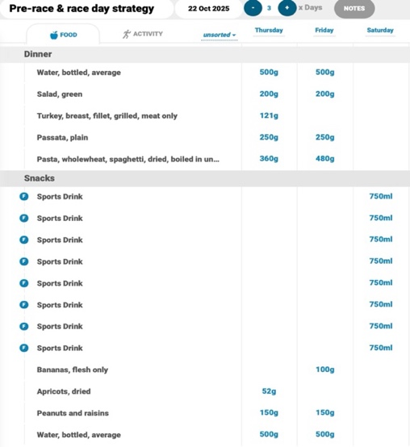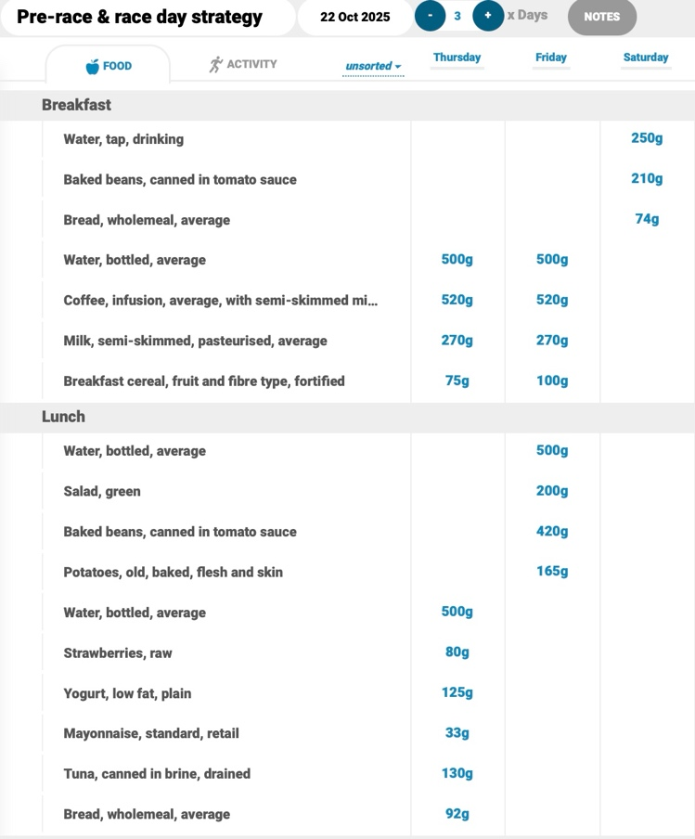

Appendix 2 – pre-race glycaemic index nutritics



