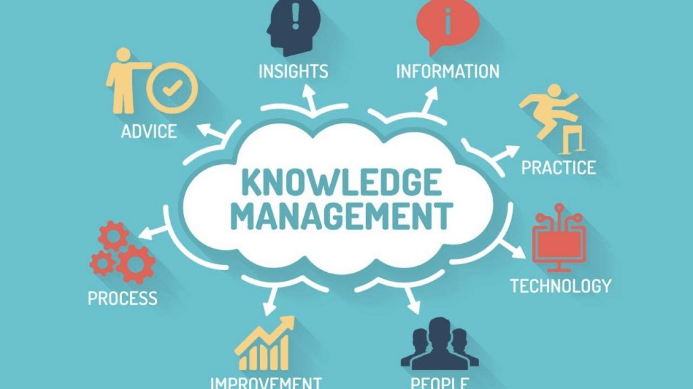

Knowledge and Information Management of Tesco

Module: Knowledge and Information Management
Module code: BMSW5106
Student name: Corina Berco
Student ID: 1918420
Lecturer name: Yohan Mendis

Executive summary

As the title of the assignment suggests, this assignment focuses on Tesco's knowledge and information management. There will be an emphasis on the advantages of using information systems and Tesco's implementation of information systems. The paper will also shed light on Tesco's use of Information and Communications Technology (ICT) and the challenges they face in implementing new ERP systems in the workplace. Finally, it can be concluded that Tesco has done an excellent job in the market by implementing a new ERP and an information system into the business process. Additionally, these help the organisation to gain a foothold in the market, as well as a customer base that will buy their products and services in the future.

Table of Content

Executive summary………………………………………………………………….2
Introduction 4
About Tesco 4
Benefits from using Information System 5
Information System implemented by Tesco 7
Ways in which IS/IT systems are used by Tesco 9
Challenges faced in implementing new ERP by Tesco 11
Plan to implement a new ERP system by Tesco 12
Recommendations 14
Conclusion 15
References 15

Introduction
The assignment deals with the knowledge and information management done by Tesco, and it will focus on the benefits of using information systems as well as the information system implemented by Tesco in its organisation. The paper will also put light on how IS/IT is being utilised by Tesco along with the challenges faced for implementing new Enterprise Resource Planning (ERP) in the workplace. These will also put light on the plan that can be implemented by Tesco so that it is capable to implement the new ERP in the business procedure.

About Tesco
Tesco is one of the leading retail supermarkets, which is a public limited company and possess headquarter in Welwyn Garden City, England. The company is the third largest retailer in terms of gross revenue (Aiello et al., 2020). The business was established in the year 1919 by Jack Cohen who used to work in Royal Flying Corps. The business mainly operates in banking; telecom; superstore; Tesco metro; fuel as well as tech support and many more. In the year 2020, the net worth of the organization was about £2,959 million (Hashim et al, 2021). So, it can be said that Tesco has done a great job in the domestic along with the international market to grow and perform well.
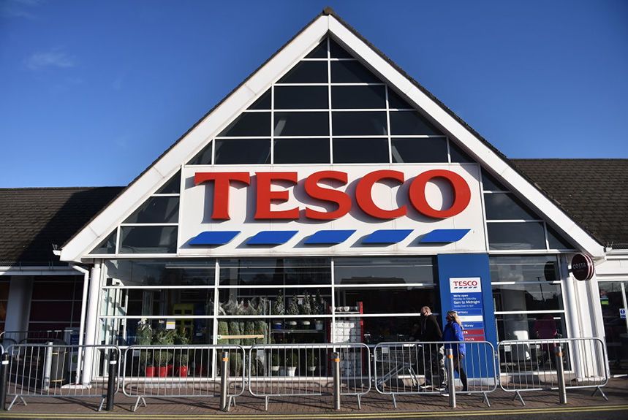
Figure 1: Tesco
(Source: Marketfeed Team, 2021)

Benefits from using Information System
There are benefits for Tesco for using and implementing information technology as it provides them with the knowledge regarding the working hours of the employee in the workplace. It also let Tesco analyse the price of the product and service in the industry where it is operating. This will let the management of the organisation accomplish the goals and mission that has been set by them during the starting of the financial year. So, it is crucial for any organisation that is using an information system to choose an appropriate information system so that it can gather information and data from the market. The benefits that Tesco is obtaining from the information system are:
- Tesco is obtaining help in the financial & accounting department as the information system enables them to look after the day-to-day invoice along with the inventory control; suppliers’ details; product details; sales and purchase ledger as well as customer details. This is quite important for the growth of Tesco in the industry where it is operating, and finance & accounting enable the top-level management to understand the success and growth rate of the organisation in the market (Nurwidayat et al., 2019). This is the main reason, appropriate attention and care should be undertaken by Tesco when it is utilizing information systems in its business procedure.
- Tesco is also getting help in human resource management by using an information system. This is so as information system enables the HR manager to understand the satisfaction level of the employees and possess the information regarding the skilled and talented candidates in the market. These will help the firm to select the right candidates for the job, which will ensure that Tesco is capable to perform well in the industry (Chiu et al., 2021). It can be noticed that the information system provides support to the HR department of the company as well and assist Tesco to hire deserving candidates from the market.
- The information system also produces assistance to Tesco in the manufacturing and production department. This enables the organisation to understand and modify the production planning as well as helps in the transactional processing system. These also assist the organisation in managing the information regarding the manufacturing of the product along with the sales figure of the same. This automatically provides the idea to the management to understand the stoke that is there in the organization along with the demand and supply of the product and service in the market. It can be noticed that the information system assists Tesco to control the manufacturing and production of the product so that they do not waste any resources.
- The information system provides Tesco with assistance in supply chain management as well. This helps the organisation to understand the demand and supply of the product and where they need to supply more volume of product. This will enable Tesco to meet the requirement of the customers and will produce them with a chance to perform well in the industry (Bakri, 2020). For this reason, it can be said that information system benefits the organization in the supply chain management and ensure that the organization is capable to sustain in the location. This also enables the organisation to generate money that will be beneficial to sustain in the market.
- Information system as to provide the information and data to Tesco, so it is a benefit to the organisation in decision support system by enabling them to make the decisions that will be beneficiary for Tesco to perform well in the industry where it is operating (Alam and Raut-Roy, 2019). So, the proper measure should be taken by Tesco in selecting the information system.
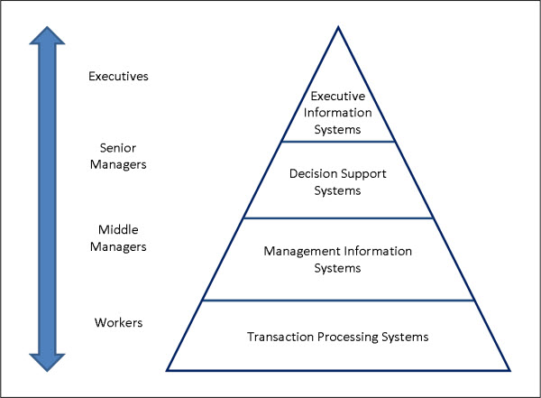
Figure 2: Utilization of Information System
(Source: Tesco, 2021)

Information System implemented by Tesco.
Management Information System (MIS) is being implemented by Tesco in its business procedure so that it is capable to deal with a huge amount of data. These will enable the organization to covert the data into information which will assist the firm to analyse the situation and take the necessary decision to gain the target in the end (Madakam et al., 2019). These also enable the organization to achieve the objectives and take care of resources, money, manpower, and machinery. This is crucial and beneficial for the organisation if it implements MIS in its business procedure.
Tesco has done a great job by implementing and utilizing MIS in the business process as this enables Tesco to manage information and utilize the same information for the benefit of the firm in the market. This also lets the organisation expand and perform well in the industry as it possesses all the necessary information that is required for the growth of the company (Zhao, 2021). So, it can be said that Tesco has done well for the growth of the company in the market by implementing MIS in the business. These will ensure that the company is capable to expand in the market and produce all the benefits to the company to perform well in it.
As per input is concerned, MIS enables Tesco to input the necessary data to the information system so that it is capable to sort out the data and convert it into information that is understandable to the manager as well as the employees working under them (Saani, 2019). These will automatically enable Tesco to provide all the information to the employees and manager so that they are capable to align their personal goals with the goals of Tesco. This will ensure that the company is capable to grow in the market and produce the best outcome in the end.
In the processing aspect, it can be noticed that Tesco after inputting the data and converting it to information moves it to the processing department. These will assist the company with the analysis procedure so that valuable information can be understood, and proper strategy can be planned accordingly in the implementation procedure (Harrison et al., 2019). These will enable Tesco to take the necessary decision so that it can perform well in the industry and sustain itself in the market. So, MIS plays a vital role in analysing the data and information to help Tesco to perform well.
In the output aspect, it can be noticed that MIS enables Tesco to undertake and implement a strategy in its business procedure so that it is capable to expand in the industry and perform well in the location. This is crucial and beneficial for the company if they can take the necessary decision and that is possible with the assistance of MIS in the end (Giannikas et al., 2019). So, proper care and support should be produced by Tesco and utilize MIS to enhance the performance and generation of money in the industry.
Lastly, it can be noticed that MIS produces support in problem identification along with the implementation of the plan. MIS also helps in searching the information as well as the need of the system; system design; documentation and testing. These will enable the company to grow in the market and perform well in it. This is the main reason, it can be said that MIS in Tesco has done great and produced with the support to the company in the procedure. These will lead them to perform well and make sure that it is capable to grow in the industry.
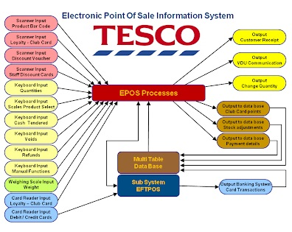
Figure 3: Management Information System of Tesco
(Source: Hero24hours.blogspot.com, 2021)

Ways in which IS/IT systems are used by Tesco
As per Porter’s Generic Competitive Strategy is concerned, four factors that require to be taken care of by the organisation. These four factors are:
- Cost leadership enables the company to reduce the cost of the product and increase profit.
- Differentiation strategy will enable the firm to differentiate their product from that of the competitors in the niche market.
- A cost focus strategy will enable the organisation to modify the cost leadership strategy by reducing the cost of the product and service along with that focusing on a market.
- Differentiation focus strategy will enable the firm to evolve the differentiation strategy and focus on the niche market. This enables the organisation to perform well in the market and lets them expand in the industry.
According to the first factor i.e., cost leadership it can be noticed that the information system produces Tesco with the information regarding the cost of the product and service that they are producing to the customers (Alexander, 2020). This enables Tesco to perform well in the industry and to reduce the cost and enrich the profit earning in the procedure. So, proper care should be undertaken by the company so that they can perform attractively in the market and grow.
MIS or other information systems enabled Tesco to differentiate its product and service from that of the competitors in the market. This enables Tesco to grab the attention of the people and ensure that it makes the actual sale in the industry. These will let the firm grow and perform in the appropriate way possible (Keiningham et al., 2020). For this reason, proper care should be produced by Tesco in adapting the information technology or information system to be able to expand and generate money from the market.
According to the cost focus strategy is concerned, it can be noticed that information systems produce the information that is necessary for Tesco to focus on the reduction of the cost price of the product and target the niche market (Woohyoung et al., 2020). These will enable Tesco to become unique from the competitors in the market in terms of the pricing strategy and will generally grab people’s attention towards the product and service of Tesco in the market. So, appropriate attention and measures should be undertaken by the company to perform well in the market and ensure that they can expand in it.
As per differentiation focus strategy is concerned, it can be noticed that Tesco has done a great job in entering the different industries and differentiating its product from that of the competitors in the market (Bilińska-Reformat et al., 2019). Tesco also focuses on the niche market who is the target audience for the firm in all the industries where it is operating. Therefore, proper support and care are being produced by an information system that has been utilized by the company to perform well in the industry and to expand.
Tesco needs to implement porter’s generic strategies in its business strategy in the future as well to gain popularity. These will also enable the organisation to perform well by utilizing information systems and ensure that it is capable to expand in the marketplace (Waters, 2019). This is the reason, appropriate strategy and measurement should be undertaken by the company to gain popularity in the market and ensure that they are performing well in the end.
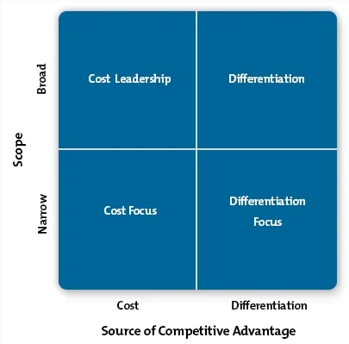
Figure 4: Porter’s Generic Strategies
(Source: Mindtools.com, 2021)

Challenges faced in implementing new ERP by Tesco
There are challenges faced by Tesco while implementing a new ERP in the business procedure. These require to be viewed and taken care of by the organisation so that they are capable to overcome the issues and fix them as soon as possible. This will enable them to perform well in the industry and generate the money that will let them sustain themselves in the industry (Cole et al., 2019). The challenges need to be identified and taken care of by Tesco so that it does not provide any sort of issues soon and let them accomplish the goals and aims in the procedure.
Initially, it can be noticed that Tesco was utilizing Linux for digital marketing procedures but now it can be seen that the organisation has implemented an Oracle marketing platform to reach the customers in less possible time. But Tesco was facing a problem in using the Oracle marketing platform as it is different in terms of the interface than Linux (Jones and Chung, 2019). So, the company must hire a competent person who possesses the knowledge of the Oracle marketing platform and should also hire trainers who will guide the present employees in using the Oracle. These will be beneficial for the company to reach directly to the customers and will produce them with a chance to understand the change in the taste and preference of the customers.
As the company was implementing new ERP in the business procedure so the human resource department was also facing problems in establishing communication with the employees working in the company along with the candidates who are beneficial for the company and deserve recognition in the end (Rogerson and Parry, 2020). These should be taken care of by Tesco properly to hire the best candidates for the job and ensure that it is capable to grow in the industry and perform effectively. If these can be done by the company then only it will be able to capture the market and provide the best solution and service along with the product to the customers.
When Tesco introduce SAP in the decision support system then it was facing issues initially as the employee do not possess any sort of information regarding the SAP and how it works. For this reason, it will be advisable for the company to hire a trainer if they are willing to implement another information system in the organisation so that they are capable to provide the training and knowledge transfer to the employee who is not accustomed to the system (Gronwald, 2020). These will lower down the risk and will produce the organisation with a chance to perform well in the market and generate the money that will assist them to sustain it. Thus, this is the main reason proper care and support should be produced by the company to accumulate the target and ensure that the company can perform effectively and efficiently.
Lastly, it can be noticed that Tesco had also implemented a new ERP in communication procedure, and employees sometimes were not able to communicate effectively with each other. The company needs to overview the matter so that they do not repeat the same mistakes in the future while implementing new communication applications in the business organisation (Butollo et al, 2019). If these can be understood and taken care of properly by the company then only the communication will be transparent and concise and will also enable Tesco to communicate efficiently with the customers.
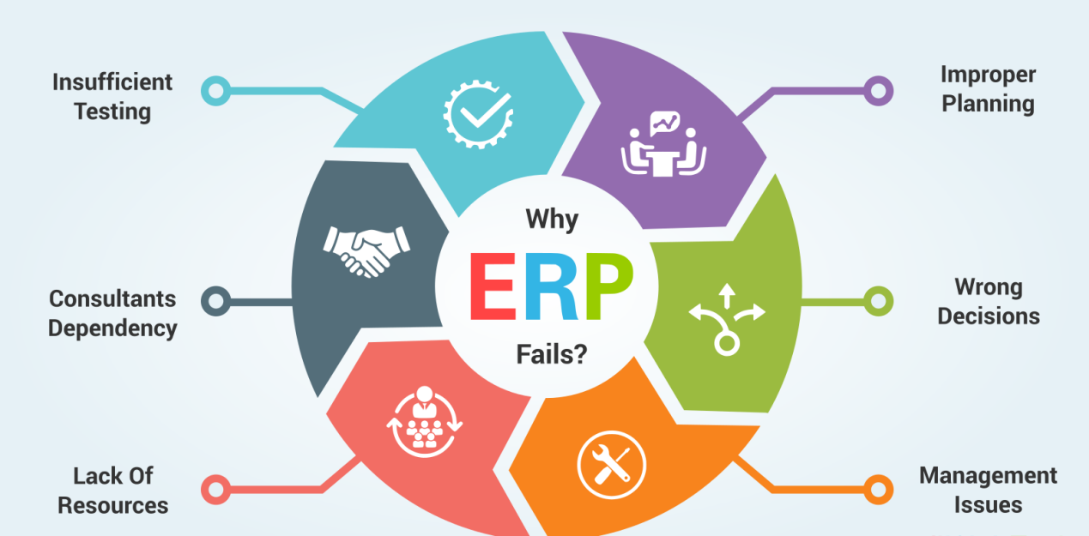
Figure 5: Challenges in New ERP
(Source: Iqminds.me 2021)

Plan to implement a new ERP system by Tesco
There are planning that is favourable and important for the company to implement new ERP in the business procedure. These will ensure that the implementation, as well as the utilization of the new ERP, will be effective and finalize that the company will perform well in the industry. If Tesco can plan the steps of implementation then only it will be able to perform well and produce the outcome with high quality.
Firstly, Tesco requires to identify the critical business procedure as this will be beneficial for the organisation in the future. This is so as it will assist the company to sort the procedure and what should be done next in the step so that it can expand in the market (Czopek and Kazusek, 2020). Then, the company needs to plot the process map so that they are capable to understand the procedure that should be followed is by the company in the long run. These will be beneficial for the growth of the company and make sure that it is capable to perform in the industry.
Secondly, Tesco requires to analyse the type of ERP implementation that it can undertake in the market so that they are capable to expand and can perform effectively. This is essential and advantageous for the growth of the company in the market and helps them to choke out the procedure that it should follow in the end (Visser and van Goor, 2019). So, if appropriate attention and care are being undertaken by the company then only the organisation will be able to perform efficiently in the industry and will also generate the money to sustain itself in the market.
Thirdly, Tesco needs to look after the implementation of the ERP that it is intending to introduce in the business procedure as these will help the organization to perform effectively and let it understand what changes require to be undertaken by the organisation (Torri et al., 2021). So, in this case, it is beneficial for the company to understand the implementation procedure and make sure that it can perform well in the market and effectively sustain itself.
Lastly, it can be noticed that Tesco must understand and possess the knowledge regarding the business benefits along with the learning so that they can be assured regarding the effectiveness of the new ERP in the market. Thus, these are crucial steps that should be followed and taken care of properly by Tesco to become effective in the market and produce the money that will be helpful in the growth procedure of the organisation (Pugna et al., 2019). Thus, it can be said that the company needs to understand the growth of the company in the market and should implement a strategy that will be quite beneficial in the end.

Recommendations.
Some recommendations should be taken care of by Tesco to it is capable to perform well in the market and produce the best outcome in it. The recommendations are:
- Tesco should look after the rewards and recognition of the employees to motivate them to perform efficiently for the company. These will enhance the performance of the employees, which will automatically result in the performance of the company in the market. So, Tesco should look after the matter and make sure that it can perform effectively and produce the best product for the people.
- Tesco should also view the advertisement procedure which will enable them to seize the attention of the customers towards the company and will encourage them to purchase the product and service from the company. If this can be done by Tesco then only it will be able to generate money from the market and will be capable to sustain it. Thus, this is the reason for the company to view the matter and adapt the strategy that will be favourable for them to acquire the goals in the end.

Conclusion
Lastly, it can be inferred that Tesco has done a great job in the market by implementing a new ERP in the business procedure and implementing an information system. This enables the organisation to perform well in the market and to seize the attention of the actual people who will purchase products or services from them. These enable them to utilize the opportunity and control the growth as per their requirement. If these can be done properly by the company then only it will be able to perform well in the industry and will also sustain and grow in the market.

References.
1. Aiello, L.M., Quercia, D., Schifanella, R. and Del Prete, L. (2020) Tesco Grocery 1.0, a large-scale dataset of grocery purchases in London. Scientific data, 7(1), pp.1-11.
2. Alam, S. and Raut-Roy, U. (2019) ‘Evaluating the Effectiveness of Reward Strategy at Tesco: Evidence from Selected Stores in UK, Indian Journal of Industrial Relations, 55(1).
3. Alexander, I.N. (2020) The influence of technological innovations on organization's competitive advantage: Case study on Irish food retail company (Tesco) (Doctoral dissertation, Dublin, National College of Ireland).
4. Bakri, M.H. (2020) ‘The factors influence retailers’ acceptance towards the adoption of information technology in retail sector in Malaysia’, The Journal of Technology Management and Technopreneurship (JTMT), 8(1), pp.83-95.
5. Bilińska-Reformat, K., Kucharska, B., Twardzik, M. and Dolega, L. (2019) Sustainable development concept and creation of innovative business models by retail chains. International Journal of Retail & Distribution Management.
6. Butollo, F., Jürgens, U. and Krzywdzinski, M. (2019) From lean production to Industrie 4.0: More autonomy for employees?. In Digitalization in Industry (pp. 61-80). Palgrave Macmillan, Cham.
7. Chiu, C.L., Ho, H.C., Yu, T., Liu, Y. and Mo, Y. (2021) Exploring information technology success of Augmented Reality Retail Applications in retail food chain. Journal of Retailing and Consumer Services, 61, p.102-561.
8. Cole, R., Stevenson, M. and Aitken, J. (2019) Blockchain technology: implications for operations and supply chain management. Supply Chain Management: An International Journal.
9. Czopek, M. and Kazusek, M. (2020) ‘Customer relationship management. Strategy and system perspectives’, Informatyka Ekonomiczna, 3(57), pp.34-48.
10. Giannikas, V., McFarlane, D. and Strachan, J. (2019) Towards the deployment of customer orientation: A case study in third-party logistics. Computers in Industry, 104, pp.75-87.
11. Gronwald, K.D. (2020) Integrated Business Information Systems. Springer Berlin Heidelberg.
12. Harrison, A., Skipworth, H., van Hoek, R.I. and Aitken, J. (2019) Logistics management and strategy: competing through the supply chain. Pearson UK.
13. Hashim, M., Nazam, M., Abrar, M., Hussain, Z., Nazim, M. and Shabbir, R. (2021) Unlocking the Sustainable Production Indicators: A Novel TESCO based Fuzzy AHP Approach. Cogent Business & Management, 8(1), 1870807, DOI: 10.1080/23311975.2020.1870807
14. Hero24hours.blogspot.com (2021) Management Information System (Assignment). Available at: Hero24Hours: Management Information System (Assignment) (Accessed: 13 November 2021).
15. Iqminds.me (2021) 5 ERP implementation challenges faced by businesses. Available at: ERP Implementation: 9 steps to success | get free real-world ERP implementation advice (erpfocus.com) (Accessed: 13 November 2021).
16. Jones, E.C. and Chung, C.A. (2019) RFID and Auto-ID in Planning and Logistics: A Practical Guide for Military UID Applications. CRC Press.
17. Keiningham, T., Aksoy, L., Bruce, H.L., Cadet, F., Clennell, N., Hodgkinson, I.R. and Kearney, T. (2020) ‘Customer experience driven business model innovation’, Journal of Business Research, 116, pp.431-440.
18. Madakam, S., Holmukhe, R.M. and Jaiswal, D.K. (2019) The future digital work force: robotic process automation (RPA). JISTEM-Journal of Information Systems and Technology Management, 16.
19. Marketfeed Team (2021) Tesco jumps on higher profits - Top International News - marketfeed.news.. Available at: Tesco Jumps On Higher Profits - Top International News - marketfeed.news (Accessed: 13 November 2021).
20. Mindtools.com (2021) Porter's Generic Strategies: Choosing Your Route to Success. Available at: Porter's Generic Strategies - Strategy Skills from MindTools.com (Accessed: 13 November 2021).
21. Nurwidayat, A., Sudarsono, B., Pratiwi, K. and Havity, M.D. (2019) ‘Implementation of Information System in Submitting Employees’ Annual Leave at PT’, Tesco Indomaritim. Sinkron: jurnal dan penelitian teknik informatika, 3(2), pp.97-103.
22. Pugna, I.B., Duțescu, A. and Stănilă, O.G. (2019) Corporate attitudes towards big data and its impact on performance management: A qualitative study. Sustainability, 11(3), p.684.
23. Rogerson, M. and Parry, G.C. (2020) Blockchain: case studies in food supply chain visibility. Supply Chain Management: An International Journal.
Saani, J.I. (2019) Management information systems. Published by Intellectual Capital Enterprise Limited ICE Kemp House, pp.152-160.
24. Tesco (2021) Tesco information system. Available at: tesco information system - tesco (weebly.com) (Accessed: 14 November 2021).
25. Torri, M., Kundu, K., Frecassetti, S. and Rossini, M. (2021) ‘Implementation of lean in IT SME company: an Italian case’, International Journal of Lean Six Sigma.
26. Visser, H.M. and van Goor, A.R. (2019) Logistics: Principles and Practice: Principles and Practice.
27. Waters, C.D.J., 2019. Logistics: an introduction to supply chain management. Red Globe Press.
28. Woohyoung, K., Kim, H. and Hwang, J. (2020) Transnational corporation’s failure in China: Focus on Tesco. Sustainability, 12(17), p.7170.
29. Zhao, C. (2021) Research on Cost Management of E-commerce Enterprises Based on Value Chain Taking Suning Tesco as an Example.

