Hannah Marie Hatherall (2012129)
2012129@Student.uwtsd.ac.uk
Paul Harries
BSc Architecture
April 29th 2022
An Exemplar of Modern Architecture – Rietveld Schrӧder House – Gerrit Rietveld
History and Theory M4x01975
Hannah Hatherall

Contents
Introduction 2
Rietveld Schrӧder House 2
Historical background 2
Plan and Section 4
Materials and Light 9
Idea and theories underpinning the design. 9
Conclusion 10
References 11
References of Images 11

Introduction

The Modernist movement or modern architecture originated in the early part of the 20th Century. The main factors of this era were to use of modern methods of construction such as steel, concrete and glass. Architects were striving to be innovative and experimental. They used more of a minimalist approach to design and removed all ornament and considered the phrase, “Form follows function” in all of their designs.

Rietveld Schrӧder House

Historical background

The Rietveld Schrӧder house was completed in 1924 on the outskirts of Utrecht in the Netherlands. The house is a small semi-detached villa located at the end of a row of traditional 19th-century brick-built townhouses. The position of the house was especially important to Ms Truus Schrӧder, the client, as she cherished the view of the ponder landscape, so much so that in 1930 she purchased the land opposite the house to ensure that no further development could be placed there. The Architect Gerrit Rietveld also felt that when in 1960 a motorway and viaduct were built next to the house he said, “The house might as well be torn down, since what linked the interior and exterior had been destroyed” (Schröder House Foundation, 2022)
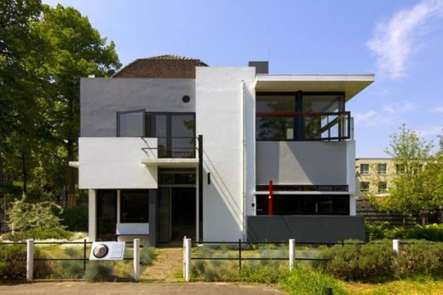
Figure 1 - Rietveld's Schrӧder House - unknown - https://www.e-architect.com/utrecht/rietveld-schroeder-house
Gerrit Rietveld (1888-1964) was born in Utrecht and became famous for his furniture designs and scale models. He was renowned for his design of the Red and Blue chair in 1918 (Shown Below) and for his dislike for the traditional and ordinary. It was for this reason that widower Truss Schrӧder commissioned him to design a residential dwelling for her and her three children. He had previously renovated a room in her existing home but had never designed a whole building. Rietveld was heavily influenced by the artists Theo Van Doesburg and Piet Mondrian who were founders of the De Stijl (The Style) movement. De Stijl was a magazine that originated in 1917, it promoted the use of Abstract Art in what it called the Neoplasticism now also known as “De Stijl”. They emphasised the use of the geometry of horizontal and vertical lines and the removal of ornament. “The reduction of the complexity of the visible world to a limited series of geometric forms and colours gives De Stijl its distinct visual character.” (Cruickshank, 2015)

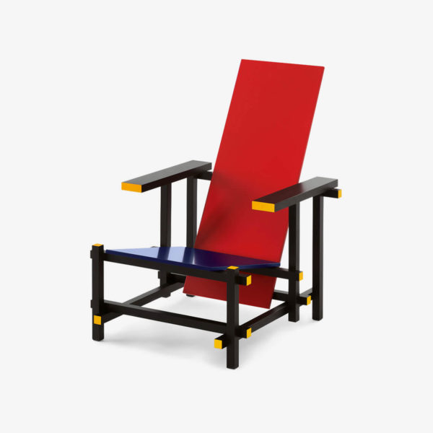
Figure 2 - Gerrit Rietveld's Red and Blue Chair - Rood Blauwe - https://rietveldoriginals.com/en/collection/red-and-blue-chair-cassina/
Ms Schrӧder had stringent ideas on what she wanted from the house and was heavily involved in the design. She was credited with the design for many years as a joint designer with Rietveld and also worked on other building designs with him. In 1982 she is quoted as having said, “I think this house Rietveld isn’t so “Rietveld”. I think he adapted himself somewhat to what I wanted. And I believe I loved this house more than Rietveld did. There is so much of myself here, I respond to the whole atmosphere of the place.” (Heathcote, 2013) She used the house as a residential dwelling until her death in 1985 when it was made into a museum and a World Heritage site.

Plan and Section
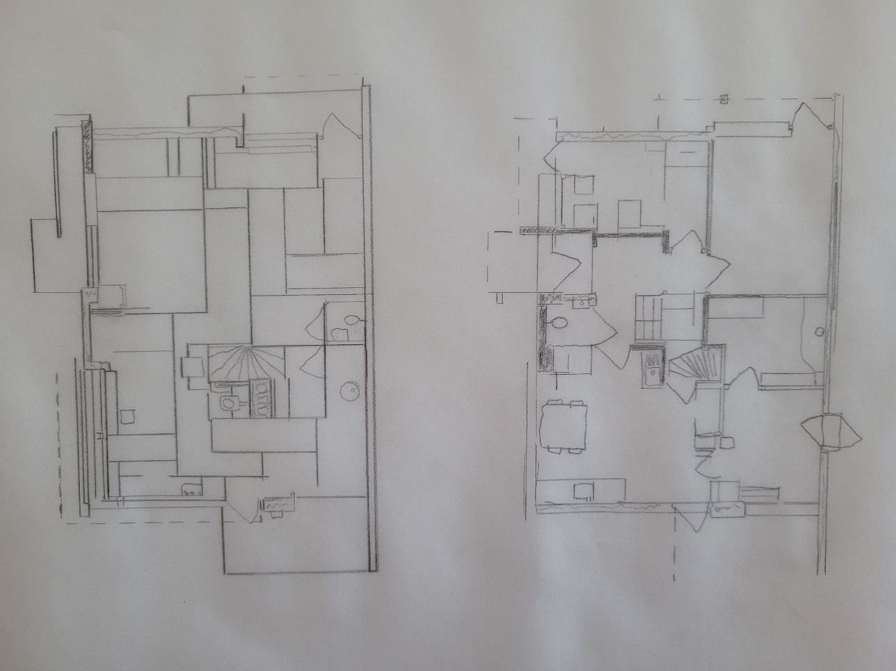
Figure 3 - Lower and upper floor plan - Scale 1:100 (Draft – Hannah Hatherall)
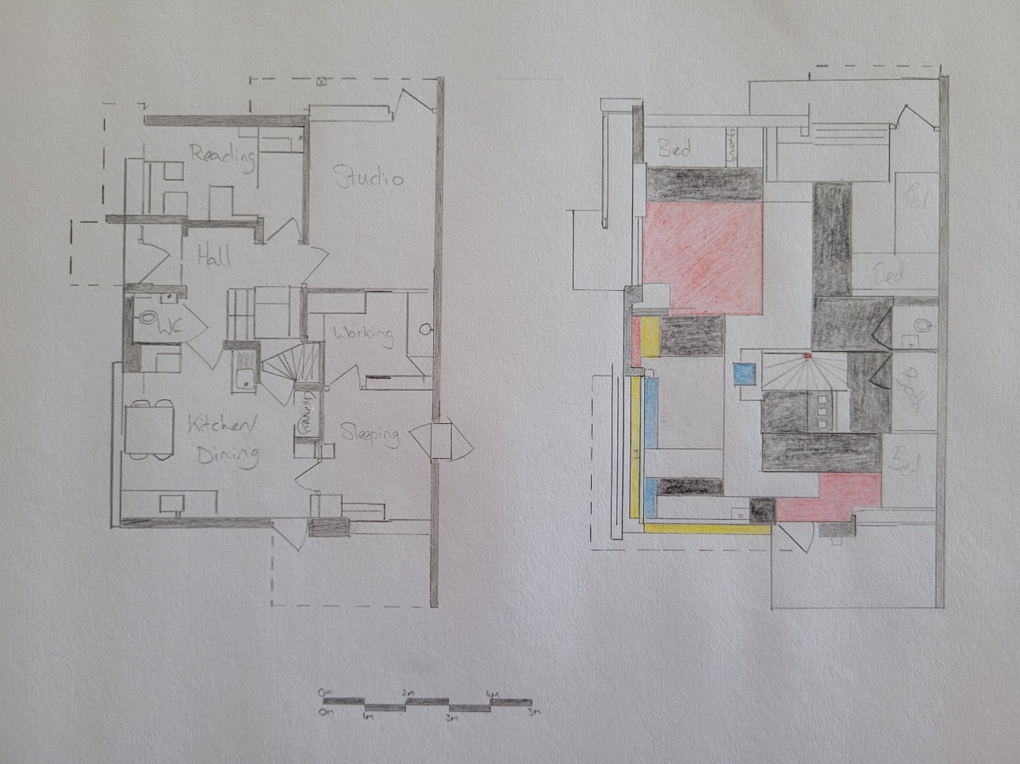
Figure 4- Lower and upper floor plan - Scale 1:100 (Hannah Hatherall)
As a young widow with three children, Ms Schrӧder wanted a house that would allow her to socialise with her children and allow them to have the freedom of space during the day and an element of privacy during the night. On the original plans to the local authority, the lower floor was to be the living space and the upper floor was labelled as “Attic” to bypass the building regulations of the time.
To comply with local building regulations the lower floor has been designed more traditionally with brick rendered walls. Located on this floor is the kitchen/dining area, reading space, with a separate sleeping corner and reading room. In reality, the residents spent the majority of their time on the upper floor where the three bedrooms, a large open living area and bathing and toilet facilities.
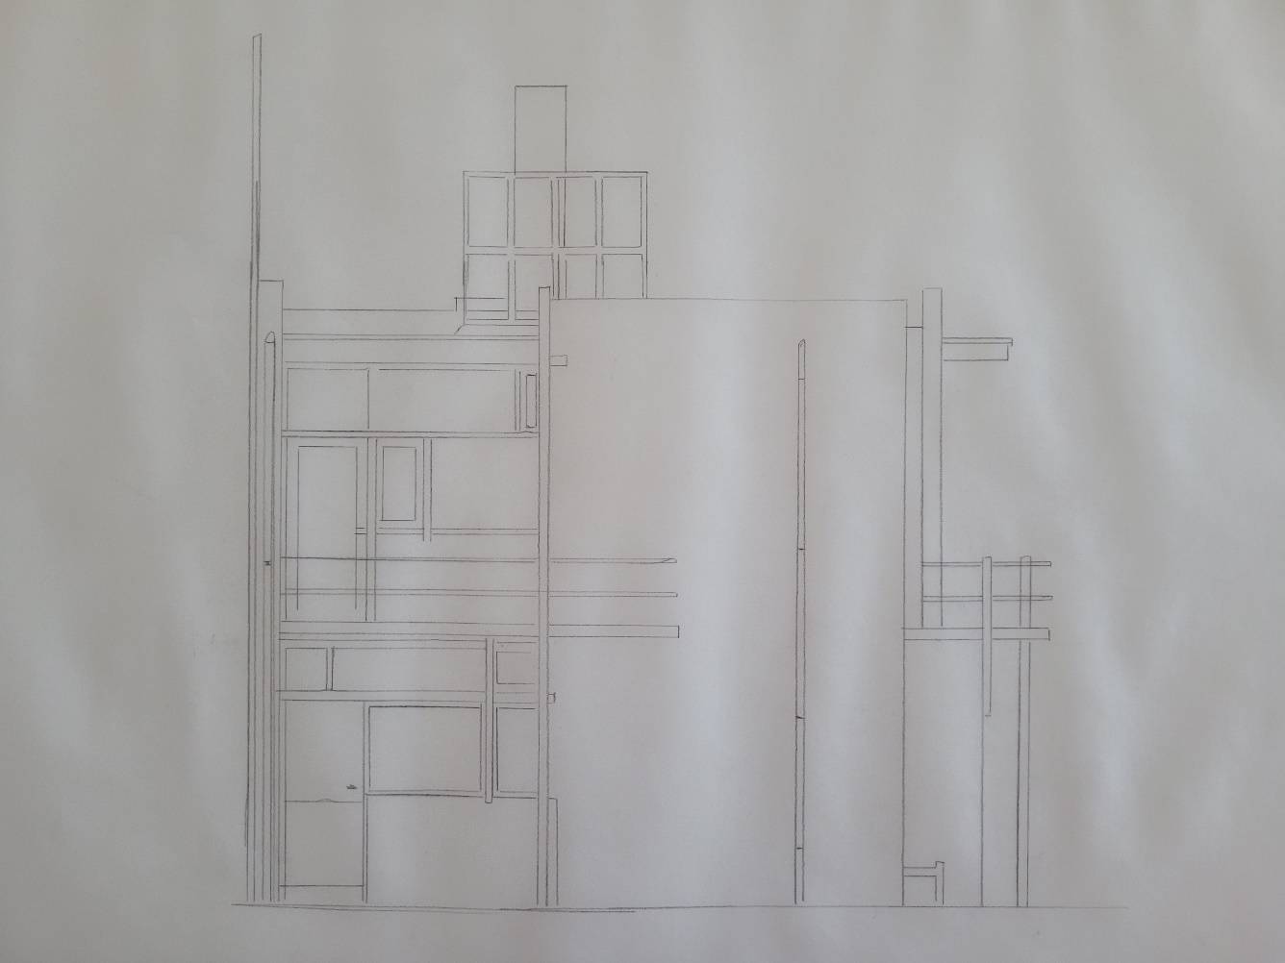
Figure 5 - Southwest Elevation - Scale 1:50 (Draft - Hannah Hatherall)
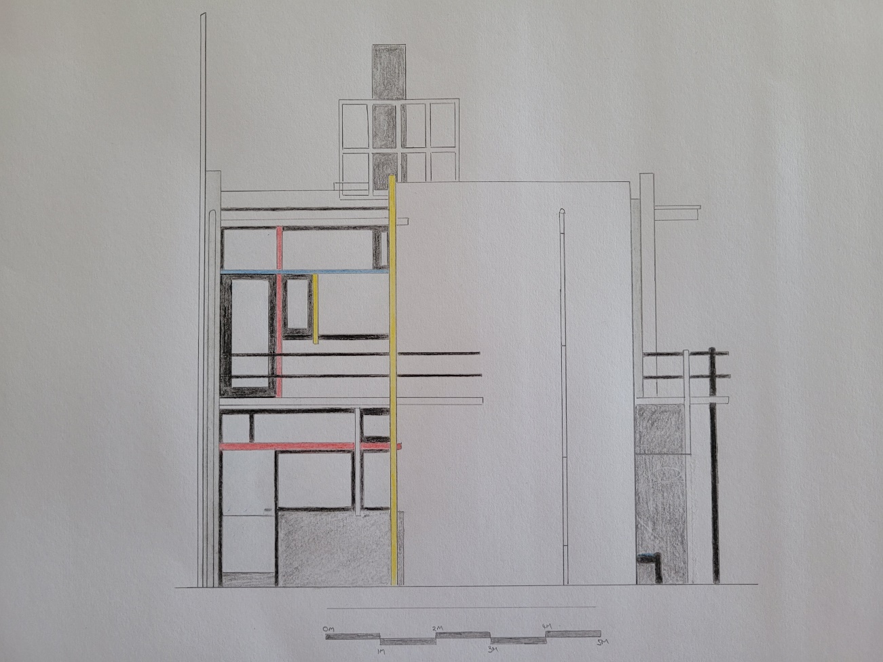
Figure 6 - Southwest Elevation - Scale 1:50 (Hannah Hatherall)
The De Stijl simplicity and primary colours continue from the interior to the exterior. With the intersecting planes of the building in White and three shades of Grey and the door and window frames in black on the exterior and black or white on the interior. The three primary colours were added to the linear aspects of the building and also to the furniture within the house.
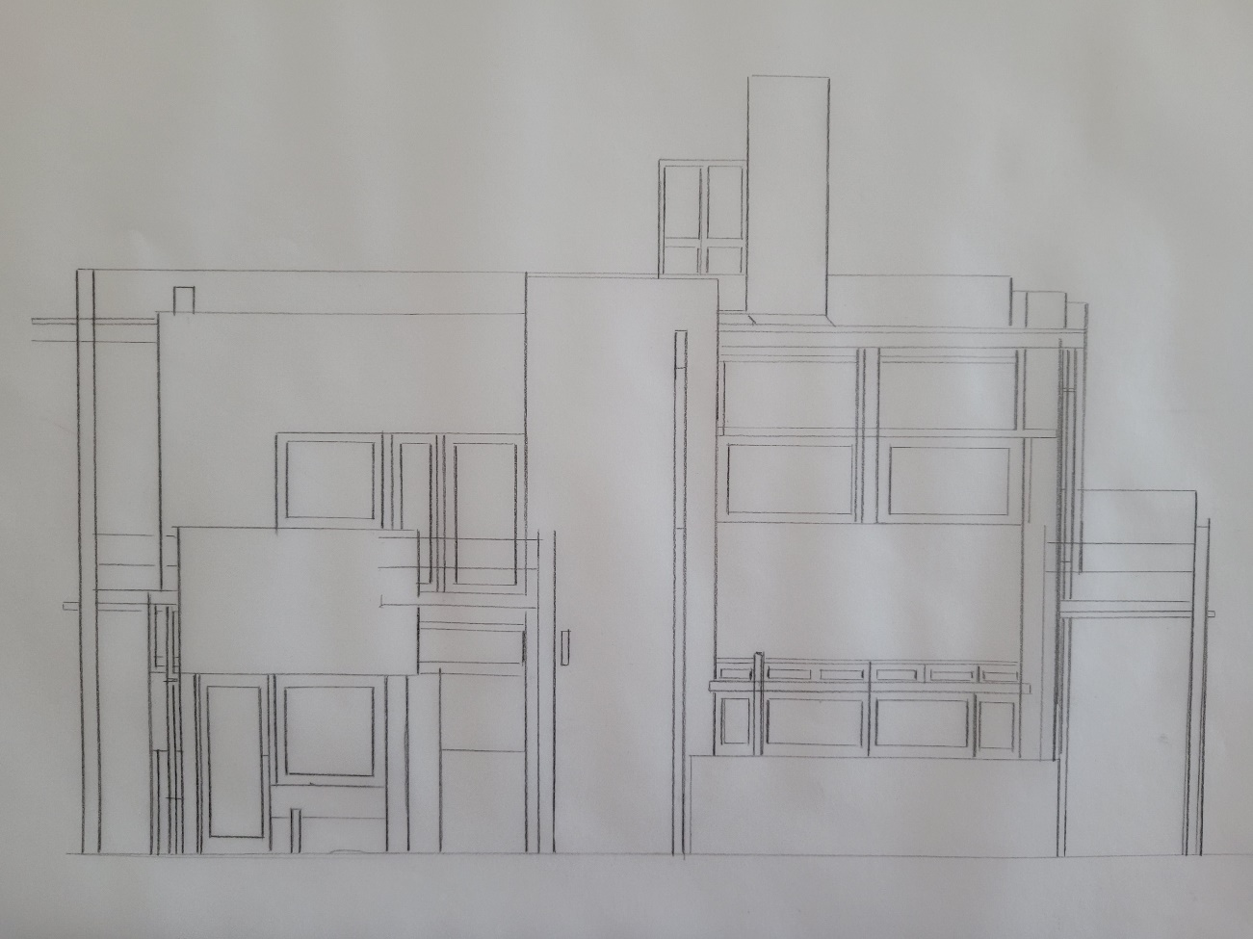
Figure 7 - Southeast Elevation - Scale 1:50 (Draft - Hannah Hatherall)
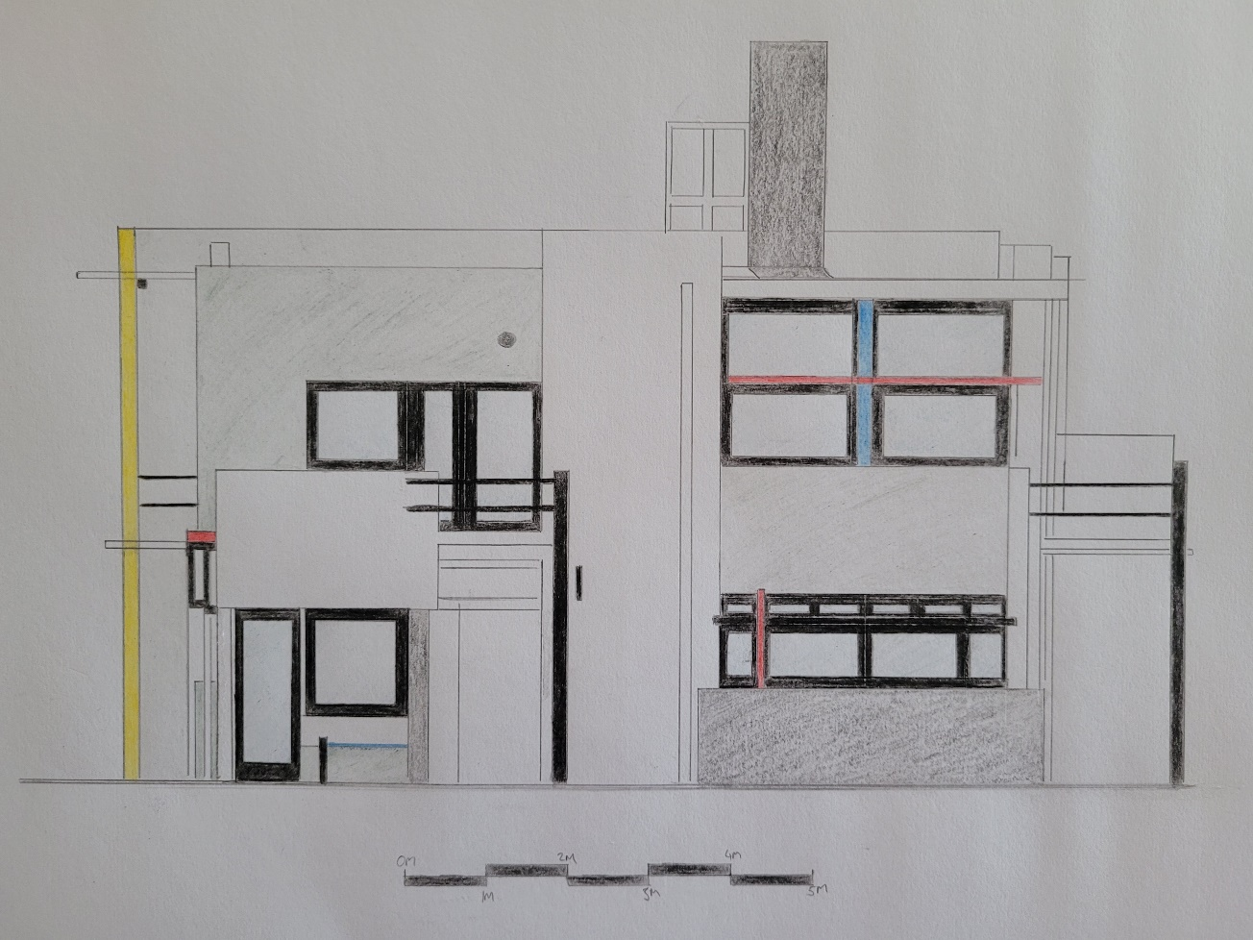
Figure 8 - Southeast Elevation - Scale 1:50 (Hannah Hatherall)
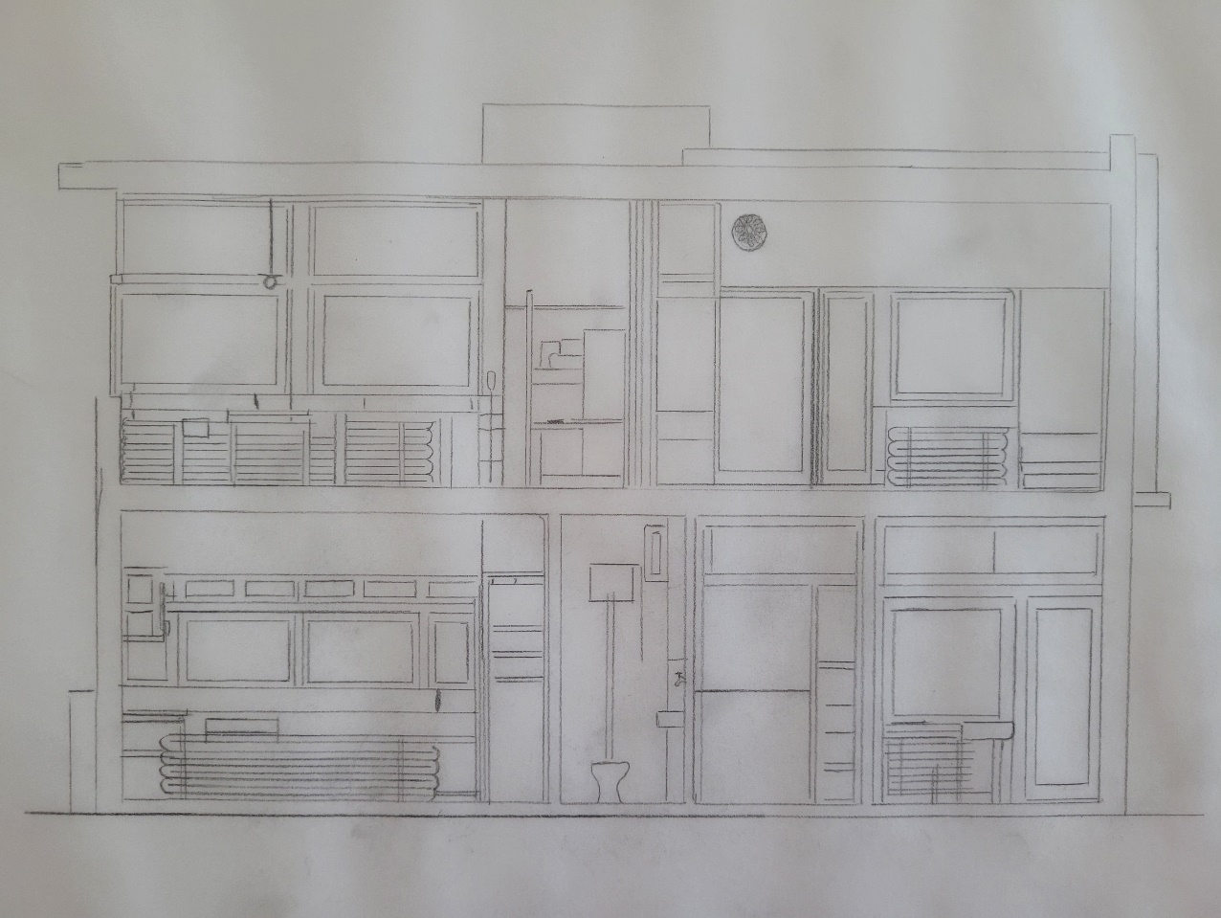
Figure 9 – Cross-Sectional View - Scale 1:50 (Draft - Hannah Hatherall)
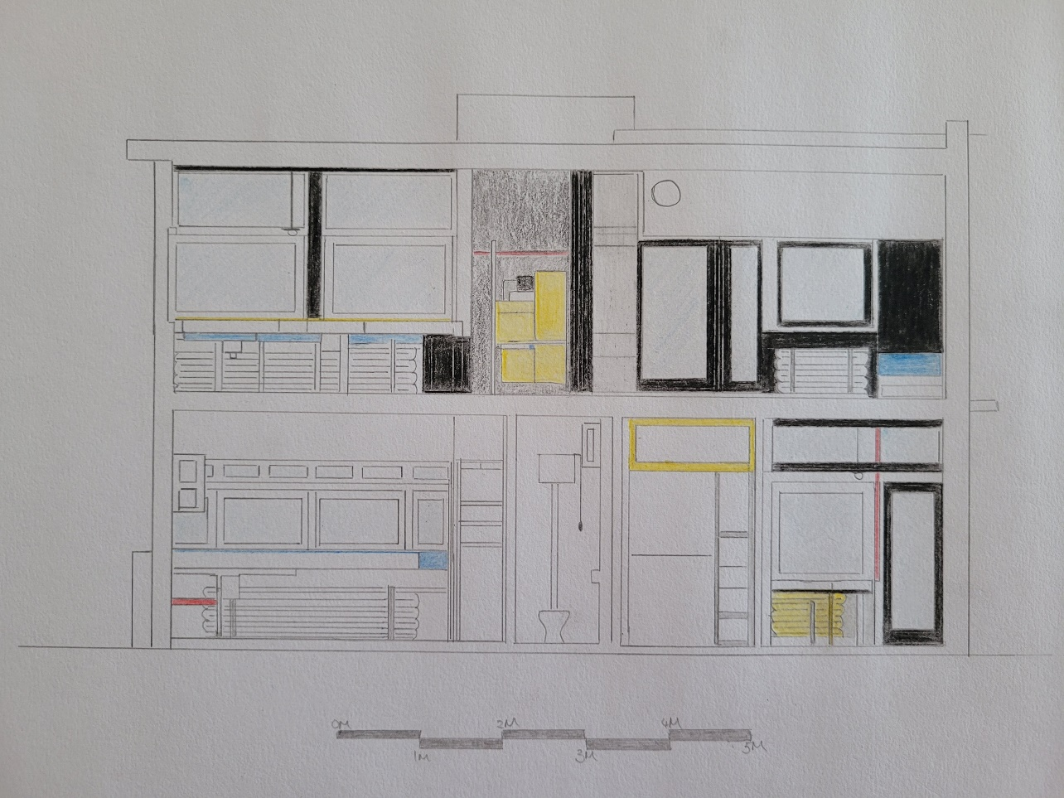
Figure 10 – Cross-Sectional View - Scale 1:50 (Hannah Hatherall)

Materials and Light
Rietveld had wanted to construct the house entirely from concrete however this was too expensive at the time and only the foundations and balconies were made of concrete. The main structural element of the house is steel girders with a wire mesh. The floors, doors and window frames were made from wood to reduce the cost of the overall build. The walls were constructed of Brick and rendered with white plaster. The vertical load-barring steel girders extend beyond the horizontal planes of the building, this not only improves the structural qualities of the steel but also improved the dynamic quality of the design. Where the steels and planes are physically joined, they are visually dissociated, this gives the impression of reduced mass and increased space which was Rietveld's main driving force in the design. “Even the windows are hinged so that they can only open 90 degrees to the wall, preserving strict design standards about intersecting planes, and further blurring the delineation of inside and out.” (Archello Classics, n.d.)
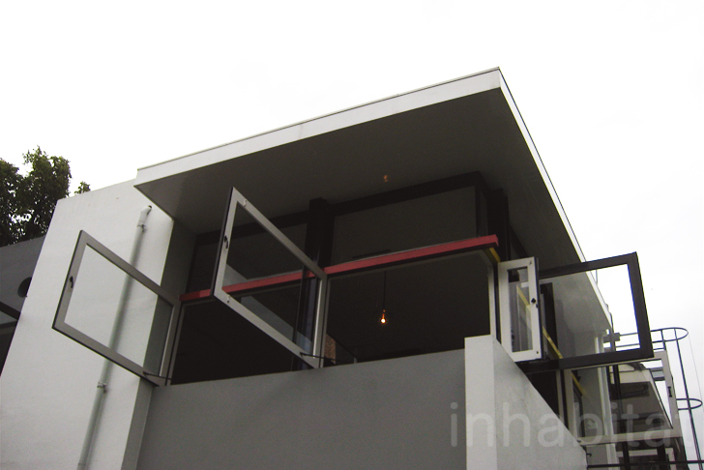
Figure 11 - The Schroder House Windows Open - https://inhabitat.com/1920s-rietveld-schroder-house-in-utrecht-is-a-simple-elegant-and-completely-transformable-home/gerrit-rietveld-adaptable-rietveld-schroder-house-utrecht-8/ (inhabital)
Large windows in a horizontal strip further accentuate the impression that the exterior merges with the interior of the house. The corner of the window section is without a frame to emphasise the open feeling. The roof skylight opened to allow for further light to penetrate the upper floor.

Idea and theories underpinning the design.
The Schrӧder House is noted to be the first house to be built in the Neoplasticism style (also known as De Stijl). “This small family house, with its interior, the flexible spatial arrangement, and the visual and formal qualities, was a manifesto of the ideals of the De Stijl group of artists and architects in the Netherlands in the 1920s and has since been considered one of the icons of the Modern Movement in architecture.” (World Heritage Convention, 2000)
The main concept of the design was to have an open, flexible house that would make the most of the landscape that surrounded it at the time of building. The open plan living aspect of the upper floor was seen as innovated along with the concept of sliding doors and walls to offer separation for privacy during the nights. Ms Schrӧder was adamant about the functionality of the space. This strength of character was not common in the woman of the time and helped to produce a design that lent itself to the life of a modern single parent of three children. It was truly a home that would grow and develop with the family.
The removal of ornamentation was critical to the design, all furniture and design features were minimal and flexible in their function. There are no diagonal lines or curves within the house, this was to give a calm and clean perspective. As the house was built after the first world war it was thought that a sense of calm simplicity was required and that families were able to live with less formal and grand properties. Rietveld had a vision of a utopian society where homes could be more adaptable without unnecessary embellishment.
One of the key features of the design for both interior and exterior was the use of De Stijl colours only. Even down to the Crockery, the only colours used were red, blue and yellow with white, three shades of grey and black. This is why the house was considered to be a 3D Mondrian painting. Rietveld himself commented, “We didn't avoid older styles because they were ugly, or because we couldn't reproduce them, but because our own times demanded their own form, I mean, their own manifestation.” (Overy, 1988)

Conclusion
The Rietveld Schrӧder House was a pioneering design, where the architect and client worked so closely together that the outcome was an ideal living environment for the client that fitted with how she and her family would use the house. The use of the Neoplasticism style was revolutionary and enabled the house to be a monument of Modernist Architecture. It showed the world that living without ornamentation and providing a flexible home would be both financially beneficial and would enhance their daily lives. Could this be something the world needs to look into again in the future to reduce waste and carbon with the removal of unnecessary ornament and ensure flexibility in our use of buildings and the furniture within in a more economical way?

References
Archello Classics, n.d. Archello.com. [Online]
Available at: https://archello.com/project/rietveld-schroder-house
[Accessed 18th April 2022].
Cruickshank, D., 2015. Rietveld Schroder House. In: A History of Architecture in 100 Buildings. London: Harper Collins UK, p. 28.
Heathcote, E., 2013. Lives lived in parallel. Financial Times, 5th April.
Kenneth Frampton, A. S., 2015. A genealogy of modern architecture: a comparative critical analysis of built form. s.l.: Lars Muller Publishers.
Luscombe, D., 2017. Illustrating architecture: the Spatio-temporal dimension of Gerrit Rietveld's representations of the Schröder House. The Journal of Architecture, 22(5), pp. 899-932.
Overy, P., 1988. The Rietveld Schröder House. s.l.:Butterworth Architecture.
P.Emmons, M., 2008. Material Models and Immaterial Paradigms in the Rietveld Schroder House. Journal of Architectural Education, 62(2), pp. 44-52.
Schröder House Foundation, 2022. Rietveld Schroderhuis. [Online]
Available at: https://www.rietveldschroderhuis.nl/en/rietveld-schroder-house?set_language=en
[Accessed 29th March 2022].
Watkin, D., 1996. A History of Western Architecture. Second Edition ed. London: Lawrence King Publishing.
Welch, A., 2017 updated 2022. e-architect - Rietveld Schroder House. [Online]
Available at: https://www.e-architect.com/utrecht/rietveld-schroeder-house
[Accessed 3rd April 2022].
Weston, R., 2004. Schroder House. In: Plans. Sections and Elevations - Key Buildings of the twentieth century. London: Laurence King Publishing, pp. 48-49.
World Heritage Convention, 2000. Rietveld Schröderhuis (Rietveld Schröder House). [Online]
Available at: https://whc.unesco.org/en/list/965/
[Accessed 18th April 2022].

References of Images
Figure 1 - Rietveld's Schrӧder House - unknown - https://www.e-architect.com/utrecht/rietveld-schroeder-house
Figure 2 - Gerrit Rietveld's Red and Blue Chair - Rood Blauwe - https://rietveldoriginals.com/en/collection/red-and-blue-chair-cassina/
Figure 3 - Lower and upper floor plan - Scale 1:100 (Draft – Hannah Hatherall)
Figure 4- Lower and upper floor plan - Scale 1:100 (Hannah Hatherall)
Figure 5 - Southwest Elevation - Scale 1:50 (Draft - Hannah Hatherall)
Figure 6 - Southwest Elevation - Scale 1:50 (Hannah Hatherall)
Figure 7 - Southeast Elevation - Scale 1:50 (Draft - Hannah Hatherall)
Figure 8 - Southeast Elevation - Scale 1:50 (Hannah Hatherall)
Figure 9 – Cross-Sectional View - Scale 1:50 (Draft - Hannah Hatherall)
Figure 10 – Cross-Sectional View - Scale 1:50 (Hannah Hatherall)
Figure 11 - The Schroder House Windows Open - https://inhabitat.com/1920s-rietveld-schroder-house-in-utrecht-is-a-simple-elegant-and-completely-transformable-home/gerrit-rietveld-adaptable-rietveld-schroder-house-utrecht-8/ (inhabital)

