

Programme: Master of Business Administration
Module: Human Capital Management
Module code: LCMB7023
Assignment Title: Assessment component 1:Individual report
Student name: Aryan Arajanbhai Odedara
Student ID number: 2603809

Table of Contents
Task A: Designing Innovative Working Practices at NexSpace Health Systems 4
A.1 Traditional work design and the need for change 4
A.1.1 High-Performance Work Systems (HPWS) 4
A.1.2 Socio-technical Systems Theory 5
A.2. Recommended innovative working practises 5
A.2.1 Cross-functional collaboration 5
A.2.2 Hybrid and flexible working 6
A.2.3 Employee autonomy 7
A.2.4 Agile project teams 7
A.2.5 Digital collaboration 8
A.3. Expected Organisational Performance Benefits 9
Task B: Breeding an Environment Where Talent May Grow 10
B.1 Strategic Talent Management and Career Development 10
B.2 Creating an Environment Where Talent Flourishes 12
B.2.1 The Learning Organisation theory 12
B.2.2 Dweck's Growth Mind-set theory 12
B.2.3 Edmondson's psychological safety concept 13
B.3 Develop a comprehensive talent growth strategy for NexSpace Health Systems. 14
Task C: Reflective Report 16
Introduction 16
C.1 AI as a Strategic HRM Tool 16
C.2 Reflective Analysis using Driscoll’s Model 16
C.2.1 What? 16
C.2.2 So What? 16
C.2.3 Now What? 17
C.3 Personal Capability Development Plan 17
Conclusion 17
Reference List 19

Task A: Designing Innovative Working Practices at NexSpace Health Systems
NexSpace health systems (NHSX) function in a knowledge-based healthcare technology environment. Here innovation, collaboration, and employee capabilities are important for organisational growth. The current hierarchical structures, limited experimentation, functional silos, and concerns for career development. It highlights traditional work design is limiting its ability for rapid response to technological and customer needs. NHSX needs innovative working practises to increase flexibility and employee involvement to maintain accountability, employee well-being, and healthcare standards. The combination of two relevant theories is High-Performance Work Systems (HPWS) (Freudenberg, 2026) and Socio-technical Systems Theory (STS) (Leeds University Business School, 2025). It can provide a framework for redesign work associating people, technology, collaboration and organisational performance.

A.1 Traditional work design and the need for change
Work design relies on hierarchy, centralised decision-making, transparently defined job, and functional specialisation. It can provide consistent control and accountability to remain important in healthcare technology. Excessive hierarchy can slowdown decision-making and departmental silos may limit knowledge sharing between the software engineers, product specialists, data scientists, clinicians, and commercial teams.

A.1.1 High-Performance Work Systems (HPWS)
HPWS provides an alternative with integration of mutually reinforcing practises like employee participation, information sharing, and performance management for employee development (Jeong et al., 2024). At NHSX specialised employees have the knowledge for operations then senior managers. NHS should combine empowerment with clear objectives, appropriate governance, and well-being. The employees are more involved in decision-making which can improve problem solving and innovation. HPWS is not critical for adoption. High responsibility can increase workload and performance pressure when the employees lack resources, necessary skills, and managerial support.

A.1.2 Socio-technical Systems Theory
STS provides a second perspective arguing that organisational performance depends on effective interaction between the social systems. It includes people, teams, and relationships supported by technical systems like technologies, processes, and digital tools (Ajmal et al., 2025).
It is appropriate for NHSX as it works its functioning depends heavily on the digital technology which needs collaboration between the professionals with different expertise. Casual approach of introducing new technologies will not improve performance if necessary work structures employ skills and team relationships are undertaken.

A.2. Recommended innovative working practises

A.2.1 Cross-functional collaboration
NHSX should increase collaboration among clinicians, data scientists, commercial teams, software engineers, and cyber-security specialists with shared knowledge and upcoming projects. It highlights HPWS by increasing employee involvement, knowledge sharing, and specialist knowledge usage. It supports STS by connecting different people and technical functions in a single integrated work systems. A recent report found that 51% of workers say functional silos hampers smooth cross-functional collaboration whereas 57% reported communication silos (Cocivera et al., 2026).

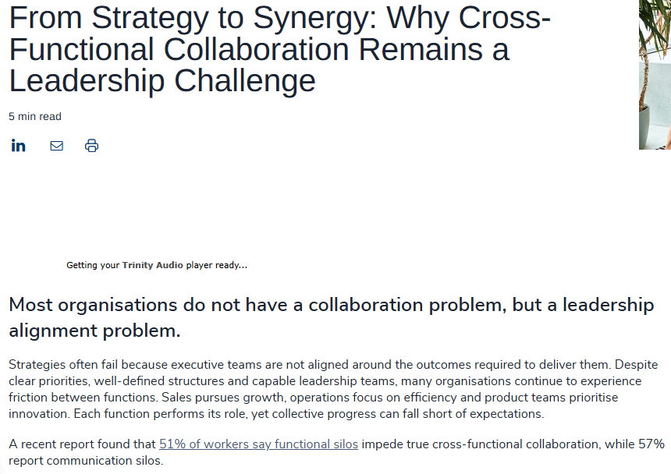
Figure 1: Cross-Functional Collaboration
(Source: Cocivera et al., 2026)

A.2.2 Hybrid and flexible working
A structured hybrid working than full-time office attendance or complete remote working is appropriate for NHSX. The employees should be flexible for focused individual work. Collaboration can be used for activities which can benefit from real-time interactions. A 2025 CIPD research found that 74% of the UK organisation had hybrid working and 91% offered some types of flexible working (CIPD, 2025).
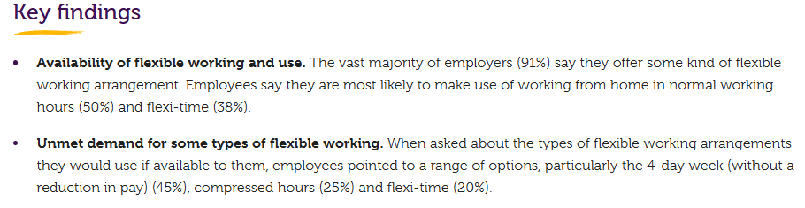
Figure 2: Majority of Employers offering flexible working
(Source: CIPD, 2025)
This research identified challenges for management effectiveness and unequal access to flexibility. NHSX should create team level agreements to cover collaboration, meeting expectations, response times, and occasions when physical presence is necessary. It is important for NHSX to implement shared project boards, recorded demonstrations, and documented decisions to reduce dependence on physical meetings and accommodate different time zones.

A.2.3 Employee autonomy
The manager should focus on establishing objectives, boundaries, and expected outcomes than autocratic approach of direction. The employee should have high control on their work procedures (Workwellbeinginitiative, 2024). It supports HPWS as the employee participation and involvement can help organisations to use specialist knowledge more effectively. It reflects that CIPD Focuses On highlighted the importance of empowering employees (CIPD, 2026). NHSX should remain strong governance for clinical safety, cyber-security, Artificial Intelligence, and data protection. Autonomy should be clearly established with boundaries then rather than unrestricted decision making.

A.2.4 Agile project teams
NHSX should create small empowered agile project teams having clear outcomes, iterative development, and regular reviews. The team should include relevant technical and healthcare expertise with authority to adapt solutions according to user feedback. It supports HPWS through empowerment and continuous learning. The STS ensures technology and team processes development develops together. Recent research by Krüger et al., (2025) with 127 agile teams found that team reflexivity and shared knowledge models positively attributed to agile team performance and team empowerment.

A.2.5 Digital collaboration
NHSX should develop an integrated digital collaboration system using the project management platforms, virtual meeting tools, AI-enabled research. It will support STS by aligning technology with employee communication and knowledge sharing requirements. HPWS encourage employees to share information for developing digital capabilities. The 2025 Microsoft Work Trend Index involving 31000 workers in 31 countries identified that 82% of the leaders observed 2025 as a pivotal year for operations with thinking and 81% expected AI agents to be integrated into their AI strategies in next 12-18 months (Microsoft, 2025).
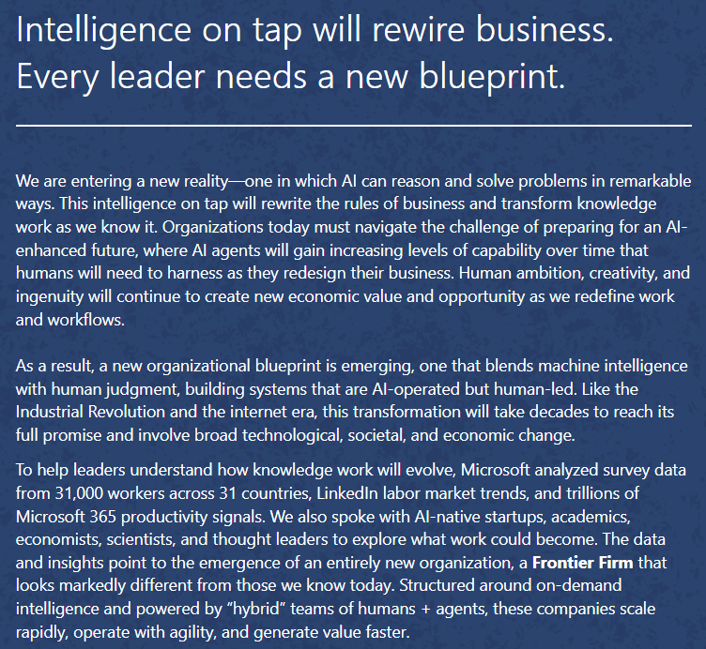
Figure 3: Microsoft Work Trend Index
(Source: Microsoft, 2025)

A.3. Expected Organisational Performance Benefits
The recommended strategies will allow NHSX to function better through a number of connected channels. Different teams can ease the obstacles between departments and promote innovation. A possible increase in autonomy could result in more efficient decision making, as employees closest to the issue would influence the outcome of the process to a greater extent. Hybrid work is also expected to help gain access to international talents while being able to establish cooperation with them (Summerfield, 2022). Technology applications can aid in reducing work duplication and keeping organisational knowledge.
In order to evaluate the success of the framework one needs measurable indicators, including, but not limited to innovation cycle time, number of experiments conducted, employee engagement, voluntary turnover, promotion levels, learning participation level, performance on cross-functional projects and wellbeing of the employees (Juniartie, 2025). These indicators comply with the requirements of the CIPD and the practice of performance evaluation.

Task B: Breeding an Environment Where Talent May Grow

B.1 Strategic Talent Management and Career Development
Talent management is crucial for the NHSX and to manage talent efficiently it is important for the in NHSX to consider recruitment, performance management, rewards, employee development, and succession planning as interconnected functions. This strategy is important for a narrow high potential employee model mainly because of the requirement within NHSX. The organisation needs specialist expertise, hybrid capabilities, and leadership abilities. It is important to combine this approach with build, buy, borrow, and bind strategy. AI and cyber-security skills shortage is prominent within the labour market (Poremba, 2025).
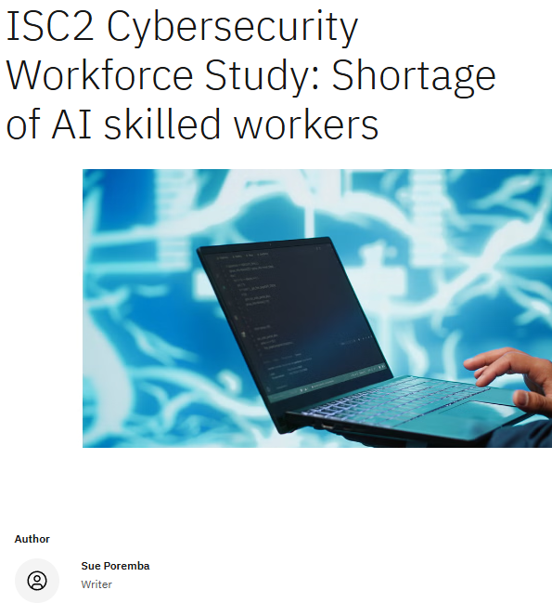
Figure 4: Shortage of AI skilled workers
(Source: Poremba, 2025)
Therefore, external recruitment is necessary but innovation capability, leadership, and organisation specific skills are more important for internal development.
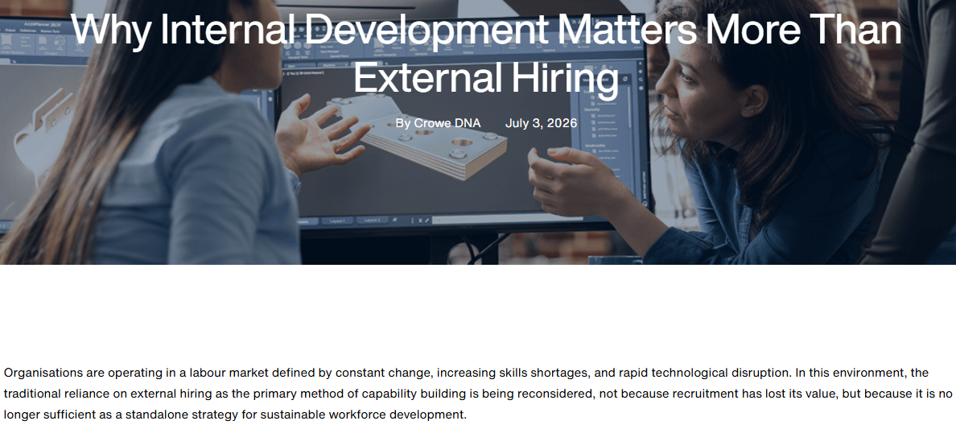
Figure 5: Importance of Internal Development
(Source: Crowe DNA, 2026)
With this approach the organization can minimise high reliance on external recruitment and protect company specific knowledge of NHSX.
Career development needs to be prioritized because according to workplace learning report 49% of learning and development professionals reported issues that employees do not have the necessary skills required for executing business strategy. Moreover, 36% of organisations can be marked as efficient in career development with effective career initiatives (Karnis, 2025).
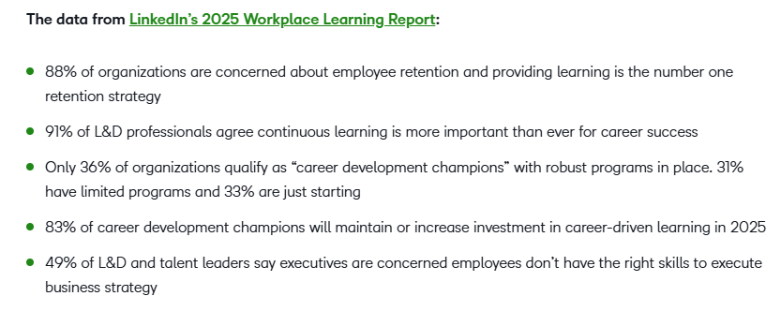
Figure 6: Workplace Learning Report
(Source: Karnis, 2025)
Therefore, it is important for NHSX to implement individual development plans, career pathways, and mentoring, internal vacancies, opportunities for Lateral movement between engineering, commercial, product, and clinical functions.

B.2 Creating an Environment Where Talent Flourishes

B.2.1 The Learning Organisation theory
The Learning Organisation Theory (Uvhagen et al., 2024) is important for NHSX. It is important for learning organization to develop its capacity in order to ensure its future growth through shared learning and knowledge. This is relevant for NHSX due to the fact that employees are required to continuously update their knowledge because of rapid technological change. The healthcare technology organisation should differentiate between training and development materials because training helps in developing job related skills but development focus is on future and support skills for higher level positions. However it is important for NHSX to ensure employees have opportunities to cross functional boundaries, share expertise, and build shared understanding and purpose (CIPD, 2022). Hence, the organisation needs to make learning part of everyday work instead of considering it as an occasional human resource intervention.

B.2.2 Dweck's Growth Mind-set theory
Growth Mind-set Theory (Kaufman, 2023) also supports this approaches because this encourages employees consider that skill can be developed with the help of effort, learning, and feedback. This is crucial for NHSX as a technology intensive organisation because within this type of organizations skills can rapidly become outdated. According to the World Economic Forum’s Future of Job Report 39% of existing skills of workers are projected to be transformed or become outdated by 2030 (World Economic Forum, 2026).
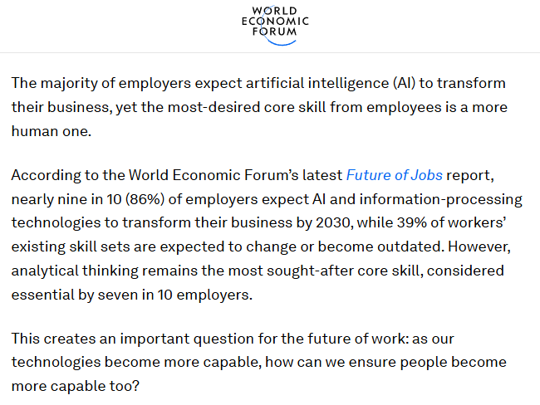
Figure 7: Future of Jobs Report
(Source: World Economic Forum, 2026)
On the other hand, 50% of workers having completing training and it became integral part of long-term learning strategies of organisations (World Economic Forum, 2025). Therefore, NHSX needs to acknowledge and reward learning behaviour, improvement, and experimentation instead of focusing only on immediate performance

B.2.3 Edmondson's psychological safety concept
It is important for organisations to ensure that to develop growth mindset unlimited responsibility for development should not be forced on employees. They need time, resources, and also managerial support. This directly aligns with Edmondson's Psychological Safety Concept (Baskin, 2023) which highlights that employees should feel able to challenge existing practices, ask questions, and admit mistakes without any kind of fear related to interpersonal consequences. This is crucial for a healthcare technology like NHSX because within the organisation experimentation is important with clinical safety, cybersecurity, and data protection. Therefore, NHSX needs to focus on differentiating between safe learning from failure and mistakes that can directly breach regulatory controls established clinical system.

B.3 Develop a comprehensive talent growth strategy for NexSpace Health Systems.
NexSpace Health Systems (NHSX) should adopt a talent growth strategy, which integrates attraction, development, career progression, engagement, wellbeing and retention. This should not stop at the conventional training and knowledge, but it has to shift to continuous learning, internal mobility and knowledge sharing. The plan should focus on building scale for NHSX's regional workforce of around 600 staff members and the acquisition of expertise in artificial intelligence, cyber security, health technology, data science and leadership.
The first step of implementing a talent framework based on skills is to identify current and future skill needs for each position. The next step for individual development plans is then to formulate learning objectives and competency gaps/ career pathways (Liu et al., 2025). It is significant given only 11% of any business with 10 or more employees have a greater than half of their workforce be training on “AI-related” technologies, per the UK Office for National Statistics in June 2026 (Office for National Statistics, 2026). It is therefore recommended that NHSX should deliver formal learning and development and mentoring, peer learning and development through projects in structured AI, cybersecurity, clinical-safety and data-governance.
Career development should include both technical and managerial and cross-functional tracks so that employees can further develop without having to necessarily step into a management role (Beretu and Charles, 2026). Link engineering, clinical, product, and commercial and data teams through internal vacancies, job rotations & mentoring. That's would be a good aid for Senge's Learning Organisation theory, as learning takes privilege of everyday work and a good aid to employee retention.
Also, NHSX should follow build, buy, borrow and bind approach. While know-how and knowledge within the Organisation should be built up in as far as possible internally, specialist knowledge and skills that require criticality should preferably be hired from outside. This is consistent with the latest CIPD evidence: 48% of UK employers increased their efforts to develop talent in-house during 2026, while 44% reported that retention had become more difficult (CIPD, 2026).
Lastly, NHSX must make everything psychologically safe encouraging learning and responsible experimentation while ensuring the proper clinical, cybersecurity and data-protection practices are in place.

Task C: Reflective Report

Introduction
As a future professional in HRM, I understand that AI is important in enhancing workforce analysis, recruitment and strategic decision making. However, it is important to ensure human evaluation. Ethical problems, confidentiality, employee well-being, bias, and empathy should be considered during AI implementations. This following reflective study can identify areas for improvement and support continuous learning.

C.1 AI as a Strategic HRM Tool
Human Resource Management professionals can utilise artificial intelligence to make data driven decisions by using vast amounts of information regarding workforce. For example, they can understand training requirements, plan workforce effectively, and process employee engagement information. However, the output of the methods created by artificial intelligence may be incorrect and biased. Therefore, given the professional responsibility, the action of human resource management specialists should be based only on the analysis of the information received through machine processing data.

C.2 Reflective Analysis using Driscoll’s Model

C.2.1 What?
I have used AI in three situations throughout the module. Firstly, I have used AI in identifying relevant theories and structuring an HR assignment. This has helped me too enhance my organization as well as academic writing. Then I have used AI in developing ideas for development strategy of employee. This significantly helped me to consider mentoring, career pathways, and skill gaps. Finally I have used AI in enhancing clarity as well as the wording of my written work. This diversified use of AI highlights importance of AI in research, communication, end problem solving.

C.2.2 So What?
With the help of this experience I have improved by critical thinking, digital literacy skills and ability to communicate my ideas clearly. I understood that AI is important for generating several perspectives an initial planning. However I also understood that it is important to check AI generated information to strengthen professional judgment. I need to evaluate suggestions because AI may not understand organisational context, ethical consequences, or employee emotions clearly. Through this reflection I came to know that effective use of AI needs verification, independent thinking, and questioning instead of high dependence.

C.2.3 Now What?
In future I will use AI to support decisions but I will be responsible for final HR decisions. I will analyse important information with the help of academic and professional sources. I will also check for potential buyers and consider the importance of human impact of recommendations.

C.3 Personal Capability Development Plan
Development Area | Planned Action | Expected Outcome
AI Literacy | Complete AI and HR analytics training. | Improve confidence using AI.
Analytical Skills | Practise interpreting workforce data. | Strengthen analytical decision-making.
Communication | Seek feedback and join collaborative projects. | Improve communication and teamwork.
Ethical Decision-Making | Reflect on technology and employee-data ethics. | Develop responsible professional judgement.
Emotional Intelligence | Practise empathy, listening and self-awareness. | Build stronger workplace relationships.
Reflection | Maintain a learning log and review progress. | Identify development needs and support continuous improvement.

Conclusion
AI has the potential to make an impact on strategic HRM by enhancing analysis, planning and decision-making processes but the importance of human judgement should be considered. Reflective writing helped me realise the necessity to develop AI literacy, analytical abilities, communication skills, ethical responsibility, and emotional intelligence for responsible HR practices.

Reference List
Ajmal, M., Islam, A. and Khalid, S. (2025). A socio-technical systems perspective on organizational performance: Integrating soft systems methodology and high-performance work systems. Zenodo. [online] doi:10.5281/zenodo.18506373.
Baskin, K. (2023). Four steps to building the psychological safety that high-performing teams need. [online] Harvard Business School. Available at: https://www.library.hbs.edu/working-knowledge/four-steps-to-build-the-psychological-safety-that-high-performing-teams-need-today.
Beretu, T. and Charles, W.P. (2026) ‘Enterprising human resource management education: A credentialism study of graduate pathways in South Africa’, SA Journal of Human Resource Management, 24, p. 13. Available at: https://sajhrm.co.za/index.php/sajhrm/article/view/3608
CIPD (2022). CIPD | effective cross-functional collaboration in a changing world of work. [online] CIPD. Available at: https://www.cipd.org/en/knowledge/reports/cross-functional-collaboration/.
CIPD (2025). CIPD | flexible and hybrid working practices in 2023. [online] CIPD. Available at: https://www.cipd.org/en/knowledge/reports/flexible-hybrid-working/.
CIPD (2026) Almost half of employers are upskilling their workers in the wake of labour market and legislative challenges. 22 September. Available at: https://prod.cipd.org/en/about/press-releases/rtp-2026/
CIPD (2026). CIPD | focus on. [online] CIPD. Available at: https://www.cipd.org/en/views-and-insights/focus-on/.
Cocivera, T., Beaudan, E., Smith, L. and Vella, P. (2026). From strategy to synergy in cross-functional teams. [online] Odgers. Available at: https://www.odgers.com/en-us/insights/from-strategy-to-synergy-in-cross-functional-teams/.
Crowe DNA (2026). Why internal development matters more than external hiring. [online] Crowe. Available at: https://www.crowe.com/za/crowedna/insights/why-internal-development-matters-more-than-external-hiring.
Freudenberg, P. (2026). What are high-performance work systems (HPWS)? [online] Rostone Operating Partners. Available at: https://www.rostoneopex.com/blog/what-is-a-high-performance-work-system/.
Jeong, J., Lee, J. and Kim, B.-J. (2024). The relationship between high-performance work system and knowledge sharing behavior via perceived organizational support: The moderating role of coaching leadership. Current psychology. doi:10.1007/s12144-024-06051-z.
Juniartie, darma and Ardianto, H. (2025). Employee engagement and turnover intention: A quantitative analysis of workforce dynamics. ResearchGate, [online] pp.876–884. Available at: https://www.researchgate.net/publication/395647873_EMPLOYEE_ENGAGEMENT_AND_TURNOVER_INTENTION_A_QUANTITATIVE_ANALYSIS_OF_WORKFORCE_DYNAMICS.
Karnis, K. (2025). Employee training statistics and trends to know in 2026. [online] D2L. Available at: https://www.d2l.com/blog/employee-training-statistics/.
Kaufman, S.B. (2023). Growth mindset theory: What’s the actual evidence? [online] www.beautifulminds-newsletter.com. Available at: https://www.beautifulminds-newsletter.com/p/growth-mindset-theory-whats-the-actual.
Krüger, F., Georganta, E., Stein, M. and Lehmann-Willenbrock, N. (2025). Conceptualizing agile teams and investigating relations between team processes and emergent states and agile team performance. Team Performance Management: An International Journal, [online] 31(7–8), pp.436–479. doi:10.1108/tpm-12-2024-0141.
Leeds University Business School (2025). Socio-technical systems theory. [online] business.leeds.ac.uk. Available at: https://business.leeds.ac.uk/research-stc/doc/socio-technical-systems-theory.
Liu, O.L., Liu, L., Sherer, D. and LeMahieu, P.G. (2025) ‘A skills-based vision for assessment, insight, and educational improvement’, in Handbook for Assessment in the Service of Learning, 3. Available at: https://www.pt.ets.org/pdfs/insights-and-perspectives/assessment-for-learning-handbook.pdf
Microsoft (2025). 2025: The year the frontier firm is born. [online] Microsoft.com. Available at: https://www.microsoft.com/en-us/worklab/work-trend-index/2025-the-year-the-frontier-firm-is-born.
Office for National Statistics (2026) Artificial intelligence in UK businesses: 2023 to 2026. Available at: https://www.ons.gov.uk/businessindustryandtrade/business/businessservices/articles/artificialintelligenceinukbusinesses/2023to2026
Poremba, S. (2025). ISC2 cybersecurity workforce study shortage AI skilled workers. [online] Ibm.com. Available at: https://www.ibm.com/think/insights/isc2-cybersecurity-workforce-study-shortage-ai-skilled-workers.
Summerfield, R. (2022). Hybrid working can help recruit and retain talent, UPSKILL leaders and boost team working, suggests a case study from an international professional services firm. Strategic HR Review, 21(1), pp.34–40. doi:10.1108/shr-11-2021-0060.
Uvhagen, H., Gärdegård, A. and Klinga, C. (2024). Through the lens of learning organization theory: Strategies used when introducing new work methods as described by practitioners and leaders in social services. Nordic social work research (Online), pp.1–17. doi:10.1080/2156857x.2024.2329945.
Workwellbeinginitiative (2024). Work design principle #1: Give employees more control over their work – work and well-being initiative. [online] Workwellbeinginitiative.org. Available at: https://workwellbeinginitiative.org/employer-toolkit/work-design-principle-1-give-employees-more-control-over-their-work/.
World Economic Forum (2025). The future of jobs report 2025. [online] World Economic Forum. Available at: https://www.weforum.org/publications/the-future-of-jobs-report-2025/in-full/3-skills-outlook/.
World Economic Forum (2026). With AI becoming more capable, here’s why people must too. [online] World Economic Forum. Available at: https://www.weforum.org/stories/jobs-and-the-future-of-work/ai-more-capable-people/.

