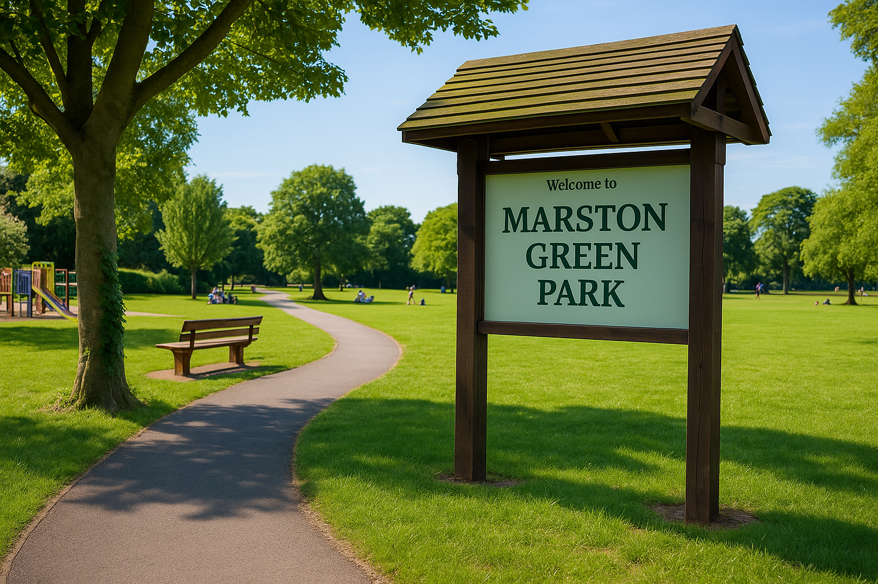
Stakeholder Engagement
UWTSD BIRMINGHAM
2312530
Hajar Takidine

Name: Hajar Takidine
Student number: 2312530
Module Code: LCBB4013
Module Title: Stakeholder Engagement
Assignment Title: Component 1:
Coursework-Portfolio (4 elements)
University of Wales Trinity Saint David, Birmingham

Table of Contents
Introduction 3
2. Application to Include Stakeholder Engagement Strategies 6
2.1 Why stakeholder analysis is essential 6
2.2 Power, Influence, and Interest Table 6
2.3 Stakeholder Mapping 7
2.4 Communication and Consultation Strategy 8
2.5 Limitations and Cautions of Stakeholder Mapping 9
2.6 Likelihood vs severity 10
3: Ethical Considerations in Consultation, Participation and Feedback 11
3.1Ethical collection and handling of data 12
3.2 Recognising and managing bias 12
3.3 Diversity, equity and inclusion 13
3.4 Using SMART commitments to avoid vague promises 13
3.5 How feedback will be collected, analysed and reviewed 14
4: Conclusion and Reflection 14
References 15

Introduction
The proposed project involves enhancing and expanding Marston Green Park, located in the village of Marston Green within the borough of Solihull, on the edge of Birmingham. The park already exists as a valued community space with children’s play facilities, sports courts, ponds, and natural areas (Solihull Metropolitan Borough Council, 2023). However, local consultations and council reports highlight demand for improved accessibility, expanded play and fitness equipment, better lighting, and new community spaces such as outdoor gyms and sheltered seating. The project aims to modernise the park, ensuring it remains a safe, inclusive, and sustainable space for current and future residents.
The relevance of this project stems from wider social and policy priorities. Public green spaces are vital for health and wellbeing, particularly in areas like North Solihull where health inequalities remain significant (NHS, 2019). Parks support physical activity, provide opportunities for social interaction, and promote mental health recovery (Public Health England, 2020). Enhancing Marston Green Park also aligns with Solihull Council’s “Green Spaces Strategy” and the UK Government’s commitment to local environmental sustainability and climate resilience (HM Government, 2023).
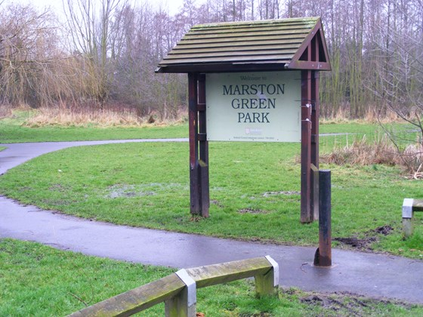

At least six key stakeholders will benefit from the enhancement project and are listed below, reflecting their power and interest:
- Local Residents: Families, young people, and older adults will benefit from upgraded play equipment, safer walking routes, outdoor fitness facilities, and community seating. Enhanced spaces also increase social cohesion and local pride.
- Solihull Metropolitan Borough Council; Gains by meeting its commitments on public health, green space management, and sustainability targets, while also demonstrating responsiveness to local needs.
- NHS and Public Health Bodies: The NHS and public health bodies will benefit indirectly from reduced demand for healthcare services as more residents use the park to support active lifestyles and mental well-being.
- Local Schools and Youth Organisations: Schools can access the improved park for outdoor learning, sports days, and educational visits, strengthening links between young people and nature.
- Community and Voluntary Groups: Local organisations, such as environmental charities and residents’ associations, gain new opportunities to host events, volunteer days, and activities that foster civic participation.
- Local Businesses: Shops and cafés in Marston Green benefit from increased footfall as visitors use nearby services before and after visiting the park. Contractors and suppliers may also benefit from construction and maintenance opportunities.
Additional stakeholders include environmental groups interested in biodiversity improvements, funding partners such as Sport England, and regional transport providers, who benefit from increased use of public transport links to the park.
Enhancing Marston Green Park offers direct health, social, economic, and environmental benefits. (Public Health England, 2020; Sport England, 2021) It ensures the park remains a safe, vibrant, and accessible public space at the heart of the community, while aligning with national and local priorities.
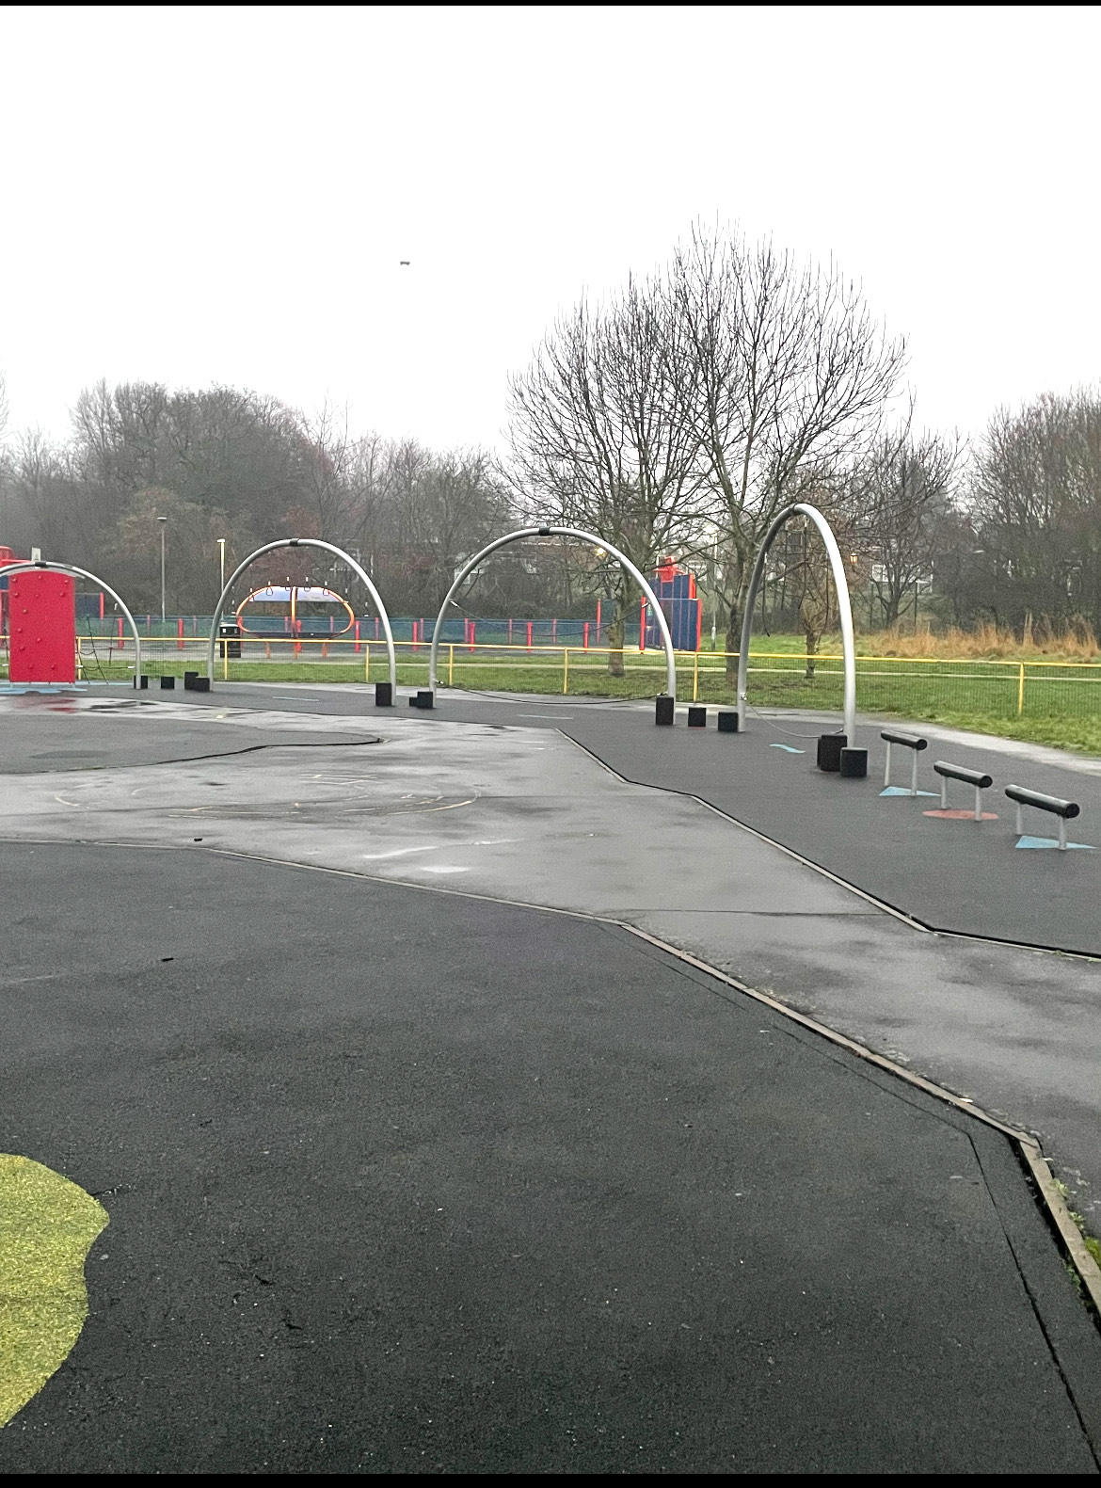
Figure 2: before picture taking with my phone
Figure 3: generated picture by ChatGPT

2. Application to Include Stakeholder Engagement Strategies
Effective stakeholder engagement is central to the success of any public infrastructure project. Stakeholders hold different degrees of power, influence, and interest, and these dynamics determine how the project should be communicated and managed. For the Marston Green Park Enhancement Project, the main goal is to ensure inclusivity, transparency, and genuine participation across all stages of planning and implementation.

2.1 Why stakeholder analysis is essential
Parks are shared spaces where diverse values intersect: leisure, health, environment, safety, and community identity. Each stakeholder group sees the park through a different lens, and these perspectives can sometimes conflict. For example, local families may seek more play equipment, while environmental groups may argue for increased green coverage. An organised stakeholder analysis helps identify these tensions early and ensures that decisions are informed by evidence and dialogue rather than assumptions. As Bryson (2018) notes, stakeholder mapping transforms complex relationships into manageable insight, supporting transparency and accountability.

2.2 Power, Influence, and Interest Table
Stakeholders were identified through three perspectives: functional (those who fund or operate the park), geographic (those living or working nearby), and thematic (those concerned with health, education, or the environment). Their position was then analysed using a power–influence–interest framework, as shown below.

Stakeholder Group | Power | Influence | Interest | Position/Notes
Solihull Metropolitan Borough Council | High | High | High | Key player – primary decision-maker and funder.
Local Residents (families, older adults, youth) | Low | Medium | High | High users - must be kept informed.
NHS & Public Health Bodies | High | Medium | High | Key player – link to health outcomes.
Schools and Youth Organisations | Low | Low | Medium | Use the space; limited influence but important long-term beneficiaries.
Community & Voluntary Groups | Low | Medium | Medium | Influence public opinion; should be engaged regularly.
Local Businesses & Suppliers | Medium | Medium | High | Beneficiaries of footfall and procurement need to be satisfied.
Environmental Groups | Medium | Medium | High | Key to ensuring sustainability and biodiversity.
Funding Partners (e.g., Sport England) | High | High | High | Key player – provide essential funding and monitoring.
Transport Providers | Medium | Low | Medium | Important for accessibility; less engaged otherwise.

2.3 Stakeholder Mapping
Using Mendelow’s power interest matrix, three broad clusters emerge.
High-power, high-interest actors such as the Council, Sport England, and NHS bodies are key players; they must be involved throughout. High-power, lower-interest actors like environmental groups and local businesses should be kept satisfied, ensuring they remain supportive but not overwhelmed. Low-power, high-interest groups, residents, schools, and voluntary organisations should be kept informed and consulted, as their legitimacy and local knowledge are vital to long-term success. The map clarifies engagement priorities but also underlines that stakeholder positions are dynamic and must be revisited as the project evolves (Reed et al., 2009).
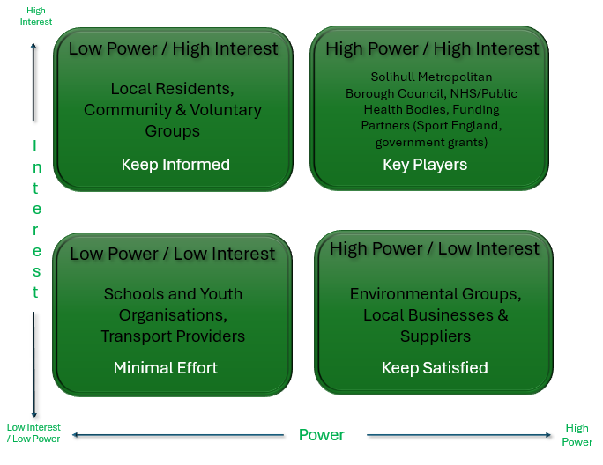

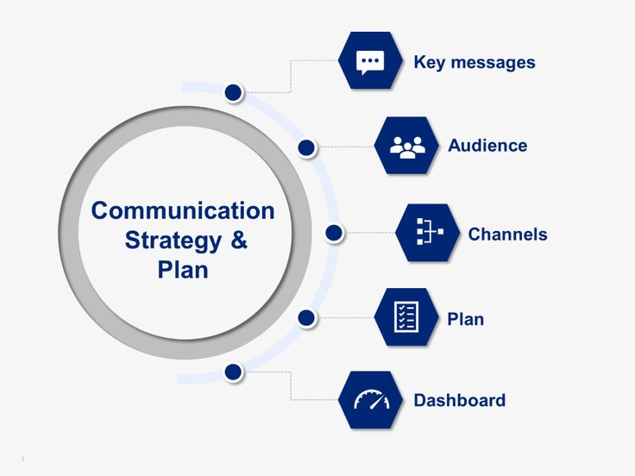
2.4 Communication and Consultation Strategy
Engagement methods vary according to each group’s role and capacity. For the Council, monthly steering meetings and structured reports will sustain political oversight and align the project with Solihull’s green space and health strategies. Clear documentation ensures accountability and minimises the risk of political disagreement or budget delay.
Local residents are the main users, and their acceptance determines success. Quarterly consultations, including surveys, drop-in sessions at the library, and community meetings, will provide space for feedback. Transparent communication channels such as newsletters, social media updates, and park noticeboards will maintain trust and ownership. Open dialogue prevents misinformation and supports co-creation of ideas (Rowe and Frewer, 2005).
NHS and public health partners will engage through workshops and health impact assessments to guarantee alignment with the NHS Long Term Plan priorities on preventative health (NHS, 2019). This partnership strengthens the health justification for the park and can unlock co-funding for active-living programmes.
Schools and youth organisations will be involved through curriculum-linked activities and student panels, fostering early awareness of environmental responsibility. Although their formal power is limited, early engagement ensures that young people see the park as a safe, inclusive space.
Community and voluntary groups such as residents’ associations or charities, will contribute through bi-monthly forums and co-design workshops. Their established local networks enable the project to reach seldom-heard voices, helping ensure diversity, equity, and inclusion (EHRC, 2020).
Local businesses and suppliers require information on procurement and opportunities. Briefings tied to project milestones will promote fairness and demonstrate local economic value. Meanwhile, environmental groups will be consulted at design and construction stages through biodiversity workshops and sustainability reviews, ensuring compliance with environmental policy and avoiding late objections.
Funding partners such as Sport England will receive quarterly progress reports and evaluation data. Their continued support depends on evidence of measurable outcomes, including accessibility, participation, and sustainability indicators (Sport England, 2021). Finally, transport providers will be engaged during the planning and post-implementation phases to improve routes and signage, encouraging sustainable travel and access for non-drivers.
This structured approach supports four key outcomes:
- transparency, so all participants understand decisions.
- inclusivity, ensuring translation, disability access, and digital as well as face-to-face options;
- accountability, through clear reporting to funders and council members
- collaboration, where residents, schools, and voluntary groups shape tangible outcomes.
Consistent communication helps prevent conflict and builds long-term trust between public institutions and citizens (Reed et al., 2009).

2.5 Limitations and Cautions of Stakeholder Mapping
Despite its usefulness, the power–interest matrix has clear limits. First, it oversimplifies complex relationships. Reducing diverse motivations to two dimensions risks ignoring interdependence between actors (Bryson, 2018). For instance, a group of residents may initially seem low-power but could gain significant influence through social media mobilisation.
Second, stakeholder positions are fluid. Power and interest can change as the project moves from design to construction. A funding partner may withdraw, or an environmental issue may raise public concern, shifting influence rapidly (Reed et al., 2009). The matrix should therefore be reviewed at each project milestone.
Third, subjectivity and bias inevitably affect categorisation. Project managers’ perceptions can undervalue marginalised or quieter groups. To counter this, multiple staff members should assess stakeholder placement, and findings should be validated through public feedback (Rowe and Frewer, 2005).
Fourth, there is a risk of exclusion. Focusing on high-power stakeholders may sideline groups such as elderly residents, people with disabilities, or those with limited English proficiency. Ethical use of the matrix requires deliberate inclusion measures, in line with the Equality and Human Rights Commission’s guidance on diversity and equity (EHRC, 2020).
Finally, stakeholder influence can change suddenly. Environmental organisations, for example, may shift from moderate to high interest if habitat loss becomes visible. Engagement plans must therefore remain flexible. The matrix should be treated as a living document, not a static map, and should be complemented by qualitative tools such as interviews and focus groups to capture nuance.
The overall caution is that analytical tools are only as effective as the ethics and reflexivity of those who apply them. Over-reliance on technical mapping may give a false sense of control, whereas authentic engagement accepts uncertainty and negotiation. Combining quantitative mapping with narrative understanding respects both evidence and empathy. As Reed et al. (2009) argue, participatory approaches improve not just project outcomes but also governance quality. Therefore, the Marston Green Park project should use these frameworks as guides to conversation, not barriers to it.

2.6 Likelihood vs severity
Risk assessment is an essential part of project governance, helping to identify and prioritise potential issues that could affect cost, schedule, quality, or stakeholder confidence. The likelihood vs severity matrix provides a structured way to assess risks by considering both the probability of occurrence (likelihood) and the potential impact (severity). This method supports transparent decision-making and allows resources to be focused on the most significant threats (HM Government, 2023).
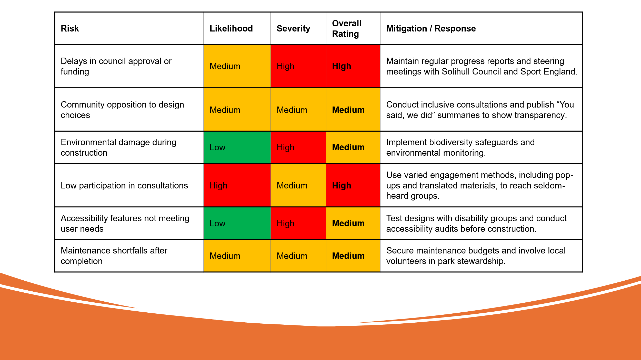
Figure X: Likelihood vs Severity Risk Matrix applied to the Marston Green Park Enhancement Project
The matrix highlights that the most significant risks relate to potential funding delays and low community participation, both of which could affect delivery and stakeholder confidence. Medium-level risks, such as maintenance capacity and accessibility concerns, require continued management and review. Lower-likelihood but high-impact risks, such as environmental damage, will be monitored through regular audits and partnership working with environmental bodies. Reviewing this matrix at each project stage ensures that emerging risks are captured early and mitigation measures remain effective (Bryson, 2018; Reed et al., 2009).

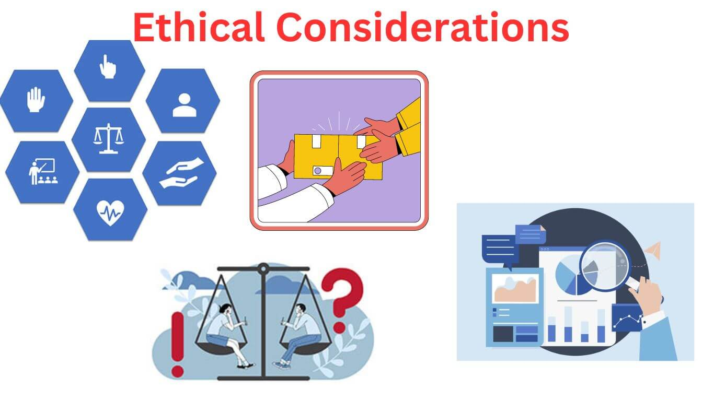
3: Ethical Considerations in Consultation, Participation and Feedback
This project uses a mixed-method consultation plan, so participation is easy, fair, and useful. Methods combine breadth and depth: an online and paper survey for reach, small co-design workshops for deliberation, pop-up intercept interviews in and around the park to include non-digital residents, and targeted sessions with seldom-heard groups such as disabled residents, carers, older adults and families with English as an additional language. Using several methods is not cosmetic variety. It is triangulation, which improves validity by checking findings across different data sources, methods, analysts and, where possible, theories (Denzin, 1978; Bryman, 2016). For example, priorities emerging from workshops will be tested against survey results and intercept interviews. If all three point to lighting and safe paths as top concerns, confidence in that priority is higher than if it appears in one channel only.

3.1Ethical collection and handling of data
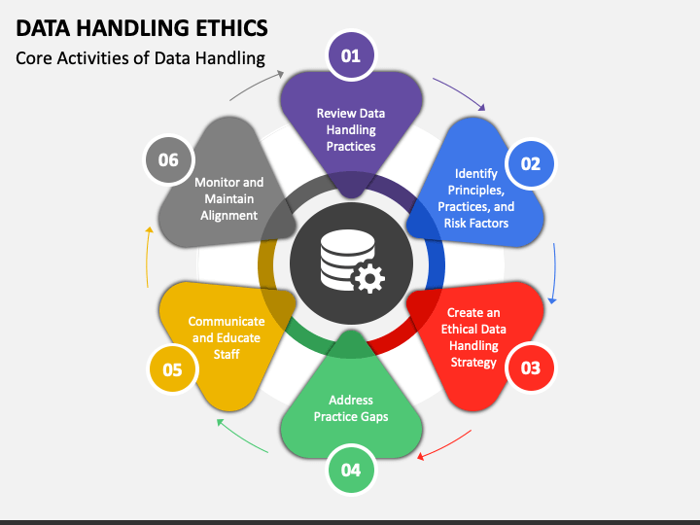
Participation will be voluntary and informed. Every touchpoint provides a plain-English information sheet that explains purpose, what will happen to data, risks and benefits, storage, retention and rights to withdraw. Consent is recorded for adults and via appropriate parental consent for children. Personal data is minimised and stored securely, with access controls and time-limited retention in line with GDPR principles of lawfulness, fairness, transparency and data minimisation (ICO, 2021). Anonymisation will be applied before analysis. Quotes used in reports will remove identifiers and any details that could reveal identity in a small community.
There is a trade-off between transparency and privacy. Publishing raw comments may aid accountability, but can compromise confidentiality. The ethical response is to publish a coded dataset and a transparent method note rather than an identifiable raw text. Complaints and withdrawal routes are stated clearly in all materials. Safeguarding procedures apply where children and vulnerable adults participate, with DBS-checked facilitators present at relevant sessions.

3.2 Recognising and managing bias
Bias can creep in at sampling, facilitation and analysis stages. Sampling bias is likely if engagement relies on online channels and weekday meetings. To counter this, the plan uses evening and weekend sessions, pop-ups at schools, GP surgeries and the station, translated materials and a phone line for those who prefer to contribute verbally. Social desirability bias can distort group discussions if confident voices dominate. Workshops will use small tables, turn-taking, visual prompts and anonymous dot-voting to reduce dominance. Confirmation bias is tackled through investigator triangulation. At least two analysts will independently code qualitative data before reconciling differences, and contradictory findings will be reported rather than smoothed over (Bryman, 2016).
Method bias is considered too. Surveys capture breadth but miss nuance, while workshops capture nuance but risk unrepresentative samples. The design, therefore, pairs methods and checks for convergence or divergence across them. Where findings diverge, reasons will be explored explicitly rather than forced into consensus. For example, if older adults prioritise benches and toilets while teens want a skate feature, both needs will be represented in the options appraisal and costed transparently.

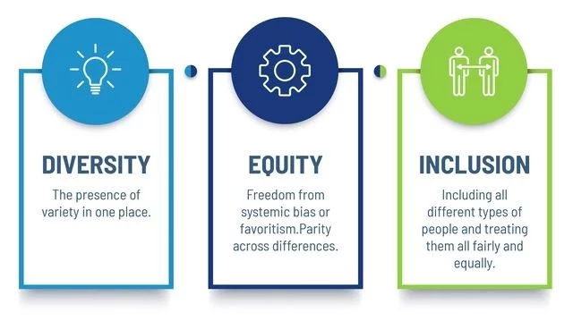
3.3 Diversity, equity and inclusion
DEI is treated as a core quality, not an add-on. The Equality Act duties require fair access and due regard to protected characteristics (EHRC, 2020). Practical steps include accessible venues, ramped and step-free access, BSL interpreters when requested, large-print and translated materials, and targeted outreach through community leaders. A small budget is reserved for childcare, travel vouchers and carers’ expenses to remove participation barriers. Monitoring forms will collect optional demographic data so we can compare participation with ward profiles. If gaps appear, corrective outreach follows.
DEI also shapes the end product. Co-design sessions will test layouts for wheelchair manoeuvring, resting points, sensory play, and lighting that improves safety without harming biodiversity. The NHS Long Term Plan emphasis on prevention supports investment in features that enable low-cost daily activity for those least likely to pay for private facilities (NHS, 2019). Ethical engagement means designing for those with the least voice as well as the loudest.

3.4 Using SMART commitments to avoid vague promises
To keep promises testable, the engagement plan adopts SMART targets: Specific, Measurable, Achievable, Relevant and Time-bound (Doran, 1981). Examples:
- Specific and measurable: at least 400 resident survey responses, with participation rates within ±10% of ward demographics on age and ethnicity.
- Achievable and relevant: run six co-design workshops, including at least two focused on accessibility and older adults, and one youth panel.
- Time-bound: publish a “You said, we did” summary within 20 working days after each engagement phase, listing decisions made, deferred and rejected, with reasons.
- Outcome tracking: within six months of opening, report user counts at three times of day and satisfaction scores from a follow-up survey.
SMART targets do not guarantee fairness, but they create auditable anchors. Failure triggers a remedial plan, for instance, an extra engagement round for groups that were underrepresented.

3.5 How feedback will be collected, analysed and reviewed
All channels feed a single evidence base. Quantitative data from surveys is analysed descriptively and, where helpful, cross-tabulated by demographic group to spot inequities. Qualitative data from workshops and open responses is coded thematically using a transparent codebook. A short methods appendix will describe coding steps and inter-coder checks so the approach is reproducible (Bryman, 2016). Triangulation is then applied: convergent themes are prioritised; divergent themes are presented as design choices with pros, cons and cost implications.
Decision rules are published in advance. Features with strong support that pass safety, equality and budget tests move forward. Where trade-offs are required, criteria are applied in order: safety, inclusion, lifecycle cost, and net environmental gain. Each phase ends with a “You said, we did” log that maps input to outcomes and explains rejections clearly. Funding partners receive the same pack with added metrics that align to grant conditions on participation, accessibility and safeguarding (Sport England, 2021). An issue log captures complaints and how they were resolved. After opening, a twelve-month review will compare promised outcomes with actual use, and lessons learned will be published.
Two tensions need open acknowledgement. First, inclusivity takes time and money. The ethical case is strong, but there is still an opportunity cost. Publishing costs, timelines and the value gained from better decisions help justify the investment. Second, transparency can collide with privacy. The correct path is to publish methods, codebooks and aggregated results rather than identifiable raw data. Ultimately, ethical consultation is less about perfect consensus and more about fair process, evidence-led trade-offs, and clear reasoning that people can respect even when they disagree (Rowe and Frewer, 2005).

4: Conclusion and Reflection
The enhancement of Marston Green Park shows that a public project succeeds only when it understands and responds to the people it serves. The technical elements of the design (paths, lighting, play equipment and planting) can only meet their purpose if they reflect the needs, concerns and hopes of the community. Stakeholder engagement provides this link. It reveals priorities, exposes possible risks early and creates a transparent process that people can trust. Research supports this approach, as projects that build structured engagement into their planning often face fewer disputes and deliver outcomes that are better used and valued (Bryson, 2018; Rowe and Frewer, 2005; Reed et al., 2009).
My lessons throughout the module helped me understand why this is the case. I learned how different groups hold different forms of power and influence, and why mapping these relationships helps set realistic expectations. I also learned the importance of reflective practice, evidence-based planning and clear communication. These ideas guided the choices made in this portfolio, such as using mixed consultation methods, testing assumptions through triangulation and setting clear objectives for participation. The lessons also emphasised quality standards, ethics and the need to plan for inclusion from the start. This helped me recognise that good engagement is not only about gathering opinions but about designing a fair and accessible process.
A key conclusion from the project is that engagement quality directly shapes project quality. Listening to a wide range of residents, including quieter or seldom-heard groups, improves the design and reduces the risk of late conflict. Tools such as the power–interest matrix were useful for identifying priorities, but I learned that such tools need to be reviewed as the project develops, because community views and political pressures can shift.
Another important point is that equity must be intentional. Translation, step-free venues, childcare support and clear communication give more people a chance to take part. “You said, we did” summaries help build trust by showing how feedback influenced decisions, even when not every suggestion can be taken forward.
Reflecting on my own development, I gained a clearer understanding of how engagement should be sequenced and how facilitation style affects participation. Approaches such as small-table discussions and anonymous voting made contributions more balanced and meaningful. I also learned the value of transparent analysis, where evidence is recorded and explained rather than simplified.
Finally, engagement should continue after the park opens. Ongoing feedback, simple in-park tools and open data on usage can support long-term sustainability. Overall, this project strengthened my belief that effective engagement is essential for project success and for building places that communities feel connected to and proud of.

References
- HM Government (2023) Net Zero Strategy: Build Back Greener. London: The Stationery Office.
- NHS (2019) The NHS Long Term Plan. London: NHS England.
- Public Health England (2020) Improving Access to Greenspace. London: PHE.
- Solihull Metropolitan Borough Council (2023) Marston Green Park. Available at: https://www.solihull.gov.uk/parks-and-open-spaces/marston-green-park (Accessed: 28 September 2025).
- Bryson, J.M. (2018) Strategic Planning for Public and Nonprofit Organizations. 5th edn. Hoboken: Wiley.
- Reed, M.S., Graves, A., Dandy, N., Posthumus, H., Hubacek, K., Morris, J., Prell, C., Quinn, C.H. and Stringer, L.C. (2009) ‘Who’s in and why? A typology of stakeholder analysis methods for natural resource management’, Journal of Environmental Management, 90(5), pp. 1933–1949.
- Rowe, G. and Frewer, L.J. (2005) ‘A typology of public engagement mechanisms’, Science, Technology & Human Values, 30(2), pp. 251–290.
- Solihull Metropolitan Borough Council (2023) Marston Green Park. Available at: https://www.solihull.gov.uk/parks-and-open-spaces/marston-green-park (Accessed: 28 September 2025
- Bryson, J.M. (2018) Strategic Planning for Public and Nonprofit Organizations. 5th edn. Hoboken: Wiley.
- Equality and Human Rights Commission (EHRC) (2020) Public Sector Equality Duty. London: EHRC.
- NHS (2019) The NHS Long Term Plan. London: NHS England.
- Reed, M.S. et al. (2009) ‘Who’s in and why? A typology of stakeholder analysis methods for natural resource management’, Journal of Environmental Management, 90(5), pp. 1933–1949.
- Sport England (2021) Uniting the Movement: A 10-Year Vision for an Active Nation. London: Sport England.
- Bryman, A. (2016) Social Research Methods. 5th edn. Oxford: Oxford University Press.
- Denzin, N.K. (1978) The Research Act. 2nd edn. New York: McGraw-Hill.
- Doran, G.T. (1981) ‘There’s a S.M.A.R.T. way to write management’s goals and objectives’, Management Review, 70(11), pp. 35–36.
- EHRC (2020) Public Sector Equality Duty. London: Equality and Human Rights Commission.
- ICO (2021) Guide to the General Data Protection Regulation (GDPR). Wilmslow: Information Commissioner’s Office.

