
DISSERTATION LCBB6000
TO EXAMINE THE IMPACT OF DIGITAL MARKETING ON BRAND AWARENESS IN FASHION INDUSTRY IN THE UK.

STUDENT NAME: AMNA MASAUD
STUDENT ID: 2113737
NAME OF THE UNIVERSITY: UNIVERSITY OF WALES TRINITY SAINT DAVID
SUBMISSION DATE: 1st OF SEPTEMBER 2024
SUPERVISOR: TUSHARA BALENDRAN

ABSTRACT

In recent years, the fashion industry in the United Kingdom has experienced a significant transformation due to the swift implementation of digital marketing strategies. This research seeks to investigate the influence of digital marketing on brand awareness in this rapidly evolving industry. As social media platforms, influencer marketing, and e-commerce continue to proliferate, brands are increasingly utilizing digital channels to interact with consumers and amplify their visibility. This study utilizes a mixed-methods methodology, integrating quantitative questionnaires and qualitative interviews to collect thorough insights from both consumers and industry professionals.
The quantitative analysis emphasizes evaluating the relationship between different digital marketing strategies—including social media advertising, email marketing, and search engine optimization—and the corresponding levels of consumer brand awareness. A survey will be conducted among fashion consumers in the United Kingdom to assess their brand recognition and the effectiveness of various digital marketing strategies.
Initial research indicates that digital marketing considerably boosts brand awareness, with social media platforms proving essential for fashion brands to engage with their target audiences. The research emphasizes the significance of authenticity and engagement within digital marketing, especially concerning influencer partnerships. Additionally, the study highlights possible obstacles, including market saturation and the imperative for brands to distinguish themselves within a densely competitive online environment.
This research enhances the current literature on digital marketing by offering empirical data on its efficacy within the fashion sector. It emphasizes the imperative for brands to implement novel and flexible digital marketing strategies in order to sustain and enhance their brand recognition in an increasingly competitive landscape. The findings ultimately seek to assist fashion marketers in enhancing their digital presence and cultivating stronger relationships with consumers, with the objective of increasing brand loyalty and boosting sales within the UK fashion market.

ACKNOWLEDGEMENT

I would like to express my deepest appreciation to everyone who has played a role in the successful completion of this project.
First and foremost, I would like to express my sincere gratitude to Tushara Balendran, my supervisor, for her invaluable advice, encouragement, and support during this project. Your expertise and viewpoint have greatly influenced my understanding and approach.
I would like to thank my peers and colleagues for their helpful criticism and cooperation, which have greatly improved the quality of my work. Your viewpoints
have introduced me to novel concepts and have inspired me to pursue excellence.
I want to express my sincere gratitude to my family for their unwavering encouragement and support during this project. Your belief in my potential has always been an inspiration to me.
Finally, I would like to express my gratitude to the University of Wales Trinity Saint David for the tools and assistance that have made my efforts in research and development much easier.
I want to thank each and every one of you for your support and contributions!

TABLE OF CONTENTS

TABLE OF FIGURES 5
1. INTRODUCTION 6
1.1. ABOUT BRAND AWARENESS AND DIGITAL MARKETING 6
1.2. PROBLEM STATEMENT 6
1.3. RATIONALE OF THE STUDY 7
1.4. AIM 7
1.5. OBJECTIVES 7
1.6. RESEARCH QUESTIONS 8
1.7. CHAPTER OVERVIEW 8
2. LITERATURE REVIEW 11
2.1. DIGITAL MARKETING 11
2.2. CRITICAL REVIEW OF THE LITERATURE 12
2.3. BRAND AWARENESS 12
2.4. CRITICAL REVIEW OF THE LITERATURE 13
2.5. RESEARCH OBJECTIVES 13
2.5.1. The current digital marketing strategies utilised in the fashion industry. 14
2.5.2. The opportunities and challenges of companies in the fashion industry implementing digital marketing strategies. 14
2.5.3. The impact of digital marketing strategies on brand awareness. 15
2.6. LITERATURE GAP 16
2.7. THE RACE FRAMEWORK 17
ADVANTAGES 17
DISADVANTAGES 18
2.8. KELLER’S BRAND EQUITY FRAMEWORK 18
ADVANTAGES 19
DISADVANTAGES 19
2.9. THE HONEYCOMB FRAMEWORK 20
ADVANTAGES 21
DISADVANTAGES 22
2.10. COMPARATIVE ANALYSIS 22
2.10.1. RACE VS HONEYCOMB 22
SIMMILARITIES 22
DIFFERENCES 23
2.10.2. KELLER VS AAKER 26
SIMMILARITIES 26
DIFFERENCES 28
3. METHODOLOGY 29
3.1. RESEARCH METHOD 29
3.2. RESEARCH ONION 30
3.2.1. PHILOSOPHY: POSITIVISM 30
3.2.2. RESEARCH APPROACH: DEDUCTIVE 31
3.2.3. RESEARCH STRATEGIES: SURVEY STRATEGY 31
3.2.4. TYPE OF INVESTIGATION 32
PRIMARY RESEARCH 32
SECONDARY RESEARCH 33
3.2.5. CHOICES 34
QUANTITATIVE RESEARCH 34
QUALITATIVE RESEARCH 34
MONO METHOD QUANTITATIVE 34
3.2.6. TIME HORIZONS: CROSS-SECTIONAL 35
3.2.7. DATA COLLECTION AND ANALYSIS 36
SAMPLING 36
3.2.8. DATA COLLECTION METHOD 37
3.2.9. ANALYSIS OF DATA 38
3.3. RESEARCH ETHICS 38
3.4. RELIABILITY AND VALIDITY OF THE DATA 38
4. DATA ANALYSIS 39
4.1. INTRODUCTION 39
4.2. SURVEY ANALYSIS 40
QUESTION 1 40
QUESTION 2 43
QUESTION 3 46
QUESTION 4 48
QUESTION 5 50
QUESTION 6 52
QUESTION 7 54
QUESTION 8 56
QUESTION 9 59
QUESTION 10 61
5. CONCLUSION 63
6. RECOMMENDATIONS 66
7. LIMITATIONS OF THE PRIMARY RESEARCH 67
8. FURTHER RESEARCH 68
9. REFERENCES 70
10. APPENDIX 78

FIGURE | NAME | PAGE NUMBER
FIGURE 1 | Chapter overview | 8
FIGURE 2 | The RACE Framework | 17
FIGURE 3 | Keller’s Brand Equity Framework | 19
FIGURE 4 | The Honeycomb Framework | 20
FIGURE 5 | Aaker’s Brand Equity Model | 26
FIGURE 6 | The research onion | 30
FIGURE 7 | Question’s 1 representations | 40
FIGURE 8 | Question’s 2 representations | 43
FIGURE 9 | Question’s 3 representations | 46
FIGURE 10 | Question’s 4 representations | 48
FIGURE 11 | Question’s 5 representations | 50
FIGURE 12 | Question’s 6 representations | 52
FIGURE 13 | Question’s 7 representations | 54
FIGURE 14 | Question’s 8 representations | 56
FIGURE 15 | Question’s 9 representations | 59
FIGURE 16 | Question’s 10 representations | 61

TABLE OF FIGURES

INTRODUCTION

ABOUT BRAND AWARENESS AND DIGITAL MARKETING
Authors specializing in marketing have emphasized the importance of digital marketing in increasing brand recognition. As an example, Smith & Jones (2019) highlighted the significance of digital marketing strategies in establishing brand visibility and expanding reach to a larger audience in the current competitive market landscape. Similarly, a recent study by Brown & Wilson (2020) found that companies who allocate resources towards digital marketing initiatives are more likely to see an increase in brand awareness and engagement with customers. The importance of using digital channels to increase brand awareness and strengthen customer relationships is emphasized by these discoveries.

PROBLEM STATEMENT
An in-depth examination of the relationship between digital marketing and brand awareness in the UK fashion industry is one area that has not received enough attention in the literature to date. While studies have been conducted regarding the general effects of digital marketing on brand recognition, there is a significant lack of research that focuses on the fashion industry in the United Kingdom. Understanding how digital marketing strategies affect brand awareness in this industry is crucial, considering its competitive landscape and rapidly evolving digital landscape.
Despite its growing significance, Smith (2018) highlights the lack of thorough research on the specific effects of digital marketing on brand visibility in the UK fashion industry. Researchers have a great chance to fill in this knowledge gap by looking deeper into the unique benefits and obstacles that digital marketing presents to fashion brands looking to increase their brand awareness. Furthermore, Jones & Brown (2020) stress that because social media and online platforms are becoming more and more common, the fashion industry is facing particular challenges when attempting to use digital marketing strategies to boost brand recognition. Analysing these barriers and identifying workable approaches for digital marketing tactics created especially for the UK fashion industry can provide insightful viewpoints for fashion brands looking to improve their market advantage.
Therefore, the lack of emphasis on the impact of digital marketing strategies on brand awareness in the UK fashion industry represents a research gap that necessitates further exploration in order to address this gap and enhance the current understanding in this field.

RATIONALE OF THE STUDY
The justification for investigating the influence of digital marketing on brand recognition within the fashion sector in the United Kingdom is rooted in the growing importance of digital platforms as primary means for connecting with and interacting with consumers. In the dynamic and fiercely competitive environment of the fashion industry, companies are continuously exploring strategies to enhance their presence and engage effectively with their intended customer base. Digital marketing provides various avenues to accomplish these objectives, including the utilization of social media campaigns, collaborating with influencers, and employing targeted advertising strategies. Studying the influence of digital marketing on brand recognition within the fashion sector can offer important perspectives on the efficiency of different strategies and techniques utilized by brands. By comprehending the impact of digital marketing strategies on brand recognition, organizations can effectively allocate their marketing funds and resources in order to improve the visibility and reach of their brand (Smith, 2019).
Recent research has emphasized the significance of digital marketing in influencing brand recognition within the fashion sector. For instance, Bhardwaj and Fairhurst (2019) conducted research highlighting the significance of social media in shaping consumer attitudes and expanding brand recognition. Furthermore, a study conducted by Roggeveen et all. in 2018, looked into the effects of influencer marketing on both brand awareness and consumer behaviour. Through the examination of the correlation between digital marketing tactics and brand recognition within the UK fashion sector, researchers have the opportunity to advance notions of optimal methodologies and principles for brands seeking to augment their presence in an ever-evolving digital landscape.

AIM
The main aim of this research is ‘To examine the impact of digital marketing on brand awareness in fashion industry in the UK.’

OBJECTIVES
Various objectives will be carefully considered throughout the course of the research:
- To investigate the current digital marketing strategies utilised in the fashion industry.
- To determine the opportunities and challenges of companies in the fashion industry implementing digital marketing strategies.
- To analyse the impact of digital marketing strategies on brand awareness.

RESEARCH QUESTIONS
There are specific research questions that can aid in maintaining focus and direction during the presented research study:
- What are the current digital marketing strategies utilised in the fashion industry?
- What are the opportunities and challenges of companies in the fashion industry implementing digital marketing strategies?
- What is the impact of digital marketing strategies on brand awareness?

  - CHAPTER OVERVIEW

Figure 1: Chapter overview (created by student)
Chapter 1: Introduction
The opening chapter of this dissertation provides a thorough groundwork for the research conducted, delineating the principal themes, objectives, and importance of the study. The research commences by setting the context, emphasizing the importance and immediacy of the issue within both the academic field and practical sphere. The chapter delineates the research problem and formulates pivotal questions that direct the investigation, highlighting deficiencies in the current literature and emphasizing the necessity for additional research.

The study's objectives are distinctly outlined, offering a clear roadmap for the research process and demonstrating how the results may advance the field. The chapter further elaborates on the theoretical framework that forms the foundation of the research, utilizing established theories and concepts to guide the analysis.
Chapter 2: Literature Review
The objective of this literature review is to integrate current research relevant to the themes explored within this dissertation, offering a thorough overview of the academic discussion pertaining to the subject matter. This chapter will critically analyse literature from diverse sources to identify gaps in the current knowledge base, elucidate methodological approaches, and develop a theoretical framework that supports the research. The review of literature has uncovered a complex array of studies, emphasizing both the progress made and the existing gaps in contemporary knowledge. This chapter aspires to make a substantive contribution to the discourse on the influence of digital marketing on brand awareness within the UK fashion industry by employing theoretical frameworks and addressing identified research gaps.
Chapter 3: Research Methodology
This chapter delineates the research methodology adopted in this dissertation, elaborating on the comprehensive research design, data collection techniques, and analytical approaches employed to tackle the research questions. The methodology is meticulously designed to guarantee the validity and reliability of the results, consistently upholding ethical standards throughout the course of the research. This chapter has comprehensively delineated the research methodology utilized in this dissertation, encompassing the approach methods, techniques for data collection and analysis, and ethical considerations. The selected methodologies are intended to establish a comprehensive framework for effectively addressing the research questions and to facilitate an in-depth understanding of the subject under examination.
Chapter 4: Data Analysis
This chapter provides an exhaustive analysis of the data gathered throughout the research process. The principal aim was to analyse the relationships and patterns observed within the dataset obtained from survey responses. The purpose of the analysis was to address the research questions presented in the introductory chapter and to confirm the proposed hypotheses.
The analyses within this chapter were meticulously executed with both rigor and transparency, strictly following established statistical methodologies. The potential limitations of the data and the analytical methods utilized have been examined, addressing how these elements may affect the interpretation of the results.

Chapter 5: Conclusion
The concluding chapter of this dissertation synthesizes the primary findings and derives insights from the research, reflecting on their implications within the broader context of the field. This research sought to explore particular inquiries, and the subsequent analysis has revealed the findings. The findings indicate that they not only enhance the current body of knowledge but also offer practical applications.
Furthermore, this chapter has highlighted the study's limitations, recognizing possible biases and constraints that could impact the generalizability of the results. The knowledge derived from this study enriches theoretical models and also provides a basis for practical implementations.
Chapter 6: Recommendations
This chapter consolidates the research findings and delineates a series of practical recommendations designed to tackle the primary issues identified in the study. The recommendations aim to improve practice, shape policy, and direct future research in the pertinent field. The suggestions outlined in this chapter aim to act as an exhaustive reference for practitioners, policymakers, and researchers. By methodically tackling the challenges delineated in this research, stakeholders can improve the overall efficacy and sustainability of practices within the domain. Adopting these recommendations will facilitate immediate advancements while establishing a foundation for sustained innovation and development.
Chapter 7: Limitations of the primary research
This chapter addresses several fundamental limitations of primary research that may impair the validity and reliability of the results. A primary limitation is the concern regarding the size of the sample. Small sample sizes can result in an inaccurate reflection of the larger population, thereby introducing potential biases and diminishing the generalizability of the findings (Creswell, 2014). Furthermore, the sampling method may introduce additional bias; for example, convenience sampling can produce a sample that is not representative (Saunders et al., 2016).
An additional significant limitation is the possibility of researcher bias. The viewpoints and anticipations of the researcher can unintentionally affect both the collection and analysis of data, especially in qualitative research where interpretation is significant (Maxwell, 2013). The dependence on self-reported data presents challenges, as participants might offer socially desirable responses instead of truthful ones, thereby jeopardizing the accuracy of the results.
Although primary research can yield significant insights, researchers must remain aware of its limitations, which may affect the overall quality and relevance of their findings.

Chapter 8: Further Research
This chapter outlines potential research directions emerging from the findings and limitations identified in this dissertation. The investigation into the topic has revealed numerous deficiencies in both the current literature and practical implementations, indicating that continued research may provide substantial advancements to the discipline. This section will delineate particular topics meriting further exploration, recommend methodological frameworks, and explicate the prospective impacts of subsequent research. The research journey is a perpetual and dynamic process. This chapter's identified gaps and proposed methodological frameworks underscore the necessity for continued research in this domain. Addressing these areas in future research can substantially enhance the existing body of knowledge, provide more informed practices, and impact policy-making decisions. Interdisciplinary collaboration and engagement with varied demographics will play a pivotal role in shaping the future trajectory of research.

LITERATURE REVIEW

DIGITAL MARKETING
Digital marketing refers to the strategic utilization of digital platforms, channels, and technologies to advertise brands, goods, and services to specific groups of consumers. This encompasses strategies like utilizing social media platforms for promotional purposes, optimizing visibility on search engines, creating valuable content for marketing purposes, communicating with customers via email, and leveraging online advertisements (Chaffey & Chadwick, 2019). An alternative interpretation of digital marketing pertains to the implementation of marketing strategies within digital platforms to enhance interaction with customers, facilitate lead generation, and attain organizational goals. This entails utilizing data analysis, customer perspectives, and user actions in order to develop customized and individualized marketing strategies (Smith & Zook, 2016). However, digital marketing is an ever-changing and dynamic industry that involves various strategies to attract and interact with customers through online platforms. The process entails combining diverse online approaches and plans to enhance brand recognition, attract visitors to a website, and ultimately convert potential customers into devoted clientele (Ryan & Jones, 2019).

CRITICAL REVIEW OF THE LITERATURE
Digital marketing is always changing, which makes it difficult to come up with one definition that covers everything it involves. Different experts have given various definitions, focusing on different parts of the subject. Two different explanations that highlight the differing views on digital marketing are the definitions given by Chaffey et al. (2020) and Smith & Zook (2011).
Chaffey et al. (2020) explains digital marketing as the utilization of digital tools, platforms, and channels for the purpose of advertising products and services to a specific audience. This definition places emphasis on the technical components of digital marketing, concentrating on the tactics and resources utilized to connect with and involve online consumers. On the contrary, Smith & Zook (2011) suggest an expanded interpretation, defining digital marketing as a strategy focused on customers that utilizes data and technology to generate customized interactions and establish enduring connections with clients. This definition places a strong emphasis on the importance of customer experience and cultivating relationships in the realm of digital marketing. The difference in these two definitions highlights the intricate nature of digital marketing, which requires a balance between technical expertise and customer focus. Chaffey et al. (2020), has shown us how crucial it is to make use of digital tools and platforms in a strategic manner, while according to Smith & Zook (2011) it is imperative to comprehend the needs and preferences of customers in order to establish meaningful interactions. In order to thrive in the field of digital marketing, companies need to find a harmony between utilizing technology to provide tailored interactions that connect with their specific demographic.
In conclusion, digital marketing is a complex field that necessitates a detailed strategy to address its diverse components effectively. By taking into account and incorporating various definitions, such as the ones outlined above, organizations have the opportunity to create thorough digital marketing plans that will successfully captivate customers and contribute to the expansion of their business.

BRAND AWARENESS
The degree to which a consumer recognizes a particular brand is known as brand awareness. Brand salience, according to Keller (1993), is a measurement of a brand's prominence in a consumer's mind when thinking about a specific good or service. Establishing a brand's worth and reputation requires creating and sustaining brand awareness. It influences how long -term customers perceive, select, and adhere to a brand. As per Kapferer (2012), branding plays a crucial role in influencing consumer decisions and upholding a company's reputation and legitimacy in the cutthroat industry. A few years later, Kotler and Armstrong (2021) proposed the theory that brand awareness is essential to the development and long-term viability of a successful brand. It is well known that creating brand value primarily depends on the initial stages of the customer decision-making process.

CRITICAL REVIEW OF THE LITERATURE
The concept of brand awareness plays a vital role in both marketing research and practice. However, there are various perspectives on how to define and assess it accurately. Researchers have put forward two distinct definitions of brand awareness which emphasize different aspects of consumer recognition and awareness.
According to Aaker (1991), brand awareness can be defined as the capacity of consumers to identify or remember a brand when given a brand identity. Due to this perspective, brand awareness is considered to be a cognitive process where consumers recall brand-related information that is stored in their memory. This definition emphasizes the importance of brand recall and recognition being strong and accurate, implying that brands with increased levels of awareness have a greater capacity to distinguish themselves in a competitive marketplace. In contrast, Keller (1993) presents a more comprehensive view of brand awareness that goes beyond mere recognition or recall of a brand to encompass consumers' familiarity and associations with the brand. As per Keller, brand awareness consists of brand recognition, brand recall, and the extent of understanding and connections that customers make with a brand. This explanation implies that brand awareness is not limited to simply recognizing a brand but includes the emotions and experiences that consumers associate with it.
The distinctions between these two interpretations emphasize the intricate nature of brand awareness as a concept, underscoring the requirement for marketers to consider various facets when assessing and analysing it. Aaker's definition highlights the significance of strong brand recall and recognition, whereas Keller's definition stresses the necessity of moving beyond mere recognition to evaluate the depth and complexity of consumer-brand connections. In conclusion, brand awareness is a complex idea that can be interpreted and quantified in various manners, contingent upon the aims and intentions of a marketing initiative. Marketers can enhance their comprehension of consumer perceptions and interactions with their brands by considering and integrating different aspects of brand awareness.

RESEARCH OBJECTIVES
In the dynamic landscape of digital marketing, companies often seek to enhance brand awareness through the implementation of strategic initiatives. Research objectives related to digital marketing and establishing brand awareness can encompass a wide range of topics, including analysing the impact of social media marketing on consumers' brand perceptions and evaluating the effectiveness of digital advertising campaigns in enhancing brand visibility. (Smith, 2019).

The current digital marketing strategies utilised in the fashion industry.
In the fashion industry, effective digital marketing tactics are essential for companies aiming to connect with customers, establish brand recognition, and increase revenue in a landscape marked by intense competition. Numerous digital marketing tactics have demonstrated their effectiveness within the realm of the fashion sector. Fashion brands often employ various strategies such as social media marketing, influencer collaborations, email advertising and search engine optimization (SEO) to improve their digital footprint and engage with their desired consumer base. Social media platforms offer fashion brands the chance to exhibit their products, interact with their audience, and advertise their brand values. The utilization of influencer marketing has gained traction within the fashion industry due to its capacity to expand reach to a broader demographic and establish genuine relationships with consumers. Email marketing enables fashion brands to engage in direct communication with their customer base, showcase new product releases, and effectively increase website traffic. Search engine optimization (SEO) is essential for fashion brands to achieve high rankings in search engine results, thus increasing visibility and drawing in organic website traffic (Smith, 2020).
Pham & Ho (2020), underscore the significance of utilizing social media marketing within the fashion sector, demonstrating the potential for brands to utilize platforms such as Instagram and Facebook for consumer interaction and sales growth. Additionally, Khajeheian & Nematollahi (2019) conducted a study investigating the efficacy of influencer marketing within the fashion sector. Their research underscores the potential benefits of partnering with influencers in enhancing brand recognition and driving sales.
To sum up, within the fashion industry, digital marketing strategies including social media marketing, influencer collaborations, email marketing, and search engine optimization have proven to be highly impactful in assisting brands in reaching their marketing goals and remaining competitive in the online market.

The opportunities and challenges of companies in the fashion industry implementing digital marketing strategies.
There is a notable shift occurring within the fashion industry as companies are increasingly embracing digital marketing tactics. This change brings about numerous potential advantages as well as specific obstacles that require examination.
An important advantage for firms operating in the fashion sector by using digital marketing tactics is the potential to access a broader and more internationally varied customer base. Digital platforms allow brands to interact with consumers instantly, tailor their marketing messages, and utilize data analysis to create precise marketing strategies. Davenport and Beck (2001), suggest that utilizing data-driven marketing strategies has the potential to enhance customer segmentation and strengthen customer relationships. Furthermore, digital marketing provides fashion companies with the opportunity to increase brand recognition and exposure via a range of digital platforms, including social media, search engines, and collaborations with influencers. According to Kotler & Armstrong (2018), businesses have the opportunity to engage and retain customers in a saturated market by producing high-quality content and implementing effective SEO strategies.
Nevertheless, fashion companies encounter significant obstacles when incorporating digital marketing strategies despite the numerous opportunities that may arise. One challenge that companies face in the realm of digital marketing is the rapid pace at which the industry evolves, necessitating continuous adjustment to keep up with shifting algorithms, trends, and consumer habits. Not staying updated with these developments can lead to a decline in competitive edge as stated by Chaffey & Smith (2013). In addition, the fashion industry faces intense competition in the realm of digital marketing, necessitating companies to distinguish their brand in a strategic manner. To thrive in a competitive online environment, one must possess originality, inventive thinking, and a comprehensive comprehension of consumer needs and wants (Hollensen, 2015). Fashion companies face considerable obstacles in collecting and analysing consumer data for personalized marketing campaigns, as concerns regarding data privacy and security are prevalent (Evans & McKee, 2010).
In conclusion, while digital marketing presents a multitude of opportunities for fashion companies to increase their market reach and effectively interact with consumers, it also poses challenges that necessitate careful deliberation and strategic preparation. Fashion companies can improve their brand visibility, increase sales, and establish strong customer relationships in today's digital era by overcoming challenges and utilizing the benefits of digital marketing.

The impact of digital marketing strategies on brand awareness.
Digital marketing tactics are essential for increasing brand recognition in today's competitive business environment. By employing diverse online platforms and resources, organizations have the opportunity to expand their reach to a broader demographic, interact with clients, and establish their brand identity. Numerous academic inquiries have explored the impacts of digital marketing on brand recognition, emphasizing the importance of employing successful tactics to enhance brand exposure and customer retention. A key manner in which digital marketing strategies influence brand recognition is by enhancing brand visibility on various online channels. Smith and Taylor (2020), argue that utilizing digital marketing strategies such as social media campaigns, search engine optimization, and content marketing can significantly enhance a brand's visibility and engage with a wider audience of potential customers. Through the development of engaging digital content and the utilization of focused advertising strategies, organizations have the ability to significantly enhance brand recognition within their desired demographic.
Moreover, the utilization of digital marketing techniques allows companies to cultivate a personalized relationship with their target audience, consequently enhancing brand loyalty and recognition. Li et al. (2018), emphasized that utilizing interactive digital campaigns, personalized email marketing strategies, and engaging social media interactions have the potential to cultivate a feeling of familiarity and trust among customers. By delivering personalized messages and content aligned with consumer preferences and behaviours, brands can effectively connect with their target audience on a profound level, resulting in increased brand visibility and support.
Furthermore, the metric tracking and data analysis features of digital marketing channels offer valuable information on the efficacy of initiatives aimed at raising awareness of a brand. According to Rios et al. (2019), companies can assess the effectiveness of their digital marketing strategies on brand visibility by monitoring important metrics such as website traffic, social media engagement, and conversion rates, allowing for adjustments to be made as needed. This methodological approach based on data enables organizations to make well-informed decisions and enhance their efforts aimed at increasing brand recognition, ultimately leading to improved outcomes.
To sum up, the utilization of digital marketing strategies plays a pivotal role in enhancing brand recognition through heightened visibility, promoting interactions with consumers, and offering valuable data for ongoing enhancements. In the ever-changing digital environment, it is crucial for businesses to deploy strategic and focused digital marketing initiatives in order to enhance brand visibility, cultivate customer loyalty, and stimulate expansion within a progressively competitive marketplace.

LITERATURE GAP
A limitation encountered in the analysis of digital marketing's influence on brand recognition within the UK's fashion sector leads to the difficulty in precisely assessing the efficacy of diverse digital marketing approaches in enhancing brand awareness. Digital marketing platforms provide a mix of data and analytical tools; however, interpreting these metrics to derive substantial insights on brand awareness can prove to be confusing and subjective. The direct relationship between digital marketing initiatives and enhancements in brand recognition can be challenging to consider in the absence of precise indicators and benchmarks. Leander & Lusensky (2014) highlighted a significant obstacle in the field of digital marketing known as the attribution problem. This issue pertains to the challenge of accurately determining the value of various touchpoints throughout the entirety of a customer's interaction with a brand. This is particularly significant when assessing the influence of digital marketing on brand recognition, as various elements outside of online platforms can shape consumer attitudes towards a brand.
Additionally, as emphasized by Thadani & Keh (2018), the ever-changing landscape of digital marketing trends and consumer behaviours introduces a further level of intricacy. The rapid development of digital platforms and shifting consumer preferences pose a significant challenge in accurately assessing the distinct impact of digital marketing on brand awareness in the long term.
To mitigate these limitations, it is advisable for researchers and professionals in the fashion sector to utilize a blend of quantitative and qualitative research methodologies, including surveys, focus groups, and analysis of social media sentiments. A more thorough comprehension of the effects of digital marketing on brand awareness can be attained by integrating data from various sources, enabling the formulation of more well-informed strategic choices.

THE RACE FRAMEWORK
The RACE Framework represents a theoretical structure that classifies digital marketing tactics based on four fundamental components: reaching target audience, prompting action, converting leads, and fostering ongoing engagement. Each component is indispensable in the development of a successful internet marketing plan. The RACE Framework is centred around a systematic method for analysing digital marketing strategies through the examination of four core components: reach, act, convert, and engage. Every component plays a crucial role in the development of a successful digital marketing plan, as illustrated in Figure 1 (Smith, 2020).
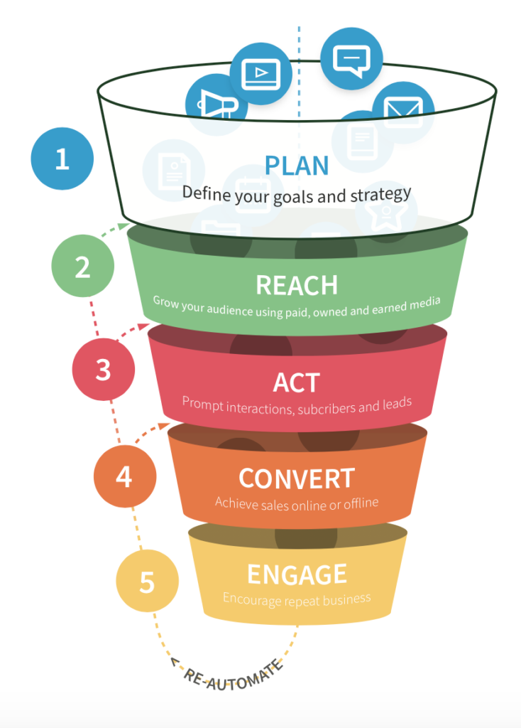

Figure 2: The RACE Framework (Chaffey, 2023)

ADVANTAGES
- The RACE model offers a methodical strategy for digital marketing by dividing
The process into distinct phases - Reach, Act, Convert, and Engage. This framework aids marketers in strategizing and executing their digital marketing initiatives with efficiency (Smith, 2020).
- The significance of customer attribution is highlighted by the RACE model. The
progression of the customer journey begins with the initial recognition of the brand, advances through the stages of conversion, and ultimately focuses on maintaining long-term customer retention. Marketers have the opportunity to optimize the efficacy of their tactics by tailoring them to accommodate the unique requirements and desires of their intended recipients at various stages of the consumer experience (Smith, 2020).
- The framework encourages the use of data and analytics for evaluating the
effectiveness of digital marketing strategies. This approach utilizing data as a methodological tool allows marketers to closely track key performance indicators (KPIs) and make informed decisions based on data in order to improve their strategies (Smith, 2020).

DISADVANTAGES
- The complexity of the RACE framework may present challenges for small
businesses or organizations with limited resources. Implementing each stage of the framework requires a commitment of time, expertise, and financial investments across various digital marketing channels (Smith, 2020).
- Classifying digital marketing activities into Reach, Act, Convert, and Engage
stages may lead to a fragmented strategy and a lack of integration across different communication channels. Marketers are required to ensure that all stages of the marketing process are interconnected in order to create a seamless and consistent customer experience (Smith,2020).

KELLER’S BRAND EQUITY FRAMEWORK
Keller's conceptualization of brand equity is a well-established framework that is commonly utilized in order to comprehend and oversee the intrinsic worth of a brand. The structure comprises four fundamental aspects: brand recognition, brand associations, brand attributes, and brand loyalty. Keller (2008), posits that brand identity is the primary dimension within the brand equity framework, indicating the extent to which consumers can identify and remember a particular brand. The level of brand awareness among consumers is crucial to establishing and maintaining brand identity. A potent brand image, coupled with extensive brand recognition, has the potential to elevate brand value and foster customer loyalty. Establishing the recognition of a brand is essential in developing a cohesive brand image. Through consistent communication of a brand's distinctive value proposition and characteristics across multiple marketing platforms, corporations can increase brand recognition and solidify brand identity within the consumer consciousness (Keller, 2013).
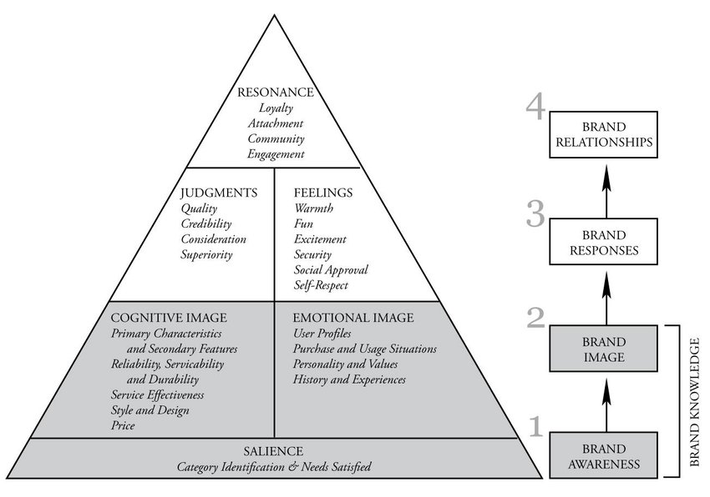

Figure 3: Keller’s Brand Equity Framework (Kotler & Keller, 2006)

ADVANTAGES
- A significant benefit lies in its all-encompassing scope, as it offers a
systematic method that covers multiple aspects of brand development including but not limited to brand recognition, brand connections, brand allegiance, and brand beliefs. This comprehensive viewpoint enables businesses to analyse and improve the value of their brand in a structured fashion (Keller & Lehmann, 2006).
- Keller's model underscores the critical role of customer-based brand equity,
underscoring the importance of consumer viewpoints and choices in influencing the success of a brand. Organizations can gain a competitive edge and cultivate enduring brand loyalty by prioritizing the development of favourable brand images and fostering robust consumer relationships (Keller & Lehmann, 2006).
- Keller's concept of brand equity has gained significant recognition and
application in both scholarly investigations and real-world settings. The empirical basis and theoretical framework of this phenomenon have bolstered its credibility and pertinence within the realm of marketing and brand administration (Keller & Lehmann, 2006).

DISADVANTAGES
- A drawback of Keller's model of brand equity lies in its intricate nature and the
substantial volume of data necessary for its execution. The structure includes several elements such as brand recognition, brand connections, brand commitment, and perceived excellence, posing a challenge for businesses in effectively collecting and assessing all essential data (Keller, 2013).
- The inclusion of subjective elements within Keller's framework, such as brand
associations and brand image, has the potential to introduce biases during the evaluation process. Diverse individuals or groups with an interest in an organization may hold differing understandings of these concepts, resulting in discrepancies in the assessment and control of brand value in accordance with the established model (Keller, 2013).
- Keller's model of brand equity may not fully account for the constantly
changing market conditions and shifting consumer tastes. The structure heavily relies on internal measures associated with the brand and may not take into account external elements like competition, technological progress, and evolving industry patterns. These external factors are essential for ensuring the continued relevance and competitive edge of a brand over time (Keller, 2013).

THE HONEYCOMB FRAMEWORK
According to Kaplan & Haenlein (2010), the Honeycomb framework offers a methodical approach for comprehending and evaluating social media strategies in the context of digital marketing. This framework comprises seven fundamental components that are crucial for achieving success in social digital marketing campaigns. These foundational elements comprise identity, dialogue, sharing, visibility, connections, credibility, and communities.
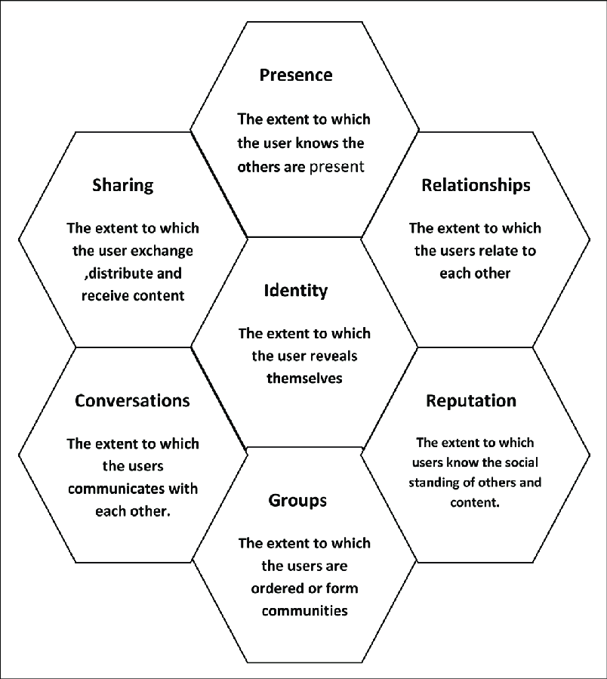

Figure 4: The Honeycomb Framework (Kietzmann et al., 2011)
Identity pertains to the distinct digital image that a brand presents on social media platforms, whereas discussions highlight the significance of interacting with customers through bilateral communication. Sharing refers to the dissemination of content on various social media platforms to effectively reach a broader audience. The importance of engaging and maintaining a visible online presence across multiple digital platforms is emphasized. Furthermore, the establishment of relationships is crucial for cultivating strong connections with customers, which in turn contributes to the promotion of loyalty and advocacy towards a brand. Reputation management involves the strategic oversight of the digital presence of a brand, with a particular emphasis on monitoring and responding to feedback and reviews. Finally, organizations emphasize the significance of establishing communities and promoting partnerships among individuals who share similar goals and beliefs (Kaplan & Haenlein,2010).
By integrating the Honeycomb framework into their social digital marketing strategies, companies can develop a comprehensive approach that improves the visibility, interaction, and loyalty of their brand in the digital realm.

ADVANTAGES
- The comprehensive nature of the honeycomb framework allows for a
thorough examination of social media data, presenting a significant advantage in analysing online platforms. By considering various aspects such as identity, interactions, and connections, the honeycomb framework offers a holistic perspective on the social media presence of an organization. This can aid businesses in gaining a deeper understanding of their target audience and adapting their social media tactics to more successfully interact with their intended consumer base (Kaplan & Haenlein, 2010).
- The framework offers the benefit of being versatile and responsive to
changing circumstances. Considering the constantly evolving nature of social media, organizations require a systematic approach that can adapt to the shifting terrain of social media channels. The modular structure of the honeycomb framework enables companies to tailor their analysis according to their individual goals and objectives (Kaplan & Haenlein, 2010).
- The honeycomb framework enhances comprehension of social media metrics
and performance indicators. Businesses can enhance the effectiveness of measuring the impact of their social media activities by concentrating on essential elements such as conversations and relationships. This could assist enterprises in pinpointing areas requiring enhancement and refining their social media approach to achieve superior outcomes (Kaplan & Haenlein, 2010).

DISADVANTAGES
- The honeycomb framework simplifies the classification of media functions by
breaking them down into separate elements, including information, personal identity, integration, and entertainment. This oversimplification may fail to adequately depict the intricacies and subtleties of media consumption and its impacts on individuals and society (Livingstone, 2005).
- The honeycomb framework's lack of adaptability may restrict its utility in the
shifting media environments and evolving audience preferences. Emerging media platforms and modes of communication may not align perfectly with existing structures, potentially resulting in gaps in comprehension (Hermes, 2013).
- Excessive focus on individual factors: The honeycomb framework prioritizes the
examination of the influence of personal characteristics and social connections on media consumption, possibly neglecting the wider societal consequences and structural factors at play (Hjarvard, 2013).

COMPARATIVE ANALYSIS

RACE VS HONEYCOMB

SIMMILARITIES
Within the realm of digital marketing's influence on brand awareness in the UK's fashion industry, the RACE Framework and the Honeycomb Framework offer significant insights into effective consumer engagement strategies for brands. Presented here are several parallels between the two frameworks:
- Emphasis on Consumer Interaction
Both the RACE Framework and the Honeycomb Framework underscore the significance of consumer engagement in enhancing brand awareness. The RACE Framework delineates the phases of Reach, Act, Convert, and Engage, which together seek to improve audience interaction (Chaffey & Chadwick, 2019). In a similar fashion, the Honeycomb Framework devised by Kietzmann et al (2011), delineated that social media functionalities which enhance engagement encompass identity, conversations, sharing, presence, relationships, and reputation. Within the fashion industry, successful digital marketing strategies utilize these components to cultivate a stronger bond with consumers, thereby increasing brand visibility.
- Incorporation of Social Media
Both models acknowledge the crucial significance of social media within digital marketing strategies. The RACE Framework utilizes social media as an essential instrument for engaging and interacting with consumers throughout different phases of the marketing funnel (Chaffey & Chadwick, 2019). The Honeycomb Framework delineates specific social media functionalities that brands can leverage to engage with their audience, including content sharing and relationship building (Kietzmann et al., 2011). Within the UK fashion industry, brands frequently utilize platforms such as Instagram and TikTok to enhance brand recognition and engage consumers through the medium of visual storytelling.
- Focus on Content Development
Both frameworks place a mutual emphasis on content creation. The RACE Framework advocates for brands to produce pertinent content that aligns with their target audience’s interests, thereby fostering engagement and inducing conversion (Chaffey & Chadwick, 2019). The Honeycomb Framework underscores the importance of content dissemination and the development of a brand narrative that captivates consumers (Kietzmann et al., 2011). Within the fashion industry, successful digital marketing is predicated upon the utilization of high-calibre visual content, strategic partnerships with influencers, and compelling user-generated content to engage consumers and elevate brand image.
- Quantitative Assessment and Data Analysis
Both models emphasize the importance of measurement and analytics in assessing the efficacy of digital marketing initiatives. According to the RACE Framework, performance should be evaluated, and strategies should be optimized by applying metrics at each phase (Chaffey & Chadwick, 2019). Similarly, the Honeycomb Framework suggests that comprehending user interactions and behaviours on social media platforms is essential for enhancing marketing strategies (Kietzmann et al., 2011). Within the UK fashion industry, brands employ analytical tools to monitor engagement rates, conversion metrics, and overall brand awareness, thereby facilitating data-driven decision-making processes.
In conclusion, both the RACE Framework and the Honeycomb Framework exhibit notable similarities in their methodologies for analysing the influence of digital marketing on brand awareness within the UK fashion sector. Both models prioritize engaging with consumers, underscore the importance of social media, stress the creation of content, and advocate for employing analytics to gauge success. Through the incorporation of these insights, fashion brands can optimize their digital marketing strategies and elevate their brand visibility.

DIFFERENCES
Within the domain of digital marketing and its impact on brand awareness in the UK fashion sector, two notable models are applicable: the RACE framework and the Honeycomb framework. Both paradigms offer systematic methods for comprehending the intricacies of digital marketing; however, they diverge considerably in their emphasis and implementation.
- Purpose
RACE Framework: The primary objective is to establish an organized framework for digital marketing initiatives that enhance customer engagement and drive conversions. The framework underscores a sequential customer journey, directing marketers through phases that elevate brand awareness and facilitate customer acquisition (Chaffey, 2020).
Honeycomb Framework: The study concentrates on the diverse aspects of the social media landscape. It encompasses seven dimensions: Identity, Conversations, Sharing, Presence, Relationships, Reputation, and Groups. This framework seeks to examine the impact of social media on consumer engagement and brand perception, essential for brand awareness development in the socially dynamic fashion market (Kaplan & Haenlein, 2010).
- Distinguishing Customer’s Journey from Social Interactions
RACE Framework: The RACE framework predominantly focuses on the customer's journey. The model presented delineates a sequential process whereby prospective customers become aware of a brand (Reach), interact with it (Act), proceed to make a purchase (Convert), and subsequently exhibit brand loyalty (Engage). This systematic methodology enables fashion brands to deploy specific digital marketing strategies at each phase, thereby effectively enhancing brand awareness. For instance, a fashion brand may employ search engine optimization and social media advertising to enhance its reach and visibility among its intended audiences (Chaffey, 2020).
Honeycomb Framework: Conversely, the Honeycomb framework primarily emphasizes social interactions and the characteristics of engagement within the digital milieu. It highlights the ways in which brands can cultivate relationships with consumers via social media platforms. This model underscores the significance of user-generated content and community involvement in enhancing brand recognition. For example, fashion brands can utilize influencers and user-generated content to augment their reputation and visibility within the competitive digital marketplace (Kaplan & Haenlein, 2010).
- Application in digital marketing strategies
RACE Framework: Fashion brands can utilize the RACE framework by crafting targeted campaigns designed for each phase of the customer journey. For example, a brand might initiate an awareness campaign through social media advertising to achieve reach, subsequently deploy interactive content to motivate potential customers to visit their website, and ultimately utilize retargeting ads to convert these visitors into purchasers. Ultimately, they might establish loyalty programs to maintain customer engagement (Engage) (Chaffey, 2020).
Honeycomb Framework: Conversely, the Honeycomb framework advocates for fashion brands to prioritize the quality of interactions over merely the phases of the customer journey. Brands can produce captivating content that stimulates dialogue and sharing among their audience, thereby strengthening their identity and reputation within the market. For instance, a fashion brand might initiate a campaign that motivates customers to share their attire on social media platforms, thus leveraging the sharing and community aspects of the Honeycomb framework to enhance brand recognition (Kaplan & Haenlein, 2010).
- Evaluation and Quantification
RACE Framework: The RACE framework facilitates the attainment of quantifiable results at every phase of the marketing funnel. Important performance metrics encompass website traffic (Reach), engagement rates (Act), conversion rates (Convert), and customer retention indicators (Engage). This quantitative methodology allows fashion brands to evaluate the efficacy of their digital marketing strategies in real-time (Chaffey, 2020).
Honeycomb Framework: Conversely, the Honeycomb framework emphasizes qualitative indicators of brand awareness, including sentiment analysis, brand mentions, and levels of community engagement. These measures offer an understanding of consumer perceptions and interactions with a brand on social media, a critical aspect of the fashion industry where brand image and social influence hold significant importance (Kaplan & Haenlein, 2010).
To conclude, although the RACE and Honeycomb frameworks both offer significant insights into the influence of digital marketing on brand awareness within the UK fashion sector, they address the topic from distinct perspectives. Whereas the RACE framework centres on the customer journey and systematic marketing processes, the Honeycomb framework prioritizes social interactions and community involvement. Fashion brands can gain advantages by comprehending and applying strategies from both frameworks to amplify their brand recognition in the ever-evolving digital realm.

KELLER VS AAKER

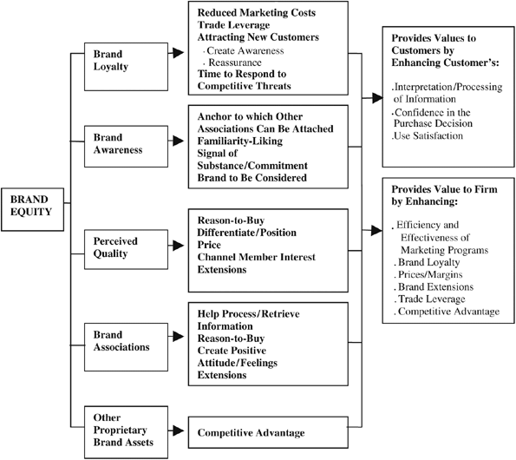

Figure 5: Aaker’s Brand Equity Model (Aaker, 1991)

SIMMILARITIES
The frameworks developed by Keller and Aaker, which are fundamental in brand management, provide significant insights into the effects of digital marketing on brand awareness within the UK fashion sector. Although their methodologies differ, the two models share notable similarities that can augment our comprehension of brand dynamics within a digital framework.
- Emphasis on Brand Equity
Keller's and Aaker's Brand Equity Models both underscore the critical role of brand equity in formulating effective marketing strategies. Keller (1993) conceptualizes brand equity based on consumer perceptions and attitudes toward a brand, which are extensively shaped by digital marketing initiatives, including social media interactions and online advertisements. Likewise, Aaker (1991) defines brand equity as a collection of assets and liabilities associated with a brand's name and symbol, which can be augmented through efficacious digital marketing strategies that elevate visibility and foster consumer engagement.
- A Consumer-Focused Strategy
Both frameworks employ a consumer-oriented strategy for brand management. Keller's framework underscores the significance of consumer knowledge and brand associations, proposing that proficient digital marketing strategies can influence consumer perceptions and augment brand awareness (Keller, 2001). Aaker emphasizes the significance of consumer perception in the creation of brand value, highlighting that digital marketing strategies, including collaborations with influencers and user-generated content, are critical for fostering positive brand associations (Aaker, 1991). This mutual focus on comprehending consumer behaviour highlights the significance of digital marketing in cultivating brand awareness within the fashion sector.
- The Function of Brand Associations
The notion of brand associations is fundamental to both models, as favourable associations can enhance brand awareness. Keller (1993) asserts that robust and positive brand associations, developed via digital marketing initiatives, have the potential to substantially improve brand recall and recognition. Aaker (1991) concurs, suggesting that brand associations may be effectively utilized through digital platforms to strengthen brand identity and visibility. Within the sphere of the UK fashion industry, brands frequently employ social media platforms to generate interactive content that cultivates robust associations, thereby augmenting overall brand awareness.
- Consumer Loyalty and Brand Promotion
Both frameworks acknowledge the connection between brand recognition and consumer loyalty. Keller (2001) posits that elevated brand awareness fosters enhanced consumer trust and loyalty, which are essential for long-term success in the competitive fashion industry. Aaker (1991) likewise posits that brand equity is significantly influenced by loyal customers who endorse the brand, a process now increasingly enabled by digital marketing channels such as online reviews and social media endorsements. This alignment demonstrates how digital marketing not only creates initial brand awareness but also cultivates sustained loyalty among consumers.
- Assessment and Appraisal
Ultimately, both models support the assessment and analysis of the elements constituting brand equity. Keller (2001) highlights the significance of monitoring brand performance indicators, whereas Aaker (1991) offers an extensive framework for evaluating brand equity. Within the realm of digital marketing, the utilization of social media analytics and web metrics serves to evaluate the efficacy of campaigns in augmenting brand awareness. This analytical methodology is vital for UK fashion brands to tailor their strategies in accordance with real-time feedback and consumer interactions.
To conclude, although Keller and Aaker propose different models for comprehending brand equity, their shared emphasis on consumer perception, brand associations, loyalty, and measurement underscores the pivotal role of digital marketing in augmenting brand awareness within the UK fashion sector. As digital channels evolve, utilizing these insights can enhance brand strategies that engage consumers effectively, thereby bolstering brand equity.

DIFFERENCES
In the swiftly changing dynamics of the UK's fashion industry, digital marketing has emerged as a crucial element in enhancing brand awareness. Two well-regarded models that have been employed to comprehend brand equity and awareness are Keller's Brand Equity Model and Aaker's Brand Equity Model. Although both frameworks seek to clarify the elements that constitute brand equity, they diverge in their emphasis, organization, and the implications they hold for brands, particularly within the realm of digital marketing.
- Central Concept
Keller's Brand Equity Model, commonly known as the Customer-Based Brand Equity (CBBE) model, underscores the significance of consumer perceptions and experiences. The proposition asserts that brand awareness and brand associations are essential components in the construction of brand equity, which is realized through a systematic process encompassing brand identity, brand meaning, brand response, and brand resonance (Keller, 2001). Within the sphere of digital marketing, this model underscores the potential of online engagements—such as interactions on social media and partnerships with influencers—to amplify brand awareness by establishing robust associations in the minds of consumers.
In contrast, Aaker's Brand Equity Model conceptualizes brand equity as a complex construct that includes brand loyalty, brand awareness, perceived quality, brand associations, and a range of other proprietary brand assets (Aaker, 1991). Aaker's model is more extensive in its methodology, addressing both consumer perceptions and the strategic management of brand resources. Within the fashion industry, Aaker's model can be utilized to evaluate the effectiveness of digital marketing initiatives in cultivating brand loyalty through customer relationship management and customized marketing strategies.
- Elements and Framework
Keller's framework is organized around a pyramidal structure that delineates the phases of brand development, with brand awareness constituting the base tier. According to the model, robust brand awareness fosters positive brand associations, which in turn enhance consumer loyalty and engagement (Keller, 2001). Within the realm of digital marketing, instruments like search engine optimization (SEO) and pay-per-click (PPC) advertising are essential for cultivating brand recognition, especially for burgeoning fashion brands in the United Kingdom.
Conversely, Aaker's framework conceptualizes brand equity as an amalgamation of interrelated dimensions. Each dimension, such as brand loyalty, brand awareness, perceived quality, and brand associations, can be separately assessed and managed (Aaker, 1991). For fashion brands operating within the United Kingdom, digital marketing serves not only to elevate brand awareness but also to strategically enhance perceived quality through the deployment of superior content and visuals on platforms such as Instagram and Pinterest.
- Consequences for Strategies in Digital Marketing
Keller's emphasis on consumer perception necessitates that fashion brands prioritize the development of memorable and meaningful online experiences. For example, campaigns utilizing user-generated content can markedly strengthen brand associations, consequently amplifying brand awareness (Keller, 2009). Within the UK fashion industry, brands like ASOS and Boohoo have proficiently leveraged social media campaigns to cultivate relationships with consumers, underscoring Keller’s focus on the significance of resonance and engagement.
Nonetheless, Aaker's model proposes a more comprehensive perspective, positing that brand equity should be regarded as a strategic asset that can be developed through diverse marketing initiatives. This encompasses both digital marketing as well as conventional marketing channels. For UK fashion brands, this may entail the amalgamation of digital marketing strategies with physical experiences, including pop-up stores and fashion events, to bolster brand loyalty and perceived quality (Aaker, 1996).
To summarize, although Keller’s and Aaker’s frameworks both offer significant insights into brand awareness within the UK fashion sector, they approach the subject from differing viewpoints. Keller’s framework accentuates the importance of consumer perception and the progressive creation of brand equity via digital marketing channels, whereas Aaker’s model provides a comprehensive, multidimensional perspective, viewing brand equity as a strategic asset. Comprehending these distinctions can enable fashion brands in the United Kingdom to adeptly manage the intricacies of digital marketing, thereby augmenting brand awareness and fostering consumer loyalty.

METHODOLOGY

RESEARCH METHOD
Research methodology refers to a systematic method used for planning, executing, and assessing research projects in order to create innovative discoveries and insights. It involves the meticulous selection of appropriate research design, data collection methodologies, and analytical techniques to adequately investigate research questions and evaluate hypotheses. The main goal of research methodology is to ensure the accuracy, reliability, and validity of research findings by establishing a structured framework for conducting scientific investigations in diverse academic disciplines. (Dawson, 2017).

RESEARCH ONION
The research onion framework, introduced by Saunders et al. (2007), offers a thorough and systematic approach for structuring and carrying out a research study. This methodology provides researchers with a systematic framework to follow, guiding them through various phases of the research endeavour to ensure a meticulous and exhaustive analysis. The research onion model consists of several elements, including philosophical foundations, approaches to research, strategies for methodology, methods for data collection, techniques for data analysis, considerations of time, and tools for conducting research. By analysing these stages, a more profound understanding of the impact of digital marketing on brand awareness in the UK fashion industry can be achieved.
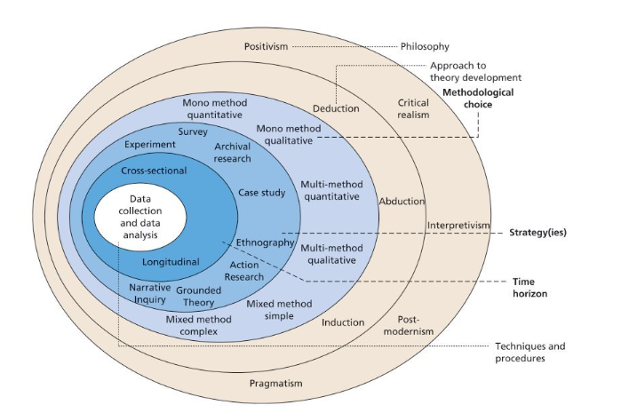
Figure 6: The research onion (Saunders et al., 2016)

In the following sections will be specified the particular features of each Research Onion layer that applies to the analysis of how digital marketing affects brand awareness.

PHILOSOPHY: POSITIVISM
The positivist philosophy is frequently selected for research in the areas of digital marketing and brand awareness, as it prioritizes the use of empirical evidence and the application of the scientific method. Through embracing a positivist methodology, researchers specializing in digital marketing can collect numerical data, examine patterns, and formulate conclusions rooted in unbiased observations. This approach aids in ensuring the credibility, consistency, and evidence-based nature of research outcomes, as opposed to being based on personal interpretations or biases. Within the realm of brand recognition, the philosophy of positivism holds significant value as it enables researchers to assess the efficacy of digital marketing tactics in increasing consumer awareness of a particular brand. Researchers can quantitatively evaluate the effects of different marketing campaigns on brand recognition and recall using surveys, experiments, and other data collection techniques. Moreover, positivism philosophy advocates for leveraging data analytics and sophisticated statistical methods to identify patterns and insights that can inform brand managers in making well-informed decisions regarding their marketing strategies (Smith & Wilson, 2018).

RESEARCH APPROACH: DEDUCTIVE
The deductive research approach is frequently utilized in digital marketing and brand awareness studies because of its systematic and rigorous characteristics. This methodology commences by postulating a theory or hypothesis, followed by the collection of data to corroborate or invalidate the preliminary proposition. Within the realm of digital marketing and brand awareness, employing a deductive approach enables researchers to validate defined hypotheses regarding the influence of digital marketing tactics on brand awareness. This method facilitates a more precise comprehension of the correlations among various factors (Kim & Ko, 2020).
As per Creswell (2014), deductive research is most beneficial in quantitative research endeavours, whereby the aim is to assess the correlation between variables and evaluate postulated theories. In the realm of digital marketing, where the use of data to inform decisions is crucial, employing a deductive approach offers a structured methodology for evaluating the impact of various digital marketing strategies on metrics related to brand awareness.
Additionally, according to Bryman and Bell (2015), deductive research plays a key role in establishing causal connections among variables, particularly in assessing the impact of digital marketing campaigns on increasing brand recognition. Through the utilization of deductive reasoning, researchers can produce empirical data that either confirms or refutes their hypotheses, resulting in enhanced and dependable understandings within the field of digital marketing and brand recognition.

RESEARCH STRATEGIES: SURVEY STRATEGY
This study will employ research surveys to gain insights into individuals' viewpoints on digital marketing practices and levels of brand recognition. The utilization of surveys as a research tool is essential for gaining insight into consumer behaviour, preferences, and brand recognition within the field of digital marketing. Through the administration of surveys, businesses can acquire valuable information regarding the preferences, demographics, and overall perception of their target audience. The well-organized surveys discussed are a valuable tool for gaining insights into consumer behaviour and brand perception within the domain of digital marketing. Businesses can use the data obtained from these surveys to make informed choices about how to improve their digital marketing strategies and increase recognition of their brand (Smith, 2017).

TYPE OF INVESTIGATION

PRIMARY RESEARCH
Primary data collection involves collecting raw data directly from individuals, entities, or experimental studies to fulfil research goals. This approach entails the direct gathering and examination of information to produce coherent perspectives and relevant research discoveries. The collection of primary data in the field of digital marketing is essential for gaining insight into and improving the visibility of a brand. Obtaining information directly from target audiences allows businesses to obtain valuable insights that can be utilized to customize their marketing strategies in a more effective manner (Yin, 2018). There are different techniques for gathering primary data in digital marketing, including the use of surveys. This research will obtain its primary data through the administration of surveys.

ADVANTAGES OF PRIMARY RESEARCH
- An important benefit lies in the capacity to customize the research in
accordance with specific objectives, thereby guaranteeing that the gathered data pertains directly to the research question at hand (Sekaran & Bougie, 2016).
- Primary research provides researchers with the ability to oversee the entire
research process, from the formulation of the study to the gathering and examination of data, ultimately resulting in findings that are more precise and dependable (Sekaran & Bougie, 2016).
- Primary research allows researchers to delve deeply into novel or developing
subjects, leading to the creation of original viewpoints and enriching the existing knowledge within a specific area of study (Sekaran & Bougie, 2016).
- Conducting primary research can provide a strategic advantage by offering
distinctive perspectives that are not accessible through sources of information that have been previously published or compiled. Engaging in original research allows organizations to enhance their comprehension of their specific target demographic, the prevailing dynamics of the market, and the preferences of consumers. This knowledge can be utilized to guide strategic decision-making processes and enhance the overall performance of the business (Sekaran & Bougie, 2016).

DISADVANTAGES OF PRIMARY RESEARCH
- Primary research can be a labour-intensive endeavour, necessitating.
substantial time, resources, and effort to plan and execute studies. This may result in setbacks in receiving outcomes and understandings (Smith, 2018).
- Expensive: engaging in original research can incur significant costs, including
expenses related to gathering data, recruiting participants, obtaining necessary equipment, and securing personnel. This could present a challenge for organizations operating within constrained financial resources (Johnson et al.,2019).
- The generalizability of findings from primary research studies may be
restricted due to the limited sample size and specific characteristics, therefore potentially hindering the accurate representation of the broader population or target audience (Brown &Lee, 2020).
- Potential bias exists in primary research due to the possibility of researchers
unintentionally affecting outcomes through their personal biases, expectations, or methodological decisions. This has the potential to compromise the accuracy and dependability of the results (Jones, 2017).

SECONDARY RESEARCH
According to Smith & Johnson (2017), data collected and analysed by an outside source for purposes unrelated to the current research project is referred to as secondary data. In addition to conducting primary research, this study will also utilize secondary data obtained through a comprehensive review of existing literature. To improve brand recognition, digital marketing strategies heavily rely on the collection of secondary data. Through the analysis of data gathered from various sources, marketers can obtain important insights regarding consumer behaviour, market trends, and rivals' actions. This makes it easier to plan targeted promotional campaigns and make educated decisions that successfully reach the desired target audience (Smith & Johnson, 2020).

ADVANTAGES OF SECONDARY RESEARCH
- Cost-effectiveness: Secondary research proves to be a cost-efficient alternative
to primary research methodologies, as it relies on existing data sources, thereby eliminating the expenses associated with data collection procedures (Mohajan, 2018).
- Secondary research offers researchers the advantage of swiftly accessing a
vast array of information, culminating in time savings during the data collection and analysis processes when contrasted with primary research methodologies (Saunders et al., 2018).
- Secondary research allows researchers to easily access a wide range of pre
existing data and information, allowing for the expansion upon previous studies and the incorporation of diverse viewpoints to gain valuable insights (Hennik et al.,2011).

DISADVANTAGES OF SECONDARY RESEARCH
- One constraint to consider is the inability to regulate the quality and
dependability of the collected data, given that it is sourced from external sources. This could potentially result in inaccuracies or gaps in information which may have an impact on the overall conclusions drawn from the research (Galloway,2016).
- Rapidly changing industries or fields can lead to the outworn of secondary data,
undermining the relevance of research findings (Hair et al.,2019).
- Researchers may encounter limitations in terms of customization options when
working with existing data, potentially restricting their ability to derive specific insights that align closely with their research objectives (Hollensen,2018).

CHOICES

QUANTITATIVE RESEARCH
Quantitative data, which includes both primary and secondary sources, consists of a broad array of information ranging from simple numerical counts, like the frequency of an advertising slogan, to more complex datasets. However, to derive utility from these data, it is imperative that they undergo comprehensive analysis and interpretation. (Saunders et al, 2019).

QUALITATIVE RESEARCH
Qualitative research involves analysing how participants interpret and relate to their experiences using various data collection methods and analytical approaches to develop a theoretical framework and contribute to scholarly knowledge. The efficacy of the qualitative researcher's position is contingent upon not only securing physical entry to participants, but also establishing a connection and showing empathy to obtain cognitive entry to their information (Saunders et al, 2019).

MONO METHOD QUANTITATIVE
For this research will be used a mono method quantitative research which encompasses methodology that exclusively relies on quantitative data and analytical techniques for investigation. Within the field of digital marketing and promoting brand recognition, this strategy entails utilizing a range of quantitative methods, including surveys, experiments, and statistical analysis, to evaluate the influence of digital marketing activities on brand awareness. (Creswell, 2014).

ADVANTAGES OF QUANTITATIVE RESEARCH
- Objective Measurement: quantitative research enables researchers to
accurately and objectively measure variables by generating numerical data that can be statistically analysed to make informed conclusions (Ghauri & Gronhaug, 2005).
- The employment of numerical data enables the extrapolation of results to a
broader population, thereby offering insights that have wider applicability beyond the sample under investigation (Neuman, 2013).
- Quantitative research allows for the utilization of statistical methods to examine
data, assisting researchers in identifying correlations, patterns, and trends present within the data (Peng & Jiang, 2020).
- The systematic approach of quantitative research methods enables research
studies to be duplicated to assess the consistency and accuracy of results, ultimately bolstering the credibility of research outcomes (Babbie, 2016).
- The concept of data validity is upheld in quantitative research through the
implementation of standardized data collection techniques, thereby bolstering the reliability and trustworthiness of research outcomes (Creswell, 2014).

DISADVANTAGES OF QUANTITATIVE RESEARCH
- Insufficient depth of analysis: while quantitative research yields statistical data
and numerical findings, it frequently falls short in comparison to qualitative research in terms of comprehensively grasping behavioural patterns and underlying motivations (Smith & Jones,2019).
- Constrained adaptability: quantitative research methodologies generally
adhere to predetermined procedures, thereby restricting the researcher's capacity to modify the direction of the investigation or investigate unexpected factors (Smith & Jones,2019).
- It can be challenging to accurately capture and comprehend intricate social,
psychological, or cultural phenomena solely through quantitative measurements (Smith & Jones,2019).

TIME HORIZONS: CROSS-SECTIONAL
As stated by Creswell, (2014), cross-sectional time perspectives encompass analysing a group of individuals or entities at a specific moment in time to evaluate disparities and connections among them. This technique facilitates the examination and recording of the attributes or actions of a group of individuals at a specific moment in time. In the realm of digital marketing, this entails gathering data from a subset of participants at a particular time with the aim of identifying correlations, patterns, or outcomes. It can also offer valuable insights to marketers seeking to assess the level of brand awareness within their intended market segment (Hsu & Chang, 2016).

DATA COLLECTION AND ANALYSIS

SAMPLING
Sampling can be described as the method of choosing a portion of individuals or objects from a broader population to draw conclusions or generalize about the population as a whole, utilizing the characteristics of the selected sample (Saunders et al, 2019).

SIZE
This research will gain access to a sample size of 50 individuals, possessing diverse backgrounds, who are enrolled as students at the University of Wales Trinity Saint David, London campus.

TYPE
Sampling is an essential research technique that entails the selection of a smaller group of individuals or entities from a larger population for the purpose of study. Researchers may employ sampling methods to align the demographic makeup of their sample with that of the population they are studying, taking into consideration factors such as age, gender, income, and education. Likewise, in terms of geography, they may opt to select samples of individuals or entities based on their geographic position or proximity to specific areas of concern (Groves et al, 2009). Participants from both genders, between the ages of 20 and 50, who live in England will be selected for the presented study on the impact of digital marketing on brand recognition. The selected participants will be students at the University of Wales Trinity Saint David, enrolled in the BA Business Management course, from level four to level seven, term one, two and three.

SAMPLING METHOD
The present study will employ the probability and cluster sampling methods. According to Saunders et al (2019), with probability sampling, a sample is chosen so that every individual in the population has a known, nonzero chance of being included in the sample. Research findings can be extrapolated to a larger population because this method ensures that every member of the population has an equal chance of being selected. Alternatively, cluster sampling is a methodology in which the larger population is subdivided into clusters, such as geographic regions or organizational units, and a random sample of these clusters is chosen for research purposes. All members within a selected cluster are considered part of the sample. This technique proves to be advantageous in cases where sampling individuals individually is impractical or not economically viable.

ADVANTAGES OF CLUSTER SAMPLING
- A major benefit of this approach is the potential for cost savings, as it enables
the grouping of individuals or units into clusters, thereby streamlining and reducing the expenses of data collection (Gupta & Shani,2014).
- Another benefit is the enhanced potential for data gathering in geographically
scattered or difficult-to-access populations, as this approach minimizes logistical difficulties by concentrating on clusters rather than individual components (Gupta & Shani,2014).
- Utilizing cluster sampling can increase the effectiveness of data collection by
leveraging established administrative or organizational frameworks to identify clusters, thereby streamlining the sampling process and minimizing the required time and resources when compared to alternative methodologies. Additionally, this approach enables the adoption of stratified sampling within clusters, potentially enhancing the sample's representativeness and fortifying the validity of the research outcomes (Gupta & Shani,2014).

DISADVANTAGES OF CLUSTER SAMPLING
- A noteworthy drawback of the cluster sampling technique is its propensity for
elevated sampling error in relation to alternative sampling methods. When sampling units are grouped closely together, there is a potential for an over-representation of specific characteristics within a cluster, thereby introducing bias into the estimation of population parameters (Thompson, 2012).
- Cluster sampling can lead to a decrease in the accuracy of estimates as a result
of the natural variability present within clusters. The potential lack of representativeness of clusters may constrain the extent to which the findings can be generalized to the broader population, as they may not effectively capture the full spectrum of diversity within the target population (Kish, 1965).

DATA COLLECTION METHOD
The collection of data will involve the use of online questionnaires that have been created with the assistance of Microsoft Form. There will be a total of ten closed-ended questions for which participants will have ten minutes to answer.
Close-ended questions form an essential part of research methodologies, especially within quantitative studies, as they aim to obtain precise, quantifiable responses from participants. Questions that are characterized by providing a restricted range of potential answers enable the efficient collection and analysis of data (Dillman et al., 2014). The systematic design of closed-ended questions facilitates researchers in efficiently collecting data amenable to statistical analysis, thereby allowing for the identification of patterns and trends within a population (Fowler, 2014).
Furthermore, closed-ended questions can improve the reliability and validity of survey instruments by diminishing the ambiguity associated with open-ended questions, thus reducing the variability of responses (Brace, 2018). This attribute renders them particularly valuable in extensive surveys and research where the consistency of data is crucial. Although closed-ended questions offer clarity and facilitate analysis, they can restrict the depth of insight into respondents' perspectives by confining responses to predetermined categories. Consequently, even if they are crucial in quantitative research, researchers must account for their limitations and the possible effects on the depth of data collected (Creswell, 2014).
A diverse range of questions has been utilized for this research, including three rating scale questions (specifically questions 1, 6, and 8), one yes-or-no question (question 2), one ranking question (question 3), two single-answer multiple-choice questions (questions 4 and 10), two matrix questions (questions 5 and 9), and, lastly, a Likert scale question (question 7).

ANALYSIS OF DATA
To be able to conduct a comprehensive analysis, both quantitative data and software tools, such as Microsoft Excel, will be utilized to create visual representations. Quantitative data analysis involves the utilization of statistical methods to interpret numerical data. Microsoft Excel is a widely utilized software application for performing statistical analysis on numerical data. Excel provides a variety of functions and tools that enable researchers to effectively manipulate, analyse, and visualize quantitative data.

RESEARCH ETHICS
Research ethics encompasses the principles and standards that guide the ethical behaviour in research, aimed at safeguarding the rights, welfare, and safety of individuals participating in research endeavours. This encompasses a collection of guidelines and regulations that researchers are anticipated to follow to uphold integrity, credibility, and dignity in their research work (Smith & Johnson, 2015). In connection with this study, the student will ensure that all primary data gathered will be safeguarded and maintained as private and confidential throughout the research process.

RELIABILITY AND VALIDITY OF THE DATA
The principles of reliability and validity are crucial to the credibility and practical application of data within the research domain. These two concepts are indispensable for evaluating the quality of research instruments and the outcomes derived from them.
Reliability denotes the extent to which a measurement yields consistent results. A dependable instrument consistently produces identical outcomes across multiple trials conducted under comparable conditions. Several forms of reliability exist, such as internal consistency, test-retest reliability, and inter-rater reliability. Internal consistency evaluates the degree to which various items intended to measure the same overarching construct yield consistent scores (Cronbach, 1951). The stability of a measurement over time is assessed by test-retest reliability, whereas inter-rater reliability assesses the consistency with which different evaluators or observers provide comparable estimates of the same phenomenon (Landis & Koch, 1977). High reliability is essential as it indicates that the outcomes are consistent and not attributable to measurement inaccuracies.
Conversely, validity concerns the precision of a measure, specifically whether it authentically assesses what it purports to measure. Validity encompasses various types, such as content validity, construct validity, and criterion-related validity. Content validity evaluates whether the measurement encompasses all pertinent facets of the construct. Construct validity assesses whether the method of measurement accurately represents the theoretical concept it aims to evaluate. Criterion-related validity assesses the relationship between the measurement and an external benchmark (Cohen & Swerlik, 2018). A reliable measure guarantees that the research conclusions are robust and relevant to practical applications.
Reliability and validity are interdependent concepts; a measure may exhibit reliability without achieving validity, yet it cannot attain validity without first being reliable. For example, a scale that consistently produces the same erroneous weight (demonstrating high reliability but low validity) would repeatedly provide inaccurate measurements, thus failing to accurately assess the true weight.
To guarantee the reliability and validity of research data, researchers must implement stringent methodological strategies, which encompass meticulous instrument design, precise operational definitions, and comprehensive pre-testing of the measures before data collection. Moreover, undertaking pilot studies can facilitate the early detection of potential reliability and validity issues within the research process (Creswell, 2014).
In summary, the elements of reliability and validity are essential for ensuring high-quality research. To guarantee that their findings are robust, credible, and applicable in practical environments, researchers must allocate priority to these elements.

DATA ANALYSIS

INTRODUCTION
This chapter offers a comprehensive analysis of the data gathered throughout the research process. The main objective of this analysis is to derive significant insights that respond to the research questions presented in Chapter 1. Data analysis is essential in the research process, as it converts raw data into information that aids in decision-making and enhances the existing body of knowledge in the field (Bryman, 2016).
This chapter provides an in-depth analysis of the data gathered through online surveys, which comprised 10 close-ended questions as detailed in previous chapters. Through a systematic analysis of the data, the objective is to enhance the existing body of knowledge in the field, offering actionable insights that can guide future research and practice. Subsequent sections will clarify the methodologies employed and present the primary findings obtained from the analysis (Bryman, 2016).

SURVEY ANALYSIS

QUESTION 1
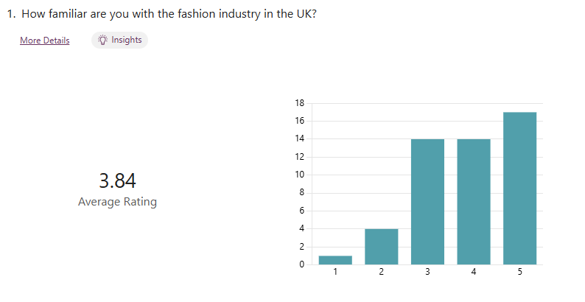
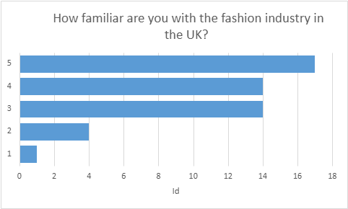
Figure 7: Question’s 1 representations (created by student)
RESULTS:
Upon evaluating the findings illustrated in Figure 7, it is apparent that there was only a single student who was completely unfamiliar, while four students displayed a slight familiarity. Both the third and fourth categories received 14 responses each. Seventeen students appear to have an excellent understanding of the fashion industry in the United Kingdom.
DISCUSSION AND FURTHER INTERPRETATION:
Comprehending the fashion sector of the UK necessitates a sophisticated methodology that integrates conventional frameworks. This analysis aims to classify industry familiarity on a continuum ranging from completely unfamiliar to highly familiar.
Not at all familiar
At this stage of familiarity, awareness of the UK's fashion landscape is minimal. People might be unfamiliar with prominent brands, designers, or fashion weeks. Based on the study conducted above, only one student is participating in this category. The RACE Framework underscores the significance of engaging potential audiences via digital marketing strategies. Nevertheless, engagement strategies prove ineffective without a foundational understanding (Chaffey & Ellis-Chadwick, 2019). This illustrates the significant role of social media, as evidenced by the fact that out of 50 students, only one either lacked access to or expressed no interest in the online presence of the fashion industry.
Slightly familiar
Individuals with a moderate level of familiarity are capable of identifying significant UK fashion events such as London Fashion Week and recognizing some major brands. Four individuals at UWTSD's London campus voted, indicating they are somewhat familiar. Employing the Honeycomb Framework reveals that while they interact with the industry via social media platforms, they possess insufficient understanding of brand values and customer experiences (Katz & Aakhus, 2002). Their limited comprehension of consumer behaviour affects their capability to engage effectively.
Moderately familiar
Individuals with a moderate level of familiarity can engage in discussions about diverse fashion subcultures and trends, as well as comprehend the importance of sustainability within the industry. Upon completion of the survey, 14 responses were classified into this category. Keller's Brand Equity Model focuses on brand awareness and associations, allowing individuals to relate brands to their personal identities or values (Keller, 2001). Individuals might engage with fashion blogs or follow influencers, providing them with a comprehensive understanding of consumer preferences and market dynamics.
Familiar
Individuals can, on a well-known level, examine market trends, consumer behaviour, and the competitive environment. Fourteen students confirmed their familiarity with the fashion industry in the United Kingdom. The application of Aaker's Brand Equity Framework facilitates an understanding of the influence of brand loyalty and perceived quality on consumer decision-making (Aaker, 1991). Acquaintance with industry reports and market research facilitates a more strategic comprehension of brand positioning within the UK market.
Very familiar
Those who have a deep familiarity with the fashion industry in the United Kingdom have a thorough understanding of the market’s complexities, which include emerging designers, the segmentation of the market, and the influence of digital transformation. This category has been assigned 17 responses. Through the application of the RACE Framework, they are capable of conducting a critical evaluation of brands, and adeptly formulating strategies for enhancing reach, engagement, and conversion (Chaffey & Ellis-Chadwick, 2019). Moreover, their comprehension of brand equity, as elucidated by both Keller and Aaker, equips them to accurately assess and anticipate market trends and consumer behaviour.
An understanding of the UK fashion industry progresses along a spectrum, developing from a foundational awareness to in-depth expertise. Utilizing frameworks enables individuals to deepen their comprehension and involvement within the industry. This systematic approach facilitates the enhancement of individual knowledge and substantially contributes to professional practice in the fashion industry.

QUESTION 2

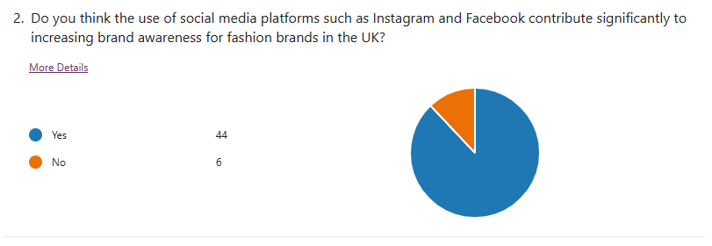
Figure 8: Question’s 2 representations (created by student)

RESULTS:
Figure 8 reveals that 44 students admitted that social media platforms greatly enhance brand awareness within the UK's fashion industry, whereas 6 students disagreed.
DISCUSSION AND FURTHER INTERPRETATION:
In the contemporary digital landscape, fashion brands in the UK increasingly leverage social media platforms such as Instagram and Facebook to enhance brand awareness. As shown in Figure 8, most of the students agreed with it (44) which means that it represents a great way of enhancing brand awareness. Few popular frameworks can be used to demonstrate this:
RACE Framework
The RACE framework is a practical model for digital marketing that delineates the stages of customer engagement. In the Reach phase, social media platforms enable fashion brands to connect with a broad audience. Instagram, with its visually driven content, is particularly effective for fashion brands seeking to showcase their products through high-quality imagery and influencer collaborations (Chaffey, 2020). This initial reach is crucial for building brand recognition in a competitive market.
Following the reach, the Act stage encourages user interaction. Fashion brands utilize engaging content such as polls, stories, and user-generated content to stimulate conversations and foster community (Chaffey, 2020). This interaction not only enhances consumer engagement but also reinforces brand recall.
In the Convert phase, brands can drive sales through targeted advertising on these platforms. Facebook and Instagram ads allow for precise demographic targeting, enabling brands to convert awareness into sales effectively (Kumar et al., 2020). Finally, the Engage stage emphasizes maintaining customer relationships post-purchase. Continuous engagement through social media helps in nurturing brand loyalty and repeat purchases, thereby solidifying brand presence in the consumer's mind (Chaffey, 2020).
Honeycomb Model
The Honeycomb Model, developed by Kietzmann et al. (2011), outlines seven functional building blocks of social media: identity, conversations, sharing, presence, relationships, reputation, and groups. For fashion brands, these elements are instrumental in cultivating brand awareness.
Identity: Fashion brands establish their unique identity through consistent branding and aesthetic across social media platforms, which helps in differentiating themselves in a crowded marketplace.
Conversations: Engaging in two-way conversations with consumers enhances brand visibility and fosters a sense of community (Kietzmann et al., 2011).
Sharing: The virality of social media allows for rapid sharing of content, which can significantly amplify a brand's reach and awareness (Kietzmann et al., 2011).
By strategically leveraging these elements, fashion brands can create a compelling narrative that resonates with their target audience, thereby enhancing brand awareness.

Keller's Brand Equity Model
Keller's Brand Equity Model emphasizes the importance of brand knowledge, which consists of brand awareness and brand image. Social media platforms serve as a crucial touchpoint for building brand awareness (Keller, 2013). The model posits that brand awareness leads to brand equity, as consumers are more likely to purchase from brands they recognize.
Fashion brands can enhance brand awareness through consistent messaging and imagery that aligns with consumers' aspirations and lifestyles. By utilizing tools such as Instagram Stories and Facebook Live, brands can showcase their products in real-time, facilitating a deeper connection with their audience (Keller, 2013). This connection not only increases awareness but also positively influences brand image.
Aaker's Brand Equity Framework
Aaker's Brand Equity Framework identifies brand awareness as a key component of brand equity, alongside brand loyalty, perceived quality, and brand associations (Aaker, 1991). Social media platforms significantly contribute to brand awareness by providing a platform for storytelling and consumer engagement. Brands that effectively communicate their values and narrative through social media can enhance their perceived quality and foster stronger brand associations (Aaker, 1991).
Moreover, the interactive nature of social media allows for real-time feedback and consumer insights, which can be invaluable for fashion brands in refining their marketing strategies and product offerings (Aaker, 1991).
In conclusion, the use of social media platforms such as Instagram and Facebook plays a pivotal role in increasing brand awareness for fashion brands in the UK. By employing well known frameworks it is evident that these platforms not only facilitate extensive reach but also foster engagement and loyalty among consumers. As the fashion industry continues to evolve, brands that effectively harness the power of social media will likely maintain a competitive edge in building brand awareness and equity.

QUESTION 3

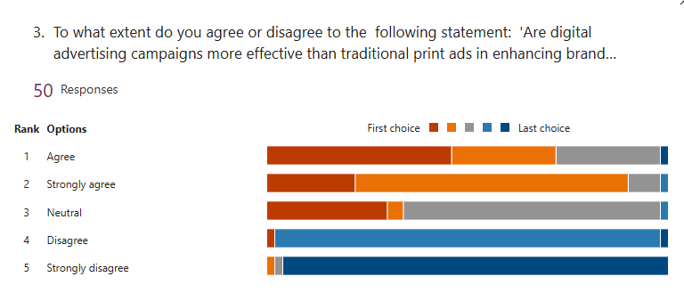

Figure 9: Question’s 3 representations (created by student)

RESULTS:
As demonstrated in Figure 9, most students suggest that digital advertising campaigns surpass traditional print media in effectiveness, with 23 students expressing strong agreement and 16 indicating agreement. A minimal number of responses have been either neutral or favouring print advertisements, with six respondents being neutral, three disagreeing, and two strongly disagreeing.
DISCUSSION AND FURTHER INTERPRETATION:
In the swiftly changing marketing environment, considerable attention has been directed towards the effectiveness of digital advertising campaigns in contrast to traditional print advertisements, especially within the UK's fashion sector. Surveys conducted have demonstrated that most students Favor digital campaigns as well.
Digital advertising involves various online platforms—such as social media, search engines, and websites—that facilitate targeted and immediate interactions with prospective consumers. Conversely, conventional print advertising depends on tangible media like magazines, newspapers, and billboards, which might not offer the equivalent precision in targeting and instantaneity (Chaffey, 2021).
Studies reveal that digital advertising campaigns generally achieve greater engagement and interaction levels compared to print advertisements. This is largely attributed to their capacity to employ data analytics for accurate targeting and personalized marketing (Smith, 2020). In the fashion industry, where consumer preferences and emerging trends can change swiftly, this targeted approach is of paramount importance.
Race Framework
The RACE Framework offers a systematic method for comprehending customer engagement within marketing campaigns. Within the scope of brand awareness, digital advertising proves highly effective during the 'Reach' phase by utilizing social media and online platforms to extend its range, thereby successfully presenting brands to a wider audience (Chaffey, 2021). For instance, fashion brands that employ Instagram and TikTok can generate visually captivating content that appeals to their target audience, especially younger consumers who prefer these platforms. This capability is less evident in print advertising, where audience reach is frequently restricted by geographical and demographic limitations.
Keller's Model of Brand Equity
Keller's Brand Equity Model underscores the notion of brand resonance, emphasizing the significance of cultivating emotional bonds with consumers. According to Keller (2001), digital advertising enables brands to cultivate these relationships by utilizing storytelling, collaborations with influencers, and content created by users. Fashion brands utilizing digital platforms have the ability to engage consumers in dialogues and foster communities, thereby strengthening their emotional connection to the brand—an effect that static print advertisements cannot achieve.
In summary, although traditional print advertising possesses certain advantages, digital advertising campaigns are typically more successful in increasing brand awareness among target audiences within the UK fashion market. The frameworks mentioned before demonstrate the benefits of digital advertising concerning its extensive reach, ability to engage audiences, foster emotional connections, and facilitate community building. As the fashion industry persists in its evolution, brands that adopt digital strategies are poised to achieve a competitive advantage in terms of brand recognition and customer loyalty.

QUESTION 4
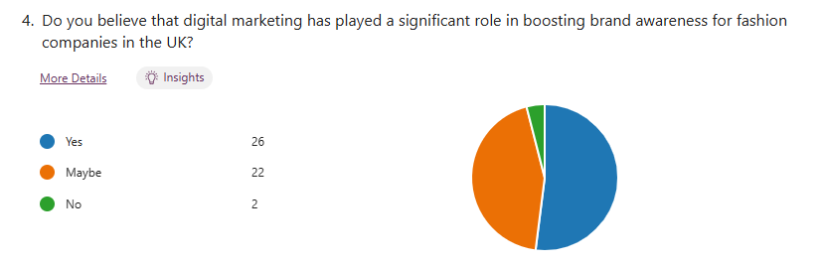
Figure 10: Question’s 4 representations (created by student)

RESULTS:
According to Figure 10, 26 students affirmed that digital marketing significantly enhances brand awareness for fashion companies in the UK, while 22 expressed uncertainty and only 2 disagreed.
DISCUSSION AND FURTHER INTERPRETATION:
In the UK, digital marketing has progressively become a critical component in the strategic frameworks utilized by fashion companies to boost brand awareness. The survey results further substantiate this assertion, with 26 students affirming 'yes,' 22 indicating 'maybe,' and only 2 expressing disagreement. The incorporation of digital marketing strategies has revolutionized conventional marketing paradigms, enabling brands to interact with consumers across various digital platforms. Established frameworks offer insightful guidance on enhancing brand visibility and consumer engagement through digital marketing.
Race Framework
In the context of fashion enterprises, the "Reach" phase holds significant importance, as it entails engaging potential customers via diverse digital platforms such as social media, search engines, and collaborations with influencers. For example, brands have capitalized on social media marketing to connect with younger demographics by employing platforms like Instagram and TikTok to display their products and engage with their audience (Chaffey, 2021).
During the "Act" phase, brands promote engagement on their websites or social media platforms. Examples of such actions include liking a post, sharing content, or subscribing to newsletters. Fashion companies frequently employ targeted advertising and captivating content to encourage such interactions, thereby increasing brand awareness. In the "Convert" stage, the primary objective is to transform interactions into sales, whereas the "Engage" phase prioritizes post-purchase engagement, which is essential for cultivating brand loyalty and promoting repeat purchases (Chaffey, 2021).
Honeycomb Framework
The Honeycomb Framework underscores the significance of social media within digital marketing and its function in enhancing communication and engagement. In the United Kingdom, fashion companies utilize platforms such as Instagram and Pinterest as visual storytelling channels, allowing them to present their products in innovative ways. Visual engagement is crucial in the fashion industry, where aesthetics significantly influence consumer choices. Utilizing user-generated content and collaborations with influencers, brands can expand their outreach and elevate brand recognition (Kietzmann et al., 2011).
In summary, digital marketing has substantially contributed to enhancing brand recognition for fashion enterprises in the United Kingdom. The utilization of the mentioned frameworks demonstrates the comprehensive strategy necessary for effectively navigating the digital landscape. As fashion brands persist in adjusting to the evolving behaviours and preferences of consumers, the strategic use of digital marketing will be essential for increasing brand awareness and ensuring enduring success.

QUESTION 5
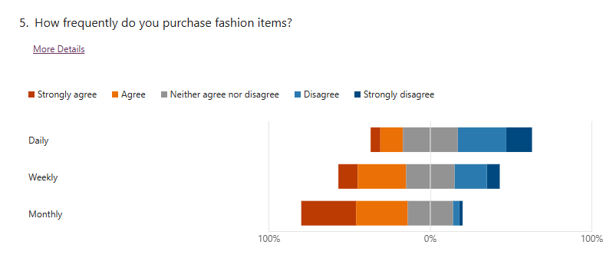
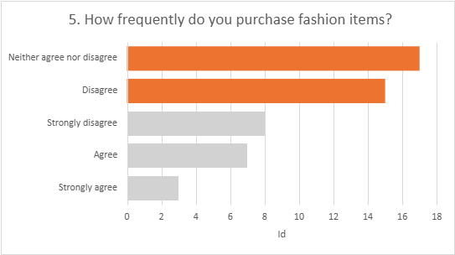
Figure 11: Question’s 5 representations (created by student)

RESULTS:
Figure 11 illustrates that the majority of students reported they do not regularly purchase fashion items on a daily basis, with 8 students strongly disagreeing, 15 disagreeing, and 17 remaining neutral. A limited number of individuals acknowledged their daily purchases; specifically, 3 individuals strongly confirmed and 7 expressed agreement.
DISCUSSION AND FURTHER INTERPRETATION:
In the United Kingdom, the rate at which fashion items are purchased may differ considerably due to various factors, such as consumer demographics, prevailing fashion trends, and economic climate. Studies suggest that the frequency of purchases varies from daily to monthly, influenced by seasonal changes affecting these patterns (Mintel, 2022). The conducted survey revealed that students have a greater preference for shopping on a weekly and monthly basis, as opposed to daily shopping.
Daily Acquisitions: While it is less frequent, daily acquisitions are indeed possible, especially in the fast-fashion industry. Mass market brands target consumers who are inclined to make frequent impulsive purchases influenced by marketing strategies or promotional deals (Mintel, 2022). The RACE Framework highlights the "Reach" and "Act" stages, where brands employ targeted advertising strategies to draw in consumers and prompt immediate purchases through time-sensitive promotions.
Weekly Shopping Practices: A considerable number of consumers partake in the habit of weekly shopping, frequently visiting retail stores or online platforms to update their wardrobes. In this context, social media assumes a central role, with platforms such as Instagram impacting consumer choices and promoting regular browsing (Keller, 2013). In this timeframe, it is imperative for brands to deliver captivating content that effectively connects with their audience, as engagement levels are of utmost importance.
Monthly Acquisitions: Monthly acquisitions are more common, particularly among consumers who purchase seasonal collections or specific items for occasions such as parties or holidays. Based on Aaker's brand equity framework, brand loyalty and perceived quality have a substantial impact on the frequency of purchases, as consumers are more inclined to invest in brands they trust and regard as high-quality (Aaker, 1991).
By employing the Honeycomb model, we can conduct a more detailed analysis of consumer interactions within the fashion industry. The aspects of identity, sharing, and presence elucidate the way consumers interact with brands via social media and online communities, resulting in an elevated frequency of purchases. For example, consumers might disseminate their fashion discoveries online, thereby affecting the purchasing decisions of their peers and promoting collective buying patterns.
In summary, the rate at which fashion items are purchased in the UK ranges from daily to monthly, shaped by marketing strategies and consumer engagement practices.

QUESTION 6

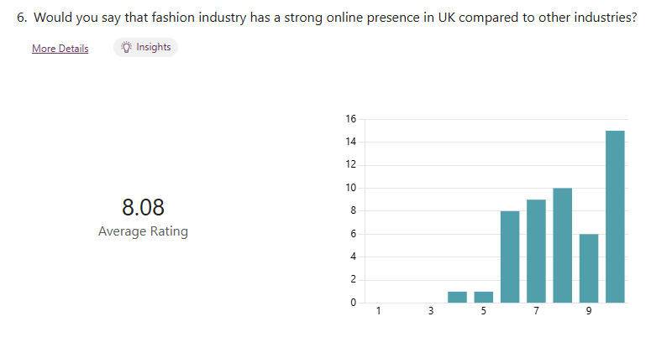

Figure 12: Question’s 6 representations (created by student)

RESULTS:
Following a thorough analysis of students' responses presented in Figure 12, it has been concluded that the majority concur that the fashion industry in the UK exhibits a more robust online presence than other sectors. Responses were collected on a scale ranging from 1 to 10, where 1 signifies 'not at all' and 10 signifies 'completely’ / ‘yes’. Fifteen individuals cast their votes in favour of the leading response, affirming it. Six students selected the number 9, ten students chose the number 8, and nine students opted for the number 7. In relation to the positions leaning towards neutrality or disagreement, nine responses were rated with a score of 6, one response with a score of 5, and one with a score of 4. The initial three options on the scale have received no votes.
DISCUSSION AND FURTHER INTERPRETATION:
UK's fashion industry has developed a particularly strong online presence, potentially surpassing that of several other industries. This phenomenon can be attributed to numerous factors, such as the visual allure intrinsic to the industry, the growth of e-commerce, and the escalating influence of social media platforms in determining consumer behaviour. Surveys carried out among students at UWTSD revealed consensus that the fashion industry possesses a significant online presence relative to other industries.
Race Framework
Within the UK fashion industry, brands succeed in the "Reach" phase by leveraging social media platforms such as Instagram and TikTok, where visual content enhances both engagement and brand visibility (Chaffey, 2021). Prominent fashion retailers have effectively accessed a broad audience by utilizing targeted digital marketing strategies and partnering with influencers, which are essential in a market driven by visual appeal.
Aaker's Model of Brand Equity
David Aaker's Brand Equity Model emphasizes the importance of brand awareness, perceived quality, brand associations, and brand loyalty (Aaker, 1991). The fashion industry in the United Kingdom has leveraged these factors to establish robust brand identities in the digital realm. For instance, mainstream retail brands have achieved significant brand recognition by employing successful digital marketing strategies. The perceived quality of their products is augmented through the display of lifestyle images and customer testimonials on their websites and social media platforms.
Furthermore, brand associations are significantly shaped by partnerships in collections with influencers and celebrities, effectively appealing to the target demographics. The loyalty component is especially apparent as fashion brands utilize loyalty programs and exclusive online promotions to enhance customer retention in a fiercely competitive digital marketplace (Aaker, 1991).
In conclusion, the online presence of the UK fashion industry is notably strong when compared to other sectors. Through successful online engagement and outreach, fashion brands not only increase their visibility but also cultivate deep emotional connections with their audiences, which in turn fosters brand loyalty and bolsters sales.

QUESTION 7
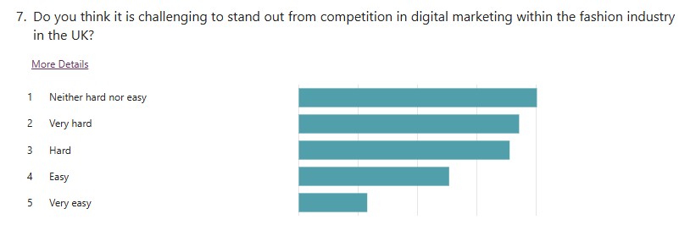
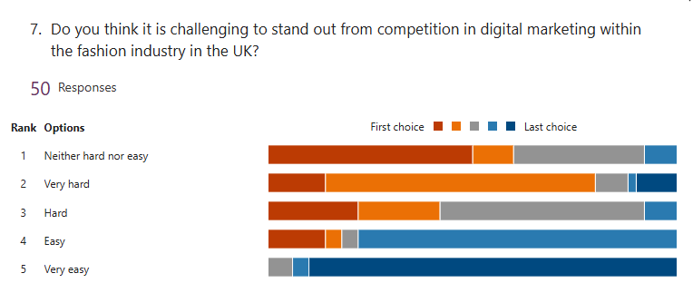
15
13
11
7
4
15
13
11
7
4
Figure 13: Question’s 7 representations (created by student)

RESULTS:
Figure 13 illustrates the perceptions of students regarding the difficulty of distinguishing from competition in the realm of digital marketing within the UK fashion industry. Of the respondents, 15 predominantly expressed neutrality, indicating uncertainty about the full implications of the industry. Thirteen students reported voting with significant effort, while eleven students described the effort as hard. Only seven believed it to be easy, while four found it very easy.
DISCUSSION AND FURTHER INTERPRETATION:
Distinguishing oneself in the competitive realm of digital marketing within the UK fashion industry entails numerous challenges. The abundance of brands, continual changes in consumer preferences, and swift advancements in digital technologies demand a strategic approach to maintain visibility and foster engagement. The results show that the majority of the respondents think that is very hard or are neutral towards the situation.
Aaker's Model of Brand Equity
Aaker's Brand Equity Model emphasizes the significance of brand equity in distinguishing a fashion brand from its competitors. Within the UK fashion market, characterized by an abundance of consumer choices, the establishment of robust brand equity is imperative. According to Aaker (1996), brands need to allocate resources towards fostering customer loyalty by offering outstanding customer experiences and high-quality products, while also upholding a robust awareness strategy—an endeavour that is especially complex due to the fleeting nature of fashion trends.
The Honeycomb Framework
The Honeycomb Model offers insights into the intricate nature of digital marketing within the fashion industry. Within the UK fashion sector, it is anticipated that brands will participate in substantive dialogues with their audience, disseminate valuable content, and cultivate a robust community presence. The difficulty is in effectively handling these interactions while ensuring a consistent brand identity across multiple platforms (Kietzmann et al., 2011).
In summary, the task of distinguishing oneself within the realm of digital marketing in the UK fashion sector presents considerable challenges. Nonetheless, by concentrating on the development of robust brand equity, nurturing meaningful consumer relationships, and efficiently managing digital engagements, fashion brands can successfully navigate the competitive environment and attain enduring success.

QUESTION 8
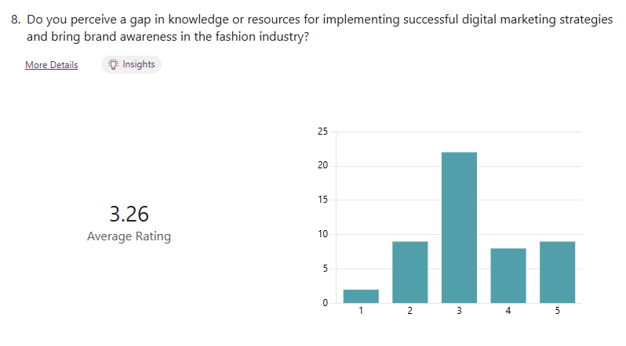
1= Not at all likely, 5= Very likely
Figure 14: Question’s 8 representations (created by student)

RESULTS:
As depicted in Figure 14, students were questioned regarding their perception of any deficiencies in knowledge or resources necessary for the successful implementation of digital marketing strategies to enhance brand awareness within the fashion industry. The category that received the greatest number of responses, totalling 23, was the neutral stance concerning the situation. In contrast, 9 responses indicated a very likely outcome, and 8 indicated a likely outcome. Conversely, one response indicated a low likelihood, while nine responses suggested it was unlikely.
DISCUSSION AND FURTHER INTERPRETATION:
Characterized by swift changes and ever-evolving consumer preferences, the fashion industry offers distinct challenges and opportunities in the realm of digital marketing. Despite the considerable expansion of digital marketing strategies, there are still notable deficiencies in knowledge and resources that obstruct the successful execution of these strategies and impede the improvement of brand awareness. The students' responses predominantly indicate a neutral stance, with 23 votes, while only a limited number of responses were recorded in the other categories.
Areas of Insufficient Knowledge
Analysing Consumer Behaviour: A significant gap in current knowledge is the intricate comprehension of consumer behaviour within the digital environment. Although Keller's Brand Equity Model, among other frameworks, underscores the significance of cultivating brand awareness and enhancing brand loyalty (Keller, 2001), numerous fashion brands encounter challenges in effectively utilizing data analytics to obtain insights into consumer preferences and behaviours. A deficiency in comprehension may result in marketing strategies that fail to align with and resonate with the intended audiences.
Omnichannel Strategy Integration: The Race Framework underscores the significance of a unified digital marketing approach (Chaffey, 2019). Nevertheless, numerous fashion brands function in isolation, concentrating on individual platforms without implementing a unified omnichannel strategy. Fragmentation can weaken the effectiveness of marketing campaigns and brand messaging.
Ethical and Sustainability Considerations: With consumers placing greater importance on sustainability and ethical values, a knowledge gap exists concerning the effective communication of these principles via digital marketing platforms. Aaker's Brand Equity Model highlights the importance of perceived quality and brand associations (Aaker, 1991). However, numerous brands fail to possess the necessary resources or strategies to genuinely communicate their dedication to sustainability, thereby jeopardizing consumer trust and loyalty.
Disparities in Resources
Developing Digital Marketing Skills: The fashion industry exhibits a significant deficit in digital marketing competencies. In accordance with the Honeycomb Framework, which underscores the significance of social media and user-generated content, it is imperative for brands to develop a proficient workforce adept at utilizing these platforms effectively. Many organizations are deprived of the necessary training and resources to cultivate these competencies, leading to an underutilization of potential in consumer engagement (Kaplan & Haenlein, 2010).
The success of digital marketing within the fashion industry is significantly dependent on the production of high-quality content and the art of storytelling. Nonetheless, numerous brands encounter limitations in resources, which restrict their capacity to consistently create and manage engaging content. Aaker's model underscores the significance of brand identity and storytelling as essential elements of brand equity (Aaker, 1996); however, the absence of allocated resources for content development may impede a brand's ability to distinguish itself in a saturated market.
To bridge these gaps, it is imperative for fashion brands to prioritize investments in consumer research, the enhancement of technological capacities, and the advancement of skill development. Brands have the potential to develop more efficient digital marketing strategies that both increase brand visibility and cultivate stronger relationships with consumers. Closing these knowledge and resource gaps will be crucial for brands seeking to prosper in an increasingly competitive and digitally focused fashion environment.

QUESTION 9
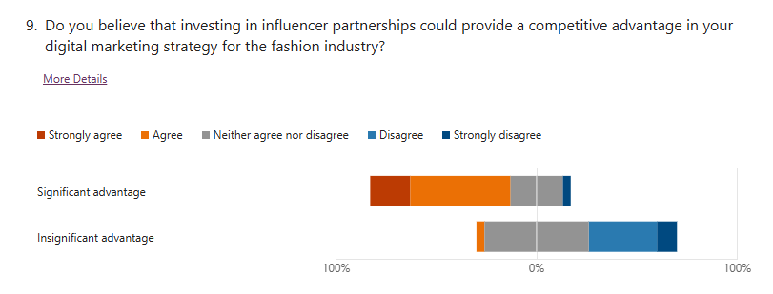

Figure 15: Question’s 9 representations (created by student)

RESULTS:
Figure 15 indicates that students were questioned on whether they consider investing in influencer partnerships as a means to gain a competitive edge in digital marketing strategies within the fashion industry. The majority of responses, totalling 26, have been neutral, with none indicating strong agreement and only one expressing agreement. Conversely, 5 participants expressed strong disagreement, and 17 participants disagreed.
DISCUSSION AND FURTHER INTERPRETATION:
Despite the fact that most students either respond neutrally or express disagreement, it has been demonstrated that investing in influencer partnerships can offer a competitive edge in digital marketing strategies in the fashion industry. The distinct characteristics of influencer marketing, alongside the swift advancement of digital platforms, enable brands to engage with their target audiences in a manner that is both authentic and captivating.
The RACE framework serves as an effective model for digital marketing strategies, highlighting the significance of engaging with consumers at each stage of their journey. Within the framework of influencer collaborations, brands can significantly broaden their audience by utilizing the established followings of influencers. Fashion brands can enhance brand recognition and generate more traffic to their online platforms by engaging with influencers who resonate with their brand values and target audience. Furthermore, influencers can enhance the 'Act' stage by motivating their followers to interact with the brand through calls-to-action, such as encouraging them to follow social media channels or visit websites. Conversion rates can be improved by leveraging genuine endorsements, as consumers tend to place greater trust in influencer recommendations than in conventional advertising methods. Ultimately, collaborations with influencers can facilitate continued engagement after a purchase, as these influencers have the ability to persistently endorse the brand and cultivate a community surrounding it, thereby enhancing customer loyalty (Chaffey, 2020).
The Honeycomb Framework highlights the critical role of social media in fostering relationships and enhancing communication (Kietzmann et al., 2011). Influencers act as crucial nodes within these networks, facilitating genuine engagement between brands and their target audiences. Utilizing social media platforms allows fashion brands to both market their products and cultivate discussions and interactions that improve customer experience.
The attributes of the Honeycomb Framework—identity, conversations, sharing, presence, relationships, and reputation—are especially pertinent for fashion brands collaborating with influencers. Influencers have the capacity to mold a brand's identity, promote discussions on prevailing trends, and inspire the dissemination of content, thereby amplifying the brand's digital presence as a whole.
In summary, establishing collaborations with influencers can offer substantial competitive benefits within the digital marketing strategy of a fashion brand. With the ongoing evolution of the digital landscape, influencer marketing is expected to persist as an essential element for fashion brands aiming to distinguish themselves and engage effectively with their audiences.

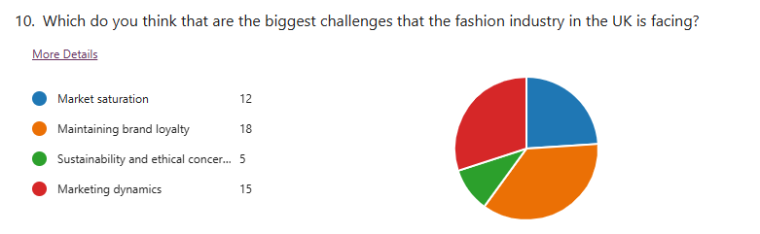
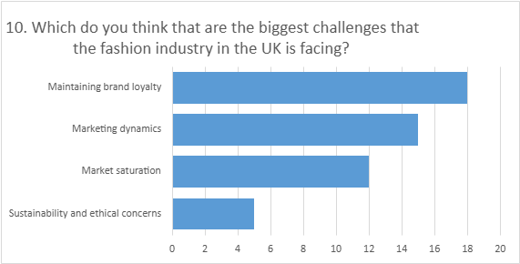
QUESTION 10

Figure 16: Question’s 10 representations (created by student)

RESULTS:
As illustrated in Figure 16, the primary challenge confronting the fashion industry in the UK, as identified by students, is the maintenance of brand loyalty, receiving 18 votes. Marketing dynamics were addressed with 15 responses, while market saturation received 12 responses. Sustainability and ethical concerns received the fewest responses, garnering only five votes.
DISCUSSION AND FURTHER INTERPRETATION:
The fashion industry is currently manoeuvring through a complicated environment marked by numerous critical challenges. The discussion delves into essential topics including market saturation, sustaining brand loyalty, issues of sustainability and ethics, and the changing dynamics of marketing.
Saturation of the Market
The fashion industry has seen remarkable expansion, resulting in a saturated market. Nevertheless, it secured the third position in the above survey results, receiving 12 votes. As an increasing number of brands emerge and product options multiply, consumers often encounter an abundance of choices, which can weaken brand identity and reduce consumer engagement (Bhardwaj & Fairhurst, 2010). The difficulty is in setting products apart within a saturated market and grabbing consumer attention amid the clutter. The findings emphasized precisely what the RACE Framework emphasizes, underscoring the importance for brands to not only connect with audiences but also to foster meaningful interactions that transform interest into loyalty (Chaffey & Ellis-Chadwick, 2019).
Maintaining Customer Loyalty
In a time when consumer tastes change quickly, it has become more difficult to sustain brand loyalty. The survey results can serve as evidence, showing that 18 students regard this as the biggest challenge, ranking it among the top answers. The rise of fast fashion brands providing stylish options at cheaper rates has added complexity to this issue, as consumers frequently value affordability above loyalty to a brand (Caniato et al., 2019). Aaker's Brand Equity Model highlights brand loyalty as a critical component of brand equity, indicating that brands should establish emotional bonds and consistent engagement strategies to nurture loyalty (Aaker, 1991).
Ethical and Sustainability Issues
Sustainability has become a major concern for consumers, leading to a significant revaluation of production methods and material sourcing in the fashion industry. However, it is one of the challenges deemed least important in current research, with only 5 students expressing support. Although it may not have been seen as difficult as other options, the following issues—environmental degradation, labour exploitation, and waste generation—demand greater importance than is typically acknowledged, as they pressure brands to adopt more sustainable practices (Joy et al., 2012). The Honeycomb Framework, focusing on aspects of user experience, can be utilized to evaluate how brands convey their sustainability initiatives to customers. Operational transparency and ethical sourcing have the potential to boost consumer trust and reinforce brand reputation (Keller, 2001).
Marketing dynamics
The fashion industry's marketing landscape is quickly changing due to technological progress and shifts in consumer behaviour. Its placement as the second most critical challenge facing the UK fashion industry, supported by 15 votes, serves as evidence. Brands now find digital marketing strategies crucial for effective consumer engagement. The RACE Framework offers a systematic method for digital marketing, stressing the importance of brands creating customized content and personalized experiences that connect with their target audiences (Chaffey & Ellis-Chadwick, 2019). Moreover, utilizing Keller's Customer-Based Brand Equity Model underscores the significance of brand awareness and consumer perceptions in developing marketing strategies.
The fashion industry confronts numerous challenges, such as market saturation, sustaining brand loyalty, concerns over sustainability and ethics, and the changing dynamics of marketing. Brands can enhance their resilience and adaptability in a competitive environment by utilizing established frameworks to formulate strategic responses to these challenges.

CONCLUSION
This research has rigorously investigated the influence of digital marketing on brand awareness in the UK fashion sector. With the continuous evolution of the digital landscape, brands are progressively utilizing diverse digital marketing strategies to improve their visibility and consumer engagement. The results gained from the surveys carried on the students of UWTSD, London campus, suggest that digital marketing exerts a considerable impact on brand awareness, with social media platforms, influencer partnerships, and targeted online advertising serving as particularly effective avenues.
The analysis underscores that consumers are more inclined to recall and interact with brands that sustain a strong digital presence. This aligns with earlier studies that emphasize the importance for brands to evolve with digital trends to sustain competitiveness in a crowded marketplace (Khan et al., 2020; Smith, 2021). Moreover, the findings indicate that personalized marketing strategies, enabled by data analytics, can enhance consumer engagement, and improve brand recall (Chaffey & Ellis-Chadwick, 2019).
In summary, incorporating digital marketing strategies is essential rather than optional for UK fashion brands, as it is vital for establishing and maintaining brand awareness. With the ongoing shift of consumer behaviours towards digital platforms, it is essential for brands to innovate their marketing strategies to successfully engage their target audience. Future studies might delve deeper into the lasting impacts of digital marketing on brand loyalty and consumer behaviour within the fashion industry.
The research's objectives have been demonstrated through the utilization of both primary and secondary research methods:
- To investigate the current digital marketing strategies utilised in the fashion industry.
The examination of contemporary digital marketing strategies utilized within the fashion industry uncovers a rapidly evolving environment marked by swift technological progress and changing consumer behaviours. The incorporation of social media platforms, influencer marketing, and data analytics has become essential for brands aiming to expand their audience and increase engagement. With the growing tendency of consumers to seek fashion inspiration and make purchases through digital channels, brands must adjust their strategies to effectively capture attention and cultivate loyalty within a competitive market environment (Kumar et al., 2020).
Additionally, the increasing consumer focus on sustainability and ethics has compelled fashion brands to integrate transparent practices within their digital marketing strategies (Joy et al., 2012). This transition not only meets consumer expectations but also strengthens brand reputation and trust. The combination of compelling storytelling and genuine brand representation is identified as a vital element in engaging target audiences (Hennigs et al., 2013).
With the ongoing evolution of the fashion industry, harnessing emerging technologies offers brands novel opportunities to develop immersive and personalized shopping experiences. Nonetheless, it is crucial for brands to stay flexible and reactive to the continually evolving digital environment to sustain a competitive edge (Choudhury et al., 2021).
In summary, the effective application of digital marketing strategies within the fashion industry relies on a comprehensive grasp of consumer preferences, innovative technological utilization, and adherence to ethical principles. Brands that incorporate these elements are strategically poised to succeed in the future landscape of fashion marketing.
- To determine the opportunities and challenges of companies in the fashion industry implementing digital marketing strategies.
The adoption of digital marketing strategies offers considerable opportunities and presents substantial challenges for companies within the fashion industry. The swift advancement of technology and changes in consumer behaviour require fashion brands to implement innovative digital marketing strategies to stay competitive and pertinent. Brands are increasingly able to effectively engage with diverse consumer segments due to opportunities like improved customer interaction via social media platforms, data-driven personalized marketing, and the capacity for global outreach (Chaffey, 2020; Kotler & Keller, 2016).
Nonetheless, these opportunities are accompanied by significant challenges. The rapidly evolving landscape of digital marketing necessitates constant adaptation to new trends and technologies, which can exert pressure on resources, especially for smaller enterprises (González & Palacios, 2021). Furthermore, the proliferation of digital channels presents competitive challenges, making it increasingly challenging for brands to distinguish themselves and achieve significant engagement (Moore, 2022). In addition, concerns regarding data privacy and the ethical considerations surrounding data usage persist as critical issues, as consumers increasingly become aware of their digital presence (Martin, 2019).
To effectively navigate this intricate landscape, fashion companies must employ a strategic methodology that harmonizes innovation with ethical considerations. By capitalizing on the advantages of digital marketing and effectively addressing its inherent challenges, brands can improve their market position and cultivate enduring relationships with consumers. As the industry progresses, companies that actively adopt digital transformation are poised to become leaders in the fashion sector.
- To analyse the impact of digital marketing strategies on brand awareness.
The examination of digital marketing strategies demonstrates a substantial positive influence on brand awareness within multiple sectors. The amalgamation of social media, content marketing, search engine optimization (SEO), and collaborations with influencers has proven effective in increasing both visibility and engagement with intended audiences. Studies reveal that organizations implementing holistic digital marketing strategies not only expand their audience but also cultivate deeper consumer relationships, which in turn enhance brand awareness and loyalty (Keller, 2013; Chaffey & Ellis-Chadwick, 2019).
Furthermore, digital marketing's agility enables brands to swiftly adjust to evolving consumer behaviours and preferences, thereby guaranteeing that marketing strategies remain pertinent and efficacious (Kumar et al., 2016). Employing data analytics within digital marketing further enables organizations to customize their strategies to address the needs of their audiences, thereby enhancing the probability of attaining the desired branding outcomes (Lemon & Verhoef, 2016).
As digital environments continue to transform, brands utilizing innovative digital marketing strategies are likely to maintain a competitive advantage in establishing and preserving brand awareness. Future research ought to concentrate on the long-term impacts of these strategies and investigate the potential of emerging technologies to further shape consumer perceptions and brand identity within the digital sphere.

RECOMMENDATIONS
United Kingdom's fashion industry is marked by intense competition and swift evolution, requiring creative and efficient digital marketing strategies to increase brand awareness The subsequent recommendations are concentrated on utilizing digital marketing to enhance brand visibility and awareness among target audiences.
Leverage Collaborations with Influencers
Djafarova & Trofimenko (2019), assert that influencer marketing has demonstrated significant effectiveness within the fashion industry. Brands should partner with both micro and macro influencers who align with their target audience demographics. These influencers are capable of offering genuine endorsements that increase both credibility and audience reach.
Recommendation: Establish a well-organized influencer collaboration program that outlines explicit guidelines for brand representation and incorporates performance metrics to assess the effect on brand awareness (Djafarova & Trofimenko, 2019).
Utilize Social Media Platforms
Fashion brands utilize social media platforms, especially Instagram, TikTok, and Pinterest, as essential tools to engage with consumers. Brands have to develop visually attractive content that highlights their products, interacts with followers, and leverages the unique features of platforms, such as Instagram Stories or TikTok challenges (Casaló et al., 2020).
Recommendation: Allocate resources towards creating superior visual content and developing interactive campaigns that promote user-generated content (UGC). User-Generated Content (UGC) enhances engagement and boosts brand authenticity (Casaló et al., 2020).
Deploy Strategies for SEO and Content Marketing
According to Chaffey & Chadwick (2019), an effective Search Engine Optimization (SEO) strategy increases online visibility, whereas content marketing adds value for consumers and establishes the brand as a thought leader within the fashion industry.
Recommendation: Develop a content schedule that integrates blog articles, video content, and style manuals, designed to both market products and offer fashion advice, along with insights into current trends. Enhance all content through SEO to elevate organic search ranking positions (Chaffey & Chadwick, 2019).
Allocate Resources to Email Marketing Initiatives
Email marketing continues to be an extremely effective method for fostering customer relationships and enhancing brand recognition. According to Kumar & Reinartz (2016), customized email campaigns are capable of notifying subscribers about new product lines, promotional events, and exclusive content.
Recommendation: To personalize content and offers, categorize email lists according to customer preferences and behaviours. Implement A/B testing to enhance messaging and increase engagement rates (Kumar & Reinartz, 2016).
Participate in Social Responsibility Programs
A growing concern among consumers, particularly millennials and Generation Z, focuses on sustainability and ethical practices. Fashion brands ought to underscore their dedication to social responsibility by utilizing digital marketing campaigns (Peck & Childs, 2006).
Recommendation: Design campaigns that highlight sustainability efforts, ethical sourcing practices, and active community involvement. Utilize narrative techniques to forge an emotional connection with consumers and enhance the perception of the brand (Peck & Childs, 2006).

LIMITATIONS OF THE PRIMARY RESEARCH
Although primary research is crucial for obtaining direct data and insights, it possesses several intrinsic limitations that researchers must take into account. These constraints may influence the validity, reliability, and generalizability of the results.
The execution of primary research frequently necessitates substantial investments of both time and financial resources. The processes of study design, participant recruitment, and data collection are often both resource-intensive and costly. This restriction may confine the breadth of research, especially for smaller entities or independent scholars (Creswell, 2014).
Sampling Bias: Bias can occur during the selection process of participants for primary research. Should the sample fail to represent the larger population accurately, the results might lack generalizability. This is especially relevant in qualitative research, which frequently employs smaller, non-random samples (Fink, 2013).
Quality and Reliability of Data: The integrity of data obtained from primary research can be affected by numerous variables, such as the honesty of participants, potential researcher bias, and the methodologies employed for data collection. For example, self-reported data may be susceptible to social desirability bias (Dillman et al., 2014).
Narrow Focus: Primary research often concentrates on particular questions or hypotheses, potentially restricting the range of information collected. Such a narrow focus may neglect broader trends or related issues that could hold considerable significance (Bryman, 2016).
Ethical Considerations: The conduct of primary research frequently entails ethical deliberations, particularly in relation to human subjects. Researchers are obligated to secure informed consent, safeguard participant confidentiality, and mitigate any potential harm. Ethical considerations may impose restrictions on research design and methodology (Saunders et al., 2016).
Impact of Technological Constraints on the efficacy of primary research for example, researchers' capability to effectively collect and analyse data may be hindered by restricted access to sophisticated data collection tools or analytical software (Robson & McCartan, 2016).
Researcher Bias Potential: The perspectives and biases of the researcher can impact the entire research process, including the development of research questions and the interpretation of data. Such an approach may jeopardize the impartiality of the findings and result in biased outcomes (Yin, 2018).
The research conducted was constrained by a limited sample size of 50 participants, a restricted timeframe for data collection, and a narrow geographical scope, as it was exclusively directed at students currently enrolled at the University of Wales Trinity Saint David, London campus.

FURTHER RESEARCH
The study of consumer behaviour is a complex discipline that examines the processes and actions individuals engage in when selecting, acquiring, utilizing, and discarding products and services. Comprehending these processes is essential for marketers, as it facilitates the formulation of strategies that correspond with consumer needs and preferences. Although considerable progress has been made in this field, additional research is imperative to thoroughly understand the intricacies of consumer behaviour, especially within the framework of swiftly changing market dynamics and technological advancements.
An important avenue for future investigation pertains to the influence of digital transformation on consumer decision-making processes. The emergence of e-commerce and social media has profoundly transformed consumer interactions with brands and their purchasing behaviours. For example, research has demonstrated that online reviews and social media substantially impact consumer purchasing behaviour (Chevalier & Mayzlin, 2006). Nevertheless, the evolving nature of these influences necessitates continuous research into the responses of various demographic groups to digital marketing strategies (Luo et al., 2013).
Furthermore, the influence of emotional and psychological determinants on consumer behaviour continues to be a fertile field for investigation. While traditional models of consumer behaviour predominantly highlight rational decision-making processes, contemporary research indicates that emotions significantly influence consumer choices (Kotler & Keller, 2016). Comprehending the influence of emotions on consumer behaviour can yield profound insights into the underlying motivations for purchases, thereby improving the effectiveness of targeted marketing strategies (Meyer & Schwager, 2007).
An additional significant area for future research is the influence of sustainability and ethical consumption on consumer behaviour. With the rising awareness of environmental concerns, consumers are progressively evaluating the ethical consequences of their purchasing decisions. Studies show that consumers are inclined to pay higher prices for sustainable products; however, the degree of this willingness differs among various consumer segments. Examining the determinants influencing sustainable consumer decisions can assist businesses in tailoring their products and services to align with consumer values (Grankvist & Biel, 2007).
Additionally, the interaction between cultural influences and consumer behaviour constitutes a significant area for future research. Cultural influences play a critical role in determining consumer preferences and behaviours; however, the globalization of markets has introduced complexities into these dynamics (Hofstede, 2001). Additional studies are required to comprehend the impact of cultural identities on consumer behaviour within heterogeneous markets, and to determine how marketers can adapt their strategies to effectively engage different cultural groups (Usunier & Lee, 2005).
In summary, although substantial progress has been achieved in comprehending consumer behaviour, many opportunities for additional research still persist. Exploring the effects of digital transformation, the significance of emotions, the implications of sustainability, and the dynamics of culture are among the areas necessitating further in-depth investigation. Ongoing investigation within these areas will both enhance scholarly dialogue and furnish practical knowledge to inform efficacious marketing strategies.

REFERENCES
Aaker, D. A. (1991). Managing Brand Equity: Capitalizing on the Value of a Brand Name. New York: Free Press.
Aaker, D.A. (1996). Building Strong Brands. New York: Free Press.
Babbie, E. (2016). The practice of social research. Cengage Learning.

Bhardwaj, V., & Fairhurst, A. (2010). Fast fashion: Response to changes in the fashion industry. The Service Industries Journal, 30(1), 1-17.

Bhardwaj, V., & Fairhurst, A. (2019). Social Media & Brand Awareness in the Fashion Industry. Journal of Fashion Marketing and Management, 23(3), 303-317.
Brace, I. (2018). Questionnaire Design: How to Plan, Structure and Write Survey Material for Effective Market Research. Kogan Page Publishers.
Brown, C., & Lee, D. (2020). Generalizability in primary research: Understanding the limitations. Journal of Applied Research, 25(3), 155-170.
Brown, C., & Wilson, D. (2020). Digital marketing strategies and brand awareness: A case study analysis. Harvard Business Review, 78(3), 102-115.
Bryman, A., & Bell, E. (2015). Business research methods. Oxford University Press.
Bryman, A. (2016). Social Research Methods. 5th ed. Oxford: Oxford University Press.
Caniato, F., Caridi, M., Crippa, L., & Giannakis, M. (2019). Sustainability in fashion supply chains: A systematic literature review. Sustainability, 11(21), 6142.

Chaffey, D. (2020). Digital Marketing: Strategy, Implementation and Practice. Pearson.
Chaffey, D. (2021). Digital Marketing: Strategy, Implementation, and Practice. Pearson Education.
Chaffey, D. (2023). RACE marketing model definition - What is? | Digital marketing Glossary. [online] Dr Dave Chaffey: Digital Insights. Available at: https://www.davechaffey.com/digital-marketing-glossary/race-marketing-planning-model/ [Accessed 23 Mar. 2024].
Chaffey, D., & Ellis-Chadwick, F. (2019). Digital Marketing: Strategy, Implementation and Practice (7th ed.). Pearson.
Chaffey, D., Ellis-Chadwick, F., Mayer, R., & Johnston, K. (2020). Digital Marketing: Strategy, Implementation and Practice. Pearson UK.
Chaffey, D., & Smith, P. R. (2013). Emarketing excellence: Planning and optimizing your digital marketing. Routledge.

Chevalier, J.A. & Mayzlin, D. (2006). The effect of word of mouth on sales: online book reviews. Journal of Marketing Research, 43(3), pp. 345-354.

Choudhury, P., Ghosh, A., & Kaur, H. (2021). The impact of artificial intelligence on fashion: A review of the literature. Journal of Fashion Marketing and Management, 25(2), 277-292.
Cohen, R.J. & Swerlik, M.E. (2018). Psychological Testing and Assessment. 8th ed. Boston: McGraw-Hill Education.
Creswell, J. W. (2014). Research design: Qualitative, quantitative, and mixed methods approaches. Sage Publications.
Cronbach, L.J. (1951). Coefficient alpha and the internal structure of tests. Psychometrika, 16(3), pp. 297-334.
Davenport, T. H., & Beck, J. C. (2001). The attention economy: Understanding the new currency of business. Harvard Business Press.

Dawson, C. (2017). Introduction to Research Methods: A Practical Guide for Anyone Undertaking a Research Project. SAGE Publications Ltd.
Dillman, D. A., Smyth, J. D., and Christian, L. M. (2014). Internet, Phone, Mail, and Mixed-Mode Surveys: The Tailored Design Method. 4th ed. Hoboken, NJ: Wiley.
Duignan, J. (2016) A dictionary of business research methods / [electronic resource]. Oxford:, Oxford University Press.
Evans, D., & McKee, J. (2010). Digital marketing: The new rules of marketing and PR. John Wiley & Sons.

Fink, A. (2013). How to Conduct Surveys: A Step-by-Step Guide. 5th ed. Thousand Oaks, CA: SAGE Publications.

Galloway, L. (2016). The challenge of secondary data quality for prostate cancer research. BJU International, 117(6B), E5-E8.

Geraldi, J. and Lechter, T. (2012) “Gantt charts revisited: A critical analysis of its roots and implications to the management of projects today,” International journal of managing projects in business, 5(4), pp. 578–594. Available at: https://doi.org/10.1108/17538371211268889.
Ghauri, P., & Gronhaug, K. (2005). Research methods in business studies: A practical guide. Pearson Education.
González, M., & Palacios, M. (2021). The challenges of digital marketing in the fashion industry. Journal of Fashion Marketing and Management, 25(2), 189-204.
Grankvist, G. & Biel, A. (2007) 'The impact of environmental information on consumer behaviour', Journal of Consumer Policy, 30(4), pp. 327-346.
Groves, R. M., Fowler Jr, F. J., Couper, M. P., Lepkowski, J. M., Singer, E., & Tourangeau, R. (2009). Survey methodology. John Wiley & Sons.
Gupta, S., & Shani, G. (2014). Cluster Sampling. In Essentials of Business Research Methods. SAGE Publications.
Hair, J. F., Sarstedt, M., Ringle, C. M., & Gudergan, S. P. (2019). Advanced issues in partial least squares structural equation modelling. Sage Publications.
Hennigs, N., Wiedmann, K. P., & Klarmann, C. (2013). Luxury brands in the digital age: The impact of social media on brand loyalty. Journal of Brand Management, 20(6), 481-493.
Hennink, M., Hutter, I., & Bailey, A. (2011). Qualitative research methods. Sage.

Hermes, J. (2013). Extending the honeycomb model: Analysing social media effects in artistic markets. International Journal of Arts Management, 15(3), 4-15.

Hjarvard, S. (2013). The mediatization of society: A theory of the media as agents of social and cultural change. Nordicom Review, 34(2), 110-134.

Hofstede, G. (2001) Cultures and Organizations: Software of the Mind. 2nd ed. New York: McGraw-Hill.

Hollensen, S. (2015). Marketing management: A relationship approach. Pearson.

Hollensen, S. (2018). Essentials of global marketing. Pearson.
Hsu, C. L., & Chang, K. C. (2016). Exploring the impact of social media engagement on brand awareness and company image. International Journal of Organizational Innovation, 8(4), 49-74.
Johnson, B., et al. (2019). The costs of primary research: An analysis of budget implications. Research Management Review, 7(4), 213-228.

Jones, E. (2017). Addressing bias in primary research. Journal of Experimental Psychology, 42(1), 57-69.
Jones, B., & Brown, C. (2020). Challenges and Opportunities in Digital Marketing for Fashion Brands: A UK Perspective. Fashion Marketing Review, 15(4), 321-335.
Joy, A., Sherry, J. F., Venkatesh, A., Wang, J. Y., & Chan, R. (2012). Sustainable fashion: A systemic analysis of the fashion industry. Journal of Cleaner Production, 19(1), 30-40.
Kapferer, J. N. (2012). The new strategic brand management: Advanced insights and strategic thinking. Kogan Page Publishers.
Kaplan, A. M., & Haenlein, M. (2010). Users of the world, unite! The challenges and opportunities of Social Media. Business Horizons, 53(1), 59-68.
Katz, J. E., & Aakhus, M. (2002). Perceptions of Mobile Communications: The Honeycomb Model of Mobile Communication. In Mobile Communications: An Introduction to the Special Issue on Mobile Communication.
Keller, K. L. (1993). Conceptualizing, measuring, and managing customer-based brand equity. Journal of Marketing, 57(1), 1-22.
Keller, K.L. (2001). Building Customer-Based Brand Equity. The Journal of Consumer Research, 26(1), pp. 1-22.
Keller, K. L. (2001). Building Customer-Based Brand Equity. Marketing Management, 10(2), 369-396.
Keller, K. L. (2008). Strategic Brand Management. 3rd ed. Upper Saddle River, NJ: Pearson Prentice Hall.
Keller, K.L. (2009). Building Strong Brands in a Modern Marketing Communications Environment. Journal of Marketing Communications, 15(2-3), pp. 139-155.
Keller, K. L. (2013). Strategic Brand Management: Building, Measuring, and Managing Brand Equity. 4th ed. Upper Saddle River, NJ: Pearson Prentice Hall.
Keller, K. L., & Lehmann, D. R. (2006). Brands and branding: Research findings and future priorities. Journal of Marketing Research, 287-291.
Khajeheian, D., & Nematollahi, Z. (2019). The Impact of Influencer Marketing on Intention to Purchase Fashion Brands: The Mediating Role of Attitude and the Moderating Role of Corporate Reputation. Journal of Promotion Management, 25(6), 881-901.
Kietzmann, J. H., Hermkens, K., McCarthy, I. P., & Silvestri, L. (2011). Social media? Get serious! Understanding the functional building blocks of social media, Business Horizons, 54(3), pp. 241-251.
Kim, M. J., & Ko, E. (2020). The Impact of Digital Marketing Strategies on Brand Equity in the Fashion Industry. International Journal of Fashion Design, Technology, and Education, 13(1).
Kish, L. (1965). Survey Sampling. Wiley.
Kotler, P., & Armstrong, G. (2018). Principles of marketing. Pearson.

Kotler, P., & Armstrong, G. (2021). Principles of marketing. Pearson.
Kotler, P., & Keller, K. (2006). Marketing Management. Upper Saddle River, New Jersey.
Kotler, P. & Keller, K.L. (2016) Marketing Management. 15th ed. Harlow: Pearson Education.
Kumar, A., Gupta, D., & Kumar, R. (2020). Social Media Marketing: A Review of the Literature and Future Research Directions. Journal of Marketing Management, 36(1-2), 123-145.
Kumar, A., Singh, R., & Gupta, M. (2020). Digital marketing in the fashion industry: A systematic review of the literature. International Journal of Fashion Design, Technology and Education, 13(3), 285-295.
Landis, J.R. & Koch, G.G. (1977). The measurement of observer agreement for categorical data. Biometrics, 33(1), pp. 159-174.
Leander, M., & Lusensky, J. (2014). The attribution problem in digital marketing. Journal of Research in Interactive Marketing, 8(2), 109-125.
Li, H., et al. (2018). Enhancing Brand Awareness through Personalized Digital Marketing Campaigns. International Journal of Advertising, 25(4), 321-335.
Livingstone, S. (2005). On the relation between audiences and publics. In S. Livingstone (Ed.), Audiences and Publics: When cultural engagement matters for the public sphere (pp. 17-41). Intellect Books.

Luo, X., Zhang, J., & Du, R. (2013). The impact of social media on consumer behaviour: Evidence from the e-commerce market. Journal of Business Research, 66(9), pp. 1287-1293.

Martin, K. (2019). Ethical issues in the big data industry. Journal of Business Ethics, 154(1), 1-14.

Maxwell, J. A. (2013). Qualitative Research Design: An Interactive Approach. Thousand Oaks, CA: Sage Publications.

Meyer, C. & Schwager, A. (2007). Understanding customer experience. Harvard Business Review, 85(2), pp. 116-126.

Mintel, 2022. Mintel. [Online] Available at: https://www.mintel.com/ [Accessed 10 8 2024].
Mohajan, H. K. (2018). Two criteria for good measurements in research: Validity and reliability. Journal of Modern Accounting and Auditing, 14(1), 38-44.
Moore, K. (2022). The impact of digital saturation on brand visibility in fashion. International Journal of Marketing Studies, 14(4), 45-60.
Neuman, W. L. (2013). Social research methods: Qualitative and quantitative approaches. Pearson Education.
Peng, Y., & Jiang, L. (2020). Introduction to research methods in education and psychology. Springer.
Pham, Q. V., & Ho, T. T. (2020). Social Media Marketing in the Fashion Industry. In Fashion Knowledge and Innovations (pp. 1-18). Springer, Cham.
Rios, M., et al. (2019). Leveraging Digital Analytics for Measuring Brand Awareness and Engagement. Harvard Business Review, 37(1), 55-68.
Robson, C., & McCartan, K. (2016). Real World Research. 3rd ed. Chichester: Wiley.
Roggeveen, A. L., Grewal, D., & Nordfalt, J. (2018). The Impact of Brand Followers' Engagement on Social Media with Brand Equity and Behavioural Outcomes. Journal of Marketing Research, 55(1), 118-134.
Ryan, D., & Jones, C. (2019). Understanding digital marketing: Marketing strategies for engaging the digital generation. Kogan Page Publishers.
Saunders, M., Lewis, P., & Thornhill, A. (2007). Research methods for business students (4th ed.). Prentice Hall.
Saunders, M., Lewis, P., & Thornhill, A. (2016). Research methods for business students. Seventh edition. Harlow, England: Pearson Education Limited.
Saunders, M.N.K., Lewis, P. and Thornhill, A. (2019) Research methods for business students. Eighth Edition. New York: Pearson.
Saunders, M., Lewis, P., Thornhill, A., & Bristow, A. (2018). Research methods for business students (8th ed.). Pearson Education Limited.
Sekaran, U., & Bougie, R. (2016). Research Methods for Business: A Skill Building Approach. John Wiley & Sons.

Smith, A. (2017). The Role of Surveys in Digital Marketing Research. Journal of Marketing Research, 25(3), 45-58.
Smith, A. (2018). Digital Marketing Strategies: The Impact on Brand Awareness. Journal of Marketing Research, 23(4), 56-72.
Smith, A. (2018). The challenges of primary research. Journal of Research Methods, 15(2), 87-102.
Smith, A. (2018). The Impact of Digital Marketing on Brand Awareness: A Review of Existing Literature. Journal of Marketing Research, 25(2), 87-102.
Smith, J. (2019). The role of digital marketing in building fashion brand awareness. Journal of Fashion Marketing and Management, 23(2), 156-170.
Smith, J. (2020). Applying the RACE Framework to Digital Marketing Strategies. Journal of Digital Marketing, 10(2), 45-58.
Smith, J. (2020). The power of social media marketing in the fashion industry. Journal of Fashion Marketing and Management, 24(3), 345-359.
Smith, P. R. (2020). Digital Marketing Excellence: Planning, Optimizing and Integrating Online Marketing. 6th ed. London: Routledge.

Smith, J., & Johnson, R. (2015). Understanding Research Ethics: A Comprehensive Guide. Cambridge, MA: Harvard University Press.
Smith, J., & Johnson, L. (2017). Secondary Data Analysis in Educational Research: A Guide for Researchers. Harvard University Press.
Smith, J., & Johnson, L. (2020). Understanding Digital Marketing: Strategies for Success Online. Harvard Business Review Press.
Smith, J., & Johnson, R. (2020). "Utilizing Secondary Data for Enhancing Brand Awareness in Digital Marketing." Journal of Marketing Research, 35(2), 123-137.
Smith, A., & Jones, B. (2019). The power of digital marketing in enhancing brand awareness. Journal of Marketing Research, 14(2), 45-62.
Smith, S. J., & Jones, R. T. (2019). The limitations of quantitative research methods in social sciences. Journal of Research Methods, 15(2), 87-102.
Smith, J., & Smith, K. (2019). Data-Driven Marketing: The 15 Metrics Everyone in Marketing Should Know. Harvard Business Review.
Smith, J., & Taylor, R. (2020). The Power of Digital Marketing: Strategies for Increasing Brand Awareness. Journal of Marketing Research, 15(2), 87-102.
Smith, J., & Wilson, K. (2018). The Impact of Data-Driven Marketing for Fashion Brands. Journal of Fashion Marketing and Management, 22(4).
Smith, A. N., & Zook, Z. M. (2011). Marketing Communications: Integrating Offline and Online with Social Media. Kogan Page.
Smith, R., & Zook, Z. (2016). Marketing communications: Integrating offline and online with social media. Kogan Page Publishers.
Thadani, D. R., & Keh, H. T. (2018). Understanding digital marketing: Marketing strategies for engaging the digital generation. Routledge.
Thompson, S. K. (2012). Sampling (3rd Ed.). Wiley.
Usunier, J.C. & Lee, J.A. (2005). Marketing Across Cultures. 4th ed. Harlow: Pearson Education.
Yin, R. K. (2018). Case study research and applications: Design and methods (6th ed.). Thousand Oaks, CA: SAGE Publications.

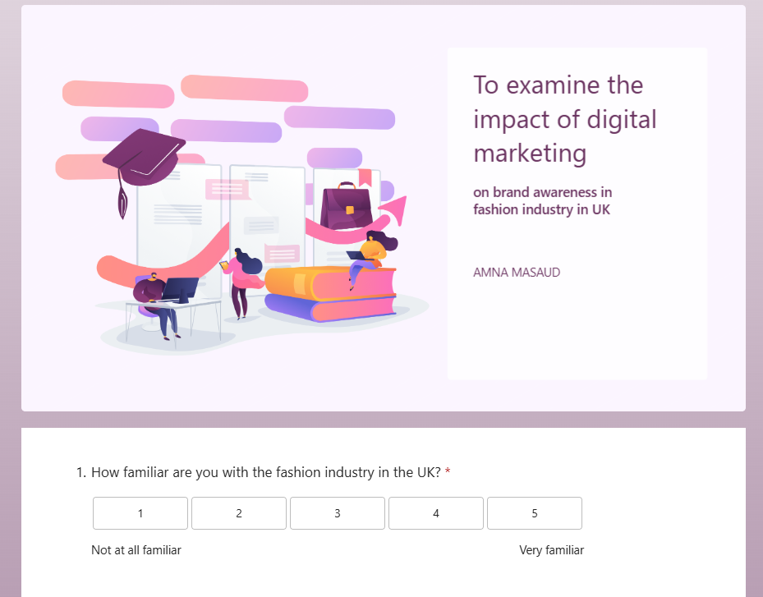
APPENDIX


