7/21/2026

University of Wales Trinity Saint David
LONDON CAMPUS
Module Name: Introduction to Web and Database Concepts
Module Code: ACCA4023

Student’s Name: Dennis Annang
Student’s ID: 2528418
Group 3

Lecturer’s Name: Anum Paracha

Link to Access Zip Folder: Attachments

Table of Contents 2
Introduction 3
1. Scenario Analysis 4
1.1 Entities and Attributes 4
1.2 Relationships 4
2. Entity-Relationship Diagram (ERD) 5
3. Data Structure Development 6
3.1 Entity, Relationships and Attributes 6
3.2 Table definitions and constraints 7
4. Normalisation Compliance (3NF) 8
5. Sample Data Population 9
6. Query Development 12
7. Validation and Testing 15
8. Design Decisions and Reflection 16
9. Conclusion 16
10.References………………………………..…………………………………………………………………………………………….....17

Introduction
Database Management System (DBMS) is an organised collection of data which enables the efficient storage, retrieval and management of information by the user and the operating system [1]Modern organisations rely on databases to maintain accurate records, support daily business operations and ensuring information can be readily accessed when required. Relational Database Systems (RDBMS) enhance these capabilities by organising data into interconnected tables, enforcing data integrity into through constraints, and supporting efficient processing of large volumes of structured data [2].
AutoPark Management Systems operate several parking sites across London and currently manages customer records, vehicle entries, parking slot allocations, and payment transactions using a manual record keeping methods. This approach has led to inconsistences in data, lost records, and inability to monitor parking occupancy and revenue in real time. In order to overcome these challenges, AutoPark requires a centralised relational database capable of automating core processes, improving data accuracy, and supporting reliable management reporting
This report presents a solution be designing and implementing a relational database for AutoPark. It includes the identification of the systems entities and relationships, development of an Entity Relationship Diagram (ERD), relational tables creation with appropriate constraints, normalisation to Third Normal Form (3NF), sample data population, query development, and system validation to ensure the database meets its functional requirements.

1. Scenario Analysis

  - Entities and attributes
An entity is an object or a concept in the real world where data is stored [3]. Six core entities have been identified from the AutoPark scenario:
Entity | Key Attributes | Purpose
ParkingSite | SiteID (PK), SiteName, Address, City, TotalSlots | Stores details of each parking location managed by AutoPark
ParkingSlot | SlotID (PK), SiteID (FK), SlotNumber, SlotType, Availability | Records individual spaces within each site
Customer | CustomerID (PK), FirstName, LastName, Email, Phone, TimeParked | Holds details registered vehicle owners
Vehicle | VehicleID (PK), CustomerID (FK), Reg.No, Make, Model, VehicleType | Records vehicles registered by customers
Booking | BookingID (PK), CustomerID (FK), SlotID (FK), VehicleID (FK), StartTime, EndTime, BookingStatus | Tracks slot reservations linking customers, vehicles, and slots
Payment | PaymentID (PK), BookingID (FK), Amount, Payment Date, PaymentMethod, PaymentStatus | Records financial transactions against each other
  - Relationships

The six entities identified in the AutoPark system interact through a set of structured relationships that define how records depend on one another [4]. These relationships form the backbone of the relational model, ensuring that each booking, payment, vehicle, and slot is correctly linked to its corresponding parent entity.

- Parking Site to Parking Slot: One-to-Many (1:M) — a site contains many slots, but each slot belongs to one site.
- Customer to Vehicle: One-to-Many (1:M) — a customer may register multiple vehicles, but each vehicle belongs to one customer.
- Customer to Booking: One-to-Many (1:M) — a customer may make multiple bookings over time.
- Parking Slot to Booking: One-to-Many (1:M) — a slot may be booked many times across different periods, but each booking occupies one slot.
- Vehicle to Booking: One-to-Many (1:M) — a vehicle may appear across multiple bookings, but each booking involves one vehicle.
- Booking to Payment: One-to-One (1:1) — each booking generates exactly one payment record.

2. Entity – Relationship Diagram (ERD)
The diagrams below depict the ERD for the AutoPark system, outlining all six entities along with their primary and foreign keys and the relationships between them [4]. The Booking table sits at the centre of the model, linking Customer, Vehicle, and ParkingSlot, which removes the need for any many-to-many relationships.
- Crows Foot Nation
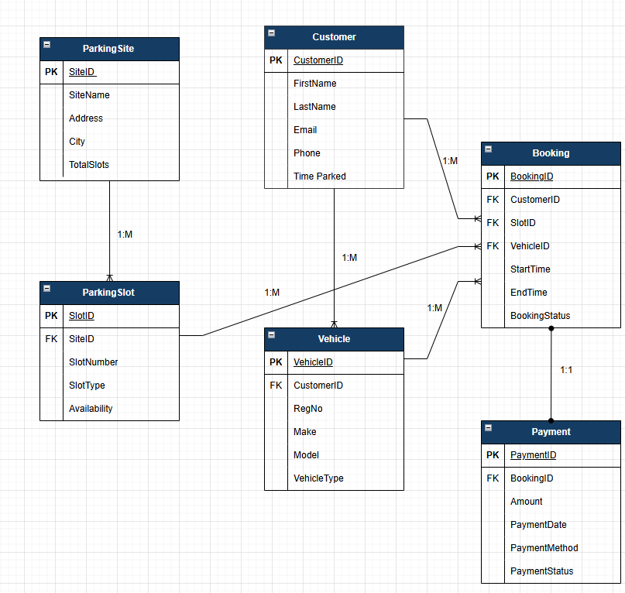
`
- Logical Entity-Relationship Diagram (ERD)
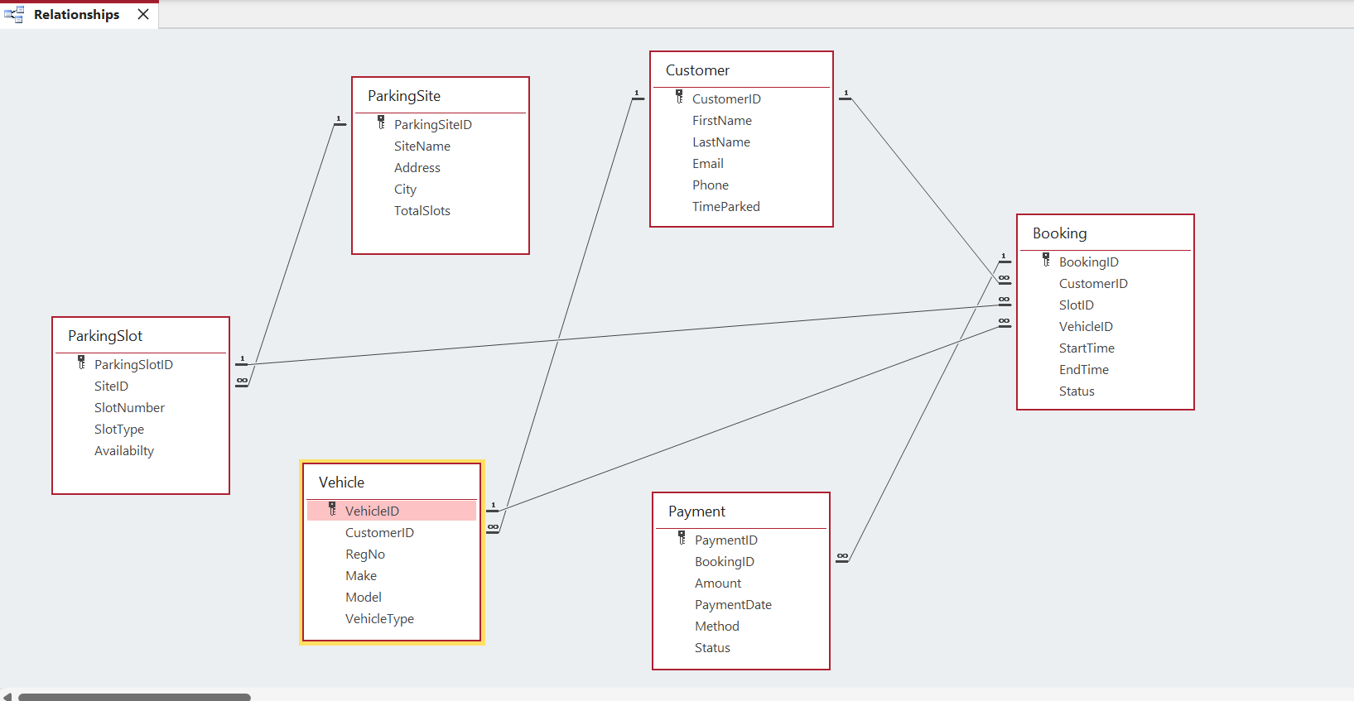

3. Data Structure Development
3.1 Entity, Relationships and Attributes
The Entity Relationship Diagram (ERD) in this section is presented using Chen notation to illustrate the conceptual structure of the AutoPark system. Chen notation focuses on entities, attributes and relationships at a high level, using rectangles, ovals and diamonds to show how data elements relate before implementation. This conceptual model supports the development process by clearly identifying the main entities and their connections within the scenario. The logical implementation of the database is shown separately in Task 2 using Crow’s Foot notation. Presenting the conceptual model here demonstrates understanding of traditional ERD techniques and how they inform later database design.
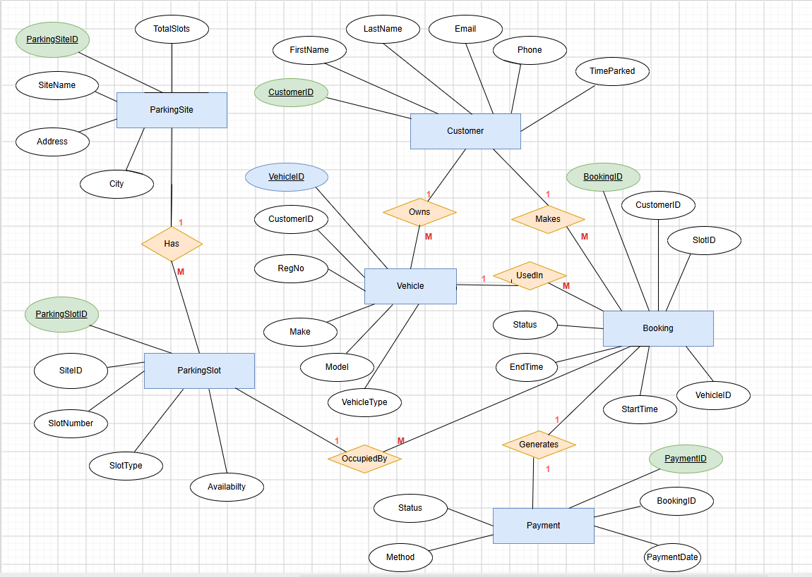
3.2 Table definitions and constraints
Using the ER model as a guide, the database structure was developed by defining each entity as a table and establishing the necessary relationships between them. Appropriate constraints were applied to maintain data integrity and ensure that the system behaves consistently during data entry and retrieval.
- ParkingSite

This table defines each parking site within the system. The primary key is ParkingSiteID, and the fields for the store the site name, address, and city. TotalSlots is stored as a number to represent capacity. These fields match the ERD and ensure each site is uniquely identified and correctly linked to its parking slots.

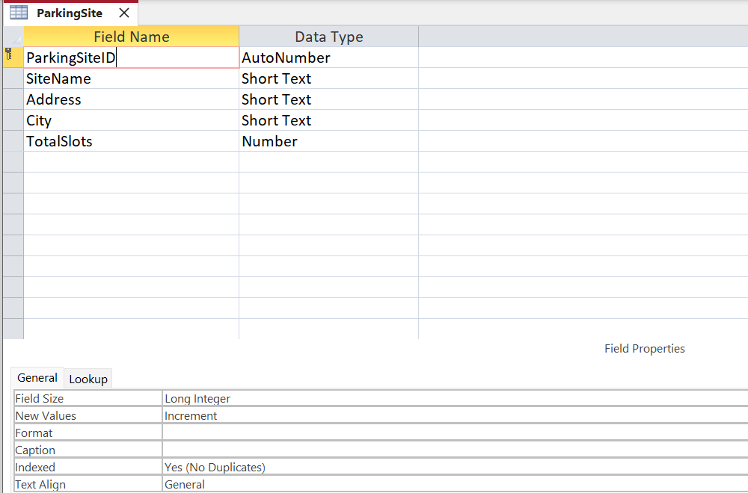

- ParkingSlot
The ParkingSlot table stores individual slot information for each site. SlotID is the primary key, and SiteID is a foreign key linking each slot to its parent parking site. SlotNumber and SlotType use text fields, while Availability is stored as a Yes/No value. This design supports the one-to-many relationship between sites and slots.

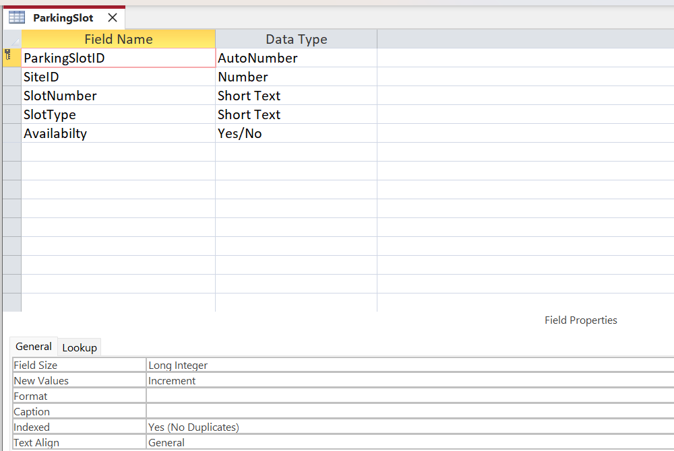
- Customer

The Customer table holds details of registered vehicle owners. CustomerID is the primary key, and fields such as FirstName, LastName, Email, and Phone use text data types. The previously included TimeParked attribute was removed because parking duration varies per booking and can be derived from StartTime and EndTime in the Booking table.

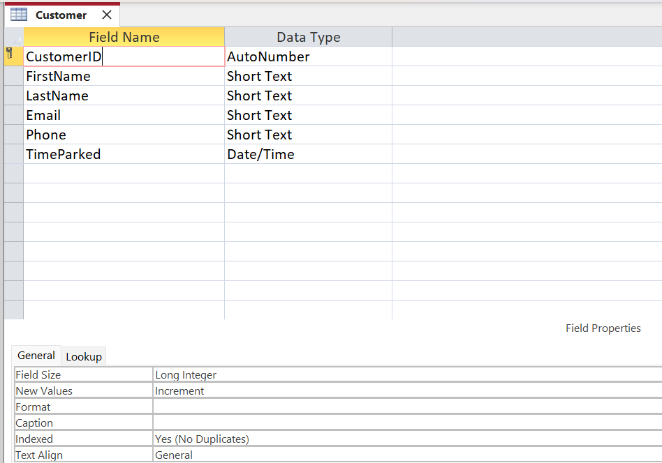

- Vehicle
The Vehicle table records details of each customer’s vehicle. VehicleID is the primary key, while CustomerID acts as a foreign key linking each vehicle to its owner. Text fields are used for registration number, make, model, and vehicle type. This supports the one-to-many relationship between customers and vehicles.

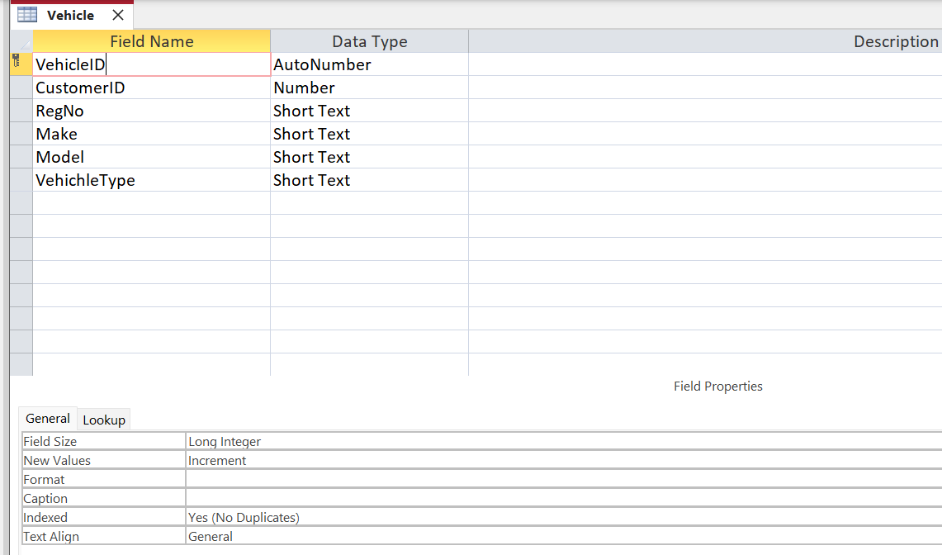

- Booking
The Booking table acts as the central link between customers, vehicles, and parking slots. BookingID is the primary key, and the foreign keys (CustomerID, SlotID, VehicleID) enforce referential integrity. StartTime and EndTime use Date/Time fields. This reflects the workflow of the booking process and prevents many-to-many relationships.

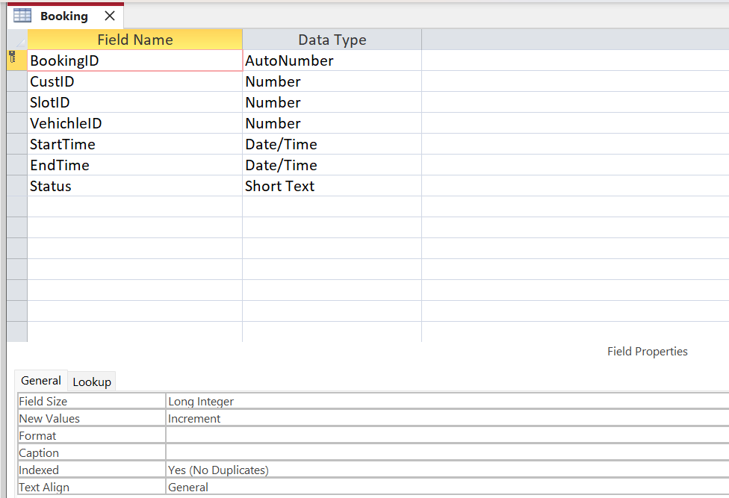

- Payment
The Payment table stores payment details for each booking. The primary key PaymentID, and BookingID is a foreign key creating a one-to-one relationship with the Booking table. Amount is stored as currency, and PaymentDate uses a Date/Time field. This helps to ensures each booking has one corresponding payment record.

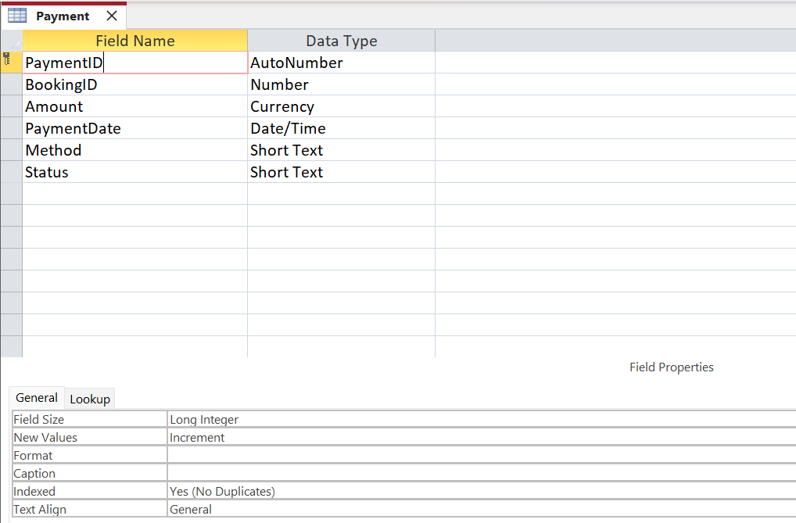

4. Normalisation Compliance (3NF)
The AutoPark Management System database has been normalised to Third Normal Form (3NF) to minimise data redundancy, improve data integrity, and support efficient data storage and maintenance. The normalisation process was applied systematically to ensure that each table contains attributes that depend only on the primary key, with no partial or transitive dependencies.
First Normal Form (1NF)
The database satisfies First Normal Form (1NF) because:
- Each table contains uniquely identifiable records using a primary key (e.g., ParkingSiteID, CustomerID, VehicleID, and BookingID).
- All attributes contain atomic (indivisible) values, such as Phone, Email, and RegNo.
- There are no repeating groups or multi-valued attributes within any table.
Second Normal Form (2NF)
The database satisfies Second Normal Form (2NF) because:
- Every table uses a single-attribute primary key, eliminating the possibility of partial dependencies.
- All non-key attributes are fully functionally dependent on their respective primary key.
For example, in the Vehicle table, the attributes Make, Model, and VehicleType depend entirely on VehicleID.

Third Normal Form (3NF)
The database satisfies Third Normal Form (3NF) because:
- There are no transitive dependencies, meaning that non-key attributes depend only on the primary key and not on other non-key attributes. For Instance, in the Customer table, FirstName, LastName, Email, and Phone depend solely on CustomerID.
- Foreign keys such as CustomerID, VehicleID, and SlotID are used to establish relationships between tables without duplicating customer, vehicle, or parking slot information.
- Each entity stores information relating only to that entity, reducing redundancy and maintaining referential integrity across the database.
Note: The Availability attribute in the ParkingSlot entity represents the current operational status of a parking space. In a fully normalised implementation, this value could be derived from active booking records rather than being permanently stored, depending on the system's performance and business requirements.

5. Sample Data Population
To demonstrate how the AutoPark Management System operates with realistic information, each table has been populated with sample data that reflects genuine use cases. The dataset includes parking sites, parking slots, customers, vehicles, bookings and payments. Each table contains at least 10 records, meeting the assignment requirement and providing enough variation to support meaningful testing and query development.
- ParkingSite - 10 Rows
This table includes multiple parking locations with different capacities and site types. Example entries include sites such as Central Car Park, Riverside Parking, and Station Road Car Park, each with unique addresses and capacity values.
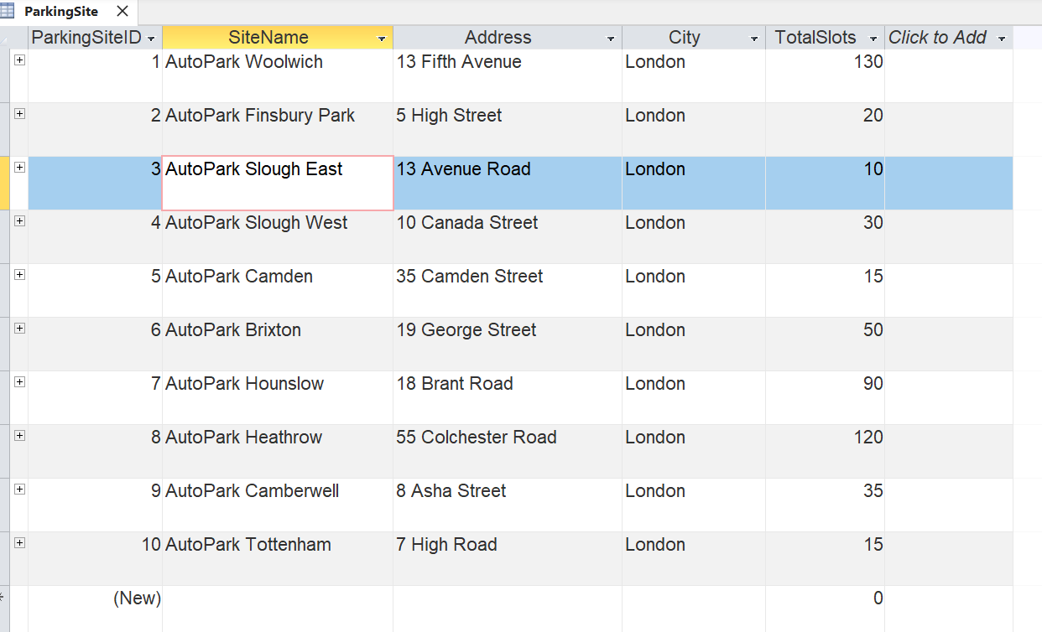
- ParkingSlot - 15 rows
Slots are distributed across the parking sites, with attributes such as SlotType (Standard, Disabled, EV) and Availability. The sample data includes a realistic mix of available and occupied slots across different sites.

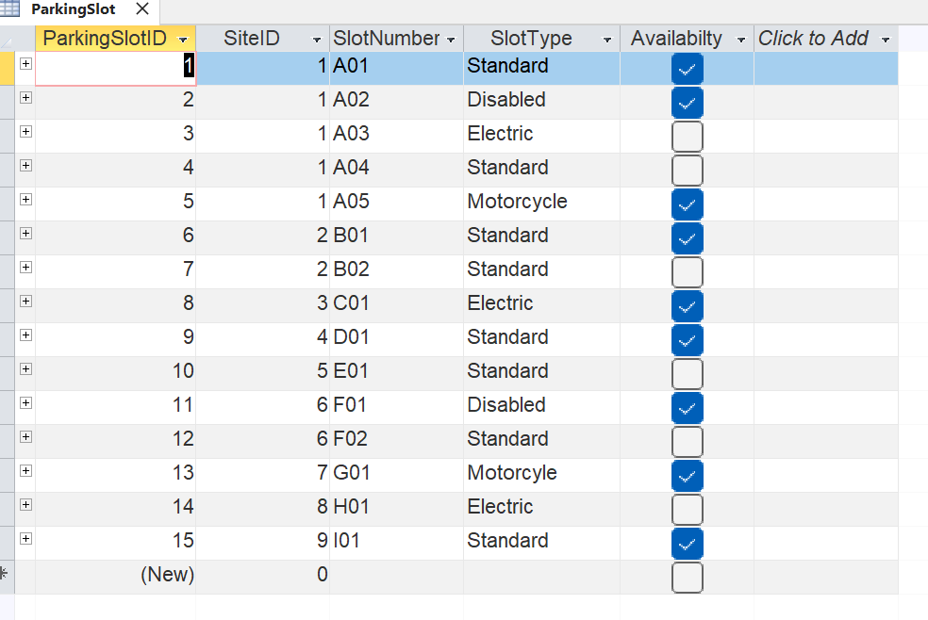
- Customer - 10 rows
Customer records include first name, last name, email, and phone number. The sample data represents a variety of users who regularly use the parking service.
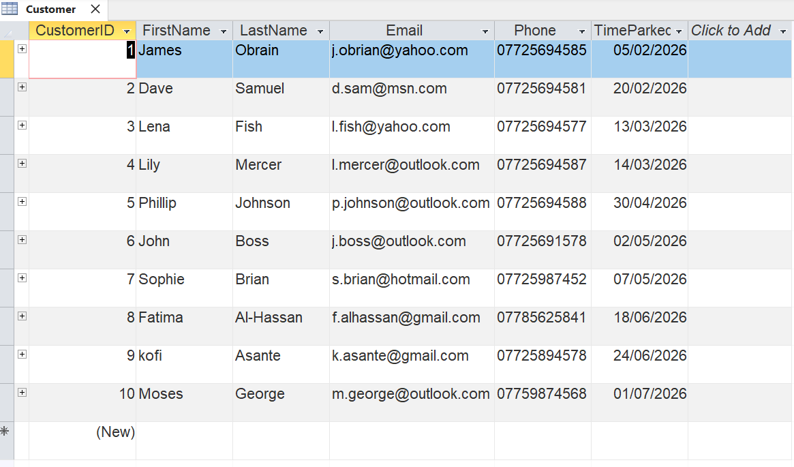
- Vehicle - 12 rows
Each vehicle is linked to a customer and includes attributes such as RegNo, Make, Model, Colour, and VehicleType. The dataset includes a realistic mix of cars, vans, and electric vehicles.
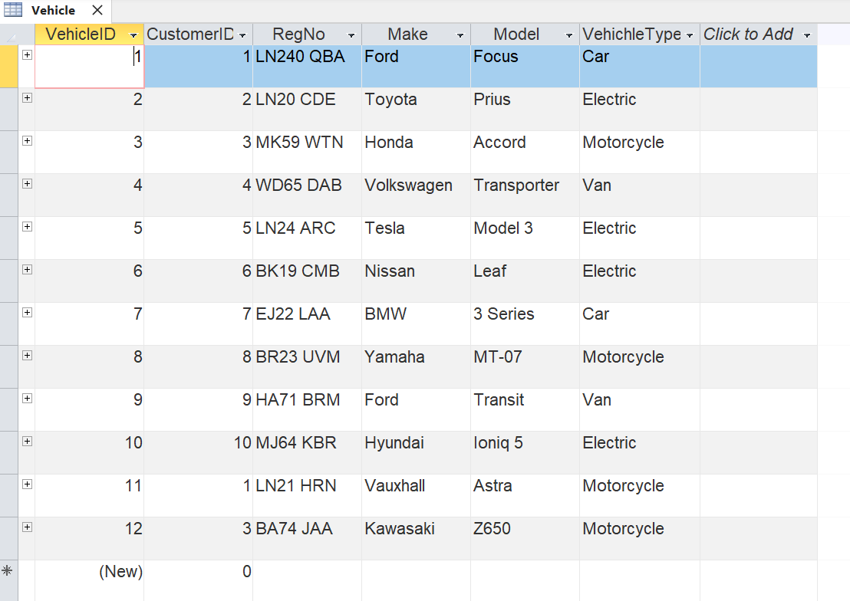

- Booking - 12 rows
Bookings link customers, vehicles, and parking slots. The sample data includes a range of booking dates, durations, and slot assignments, demonstrating typical usage patterns such as short-stay, long-stay, and repeat bookings.

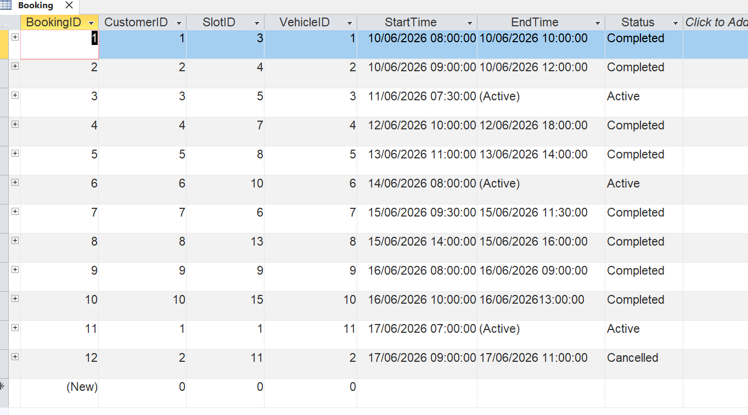
- Payment - 12 rows

Payment records include PaymentDate, Amount, Method (e.g., Card, Cash), and BookingID. The sample data reflects realistic payment behaviour, including varied amounts and payment methods.

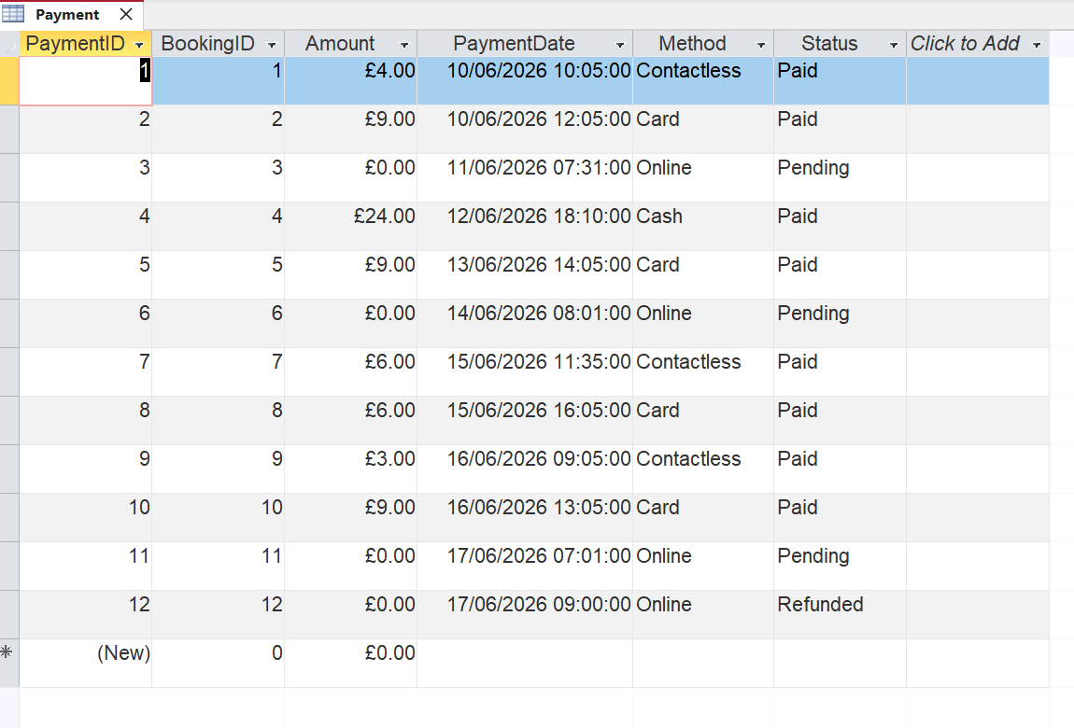

6. Query Development
A series of practical queries were designed and executed in Microsoft Access to show how the AutoPark Management System supports real-world operational tasks. These queries show how staff can check parking availability, view customer activity, monitor vehicle usage, and manage bookings and payments. Each query uses the relationships established in the ERD and the sample data populated in Task 5.
6.1 Query 1: Available Parking Slots
The query joins ParkingSlot and ParkingSite using ParkingSiteID and filters the records where Availability = Yes. This returns only the parking spaces that are currently free. The output lists SlotID, SlotNumber, SlotType, Availability, and SiteName, giving staff a clear overview of all available parking slots across AutoPark sites. Including the SlotNumber provides practical operational detail, allowing staff to identify exactly which specific space is available.
Script:

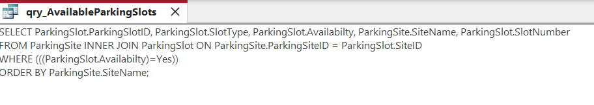
Output:
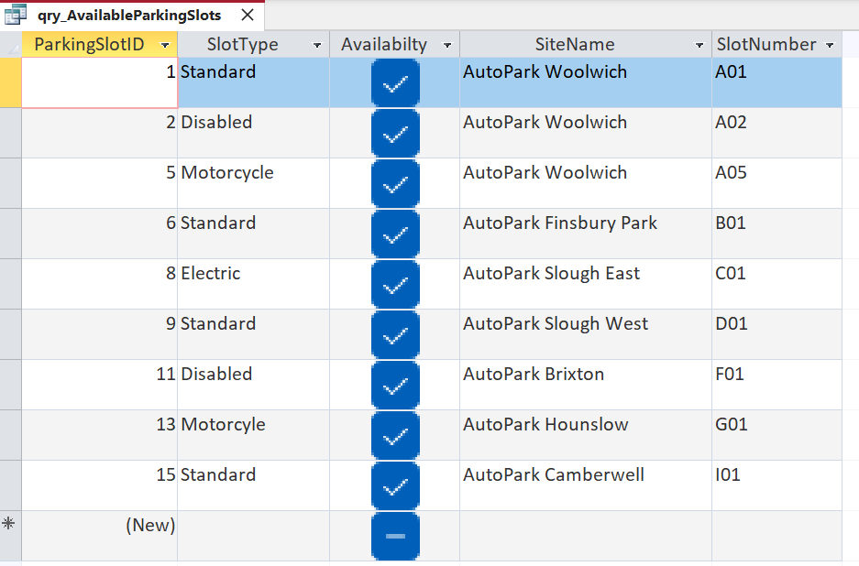
6.2 Query 2: Active Bookings
The query joins Booking, Customer, and Vehicle using CustomerID and VehicleID, and filters records where EndTime Is Null. This returns only bookings that are still in progress. The output lists BookingID, StartTime, EndTime, Status, FirstName, LastName, and RegNo, giving staff a clear view of all currently active bookings across the AutoPark system.
- Script
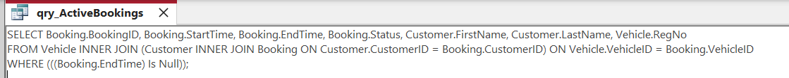
- Outcome
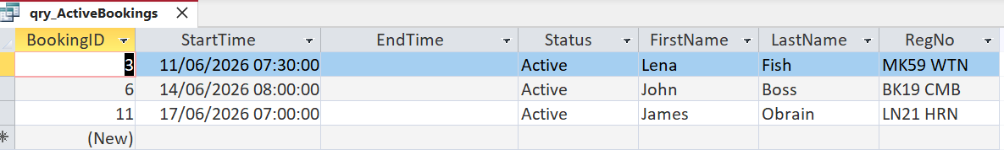
6.3 Query 3: Customer Vehicles
The query joins Customer and Vehicle using CustomerID to show each customer alongside their registered vehicle. The output lists CustomerID, FirstName, LastName, RegNo, Make, Model, and VehicleType, giving staff a clear view of all vehicles linked to each customer across the AutoPark system. This query identifies every customer who has a vehicle recorded, and including full vehicle details provides clearer operational insight when managing bookings, verifying registrations, and supporting day-to-day site operations.
- Script:
- Outcome:
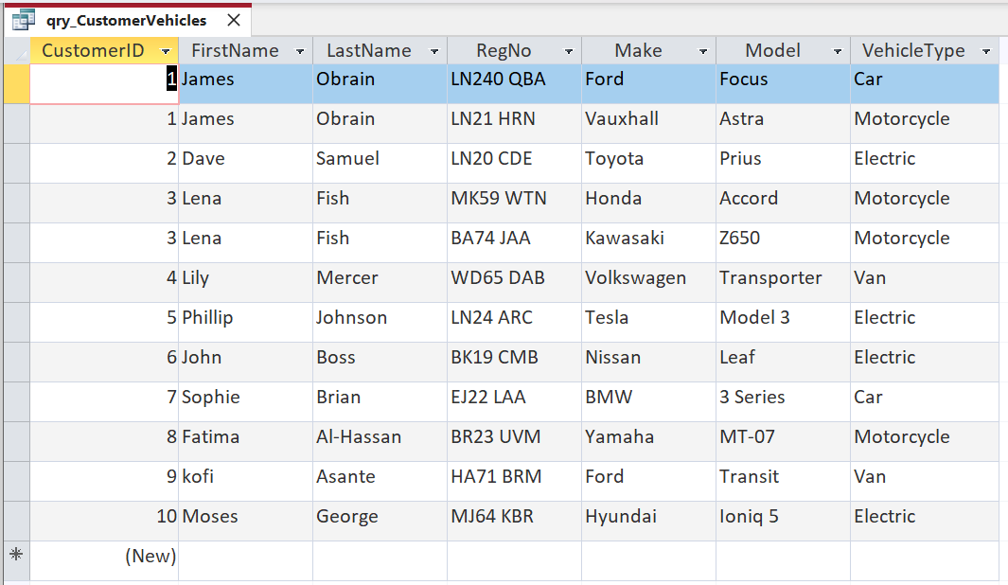
6.4 Query 4: Payments Received (Revenue)
The query joins Payment, Booking, and Customer using BookingID and CustomerID to display all payments linked to customer bookings. It filters the results to show every recorded payment and orders them by PaymentDate for clearer tracking. The output lists PaymentID, Amount, PaymentDate, FirstName, LastName, and BookingID, giving staff a complete view of all payments received across the AutoPark system. This query identifies all revenue generated and highlights which customers made payments, supporting accurate financial monitoring and reporting.
- Script:
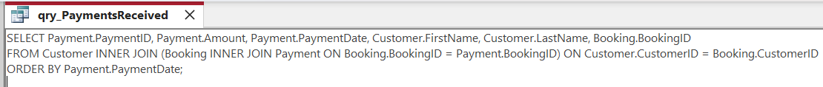

- Outcome:
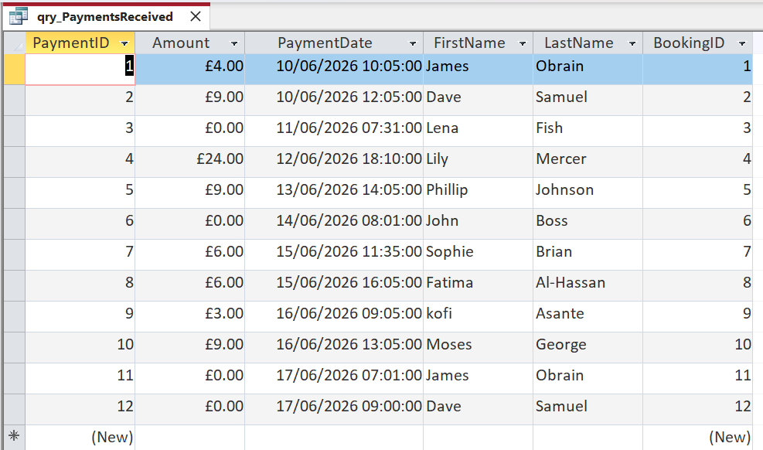

6.5 Query 5: Payments over £5
The query joins Payment, Booking, and Customer using BookingID and CustomerID, and filters the records where Amount > 5 to show only payments above £5. The output lists CustomerID, FirstName, LastName, PaymentID, PaymentDate, Amount, and BookingID, giving staff a clear view of higher-value payments across the AutoPark system. This query identifies customers who paid more than £5 and highlights the bookings that generated greater revenue, supporting financial analysis and reporting.

- Script:
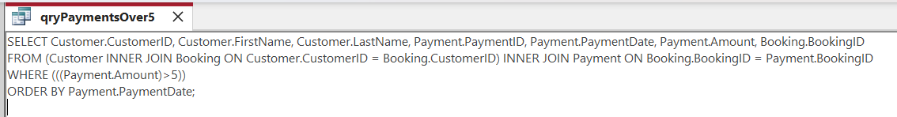

- Outcome:
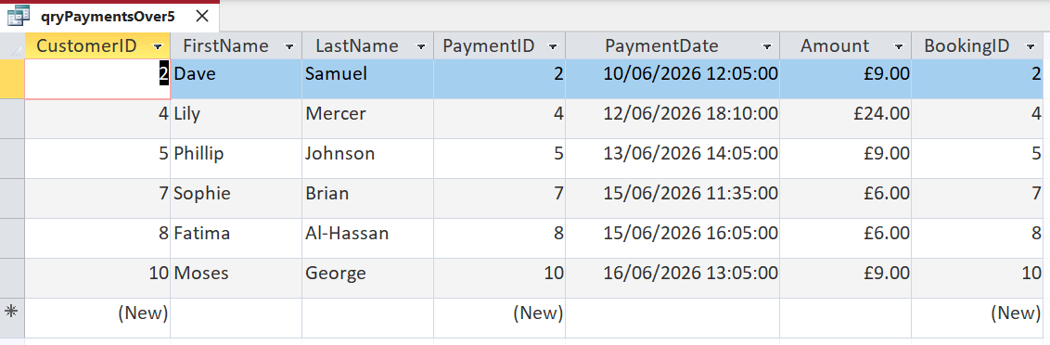

6.6 Query 6: ParkingSite Capacity
The query joins ParkingSite and ParkingSlot using ParkingSiteID and groups the results by site to count how many parking slots are occupied at each site. The output lists ParkingSiteID, SiteName, and the total number of occupied slots per site, giving staff a clear view of current usage across all AutoPark locations. This query identifies how many spaces are in use at each site, supporting planning and operational decision-making.
- Script:
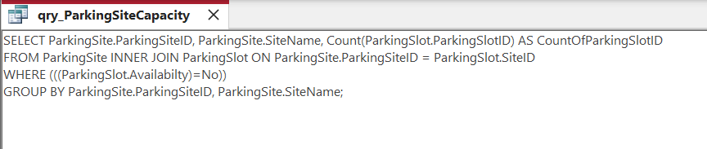

- Outcome:
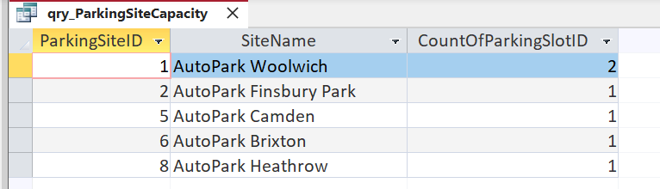
6.7 Query 7: Available Electric Slots
The query joins ParkingSite and ParkingSlot using ParkingSiteID and filters the results to only include electric slots that are currently available. It then groups the data by site and counts how many available electric spaces each location has. The output lists ParkingSiteID, SiteName, and the total number of available electric slots per site, giving staff a clear view of EV-friendly capacity across AutoPark locations.
- Script:
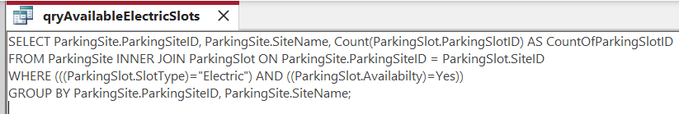
- Outcome:
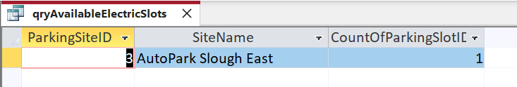

7. Validation and Testing
During the development, several validation errors were encountered in Microsoft Access, such as incorrect data types, missing required fields, and referential integrity violations. These errors confirmed that the database constraints were functioning correctly. Once corrected, all tables and queries operated as expected, demonstrating successful validation and testing.
Ten test cases were executed to confirm the database meets its functional requirements and enforces all integrity rules.
- Validation and test results table:
Test No. | Test Case | Action | Expected Result | Outcome
T1 | Referential Integrity | Delete Customer with linked Vehicles/Bookings | Error: deletion prevented | Pass
T2 | Required Fields | Save ParkingSite without SiteName | Error: required field missing | Pass
T3 | Data Type Validation | Enter text into numeric field (TotalSlots) | Data type mismatch error | Pass
T4 | Slot Availability Validation | Set Availability to invalid value | Value rejected | Pass
T5 | Negative Payment Amount | Insert Amount = -5 | Negative value rejected | Pass
T6 | Query: Available Slots | Run Query 1 | Only Availability = Yes returned | Pass
T7 | Query: Active Bookings | Run Query 2 | Only EndTime = Null returned | Pass
T8 | Query: Customer Vehicles | Run Query 3 | All vehicles linked to customers displayed | Pass
T9 | Query: Payments Received | Run Query 4 | All payments returned in date order | Pass
T10 | Query: Available Electric | Run Query 7 | Only Electric + Available slots returned | Pass

8. System Evaluation, Reflection & Conclusion

The AutoPark database was designed using a structured relational approach to ensure data integrity, efficient storage, and clear relationships between entities. Chen notation was first used to conceptualise the system and identify the main entities and attributes. Crow’s Foot notation was then applied to produce the logical ERD, guiding the implementation of tables, primary keys, and foreign key constraints in Microsoft Access. Normalisation to Third Normal Form (3NF) ensured each table stored only relevant attributes, reducing redundancy and improving maintainability.
A minor modelling improvement was made by removing the TimeParked attribute from the Customer entity, as parking duration can be derived directly from StartTime and EndTime in the Booking table. This adjustment strengthened the design’s alignment with 3NF principles and ensured that each attribute was stored in the correct entity.
During development, challenges such as data type mismatches, relationship errors, and query join issues were resolved through iterative testing, strengthening the final design. Future enhancements could include automated occupancy tracking, dynamic pricing, and improved reporting features. Overall, the database meets the functional requirements of the scenario and provides a reliable foundation for managing AutoPark operations.

References

[1] J. Paredaens, P. De Bra, M. Gyssens and D. Van Gucht,The structure of the relational database model, Springer Science & Business Media, 2012.
[2] J. Berrington, "Databases," vol. 18, no. 3, pp.155–157, 2017,
[3] K. Balog, Entity-oriented search, Springer, 2018.
[4] T. Connolly and C. Begg, "Database Systems A Practical Approach to Design, Implementation, and Management Global Edition by Thomas Connolly, Carolyn Begg - DCS2233 (3)," in Database Systems: A Practical Approach to Design, Implementation, and Management, Global Edition, Ed., Pearson,

