Module: Managing the Customer Experience
Module code: BMSW 5103
Assignment Title: Customer Relationship Management Emerging Themes
Programme: BA Leadership and Management
Tutor: Dr. King
Student: Mihail Croitoru
Student Number: 2124152

Table of Contents
1 Introduction 3
2 Part 1 3
2.1 Customer touchpoints 3
2.2 Customer Experience and Brand Experience 5
2.3 A critical literature review on the customer experience. 8
2.3.1 Firm’s Perspective 8
2.3.2 Co-Creation Perspective 10
3 Conclusion 10
4 References 12

Introduction
Customers are the backbone of a business that helps maintain the profitability and revenue stream of an organisation. However, based on the increasing importance of customers, it is necessary to manage exceptional customer experience. It is the process employed by a firm to track, organise and oversee interaction between the firm and the customer throughout the customer lifecycle. In this report, customer experience and management of Cazoo will be provided.

Part 1

Customer touchpoints
According to Zimand Sheiner and Lahav (2020), customer touchpoints refer to the customer contact points with the brand from the initiation to the finish stage. Customer touchpoints allow for shaping the ways customer views a brand. The interaction with the customer can be through the website of company, an employee, via app or any social media advertisement. Once the basic customer touchpoints are identified, a better and more seamless customer experience can be delivered by the brand. It also helps develop a loyal customer base and will ensure that customers make repeated purchase decisions.
At Cazoo, the focus is on delivering convenient services to the customer. The company aims to transform the way people buy and sell cars across the UK. The tech firm mainly focuses on using technology to connect with the customer and ensure that car buying and selling becomes no different from the ordering of other products online. To achieve the core mission of the company, a customer-obsessed value is fostered by the firm by putting the customer at the heart of every function (Cazoo, 2023). In addition to this, to further diversify the customer experience, Cazoo focuses on various customer touchpoints to ensure that the potential customer is transformed into a loyal customer for the firm. A major focus of the company is to connect with the customer via the use of digital touchpoints. This type of customer touchpoint is based on the interaction via the use of the website or the mobile application of the company. The digital touchpoints also allow one to anticipate the needs of the customer and ensure that they end up making the purchase decision (Gerea and Herskovic 2022).
At Cazoo, buying a car is convenient and completely online. Customers interact with the business by visiting the company website and browsing the wide range of great value and high-quality used cars at Cazoo. After the customer selects the desired car, the website presents two options for the customer. The customer can either buy outright or can even apply for car finance by signing all agreements online. The next is to choose the delivery or collection option and an appropriate time slot within 72 hours to get the car delivered to the doorstep between 7 am-9 pm. The last digital touchpoint of customers at the Cazoo website is the option to enjoy the car for 7 days and can claim a full refund if the customer decides to change their purchase decision. For 7 days, the customer is allowed to drive for up to 250 miles.
The tech firm also maintains customer touchpoints, allowing them to interact with the firm for any queries using Cazbot. Behera et al. (2021) provided that Chatbots serves as a brand touchpoint and improve customer experience and management by providing quick response to customer questions and extending support services. Therefore, at Cazoo, customer service Cazbot has been maintained to extend better and more precise customer experience.
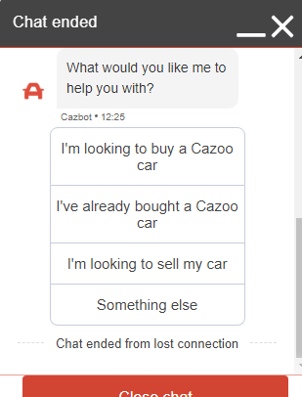
Figure 1: Cazoo Cazbot
Furthermore, Tivasuradej and Pham (2019) provided that customer touchpoint fuels the passion of customers towards the brand and ensured that a value proposition is created. However, to achieve this value proposition, the use of social media channels and other electronic media is particularly useful. Cazoo interacts with its customer using three major social media channels, including Instagram, Twitter and Facebook. Social media serves as a direct touchpoint employed by businesses to leverage customer experience and cater to the needs of the customer better. Cazoo ensures to provide customers with visually appealing experiences on social media. The interactive videos, pictures, and customer testimonials are all essential elements that are focused on by the brand to ensure that customers are captivated by the visuals and immediately make a purchase decision. Social media channels also serve to create a positive image of the brand. The use of social media and other digital channels does not serve as a sales channel; rather, it helps the brand to build a relationship and connect with the customer, which would help lead sales and drive performance for the company.

Customer Experience and Brand Experience
Customer experience and brand experience are both focused towards engaging and delighting the customer. The focus of the brand experience is to cater for the needs and desires of customers even before they become part of the business or engage with the business. A business is liable to communicate brand experience by making use of multiple channels such as product offers, paid media, taglines and website. The key element of brand experience is based on the recognisable and consistent design, which is then made in used to develop effective marketing campaigns. The goal of the overall brand experience is to establish a loyal customer base for the business (Mostafa and Kasamani, 2021). At Cazoo, a major focus is given to providing an exceptional brand experience to the customer. By fostering brand awareness and ensuring the use of the right channel, the company focus on establishing a lasting impression of the brand on the customers. With the increasing focus on brand experience, Statista (2022) stated that the brand awareness of Cazoo amongst UK customers is approximately 74%. This indicates that the company successfully delivers the desired brand experience.
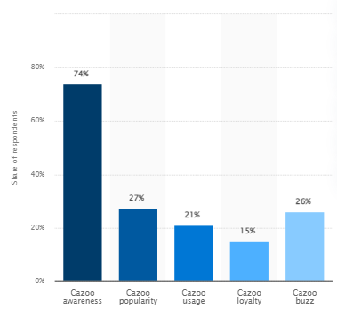
Figure 2: Brand Awareness of Cazoo
(Source: Statista 2022)
In the view of Olson et al. (2021), brand experience is heavily dependent on advertising and marketing strategy. At Cazoo, the brand increased its marketing spending to approximately £45m.
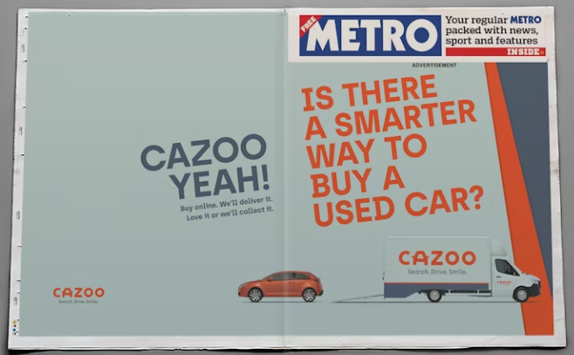
Figure 3: Marketing Adverts of Cazoo
(Source: Marketing Week 2022)
In addition to this, the brand experience can also be described as the feelings, thoughts, reactions and perceptions of customers to the large-ad scale campaign and direct marketing efforts of a firm. To witness exceptional brand experience, Cazoo in 2020, has also launched a new national marketing campaign. The campaign includes radio and TV ads together with outdoor creative prints with the aim to celebrate the convenience and comfort brought about by the online buying process. The ad campaign also focused on celebrating the joy customer experience when they buy a used car from Cazoo. The campaign has been advertised across Sky channels, ITV and across the entire Global radio network. The use of outdoor sites with the busiest environment was also made in used to deliver an exceptional brand experience. The brand also featured as a main shirt sponsor for Aston Villa and Everton (Cazoo 2020).
Contrary to brand experience, Becker and Jaakkola (2020) describe customer experience as the holistic perception or the subjective response of the customer across the various aspects of the buyer's journey. It also refers to the ways in which a company interact with the customer at all stages of the customer journey. From the customer feedbacks preset at Trustpilot, it is visible that the brand ensures clear communication throughout the customer journey to ensure that exceptional customer services are offered and the customer makes the decision of repetitive purchases. To further explain the customer experience at Cazoo, the use of a customer journey map is appropriate.
For the customer journey map, there are five stages; these include creating awareness, searching for the product, considering important features and other aspects, support and the purchase decision. The below table sheds light on the customer journey of Cazoo.

 | Awareness | Search | Consider | Support | Purchase
Actions | -Need to buy a second-hand car at an affordable price range and at the convenience of doorstep. | -Browse the cars on various websites.  -Compare the price and the quality  -Taking into account the feedback of customer  -Looking for similar products | -Make a decision to buy a high-quality car.  -Compare three cars on the basis of quality and price | -Contact Cazoo support  -Receives help via Cazbot  -Cazbot offers the best solutions.  -Also, consider the FAQs and testimonials before making a purchase decision. | -The most preferable product is brought.  -An order confirmation email is received  -Product received within 72 hours.  -7-day return policy

Cazoo has also made efforts to ensure that when customer visits the website to make a purchase decision, they are provided with convenient and simple solutions. To further enhance their customer experience, the website also provides filters that ease the selection of the product. The filter includes the selection of cars based on model, price, year, mileage, gearbox and engine, body type and colour. Additionally, when the customer is pleased by the price and model of the car, the website provides a 360-degree view of the car that further makes it easier for the customer to make a purchase decision. Thus, the company has demonstrated exceptional efforts to yield profound customer and brand experience.

A critical literature review on the customer experience.

Firm’s Perspective
According to Lemon and Verhoef (2016), customer experience refers to the establishment of a relationship between a firm and the customer. However, when considering the firm’s perspective of customer experience, it is commonly known that customers are kept at the heart of the business operations as their satisfaction serves as a stream of revenue for the firm. In order to keep the business productive and to ensure continuity and success, the firm’s perspective of customer experience is always kept positive. Within information technology firms, the focus on automation ensures that customer service is quicker and more responsive, allowing better and improved customer outcomes. With the aid of automation, firms are able to assess the buying behaviour and preferences of the customer and are therefore able to increase retention and generate a loyal customer base. Information technology firms are also able to deliver better-individualised attention and a faster response time to address the changing needs and want of the customer. At Deliveroo, the organisation is of the view that great reviews attract customers. In addition, the firm’s perspective of Deliveroo in shaping customer experience is based on five value propositions. These include availability, selection, experience, price and love for the brand. The company is also focused on improving the customer experience via the use of in-app search and discovery, fast, reliable delivery and better ordering and tracking facility. The Plus subscription program of Deliveroo further enhances customer experience and provides them with additional rewards. Deliveroo is well aware that the customer wants a contactless and reliable experience and, therefore, the organisation allows the customer to interact with the in-app search option and faster tracking to ensure that customer satisfaction is maintained and beneficial organisational and customer outcomes are yielded (Deliveroo 2023).
Contrary to this, Shi et al. (2020) provided that IT firms are of the perspective that technology is an ideal way that shapes customer experience and therefore, the tech firm takes advantage of the latest technological advancement in shaping the customer experience. With the growing risk of cyber-attacks, it is important to strengthen cyber risk management. The IT firm targets the business and consumers’ pain point and ensure it provides them with a solution that helps yield beneficial organisational and product outcomes. Furthermore, Cambra-Fierro et al. (2021) stated that firms usually invest in terms of customer experience as they believe that it will ultimately provide relevant financial returns. Since the customers are surrounded by a market full of opportunities, and therefore the firm’s perspective regarding the market turbulence needs to be taken into account when focusing on customer experience and customer retention. The tech firms, therefore, keep an eye on the changing customer trends and quickly respond to their changing needs with the advancement of technology. This helps yield a positive customer experience.

Co-Creation Perspective
The co-creation perspective serves as a business strategy that emphasises interactive relationships and customer experience. It encourages and allows active involvement and collaboration from the customer and provides them with a value-rich experience. In the view of Buhalis and Sinarta (2019), the co-creation perspective serves as a corporate philosophy or a mindset and transforms the customer experience by indulging the customer in the initiatives taken by the brand. This makes the customers feel valued and respected, and a mutually-valued outcome is generated. Furthermore, the co-creation perspective also helps establish deep brand loyalty and extends innovative efforts.
Several Informational technology firms have raised a major focus on the co-creation perspective that helps shape the exceptional customer experience and delivers likely outcomes that help the firm outstand in the competitive business environment. The organisation believes that collaboration is everything, and if something is meant to happen, then ensuring that everyone is on board is necessary. Therefore, based on the co-creation perspective, the organisation needs to indulge its customers and employees in the key decision-making process.
For example, a popular tech firm, Monzo, has also taken advantage of the co-creation perspective to boost customer experience and ensure that relevant outcomes are achieved by the organisation. According to Kiplagat (2020), Monzo has been able to build a community that comprises engaged advocates. This helps them establish meaningful relationships and engagements with the customer and interact with them at all aspects of the decision-making. The organisation believes that customer loves to be heard, and therefore involving and indulging them in the co-creation process can help yield productive outcomes. Monzo also categorised the active members of the community by using the Coral Crew, which is a community leader programme where the members are awarded titles and badges. Thus, it can be said that the firms have rested a major focus on the co-creation perspective to achieve an inclusive work environment and ensure that customers are aware of the company’s process and consider them an important asset for the organisation.

Conclusion
Based on the overall discussion, the importance of shaping customer experience has been analysed. The focus of part ‘a’ was mainly on the customer touchpoint, customer experience and brand experience at Cazoo. It has been identified that Cazoo has been working exceptionally well in terms of shaping the customer experience, which contributes to the success of the organisation. On the contrary, part 'b' emphasised two major perspectives that help shape the customer experience. These were the firm’s perspective and the co-creation perspective. By focusing on these two areas, the information technology firm is able to deliver exceptional customer experience.

References
Becker, L. and Jaakkola, E., 2020. Customer experience: fundamental premises and implications for research. Journal of the Academy of Marketing Science, 48, pp.630-648.
Behera, R.K., Bala, P.K. and Ray, A., 2021. Cognitive Chatbot for personalised contextual customer service: Behind the scene and beyond the hype. Information Systems Frontiers, pp.1-21.
Buhalis, D. and Sinarta, Y., 2019. Real-time co-creation and nowness service: lessons from tourism and hospitality. Journal of Travel & Tourism Marketing, 36(5), pp.563-582.
Cambra-Fierro, J., Gao, L.X., Melero-Polo, I. and Trifu, A., 2021. How do firms handle variability in customer experience? A dynamic approach to better understanding customer retention. Journal of Retailing and Consumer Services, 61, p.102578.
Cazoo 2020. Cazoo set to launch new national marketing campaign. [Online] Available at https://www.cazoo.co.uk/press/cazoo-set-to-launch-new-national-marketing-campaign/
Cazoo 2023. About Cazoo. [Online] Available at https://www.cazoo.co.uk/
Deliveroo 2023. Consumers. [Online] Available at https://corporate.deliveroo.co.uk/our-marketplace/consumers/
Gerea, C. and Herskovic, V., 2022. Transitioning from multichannel to Omnichannel customer experience in service-based companies: Challenges and coping strategies. Journal of Theoretical and Applied Electronic Commerce Research, 17(2), pp.394-413.
Kiplagat A. 2020. How Monzo Built A Modern Bank From Scratch Through Brand Advocacy. [Online] Available at https://www.hyvespace.com/how-monzo-built-a-modern-bank-from-scratch-through-brand-advocacy/
Lemon, K.N. and Verhoef, P.C., 2016. Understanding customer experience throughout the customer journey. Journal of marketing, 80(6), pp.69-96.
Marketing Week 2022. Cazoo to slash brand to one-third of marketing spend by 2023. [Online] Available at https://www.marketingweek.com/cazoo-slash-brand-marketing-spend/
Mostafa, R.B. and Kasamani, T., 2021. Brand experience and brand loyalty: is it a matter of emotions?. Asia Pacific Journal of Marketing and Logistics, 33(4), pp.1033-1051.
Olson, E.M., Olson, K.M., Czaplewski, A.J. and Key, T.M., 2021. Business strategy and the management of digital marketing. Business horizons, 64(2), pp.285-293.
Shi, S., Wang, Y., Chen, X. and Zhang, Q., 2020. Conceptualization of omnichannel customer experience and its impact on shopping intention: A mixed-method approach. International Journal of Information Management, 50, pp.325-336.
Statista 2022. Cazoo brand awareness, usage, popularity, loyalty, and buzz among car and motorcycle online shop users in the UK in 2022. [Online] Available at https://www.statista.com/forecasts/1252196/cazoo-car-and-motorcycle-online-shops-brand-profile-in-the-uk
Tivasuradej, Y.C.T. and Pham, N., 2019. Advancing customer experience practice and strategy in Thailand. Asia Pacific Journal of Marketing and Logistics, 31(2), pp.327-343.
Zimand Sheiner, D. and Lahav, T., 2020. Managing marketing communications: Customer-initiated contact on Israeli Facebook brand pages. Qualitative Market Research: An International Journal, 23(3), pp.363-379.

