Portfolio
Resilience,
Talent
and Technology

Module Tutors:
Julie Hayward and Gareth Hughes
Student:
Xi Jiang (Sissi), 1811683
Data: 04/11/2019


Contents
Graphic Content 3
Chosen organization background-- Salesforce.com 4
Reference 5
1. PESTLE analysis for attract talent 7
Reference 11
2. Labour market trends 15
Reference 22
3. Human resource planning TED Talk 26
Ted Talk Link 26
Reference 27
4. Tailor(adjust) its HRM policy (aimed at a senior management audience) 29
Reference 33
5. Human resource planning TED Talk 36
Slideshow link: 36
6. Atkinson’s Flexible Firm Model 37
Reference: 40
7. Create a model 44
Reference: 46

Graphic Content
Figure 1.1 Salesforce.com on PESTEL analysis
Figure 2.1 Basic indicators comparation between China and U.S.
Figure 2.2 The countries with the most STEM graduates
Figure 2.3 Gig work as the source of income in selected countries in 2018
Figure 2.3 Global AI talent quantity "heat map"
Figure 3.1 Outline of Human resource planning
Figure 4.1 Culture dimension between China and U.S.
Figure 4.1 Salesforce.com’ s perks and benefits
Figure 7.1 Resilient Human Resource Practice Model

Chosen organization background-- Salesforce.com
Salesforce.com was founded by Marc Benioff (former Oracle executive), Parker Harris, Frank Dominguez, and Dave Moellenhoff, as an U.S. high-tech company based in San Francisco, California (Benioff and Adler,2009). Owing to steady growth, it has now expanded all over the world by providing multiple cloud computing products such as Customer Relationship Management (CRM) (SaaS platform); Community Cloud, Analytics Cloud, IoT Cloud, App Cloud (PaaS platform); AppExchange and newest Salesforce AI – Einstein. According to the 2018 records, it has 25,000 employees and $8.39 billion in revenue (Salesforce.com, 2019).
Salesforce.com has been ranked No.2 in 2019 Fortune “100 Best Companies to Work For”, No. 1 in Forbes “The World's Most Innovative Companies 2018”, No. 7 in the list of “the world's top 30 listed Internet companies 2019”; No. 49 in Fortune list of "companies that changed the world 2019"(Salesforce.com, 2019).
Through a period of significant growth over the last ten years, Salesforce.com has shifted its focus from an organization-centric approach to ecosystem-centric to cope with today’s complex and volatile, uncertainty, ambiguous business environment. Having announced a strategic partnership with Alibaba.com, Salesforce.com is now looking to expand its operations offering a variety of services (including sales cloud, service cloud, business cloud and Salesforce platform) and opening new offices in China. (Salesforce.com, 2019; baike.com, 2019; Vanian, 2019; Forbes.com, 2019; Greatplacetowork.com,2019).
Salesforce operates on 4 core values: trust, growth, innovation, and equality.
Salesforce has been implementing the 1/1/1 model of philanthropy for many years, giving 1% of its equity, 1% of its profits and 1% of its employees' time to charity. This is a huge investment that many companies can learn from. (Salesforce.com, 2019)

Reference
Baike.baidu.com. (2019). Salesforce. [online] Available at: https://baike.baidu.com/item/Salesforce.
Benioff, M. and Adler, C., (2009). Behind the cloud: the untold story of how Salesforce. com went from idea to billion-dollar company-and revolutionized an industry. John Wiley & Sons.
Forbes.com. (2019). [online] Available at: https://www.forbes.com/innovative-companies/list/#tab:rank.
Greatplacetowork.com. (2019). Great Place to Work United States. (2019). 2019 Fortune 100 Best Companies to Work For®. [online] Available at: https://www.greatplacetowork.com/best-workplaces/100-best/2019.
Liao, R. (2019). Alibaba to help Salesforce localize and sell in China – TechCrunch. [online] TechCrunch. Available at: https://techcrunch.com/2019/07/24/alibaba-salesforce-partnership-asia/.
Salesforce.com. (2019). About us. [online] Available at: https://www.salesforce.com/cn/company/about-us/.
Vanian, J. (2019). Salesforce Just Bought MuleSoft, an IT Company That Went Public Last Year. [online] Fortune. Available at: https://fortune.com/2018/03/20/salesforce-mulesoft-acquisition-deal/.

1. PESTLE analysis for attract talent
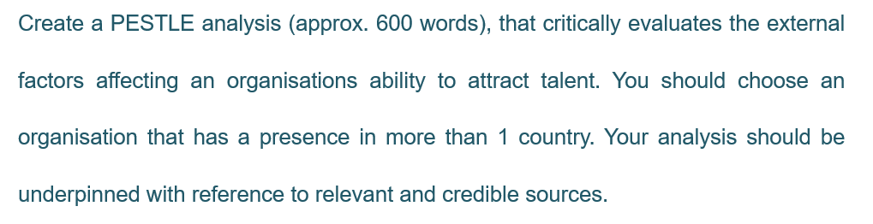
PESTEL analysis, first formulated by Harvard professor Francis Aguilar, consist of various factors to indicate external business environment influence. With these detailed potential operating challenges insights, Salesforce.com can collect qualitative external data to instruct workforce planning (Murphy, 2019; Pratap, 2019; Armstrong, 2017). A highly profitable Industry(economic) will not be beneficial Salesforce.com if is located in an unstable political environment. Consequently, several key factors have been listed and analysed which would influence how Salesforce.com operates in China during the context of the fourth industry revolution.
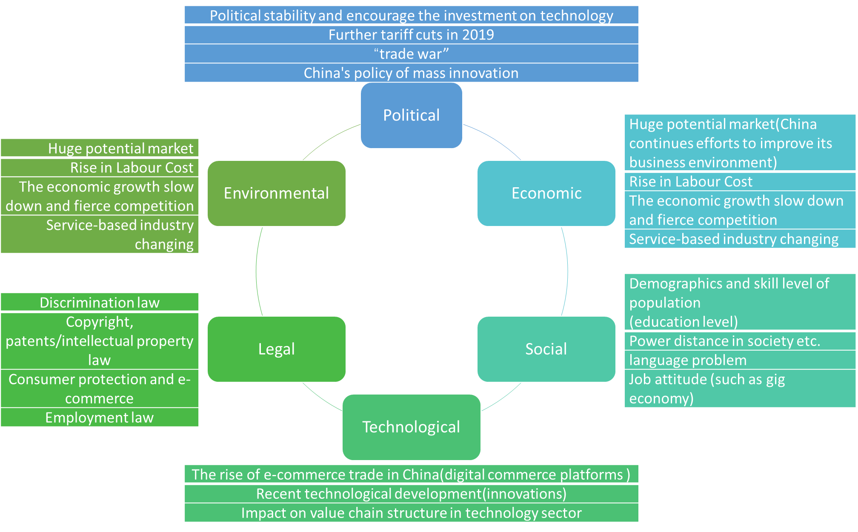
Figure 1.1 Salesforce.com on PESTEL analysis

Armstrong (2017) lists 10 detailed process to recruit and select talent, need identify/evaluate/intervene applicants’ sources with effectively, efficiently, lawfully and professionally select/manage activities (Tylor, 2018), Salesforce.com need to analysis its own requirements and the strengths/ weaknesses of it as an employer in China, identify and predicted sources of candidates Salesforce.com:
- Stable political, high potential market and environmentally friendly society provide a basic environment for a healthy talent pool
Peace and development are the two main themes of the world today. President of China Xi Jinping stressed the need to maintain political stability in recent open speech (Cheng, 2019) and announced further tariff cuts in 2019 in G20 Osaka Summit after four cuts in 2018(7.5%).
- ‘Trade War’ may lead to higher cost of talent attraction
Massive media indicate that wide-ranging tariff increases will cause a large prolonged trade dispute could not only hurt business sentiment (include IT industry), investment spending and employment (BBC News, 2019; Putz, Mirhaydari and Clark, 2019), although the list of impose tariffs is on tertian goods (Romans, 2019; Shane, 2018; South China Morning Post, 2018). Millions jobs will at risk due to global trade wars (HRM Asia Newsroom;2018), and will cause the shortage of chip designer, software develop engineers, data analyses and so on.
- The economic growth slow down and fierce competition will increase the cost of talent attraction
Ranked No. 86 in world UN’s HDI (Human Development Index) in 2017, No. 32 best place doing business in 2018 and owing to economic reforms, ‘opening up’ policy, its growing status as a consumer market, supplier and provider of capital, China practiced rapid economic growth( 10%average from 1970s to 2010, doubled size each eight years).There is still room for China to deepen its integration despite the fact that it has already become one of the world's two largest economies with U.S. with global influence, which means great opportunities (Gov.uk, 2019; Xinhuanet.com, 2019). The annual growth rate of China's SaaS market reached 19%, and the market size reached 45.2 billion yuan. According to IDG's statistics, it is estimated that by 2020, the size of China's SaaS market will reach 182.49 billion yuan, with a compound annual growth rate of 26.7% from 2015 to 2020. (Stats.gov.cn, 2019; World Bank, 2019;iReach, 2018; Zhang, 2019)
- Higher education level increases the likelihood to find appropriate candidates
As Chinese population growing, 170.9 million people holding colleges or universities’ degrees in 2016, which is better than world average(China daily, 2016), especially compare with 20% high school graduates in 1980s(Levin, 2010; Mike, 2018). Over 1,200,000 IT professionals and Adding 400,000 Hi-tech graduates every year in China. (Fang, 2007)
- Government encourage technology innovation will accelerate the speed of talent attraction and also will attract a diverse range of candidates
Emphasise on technology commercialisation’s innovation and invest--AI market, Big data industry, Internet of things, China embrace international collaboration. Partnering with Chinese companies Alibba.com (Salesforce.com, 2019; Wipo.int, 2018; New,2019) which has world-leading facilities can help Salesforce.com unlock new markets. Furthermore, marketing techniques to reach their customers and prospective consumers as well as the process of attracting talent.
Above all, we can see the process to talent attraction will become quicker but more expensive to Salesforce.com.

Reference
Armstrong, M., (2018). Armstrong’s handbook of human resource management practice.14th Edition. Kogan Page Publishers.
BBC News. (2019). US-China trade war in 300 words. [online] Available at: https://www.bbc.co.uk/news/business-45899310.
Chinadaily.com.cn. (2016). As country's population has grown, so has the level of higher education - China - Chinadaily.com.cn. [online] Available at: https://www.chinadaily.com.cn/china/2016-04/21/content_24714296.htm.
Cheng, E. (2019). China's Xi: 'No force can stop the Chinese people and the Chinese nation'. [online] CNBC. Available at: https://www.cnbc.com/2019/10/01/china-70th-anniversary-xi-says-no-force-can-stop-the-chinese-people.html.
Delhi, N. (2019). Global Innovation Index 2019: India Makes Major Gains as Switzerland, Sweden, U.S., Netherlands, U.K. Top Ranking; Trade Protectionism Poses Risks for Future Innovation. [online] Wipo.int. Available at: https://www.wipo.int/pressroom/en/articles/2019/article_0008.html.
Great.gov.uk. (2019). China market guide - great.gov.uk. [online] Available at: https://www.great.gov.uk/markets/china/.
iResearch.cn. (2019). 2019 cloud market report. [online] Available at: http://report.iresearch.cn/report/201909/3439.shtml.
HRM Asia Newsroom, H. (2018). Millions at risk of losing jobs due to global trade wars | HRM Asia. [online] HRM Asia. Available at: http://hrmasia.com/millions-at-risk-of-losing-jobs-due-to-global-trade-wars/.
Levin, D. (2010). The China Education Boom on U.S. Campuses. [online] Nytimes.com. Available at: https://www.nytimes.com/2010/11/07/education/07china-t.html.
Mike, C. (2018). Education in China | Key Facts & Statistics - China Mike. [online] China Mike. Available at: https://www.china-mike.com/facts-about-china/facts-chinese-education/.
Murphy, F. (2019). Salesforce com Inc PESTEL & Environment Analysis. [online] Essay48. Available at: https://www.essay48.com/term-paper/15423-Salesforce-com-Inc-Pestel-Analysis.
Pratap, A. (2019). Salesforce.com SWOT Analysis. [online] notesmatic. Available at: https://notesmatic.com/2018/09/salesforce-com-swot-analysis/.
Putz, A., Mirhaydari, A. and Clark, K. (2019). How Trump's Trade War With China Will Affect U.S. Investment Markets. [online] Seattle Business Magazine. Available at: https://www.seattlebusinessmag.com/finance/how-trumps-trade-war-china-will-affect-us-investment-markets.
Romans, C. (2019). US and China trade war: Two steps forward, three steps back. [online] CNN. Available at: https://edition.cnn.com/2019/10/29/investing/us-china-trade-war/index.html.
Shane, D. (2018). China fires back, announcing tariffs on US planes, cars and soybeans. [online] CNNMoney. Available at: https://money.cnn.com/2018/04/04/news/economy/china-tariffs-us-goods-soybeans/index.html.
South China Morning Post. (2018). US concerns about impact of China trade war growing. [online] Available at: https://www.scmp.com/news/china/diplomacy-defence/article/2160932/us-concern-about-impact-china-trade-war-jobs-and-prices.
Stats.gov.cn. (2019). Spokesperson of the National Bureau of Statistics answered questions on the performance of the national economy in 2019. [online] Available at: http://www.stats.gov.cn/tjsj/sjjd/201910/t20191018_1703403.html.
Wipo.int. (2018). World intellectual property index. [online] Available at: https://www.wipo.int/publications/en/details.jsp?id=4369.
World Bank. (2019). China Overview. [online] Available at: https://www.worldbank.org/en/country/china/overview.
Xinhuanet.com. (2019). The world's economic depend more on China. [online] Available at: http://www.xinhuanet.com/finance/2019-07/07/c_1210182505.htm.
Zhang, Y. (2019). Will three strategies of Salesforce.com work in China? [online] Cloud.tencent.com. Available at: https://cloud.tencent.com/developer/article/1070522.

2. Labour market trends
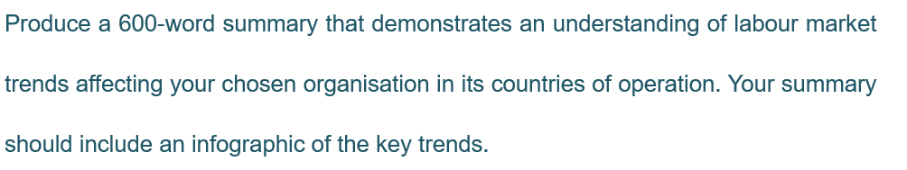
Labour market trends analysis can collect quantitative external data to instruct workforce planning (Armstrong, 2018), while understanding the macro-economic context organisation could shape their HR practice(recruit, retain, motivate and develop employee) in alignment with organisational strategies(CIPD,2019).
Basic indicators (GDP, Inflation Rate, Total population, Employed persons, Unemployment Rate, Wages) will give us an indication of the comparison of China and U.S. which will impact the operation strategies of Salesforce.com.

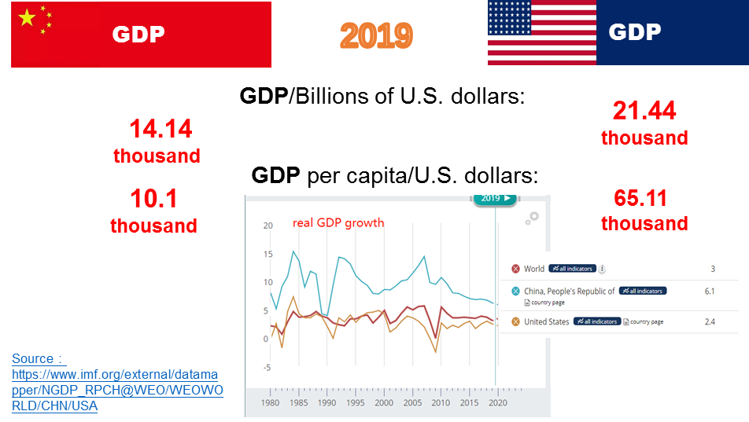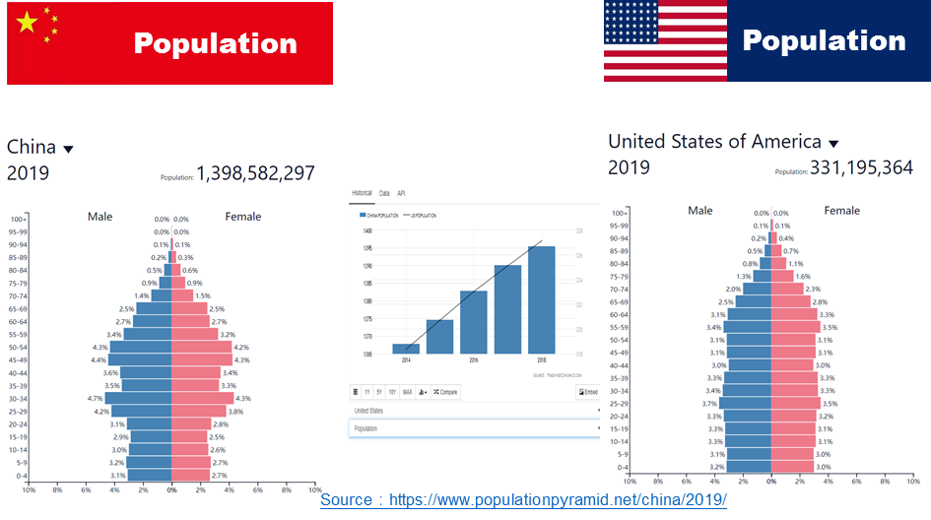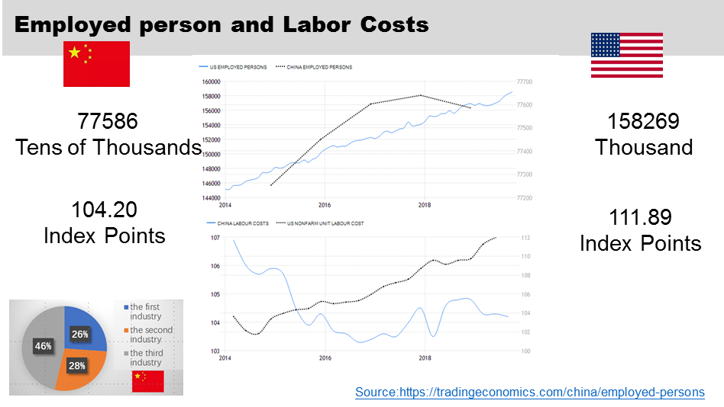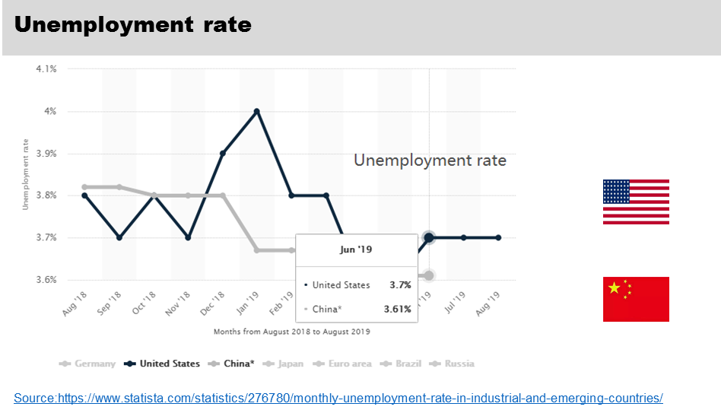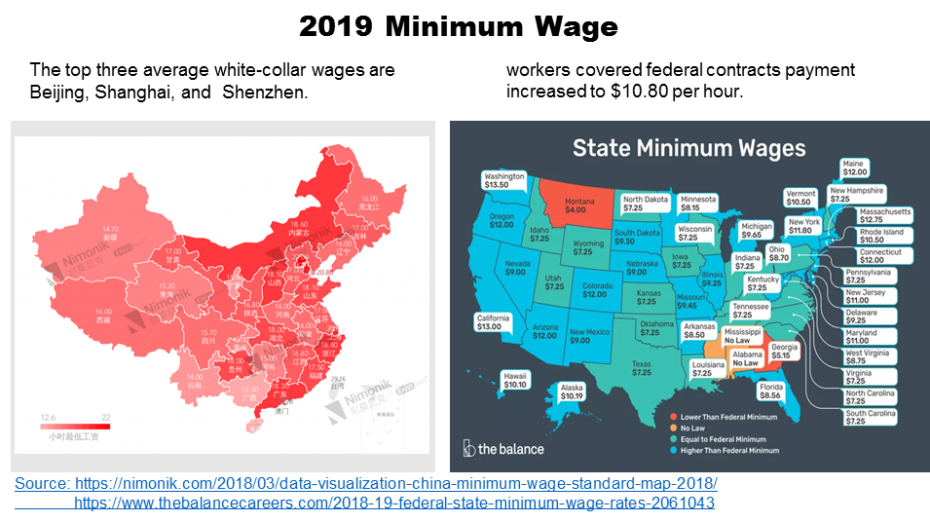
Figure 2.1 Basic indicators comparation between China and U.S.

China is GDP ranked No.2 behind the United States, but the GDP per capita is more than 6 times, the inflation rate both higher than last year ().While Aging population is a worldwide problem, form the population pyramid, we can find that China’s demographic advantaging is disappearing(). The number of employed persons in China decreased while Job Vacancies decreased in 2018 like the situation in the United States. Among these, the first the industry employed 26.1%; the second production employment of the industry accounted for 27.6%; employment in the tertiary industry accounted for 46.3 % in China with record-high 8.3 million graduates from university 2019. (South China Morning Post, 2019). To contrast, Labor Costs in China decreased to 104.20 Index Points while in the United States reaching an all-time high of 111.89 Index. Unemployment rate both decreased in China (3.61%) and the United States (3.7%). The wages between China and the United States is huge, while workers covered federal contracts payment increased to $10.80 per hour, payment for one hour may less than $2 in China which is rising. Glassdoor highlighted some companies with higher minimum wages like Amazon, Facebook (Glassdoor,2019).
In China, demand for new-media management employees grew 10.8 times (Chinadaily.com.cn, 2019). Other new characteristics as shown: (1) home-grown talent base is limited(Briefing and Cyrill, 2019); (2) number of jobs positions in private enterprises increased by 109 % (Xinhuanet.com, 2019); (3) Talents in intelligent manufacturing, product development, quality control and supply chain management，education, consulting, internet, e-commerce, media and culture industries will be highly sought in the coming years (Hays.cn, 2019; Zhaopin.com,2019).
While new characteristics in the United States has experienced:(1) Knowledge work will represent 75% of all jobs by the year 2020(Bls.gov, 2019); (2) Notable job gains appeared in industries like health care and social assistance (BBC, 2019; Albouy, 2019);(3) The living costs continued to rise and contribute to the continuous widening of income and wealth inequality (Aronson, 2019).
Based on the statistics, the U.S. and China both at a state of the tight labour market in terms of employment opportunities. As Deloitte(2019) put forward ‘social enterprise’ to indicate these companies faced disruption with AI, cognitive technologies, automation and struggled with intensifying combination of political, social and economic issues, whose still need to balance financial growth with environment responsibility and stakeholder networks’ requirement. If Salesforce.com see itself is a ‘social enterprise’, then it can’t ignore the trend to refresh, rewrite or recode future workforces, organization and HR (Deloitte, 2019; Frey and Osborne, 2017). So, focused on Salesforce.com, we may neglect some other environmental factors (low skilled industry, low-tier manufacturing, uneven urbanization, policies, market turbulence and international relationship, e.g. Trade war between the U.S. and China.) and focus more on the STEM Graduates situation (a vital cog in global prosperity, unsurprisingly) shows below, the gap between two countries are widening(McCarthy, 2017).

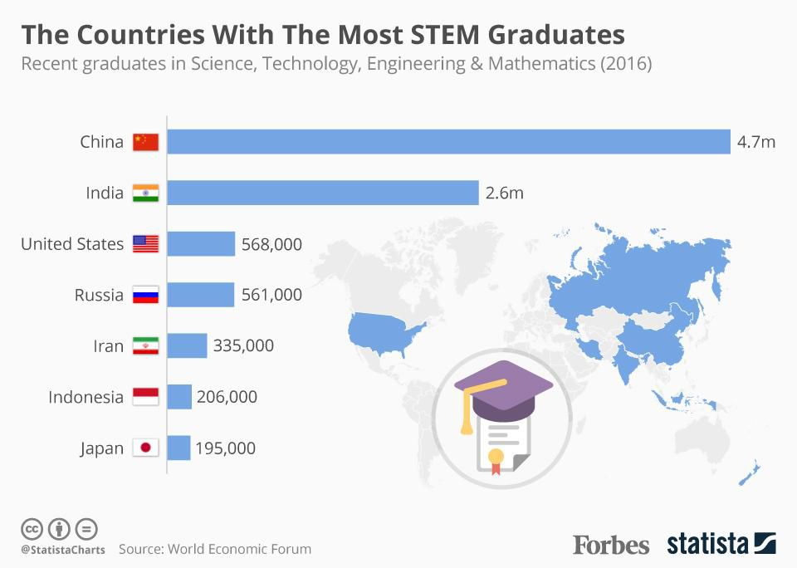
Figure 2.2 The countries with the most STEM graduates

The key point of future workforce is “how organizations should adapt to the forces restructuring job and work design, the open talent economy, leadership”(Deloitte,2019).Alternative workforces become mainstream which is also important for Salesforce.com to manage multiple talent pools(internal workforce, partnerships, freelance, crowdsourced) and spanning multiple generations(Chinadaily.com.cn, 2019; Saracco, 2019).

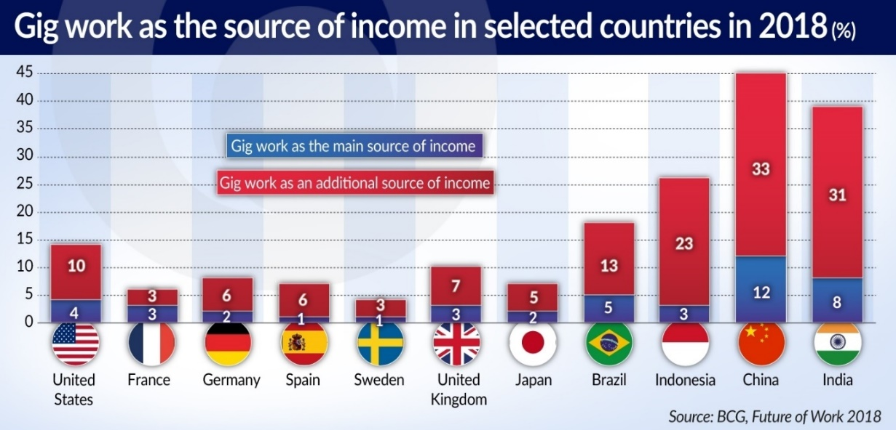
Figure 2.3 Gig work as the source of income in selected countries in 2018
Last but not least, Salesforce.com must not neglect the ‘talent war’ (Beechler and Woodward,2009) around the world as well as global AI talent shortage. Global AI talent quantity "heat map" analysis shows that China's global ranking 7th while U.S. ranking No.1 (Jfgagne.ai, 2019; Gov.cn, 2019).
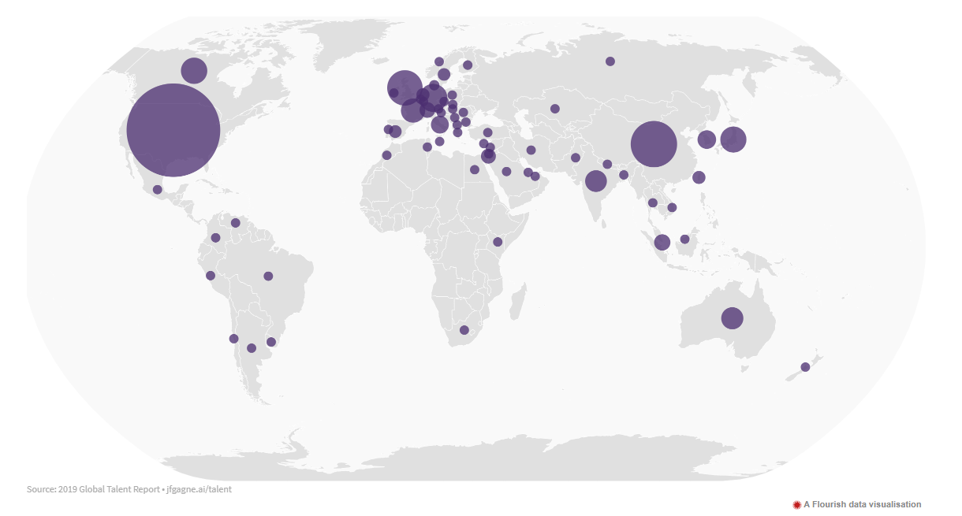
Figure 2.3 Global AI talent quantity "heat map"

Reference
Albouy, D. (2019) Labor Markets in Canada and the United States. Journal of Labor Economics, 37(S2), pp. S533-S594.
Aronson, R.L. (2019) Self-employment: A labor market perspective. Cornell University Press.
Armstrong, M., (2018). Armstrong’s handbook of human resource management practice.14th Edition. Kogan Page Publishers.
Beechler, S. and Woodward, I.C., (2009). The global “war for talent”. Journal of international management, 15(3), pp. 273-285.
Bls.gov. (2019). Projections overview and highlights, 2018–28: Monthly Labor Review: U.S. Bureau of Labor Statistics. [online] Available at: https://www.bls.gov/opub/mlr/2019/article/projections-overview-and-highlights-2018-28.htm.
Briefing, C. and Cyrill, M. (2019). China Labor Market: Hiring Costs, Job Preferences, Talent Acquisition. [online] China Briefing News. Available at: https://www.china-briefing.com/news/china-labor-market-hiring-costs-job-preferences-talent-acquisition/
Ceicdata.com. (2019). China Labour Productivity Growth [1953 - 2019] [Data & Charts]. [online] Available at: https://www.ceicdata.com/en/indicator/china/labour-productivity-growth.
Chen, B. (2019). Data Visualization: China Minimum Wage Standard Map 2018 | Nimonik Environment, Health & Safety and Quality Compliance. [online] Nimonik.com. Available at: https://nimonik.com/2018/03/data-visualization-china-minimum-wage-standard-map-2018.
Chinadaily.com.cn. (2019). China's job market stable with new features: report [online] Available at: http://www.chinadaily.com.cn/a/201903/20/WS5c91d1f3a3104842260b197c.html.
Chinadaily.com.cn. (2019). Returnees finding big opportunities [online] Available at: http://www.chinadaily.com.cn/china/2017-02/25/content_28345785.htm.
CIPD. (2019). Understanding Economy & Labour Market. [online] Available at: https://www.cipd.co.uk/knowledge/work/trends/economy-labour-market-factsheet
Deloitte.com. (2019). Leading the social enterprise: Reinvent with a human focus. [online] Available at: https://www2.deloitte.com/content/dam/insights/us/articles/5136_HC-Trends-2019/DI_HC-Trends-2019.pdf.
Glassdoor.co. (2019). [online] Available at: https://www.glassdoor.co.uk/index.htm?countryRedirect=true.
Frey, C.B. and Osborne, M.A., (2017). The future of employment: How susceptible are jobs to computerisation? Technological forecasting and social change, 114, pp. 254-280.
Gov.cn. (2019). Circular of the State Council on the issuance of the development plan for the new generation of artificial intelligence (Guo Fa [2017] No. 35) [online] Available at: http://www.gov.cn/zhengce/content/2017-07/20/content_5211996.htm.
Hays.cn. (2019). [online] Available at: https://www.hays.cn/en/press-releases/HAYS_2014750.
Imf.org. (2019). [online] Available at: https://www.imf.org/external/datamapper/NGDP_RPCH@WEO/WEOWORLD/CHN/USA.
Jfgagne.ai (2019). Global AI Talent Report 2019. [online] jfgagne. Available at: https://jfgagne.ai/talent-2019/.
McCarthy, N. (2017). The Countries With The Most STEM Graduates [Infographic]. [online] Available at: https://www.forbes.com/sites/niallmccarthy/2017/02/02/the-countries-with-the-most-stem-graduates-infographic/#10d71b9c268a.
Populationpyramid.net. (2019). [online] Available at: https://www.populationpyramid.net/china/2019/.
Saracco, R. (2019). The Gig economy keeps growing. [online] IEEE Future Directions. Available at: https://cmte.ieee.org/futuredirections/2019/09/15/the-gig-economy-keeps-growing/.
South China Morning Post. (2019). China job market improves in second quarter despite record low growth rate. [online] Available at: https://www.scmp.com/economy/china-economy/article/3019015/chinas-job-market-improves-second-quarter-despite-record-low.
Stats.gov.cn. (2019). The employment scale continues to expand stably for a long time - Report on the series of economic and social development achievements of the 70th anniversary of the founding of New China. [online] Available at: http://www.stats.gov.cn/tjsj/zxfb/201908/t20190820_1692213.html.
Stats.gov.cn. (2019) Meng Canwen: The employment priority policy is fully exerted. The employment situation is generally stable. The Director of the National Bureau of Statistics interprets the “semi-annual report”.[online] Available at: http://www.stats.gov.cn/tjsj/sjjd/201907/t20190717_1676917.html.
The Balance Careers. (2019). List of Federal and State Minimum Wage Rates for 2019 and 2020. [online] Available at: https://www.thebalancecareers.com/2018-19-federal-state-minimum-wage-rates-2061043.
Trading Economics.com. (2019). 20 million indicators from 196 countries. [online] Available at: https://tradingeconomics.com/.
Xinhuanet.com. (2019). More jobs available for Chinese graduates: report - Xinhua | English.news.cn. [online] Available at: http://www.xinhuanet.com/english/2018-12/14/c_137673782.htm.

3. Human resource planning TED Talk
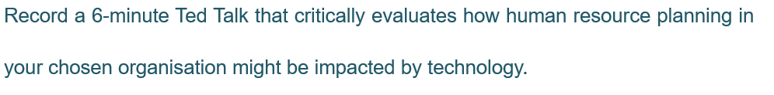
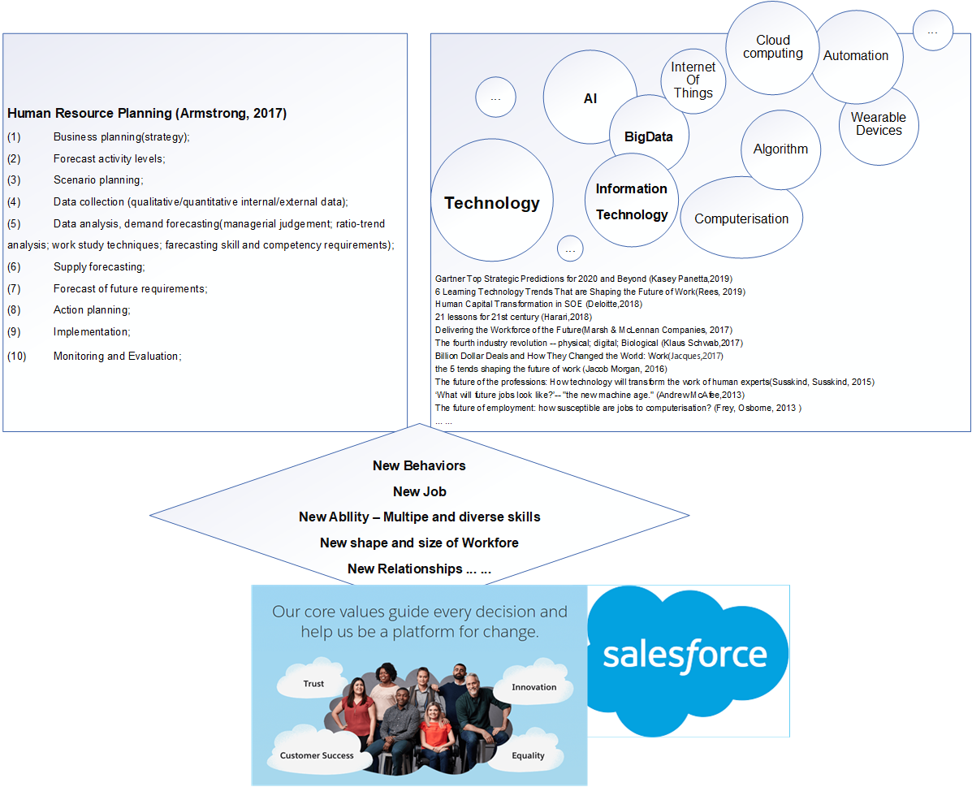
Figure 3.1 Outline of Human resource planning

Ted Talk Link
https://uowtsd-my.sharepoint.com/:u:/g/personal/1811683_student_uwtsd_ac_uk/EelMiYhOXGZEtMEs3RkMDgQBJzgUYgzparUzNCKl0cxqrg?e=0hHaHU

Reference
Armstrong, M., (2018). Armstrong’s handbook of human resource management practice.14th Edition. Kogan Page Publishers.
Benioff, M. and Adler, C., (2009). Behind the cloud: the untold story of how Salesforce. com went from idea to billion-dollar company-and revolutionized an industry. John Wiley & Sons.
Boxall, P., (1996). The strategic HRM debate and the resource‐based view of the firm. Human resource management journal, 6(3), pp. 59-75.
Davenport, T. (2019). Building a Culture That Embraces Data and AI. [online] Harvard Business Review. Available at: https://hbr.org/2019/10/building-a-culture-that-embraces-data-and-ai.
Frey, C.B. and Osborne, M.A., (2017). The future of employment: How susceptible are jobs to computerisation? Technological forecasting and social change, 114, pp. 254-280.
Gu, X. (2010). [online] Ibm.com. Available at: https://www.ibm.com/downloads/cas/9XZ4XZO5.
Harari, Y.N., (2018). 21 Lessons for the 21st Century. Random House.
Jacques (2017). [online] Dailymotion. Available at: https://www.dailymotion.com/video/x64iv23.
McAfee, A. (2013). Transcript of "What will future jobs look like?". [online] Ted.com. Available at: https://www.ted.com/talks/andrew_mcafee_what_will_future_jobs_look_like/.
Morgan, J. (2016). The 5 Trends Shaping the Future of Work. [online] YouTube. Available at: https://www.youtube.com/watch?v=LrhmHbDLM8o.
Taylor, S., (2018). Resourcing and talent management. 7th Edition. Kogan Page Publishers.
Oliverwyman.com. (2019). Delivering the Workforce of the Future. [online] Available at: https://www.oliverwyman.com/content/dam/oliver-wyman/v2/publications/2017/oct/Delivering%20The%20Workforce%20For%20The%20Future.pdf.
Panetta, K. (2019). Gartner Top Strategic Predictions for 2020 and Beyond. [online] Gartner.com. Available at: https://www.gartner.com/smarterwithgartner/gartner-top-strategic-predictions-for-2020-and-beyond/.
Rees, B. (2019). 6 Learning Technology Trends That are Shaping the Future of Work. [online] Headspring Executive Development by Financial Times and IE Business School. Available at: https://www.headspringexecutive.com/users/264236-bevan-rees/posts/51213-6-learning-technology-trends-that-are-shaping-the-future-of-work.
Schwab, K., 2017. The fourth industrial revolution. Currency.
Susskind, R.E. and Susskind, D., 2015. The future of the professions: How technology will transform the work of human experts. Oxford University Press, USA.

4. Tailor(adjust) its HRM policy (aimed at a senior management audience)
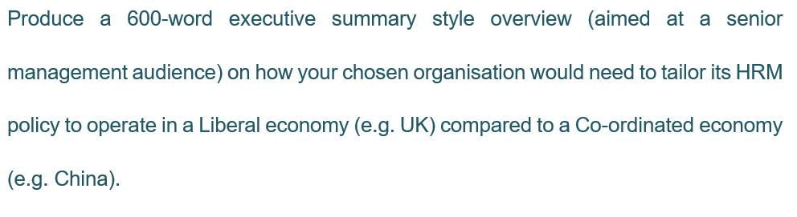
Globalization is one of the megatrends to shape future work (Morgan, 2016), which is also a process deeply embedded in the political, cultural, social especially borderless economy and empowered highly developed technology. (Ohmae,1995) Globalized economies as a complex network have multiple linkages and interconnecting dimensions (Humbert, 1994; Hudson,2004; Dicken,2015), the global economic map never stops the state of ‘becoming’. LME (Liberal Market Economy) and CME (Co-ordinated Market Economy) are changing, overlapping: liberty’s ‘set-menu approach’ or ‘buffet mentality’ show various influence in different sectors (Dicken,2015; Akkermans, Castaldi et al. 2009), while China betweenness a liberal international order with Marxism-Leninism and national coordinate Harari (2018). as a foreign-owned MNCs (Multinational corporations) and TNCs (Transnational Corporations) motivated by market, asset, Salesforce.com need to consider how to ‘Uphold a One-Company Attitude Across Borders’, both in terms of convergence and divergence. (Benioff, Adler, 2009).
When Salesforce.com are formulating HR policies, such as adaptive, explorative or integrative (Taylor et al, 1996), they need to remain aware the bigger picture. This would include factors such as higher complexities’ differences, external factors (legislation, salary settlement currency, exchange rate impact, over time, average domestic income level, double taxation subsidies and so on), sensitive different local business cultures and environments. (Armstrong,2018). Despite linguistic issues, Dicken (2015) put forward other geographical variations, such as wages, knowledge and skills, controllability, productivity. Additionally, some academics (Griffiths, 2019; Edwards and Rees, 2006) suggest that HRM in LME is more difficulty in obtaining commitment than CME and more individualized at pay and career development. In addition, vocational training/ education, employment relationships, trade union etc. would all be have distinction. Finally, related to Salesforce.com ‘s business strategies, providing cloud computing service to International companies (Luoma and Nyberg, 2011), Salesforce. com needs to pay attention to some specific HR policies in China (Gamble, 2011; Warner,2004). Examples of these would include the following:
(1) how to attract and retain top talent;
(2) how to improve employee behavior;
(3) how to cultivate diversity and inclusive culture.
Cultural structures and practices are closely related to economic activity, Schwartz identified seven distinctive cultural dimensions while Hofstede uses six dimensions to compare the Chinese and American ways of thinking which will have a profound influence in the workplace (Hofstede et al. 2005).
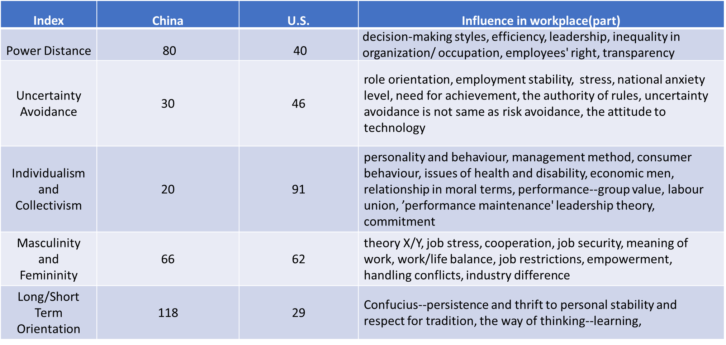
Figure 4.1 Culture dimension between China and U.S.

As China’s PDI is higher than the U.S., we can predict the organization structure may differ and the hiring process in China (more of a collective society) may take the in-group into account. Long/Short-term Orientation difference indicated that Salesforce.com will find it more difficult tougher to attract talent who has global leadership to build a team in China and ‘Inject’ Local Leaders with organizational DNA cannot use the ‘‘Seagull Approach’’. Successful approaches to retaining high-performance people include: (1) build commitment (Tylor, 2018), which is one out of three factors influencing employee behavior (Armstrong, 2018); furthermore, (2) monitoring people’ feel (include metal health), Storey et al (2009) and Guest (1997) assumed the ‘appropriate’ HRM practices tap the motivation of employees. Moreover, the components of engagement have organizational citizenship behavior and job satisfaction (Arnold et al,1991).
Salesforce.com found they should act like a Start-Up, counting on the ‘‘80-20 rule’’ to find bedrock customers before hiring local employees and be mindful of over-hiring. By placing emphasis on keeps things dynamic, they will try to have two leaders— An international leader who concentrates fully on the local market and a global leader who focuses on consistency with headquarters and determines fits in with global (Benioff and Adler, 2009). Purcell et al(2003) emphasized the line managers’ role, Salesforce.com intrinsically should adopt pink’s motivation theory(2009): autonomy; mastery; purpose; extrinsically refer AMO theory(Purcell et al, 2003) enhancing commitment like develop a climate of trust, develop a positive psychological contract, establish a partnership with trade unions and so on.
Ana Recio, EVP, shared Salesforce.com some unique and innovative practices to developed a friendly culture:

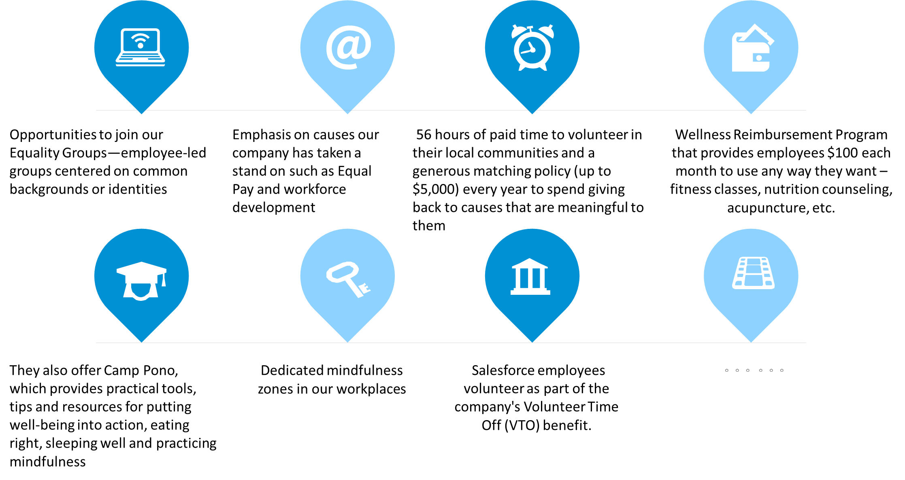
Figure 4.1 Salesforce.com’ s perks and benefits

Reference
Akkermans, D., Castaldi, C. and LOS, B., 2009. Do ‘liberal market economies’ really innovate more radically than ‘coordinated market economies’?: Hall and Soskice reconsidered. Research Policy, 38(1), pp. 181-191.
Benioff, M. and Adler, C., (2009). Behind the cloud: the untold story of how Salesforce. com went from idea to billion-dollar company-and revolutionized an industry. John Wiley & Sons.
Bosch, G. and Charest, J., 2008. Vocational training and the labour market in liberal and coordinated economies. Industrial relations journal, 39(5), pp. 428-447.
Brown, K. (2018). To Retain Employees, Focus on Inclusion — Not Just Diversity. [online] Harvard Business Review. Available at: https://hbr.org/2018/12/to-retain-employees-focus-on-inclusion-not-just-diversity.
Brownlee, D. (2019). How The ‘Best Companies To Work For’ Engage Employees And Retain Top Talent. [online] Forbes.com. Available at: https://www.forbes.com/sites/danabrownlee/2019/09/04/how-the-best-companies-to-work-for-engage-employees-and-retain-top-talent/#70d86d521eca.
Bughin, J., Lund, S. and Manyika, J., 2015. Harnessing the power of shifting global flows. McKinsey Quarterly, 7(1), pp. 1-13.
Cipd.co.uk. (2019). Building inclusive workplaces. [online] Available at: https://www.cipd.co.uk/Images/building-inclusive-workplaces-report-sept-2019_tcm18-64154.pdf.
Dicken, P., (2015). Global Shifting: Mapping the Contours of the World Economy.
Edwards, T. and Rees, C., 2006. International HRM: globalization, national systems and multinational companies. Harlow: Pearson .
Farndale, E., Brewster, C. and Poutsma, E., (2014). Coordinated vs. liberal market HRM: the impact of institutionalization on multinational ﬁrms. International human resource management. Routledge, pp. 20-39.
Gamble, J., (2011). Transferring Human Resource Practices from the United Kingdom to China. Multinational Retailers and Consumers in China. Springer, pp. 32-52.
Griffiths, D. (2019). Differences between Liberal Versus Coordinated Market Economies. [online] Atavist. Available at: https://davidg.atavist.com/differences-between-liberal-versus-coordinated-market-economies
Hofstede, G., Hofstede, G.J. and Minkov, M., (2005). Cultures and organizations: Software of the mind. Citeseer.
Luoma, E. and Nyberg, T., (2011). Four scenarios for adoption of cloud computing in china. ECIS 2011, pp. 123.
Purcell, J., (2003). Understanding the people and performance link: Unlocking the black box. CIPD Publishing.
Warner, M., (2004). Human resource management in China revisited: introduction. The International Journal of Human Resource Management, 15(4-5), pp. 617-634.
Werbel, J.D., Song, L.J. and Yan, S., (2008). The influence of external recruitment practices on job search practices across domestic labour markets: A comparison of the United States and China. International Journal of Selection and Assessment, 16(2), pp. 93-101.

5. Human resource planning TED Talk
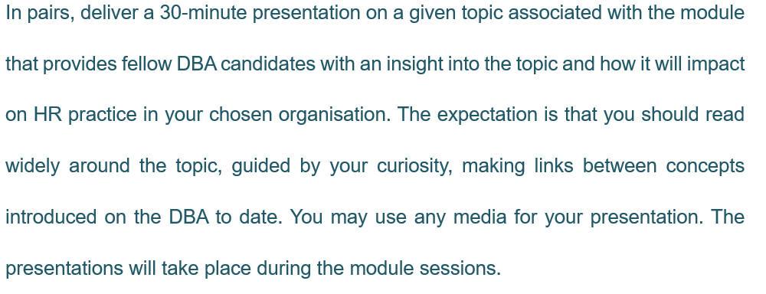

Slideshow link:
https://uowtsd-my.sharepoint.com/:p:/g/personal/1811683_student_uwtsd_ac_uk/EY7HI5T3TKxNlKcdXPwO26YBkyHXrkgvCYpxDnXIWkNFjg?e=uMXjKV

6. Atkinson’s Flexible Firm Model
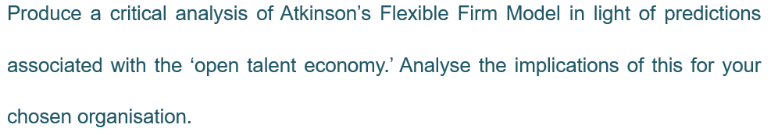

Atkinson’s Flexible Firm Model (AFFM) developed in the mid-1980s, aim to precisely matched work time to job requirements when facing market stagnation, job loss, uncertainty, technological changes etc. problems in the UK in the post-second industry revolution similar to Shamrock organization (Morgan, 2003). AFFM first focus on functional, numerical and financial flexibility, with globalization, political issues, labour market status change etc., there are more kinds of flexibility are required. Such as temporal flexibility (Typlor,2018), organizing flexibility (Kalleberg,2001), labour market flexibility (Singh and Zammit, 2019); time flexibility, strategy flexibility (Carvalho and Cabral-Cardoso, 2008). AFFM divided workforces into ‘core’ and ‘peripheral’, develop stable/ committed/job-secured core employees to multi-skills, cross-discipline ability to fulfil the functional flexibility while use peripheral employees to accomplish numerical flexibility. Procter, Rowlinson et al (1994) analysed two main defeats on AFFM: (1) Pollert’s criticisms it lacks a view of political level; (2) it’s ‘non-strategic’ nature need be recast. When AFFM associated with the ‘open talent economy’ in the fourth industrial revolution context, what implications for HRM to adapted and remain related in the future (Cappelli, 2015)?
Globalization, technology(mobility), social (ageing workforce and increase in female workers), education progress, culture(diversity) are the forces push to flexible work options from both directions nowdays. Organizations need cost more effectively and developed more agile and resilience (BSI, 2019), reshape the cross-national structures more flat, network shape and organism-oriented; while employees want flexible work hours and schedules, sub-source of income gig work from are some effective motivators (Forbes,2019; CIPD, 2019;The RSA, 2019). Deloitte (2013) first termed ‘the open talent economy’ (OTE) to show collaborative/transparent/technology-enabled/rapid-cycle way of doing business, similar to gig economy—consists of independent workers, service consumers and connected platform (CIPD,2019).
Most common job (for salaried employee) in Salesforce.com is Software Engineering (Fortune,2019), so it has engineering DNA on one hand and flexible sales culture on the other hand. Employees in Salesforce.com review their fancy to ‘flexible work hours, flexible location, ability to choose projects great engineering process and tools’ and advice to invest more into developing and training organisational internal employee’s capabilities, especially some line program managers (Glassdoor, 2019). Implications to salesforce.com are numerous take flexibility in Chinese firms (Malcolm Warner,2000) into consideration.
Deloitte (2013) lists a wide range of work types and gives detailed step to formulating a talent strategy. In OTE, the gig economy and sharing economy scenarios, an organization can expand its talent network, recruitment become worldwide, two-way choice and on-demanded effective. Choice, communication, collaboration and culture become new 4Cs strategies to engaging people while facing challenges like talent attraction and regulation. Meanwhile future of work needs to be reshaping, noting the on-demand talent’s need, filling skills (dynamism, customer devotion, behaviour skills, humanization) and knowledge gaps within or without organization. Furthermore, the organization need to manage multiple talent pools (to name four: internal workforce, partnerships, freelance, crowdsourced) and multiple generation workforces in a unified way (Marsh & McLennan companies, 2019). Four types of connection may cultivate with line managers help is place; routines, purpose, people (Armstrong, 2018). More attention required to 300,000 AI professional’s shortage (Vincent, 2017), the organization may share talents instead of owning them.
The core workers of Salesforce.com will become less for the agile purpose, through task segmentation, flowed the instruction of agile manifesto and the mythical man-month (Brooks Jr, 1995). In the flexible and highly mobile nature of the workforce build psychological contract, share company vision important (Coyle, Shapiro, Kessler,2000). Leverage Everything (employees’ networks, skills of outside organizations, customers’ energy) is a constant theme at in Salesforce.com, specific to the training and certification program, it becomes flexible by virtual and physical classrooms (Benioff and Adler,2009).
At the end, I want to put forward Tylor’s conclusion that the ratio of employees with flexible work changes subtly in recent years (Taylor, 2019). Still OTE or gig economy does not apply to all companies and positions, disadvantages need help from employee, employer, industry, trade union and government.

Reference:
Armstrong, M., (2018). Armstrong’s handbook of human resource management practice.14th Edition. Kogan Page Publishers.
Atkinson, J., (1984). Manpower strategies for flexible organisations. Personnel management, 16(8), pp. 28-31.
Benioff, M. and Adler, C., (2009). Behind the cloud: the untold story of how Salesforce. com went from idea to billion-dollar company-and revolutionized an industry. John Wiley & Sons.
Brooks JR, F.P., (1995). The Mythical Man-Month: Essays on Software Engineering, Anniversary Edition. Pearson Education India.
Brownlee, D. (2019). 4 Employee Engagement Trends That Leaders Need To Know. [online] Forbes.com. Available at: https://www.forbes.com/sites/danabrownlee/2019/08/18/4-employee-engagement-trends-that-leaders-need-to-know/#5b406c5233f7.
BSIgroup.com. (2019). Cranfield University Organizational Resilience Research | BSI Group. [online] Available at: https://www.bsigroup.com/en-GB/our-services/Organizational-Resilience/Organizational-Resilience-Research/.
Carvalho, A. and Cabral-cardoso, C., (2008). Flexibility through HRM in management consulting firms. Personnel Review, 37(3), pp. 332-349.
Cipd.co.uk. (2017). To gig or not to gig. [online] Available at: https://www.cipd.co.uk/Images/to-gig-or-not-to-gig_2017-stories-from-the-modern-economy_tcm18-18955.pdf .
Cipd.co.uk. (2019). Atypical working -- A guide to successfully implementing atypical work in your organization [online] Available at: https://www.cipd.co.uk/Images/7904-atypical-working-guide-web_tcm18-61555.pdf.
Coyle‐shapiro, J. and Kessler, I., (2000). Consequences of the psychological contract for the employment relationship: A large scale survey. Journal of management studies, 37(7), pp. 903-930.
Hakim, C., (1990). Core and periphery in employers' workforce strategies: evidence from the 1987 ELUS survey. Work, employment and society, 4(2), pp. 157-188.
Morgan, R.E., (2003). Outsourcing: towards the ‘shamrock organization’. Journal of General Management, 29(2), pp. 35-52.
Fortune. (2019). Salesforce. [online] Available at: https://fortune.com/best-companies/salesforce/.
Glassdoor.co. (2019). [online] Available at: https://www.glassdoor.co.uk/index.htm?countryRedirect=true.
Kalleberg, A.L., (2001). Organizing flexibility: the flexible firm in a new century. British Journal of Industrial Relations, 39(4), pp. 479-504.
Luoma, E. and Nyberg, T., (2011). Four scenarios for adoption of cloud computing in china. ECIS 2011, pp. 123.
Procter, S.J., Rowlinson, M., Mcardle, L., Hassard, J. and Forrester, P., (1994). Flexibility, politics & strategy: In defence of the model of the flexible firm. Work, Employment and Society, 8(2), pp. 221-242.
Ruiner, C., Wilkens, U. and Küpper, M., (2013). Patterns of organizational flexibility in knowledge-intensive firms—going beyond existing concepts. management revue, , pp. 162-178.
Singh, A. and Zammit, A., (2019). Globalisation, labour standards and economic development. The Handbook of Globalisation, Third Edition. Edward Elgar Publishing.
Taylor, S., (2018). Resourcing and talent management. 7th Edition. Kogan Page Publishers.
The RSA (2019). RSA ANIMATE: Re-Imagining Work. [online] YouTube. Available at: https://www.youtube.com/watch?v=G11t6XAIce0&feature=youtu.be.
Vincent, J. (2017). Tencent says there are only 300,000 AI engineers worldwide, but millions are needed. [online] The Verge. Available at: https://www.theverge.com/2017/12/5/16737224/global-ai-talent-shortfall-tencent-report.
Werbel, J.D., Song, L.J. and Yan, S., (2008). The influence of external recruitment practices on job search practices across domestic labor markets: A comparison of the United States and China. International Journal of Selection and Assessment, 16(2), pp. 93-101.

7. Create a model
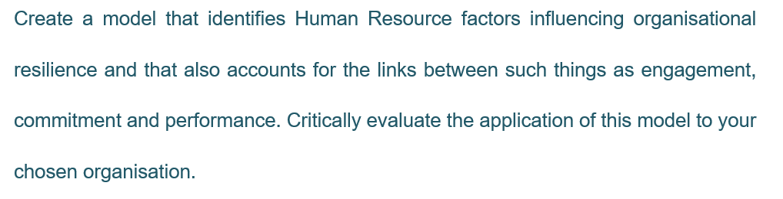
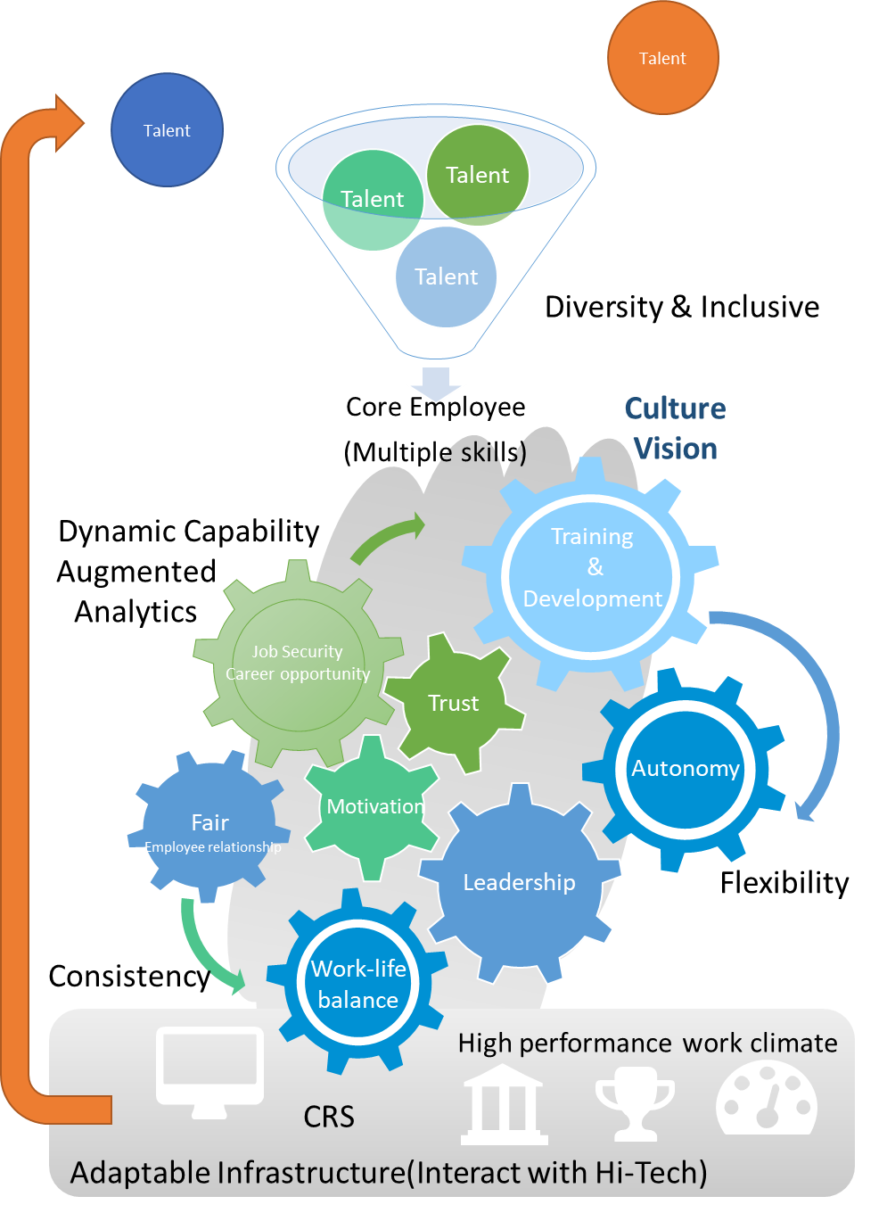
Figure 7.1 Resilient Human Resource Practice Model

Reference:
Armstrong, M., (2018). Armstrong’s handbook of human resource management practice.14th Edition. Kogan Page Publishers.
Benioff, M. and Adler, C., (2009). Behind the cloud: the untold story of how Salesforce. com went from idea to billion-dollar company-and revolutionized an industry. John Wiley & Sons.
Frey, C.B. and Osborne, M.A., (2017). The future of employment: How susceptible are jobs to computerisation? Technological forecasting and social change, 114, pp. 254-280.
Harari, Y.N., (2018). 21 Lessons for the 21st Century. Random House.
(Marsh & McLennan Companies, 2017)
Hofstede, G., Hofstede, G.J. and Minkov, M., (2005). Cultures and organizations: Software of the mind. Citeseer.
Jacques (2017). [online] Dailymotion. Available at: https://www.dailymotion.com/video/x64iv23.
Morgan, J. (2016). The 5 Trends Shaping the Future of Work. [online] YouTube. Available at: https://www.youtube.com/watch?v=LrhmHbDLM8o.
Panetta, K. (2019). Gartner Top Strategic Predictions for 2020 and Beyond. [online] Gartner.com. Available at: https://www.gartner.com/smarterwithgartner/gartner-top-strategic-predictions-for-2020-and-beyond/.
Purcell, J., (2003). Understanding the people and performance link: Unlocking the black box. CIPD Publishing.
Rees, B. (2019). 6 Learning Technology Trends That are Shaping the Future of Work. [online] Headspring Executive Development by Financial Times and IE Business School. Available at: https://www.headspringexecutive.com/users/264236-bevan-rees/posts/51213-6-learning-technology-trends-that-are-shaping-the-future-of-work.
Schwab, K., 2017. The fourth industrial revolution. Currency.
Susskind, R.E. and Susskind, D., 2015. The future of the professions: How technology will transform the work of human experts. Oxford University Press, USA.
Taylor, S., (2018). Resourcing and talent management. 7th Edition. Kogan Page Publishers.

