This report is about the basic organisational function of the company we all know as Amazon. Hartmans A. (JULY 202) Amazon was founded by Jeff Bezos in 1994 from his own garage, he was originally going to call it Cadabra but was talked out of it as it sounded way too similar to the company Cadaver, also he liked the name Relentless so if you were to visit relentless.com it sends you to Amazon. But he eventually picked the name Amazon as it would mean the company would be named after the Amazon River, the largest river in the world and that also reflects on the company’s original company logo compared with what it looks like today
(Figure 1)

Hartmans A. (July 2021) Just in the first month of the company’s launch it had already sold books to all of American states plus 45 countries around the world. In the beginning Jeff Bezos started a bell ringing for each sale meaning that every time they sold an item that they would have to ring the bell, but as the company grew this soon stopped as the bell ringing was more or less constantly going off.
But going from a starting company in 1994 from the garage, Shvartsman D. (Nov 2022) Amazon is a much more successful phenomenon than anyone imagined for instance in 2012 Amazon bought the company Kiva Systems and now has over 200,000 mobile robots through there whole company, Amazon has over 300,000,000 active users and more than 205 million are prime subscribers, just these subscribers alone generate over $25 billion dollars. Now Amazon is worth a staggering $1.105 trillion and are second only to Apple leaving the likes of Google and Microsoft behind. They employ over 1.2 million people worldwide; in the second half of 2021 they hired 270,000 extra staff so they had help to provide its one-day and same day delivery service. Jeff Bezo’s net wort in 1997 was $120 million but after a tremendous achievement in 2022 he is now worth an estimated $130 billion, and after being the CEO and founder for than 25 years he stepped down from this position on July 5 2021.
Dudovskiy J. (March 2022) Amazons organizational structure is a hierarchical one. The management team consists of 3 CEO’s and 3 vice presidents whose job is the responsibility of all different aspects throughout the company and they all report directly to CEO Andy Jassy.

Figure 2
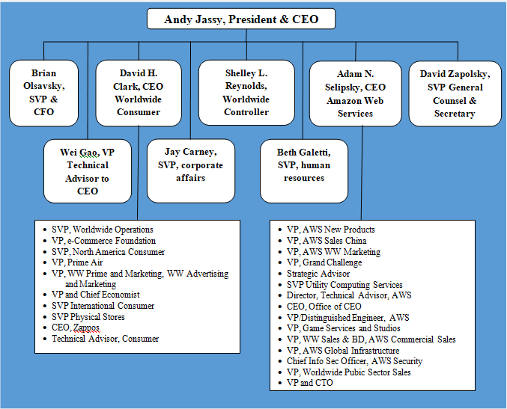
Amazons organizational is set up following 4 features
Hierarchical, Hybrid project groups, Flexibility, Stability
Due to Amazons adherence to diversification in an aggressive manner the business should stay dynamic while subjected to changes in certain areas all depending on the situation.
While carrying out a SWOT analysis its easy to see that the strength Amazon has is being the leading factor for online shopping and now more recently into other areas of business, it’s Weakness is that they have only fairly recently gone towards the bricks and mortar side of being a competitive trader where stores like ARGOS and similar stores have been doing this for a long time, its opportunities is that its got a good name behind it due to there very strict managemental side so when people hear or see the name Amazon they know that they will get a good product and any problems Amazon are very keen to sort them out as quickly as possible, but there Threats would probably be companies like EBAY that do very similar things as Amazon so if they were to drop the ball in any of its sales then there is a high likely hood that they could lose customers that way.
Partridge J. (Oct 202) On top of Amazon being one of the leading company’s online they have now opened there first bricks and mortar store selling books, electronics, games and household items. This is the first one of a 4-star quality outlet in Britain. They already have stores in the US but now have brought that same thing to the UK streets. They will be using data from the items selling online to know what to stock the store with to keep up with the demand that is needed, staff will be responding to customers feedback to ensure that the items they change is according to their needs especially on new released items.
Amazon’s (2021) summary
Amazon’s approach to sustainability is down to bold thinking, they are one of the largest buyers of renewable energy and aiming to be on the way for 100% renewable energy by 2025.
They are trying to reinvent and make it easier on the sustainable packaging, they have got rid of 1.5 million tons of packaging since 2015 and by doing that has reduced the shipping weight by 38%, they have done this by using a lot more padded enveloped instead of the oversized boxes we are all very familiar with.
They are trying to forge an industry alliance with different transportation companies to decarbonise the transport used in an innovative way to reduce the carbon footprint they are leaving.
They are making moves to become Earths best company to work for by giving competitive wages and benefits that suit them, and by fostering diversity, equity and inclusion will hopefully have a profound response with all employees.
They also support many charities and different organisations to try strengthen the communities for not only their employees but for the customers aswel.
Amazon are a very conscientious company and go above and beyond for their staff members, for instance, Amazon staff (oct 2022) an employee of Amazon named Trixie Ingleby was attracted to join Amazon as a train driver due to its fantastic health care benefits, this also included Gender affirming surgery. For the employee this was life changing and one of the main reasons for joining the company, so together with the support of her team managers and amazing health care plan she was able to live her own life on her terms and is hoping that through her story others will take the opportunity and follow-on suit. In her own words Ingleby T. (Oct 2022) “I was born as a male and raised as a male, after figuring out who I was, I went from Matthew to Trixie. I love the people that I work with. They Are so supportive of me and my journey. I feel welcomed, feel included, feel seen, and able to be me.”
In my own eyes this shows that Amazon are committed to ensuring that their staff are not only safe in their environment, that their health and well-being is being looked after. On top of this Amazon staff (Oct 2022) show that Amazon jobs come in with an average starting pay of $18 per hour which is more than the federal min wage, in some areas the wage may rise to $28 per hour. They offer health insurance from their very first day on the job, the possibility of up to 20 paid weeks leave for any new parents, completely free access mental health support and also help towards further skills training.
Amazon Staff (July 2022) Amazon are eager to try to get staff to better themselves as much as possible for instance at the moment they have over 15,000 interns which is the most that they have ever had at one time, these contribute to programs in a varied number of global teams. Throughout the very robust and rewarding time the internship lasts for between 12 & 16 weeks they are encouraged to disrupt the status quo, there are rewards available for the big ideas, and by forming groups of similar open-minded thinkers the possibilities are endless. Lots of the interns that go to Amazon end up with full time positions at Amazon.

REFERENCECES
Amazon Staff (July 2022) Former Amazon interns reveal how to build a successful career aboutamazon.com
Amazon staff (oct 2022) I feel welcomed, I feel included, I feel seen, and able to be me aboutamazon.com
Amazon’s (2021) Executive Summary sustainability.aboutamazon.co.uk
Hartmans A. 14 facts about the early days of the e-commerce giant buisinessinsider.com
Hartmans A. 14 facts about the early days of the e-commerce giant buisinessinsider.com
Ingleby T. (Oct 2022) I feel welcomed, I feel included, I feel seen, and able to be me aboutamazon.com
Partridge J. (oct 2021) Amazon opens first UK bricks-and-mortar non-food store theguardian.com
Shvartsman D. (Nov 2022) Amazon: the worlds most powerful economic and cultural force investing.com

Figure 1. Amazon logo logolook.net
Figure 2. Amazon organizational structure: a brief overview research-methodology.net

