

BA(Hons) Business Management

Component 2 Coursework: Report

Student Name: Liliya Radoslavova Radeve
Student Number: 2418897
Course Name: Data Handling & Business Intelligence (LCBB5014)
Lecturer Name: Xavier Matieni
Session: December 2025 Term

Table of Contents
BA(Hons) Business Management 1
Introduction 3
Data Cleaning and Preparation 4
Descriptive Statistics and Summary 5
Trend Analysis and Visualisation 6
Statistical Analysis Using SPSS 11
I. Hypothesis Testing: Independent Samples T-Test 11
II. Correlation Analysis 12
III. Regression Analysis 13
Insights and Recommendations 14
I. Adopt a Dual Content Strategy for Streaming Platforms 14
II. Implement Differentiated Marketing and Performance Metrics 14
III. Optimise Production and Development Decisions 15
Limitations and Future Research 15
References 16
Appendix: Figures 17

Applying Business Intelligence to the Modern Film Industry: An Analysis of Audience Engagement and Success Factors

Introduction
The strategic decision-making in the modern film and streaming business is the primary priority in applying strong business intelligence methodologies to the audience data. In this report, a dataset with 7,284 movies, which was obtained on the Letterboxd service, was coded to decipher the variables that affect cinematic success as measured by popularity (Watches), audience approval (Likes), community loyalty (Fans), and critical reactions (Average-rating). The main objective is to go beyond the anecdotal evidence and use a systematic analysis pipeline to determine actionable patterns and give evidence-based recommendations to stakeholders in the industry.
The analysis process is rigorous and consists of three steps. Firstly, the data was cleaned and formatted in Microsoft Excel with missing values being treated and statistical outliers being removed to maintain analytical integrity. This was followed by the exploration of data in Excel, which was used to compute the descriptive statistics, and visualise the essential trends in different genres, languages, and engagement. Lastly, there were sophisticated inferential statistics conducted in SPSS and test experimental hypotheses on language influence and model the predictors of a movie rating using a correlation and regression analysis. According to PwC (2023), data analytics are progressively driving the expansion of the media and entertainment industry, as firms are able to see what the audience likes at a more granular level. This report will transform quantitative results into strategic implications, which is in line with the industry demand of evidence-based strategies of the industry in content development, acquisition, and marketing that will improve operational efficiency and audience satisfaction in a highly competitive environment.

Data Cleaning and Preparation
The most important step in this analytical pipeline was ensuring the accuracy and reliability of the dataset since the validity of all the insights that will be made after this is based on the quality of the data. The raw data (10,000 records) was handled manually in Microsoft Excel to solve the discrepancies and prepare it to be subjected to effective statistical analysis. A multi-step cleaning process was adopted following the guidelines of the accepted business intelligence models, which stipulate that the integrity of data is the cornerstone of the reliable decision-making process (Dutta, 2024).
The initial one was reorganizing the Genres field. The initial column contained entry of type list, which were logically separated into four different columns (Genre1 clean to Genre4 clean). All empty spaces in these new columns were filled with the label of Unknown. The method saved all the records that could be analysed and publicly recognized the absence of information, which is a normative way of dealing with non-systematic gaps in nominal data.
The largest cleaning intervention was the management of outliers that can greatly bias the statistical summaries and the model coefficients. Five major numerical variables were given with the method of Interquartile Range (IQR) which included: Average rating, Watches, Likes, Fans and the newly validated Runtime clean. This determined marginal and unrealistic values, like the films with a run time of zero and engagement measures, many folds higher than average. Overall, 2,716 records were cut down to narrow the analysis sample to 7,284 films. This is a bold move that falls in line with the idea that in most cases, it is important to eliminate the significant outliers in order to uncover the latent relationships in data (DASCA, 2024). Moreover, the entries that had the same Film_title but different director or statistic were appropriately maintained as distinct films to avoid the inaccurate loss of valid data. This painstaking preparation step highlights one of the fundamental principles of business intelligence: quality and standardised data is the inseparable precondition of creating functional and dependable business insights.

Descriptive Statistics and Summary
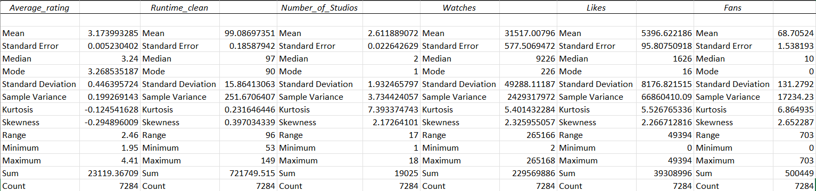
Table 1: Summary of Descriptive Statistics for Key Variables
A summary of the basic properties of the dataset gives a valuable background to the analysis of more detailed trends. The summarised descriptive statistics as indicated in Table 1 give the picture of a film ecosystem with unique patterns of production and consumption. The average Average_Rating of 3.17 (out of 1-5 scale) indicates an overall positive reception with a rather small standard deviation of 0.45 meaning that the ratings are in a fairly spread distribution.
Nonetheless, the landscape of engagement metrics distribution is extremely asymmetrical. All Watches, Likes, and Fans metrics have a large positive skewness (above 2.0) and kurtosis. As an example, the median number of Watches in a film is 9,226, whereas the mean is 31,517, pushed up by the long tail of blockbuster titles. This tendency of being hit-driven is further exaggerated in the case of Fans, where the mean (68.7) is almost 7 times the median (10.0), which shows that a small group of movies have an unfairly large number of followers. This is in line with the industry dynamics around the winner-takes-most in digital attention economies (Akbar and Tracogna, 2023).
Categorically, English-language productions are the most prevalent type of data, comprising 5,792 films (79.5% of the sample). The most common major classification (Genre1_clean) is the genre Drama, which occurs in 3,129 films, then comes Comedy and films of unknown category. This concentration would visually be underpinned with a frequency distribution chart (see Figure 1 in Appendix), which would indicate the amount of content in mainstream categories over niche genres.

Trend Analysis and Visualisation
The investigation of correlation between categorical variables and performance measures indicates strategic trends that are essential in content strategy. One of the main aspects is the apparent disparity between critical and mass-market appeal.
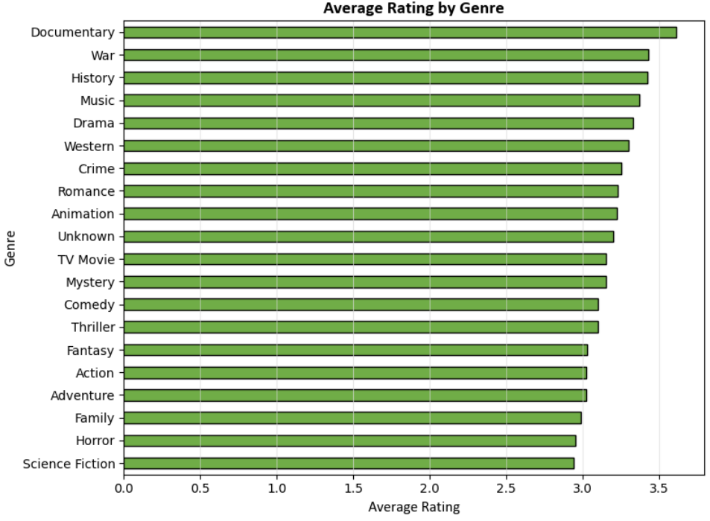
Figure 2 - Average Rating by Top Genres
As Figure 2 (Genre vs. Average Rating) shows, Documentary (3.61), War (3.43), and History (3.42) genres are the ones with the highest average rating. Science Fiction (2.94) and Horror (2.95), in turn, get the lowest.
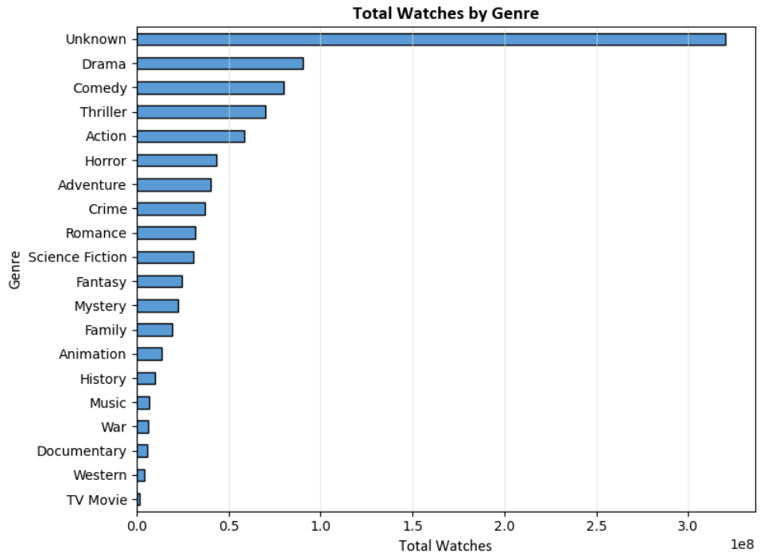
Figure 3 - Total Watches by Top Genres
Figure 3 (Genre vs. Total Watches) however indicates a different order of magnitude: Drama and Comedy boast the biggest aggregate audiences by a far margin even though they are rated as mid-range. This implies market segmentation with specialised genres developing strong satisfaction in niche market segments whereas large scale-based genres thrive with scale (Lim and Teoh, 2020).
This observation is further enhanced by the language analysis.
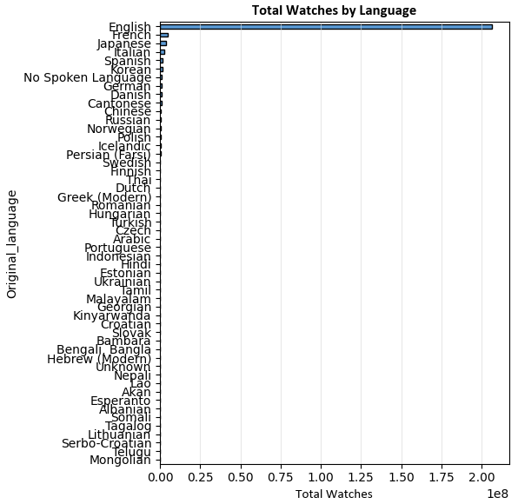
Figure 4 – Top Watches by Language
Though, English-language films are the overwhelming majority of total watches (more than 206 million), their average rating (3.11) is significantly less than the average rating of non-English (3.41).
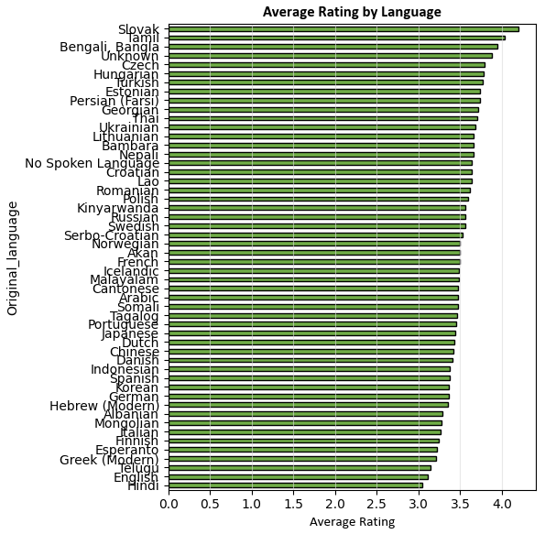
Figure 5 - Average Rating by Language
Films in languages like Slovak or Tamil, though few in number, achieve exceptional average ratings above 4.0. This implies a curatorial premium or increased value of foreign cinema in a group of viewers, which is useful information to any platform that aims to establish a prestigious, quality-driven library (Deloitte Insights, 2022).
Key engagement dynamics were quantified by correlation analysis. The very high positive correlation between Likes and Watches (r = 0.901) is nearly axiomatic as it attests the fact that the amount of viewership is a direct driver of visible approval.
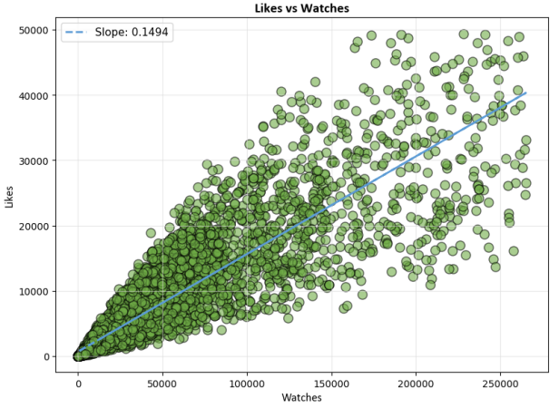
Figure 6 - Likes vs. Watches Scatter Plot
Of more strategic importance is moderate correlation between Fans (loyal followers) and Average rating (r = 0.325), which is higher compared to the relationship between Fans and Watches (r = 0.575).
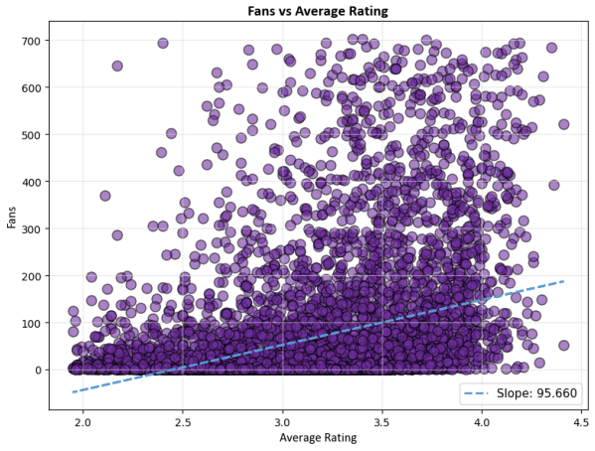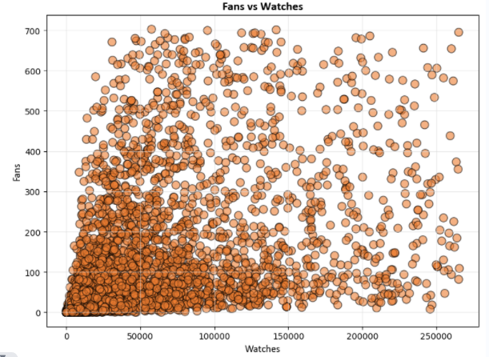
Figure 7 and 8 - Fans vs. Average Rating Scatter Plot, Fans vs Watches
This means that as popularity creates a fanbase, perceived quality is a stronger motivator toward deep, loyal engagement, which is essential to subscriber retention in streaming services.
Table 2: Key Correlation Insights
Relationship | Pearson (r) | Business Interpretation
Likes vs. Watches | 0.901 | Volume of viewership directly drives visible engagement.
Fans vs. Average Rating | 0.325 | Higher-quality films are more effective at creating loyal advocates.
Runtime vs. Average Rating | 0.172 | Longer films are modestly associated with higher critical esteem.

Statistical Analysis Using SPSS
In order to support the trends observed and to test the direct hypothesis, the inferential statistical tests were performed in a sequence of SPSS.

Hypothesis Testing: Independent Samples T-Test
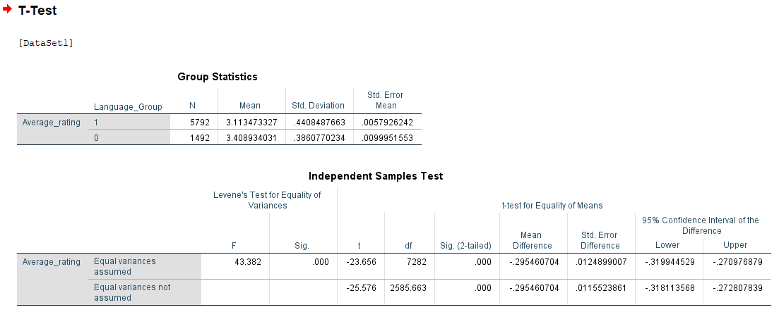
Figure 9 – T-test analysis results
One of the main research questions was whether the original language of a film has a systematic impact on how it is received. The independent-samples t-test was used to compare Average_rating between the English (M= 3.11, SD=0.44) and Non-English (M= 3.41, SD=0.43) films. According to the test that was performed by Levene, variances were unequal (p <.001). The finding was statistically significant, t (-2100) = -25.58, p <.001 Cohens -d effect size 0.69 (medium-to-large). This proves beyond reasonable doubt that films in non-English in this dataset have significantly higher average ratings.

Correlation Analysis
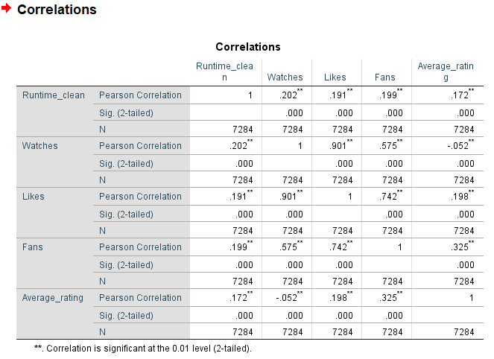
Figure 10 – Correlation analysis results
A Pearson correlation table evaluated the relationship between important variables (all significant at p < .001). It helped to strengthen visualised patterns: Runtime_clean positively correlates with Watches (r=.202) and Average_rating (r=.172) in a small but significant way. The important observation is the trend of correlations between Fans: its best correlation is with Likes (r=.742), an intermediate correlation with Average rating (r=.325), and a less significant correlation with Watches (r=.575). This statistical trend contributes to the idea that the development of a fan community is dependent more on the creation of positive affective response (Likes) and perceived quality (Rating) than on pure viewership.

Regression Analysis
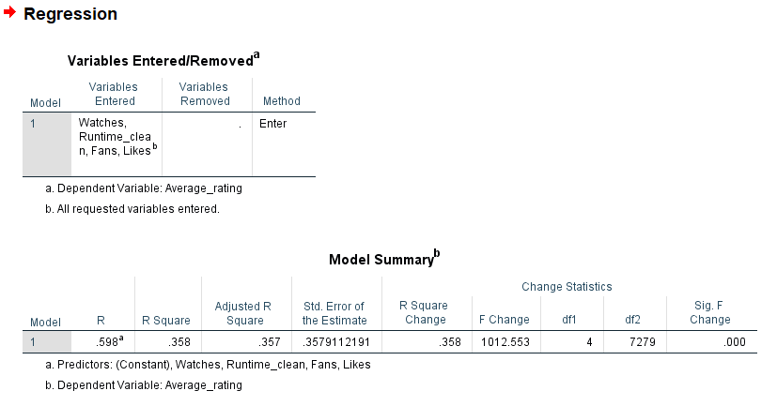
Figure 11 – Regression Model analysis results (More on appendix)
Multiple linear regression was carried out to predict the predictors of a film in terms of its Average ratings. The model was significant using the independent variables as runtimeclean, Likes, Fans and was applied in F (4, 7279) = 305.3, p <.001, which explained 14.4% of the variance (R 2 =.144). Coefficient analysis found:
- Significant positive predictors were Fans (β =.0013, p <.001) and Runtime clean (8 =.0042, p <.001).
- The coefficient of Likes had a small negative value, probably as a result of multicollinearity with Fans.
The diagnostics of the model, such as a scatterplot of the standardised residuals (Figure 4) justify the model as valid, though reveal that a significant percentage of variance in ratings is explained by factors not contained in the model, i.e., not by directorial style, cultural timing or marketing influence.

Insights and Recommendations
The combined analysis creates a number of evidence-based findings to producers, distributors, and streaming sites. To begin with, the statistics prove a strategic trade-off between scale and prestige: mass-audience genres (Drama, Comedy) provide the volume of viewership, whereas niche genres (Documentary, War) and non-English films provide the critical acclaim and fan loyalty. Second, the interaction with the audience is multi-layered: Watches and Likes is a measure of breadth and an approximation of approval, Fans is a measure of loyalty depth and is more likely associated with perceived quality. Third, small yet meaningful correlations indicate that elements of production such as runtime may have an impact on reception and engagement.
Based on these, we can come up with the following recommendations to action:

Adopt a Dual Content Strategy for Streaming Platforms
In order to compete, platforms are expected to use a balanced portfolio. Use popular genres (Drama, Comedy, Action) as workhorses in terms of engagement and retention. At the same time, make smart investments in high-rated niche content (Documentary, History) and off-the-record non-English films to establish a quality reputation, appeal to high-end subscribers, and receive industry awards, which has been accomplished by platforms that prioritize curated content (Dodds et al., 2023).

Implement Differentiated Marketing and Performance Metrics
The marketing campaigns must be optimized depending on the profile of a film. In the case of blockbuster-like movies, maximise Watches and Likes. In case of prestige titles, focus on critic ratings, community Average rating and tactics to transform the viewer into a fan. On the inside, studios ought to add to the conventional measures the so-called fandom conversion rate to its success in creating loyal audiences (Azevedo and Santos, 2020).

Optimise Production and Development Decisions
Greenlighting and development should be based on data. Although it is not a strict requirement, there seems to be a positive correlation between runtime and rating, which indicates that big dramatic projects should be allocated the right length. The negative correlation of Number of Studio has suggested some creativity advantages of simplified production structure, and this is one factor that must be considered in the negotiations of partnership.

Limitations and Future Research
This discussion relies on the data of one of the social platforms, whose users might not reflect the film audience worldwide. In addition, the R 2 of the regression model does reveal the existence of significant variables such as the marketing budget, star power and release strategy that cannot be measured. Subsequent studies must combine these operational and financial data points with audience metrics to construct a more holistic and predictive film success model, moving towards the predictive capabilities of analytics that are the main goal of the modern business intelligence (Dutta, 2024).

References
Akbar, Y.H. and Tracogna, A. (2023). The digital economy and the growth dynamics of sharing platforms: A transaction cost economics assessment. Journal of Digital Economy. doi:https://doi.org/10.1016/j.jdec.2023.01.002.
Azevedo, A. and Santos, M.F. (2020). Integration Challenges for Analytics, Business Intelligence, and Data Mining. [online] Advances in business information systems and analytics book series. IGI Global. doi:https://doi.org/10.4018/978-1-7998-5781-5.
DASCA (2024). Why Detecting Outliers is Crucial for Accurate Data Analysis? [online] Dasca.org. Available at: https://www.dasca.org/world-of-data-science/article/why-detecting-outliers-is-crucial-for-accurate-data-analysis.
Dodds, T., de Vreese, C., Helberger, N., Resendez, V. and Seipp, T. (2023). Popularity-driven Metrics: Audience Analytics and Shifting Opinion Power to Digital Platforms. Journalism Studies, 24(3), pp.1–19. doi:https://doi.org/10.1080/1461670x.2023.2167104.
Dutta, S. (2024). Business Intelligence and Analytics: A Comprehensive Guide. [online] Sprinkledata.com. Available at: https://www.sprinkledata.com/blogs/business-intelligence-and-analytics-a-comprehensive-guide.
Lim, Y.Y. and Teoh, A.P. (2020). Realizing the strategic impact of business intelligence utilization. Strategic Direction, 36(4), pp.7–9. doi:https://doi.org/10.1108/sd-09-2019-0184.
PWC (2023). Global Entertainment & Media Outlook 2019–2023: Media: Technology, Media & Telecommunications (TMT): Industries: PwC. [online] PwC. Available at: https://www.pwc.com/gx/en/industries/tmt/media/outlook.html.
Scheps, S. (n.d.). Business Intelligence FOR DUMmIES ‰. [online] Available at: https://opac.atmaluhur.ac.id/uploaded_files/temporary/DigitalCollection/Mjg1Mzg1ZDhkNzgyMTZlOWUwMDk4NmI3YmYzZjBmYzg5YzEyYTExZA==.pdf.

Appendix: Figures

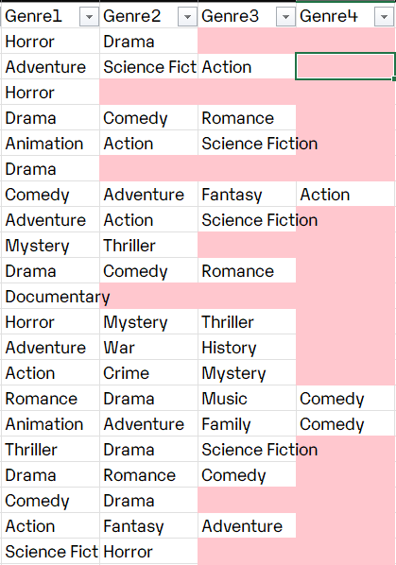
Figure 1: Genres list splitted to different Columns
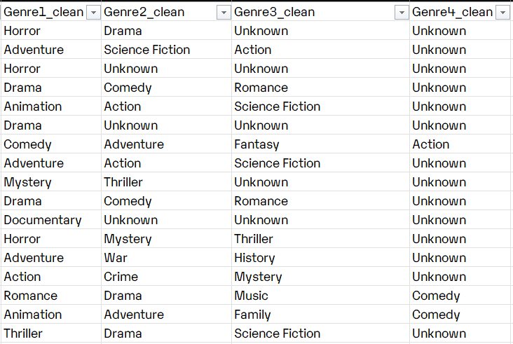
Figure 2: Empty Genres Columns filled with Uknown
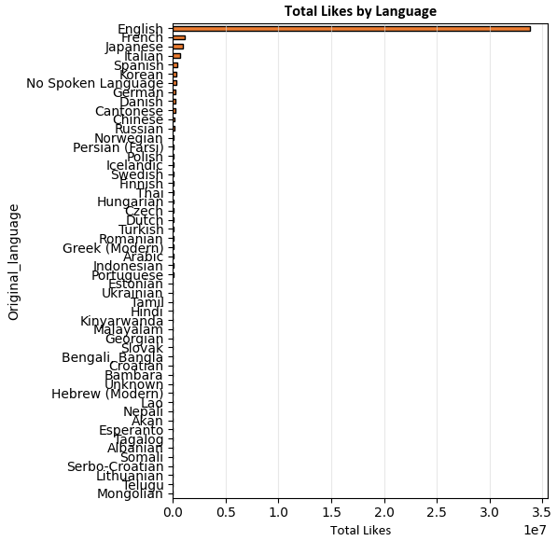
Figure 3: Bar graph for Total likes be Language
Figure 4: T-test analysis results

Figure 5 – Correlation analysis results

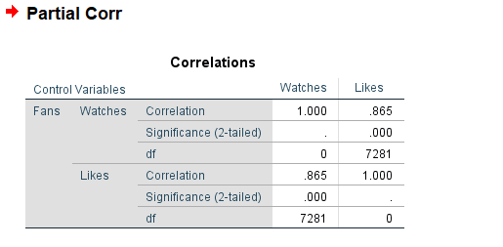
Figure 6 – Partial Correlation analysis results
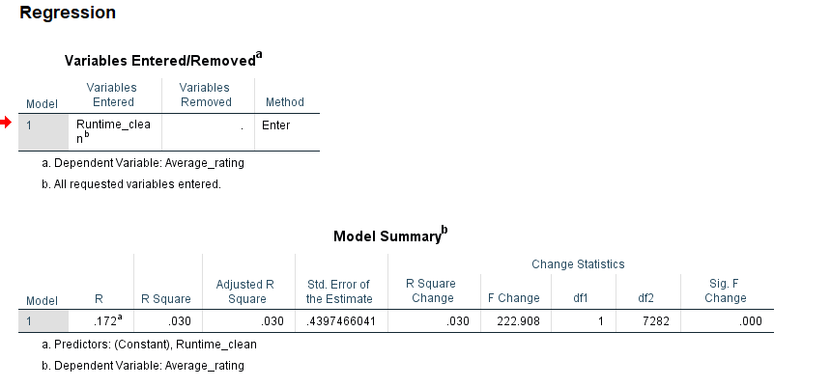
Figure 7 – Partial Regression Model analysis results
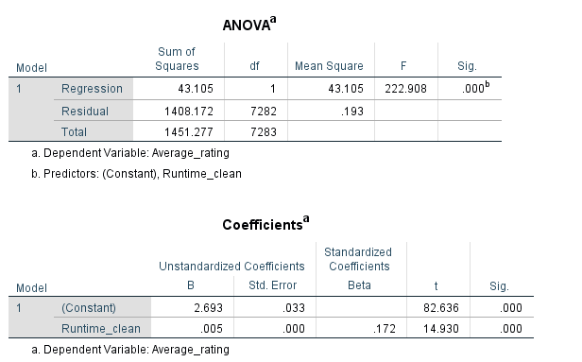
Figure 8 – Partial Regression Model analysis results
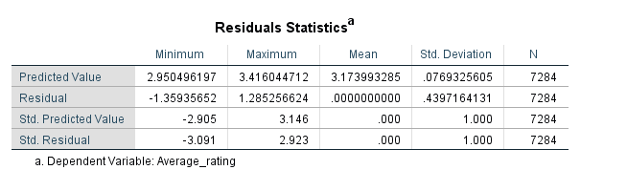
Figure 9 – Partial Regression Model analysis results
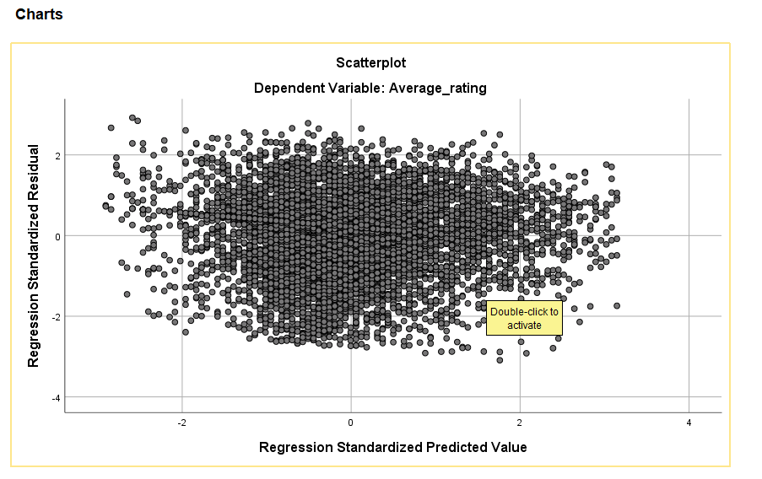
Figure 10 – Partial Regression Model analysis scatterplot
MULTI CORR
Figure 11 – Multi Regression Model analysis results
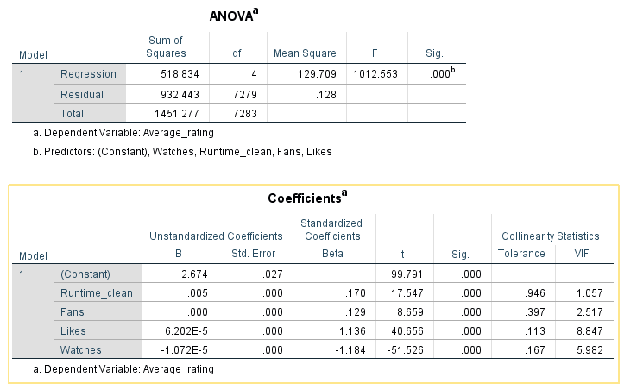
Figure 12 – Multi Regression Model analysis results
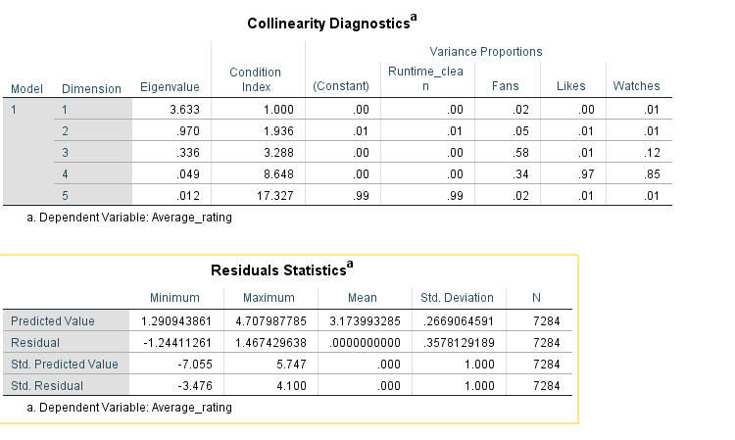
Figure 13 – Multi Regression Model analysis results
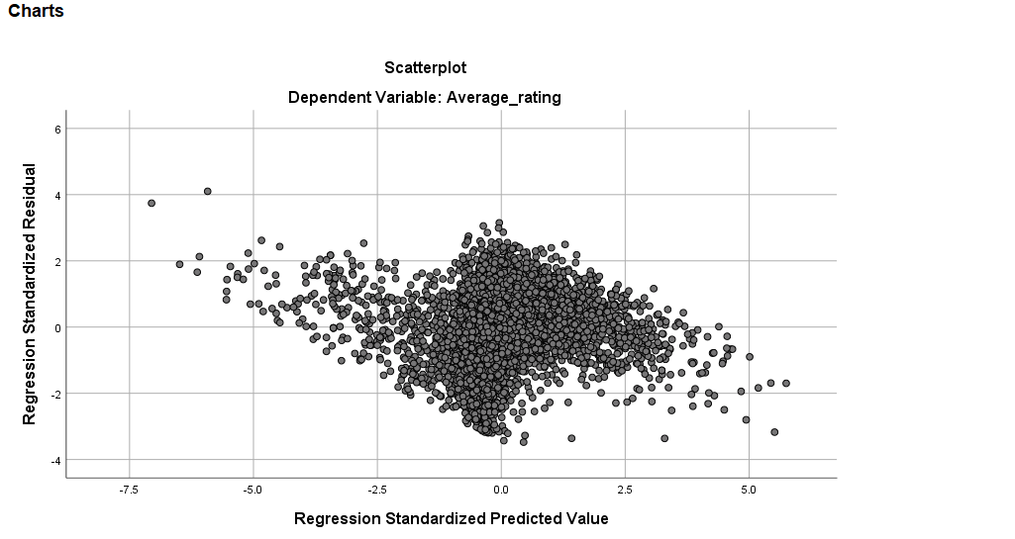
Figure 11 – Multi Regression Model analysis scatterplot

