Introduction
This chapter presents the analysis of the results conducted to address the research outlined in my proposal. The survey aimed to reach participants within the police service where the author seeks to close the gap in the research of Body Worn Video, identifying as to whether it has changed a police behaviour whilst dealing with an incident. the collected data provides insights into the type of persons who utilise Body Worn Video and furthermore we reach the analysis into the participants thoughts on the questions put to them.
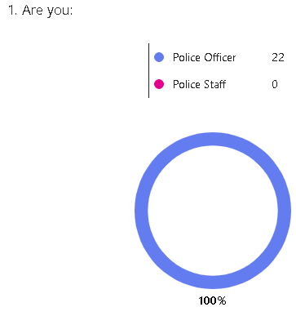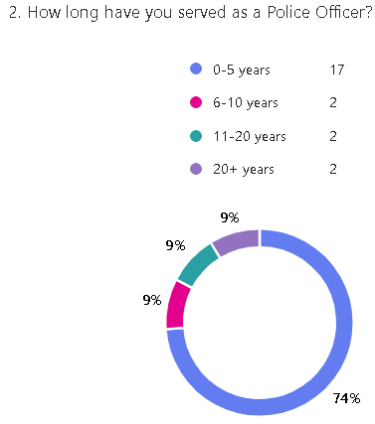
The first two questions are based on gathering infomration on the type of participants. Here we can see that all participants were police officers, it is important that this survey was open to both police officers and police staff. Q2 we can also see that the majority of participants have between 0-5 years service.
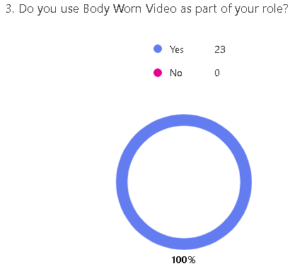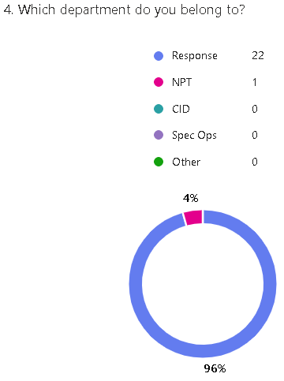
Q3-4, gathers infromation regarding the use of BWV and what department the participants belong to, all participants utilise BWV as part of their role along with all participants working on frontline operational jobs, in this case Response and NPT.
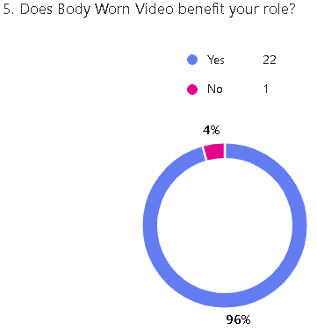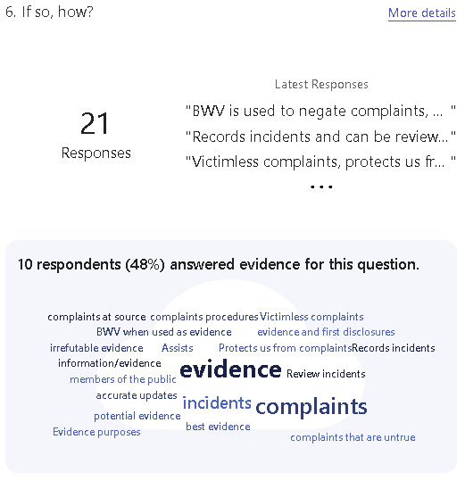
Q5-6 aims to recognise the benefits of the use of BWV within the participants role, 1 paticipant stated that BWV does not benefit their role. The author has then asked for the participant to elaborate their answers, some of the responses were the following:
“It add protection and reassurance to both the public and myself as an officer to ensure that incidents are recorded accurately and truthfully. It also enables my to review the footage back for any key information/evidence that I may have missed at the time.”
“Holds officers accountable due to it being monitored. Prevent potential complaints, aids with remembering what happened at incidents”

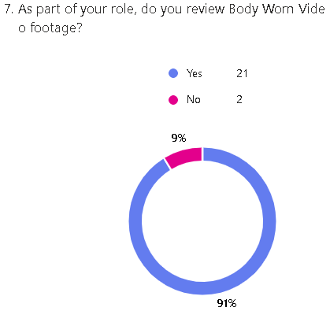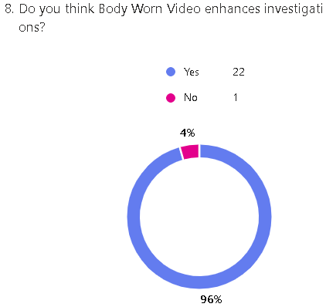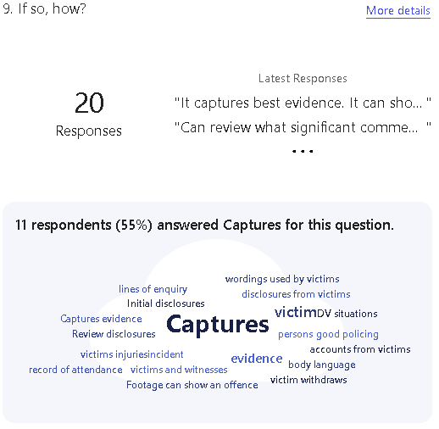
Q7-8-9 looks into the benefits of its use, the majority state that they review BWV as part of their role, furthermore the majority believe that BWV enhances investigation. Participants have then been asked to elaborate as to how BWV enhances investigations, the responses are as follows:
“Initial disclosures especially for DV situations, if the victim withdraws and we proceed with a victimless prosecution.”
“It captures best evidence. It can show a victims injuries, emotions and vulnerabilities at the time of or following an incident.”
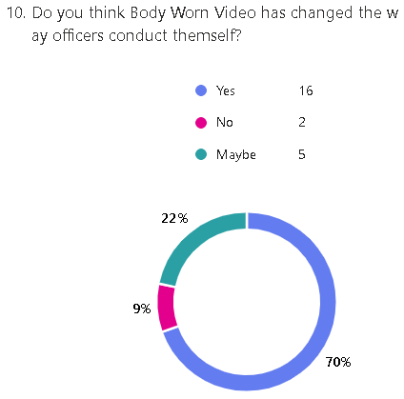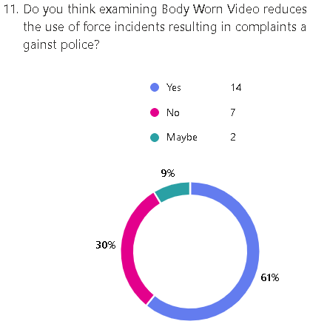
Q 10-11, identifies the way BWV gets used during complaint against police, this has the most mixed reviews. 70% of participants state that BWV has changed the way officers conduct themselves, 22% state that maybe and 9% state no. 61% state that examining BWV reduces the use of force incidents resulting in complaints however 30% state that no.

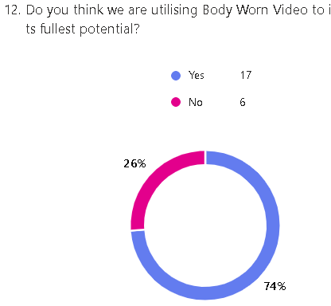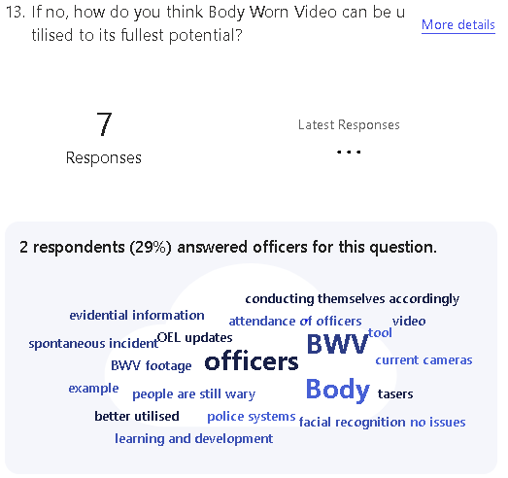
Q12-13 looks into the way we utilise BWV, and gaining insights into how BWV can be improved. Some of these responses are as follows:
“Body worn could be better utilised with updating police systems, for example working tandem with OEL updates for calls.” – this open ideas in relation to the use of AI.
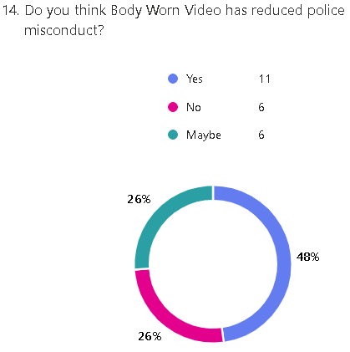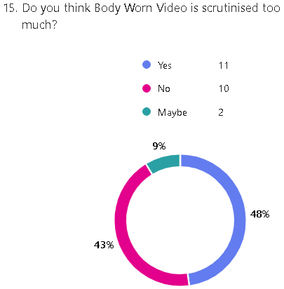
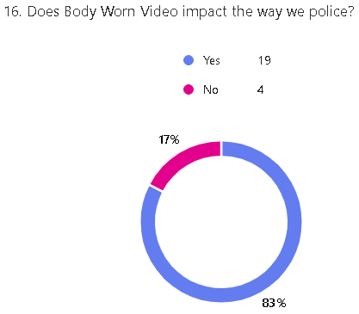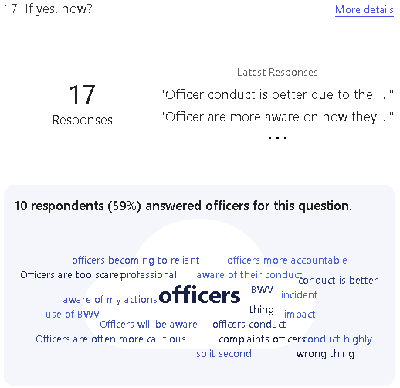
Q’s 14/15/16/17 shows the impacts of BWV on the polcie, participants state the following:
“Officers will be aware of their conduct and that if they aren't conducting themselves in an appropriate, professional and lawful manner then they will be held to account.”
“We have become more professional as an organisation in the way we're able to investigate”

