

Programme: MSc Public Health and Social Care in Practice

Module: Health Care System Organisation and Leadership
Module code: LCHS7002
Name: Jatin Makwana
Student Id: 2521166
Title: Len Case Study- Medication Safety and Leadership Failure
Case study 2

4869 words

Table of Contents
1. INTRODUCTION 3
2a. PROBLEM + SYSTEMS THINKING + RICH PICTURE 4
2b. CENTRALISATION VS DECENTRALISATION 7
2c. LEADERSHIP THEORIES 10
2d. IMPROVEMENT and LESSONS 13
3. RECOMMENDATIONS 16
4. CONCLUSION 17
REFERENCES 19

1. INTRODUCTION
The example of an 89-year-old patient Len living with the Charcot-Marie-Tooth (CMT) disease contradicts the fact that the topics of medication safety, communications, and leadership in health and social care are highly important. Len was put on morphine oral solution following falls and a few symptoms and effects of chest pain and shortness of breath. Nevertheless, he took a much more dose than a planned one because of a misinterpretation of the labels of the medication on the bottle by both Len and his wife. This caused a possible morphine overdose and the condition was complicated by pneumonia and aggravation of his pre-existing condition which later caused his death. The aim of the case study is to analyse the impact of leadership, communication and organisational structures to patient safety and care outcome in high risk situations involving vulnerable people.
Leadership in health and social care, is the ability to have influence, guide and support individuals or groups to achieve universal goals, particularly in delivering safe, effective, and patient-focused care (Diggele et al., 2020). Effective leadership involves effective communication, delegation and accountability which is very important in preventing errors such as medication mismanagement. In this respect, leadership is not focused on the formal managerial responsibilities but is the role of all the healthcare professionals who would participate in patient care and safety.
Organisational structure is another factor that is extremely crucial and impacts the delivery of care. Centralisation presents a situation where decision making is potentially done at higher levels of management and this could result in uniformity and even standardisation of practices. On the other hand, decentralisation will make it possible to make decisions on lower levels and consequently respond quicker and be more adaptable concerning the handling of patients (Tavares, Vale and Costa, 2024). In this case, a number of leadership theories and styles are applicable. Transactional leadership emphasises procedures, routine and compliance to the set protocols whereas transformational leadership is all about inspiring and motivating personnel to ensure there is betterment of practices and a strong emphasis on patient safety (Research gate, 2023) . On the other hand, situational leadership modifies the leadership style according to the demands of the situation which holds great significance especially in the dynamic type of healthcare setup (Research gate, 2023). The communication breakdown, medication safety and leadership roles are some of the critical issues that have arisen during the case and they will be discussed in this report. It will discuss how such an incident can be prevented through the styles of leadership and how patient care and quality of care can be improved in such cases by using the organisational structure.

2a. PROBLEM + SYSTEMS THINKING + RICH PICTURE
Central Problem
The problematic situation with the central issue in this case is a life-threatening medication mistake due to ineffective communications and lack of patient education and system-based defenses. The fact that the dosage information was not understood means that the medical staff did not ensure that the patient and his long-term caregiver understood that they need to take the drug safely. Also the practice did not have follow up or verification measures to ensure the proper use. It implies that it is not just an error of a person, but a malfunction in the system that involves multiple stages of care delivery, all of which include prescribing, dispensing, and monitoring.
The international attitude towards medication errors
Medication errors are a big concern as far as population health across the globe is concerned. The World Health Organization (WHO) estimates that every day, at least one person dies as a result of medication errors and that an estimated 1.3 million people around the globe are injured by them on a yearly basis (Naseralallah et al., 2023). Moreover, unsafe medication practices are approximated to cost about 42 billion per year (WHO, 2022). These figures illustrate the magnitude of the issue and indicate that the case of Len is not an act of a single event but a trend all over the world. The elderly are a vulnerable customer to this risk due to factors such as use of many drugs, cognitive impairment and complex health conditions as all these factors predispose this age group to medication related injuries (Chippa and Roy, 2023).
National Environment and Organisational Environment
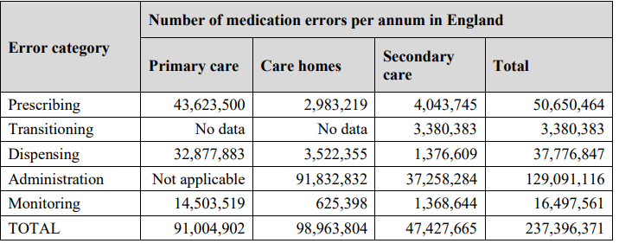
Table 1: number of medication errors in England
(Source: Elliott et al., 2018)
These trends may be identified on the national level. The issue of medication errors in the National Health Service (NHS) of the UK occurs annually in England and comprises approximately 237 million and 66 million, respectively, which could be medically significant (Elliott et al., 2018). These data show that medication errors are among the most common patient safety issues and most of the time are related to inadequate communication, vague labelling, and insufficient counselling of patients.
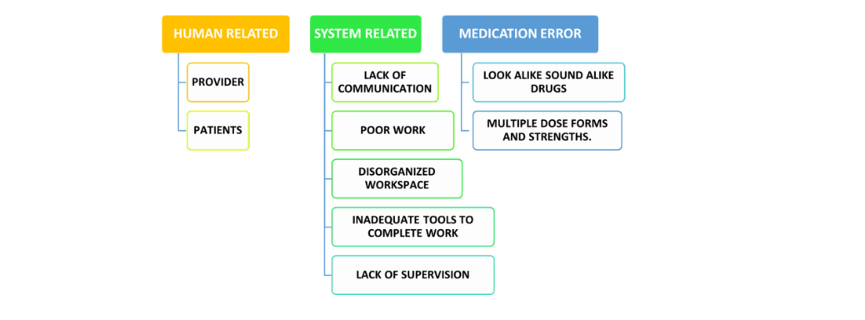
Figure 1: Factors contributing medication error
(Source: Self-created)
This is further complemented by other organisations such as the Institute of Healthcare Improvement (IHI) that further states that most medical errors are not yet caused by negligence of individuals but can be because of system failure. The IHI stresses that the design of the system, communications, and leadership can prevent a high ratio of adverse events (Rodziewicz et al., 2024). Comparing these data with the international data, these numbers support the fact that medication errors are a system disorder which needs the joint work at different levels.
Systems Thinking Approach
Systems thinking gives a comprehensive representation of the interaction of various aspects that make up healthcare systems so that they can bring about output. It views healthcare as a form of complex adaptive system which involves patients, healthcare professionals, organisational structures, policies (Thelen et al., 2023). The fault of medications was brought about in the case of Len by interaction of different components of the system rather than failure point.
The significant systemic weak points might have been identified. Firstly, the healthcare givers did not understand the patient due to language barrier and consequently had no understanding about his medication instructions (Bhagat, Puga and Keller, 2025). Second, absence of verification mechanisms, such as follow up consultations or pharmacist counselling was employed to make sure that it was well used (Dijk et al., 2023). Third, leadership and accountability structures might have failed to have regular implementation of patient safety protocols.
Young Government and Background
Different tiers of governance are an issue in this case. The local level is involved in the prescribing, dispensing and conveyance of medication by health care workers such as general practitioners, pharmacists and hospital personnel (WHO, 2026). Disasters at this stage especially in regard to patient education and communication directly led to the incident.
However, they include, but are not most importantly, regional and national systems of governance which determine policies and standards of medication safety. More sophisticated decisions are more likely to affect a larger systemic problem, such as employee and resource shortage. Otherwise, in the event of shortage of staff in the health facility, time to engage the patients will be minimal, therefore, consultations can be rushed and possibilities of miscommunication are even more likely (Atinga et al., 2024).
Putting the Rich Picture into practice
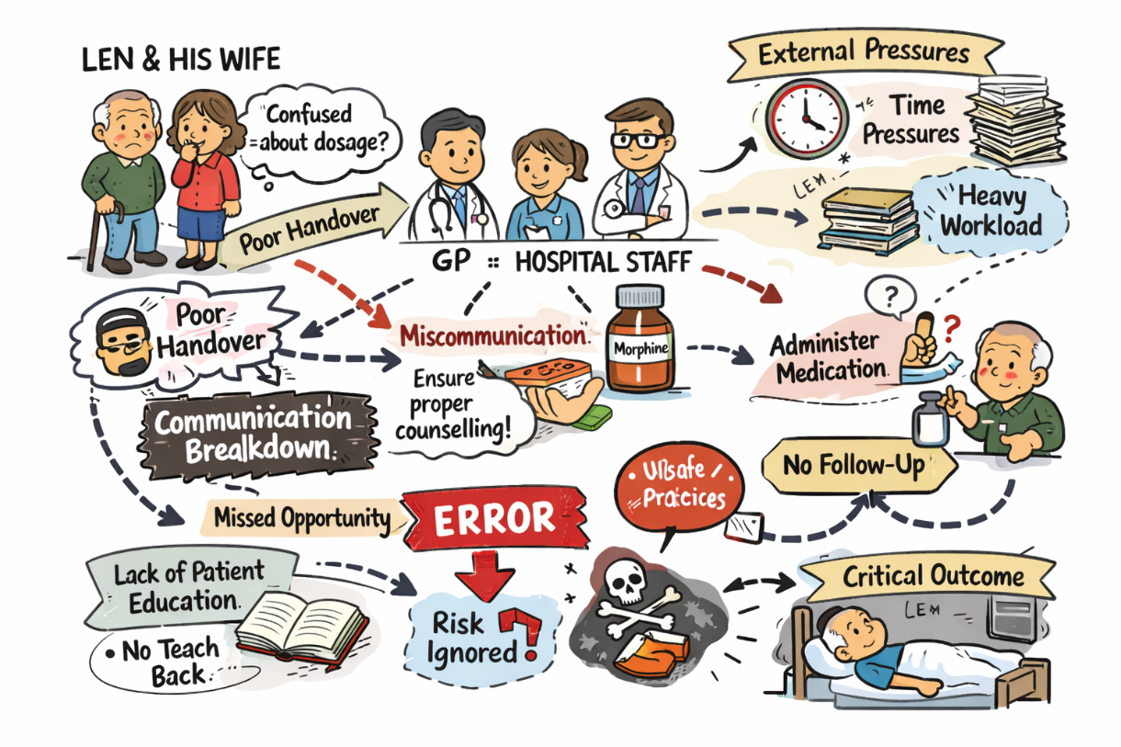
Figure 2: Rich Picture
(Source: Self-created)
Rich Picture is a systems thinking tool that is used to graphically explain complex situations, and illustrates relationships, processes and issues. The key stakeholders that can be identified in the Rich Picture of Len would be Len, his wife, general practitioner, the staff of the hospital and the pharmacist. It would also demonstrate significant processes which include diagnosis, prescribing, dispensing and administration of medication.
The Rich Picture would show at which points of communication breakdown are present as between healthcare professionals and between professionals and the patient where instructions have not been properly delivered. It would connote dependencies as well like the dependence on good labelling and good patient teaching. Feedback loops follow up care and monitoring would have been detected weak/ missing and this is the opportunity that would have been used to detect and prevent the error missed.
Analysis-supported by the theoretical models
Reason’s Swiss Cheese Model
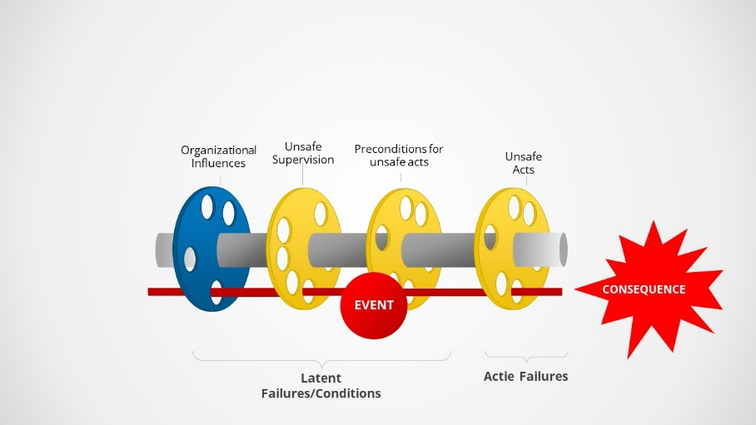
Figure 3: Reason’s Swiss Cheese Model
(Source: As inspired from: Wiegmann et al., 2022)
The Swiss Cheese Model of Reason explains how a failure or mistake occurs when the different layers of defence present in a system interact to lead to failure. Weaknesses were also found in the prescribing, labelling, communication and patient understanding layers in this case (Wiegmann et al., 2022). When these weak areas worked along, they even enabled the misjudgement to slip through all safety checks and convey a deadly result. This model highlights a need to improve all features of the layer, thereby increasing patient safety.

2b. CENTRALISATION VS DECENTRALISATION
Healthcare Systems: Centralisation
Aspect | Centralisation | Decentralisation
Decision-making | Concentrated at higher/national level | Distributed to local professionals
Advantages | Standardisation reduces variation by 30–40%; improves reporting by 20–25%; enhances accountability | Flexible, patient-centred care; reduces medication errors up to 50%; faster decisions
Disadvantages | Poor communication (≈50% errors); time pressure (8–12 min consults); checklist culture | Unclear accountability; inconsistent practices; only 30–40% errors detected early
Impact in Len’s case | Protocols existed but poorly implemented | Failed communication and follow-up led to overdose
Table 2: Centralisation and decentralization in healthcare
(Source: Self-created)
Centralisation is the act of having decision making authority being concentrated at a higher level of organisational or national level. Centralisation is also found in healthcare systems such as the NHS, their national prescription guidelines, and policies to deal with medication safety, as well as nationalised structures in labelling (Scarffe et al., 2022) . One such area is national protocols, to reduce the inconsistency of clinical practice, and research shows the variation between treatments could be reduced by a factor of 30-40 by standardisation.
Centralised clinical guidelines would have been used in prescribing morphine in the case of Len; the morphine would have been used safely and appropriately.
Advantages of Centralisation
One of the benefits of centralisation is uniformity of care provision. Standardised prescribing and labelling systems are intended to decrease the ambiguity and make sure all patients get evidence-based care (Ramsay et al., 2025). Research has clearly demonstrated the fact that severe medication-associated mishaps can be supplanted to up to 25% with the help of centralised efforts in safety practices (Tariq et al., 2024). In addition to that, centralisation improves the transparency of incident reporting and there has been an improvement in the reporting rates of 20-25% as national systems were introduced (de Kam et al., 2020) .
Accountability would also be enhanced by the centralisation as role is defined and roles are clear. Within healthcare settings, national policies provide assurance that the providers undertake particular guidelines, which minimizes the chances of engaging in unhealthy practices. This would have ideally cut short the sort of mistakes that were witnessed in the case of Len.
Disadvantages of Centralisation
Centralisation, in spite of its advantages has some significant limitations. Among the significant drawbacks is less freedom of interaction with patients. Guidelines can be obvious, but they do not necessarily take into consideration patient needs, especially older patients (Ghassab-Abdollahi et al., 2024). It has been pointed out that nearly half of the medication errors are attributed to poor communication and misconception hence the need to go beyond only standardisation. Time pressures can also be caused due to centralised systems. The average length of stay in most healthcare centers is 8-12 minutes in the consultation with professionals who are not able to provide an in-depth explanation (AlShammari et al., 2025) . Besides, labor crises (it is expected that more than 100 000 vacancies will appear in large healthcare organizations) can contribute to the increase of the workload, which, in its turn, will cause the deterioration of the quality of the services (KPMG, 2022). The other weakness is the centralised systems may create the checklist mentality where medical staff focuses on ensuring tasks are completed, rather than ensuring that a patient understands.
Healthcare Systems: Decentralisation
Decentralisation entails sharing of decision-making powers with the lower levels, and comes with the benefit of giving healthcare providers the ability to make clinical judgements depending on the needs of patients (Dougherty et al., 2021). Practically, a high level of decentralisation of communication, education and follow-up is focused on GPs, nurses and pharmacists. Decentralisation in the case of Len presents in the accountability of the healthcare professionals on the issues of ensuring that the patient and his caregiver comprehended the instructions on medication (Dougherty et al., 2021).
Advantages of Decentralisation
One of the significant advantages of decentralisation is flexibility. The providers of healthcare can adjust the communication techniques to the needs of the particular patients (Saltman, Bankauskaite and Vrangbaek, 2023). Studies have shown that patient counselling has the ability of reducing medication errors by up to 50-per cent, in particular targeting risk populations such as the elderly patients (Saltman, Bankauskaite and Vrangbaek, 2023). The idea of decentralisation also comes into use to make faster decisions. The medical workers are not required to await the dissent of higher authorities, since they are at liberty to do things immediately.
Disadvantages of Decentralisation
Decentralisation also may result in vague accountability. With more than one professional, it could be difficult to establish who should make sure that the patients are informed about the information. The misunderstanding when it came to the deliberation of the duty to educate patients in the case of Len made the error possible. In addition, systems of decentralisation might not have effective monitoring and feedback. This study points out that the most prevalent causes of medication are that out of 30-40 percent errors of medication identified before being harmful, and therefore there have been holes in the follow up and verification (Coelho et al., 2024).
Critical Analysis Effect on the Crisis Management and responsibility
As the case of Len demonstrates, the system of healthcare turned into a hybrid system with both its centralised and decentralised elements. Centralised systems led to the provision of the standardised guidelines in the prescribing field and decentralised practices led to the control over patient communication and education. These problems are further statistically supported. The number of patients per staff is high (sometimes taking above the suggested ratios) and diminishes the quality of care. As an illustration, in certain areas nurse-to-patient ratios may be high, more than 1: 10, which may lead to the probability of making the mistake. Also, research indicates that workload can increase up to 15 times the chances of making medical errors when it is increased by only 10 percent. Policy compliance is another consideration (Chen et al., 2025) . The compliance with clinical guidelines is high (100 per cent, on average), whereas it is, on average, significantly less with other standards, communication and patient education. This loophole points to a serious shortfall in the system.

2c. LEADERSHIP THEORIES
The primary consideration of how the medication error of Len turned into a deadly event is the aspect of leadership. Even when there were clinical procedures and guidelines, the failure was due to the fact that the leadership failed to provide proper communication, patient comprehension as well as the proactive utilization of risk management. To determine how leadership affected decision making and patient safety in this scenario, this section critically reviews three leadership theories: transformation, transactional, and situational leadership through pertinent healthcare data, safety data, and workforce evidence.
Transformational Leadership
Concept
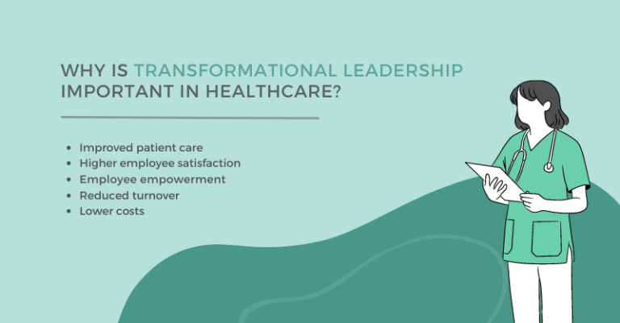
Figure 4: Impact of transformational leadership in healthcare
(Source: As inspired from: Ystaas et al., 2023)
Transformational leadership is geared towards motivating employees, developing a common vision, and establishing robust culture of safety. Leaders promote motivation, collaboration and unmeaningness to improvement to ensure that the safety of patients is a personal organisational value and not a legislative dictum.
Using Len Case
In the case of Len, the application of transformational leadership is not evidently applied. Transformational approach would have been used to ensure high risk medications like morphine were managed by improved patient education, effective communication and compulsory examinations of understanding. There is, however, evidence of lack of safety culture gaps which are indicated by the NHS workforce data.
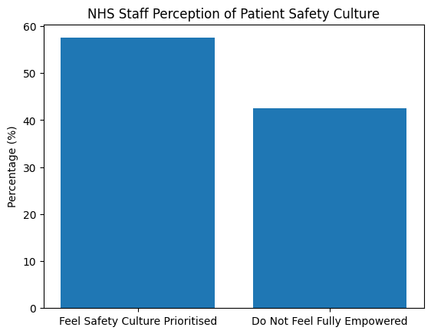
Figure 5: Contrast between NHS staff who feel patient safety is prioritised
(Source: As inspired from: patient safety, 2023)
It has been estimated that about 55-60% of the NHS employees feel comfortable that their organisation takes priority on patient safety culture, i.e. a large percentage of the employees do not feel fully empowered to speak up or enforce best practice (patient safety, 2023). Also, medication-related incidents have been one of the predominant types of patient safety events in the NHS, leading to thousands of preventable negative outcomes in a year.
Critique
Instead, there is no proactive payment of attention to vulnerable patients such as Len, and this lack of transformational leadership becomes apparent. Transformation leader would have provided both patient and caregiver with structured education since Len was aged and had neurological problem (CMT) that put him at risk of being misunderstood (Ystaas et al., 2023).
Although WHO has estimated that worldwide around one point three million people are injured due to medication errors every year, leadership in this situation failed to transfer global awareness on safety into the local practice (WHO, 2023).
2. Transactional Leadership
Concept
Transactional leadership premises on the structure, rules, compliance, and performance monitoring. This is very important since the staffs operate in accordance to procedures whose accountability is maintained by auditing, documentation and standard operating procedures (Hutama, Noermijati and Irawanto, 2024) .
Application to Len’s Case
Partly transactional leadership is reflected in the controlled drug regulations, prescribing guidelines, and pharmacy labelling systems exist. Prescription of morphine in a healthcare system such as the NHS is highly controlled and the safety measures are well outlined.
But these systems did not eliminate the errors. Studies indicate that the results of compliance with clinical documentation are about 80-90 percent, but can decrease to less than 60 percent compliance with standards of patient communication and education in crowded clinical situations (Bunting and Klerk, 2022) . This is an essential gap since Len did not fail in the prescribing level but in the communication and understanding stage.
Critique
In this instance, transactional leadership seems to have brought about a culture of checkbox where employees are involved in filling purely documents instead of making patients understand. It has been shown that as many as 70 percent of severe medication errors are as a result of communication failures as opposed to a prescribing error, with one limitation of the rule-based systems (Branch, Hiner and Jackson, 2021). The lack of human understanding cannot be addressed with the help of transactional leadership only. Also, excessive dependence on processes can depress clinical judgement. When patients are at high risk, staff can believe that they do not need to go through official procedures. This helped in the lack of other protection measures like a teach-back or a follow-up call.

2d. IMPROVEMENT and LESSONS
The case of Len illustrates that defects in leadership and governance may be coupled with the failures of the system to create lethal effects. The healthcare mistake was not the phenomenon that was simply related to the individual negligency but the systemic breakdown of the processes, as well as the fact of ineffective feedback systems. This part critically examines these interactions in a problem data solution approach, connecting leadership style, governance and feedback loop to derive some of the key lessons, which can be applied to the enhancement of patient safety.
Issue 1: Lack of communicating and Understanding patient
It has been shown that drug errors are connected with the failure of communication especially among older patients with intricate conditions. Also, it was reported that the level of medication instructions comprehension of patients following consultations.
Solution: Be equipped with many forms of organized communication such as those in the teach back method where the patients have to repeat what is being told to them so they can get it. This has been found to enhance understanding by 80 percent and minimize drug errors by almost 50 percent (Talevski et al., 2020) .
Critical Evaluation:
This was not an effective solution due to both a failure of leadership and a failure of governance. Patient-centred communication was not given priority as a form of leadership which is a poor transformational leadership (Ghiasipour et al., 2018). At the governance level, even though there are specifics of communication, they were not monitored or implemented in a suitable way. This shows the absence of information between policy (centralised governance) and practice (decentralised implementation).
Issue 2: Minimal Adoption of Medication safety measures.
Adherence to prescribing documentation is good whereas the levels of compliance with patient education process might be even less. Furthermore, of drug errors, there are defences that occur prior to injury causing damage, which is ineffective system prevents (Mutair et al., 2021).
Solution: Improve transactional leadership by regularly inspecting safety, mandatory counselling of medications posing high risks and electronic prescribing messages. It has been shown that electronics prescribing systems and pharmacist-led intervention can help reduce medication errors by 30-70 percent.
Critical Evaluation:
This was not because of absence of protocols but failure to use the same. It had a weak form of transactional leadership but it was not effective and instilled the culture of checkbox where how to comply could be done on the surface (Mutair et al., 2021). The shortcomings of governance mechanisms which ensured accountability also occurred, due to the absence of safety auditing in common front-line practice.
Issue 3: Risk Assessment and Monitoring are not proactive
It is estimated that monitoring and early intervention can help avoid the harm related to medicine. Follow-back care though is not routine and less than half of those at high risk are followed up after the prescription has been made (Dowell et al., 2022).
Solution: Suggestions of risk stratification tools, distinguishing vulnerable patients (e.g. old age people under opioid medication) and provide mandatory follow-up (e.g., phone calls or visits) (Skeer et al., 2023).
Critical Evaluation:
This portrays an inadequacy of situational leadership. Leaders failed to change their approach according to high-risk profile of Len. Rather, there was uniformity of care as opposed to individualisation. The inability of governance systems to lead to more monitoring of vulnerable populations also demonstrated that there was no integration of policy and clinical risk management.
Issue 4: Ineffective Feedback Loops and Incident Reporting
It has been noted that, out of the total medication errors, less are reported and in some cases, the same may remain unreported or reported late. This makes learning in organisations slow and repeating of errors are also promoted (Lei and Eitan Naveh, 2023) .
Remedy: Adopt the electronic real time reporting and instill no punishment reporting culture. There is also some evidence of how strong reporting cultures within organisations lead to higher incident reporting, and this raises the level of safety (Mohammed Abdalraheem Alalaween and Karia, 2024) .
Critical Evaluation:
The absence of effective loop of feedback implies the shortcomings in the leadership and governance. The culture of transparency that was encouraged by the leadership (there was lack of transformational leadership) and reporting and learning on events were not imposed on events as there were governance systems in place. The system is unable to correct itself without feedback.
Lessons Learned
Patient Safety Requires Systems Thinking
In the example of Len, it can be demonstrated that mistakes are not so solitary. Their arising is predetermined by a failure in communication, leadership, and system designs. To tackle these interdependencies, healthcare organisations need to implement a systems thinking approach to create and solve them. A culture in which patient safety is of priority has to be developed with the help of transformational leadership whereas protocols should be implemented actively with the help of transactional leadership (Huang et al., 2024).
Leadership Must Enable Accountability
Reactive leadership as is observed in the case is dangerous. Early intervention and risk assessment are some of the proactive interventions that need to be implemented in preventing injuries, particularly in the context of vulnerable patients (Picoito et al., 2025).
Data-Driven Governance is Crucial
Good governance is based on proper and prompt data. The use of safety audits, performance measures and incident reports should be used in a positively way so that the risks and the development of improvement may be highlighted (Orvik et al., 2025). Without data, organisations will not be able to learn and prevent mistakes.

3. RECOMMENDATIONS
According to the case study conducted on the Len scenario, it is clear that the leadership, governance, communication and system integration aspects ought to be improved to avoid occurrence of such medication errors. The recommendations below specify some evidence-based practical measures that the organisation should take, in order to improve patient safety and efficiency of the systems.
Improving Leadership so as to guarantee Long-term Improvement
The organisation should also have a blended type of leadership that consists of transformational, transactional and situational leadership (Mouazen et al., 2023). Transformational leadership can be used to support a robust patient safety culture since the personnel will be enabled to concentrate on the dialogue and how to resolve any issues. Positive safety cultures have been shown to lead to a reduction in up to 25% of less adverse events in organisations. Strong compliance with medication safety measures should be a byproduct of audits and accountability systems via transactional leadership. Situational leadership will significantly help in offering high-risk patients the appropriate care so that vulnerable individuals such as Len have the opportunity to get the necessary help (Hasan Fehmi Dirik, Chrysanthi Theiakouli and Efstathiou, 2026). Executives will have to change the approach towards the reactive to the proactive aspect of leadership where they are to concentrate more on the preventive instead of the reactionary.
Improvement in Governance and Accountability
There should be enhancement of the governance systems by formulating powerful monitoring and reporting systems. The application of digital incident reporting system should be done in such a way that documentation of medication errors should be real-time since the digital system is capable of increasing the reporting rates by 20-25 per cent (Engstrom et al., 2023) . Safety audits should be done on a regular basis and there should be accountability, both at the organisational and an individual level. In addition, it must governance assume the enhanced processes of high-risk drugs, and mandatory patient counselling and follow-up (Hibbert et al., 2023) .
Enhancing Messaging and integration of systems
Communication has to be put at the fore front in order to minimise errors of medication. The organisation ought to adopt well organised means of communication like the teach-back strategy which can enhance the comprehensible nature of the patient by 80 per cent (Mahmoodi, 2025). Scientific interactions between pharmacists and patients should be more heavily involved in the process of patient education since pharmacist-led interventions are able to decrease medication errors by 30-70 percent. In addition, through installing electronic prescribing systems in the patient records, misinterpretation must be minimised and improve the degree of coordination among the healthcare providers.
Making Techneical and Allocative Efficiency Improved.
By involving itself in digital health technologies, e-prescribing and automatic warnings on high-risk medications, the organisation will need to invest in improving their technical efficiency. Not only can they cause the reduction of prescription errors, but such systems can streamline workflow. Allocative efficiency can be used to increase the allocation of resources to risky patients, elderly individuals to provide them with more support and observation (Pappalardo, Floriana d’Ambrosio and Calabrò, 2025) . It is also important to overcome the issue of shortages and workload pressure as more workload can lead to an increase in error rates up to 15 times.

4. CONCLUSION
The case study of Len shows that the error of fatal medication was not caused by one individual error but a set of interrelated system failures in communication and leadership and the governance. The analysis ensued that, despite the standardised protocol and prescribing guidelines, they were not well implemented in practice. The misperception of the patient, non-follow-up and poor verification procedures culminated in a negative outcome that could have been avoided. This underscores policy versus implementation in the healthcare systems.
The results are powerful points to the importance of leadership in patient safety. The lack of transformational leadership constrained the building of a strong safety culture, and transactional leadership was limited to a compliance-based strategy with little actual enforcement. There was also a lack of good application of situational leadership whereby the care was not modified to the high-risk status of Len. Consequently, leadership was more reactionary than proactive to reduce risks by not anticipating them.
The form of government was also a factor. Whereas centralised systems offered transparent policies and structures, the implementation in much-devolved structures was not very cohesive and responsible. Poor incident reporting and monitoring were also part of the weak feedback mechanisms that prevented timely intervention and organisational learning.
Altogether, the case promotes the need to consider the significance of systems thinking in healthcare. The combination of the leadership, governance, and operational processes is crucial to patient safety. To achieve sustainable progress, it is essential to have a proactive leadership, good accountability systems, and data-driven decisions to make sure that the policies become a reality on the ground and comparable occurrences can be prevented in the future.

REFERENCES
AlShammari, S.A., AlSaif, H.I., Karim, S.I. and Alsaad, S.M. (2025). Trends of consultation time, waiting time, and satisfaction in family medicine/primary health care centers in Saudi Arabia: Systematic review and meta-analysis. Journal of Family Medicine and Primary Care, 14(9), pp.3618–3629. doi:https://doi.org/10.4103/jfmpc.jfmpc_426_25.
Atinga, R.A., Gmaligan, M.N., Ayawine, A. and Yambah, J.K. (2024). ‘It’s the Patient That Suffers from Poor communication’: Analysing Communication Gaps and Associated Consequences in Handover Events from Nurses’ Experiences. SSM - Qualitative Research in Health, [online] 6(100482). doi:https://doi.org/10.1016/j.ssmqr.2024.100482.
Bernal, I.B., García, C.Q. and Lara, M.M. (2024). Safety culture, safety performance and financial performance. A longitudinal study. Safety Science, [online] 172(106409), p.106409. doi:https://doi.org/10.1016/j.ssci.2023.106409.
Bhagat, M., Puga, C. and Keller, M.S. (2025). Interventions to Optimize Medication Management in Patients with Language and Health Literacy Barriers: A Scoping Review. Research in Social and Administrative Pharmacy, [online] 12(15). doi:https://doi.org/10.1016/j.sapharm.2025.08.005.
Branch, J., Hiner, D. and Jackson, V. (2021). The impact of communication on medication errors. Patient Safety Network, [online] 14(15). Available at: https://psnet.ahrq.gov/web-mm/impact-communication-medication-errors [Accessed 17 Apr. 2026].
Bunting, J. and Klerk, M. (2022). Strategies to improve compliance with clinical nursing documentation guidelines in the acute hospital setting: A systematic review and analysis. SAGE Open Nursing, [online] 8(1), pp.1–34. doi:https://doi.org/10.1177/23779608221075165.
Chen, Y.-C., Wu, H.-C., Ho, J.-J., Cheng, N.-Y., Guo, Y.L. and Shiao, J.S.-C. (2025). Exploring the Association Between Patient–Nurse Ratio and Nurses’ Occupational Stressors: A Cross‐Sectional Study. Journal of Nursing Management, 2025(1). doi:https://doi.org/10.1155/jonm/6160674.
Chippa, V. and Roy, K. (2023). Geriatric cognitive decline and polypharmacy. [online] PubMed. Available at: https://www.ncbi.nlm.nih.gov/books/NBK574575/ [Accessed 17 Apr. 2026].
Coelho, F., Furtado, L., Mendonça, N., Soares, H., Duarte, H., Costeira, C., Santos, C. and Pereira Sousa, J. (2024). Predisposing Factors to Medication Errors by Nurses and Prevention Strategies: A Scoping Review of Recent Literature. Nursing Reports, [online] 14(3), pp.1553–1569. doi:https://doi.org/10.3390/nursrep14030117.
de Kam, D., Kok, J., Grit, K., Leistikow, I., Vlemminx, M. and Bal, R. (2020). How incident reporting systems can stimulate social and participative learning: A mixed-methods study. Health Policy, 124(8), pp.834–841. doi:https://doi.org/10.1016/j.healthpol.2020.05.018.
Diggele, C. van , Burgess, A., Roberts, C. and Mellis, C. (2020). Leadership in Healthcare Education. BMC Medical Education, [online] 20(S2), pp.1–6. doi:https://doi.org/10.1186/s12909-020-02288-x.
Dijk, van, Linda van Eikenhorst, Fatma Karapinar-Çarkit and Wagner, C. (2023). Patient participation during discharge medication counselling: Observing real-life communication between healthcare professionals and patients. Research in Social and Administrative Pharmacy, 19(8). doi:https://doi.org/10.1016/j.sapharm.2023.05.008.
Dougherty, S., Lorenzoni, L., Marino, A. and Murtin, F. (2021). The impact of decentralisation on the performance of health care systems: a non-linear relationship. The European Journal of Health Economics, 23(12). doi:https://doi.org/10.1007/s10198-021-01390-1.
Dowell, D., Ragan, K., Jones, C., Baldwin, G. and Chou, R. (2022). CDC Clinical Practice Guideline for Prescribing Opioids for Pain. MMWR. Recommendations and Reports, [online] 71(3), pp.1–95. doi:https://doi.org/10.15585/mmwr.rr7103a1.
Elliott, R., Camacho, E., Campbell, F., Jankovic, D., St James, M., Kaltenthaler, E., Wong, R., Sculpher, M. and Faria, R. (2018). PREVALENCE AND ECONOMIC BURDEN OF MEDICATION ERRORS IN THE NHS IN ENGLAND Rapid evidence synthesis and economic analysis of the prevalence and burden of medication error in the UK. [online] Available at: https://www.bpsassessment.com/wp-content/uploads/2020/06/1.-Prevalence-and-economic-burden-of-medication-errors-in-the-NHS-in-England-1.pdf [Accessed 17 Apr. 2026].
Engstrom, T., McCourt, E., Canning, M., Dekker, K., Voussoughi, P., Bennett, O., North, A., Pole, J.D., Donovan, P.J. and Sullivan, C. (2023). The impact of transition to a digital hospital on medication errors (TIME study). npj Digital Medicine, [online] 6(1), pp.1–9. doi:https://doi.org/10.1038/s41746-023-00877-w.
Ghassab-Abdollahi, N., Ghorbani, Z., Kheirollahi, N., Nadrian, H. and Hashemiparast, M. (2024). Exploring the reasons for self-administration medication errors among illiterate and low-literate community-dwelling older adults with polypharmacy: a qualitative study. BMC Geriatrics, 24(1). doi:https://doi.org/10.1186/s12877-024-05595-w.
Ghiasipour, M., Mosadeghrad, A.M., Arab, M. and Jaafaripooyan, E. (2018). Leadership Challenges in Health Care organizations: the Case of Iranian Hospitals. Medical Journal of the Islamic Republic of Iran, [online] 31(1), pp.560–567. doi:https://doi.org/10.14196/mjiri.31.96.
Hasan Fehmi Dirik, Chrysanthi Theiakouli and Efstathiou, N. (2026). The Influence of Nursing Leadership Styles on Medication Safety: A Mixed-Methods Systematic Review. PubMed, 73(1), pp.e70166–e70166. doi:https://doi.org/10.1111/inr.70166.
Hibbert, P.D., Stewart, S., Wiles, L.K., Braithwaite, J., Runciman, W.B. and Thomas, M.J.W. (2023). Improving Patient Safety Governance And systems through Learning from Successes and failures: Qualitative Surveys And interviews with International Experts. International Journal for Quality in Health Care, 35(4). doi:https://doi.org/10.1093/intqhc/mzad088.
Huang, C.-H., Wu, H.-H., Lee, Y.-C. and Li, X. (2024). The critical role of leadership in patient safety culture: A mediation analysis of management influence on safety factors. Risk Management and Healthcare Policy, [online] 5(17), pp.513–523. doi:https://doi.org/10.2147/rmhp.s446651.
Hutama, A.A., Noermijati, N. and Irawanto, D.W. (2024). The effect of transactional leadership on employee performance mediated by job satisfaction, job stress and trust. International journal of research in business and social science, [online] 13(3), pp.151–166. doi:https://doi.org/10.20525/ijrbs.v13i3.3297.
KPMG (2022). Strengthening healthcare workforce in India: the 2047 agenda Top 20 priorities. [online] Available at: https://assets.kpmg.com/content/dam/kpmg/in/pdf/2022/10/Strengthening-healthcare-workforce-in-India.pdf [Accessed 17 Apr. 2026].
Lei, Z. and Eitan Naveh (2023). Unpacking Errors in Organizations as Processes: Integrating Organizational Research and Operations Management Literature. The Academy of Management Annals, 17(2), pp.798–844. doi:https://doi.org/10.5465/annals.2021.0066.
Mahmoodi, H. (2025). Empowering patients through effective communication: The teach-back method as a tool for health literacy. Health Promotion Perspectives, 15(3), pp.211–212. doi:https://doi.org/10.34172/hpp.025.44214.
Mohammed Abdalraheem Alalaween and Karia, N. (2024). The predictive power of electronic reporting system utilization on voluntary reporting of near-miss incidents among nurses: A PLS-SEM approach. Belitung Nursing Journal, 10(1), pp.15–22. doi:https://doi.org/10.33546/bnj.2805.
Mouazen, A.M., Hernández-Lara, A.B., Abdallah, F., Ramadan, M., Chahine, J., Baydoun, H. and Bou Zakhem, N. (2023). Transformational and transactional leaders and their role in implementing the kotter change management model ensuring sustainable change: An empirical study. Sustainability, 16(1), p.16.
Mutair, A.A., Alhumaid, S., Shamsan, A., Zaidi, A.R.Z., Mohaini, M.A., Al Mutairi, A., Rabaan, A.A., Awad, M. and Al-Omari, A. (2021). The effective strategies to avoid medication errors and improving reporting systems. Medicines, [online] 8(9), p.46. doi:https://doi.org/10.3390/medicines8090046.
Naseralallah, L., Stewart, D., Price, M.J. and Paudyal, V. (2023). Prevalence, contributing factors, and interventions to reduce medication errors in outpatient and ambulatory settings: a systematic review. International Journal of Clinical Pharmacy, 45(6), pp.1359–1377. doi:https://doi.org/10.1007/s11096-023-01626-5.
Orvik, C.P., Albrechtsen, E., Trond Kongsvik, Holen, S.M., Lene Elisabeth Bertheussen and Stine Thordarson Moltubakk (2025). What is safety performance? A systematic review of conceptualizations in the construction safety research. Safety Science, [online] 193(12), pp.107025–107025. doi:https://doi.org/10.1016/j.ssci.2025.107025.
Pappalardo, C., Floriana d’Ambrosio and Calabrò, G.E. (2025). Navigating the Increasing Complexity of Health Technology Assessments in the Digital Era: How to Support Value-Based Personalized Healthcare? Data science, machine intelligence, and law, [online] 12(14), pp.147–175. doi:https://doi.org/10.1007/978-3-031-99709-9_8.
patient safety (2023). Still not safe to speak up: NHS Staff Survey Results 2022. [online] Patient Safety Learning. Available at: https://www.patientsafetylearning.org/blog/still-not-safe-to-speak-up-nhs-staff-survey-results-2022 [Accessed 17 Apr. 2026].
Picoito, R., Manuel, T., Vieira, S., Azevedo, R., Nunes, E. and Alves, P. (2025). Recommendations and Best Practices for the Risk Assessment of Pressure Injuries in Adults Admitted to Intensive Care Units: A Scoping Review. Nursing Reports, 15(4), pp.128–128. doi:https://doi.org/10.3390/nursrep15040128.
Ramsay, A.I., Tomini, S.M., Gandhi, S., Fulop, N.J. and Morris, S. (2025). Centralisation of specialised healthcare services: a scoping review of definitions, types, and impact on outcomes. Health and Social Care Delivery Research, 12(15), pp.1–70. doi:https://doi.org/10.3310/remd6648.
Research gate (2023). Transactional or Transformational Leadership: Which Works Best for Now? | Request PDF. [online] ResearchGate. Available at: https://www.researchgate.net/publication/334989022_Transactional_or_Transformational_Leadership_Which_Works_Best_for_Now [Accessed 17 Apr. 2026].
Rodziewicz, T.L., Houseman, B., Vaqar, S. and Hipskind, J.E. (2024). Medical error reduction and prevention. [online] National Library of Medicine. Available at: https://www.ncbi.nlm.nih.gov/books/NBK499956/ [Accessed 17 Apr. 2026].
Saltman, R., Bankauskaite, V. and Vrangbaek, K. (2023). Decentralization in health care. [online] Available at: https://eurohealthobservatory.who.int/docs/librariesprovider3/studies---external/decentralization-in-health-care.pdf?sfvrsn=1f1d5377_3&download=true [Accessed 17 Apr. 2026].
Scarffe, A.D., Coates, A., Evans, J.M. and Grudniewicz, A. (2022). Centralization and innovation: Competing priorities for health systems? The International Journal of Health Planning and Management, [online] 37(5), pp.2534–2541. doi:https://doi.org/10.1002/hpm.3531.
Skeer, M.R., Jier, Y., Booth, M., Robison, E., Hajinazarian, G., Boyadjian, T., Sabelli, R.A., Chui, K. and Stopka, T.J. (2023). Opioid prescriber screening practices to detect risk for developing opioid use disorder: Qualitative perspectives from providers during the fourth wave of the opioid crisis. SSM - Qualitative Research in Health, 12(12), p.100281. doi:https://doi.org/10.1016/j.ssmqr.2023.100281.
Talevski, J., Wong Shee, A., Rasmussen, B., Kemp, G. and Beauchamp, A. (2020). Teach-back: a Systematic Review of Implementation and Impacts. PLOS ONE, [online] 15(4), pp.1–18. doi:https://doi.org/10.1371/journal.pone.0231350.
Tariq, R., Scherbak, Y., Vashisht, R. and Sinha, A. (2024). Medication dispensing errors and prevention. [online] National Library of Medicine. Available at: https://www.ncbi.nlm.nih.gov/books/NBK519065/ [Accessed 17 Apr. 2026].
Tavares, M.C., Vale, J. and Costa, A. (2024). The Role of Decentralised Managers in Decision-Making in a Large Industrial Company. Administrative Sciences, 14(9), pp.202–202. doi:https://doi.org/10.3390/admsci14090202.
Thelen, J., Sant Fruchtman, C., Bilal, M., Gabaake, K., Iqbal, S., Keakabetse, T., Kwamie, A., Mokalake, E., Mupara, L.M., Seitio-Kgokgwe, O., Zafar, S. and Cobos Muñoz, D. (2023). Development of the systems thinking for health actions framework: A literature review and a case study. BMJ Global Health, [online] 8(3), pp.1–10. doi:https://doi.org/10.1136/bmjgh-2022-010191.
WHO (2022). Medication without harm. [online] World Health Organization. Available at: https://www.who.int/initiatives/medication-without-harm [Accessed 17 Apr. 2026].
WHO (2023). Patient safety. [online] Available at: https://www.who.int/news-room/fact-sheets/detail/patient-safety [Accessed 17 Apr. 2026].
WHO (2026). DSpace. [online] Who.int. Available at: https://iris.who.int/bitstream/handle/10665/326394/9789289054249-eng.pdf?sequence=1 [Accessed 17 Apr. 2026].
Wiegmann, D.A., J. Wood, L., N. Cohen, T. and Shappell, S.A. (2022). Understanding the ‘Swiss cheese model’ and its application to patient safety. Journal of Patient Safety, [online] 18(2), pp.119–123. Available at: https://www.ncbi.nlm.nih.gov/pmc/articles/PMC8514562/.
Ystaas, L.M.K., Nikitara, M., Ghobrial, S., Latzourakis, E., Polychronis, G. and Constantinou, C.S. (2023). The impact of transformational leadership in the nursing work environment and patients’ outcomes: A systematic review. Nursing Reports, [online] 13(3), pp.1271–1290. doi:https://doi.org/10.3390/nursrep13030108.

