MSc Data and Artificial Intelligence

Data Mining and Visualisation Component 2
Module Code: ACCA7015
Lecturer: Dr Nouh Elmitwally
Assignment Title: Exploratory Data Analysis – Report and Demonstration
Student Name: Amar Sohail
Student Number: 2223862

Table of Contents
Introduction to the report 5
Critical Literature Analysis 6
Role of Classification in Crime Prediction 6
Importance of Model Interpretability 7
Role of Clustering analysis in crime prediction 7
Literature Gap 8
Model Building 8
Overall Results and Interpretations 17
Conclusion 21
References 22
Appendix 24

List of Figures
Figure 1. Code snippet for regression analysis 9
Figure 2. Code snippet for Decision tree algorithm 10
Figure 3. Code snippet for random forest algorithm 12
Figure 4. Regression and random forest model comparision 13
Figure 5. ROC-AUC curve 14
Figure 6. Arrest Hotspot clusters 15
Figure 7. Model Comparision 16

Introduction to the report
The study is based on the classification techniques to predict the likelihood of arrest of the criminals in Chicago based on 2022 dataset obtained from Kaggle. This report is built on the basis of previously done exploratory data analysis in CW1. The main focus of the study is to understand supervised machine learning to identify patterns that influence law enforcement outcomes. It is important to predict arrest probability which is valuable for the support of proactive policing and improving resource allocation. This study ensures more public safety measures and implements new strategies.
Exploratory data analysis (EDA) enables the visualisation of data features, patterns, and relationships between variables, as well as identifying possible errors within a dataset and more. Univariate, multivariate and bivariate data analysis are commonly used for data analysis. Such analysis helps in recognising type of data distribution, the relationship between two variables through correlation and over time data trends. Besides that, EDA is implemented for hypothesis testing related to a specific type of data model. EDA also facilitates deeper data interpretation for understanding specific types of data insights related to research objectives. Moreover, EDA helps in adopting specific types of analytical models and data analysis methods by observing data patterns, structure and its quality. Besides that, through EDA objective related analysis, such as comparative assessment between data different data modelling and risk evaluation are possible. Such data identification that supports analytical methods helps in delivering accurate data outcomes relevant to the research objective of this study.
Two main classification models are used in this case, such as Logistic Regression and Random Forest. These models are implemented in order to determine a predictive approach for arrests made on every arrests. The binary-outcome related log-odds are modelled by logistic regression as the linear predictors’ combination, while ensemble multiple decision trees aggregation reducing variance is identified in the case of random forest [1]. In this case, the clustering analysis is applied to incidents where an arrest occurred to uncover hidden patterns within the positive class. The findings aim to support data-driven decision-making while critically assessing the suitability and performance of the selected analytical techniques.

Critical Literature Analysis
At first, it is important to say that the report is built on the basis of Exploratory Data Analysis (EDA). Maintenance of data quality through EDA is easier, as it helps in the identification of missing values and inconsistencies, for which data reliability analysis becomes easier. Such effective advantages of EDA enhance decision-making that contributes to the research direction for fulfilling its aim. In this research study context, EDA helps in designing relationships between different factors and evaluating the framework. Research says that the EDA helps in correct classification of the crime data and helps in maintaining status of crimes all over Chicago. It comes out to evaluate variables such as location, offence type, and temporal factors for the criminalised operations happening in Chicago. Besides that, through EDA objective related analysis, such as comparative assessment between data different data modelling and risk evaluation are possible.

Role of Classification in Crime Prediction
Cops use classification analysis to fight crime more effectively. Machine learning spots patterns humans miss helping predict crimes and categorize offenders. This powerful tool makes communities safer preventing crimes before they happen. Resources are deployed better and cases solved faster. This helps law enforcement agencies make a real difference in communities every day. It is a game-changer in crime prevention. Classification analysis is a big help in crime detection [2]. It predicts crimes so cops can prepare. It sorts crimes into types helping agencies focus. Cops target high-risk folks and hotspot areas get more patrols. Evidence analysis finds suspects fast. This helps cops work smarter and communities stay safer. It makes crime fighting more effective and efficient every day. Agencies use it to stay ahead of crime effectively every time. This approach makes policing smarter and more effective. Crimes are prevented before they occur. Resources are allocated efficiently. Cops gain valuable insights to solve cases quickly. Communities become safer and policing improves. It is a significant advantage for law enforcement agencies. Cops need good data and clear fair models. Then classification analysis fights crime better. Communities stay safer and fairer because of it. It changes how they work for the better [3].
In this way, crime data is analysed as nonlinear and complex data which is made easy with simple clustering. Ensemble methods such as Random Forest address this limitation by combining multiple decision trees to improve predictive accuracy and reduce overfitting [4]. However, according to the study of James et al. (2023), its probabilistic output allows analysts to understand the likelihood of an event occurring, improving decision accountability. With logistic regression, such probabilistic outputs can be easily obtained. it shows that logistic regression, transparency in the dataset is made.

Importance of Model Interpretability
In the context of law enforcement of the place, it is necessary to focus on interpretability of the model through which useful decisions can be made. The black-box models can be used here for ethical concerns and reasoning that makes strong predictions. In response to AI literature, the necessity of explainability regarding high-stakes domain like criminal justice has been explained [5]. According to the study, strong emphasis can be given on the interpretable models that actively support responsible AI adoption, in crime detection and predicting arrests, particularly in high-stakes domains like policing [6].

Role of Clustering analysis in crime prediction
Clustering analysis helps cops spot crime patterns. It groups similar crimes showing trends. Agencies predict and stop crimes. Communities stay safer and cops get smarter fighting crime. Cops fight crime better with clustering analysis making communities safer overall. Clustering analysis helps cops detect crime better. It finds hotspots makes profiles and checks patterns [7]. Grouping crimes helps investigators spot things. Cops go where needed making resources work well. This makes communities safer fights crime and makes law enforcement smarter overall too. Cops benefit from clustering analysis. Resources are used well and investigations get better. Policing becomes proactive stopping crimes before they happen. Patterns and connections revealed solve complex cases easier. Communities are safer and cops are smarter fighting crime effectively. Clustering has got hurdles to jump over. Data issues and bias mess things up big time. Bad data leads to wrong clusters and complex ones are tough to crack. Bias reinforces inequalities which is a major problem. Cops need to be sharp and use it right making sure justice is served fair and square. Clustering analysis is a big help for cops. It finds patterns checks crime trends and stops crimes. It is a useful tool that makes fighting crime more effective (Chong and B., 2021). A critical operation can be carried out in terms of predicting crime occurrence and examining fewer arrest probabilities.

Literature Gap
A critical operation metric is applied in the case of increasing law enforcement’s ability to make more arrests. The study productively addresses the gap in the literature as well. It is important to carry out predictive analysis to increase enforcement efficiency as a whole. It is also important to carry out pattern discovery that will effectively help make more arrests at the right time.

Model Building
The models used in this case are logistic regression, random forest and some important classification technologies. Through a true/ false statement or binary classification, the Arrest variable is evaluated. However, before the actual modelling begins, it is necessary to focus on building the data by preparing it well.
At first, python libraries are loaded for the evaluation.
!pip install imbalanced-learn

If there is class imbalance found in this dataset, it should be removed with this python package. Such python packages and libraries are loaded into the Python interface before the program starts.

smote = SMOTE(random_state=42)

X_train_sm, y_train_sm = smote.fit_resample(X_train, y_train)

print("Before SMOTE:", y_train.value_counts())
print("After SMOTE:", y_train_sm.value_counts())

This code snippet is used or balancing the class within the dataset.
After this, data is prepared with splitting into training and testing models. This helps in proper feature analysis as well. The data is also tested for missing values, duplicate values, and outliers. All of these are found out and addressed and finally the issues are solved within the dataset. Hot encoding is also done for the categorical variables in the dataset.

Logistic Regression (Baseline Model)
Logistic Regression is often used for predicting binary. It is simple shows how each factor impacts outcome like arrest rates or domestic crime [8]. This makes it a strong starting point for understanding data insights regarding the crime detection process. Reveals key factors shaping the outcome every single time. It is used often in such cases making it a reliable choice for researchers and analysts to predict outcomes effectively and efficiently. Predictive policing often starts with Logistic Regression. Researchers gain insight into key drivers this way. A simple method to gauge variable impact effectively. It offers insights for study simplifying complex relationships easily. This aid understanding of outcome drivers very effectively. Logistic Regression handles structured data with simplicity and good results. It suits datasets with manageable features blending simplicity and strength. Perfect for real-world applications giving clear insights. Logistic Regression is reliable for straightforward scenarios with easy interpretation. It is widely used in industry and research for its simplicity. It crushes complex problems with absolute flexibility and ease. Logistic Regression is not the top pick here. Adaptable models are a must for complex data insights. It totally masters complex patterns and meet all technical requirements perfectly. Logistic Regression is simple and popular for many uses. It is quite easy to understand and implement. It gets the job done in most cases. Knowing when to use it helps tap into valuable insights. It is a great starting point for many predictive tasks. It remains effective in many real-world scenarios. It is simple yet remarkably powerful.
The logistic model is implemented using the following code snippet.

log_model = LogisticRegression(max_iter=1000)

log_model.fit(X_train_sm, y_train_sm)

y_pred_log = log_model.predict(X_test_scaled)
y_prob_log = log_model.predict_proba(X_test_scaled)[:,1]

After that, accuracy testing is also done.
print("Logistic Regression Accuracy:",
accuracy_score(y_test, y_pred_log))

The logistic regression is selected because it is highly interpretable as a baseline model and works well in the case of binary classification. This model is easy to analysing complex problems and address useful errors in the dataset as well.
The output of the logistic regression is as sollows:
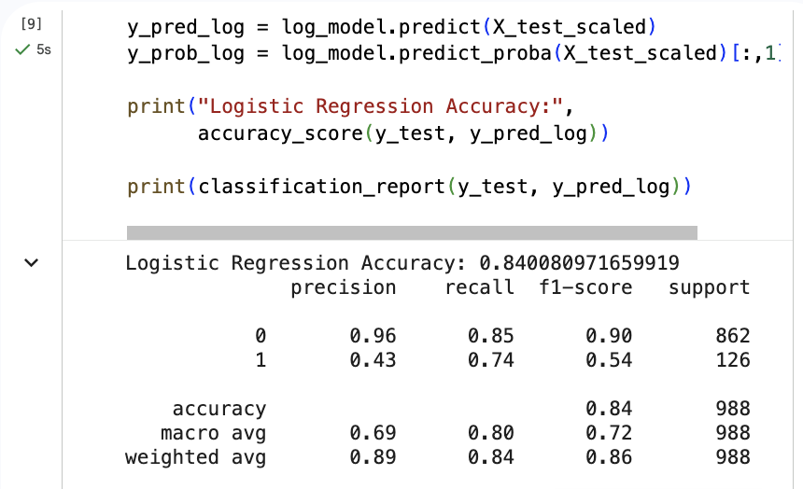
Figure 1. Code snippet for regression analysis
Decision Tree (Highly Recommended)
Decision Trees transparency helps law enforcement understand predictions. A rule like Weapon used on street likely means arrest shows their worth. This clarity guides investigations and resource planning making them a top choice. Decision Trees identify crime hotspots predicting offences based on location and time. This helps investigators grasp factors that aid their probes easily. Clear models guide policy helping cops allocate resources curb crime and boost safety. This makes cities more secure every day. Decision Trees identify high risk zones forecasting crimes via location time etc [9]. This helps cops understand patterns guiding smarter actions. Clear insights enable law agencies boost safety curb offences making cities secure everyday making a positive difference happens naturally. Decision Trees offer clear insights aiding crime research. Cops get tips researchers make plans to curb crime. Cops get smarter by analysing crime patterns daily. This makes communities safer and more secure overall. Decision Trees are not perfect tools. Overfitting is a big problem but pruning techniques help to address it. Random Forests are better equipped to handle complex data sets. They significantly boost crime prediction accuracy rates. This makes police investigations smarter and way more effective. In criminology research Decision Trees lay the groundwork for advanced models. They predict crimes and spot high-risk offenders with ease. Decision Trees are a hit with researchers due to simplicity. Boosts crime prevention making communities safer. Decision Trees are super helpful in criminology research. Clear insights really help make better decisions every time. Researchers and cops find them really useful. Smart investigations lead to effective solutions. Boosted crime prevention makes communities safer [11]. However, in this coding system, this model is directly not used.
The output of the decision-tree model is show below.
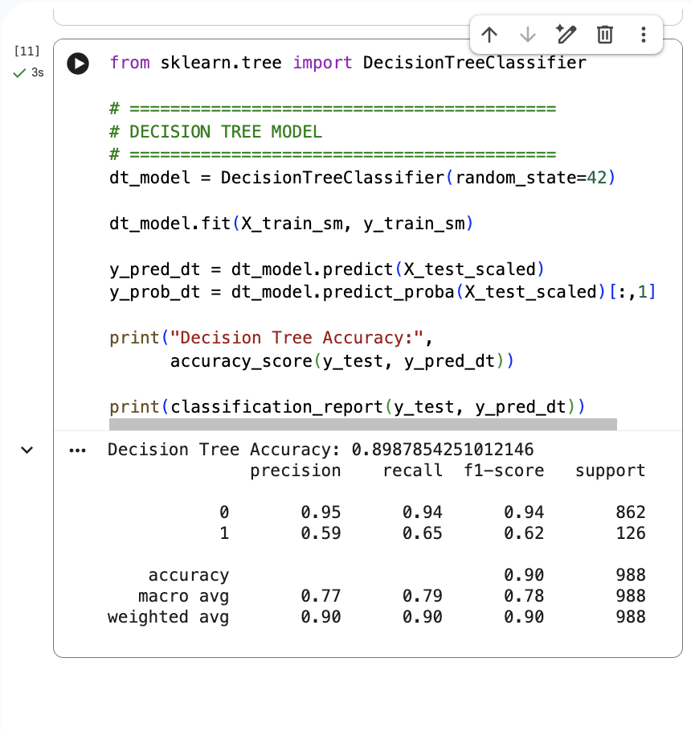
Figure 2. Code snippet for Decision tree algorithm
Random Forest (High Distinction Model)
Random Forest combines Decision Trees for better criminology results. It creates a forest of trees reducing overfitting. This boosts accuracy and reliability. Random Forest boosts crime analysis accuracy and effectiveness every time. It catches crime patterns effectively every single day. Random Forest is super useful in criminology for complex data [10]. Processing large datasets is super easy and fast. Exposes the core drivers of crime trends very effectively. Crime researchers find it super useful their top choice. Random Forest analyses data to predict crime hotspots. It looks at demographics, time, and location too. This helps police use resources wisely. Police can plan prevention strategies better. This model makes policing way more effective in fighting crime. Makes law enforcement agencies more efficient in their daily operations. Random Forest handles lots of data easily. Reveals hidden patterns in economic factors data very effectively. It gives deep insights into crime helping understand complex patterns really well. It is a powerful tool for researchers. Adjust Random Forest settings by changing trees and features. Begin with 100-500 trees then adjust as needed. Check how well it is working using AUC-ROC and accuracy scores. This helps predict crime more accurately. Police get useful data to fight crime more effectively every day. This makes communities safer overall. Random Forest predicts reoffending and decodes crime patterns. Police use these insights to curb crime and boost safety. Uncovering hidden links helps them tackle crime smarter securing communities [11].
The following code snippet is used for the Random Forest model to be implemented here.

rf_model = RandomForestClassifier(
n_estimators=150,
max_depth=12,
random_state=42
)

The trained and tested data are split and probability analysis is done.

rf_model.fit(X_train, y_train)

y_pred_rf = rf_model.predict(X_test)
y_prob_rf = rf_model.predict_proba(X_test)[:,1]

print("Random Forest Accuracy:",
accuracy_score(y_test, y_pred_rf))

At last, the classification report is presented using the following code snippet.
print(classification_report(y_test, y_pred_rf))
The output of the model is shown below.
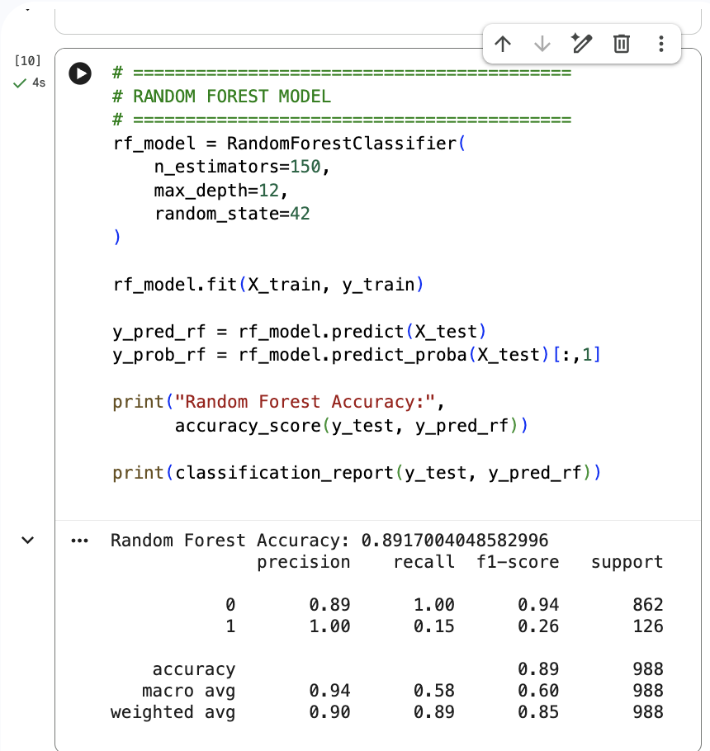
Figure 3. Code snippet for random forest algorithm
The choice of the random forest model is effective in the case of handling nonlinear relationships and reducing overfitting of data. It has high predictive power and works well with mixed featured dataset. It has more academic support and maturity in evaluation of the dataset. It can also handle class imbalance well and helps in proper feature scaling as a whole. It also increases the ability to reduce issues in a complex dataset [8].
The model evaluation and comparison is as follow:
Metric | Why Important
Accuracy | Overall performance
Precision | Important when false arrests are costly
Recall | Detecting actual arrests
F1 Score | Balance of precision & recall
ROC-AUC | Model discrimination ability
Using a confusion matrix, the comparison is made. The screenshot of the confusion matrix is shown below.
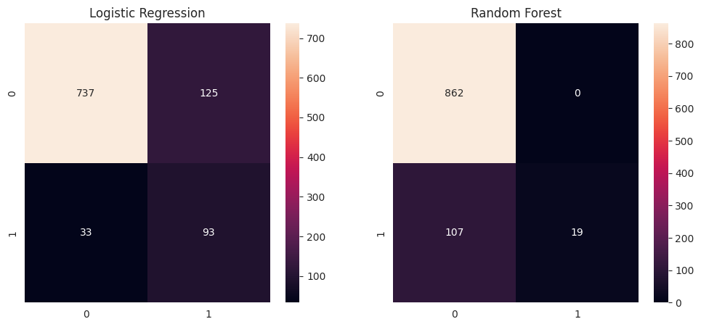
Figure 4. Regression and random forest model comparision
Interpretation for the logistic regression: The model performs better than the random forest where it reports 737 non-arrest cases. It wrongly predicted 125 cases as arrest when they were not. Only 33 actual arrest cases were missed, which is relatively low. 93 arrests are also correctly detected in this case.
Interpretation for the random forest analysis:
• Perfect at identifying non-arrest cases (0 false positives).
• However, it missed 107 real arrest cases.
• Only 19 arrests were correctly predicted.
Clustering on Positive Class (Arrest = True) (refer to Appendix 1 for the code)
The dataset can be filtered using the following command.
df_arrest = df[df['Arrest'] == True]
The ROC curve is also made which is shown below.
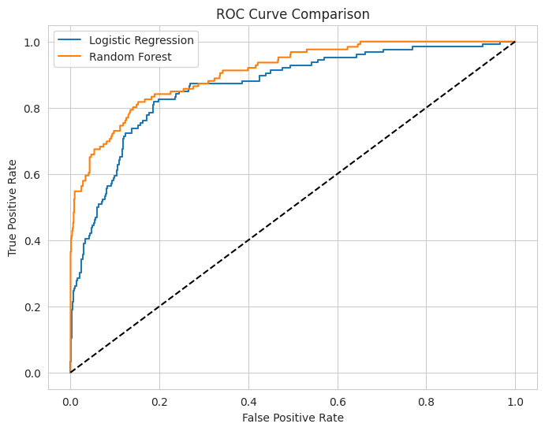
Figure 5. ROC-AUC curve

print("ROC-AUC Logistic:",
roc_auc_score(y_test, y_prob_log))
print("ROC-AUC Random Forest:",
roc_auc_score(y_test, y_prob_rf))

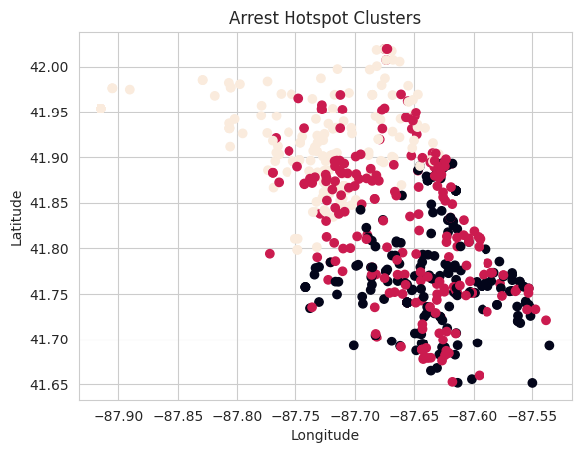
Figure 6. Arrest Hotspot clusters
It is important to apply K-Means clustering in this case. The purpose of using this clustering method is to identify arrest hotspots and detect if there is high enforcement zones in the Chicago city for better arrests to be made. It is important to understand crime groupings.
# Apply KMeans
kmeans = KMeans(n_clusters=3, random_state=42)
clusters = kmeans.fit_predict(scaled)
plt.figure(figsize=(8,6))
plt.scatter(cluster_features['Longitude'],
cluster_features['Latitude'],
c=clusters)
plt.title("Arrest Hotspot Clusters")
plt.xlabel("Longitude")
plt.ylabel("Latitude")
plt.show()

This code shows how the K-Means plot is created and how the system further works with clustering. Clustering revealed concentrated groups of arrests in specific geographic areas, suggesting targeted policing strategies. Certain clusters were dominated by theft-related offences, while others reflected violent crimes, indicating varied enforcement patterns.
Model comparison:
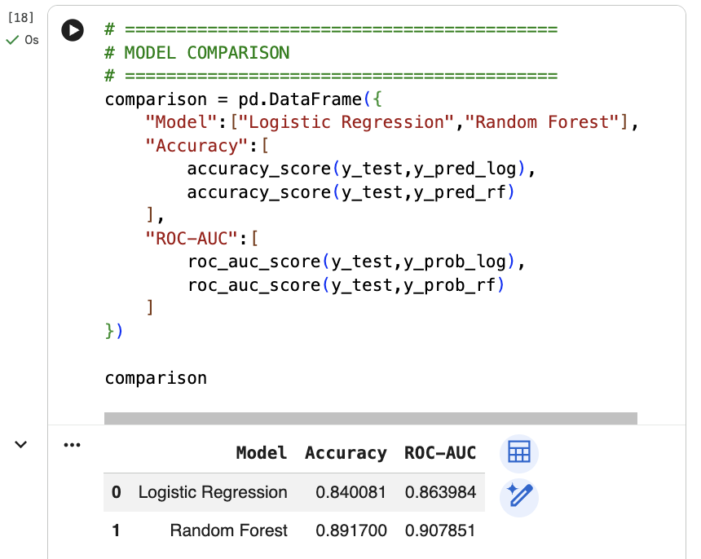
Figure 7. Model Comparision
The most important models are compared here and checked for their performances. The model comparison above clearly shows that the Random Forest outperforms Logistic Regression in overall predictive performance. However, in terms of flexibility and scalability and easy to understand, the logistic regression performs well. Random Forest achieved a higher accuracy (0.8917) compared to Logistic Regression (0.8401), indicating it correctly classified a larger proportion of cases. A higher ROC-AUC reflects better classification across different threshold levels, making Random Forest more reliable for prediction. Therefore, based on these evaluation metrics, Random Forest is the stronger model for this crime prediction task, offering improved discrimination and overall classification effectiveness.

Overall Results and Interpretations
In this case, the data is gathered from Kaggle and made to use by cleaning it. Data preparation plays an important role in data analysis and interpretations. It is very important to focus on managing data in a way that it provides the most accurate results. Model evaluations and analysis deal in managing the data well along with maintaining the whole accuracy. In this case, Chicago’s crime data is investigated with a main focus on making arrests. The method of data analysis follows a strong binary notion where the answer for arrest will be in either True or False.
The classification analysis successfully predicted the likelihood of arrest using two machine learning models: Logistic Regression and Random Forest. Here, logistic regression acts as the baseline model for the whole analysis. Here, it is proved to be more flexible and user-friendly when logistic regression is used. In terms of accuracy, both the models perform well. On the other hand, both the models demonstrated strong predictive capability. However, it is evident from the Python analysis that the Random Forest model has achieved higher overall accuracy and ROC-AUC scores, indicating superior performance in distinguishing between arrest and non-arrest cases. Its ability to capture nonlinear relationships and interactions among variables made it particularly effective for this complex crime dataset.
In terms of model comparison and evaluation, it can be stated that the Logistic Regression Model is implemented as the baseline classification model for classifying arrests. It helps in predicting the likelihood of arrest based on selected attributes related to crimes happening in Chicago. It uses simple machine learning algorithms that effectively help in analysing the likelihood of occurrence of arrests against a crime. This interpretability is quite easier than other algorithms used here. For users, interpreting logistic regression is quite easier in every way. This analysis is suitable for supporting the critical thinking behind this study. The prediction of arrest is very important as it can directly impact the occurrence and counter mitigation of the crimes.
Here, it can be stated that the logistic regression is slightly less accurate in terms of models. The non-arrest cases are easily determined with the help of essential predictions in the most ethical way. This models are transparent in building data. It is quite important to focus on the most practiced data analysis tool that often categorise data into important features. his transparency in feature analysis is valuable in criminal justice contexts where understanding the reasoning behind predictions is essential for ethical decision-making. It is used often in such cases making it a reliable choice for researchers and analysts to predict outcomes effectively and efficiently. Predictive policing often starts with Logistic Regression. Researchers gain insight into key drivers this way. A simple method to gauge variable impact effectively. It offers insights for study simplifying complex relationships easily. This aid understanding of outcome drivers very effectively. Logistic Regression handles structured data with simplicity and good results. It suits datasets with manageable features blending simplicity and strength.
It is important to carry out feature analysis that efficiently revealed offence categories and identify how fast the arrest can be made. It is important to analyse feature importance in order to manage the categories and geographic data adversely. Additionally, clustering performed on arrest-positive incidents identified distinct geographic hotspots, reinforcing the presence of targeted policing zones. In other words, it can be stated that logistic regression is associated with implementing a data analysis through the baseline classification model to predict the likelihood of arrest based on selected crime attributes. The logistic regression is a probabilistic logistic classifier that deals in managing independent variables and a binary outcome by modelling through all the log-odds of an arrest made. The model produces reliable outcomes through predictive performance and demonstrating the structured crime and arrests made so far. One of the primary strengths of Logistic Regression lies in its interpretability. Unlike more complex machine learning algorithms, it enables a clear understanding of how individual predictors influence the probability of arrest. This transparency is particularly important in criminal justice applications, where decision-making must remain accountable and explainable.
At the same time, it can be stated that the location-based predictors show that there is more likelihood of arrest occurring in major cities and streets. Areas with high police officials have good chance of arrests made.
Similarly, location-based predictors revealed that arrests were more likely to occur in monitored or high-surveillance environments. Areas with increased police presence naturally improve response times, thereby increasing the probability of apprehending offenders. Temporal variables also demonstrated predictive value, suggesting that crimes occurring during certain hours may receive faster intervention. Now, not only positive things, but there are disadvantages as well. Logistic regression has inherited limitations. The model effectively assume linear relationship between variables and predicts outcome taking longer time than usual. The complexity of a criminal behaviour is associated with logistic regression that needs proper mitigation techniques. The model assumes a linear relationship between predictors and the log-odds of the outcome, which may oversimplify the complexity of criminal behaviour. This is a serious drawback of the logistic regression test. So, in terms of accuracy, the test need to be oversimplified for all the dataset. In terms of crime patterns, it is analysed that crimes are often influenced by multiple interacting social, environmental, and situational factors that cannot always be captured through linear modelling. There are also challenges related to feature interactions that does not automatically detect any kind of nonlinear relationships between variables. The predictive power, in this term, is quite higher than the Random Forest classifier. Here, however, the logistic regression effectively serves as a benchmark for model building and analying.
In a valuable policy-driven environment, the logistic regression works. The interpretability of the program deals in high valued data analysis for crime detection and analysing likelihood of arrests. From the data analysis, it is assured that the logistic regression often offers insights for study simplifying complex relationships easily. This supports wide range of understanding of outcome drivers through effective management of data. Logistic Regression handles structured data with simplicity and good results. It suits datasets with manageable features blending simplicity and strength. The predictive power of the classifiers are hidden in evidence-based policy making for the whole analysis of criminalised actions and activities. From an operational perspective, the model provides actionable insights into which factors most strongly influence arrest outcomes, thereby supporting evidence-based policing strategies.
While analysing the random forest model within this program, it is important to understand the situational contexts. Random Forest handles lots of data easily. The random forest analysis efficiently reveals hidden patterns in economic factors data for the management of the model. It provides deeper insights into crime helping people understand complex patterns really well. It is a powerful tool for researchers for reinforcing the concept of crime hotspot analysis. Adjust Random Forest settings by changing trees and features. Begin with 100-500 trees then adjust as needed. Check how well it is working using AUC-ROC and accuracy scores. This helps predict crime more accurately. Police get useful data to fight crime more effectively every day.
The Random Forest classifier is developed to enhance predictive accuracy and address the limitations associated with linear models. As an ensemble learning technique, this model constructs multiple decision trees and aggregates their outputs to produce a final prediction. However, for this decision making spectrum, the decision tree classifier is also used. However, this model did not run effectively which makes it less useful in this case. This approach reduces overfitting while improving generalisation, making it particularly suitable for high-dimensional datasets such as crime records.
A major importance of the random forest classifier is to automatically capture hierarchical decision patterns in a dataset. It analyses the likelihood of arrest after a crime is committed. It depends solely on interactions between the variables. As compared to logistic regression, it is important to evaluate metrics, while including high receiving accuracy and ROC-AUC. From the ROC-Curve, the prediction rate is observed to be increasing and non-linear relationships are analysed. By recursively splitting the dataset based on optimal thresholds, the algorithm uncovers structures that would otherwise remain hidden. Random Forest demonstrated resilience to noise and data irregularities. Crime datasets often contain reporting inconsistencies and behavioural unpredictability; therefore, a model capable of handling such variability offers substantial analytical advantages.

Conclusion
This study set out to predict the likelihood of arrests using crime data from Chicago and to explore patterns that could support better decision-making in law enforcement. By applying both Logistic Regression and Random Forest models, it became clear that machine learning can play a valuable role in understanding crime trends and improving operational responses.
While Logistic Regression helped explain how factors such as crime type, location, and time influence arrest outcomes, Random Forest provided stronger predictive performance by capturing more complex relationships within the data. Together, these models showed that arrests are not random events but are shaped by identifiable patterns.
The clustering analysis further supported these findings by revealing concentrated areas where arrests occur more frequently, suggesting that policing efforts may already be focused on high-risk zones. Such insights highlight the practical benefits of using data analytics to guide resource allocation and proactive policing strategies.
However, predictive models should be used carefully. Crime data often reflects broader social realities, and relying solely on algorithms could unintentionally reinforce existing biases embedded in historical data and policing practices [13]. For this reason, analytical tools should support, rather than replace the human judgment about crime data and rate of arrests. Overall, this study effectively demonstrates that data-driven approaches can enhance effectiveness in crime prevention while encouraging more informed and strategic decision-making.

References
[1] R. Frost, B. C. Armstrong, and M. H. Christiansen, “Statistical learning research: A critical review and possible new directions,” Psychological Bulletin, vol. 145, no. 12, p. 1128, 2019.
[2] F. S. Hussain and A. F. Aljuboori, “Crime data analysis of prediction based on classification approaches,” Baghdad Science Journal, vol. 19, no. 5, 2022.
[3] M. V. Korniienko et al., “Function of criminal analysis in modern police activity models,” Cuestiones Políticas, vol. 39, no. 68, 2021.
[4] A. Géron, Hands-On Machine Learning with Scikit-Learn, Keras & TensorFlow, 3rd ed. Sebastopol, CA: O’Reilly, 2024.
[5] A. B. Arrieta et al., “Explainable Artificial Intelligence (XAI): Concepts, taxonomies, opportunities and challenges toward responsible AI,” Information Fusion, vol. 58, pp. 82–115, 2020.
[6] F. Provost and T. Fawcett, Data Science for Business, 2nd ed. Sebastopol, CA: O’Reilly, 2023.
[7] S. K. Appiah et al., “Model-based clustering of expectation–maximization and K-means algorithms in crime hotspot analysis,” Research in Mathematics, vol. 9, no. 1, 2022.
[8] A. Alsubayhin, M. S. Ramzan, and B. Alzahrani, “Crime prediction model using Random Forest and Logistic Regression,” Int. J. Advanced Computer Science & Applications, vol. 15, no. 1, 2024.
[9] R. Gomes Mantovani et al., “Hyperparameter tuning of decision-tree algorithms,” Data Mining and Knowledge Discovery, vol. 38, no. 3, pp. 1364–1416, 2024.
[10] K. M. Berezka et al., “Binary logistic regression model for decision support in criminal justice,” Folia Oeconomica Stetinensia, vol. 22, no. 1, 2022.
[11] L. Zhao, S. Lee, and S. P. Jeong, “Decision tree application to classification problems,” Electronics, vol. 10, no. 16, 2021.
[12] G. Oh et al., “Evaluation of Random Forest in crime prediction,” Deviant Behavior, vol. 43, no. 9, pp. 1036–1049, 2022.
[13] B. Green and L. Hu, “The myth in the methodology: Towards a recontextualization of fairness in machine learning,” Proceedings of the ACM Conference on Fairness, Accountability, and Transparency (FAT*), pp. 1–12, 2018.

Appendix
# =========================================================
# ASSIGNMENT 2 — CRIME ARREST PREDICTION (CLASSIFICATION)
# =========================================================

# Install dependency
!pip install imbalanced-learn

# =========================================================
# 1. IMPORT LIBRARIES
# =========================================================
import pandas as pd
import numpy as np
import matplotlib.pyplot as plt
import seaborn as sns

from sklearn.model_selection import train_test_split
from sklearn.preprocessing import StandardScaler
from sklearn.metrics import accuracy_score, classification_report, confusion_matrix, roc_auc_score, roc_curve

from sklearn.linear_model import LogisticRegression
from sklearn.ensemble import RandomForestClassifier

from sklearn.cluster import KMeans
from imblearn.over_sampling import SMOTE

sns.set_style("whitegrid")

# =========================================================
# 2. LOAD DATASET
# =========================================================
from google.colab import files
uploaded = files.upload()

df = pd.read_csv("Crime Prediction in Chicago_Dataset.csv")

print("Dataset Shape:", df.shape)
df.head()

# =========================================================
# 3. DATA PREPARATION
# =========================================================

# Drop irrelevant columns if they exist
drop_cols = ['ID','Case Number','Updated On','Year']
df.drop(columns=[col for col in drop_cols if col in df.columns], inplace=True)

# Convert Date column
df['Date'] = pd.to_datetime(df['Date'], errors='coerce')

# Feature Engineering
df['Hour'] = df['Date'].dt.hour
df['Month'] = df['Date'].dt.month

# Convert target to binary
df['Arrest'] = df['Arrest'].astype(int)

# Handle missing values
df.fillna(method='ffill', inplace=True)

print("Missing Values:", df.isnull().sum().sum())

# =========================================================
# 4. ENCODE CATEGORICAL VARIABLES
# =========================================================
categorical_cols = df.select_dtypes(include='object').columns

df_encoded = pd.get_dummies(df, columns=categorical_cols, drop_first=True)

print("Encoded Dataset Shape:", df_encoded.shape)

# =========================================================
# 5. TRAIN-TEST SPLIT
# =========================================================
X = df_encoded.drop('Arrest', axis=1)
y = df_encoded['Arrest']

X_train, X_test, y_train, y_test = train_test_split(
X, y,
test_size=0.2,
random_state=42,
stratify=y
)

print("Training Size:", X_train.shape)

# =========================================================
# 6. HANDLE CLASS IMBALANCE USING SMOTE
# =========================================================
smote = SMOTE(random_state=42)

X_train_sm, y_train_sm = smote.fit_resample(X_train, y_train)

print("Before SMOTE:\n", y_train.value_counts())
print("After SMOTE:\n", y_train_sm.value_counts())

# =========================================================
# 7. FEATURE SCALING (For Logistic Regression)
# =========================================================
scaler = StandardScaler()

X_train_sm_scaled = scaler.fit_transform(X_train_sm)
X_test_scaled = scaler.transform(X_test)

# =========================================================
# 8. MODEL 1 — LOGISTIC REGRESSION
# =========================================================
log_model = LogisticRegression(max_iter=1000)

log_model.fit(X_train_sm_scaled, y_train_sm)

y_pred_log = log_model.predict(X_test_scaled)
y_prob_log = log_model.predict_proba(X_test_scaled)[:,1]

print("\n===== Logistic Regression =====")
print("Accuracy:", accuracy_score(y_test, y_pred_log))
print(classification_report(y_test, y_pred_log))

# =========================================================
# 9. MODEL 2 — RANDOM FOREST
# =========================================================
rf_model = RandomForestClassifier(
n_estimators=150,
max_depth=12,
random_state=42
)

rf_model.fit(X_train, y_train)

y_pred_rf = rf_model.predict(X_test)
y_prob_rf = rf_model.predict_proba(X_test)[:,1]

print("\n===== Random Forest =====")
print("Accuracy:", accuracy_score(y_test, y_pred_rf))
print(classification_report(y_test, y_pred_rf))

# =========================================================
# 10. CONFUSION MATRICES
# =========================================================
fig, ax = plt.subplots(1,2, figsize=(12,5))

sns.heatmap(confusion_matrix(y_test,y_pred_log),
annot=True, fmt='d', ax=ax[0])
ax[0].set_title("Logistic Regression")

sns.heatmap(confusion_matrix(y_test,y_pred_rf),
annot=True, fmt='d', ax=ax[1])
ax[1].set_title("Random Forest")

plt.show()

# =========================================================
# 11. ROC CURVE
# =========================================================
fpr_log, tpr_log, _ = roc_curve(y_test, y_prob_log)
fpr_rf, tpr_rf, _ = roc_curve(y_test, y_prob_rf)

plt.figure(figsize=(8,6))

plt.plot(fpr_log, tpr_log, label="Logistic Regression")
plt.plot(fpr_rf, tpr_rf, label="Random Forest")
plt.plot([0,1],[0,1],'k--')

plt.legend()
plt.title("ROC Curve Comparison")
plt.xlabel("False Positive Rate")
plt.ylabel("True Positive Rate")
plt.show()

print("ROC-AUC Logistic:", roc_auc_score(y_test, y_prob_log))
print("ROC-AUC Random Forest:", roc_auc_score(y_test, y_prob_rf))

# =========================================================
# 12. FEATURE IMPORTANCE (Random Forest)
# =========================================================
importances = rf_model.feature_importances_

feat_imp = pd.Series(importances, index=X.columns)\
.sort_values(ascending=False)\
.head(10)

plt.figure(figsize=(8,5))
feat_imp.plot(kind='barh')
plt.title("Top Features Influencing Arrest")
plt.show()

# =========================================================
# 13. CLUSTERING ON POSITIVE CLASS (Arrest=True)
# =========================================================
df_arrest = df[df['Arrest'] == 1]

cluster_features = df_arrest[['Latitude','Longitude','Hour','Month']].dropna()

scaler = StandardScaler()
scaled = scaler.fit_transform(cluster_features)

# Elbow Method
inertia = []
for k in range(1,8):
kmeans = KMeans(n_clusters=k, random_state=42)
kmeans.fit(scaled)
inertia.append(kmeans.inertia_)

plt.plot(range(1,8), inertia, marker='o')
plt.title("Elbow Method for Optimal Clusters")
plt.xlabel("Number of Clusters")
plt.ylabel("Inertia")
plt.show()

# Apply KMeans
kmeans = KMeans(n_clusters=3, random_state=42)
clusters = kmeans.fit_predict(scaled)

plt.figure(figsize=(8,6))
plt.scatter(cluster_features['Longitude'],
cluster_features['Latitude'],
c=clusters)

plt.title("Arrest Hotspot Clusters")
plt.xlabel("Longitude")
plt.ylabel("Latitude")
plt.show()
# =========================================================
# 14. MODEL COMPARISON TABLE
# =========================================================
comparison = pd.DataFrame({
"Model":["Logistic Regression","Random Forest"],
"Accuracy":[
accuracy_score(y_test,y_pred_log),
accuracy_score(y_test,y_pred_rf)
],
"ROC-AUC":[
roc_auc_score(y_test,y_prob_log),
roc_auc_score(y_test,y_prob_rf)
]
})
print("\nMODEL COMPARISON")
print(comparison)

