Program: BA International Hotel Management
Module: Financial Management for the Hotel Industry

Module code: BMIH5007
Student name: Syed Ariful Islam
Student ID number: 2109020
Lecturer Name: Dale Clarke

Assignment Title: Comparison of Two Hospitality Organizations

Table of Contents
Introduction 1
Overview of organizations 1
Comparison between approaches of financial management 3
Total Revenue 3
Market Position 4
Growth Potential 5
Financial Commitment to CSR 6
Risk of financial investment 7
Recommendations 8
Conclusion 8
References 10

Introduction
Financial management refers to organizing, directing, and controlling financial activities within business organizations. Analyzing the approaches of financial management is the purpose of this study. The study includes the critical analysis and evaluation total revenue, market position, growth potential, and financial commitment to CSR. Comparison between approaches of financial management when considering the revenue, market position, growth potential, and financial commitment to CSR.

Overview of organizations

Figure 1: Intercontinental Hotels Group (IHG).
Source: (Apreda, 2020).
Intercontinental Hotels Group (IHG) is one of the largest hotel chains in the world which has business operations in approximately 100 countries of the world. The portfolio of Intercontinental Hotels Group (IHG) is differentiated into brands like Atwell Suites, EVEN Hotels, Avid Hotels, and so on are well-known brands. The financial department of Intercontinental Hotels Group (IHG) follows a modern approach to financial management that inspired it to engage in acquisition and merger (Copeland and Copeland, 2020).

Figure 2: Hilton Hotel.
Source: (Bowen, 2022).
Hilton hotel is one of the largest hotel chains in the world and is most famous for its world-class designs, signature food and beverage, state of the art technology, and dynamic meeting and events capabilities. Hilton hotel operates in approximately 122 countries of the world with 18 distinct brands (Avi, 2022). The finance department of Hilton Hotels follows the traditional approach of financial management. So, it does not involve in merger and acquisition but focus on investing in profitable projects.

Comparison between approaches of financial management

Total Revenue
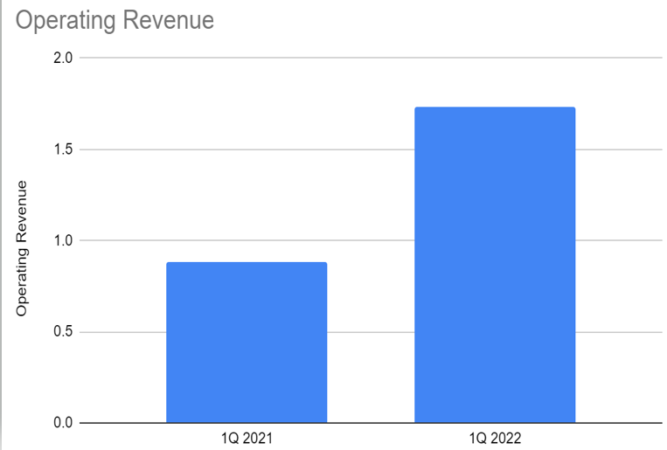  Figure 3: Total revenue of Hilton Hotel.  Source: (Crawford-Welch, 2022). | 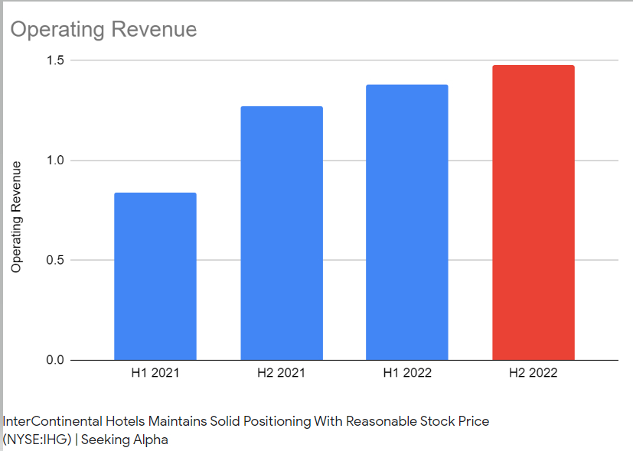  Figure 4: Total revenue of Intercontinental Hotels Group (IHG).  Source: (Figlewicz and Zeller, 2022).
Intercontinental Hotels Group (IHG) which is following the modern approach of financial management has revenue in 2021 is approximately 1.2 billion and revenue in 2022 of less than 1.5 billion (Figlewicz and Zeller, 2022). Another side Hilton hotel who is following the traditional approach of financial management has revenue in 2021 is less than 1.0 billion and that increased in 2022 which was approximately 1.8 billion (Crawford-Welch, 2022). The traditional approach of financial management refers to maximizing the profitability of the company to maximize the firm’s wealth. So, Hilton hotel focus on internal funds theory the refers to investment depending on the level of profitability so Hilton hotel investment in profitable projects to build brands rather than mergers and acquisitions. That positive impact on its total revenue which is more than Intercontinental Hotels Group (IHG) along with increases the wealth of the firm by increasing retained earnings of Hilton Hotel (John, 2022). But the Intercontinental Hotels Group (IHG) follows the modern approach of financial management where the financial manager of Intercontinental Hotels Group (IHG) focuses on investment decisions that refer to scarce resources of an organization investing in the acquisition of an entity or equipment (Kent Baker, 2022). So, the financial manager focuses on investing in mergers and acquisitions over 5 years and investing in performed 2 mergers and acquisitions. That increases the revenue of the Intercontinental Hotels Group (IHG) but along with increased expenses of business created barriers to gaining higher revenue that is supported by the accelerator theory of investment. accelerator theory of investment refers to investment expenses increasing when the income increased from investment (Linzer and Linzer, 2021).

Market Position
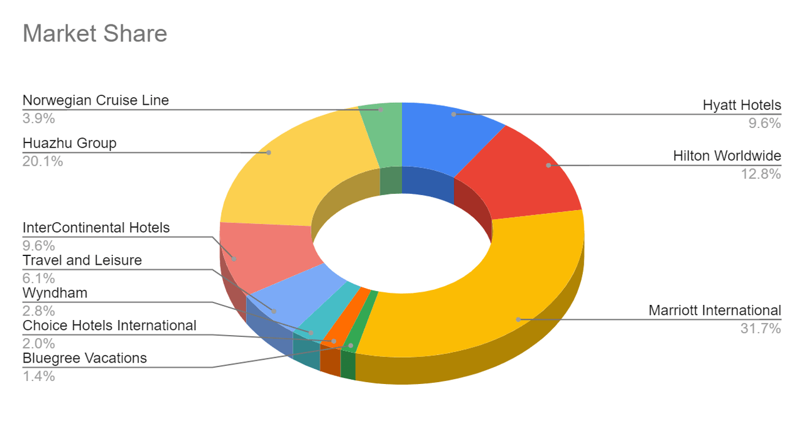
Figure 5: Market position of hotels.
Source: (Seekingalpha.com, 2022).
The traditional approach of financial management focuses on mostly maximizing the wealth of the firm to maximize the benefits of the stockholders by performing short-term funding in business through debt capital and long-term funding through retained earnings (Magill, 2020). But the modern approach of financial management refers to investing in short-term investment proposals by using retained earnings rather than taking loans. So, by following the traditional approach of financial management Hilton Hotels gained 12.8% of the market share whereas Intercontinental Hotels gained 9.6% of the market share (Seekingalpha.com, 2022). Because Hilton’s hotel focuses to use retained earnings in long-term investments which causes the lower cost of funding it increases its ability to extend its business activities more efficiently which helped it to maximize the firm’s wealth. There Hilton hotel follows the traditional theory of capital structure which refers to maximizing the firm’s wealth and minimizing WACC (Weighted Average Cost of Capital) (Seekingalpha.com, 2022). So, the finance manager of Hilton Hotel focuses more on profitable investment projects rather than purchasing assets. But Intercontinental Hotels follows the modern approach of financial management which inspires its finance manager to invest in assets more than maximizing the firm's value (Peter, 2022). That is opposite to the traditional theory of capital structure where finance management invests capital in acquiring assets through mergers and acquisitions. That is causing Intercontinental Hotels to have a lower market share where Intercontinental Hotels is a market niche which means Intercontinental Hotels serves segments too small. But Hilton Hotels has gained the position of market follower which refers that Hilton hotel protects a position within the market rather than competing forcefully (Madura and Hoque, 2018).

Growth Potential
According to Stephen (2020), the traditional approach of financial management refers the short-term investment by collecting funds from financial institutions like banks, brokerage firms, and so on to maximize the profitability of the organization rather than collecting funds from retained earnings. But the modern approach of financial management refers to making investments by using retained earnings to maintain capital structure (Usher, 2022). So, by following the modern approach of financial management, the Intercontinental Hotels Group (IHG) do not collect fund through debt capital which causes the finance manager of Intercontinental Hotels Group (IHG) to use retained earnings to invest in investment proposals but retained earnings not offer a huge amount to perform long-term investments which reduction in market price per stock of Intercontinental Hotels Group (IHG) which is $71.74 USD that is undervalued because its intrinsic value per stock is $78.33 (VasiC and CeroviC, 2022). That will increase the growth potential of Intercontinental Hotels Group because retain investors within the market perform value investing so retail investors will motivate to select stock of Intercontinental Hotels Group to invest in that will help Intercontinental Hotels Group to gain higher funding opportunity (Voegeli, 2021). That will help Intercontinental Hotels Group to invest in long-term projects.
But by following the traditional approach of financial management the finance manager of Hilton Hotel collects funding for business investment from debt capital by taking loans from financial institutions which are causing an imbalance situation of debt to equity (Apreda, 2020). Because the Debt-to-Equity ratio of Hilton Hotel is 11.87 in 2022 and it is estimated that the debt-to-equity ratio will rise to 12.83 in 2023 by dropping the 1.2 billion in equity in 2023 (Zheng and Forgacs, 2022). That is showing debt of Hilton Hotel is 11.87 times more than the equity of Hilton Hotel. That will negatively impact the growth potential of Hilton Hotels because by demotivating financial institutions to provide loans to Hilton Hotels for business expansion. Because before providing loans financial institutions analyze the debt-to-equity capital of the organizations and when financial institutions will identify higher debt of Hilton Hotel than its equity (Avi, 2022). That will create barriers in funding for the business growth of Hilton Hotel.

Financial Commitment to CSR
CSR refers to a positive impact on society, the economy, and the environment through business activities to ensure busienss sustainability financial commitment to CSR refers to business organizations should enable finance for society people, to protect environment, and positively contribute in the economy of the country (Vos, 2018). So, Intercontinental Hotels Group which follows the modern approach of financial management invests in investment proposals by measuring risks and uncertainties which is helping the Intercontinental Hotels Group to gain profitability and sustainability within the industry (Bowen, 2022). That is helping to contribute to the economy of the country, helping to protect the interest of the stakeholders, and enabling job opportunities for employees which is helping to meet its financial commitment to CSR. because stockholders and employees are society people along with profitability contributing to the economy (Copeland and Copeland, 2020). Also, Hilton Hotel which is following the traditional approach of financial management that is helping Hilton hotel get higher profitability inspired Hilton Hotel to award $2.4 billion to grant distribution $339 billion to disaster relief projects (Crawford-Welch, 2022). That is helping Hilton Hotel to protect the interest of society people, contributing to the economy, and protecting interests of the stockholders. s

Risk of financial investment
The traditional approach of financial management refers to making an investment in profitable investment projects which has a higher rate of return that increases the risk of financial investment (Figlewicz and Zeller, 2022). But the modern approach to financial investment refers to appraisals and the selection of capital investment proposals by measuring of risk and uncertainty of the investment proposals (John, 2022). So, by following the traditional approach of financial management the finance manager of Hilton Hotel performs makes investment decisions in the most profitable investment proposals by taking higher risks. For this, the finance manager of Hilton Hotel calculates only the Internal rate of Return (IRR) which is a metric that identifies the estimated profitability of the potential investment proposal (Johnson and Melicher, 2021). Then make investment decisions based on the profitable projects which consist of a higher risk of financial investment of the Hilton Hotel. As Hilton Hotel is a public Limited company and gathers capital through a stock offering to the public so such kind of risky investments by the Hilton Hotel could demotivate investors to invest in stocks of Hilton Hotel (Kent Baker, 2022). Because investors perform investment decisions on the stock by following value investing which refers to invest in undervalued stock but the $144.71 which is overvalued because its intrinsic value is $24.84 that will demotivate investors to purchase stocks of Hilton Hotel (Seekingalpha.com, 2022). But Intercontinental Hotels follows the modern approach of financial management which inspired the finance manager of Intercontinental Hotels to measure the risk and uncertainty of the investment proposals. So, performing IRR, PBP, NPV, and ARR to calculate before recovering the initial investment in projects, identifying the rate of return, along with identifying cash flows throughout the project and then make financial investment decisions on investment proposals (Peter, 2022). Because the modern approach of financial investment refers that firms should make investment decisions only when NPV remains positive, the rate of return remains to exceed the capital cost. That is reducing the risk and uncertainty of financial investments of Intercontinental Hotels (Madura and Hoque, 2018).

Recommendations
As Hilton Hotel has higher debt than equity that is negatively impacting its growth opportunity by creating barriers to collecting funding from financial institutions. So, Hilton Hotel should use its retained earnings to fund investment projects of the Hilton Hotel where Hilton Hotel could expand its business within a new market by utilizing its retained earnings rather than collecting funds from debt. Also, overvalued stocks of the Hilton Hotel will inspire those investors who believe in taking higher risks to gain higher profitability to invest in stock. So, Hilton Hotel could collect funding by offering stock that will help to gain equity and use that equity capital in further growth opportunities which will also balance the debt-to-equity capital.
By following the modern approach to financial management Intercontinental Hotels is facing lower profitability because of modern approach refers to investing in those investment projects which have a lower risk of financial investment. That is causing lower profitability because projects with lower risk contain lower profitability. So, to gain higher profitability Intercontinental Hotels should focus on potential for outsourcing. Outsourcing could for cleaning services, food, recruitment, and so on. That will help Intercontinental Hotels to reduce its cost by engaging third party organzaiiton to perform cleaning activities, or offering food, or could perform recruitment in behalf of Intercontinental Hotels at a specific fee. That will help to reduce operational cost of Intercontinental Hotels and will increase proftibaility.

Conclusion
Both the traditional approach and modern approach of financial management has benefits and limitations. Because modern approach of fianncial management inspiring the Intercontinental Hotels to invest in risk free investment projects but that is reducing profitbaility of the Intercontinental Hotels. Another side traditional approach of financial management inspiring Hilton Hotel to invest in such investment projects which has higher profitbsility with higher risk that is enabling higher profitability for Hilton Hotel but along with increasing the debt capital than equity capital. Because investm,ent in projects refers to collect funding from debt capital which could negativelyimapct on business sustainability of hilton Hotel.

References
Apreda, R. (2020). Shaping Up the Company’s Internal Investment Fund Through Separation Portfolios. SSRN Electronic Journal.
Avi, M.S. (2022). Revenue managers in hotels: Is revenue focus enough? International Journal of Tourism and Hotel Management, 4(2), pp.55–74.
Bowen, J.T. (2022). A market‐driven approach to business development and service improvement in the hospitality industry. International Journal of Contemporary Hospitality Management, 9(7), pp.334–344.
Copeland, T. and Copeland, M. (2020). Managing Corporate FX Risk: A Value-Maximizing Approach. Financial Management, 28(3), p.68.
Crawford-Welch, S. (2022). Market Segmentation in the Hospitality Industry. Hospitality Research Journal, 14(2), pp.295–308.
Figlewicz, R.E. and Zeller, T.L. (2022). Ratios from Statement of Cash Flows Complement Traditional Analysis. Financial Management, 17(4), p.9.
John (2022). 3 Main Approaches to Financial Management | Management. Learn Accounting: Notes, Procedures, Problems and Solutions.
Johnson, R.W. and Melicher, R.W. (2021). Financial management. Boston: Allyn And Bacon.
Kent Baker (2022). Understanding Financial Management [electronic resource] : A Practical Guide. Wiley Uuuu-Uuuu.
Linzer, R.S. and Linzer, A.O. (2021). Cash Flow Strategies. John Wiley & Sons.
Madura, J. and Hoque, A. (2018). International financial management. South Melbourne, Australia: Cengage Learning Australia.
Magill, M.J.P. (2020). The preferability of investment through a mutual fund. Journal of Economic Theory, 13(2), pp.264–271.
Peter (2022). Hilton Stock: High Capacity To Accommodate Growth Prospects | Seeking Alpha. [online] seekingalpha.com. Available at: https://seekingalpha.com/article/4521113-hilton-worldwide-high-capacity-accommodate-growth [Accessed 24 Sep. 2022].
Seekingalpha.com, I.T.S. (2022). Intercontinental Hotels Group (IHG): An Opportunity In A Larger Operating Capacity (NYSE:H). seekingalpha.com.
Stephen (2020). 16 IHG Hotel Brands: Mainstream, Upscale & Luxury. UpgradedPoints.com.
Usher, D. (2022). Traditional Capital Theory. The Review of Economic Studies, 32(2), p.169.
VasiC, Ž. and CeroviC, S. (2022). Financial function transformation in the information era case study Intercontinental Hotels Group. Turisticko poslovanje, (22), pp.51–59.
Voegeli, C. (2021). A CASE STUDY OF KNOWLEDGE MANAGEMENT PRACTICES AT THE INTERCONTINENTAL HOTELS’ GROUP. International Journal of Tourism & Hospitality Reviews, 8(1), pp.17–29.
Vos, E. (2008). Theory View of Capital Structure. SSRN Electronic Journal.
Zheng, C. and Forgacs, G. (2022). The emerging trend of hotel total revenue management. Journal of Revenue and Pricing Management, 16(3), pp.238–245.

