
Module Code and Name | Food and Beverage Operations
Assignment Title | Portfolio 6 Elements
Student ID Name | Simona Patrascu
Student ID Number | 2123259
Lecturer’s Name | Lisa-Marie Bassler
Date of Submission | 18/07/2025

Acknowledgement
I hereby declare that this report was completed without the assistance of any artificial intelligence tools or platforms. All research, analysis, and writing were conducted independently, adhering to academic integrity and originality standards.

Table of Contents
Part 1: Reflective Writing Using Gibbs’ Model 3
Introduction 3
Description 3
Feelings 4
Evaluation 4
Analysis 5
Conclusion 6
Action plan 7
Part 2: Hotel Mentor Feedback 8
Part 3: Academic Tutor Feedback 14
Part 4: Reflection on Feedback 17
Introduction 17
Understanding the Feedback 17
Impact of the Feedback 18
Action Steps for Growth 19
Part 5: Placement Presentation Summary 20
Part 6: Q&A 20
References 21

Part 1: Reflective Writing Using Gibbs’ Model

Introduction
During this year of study, I was encouraged by the university to complete a placement at a hotel of my choice to obtain hands-on experience in the hospitality industry, have an opportunity to test my knowledge and meet new people as well as new opportunities to start a career in this sector before I finish my degree. I was assigned to do my placement at Leonardo Hotels. The placement implied me working in three departments including Food and Beverages, Operating Facilities and Front Desk. This assessment here includes a reflection of my activities in the food and beverages department of the hotel. The reflection is completed with the support of Gibbs’ model of reflection because this model includes 6 stages of reflection that help me organise my ideas in a more constructive and critical manner (The University of Edinburgh, 2024).

Description

On my first placement day, I was offered an induction day during which the operational manager talked about health and safety, fire risks and presented me with the hotel facilities. After this, I spent 6 hours in front of a computer to complete some tests to understand how to follow fire safety protocol, health and safety protocol and other security issues related to hotel management. Working in the food and beverage department of the hotel implied handling food, serving food and assisting customers with food enquiries. As I practiced here, I delivered food to tables, I took orders in the restaurant, I communicated with customers to ensure they have a great experience in our premises, and I participated in cleaning activities to keep the restaurant in a pleasant, welcoming and safe state. When I started working here, I was introduced to the team by my mentor at the hotel. I met the manager of the department and my colleagues and over my working days here I like to think that I had a nice relationship with them. I received a small training about food safety, but I believe more information should be provided in the induction session offered by the hotel.

Feelings

Before starting the placement, I had mixed emotions because this hotel was not on my list of chosen hotels, however because those chosen by me did not respond, I was given the opportunity to complete my placement at Leonardo Hotels. I was also nervous because I wanted to make a good impression, demonstrate my knowledge acquired and make new connections in this area. According to Dempsey et al., (2023), students that participate in academic placements tend to feel more pressure than regular employees because they answer both to the university and the placement provider and they know expectations are high in this area. After starting the placement, I felt more relaxed because I saw what I am dealing with. Understanding their activities, communicating well with my colleagues and having a good relationship with the manager from food and beverages made it easier for me to concentrate on my activities and leave my emotions alone. In the hospitality sector it is very important to work well under pressure and avoid being emotional, as employees deal with multiple tasks at once, a diverse pool of customers with individual needs and preferences (Taylor, 2025). At some point during the placement, I experienced a bad incident outside the food and beverages department, and this made me angry and powerless and also affected my entire view of the hotel. However, I kept going on and I put a 100% effort into my placement, and I did not let my emotions affect my relationship with the customers or my colleagues.

Evaluation

My experience in the food and beverages department was overall good. In the food and beverages department I had the opportunity to apply my knowledge about food handling, restaurant cleanliness and customer relationships. I was satisfied with the way I handled communication with my colleagues and customers. Seeing that I am able to apply communication techniques learnt during classes and understanding their impact in the workplace, increased my confidence that I could bring a positive change in the management of hospitality services. Having a multicultural background and learning about intercultural communication helped me to be more understanding and more supportive with both my colleagues and the hotel guests and offer them a tailored customer experience in the hotel (Middlebury Language Schools, 2024). As I was a learner there, I did not deal with the managerial duties myself, but I observed the actions and behaviour of the food and beverages manager. He was supportive, he helped with overall feedback when the operational manager did not do it, and he treated his team nice. He showed compassion for my complaints, and this made my journey here easier. He was a positive example of good leadership for me.

Analysis

I believe I established a good relationship with my colleagues because at university I studied many theories about team collaboration, and this guided my behaviour as a team member in this placement. For example, the Tuckman’s theory of team formation helped me understand that is normal for team members to be reluctant when a new member joins their team, not because they do not like him, but because they do not know his behaviour, his style of work, or his willingness to put effort into team objectives (Stein, 2025). I was patient, I did not stress them, I used my knowledge from my academic journey to demonstrate my ability to handle and serve food at their expectations and I took the initiative of helping without them asking me to do it. This helped me to gain their confidence and made it easier for them to accept me as one of their own. Another theory that helped me be a better team player in this department was Belbin’s team roles theory. According to Belbin, there cannot be more than one role in a team, otherwise the team will experience conflicts, and overall output can be negatively affected (Boddy, 2017). Following this, I went there as a team member, one that is ready to learn from them, help them with their tasks, complete the activities assigned to me and learn more about the hospitality sector from their practical knowledge in the area. This attitude again showed my willingness to learn, maintained a positive atmosphere in the team and motivated them to treat me well and teach me their wisdom. I believe I had a good relationship with the customers because of the many projects related to cultural diversity at university. Last semester, at university, I completed a whole unit on cultural diversity, during which someone from different cultures came and talked about their culture from their own perspective. This helped me in my interactions with the restaurant guests. For example, I knew about Muslims dietary preferences, and I made better food recommendation, I knew about Spanish people need of warm communication, and this made them feel like home when eating in our premises and I also knew about Britons need of privacy but yet need of excellent customer service which is not intrusive, and this helped me to enhance their guest experience. Having an academic background, improved my customer service skills, my ability to avoid conflicts, my team working style and my overall behaviour in this placement. Having good emotional skills and not letting my emotions regarding other incidents at the hotel, helped me to complete my placement here and demonstrated to me that one day I can make a positive change in the hospitality sector.

Conclusion

One important lesson that I took from this placement is that the hospitality sector is in need of skilled and trained workers and managers. I learned faster and I was able to communicate well with others because I knew what is expected from me and how important is this for the client, but as I worked there I saw how many employees do not have this knowledge and makes it more difficult for them to accept feedback, to deal with clients from other countries or to cope under pressure. My observations are also supported by many other people who keep reporting the issues of this service industry. The lack of personnel and the lack of training in this department were made easier by the manager of the department who took care of his team as much as possible. However, this cannot lift the burden completely and in the long term it has a negative impact on employee morale and level of motivation.

Action plan

Following this experience, my action plan for further development is focused on a continuous improvement of my communication skills, my intercultural communication skills and my leadership skills. In my opinion, any manager in a hotel should be able to communicate clearly with the staff, establish expectations, give clear directions and offer support. Any manager should also know that not only guests come from a diverse cultural background, but also employees do this and addressing their needs can have a positive impact on them, make them feel more valued and increase their motivation at work. Lastly, any manager should also act as a leader to be able to create a supportive work environment within which employees feel heard and safe.

Part 2: Hotel Mentor Feedback
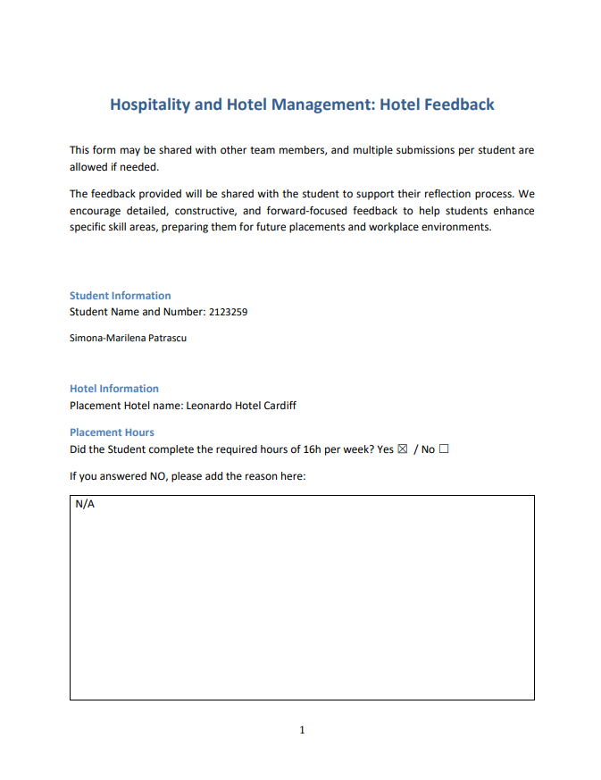

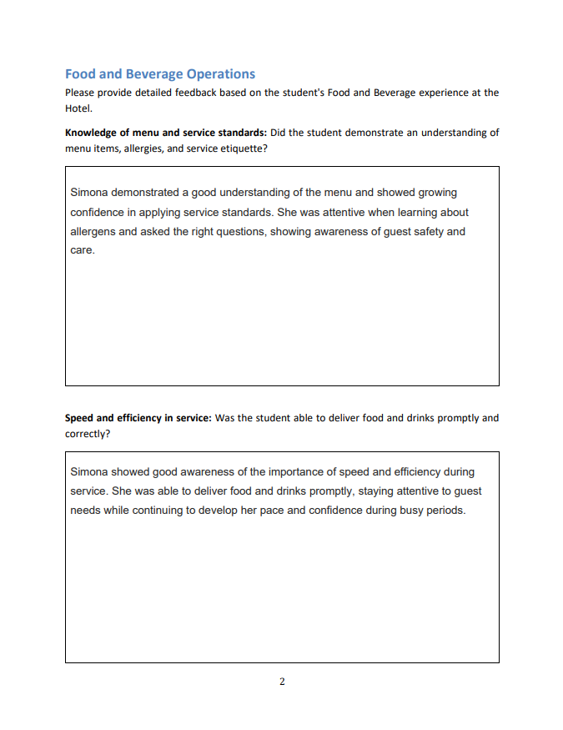
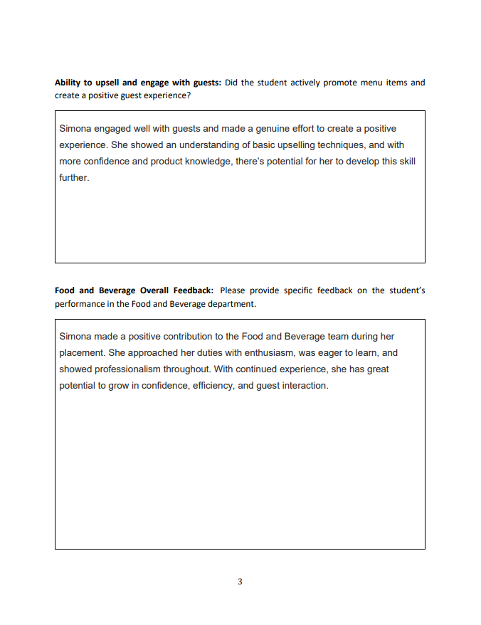
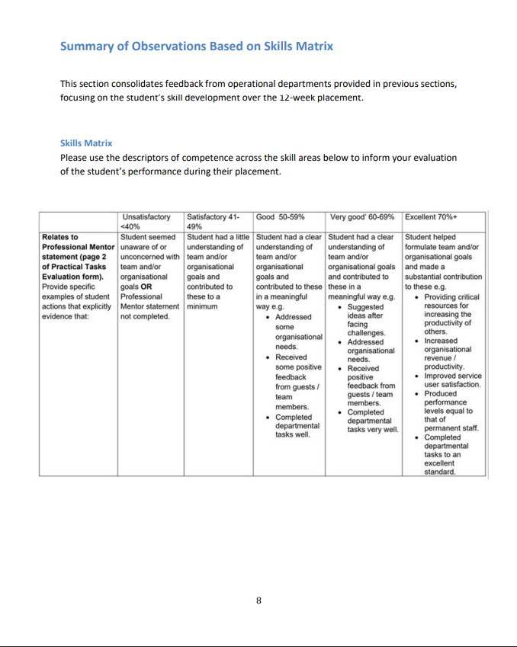
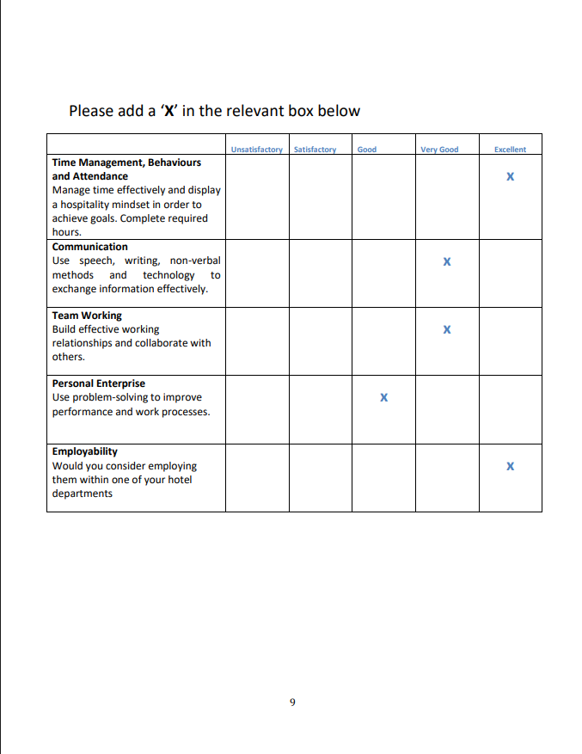
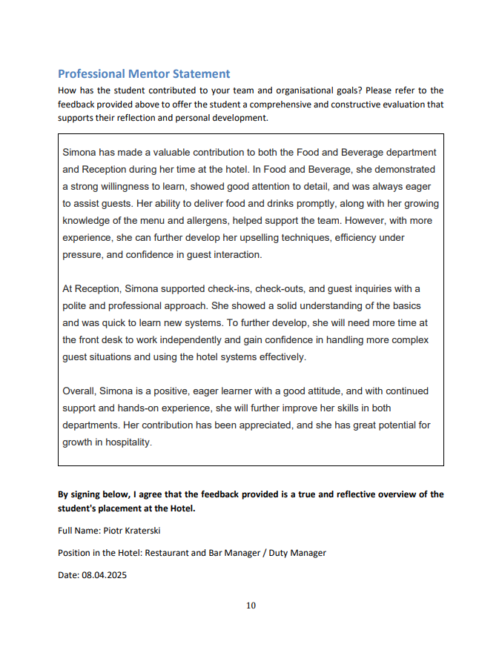

Part 3: Academic Tutor Feedback
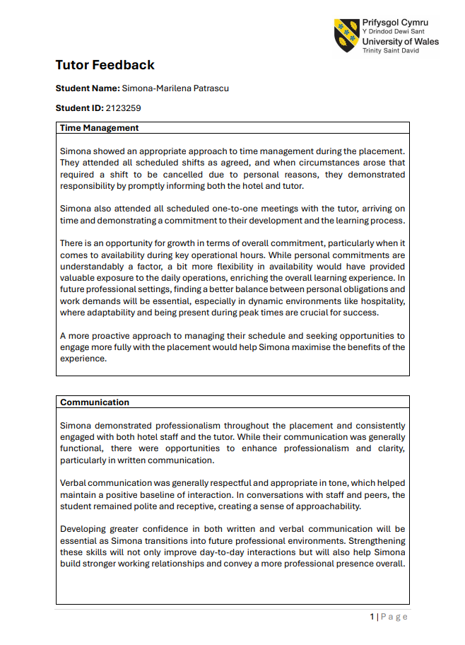
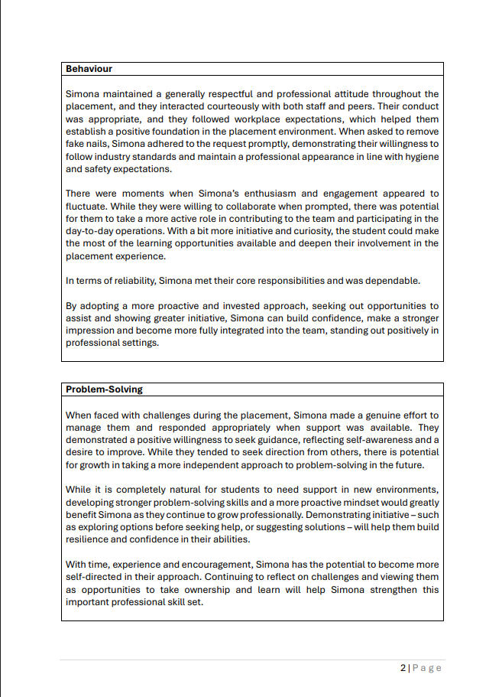
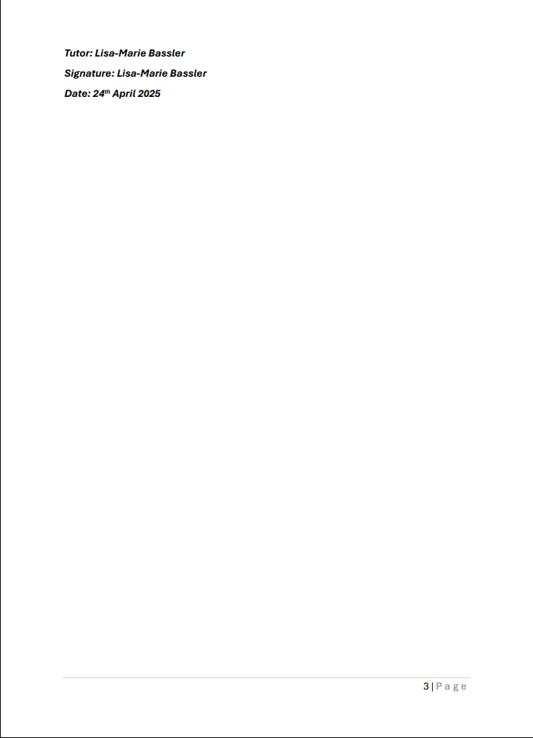

Part 4: Reflection on Feedback

Introduction
This report includes a reflection on the feedback received during my placement from both my hotel mentor and my academic tutor. The report will focus on three areas: demonstrate an understanding of the feedback, analyse the impact of this feedback on my development as a student and as an employee in the hospitality sector and create an action for continuous development. According to feedback acts in the same way as the reflective practice because it allows me to become self-aware of my strengths and weaknesses, supports continuous development, helps me to improve my skills and knowledge in my chosen career, allows me to establish clear goals and can increase my motivation in the workplace (Lichtenberger-Majzikné & Fischer, 2017). Considering these benefits of feedback, it is important for me to understand my performance during this placement, identify my strengths and weaknesses and develop an action plan for further development.

Understanding the Feedback
The feedback received from my mentor focused on my employability skills in the hospitality industry. In terms of knowledge of menu and service standards, the mentor praised my ability to learn fast their service standard, my active listening skills and my academic knowledge of guest safety and care. In terms of speed and efficiency in service, I am pleased to see that my mentor noticed my ability to work well and fast under pressure but also deliver good customer service. In terms of ability to upsell and engage with clients, my mentor observed my ability to create a positive atmosphere for the guests, but he also highlighted that I need to improve my upselling techniques. The skills matrix completed by my mentor highlighted that I have excellent time management skills, very good communication and team working skills, good personal enterprise skills and excellent employability skills. My academic tutor focused on my skills from an academic perspective analysing my behaviour at the hotel, my communication with her and the hotel, my ability to solve problems and my overall behaviour during this placement. In terms of time management, my tutor also praised me for my good organisational skills. However, she advised me that I can improve this skill by showing more commitment to work during key operational hours and be more flexible in my work schedule as this can help me to be more exposed to daily operations and enhance my learning. In terms of communication with her and the hotel staff, she praised my ability to communicate professionally, to engage with the team and to use a positive approach that encouraged them to work well with me. However, she highlighted that my written communication could be improved. I could add more clarity to my communication style and communicate in a more professional manner. In terms of behaviour, my academic tutor said that I was polite and respectful with my peers at the hotel, an attitude that helped me to establish good relationships with them. However, she expected me to be more proactive and to take more initiative as this can help me to learn more and enhance my skills in the hospitality sector. In terms of problem-solving skills, my academic tutor noticed that when faced with challenges I needed support and guidance to overcome them. She highlighted that I should be able to take a more proactive attitude and try to seek alternatives before seeking help. Developing further my problem-solving skills could help me to be more resilient, work better on my own and solve challenges on my own increasing my overall confidence.

Impact of the Feedback

The feedback received boosted my morale and helped me understand how others viewed me during the placement, how they valued my activity and the impact I made on the team. Their feedback made me reconsider my experience, detach myself from the bad incidents that I experienced and analyse this experience and their feedback with a more objective approach. The feedback received from my mentor had a positive impact on me, because he saw my efforts, my commitment to work and learn and my willingness to collaborate well with my colleagues. He also made me aware that I need to improve my upselling techniques and this gave me a direction for further improvement. The feedback received by my academic tutor also contributes to my development. For example, learning about how employers must be flexible in shifts scheduling for their employees, I almost forgot that I also need to provide flexibility in return. With a busy schedule around job, academic work and household duties, this impacted my ability to be more flexible in my placement and limited my learning experience. However, I will remember this when coming to my actual job and I will also try to be more available during busy hours to enhance my learning. I am aware of her highlights in terms of written communication skills, but during this placement I did not have many opportunities to use written communication. My experience here was limited by hotel regulations and focused more on low skilled activities. However, this is something I am aware of, and I am working hard to improve it. In terms of being more proactive and taking more initiative in a new setting, her feedback made me question and reflect more on my attitude. I asked for guidance, and I let myself led because I wanted to learn from them. Perhaps my expectations from the placement and their expectations from me were not on the same page, a fact that made me act differently from their expectations.

Action Steps for Growth

My action plan following the analysis of this feedback focuses on the development of my written communication skills in a professional setting, my problem-solving skills and my upselling techniques. I will seek more opportunities to write in a more professional manner, I will identify new opportunities to improve my upselling techniques, and I will first try to solve a problem on my own. I can do this in an environment that I am comfortable with, but in a situation within which I am expected to learn, I thought is better to seek help and learn the good way of dealing with an issue then guess on possible solutions myself. However, I understand that employers are looking for more proactive, confident and resilient employees and I will do my best to become one.

Part 5: Placement Presentation Summary

Part 6: Q&A

References
Boddy, D. (2017). Management. 7th ed. Harlow, England: Pearson.
Dempsey, S., Healy, M. and Linehan, C. (2023) ‘Placement experiences as identity work: Crafting fit with professional possibilities’, Studies in Higher Education, 49(8), pp. 1346–1359. doi:10.1080/03075079.2023.2265404.
Lichtenberger-Majzikné, K. and Fischer, A. (2017) ‘The role of feedback in developing reflective competence’, Practice and Theory in Systems of Education, 12(3), pp. 119–127. doi:10.1515/ptse-2017-0012.
Middlebury Language Schools (2024) Language learning: Why is intercultural communication important?, Middlebury Language Schools. Available at: https://www.middlebury.edu/language-schools/blog/language-learning-why-intercultural-communication-important (Accessed: 18 July 2025).
Stein, J. (2025) Using the stages of Team Development, MIT Human Resources. Available at: https://hr.mit.edu/learning-topics/teams/articles/stages-development (Accessed: 18 July 2025).
Taylor, S. (2025) Managing mental health & wellbeing in hospitality, The Hub | High Speed Training. Available at: https://www.highspeedtraining.co.uk/hub/stress-in-hospitality/ (Accessed: 18 July 2025).
The University of Edinburgh (2024) Gibbs’ reflective cycle: Reflection toolkit, Reflection Toolkit. Available at: https://reflection.ed.ac.uk/reflectors-toolkit/reflecting-on-experience/gibbs-reflective-cycle (Accessed: 18 July 2025).

