

Applied Leadership and Management in the Workplace
Module Assignment Submission
Student Name: | Anna Vakulenko
Student Number: | 2532402
Module No: | BMSK4013
Module Title: | Management Communication

Statement of Confirmation of Authenticity
By the act of making this submission, the student declares that this is the work of the student named above. The work has not, in whole or in part, been knowingly presented elsewhere for assessment, or where assessment has been built on a previous assessment, this has been identified. Where materials have been used from other sources it has been properly acknowledged. If this statement is untrue, the student acknowledges that an assessment offence has been committed.
Attention is drawn to the plagiarism and unfair practice policies of both the University and of ILM.

Table of Contents
1. Introduction 3
2. Communication models in management 3
2.1. Communication Cycle 3
2.2. Shannon and Weaver Communication Model (1949) 4
2.3. Berlo Communication Model (1960) – SMCR Model (Source, Message, Channel, Receiver) 5
2.4. Schramm Communication Model (1954) – The Interactive Model 6
3. Verbal and Non-verbal Communication, Tone, Language and Formality 6
3.1. Tone 7
3.2. Language 7
3.3. Formality 8
4. Workplace communication barriers 8
5. Conflict and conflict resolution strategy 9
5.1. Conflict in the workplace 9
5.2. Conflict resolution strategy 10
6. Motivation and performance 10
6.1. Intrinsic Motivation 10
6.2. Extrinsic motivation 10
7. Motivation theories 11
7.1. Maslow’s Hierarchy of Needs (1943) 11
7.2. McClelland's Theory of Needs (1961) 12
7.3. Herzberg's two-factor Theory (1959) 12
7.4. McGregor's Theory X and Theory Y (1960) 13
8. Self-Evaluation and Development 14
8.1. Feedback Analysis 14
9. Conclusion 15
10. References 16
Appendix A 17
Appendix B 18
Appendix C 19

1. Introduction
The last few years have seen an increased interest in the development of communication skills in management. It has been widely studied because effective communication has become one of the key factors of organisational success.
Recent research has tended to explain that communication is a process when a person or several people, groups, organisations, and communities create and use information to connect with the environment and other people (Erwan Efendi et al.,2024). This paper provides an overview of the importance of effective communication in the workplace.
The modern working environment shows that effective communication contributes to higher employee motivation, stronger trust between management and staff, and more successful achievement of organisational goals.
To explain communication, there are some models, four of which are below.

2. Communication models in management

2.1. Communication Cycle
The Communication Cycle Model has been extensively researched. Basically, it is the process of relaying information between sender and receiver. The process begins with the sender, who chooses what to say, how to say it, and the best way to send the message. The receiver then understands the message and responds.
In the picture below, the typical Communication Cycle Model, the terms encoded and decoded describe two important stages of communication. Encoded information is when the sender transforms their thoughts into a message, while decoded information is when the receiver interprets and understands the message.
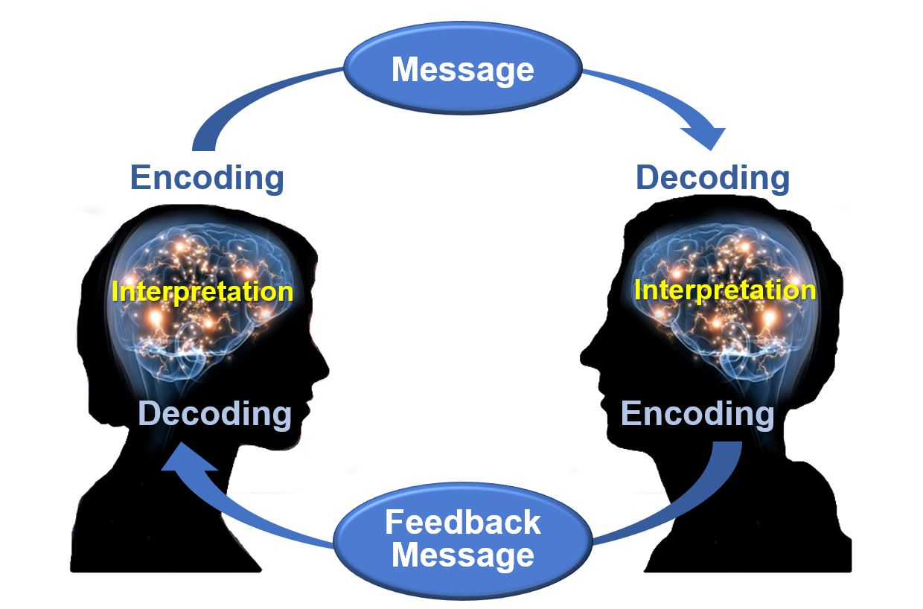
In my workplace, the communication process can be clearly seen when the Head of HR gives instructions regarding employee schedules, internal procedures, and required documentation. For example, the Head of HR may send an email or WhatsApp message informing staff about updated company policies, training sessions, or deadlines for submitting important documents. The Head of HR encodes the message by translating organisational requirements into clear written instructions, including specific deadlines, required actions, and necessary supporting information. Employees then decode the message by reading and interpreting the instructions to understand what is expected of them. Feedback is important. When employees respond to confirm they have received the information, ask questions for clarification, or complete the required task, such as submitting documents or attending scheduled training. For example, if the Head of HR requests updated employee records by a certain date, employees confirm receipt of the request and notify HR once the documents have been submitted. This communication process helps ensure that organisational procedures are followed correctly, reduces misunderstandings, and supports efficient workplace coordination.

2.2. Shannon and Weaver Communication Model (1949)
The Transmission Model was developed to represent the basic elements of communication and explain how messages can become lost or distorted. Chandler (1994) has argued that Shannon and Weaver believed that by avoiding barriers of communication, you could develop strategies to overcome them. Their research seems to consider the impact of ‘noise’ on effective communication. Noise is classified as anything that might distort the message.
As shown in the picture, noise is any barrier or disturbance that affects the accurate transmission and understanding of a message.
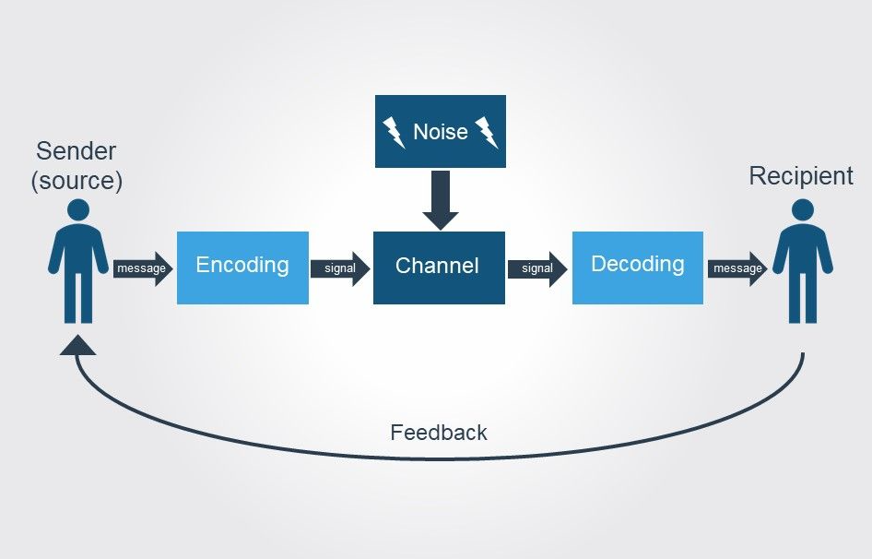

In Flensburg's 2009 study he argues that, the Shannon-Weaver communication-system model, considers a model of signal processing. Clearly the TRANSMITTER “transforms” the MESSAGE into SIGNAL, but then the exact conceptual relationship between them is not clear. Similarly, RECEIVER “transforms” SIGNAL into MESSAGE. This research shows that, although the model is useful for understanding technical communication processes, it may not fully explain the complexity of human communication.
In my workplace, noise refers to anything that interrupts, distracts, or interferes with communication between employees and the Head of HR. It could be loud conversations in the office, poor internet or phone connection, etc. For example, during an online team with the Head of HR meeting, a poor internet connection may cause employees to miss important instructions from the HR. As a result, tasks may be completed incorrectly. This shows how noise can negatively affect communication and workplace performance.

2.3. Berlo Communication Model (1960) – SMCR Model (Source, Message, Channel, Receiver)
The role of effective communication has been extensively studied in recent years. The Berlo Communication Model attracted significant interest. Hartley and Bruckmann (2001) have carried out an extensive study on the Communicational model, reminding us that out of a number of models of communication that exist, David Berlo's SMCR model is the most common and most referred to model that seems to help most other models expand their horizons on what good communication means.
As illustrated in the figure below, communication works by focusing on the relationship between the sender and the receiver and the factors that influence effective communication.
This model is also called the SMCR Model, which includes:

S (sender/source) Message Channel Receiver

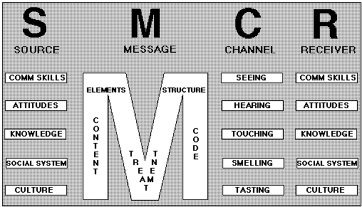
Speaking about the workplace context:
- The sender is the person who sends the message. This may include emails, phone calls, or spoken communication.
- The message is the information or idea that is being communicated.
- The channel refers to the method through which the information is transmitted, such as hearing, seeing, touching, or speaking.
- The receiver is the person who receives and interprets the message or information.
In my workplace, this process is very important: for example, a manager (source) explains daily tasks to employees during a morning meeting. The manager uses clear language and professional communication skills. Employees (receivers) listen, understand the instructions, and complete their work correctly. This demonstrates how effective communication can improve productivity and teamwork in the organisation.

2.4. Schramm Communication Model (1954) – The Interactive Model
The last model I would like to consider in this paper is the Schramm Communication Model. It explains communication as a two-way interactive process between a sender and a receiver. Unlike other models, this model focuses on encoding, decoding, interpretation and feedback. Kapur (2020) argued that Schramm has advanced the point that both people involved in communication continuously send, receive, and interpret messages.
The following picture shows that communication is more successful when people share similar knowledge, culture, language, or experiences.
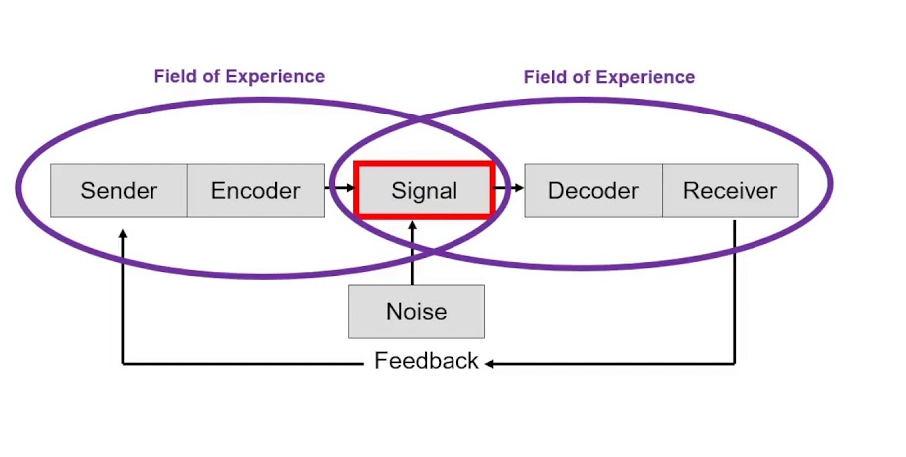
The Schramm model is important in the workplace because it highlights the role of feedback. Effective two-way communication helps improve teamwork, reduce misunderstandings, and support teamwork between employees and managers.
In my workplace, different departments use different communication models depending on their responsibilities and working style. However, in my HR department, the most effective approach is the Schramm Communication Model because it supports two-way communication, feedback, and mutual understanding between employees and managers.

3. Verbal and Non-verbal Communication, Tone, Language and Formality
This paragraph is generally about how people communicate in the workplace and the different factors that influence effective communication. The table below explains types of workplace communication and provides recommendations for improving ineffective communication.
 |  | How it works in my workplace | Prose /how successful) | Con /Unsuccessful | Recommendation
Verbal | Face-to-face conversation | During a shift, an employee may speak directly with the team leader to report a problem. The manager can immediately give instructions. | Fast communication, immediate feedback | Misunderstandings may happen if instructions are unclear. | Use clear language and confirm understanding.
Verbal | Meetings | During a meeting, we can discuss upcoming tasks, and any workplace issues. Team can ask questions, share their opinions, and receive clear instructions. | Encourages teamwork | Some employees may not participate actively. | Encourage feedback from all staff.
Verbal | Phone calls | Our manager may use a phone call to quickly contact a team member when there is an urgent issue. | Quick response | Information may be forgotten or misunderstood. | Follow up important calls with written confirmation by e-mails.
Non-verbal written | Posters | Posters placed in the workplace may show important safety rules, such as fire exit routes or hygiene guidelines. | Easy to see and useful for reminders. | Employees may ignore or overlook them. | Update posters regularly and keep them visually clear.
Non-verbal written | Emails | Daily emails are used for formal communication and sharing documents. | Clear instructions. | Too many emails can reduce attention. | Write emails clearly, using the simple language.
Non-verbal written | WhatsApp | we use WhatsApp group to quickly share updates such as a change in shift time or a reminder about a task. | Fast and convenient communication. | Messages can be missed outside working hours. | Use WhatsApp only for urgent or simple communication.

3.1. Tone
Tone refers to the way a person speaks or writes and the attitude or emotion expressed during communication. Tone is very important in the workplace because it can influence how messages are understood by employees and managers. A respectful and professional tone helps create positive relationships, improves teamwork, and reduces misunderstandings. Fasbinder (2021) supports the notion that the tone of voice transmits emotion when you communicate with others. Not only does your tone influence how others see you, but it also influences their desire to listen to you.
In my workplace, tone is used during face-to-face conversations, meetings, phone calls, emails, and messages. Using the wrong tone can negatively affect communication. For example, if our manager speaks in an aggressive or rude tone while giving instructions, we may feel stressed, uncomfortable, or unmotivated.
However, it is important to use a clear, respectful tone to maintain effective communication and a positive working environment.

3.2. Language
In addition to verbal and non-verbal communication, language also plays a significant role in the workplace. In my workplace, using clear and professional language is important because it helps employees understand information correctly and avoid misunderstandings. Language is used in conversations, meetings, emails, phone calls, and written instructions. All employees are using the same language, without slang. For example, using complicated terminology, slang, or rude language may confuse employees or create conflict in the workplace. Therefore, clear and professional language is essential for effective communication and teamwork.

3.3. Formality
A number of recent studies have focused on formality. Formality refers to the level of professionalism and appropriateness used during communication in the workplace. It is important because it helps maintain respect, professionalism, and clear relationships between employees, managers, and customers.
Formal communication is commonly used in emails, meetings, reports, and communication with managers or partners. Informal communication may be used during everyday conversations between colleagues. Using the wrong level of formality can create communication problems. For example, if an employee communicates too informally with a manager or customer, it may appear disrespectful or unprofessional.
In my workplace, it is important to choose the appropriate level of formality to avoid misunderstandings and create respectful communication between employees and managers.

4. Workplace communication barriers
To create a successful and productive workplace, it is important to maintain a positive team environment.
There are a number of communication barriers, which are shown in the table, including:

Barrier | Example | Strategy to Overcome
Environmental | Team meetings in a noisy open office | Book quiet meeting room
Linguistic | Employees in my workplace have different levels of fluency in the English language | Use simple words, short phrases, speak slowly, and avoid unnecessary jargon and idioms, and academic terminology
Psychological | In my workplace, often by the end of the month, the manager wants to review everything, ask for additional information, and ask to prepare a supplementary report. | Balance workloads and tasks during the month, set priorities, and reduce unnecessary pressure by the end of the month.
Physiological | Hearing issues in a loud workplace make it difficult for the workers to understand spoken information | Put all the information into a paper, so workers can read it
Perceptual | In a workplace meeting, a manager gives a long presentation with lots of unnecessary details, so staff miss the core functions. | The speaker should keep communication clear by breaking information into key points and only including relevant and useful information.
Content | Long or unclear emails with too much information may confuse employees. | Avoid unnecessary details, structure messages clearly, and confirm understanding through feedback or follow-up questions.
Personal | Lack of confidence may prevent employees from asking questions or sharing ideas. | Encourage open communication, provide support and feedback, and create a positive workplace environment where employees feel comfortable expressing their opinions.

In 2002, Erven argued that removing barriers to communication is one of the easiest ways to improve communication. Removing these barriers starts with an understanding of a communication model.
The barrier I selected is a content barrier, which exists in my workplace when employees receive too much unclear or irrelevant information. This negatively affects productivity because employees may become confused, misunderstand instructions, or spend extra time identifying the important information. As a result, communication becomes less effective, and tasks may not be completed efficiently.

5. Conflict and conflict resolution strategy

5.1. Conflict in the workplace
Conflict is a common part of workplace communication and may occur when individuals or groups have different opinions, goals, needs, or ways of working.
Personal conflict normally stems from differences in personalities, emotions, stress levels, or interpersonal relationships among employees. In some cases, conflict arises because of differences in working styles or personal stress factors influencing people outside their work environment.
On the other hand, professional conflict involves aspects of work and organisational activities. Professional conflict usually emanates from differences in goals, unclear roles, common resources, competition for priorities, or power discrepancies among workers and departments within an organisation.
It is important to understand the difference between personal and professional conflict because they require different approaches to management.
For example, in my workplace, a communication misunderstanding once occurred when the Head of HR shared urgent instructions about updated employee documentation requirements through WhatsApp without providing sufficient detail. This resulted in confusion among HR staff regarding submission deadlines and the specific documents required, which delayed task completion.
The conflict was resolved through a follow-up face-to-face clarification with the Head of HR, during which the requirements were explained more clearly. Following this, the team agreed to use more detailed written communication for urgent HR requests to reduce misunderstandings and improve workflow efficiency.

5.2. Conflict resolution strategy
Conflict resolution strategy in a professional environment entails a systematic and balanced process used to handle disputes in the workplace. The strategy highlights the importance of communication, objectivity, and coming up with a viable solution that is acceptable by everyone.
The general steps involved in implementing such a strategy include:

- Handling the disagreement in a private and professional manner
- Listening to everyone’s opinion without being subjective
- Sticking to facts and avoiding feelings
- Agreeing to the resolution that is realistic
- Following up to ascertain whether the problem has been sorted out

Such a strategy helps keep communication clear and ensures that disputes are more likely to be solved rather than rehashed.

6. Motivation and performance
Motivation is an important factor in influencing workplace performance and employee behaviour. It affects how employees do their work, interact with the managers, and accomplish business goals. Generally, a motivated employee tends to be more productive, active, and committed to their duties. Therefore, understanding motivation is important for good management and business performance.
Managers need to understand motivation because communication, leadership, and performance are all influenced by what drives people to act.
In my workplace, motivation is important because employees often work under pressure and need support, recognition, and clear communication to remain productive and engaged.

6.1. Intrinsic Motivation
Motivation is intrinsic when its source is within the person himself. People become motivated when they find pleasure in what they do, feel that their activities have significance, or feel a sense of accomplishment in their task performance.
Some examples of intrinsic motivation are:
- working on difficult tasks or problem-solving
- being proud of doing great work
- acquiring knowledge and skills
- enjoying helping others

6.2. Extrinsic motivation
In contrast to intrinsic motivation, extrinsic motivation is driven by external factors.
Extrinsic motivation comes from external rewards or consequences. Employees are motivated by salary, bonuses, promotions, benefits, or fear of negative consequences.
Examples include:
- financial rewards
- bonuses
- promotion opportunities
- recognition from managers
- performance targets
Accordingly, extrinsic motivation seems to have ambiguous effects on overall work performance. This is partly attributed to the multitasking effect: In a context of strong tangible incentives, employees will concentrate on those tasks that are directly incentivized and neglect those that are not (Gibbons, 2005).
In my workplace, both intrinsic and extrinsic motivation affect employee performance. Employees are motivated when they receive recognition, clear communication, and support from management. Teamwork and positive workplace relationships also contribute to motivation and productivity.
Understanding motivation helps organisations create a more engaged, productive, and successful workforce.

7. Motivation theories
The role of motivation theories has been largely overlooked. Motivation theories explain why employees behave in certain ways and what factors encourage them to work effectively. These theories help managers understand how to improve employee satisfaction, performance, and productivity in the workplace.
There are several motivation theories commonly used in workplace management.

7.1. Maslow’s Hierarchy of Needs (1943)
Developed by Abraham Maslow, this theory explains that people are motivated by different levels of needs.
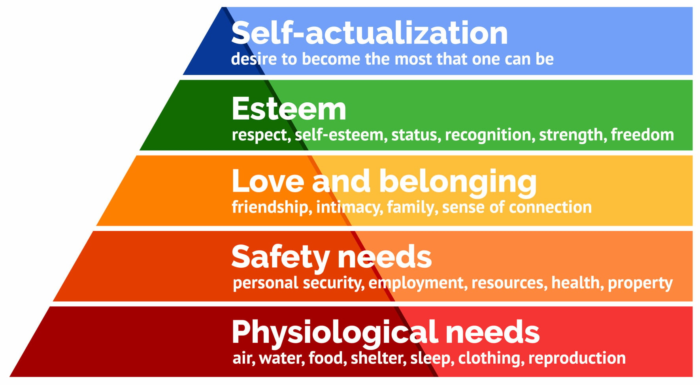
This motivation theory explains that people are motivated by different types of needs, which are organised in levels from basic needs to personal development needs.
Regarding the structure of the hierarchy, Maslow (1987) argued that survival needs must be satisfied before the individual can satisfy the higher needs.
This theory applies to my workplace because employees must first satisfy their basic survival needs before they can focus on higher-level needs such as recognition, personal growth, and self-actualisation. This theory helps explain how different levels of needs can influence employee motivation and behaviour in the workplace.
In my workplace, Maslow’s theory is clearly visible. Employees first expect stability, predictable schedules, and fair compensation. Once these needs are met, motivation increasingly depends on recognition, trust from management, and opportunities for professional development. This explains why positive feedback from the Head of HR often has a stronger motivational effect than financial incentives alone.

7.2. McClelland's Theory of Needs (1961)
McClelland mentioned three basic needs that people derive from their life experiences: Need for Achievement, Need for Affiliation and Need for Power (Turabik, 2017). People will have different characteristics depending on their dominant motivator. The picture below explains this theory.

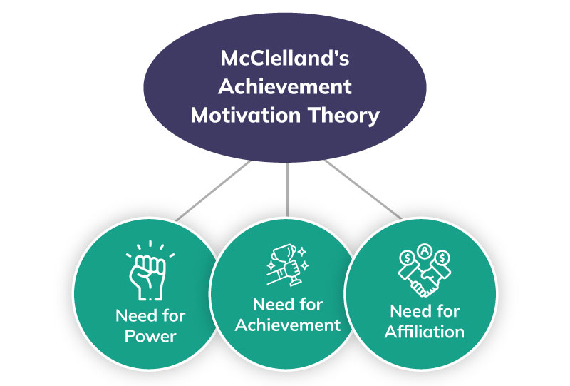

However, it still remains a popular option among leaders and is often chosen over other workplace motivation theories.

7.3. Herzberg's two-factor Theory (1959)
Another important theory related to workplace motivation is Herzberg’s Two-Factor Theory.
It explains that employee motivation is influenced by two different groups of factors: hygiene factors and motivators. Hygiene factors are basic workplace conditions that help prevent employee dissatisfaction, but they do not necessarily increase motivation. Motivational Factors are factors that increase employee satisfaction and encourage better performance.
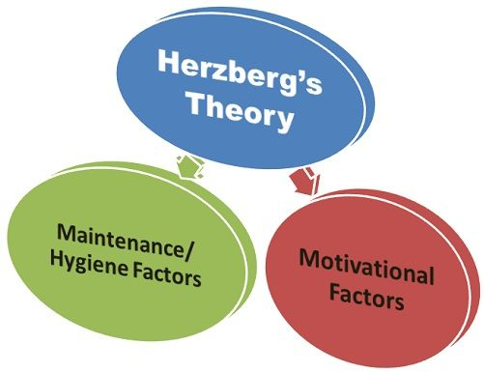

In my workplace, hygiene factors include stable salary, safe working conditions, and clear company policies. Motivators include recognition from managers, opportunities for professional development, and positive feedback for successful work.
This theory shows that organisations should not only provide acceptable working conditions, but also create opportunities for employees to feel appreciated and motivated.

7.4. McGregor's Theory X and Theory Y (1960)
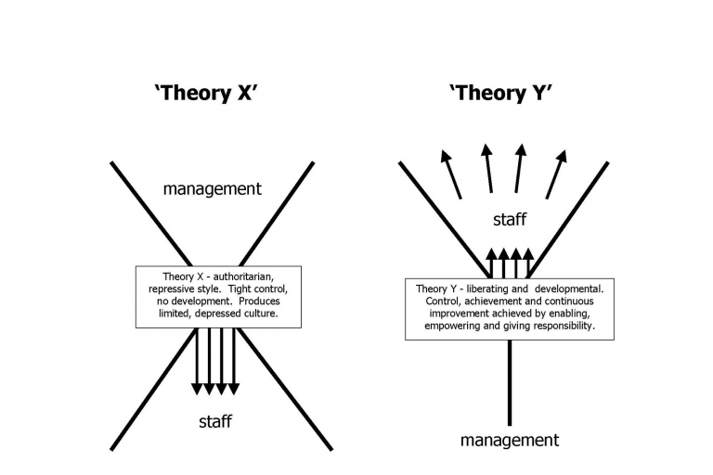
Theory X and Theory Y are still used in modern management, but in contemporary workplaces, there is generally a stronger emphasis on Theory Y. This is because Theory Y supports employee trust and two-way communication between staff and management, which improves motivation and productivity. However, some elements of Theory X (military, factories) may still be used, where strict control or close supervision is required.
Theory X assumes that employees: | Theory Y assumes that employees:
- dislike work  - avoid responsibility  - require close supervision  - need strict rules and control | - are self-motivated  - enjoy responsibility  - can work independently  - want personal and professional growth

Among all the motivation theories, the most relevant to me is Abraham Maslow's Hierarchy of Needs Theory, because it clearly explains how different levels of needs influence employee motivation in the workplace, starting from basic needs such as salary and job security to higher-level needs such as recognition and personal development. This theory best reflects my experience in the workplace, where employees are motivated by both basic conditions and opportunities for growth.

8. Self-Evaluation and Development
In order to systematically evaluate my communication in the workplace, I have carried out a questionnaire. The questionnaire is presented in Appendix A, which provides a clear overview of both verbal and non-verbal communication analysis.
Based on the self-assessment results, I am competent in adjusting my communication style, asking questions, and conducting proper non-verbal communication. I scored the highest in this section. In my workplace, these strengths reflect my awareness of professional communication requirements.
However, the results also highlight areas for improvement, particularly in managing nervous habits during formal situations and improving the structure and accuracy of written communication. The GAP analysis (Appendix B) identifies these as key development areas.
The GAP analysis highlights both strengths and weaknesses in my workplace communication skills. The results indicate that I perform strongly in asking relevant questions and adapting the tone and level of formality in written communication. In addition, my score for active listening suggests that I need to improve my attentiveness during conversations and avoid interruptions.
Based on the gaps identified through the self-assessment and gap analysis, a Personal Development Plan (Appendix C) has been developed to address these areas and support the continuous improvement of my workplace communication skills.

8.1. Feedback Analysis
To gain a broader perspective, I asked two colleagues and one manager to provide informal feedback based on the questionnaire criteria.
The feedback highlighted strong adaptability in verbal communication and professional tone when communicating with different workplace stakeholders.
Areas identified for improvement included written accuracy under time pressure and occasional nervousness during formal discussions.
One surprising point was that colleagues rated my listening skills higher than I rated myself, suggesting that I may underestimate my active listening ability.

9. Conclusion
This report demonstrated that effective workplace communication is essential for operational efficiency, employee motivation, and conflict prevention.
The results presented in Appendix A identified both strengths and areas for improvement in my verbal, non-verbal, and written communication. The GAP analysis in Appendix B highlighted specific development needs, particularly managing nervous habits, improving written accuracy, and structuring professional documents more effectively. To address these areas, a Personal Development Plan was developed in Appendix C with clear and measurable actions. By implementing this plan, I aim to further strengthen my communication skills and improve my overall professional effectiveness in the workplace.

10. References
1. Analisis unsur-unsur komunikasi. (2024). Da’watuna: Journal of Communication and Islamic Broadcasting. https://journal-laaroiba.com/ojs/index.php/dawatuna/article/view/512
2.Chandler, D. (1994). The transmission model of communication. University of West England. https://www.aber.ac.uk/media/Documents/short/trans.html
3. Erven, B. L. (2002). Overcoming barriers to communication. Ohio State University Extension. http://www.agecon.ohio-state.edu/people/erven.1/HRM/communication.pdf
4. Fasbinder, F. (2021, September 13). How to establish credibility in a speech. Moxie Institute. https://www.moxieinstitute.com/how-to-establish-credibility-in-a-speech/
5. Flensburg, P. (2009). An enhanced communication model. International Journal of Digital Accounting Research, 9, 31–43. https://doi.org/10.4192/1577-8517-v9_2
6. Hartley, P., & Bruckmann, C. G. (2002). Business communication. Routledge.
7. Kapur, R. (2020). The models of communication. University of Delhi.
8. Herzberg, F., Mausner, B., & Snyderman, B. B. (1959). The motivation to work (2nd ed.). John Wiley & Sons.
8. Maslow, A. H. (1987). Motivation and personality (3rd ed.). Harper & Row.
9. McGregor, D. (1960). The human side of enterprise. McGraw-Hill.
10. Gibbons, R. (2005). Incentives between firms (and within). Management Science, 51(1), 2–17.
11. Turabik, T., & Baskan, G. A. (2015). The importance of motivation theories in terms of education systems. Procedia - Social and Behavioral Sciences, 186, 1055–1063. https://doi.org/10.1016/j.sbspro.2015.04.006

Appendix A
Management Communication Workplace Self-Assessment Questionnaire
Name: ____________________________
Date: _____________________________
Instructions
Please rate each statement on a scale of 1 to 5 based on how accurately it reflects your behaviour in a workplace or academic context.
Scale:
1 = Strongly Disagree
2 = Disagree
3 = Neither Agree nor Disagree
4 = Agree
5 = Strongly Agree

 | Question | 1 | 2 | 3 | 4 | 5
1 | I communicate my ideas in a clear and concise manner during conversations.
2 | I ask relevant questions to ensure full understanding and to clarify information when necessary.
3 | I listen attentively to others without interrupting them.
4 | I adjust my speaking style according to the audience (e.g., managers, colleagues, clients).
5 | My body language (e.g., eye contact and posture) aligns with and supports my verbal messages.
6 | I manage nervous habits (e.g., fidgeting or avoiding eye contact) when speaking in formal situations.
7 | I consciously adapt my non-verbal communication (e.g., gestures, eye contact, tone of voice) depending on the context and audience.
8 | I am aware of how my facial expressions influence others’ perceptions of me.
9 | My written communication is clear, accurate, and free from grammatical or spelling errors.
10 | I adapt the tone and level of formality in my writing depending on the recipient and context.
11 | I select suitable formats for different types of written communication (e.g., emails, reports, memos).
12 | I structure written documents in a logical and well-organised manner using appropriate headings and formatting.

Appendix B
GAP ANALYSIS
Current State | GAPS | DESIRED OUTCOME
Generally communicate ideas clearly | Greater conciseness and precision needed in complex discussions | Deliver clear and concise messages consistently in all workplace situations
Strong ability to ask relevant questions | No significant gap identified | Maintain effective clarification skills
Moderate listening skills | Need to improve focus and avoid occasional interruptions | Demonstrate fully attentive and responsive listening
Good adaptation to different audiences | Minor improvements in consistency | Communicate confidently with all workplace stakeholders
Appropriate non-verbal alignment | Lack of confidence under pressure | Use confident and professional body language at all times
Difficulty managing nervous behaviours in formal situations | Lack of confidence under pressure | Remain calm and composed during formal presentations and meetings
Good awareness of audience context | Further refinement needed | Consistently adjust non-verbal cues effectively
Good awareness | Minor inconsistency | Maintain positive and professional facial expressions
Weak written accuracy | Errors in grammar and spelling | Produce clear, accurate, error-free written communication
Strong ability to adapt writing style | No significant gap identified | Maintain professional written adaptability
Limited confidence in choosing suitable formats | Need a stronger understanding of document types | Select appropriate formats confidently
Weak document organisation | Lack of logical structure and formatting consistency | Produce well-organised and professionally structured documents

Appendix C
Personal Development Plan
Development area | Why this matters | Smart action | Resources/Support needed | Timescale | How I will measure progress
Managing nervous habits during formal communication | Confidence is essential for effective workplace presentations and professional interactions | Practise formal presentations once a week and participate actively in workplace discussions for the next 8 weeks | Feedback from colleagues/supervisor; presentation practice materials | 2 months | Reduced signs of nervousness and increased confidence during formal communication
Improving written accuracy | Accurate written communication is necessary for professionalism and clarity | Proofread all written tasks and use grammar-checking tools before submission over the next 6 weeks | Grammar-checking software; writing guidelines | 6 weeks | Fewer grammatical and spelling errors in written work
Structuring written documents logically | Well-organised documents improve readability and professionalism | Produce at least one structured professional document each week using clear headings and formatting for 8 weeks | Sample reports; workplace document templates | 2 months | Improved organisation and positive feedback on written documents
Selecting suitable written formats | Choosing the correct format ensures communication is appropriate for purpose and audience | Review and practise using different workplace communication formats (emails, reports, memos) twice a week for 6 weeks | Example workplace documents: supervisor guidance | 6 weeks | Greater confidence in selecting appropriate communication formats
Developing active listening skills | Active listening improves teamwork and reduces misunderstandings |  | Feedback from colleagues; reflective notes | 1 month | Improved engagement in discussions and fewer interruptions
  Apply active listening techniques in all meetings and summarise key points after discussions for 4 weeks

