

FINANCIAL HEALTH, WORKING CAPITAL, RESTRUCTURING AND CAPITAL BUDGETING ANALYSIS
Hyatt Hotels Corporation (NYSE: H)

Student Name: Lutfiya Imtiyaz Ghanchi
Student ID: 2536172
Subject Name: Financial Management
Course Name: Master of Business Administration
Module code: LCMB7024
Word Count: 5200 Approx.

Table of Contents

1. Introduction 3
2. Financial Health Check 3
2.1 Five-year financial performance 3
2.2 Profitability, returns and asset utilisation 4
2.3 Liquidity and working-capital ratios 4
2.4 Gearing, debt service and cash flow 5
2.5 Competitor and industry perspective; SWOT 7
3. Working Capital Management 7
4. Strategic Financial Restructuring Plan 8
4.1 Diagnosis and restructuring objective 8
4.2 Debt and financing strategy 8
4.3 Equity, dividends and shareholder implications 8
4.4 International tax, FX, interest and macroeconomic risk 8
4.5 ESG, CSR and stakeholder consequences 9
4.6 Implementation priorities 9
5. Investment Appraisal & Capital Budgeting 9
5.1 Project data and assumptions 9
5.2 Payback Period (PBP) 9
5.3 Accounting Rate of Return (ARR) 10
5.4 Net Present Value (NPV) 10
5.5 Internal Rate of Return (IRR) 10
5.6 Project recommendation and qualitative risk 10
5.7 £100 million capital rationing 11
6. Critical Reflection on AI Usage 11
7. Conclusion 12
8. Recommendations 12
References 13
Appendices 14
Appendix A – Five-year ratio calculations 14
Appendix B – Detailed NPV workings 14
Project A 14
Project B 14
Project C 14
Appendix C – ARR workings 14
Appendix D – IRR and capital-rationing results 15
Appendix E – Source and data-control note 15

1. Introduction

Hyatt Hotels Corporation is a US-listed international hospitality company whose portfolio includes full-service and resort hotels, select-service hotels, all-inclusive resorts and other hospitality offerings. At 31 December 2025, Hyatt reported 1,528 hotels and 372,763 rooms across 83 countries, illustrating the scale and geographic diversification of the group (Hyatt Hotels Corporation, 2026a). The business model combines owned and leased hotel operations with management contracts, franchising, licensing, distribution and destination-management activities. This mix matters financially: management and franchise fees are relatively asset-light and recurring, whereas owned and leased operations require more capital and expose the group to operating leverage.
This report evaluates Hyatt's five most recent complete financial years, 2021–2025, using audited annual-report and SEC information, supported by Hyatt investor disclosures and selected peer and academic evidence. The analysis covers profitability, liquidity, efficiency, gearing, investment returns, cash flow and working-capital management, before developing a restructuring plan. The report then evaluates the three investment projects specified in the assignment using payback period, accounting rate of return, net present value and internal rate of return at an 8% discount rate. All project cash flows are reproduced exactly from the assignment brief; no missing project inputs are invented.

2. Financial Health Check

2.1 Five-year financial performance

Hyatt's five-year trajectory is best interpreted as a recovery-and-transformation cycle rather than a smooth growth story. Revenue rose 46.6% in 2022 and 13.2% in 2023 as travel demand recovered, was broadly flat in 2024, and increased 6.8% to $7.101 billion in 2025. The revenue composition is important. Gross fees rose from $418 million in 2021 to $1.198 billion in 2025, while 2025 owned-and-leased revenue increased to $1.375 billion. At the same time, reimbursed-cost revenue reached $3.629 billion. Such reimbursed revenue inflates the reported top line without representing an equivalent economic margin contribution, so management-fee growth and adjusted EBITDA are more informative indicators of the underlying asset-light model (Hyatt Hotels Corporation, 2022; 2026a).
$m / ratio | 2021 | 2022 | 2023 | 2024 | 2025
Revenue | 3,028 | 5,891 | 6,667 | 6,648 | 7,101
Net income attributable to Hyatt | (222) | 455 | 220 | 1,296 | (52)
Adjusted EBITDA | 257 | 908 | 1,029 | 1,096 | 1,159
Operating income | (251) | 392 | 289 | 374 | 348
Operating margin | -8.3% | 6.7% | 4.3% | 5.6% | 4.9%
Net margin | -7.3% | 7.7% | 3.3% | 19.5% | -0.7%
Table 1. Hyatt five-year financial performance. Source: Hyatt annual reports and SEC filings; ratios calculated from reported data.
The 2024 net-income spike should not be treated as a recurring profitability baseline. Hyatt recorded $1.245 billion of gains on sales of real estate and other assets in 2024. Consequently, the 19.5% net margin in that year is economically misleading if used as a proxy for sustainable hotel profitability. In 2025 the company reported a $52 million attributable loss, but adjusted EBITDA increased to $1.159 billion. The contrast shows why a CFO should reconcile statutory earnings to recurring operating cash generation rather than relying on one headline profit measure. Interest expense also increased sharply from $180 million in 2024 to $317 million in 2025, demonstrating the cost of the acquisition-led expansion programme (Hyatt Hotels Corporation, 2026a).
Profitability therefore has two layers. The first is operating resilience: adjusted EBITDA improved each year after the pandemic and reached a record reported level in 2025. The second is accounting volatility: asset disposals, impairments and acquisition-related charges materially affect GAAP earnings. Hyatt's strategy of selling owned hotels while retaining long-term management or franchise contracts can improve capital efficiency, but it also creates volatile disposal gains and tax cash flows. The correct management objective is therefore to increase recurring fee income and EBITDA while reducing dependence on asset-sale gains to fund distributions or investment.

2.2 Profitability, returns and asset utilization

Operating margin recovered from -8.3% in 2021 to 6.7% in 2022, slipped to 4.3% in 2023, improved to 5.6% in 2024 and remained 4.9% in 2025. That pattern is consistent with recovery followed by a more acquisition-intensive operating structure. ROA, calculated using average total assets where available, was -1.8% in 2021, 3.7% in 2022, 1.7% in 2023, 9.9% in 2024 and -0.4% in 2025. ROE moved from -6.2% to 12.5%, 6.1%, 35.1% and -1.4% respectively. The exceptionally high 2024 ROE again reflects the exceptional asset-sale gain rather than a normalized return on capital.
Asset turnover improved from approximately 0.24 times in 2021 to 0.51 times in 2025. This is encouraging because revenue has grown faster than the asset base over the period, but the ratio remains affected by the consolidation of different business lines and the unusually high level of reimbursed-cost revenue. Academic evidence on international hotel chains supports the strategic importance of asset-light expansion: management contracts and franchising can produce stronger economic efficiency and flexibility than ownership-heavy expansion because they require less capital investment (Mulet-Forteza et al., 2024). Hyatt's growing fee base is therefore strategically aligned with improved asset utilization.
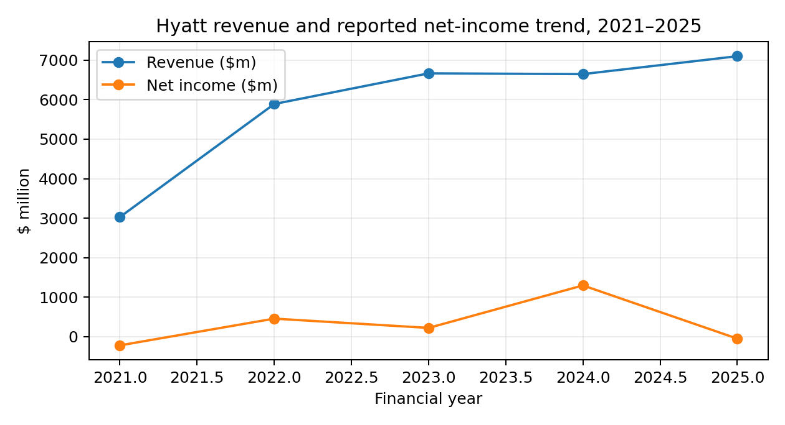
Hyatt revenue and reported net-income trend, 2021–2025

2.3 Liquidity and working-capital ratios

Hyatt's liquidity position is a key weakness. The current ratio was 0.92 in 2021, 0.68 in 2022, 0.60 in 2023, 0.83 in 2024 and 0.75 in 2025. The quick ratio was almost identical because inventory is immaterial for Hyatt. On a conventional manufacturing benchmark, a ratio below 1.0 would signal material short-term liquidity pressure. However, hotel groups differ because substantial contract liabilities represent advance customer cash and can fund operations before the related service is delivered. Therefore, Hyatt's sub-1.0 ratio is not automatically evidence of distress, but it does mean that liquidity depends on cash conversion, operating cash flow, committed facilities and refinancing access rather than a large current-asset cushion.
Liquidity ratio | 2021 | 2022 | 2023 | 2024 | 2025
Current ratio | 0.92 | 0.68 | 0.60 | 0.83 | 0.75
Quick ratio | 0.92 | 0.68 | 0.59 | 0.83 | 0.75
Cash + ST investments / current liabilities | 0.53 | 0.36 | 0.25 | 0.42 | 0.28
Liquidity weakened in 2025 because cash and short-term investments fell from $1.384 billion at 2024 year-end to $813 million, while current liabilities remained $2.894 billion. Current contract liabilities were $1.584 billion, reflecting advance consideration and loyalty-related obligations. The structure is therefore partly self-financing, but it also creates service obligations that cannot simply be treated as excess cash. Management should maintain a minimum liquidity buffer against seasonality, geopolitical disruption, acquisition integration and debt maturities rather than targeting a superficial improvement in the current ratio.
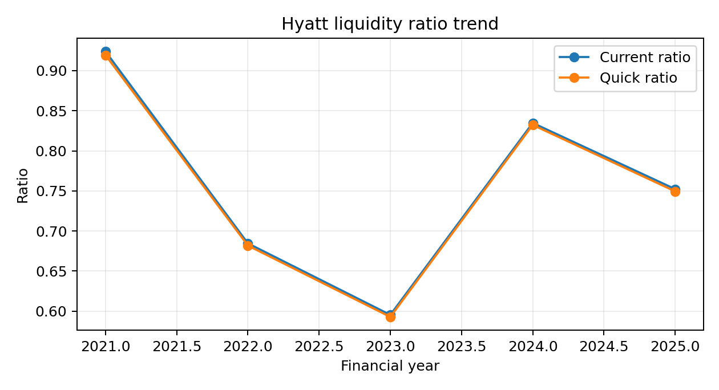
Hyatt liquidity ratio trend

2.4 Gearing, debt service and cash flow

Debt-to-equity declined from 1.22 times in 2021 to 0.93 times in 2022, remained around 0.94 times in 2023, increased to 1.06 times in 2024 and reached 1.25 times in 2025. Total debt rose from $4.362 billion in 2021 to $4.556 billion in 2025, with the largest recent increase occurring around the Playa transaction and related financing. Total liabilities reached $10.377 billion against total equity of $3.659 billion in 2025. The leverage position is not inherently excessive for a global hotel group, but the direction of travel is important because higher interest expense reduces the cash available for reinvestment and shareholder distributions.
Using Hyatt's reported adjusted EBITDA as a consistent operating proxy, interest cover was approximately 1.8 times in 2021, 6.1 times in 2022, 7.1 times in 2023, 6.1 times in 2024 and 3.7 times in 2025. The 2025 decline is significant: EBITDA grew, but interest expense grew much faster. That is a warning that acquisition financing is beginning to absorb a larger share of operating capacity. Hyatt should therefore avoid interpreting EBITDA growth alone as evidence that leverage is comfortable. Cash interest and free cash flow should govern capital allocation.
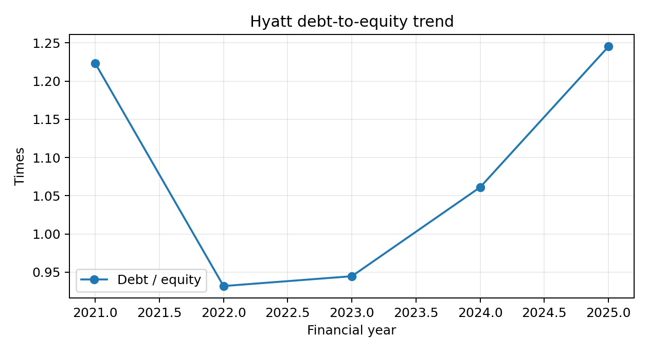
Hyatt debt-to-equity trend
Cash flow confirms the pressure. Operating cash flow was $674 million in 2022, $800 million in 2023, $633 million in 2024 and $379 million in 2025. Free cash flow, defined here as operating cash flow less capital expenditure, was $473 million, $602 million, $463 million and $159 million respectively. Hyatt's own 2026 investor materials identify 2025 adjusted free cash flow of $474 million after adjusting for asset-sale taxes and Playa acquisition costs, compared with reported free cash flow of $159 million. The distinction is useful for diagnosis but should not be used to ignore actual cash outflows: acquisition and integration costs are real cash demands.
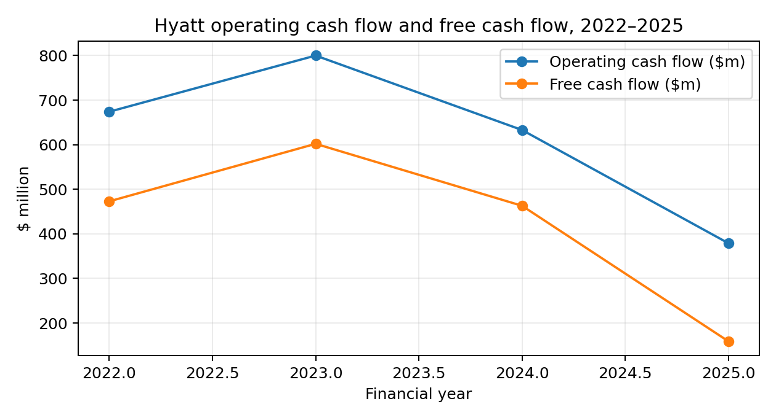
Hyatt operating cash flow and free cash flow, 2022–2025

2.5 Competitor and industry perspective; SWOT

Peer comparison must be treated carefully because Marriott, Hilton and Hyatt use different mixes of owned assets, managed hotels, franchising, loyalty economics and reimbursed revenue. Marriott's 2025 audited statements, for example, show a current-asset base of $3.584 billion and net income of $2.601 billion, but its capital structure and accounting presentation differ materially from Hyatt's (Marriott International, 2026). Hilton is another useful asset-light comparator, but its extensive franchising and management model also makes simple current-ratio comparisons imperfect (Hilton Worldwide Holdings, 2026). Accordingly, Hyatt's strongest benchmark is not a single industry ratio but the direction of recurring fees, EBITDA, leverage, cash conversion and net rooms growth relative to peers.
Strengths include global brand breadth, a growing fee-based business, a large development pipeline, strong loyalty economics and the ability to recycle owned assets into lower-capital management contracts. Weaknesses include sub-1.0 liquidity, increased debt, rising interest expense, earnings volatility and sensitivity to acquisition integration. Opportunities include international growth, luxury and lifestyle demand, all-inclusive resorts, conversions, digital distribution and continued asset-light expansion. Threats include recession, geopolitical shocks, currency volatility, labour and energy inflation, cyber risk, climate events, changing travel demand and refinancing conditions. Overall, Hyatt is financially viable but requires tighter balance-sheet discipline after the 2025 expansion.

3. Working Capital Management

Working capital at Hyatt differs from that of a traditional manufacturer. Inventory is only $8–10 million, so inventory days are economically insignificant. The major working-capital components are receivables, cash, prepaid and other current assets, accounts payable, accrued expenses, contract liabilities, loyalty-program deferred revenue and current debt. At 2025 year-end, receivables were $1.123 billion, accounts payable $451 million and current contract liabilities $1.584 billion (Hyatt Hotels Corporation, 2026a). The balance illustrates that customer and loyalty advances are more important to liquidity than physical inventory.
Receivables increased substantially from $633 million in 2021 to $1.123 billion in 2025. Some of that increase reflects scale and the expansion of managed, franchised and distribution activities, but it also creates a cash-conversion requirement. Hyatt should segment receivables by management-contract fees, franchise fees, distribution services and other categories, because credit quality and payment timing differ. Automated invoicing, stronger electronic payment mandates, customer credit scoring and early escalation of overdue balances can reduce days sales outstanding without reducing service quality.
Payables provide an important natural financing source. Accounts payable were $451 million at 2025 year-end, but supplier credit should not be stretched indiscriminately. Hotels depend on reliable food, beverage, linen, maintenance, technology and energy suppliers; delayed payment can weaken resilience and increase costs. A better approach is dynamic supplier segmentation: negotiate longer terms with financially strong strategic suppliers, maintain agreed terms with smaller vendors, and use supply-chain-finance programmes where appropriate. This preserves supplier relationships while releasing cash.
Contract liabilities require special attention. Hyatt receives cash before delivering hotel nights, loyalty rewards or other services. Such balances improve operating liquidity but are not unrestricted cash because they represent performance obligations. Management should therefore monitor the maturity profile of contract liabilities and loyalty redemptions alongside the cash forecast. A rolling 13-week cash-flow model should incorporate occupancy seasonality, group bookings, payroll, supplier payments, debt service, tax payments and expected acquisition or disposal cash flows.
The 2025 cash-flow statement shows the importance of working-capital movements. Changes in accounts payable, accrued expenses and other current liabilities reduced operating cash by $176 million; contract liabilities reduced cash by $108 million; meanwhile deferred loyalty revenue increased cash by $271 million. These movements demonstrate that operating cash flow can diverge sharply from accounting earnings. The recommended working-capital programme is therefore: first, improve receivables collection; second, optimize supplier terms without harming vendors; third, centralize treasury and cash pooling where legally feasible; fourth, forecast loyalty and contract-liability cash obligations; and fifth, maintain liquidity headroom above the minimum covenant requirement.
Short-term financing should be reserved for seasonal or temporary gaps, using revolving credit and committed facilities rather than repeatedly funding structural deficits with short-term debt. Long-term financing should fund acquisitions and durable strategic assets. This maturity matching reduces rollover risk. The objective is not to maximize net working capital, because idle cash carries an opportunity cost; rather, Hyatt should minimize non-earning working capital while preserving a credible liquidity buffer.

4. Strategic Financial Restructuring Plan

4.1 Diagnosis and restructuring objective
Hyatt does not require a distress restructuring. It requires a proactive capital-structure optimization programme after a period of acquisition-led expansion. The 2025 balance sheet contains $4.278 billion of long-term debt and $6 million of current maturities, while interest expense reached $317 million. The immediate objective should be to reduce refinancing risk and restore stronger free-cash-flow coverage without sacrificing Hyatt's strategic growth platform.

4.2 Debt and financing strategy
First, Hyatt should refinance material maturities at least 12–18 months before due dates and maintain a staggered maturity ladder. Second, a greater proportion of debt should be fixed-rate or hedged, because the 2025 rise in interest expense shows the sensitivity of cash flow to financing costs. Third, management should prioritize unsecured debt where pricing is competitive and preserve committed revolving capacity as a liquidity backstop rather than routinely drawing it for permanent investment.
A second lever is asset recycling. Hyatt has demonstrated the ability to sell owned hotels while retaining management agreements. Disposing of non-core or lower-return owned assets can release cash for debt reduction while preserving fee revenue. This is preferable to an indiscriminate equity issue because a new equity issue would dilute existing shareholders and may be unnecessary if asset sales and free cash flow can restore leverage. However, asset sales should be based on forward ROIC and strategic value, not simply the availability of a high sale price.

4.3 Equity, dividends and shareholder implications
Hyatt should temporarily prioritize balance-sheet resilience over maximum share repurchases. Repurchases create value when shares are attractively valued and when the balance sheet can comfortably support them; they destroy flexibility when debt-funded. Dividends can continue at a sustainable level, but discretionary repurchases should be linked to leverage thresholds and free-cash-flow coverage. Once net leverage and interest coverage return to safer targets, capital can progressively be returned to shareholders.

4.4 International tax, FX, interest and macroeconomic risk
Hyatt operates in 83 countries, making foreign exchange a structural risk. Revenue, expenses, assets and liabilities are denominated in multiple currencies, and 2025 foreign-currency translation adjustments increased comprehensive income by $153 million. Natural hedges should be prioritized: match local revenues and costs and, where appropriate, local debt. Material transaction exposures can be hedged with forward contracts or options under treasury policy, with hedge effectiveness monitored regularly.
International taxation should be managed through compliant transfer-pricing policies, careful use of tax attributes, efficient financing locations and monitoring of global minimum-tax developments. Tax planning must remain consistent with substance and governance requirements; reputationally aggressive structures are inconsistent with Hyatt's stakeholder obligations. Inflation creates pressure through wages, food, utilities, maintenance and insurance. Revenue management, procurement contracts, energy efficiency and selective pricing are preferable to blunt cost cutting that could damage guest experience.

4.5 ESG, CSR and stakeholder consequences
Restructuring should not treat ESG as a separate reporting exercise. Hotel assets consume significant energy and water and depend on employees and local communities. Capital expenditure should therefore prioritize projects with measurable operating savings, resilience benefits and guest-value effects. Green or sustainability-linked financing can be considered only when targets are material, independently measurable and economically sensible. Creditors benefit from stronger cash-flow coverage; shareholders benefit from lower financial risk and preserved growth optionality; employees and suppliers benefit from avoiding destabilizing cost reductions.

4.6 Implementation priorities
In the next 12 months Hyatt should establish a minimum liquidity policy, refinance maturities early, suspend value-destructive discretionary buybacks, identify non-core assets for recycling and implement a group-wide 13-week cash forecast. Over 12–36 months, management should reduce leverage through free cash flow and selective asset sales, expand asset-light fee revenue and increase fixed-rate debt where cost-effective. Over three to five years, the target should be a more stable capital structure in which recurring fee income covers corporate costs and interest comfortably, acquisitions are funded from a balanced mix of retained cash and debt, and shareholder returns are made from sustainable free cash flow rather than exceptional disposal gains.

5. Investment Appraisal & Capital Budgeting

5.1 Project data and assumptions
The assignment specifies an initial investment of £50 million for each project, five annual net cash inflows, an 8% discount rate and straight-line depreciation to zero. Accordingly, annual depreciation is £10 million for each project. All project cash flows below are reproduced exactly from the brief; no project value has been estimated or substituted.
£m | Initial investment | Year 1 | Year 2 | Year 3 | Year 4 | Year 5
Project A | 50 | 10 | 12 | 14 | 10 | 8
Project B | 50 | 11 | 11 | 11 | 11 | 11
Project C | 50 | 5 | 10 | 20 | 25 | 5
Table 2. Investment project cash flows supplied in the assignment brief.

5.2 Payback Period (PBP)
Formula: Payback Period = years before full recovery + (unrecovered investment / cash flow in the recovery year). PBP measures liquidity and speed of capital recovery but ignores the time value of money after the recovery point and ignores cash flows beyond payback.
Project | Cumulative cash flow (£m) | PBP
A | 10; 22; 36; 46; 54 | 4.50 years
B | 11; 22; 33; 44; 55 | 4.55 years
C | 5; 15; 35; 60; 65 | 3.60 years
Project C is clearly superior on payback because £35 million is recovered by the end of Year 3 and the remaining £15 million is recovered from the £25 million Year-4 inflow. Project A recovers in 4.50 years and B in approximately 4.55 years. The technique is useful for Hyatt because hospitality investments face demand uncertainty and rapid changes in customer behavior, but PBP should not be the primary decision rule because it ignores discounted cash flows and terminal cash flows.

5.3 Accounting Rate of Return (ARR)
Using the conventional classroom formulation required for this appraisal: ARR = average annual accounting profit / average investment × 100. With straight-line depreciation to zero, annual depreciation is £10 million and average investment is £25 million. Accounting profit equals annual cash flow less £10 million depreciation.
Project | Annual accounting profits (£m) | Average profit (£m) | Average investment (£m) | ARR
Project A | 0, 2, 4, 0, -2 | 0.80 | 25.00 | 3.20%
Project B | 1, 1, 1, 1, 1 | 1.00 | 25.00 | 4.00%
Project C | -5, 0, 10, 15, -5 | 3.00 | 25.00 | 12.00%
Project C has the highest ARR at 12.0%, followed by B at 4.0% and A at 3.2%. ARR is easy to communicate and links the project to accounting performance, but it depends on accounting depreciation and can disagree with value-based methods. NPV is therefore given greater decision weight.

5.4 Net Present Value (NPV)
Formula: NPV = Σ[CFt/(1+0.08)^t] − £50m. A positive NPV indicates that the project is expected to create value above the required return of 8%.
Project | PV Y1 | PV Y2 | PV Y3 | PV Y4 | PV Y5 | PV inflows | NPV
Project A | 9.26 | 10.29 | 11.11 | 7.35 | 5.44 | 43.46 | -6.54
Project B | 10.19 | 9.43 | 8.73 | 8.09 | 7.49 | 43.92 | -6.08
Project C | 4.63 | 8.57 | 15.88 | 18.38 | 3.40 | 50.86 | 0.86
Project A has an NPV of approximately -£6.54 million, B -£6.08 million and C +£0.86 million. Only C clears the 8% required return. The result is economically intuitive: C sacrifices early cash flow but produces a large Year-3 and Year-4 cash inflow, and those later flows are sufficiently large to exceed the £50 million investment after discounting. NPV is the strongest of the four methods because it directly measures shareholder-value creation in present-value terms.

5.5 Internal Rate of Return (IRR)
Formula: 0 = −Initial investment + Σ[CFt/(1+IRR)^t]. IRR is the discount rate at which NPV equals zero. Comparing IRR with the 8% required return provides a simple accept/reject rule when cash-flow patterns are conventional.
Project | IRR | Decision against 8% hurdle
Project A | 2.72% | Below 8%
Project B | 3.26% | Below 8%
Project C | 8.59% | Above 8%
Project C produces an IRR of approximately 8.59%, marginally above the 8% hurdle. Projects A and B produce only 2.72% and 3.26%, respectively. IRR is intuitive and useful for communicating percentage returns, but it can mislead when projects have unconventional cash flows or different scales. Here the cash flows are conventional, so IRR and NPV broadly agree. The narrow 0.59 percentage-point margin for C nevertheless means that its financial case is sensitive to forecast error.

5.6 Project recommendation and qualitative risk
Project C is the recommended individual project on financial grounds. It is the only value-creating investment, has the highest ARR, the shortest payback and the highest IRR. However, its positive NPV is small relative to the £50 million investment. Management should therefore conduct sensitivity analysis around occupancy, average daily rate, labor cost, energy cost, capital expenditure overruns and residual cash flows before committing.
Financial appraisal should also be supplemented by non-financial considerations. For Hyatt, customer loyalty, brand positioning, political risk, regulatory stability, destination attractiveness, climate exposure, workforce availability and the ability to convert a project into a long-term management contract may materially affect strategic value. A project with a negative standalone NPV could theoretically be justified if it unlocks a high-value brand market or cross-selling opportunity, but such benefits should be explicitly quantified rather than assumed.

5.7 £100 million capital rationing
Because each project costs £50 million, a £100 million maximum permits any two projects. The combined cash flows and NPVs are shown below. Importantly, a capital ceiling is not the same as an instruction to spend the full £100 million.
Combination | Annual combined cash flows (£m) | Combined NPV (£m)
Project A + Project B | 21, 23, 25, 21, 19 | -12.62
Project A + Project C | 15, 22, 34, 35, 13 | -5.69
Project B + Project C | 16, 21, 31, 36, 16 | -5.22
The optimal economic decision is Project C alone because it has positive NPV while A and B each have negative NPV. Leaving £50 million uninvested is rational if the alternative projects cannot earn the 8% hurdle. If management is forced by the assignment scenario to deploy the entire £100 million, B+C has the highest combined NPV at approximately -£5.22 million, compared with -£5.69 million for A+C and -£12.62 million for A+B. Even B+C should then be viewed as a constrained, second-best solution rather than a value-creating one.
The opportunity cost of selecting A or B is the positive NPV and strategic flexibility associated with C. Capital rationing should therefore rank projects by incremental value, not by the desire to exhaust a budget. Hyatt's real-world capital allocation should similarly prioritize projects that strengthen recurring fee income, generate resilient cash flows and improve strategic positioning while meeting the group's hurdle rate.

6. Critical Reflection on AI Usage

AI was used in this report as a research, structuring, calculation-checking and editing support tool rather than as an autonomous financial decision-maker. It was useful for organizing the assignment requirements, suggesting analytical structures, checking formulas, identifying potential ratio relationships and helping convert financial data into tables and charts. AI also assisted with drafting and language refinement, which improved consistency and reduced repetitive wording. However, every material company figure used in the analysis was checked against Hyatt's SEC filings or official investor materials before being included.
The principal risk is hallucination. Financial AI systems can generate plausible but incorrect revenue figures, dates, ratios, competitor statistics or references. This is especially dangerous in corporate finance because a small numerical error can change a ratio, investment decision or strategic recommendation. The report therefore distinguishes reported figures from calculated ratios and explicitly identifies the assumptions behind the investment appraisal. The Project A, B and C cash flows were not inferred by AI; they were copied exactly from the assignment brief and independently recalculated at the 8% discount rate.
Verification was performed by prioritizing original sources: Hyatt's 2025 Form 10-K, earlier Hyatt annual reports, SEC filings and Hyatt's investor disclosures. Where peer comparison was used, the analysis recognized differences in business models rather than treating a peer ratio as a universal benchmark. Calculations were independently reproduced, including current ratio, quick ratio, debt-to-equity, ROA, ROE, interest coverage, free cash flow, PBP, ARR, NPV and IRR. This process demonstrates why AI output should be treated as a draft hypothesis requiring evidence rather than as authoritative financial data.
Ethically, responsible AI use requires transparency, data privacy, academic integrity and human accountability. Sensitive corporate information should not be entered into public AI tools without authorization. Students should not represent AI-generated analysis as independent human work where institutional rules require disclosure. Likewise, an executive should not allow an AI system to approve debt issuance, acquisitions or capital allocation without governance, professional review and an audit trail.
Human judgement remains essential because financial decisions combine quantitative evidence with strategy, risk appetite, stakeholder interests and uncertainty. AI can identify patterns, but it cannot independently determine whether a negative-NPV project should be accepted for strategic reasons, whether supplier terms are ethically sustainable, or whether a balance-sheet risk is acceptable to Hyatt's board. The appropriate principle is therefore augmentation, not substitution: AI can accelerate analysis and improve consistency, but final interpretation and accountability must remain with qualified financial professionals.

7. Conclusion

Hyatt enters the post-pandemic period with a stronger global platform and a growing asset-light fee engine, but its financial profile in 2025 shows the cost of rapid expansion. Revenue and adjusted EBITDA are strong, yet statutory profitability is volatile, liquidity remains below 1.0 on conventional current and quick ratios, leverage has increased and interest expense has risen materially. The most important strategic priority is therefore to convert operating scale into recurring free cash flow while preserving financing flexibility.
The working-capital analysis supports tighter receivables management, disciplined supplier terms, centralized cash forecasting and careful monitoring of contract and loyalty liabilities. The restructuring plan recommends early refinancing, selective asset recycling, greater interest-rate protection, moderate shareholder distributions and stronger ESG-integrated capital allocation. Finally, the investment appraisal identifies Project C as the only financially acceptable project at an 8% hurdle rate. Under a £100 million ceiling, C alone is preferable to forcing the remaining capital into value-destroying projects.

8. Recommendations
- Adopt Project C as the preferred investment, subject to sensitivity analysis and strategic due diligence.
- Do not automatically spend the full £100 million budget; invest only where NPV is positive at the approved hurdle rate.
- Prioritize debt maturity management and refinancing before maturities become concentrated.
- Use selective owned-asset disposals to reduce leverage while retaining management/franchise contracts where economically attractive.
- Set a formal minimum liquidity buffer and maintain a rolling 13-week group cash-flow forecast.
- Improve receivables collection through automated billing, payment controls and customer segmentation.
- Protect supplier relationships while using negotiated terms and supply-chain finance selectively.
- Link share repurchases to leverage and free-cash-flow thresholds rather than funding buybacks with additional debt.
- Increase fixed-rate debt or hedging where cost-effective and manage foreign-exchange exposure through natural and financial hedges.
- Integrate ESG and climate-resilience criteria into capital budgeting and financing decisions.

References

Hyatt Hotels Corporation (2026a). Annual Report 2025 / Form 10-K, fiscal year ended 31 December 2025. U.S. Securities and Exchange Commission. [Original source]
Hyatt Hotels Corporation (2026b). Fourth Quarter and Full Year 2025 Results. [Original source]
Hyatt Hotels Corporation (2026c). Investor Day 2026: Strategy, outlook and non-GAAP reconciliations. [Original source]
Hyatt Hotels Corporation (2025). Annual Report 2024 / Form 10-K. [Original source]
Hyatt Hotels Corporation (2024). Annual Report 2023 / Form 10-K. [Original source]
Hyatt Hotels Corporation (2023). Annual Report 2022 / Form 10-K. [Original source]
Hyatt Hotels Corporation (2022). Annual Report 2021 / Form 10-K. [Original source]
Marriott International, Inc. (2026). Annual Report 2025 / Form 10-K. [Original source]
Hilton Worldwide Holdings Inc. (2026). Annual Report 2025 / Form 10-K. [Original source]
Mulet-Forteza, C., Ferrer-Rosell, B., Martorell Cunill, O. and Linares-Mustarós, S. (2024). The role of expansion strategies and operational attributes on the performance of international hotel chains. arxiv. [Original source]
Atrill, P. and McLaney, E. (2022). Accounting and Finance for Non-Specialists. 12th ed. Harlow: Pearson.
Brealey, R.A., Myers, S.C. and Allen, F. (2020). Principles of Corporate Finance. 13th ed. New York: McGraw-Hill.
Brigham, E.F. and Ehrhardt, M.C. (2017). Financial Management: Theory & Practice. 15th ed. Boston: Cengage.
Ross, S.A., Westerfield, R.W. and Jordan, B.D. (2022). Fundamentals of Corporate Finance. 14th ed. New York: McGraw-Hill.
Securities and Exchange Commission (2026). EDGAR company filings: Hyatt Hotels Corporation. [Original source]
Hyatt Hotels Corporation (2026). Investor Relations – Quarterly Results and financial information. [Original source]

Appendices

Appendix A – Five-year ratio calculations
Year | Current | Quick | Debt/Equity | Asset turnover | Net margin | Operating margin | ROA | ROE | Adj. EBITDA/interest
2021 | 0.92 | 0.92 | 1.22 | 0.24 | -7.3% | -8.3% | -1.8% | -6.2% | 1.77
2022 | 0.68 | 0.68 | 0.93 | 0.48 | 7.7% | 6.7% | 3.7% | 12.5% | 6.05
2023 | 0.60 | 0.59 | 0.94 | 0.52 | 3.3% | 4.3% | 1.7% | 6.1% | 7.10
2024 | 0.83 | 0.83 | 1.06 | 0.50 | 19.5% | 5.6% | 9.9% | 35.1% | 6.09
2025 | 0.75 | 0.75 | 1.25 | 0.51 | -0.7% | 4.9% | -0.4% | -1.4% | 3.66
Calculation notes: Current ratio = current assets/current liabilities. Quick ratio = (current assets – inventory)/current liabilities. Debt/equity = total debt/total equity. Asset turnover = revenue/total assets. Net margin = attributable net income/revenue. Operating margin = operating income/revenue. ROA and ROE use average assets/equity where a prior-year balance is available. Interest cover uses reported Adjusted EBITDA divided by reported interest expense and is therefore a management-performance proxy rather than a GAAP EBIT coverage ratio.

Appendix B – Detailed NPV workings

Project A
Year | Cash flow (£m) | Discount factor | Present value (£m)
1 | 10 | 1/(1.08^1) | 9.26
2 | 12 | 1/(1.08^2) | 10.29
3 | 14 | 1/(1.08^3) | 11.11
4 | 10 | 1/(1.08^4) | 7.35
5 | 8 | 1/(1.08^5) | 5.44
NPV = −£50.00m + sum of present values = £-6.54m.

Project B
Year | Cash flow (£m) | Discount factor | Present value (£m)
1 | 11 | 1/(1.08^1) | 10.19
2 | 11 | 1/(1.08^2) | 9.43
3 | 11 | 1/(1.08^3) | 8.73
4 | 11 | 1/(1.08^4) | 8.09
5 | 11 | 1/(1.08^5) | 7.49
NPV = −£50.00m + sum of present values = £-6.08m.

Project C
Year | Cash flow (£m) | Discount factor | Present value (£m)
1 | 5 | 1/(1.08^1) | 4.63
2 | 10 | 1/(1.08^2) | 8.57
3 | 20 | 1/(1.08^3) | 15.88
4 | 25 | 1/(1.08^4) | 18.38
5 | 5 | 1/(1.08^5) | 3.40
NPV = −£50.00m + sum of present values = £0.86m.

Appendix C – ARR workings

Project A: accounting profits = cash inflows less £10m annual depreciation = [0, 2, 4, 0, -2]; average annual profit = £0.80m; average investment = £25m; ARR = (0.80/£25m) × 100 = 3.20%.
Project B: accounting profits = cash inflows less £10m annual depreciation = [1, 1, 1, 1, 1]; average annual profit = £1.00m; average investment = £25m; ARR = (1.00/£25m) × 100 = 4.00%.
Project C: accounting profits = cash inflows less £10m annual depreciation = [-5, 0, 10, 15, -5]; average annual profit = £3.00m; average investment = £25m; ARR = (3.00/£25m) × 100 = 12.00%.

Appendix D – IRR and capital-rationing results
Project | PBP | ARR | NPV @ 8% | IRR
Project A | 4.50 years | 3.20% | £-6.54m | 2.72%
Project B | 4.55 years | 4.00% | £-6.08m | 3.26%
Project C | 3.60 years | 12.00% | £0.86m | 8.59%
Capital-rationing interpretation: C alone costs £50m and creates £0.86m NPV. A+B, A+C and B+C are all £100m combinations; all have negative combined NPV. B+C is the least negative combination, but should only be selected if the £100m ceiling is treated as a mandatory spend requirement.

Appendix E – Source and data-control note

Reported financial figures were taken primarily from Hyatt's audited Form 10-K filings for 2021–2025 and official Hyatt investor disclosures. Ratios and investment-appraisal results were independently calculated from those reported values. Where a ratio is a calculated management metric rather than a company-reported KPI, it is labelled as such. Project data are taken solely from the supplied assignment brief.

