

LEVEL 5

SEMESTER 1 and 2

MODULE CODE: SHSS5069

MoDule Title: Research in Health & Physical Activity
aSSESSMENT TYPE: Research Article
Assessment/Component: 2

COMPONENT WEIGHTING: 50 %

WORD COUNT: 2000

MODULE TUTOR: David Gardner

SUBMISSION DETAILS: submit by 12th April 2019 by 3.00 pm through turnitin.

Having obtained feedback from your research proposal form group with 2-3 other students from your degree discipline and agreed to conduct one of your proposals. Discuss this with the module tutor or your discipline tutor and subsequently conduct the small scale research project.

Task

Having agreed a final research question and obtained ethical approval conduct the research required to answer the question. Product your own journal based article, in the format of the journal of Sport Sciences that effectively presents your research;

Title

Abstract

Introduction

Methods

Results

Discussion

Conclusions

References

Depending on the nature of your data / information collected there may be additional subsections under these heading. More detail of the specific requirements for each section will be provided during lecturers but you should certainly read the JSS to get an understanding of the sections and the main JSS web site will provide additional information on requirement and formatting;

http://www.tandfonline.com/loi/rjsp20

Your discipline tutor may instruct you on an alternate article format. You will not be penalised for following this new format as they will be the people marking the article.

Assessment

Produce a 2000 word journal article (individual – this is not a group assignment, apart from collecting the data) using the information gained from the group research. The article should be that of a journal relevant to your degree discipline, but using the referencing style of Cite Them Right.

School of Sport, Health & Outdoor Education

Assessment Feedback Sheet

Student No./Name: 1807844/ Tomos Morris

Module Code: SHSS5069
Module: Research in Health and Physical Activity

Personal Evaluation – to support your academic progress please complete the section below BEFORE submitting your work.
What do you consider to be the best aspects of this work? |  |  | The introduction I would consider to be the best aspect of this
Which aspects do you consider could have been improved in this piece of work? |  |  | The discussion could have been improved
What have you found most satisfying whilst undertaking this submission? |  |  | Understanding the different characteristics of a sprint
ASSESSMENT CRITERIA | Learning  Outcomes |  | GRADE
ASSESSMENT CRITERIA |  |  | Poor  0-25% | Unsatisfactory  26-39% | Satisfactory  40 – 49% |  | Good  50 – 59% | Very Good  60 – 69% | Excellent  70 – 85% |  | Exceptional  86– 100% | %
Abstract |  |  |  |  |  |  |  |  |  |  |  | 5
Rationale and literature review | 2 |  |  |  |  |  |  |  |  |  |  | 20
Methods / protocols | 2 |  |  |  |  |  |  |  |  |  |  | 20
Results | 2 |  |  |  |  |  |  |  |  |  |  | 20
Discussion | 2 |  |  |  |  |  |  |  |  |  |  | 20
Conclusions | 2 |  |  |  |  |  |  |  |  |  |  | 10
References |  |  |  |  |  |  |  |  |  |  |  | 5
It is expected that students will present work that is proof read, correctly referenced and adheres to the Assessment Checklist. Therefore a range of 0 – 10 marks will be deducted for non-completion of any of the points on the checklist below.
TUTOR COMMENTS:

Submission date:  via Turnitin |  | Return date:  (at least within 4 weeks) |  |  |  | Tutor: |  |  |  | Mark:

The requirement to achieve each grading criteria level is outlined in the student handbook and will be elaborated on in lectures. Any specific questions can be addressed within tutorials
Assignment Checklist

- Please complete the Personal Evaluation section of the Assessment Feedback sheet, add your name and details, and paste the whole of this assignment document into the front of your assignment

- Submission is a single word file, clearly labelled with your name and module code
- Font style - Times New Roman, size -12 for text and 14 for headings
- Ink colour – black only
- Line spacing – 1.5 line spacing and 2cm- 2.5cm page margins
- Quotations more than three lines to be indented 1 line spacing
- One line space between paragraphs, paragraphs must be left aligned
- Pagination (your assignment should have page numbers)
- All tables and figures are internally referenced and have a title
- Word count checked and written at end of text (before references and any appendix)
- Assignment is within 10% of the word limit (excluding references and any appendices)
- All references in the text are included in the reference list
- Correct referencing following the Harvard style, as described in the Palgrave study skills book ‘Cite them Right’.
- Correct spelling using UK English
- Correct use of punctuation
- Grammar and syntax correct- double check anything that has a green line under it
- I have read my assignment out loud to myself and it makes sense and is easy to read
- Somebody else has read my work and it makes sense to him or her!
- I have checked and I have not plagiarised

The Dynamics of Sprinting
Tomos Rhys Morris
School of Sport, Health and Outdoor Education, UWTSD, College Road, Carmarthen, Wales
(Accepted January 2017)
Abstract
Sprint Performance, like all endurance activities, can be improved by training. Strength and power movement plays a key role in developing this. This study’s focus was to analyse the acceleration phase (0-30m) of the sprint where the most power is required to be produced by the athlete. The three power movements that were used were (i) the back squat, (ii) the vertical jump and (iii) the leg press. These results were analysed using SPSS. After analysis, it was recommended that the two movements that would improve sprint performance the most was, (i) the vertical jump for the initial take off from the blocks at the very start of the race and (ii) the back squat as this had the greatest significance after analysis.
Introduction
Sprinting is a maximal intensity activity and according to Majumdar and Robergs (2011) sprinting is “influenced by a multitude of factors including starting strategy, stride length, stride frequency, physiological demands, biomechanics, muscle composition, and track and environmental conditions.” They also stated that the start of a sprint is the accelerative phase of 100m race and that this phase requires a great deal of muscular power to achieve maximum acceleration. Hansen et al (2006) split a 100m race into 3 phases: an “acceleration phase” from 0 to 10 m; a “transition phase”, and then a “maximum velocity phase” from 36 to 100 m. Therefore, understanding which of these phases will assist to further maximise the explosiveness of the start of a sprint will be vital to improve performance. The movements chosen must therefore be related to power to help the athlete to understand and to assist in improving the athlete’s acceleration in a race.
Maulder et al (2008) said that a greater execution at the start of a race and in the “early acceleration phase is critical for achieving a performance better than the competition in the short sprint events.” Also at the start of the race Maulder et al (2008) further suggested that “A successful sprint start requires the development of large horizontal forces at a high rate while in the blocks” to be able to move into the following stages more efficiently.”
However according to Cross et al. (2016) the ability of the human body to generate maximal power is linked to the participants previous successes; “the Power-force-velocity relationships characterize limits of the neuromuscular system to produce power and their measurement has been a common topic of research for the past century.” This means that the body can also act as a limiter and can only ever produce a certain amount of power. The result is that different people will have different maximum power outputs. Delecluse (1997) said that “gluteus maximus are considered to make the most important contribution in producing the highest levels of speed”. The three power movements that will be assessed will be the (i) 1 rep max back squat, (ii)the Kaiser power leg press, and (iii) the vertical jump test. Each test will be analysed to see which movement will have the greater effect on sprint speed as they all incorporate the glutes as one of the main muscle’s groups.
The back squat is one of the main fundamentals in sport and Myer et al (2015) stated that “the squat movement pattern is arguably one of the most primal and critical fundamental movements necessary to improve sport performance.” This shows that when it is incorporated with the 1 rep max protocol it is a good representation as to whether it has much of an effect on acceleration and the time it takes to complete the 30m sprint.
The vertical jump test is a test designed by Sargent (1921) and is used as a test for lower body power. When consideration is given to the importance of the starting force of the push off the blocks at the start of the race this test helps identify the force the participant will be able to apply at the start of the sprint. As the jump test does require the participant to react to a time or to achieve a specific timing it is therefore one the most reliable ways to calculate jump height.
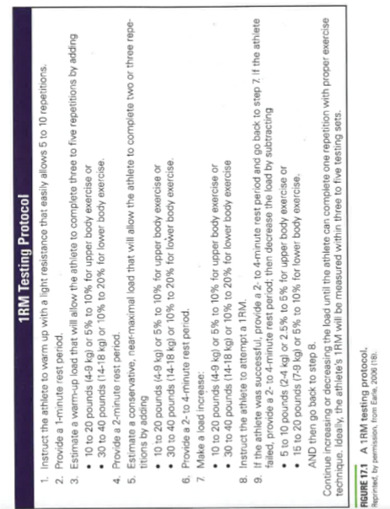
A coach (Glenn, 1996) should focus on a sprinter increasing the length of each stride or quicken the speed of each step as well as increasing the power of the athlete. A coach should always approach a workout with this in mind for each phase. Alcaraz et al (2008) said that “high-intensity strength training exercises with free weights and machines can improve the strength of the musculature of the hips, quadriceps, and hamstrings” which would therefore increase a sprinters acceleration and maximum velocity.
Figure 1- Table showing the 1 rep max testing protocol

Method
This research will comprise participants taking part in the required movements with the data being subsequently recorded. The study will use healthy males between the ages of 18-24 who partake in frequent physical activity to help maintain the reliability of the research
This study will mainly use primary data produced by the participants studied in this research. Each of the participants will have completed an informed consent form and a Par-Q form before taking part in any testing. The four movements being assessed will be;
- Keiser Air 400 – Leg press protocol
- Back squat – 1 rep max protocol as seen in Essentials of strength training and Conditioning (Haff, Triplett, pp. 266, 2016)
- Vertical Jump- Using the Vertical Jump Mat
- 30m Sprint

The sprint will be assessed over 30m and repeated three times to obtain the mean time of each participant. As sprinting is an anaerobic activity each participant will have a 1 minute 30 second rest between each 30 m sprint so that the participants have time to replenish their ATP stores ready for the next sprint. The sprint time will be recorded using light gaits to improve the accuracy of the study.
The leg press power will be analysed using the Keiser Air 400 and the protocol will follow the one specifically designed for the Keiser 400 where the force needed to apply will increase between each attempt until the participants power decreases on two successive occasions . The Back squat will follow the procedure stated in the Essentials of strength training and Conditioning (Haff, Triplett, pp. 266 pp.453-457, 2016) The participant will first be given a silent demonstration on how to perform a back squat and will be instructed on how to perform the proper technique. He will then perform a warm-up of 5-10 repetitions with a light to medium load. See figure 1 for the 1 rep max testing protocol. If a participant cannot complete the 1 rep max, then he will follow the predicted 1 rep max protocol.
For the vertical jump, the Vertical jump mat will be used, the participant will be required to wear a waist belt attached to a measuring tape that is itself attached to the mat. The measuring tape will be set to zero and the participant then be instructed to jump as high as possible; repeating the action 5 times with a 30s rest between each jump.
Results
All 12 participants for the testing were retained which gives a full table of results. Fortunately, all participants were able to take part in the 1 rep max protocol so the predicted 1RM protocol was not needed.
Vertical Jump (cm) | Kaiser Leg Press (w) | 1 RM Back Squat (KG) | Sprint time over 30m (s)
46.6 | 3658 | 230 | 5.97
58.3 | 2731 | 210 | 5.94
52 | 2343 | 190 | 5.2
44.5 | 2882 | 210 | 5.15
40.6 | 2285 | 158 | 4.5
55.3 | 3128 | 170 | 4.1
57 | 2476 | 140 | 4.3
52 | 2007 | 150 | 4.27
54 | 2511 | 140 | 4.56
44 | 2225 | 110 | 5.12
37 | 3185 | 190 | 6.3
59 | 2876.5 | 125 | 4.45
Table 1- results of all testing
By simply just looking at the results table it is clear to see that the higher the vertical jump achieved the quicker the sprint time is. Participants 6-9 jumped higher than 50cm and their sprint time was lower than 4.5 seconds with a mean time of 4.31 seconds which is .7s lower than the mean time of 4.99s of the whole group. However two anomalies appear in this data as two participants jumped higher than 50cm and had running a time of 5+s but the mean time of all participants who jumped higher than 50cm is still .3s (4.69s) lower than the whole group combined.
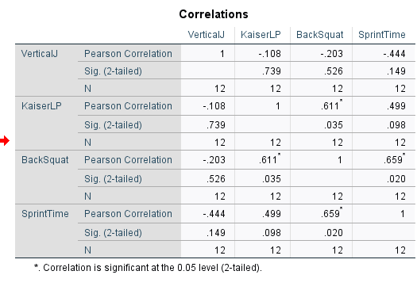
Figure 2 showing correlation between all power movements
After correlating the results on IBM SPSS, it shows that there is no direct relationship between sprint time and vertical jump with a significance of .149. However, there is a clear relationship between back squat and sprint time with a significance of lower than .05, (.020) This would suggest that the back squat would have the greatest effect on sprint time. This suggestion is further supported by the correlation also showing that there is a relationship between back squat and Kaiser leg press with a significance of .035.
As there appeared to be no relationship between vertical Jump and sprint time according to the correlation, vertical jump was changed to “relative” Vertical jump to see if weight would change the relationship.
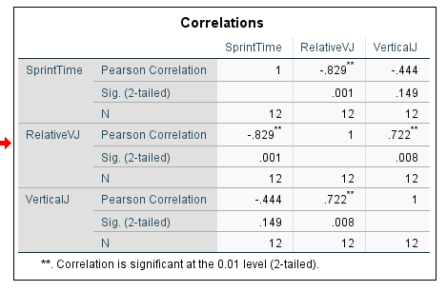
Figure 3 showing correlation of Relative Vertical Jump
This correlation however shows that when the vertical jump is relative to weight then there is a relationship between sprint time with a significance of .001.
Discussion
The aim of this study was to look at which power movements would benefit a sprinter more when training and what they should focus on.
The results attained help to reinforce the statement made by Myer et al (2015) that the back squat is one of the main fundamentals in improving sporting performance as the correlation shows that it has a significant relationship in a 30m sprint. This would mean that a sprinter would want to have a strong focus on squatting There was also a relationship between the Kaiser leg and the 1 rep max back squat, which would tend to indicate that to help to improve the back squat a sprinter would want to focus on the Kaiser leg press movement as well.
With there being a relationship between the Relative Vertical Jump and sprint in the correlation, and there clearly being a relationship before being correlated that the higher the Vertical jump the quicker the sprint time. This helps to endorse the statement by Maulder et al (2008) that “A successful sprint start requires the development of large horizontal forces at a high rate while in the blocks” which has a very similar movement pattern to the vertical jump and therefore focussing on this movement should be recommended so that the initial movement out of the blocks can be maximised.
What the results do not show is the body’s limitations and whether each participant was exerting his maximum effort for each movement. This lack of knowledge could affect the results. One method to improve the accuracy of the results would be to create a six week training programme with the participants focusing on these power movements to establish whether there is any change in sprint time between the start and the end of such programme This would assist in making the study more reliable as all the participants would have done the exact same training.
Conclusion
To conclude; a sprinter should be recommended to have a key focus on the back squat due its greater significance in improving the sprint time, This concentration would improve the power output of the sprinter at the acceleration phase of the race. When training using the back squat there should be a focus on the leg press as well due to the established relationship between the leg press and the back squat. At the very start of the race it should be recommended that the printer also train utilising the vertical jump to maximise the power that the athlete is able to transfer onto the blocks so that he can power off from the blocks effectively and efficiently.
Acknowledgements
There were no acknowledgements needed for this article
Conflicts of Interest
None of the authors has a financial or proprietary interest in the subject matter or materials discussed in the manuscript, including, but not limited to, employment, consultancies, stock ownership, honoraria, unpaid expert testimony.
Word Count - 2045
References
Alcaraz, P., Palao, J., Elvira, J. and Linthorne, N., 2008. Effects of Three Types of Resisted Sprint Training Devices on the Kinematics of Sprinting at Maximum Velocity. Journal of Strength and Conditioning Research, 22(3), pp.890-897.
Behrens, M. and Simonson, S., 2011. A Comparison of the Various Methods Used To Enhance Sprint Speed. Strength and Conditioning Journal, 33(2), pp.64-71.
Cross, M., Brughelli, M., Samozino, P. and Morin, J., 2016. Methods of Power-Force-Velocity Profiling During Sprint Running: A Narrative Review. Sports Medicine, 47(7), pp.1255-1269.
Delecluse, C., 1997. Influence of Strength Training on Sprint Running Performance. Sports Medicine, 24(3), pp.147-156.
Haff, G. and Triplett, N., 2016. Essentials Of Strength Training And Conditioning. Champaign, IL: Human Kinetics.
Hansen, K. and Cronin, J., 2006. Resisted Sprint Training for the Acceleration Phase of Sprinting. Strength and Conditioning Journal, 28(4), pp.38-39.
Kushner, A., Brent, J., Schoenfeld, B., Hugentobler, J., Lloyd, R., Vermeil, A., Chu, D., Harbin, J., McGill, S. and Myer, G., 2015. The Back Squat. Strength and Conditioning Journal, 37(2), pp.13-60.
Majumdar, A. and Robergs, R., 2011. The Science of Speed: Determinants of Performance in the 100 m Sprint. International Journal of Sports Science & Coaching, 6(3), pp.479-493.
Maulder, P., Bradshaw, E. and Keogh, J., 2008. Kinematic Alterations Due to Different Loading Schemes in Early Acceleration Sprint Performance From Starting Blocks. Journal of Strength and Conditioning Research, 22(6), pp.1992-2002.
Sargent, D., 1921. The Physical Test of a Man. American Physical Education Review, 26(4), pp.188-

