


An Experiment to Measure and Evaluate Performance Improvements on a Spring Boot API
Oliver Bird
Apprentice Software Engineer – BT, Data Services
Applicable word count - 14250
1910716@student.uwtsd.ac.uk

Lecturer: Michael Dacey
Lecturer: Dr Tim Bashford

Research submitted as part of the requirements for the award of B.Sc.(Hons) Computing
and is funded solely by BT, Digital – Data Services

July 2023
DECLARATION

I, Oliver Bird, declare that I am the sole author of this Project; that all references cited have been consulted; that I have conducted all work of which this is a record, and that the finished work lies within the prescribed word limits.

This work has not previously been accepted as part of any other degree submission.

Date : 21/07/2023

FORM OF CONSENT

I Oliver Bird, hereby consent that my Project, submitted in candidature for the B.Sc.(Hons) Computing (stream) degree, if successful, may be made available for inter-library loan or photocopying (subject to the law of copyright), and that the title and abstract may be made available to outside organisations.

Date : 21/07/2023
ABSTRACT – Application load time is a metric often taken for granted by the modern software user. This investigation details a wealth of literature on the subject of code and application optimizations, before experimentally determining a fitting software solution for a user reported loading time issue on a productionised Spring Boot API. It concisely evaluates a number of potential software improvements and provides advice to engineers about simple methods to improve performance.

Contents
1. Introduction
A. Identified Problems
2. Aims and Objectives
3. Literature Review
A. Code Optimization
B. Efficiency in object relational mapping
C. ORM Efficiency in JPA / Hibernate
D. Application Efficiency Testing
E. Conclusion
4. Research Methodology
A. Research Rationale:
1) Positivistic
2) Phenomenology
5. Experimental Methodology
A. Positivistic Investigation
B. Phenomenology
C. Validity
D. Reliability
E. Environmental Detail
6. Initial Findings
A. Review of general user feedback
B. Reviews from Key Stakeholders
C. NPS Survey
D. Dynatrace
E. Integration Test
F. Object Types
7. Design
A. Introduction
Lazy Loading Binding Between IAM Collection and Project - A
IAM Collection loading method refactor to Database source of truth– B
Modify IAM Collection Search Query to be more efficient – C
Modification of Admin Group Determination – D
My IAM Collections Data Transfer Object - E
8. Results
A. Positivistic
Lazy Loading – A
Database Driven Solution – B
Combined Database driven solution, Lazy Loading and Refined Admin Logic ABD
My IAM Collections DTO – E
Combining Lazy Loading with IAM Collection DTO – AE
More Efficient IAM Identification Query – C
Combined Lazy Loading with A More Efficient Query – AC
Modification To Admin Group Decision Logic – D
Combining Lazy Loading, More Efficient Selection Query and Improved Admin Logic – ACD
Unit Test Results Consolidation
Deployed NPS Survey Results
B. Phenomenology
Stakeholder Comments
9. Experimental Evaluation
10. Conclusion
11. Self-Reflection

1. Introduction
Code optimization is a concept as old as computing itself. As hardware becomes more powerful, environments become more scalable, languages refine over time, frameworks develop greater functionality, and internet speed improves it is easy to see how code optimization has been left by the wayside. With the onset of Cloud Computing and faster hardware, everyday users of technology are unaware that they are exposed to an extraordinary number of underlying systems, completely seamlessly (for example applications such as Google, Netflix and YouTube etc). The power of these systems has consequently instilled expectations from users and developers that their user experience should be fast, easy to use and self-documenting etc. It would not be acceptable for a consumer to access one of these on demand services and be forced to wait a long time for the content to initially load. In business applications, where it is company time (and therefore money) being wasted while content loads – for example data visualisations loading on demand, this is evidentially unacceptable.
The experimentation undertaken in this report is done with a view to optimizing an extensive system and data access application which is currently productionised for British Telecommunications PLC through their ‘Digital’ subunit. The team managing this application is Data Services (henceforth referred to as DS) and is maintained by a small number of full stack software engineers and a product owner. The application is designed to be a central tool for users to access other data related applications hosted within the business such as Google Cloud Projects, Identity Access Management (IAM) Collections, Data Visualisation Tools, and others. The site also allows administration for access to the above tools, through an approval automation pipeline allowing power users to approve or deny access. This makes the DS application a key tool to the productivity of many aspects of the business. Since inception it has handled over 150k access requests to various systems and groups, and is used by thousands of users daily.
The DS application comprises of an Angular powered front end – FE (using Typescript) and a Java Spring Boot backend – BE, which are containerised on a single server with a single Oracle database driving the data for the system. Both FE and BE have their respective baked in unit testing frameworks in Jasmine and JUnit however there is currently no implementation of automated integration testing such as Selenium [39]. The DS Tool (DST) in total comprises approximately 100,000 lines of code inclusive of testing, functionality, and infrastructure management.
This report details experimental techniques applied to attempt to remediate a particular issue noted by users when accessing the My IAM Collection user administration page (herby referred to as The My IAM Page). The My IAM Page is available to all users who have access to the Google Cloud Platform via DS and have joined or created an IAM Collection.
An IAM Collection is a collection of groups of permissions which a user can be associated with within the scope of the Google Cloud Platform. When creating this collection, the DST automatically creates a set of default groups, each of which have their default permissions attributed with them. A user can request access to the specific group containing the permission they need to undertake their current line of work. Custom groups (of permissions) can be created additionally by the Owner of a given IAM Collection. The content [A] of the My IAM page is a list of all IAM Collections the user is a part of, with all of the subgroups of each IAM and their respective members shown additionally.
Furthermore, this report details improvements to the existing code delivering this page, in addition to the issue currently highlighted by its users. The development team of DS have strict code standards which must be adhered to when deploying refactors or new code solutions. The refactors implemented in the experimental section of this report will attempt to remediate standard breaches within the current code producing the My IAM page.

A. Identified Problems
The following issues have been noted with the current implementation, along with the users affected by it. For a full description see [B]:
- Loading Time
- Financial Implications
- Code Standards
- Active Directory Driven Attribution Model
- Lack of Database Driven Solution
Remediating the above issues in the format which gains the most benefit in relation to all of them is the ultimate goal of this experiment. The importance of which is discussed throughout.
Project Scope
9 Solutions are presented in this report, the effectiveness of each is measured where applicable.
The current state of the page is rigorously tested and monitored to discern its effectiveness from a user and developer perspective using a number of tools, measurables and testing suits.
For the purposes of this experiment, a universal measurement system is proposed to evaluate each solution through a series of testing criteria. Merge request reviews and product owner opinions will be applied once and if a fitting solution is identified.
Some of the measurables are only applicable in a ‘before and after’ sense, as they cannot feasibly be measured for each solution, such as the use of surveys and stakeholder statements. As the most appropriate solution will be deployed, the user group to test the solutions will be the author.

2. Aims and Objectives
Aim
To demonstrate and evaluate the implementation of various code optimisations for the Data Services My IAM Collection administration page, with a single solution proposed to be deployed.
Objectives
To investigate the state of current and past literature to guide the development and testing process.
To design and implement an array of working solutions which completely or partially meet the requirements provided by Data Services.
To evaluate the effectiveness of each solution to determine the most fitting implementation for deployment.
3. Literature Review

A review of past and present research and documentation into a number of aspects regarding the testing, debugging, modification and design of a data model driven system has been undertaken. The goals of this investigation are described below. Each question has been denoted with a number for the ease of identification:
(1) To understand the most general principles of how and when to optimize a piece of logic or wider system.
(2) How are data models designed to promote efficiency within a system.
(3) How in the specific case of Spring Boot / JPA / Hibernate are data models capable of efficient loading.
(4) What testing methodologies and tools exist to measure and evaluate the speed of a system.
The review has been undertaken via an investigation of a collection of research articles which were found to be applicable to the above, grey studies from technical organisations, developers notes and applications which have been specifically designed for speed (or the measurement of efficiency), developer forums and finally technical speakers. Justification of each of these research questions are outlined prior to the description of findings for each.
The investigation follows the principles set out by [1], which describes a systematic appraisal of current research and its relevance against a set of specific questions (as outlined generally above). A combined manual and automated search for these have been undertaken using the tools and processes below:
- UWTSD Library
- IEE Xplore
- Springer Link
- Proquest
- Google
- Google Scholar
- Science Direct
- Paperdigest.org
The use of each of these engines and natural language processing tools has been used independently where required to investigate each question. Articles etc. have been selected according to [1] which were found to be the most relevant, or where the abstract indicated there may be some connection to the above questions. This was not always easy to find, certainly in the case of the most general question (1) as the scope of this permeates the entire world of software development. For developer notes and tools, similarly a very wide range of topics and applications were found to be available. This review covers a small selection of the most prominent cases, where applicability is maximised; For example, as this study relates to the optimization of source code covered as intellectual property of British Telecommunication PLC, no automated, cloud based, or financially restricted tools are included. In some cases, mainly in the case of grey studies and developer notes, suitability against the above questions was found by happenstance. A review of the accuracy and reliability is provided in [C].

For each of the above research questions, a set of key phrases was used to undertake the automated section of the search. More general phrasing was used to conduct a physical literary review. The used phrases are shown below:
Research Question | Phrase(s)
1 | Optimization, Code, Program, Automation, Java, Bentley, Premature
2 | Relational, Data Model, Data Structure, Optimization, Object, ORM
3 | Hibernate, JPA, Efficiency, Loading, Efficient, Lazy, Eager
4 | Testing, API, REST(ful), Scalability, automated, unit, integration, Spring Boot, free, open source

N.B. the phrases shown in the above table were added iteratively as the review was conducted, as more information became available and understanding gained.
A. Code Optimization
Code optimization is a topic fundamental to the evolution of software development. There is huge plethora of information, research, and tooling available in this field. This first section of the literature review will cover the optimization of code in general to provide a solid foundation for more niche cases within the review in later sections. It should be noted that a large number of guidelines found during this literature review were found to not be relevant in the case of DS, as these pre-date the language being used (Java) and hence do not have characteristics such as garbage collection and polymorphism. All information included within this review has been strictly filtered to be relevant only to the current application of DS.
a) Bentley’s laws – The work of J.L Bentley [2] in his book ‘Writing Efficient Code’ outlines in explicit detail considerations and rules to follow in the discipline of code optimization. His text has been reviewed in detail, and the appropriate and relevant information in regard to the DS problem extracted.
In the general sense, Bentley describes code optimization as requiring the following to be true:
- Application State must be preserved – Meaning that the ultimate goals and functionality of the application must remain the same as to prior the refactoring.
- The runtime of the application must be reduced.
- The application in general will increase in length.
- The readability of the code for a human is reduced.
[2] dictates the conditions to which code optimization becomes necessary. It describes that application functionality comes first, and once the functionality becomes impeded by its own performance, optimizations should take sole priority.
[2] consolidates the research of many prior engineers into a concise collection of rules to follow, named Bentley’s Laws, which are described (for the sake of space) briefly below.
Modification of data structures – More efficient data structures should be selected where they can be made easily applicable.
Space for time rules - A set of rules which guide the common / obvious reduction in time to complete an action. For example, the case of a single computation of a value, which is then stored as opposed to re-calculating it each time it is required (SFT Rule 2).
Loop Optimization Rules – In general, these loop rules pertain to the removal of expensive / unnecessary logic to the outside of the loops. They summarise that logic contained with loops should be as efficient as possible, with the minimization of frequent nested loops.
Simple logic optimizations – Some examples of considerations are included below:
- Replace complex computations with similar equivalents e.g., is sqrt(x) > 0 can be replaced with ? x>0 as both evaluate as positive.
- Break out of loops early if a required condition is found.
- Order test cases with the most common cases first, e.g., is a number divisible by another, checking if the number is divisible by 2 should come first.
- Boolean variables which are used a single time can be avoided by if-else.
Procedural rules pertain to wider sections of applications, such as function declaration and design:
- Code should be able to handle similar cases generically and efficiently (heavily implemented through inheritance in polymorphic languages).
- Multiple pass algorithms (functions which may use the same data in multiple stages) should be condensed into a single algorithm.
- Parallelism should be used as much as possible to ensure maximum efficiency where it is easy and necessary to do so.
Expression rules in most cases are logical restatements or specific case examples of the above rules and shall not be included here.
[2] concludes with a simple guideline to optimization. The worst sections of the code should be identified and optimized first, and the results measured. Optimizations can only go so far and may end in diminishing returns.
b) Further optimizations - A more general evaluation of code optimization is found in Amdahl’s Law, which can be used to approximate the potential gains made by improving a section of a system, given the amount of time out of the overall execution period that section of the system uses [3].
[4] is a particularly old publication with little direct relevance given modern compilers, however some useful general principles are detailed:
- Single use of variables as opposed to multiple instances of the same underlying computation across multiple variables.
- The use of DeMorgan’s Theorem to convert AND, OR, NAND and NOR cases to more computationally efficient evaluations.
- The use of the Huffman Code Principle (as is noted by [2] in logic optimizations) by ordering test cases with the most likely first.
c) Optimization Automation - A more modern case of pure code optimization is discussed and implemented by [5]. He poses that the task of code optimization at a low level should be done automatically, and that a set of inputs (or requirements) be given by a developer. The system can then produce a set of applications which will carry out the task in the most efficient ways, thereby removing the bias included if the developer themselves attempted to build a solution. Foundationally speaking, this has been accomplished by abstraction in some higher-level languages already, such as Python through its interpreter. Furthermore, it may be difficult to build such functionality on a small scale. Tools like Spring Boot (applicable to DS) provide similar abstraction through simplification of complex underlying methods (Object Relational Mapping / ORM, networking and autowired [6]).
d) Java Optimizations - Focusing on the area most relevant to DS would naturally be Java. The O’REILLY book, ‘Java Performance, The Definitive Guide’ [7] provides a huge amount of detail when discussing how to optimize Java applications. Some useful considerations are found, many of which are re-iterated across the software engineering space:
- Java is usually one section of a larger system. Do not assume that the Java specific part of an overall application is definitely the slowest. For database driven systems, there can be a whole host of other slowdowns which may manifest when the Java portion accesses it.
- ‘Less is more’, every attempt should be made to write less overall code. A short application will always be faster than a longer application, even if both are similarly well written.
- Be mindful of code additions, each addition to a system will make the code slower. This specific lesson is a primary reason behind the onset of cloud and distributed computing (such as microservices), as vertically scaling applications become more and more difficult and expensive to maintain and run [8].
- Always choose faster code if it is easy to implement (as was discussed in [2]).
- Identify the sections of a system which are definitively slow and optimize those only. Do not try to optimize around a problem by making already fast sections faster.
- Occam’s Razor is an excellent analogy to use when optimizing a piece of code. The simplest answer is likely to be a suitable one.
- Do not re-invent the wheel. Many libraries (such as Collections in Java) have been built to handle a large number of common activities required by software engineers. These should be used extensively when appropriate to save time in both development and testing. This theme is present in many languages, such as the use of the Python code standard (pep8) which suggests formatting and standard library inclusion. Furthermore, a similar book to [7] is C++ Coding Standards [9] which advises heavy usage of the Software Tool Library (STL) as opposed to many bespoke implementations which could be enacted.
e) Clean Code - [10], whilst not a peer reviewed or particularly academically recognized publication, provides some fascinating real-world experiences of a long-standing software engineer, C. Mayer. It details a number of interesting philosophies and techniques which may be implemented more generally when optimizing code.
Code should be investigated thoroughly prior to any attempt at optimisation. You can only make improvements to something that has been measured with a baseline. Doing so prematurely (as is discussed later) may provide little benefit and cost a significant amount of time.
The Pareto Principle [11] is stated to be applicable to many code problems, in that 80% of the issues can be associated with 20% of the code. Mayer discusses that all applications will have a bottleneck somewhere, which consumes the majority of the system resources when compared to other parts, and even once this bottleneck is optimized another will become present. He postulates that it is key to find a local minimum of optimization, where the developers and stakeholders are happy with the current speed of the program.
Interestingly, and highly coincidental to this review, Mayer notes that research into a topic, tool or algorithm is key to its optimization. It is useful to consider that an application in its current state, whilst is a specific implementation for a given purpose, may have been replicated tenfold across the globe with similar designs and functions. Therefore, research should be conducted into specific problems with a piece of code to understand better solutions.
[10] furthermore describes the simple process of abstraction (similarly to [2] in the replacement of sqrt(x)). A problem as it has been coded within an application may not be the simplest description of the problem. It may be beneficial to think of this when optimizing code, to consider whether the current problem being solved is the correct one, and more so the appropriate description of the problem. It is not always necessary to keep / dwell on the current implementation of a problem and can be made easier by a completely clean slate.
f) The Root of All Evil – When undertaking this review, a single phrase was found in 10’s of articles reviewed. They refer to a statement from a software engineering pioneer Sir Tony Hoare, ‘Premature Optimization is the Root of All Evil’. [10] was no exception. Mayer warns of a list of potential issues which arise if code optimizations are prioritized too heavily, early in the process. Included below are the relevant inclusions for DS:
- Optimizing logical aspects of the code, which ultimately are not used often and do not take up much execution time.
- Optimizing Scalability. Be mindful of the scale and use case for your application, and do not over engineer a solution for a non-feasible number of users.
- Optimizing testing design. Considering the testing process prior to any code implementation is nonsensical as by the nature of software engineering, when developing an application, you in turn are testing it with different solutions. Premature optimization purely for the sake of unit tests provides little benefit when compared to the integration testing performed by a human.
- Optimization of Object-Oriented Code. Do not over engineer polymorphic relationships too early if they are not required.
Contrary to the above (and the reasonably general consensus of many modern software engineering articles and standards), [12] argues that the statement from Hoare has been twisted and misconstrued by many. They argue that developers have become lazy when it comes to optimizations, when in many cases simple solutions could have been implemented which would provide meaningful results. They claim that through the investigation and testing of a multitude of complex solutions by a developer, that a developer improves their skills to be able to find the optimal solutions to problems before they ever require optimization, superseding all of the aforementioned techniques.

B. Efficiency in Object Relational Mapping (ORM)
Once the algorithms controlling a system have been optimized, the obvious next step is to optimize the relationships defined between classes, through polymorphism or through the relationships between objects. In many systems, ORM [13] can be applied to bridge the gap between database defined relationships and language objects.
A number of automatic optimization tools (such as HBSniff [14]) were found. Unfortunately, the use of tools like these are prohibited, however the optimizations and suggestions found when developing the software are useful markers relating to ORM.
[15] performs an experiment to compare the energy efficiency of various data model types on a SQL driven database. Additionally, the time efficiency of each ORM type is measured. Their findings indicate that for maximum performance, no ORM solution should be used, and pure SQL should be enacted. [14] details that there always will be some level of trade-off between readability and the performance of a system, furthering the previous suggestions of the same paradigm above.
[16] argues that there are few modern use cases for pure SQL in backend systems. The performance gains attained from using pure SQL over the overwhelming convenience, modifiability, and maintainability of ORMs are folly. The addition of lazy loading can sometimes bridge the overall performance gap if implemented well.
[17] compares 12 ORM APIs enabled on a Ruby on Rails framework application. Their result set shows a widespread range of performance issues present in all 12 APIs, with different levels of severity. They indicate that a large proportion of the performance issues are due to an underlying lack of understanding and thought into the ORM designs, the database design, and the front-end design. Over selection of data appears to be the primary cause of many of these issues when combined with an inefficient ORM design. [16] suggests that many of the performance issues can be remediated through the use of query limiting (e.g., lazy loading), pagination and a reduction in the data model sizes.
C. ORM Efficiency in JPA / Hibernate
As the DS application uses JPA and Hibernate as its ORM tool, a specific investigation into optimizations for these has been undertaken.
When using the above, a complete design of the underlying data structure between classes should be implemented. This means that the relationships should be defined as they are in reality (e.g., one to one) on an entity relationship diagram. When using the mapping annotations provided through hibernate, these include a default loading type of either lazy (data is fetched on demand) or eager (all associated data is fetched at once) [18]. [19] [20] [21] [22] follow a trail of key aspects of certain mapping types in Hibernate, indicating that some mapping types load eagerly, unless specified otherwise. This is may be key for the DS issue.
[23] similarly investigates performance issues specifically using Hibernate. Their findings are similar to the above listings, however detail specifically that the use of pre-computation and caching can alleviate a large number of loading issues.
[24] experiments with a number of popular JPA based ORM APIs to compare performance. They find that Hibernate is the most efficient of the selection tested and provide some recommendations to reduce execution time. Adding more threads and a reduction in the overall size of the data model was found to improve performance (as would be expected).
[25] provides an extensive set of optimizations, design choices and best practices to follow when designing a Spring Boot application. The specific details of these far extend what is practical for this report, but the author recommends this text be used as a reference for anyone wishing to understand the many complexities of Spring Boot, JPA and Hibernate backend driven systems!
A final optimization is found through Martin Fowler, a spokesman and lecturer on modern software engineering standards and practices. He details [26] the concept of the Data Transfer Object (DTO); an optimization of ORM models in the case of only specific fields being required from multiple tables. He describes the use of an assembly class to select only the required fields from the database and serve them through the application as a standalone class, hence reducing the slowness issues found in larger scale ORM models.
D. Application Efficiency Testing
A review of applicable tools for DS has been undertaken. Conditions for these tools were that they were open-source, free, well reviewed, offline capable and have been assessed as safe for internal enterprise use. There is a plethora of applications available for this, only some of which are included.
Gatling provides a manual and automation capable integration testing suite for APIs [27]. The tool would allow for pre-production testing of response times over a range of scenarios. A guide for this is found here using a Spring application [28].
Artillery [29] can be used in a similar fashion to Gatling, allowing for CI/CD integration and a manual GUI. Furthermore, it can be used as an end-to-end testing solution via a headless browser, meaning it can be run against web UIs (experimental).
Cypress [30] provides an extensive front end integration testing suite similar to a system like Selenium [39] which could be used to provide a set of automated integration tests during testing. It also provides optimization suggestions for the underlaying application and the testing suite itself.
Dynatrace [31] provides an extensive range of API monitoring, case management and auto remediation tools (more than can be described here). The application is already funded by BT and in use by DS, however its full potential could be expanded upon.
[32] provides a simple design for the modern unit testing suite provided as part of Spring Boot using Junit. Sample test cases are included for reference for a selection of database applications via a built Spring API. Contained in a number of the above articles are further examples of test cases, testing standards and other test related configurations. DS already uses Junit within its Spring application, meaning this tool will continue its use.
[33] is an open-source web performance and accessibility suite provided by Google. It is included here due to the nature of the DST interacting with a human centric front end. It provides insights into the average feelings of humans regarding page load times and is quantified into a large number of metrics. However, whilst it ultimately couldn’t be used internally, it provides useful considerations regarding human tolerance.
E. Conclusion
This review has been undertaken to understand how an application can be optimized and its performance measured generally and specific to Spring Boot. The results of this will be used in the design process in solving the DS issue.

4. Research Methodology
Research Rationale:
Prior to enacting any form of investigation, an evaluation as to the most suitable method of undertaking has been conducted, in which types of research are considered against the project in question. Given the project aims, possible research use cases are evaluated below:
- Positivistic
  - Surveys
    - Structured questionnaire
A structured questionnaire provided to main stakeholders of the DS platform, or key users is not felt to likely provide enough significant data given the nature of the project. There would be few possible question responses to select due to the low amounts of applicable and quantifiable subjective opinions. This ultimately would not provide a valuable or consistent set of data. A simpler form of analysis such as an NPS survey could be employed, which aims to concisely measure user opinions.

    - Structured interview
A structured interview could provide a useful set of measurables as provided answers are likely to be very specific. This could be enacted prior to and post deployment of any improved code. This type of survey may suffer in an enterprise environment, as receiving time from key stakeholders for meetings regarding a product they do no manage may not yield many interviews. Furthermore, the resulting answers suffer similarly to a questionnaire, in which few questions could be posed to users due to the lack of subjectivity in the user facing requirements.

  - Software Development
Given the project nature, it is evident that software development will be an included avenue of research. A single code improvement of the serving system will not be conclusive enough to determine if the solution is most optimal, and furthermore does not provide an evaluation into individual optimizations and their effects on a system similar to DS.

  - Experimentation
Experimentation provides a clear set of measurables applicable directly to the goals of this project. The effects of optimizations on the system are easily measured using a controlled, experimental environment. Furthermore, a number of different optimizations can be proposed to DS allowing the team to decide on the most appropriate solution using the experiment as a guideline.

- Phenomenology
  - Case study
A case study alone may not be suitable given the required outcomes for this project. Perhaps combined with a pure software development approach to provide a single solution, and to investigate its effectiveness from a purely user perspective, could be more effective.

  - Unstructured Interviews
Unstructured interviews or comments could provide a useful avenue for subjective opinions regarding the DS tool before and after a solution is found. Within an enterprise, these data points are easily available through passing statements, emails, instant messages, and comments from senior leaders.
Additionally, regarding the selection of a solution, this is at the discretion of the DS team. This will be based on the subjective and expert opinions of the senior developers within the team. This takes the form of an unstructured interview as the code and implementation will be analysed externally given the enterprise specific requirements.

5. Experimental Methodology
The very nature of the problem in question demands a complex experimental structure to evaluate the success of the experiment. A pure experiment into solutions to improve the loading time of a system is void if the final outcome is folly in the eyes of its users. For example, given an initial loading time of 150 seconds, a reduction in loading time of 80% would still be unacceptable to the majority of users. Thus, a combination of experimental positivism in the form of software development measurables, and a phenomenological approach in the opinions of the application user base are chosen as the most applicable type of research method.
A. Positivistic Investigation
In order to investigate the loading times of the Data Services API, a set of clear measurables and hypothesises are discussed.
An initial simple hypothesis is defined as:
$The loading time of the My IAM Page will decrease as the underlying code is optimized$
(1)
From the research provided in section 3. it is evident that (1) can be modified into the following complex hypothesis containing 3 discrete independent variables:
$$The loading time of the My IAM Page will decrease as the:$$
$$a) Serving Code, b) ORM Solution and c) Network are optimized \\ for a given set of applicable requests$$
(2)
The scope of this investigation will only allow variables a and b to be considered, as the network interconnectivity between the DS database and Spring boot container cannot be optimized or modified by the DS team. Furthermore, no frontend modifications are proposed due to limitations enforced by the DS Senior Management.
Procedure:
A number of potential software solutions are developed to change the above independent variables, with the resultant loading times measured. These loading times are measured both using automated API integration tests using the Spring Boot testing suite, along with further end to end integration tests from the user interface to the newly developed API. In the production environment however, the loading times are measured and evaluated precisely using the API monitoring software Dynatrace.
Furthermore, as each solution is tested, there are a number of standards enforced by the DS team which limit the value of each solution, meaning that just because a particular solution is found to be optimal in terms of loading time, the underlying code may not fit into the standards, technology stack or infrastructure available to DS.
Issues 1-5 highlighted previously in 1.A detail what the chosen solution must ultimately address, and hence guide the positivistic approach:
Issue 3 and 4 mean that the experimental solutions must ultimately exist within the current DS technical stack and cannot use software which would exist outside of this or require additional funding and modification at a later date. This rules out potential solutions highlighted as part of the literature review such as:
- Network optimization
- Cloud based high performance databases (such as Spanner).
- Cloud based implementations / pre-processing.
- Additional On-premises bulk computation processing
- Modifications to the Data Service front end
The final chosen solution therefore is chosen completely at the discretion of the DS team given the above conditions.
Positivistic Measurables:
To ultimately evaluate the loading time, the measurable is naturally the time taken for the page to load.
N.B it is imperative to note the degenerative nature of the DST in its current form. The application was performant on its initial deployment but over time has regressed in its performance.
To measure the loading times fairly across all measured solutions, an even baseline method is proposed:
- An integration test suite against the service method which finds the IAM collections a user is a part of and serves them. The test is written in such a way that the number of requests within the tables of the underlying IAM collection data model can be changed. This is imperative to understand not only the loading time when compared to a similar database as Production, but how it will evolve over time as the number of requests rises. The underlying data model shown in [D] needs to be populated correctly to reasonably match the nature of the Production data. This is shown in [E].
The above test is adaptable to be capable of measuring the loading time taken, using the system clock, of any potential system that serves IAM Collection objects defined by DS, meaning it can be used directly or slightly modified between solutions while keeping a similar base test.
In addition to the above, when deployed to Production, a BT standard API monitoring system known as Dynatrace is used to evaluate the response time on a deeper level. It is capable of identifying the dynamic queries generated by the Hibernate ORM layer and hence the object creation time. This will be the ultimate measure of loading time once a chosen solution is deployed.
The loading time is measured multiple times for each scenario as described in 1. A level of statistical analysis is undertaken to determine the average loading time per solution, its equivalence to the current implementation locally, its scaled loading time when compared to Production and the most suitable regression model to describe the scaling of the algorithm as the number of applicable requests changes.
N.B It is noted that the number of requests measured in each test will differ between each solution. In some cases, the proposed experiments are mutually exclusive when compared to the current implementation. To evaluate the loading time across a range of scenarios, in some cases the number of requests of different types will differ between each experiment. Whilst the numbers may not exactly match, they have been chosen to provide indications as to how the loading time will change. For example, a method which is not impacted by the number of total IAM collections, is not tested for this condition.

B. Phenomenology
Given that issue (1) is highlighted purely at a human level, it makes logical sense to measure the effectiveness of a loading speed improvement through that same medium, as well as purely experimentally.
Therefore, a simple hypothesis is given:
$$As loading time reduces, user opinion improves$$
(3)
(3) can be measured purely using the opinions of major stakeholders, developers, and most importantly, regular users of the page. These take the forms of:
- A collection of comments made directly to team members, managers, and in team contact systems.
- A collection of comments made by key stakeholders and users of the system.
- Responses to a Net Promoter Score survey (NPS) [33]. This is a standard business and market research metric to determine customer satisfaction.
C. Validity
Within the above positivistic approach there is clear deliberate strong internal validity. The measurables are clearly defined for a very specific purpose against the hypothesis (2) and is designed in such a way that results can be measured repeatedly in the same environment for each iteration. [34] outlines the cases for risk to experimental validity. There are no cases in which any of the measurement techniques or environment states are relevant to the aforementioned risks, due to the reproducible nature of the created software testing suite.
In contrast, this experiment suffers from threats to external validity. In general, as previously discussed certain modifications to ORM solutions (e.g., reduction in mapping size, pagination etc) can reduce the time to load complex objects from a database through an API. However, this is only a general rule, meaning that specific nuances of a given system may hinder these solutions working effectively. This means, the results found from this experiment may not be applicable to separate systems using the same basic operands, and only to near identical systems. However, it may further bolster the findings of Section 3 that ORM solutions, and the software delivering them can be optimized using the described methods in Section 3.
D. Reliability
A distinction is made between the experimental reliability and the reliability of the results. The experimental reliability is reasonable due to the testing environment design. The testing suite uses a configuration each time it is initialised, which is common between all experiments, that clears the environment of any manually added requests onto the database, meaning it is clean for each test case. This ensures the mutual exclusivity between individual test cases and furthermore different loading time solutions.
E. Environmental Detail
This is described in full in [F].

6. Initial Findings
Prior to a discussion of the experimentation undertaken into the page loading times, a benchmark of the state of the current implementation should be noted. This will include the following:
- Review of current state of user feedback for the My IAM Collection page – Emails + Comments
- NPS Survey score for the page from the most prevalent users
- Comments from key stakeholders
- Dynatrace endpoint load times – Production
- Unit Testing results
[G] shows the current loading algorithm.
A. Review of general user feedback
A collection of direct messages and complaints sent to the team mailbox have been collected in order to understand the business impact of the loading page issues. The collection highlights the issues of loading time, with key phrases such as ‘unusable’ and ‘serious business impacts’ being used. Furthermore, comments made from many sources have been condensed into feedback via the product owner of DS. The results of this were similar to the direct comments made, in that the current system is not really fit for purpose, cannot be used in demonstrations to new users and has a significant user impact.
B. Reviews from Key Stakeholders
A smaller review of comments made by the key stakeholders of the My IAM Collection page has been conducted. These comments are more applicable as feedback due to the importance and closeness of the commenters to the DS site and team.
[H] – comments from key stakeholders.
C. NPS Survey
An internal NPS survey has been conducted to quantitatively measure the opinion of the most affected users of the My IAM Page. Due to the scaling nature of the current algorithm, a logical inference was made that the most negatively affected users were those with the most IAM Collection attributions. The following simple SQL was used to identify the users with the most requests:
select email, count(1) numRows from DATA_SERVICES.gcp_iam_collections_join_request
where status = 'Complete' group by email order by count(1) desc;
The above SQL identified users with collection numbers across the entire database, where the top 15 users were chosen initially. This was expanded further at a later date.
A simple guide to NPS can be found here [37].
The current page was evaluated as -100, the worst possible score available through an NPS survey:

Fig. 6.1 Current Data Services IAM Page NPS

This means that of all of the users surveyed, nobody would recommend / say that the page was usable, giving an average score of 7/10 or lower.
D. Dynatrace
The infrastructure monitoring tool Dynatrace was used to evaluate the health and effectiveness of the current API endpoint serving IAM Collections. This has been done multiple times over the lifetime of the project to measure scalability.
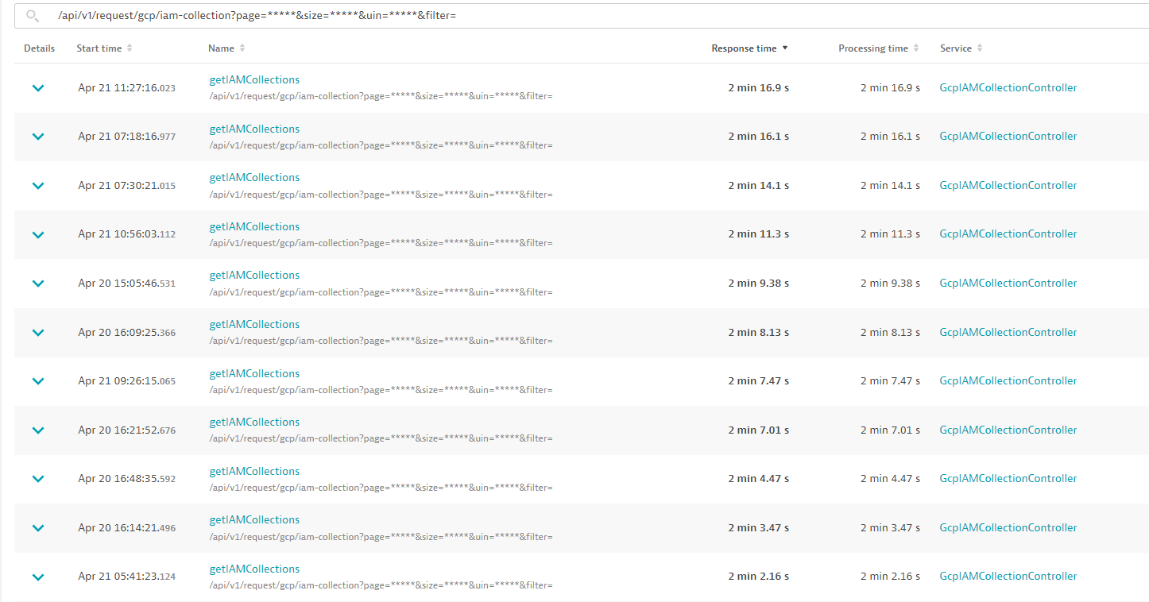
Fig. 6.2 Loading Times for the Serving Endpoint - April 20-21st.
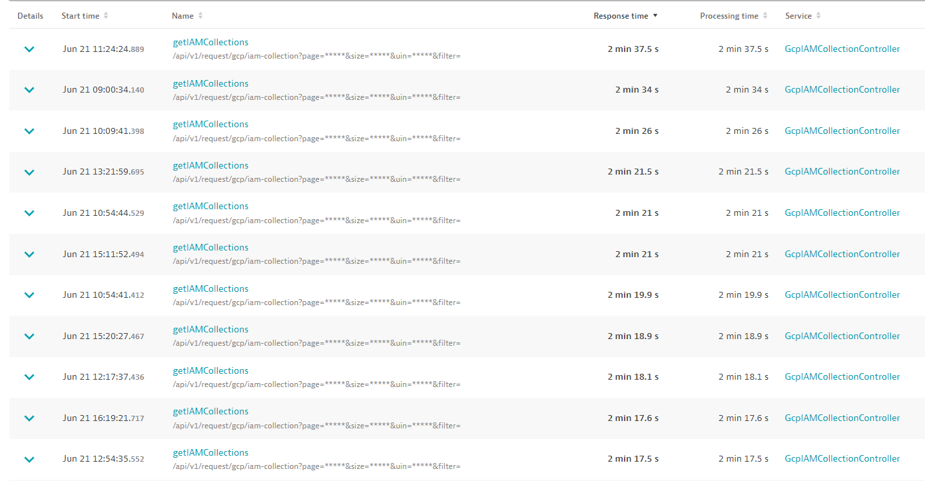
Fig. 6.3 Loading Times for the Serving Endpoint - Jun 21st.

From these results it is evident that the endpoints scaling is regressing over time.
E. Integration Test
[E] documents an integration testing suite written as a service test method in Spring Boot. This testing suite instantiates the real IAM Collection Service it is testing, with various testing type objects to its constructor. The test suite then interacts with the service object to enact the test criteria.
F. Object Types
Within the Spring Architecture, the service object must interact with other services and repositories to receive information and save information to the database. The types of these objects have been given Spring annotations [38] depending on their use cases for the given testing suite. Attributes marked as @Mock are not required for the testing but allow the service object to be constructed without its real dependencies. Those marked as @Autowired are real dependencies which Spring maps to real objects that the test methods need to interact with (and by extension real service methods also). This is required for the IAM get method to pull data from the required repositories, and the testing suite to save objects and their associated mappings defined as part of the ORM layer. This is why some annotation attributes are not inherently used in the service code but are required to be interacted with to fetch certain mapped objects (e.g., GcpGroupCategoryRepository).
The test suite has been condensed to two simple test cases which can be easily manipulated to change the scale of the test by increasing or decreasing the number of associated requests in the various tables.
The first test case allows the user to simply evaluate the construction and saving time for a set of objects to the database, which is useful when preparing for a large-scale test.
The second test case enacts a complete scale test on the method serving the IAM Collections which ultimately measures the loading time performance. Similarly to the first, the number of requests related to a user, and requests also not relevant to them can be modified using the plethora of helper methods written as part of the test suite. For consistency, the test suite has combined use cases for all measured solutions, as the underlying methods and request structure for each experiment is different. For example, a method is created to mock an API response from BT’s internal AD service – generateGroupAttributations().
A measure of the current IAM loading performance is detailed in the below table:
Solution | number of Projects | Number of IAMs | Number Of Join Requests | Number of Iams User is a part of | time to load(s) | time to load(s) | time to load(s) | Average | Scaling Coefficient
Current | 10000 | 10000 | 0 | 0 | 243 | 275 | 254 | 257.3333 | 38.86010363
Current | 10000 | 10000 | 10000 | 1000 | 260 | 272 | 271 | 267.6667 | 37.35990037
Current | 1000 | 1000 | 0 | 0 | 14 | 15 | 15 | 14.66667 | 68.18181818
Current | 1000 | 1000 | 1000 | 0 | 16 | 15 | 15 | 15.33333 | 65.2173913
Current | 1000 | 1000 | 1000 | 1000 | 14 | 15 | 15 | 14.66667 | 68.18181818
Current | 1000 | 1000 | 1000 | 100 | 17 | 17 | 16 | 16.66667 | 60
Current | 500 | 500 | 500 | 100 | 5 | 6 | 5 | 5.333333 | 93.75
Current | 500 | 500 | 500 | 500 | 5 | 5 | 5 | 5 | 100
Current | 5000 | 5000 | 1000 | 1000 | 95 | 100 | 106 | 100.3333 | 49.83388704
Fig. 6.4 Current IAM Loading Performance
Correlations of the most meaningful results are given below:

Fig. 6.5 – Current Solution scaling coefficent relative to total number of IAMs

Fig. 6.6 – Current Solution Loading Time for Attributed IAM collections

Fig. 6.7 – Current Solution Loading Time Against Total Number Of IAM Collections

Figs.5&7 both indicate that the current loading system operates with a nonlinear scaling pattern.
$$Correlation Coefficient C= \frac{Total Number Of Request n}{\frac{Loading time T}{Total Number Of Request n}}$$
The correlation coefficient aims to indicate how the loading time is affected by the total number of IAM Collections / Projects, in which a higher value of C indicates a large number of requests served per increment T.
Furthermore, Fig.6 shows that the number of IAM collections a user is part of, is mutually exclusive to the loading time for the method, meaning that for a user with no IAM collections, the loading time can still be long. This is corroborated in the raw data when observing loading times of equal numbers of total requests and dissimilar numbers of IAM memberships. The number of IAMs a user is part of does not affect the loading time.
Comparing rows 1 & 2 show that given 10000 total IAMs, for 1000 memberships and 0 memberships, results in a 4% increase in loading time for the higher number of joined IAMs.
The significant financial implications of this loading time should be noted. Given a 37.5-hour week of 7.5 hours per day with an average cloud engineer cost of £400 per day, a 120 second loading time with an average of 50 queries per day, it is estimated that it would cost £32500 a year to load the page, ignoring any variance in these values.

7. Design
A. Introduction:
All of the described experimental solutions have been decided upon based on a set of requirements provided by DS. These requirements are directly correlated against the issues highlighted previously. The requirements are detailed below:
Requirement 1 – Issues 1 & 2 describe the loading time problem. Therefore, the resulting experiments and chosen solution should attempt to reduce the loading time. Furthermore, users with no requests should experience significantly faster loading times.
Requirement 2 – Issue 3 highlights the problem of the current code standards within DS. The experiments and chosen solution must adhere to the DS coding standards and ultimately maintenance standards. Furthermore, no modifications made should disable previous code from functioning.
Requirement 3 – Issues 4 & 5 describe and end of life software application being the driving component to determine IAM collection attribution. The ambiguity provided by this system needs to be removed or minimised. Thus, the experiment must aim to reduce or remove the effects of this aged system.
The design section of this document will describe the implementation and rationale of each experimental optimization through diagrams, code examples and their explanation, and their associated benefits and drawbacks against the above requirements. Risks are outlined for each proposed solution in the cases where they are present. These are provided as an additional requirement consideration which is superseded by the suitability Requirement 2.
Solutions are denoted with an alphabetical key, combinations of solutions are described cumulatively, e.g., AB would indicate a combination of solution A and B.
Lazy Loading Binding Between IAM Collection and Project – A
During the evaluation process of the current system, a read out of everything being returned from the API was collected. It was evident that a large proportion of the data being sent back was not applicable or useful to the receiving page. As per the suggestion of the plethora of research undertaken in optimization of ORM models, an obvious solution was to lazily load any data bindings which were non-essential in every case. [I] shows an anonymous example of the data returned for one IAM collection. It is notable that information from lines 124-321 are not required, approximately 55% of the overall object.
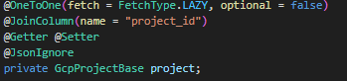
Fig. 7.1 Lazy Loading Implementation
Fig.1 shows the lazy loading binding applied between the IAM Collection entity and the project entity in the relationship mapping field (i.e., OneToOne). Overall, the data model now operates as is described in [J].
Requirements:
Requirement 1 is partially satisfied with this implementation as it is an attempt to reduce loading time. Users with 0 IAM Collections will still suffer a long loading time.
Requirement 2 is satisfied with this implementation, with the caveat that the data model is understood by the development team.
Requirement 3 Is not satisfied as the solution still relies upon AD.
Implementation:
Changing the data bindings caused errors in the logic used previously which exploited the eager loading nature of the previous model. Upon instantiation of an IAM collection object, previously Hibernate would also load the associated project automatically. This is no longer the case, and hence requires the creating query to be instructed to fetch any associated project for an IAM collection, in the case where the business logic dictates that the project is required.
Fig. 7.2 Previous Query Example
Fig. 7.3 Updated Query to Fetch Project with IAM Collection
Fig.3 shows the updated query which fetches the project when constructing the IAM Collection object. There were a number of these modifications made across the codebase to account for the new lazy loading.
Furthermore, the optional flag included as part of the binding definition is an important consideration for the team’s developers. In short it indicates that the ORM solution (Hibernate) will assume there is no associated project unless the defining query / constructor defines one (through JOIN FETCH etc). A descriptive comment is included in the final code inclusion.
Testing Strategy:
A large number of complimentary tests to ensure the business logic still ensured that the project was returned were written, alongside query tests. To ensure that requirement 2 was still met, all previous logic utilizing the eager loading was given appropriate modifications and unit tests.
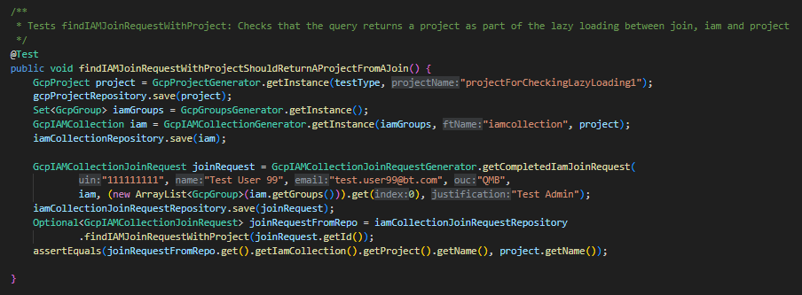
Fig. 7.4 Repository Unit Test to Ensure Projects are Returned When Required
Fig.4 shows an example test written in the case of a query which should return a project when the IAM collection is loaded.
Risk:
Little risk is associated with this change, as all current usages of the eager loading have been converted to use the lazy implementation. Any risk present matches the current implementation levels.
IAM Collection loading method refactor to Database source of truth– B
The current implementation of the IAM loading method uses as AD as a source of group data for a given user. Issues 4 & 5 describe the problems posed, with requirement 3 driving the solution. Ultimately the loading method should be as decoupled as much as possible from AD and instead source the group data from the DS database. This is possible to attain due to users joining IAM collections through the DST, and those requests being stored as a an GcpIAMCollectionJoinRequest in the database.
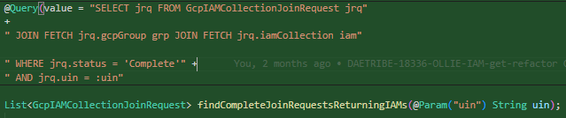
Fig. 7.5 New IAM Join Request Query to return IAM Collections from IAM Join Requests
Fig.5 shows a new query to specifically return IAM collections from join requests associated with them, as the IAM join request object contains a field: GcpIAMCollection, which allows this to be returned through the ORM solution.
Generally speaking, the refactor replaces the AD dependency with a system driven by join requests for a given user. The rest of the method is unchanged.
Requirements:
Requirement 1 is satisfied as the new method executes far less computation that the original which should reduce loading times. Furthermore, users with 0 IAM collections will experience a rapid loading time.
Requirement 2 is satisfied as the new function is a hot swap of the previous method, but now abiding by the DS coding standards. Furthermore, general readability is improved. Previous tests are still usable in many cases with only minor additions being added to check functionality.
Requirement 3 is completely satisfied as the reliance on AD is removed.
Drawbacks:
A notable drawback to a join request driven method is that there are significantly more join requests than pure IAM Collection requests. This means that there is a loading component when the ORM system interacts with the database to load the correct join requests and hence IAM Collections. It was noted during the development that the database responds quickly, and hence the solution was included.
Testing Strategy:
The new method is tested in line with DS standards of unit and integration testing.

Risks:
A significant flaw is identified using this method, as it heavily relies on the status of requests within the DS database to be accurate. Status is the delimiting factor on request selection, meaning if this field is not correct, IAM Collections are not shown. Furthermore, the Join Request table is heavily coupled with many other systems of the site which interact with these requests. There is scope for inaccuracies in the displayed IAM Collections due to this.
Modify IAM Collection Search Query to be more efficient – C
The current IAM collection selection query and design are not suited for scaling, eager loading ORMs.
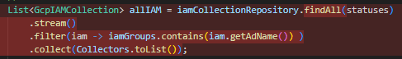
Fig. 7.6 – Current IAM Search Implementation – Java
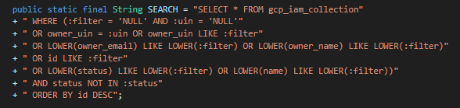
Fig.7.7 – Current IAM Search Query
The current query is genericized for use in multiple places with multiple search conditions. This is nonsensical given the driving business logic has two completely separate use cases for this query, one with a filter and one without. This genericism results in a slower query with far greater conditional checks, which compound into the ORM layer.
Furthermore, the business logic driving this is ignorant to an implementation at scale. All current IAM collections in the database are constructed, along with all of their associated groups and project. This list is then filtered against the returned list of IAM collection groups from AD to filter them for matching names. This ultimately means, for every single page load all of these objects are constructed and filtered each time, then destroyed once the method has completed.
It is then an obvious potential solution, to optimize the query in such a fashion as it can return only the IAM Collections a user is part of, thus reducing the overall number of objects to construct in the Java layer.
Fig. 7.8 – Modified Query
Fig.8 shows a modification to the search query which matches the IAM Collection names returned from active directory using a string matcher.
Codebase impacts are minimal with this solution, as this query is easily swapped with the original.

Testing Strategy:
The new query theoretically will pass all of the current service level tests which are not enacting the generic nature of the previous query. Also the query is tested following DS unit testing standards, along with the calling method.
Requirements:
Requirement 1 is fulfilled due to the estimated reduction in loading time, specifically regarding users with 0 or few IAM collections.
Requirement 2 is not fulfilled as the majority of the service method still does not conform to the DS code standards. Furthermore, the service layer method is also not tested in line with the DS standards.
Requirement 3 is also not satisfied as there is still reliance on the End-of-Life AD group delivery system.
Risks:
All of the same risks as the current implementation are present within this experimental solution.
Modification of Admin Group Determination – D:
The current service layer loading method contains logic to determine whether a user is an administrator of an IAM Collection or not. How this logic is currently written follows O( $N^{2})$ as the overall list of IAM collections is iterated over two times.
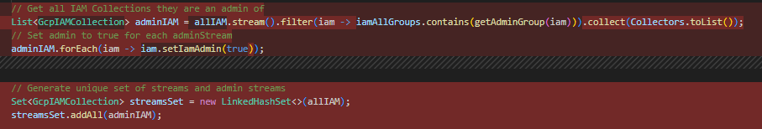
Fig. 7.9 Current IAM Group Administrator Logic
The current method checks all IAM collections a user is a part of to see if they are an administrator. The filtered list is then iterated over to mark a Boolean on each value as true. A set of all possible IAM collections is then created with the administered IAMs inserted into it.
This four-step process is too verbose and can easily be reduced.
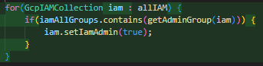
Fig. 7.10 – Admin Group Iterator
Fig.10 shows a simple O(N) Loop of the original list of IAM Collections in which the state of each IAM Collection Group is checked based on the user’s existence in them. If they exist in the group that is an admin group, set the flag to true.
Testing Strategy:
All existing tests should still function correctly given this change. Specific tests are written to ensure that the administrator flag is correctly set for groups in which a user is an admin.

Requirements:
Requirement 1 is minimally satisfied due to a very small, estimated improvement in loading time. No improvement is predicted for users with 0 IAM collections.
Requirement 2 is partially satisfied with the inclusion of additional tests. Furthermore, the method still suffers with not abiding by DS code standards.
Requirement 3 is also not satisfied as there is still reliance on the End-of-Life AD group delivery system.
Risks:
All of the same risks as the current implementation are present within this experimental solution.
My IAM Collections Data Transfer Object – E
Data transfer objects can be used to improve the readability and efficiency of the network performance of a Spring boot API by reducing the overall object size to only send the fields specifically required by a different system. In the case of the My IAM Collection page, only very specific fields are required.
These objects are more readable as they are specific to a use case of the application, by extracting fields from a parent object and constructing a new, smaller object. Evidently, this will not improve the time taken to construct objects from the result of a database query, as the full object is constructed initially using the ORM solution, and then the required values extracted out.

8. Results
Below is described the results of the positivistic and phenomenological experimentations which are detailed in the design section, along with combinatorial cases.
A. Positivistic
The complete results of all the experiments are shown in [K]
Each experiment has had the raw data condensed visually into 4 separate graphs to demonstrate the loading and scale coefficients.
A graph of the scaling coefficients C against number of affected scalable entities is created to visually determine how the solution compares against the current, over the varying number of requests. Given that C represents the number of requests which cause the solution to scale per second, scaled again against the number of applicable requests, it is evident that the relationship between the loading time and the number of requests and the scaling coefficient be modelled by a reciprocal in $C=\frac{1}{T}$ . An elevated scaling coefficient indicates that the solution acts more efficiently over the given number of scaling requests, i.e., the solution takes less time to complete. This graph attempts to provide a non-trivial link between how loading time for the wanted IAMs is affected by the algorithms scaling.
A graph of how many IAM collections a user is part of, compared to loading time is also plotted. This graph visually represents the effectiveness of a given solution at serving IAM Collections for a given user. Furthermore, it provides a clear visualisation to determine if a given solutions loading time is correlated with the number of IAM Collections a user is part of. These results are plotted alongside the current implementations’ loading time for comparison.
A graph is plotted of the total number of scalable entities against loading time. This plot aims to show any relationships between loading time and requests which affect the algorithms loading time. This graph is also plotted against the current, to visually demonstrate the effectiveness of a given solution.
Finally, a graph is plotted of the scaling coefficient against loading time. This graph may seem trivial or irrelevant as it plots a calculated field against one of its factors, however the graph does depict whether a solution fits the predicate that the loading time and hence scaling factor are exclusively affected by the scaling predicate, i.e., the number of a specific type of request being believed to affect how efficient the algorithm is. If the data is found to have perfect regression, then it is found that the predicate was correct.

Initially, average scaling and loading times are detailed for ease of viewing, prior to an individual breakdown of each solution:

 | Average Scaling Coefficient | Avg load time (S) | Scaling Compared to Current | Load Compared to Current | Scaling Compared to Current % | Load Compared to Current %
Current | 0.07 | 77.44 | 100 | 100 | 100% | 100%
A | 0.11 | 19.47 | 146.73 | 397.83 | 146.73% | 397.83%
B | 0.04 | 29.38 | 59.45 | 263.59 | 59.45% | 263.59%
ABD | 0.17 | 11.33 | 227.48 | 683.33 | 227.48% | 683.33%
E | 0.04 | 97.67 | 51.75 | 79.29 | 51.75% | 79.29%
AE | 0.10 | 19.33 | 132.34 | 400.57 | 132.34% | 400.57%
C | 0.07 | 21.17 | 92.37 | 365.88 | 92.37% | 365.88%
AC | 0.09 | 10.29 | 127.42 | 752.93 | 127.42% | 752.93%
D | 0.06 | 74.58 | 84.45 | 103.84 | 84.45% | 103.84%
ACD | 0.26 | 9.14 | 346.66 | 847.05 | 346.66% | 847.05%
Fig.8.1– Average Performance Metrics
The table shows the percentage differences between the current solution and each experiment. The value is displayed with reference to the current solution, meaning that 100% matches the performance of the original solution.
The tables clearly show that the combinatorial solutions ABD, AC and ACD all provide exceptional average gains in comparison to the currently deployed code. This view however does not definitively show how each solution fits the requirements, and how each perform under specifically designed test cases.

Lazy Loading – A
It was hypothesized that the loading time would be affected by the total number of IAM Collections present in the database. Furthermore, it was predicted that only Requirement 2 would be fulfilled with a sole lazy loading approach. The results are visualised below:

Fig. 8.2 – A C vs n
Fig. 2 shows that A is able to iterate over more applicable records than the current implementation, whilst following a similar, fixed power relationship.

Fig. 8.3 – A # IAMs a user is part of against T.
Fig. 3 shows that A has the same relationship as the current implementation, but at a reduced cost of loading time. It is evident that for users with 0 IAM collections that there is still a loading time, which fluctuates independently of how many they are a part of.

Fig. 8.4 – A total number of projects against loading time
Fig.4 shows that there is a definite linear relationship between the total number of projects and the loading time but served the same information 5x faster than the current method.

Fig. 8.5 A evaluation of C model
Fig.5 shows the perfect regression of A against the current model. This corroborates what is found in Fig.4 that the algorithm scales with the total number of IAM collections / projects.
Solution A provides gains in loading times as was predicted in the research and design stages but suffers all of the same drawbacks as the current implementation, hence failing requirements 1 and 3.

Database Driven Solution – B
B provided a complete refactor of the serving method. It was predicted that this method would not be affected by the total number of IAM collection join requests, with some minor adages from the eager loading component of the data model. The results are visualised below:
This experiment was predicted to provide solutions to all 3 requirements.

Fig. 8.6 – B C vs # of IAM Collections / Projects
Fig.6 shows clearly that the newly implemented method of serving IAM collections provides a near constant value for C, regardless of the number of requests contributing to the loading time. This means that as the number of scaling requests rises, the change in loading time should be proportional to the amount the requests have risen.

Fig. 8.7 – B user joined IAMs vs loading time.
Fig.7 shows a linear relationship between the number of IAMs a user is part of and the loading time. A simple relationship was expected in this regard, as the method should have only been dependant on this variable. This is a clear improvement over the current, with significantly shorter loading times.

Fig. 8.8 – B Number of Applicable Requests against Loading Time
Fig.8 shows that the loading time is no longer affected by the total number of contributing scaling requests. This is evident through the large loading time difference between the [20,80000] and [100, 80000] points, as for the same total number of requests, there was a >1 minute loading time difference.

Fig. 8.9 B – C against Loading Time
Fig.9 shows a more clustered relationship of scaling coefficients to loading time, with a minimal regression coefficient. This corelates to Fig.7 in that B is unlikely to be affected by the total number of join requests as a scaling factor and is much more affected by the number of joined IAMs.
Solution B provides a clear benefit to loading time in all cases, as well as meeting requirements 2 and 3. The raw data in the worst cases indicates an improvement of 80%, with an average of 50% for lower numbers of requests. It will likely be the basis of a chosen solution due to this.

Combined Database driven solution, Lazy Loading and Refined Admin Logic ABD
A final solution of ABD was hypothesized to provide the best loading times across all request ranges, as well as meeting requirements 2 and 3. It was predicted that the algorithm would scale with the number of join requests. The results are visualised below:

Fig. 8.10 – ADB Scaling Coefficient Vs Join Request
Fig.10 shows that ABD follows a similar, but not equal model as the current, however at much more preferable rates, with an average scale factor increase of 2.1 times. There is some evidence of an additional variable affecting loading time, beyond what was hypothesized.

Fig. 8.11 - ABD Loading Time for Required Requests
Fig.11 shows a well-defined linear relationship between IAM Collections a user is part of and their loading time. A large number of IAM joins were created as a scale test for DS to test IAMs in the most extreme case. Almost all reasonable numbers of IAMs loaded well within an acceptable time window of <10 seconds, with the most exaggerated case being an improvement of 39 times faster than the current and a minimum of twice as fast. Furthermore, for users with no IAM collections, no loading time is observed.

Fig. 8.12 ABD Total Number of IAM Joins vs Loading Time
Fig.12 details a very limited relationship between the total number of IAM join requests and the loading time. No reasonable correlation was found.

Fig. 8.13 – ABD Correlation with C Model
Fig.13 shows the lack of conformity to the scaling coefficient model. This conforms to Fig.10 which further indicates an additional relationship between loading time and scaling coefficient which was not apparent from the hypothesis.
ABD shows a potentially ‘productionisable’ solution, in which all requirements are met. Based on the benefits provided by A, B and D it was expected that this solution would provide fast loading times for users with many requests, in addition to those with few.

My IAM Collections DTO – E
E was proposed as an additional investigation by DS to evaluate the additional loading time through the use of a DTO. Minor additional loading time was expected when implementing the DTO but should ultimately follow the same model as the current solution. Requirement 2 would be exceeded when using the DTO, but its effectiveness when applied to the loading time problem should be measured. The results are shown briefly below.

Fig. 8.14 – E Scaling Coefficient against number of IAM Collections

Fig. 8.15 – E for User Attributed Requests against Load Time

Fig. 8.16 – E Compared to Number of Effected Requests

Fig. 8.17 – E Scaling Coefficient Against Loading Time
The results from E do not require individual evaluation, as overall the results are extremely similar to the current solution. Figs 14,15 and 16 all corroborate the expected result that the application of a DTO will slow down loading time by a small amount. Taking an average of loading times and comparing them provide a ~20% increase in loading time when using a DTO in this configuration. This is likely skewed due to the large number of IAM Collections constructed on scale testing and would not be realistic to most users.

Combining Lazy Loading with IAM Collection DTO – AE
The experimentation with using a DTO when combined with a solution found to improve loading time was measured. It was estimated that it was exceedingly likely that the results found would closely match those obtained when measuring lazy loading. Requirements 1 and 2 are predicted to be met at least in some capacity.

Fig. 8.18 – AE Scaling Coefficient against Applicable Requests

Fig. 8.19 – AE #IAMs a User is Part of Vs Loading Time

Fig. 8.20 AE – Total Number of Requests against Loading Time

Fig. 8.21 AE C vs Loading Time

Comparing the graphs of A and AE yield very few differences in the visualised data. As expected, the results are now extremely similar as the overall size of the objects to which the DTO is applied are much smaller (up to 70% as is discussed in the initial findings). Fig.21 shows that AE follows the exact same model as the current implementation, meaning there has been no change in the scaling factor, much the same as A. As predicted, AE suffers the exact same drawbacks as A and hence the current solution, with an additional 10% increase in loading time to provide the DTO. This increase in loading time removes the case for which a DTO can be used.

More Efficient IAM Identification Query – C
It was hypothesized that C would provide a much more efficient identification of IAM Collection attribution, which would be impacted less by an increasing number of records in the database. It was predicted that a reduction in loading time would be observed across all possible scenarios, therefore completely fulfilling Requirement 1.

Fig. 8.22 C – C Compared Against Number of Applicable Requests
Fig.22 shows a clear, linear, essentially constant value for C. This was to be expected as the new query identifies IAM Collections solely from the list provided from AD, meaning the loading time would be affected purely by how fast AD responds, and how fast the SQL can match records on the database.

Fig. 8.23 C – Number of Attributed IAMs vs Loading Time
Fig.23 shows a linear relationship between the number of IAMs a user is a part of and the loading time. For users with 0 IAM Collections, an instant loading time is observed. Outside of this, the overall loading time is an improvement over the original implementation.

Fig. 8.24 – C Total Scaling Requests vs Loading Time
Fig.24 shows a significantly faster average loading time than the current implementation with minimal linear scaling. This shows that the loading time is loosely coupled to the overall number of records in the database.

Fig. 8.25 – C Model showing Loading Scaling Conformity

Fig.25 shows that the algorithm does conform to the loading time scaling with the identified request type. Noticeably and in contrast to the current implementation, C is limited strongly within the lower section of the graph 0.05<C<0.15, which is further corroborated by Fig.22.
C provides a significant improvement to loading time and average scaling coefficient across the range of possible request numbers. Requirement 1 is fulfilled but further improvement regarding Requirements 2 and 3 will need to be identified. The solution matched expectations in all regards.

Combined Lazy Loading with A More Efficient Query – AC
AC is hypothesized to provide further and consistent loading time improvements across the range of requests by combing the stability benefits of lazy loading with a more effective loading query. It is predicted that AC will meet requirements 1 and 2 but certainly will not accomplish 3. Furthermore, it is estimated that this method will scale with total number of IAM collections.

Fig. 8.26 AC – C vs # of Applicable Scaling Values – IAM Collections
Fig.26 shows the additional improvement that lazy loading provides when compared to with C alone. The relationship found provides an almost constant value for C compared to an ever negatively scaling C for the non-combined solution, thus a more efficient implementation.

Fig. 8.27 – AC # IAMs attributable VS Loading Time
Fig.27 shows a clear correlation between IAM attribution and loading time across all request ranges, contrasted heavily against the current which does not. It further indicates that loading time is instantaneous for users with no IAM collections. In extreme cases, an improvement of ~80% is noted in loading time.

Fig. 8.28 – AC Total # IAM Collections VS Loading Time
Fig.28 shows some level of correlation between the total number of IAMs and the loading time, however, is not definitive enough to indicate a direct causal link, notably due to the inconsistency between loading times for the same total number of requests.

Fig. 8.29 AC – C scaling with Loading Time
Fig.29 corroborates the hypothesis that the method scales with the total number of IAM collections due to the exact match of the C model. It also corelates with the data shown in Fig.26 which identifies C as near constant.
AC provides the most consistent set of results thus far and fits well as the best current solution for the loading time issue. Requirements 1 and 2 are completely met with the loading time improvements and the increase in code quality.

Modification To Admin Group Decision Logic – D
It is estimated that this solution will have a small overall reduction in loading time when compared to the current implementation, which will be most prevalent for large numbers of requests. Alone, this solution will only partially meet Requirement 1. It is presumed that it will still suffer the same drawbacks as the current implementation.

Fig. 8.30 D – Scaling Coefficient for Associated Requests

Fig. 8.31 D – Number of Attributed IAMs vs Loading Time
Fig.31 clearly demonstrates the above hypothesis, in that the loading time would be very close to the original for a small number of IAM collections but would improve this as the total number of joined IAMs rose, as is seen near [250,1000].

Fig. 8.32 D – Total IAM Collections VS Loading Time

Fig. 8.33 D – Scaling Coefficient VS Loading Time
Fig.30,32 and 33 all correlate closely to what currently exists, with 32 showing again the improved load time for a large number of IAM Collections.
Minimal testing of loading time performance was executed for this solution as the changes made to the overall method were not going to impact users with none to a few IAMs. The proposed solution aimed to improve requirements 1 and 2 mildly to use more efficient code. This has clearly been accomplished as the code quality has been improved with minor gains to loading time, however, does not affect users with few IAMs. This solution can obviously then be included in any further proposed experiments.

Combining Lazy Loading, More Efficient Selection Query and Improved Admin Logic – ACD
The final experiment was hypothesized to be the best fit of all solutions due to the benefits provided by each of the respective constituents with regards to Requirement 1. It was predicted that the solution would scale with the total number of IAM Collections but would likely be minimal.

Fig. 8.34 ACD – Scaling Coefficient against Attributed Requests
Fig.34 shows the extreme improvements available in some cases in which there are many related requests. All recorded values show an increase in scaling factor for equal numbers of records. C still has some relation to the original loading method, however, as is shown is improved.

Fig. 8.35 – ACD Attributed IAMs vs Loading Time
Fig.35 shows the best overall loading times for any given system tested when compared to the current solution. Users with low numbers of IAMs experience the shortest loading times, with the most extreme case of 10x what is currently in Production, being over 80% faster loading time. Furthermore, as found previously, users with 0 IAMs experience an instant page load.

Fig. 8.36 ACD – Total IAM Collections vs Loading Time
Fig.36 shows a loose correlation between total number of IAMs and loading time, corroborating the hypothesis that this would be the case. The wide disparity between the load time of an equal number of total projects shows this. Furthermore, there is an obvious overall reduction in the loading time of between 50% and 80%

Fig. 8.37 ACD – C compared with Loading Time
Fig.37 shows a complete disconnect from the previous loading model. It is evident that the algorithm scales additionally to both number of IAM collections, and furthermore the total number of IAMs that a user is part of. The found results do not conform to the original model of C, and hence it is determined that the original hypothesis is false.
ACD shows the best overall loading times for any experimental solution and shows a very obvious linear scaling of IAM attributable requests with a low gradient. Both requirements 1 and 2 are completely met by this solution but has made no improvements to requirement 3. These solutions are now to be judged by the DS team.

Unit Test Results Consolidation
Average loading and scale coefficients have been visualised for all solutions to easily see the overall effectiveness of each when considering their loading times.

Fig. 8.38 – Average Scaling Coefficients
Fig.38 shows clearly the most effective solutions across a range of scenarios. Notably the best performing cases were those with combinatorial approaches, which was to be expected from the design. Experiments ABD and ACD which were predicted to scale well given their specific designs are obviously significant improvements over other solutions, with ACD being the most performant. There is potentially a large amount of skew in these averages’ dependant on the total number of iterations per experiment conducted, in which cases where further tests were conducted with fewer overall requests, they yielded higher values for C and hence µC.

Fig. 8.39 – Average Load Time
Fig.39 ultimately shows the most optimal solutions in terms of loading time, irrespective of scenario. It is noted that in all cases, the expected outcomes were reached in improvements and reduction of loading time, however these are shown as generalities. Similarly, to Fig.38 the combinatorial solutions are the most performant, being ABD, AC and ACD, all of which completely fulfil requirement 1 and 2.
Requirement 3 is only met by solution ABD which decouples the application for the End-of-Life AD driven system, therefore this implementation was proposed to DS as the most fitting solution to be deployed to Production.
Deployment
ABD was deployed to the DST Production system by the author on 04/07/2023 after passing the DS code review and integration testing process. Below is shown the use of the affected page pre and post deployment.
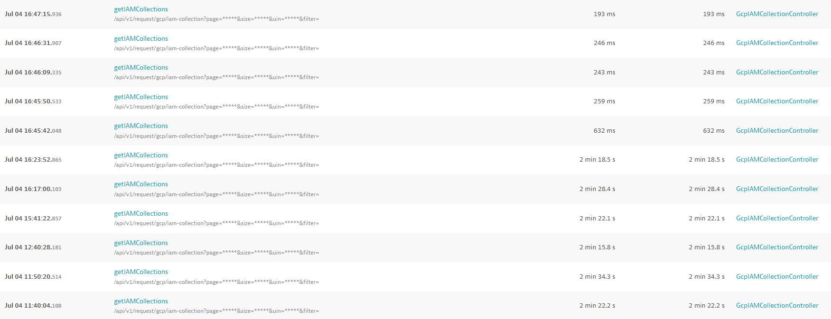
Fig. 8.40 – Spring API Response Time
Fig.40 shows the performance of the API around the time of the deployment. These results clearly show the huge loading time improvements made possible by the introduction of ABD, with an average improvement of 350x.
Deployed NPS Survey Results
Post deployment, a similar NPS survey was conducted on heavily affected users asking for a rating on the new update.
The following question was posed to the user base:
How likely are you to recommend the newly deployed My IAMs page as a suitable solution to managing IAM collections?

Fig. 8.41 – Post Deployment NPS
The new value for NPS as shown in Fig.41 is 100, meaning that all users surveyed believe that the tool is now fit for purpose.
This is a direct contradiction to the previous version, in which no user described the system as fit.
B. Phenomenology
Stakeholder Comments
Unanimously from all users and stakeholders, their comments can be condensed into a single phrase:
Much better.
A small number of these are shown below:
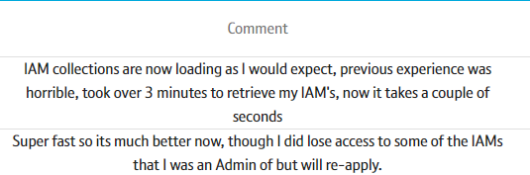
Fig. 8.42 – Example Comments

9. Experimental Evaluation
A small summary of the results and their conclusions are detailed below:
- Each experimental result set matched their predicted outcomes as a result of the research conducted in the literature review.
- Objectives 1,2 and 3 were all met through the completion of this project.
- The overall aim of the project was met through the deployment and shown effectiveness of the ABD solution.
- A complete overhaul of the data model, and generation method provided the best results indicating multiple different areas of the overall implementation which affected the loading time.
- Solutions which did not improve the eager data model still suffered increased loading times due to over fetching of data.
- Implementing lazy loading resulted in the largest overall performance improvement for scenarios with a large number of associated IAM collection requests.
The experiment undertaken has concerned specifically only the Java layer of a more complicated system. Further sections could have been optimized to measure potential additional performance gains. Experimentation into the front-end display of the data could have been undertaken as was suggested as part of the literature review, or furthermore modifications to the underlying database structure be measured. Both of these were deemed out of scope by the author, and additionally declined as possibilities by the DS team.
Potential improvements to data quality and applicability to Production are explained below:
- A larger number of results could have been obtained per experiment to improve the accuracy, and potentially the precision. A smaller number of measures were taken due to time constraints of generating requests, in addition to the results closely matching the expected outcomes. It was felt that it would be unlikely that the results would deviate further from what was recorded.
- The test suite provided results which ultimately did not match what was found in Production. The production environment was notably slower than expected initially, with the local suite providing results 10x faster than is currently deployed. Strangely, when ABD was deployed, the efficiency of the system far outperforms what was expected. To more accurately attempt to model Production in future experiments, a more powerful test machine, and one which architecturally matches the current system should be used.

10. Conclusion
The author is an active member of the DS team under the BT ‘Digital’ subunit. Through work conducted in this area an issue of loading time for a page containing a list of the Google Cloud concept ‘IAM Collections’ used regularly by users of the Data Services site was identified.
The area of code causing these problems was identified, and an appropriate investigation as to possible improvements undertaken covering general code optimizations, optimizations for data models / objects relational mappings, specific optimizations for Spring Boot systems and finally methods to measure code efficiency.
An experiment into possible loading time improvements for a Spring Boot API has been conducted following the procedure described in the design, guided by research into the field as a systematic literature review.
The current solution was measured as a baseline, with all experimental solutions measured against it.
The results of each experiment have been discussed and evaluated, with the best solution when measured against the requirements chosen to be deployed. This solution was found to be a complete rebuild of the entire serving method, in which the ORM solution was changed from eager to lazy, the driver to decide if a user was part of a given IAM collection was changed from using Active Directory groups, to IAM Collection Join requests in the DS database, and the system to decide if a user was an admin of that IAM collection was modified. This solution was both experimentally and experientially shown to be a significant improvement, with the deployed nature surpassing expectations with an average reduction in loading time by 350 times.
The use of DTOs as described in [26] are shown to be detrimental in reducing load time, with around a 25% increase, regardless of eager or lazy initialisation.
This experiment has provided benefits both academically and organizationally to BT. It has corroborated what was found in the literature review in that lazy loading will provide a huge benefit to performance for systems using eager loading. It has provided raw data, with example productionised code in order to quantitatively demonstrate the performance improvements for various types of program optimizations. Users of the page now describe the page as fit for purpose and enjoy the benefits of sub second loading for the majority of cases. The business benefit provided from the improvements as shown in the initial findings is estimated as £32500 per year, however, could fluctuate up and down dependant on other factors external to this report (different numbers of requests, distraction from long loading times etc).
Some difficulties are noted which affected the experimental process. DS development and test environments suffered a massive outage for approximately 2 weeks resulting in a delay in the review process for ABD. Notable time was recorded to generate large numbers of requests using Java. This could have been improved with a better strategy, such as using SQL. As a member of the development team for DS, there were a number of cases in which the author was unable to focus on the experiment at hand, due to organisational requirements for the team.
Future work could be undertaken as an expansion to the identified problem, to allow for greater replicability and use cases for other software engineers. Investigations into improvements provided through front end redesigns (most notably pagination), database modifications, cloud database use cases (such as Cloud Spanner through Google Cloud) and infrastructure re-architecture could provide a more applicable and general guide to improvements to page loading for engineers facing similar issues to DS. As was found in the literature review, and a manual review of the system, there are many components which can cause performance issues, therefore an obvious proposition is that the underlying system architecture may not be suitable for the use case being acted upon it. Additionally, an investigation into the time taken to improve the system versus the amount of time gained by users may be of validity within this field. Organizations must decide on the benefits of improving a system before committing resource to do so, as ultimately the time cost may not be of overall benefit.
11. Self-Reflection
The past six months of work have been extremely difficult for me. Working nights, weekends, much of the day, every day has really taken its toll on me. Regrettably, BT’s HR system has a helpful notification as to when it recommends taking leave and how long it has been since it was last taken. For myself, as of writing, the number is 174 days since my last official day of leave. Alongside this project, a professional software engineering position, GCP certification, Type 1 Diabetes, and frankly general life, felt like quite a high stack of work to undertake, of which it has taken great willpower to continue with. Granted however, I have certainly learned some useful organisational, and certainly technical lessons to which I won’t soon forget.
Generally (and certainly stereotypically!) I found that having a distinct plan of action for each undertaking for the project was the most beneficial to its completion. Certainly, regarding the literature review and design process, without a distinct plan it would not have been nearly as thorough, and more so it would have been an insurmountable task. The literature review topic felt like an endless ocean of information, as the topic was so broad initially, it was difficult not to drown. The creation of a clear strategy about how to distil information, recognise what was worth reading and what wasn’t, and taking it slowly allowed me to absorb the information significantly more effectively than I feel I would have been able to otherwise.
I have definitely realised that large projects like this, require not just planning, but commitment. Much like a runner, there were numerous moments where I felt I had hit a wall, and questioned whether I had the willpower to continue. Taking the time to break down the work into manageable pieces has allowed me to work through these blockers, as the mountain climb is made to feel so much smaller. The time that I have sacrificed to this project has been significant, which I did not consider prior to starting. Going forward I feel it would be beneficial to keep this in mind, especially regarding the next point.
Things change, who would have guessed. Life is not always easy to plan for, and this project was no exception. There are an indescribable number of distractions and interruptions in the modern world, both personally and professionally which can drag a person away from what they are trying to focus on. I have found especially during this project; this has affected me greatly. Asks from work, personal commitments and momentary distractions have had dramatic effects on productivity and time allocation with regards to this dissertation. This has resulted in an overload of information, in which I certainly felt that I could not focus on a single thing at a time, as my mind was completely saturated with differing thoughts. I note many nights in which I would stand staring mindlessly into the soup aisle of my local supermarket, without the mental capacity to decide on which would be my evening meal. In hindsight, I would be unlikely to attempt to undertake so many personal and professional goals in one sitting again, as I have effectively had to put so many other passions on hold during this time. This again is a testament to planning, as without a plan, I would have been adrift and ultimately have failed.
On a technical level however, I have certainly gained some valuable use case knowledge. Take, for example ORM structures. The theory of them works very well, and in a perfect world models could be changed easily. In practice however, code coupling haunted a large amount of the work undertaken in this investigation. Data Services is lucky in that they have developed a large number of unit tests to ensure their code works as intended beyond updates, however they are not conclusive. There are edge cases which are only really identified once an application has been rigorously used in Production. Simply changing the relationship from eager to lazy for IAM Collections, in practice should have been an easy solution, in which this project could have been completed in a single line of code. The impacts of doing this spread through many parts of the codebase and could not be ignored. The lesson here, is that retrofitting an existing code base takes careful practice, testing and thought before any concrete statements can be made about a piece of program functionality. Similarly in cartography, the annotation ‘hic sunt dracones’, or ‘Here Be Dragons’ resonates closely, as in computer science it is difficult to definitively know where the dangers lie, and sometimes, the inevitability that, with changes come consequence. However, without people to challenge what is understood, the world never changes.
References
[1] | H. Mackenzie and D. A, “Systematic reviews: what they are, why they are important, and how to get involved,” Journal of Clinical and Preventive Cardiology, vol. 1, no. 4, pp. 193-202, 2012.
[2] | J. Bentley, Writing Efficient Code, Pittsburgh: Carnegie-Mellon University, 1981.
[3] | G. Amdahl, “Validity of the single processor approach to achieving large scale computing capabilities,” in AFIPS, Atlantic City, 1967.
[4] | E. S. Lowry and C. S. MedLock, “Object Code Optimization,” Communications of the ACMM, vol. 12, no. 1, 1969.
[5] | H. H. Hoos, “Programming by Optimisation,” Communications of the ACM,, vol. 55, no. 2, pp. 70-80, 2012.
[6] | Baeldung, 26 03 2023. [Online]. Available: https://www.baeldung.com/spring-autowire. [Accessed 28 03 2023].
[7] | S. Oaks, Java Performance, The Definitive Guide, Sebastopol: O’Reilly Media, 2014.
[8] | P. Rodgers, “SysCon Webservices,” Boston, 2005.
[9] | H. Sutter and A. Alexandrescu, C++ Coding Standrds, 101 Rules, Guidelines and Best Practices, Stoughton: Pearson, 2010.
[10] | C. Mayer, The Art of Clean Code, San Francisco: No Starch Press, 2022.
[11] | V. Pareto, Cours d’économie politique, 1896.
[12] | R. Hyde, “The Fallacy of Premature Optimization,” Ubiquity, vol. Volume 2009, no. February 2009, 2009.
[13] | I. Abba, “What is an ORM – The Meaning of Object Relational Mapping Database Tools,” 21 Oct 2022. [Online]. Available: https://www.freecodecamp.org/news/what-is-an-orm-the-meaning-of-object-relational-mapping-database-tools/. [Accessed 28 03 2023].
[14] | Z. Huang and Z. Shao, “HBSniff: A static analysis tool for Java Hibernate object-relational mapping code smell detection,” Science of Computer Programming, vol. 217, no. 1, 2022.
[15] | G. Proccianti, P. Lago and D. W, “Energy Efficiency of ORM Approaches: an Empirical Evaluation,” Proceedings of the 10th ACM/IEEE International Symposium on Empirical Software Engineering and Measurement, pp. 1-10, 2016.
[16] | J. Trask, “Optimizing ORM Performance,” 07 Mar 2012. [Online]. Available: https://www.infoq.com/articles/optimizing-orm-performance/. [Accessed 28 03 2023].
[17] | J. Yang and C. Yan, “How not to structure your database-backed web applications:,” in 2018 ACM/IEEE 40th International Conference on Software Engineering, Gothenburg , 2018.
[18] | baeldung, “Eager/Lazy Loading In Hibernate,” 24 Dec 2021. [Online]. Available: https://www.baeldung.com/hibernate-lazy-eager-loading. [Accessed 29 03 2023].
[19] | “Default fetch type for one-to-one, many-to-one and one-to-many in Hibernate,” Dec 2014. [Online]. Available: https://stackoverflow.com/questions/26601032/default-fetch-type-for-one-to-one-many-to-one-and-one-to-many-in-hibernate. [Accessed 29 03 2023].
[20] | baledung, “One-to-One Relationship in JPA,” 10 Jan 2023. [Online]. Available: https://www.baeldung.com/jpa-one-to-one. [Accessed 29 03 2023].
[21] | N/A, “Hibernate one-to-one loads eagerly always,” Jan 2017. [Online]. Available: https://stackoverflow.com/questions/41349498/hibernate-one-to-one-loads-eagerly-always. [Accessed 29 Mar 2023].
[22] | ‘olddave’, “Can dev explain why you decided to ignore 1to1 lazy loading?,” Hibernate, 29 Jan 2009. [Online]. Available: https://forum.hibernate.org/viewtopic.php?f=1&t=994203. [Accessed 29 Mar 2023].
[23] | Q. Wu, Y. Hu and Y. Wang, “Research on Data Persistence Layer Based on Hibernate Framework,” in 2010 2nd International Workshop on Intelligent Systems and Applications, Wuhan, 2010.
[24] | N. Dhingra, “PERFORMANCE EVALUATION OF JPA BASED ORM TECHNIQUES,” in Proceedings of 2nd International Conference on Computer Science Networks and Information Technology, Montreal , 2016.
[25] | A. Leonard, Spring Boot Persistence Best Practices, Romania: Springer Nature, 2020.
[26] | M. Fowler, “Data Transfer Object,” MartinFowler.com, [Online]. Available: https://martinfowler.com/eaaCatalog/dataTransferObject.html. [Accessed 01 April 2023].
[27] | Gatling, “Gatling,” [Online]. Available: https://gatling.io/. [Accessed 02 Apr 2023].
[28] | P. Hampton, “Performance Testing Spring Boot with Gatling,” Opsian, 14 Jan 2020. [Online]. Available: https://www.opsian.com/blog/performance-test-spring-boot-gatling/. [Accessed 02 Apr 2023].
[29] | Artillery, “The most advanced load-testing platform in the world,” 02 Apr 2023. [Online]. Available: https://www.artillery.io/. [Accessed 02 Apr 2023].
[30] | Cypress, “Test. Automate. Accelerate.,” [Online]. Available: https://www.cypress.io/. [Accessed 03 Apr 2023].
[31] | Dynatrace, “Modern Cloud Done Right,” 2023. [Online]. Available: https://www.dynatrace.com/. [Accessed 03 Apr 2023].
[32] | P. K. Venkatesan, “Junit framework for unit testing,” University, Thunder Bay, 2020.
[33] | F. Reichheld, “The Only Number You Need To Grow,” Harvard Business Review, 2003.
[34] | D. Campbell and T. Cook, Quasi-Experimentation: Design and Analysis Issues for Field Settings, Houghton Mifflin, 1979.
[35] | HashiCorp, “Development environments simplified.,” 2023. [Online]. Available: https://www.vagrantup.com/. [Accessed 30 05 2023].
[36] | GeeksForGeeks, “Spring Boot – Architecture,” 2023. [Online]. Available: https://www.geeksforgeeks.org/spring-boot-architecture/. [Accessed 10 May 2023].
[37] | TechTarget, “Net Promoter Score (NPS),” Feb 2023. [Online]. Available: https://www.techtarget.com/searchcustomerexperience/definition/Net-Promoter-Score-NPS. [Accessed 05 May 2023].
[38] | Baeldung, “Spring Core Annoations,” 2023. [Online]. Available: https://www.baeldung.com/spring-core-annotations. [Accessed 10 May 2023].
[39] | Selenium, “Selenium Automates Browsers. That’s it!,” 2023. [Online]. Available: https://www.selenium.dev/. [Accessed 15 May 2023].

Appendix
[A] – Image of the My IAM Page
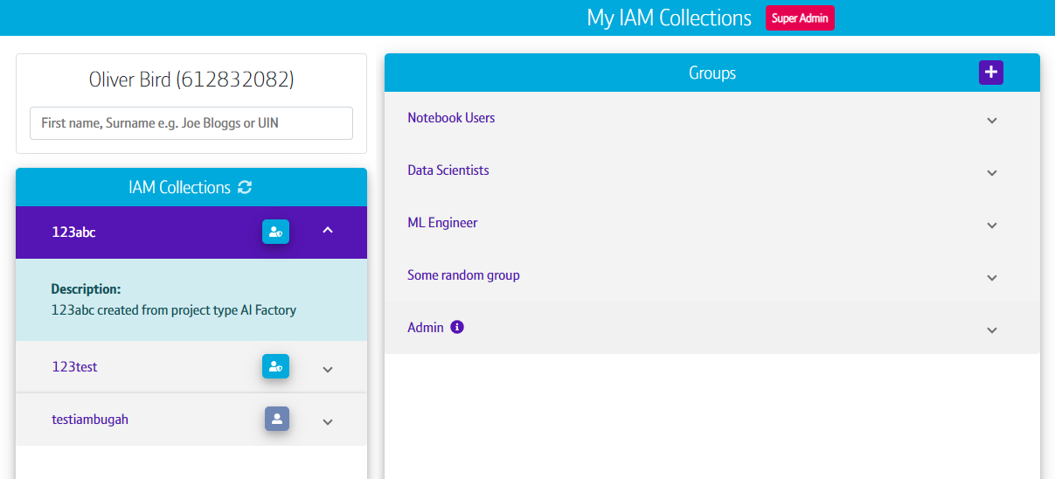

[B] A description of each of the issues related to the DS platform, and their affected users
Loading Time – All Users – The average loading time for the page is fast, however the content within the page takes a minimum of over a minute. This is exacerbated by what feels like an endless graphical spinner which results in users having no confidence that the page will ever load.
Financial – BT Digital Corporate Unit, Data – The time taken to load the page, given the large number of engineers using it multiple times a day has a significant financial cost to the company, certainly in the case of subcontracted employment.
Code Standards – DS Developers & Key Stakeholders – The current methods and models used to power this page do not adhere to the teams current coding standards. This has caused large amounts of time to be used in debugging sections of the codebase, both the area in question and those which are coupled with these systems (such as the Java classes used to describe the data being used for IAM Collections). Further time is used when extending sections of the codebase as the logic used is significantly over complex, badly documented, and difficult to follow.
Reliance on third party API – DS Developers & Key Stakeholders – DS uses a third-party API to enact many of the functions when provisioning access to systems. A key feature of this API allows the DS BE to connect to BT Active Directory (known as AD), one of the underlying systems which physically controls access. This is noted as a risk of the platform, and as of recently this API has been marked as End of Life (EoL). IAM groups are provisioned directly using AD, with all of the instructions and queries using the EoL API. Being marked as EoL has the connotation of a service which is not potentially going to be maintained. This poses a direct issue with the current implementation of IAM Collections (and other services).
Lack of a database driven trust model – DS Developers & Key Stakeholders – As above, the source of truth for access is being described from AD via a user’s membership within AD groups. The same information could be gained from the DST database, based on the status of access request (i.e., an access request marked as ‘Complete’ in the database means that the user should have been added to the correct AD group, similarly with ‘Removed’ meaning access was removed). This reliance on a third party slows down the system further and worsens the slowness issue.
[C] Literature Review Error Analysis
A large number of articles n are predicted due to in some cases a large number of relevant articles. This value in each case therefore has a large error ∆n as there could potentially be a huge number of articles relevant for which an exact total cannot be found.
Furthermore, the returned number of relevant articles rt and the overall number of articles reviewed o have no error associated with them as these are empirical results of the investigation. Not all articles reviewed are included within this report, with only the most relevant discussed.
In some cases, it was difficult to find highly accurate studies with the exact use case of DS. This is discussed further with regards to (3).
The resultant literature review therefore has low sensitivity s, low precision p and narrow scope due to the large potential number of relevant articles that exist n, those returned and not relevant o and those returned rt. These are described below:
$$s= \frac{rt}{n}$$
$$p= \frac{n}{o}$$
Using error propagation rules, the found error is given in general by:
$$∆a=a. \sqrt{{(\frac{∆b}{b})}^{2}+{(\frac{∆c}{c})}^{2}}$$

[D] Current IAM Collection Data Model
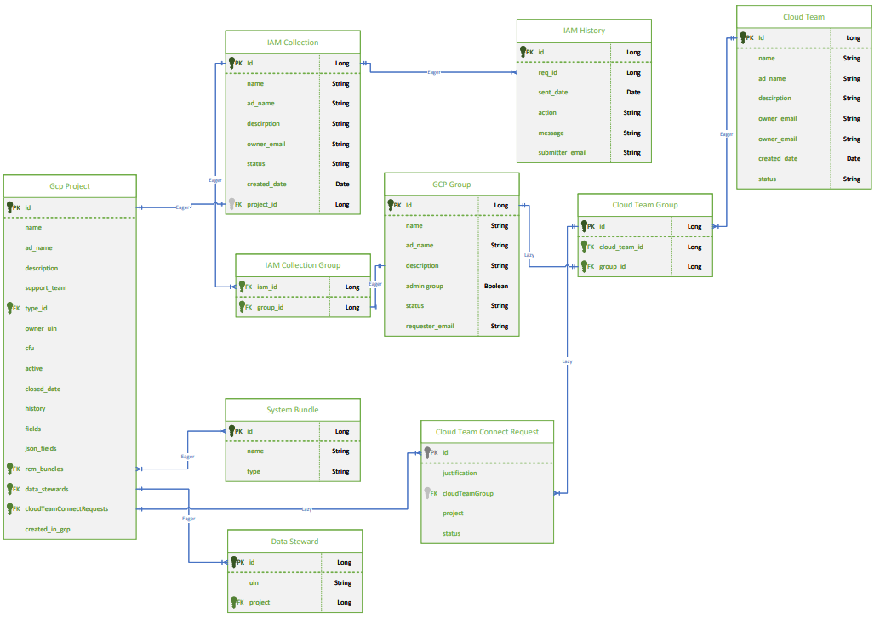

[E] – Condensed Unit Test Suite
package com.bt.data.services.gcp;

import static org.junit.Assert.assertTrue;
import static org.mockito.ArgumentMatchers.any;
import static org.mockito.Mockito.when;

import java.util.ArrayList;
import java.util.Arrays;
import java.util.Calendar;
import java.util.Date;
import java.util.HashSet;
import java.util.List;
import java.util.Optional;
import java.util.Set;
import java.util.stream.Collectors;

import com.bt.data.dao.gcp.*;
import com.bt.data.helpers.gcp.GcpIAMCollectionJoinRequestGenerator;
import com.bt.data.model.gcp.*;
import org.junit.jupiter.api.BeforeAll;
import org.junit.jupiter.api.BeforeEach;
import org.junit.jupiter.api.Test;
import org.mockito.Mock;
import org.springframework.beans.factory.annotation.Autowired;
import org.springframework.boot.test.mock.mockito.SpyBean;
import org.springframework.data.domain.Page;

import com.bt.data.dao.site.DSServiceRepository;
import com.bt.data.dao.site.RoleRepository;
import com.bt.data.dao.site.ServiceEmailsRepository;
import com.bt.data.dao.site.UserRepository;
import com.bt.data.helpers.gcp.GcpIAMCollectionGenerator;
import com.bt.data.helpers.gcp.GcpProjectGenerator;
import com.bt.data.helpers.gcp.GcpProjectTypeGenerator;
import com.bt.data.security.PropertyConfig;
import com.bt.data.services.AuditService;
import com.bt.data.services.MarketplaceService;
import com.bt.data.services.ServiceTest;
import com.bt.data.services.UserRoleService;
import com.bt.data.util.Employee;
import com.bt.data.util.core.CrudHelper;

/**
* Please note this class contains methods capable of generating a large number of requests
* If you find yourself here without the explicit permission of the senior developers of the
* Data Services team, please do not enact any of the tests contained within this class.
*
* This class is to be used for scale testing methods relating to IAM collections, projects and Join requests.
* The relevant repositories are autowired to allow for the above classes to be saved.
*/
public class GcpIAMCollectionServiceScaleTest extends ServiceTest {
@SpyBean
private CrudHelper crudHelper;
@Mock
private PropertyConfig config;
@Autowired
private GcpIAMCollectionRepository iamCollectionRepository;
@Mock
private GcpIAMCollectionHistoryRepository iamCollectionHistoryRepository;
@Mock
private GcpIAMCollectionAuditRepository iamCollectionAuditRepository;
@Autowired
private GcpGroupRepository groupRepository;
@Autowired
private GcpGroupCategoryRepository groupCategoryRepository;
@Mock
private DSServiceRepository serviceRepository;
@Mock
private ServiceEmailsRepository serviceEmailRepository;
@Mock
private GcpADService adService;
@Mock
private GcpAccessService accessService;
@Mock
private UserRepository usersRepo;
@Mock
private RoleRepository rolesRepo;
@Mock
private AuditService auditService;

private UserRoleService userRoleService;
@Mock
private MarketplaceService marketplaceService;
@Autowired
GcpProjectTypeRepository gcpProjectTypeRepository;
@Autowired
GcpProjectRepository gcpProjectRepository;
@Autowired
private GcpIAMCollectionJoinRequestRepository iamCollectionJoinRequestRepository;
private GcpIAMCollectionService iamCollectionService;
String projectTypeName = “test”;
String json = “{\”fields\”:[ { \”label\”:\”Cloud Core Node Name\”,\”type\”:\”ollect\”,\”required\”:true,\”description\”:\”\”,\”hint\”:\”\”,\”validation\”:\”NONE\” } ]}”;
GcpProjectType testType = GcpProjectTypeGenerator.getInstance(projectTypeName, json);
Employee employee;
@BeforeEach
@Override
public void beforeEachTest() {
userRoleService = new UserRoleService(ldapService, usersRepo, rolesRepo, auditService, crudHelper);
iamCollectionService = new GcpIAMCollectionService(config, crudHelper, emailService, adService, iamCollectionRepository,
iamCollectionHistoryRepository, groupRepository, groupCategoryRepository, iamCollectionAuditRepository,
serviceRepository, serviceEmailRepository, accessService, ldapService, userRoleService,iamCollectionJoinRequestRepository);
}
@BeforeAll
public void beforeALl() {
testType = gcpProjectTypeRepository.save(testType);
}

/**
* Tests createLargeNumberOfIamCollectionsAndProjects: Asserts the length of time taken to create a large number of projects and Iams
*
* Consider using this test prior to any further scale testing to understand how the pipeline may be affected by a significant number of requests.
* Simple assertion that the method takes some time to run
*/
//@Test
public void timeCheck() {
Calendar beforeCreation = Calendar.getInstance();
createLargeNumberOfIamCollectionsAndProjects(10, testType);
Calendar afterCreation = Calendar.getInstance();
double timeTaken = (afterCreation.getTimeInMillis()-beforeCreation.getTimeInMillis())/1000;
System.out.println(“Time take: “ + timeTaken);
assertTrue(beforeCreation.getTimeInMillis() < afterCreation.getTimeInMillis());
}

/**
* DANGEROUS TEST METHOD. TAKE GREAT CARE TO NOT ENABLE THIS METHOD WHEN PUSHING TO A SERVER.
*
* This method is capable of generating a massive amount of projects, iams and join requests.
*
* Tests getAllIamCollectionsUserMemberOf: A potential scale test to measure the performance of the
* Get Iam collection method.
*
* It should be noted, that generating a large number of objects takes time, therefore if a user is part
* of a huge number of IAM collections, there will be a delay in the objects being returned.
*
* There is no way around the above, for now...
*/

//@Test
public void getAllIamCollectionsUserMemberOfResponseTimeTest() {

createLargeNumberOfIamCollectionsAndProjects(1,testType);
generateLargeNumberOfIAMJoins(1L, “222222222”);

Calendar beforeCreation = Calendar.getInstance();
Page<GcpIAMCollection> iams = this.iamCollectionService.getAllIamCollectionsUserMemberOf(1,10000,Optional.empty(),Optional.of(“111111111”));
Calendar afterCreation = Calendar.getInstance();
double timeTaken = (afterCreation.getTimeInMillis()-beforeCreation.getTimeInMillis())/1000;
System.out.println(“Time take: “ + timeTaken);

assertTrue(beforeCreation.getTimeInMillis() < afterCreation.getTimeInMillis());
}

//@Test
public void serverTestingToReplicateProd() {
createLargeNumberOfIamCollectionsAndProjects(1200,testType);
generateLargeNumberOfIAMJoins(500L, “”);
generateLargeNumberOfIAMJoins(100L, “”);
generateLargeNumberOfIAMJoins(150L, “”);
generateLargeNumberOfIAMJoins(10L, “”);
generateLargeNumberOfIAMJoins(50L, “”);
generateLargeNumberOfIAMJoins(35L, “”);
generateLargeNumberOfIAMJoins(350L, “”);
assertTrue(true);
}

/**
* Method to generate a larger number of IAM groups
*/
private Set<GcpGroup> createMoreGroups() {
return new HashSet<>(Arrays.asList(
new GcpGroup(“Admin”, “description”, true, “111111111”, “test@bt.com”, “Test User”, “TAF4”),
new GcpGroup(“Big Data Viewer”, “big data viewer description”, false, “111111111”, “test@bt.com”, “Test User”, “TAF4”),
new GcpGroup(“Big Data Viewer 2”, “big data viewer description”, false, “111111111”, “test@bt.com”, “Test User”, “TAF4”),
new GcpGroup(“Big Data Viewer 3”, “big data viewer description”, false, “111111111”, “test@bt.com”, “Test User”, “TAF4”),
new GcpGroup(“Big Data Viewer 4”, “big data viewer description”, false, “111111111”, “test@bt.com”, “Test User”, “TAF4”)
));
}

/**
* Method to generate and save a predefined number of projects, iam collections and join requests.
*
* For now these values will all be the same, meaning the number that is passed, the equivalent number of
* the above are created.
*
* @param numberOfRequest the number of entries to be created
* @param type some project type to be created, not explicitly needed ultimately, but drives the generators
*/
private void createLargeNumberOfIamCollectionsAndProjects(long numberOfRequest, GcpProjectType type) {
for(long I = 1; I <= numberOfRequest; i++) {
GcpProject project = GcpProjectGenerator.getInstance(type, “projectForTesting” +i);
gcpProjectRepository.save(project);
// For each IAM, unique groups must be created, hence this is done for every iteration
Set<GcpGroup> iamGroups = createMoreGroups();
GcpIAMCollection iam = GcpIAMCollectionGenerator.getInstance(iamGroups, “iamcollectionForTesting” + I, project);
iamCollectionRepository.save(iam);
GcpIAMCollectionJoinRequest jrq = GcpIAMCollectionJoinRequestGenerator.getCompletedIamJoinRequest(“111111111”,
“testing tester”, “testing.tester@bt.com”, “QMJ”, iam, (new ArrayList<GcpGroup>(iam.getGroups())).get(0), “I want to join”);
iamCollectionJoinRequestRepository.save(jrq);
GcpIAMCollectionHistory hist = new GcpIAMCollectionHistory(iam.getId(),new Date(), “string”,”string”,”string”);
iamCollectionHistoryRepository.save(hist);
// Simple print out for every 10 iterations to print the stage of creation.
If((i%10) == 0) {
System.out.println(“Saved Projects between: “ + (project.getId()-10) + “ and “+ (project.getId() ) + “ and IAM Collecitons: “ + (iam.getId() -10)+ “ and “ +iam.getId());
}
}
}

/**
* Method to generate IAM join requests
*
* IAMs created target a single IAM ollection, as ultimately the IAM I matter I matter.
*
* Method may appear to freeze
*
* @param numberOfRequests the number of requests to generate
*/
private void generateLargeNumberOfIAMJoins(long numberOfRequests, String uin) {
System.out.println(“Starting mass generation of requests”);
List<GcpIAMCollectionJoinRequest> joins = new ArrayList<>();
Calendar beforeCreation = Calendar.getInstance();
for(long I =1; I < numberOfRequests; i++) {
Optional<GcpIAMCollection> iam = iamCollectionRepository.findById(i);
List<GcpGroup> groupsList = new ArrayList<>(iam.get().getGroups());
List<GcpGroup> adminGroup = groupsList.stream().filter(group -> group.isAdminGroup()).collect(Collectors.toList());
GcpIAMCollectionJoinRequest jrq = GcpIAMCollectionJoinRequestGenerator.getCompletedIamJoinRequest(uin,
“testing tester”, “testing.tester@bt.com”, “QMJ”, iam.get(), adminGroup.get(0), “I want to join”);
joins.add(jrq);

// Prints out every 100 join requests, created. This is likely pretty much instant in most cases though
if((i%100) == 0) {
System.out.println(“Created join requests between: “ + (i-100) + “ and: “ +i);
}
}
// This section will take some time, it may appear to have frozen but be patient.
// Using save all is faster overall, but provides no method to track progress
iamCollectionJoinRequestRepository.saveAll(joins);
Calendar afterCreation = Calendar.getInstance();
double timeTaken = (afterCreation.getTimeInMillis()-beforeCreation.getTimeInMillis())/1000;
System.out.println(“Time taken to generate additional joins: “ + timeTaken);
}

/**
* Method to mock the results from AD for a users groups.
*
* Both groups relating to IAM membership, and others are created for accuracy
*
* @param numberOfWantedGroups number of AD groups to mock
*/
private List<String> generateGroupAttributations(long numberOfWantedGroups) {
List<String> adGroups = new ArrayList<>();
List<String> groupNames = Arrays.asList(“Admin”,”Big Data Viewer”,”Big Data Viewer 2”,”Big Data Viewer 3”,”Big Data Viewer 4”);
for(long I = 1; I <= numberOfWantedGroups; i++) {
for(String groupName: groupNames) {
adGroups.add(“iamd_” +”iamcollection” + i+”_”+ groupName);
adGroups.add(“SomeRandomGroup” +i);
}
}
return adGroups;
}
}

[F] System Architecture
The local testing environment comprises of a windows 10 software engineering capable laptop running the Spring Boot application natively on the system. A Vagrant [35] managed virtual machine hosts the database driving the application using Docker. Complete details are below:
Local testing environment (LTE) OS: MS Windows 10 Enterprise
LTE Processor: Intel® Core™ i7-8850H @2.60Ghz, 6 Core(s)
LTE Memory: 24.0GB, 2667MHz
VM OS: Red Hat
VM Memory: 2GB
VM Processors: 2
VM Configuration: PAE/NX enabled, IO APIC enabled, Nested Paging Enabled
Java Configuration: N/A
Java Version: 11
Spring Boot Version: 2.3.1.RELEASE
Spring Dependency Management: 1.0.9.RELEASE
Gradle Version: 6.3’
For the understanding of the reader, the DS Spring boot architecture can be simplified using the following diagram:
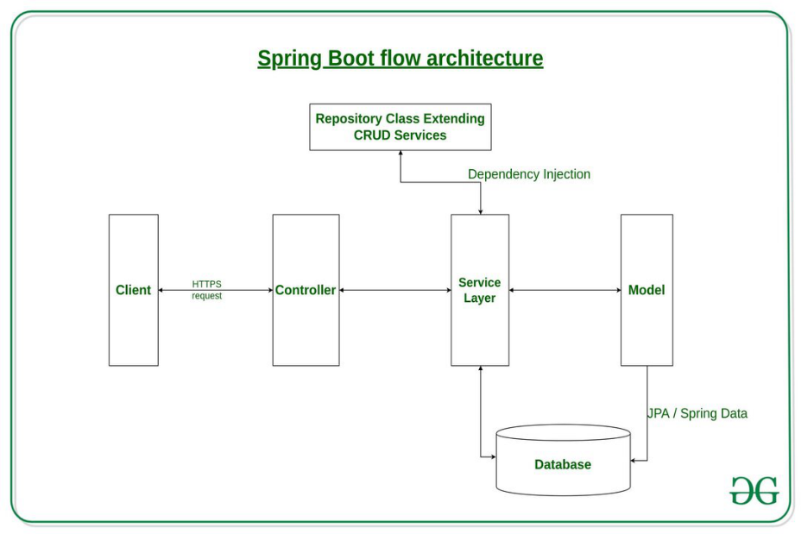
Fig. 1 – DS Spring Architecture [36]
The components of this experiment are the service layer, the model, the repository layer, and the database. In general, and will henceforth be described as:
- The Service / Service Layer – holds business logic to manipulate information from the database and to control the applications implementation.
- The Model – Java classes to describe the data model present in the database. This is Hibernate in the DS application.
- The Repository – A collection of SQL and JPQL queries for specific use cases of business logic to retrieve information from the database.
- The Database – An Oracle database housing all data related to the DS application.

[G] – Current IAM Collection Serving Method Logic Flow
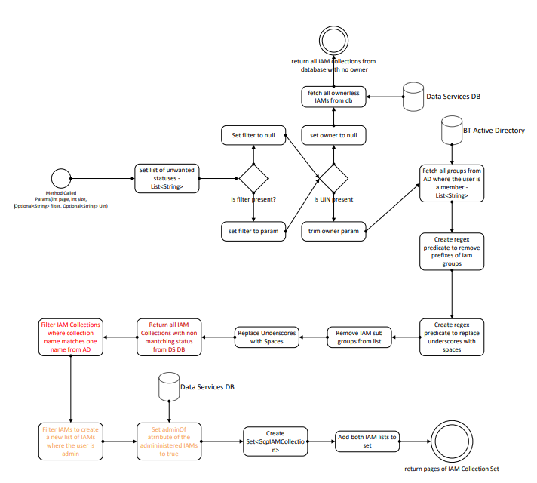
[H] – Comments from Key Stakeholders
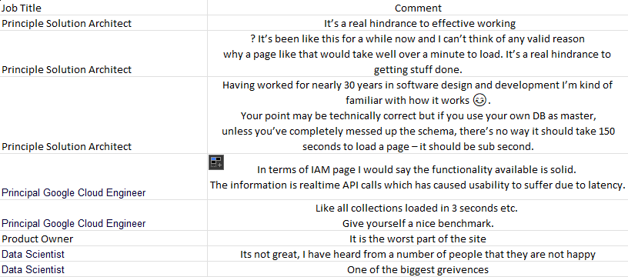

[I] – Example network JSON from the API in Production
{
"content": [
{
"id":"Some Value",
"name":"Some Value",
"adName":"Some Value",
"description":"Some Value",
"ownerUin":"Some Value",
"ownerName":"Some Value",
"ownerEmail":"Some Value",
"ownerOuc":"Some Value",
"status":"Some Value",
"createdDate":"Some Value",
"groups": [
{
"id":"Some Value",
"name":"Some Value",
"adName":"Some Value",
"description":"Some Value",
"adminGroup":"Some Value",
"status":"Some Value",
"requesterUin":"Some Value",
"requesterName":"Some Value",
"requesterEmail":"Some Value",
"requesterOuc":"Some Value",
"createdDate":"Some Value",
"category": {
"id":"Some Value",
"name": "Some Value"
},
"cloudTeamGroup": null
},
{
"id":"Some Value",
"name":"Some Value",
"adName":"Some Value",
"description":"Some Value",
"adminGroup":"Some Value",
"status":"Some Value",
"requesterUin":"Some Value",
"requesterName":"Some Value",
"requesterEmail":"Some Value",
"requesterOuc":"Some Value",
"createdDate":"Some Value",
"category": {
"id":"Some Value",
"name": "Some Value"
},
"cloudTeamGroup": null
},
{
"id":"Some Value",
"name":"Some Value",
"adName":"Some Value",
"description":"Some Value",
"adminGroup":"Some Value",
"status":"Some Value",
"requesterUin":"Some Value",
"requesterName":"Some Value",
"requesterEmail":"Some Value",
"requesterOuc":"Some Value",
"createdDate":"Some Value",
"category": {
"id":"Some Value",
"name": "Some Value"
},
"cloudTeamGroup": null
},
{
"id":"Some Value",
"name":"Some Value",
"adName":"Some Value",
"description":"Some Value",
"adminGroup":"Some Value",
"status":"Some Value",
"requesterUin":"Some Value",
"requesterName":"Some Value",
"requesterEmail":"Some Value",
"requesterOuc":"Some Value",
"createdDate":"Some Value",
"category": {
"id":"Some Value",
"name": "Some Value"
},
"cloudTeamGroup": null
},
{
"id":"Some Value",
"name":"Some Value",
"adName":"Some Value",
"description":"Some Value",
"adminGroup":"Some Value",
"status":"Some Value",
"requesterUin":"Some Value",
"requesterName":"Some Value",
"requesterEmail":"Some Value",
"requesterOuc":"Some Value",
"createdDate":"Some Value",
"category": {
"id":"Some Value",
"name": "Some Value"
},
"cloudTeamGroup": null
}
],
"historyList": [
{
"reqId":"Some Value",
"sentDate":"Some Value",
"action":"Some Value",
"message":"Some Value",
"submitterEmail":"Some Value",
"id": "Some Value"
},
{
"reqId":"Some Value",
"sentDate":"Some Value",
"action":"Some Value",
"message":"Some Value",
"submitterEmail":"Some Value",
"id": "Some Value"
}
],
"project": {
"instanceofCdi":"Some Value",
"id":"Some Value",
"name":"Some Value",
"adName":"Some Value",
"description":"Some Value",
"supportTeam":"Some Value",
"type": {
"id":"Some Value",
"name":"Some Value",
"automationName":"Some Value",
"description":"Some Value",
"fieldsDefinition":"Some Value",
"termsConditions":"Some Value",
"ownerLabel":"Some Value",
"suffix":"Some Value",
"requiresApproval":"Some Value",
"enabled":"Some Value",
"groups": [
{
"id":"Some Value",
"name":"Some Value",
"adName":"Some Value",
"description":"Some Value",
"adminGroup":"Some Value",
"category": {
"id":"Some Value",
"name": "Some Value"
}
},
{
"id":"Some Value",
"name":"Some Value",
"adName":"Some Value",
"description":"Some Value",
"adminGroup":"Some Value",
"category": {
"id":"Some Value",
"name": "Some Value"
}
},
{
"id":"Some Value",
"name":"Some Value",
"adName":"Some Value",
"description":"Some Value",
"adminGroup":"Some Value",
"category": {
"id":"Some Value",
"name": "Some Value"
}
},
{
"id":"Some Value",
"name":"Some Value",
"adName":"Some Value",
"description":"Some Value",
"adminGroup":"Some Value",
"category": {
"id":"Some Value",
"name": "Some Value"
}
}
],
"cloudTeamConnectable":"Some Value",
"ownedByAi": false
},
"requesterUin":"Some Value",
"requesterName":"Some Value",
"requesterEmail":"Some Value",
"requesterOuc":"Some Value",
"requesterCfu":"Some Value",
"ownerUin":"Some Value",
"cfu":"Some Value",
"active":"Some Value",
"status":"Some Value",
"createdDate":"Some Value",
"reviewDate":"Some Value",
"closedDate":"Some Value",
"historyList": [
{
"reqId":"Some Value",
"sentDate":"Some Value",
"action":"Some Value",
"message":"Some Value",
"submitterEmail":"Some Value",
"id": "Some Value"
},
{
"reqId":"Some Value",
"sentDate":"Some Value",
"action":"Some Value",
"message":"Some Value",
"submitterEmail":"Some Value",
"id": "Some Value"
}
],
"jsonFields":"Some Value",
"rcmSystemBundles": [
{
"id":"Some Value",
"name":"Some Value",
"type": "Some Value"
}
],
"createdInGcp":"Some Value",
"cdiProject":"Some Value",
"historyLatest":"Some Value",
"email":"Some Value",
"instanceofCdi":"Some Value",
"uin":"Some Value",
"projectName":"Some Value",
"keyInfo": "Some Value"
},
"serviceName":"Some Value",
"iamAdmin":"Some Value",
"historyLatest":"Some Value",
"email":"Some Value",
"activeGroups": [
{
"id":"Some Value",
"name":"Some Value",
"adName":"Some Value",
"description":"Some Value",
"adminGroup":"Some Value",
"status":"Some Value",
"requesterUin":"Some Value",
"requesterName":"Some Value",
"requesterEmail":"Some Value",
"requesterOuc":"Some Value",
"createdDate":"Some Value",
"category": {
"id":"Some Value",
"name": "Some Value"
},
"cloudTeamGroup": null
},
{
"id":"Some Value",
"name":"Some Value",
"adName":"Some Value",
"description":"Some Value",
"adminGroup":"Some Value",
"status":"Some Value",
"requesterUin":"Some Value",
"requesterName":"Some Value",
"requesterEmail":"Some Value",
"requesterOuc":"Some Value",
"createdDate":"Some Value",
"category": {
"id":"Some Value",
"name": "Some Value"
},
"cloudTeamGroup": null
},
{
"id":"Some Value",
"name":"Some Value",
"adName":"Some Value",
"description":"Some Value",
"adminGroup":"Some Value",
"status":"Some Value",
"requesterUin":"Some Value",
"requesterName":"Some Value",
"requesterEmail":"Some Value",
"requesterOuc":"Some Value",
"createdDate":"Some Value",
"category": {
"id":"Some Value",
"name": "Some Value"
},
"cloudTeamGroup": null
},
{
"id":"Some Value",
"name":"Some Value",
"adName":"Some Value",
"description":"Some Value",
"adminGroup":"Some Value",
"status":"Some Value",
"requesterUin":"Some Value",
"requesterName":"Some Value",
"requesterEmail":"Some Value",
"requesterOuc":"Some Value",
"createdDate":"Some Value",
"category": {
"id":"Some Value",
"name": "Admin"
},
"cloudTeamGroup": null
}
],
"serviceId":"Some Value",
"uin":"Some Value",
"closedDate":"Some Value",
"keyInfo": "Some Value"
}
],
"pageable": {
"sort": {
"sorted":"Some Value",
"unsorted":"Some Value",
"empty": true
},
"pageSize":"Some Value",
"pageNumber":"Some Value",
"offset":"Some Value",
"paged":"Some Value",
"unpaged": false
},
"last":"Some Value",
"totalPages":"Some Value",
"totalElements":"Some Value",
"sort": {
"sorted":"Some Value",
"unsorted":"Some Value",
"empty": true
},
"numberOfElements":"Some Value",
"first":"Some Value",
"size":"Some Value",
"number":"Some Value",
"empty": false
}

[J] – Lazy Loaded IAM Model
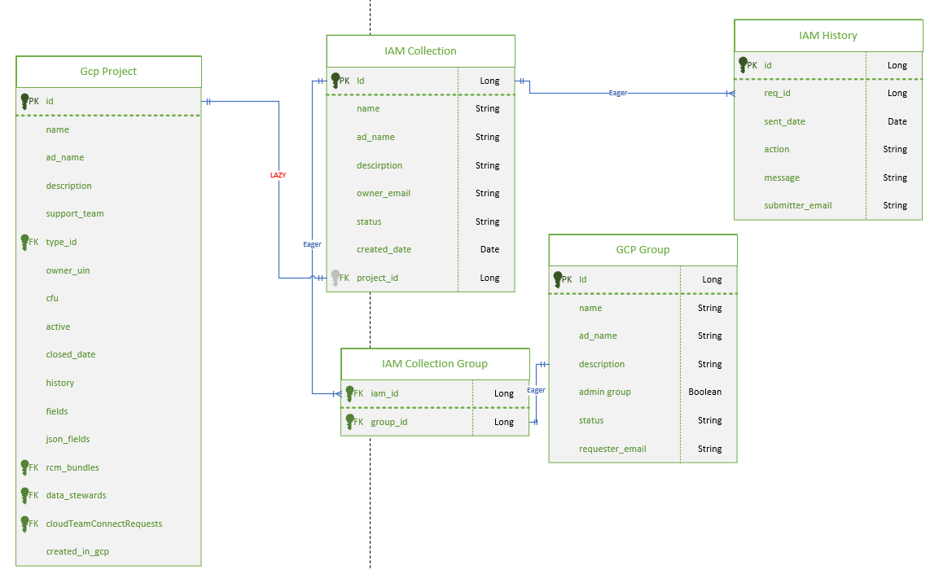
[K] Raw Data
Solution | number of Projects | Number of IAMs | Number Of Join Requests | Number of IAMS User is a part of | time to load(s) | time to load(s) | time to load(s) | Average | Scaling Coefficient
Current | 10000 | 10000 | 0 | 0 | 243 | 275 | 254 | 257.3333 | 0.00
Current | 10000 | 10000 | 10000 | 1000 | 260 | 272 | 271 | 267.6667 | 0.00
Current | 1000 | 1000 | 0 | 0 | 14 | 15 | 15 | 14.66667 | 0.07
Current | 1000 | 1000 | 1000 | 0 | 16 | 15 | 15 | 15.33333 | 0.07
Current | 1000 | 1000 | 1000 | 1000 | 14 | 15 | 15 | 14.66667 | 0.07
Current | 1000 | 1000 | 1000 | 100 | 17 | 17 | 16 | 16.66667 | 0.06
Current | 500 | 500 | 500 | 100 | 5 | 6 | 5 | 5.333333 | 0.19
Current | 500 | 500 | 500 | 500 | 5 | 5 | 5 | 5 | 0.20
Current | 5000 | 5000 | 1000 | 1000 | 95 | 100 | 106 | 100.3333 | 0.01
lazy-loading A | 1000 | 1000 | 0 | 0 | 6 | 6 | 6 | 6 | 0.17
lazy-loading A | 10000 | 10000 | 0 | 0 | 49 | 54 | 55 | 52.66667 | 0.02
lazy-loading A | 1000 | 1000 | 1000 | 1000 | 7 | 5 | 5 | 5.666667 | 0.18
lazy-loading A | 1000 | 1000 | 1000 | 100 | 7 | 7 | 7 | 7 | 0.14
lazy-loading A | 5000 | 5000 | 1000 | 1000 | 25 | 27 | 26 | 26 | 0.04
db-driven solution B | 1000 | 1000 | 0 | 0 | 0 | 0 | 0 | 0 | 1.00
db-driven solution B | 1000 | 1000 | 1000 | 1000 | 19 | 17 | 17 | 17.66667 | 0.06
db-driven solution B | 1000 | 1000 | 2000 | 1000 | 19 | 19 | 17 | 18.33333 | 0.05
db-driven solution B | 10000 | 10000 | 2000 | 1000 | 19 | 19 | 17 | 18.33333 | 0.05
db-driven solution B | 10000 | 10000 | 80000 | 1000 | 21 | 22 | 24 | 22.33333 | 0.04
db-driven solution B | 10000 | 10000 | 80000 | 5000 | 100 | 104 | 105 | 103 | 0.01
Combined Db and lazy ABD | 1000 | 1000 | 1000 | 0 | 0 | 0 | 0 | 0 | 1.00
Combined Db and lazy ABD | 1000 | 1000 | 1000 | 1000 | 7 | 7 | 7 | 7 | 0.14
Combined Db and lazy ABD | 1000 | 1000 | 20000 | 1000 | 9 | 9 | 9 | 9 | 0.11
Combined Db and lazy ABD | 5000 | 5000 | 80000 | 5000 | 42 | 43 | 42 | 42.33333 | 0.02
Combined Db and lazy ABD | 1000 | 1000 | 80000 | 1000 | 7 | 7 | 8 | 7.333333 | 0.14
Combined Db and lazy ABD | 500 | 500 | 500 | 500 | 2 | 2 | 3 | 2.333333 | 0.43
Currrent Solution DTO E | 1000 | 1000 | 1000 | 1000 | 19 | 18 | 17 | 18 | 0.06
Currrent Solution DTO E | 10000 | 10000 | 10000 | 1000 | 251 | 280 | 240 | 257 | 0.00
Currrent Solution DTO E | 1000 | 1000 | 1000 | 0 | 18 | 18 | 18 | 18 | 0.06
Combine Lazy loading & DTO AE | 1000 | 1000 | 1000 | 1000 | 8 | 6 | 7 | 7 | 0.14
Combine Lazy loading & DTO AE | 1000 | 1000 | 1000 | 100 | 8 | 8 | 7 | 7.666667 | 0.13
Combine Lazy loading & DTO AE | 10000 | 10000 | 1000 | 100 | 43 | 44 | 41 | 42.66667 | 0.02
Combine Lazy loading & DTO AE | 1000 | 1000 | 0 | 0 | 6 | 6 | 7 | 6.333333 | 0.16
Combine Lazy loading & DTO AE | 5000 | 5000 | 0 | 0 | 25 | 25 | 27 | 25.66667 | 0.04
More efficient DB query C | 1000 | 1000 | 1000 | 1000 | 15 | 15 | 14 | 14.66667 | 0.07
More efficient DB query C | 10000 | 10000 | 1000 | 1000 | 16 | 15 | 16 | 15.66667 | 0.06
More efficient DB query C | 1000 | 1000 | 500 | 500 | 7 | 8 | 8 | 7.666667 | 0.13
More efficient DB query C | 10000 | 10000 | 1000 | 0 | 0 | 0 | 0 | 0 | 1.00
More efficient DB query C | 1000 | 1000 | 1000 | 0 | 0 | 0 | 0 | 0 | 1.00
More efficient DB query C | 10000 | 10000 | 10000 | 5000 | 90 | 91 | 86 | 89 | 0.01
Combine new query with lazy AC | 1000 | 1000 | 1000 | 1000 | 8 | 8 | 8 | 8 | 0.13
Combine new query with lazy AC | 1000 | 1000 | 1000 | 0 | 0 | 0 | 0 | 0 | 1.00
Combine new query with lazy AC | 10000 | 10000 | 1000 | 1000 | 9 | 8 | 8 | 8.333333 | 0.12
Combine new query with lazy AC | 10000 | 10000 | 1000 | 0 | 0 | 0 | 0 | 0 | 1.00
Combine new query with lazy AC | 5000 | 5000 | 1000 | 1000 | 9 | 9 | 9 | 9 | 0.11
Combine new query with lazy AC | 5000 | 5000 | 1000 | 0 | 0 | 0 | 0 | 0 | 1.00
Combine new query with lazy AC | 10000 | 10000 | 10000 | 5000 | 45 | 49 | 46 | 46.66667 | 0.02
Modified Admin Group Acquisition D | 1000 | 1000 | 1000 | 1000 | 17 | 17 | 17 | 17 | 0.06
Modified Admin Group Acquisition D | 1000 | 1000 | 1000 | 0 | 15 | 16 | 17 | 16 | 0.06
Modified Admin Group Acquisition D | 10000 | 10000 | 1000 | 1000 | 258 | 265 | 249 | 257.3333 | 0.00
Modified Admin Group Acquisition D | 500 | 500 | 500 | 500 | 9 | 8 | 7 | 8 | 0.13
Combined new query, lazy and above ACD | 1000 | 1000 | 1000 | 0 | 0 | 0 | 0 | 0 | 1.00
Combined new query, lazy and above ACD | 1000 | 1000 | 1000 | 1000 | 8 | 7 | 8 | 7.666667 | 0.13
Combined new query, lazy and above ACD | 1000 | 1000 | 1000 | 100 | 1 | 2 | 1 | 1.333333 | 0.75
Combined new query, lazy and above ACD | 10000 | 10000 | 10000 | 1000 | 8 | 8 | 7 | 7.666667 | 0.13
Combined new query, lazy and above ACD | 10000 | 10000 | 10000 | 5000 | 45 | 43 | 42 | 43.33333 | 0.02
Combined new query, lazy and above ACD | 500 | 500 | 500 | 500 | 4 | 4 | 4 | 4 | 0.25
Combined new query, lazy and above ACD | 500 | 500 | 500 | 0 | 0 | 0 | 0 | 0 | 1.00

