DSR-Health & Social Care-Assignment 2-Module Code: LCHS4002- Research report Use of Technology in Modern Healthcare workplace University of Wales Trinity Saint David

03/05/2023
Ana Venancio Dos Santos
Student ID: 2224733
Lecturer: Koushik Modak

Table of Content

- Introduction…………………………………..pg1
- Research topic……………………………….pg2
- Justify the topic……………………………….pg3
- Research Idea………………………………….pg4
- Methodology research…………………………….pg5
- Credible Sources…………………………………..pg6
- Conclusion………………………………………pg7
- Reference…………………………………………pg8

Introduction
In hospital ICT is an important aspect of hospital ministrative life; because they rely on ICT systems to communicate with patients, for hospital bookings and surgery appointments and to maintain patients records so if there is any problem with their IT systems then they would lose those appointment, those appointments will get lost. Furthermore, if there is a problem with the records, they would not know what health problems those patients have been suffering with. Moreover, they would not have a history of the patient’s medical records and what intervention that patients would have. In addition, there is a really big issue with data protection so it is fundamental and really important for hospital to be able to protect their patients data because it is a private data and it could be really dangerous if other organisations or other individuals get hold of a patient data, they would know not only have access to their private information name, address, phone numbers, emails and someone and they would also know what medical problems as it might be experiencing as well. This is sensitivity issues.
On the other hand, St. Thomas Hospital, is one of the largest and most prestigious medical facilities in London. (Thomas, 2022) ST. Thomas Hospital has been facing a severe IT issue in recent months. The problem has cause significant disruption to the hospital operations, leading to delays, cancellations, and long waiting, times for patients. I believe that it is imperative to address this pressing matter as soon as possible, the IT issue at ST. Thomas Hospital has not only affected patient care but also created a hazardous work environment for healthcare professionals. Physicians and nurses are struggling to access critical patient data and communicate with each other effectively due to technical glitches such as system crashes and slow internet speeds. These problems have resulted in unnecessary stress on staff members and put patients’ lives at risk. Therefore, it is essential that the administration takes immediate action to resolve these issues and ensure that their IT infrastructure is robust enough to support the needs of their staff and patients efficiently.

Research Topic
ST. Thomas Hospital
According to (Campbell,2022), St. Thomas Hospital experienced a major IT issue that caused disruptions to patient care and daily operations. The hospital and the entire computer system went down due to a cyber-attack that targeted their servers, leaving staff unable to access essential data such as patient records and medication orders. (BBC,2022)
the impact of this IT issue was significant as it affected the delivery of healthcare services, causing delays and cancellations of appointments, surgeries and other medical procedures. Patients were left stranded with no clear communication about when they would receive treatment or how long they would have to wait for rescheduled appointments. Furthermore, St. Thomas Hospital is a leading healthcare institution in London, providing essential services to patients from all over the world.
Moreover, the IT malfunction also impacted the administrative side of the hospital operations. Staff had to resort back to manual processes such as writing patient details on paper charts which slowed down their work pace considerably resulting in longer waiting times for patients.
They highlighted the importance of having strong cybersecurity measures in place for any institution that relies heavily on technology like hospitals do. A failure in maintaining adequate security protocols leaves organisations vulnerable to these types of attacks from malicious actors who use various methods such as ransomware or phishing emails. This incident has brought to light the importance of regular system backups, disaster recovery plans and security measures in place for any organisation that relies heavily on IT systems. St. Thomas Hospital must take preventative measures such as conducting regular cybersecurity training sessions for employees to prevent future attacks on their systems. (News, 2022) operations at Guy’s St Thomas’ Hospitals in south London were cancelled after IT servers broke down in 40C(104F) temperature on 19 July. Moreover, the lack of integration between different systems within the hospital has created a communication gap among departments, leading to miscommunication and errors in patient information. This not only affects patient care but also compromises data security as confidential information can be lost or stolen due to inadequate security measures.

Topic
There are several reasons why I chose IT as a topic in my report. In addition, the field of information Technology is constantly evolving and expanding with new technologies being introduced every year. This makes it an exciting area to research and write about, especially as it has significant implications for society’s future development. The field of IT encompasses everything from software development to cybersecurity, and it has a significant impact on society as whole. Furthermore, IT professionals are responsible for creating and maintaining the systems that allow businesses to operate efficiently. Moreover, IT plays a crucial role in our everyday lives, from the way we communicate to the way we work and access information. It has revolutionized industries such as healthcare, finance, education, and transportation. Understanding how technology works and it is impact on society can help us make informed decisions about how we use it and ensure that we maximize it is potential benefits while minimizing any negative consequences. Therefore, I believe that exploring this topic will not only be interesting but also relevant and beneficial to readers. Another reason why I selected IT as my report topic is because of diverse nature. The world of IT is vast and encompasses several subfields such as software development, networking, cybersecurity, data analytics, artificial intelligence and so much more. With this diversity comes endless opportunities for research and exploration which makes writing about IT both exciting and challenging. Lastly, writing about Information Technology will enable me to enhance my knowledge base about emerging technologies that are shaping our future. By researching and analysing cutting-edge technologies such as blockchain, machine learning or quantum computing, I can gain a deeper understanding of their impact on society and how they can transform industries like healthcare, finance or manufacturing. In conclusion, there are numerous reasons why I chose to write about IT in my report; however, the most important one is that it offers an opportunity to learn about one of the fastest-growing fields in the world that promises to shape our future profoundly.

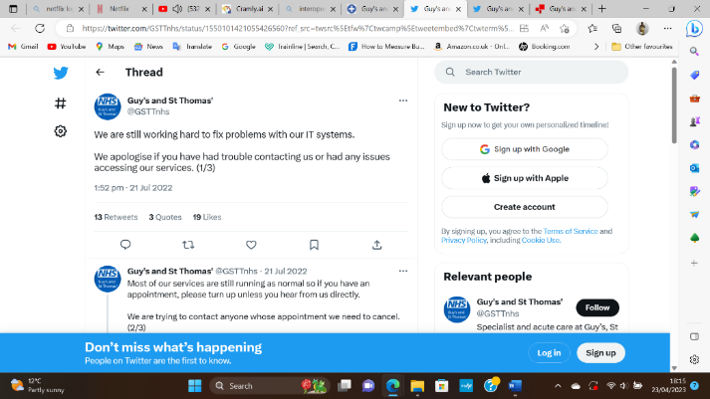
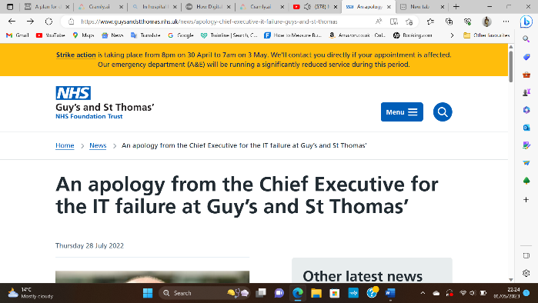
As solution to this IT issue, St. Thomas Hospital management took decisive action by contacting law enforcement agencies immediately and engaging with external experts specialising in cyber-security issues The hospital also communicated transparently with its stakeholders through regular updates via social media platforms like Twitter, email newsletters and press releases. (Thomas,2022) this is one of the posts.

St. Thomas Hospital management ensured minimal disruption by transferring some patients to nearby hospitals while working tirelessly around the clock with technical teams to restore normalcy back into their systems. By restoring backup data onto unaffected servers, eventually they managed to regain control over their systems after several days of hard work. Another crucial step that hospitals can take is implementing robust backup systems and disaster management strategies. This involves regularly backing up critical data to secure locations that are not connected to the internet or hospital networks. It also entails developing contingency plans for dealing with cyber-attacks and other disasters, including power outages and natural calamities.
To prevent future attacks on their systems, hospitals must take preventative measures such as conducting regular cybersecurity training sessions for employees. Employees need to be aware of the risks associated with opening suspicious emails or clicking on links from unknown sources. Cybersecurity training should also include guidelines on how to create strong passwords and avoid using public Wi-Fi connections when accessing sensitive information. In addition to these measures, hospitals should invest in advanced cybersecurity technologies such as intrusion detection systems and threat intelligence platforms. These solutions enable hospitals to detect potential threats early and respond promptly before significant damage occurs. They also provide real-time alerts on emerging threats within the industry and offer recommendations on how best to mitigate them. It is also crucial for hospitals to invest in robust backup systems and disaster management strategies that can mitigate any disruptions caused by cyber-attacks or other technological failures. These measures can significantly reduce the impact of such incidents on patient care and hospital operations. Finally, hospitals should collaborate with government agencies responsible for cybersecurity regulation and compliance standards. Such partnerships ensure that hospitals remain compliant with regulations while maintaining effective cybersecurity practices tailored for their spec.

Justification of Methodology
The qualitative methodology is the most appropriate approach for studying the IT issue in ST Thomas’ Hospital. This method involves collecting data through observation, interviews, and focus groups to gain an in-depth understanding of the problem. Qualitative research allows for a broader exploration of issues beyond what can be measured quantitatively. It also enables researchers to capture the subjective experiences and perspectives of individuals involved in the issue. Through this methodology, we can identify the main causes of the IT issues and understand how it affects hospital operations and patient care. Furthermore, we can also explore potential solutions that consider the needs an opinion of stakeholders, such as hospital staff and patients. Overall, using a qualitative approach will provide rich insights into the IT issue ST Thomas’ Hospital and help inform effective strategies for addressing it.

Credible Sources
BBC News, NHS website, ST Thomas’ Hospital, The Guardian and Scribbr these were the websites that I use to help me find out and understand even more about my topic. Google was one of them because I use Google Chrome to set up all these information. I use these sources because it was must easier for to discovery all the information regarding to my aims. Furthermore, I went to BBC News where I found the news regarding to IT issue in ST. Thomas’ Hospital. Also, NHS website was the website that explain me most of the problem. In addition, Scribbr set up the information about methodology, The Guardian website explain how this issue was affecting ST. Thomas’ Hospital.

Conclusion

In conclusion, the St. Thomas Hospital IT issue serves as a wake-up call for all healthcare organisations to prioritise their investments in cybersecurity and disaster management strategies. By partnering with expert IT security firms, implementing strong cybersecurity measures, and investing in reliable backup systems, hospitals can protect themselves against cyber threats and ensure that they continue to provide high-quality patient care without interruption. This issue was a reminder of how technology can fail us at unexpected times and how it is failure can have dire consequences. Moreover, it is essential for the hospital administration to invest in modern technology that can enhance patient care and streamline processes. This can include electronic medical records, online appointment booking systems, and virtual consultation services. These upgrades will not only improve the quality of care but also increase efficiency and reduce costs. In summary, the IT issues faced by St Thomas' Hospital require urgent attention and strategic planning to safeguard patient data and provide optimal healthcare services. By investing in modern technology, implementing strict cybersecurity protocols, and collaborating with expert IT companies, St Thomas' Hospital can mitigate risks and establish a robust IT framework that meets the highest standards of excellence in healthcare delivery. It also emphasises the need for hospitals and other organisations to invest in strong cybersecurity measures and ensure they are prepared with robust backup systems and disaster management strategies. Finally, collaboration with expert IT companies can provide additional support in maintaining a secure network infrastructure. Regular audits by these professionals can identify potential threats before they become major problems. It is crucial that St Thomas' Hospital takes a proactive approach towards securing, it is IT infrastructure to ensure uninterrupted patient care.

Reference
BBC, 2022. Home page. [Online]
Available at: https://www.bbc.co.uk/news/uk-england-london-62308447
[Accessed 27 April 2023].
Bhandari, P., 2020. Home page. [Online]
Available at: https://www.scribbr.com/methodology/qualitative-research/
[Accessed 1 May 2023].
Campbell, D., 2022. Home page. [Online]
Available at: https://www.theguardian.com/society/2022/jul/21/london-nhs-trust-cancels-operations-as-it-system-fails-in-heatwave
[Accessed 1 May 2023].
Thomas', G. a. S., 2022. Home page. [Online]
Available at: https://www.digitalhealth.net/2022/07/guys-st-thomas-heat-it-problems/
[Accessed 23 April 2023].
Thomas', G. a. S., 2022. Home page. [Online]
Available at: https://www.guysandstthomas.nhs.uk/news/apology-chief-executive-it-failure-guys-and-st-thomas
[Accessed 1 May 2023].
News, B., 2022. Home page. [Online]
Available at: https://www.bbc.co.uk/news/uk-england-london-62308447
[Accessed 28 April 2023].

