1.How can Jewellery Design design foster public empathy and drive action for the protection of endangered marine species?

2. Mandy Barker
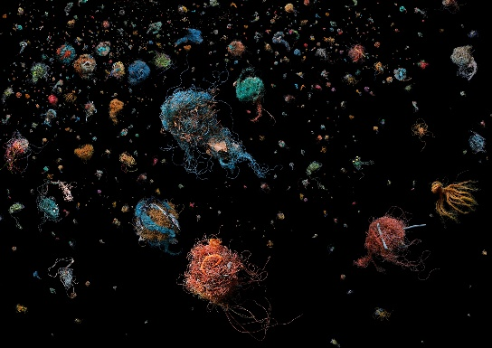
Mandy Barker is a British photographer with a longstanding focus on marine plastic pollution. She collects plastic waste from oceans worldwide, composing it into visually striking images that evoke starry skies, living creatures, or otherworldly landscapes. Series such as Soup and Adrift Beyond: Animals Not Fully Known reveal plastic's impact on marine life. Her approach is rigorous and research-driven, frequently involving collaborations with scientists to ensure authenticity. Through her art, she transforms unsettling environmental data into aesthetic experiences that evoke both wonder and sorrow in viewers. By making the invisible visible—translating abstract statistics into emotionally resonant imagery—she compels reflection on our own consumption habits.
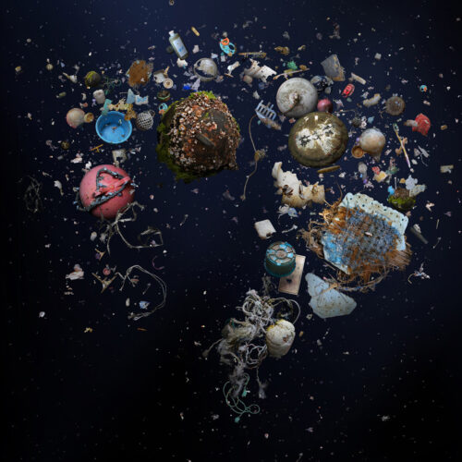

ralph steadman
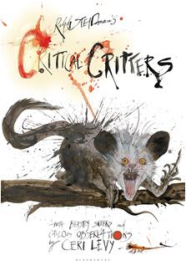
Frequently expresses outrage at environmental destruction and animal extinction through intense, even “aggressive” visual language. Ralph Steadman is a renowned British illustrator celebrated for his explosive ink splatter lines and exaggerated stylisation. He excels at conveying fury and criticism towards environmental destruction and species extinction through splattered ink dots, distorted animal forms, and stark black-and-white contrasts. In his animal conservation-themed works, he deliberately avoids depicting cute imagery, instead portraying creatures in states of anguish, fury or protest to provoke emotional resonance and reflection in viewers. His visually potent creations often employ scenes of apparent chaos to metaphorically convey ecological imbalance, thereby transforming environmental concerns into visually compelling expressions imbued with artistic tension and social agency.

3. Buck's creative approach has made me realise that aesthetics can serve as a powerful vehicle for environmental issues. Her ability to transform waste into art has inspired me to consider how conservation topics can be presented not merely as “problems”, but as visual narratives worthy of reflection. The Ocean Agency, meanwhile, has taught me the importance of accessibility and emotional resonance. Their use of diverse media forms reminds me that reaching different audiences requires flexible modes of expression. The prerequisite for protecting marine life is enabling people to “see” it—not merely as data, but as beings worthy of care. I aspire to balance aesthetic appeal with a sense of urgency in my work, using visual storytelling to bridge science and empathy.

4.A Toxic Love Story by Susan Freinkel
Freinkel explores our relationship with plastic, from its invention to its environmental consequences. This text helps me think about the materiality of pollution and how everyday objects become ecological threats. It informs the visual and conceptual direction of my project, especially in considering how to represent invisible threats like microplastics.

Art and Ecology Now by Andrew Brown
This book surveys contemporary artists engaging with environmental issues. It helps me think about the role of art in ecological discourse—how it can provoke, educate, and inspire. It connects to my project by offering a framework for positioning my work within a broader cultural and activist context, and by showing how others have navigated similar questions.

Silent Spring by Rachel Carson. This book helped me understand how environmental destruction often becomes invisible until it is too late. It connects to my project because I want my poster to make ecological crisis visually visible and emotionally immediate. This connects strongly to endangered animal art and design because many threats to wildlife today—pollution, habitat loss, climate change—are not always visually dramatic. They are systemic and gradual. As a designer, this challenges me to think about how to visualise the invisible. For example, I could use fading forms, dissolving textures, or layered imagery to suggest contamination and disappearance. Carson’s work reminds me that effective environmental design should not only show animals as victims but also reveal the hidden systems harming them. Her approach encourages me to combine emotional impact with conceptual clarity, making the ecological crisis both intellectually understandable and visually urgent.

