

LCLM-6005 (BIRM)

Title: Investigating Transparency and Fairness in Algorithmic Pricing at Uber: Impacts on User Trust, Driver Satisfaction, and Business Performance

An Explanatory Study

By
Muhammad Imran Khan (2314191)

Supervisor Name:
Dr Fa (Frank) Wang

Dissertation submitted part of the requirements for the award of BA Leadership and Management
July 2026


Date: 26th June 2026

ACKNOWLEDGEMENT


Contents
Title: Investigating Transparency and Fairness in Algorithmic Pricing at Uber: Impacts on User Trust, Driver Satisfaction, and Business Performance 2
An Explanatory Study 2
ACKNOWLEDGEMENT 4
CHAPTER 1: INTRODUCTION 10
1.1 Introduction 10
1.2 Background 10
1.2.1 Surge Pricing 10
1.2.2 The Root Problem: Algorithmic Opacity 11
1.3 Research Aim 11
1.4 Research Objectives 12
1.5 Research Questions 12
1.6 Chapter Summary 12
CHAPTER 2: LITERATURE REVIEW 14
2.1 Introduction 14
2.2 Theoretical Frameworks 15
2.2.1 The Psychology of Fairness 15
2.2.2 Distributive Fairness and Equity Theory 15
2.2.3 Procedural Justice and Algorithmic Decision-Making 15
2.2.4 Fairness Heuristic Theory and Trust 16
2.3 Trust in Digital Platforms 16
2.3.1 The Dimensions of Trust 16
2.3.2 Algorithmic Opacity and Trust Erosion 17
2.4 Market Realities 17
2.4.1 Surge Pricing and Consumer Perception 17
2.4.2 Driver Outcomes and Structural Inequality 18
2.4.3 Synthesis: The Need for an Integrated Framework 18
2.5 Chapter Summary 19
CHAPTER 3: METHODOLOGY 20
3.1 Research Design and Framework 20
3.2 Questionnaire Operationalization Strategy 20
3.3 Quantitative Data Infrastructure 20
3.3.1 Data Collection Instruments 21
3.4 Target Population and Sampling 21
3.4.1 Inclusion, Exclusion, and Participant Screening 22
3.5 Qualitative Phase: Face-to-Face Discussions 22
3.6 Data Analysis Protocols 22
3.7 Ethical Considerations 23
3.8 Chapter Summary 23
CHAPTER 4: RESULTS AND DISCUSSIONS 24
4.1 Introduction 24
4.2 Results 24
4.3 Descriptive Results of Study Cohorts 24
4.3.1 Participant Ride Frequency 24
4.3.2 Geographic Distribution of Rider Cohort 25
4.3.3 Rider Exposure to Surge Pricing 25
4.3.4 Driver Occupational Status 26
4.3.5 Driver Tenure and Platform Experience 27
4.3.6 Driver Weekly Schedule and Operational Intensity 27
4.4 Integrated theoretical framework output (Riders) 28
1: Perceived Transparency (Procedural Justice) 28
1. Fare Calculation Transparency and Clarity 28
2. Surge Pricing Communication and Justification 29
3. Itemized Cost Breakdown Sufficiency 30
2: Perceived Fairness (Equity Theory) 30
1. Price-to-Value Proportion and Fairness 30
2. Peak-Hour Pricing and Exploitation Boundaries 31
3. Perception of Exploitation 32
3: Trust 32
1. Ethical Trust in Pricing Practices 32
2. Impact of Price Discrimination on Consumer Trust 33
3. Competitive Switching and Market Navigation 34
4: Behaviorial Intention 34
4.5 Integrated theoretical framework output (Drivers) 35
1: Transparency (Procedural Justice) 35
1. Algorithm Comprehension and Remuneration Mechanics 35
2: Fairness (Equity Theory) 36
1. Compensation Equity Relative to Effort and Hours 36
2. Surge Pricing Validity and Ground Conditions 36
3: Trust (Trust Theory) 37
1. Institutional Confidence in Pricing Policy Updates 37
2. Automated Dispute Resolution Trust for Cancelled Trips and Fares 38
4: Behavioural Intentions 38
1. Short-Term Driver Retention and Platform Dependency 38
2. Retention Likelihood and Economic Dependency 39
4.6 Discussions 40
4.6.1 Thematic analysis 43
CHAPTER 5: CONCLUSION AND RECOMMENDATIONS 45
5.1 Conclusion 45
5.2 General Recommendations 46
5.2.1 Solution: Core Operational Mechanics 46
5.3 Limitations 47
REFERENCES 48
APPENDICES 52
1) Pearsons Correlation (r) calculation of riders in terms of fairness, trust and behavioural intension with respect to transparency 52
1.1) Result 53
2) Pearsons Correlation (r) calculation of Drivers in terms of fairness, trust and behavioural intension with respect to transparency 54
2.1) Result 54
3) Cronbach’s Alpha Score 54

LIST OF FIGURES
Figure 1: User ride frequency 24
Figure 2: User Geographic distribution 25
Figure 3: User Ride Surge 26
Figure 4: Drivers operational status 26
Figure 5: Driving Timeline 27
Figure 6: Driver operational frequency 28
Figure 7: User clarity of fares 29
Figure 8: Users surge price information 29
Figure 9: Breakdown and justification of fare 30
Figure 10: User proportion and fairness 31
Figure 11: User perception of exploitation 31
Figure 12: Users trips consistency 32
Figure 13: Users ethical and fairness perceptions 33
Figure 14: User trust and price consistency 33
Figure 15: User other platform consideration 34
Figure 16: User Retention 35
Figure 17: Drivers comprehension of fare calculation 35
Figure 18: Users compensation and expectations 36
Figure 19: Reflection of surge pricing and ground realities 37
Figure 20: Drivers trust on platform policies 37
Figure 21: Drivers trust in automated systems 38
Figure 22: Drivers continuation and retention 39
Figure 23: Driver view of platform omission and service 40

LIST OF TABLES
Table 1: Core Dimension variables for survey instruments 20
Table 2: Cronbach's alpha validity range 22
Table 3: Drivers Behavioural Stats 43
Table 4: Pearsons Correlation (r) calculation of riders (1) 52
Table 5: Pearsons Correlation (r) calculation of riders (2) 53
Table 6: Pearsons Correlation (r) calculation of riders’ result 53
Table 7: Pearsons Correlation (r) calculation of Drivers in terms of fairness, trust and behavioural intension with respect to transparency (1) 54
Table 8: Pearsons Correlation (r) calculation of Drivers in terms of fairness, trust and behavioural intension with respect to transparency: Result 54
Table 9: Cronbach's Alpha Score for Riders 54
Table 10: Cronbach's Alpha Score for Drivers 55

ABBREVIATIONS
Abbreviation | Full Form
AI | Artificial Intelligence
WIE | Work Info Exchange
IT | Information Technology

CHAPTER 1: INTRODUCTION

1.1 Introduction
This dissertation deals with the increasing tension between efficiency of algorithms and trust of stakeholder through investigation of how opaque pricing mechanism of Uber impact the perceptions of its users, satisfaction of drivers, and long-term sustainability of the platform. Uber Technologies Inc. is operational a digital platform by connecting riders and drivers in about 405 cities across 60 countries throughout the world. Additionally, the services like freight, food delivery are provided by Uber but its ride-hailing the primary generator of revenue (Uber, 2026a). Fares are calculated in real-time across the platform of Uber by utilization of algorithms which are calculating and predicting demand, availability of drivers, distance and time of travel, and overall traffic. Uber functions as a digital intermediary which implies that it is a digital platform which classifies drivers as independent contractors instead of employees (Slavulj, Kanizaj and Durdevic, 2016). This business model allows for rapid scaling, but it drives a wedge in terms of transparency in pricing and the distribution of earnings between the platform and drivers.

1.2 Background
Operational as a digital intermediary in the ride-hailing sector, Uber is dependent on AI, data analytics and algorithmic matching and IT infrastructure (Uber, 2021) for setting real-time fares depending on demand, traffic, and availability of drivers. Platform of uber provides real-time connectivity of drivers and riders. Drivers use the Uber Partner app on their smartphone which indicates their availability. Uber Client app is used by riders for determination of the availability of rides and catch on estimated prices.
1.2.1 Surge Pricing
Calculation of fare of Uber changes depending on local transportation laws. It usually includes a minimum base fare, per mile cost, per minute cost and lastly tolls and taxes. The base fare and charges are dependent varying subject to the type of vehicle like UberX, Ubber Go, UberBLACK and so on (Uber, 2026b). A dynamic pricing component widely known as the surge multiplier was introduced in 2012 by Uber. As suggested by its name, prices of fare are multiplied via surge multiplier. Initially the multiplier is 1, which increases during periods of high demand. According to Uber, the two goals of this system are firstly higher profits, increasing supply by stimulating drivers to be online. Secondly the higher prices that may result in reduction of demand by discouragement of price-sensitive or fluctuating customers. Very less is known about surge pricing algorithm of Uber or if the system successfully addresses imbalances between supply and demand (Chen, Mislove and Wilson, 2015). Based on location surge multipliers modify, and it is suggested in recent measurements that the multipliers are updated or modified every 3-5 minutes (Diakopoulos, 2015).

1.2.2 The Root Problem: Algorithmic Opacity
Success for the platform requires balancing rider demand with driver supply (Uber, 2024). Disruptions to this balance weaken overall performance. Governments now are scrutinizing these algorithmic models, raising concerns about fairness and labour protection. Uber’s current pricing system is often viewed as opaque. Riders report sudden price shifts without clear breakdowns, while drivers face inconsistent commission structures. According to the University of Oxford (2025), these issues diminish user trust and impact driver income predictability. Analysis by Stichting WIE International (2025) indicates that new pay algorithms have shifted financial risk onto drivers, with commission rates occasionally exceeding 50% of the fare.
These indicators suggest that the root problem is algorithmic opacity, leading to systemic unpredictability. Due to the reason of these pricing mechanisms being complex, empirical study is required to assess how perceptions of unfairness influence trust and platform stability. Without clarity, the company risks rider churn, lower driver retention, and increased regulatory intervention.

1.3 Research Aim
This research inspects that how pricing algorithm of Uber impacts and affects trust and satisfaction of users and drivers. It focuses on the gap between the dynamic mechanics related to pricing of platform and the actual real-life practical experience of riders and drivers. The study identifies how perceptions of fairness and long-term service usage is impacted by opaque pricing for both riders and drivers within a combined single framework. Link between fluctuating structures of commission and driver income stability are analysed. By investigation these relationships, empirical evidence is gathered on how platform stability is impacted by pricing opacity.
The primary goal is the provision of evidence-based strategies for pricing design. These recommendations aim for improvement of transparency without stopping the platform from adjusting prices based on supply and demand. The findings will help in determining whether clearer fare breakdowns and better earnings forecasting tools can result in reduction suspicion and keep both riders and drivers engaged with the service. This work moves past assumptions to offer clear, practical improvements for platform governance.

1.4 Research Objectives
- Examination of how users and drivers perceive fairness, transparency, and clarity in Uber’s algorithmic pricing and commission system.
- Assess drivers’ understanding and comprehension of fare calculations, deductions in commission, and distribution of earnings, and analyse how this influences their satisfaction and income predictability.
- Develop evidence-based strategic recommendations that enhance pricing transparency while maintaining the effectiveness of dynamic pricing mechanisms.

1.5 Research Questions
RQ1: To what extent do users perceive Uber’s pricing algorithm as fair, transparent, and consistent?
RQ2: How evidently do drivers understand fare and commission structures, and how does this affect their satisfaction and perceptions of income stability?
RQ3: What is the relationship between perceived pricing transparency and key outcomes such as user trust, continued usage, and driver retention intentions?

1.6 Chapter Summary
Chapter 1 has provided an outline of Uber is operational within the industry of ride-hailing, while emphasizing its dependency on algorithm-driven systems for connecting riders and drivers. The discussion outlined the Uber functional model which makes it operate as a digital intermediary, highlighted the core role of data analytics in real time in determination of fares based on factors such as demand, supply, distance, and traffic conditions.
It is further explored in the chapter the concept of dynamic pricing emphasizing focus on surge pricing as a mechanism designed for balancing demand of market and availability of driver. While enabling efficiency and scalability of operations, significant challenges are introduced in relation to transparency, fairness, and predictability of income. Concerns revolving around algorithmic unclarity were identified as a core issue, which effects trust of rider and satisfaction of driver (M. Kamraju, 2025). The lack of clarity in fare calculations and commission structures has been shown to contribute to perceptions of unfairness, thereby influencing user behaviour, driver retention, and overall platform stability.
In response to these challenges, the chapter established the research aim, which is to examine the impact of Uber’s pricing algorithm on user trust and driver satisfaction. The research objectives were outlined to investigate perceptions of fairness and transparency, assess drivers’ understanding of pricing and earnings distribution, and develop strategic recommendations to improve transparency while maintaining the effectiveness of dynamic pricing systems.
In conclusion, the research questions were presented to guide the study, focusing on the extent of perceived fairness and transparency, the level of driver understanding of pricing mechanisms, and the relationship between transparency and key outcomes such as trust, continued usage, and retention. Overall, this chapter lays the conceptual and contextual foundation for the next Chapter 2: Literature Review for the subsequent investigation into algorithmic pricing and its implications for platform governance and sustainability.

CHAPTER 2: LITERATURE REVIEW

2.1 Introduction
Price surging, also known as dynamic pricing or algorithmic pricing, has become pervasive in digital platform economies. Utilizing machine-learning techniques and real-time data, prices to changing supply-and-demand conditions are updated by firms (Chen et al., 2017). The boom of ride-hailing platforms has repositioned the traditional understanding of pricing of market, drifting away from static models toward algorithm-driven mechanisms that are complex, standard-bearers suggest that improves economic efficiency is improved by dynamic pricing and it mitigates market frictions by encouragement of drivers to be available at the periods of high demand (Castillo, Knoepfle, & Weyl, 2017). Dynamic pricing mechanisms can lessen shortages and reduce wait timing by inducing drivers in working at times when demand exceeds supply. It in turn leads to better performance and reliability of the platform. Despite its potential advantages, sentiment of public regarding dynamic pricing remains mixed. It can be interpreted as unfair practice specially in situations like occurrence during emergencies, natural disasters, or public events (Haws & Bearden, 2006). While design of these systems is for balancing market equilibrium between rider demand and driver supply, they simultaneously lead to introduction of significant challenges regarding transparency, fairness, and stakeholder trust (Zarsky, 2016). This chapter critically examines the academic literature surrounding algorithmic pricing, focusing on how these systems impact the perceptions and behaviours of both riders and drivers within the digital platform economy.
In order to understand the complex dynamics of this environment, this review integrates several key theoretical frameworks. First, it analyses Equity Theory and Procedural Justice Theory, which provide a foundation for understanding how stakeholders evaluate fairness not only based on final costs or earnings but also on the perceived legitimacy of the processes that determine them. Furthermore, it incorporates Fairness Heuristic Theory and Trust Theory to explore how algorithmic opacity functions as a barrier to building long-term relationships between platform providers and their users.
In addition to these theoretical lenses, this chapter synthesizes empirical evidence regarding the specific impact of dynamic and surge pricing. It distinct the platform-driven objectives relating to operational efficiency and scalability with the endured experiences of stakeholders, particularly regarding volatility of income for drivers and price unpredictability for riders. By identification these tensions, a significant gap in existing research is highlighted by this review. While academic focus has often revolved in isolation for either around the consumer or the driver, lack of integrated study exploring how transparency influences both sides of the marketplace within a unified framework exists. Conceptual basis for the study are established in this chapter, demonstrating that addressing algorithmic opacity is not merely a technical concern but a strategic priority for platform sustainability and governance.

2.2 Theoretical Frameworks
The dissertation investigates the transparency and fairness of Uber’s algorithmic pricing by integrating several key theoretical frameworks from behavioural economics, management, and organizational justice. These frameworks help explain how stakeholders (riders and drivers) perceive, evaluate, and react to dynamic pricing.

2.2.1 The Psychology of Fairness
Analysing reactions to dynamic pricing, it is vital for establishing how individuals define and evaluate fairness in transactional exchanges. Research in this field suggests that fairness not being a static concept rather it is a dynamic judgment which is shaped by both outcomes and the processes determining them. As reported by Yeomans (2019), there is a lot of scepticism in consumers when transparency in the reasoning is lacked in algorithmic decision-making. In the ride-hailing case, part of what makes consumers so uncertain is that pricing structures are opaque, leaving would-be riders unsure whether their price was increasing in an effort to optimize efficiency or, instead, company profits.

2.2.2 Distributive Fairness and Equity Theory
At the foundation of fairness evaluation is Equity Theory, which posits that individuals assess the justice of an exchange by comparing their input-output ratios to those of others (Adams, 1965). In the context of ride-hailing, this involves a comparison between the price paid or earned and the perceived value received. Anderson and Wieseke (2015) argue that fairness perceptions emerge when individuals compare their costs with those of other users or market standards. Building on this, Kahneman, Knetsch, and Thaler (1986) discuss fairness in terms of a social norm. When surge pricing causes irregular price fluctuations for the same route, riders may perceive this as a violation of distributive fairness, as they cannot justify the discrepancy based on the service provided.

2.2.3 Procedural Justice and Algorithmic Decision-Making
While the focus of distributive fairness is on the result of a transaction, Procedural Justice Theory emphasizes that individuals assess the fairness regarding processes that are producing those results (Thibaut and Walker, 1975; Leventhal, 1980). In traditional markets, pricing processes are having transparency followed by established norms. However, within algorithmic pricing systems, the decision logic is frequently obscured, making it difficult for stakeholders to evaluate the legitimacy of the process. Even when aa adjustment of price is justified economically by supply and demand, users have a possibility in questioning the fairness of the algorithm if the mechanism remains opaque (Leventhal, 1980). Consequently, the lack of transparency in calculation of fares by Uber can be interpreted as a failure of procedural justice, leading to suspicion rather than acceptance of price volatility.

2.2.4 Fairness Heuristic Theory and Trust
Fairness Heuristic Theory provides a critical view to understand how stakeholders navigate this uncertainty. Lind (2001) proposed that when individuals are facing environments that are complex where logic decision is hidden, they use perceived fairness as a mental shortcut, a heuristic, determining whether the system is legitimate and worthy to trust. For Uber users and drivers, the algorithmic "black box" forms a basis of a state of high uncertainty. In the absence of clear information, stakeholders are reliant on their perceptions of fairness in deciding continuation of usage or working for the platform (Lind, 2001). Bolton, Warlop, and Alba (2003) hold the view that a huge impact on satisfaction and long-term loyalty is because of perceived price fairness. If the system is viewed as fundamentally unfair, this heuristic works as a signal for distrusting the platform entirely, leading to reduction in engagement or churn. This suggests that for digital platforms, fairness is not just a secondary concern rather it acts as a primary driver trust and retention of stakeholder.

2.3 Trust in Digital Platforms
In the context of digital intermediaries like Uber, trust serves as the primary mechanism for mitigating the risks associated with information asymmetry. Because the platform acts as a "black box" where decision-making logic is hidden from participants, the reliance on trust becomes more acute than in traditional service environments. Fudenberg and Villas (2006) add that, while behavior-based pricing strategies may be cost-effective, they can backfire when viewed as discriminatory or deceptive.

2.3.1 The Dimensions of Trust
According to Mayer, Davis and Schoorman (1995), Trust Theory suggests that stakeholder confidence is built upon three distinct perceptions: ability, benevolence, and integrity.
- Ability: This reflects the competence of platform in provision of a reliable service, such as accurate matching and timely arrivals.
- Benevolence: This perception denotes that the platform is acting in the best interest of its stakeholders instead of sole prioritization its own profit margins.
- Integrity: This is related to the adherence of platform to a set of acceptable principles, with the inclusion of transparent communication regarding pricing and earnings.
Frequent or unexplained price surges may weaken perceived benevolence, while opaque pricing mechanisms may reduce perceived integrity. Consequently, diminished fairness perceptions may translate into reduced trust of user and lower long-term engagement.

2.3.2 Algorithmic Opacity and Trust Erosion
The lack of transparency inherent in algorithmic management directly challenges these dimensions of trust. Pasquale (2015) contends that when decision processes remain hidden, the platform undermines its own credibility because stakeholders cannot scrutinize the logic behind price surges or commission deductions. When Uber’s pricing logic is perceived as inconsistent or opaque, it signals a potential lack of integrity, which directly weakens the perceived benevolence of the platform.
Mittelstadt et al. (2016) further observes that trust significantly declines when algorithmic decisions lack adequate explanation. For riders, an unexplained price spike can be interpreted as exploitation, while for drivers, the inability to understand how their earnings are calculated creates a sense of vulnerability. Consequently, the "black box" nature of these systems functions as a significant barrier to maintaining long-term stakeholder engagement, as the inability to verify the fairness of a transaction forces users and drivers to rely on perceptions rather than facts to assess the platform’s reliability.

2.4 Market Realities
The operational reality of Uber’s pricing model is defined by a continuous tension between achieving market efficiency and managing the socio-economic impacts on its participants. Empirical research suggests that while dynamic pricing serves as a functional tool for market clearing, its practical application results in divergent outcomes for riders and drivers.

2.4.1 Surge Pricing and Consumer Perception
It is indicated in the research that critical moderator in consumer perception is transparency. Ameen and Malik (2026) report that through enhanced transparency, perceived unfairness among users is reduced by 18%. Furthermore, presentation of surge pricing as a form of "demand management" rather than "maximization of profit " reduces perceptions of unfairness by an additional 15%. However, the recurrence of these pricing events is problematic; Ameen and Malik (2026) found that frequent surges are associated with a 25% increase in negative evaluations by customers, suggesting that perceptions of exploitation are significantly amplified when dynamic pricing is experienced repeatedly.

2.4.2 Driver Outcomes and Structural Inequality
Employee satisfaction is considered as a consonance between rewards given by the work environment and the desire of the individual for these rewards ((Scarpello and Vandenberg, 1992, p.125). Consumer-focused findings are challenged by research examining driver outcomes highlighting structural concerns regarding earnings and predictability. By analysing 1.5 million UK trips, Binns et al. (2025) determined that dynamic pricing significantly resulted in reduction of earnings predictability and elevated income inequality among drivers. Although a standard 25% commission rate is proclaimed by Uber, the study found that the median take rate has risen to 29%, with some specific instances exceeding 50%. Employee behaviour and attitude is seriously influenced by financial pressure and thereby the general level of satisfaction (Brett, Cron and Slocum, 1995, p.261). These findings indicate that algorithmic pricing may effectively shift economic risk toward drivers while simultaneously increasing platform margins.

2.4.3 Synthesis: The Need for an Integrated Framework
Ride-hailing is in contrast immediate, personal services where price sensitivity or fairness expectations might vary. Secondly, few empirical studies systematically view how transparency, frequency of surge, and framing of pricing rationales interact in affecting fairness perceptions in algorithmic-mediated markets. Third, despite existing work on distributive and procedural fairness, relatively little is known this context about the interactional dimension of fairness in, especially how platforms are communicating their strategies. Regardless of growing body of literature on fairness, transparency, and income volatility, a there remains a significant research gap. In most existing studies consumers or drivers are examined in isolation. Consumer research emphasizes trust and psychological perception, whereas structural inequality and earnings instability is highlighted in driver research. Within a unified framework, limited research currently blends these perspectives. This division underlines the need for a study, examining how the interconnected relationship between trust of user, satisfaction of driver, and the long-term sustainability of the platform are influenced by algorithmic transparency.
For addressing the identified research gap, this dissertation adopts an integrated theoretical framework by utilization Procedural Justice Theory for evaluating the neutrality and transparency of determining algorithmic price. Furthermore, it incorporates Equity Theory for quantifying the tension between driver and labour inputs and related financial outcomes. Lastly it integrates Trust Theory as an overarching lens for analysing the behavioural consequences of perceived unfairness across both consumer and driver populations.

2.5 Chapter Summary
Chapter 2 provides a comprehensive review of the academic landscape surrounding algorithmic pricing, establishing that fairness is a dynamic judgment rather than a static concept, often leading to scepticism when algorithmic decision-making lacks transparency. By integrating Equity Theory, which evaluates the justice of exchanges based on input-output ratios, and Procedural Justice Theory, which examines the legitimacy of the processes themselves, this review addresses how stakeholders navigate the uncertainty of "black box" pricing. Furthermore, by incorporating Fairness Heuristic Theory and Trust Theory which identifies ability, benevolence, and integrity as core pillars. This chapter explores how algorithmic opacity serves as a barrier to stakeholder retention. The synthesis of empirical evidence reveals a clear research gap, as existing studies often isolate consumer perceptions of unfairness from the structural concerns of driver earnings instability. Consequently, this dissertation adopts an integrated theoretical framework, utilizing Procedural Justice Theory to evaluate the neutrality and transparency of algorithmic price determination, Equity Theory to quantify the tension between driver labour inputs and financial outcomes, and Trust Theory as an overarching lens to analyse the behavioural consequences of perceived unfairness across both consumer and driver populations. Building upon the theoretical and empirical foundations established here, Chapter 3 will detail the methodology employed to operationalize these concepts, providing a structured approach for evaluating the mechanisms of algorithmic transparency and fairness.

CHAPTER 3: METHODOLOGY

3.1 Research Design and Framework
This research adopts a mixed-methods approach, combining quantitative and qualitative techniques. Mixed-methods designs are beneficial in inquiring complex socio-technical phenomena like algorithmic fairness. Measurable behaviour changes is determined by these methods while also catching subtle perceptions that are subjective (Creswell & Plano Clark, 2017). The nature of this research is explanatory, examining the relationships between perceived algorithmic transparency, perceptions of fairness (distributive and procedural), trust, and satisfaction of stakeholder within ride-hailing platforms. Employing a parallel convergent mixed methods approach this study implements gathering quantitative survey data from both riders and drivers to evaluate the impact of algorithmic management on trust, fairness, and procedural justice. Combining quantitative survey instruments with supplementary qualitative items like semi structured interviews allowed a robust examination of how platform pricing transparency affects user and driver behaviour.

3.2 Questionnaire Operationalization Strategy
For operationalizing the variables outlined in the research framework, custom measurement instruments were developed using a targeted literature search on Google Scholar. This search identified the anchor publication by Ameen and Malik (2026), which establishes the foundational definitions for Equity Theory, Trust Theory, Procedural Justice Theory, and Fairness Heuristic Theory. Rather than conducting a systematic literature review to synthesize historical data, this search served exclusively as an instrument-building strategy. The theoretical definitions and metrics extracted from Ameen and Malik (2026) were adapted into platform-specific linear scale questionnaires. These custom items capture the lived experiences of both Uber riders and drivers encountering algorithmic pricing deployed via Google Forms. The outcome variables were perceived fairness, platform trust, and continued use intention. Reactions were assessed by means of Likert scales used in previous studies on fairness perception (Bolton, Warlop, and Alba, 2003).

3.3 Quantitative Data Infrastructure
Primary quantitative responses were compiled via a cloud-integrated data architecture. Specifically, two distinct, structured instruments deployed through Google Forms utilized linear interval Likert scales to capture user metrics. These platforms dynamically transferred real-time entries directly into centralized, cloud-hosted Google Sheets relational databases. To safeguard confidentiality and integrity, raw datasets were isolated and maintained within an encrypted Google Drive repository, with access restricted to prevent unauthorized viewing or modification.

3.3.1 Data Collection Instruments
Two custom survey instruments were developed to capture parallel psychological constructs from both perspectives: The questionnaire measures core constructs using Likert-scale items anchored from 1 (Strongly Disagree) to 5 (Strongly Agree) based on the dimension variables:
Table 1: Core Dimension variables for survey instruments
Dimension | Riders | Drivers
Transparency (Procedural Justice) | Understanding of upfront fares, surge triggers, and fee breakdowns. | Understanding of earnings calculations, dispatch logic, and commissions.
Fairness (Equity Theory) | Alignment of fares with service value, distance, and market rates. | Compensation for fuel, maintenance, and working hours.
Trust (Trust Theory) | Confidence in surge pricing fairness and customer support resolution. | Trust in automated support, dispute resolution, and time tracking.
Behavioral Intentions | App retention, recommendation likelihood, and platform switching. | Retention likelihood, recommendation willingness, and migration.

3.4 Target Population and Sampling
A non-probability purposive sampling technique was employed for this research, targeting a sample size of n = 25 for both riders and drivers separately within UK. This technique enabled the research in focusing on participants who were diverse in demographics and in ride-hail usage frequency, thus fetching out a variety of responses (Patton, 2002). Participants were deliberately selected based on two rigid eligibility constraints: direct operational or consumer experience with ride-hailing platforms and explicit exposure to automated surge pricing mechanisms. To ensure data integrity, a multi-stage screening strategy was applied using automated binary gatekeeping filters embedded at the start of the online instruments.

3.4.1 Inclusion, Exclusion, and Participant Screening
- Rider Cohort Inclusion Criteria: Participants must be at least 18 years of age and hold active user histories with the Uber platform involving direct exposure to automated surge pricing events. Individuals less than 18 years of age or those having no direct transactional experience with ride-hailing applications were automatically exempted from the study.
- Driver Cohort Inclusion Criteria: Participants must be currently or former Uber drivers working on either a full-time or part-time basis. Individuals with no operational driving history on ride-hailing networks were filtered out prior to survey initiation.

3.5 Qualitative Phase: Face-to-Face Discussions
The qualitative phase included face-to-face semi-structured interviews with 2 Uber drivers and 2 riders respectively. This track operated entirely separate from mathematical calculations and were analysed thematically (Braun and Clarke,2006).
Comprehensive textual notes captured during each session were reviewed to achieve data immersion. Open codes were generated directly from participant statements regarding dynamic surge multipliers, operational transparency, and financial equity. These codes were clustered into broader themes mapped to Procedural Justice Theory, Equity Theory, and Fairness Heuristic Theory.

3.6 Data Analysis Protocols
The measurement instruments were self-developed from theoretical constructs due to which rigorous internal consistency checks are essential. Content validity was established by mapping every linear scale question directly to peer-reviewed definitions of fairness, equity, and trust. Following data collection, scale reliability will be evaluated using Cronbach's alpha α within the Google Sheets database prior to final correlation analysis.
Table 2: Cronbach's alpha validity range
Cronbach's Alpha Range (Connelly, 2007) | Academic Interpretation
α ≥ 0.90 | High Internal Consistency
0.80 ≤ α < 0.90 | Reliable
0.70 ≤ α < 0.80 | Acceptable
α < 0.70 | Removeable

Given the exploratory design and sample size of n=25 per cohort, the analysis evaluated linear associations between variables. Relationships were assessed using the Pearson Correlation Coefficient (r) in Excel for determining the strength and direction of associations without assuming causality. This analysis will strictly evaluate how variables move together linearly, avoiding over-extended causal modelling due to the exploratory sample constraints.

3.7 Ethical Considerations
Ethical compliance is implemented via mandatory informed consent, full anonymity, and strict security of data. Every participant had to agree to study terms before accessing the survey. The right to withdraw at any time without consequence was retained thoroughly. No personally identifiable information is collected, protecting financial sensitivity, while all quantitative records and interview notes remained isolated in a private, password-protected, encrypted Google Drive repository accessible exclusively by the primary researcher.

3.8 Chapter Summary
This chapter outlines a parallel convergent mixed methods design for examining how ride-hailing algorithmic pricing is affected transparency, fairness, trust, and behavioural intentions. A non-probability purposive sampling method to target 25 UK riders and 25 UK drivers was used through cloud-integrated Google Forms. Custom survey instruments measure core variables using Likert scales, while semi-structured interviews with 4 total participants provide qualitative insights analysed via thematic analysis. Data integrity and internal consistency are managed through Cronbach's alpha reliability checks, secure Google Drive storage, and Pearson correlation analyses to evaluate linear associations without assuming causality.

CHAPTER 4: RESULTS AND DISCUSSIONS

4.1 Introduction
Chapter 4 offers a descriptive and statistical analysis of the data which was collected in this study. Key findings through summary statistics and explores the relationships between variables are outlined utilizing appropriate analytical techniques. In addition, this chapter discusses the emergent patterns within the results with the provision of interpretation and linking them to the research objectives. The aim is to provide a clear understanding of the data trends and their implications for the study.

4.2 Results
This section presents the descriptive results of the study cohorts alongside the empirical findings derived from the integrated theoretical framework questionnaire.

4.3 Descriptive Results of Study Cohorts
This section details the demographic and behavioural characteristics of the participant samples. It establishes the baseline profile for both the rider and driver cohorts. The following data defines key operational metrics, geographical distributions, and platform usage frequencies to provide context for the survey responses regarding dynamic pricing.

4.3.1 Participant Ride Frequency
Ride frequency across of riders five categories was reported for capturing behavioural patterns and platform engagement. The modal response indicated that the largest proportion of respondents used the platform once a week (36%) which is followed closely by users who use it multiple times a week (32%). Less frequency of usage is comparatively limited, with 12% using the platform once or twice a month and another 12% who use it rarely, while only 8% report daily use. Overall, the distribution indicated that a clear majority of riders (68%) engaged with the platform on a frequent, weekly basis.
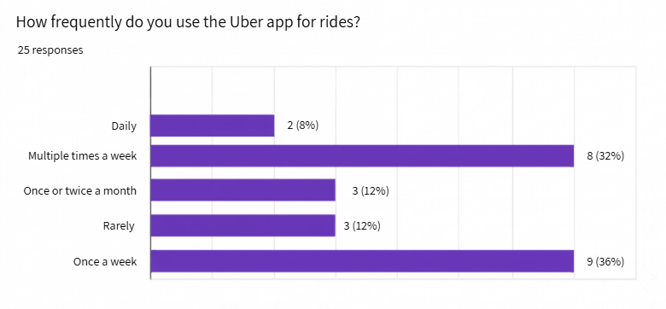
Figure 1: User ride frequency

4.3.2 Geographic Distribution of Rider Cohort
For examining geographic distribution, participants were asked to be identified in the primary location where they use the Uber application. It captured regional engagement across the United Kingdom. As a result, the data spanned across 12 distinct locations with indication of broad geographic coverage rather than concentration in a single area.
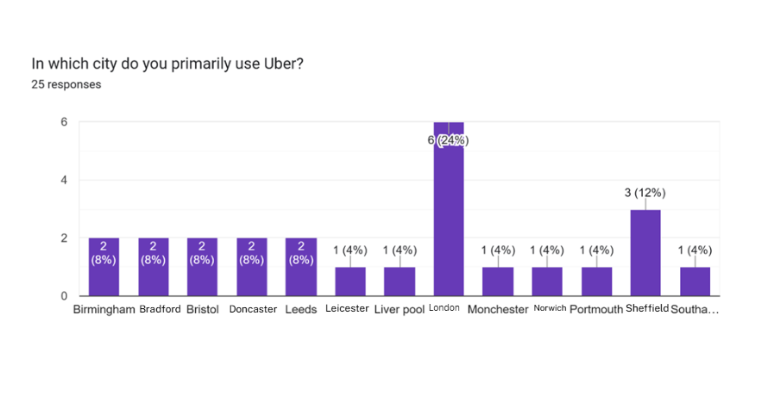
Figure 2: User Geographic distribution

4.3.3 Rider Exposure to Surge Pricing
For assessing transparency of platform and awareness consumers of dynamic pricing, participants were asked whether they had experienced surge pricing during the usage of application. The results indicated a majority with 92% of respondents, who reported that they had encountered surge pricing. This highlights that dynamic fare adjustments are a prevalent and widely recognized feature among the riders in survey. In contrast, only a small minority reported otherwise, with 4% stated they had not experienced surge pricing while uncertainty was indicated by another 4%. Collectively, these responses account for just 8% of the sample which means that exposure to algorithm-driven price fluctuations is nearly universal within this cohort.
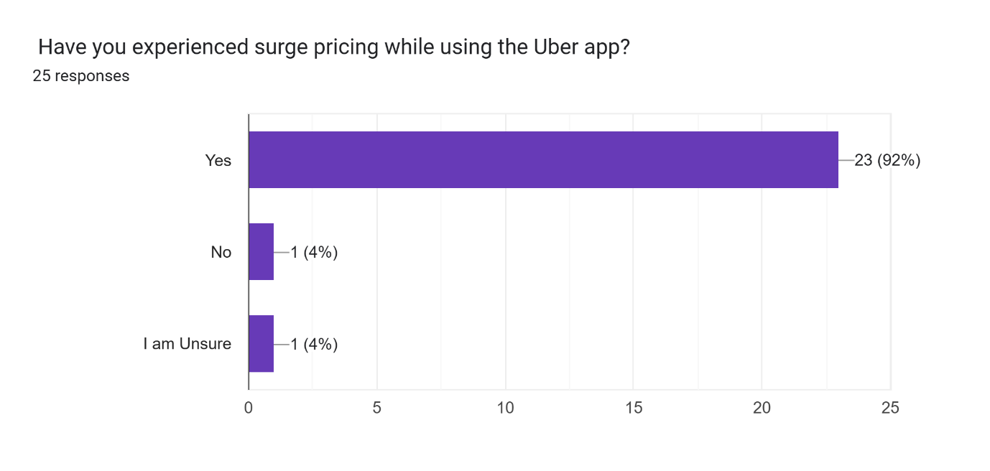
Figure 3: User Ride Surge

4.3.4 Driver Occupational Status
Establishing a professional standing and familiarity of operations within the driver cohort, participants reported their occupational status on the platform. The dataset indicated a strong concentration of active participation, with 84% of respondents identified as currently active drivers. It was demonstrated that the sample largely consisted of individuals with direct, ongoing experience of the platform’s operational and algorithmic systems. In contrast, 16% of participants reported being formerly active drivers which provided retrospective perspectives and ensuring representation from both current and past platform engagement.

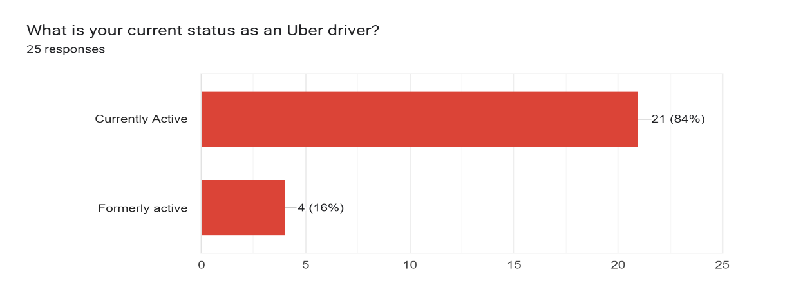
Figure 4: Drivers operational status

4.3.5 Driver Tenure and Platform Experience
To establish professional standing and operational familiarity within the driver cohort, participants reported their occupational status on the platform. The dataset indicated a strong concentration of active participation, with 84% of respondents identifying as currently active drivers. This demonstrated that the sample largely consisted of individuals with direct, ongoing experience of the platform’s operational and algorithmic systems. In contrast, 16% of participants reported being formerly active drivers, providing retrospective perspectives and ensuring representation from both current and past platform engagement.
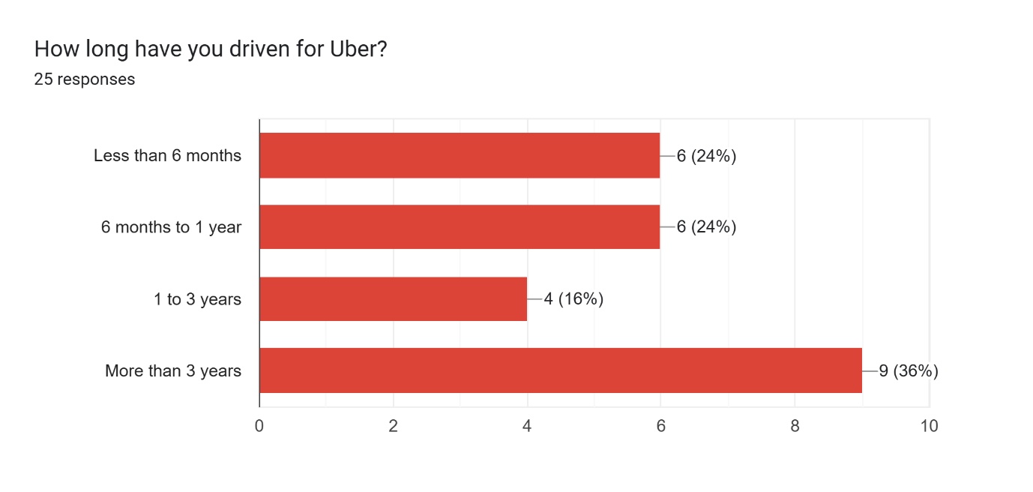
Figure 5: Driving Timeline

4.3.6 Driver Weekly Schedule and Operational Intensity
To evaluate labour patterns and operational intensity within the driver cohort, participants described their weekly driving schedules across two categories. The results showed that a high portion of respondents (56%) operated on a part-time basis which means working fewer than 30 hours per week. In contrast, the participants who reported driving full-time were 44%, with 30 or more hours per week. This distribution reflects a relatively balanced representation between part-time and full-time driver.
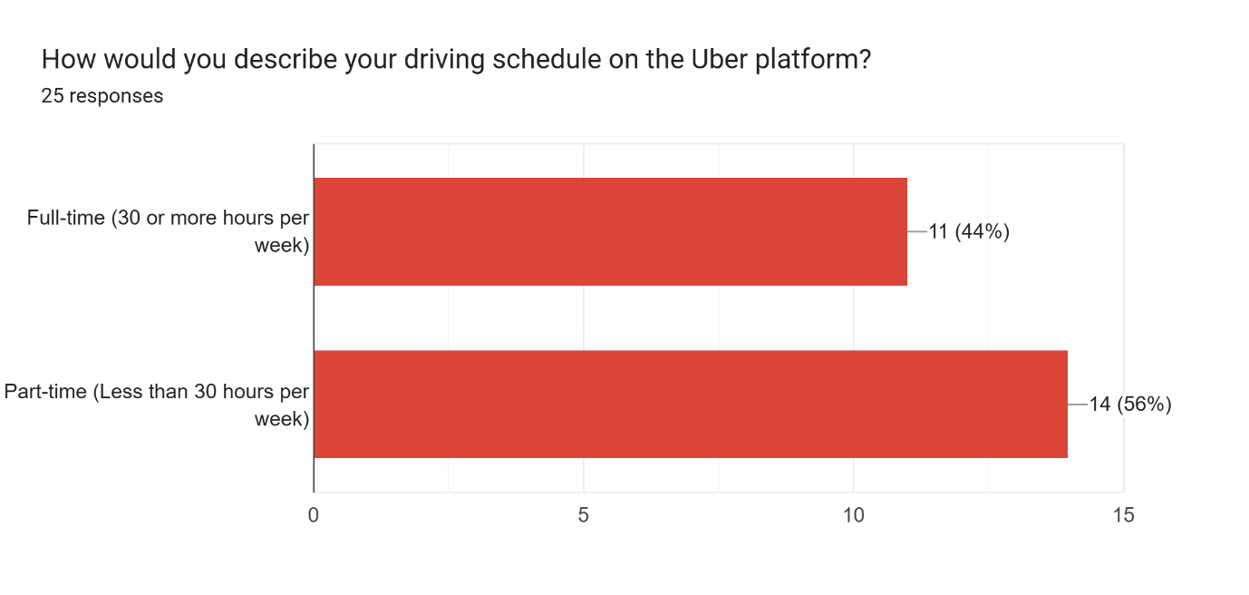
Figure 6: Driver operational frequency

4.4 Integrated theoretical framework output (Riders)

1: Perceived Transparency (Procedural Justice)

Fare Calculation Transparency and Clarity
For evaluation of user perceptions regarding algorithmic transparency and fairness, participants were prompted to rate their agreement with the aspect that the process of fare calculation was clear and easy to understand. The responses indicated a strong response indicating a lack of clarity in the pricing mechanism. The modal response represented 52% of the sample in selection the lowest rating with an additional 36%, who selected the second-lowest option which resulted in 88% of participants expressing disagreement with the statement.
The system was perceived as understandable by only a small minority. A neutral rating was provided of 8%, and just 4% expressed some level of agreement and no participants selected the highest rating. Overall, this distribution indicated fare calculation was experienced as an opaque and difficult-to-understand process by drivers widely.
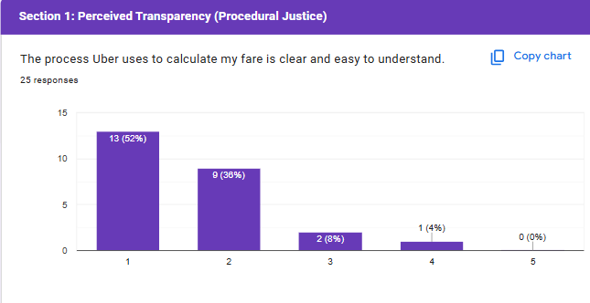
Figure 7: User clarity of fares

Surge Pricing Communication and Justification
Participants rated their agreement on whether Uber provided sufficient information to explain price increases, such as surge pricing. The results are indicating a strong tendency toward disagreement. The modal response of 64% of the sample selected a low rating, while the lowest option was chosen by additional 20%, bringing total disagreement to 84%.
Neutral and positive responses remained minimal. A total of 8% of participants selected a neutral rating, and another 8% expressed some level of agreement, with no respondents selecting the highest rating. Overall, this distribution suggested that the platform did not adequately communicate the underlying reasons for fare increases.
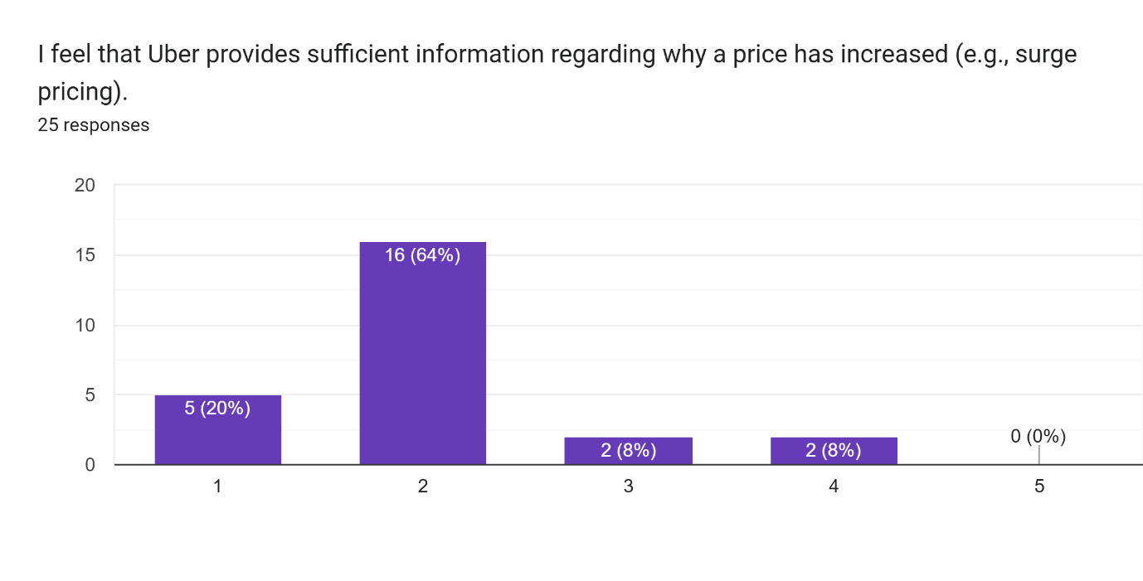
Figure 8: Users surge price information

Itemized Cost Breakdown Sufficiency
Participants rated whether fare breakdowns provided sufficient detail to justify the final cost. The results showed continuation of dissatisfaction with pricing transparency as 72% of respondents expressed disagreement, including a modal 56% who selected a low rating. There were limited neutral and positive responses, with 16% neutral and 12% indicating some agreement, and the highest rating was selected by none of the participants. Overall, the findings indicated that the itemized breakdowns was largely found by users to be insufficient to justify the final fare.
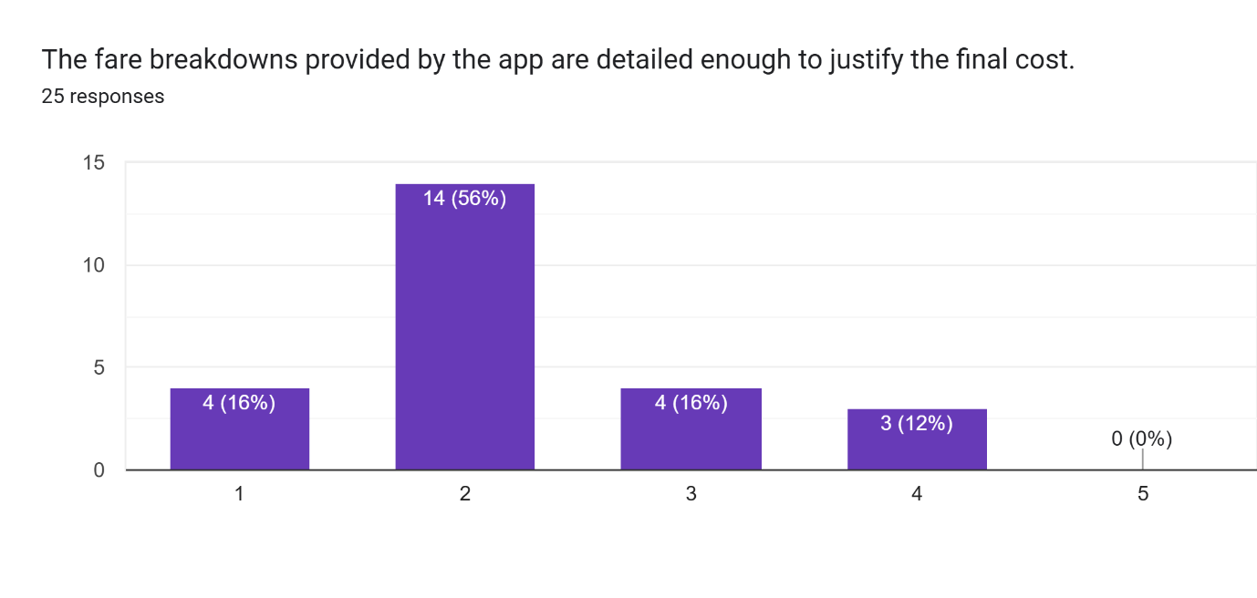
Figure 9: Breakdown and justification of fare

2: Perceived Fairness (Equity Theory)

Price-to-Value Proportion and Fairness
Participants expressed their agreement on whether the price paid for a ride was fair with respect to the value of the service they get. A shift toward neutrality was observed in results and moderate agreement, with the modal response (48%) selected a neutral rating. Further, agreement was expressed by 48% which includes 40% selection of a higher rating and 8% the highest. There was minimal disagreement, with only 4% indicating slight disagreement and while the lowest rating being selected by none. Overall, in spite of concerns regarding pricing transparency, it was still perceived by many users that the cost as reasonably aligned with the value received.
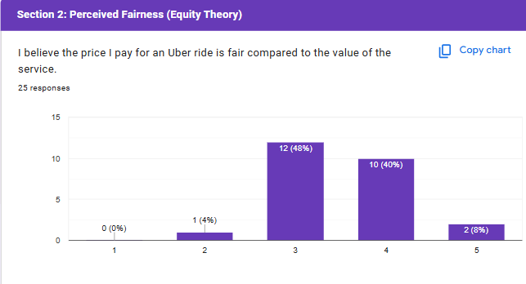
Figure 10: User proportion and fairness

Peak-Hour Pricing and Exploitation Boundaries
Participants rated their agreement on whether Uber’s pricing algorithm avoided exploiting users during peak hours. The results indicated a tendency toward perceived exploitation, as the modal response (44%) selected a low rating and no participants choosing the lowest option. The remaining responses were distributed evenly as 28% selected a neutral rating and 28% expressed some level of agreement, while the highest rating was selected by no respondent. These findings suggested that a considerable proportion of users questioned the fairness and ethical limits of peak-period pricing.
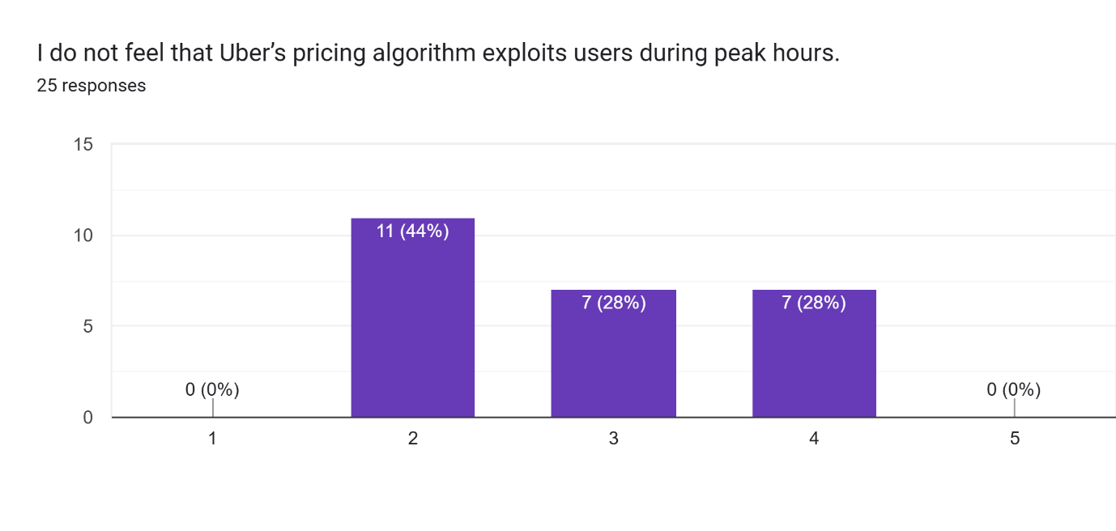
Figure 11: User perception of exploitation

Perception of Exploitation
Participants rated their agreement on whether Uber’s pricing algorithm avoided exploiting users during peak hours. The results displays an incline toward perceived exploitation, with the modal response (44%) who selected a low rating and no respondents choosing the lowest option. The remaining responses were distributed evenly as28% selected a neutral rating and 28% expressed some level of agreement. The highest rating was selected by none of the participants. Overall, it is suggested by these findings that a notable proportion of users questioned the ethical boundaries of peak-period pricing.
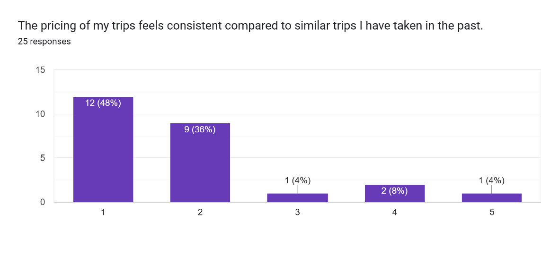
Figure 12: Users trips consistency

3: Trust

Ethical Trust in Pricing Practices
Participants rated their agreement on whether they trusted that Uber’s pricing practices were ethical and fair. The results indicated a clear lean toward distrust, with the modal response (48%) selecting a low rating and no respondents choosing the lowest option.
The remaining responses were divided between neutrality (24%) and moderate agreement (28%), with no participants selecting the highest rating. Overall, the findings suggested that fewer than one-third of respondents expressed trust in the ethical fairness of the platform’s pricing.
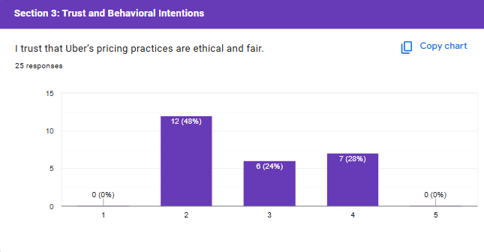
Figure 13: Users ethical and fairness perceptions

Impact of Price Discrimination on Consumer Trust
Participants rated their agreement on whether trust in Uber pricing suffered when observing different prices for the same route compared to other riders. The results demonstrated an overwhelming weightage on the negative impact of price differences, with the modal response of (68%) selected the highest rating and no respondents chose the lowest options. A further strong agreement was further expressed by 28%, bringing total agreement to 96%. Only 4% remained neutral. It is indicated that visible price variation among riders trust in the platform’s pricing practice is significantly undermined
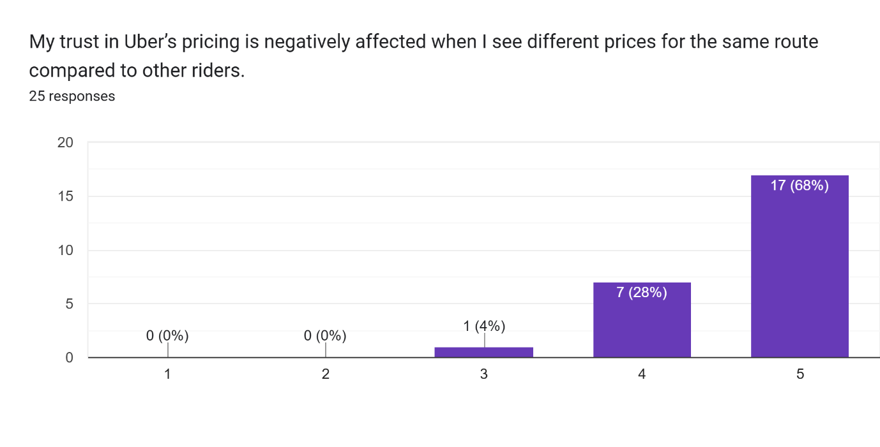
Figure 14: User trust and price consistency

Competitive Switching and Market Navigation
Participants rated their agreement on whether they checked competitor applications when Uber prices were high. A strong behavioral shift toward platform switching is indicated in the result, with 48% selecting a high rating and an additional 32% selecting the highest rating, resulting in a total of 80% agreement.
There was minimal disagreement and neutrality as 8% expressing disagreement, none selected the lowest option, and 12% remained neutral. Overall, the findings describe that users were prompted by elevated pricing to compare alternatives and navigate competing platforms.
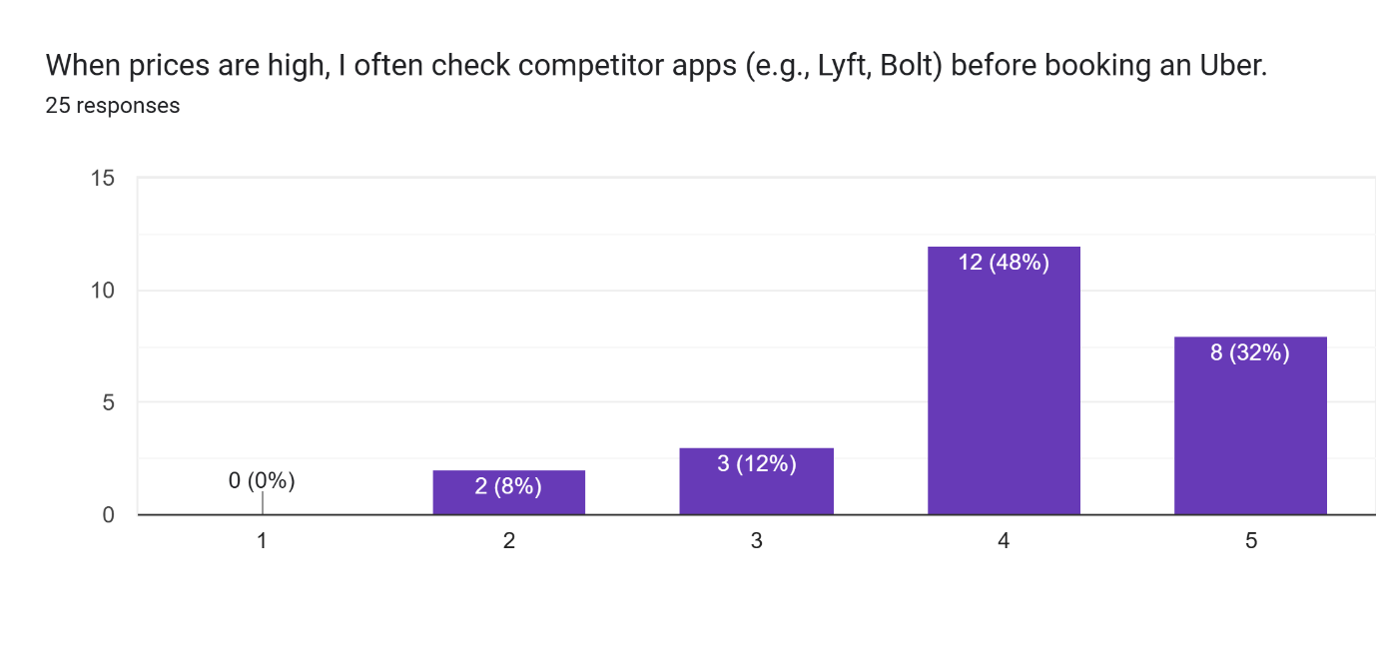
Figure 15: User other platform consideration

4: Behaviorial Intention
Long-Term Platform Loyalty and Retention
It was rated by the participant to prompt their agreement on whether they were willing in continuing the usage of Uber as their primary ride-hailing service despite its pricing model. A mixed divided stance was indicated on long-term loyalty, with the modal response (32%) selecting a neutral rating.
Disagreement and agreement accounted for the remaining distribution as 24% expressed disagreement and 44% indicated agreement. It was suggested by these findings that while hesitation is created by pricing concerns, a considerable proportion of users still intended for retaining Uber as their primary platform.
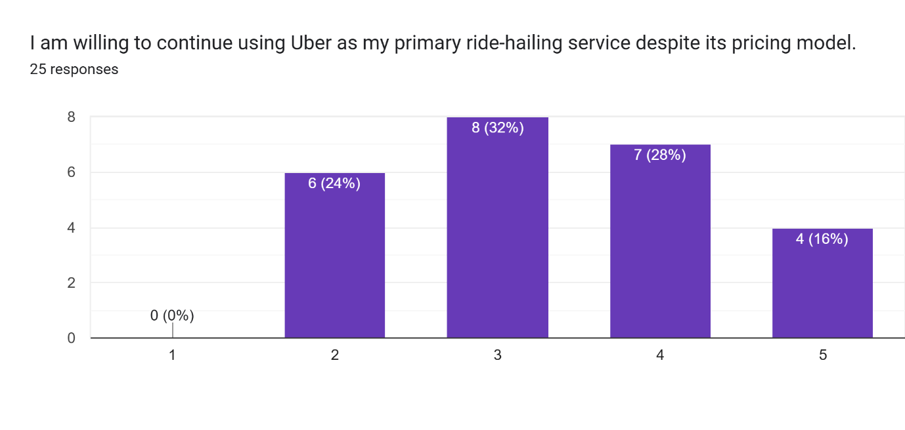
Figure 16: User Retention

4.5 Integrated theoretical framework output (Drivers)

1: Transparency (Procedural Justice)

Algorithm Comprehension and Remuneration Mechanics
Drivers rated their understanding of how the algorithm determined daily earnings and fare splits. The results indicated a widespread lack of transparency, with the modal response (64%) selected the lowest rating and an additional 32% selected the second-lowest option which resulted in a 96% disagreement. Neutral and positive responses were nearly absent, with only 4% selecting a neutral rating and none indicating agreement. Overall, the findings suggested that drivers operated with very limited visibility into how their earnings and fare allocations were calculated.
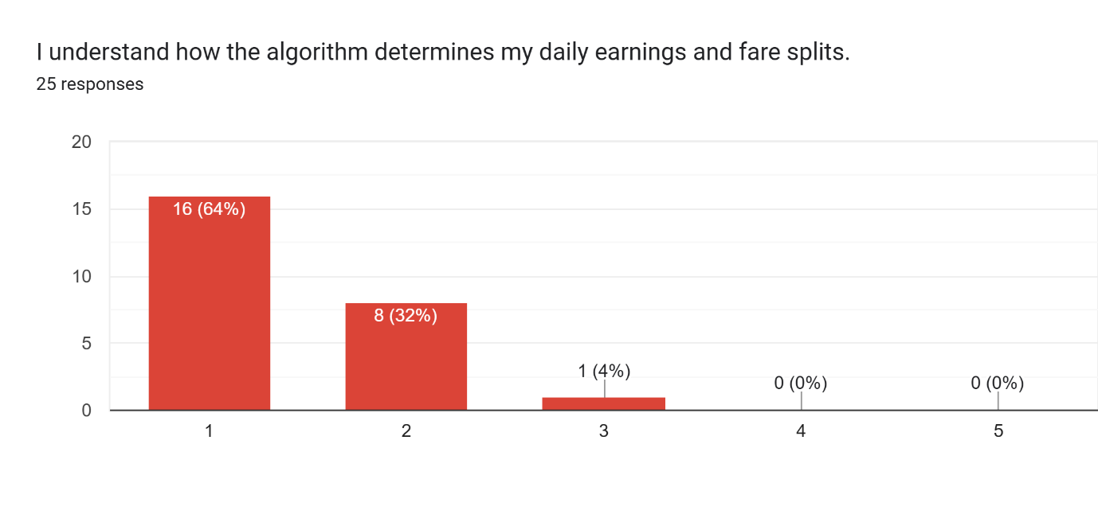
Figure 17: Driver’s comprehension of fare calculation

2: Fairness (Equity Theory)

Compensation Equity Relative to Effort and Hours
Drivers rated their perception regarding whether their pay is fair as compared to the effort, hours, and expectations they put in. The findings reflect a strong perception of inequity from drivers’ point of view. The modal response (48%) selected a rating of 2, with an additional 16% selecting the lowest rating, totalling the disagreement to 64%. Remainder of the distribution responses accounted for neutral and positive. Exactly 16% selected a neutral rating, while agreement was indicated by 20%. No respondents selected the highest rating. Overall, it is suggested by the result that compensation by a clear majority of drivers is perceived as insufficient relative to the time and labour they invest.
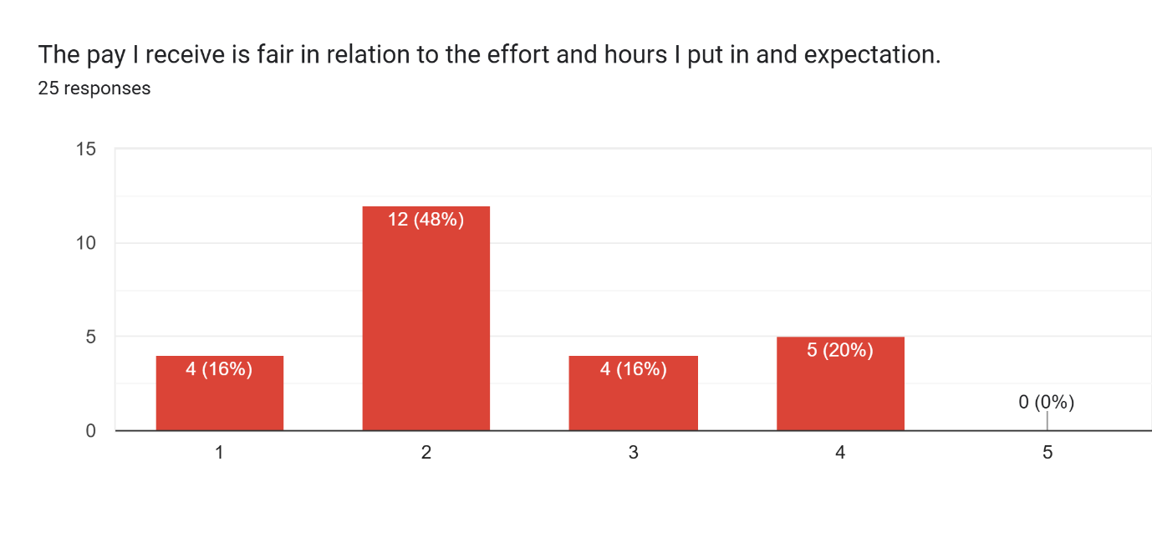
Figure 18: Users compensation and expectations

Surge Pricing Validity and Ground Conditions
Actual reflection of accuracy of surge pricing demand and real-world road conditions was rated by the drivers. It is indicated by the findings an almost complete rejection of surge validity. The modal response indicates (80%) selected a rating of 2, with an additional 12% selecting 1, making a combined disagreement of about 92%.
There were extremely limited Neutral and positive evaluations. Only 4% selected a neutral rating, and 4% agreed, with the highest rating selected by no respondents. It is suggested by the results that surge pricing is overwhelmingly perceived by drivers as misaligning with actual conditions of traffic and demand patterns.
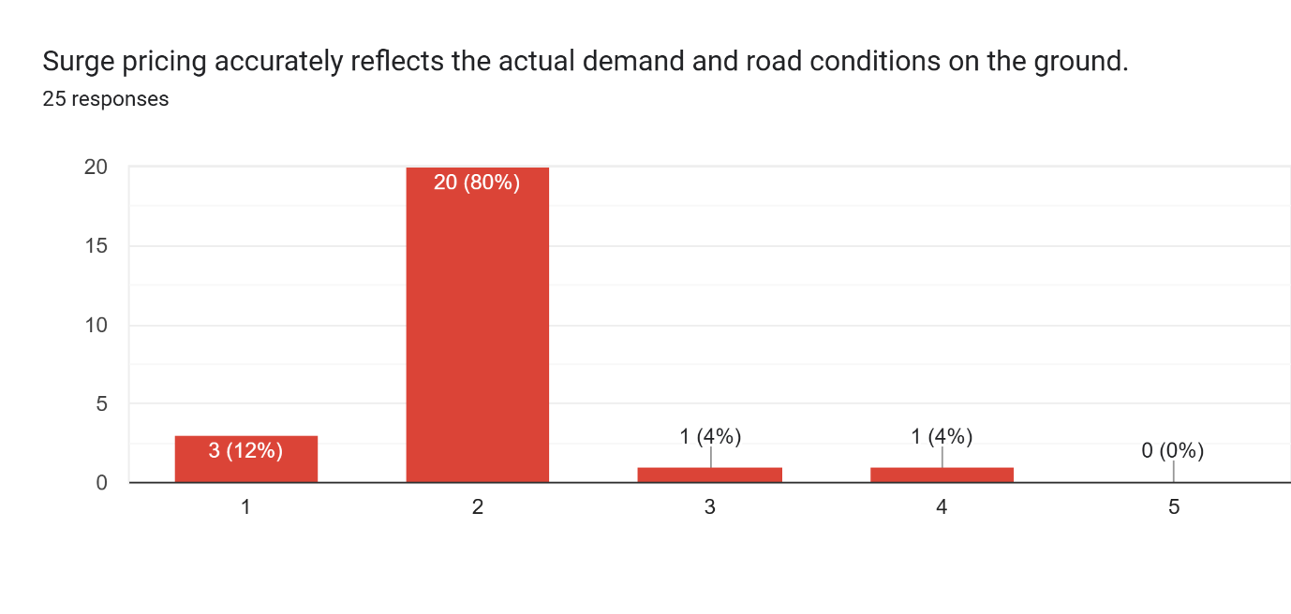
Figure 19: Reflection of surge pricing and ground realities

3: Trust (Trust Theory)

Institutional Confidence in Pricing Policy Updates
Drivers rated their confidence in whether the platform keeps their best interests in mind when updating pricing policies. A unanimous lack of confidence across the cohort was observed. The modal response (76%) selected a rating of 2, while the remaining 24% selected the lowest rating, resulting in 100% disagreement.
There was no presence of neutral or positive evaluations, with zero respondents selected other scale rating items. These findings point to complete institutional distrust with pricing policy changes is uniformly perceived by drivers as misaligning with their professional and financial well-being.
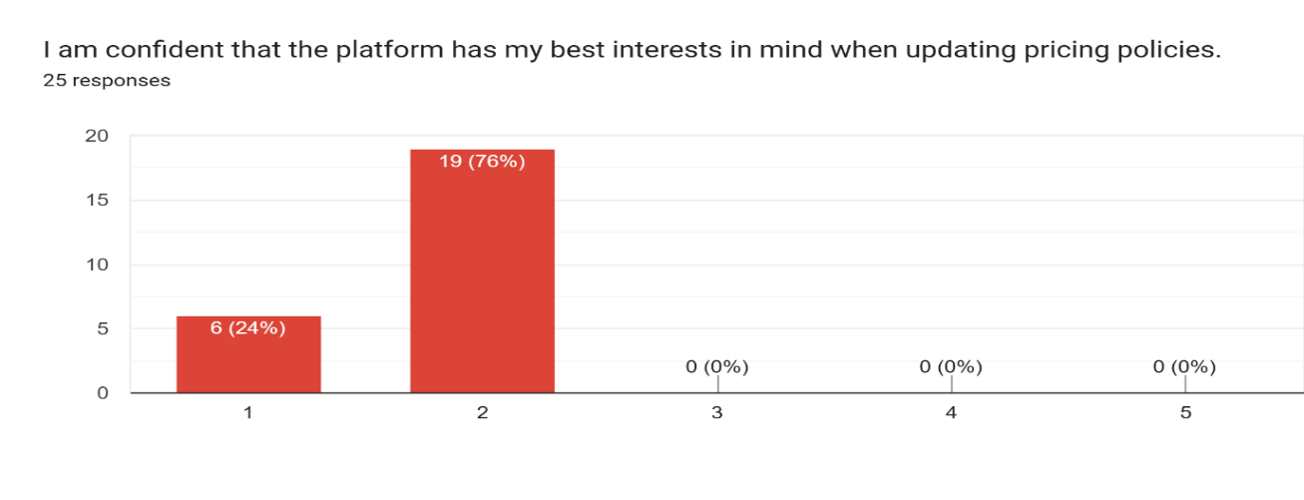
Figure 20: Drivers trust on platform policies

Automated Dispute Resolution Trust for Cancelled Trips and Fares
Drivers rated their trust in the automated dispute resolution process for handling reduced fares and cancelled trips. A pervasive distrust in platform mechanisms was revealed in the results. The modal response (48%) selected a rating of 2, with an additional 40% selecting the lowest rating accounting the total disagreement to 88%.
Neutral evaluations were absent completely. Only 12% of participants indicated agreement and highest rating was selected by none. Overall, the findings highlight that limited confidence of drivers in automated support systems, viewing them as ineffective in delivery of fair outcomes during fare disputes and trip cancellations.
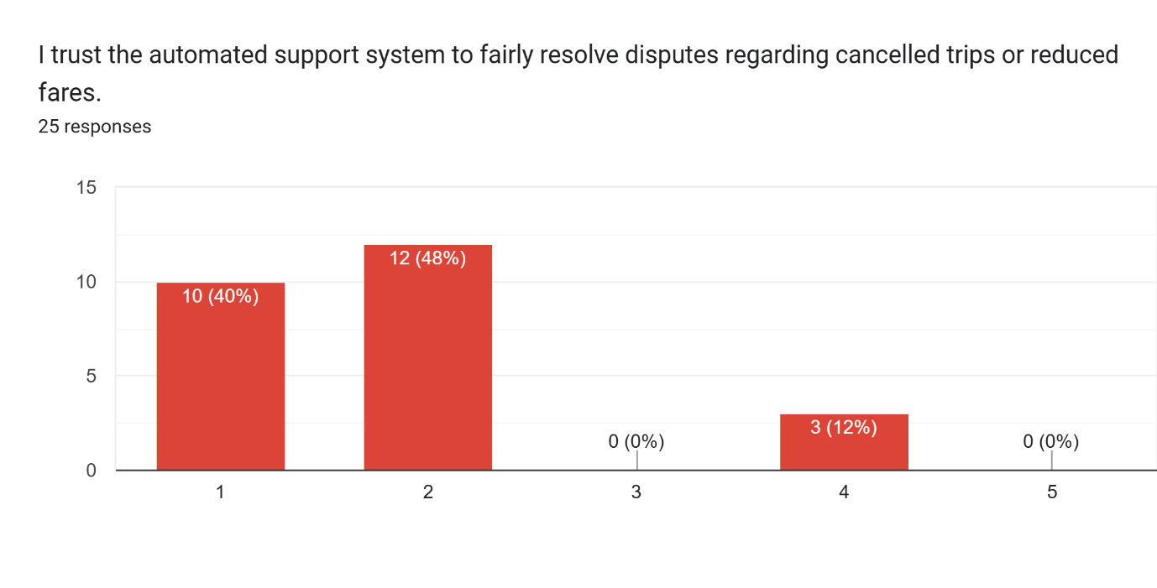
Figure 21: Drivers trust in automated systems

4: Behavioural Intentions

Short-Term Driver Retention and Platform Dependency
Drivers rated their likelihood of continuing to drive for the platform over the next six months. The distribution indicates a notable inclination toward retention of 48%, despite widespread institutional grievances because many drivers appear economically dependent on the platform, sustaining overall retention

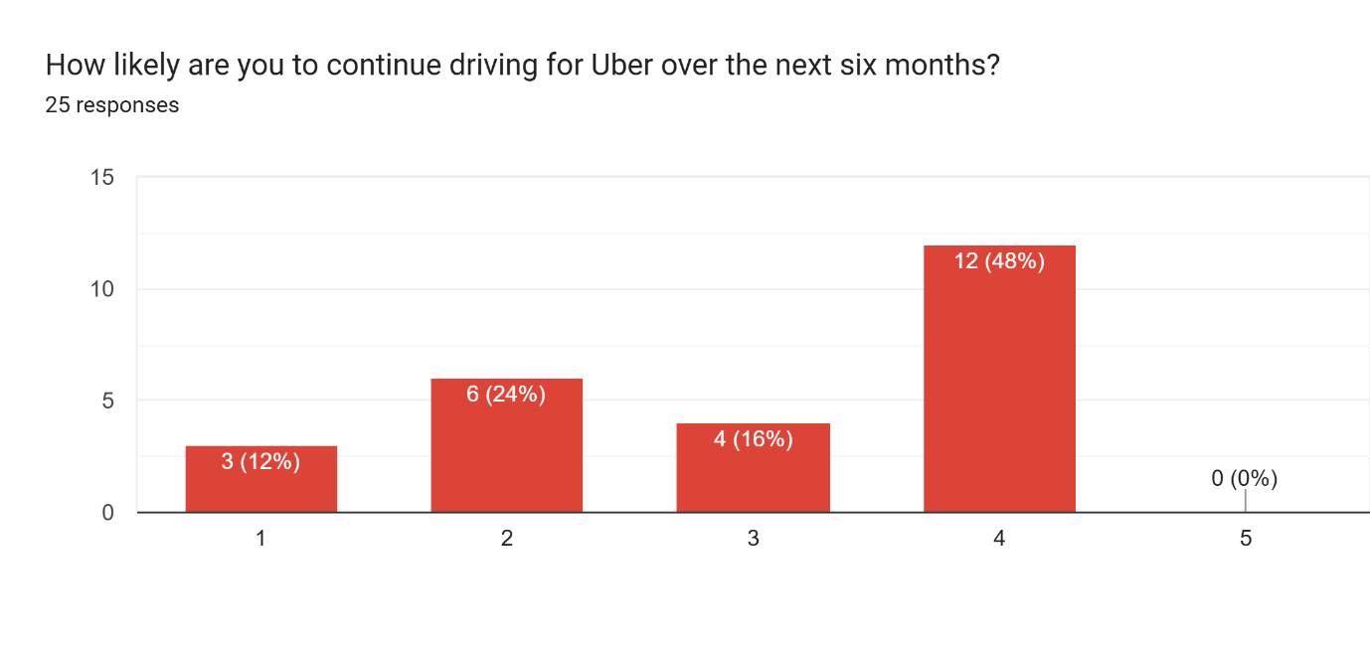
Figure 22: Driver’s continuation and retention

Retention Likelihood and Economic Dependency
Likelihood of continuing to drive for the platform over the next six months was prompted by drivers. Indicated by the results, a notable inclination toward retention despite a widespread dissatisfaction. The modal response (48%) selected a rating of 4, which suggests that a there exists a moderate willingness in remaining active on the platform. A meaningful degree of hesitation is revealed by neutral and lower-intent response. A neutral rating was selected by 16%, while 24% and 12% selected ratings of 2 and 1, respectively, bringing total potential uncertainty to 36%. Highest rating was not selected by any respondent, overall retention intent still stood at 48%. Suggested by the findings, despite concerns revolving pricing transparency and platform support, a substantial portion of drivers continues to be reliant on the platform for consistent income indicating a tension between dissatisfaction and economic dependence.
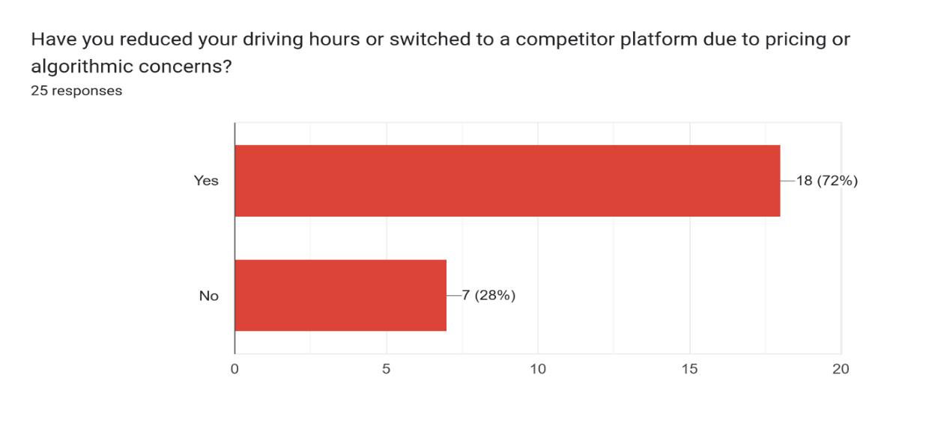
Figure 23: Driver view of platform omission and service

4.6 Discussions
The findings of this dissertation highlight that transparency in pricing portrays a crucial role in shaping of riders’ perceptions and behavioural responses within ride-hailing platforms. In relation to perceived fairness, a strong positive correlation is revealed (r = 0.650) depicting that riders who have a clear understanding how fares are calculated are prone to evaluating pricing as reasonable and justified. With effective communication of fare structure specially during periods of surge pricing, users display less inclination to interpreting higher costs as exploitative. Instead, transparency appears to be reframing increases in price as a function of market dynamics, thereby leading to enhancement of perceptions of procedural fairness.
In addition, a meaningful impact is demonstrated on trust which evidenced by a moderately strong correlation (r = 0.567). This finding indicates the importance of clear and detailed breakdowns of fare in fostering institutional confidence. When riders are provided with pricing information which is predictable and explicit explanations of components of cost, they tend to perceive the mechanisms of pricing as ethical and reliable. This leading to emphasizing with broader theoretical perspectives that highlight the role of transparency in reduction of uncertainty and strengthening trust of users in algorithm-driven systems.
Furthermore, it is shown in the results that the strongest relationship between transparency and behavioural intentions (r = 0.694), indicates that communication clarity particularly influences rider loyalty and decisions regarding future usage. Riders who view the pricing model as transparent are more inclined to continuation in usage of the platform as their primary mode of transportation, even in the while in existence of surge pricing. Moreover, such users are more likely to be engaging in positive word-of-mouth and recommendation of the service to others. This suggests that immediate user satisfaction is not only enhanced by transparency but also contributes to long-term customer retention and advocacy.
The analysis of the dataset of drivers presents a notedly different pattern as compared to the riders in relation to the role of transparency. The relationship between transparency and perceived fairness is weak (r = 0.18), which indicates that provision clear explanations of fare calculations or surge pricing mechanisms to drivers does not evidently influence their perception of whether if a compensation is fair. Even with the visibility of pricing mechanisms and fare breakdown, drivers might still be perceiving outcomes as inequitable, especially during durations of fluctuating demand. This suggests that transparency alone is insufficient in addressing concerns related to distributive fairness in earnings of driver.
Similarly, negligible relationship exists between transparency and trust (r = 0.04), which highlights that informational clarity does not translate into increase in confidence in the pricing system of platform. Despite access to detailed trip receipts or algorithmic explanations, no stronger beliefs appear to be developed in drivers in the integrity or ethical functioning of the system. It implies that trust from the perspective of driver is not built through communication features, but rather through earning experiences over time which are consistent and satisfactory.
The weak association is there between transparency and behavioural intention (r = 0.18), which further reinforce that the limited practical impact of transparency on engagement of driver. Clear communication in terms of pricing does not significantly influence willingness of drivers in continuing using the platform or recommendation to others. Unlike riders, strong behavioural intentions are shaped by transparency, drivers appear to pin their continued participation on outcomes that are more tangible, such as income stability and perceived fairness of compensation.
In contrast, there emerged a strong relationship between fairness and trust (r = 0.58), displaying the most influential trail within the driver model. It is demonstrated in the finding that their perception of fair compensation primarily drive trust of drivers in platform. When drivers are of the view that their earnings accurately reflect their effort, time, and invested resources, they are more likely to see the platform as trustworthy. Notably, this relationship is operational independently of transparency, depicting that this effect is not mediated by explanatory clarity
The findings further find out several important implications for platform dynamics, particularly in relation to how both rider and driver experiences are shaped by interaction with transparency and fairness. One notable outcome is that transparency of surge pricing may inadvertently cause production of negative consequences for drivers. Considering the weak relationship between transparency and perceived fairness (r = 0.18), riders with exposure to detailed surge breakdowns do not necessarily be interpreting higher fares as justified. Instead, such visibility can elevate the frustration toward the pricing system, which is often misapplied at drivers through lower rating or reduction in tipping. This is especially problematic because drivers have no control over algorithmic pricing at all but yet they are dependent on surge periods to enhance their earnings. As a result, transparency, rather than in mitigation of dissatisfaction, may unintentionally enhance tensions within the platform ecosystem.
In addition, the strong relationship emerges between fairness and trust (r = 0.58) which highlights that the central role of perceived equity in maintenance of overall platform stability. When pricing is perceived as exploitative by riders particularly during peak demand, their trust in the platform is deteriorated significantly. This erosion of trust causes leading to decreased platform usage, ultimately reduction of ride demand and negatively affecting the driver utilization and their income. Therefore, fairness is not only a psychological construct but also a critical economic driver that underpins the sustainability of the platform.
Moreover, the relationship between transparency and trust is negligible (r = 0.04) which suggests that improvements in design of user interface or communication features alone are not sufficient in resolving underlying dissatisfaction. While clearer receipts or fare explanations may enhance informational clarity, deeper concerns about pricing equity are not addressed. From a driver perspective, platform-level interventions must move beyond surface-level transparency and must have a focus on structural pricing strategies balancing rider affordability with fair driver compensation.
Behavioural data further reinforces the complexity of driver engagement and their retention. Full-time drivers appear to be more committed at a stated level, with 82% expressing an intention of continuing driving in comparison to only 50% of part-time drivers. However, this complicates the high inclination of multi-platform usage A significant proportion of both full-time (82%) and part-time drivers (64%) responded about having consideration or active usage of alternative platforms. Overall, 72% of drivers indicate that they have reduced their working hours or shifted to competitor platforms because of concerns relating to pricing and algorithmic management. A pattern of “conditional loyalty” is revealed where drivers may continue operation on the platform while simultaneously sidestepping their risk by diversifying across multiple apps.
A notable divergence revealed between full-time and part-time drivers by analysis of continuation intentions, exposing underlying inconsistencies in commitment of drivers. Full-time drivers reportedly have substantially higher intentions to continue using the platform, with 82% indicating a willingness in remaining active in comparison to only 50% of part-time drivers, who were evenly divided in their responses. At face value, this suggests a stronger level of commitment among full-time drivers who likely reflect their greater financial dependence on platform-based income.
However, this interpretation of behavioural patterns are complicated a closer examination. The same 82% of full-time drivers who expressed an intention of continuing driving also significantly overlap with the 82% who report to having already reduced their working hours or switched to a competing platform. This indicates that intention which is and actual behaviour are not mutually exclusive but rather they coexist within the same group. In other words, while full-time drivers may be expressing loyalty in survey responses, parallel strategy of risk diversification is indicated in their actions.
The concept of conditional or fragile commitment is highlighted by this pattern, where drivers keep engaged with the platform not out of exclusive loyalty, but because of the necessity and the absence of better alternatives. Simultaneously, they are precautious against uncertainty in earnings and algorithmic management by their participation in multiple platforms. Such behaviour reflects a pragmatic adaptation to perceived instability in pricing and income structures.
Table 3: Drivers Behavioural Stats
Schedule | n | Likely to continue | Not likely | Reduced hours / switched to competitor
Full-time | 11 | 9 (82%) | 2 (18%) | 9 (82%)
Part-time | 14 | 7 (50%) | 7 (50%) | 9 (64%)
Overall | 25 | 16 (64%) | 9 (36%) | 18 (72%)

4.6.1 Thematic analysis
From the interviews two core themes emerged which highlighted distinct challenges for drivers and riders. The first theme revolves on structural distrust and economic constraint among drivers. Both interviewed participants expressed deep scepticism facing platform pricing mechanisms and frequent reductions in commission. Despite perceiving these financial structures as unfair, still participants continue driving out due to their economic needs. Not having a viable alternative income source traps them within the system with a creation of a dynamic where labour persistence is derived from financial pressure rather than platform loyalty.
Pricing predictability and service reliability for riders were the focuses second theme. Both passenger participants emphasized the need for a consistent fare structure, highlighting that frequent friction is caused by unpredictable pricing during daily commutes. Riders report frustration with sudden cost fluctuations that occur without proportional changes in service quality.
Combined, it is indicated by these findings that a shared user base are bound by dependency while being frustrated by opaque financial terms. Unfavourable commission models are endured by drivers due to limited employment options, while riders demand greater tariff transparency and stability. Addressing these friction points requires platforms to align driver compensation fairness with predictable passenger pricing to secure long-term trust from both groups.

CHAPTER 5: CONCLUSION AND RECOMMENDATIONS

5.1 Conclusion
This study demonstrates that fundamental structural tensions across ride-hailing ecosystems are created by surge pricing and algorithm-driven fare structures which impact riders and drivers in several distinct ways. Empirical findings reveal that widespread opacity in fare calculations and surge communications are experienced by riders, with 88% reporting a lack of clarity and 92% to have witnessed and experienced frequent surge pricing. While transparency moderately correlates with rider trust (r = 0.567) and behavioural retention (r = 0.694), it is insufficient to establish perceived fairness via communication features alone, echoing broader findings on algorithmic opacity in platform economies (Karanasiou and Patel, 2018). As argued by Castillo, Knoepfle, and Weyl (2017), surge pricing is effectively respondent to the market of supply and demand, its legitimacy may be affected due to excessive recurrence in fragile moments, a dynamic further combined by an asymmetric information structure (Cramer and Krueger, 2016). When price spikes lack apparent equity, rider trust collapses, triggering platform switching and negative word-of-mouth, which aligns with established consumer behaviour models in digital marketplaces (Zeithaml, Berry, and Parasuraman, 1996).
Conversely, a stark divergence is uncovered in driver analysis: transparency has a little or negligible effect on trust of driver (r = 0.04) and fairness (r = 0.18). Instead, driver retention is directed and impacted by equity in compensation, where institutional trust is derived by perceived fairness strongly (r = 0.58), supporting the core tenets of organizational justice theory in gig work environments (Colquitt, 2001; Rosenblat, 2018). Despite widespread grievances which include a 92% rejection of surge validity and 100% distrust in policy of pricing updates, patterns of conditional loyalty is exhibited by drivers. A significant majority (72% overall, including 82% of full-time drivers) reduce their economic risk by minimizing hours or utilization of competing platforms out of financial necessity rather than genuine loyalty of brand, which reflects the precarious nature of algorithmic labour management (Schor et al., 2020). This is consistent with Shapiro and Varian’s (1999) observations about strategic communication in information markets, were framing matters for consumers’ interpretation of pricing strategies. Therefore, ride-hailing sustainability cannot reliant solely on interface-level disclosures. It requires structural alignment between fair driver compensation and predictable passenger pricing.

5.2 General Recommendations
• Refructure Algorithmic Fare Communication: Platforms must move beyond raw numerical cost breakdowns and focus on contextualized value communication. Because transparency alone does not establish fairness, messaging must clearly tie peak pricing directly to driver availability and real-time supply constraints rather than abstract algorithmic metrics.
• Implement Pricing Threshold Caps for Crises: To protect consumers during emergency scenarios or extreme demand spikes, regulatory bodies should establish structural safeguards. Regulators might be required to have in place emergency measures that protect against the algorithm-driven plundering of the public in times of crisis (Castillo, Knoepfle, & Weyl, 2017).
• Balance Driver Compensation with Rider Equity: Platform operators must design fare architectures that protect driver earnings during peak periods without alienating passengers through excessive price multipliers. Aligning platform incentives with consumer expectations of fairness will stabilize long-term retention and protect user trust.
• Adopt Practical Design Frameworks: From a practical standpoint, this work suggests the need for developing ride-hailing systems that are economically viable and ethically acceptable. Operators should pilot predictable peak-smoothing features, such as loyalty-based surge protection or subscription caps, to maintain high user retention without undermining marketplace equilibrium.

5.2.1 Solution: Core Operational Mechanics
Fixed Baseline Calculation: The platform of Uber should establish a non-surge algorithmic baseline fare for every route. It should still be calculated by distance, estimated time, and standard operating costs. This baseline must guarantee a predictable minimum floor that covers core operational expenses for both the platform and the driver.
Rider-Initiated Offers: When requesting a trip during peak periods or standard hours, the app should present the rider with the baseline fare. Riders should have a choice to retain the option to accept the baseline price or manually input an additional monetary amount (or match the exact base fare) to create a total fare offer that incentivizes faster driver acceptance.
Driver Counter-Offer Capability: Participating drivers should be to view the complete fare offer, including the baseline and any rider-added premium before accepting. If the offer is deemed insufficient for prevailing road or traffic conditions, drivers can submit a single counteroffer to the rider. Upon mutual acceptance on a set fare, they should be able to operate or start the ride.
Fixed Platform Share: Uber should secure its revenue by taking a fixed, predetermined percentage or absolute fee exclusively from the baseline price component. Any additional discretionary amount offered by the rider flows directly to the driver to incentivize service fulfillment during high-demand windows.

5.3 Limitations
This dissertation is subject to several limitations that should be considered when interpreting the findings like:
Limited Sample Size: The relatively small sample restricts the statistical generalizability of the results. While the insights are indicative, they may not fully represent the broader population of riders and drivers on the platform. The relatively small sample restricts the statistical generalizability of the results. The dataset consists of 25 responses from users and drivers for the quantitative portion, alongside qualitative interviews with two users and two drivers. While these insights point toward specific trends, they do not fully represent the broader population of riders and drivers on the platform.
Lack of Geographical Specificity: The study does not focus or narrow downs on a particular city or region but rather collects a small sample size country wide. Given that pricing dynamics, regulations, and user behaviour can be varying significantly across locations. This can be a limiting factor in terms of the ability to draw location-specific conclusions.
Responses Subjectivity: Data was collected and gathered through self-reported responses through utilisation of Google Forms, which highlights and signals subjectivity clearly. Participants’ answers reflect personal perceptions and experiences rather than objective measures of Uber’s pricing mechanisms, potentially leading to response bias.
Generalization: The categories of drivers, types of rides they offer, and users based upon their aspects of profession, schedule and economic situations are not considered. The study can be further narrowed down to a specific niche providing an in-depth ground reality. This study just in an explanatory regard utilizes a generalized purpose of the view they hold for the platform of Uber in terms of operations, service and experience.

REFERENCES
- Adams, J.S. (1965) 'Inequity in social exchange', Advances in Experimental Social Psychology, 2, pp. 267–299. Available at: https://doi.org/10.1016/S0065-2601(08)60108-2.
- Ameen, S. and Malik, I. (2026) 'Dynamic pricing algorithms and consumer fairness perceptions: experimental evidence from ride-hailing apps', AMRRJ. Available at: https://amrrj.com/index.php/3/article/view/10/1
- Anderson, L. and Wieseke, J. (2015) 'How perceived fairness of pricing influences customer satisfaction and loyalty', Journal of Service Research, 18(3), pp. 1–15.
- Binns, R., Stein, J., Datta, S., Van Kleek, M. and Shadbolt, N. (2025) 'Not even nice work if you can get it: a longitudinal study of Uber’s algorithmic pay and pricing', The 2025 ACM Conference on Fairness, Accountability, and Transparency, pp. 1484–1497. Available at: https://doi.org/10.1145/3715275.3732099.
- Bolton, L.E., Warlop, L. and Alba, J.W. (2003) 'Consumer perceptions of price (un)fairness', Journal of Consumer Research, 29(4), pp. 474–491. Available at: https://doi.org/10.1086/346244.
- Braun, V. and Clarke, V. (2006) 'Using thematic analysis in psychology', Qualitative Research in Psychology, 3(2), pp. 77–101. Available at: https://doi.org/10.1191/1478088706qp063oa.
- Brett, J.F., Cron, W.L. and Slocum, J.W. (1995) 'Economic dependency on work: a moderator of the relationship between organizational commitment and performance', Academy of Management Journal, 38(1), pp. 261–271. Available at: https://doi.org/10.5465/256735.
- Castillo, J.C., Knoepfle, D. and Weyl, E.G. (2017) 'Surge pricing solves the wild goose chase', Proceedings of the ACM Conference on Economics and Computation, pp. 241–242. Available at: http://dx.doi.org/10.1145/3033274.3085098.
- Chen, L., Mislove, A. and Wilson, C. (2015) 'Peeking beneath the hood of Uber', Proceedings of the 2015 ACM Conference on Internet Measurement Conference - IMC ’15. Available at: https://doi.org/10.1145/2815675.2815681.
- Chen, M.K., Rossi, P.E., Chevalier, J.A. and Oehlsen, E. (2017) 'The value of flexible work: evidence from Uber drivers', Journal of Political Economy, 127(6), pp. 2735–2794. Available at: https://www.nber.org/system/files/working_papers/w23296/w23296.pdf.
- Colquitt, J.A. (2001) 'On the dimensionality of organizational justice: a construct validation of a measure', Journal of Applied Psychology, 86(3), pp. 386–400. Available at: https://doi.org/10.1037/0021-9010.86.3.386.
- Connelly, L.M. (2011) 'Cronbach's alpha', Medsurg Nursing, 20(1), pp. 45–47.
- Cramer, J. and Krueger, A.B. (2016) 'Disruptive change in the taxi business: the case of Uber', American Economic Review, 106(5), pp. 177–182. Available at: https://doi.org/10.1257/aer.p20161002.
- Creswell, J.W. and Zhou, Y. (2017) Designing and conducting mixed methods research. 3rd edn. London: SAGE Publications, pp. 35–50. Available at: https://www.cambridgeenglish.org/Images/735110-studies-in-language-testing-volume-43.pdf#page=53.
- Diakopoulos, N. (2015) 'How uber surge pricing really works', Washington Post, 17 April. [online] Available at: https://www.washingtonpost.com/news/wonk/wp/2015/04/17/how-uber-surge-pricing-really-works/ [Accessed: 16 July 2026].
- Fudenberg, D. and Villas-Boas, J.M. (2006) 'Behavior-based price discrimination and customer recognition', Handbook on Economics and Information Systems, 1, pp. 377–436. Available at: https://faculty.haas.berkeley.edu/VILLAS/surveypaper9-06.pdf.
- Haws, K.L. and Bearden, W.O. (2006) 'Dynamic pricing and consumer fairness perceptions', Journal of Consumer Research, 33(3), pp. 304–311. Available at: https://doi.org/10.1086/508435.
- Kahneman, D., Knetsch, J.L. and Thaler, R.H. (1986) 'Fairness and the assumptions of economics', Journal of Business, 59(4), pp. S285–S300. Available at: https://www.researchgate.net/profile/Richard-Thaler/publication/24102966_Fairness_and_The_Assumptions_of_Economics/links/0912f50eb073af2b1d000000/Fairness-and-The-Assumptions-of-Economics.pdf.
- Kamraju, M. (2025) 'Algorithmic pricing and consumer vulnerability: the ethical and economic implications of artificial intelligence (AI)-driven pricing models', ResearchGate, 3(2), pp. 201–208. Available at: https://www.researchgate.net/publication/389427062_Algorithmic_Pricing_and_Consumer_Vulnerability_The_Ethical_and_Economic_Implications_of_Artificial_Intelligence_AI-Driven_Pricing_Models.
- Karanasiou, A. and Patel, S. (2018) 'Algorithmic transparent governance in the sharing economy', European Journal of Law and Technology, 9(2), pp. 1–15.
- Leventhal, G.S. (1980) 'What should be done with equity theory? New approaches to the study of fairness in social relationships', in Gergen, K., Greenberg, M. and Willis, R. (eds.) Social exchange: advances in theory and research. New York: Plenum Press, pp. 27–55. Available at: https://files.eric.ed.gov/fulltext/ED142463.pdf
- Lind, E.A. (2001) 'Fairness heuristic theory: justice judgments as pivotal cognitions in organizational relations', in Greenberg, J. and Cropanzano, R. (eds.) Advances in organizational justice. Stanford: Stanford University Press, pp. 56–88. Available at: https://www.academia.edu/download/67791974/Fairness_heuristic_theory_Justice_judgme20210628-2487-16jbvdz.pdf [Accessed: 24 July 2026].
- Mayer, R.C., Davis, J.H. and Schoorman, F.D. (1995) 'An integrative model of organizational trust', The Academy of Management Review, 20(3), pp. 709–734. Available at: https://doi.org/10.2307/258792.
- Mittelstadt, B.D., Allo, P., Taddeo, M., Wachter, S. and Floridi, L. (2016) 'The ethics of algorithms: mapping the debate', Big Data & Society, 3(2), pp. 1–21. Available at: https://doi.org/10.1177/2053951716679679.
- Pasquale, F. (2015) The black box society: the secret algorithms that control money and information. Cambridge, MA: Harvard University Press. Available at: https://doi.org/10.4159/harvard.9780674736061.
- Rosenblat, A. (2018) Uberland: how algorithms are rewriting the rules of work. Oakland: University of California Press.
- Scarpello, V. and Vandenberg, R.J. (1992) 'Generalizing the importance of occupational and career views to job satisfaction attitudes', Journal of Organizational Behavior, 13(2), pp. 125–140. Available at: https://doi.org/10.1002/job.4030130203.
- Schor, J.B., Attwood-Charles, W., Cansoy, M., Ladle, K. and Wengronowitz, R. (2020) 'Dependence and precarity in the platform economy', Theory and Society, 49(5), pp. 833–861. Available at: https://pmc.ncbi.nlm.nih.gov/articles/PMC7410973/pdf/11186_2020_Article_9408.pdf.
- Shapiro, C. and Varian, H. (1999) Information rules: a strategic guide to the network economy. Boston: Harvard Business School Press. Available at: https://kcmit.edu.np/Uploads/information-rulesLarge20210211052224.pdf [Accessed: 23 July 2026].
- Slavulj, M., Kanizaj, K. and Durdevic, S. (2016) 'The evolution of urban transport: Uber', Road and Rail Infrastructure IV, pp. 359–364. Available at: https://dabar.srce.hr/books/grad:711/download/0#page=359.
- Stichting WIE International (2025) The dynamic pay claim from Stichting WIE International. [online] Available at: https://dynamicpay.org/ [Accessed: 6 July 2026].
- Thibaut, J. and Walker, L. (1975) Procedural justice: a psychological analysis. Hillsdale, NJ: Erlbaum.
- Uber. (2021). How Data Shapes the Uber Rider App. [online] Available at: https://www.uber.com/au/en/blog/how-data-shapes-the-uber-rider-app/ [Accessed 8 July 2026].
- Uber (2024) How surge pricing works. Available at: https://www.uber.com/us/en/drive/driver-app/how-surge-works/ [Accessed 8 July 2026].
- Uber (2026a) Cars available on Uber in the UK: ways to travel in style. [online] Available at: https://www.uber.com/gb/en/blog/uber-ride-options/ [Accessed 9 July 2026].
- Uber (2026b) Uber apps, products, and offerings. [online] Available at: https://www.uber.com/us/en/about/uber-offerings/?uclick_id=54d354ff-940d-429d-8508-7b4718982f5f [Accessed 9 July 2026].
- University of Oxford (2025) New Oxford research reveals Uber’s algorithmic pricing leaves drivers and passengers worse off. [online] Available at: https://www.ox.ac.uk/news/2025-06-23-new-oxford-research-reveals-uber-s-algorithmic-pricing-leaves-drivers-and-passengers [Accessed: 16 July 2026]
- Van Kleek, M., et al. (2023) 'You are you and the app. There's nobody else.': building worker-designed data institutions within platform hegemony. [online] Available at: https://www.researchgate.net/publication/392934262 [Accessed: 23 July 2026]
- Zarsky, T. (2016) 'The trouble with algorithmic decisions', Science, Technology, & Human Values, 41(1), pp. 118–132. Available at: https://doi.org/10.1177/0162243915605575.
- Zeithaml, V.A., Berry, L.L. and Parasuraman, A. (1996) 'The behavioral consequences of service quality', Journal of Marketing, 60(2), pp. 31–46.

APPENDICES

Pearsons Correlation (r) calculation of riders in terms of fairness, trust and behavioural intension with respect to transparency
Table 4: Pearsons Correlation (r) calculation of riders (1)
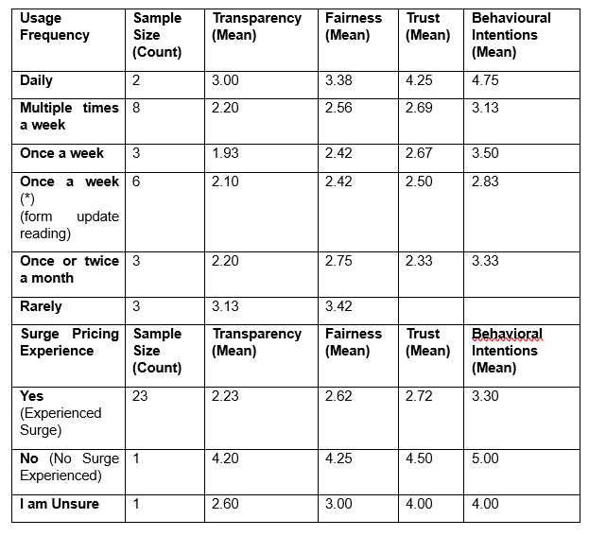

Table 5: Pearsons Correlation (r) calculation of riders (2)
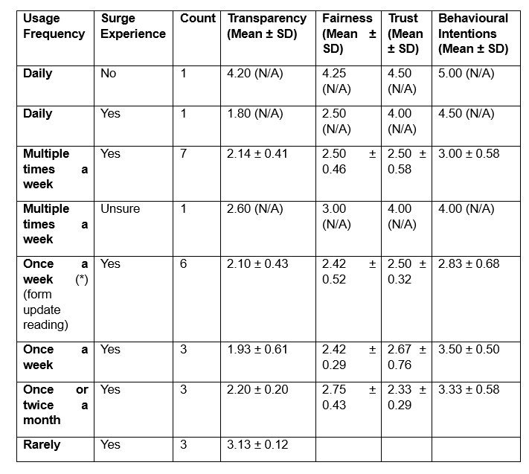

Result
Table 6: Pearsons Correlation (r) calculation of riders’ result
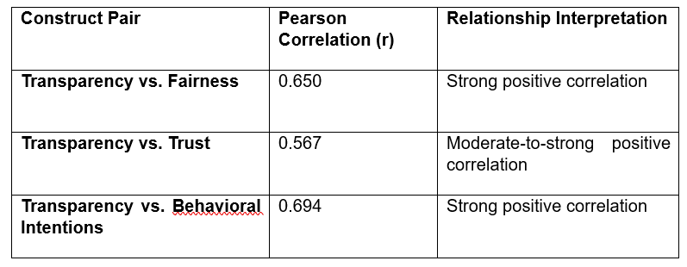

Pearsons Correlation (r) calculation of Drivers in terms of fairness, trust and behavioural intension with respect to transparency
Table 7: Pearsons Correlation (r) calculation of Drivers in terms of fairness, trust and behavioural intension with respect to transparency (1)
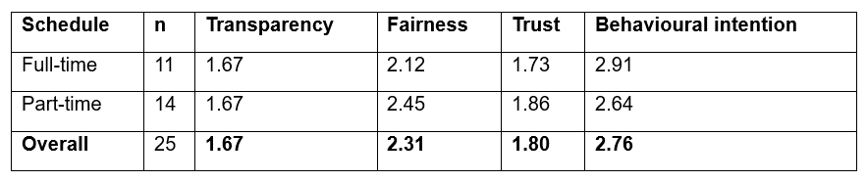

2.1) Result
Table 8: Pearsons Correlation (r) calculation of Drivers in terms of fairness, trust and behavioural intension with respect to transparency: Result
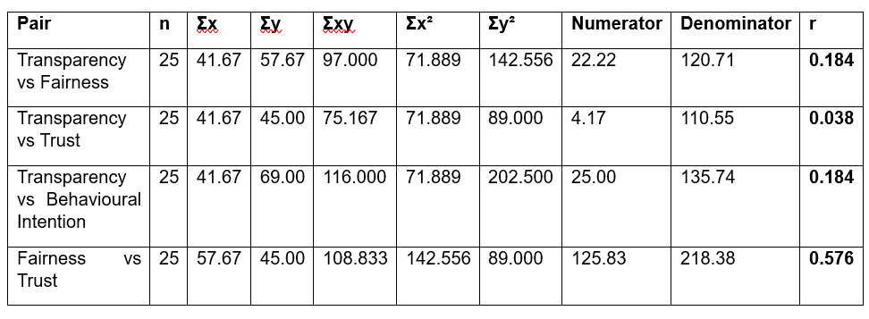

Cronbach’s Alpha Score
Table 9: Cronbach's Alpha Score for Riders
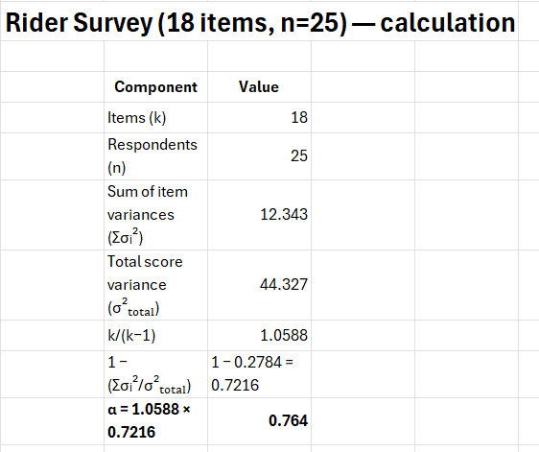

Table 10: Cronbach's Alpha Score for Drivers


