Sofia Maria Gasdali
ID: 2023081
BMSW4004
Charles Oham
Problem Solving and Decision Making

Problem-solving is usually a rather preferred skill in todays job market. Having the cap-potential to remedy complicated and easy troubles is frequently an essential part of fulfilment in lots of industries and job positions. The development and use of problem-solving skills also improves learning. Rossman (1993) suggests that when students use problem-solving skills, "The role of the student changes from a passive recipient of information to a participant in the creation of understanding. In the day to day of a business professional solving problems and decision making is required.

Problem-solving and decision-making are essential life and business abilities. Problem solving frequently necessitates decision-making, which is especially critical for management and leadership. There are methods and approaches for improving decision-making and decision quality.

What is problem solving and decision making? Problem solving is an analytical process used to distinguish the potential solutions for the current circumstances. Making decisions is a vital part of problem solving. Problem solving can be a complicated process, and informed decisions or choices will be made on the way. Decision making is a choice made by utilising one’s judgment.

What are problem solving skills? Problem solving skills help you figure out the source of the problem and find the most beneficial solution. There are many other skills that contribute to this such as;
- Research
- Analysis
- Active listening
- Communication
- Time management
- Creativity
- Team building
- Decision making

What are decision making skills? Having a problem solving skill means you will have to make vital decisions for a company or organisation. Some of the decision making skills needed are,
- Leadership
- Logical reasoning
- Teamwork
- Emotional intelligence
- Time management
- Creativity
- Intuition

A complex problem is when something is too complicated for one person to understand. Some problems that may occur in a workplace is lack of training which leads to employees like myself not knowing or understand what they’re required to do and how things should be done with a high standard.

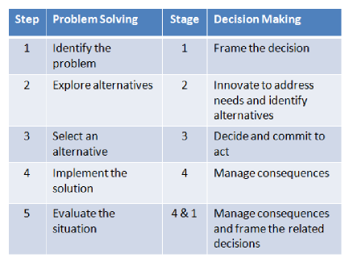
Employers like to hire people who can solve problems and work well under pressure. A complex problem I have been facing at my workplace recently is having way too many hours and hardly any vacations, or days off, also not being paid enough. The problem is due to the covid19 global pandemic it has really taken its toll on the company and has been a big struggle due to the fact the company has lost a lot of money and had no other choice but to make many employees redundant as there wasn’t enough money to pay everyone. We are opened full time and have very little staff so unfortunately a lot of our staff have to work long hours. From what I know there are many job advertisements put up on social media, however, we have not got a lot of people applying to work for our company as the hourly rate is very low. Moreover, since Brexit has happened it’s been significantly difficult to find staff especially ones with some type of experience.

Another problem occurring in our workplace is that many of our employees such as myself feel as if they are not herd by the manager and feel disrespected as if their requests and opinions as an employee are ignored. We have made our concerns clear to our manager that we feel as though we have no time for ourselves, no form of social life and no time to spend with our family. We use to enjoy work but now we hardly have any motivation to work to our best ability at work.

The most sufficient way to analyse a problem is to view the problem as a opportunity for improvement. In order to help solve these problems it is vital to follow a structure to ensure nothing is overlooked. According to Myers-Briggs Type Indicator, that is specially designed in order to measure the individual’s problem solving style, there are several problem-solving styles. (Mosley, 1991, para.2)

Steps to problem solving process:
- Define the problem
- Clarify the problem
- Identify the problem from more than one perspective
- Evaluate the options
- Select an option/options
- Evaluate the results
- Make sure it benefits everyone and makes everyone happy equally
- Continuously improve and make room for more improvement

In order to problem solve the issues and come up with a decision to solve the problems occurring in the workplace a few tools and techniques were used to come up with a mutual beneficial decision. This includes a SWOT analysis, risk analysis, decision making matrix and fishbone diagram. These tools helps to breakdown and fully understand the complicated problems. Without these helpful tools and techniques, problem solving and decision making can be quite difficult. A SWOT analysis was used to help workout a successful strategy. The risk analysis was used to lay out all of the potential risks and helps to identity a strategy for controlling and preventing them from happening. Another tool used was the fishbone diagram, this was used to visualise the cause and effects. This was really helpful in identifying possible causes for a problem and helped think of alternative solutions that will benefit everyone in the long run.

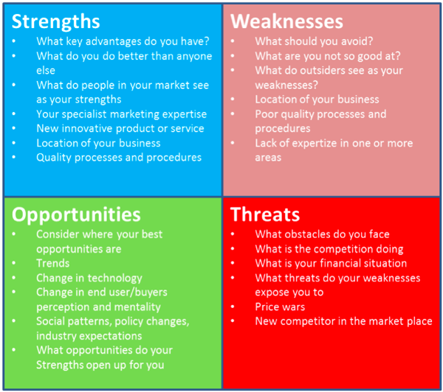

We have come up with a variety of solutions which makes all employees satisfied and eager to come to work everyday. A problem that I was facing in the workplace was no growth. I have been stuck working in the same position for four years, I have lost all motivation at work and feel as if I’m not getting the right appreciation for what I do, I don’t feel like I’m getting nowhere within the company. I made a request that I’d like to move up in positions which will also allow me to earn more and have some leadership within the company. Everything was taken into consideration and dealt with appropriately.

The decision that was made with the underpaid problems, I was given a opportunity to work as a higher position in the company as I have the experience and have gained great knowledge throughout the four years of working for this company. This has enabled me to a higher hourly rate. As majority of the staff wasn’t trained properly and don’t have a lot of experience compared to me they’re wages have just been raised by 5%.

At the moment I’m working Monday-Sunday due to lack of staff and the reason for lack of staff is all down to Brexit occurring and the low minimum wage salary. But due to working Monday-Sunday I have no time for myself, a social life and my family. I also feel really tired as I don’t get much sleep either due to working early mornings and late nights. In four years of working in this company I have only been on vacation twice and no more over four days. It is critical that us employees are able to take time for ourselves and deserve a vacation as it will help my mental health and enable me to do better at work. I have now been given my weekends off and have been granted one whole week off for myself so I’m able to spend some time with my family and friends. I’ve also been given a 28 day holiday throughout the year, anytime of my choice. My monthly wage has also been increased and a new holiday and sick pay has been put in order. I also start an hour later and only work late 2 nights a week so I’m able to juggle work, university and a social life.

Another problem we was facing within the company was the manager having as little communication with the employees as possible. Many of us, including myself have new ideas that may better the company but it’s impossible as there is no communication or feedback from our manager and we feel as if we are always ignored and not important enough. However, the solution that has been placed within the company is that the manager will meet with their staff individually every other week and have a meeting to discuss any problems or new ideas we may have that can make the company more great, help bring more money into the company and ideas that will satisfy the customers as-well as the employees.

It is important for us to develop a monitoring and evaluation is a management function which helps assess whether we as a company are progressing and achieving the best results as expected. In order to monitor and evaluate we

Needs Analysis: A need analysis can help figure out where to begin the planning process or what to focus on next. This can also be used to assess employee interests and needs within the workplace environment.

Monitoring and Evaluation design: This helps assess the progress and results throughout the entire process. An M&E will include certain documents that may have been created during the decision making process.

- Use a planning tool – problem solving tool such as fishbone diagram or swot analysis
- Describe the outputs
- Set outputs indicators
- Describe our outcomes
- Set outcome indicators
- We then plan how to measure a beneficial outcome
- Test all our knowledge and awareness
- We then review and priorities the outcome indicator

Milestone identification: After we are all clear on the results we then need to look focus on time. We need to make sure that all the goals that are expected are achieved by a certain period of time, what needs to be set in place before a certain time, what goals are next after one’s been achieved etc.
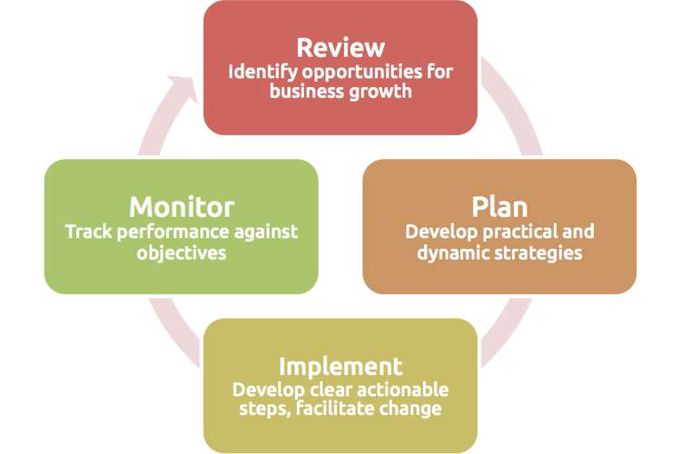
Implement and a monitor: This comes in place when we look at how we get the job done and achieve excellent results, while also making efficient use of available resources and learning more along the way.

There are three stages to implementation:
- Start-up or inception – A staring point of a plan.
- Main implementation – The start of plan or procedures being put into action.
- Phase out – Gradually stop the plan if it isn’t working.

Some basic monitoring techniques were assessed and put into action in order to have a successful plan. Some of the monitoring techniques are;
- Observation
- Monitoring
- Talking to people
- Monitoring work performance and output
- Employee surveys (before, during and after the change)
- Baseline measurement before and after the change
- Benchmarking with other work units

In order to achieve a successful implementation of the problem we have decided to develop the plan for implementing the solution. We did that by, identifying the things needed to be done, scheduled actions, identify the resources required, put demands into place, identify management of the action, review the plan and make sure everyone’s happy with the mutual beneficial plan.

In order to attain this goal, a review of relevant literature is required, which will allow an in-depth examination of the aforementioned issues.
This is an intriguing topic since it demonstrates the importance of developing decision-making and problem-solving skills in today's managers.
Furthermore, this topic is both personally and professionally satisfying, as it aids inthe resolution of workplace issues and provides managers with a means of professional progress.

Finally, it is crucial to mention that decision-making and problem-solving are critical managerial activities.
I believe that intuitive decision making, which is a bridge between unconscious and conscious decision making, can aid in recognising potential changes, identifying existing and future difficulties, properly managing information, and dealing with conflict situations.My own experience shows that solid decision-making and problem solving skills can assist managers in determining the best solutions for a given workplace environment.Furthermore, I am confident that in order to speed up the decisionmaking process,needless paper work and approvals must be eliminated, the decisionmaking process must be simplified, and operational staff's talents and knowledge must be combined.In today's competitive workplace environment, special attention should be made to creativity in issue solving, as creative managers are always ready to deal with any challenging circumstance and create great outcomes.

Mosley, D., O’brien, F., Pietri, P. (1991) Problem Solving Styles Determine Managers’ Approach to Making Decisions. Industrial Management. September 1, 1991. Retrieved from:<http://www.thefreelibrary.com/Problem+solving+styles+determine+manager’s+approach+to+making…-a011550855>

