

University of Wales Trinity Saint David
BSC Applied Computing
Module: Usability Engineering
Module Code: ACCB6017

Assignment Title:
Full Interface & Testing
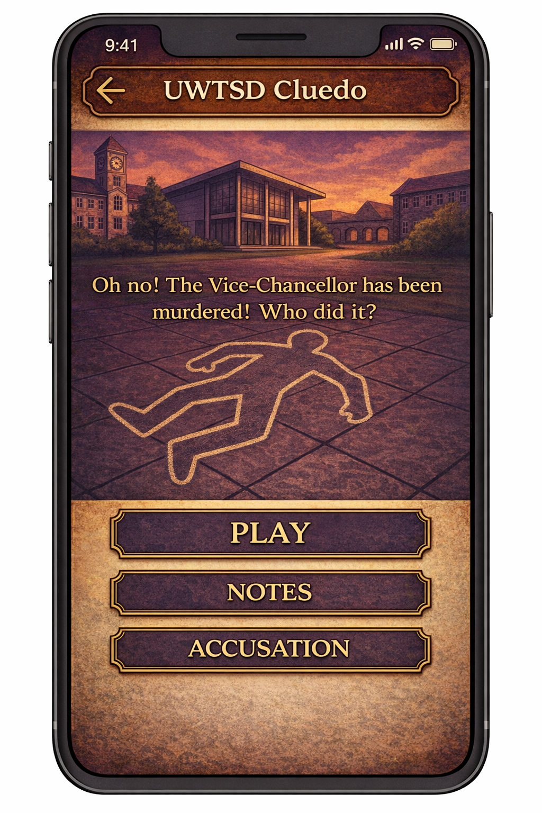

Paulin Bijou Banza
2213374

Lecture:
Koushik Modak
Date: 21 December 2025
Table of Contents
UWTSD Cluedo: Interaction Design Report 2
1. Introduction 2
2. Design Goals and Intended User Experience 2
3. Full-Colour Storyboards and Major App Functionality 3
3.1 Role of Storyboards 3
3.2 Key Screen Designs 3
Game Mode Selection 3
. Multiplayer Creation and Lobby 4
Campus Map Screen 5
Clue Log Screen 6
Accusation Screen 7
4. Transition from Wireframes to Full-Colour Designs 8
4.1 Differences from Wireframes 8
4.2 Justification of Changes 9
5. Colour Schemes and Graphic Design Choices 9
5.1 Colour Scheme Selection 10
5.2 Contemporary Academic Colour Mode (Alternative Design) 10
6. Feedback Collection and Persona Coverage 11
6.1 Feedback Collection Methods 11
6.2 Coverage of Personas 11
6.3 Feedback Summary 11
7. Data Collection in a Working Version 12
7.1 Types of Data 12
7.2 Differences Between Data Types 13
7.3 Differences Between Data Types 13
8. Usability vs User Experience (ILO1, ILO4) 13
9. Reflective Summary of the Design Process 14
10. Conclusion 14
Appendix A: Full-Colour Storyboards 14
11. References 17

UWTSD Cluedo: Interaction Design Report

1. Introduction
This project involved designing a mobile application inspired by the classic board game Cluedo, reimagined for the University of Wales Trinity Saint David (UWTSD). The narrative premise of the game is: “Oh no! The Vice-Chancellor has been murdered! Who did it?” Players must explore different university campuses, gather clues, and make logical deductions to identify the suspect, weapon, and location of the crime.
The purpose of this assignment was not to develop a working application, but to design a complete interaction concept that demonstrates strong principles of usability and user experience. The project builds on earlier wireframe designs and develops them into a complete set of full-colour digital storyboards suitable for a mobile phone interface. These storyboards illustrate all significant functionality of the app, including navigation, interaction flow, feedback, and decision points.
Throughout the design process, we adopted a user-centred and iterative approach, informed by established usability theory and direct feedback from potential users [1] [2]. This report documents the design decisions made, explains how usability and user experience considerations shaped the final storyboards, evaluates the input received, and critically reflects on the overall design process.

2. Design Goals and Intended User Experience
The app was designed primarily for university students and staff, many of whom are familiar with mobile applications and casual games. However, users were assumed to have varying levels of familiarity with deduction-based games such as Cluedo. As a result, the design needed to be accessible to new players while still engaging experienced ones.
The main design goals were:
- To create an interface that is intuitive and easy to learn without instructions
- To support logical deduction without overwhelming the user
- To provide an engaging and thematic experience appropriate to an academic setting
- To ensure accessibility and clarity on a mobile device
The intended user experience balances usability (efficiency, clarity, error prevention) with user experience (atmosphere, narrative engagement, emotional response). Research in interaction design highlights that emotional engagement is critical in games and entertainment-focused systems, where enjoyment directly affects continued use. $[3]$, $[4]$.

3. Full-Colour Storyboards and Major App Functionality

3.1 Role of Storyboards
The full-colour storyboards represent the final stage of the interaction design process. They were created digitally (not hand-drawn), at a scale appropriate for modern smartphones, and depict both individual screens and the transitions between them. Storyboarding is widely used in interaction design to visualise user journeys and evaluate design concepts before implementation. $[5]$.
The storyboards demonstrate:
- The overall navigation structure
- Visual hierarchy and layout
- System feedback and status visibility
- User decision points and error prevention
- The relationship between screens
Presenting the storyboards sequentially allows both designers and users to understand how interaction unfolds over time, rather than viewing screens in isolation. $[6]$.

3.2 Key Screen Designs

Game Mode Selection
The game mode selection screen allows users to choose between Single Player and Multiplayer. Large, clearly labelled buttons support touch interaction, while brief descriptive text reduces cognitive load. This follows Nielsen’s heuristic of recognition rather than recall, as users are not required to remember information from previous screens. $[1]$.

. Multiplayer Creation and Lobby
The multiplayer flow includes screens for creating or joining a game and waiting in a lobby until all players are ready. Player status is clearly displayed through text labels and visual cues, ensuring users always understand the system's current state [1] [7].
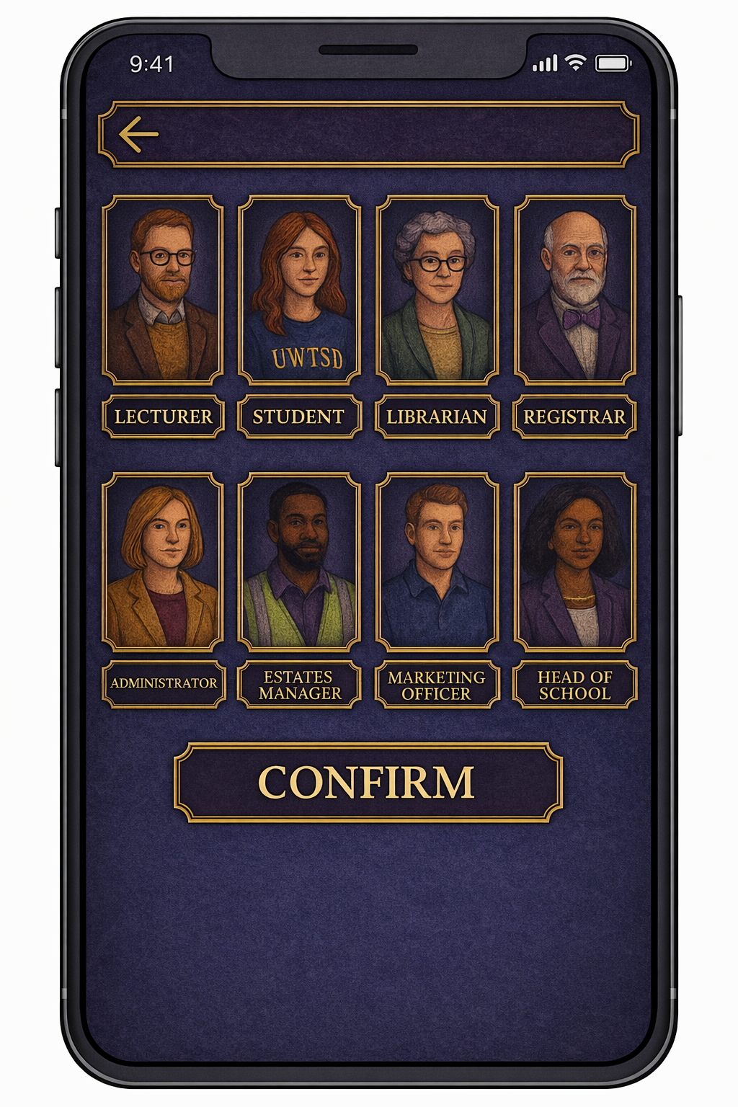

During usability testing, participants were able to explain the purpose of the lobby screen without prompting, indicating that the design successfully communicates its function. This reflects the principle of system status visibility, which is particularly important in multiplayer contexts.

Campus Map Screen
The campus map acts as the digital equivalent of the Cluedo board. Using a real-world metaphor allows users to transfer existing knowledge into the digital environment, improving learnability.$[2]$.
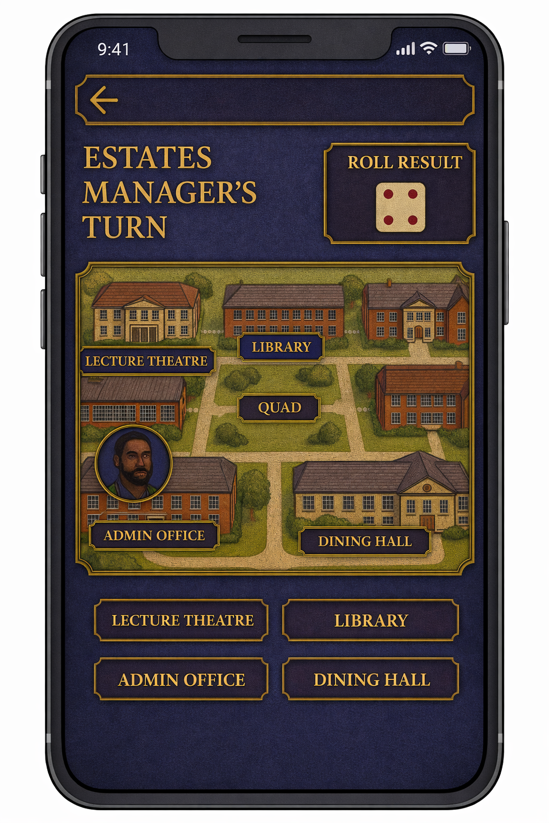
This design uses a familiar real-world metaphor, allowing users to transfer existing knowledge of physical campus spaces into the digital environment. Persistent navigation buttons for Notes and Accusation are included to support flexible movement through the app without forcing a linear path.

Clue Log Screen
The clue log presents all discovered clues in a notebook-style layout. This screen allows players to review information at any time, supporting logical reasoning and long-term memory. By externalising details, the design reduces cognitive load and enables players to focus on deduction rather than memorisation [8].
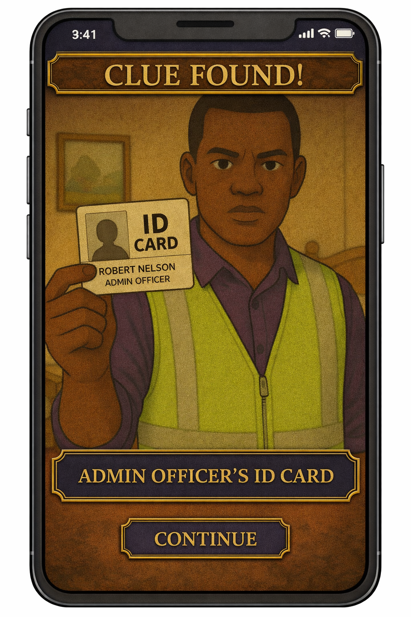
Feedback indicated that this screen was invaluable for players unfamiliar with deduction games, as it provided a clear overview of progress.

Accusation Screen
The accusation screen represents a high-stakes decision point within the game. The interface is deliberately structured and visually distinct to communicate importance. Dropdown selections for suspect, weapon, and location reduce error risk, while clear Submit and Cancel options prevent accidental confirmation [1].
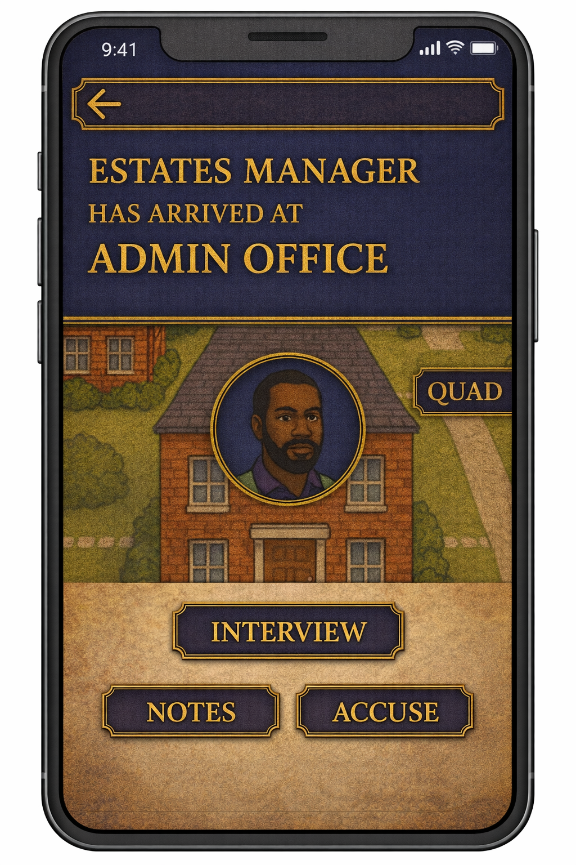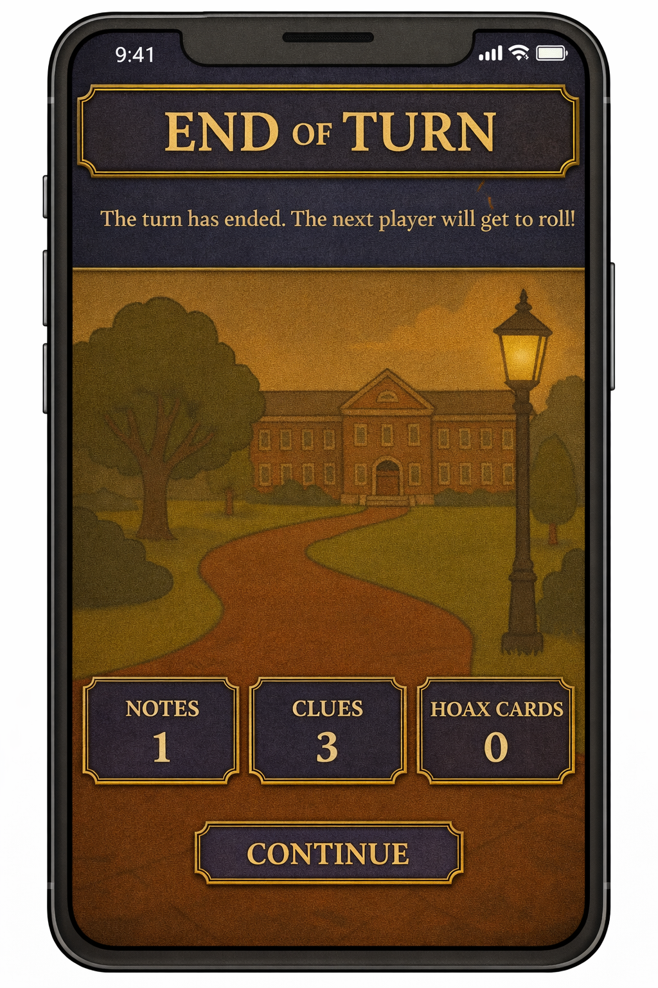
This screen demonstrates the usability principle of error prevention, ensuring that irreversible actions require deliberate user intent.

4. Transition from Wireframes to Full-Colour Designs

4.1 Differences from Wireframes

The initial wireframes focused on layout, navigation, and basic interaction flow. While they successfully communicated structure, feedback revealed that they lacked emotional impact and thematic clarity. Users described the wireframes as “functional but bland.
Key changes introduced in the full-colour designs included:
- Textured backgrounds and thematic imagery
- Stronger colour hierarchy to guide attention
- Iconography to support recognition
- Increased visual emphasis on key actions

4.2 Justification of Changes

The changes made between the initial wireframe designs and the final full-colour storyboards were justified by the application's nature and purpose. Unlike a productivity or information-focused system, this project is a game in which sustained engagement, curiosity, and emotional involvement are essential to success. While the wireframes effectively communicated layout and navigation, they did not adequately convey the narrative tension or sense of mystery required to motivate continued play.
From a usability perspective, the wireframes already met many functional requirements, such as clear navigation paths and logical screen structure. However, feedback collected during wireframe testing indicated that users perceived the interface as “functional but flat,” suggesting that usability alone was insufficient to deliver a compelling experience. This highlighted the need to move beyond basic efficiency and address user experience factors, such as atmosphere, immersion, and emotional response [5].
The introduction of full-colour visuals, textured backgrounds, and a consistent mystery-themed aesthetic served several purposes simultaneously. First, these enhancements strengthened narrative coherence, reinforcing the detective theme through visual cues such as parchment-style panels, dark colour palettes, and gold accents. Second, they increased emotional engagement, making the game feel more like an unfolding mystery rather than a sequence of tasks. Third, they improved usability indirectly by guiding attention; for example, high-contrast gold buttons and darker backgrounds helped users identify primary actions more quickly [3].
Importantly, these visual enhancements were applied carefully to avoid compromising clarity or accessibility. Interaction design principles such as visual hierarchy, consistency, and recognition over recall were maintained throughout. For instance, although the accusation screen was made visually heavier to emphasise its importance within the narrative, its layout remained structured and straightforward to prevent user error. This demonstrates how usability and user experience were treated not as competing goals, but as complementary aspects of the same design process.
Overall, the transition from wireframes to full-colour storyboards reflects a deliberate shift from designing for function alone to designing for experience. The final designs show that it is possible to enhance immersion and emotional impact while still adhering to established usability principles, resulting in an interface that is both easy to use and engaging to interact with.

5. Colour Schemes and Graphic Design Choices

Visual design plays a significant role in shaping both usability and user experience, particularly in game-based applications where atmosphere and emotional engagement influence player motivation. In this project, colour and graphic choices were treated as functional design elements rather than purely aesthetic decisions. Two visual approaches were considered: an initial Gothic Academic colour mode and an alternative Contemporary Academic colour mode. Both methods use the same interaction structure and layout but differ in emotional tone and visual emphasis.

5.1 Colour Scheme Selection
The primary colour scheme used in the final storyboards adopts a Gothic Academic aesthetic, combining traditional mystery themes with the institutional identity of a university setting. This mode was selected to reinforce the narrative of investigation and deduction, echoing the atmosphere of the original Cluedo board game while adapting it to a digital environment.
The palette includes:
- Deep burgundy and dark red tones are used for high-stakes screens, such as the accusation interface, to convey tension, seriousness, and finality.
- Cream and parchment colours, referencing notebooks, archival documents, and academic materials, particularly in the clue log and information panels.
- Gold and blue accents are used sparingly to highlight interactive elements and primary actions, drawing user attention without overwhelming the interface.
- Muted greens and greys, reflecting real campus environments and providing visual balance.
From a usability perspective, this palette supports visual hierarchy by clearly distinguishing primary actions from secondary ones. The strong contrast between background textures and interactive panels ensures that buttons and selectable elements remain clearly identifiable. The Gothic Academic mode also enhances emotional engagement, encouraging immersion in the mystery narrative, which is particularly important in maintaining player interest in a game context (Norman, 2004).
However, reflective evaluation identified that the visual richness of this palette, while compelling narratively, could feel heavy during extended use or less approachable to casual players.

5.2 Contemporary Academic Colour Mode (Alternative Design)
To explore how colour influences usability and emotional response, an alternative Contemporary Academic colour mode was developed. This mode retains the same layout, interaction flow, and functionality as the Gothic version, allowing direct comparison of visual impact without altering usability fundamentals.
The Contemporary Academic palette includes:
- Deep navy blue as the primary structural colour, conveying professionalism, stability, and focus.
- Soft slate blue backgrounds, reducing visual noise and texture.
- Muted teal or cyan accents, used to indicate active states and interactive elements.
- Warm amber highlights, reserved for primary actions such as “Start Game” or “Submit Accusation”.
- White or off-white panels, improving readability and contrast on mobile screens.
This alternative mode prioritises clarity, accessibility, and visual comfort. By reducing texture and dark saturation, it minimises visual fatigue and improves legibility, particularly during longer gameplay sessions. Feedback-informed reflection suggests that this mode may be more suitable for first-time users or those less drawn to highly stylised interfaces.
Importantly, usability principles such as recognition rather than recall, consistency, and error prevention are preserved. The change in colour scheme alters emotional tone but does not affect interaction efficiency or learnability.

6. Feedback Collection and Persona Coverage

6.1 Feedback Collection Methods
Feedback was collected using storyboard walkthroughs, think-aloud testing, and task-based scenarios. Participants were asked to complete tasks such as navigating to a location, reviewing clues, and making an accusation while verbalising their thought process.
This approach allowed us to identify usability issues early and gather qualitative insights without requiring a functional prototype.

6.2 Coverage of Personas
Participants were selected to represent a range of personas, including casual gamers, experienced gamers, users familiar with Cluedo, and users unfamiliar with deduction games. This ensured that feedback reflected diverse expectations and abilities.

6.3 Feedback Summary
Positive feedback highlighted the engaging visual theme, straightforward navigation, and usefulness of the clue log. Constructive feedback included concerns about information density on some screens, requests for clearer multiplayer turn indicators, and suggestions for non-colour-based accessibility cues.
Some emotional responses, particularly the desire for more dramatic feedback animations, were stronger than expected, reinforcing the importance of emotional engagement in game design.

Some emotional responses, such as a desire for more dramatic feedback animations, were stronger than expected, highlighting the importance of UX beyond basic usability.

7. Data Collection in a Working Version

If a fully functional version of the UWTSD Cluedo app were built and released, collecting data from users would be essential to evaluate the design's effectiveness and inform future iterations. Data collection would focus on two complementary categories: usage data and emotional or qualitative response data. Together, these data types would provide insight into both user behaviour and user experience.

7.1 Types of Data
Usage data refers to quantitative information about how users interact with the app. This type of data could be collected automatically through built-in analytics tools without requiring direct user input. Examples of usage data include:
- Screen visit frequency, indicating which screens are accessed most often and which may be underused or overlooked.
- Time spent per screen, helping to identify areas where users may be confused, overly engaged, or disengaged.
- Navigation paths, showing how users move through the app and whether they follow the intended gameplay flow.
- Game completion rates, indicating whether players can finish games or abandon them partway through.
- Accusation success rates, revealing whether the game’s difficulty and clue distribution are balanced appropriately.
This data would be valuable for identifying usability issues that may not be immediately obvious through observation alone. For example, if users consistently spend a long time on the accusation screen, this may suggest uncertainty or unclear information. Conversely, if players rarely access the clue log, this could indicate that the feature is poorly integrated or insufficiently emphasized.
Because usage data can be collected automatically and continuously, it allows designers to analyse patterns across many users, making it particularly useful for identifying systemic design problems and validating design assumptions.

7.2 Differences Between Data Types
Emotional and qualitative data would be collected through:
- In-app surveys
- Optional feedback prompts
- Post-game ratings
Unlike usage data, emotional response data requires direct user interaction and cannot be fully automated.

7.3 Differences Between Data Types
While both usage data and emotional response data are valuable, they serve different purposes and answer different questions. Usage data reveals what users do, such as which screens they visit or how long they spend playing. In contrast, emotional data explains why users behave in specific ways, such as why they abandon a game or avoid a particular feature.
For example, usage data might show that many players exit the game shortly after making an incorrect accusation. Emotional feedback could reveal that this outcome feels too punishing or discouraging. By combining both data types, designers can make informed decisions that address not only functional issues but also experiential ones.
Together, these forms of data support an evidence-based, user-centred approach to iterative design. Usage data highlights patterns and problem areas, while emotional response data provides the context needed to interpret those patterns meaningfully. This combination would be essential for guiding the next version of the app and ensuring that future design changes improve both usability and overall user experience.

8. Usability vs User Experience (ILO1, ILO4)

This project demonstrated the importance of iterative, user-centred design. Wireframes were essential for establishing structure, but full-colour storyboards revealed how visual design and emotional engagement significantly influence perceived usability.
User feedback challenged several initial assumptions and directly informed design improvements. By combining usability theory with real user input, we produced a design that balances clarity, accessibility, and immersion.

9. Reflective Summary of the Design Process

This project reinforced the importance of iterative, user-centred design. Wireframes were essential for structure, but the full-colour storyboards revealed how visual design and emotional engagement significantly affect usability perception.
By incorporating user feedback and usability theory throughout the process, we achieved a balanced design that supports both functional clarity and immersive experience.

10. Conclusion

This project demonstrates a comprehensive interaction design process, from wireframes to full-colour storyboards. The final designs reflect careful consideration of usability principles, visual communication, user feedback, and data-driven iteration.
The app concept successfully balances academic context, playful mystery, and mobile usability, meeting the assignment's learning outcomes and objectives.

Appendix A: Full-Colour Storyboards
(All storyboard screens presented sequentially, showing user flow and interaction transitions.)

11. References
[1]. J. Nielsen, Usability Engineering. San Francisco, CA, USA: Morgan Kaufmann, 1993.
$\left[2\right].$H. Sharp, Y. Rogers, and J. Preece, Interaction Design: Beyond Human–Computer Interaction, 5th ed. Hoboken, NJ, USA: Wiley, 2019.
$\left[3\right].$ D. A. Norman, Emotional Design: Why We Love (or Hate) Everyday Things. New York, NY, USA: Basic Books, 2004.
$[4]$. J. Schell, The Art of Game Design: A Book of Lenses, 3rd ed. Boca Raton, FL, USA: CRC Press, 2019.
$\left[5\right].$B. Buxton, Sketching User Experiences. San Francisco, CA, USA: Morgan Kaufmann, 2007.
$\left[6\right].$S. McCloud, Understanding Comics: The Invisible Art. New York, NY, USA: HarperCollins, 1993.
$\left[7\right].$ISO 9241-210, Ergonomics of Human-System Interaction – Human-Centred Design for Interactive Systems. Geneva, Switzerland: ISO, 2019.
$\left[8\right].$J. Sweller, “Cognitive load during problem solving: Effects on learning,” Cognitive Science, vol. 12, no. 2, pp. 257–285, 1988.
$\left[9\right].$W3C, Web Content Accessibility Guidelines (WCAG) 2.1, 2018.
$\left[10\right].$M. Harrison, A. Flood, and D. Duce, “Usability of mobile applications: Literature review and rationale for a new usability model,” Journal of Interaction Science, vol. 1, no. 1, pp. 1–16, 2013.

