Student name:Szilard Szanto
Student id:Szilard Szanto
Module cod:(BMHP6022_Lon)
Lecturer Name: Bianca Sanfilippo
Szilard Szanto
1808072
Table of Contents
1. Introduction 2
2. Population 2
3. Employment 3
4. Skills 4
5. Health Inequality 4
6. Child poverty 4
7. Housing 4
8. Education and Attainment 4
9. Crime 5
10. Child poverty 5
11. Drivers of child poverty 5
12. Unemployment in Harrow 5
13. Development efforts 6
14. Inclusion for Women in Harrow – Project 6
15. Positive and negative aspects of these digital media 6
16. Positive Effects of social media 6
17. Adverse Effects of social media 7
18. Policy 7
19. Conclusion 8
20. References 8

- Introduction
Harrow is one of the most religiously and ethnically diverse boroughs in London, with residents hailing from a variety of backgrounds and experiences. We believe that the breadth of this diversity, as well as its positive impact on the borough and our community, contribute to Harrow's appeal as a location to work, live, and visit. We appreciate and value the borough's diversity. This report highlights our commitment to sustaining and improving on our strengths through the integration of equality and diversity into all we do.
The Council's goal is to provide opportunity equality for all residents, service users, employees, elected officials, stakeholders, and partner organisations. To end unlawful discrimination, advance opportunity equality, and develop positive relationships among Harrow's diverse communities, we recognise our commitment to do so Equality Impact Assessmen. (EqIA) APPENDIX 8, 2018).”
- Population
It is projected that Harrow has a resident population of 248,7501, which indicates that the town's population has increased by 42,550 people (20.5 percent) since 2001.
Between 2014 and 2024, it is predicted that the number of children aged 0-15 would rise by 14%, according to the United Nations Development Programme.
Disability — A total of 22,100 persons, or 13.7 percent of the working-age population of Harrow, were classified as disabled in 2010. Disability Living Allowance is paid to 6,470 people, or 2.6 percent of the total population, in the United Kingdom. 6 Long-term social care services were provided to a total of 2302 people in 2016-17, with the vast majority of those receiving physical assistance. This represents around one percent of the entire resident population.
The number of live births per 1000 people in the United Kingdom grew to 14.5 in 2016, an increase from the previous year's figure of 14.5 in 2015. The fertility rate in the country is 2.03 children per woman, which is much higher than the rate in the United Kingdom, which is 1.79. (Our Harrow, Our Community -Equality Profile Annual Data Report 2017/18 2, n.d.).”
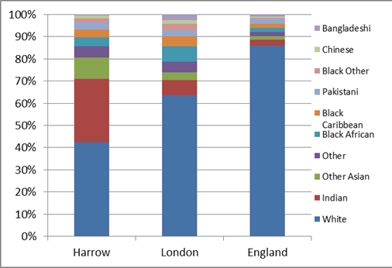
Race (ethnicity) - A total of 61.8 percent of the population claims to be a member of a minority ethnic group. White British people account for 38.2 percent of the population, which is the largest proportion of any ethnic group (down from 50 per cent in 2001). In Harrow, Indians account for 26.4 percent of the population, making them the borough's most prominent minority ethnic community, followed by Kenyans and Sri Lankans, who account for the remaining ten percent. Harrow is home to the country's largest concentration of Sri Lankans, who live in the surrounding area. Approximately 8.2 percent of the population resides in the city, up from 4.5 percent in 2001.
Harrow recorded its second-highest migration levels in a decade in 2015/16, indicating a considerable shift in the borough's demographic composition since the 2011 census. The majority of these newcomers hail from Romania, India, and Poland, the country's top three nationalities.
While English, Gujarati, Tamil, Romanian, and Arabic are the district's top five declared community languages, the district's schools serve children who speak a total of 155 more languages.
Religion or Belief - In addition to being the most religiously diverse borough in the UK, Harrow is also the most ethnically diverse. The borough has the largest concentrations of Hindus, Jains, and members of the Unification Church, the second highest concentrations of Zoroastrianism, and the sixth highest concentrations of Judaism. Christianism accounted for 37% of the population, the country's fifth lowest rate. 12.5 percent of the population were Muslims8. Greenhill and Wealdstone have a somewhat higher Muslim population and a little lower Hindu population.
Males account for 49.9% of the population, while females account for 51%.
- Employment
In Harrow, both unemployment and the number of long-term jobless claims have decreased. However, many inhabitants work in low-wage professions and possess limited functional skills.
Income deprivation - According to the Income Deprivation scale, 30,733 citizens of Harrow are living in poverty. Wealdstone is the most impoverished ward in Harrow in terms of financial deprivation and child poverty, followed by Marlborough and Harrow Weald.
- Skills
Fourty-five per cent of Harrow residents (aged 16-64) have a higher level of education (NVQ Level 4+), whereas only 2.8 percent have no formal education or training. In comparison to the capital (8.2 percent) and the rest of England, the borough has a high proportion of residents with 'Other' credentials (including overseas qualifications), accounting for 11.5 percent of the total population of the borough (6.7 per cent). Kenton East, Edgware, Roxbourne, and Roxeth are the districts in Harrow with the highest proportion of residents who do not have a degree or just have low-level qualifications (Our Harrow, Our Community -Equality Profile Annual Data Report 2017/18 2, 2018).”
Language issues are a hindrance to advancement in the workplace. Local government districts having a high need for English Language services for Communities and Local Governments were identified by the Department as priority areas. Harrow has a population of 28.5 percent who are multilingual. Households in which English is not the predominant language spoken by any household member account for 15.9 percent of all households countrywide, ranking tenth overall and much higher than the national average of 4.3 percent. One percent of Harrow residents could not converse in any form of English in 2011, compared to one percent of Londoners and one percent of the entire country.
- Health Inequality
Harrow’s health deprivation rating has improved and is now better than the national average. However, the borough still maintains health inequalities. The borough’s overall health statistics are favourable. According to the 2011 census, 14.6 per cent of Harrow inhabitants had a limiting long-term disease or disability. This is a 13.2 per cent (+4,000) growth from 2001. Harrow’s rate is presently more significant than the London average (14.2 per cent).
- Child poverty
“The number of children living in poverty is increasing. Poverty affected 4.1 million children in the United Kingdom last year (up from 3.7 million in 2013/14), accounting for 30 percent of all children or nine students in a classroom of thirty. Child poverty is highest in London, which has the highest rate in the country (NEU, 2019).”
- Housing
Households in social housing constitute 10% of the population of Harrow, which ranks third among London boroughs. According to official figures, there were 4,759 council dwellings and a comparable number of housing associations in March 2018. Harrow's social housing is home to people from a wide range of ethnic backgrounds, which reflects the borough's demographic makeup. Asians and Blacks are outnumbered by whites in the Council's stock.
- Education and Attainment
“For many years, Harrow's schools have consistently been named among the best in the United Kingdom. A total of 59 schools operate in the borough, with an outstanding or exceptional rating from Ofsted in 96 percent of those institutions. Our elementary schools rank in the top ten percent of all schools nationwide in terms of the number of students who obtain a grade of 5 or better in English and mathematics. When it comes to achieving Attainment 8 at KS4, our secondary schools rank 15th out of 150 local authorities, and 22nd when it comes to students obtaining a five or above in English and arithmetic (Whymark, 2019).”
- Crime
Harrow borough is London's safest city and the capital's safest town, hamlet, or city. Harrow had a total crime rate of 60 offences per 1,000 people in 2020. This compares well to the overall crime rate in London, which is 45 per cent lower at 87 offences per 1,000 people. Harrow is one of the safest cities in England, Wales, and Northern Ireland, and it is the 2,057th safest town, city, or hamlet in the country.
“In Harrow, violence and sexual offences are the most prevalent crimes, accounting for 4,667 offences in 2020, resulting in a crime rate of 19. This is a decrease of 2.0 per cent from the 4,759 offences reported in 2019 and a decrease of 0.37 per cent from the 19 crime rate reported in 2019. Possession of weapons is Harrow’s least prevalent crime, with 93 offences registered in 2020, the same as in 2019 (crimerate.co.uk, 2021).”
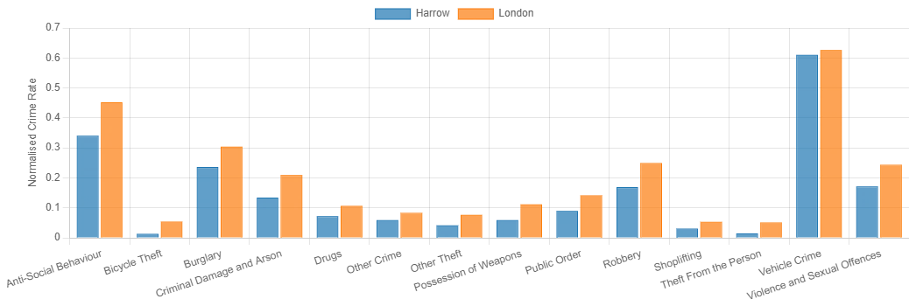
- Child poverty
“Local governments have acknowledged child poverty as a priority, as seen by the Harrow corporate strategy 2016-2019 and the health and well-being policy. On the index of multidimensional deprivation (IMD) and child poverty indicators, Harrow outperforms the rest of London's boroughs. However, the data shows that children and families in the borough are poor. The high housing and childcare costs in Harrow, for example, make it more difficult for low-income families and low-skilled people to make ends meet (HOWE, 2017a).”
- Drivers of child poverty
Poverty affects families for various reasons, the most common of which is a lack of cash to cope with their present situation. A family may become impoverished due to growing living costs, job loss, or benefit changes. “Childcare and housing are two of the most expensive items for families to purchase. Wealdstone and Roxbourne are the destitute wards in Harrow in terms of child poverty (Trumpold et al., 2021).”
- Unemployment in Harrow
In January 2017, 745,000 persons claimed jobless benefits. This decreased by 42,400 from December 2016 and an increase of 2,800 from a year earlier. This included 498,100 claimants of Jobseeker’s Allowance and 246,900 claimants of Universal Credit. There were 1.60 million jobless persons (those who are not working but are looking for employment) in September, scarcely changed from July to September 2016, but 97,000 fewer than a year earlier. Count of Harrow Claimants: In January 2017, there were five more claims than the previous month and a 17% (271) rise over the same month last year.
“Poverty, crime, drug addiction, poor health, low educational attainment, and family dissolution are all factors that contribute to low employment. Harrow had 2,490 persons requesting Jobseeker's Allowance in August 2014, the lowest proportion among the West London boroughs at 2.3 per cent. According to the research, owing to the high cost of healthy foods, unemployment and other life upheavals may limit a family's ability to get fresh meals and maintain a balanced diet (HOWE, 2017b).”
- Development efforts
The worldwide COVID-19 epidemic has created an uncertain environment for millions of families, resulting in an unprecedented food supply crisis; many individuals are suffering financially, and many more are unable to get basic food requirements owing to isolation. We have established a Food Distribution Hub in the heart of Harrow to ensure that thousands of people throughout the borough get food supplies. We collaborate with grassroots organisations and local volunteer partners to reach out to our most disadvantaged neighbourhoods with as much food as possible. We assist shelters, isolated individuals, the elderly, and families that cannot deal with the present situation. Our work also extends to local NHS trusts, care homes, and organisations that assist persons with mental illness and disabilities; our activities are critical for the foreseeable future (Crowdfunder UK, 2020).”
- Inclusion for Women in Harrow – Project
Through counselling, advice, complementary therapies, and training opportunities, this project aims to address economic and social exclusion for disadvantaged women in Harrow, improving their skills and employability, increasing opportunity equality, decreasing social isolation, and improving their mental and/or physical health.
- Positive and negative aspects of these digital media
Today’s media is more powerful than ever. It keeps us informed about international events. It has altered every area of human existence, including how we socialise, do business, and obtain an education.
- Positive Effects of social media
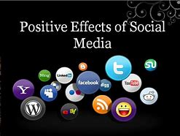
Businesses profit from social media platforms in a variety of ways. However, businesses may communicate with their targeted clientele for free via social media; energy and time are only expenditures. Utilising Facebook, Twitter, LinkedIn, and other social media networks, can dramatically lower your marketing costs.
As social media platforms such as Twitter, Facebook, and LinkedIn continue to grow in popularity, bloggers, article writers, and content producers have discovered that social media is the most practical way to connect.
Social networks have removed all barriers to communication and interaction, enabling individuals to share their perspectives and thoughts on a wide variety of topics. Students and professionals can interact and connect with like-minded individuals to exchange information and thoughts about a particular subject.
Additionally, social networking sites benefit society by bringing people together on a broad scale to accomplish a common purpose. This is vital if we are to affect positive change in society. (Ali, 2015).”

- Adverse Effects of social media

Addiction is one of the social media's disadvantages. Spending an excessive amount of time on social media may result in challenges with concentration and focus. It demotivates individuals, particularly children and students. They rely on technology and the internet for information and experience rather than acquiring real-world knowledge and experience.
These social networking sites may potentially have a harmful effect on children if used. The reason for this is that people occasionally publish violent and sexy photographs on social media, which can have a negative impact on children and teenagers.
Students and adolescents spend excessive time on social media platforms, causing them to lose focus on their academic work. As a result, they do not complete their lecturers' prescribed work in high school, college, or university. As a result, individuals cannot perform at their peak during tests. (Ali, 2015b).”
- Policy
“It came into action on October 1, 2010. It consolidates over 116 sections of law into one Act. The Act protects individual rights and promotes equality of opportunity for everyone. It protects people from unjust treatment and fosters a fair and equitable society. The nine key laws that combined are:
1 Equal Pay Act 1970
2 Sex Discrimination Act 1975
3 Race Relations Act 1976
4 Disability Discrimination Act 1995
5 Employment Equality (Religion or Belief) Regulations 2003
6 Employment Equality (Sexual Orientation) Regulations 2003
7 Employment Equality (Age) Regulations 2006
8 Equality Act 2006, Part 2
9 Equality Act (Sexual Orientation) Regulations 2007 (www.equalityhumanrights.com, n.d.).”

- Conclusion
In conclusion increased housing and childcare costs make it more difficult for low-income families and those with low levels of education and training to make ends meet. A person's attention may be diverted from other activities such as schoolwork or studies if he or she spends an excessive amount of time on social networking sites. It demotivates young people who rely mostly on technology and the internet for their daily lives and activities.

20. References


