

Providing Appropriate Advice to the Management Teams at two UK based Organisations.
Advanced Application of Employment Law.
May 2024

Stuart Davies-Jaynes (0151126)
University of Wales Trinity Saint David
PGDip/MA in Strategic People Management
Word Count = 3299



SECTION A.1

MEMORANDUM

To: Mr. Smith, MD.

Subject: Employment Advice

Dear David,

I am writing to advise on how and when Capital Garden Centre Limited (“Capital”) should respond to the claim made by Sarah Walters (SW) with an explanation of the claim(s) which she may bring.

- How and when to respond to the ET1.

I refer to the ET1 of the employment tribunal case number 3575/2024. The Advisory, Conciliation and Arbitration Service (Acas) is responsible for facilitating conciliation in cases brought before Employment Tribunals (ET). Following the addition of section 18A to the Employment Tribunals Act 1996, individuals seeking to file a claim with the ET are typically required to provide Acas with information regarding their case prior to initiating the tribunal process (Lewis, Sargeant and Schwab, 2023, pp. 10–11). SW has confirmed that she has tried early conciliation with Acas, but did not proceed, therefore SW has been issued with a certificate to proceed to an ET.

Concerning time constraints, you must complete the response form known as the (ET3) to the tribunal within 28 days, which is 09 March 2024. Extensions to this deadline are permissible upon request; failure to respond within the designated timeframe may result in the tribunal making a decision against you without convening a hearing (Gov.UK, 2019).

The countdown for response submission commences upon the tribunal dispatching a copy of the claim, as opposed to its receipt. You should submit responses via email or by postal delivery to the relevant tribunal office which will be stipulated in your correspondence (CIPD, 2022).

Summary of claims process:
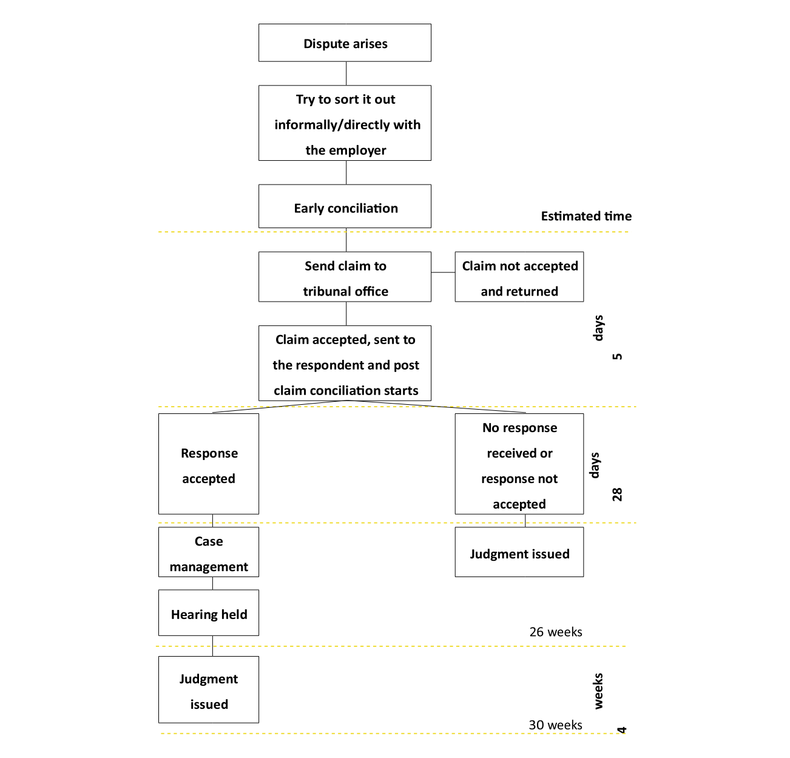
(Gov.UK, 2017)

- Grounds of proposed claims and SW eligibility to bring them.

UK equality legislation is designed to safeguard individuals who face disadvantages and unequal treatment due to specific characteristics. The aim is to ensure that these marginalised groups have equal opportunities to secure and maintain employment and to advance in their careers, on par with everyone else. The primary sources of equality law in the UK include the Equality Act 2010 (EA 2010), alongside EU law comprising treaty articles and secondary legislation (Lewis, Sargeant and Schwab, 2023a, pp.108-119).

Provisions of the EA 2010, individuals are safeguarded against discrimination related to nine protected characteristics. Unless an exemption is applicable, discriminating against individuals based on any of the below characteristics is deemed unlawful (Malleson, 2018).
- age
- disability
- gender reassignment
- marriage and civil partnership
- pregnancy and maternity
- religion or belief
- sex
- sexual orientation

Upon review of the ET1 form, SW is protected under section 6 of the EA 2010 due to her known disability, depression. The Act defines disability as a physical or mental impairment that significantly and enduringly impacts an individual's ability to carry out typical daily activities. This definition encompasses a wide range of conditions, both physical and mental (Ashcroft and Ratnayaka, 2014).

The EA 2010 addresses prohibited conduct, encompassing various forms of discrimination deemed unlawful under the Act. SW has a case of discrimination arising from disability and the failure to fulfill the duty to make reasonable adjustments will be subject to scrutiny by the tribunal (Richardson, 2021).

SW informed Capital that her GP had verified the connection between her migraines and depression, and she was undergoing medication to manage both conditions. During employment, SW made reasonable requests to work more flexibly on days when migraines occurred and take breaks at different times. There is no evidence to support that Capital considered these requests.

Capital has failed to consider or implement reasonable adjustments, as required by sections 20-22 of the EA 2010. This duty to make reasonable adjustments applies throughout the employment relationship. The responsibility to make these adjustments and cover their costs falls on the employer (Bell, 2015). Regrettably, Capital has failed to fulfill this duty, constituting discrimination.

Within the EA 2010, three forms of harassment are recognised. These encompass harassment linked to particular 'protected characteristics', instances of sexual harassment, and situations where individuals face less favorable treatment due to harassment (Acas, 2023).

Based on the circumstances, it is likely that SW would have eligibility to also bring a claim of harassment linked to her protected characteristic of ‘disability’. This is predicated on comments made to her by management which link to her condition.

For behaviour to qualify as harassment, it must either undermine the individual's dignity or create an environment that is intimidating, hostile, degrading, humiliating, or offensive.
Even if unintended, behaviour can still be considered harassment if it has one of these effects. The ET would assess whether a 'typical' person would interpret the behaviour as harassment (Acas, 2023).

Considering the above, SW could bring the following claims:

- a claim of constructive dismissal, this type of resignation is treated as a form of unfair dismissal (Willis, 2023). Employees have the right to consider themselves constructively dismissed solely if the employer engages in conduct that significantly breaches the fundamental terms of the contract or indicates that the employer no longer intends to adhere to one or more essential terms.

- Capital's failure to address or offer meaningful consideration for reasonable adjustments and protect SW from harassment based on her protected characteristic of ‘disability’ means SW can bring claims of discrimination (Brodie, 2022).

- Defence for the Claims

The Acas Code of Practice on Disciplinary and Grievance Procedures 2015 does not carry the weight of law. Nevertheless, failure to adhere to it can significantly impact an employer, as tribunals may consider it when adjusting any awards granted (Lewis, Sargeant and Schwab, 2023c, pp. 327–337). In the case of SW, Capital can evidence the key steps to handling disciplinary matters in the workplace have been followed, which include:
- Investigating the details of the case, which was conducted by Angela Davies
- Notifying the claimant about the issue
- Allowing the claimant to have a companion during the meeting, this was provided in writing to SW in a letter dated 12 December 2023.
- Determining suitable measures to address the situation.
- Offering the employee an opportunity to appeal

SW was provided with the right to appeal against the written warning imposed upon her within her disciplinary outcome letter dated 19 December 2023, to which was not pursued. Whilst opting not to appeal is not mandatory, it is advisable if there is a possibility of pursuing the matter further at an employment tribunal. SW’s failure to appeal to Capital initially might result in a reduction of compensation by the tribunal in the event of a successful case (Citizens Advice, 2022).

According to Acas (2022), in disciplinary cases, it is advisable for different individuals to handle various stages, such as the investigation, the disciplinary hearing, and any appeals, this can be demonstrated with different personnel managing each step of the process at Capital.

In the recent case of Miller v Rentokil (2024), the employee's diagnosis of multiple sclerosis, acknowledged as a disability under the EA 2010, exempts them from proving substantial disadvantage or difficulty with daily activities. This aligns with precedents established with SW’s claims relating to her disability. Thus, the tribunal would focus directly on evaluating Capital's treatment of her (Gov.UK, 2024b).

SECTION A.2

Recommended Remedies

SW could raise multiple reasons for leaving Capital. The ET must determine if any of these reasons constitute a response to a breach (Lewis, Sargeant, & Schwab, 2023, pp. 298-299). In this scenario, constructive dismissal could serve as the foundation for an unfair dismissal claim by SW. However, it could also form the basis of a discrimination claim, connected to her protected characteristic of disability (Barnett, 2022, pp.128–129).

To bring a claim, the tribunal will need to establish that SW has been “dismissed”. There are three categories of dismissal, termination by the employer, expiry of a fixed-term contract and in this instance, constructive dismissal (Lockwood, Henderson and Thornicroft, 2014). An employee will be eligible to claim ‘constructive unfair dismissal’ if they have worked for you continuously for at least two years. However, there will be no qualifying length of service where the reason for the constructive dismissal is one which can be classed as automatically unfair (Dyer, 2016).

To prevent financial burden on employers, there exists a statutory cap that sets a limit on the total amount of compensation payable. The maximum compensatory award for unfair dismissal is either £115,115 (effective from April 06, 2024) or 52 weeks' worth of the employee's wages, whichever is lower. This fixed amount undergoes annual review to keep pace with economic conditions and legal changes (Guinan, 2022). However, successful discrimination claim awards are considered 'uncapped', meaning there is no upper limit set.

A successful claim award comprises two components: the basic and compensatory award. The basic award element is similar to a redundancy payment which is based on a formula that takes account of the employees’ age, length of service and the value of one week’s pay. Specific award bands dictate the compensation amounts. From April 06, 2024, the maximum basic award for unfair dismissal, calculated based on 30 weeks of pay and subject to weekly pay limits is £21,000 (CIPD, 2024). In contrast, a successful discrimination claim would be unlimited in potential compensation, posing a significant financial burden for the business.

The Presidents of the ETs have issued guidance to tribunals regarding the compensation bands for injury to feelings in discrimination cases. Effective from 06 April 2022, the bands are outlined as follows:

- A lower band- less severe cases: £990–£9,900
- A middle band - moderately severe cases: £9,900–£29,600.
- An upper band - the most severe cases: £29,600–£49,300.

Awards exceeding £49,300 for injury to feelings would only be applicable in the most exceptional cases, (CIPD HR-Inform, 2023).

The tribunal will determine a fair and reasonable amount considering the financial harm caused to SW due to unfair dismissal or discrimination. The claimant is obligated to make reasonable efforts to minimise their losses. The tribunal has the authority to decrease the awarded amount, taking into consideration factors such as the employees’ failure to mitigate their losses and the possibility that the dismissal would have been fair if proper procedures had been followed. The ET would also consider the likelihood that the claimant would have been fairly dismissed in any event at a later date, and any conduct by the employee that has contributed to the dismissal formally known as "contributory fault", (Wilcox, 2008).

The tribunal will assess the concept of 'reasonableness.' Capital's responsibility to enact reasonable adjustments is not absolute, as employers are not obliged to take actions that would impose a 'disproportionate burden' on the company (Gov.UK, 2010). An instance often cited is the case of Dyer v London Ambulance Trust (2014), where it was deemed that there were no feasible adjustments the employer could reasonably make to accommodate an employee vulnerable to life-threatening reactions to perfumes while working in a busy call centre. The tribunal must navigate a 'balancing act' between Capital’s policies, available resources, and the employee's requirements. However, the EHRC Employment code underscores that even more costly or extensive adjustments need to be carefully weighed against factors like the expense of recruiting and onboarding new employees. All of which may increase or decrease the amount awarded by the tribunal (Bunbury, 2009).

In this case, the ET will analyse if reasonable adjustments that could be accommodated by the business are proportionate. For example, if they were of a significant cost to the business; if Capital cannot reorganise the work among other staff or if there would be a negative effect on the business's ability to meet customer demand this could decrease the award given by the tribunal.

Proposed Settlement Recommendation

The circumstances of this case indicate that SW could present a strong case at ET.

A favourable outcome for the claimant could potentially lead to significant financial consequences for the Company, possibly reaching the maximum compensatory award of £115,115 for unfair dismissal or an uncapped value of a successful discrimination claim. Further tribunal costs to consider include legal fees, court fees, and miscellaneous expenses (Acas, 2018).

The CIPD (2023), advocates the use of alternative dispute resolutions, such as Settlement Agreements (SA). There can be a lengthy wait for a hearing depending on various factors such as case complexity, court schedules, and the availability of witnesses. ETs will require significant resource investment which can be costly and distracting from the day-to-day running of the business. Legal representation (fees), time of resource allocated from Capital to prepare and attend the ET should be carefully considered.

If a SA was mutually agreed SW should fully understand her right to pursue a future tribunal claim would be removed. If agreed, this could protect Capital’s employee reputation within the local community as the terms of the agreement remain confidential versus an employment tribunal which is open to media scrutiny (Conn, 2000).

In determining the appropriate amount of compensation, Capital should consider the following factors:

- Provisions outlined in the employment contract regarding matters such as salary (£16,250 pa), notice period (statutory notice is 1 week for each full year worked), and any untaken annual leave.
- The duration of SW's employment with the company (2 years, 3 months, 2 weeks and 1 day)
- Anticipated duration for resolving the issue if a settlement is not reached.
- The level of challenge in finding a replacement for the position.
- Estimated time for the employee to secure alternative employment – this may present a challenge for SW considering her lack of skills.
- Motives behind offering a settlement.

Under section 111A of the Employment Rights Act, a total settlement payment of £6,250 is recommended, made up of the following amounts:

• 8 weeks’ notice pay £2,500. To be paid in lieu of notice, subject to statutory deductions.

• An ex-gratia payment of £3,750 (x 12 weeks’ pay) - an ex-gratia payment not subject to deductions.

Holiday pay accrued up to the termination date should be paid, subject to statutory deductions.

Settling the matter outside of court through a SA is strongly recommended as the most pragmatic and financially prudent choice for Capital. This approach not only minimises financial risks and operational disruptions but preserves Capital's reputation and fosters a swift resolution to the dispute.

Regards,
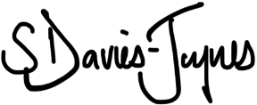

Stuart Davies-Jaynes

Section B

MEMORANDUM

To: Mr. Smith, MD.

Subject: Redundancy and Redeployment

Dear David,

I appreciate the opportunity to advise you on the redundancy process.

Redundancy and redeployment situations can be challenging and distressing for both employers and employees, and it is crucial to navigate them with care and adherence to employment law and ethical considerations (Rydell and Storman, 2022). It is important to advise that organisations initiating redundancy procedures can also face adverse effects, including diminished staff morale and motivation, ultimately resulting in decreased productivity and profitability. Hence, redundancy processes should be considered as a final option (Whyman and Petrescu, 2013).

Please find below some initial steps and considerations to help streamline the process and ensure it is conducted with professionalism and fairness.

The statutory definition of redundancy is defined in section 139(1) of the Employment Rights Act (ERA) 1996. Within ERA 1996 redundancy situations can be classified into three main categories:

- Temporary or permanent closure of all or part of the business.
- Closure of a workplace, which may involve relocation or the shutting down of a site.
- Reduced demand for employees to perform specific types of work within the business, including scenarios such as:

Having the same amount of work of a particular kind but requiring fewer employees to fulfill it.
Experiencing a decrease in the amount of work of a particular kind, resulting in fewer employees needed for the task. Requiring certain roles' duties to be absorbed by other roles, whether existing or newly created within the organisation (Barnett, 2023, pp.179–189). It is paramount that the redundancy falls within the above definition, otherwise it will not count for ERA 1996 purposes.

Capital can justify dismissing for reasons due to redundancy because within the garden centre the revenue has diminished by 30% due to the economic climate and cost efficiencies applied through alternative plant supplies. It is important to note that a business reorganisation does not necessarily mean cutting the number of employees. Rather, it typically involves redistributing responsibilities. According to section 139 of the ERA 1996, if the same quantity of employees is still required to perform specific tasks, such reorganisation may not qualify under its definition (CIPD, 2023b). In the circumstances of Bob Davies’ responsibilities going to George as the General Manager, Capital should consult with George to agree new terms of employment.

Before initiating the redundancy process, it is advisable for Capital to explore all viable options to avoid redundancies. For instance, Capital could consider offering voluntary redundancy, adjusting work schedules, transitioning Daniel, Jane and Steve to different roles, possibly within the Café. You should also consider reducing overtime, and refraining from hiring new staff (ACAS, 2021). It is essential for Capital to seek suitable alternative employment for redundant employees, although creating new positions is not mandatory.

Failure to adhere to proper procedures may result in claims of unfair dismissal or demands for protective awards. Making an employee redundant is inherently unjustified for several reasons, including their affiliation or non-affiliation with a trade union; their part-time employment status; circumstances related to pregnancy or maternity (Wynn-Evans, 2009). As of April 6, 2024, there are adjusted redundancy safeguards in place for pregnant employees and those on maternity, adoption, and shared parental leave. Terminating an employee with an identified protected characteristic is also illegal under the EA 2010 (Gov.UK, 2024), so it is important to identify such protected characteristics and seek advice before proceeding.

Only employees who have completed two or more years of service at the time of termination are eligible to file an unfair dismissal claim (Gov.UK, 2012). Your correspondence states that Daniel Barnes has 18 months’ service, therefore he would not qualify for redundancy, you may wish to offer him alternative options as previously mentioned.

Having already identified employees identified for possible redundancy it is important to follow a fair and robust consultation process. Employees should be allowed to be accompanied by a trade union representative or colleague to this meeting. At the initiation of the consultation meeting, Capital is legally required to provide the representatives with the following details:

- Explanation for the redundancy dismissals.
- Quantity of proposed redundancies and their respective job roles.
- Overall count of affected employees.
- Planned criteria for selection.
- Protocol for addressing the redundancies, and;
- Approach for determining redundancy payments.
(CIPD, 2023b)

Consultations should include at least one additional meeting; the number of meetings will vary based on the employee's suggestions. Any response to the employees’ challenge to their redundancy should be outlined. Additionally, in the case that no suitable alternative employment can be found, the employees should be informed (CIPD, 2022a). There is no specified maximum duration for the consultation period for under 20 employees. However, when considering 20 to 99 redundancies, the consultation must commence at least 30 days before any dismissals are enacted, (Gov.UK, 2023).

Following the consultation process, Capital must determine whether to proceed with the employee’s redundancy and issue a written redundancy notice, stating the employee’s right to appeal the redundancy decision (Acas, 2020). Capital must clarify the calculation of the redundancy payment. Final pay considers pay in lieu of notice payments (PILON), this means the employee stops working but still gets paid for their notice period. Redundancies will take place on 31 March 2024.

Employee Name | Length of Service (Years) | Employee Age | Salary per Annum | Weekly Pay (Before Deductions) | Notice Pay (1 week pay for each full year of service) | Statutory Redundancy
Bob Davis | 6 | 58 | £27,820 | £535 | £3,210 | £4,815
Jane Maddison | 3 | 27 | £13,260 | £255 | £765 | £765
Steve Tyler | 10 | 43 | £19,760 | £380 | £3,800 | £4,180
 |  |  |  | Total | £7,775 | £9,760
(Gov.UK, 2016)

The total redundancy liability including notice pay would equate to £17,535, of which up to £30,000 of redundancy pay is tax free (Acas, 2023). It is advised that any communication is paused until the redundancy process has been concluded and all parties are satisfied (People Management, 2000).

In conclusion, it is crucial for Capital to follow these steps to ensure fairness and legal compliance in the redundancy process.

Regards,
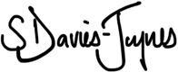

Stuart Davies-Jaynes

Reference List
ACAS (2018) Settlement Agreements. Available at: https://www.acas.org.uk/sites/default/files/2021-03/settlement-agreements.pdf (Accessed: 17 March 2024).
ACAS (2021) Manage Staff Redundancies | Acas, Acas.org.uk. Available at: https://www.acas.org.uk/manage-staff-redundancies (Accessed: 20 March 2024).
ACAS (2023) Harassment: Discrimination and the Equality Act 2010, Acas. Available at: https://www.acas.org.uk/discrimination-and-the-law/harassment (Accessed: 6 March 2024).
Acas (2013) Settlement Agreements (under section 111A of the Employment Rights Act 1996), Acas. Available at: https://www.acas.org.uk/acas-code-of-practice-settlement-agreements/html (Accessed: 17 March 2024).
Acas (2020) Give Employees Notice of Redundancy | Acas, Acas.org.uk. Available at: https://www.acas.org.uk/manage-staff-redundancies/give-employees-notice-of-redundancy (Accessed: 20 March 2024).
Acas (2022) Step 2: Preparing for an Investigation | Acas, www.acas.org.uk. Available at: https://www.acas.org.uk/investigations-for-discipline-and-grievance-step-by-step/step-2-preparing-for-an-investigation (Accessed: 6 March 2024).
Acas (2023) Redundancy pay: Your Rights during Redundancy - Acas, www.acas.org.uk. Available at: https://www.acas.org.uk/your-rights-during-redundancy/redundancy-pay (Accessed: 3 April 2024).
Ashcroft, J. and Ratnayaka, N. (2014) ‘The Equality Act 2010 in Mental Health’, Mental Health and Substance Use, 7(3), pp. 256–256. Available at: https://doi.org/10.1080/17523281.2014.902612.
Barnett, D. (2023) Employment Law Handbook. 9th edn. ELS, pp. 224–258, 128–129, 179–189.
Bell, M. (2015) ‘Mental Health at Work and the Duty to Make Reasonable Adjustments’, Industrial Law Journal, 44(2), pp. 194–221. Available at: https://doi.org/10.1093/indlaw/dwv009.
Brodie, D. (2022). Constructive Dismissal: The Contractual Maze. King’s Law Journal, 33(2), 151–168. https://doi.org/10.1080/09615768.2022.2093620
Bunbury, S. (2009) ‘The Employer’s Duty to Make Reasonable Adjustments. When Is a Reasonable Adjustment, Not Reasonable?’, International Journal of Discrimination and the Law, 10(3), pp. 111–131. Available at: https://doi.org/10.1177/135822910901000302.
CIPD (15AD) CIPD | Information on Bullying & Harassment, CIPD. Available at: https://www.cipd.org/uk/knowledge/employment-law/harassment/#legislation-overview (Accessed: 6 March 2024).
CIPD (2022a) CIPD | Redundancy Basics and Changes in the Law for 2022, CIPD. Available at: https://www.cipd.org/uk/views-and-insights/thought-leadership/people-profession/redundancy/ (Accessed: 20 March 2024).
CIPD (2022b) CIPD | Tribunal claims: Employment Law, CIPD. Available at: https://www.cipd.org/uk/knowledge/employment-law/tribunals/ (Accessed: 28 February 2024).
CIPD (2023a) CIPD | Employment Tribunals | Factsheets, CIPD. Available at: https://www.cipd.org/uk/knowledge/factsheets/tribunals-factsheet/#Settlement (Accessed: 17 March 2024).
CIPD (2023b) CIPD | Redundancy | Factsheets, CIPD. Available at: https://www.cipd.org/uk/knowledge/factsheets/redundancy-factsheet/ (Accessed: 20 March 2024).
CIPD (2024) CIPD | Statutory Rates and Compensation Limits, CIPD. Available at: https://www.cipd.org/uk/knowledge/employment-law/statutory-rates/#statutory-rates-for-england-scotland-and-wales (Accessed: 13 March 2024).
CIPD HR-Inform (2023) CIPD HR-inform | CIPD HR-inform, www.hr-inform.co.uk. Available at: https://www.hr-inform.co.uk/ (Accessed: 24 April 2024).
Citizens Advice (2022) Dealing with Disciplinary Action at Work, www.citizensadvice.org.uk. Available at: https://www.citizensadvice.org.uk/work/disciplinary-meetings/dealing-with-disciplinary-action-and-dismissal-at-work/#:~:text=Your%20employer%20should%20give%20you%20the%20opportunity%20to%20appeal%20against (Accessed: 6 March 2024).
Conn, E.J. (2000) ‘Hanging in the Balance: Confidentiality Clauses and Post judgment Settlements of Employment Discrimination Disputes’, Virginia Law Review, 86(7), p. 1537. Available at: https://doi.org/10.2307/1073879.
Dyer, C. (2016) ‘Trust Pays Cardiologist £1.22m for Unfair Dismissal’, BMJ, p. i787. Available at: https://doi.org/10.1136/bmj.i787.
Gov. UK (2022) Employment Tribunals. Available at: https://assets.publishing.service.gov.uk/media/63075e4ad3bf7f36638f9662/Ms_L_Hedger_v_British_Deaf_Association_-_3318925-2019-_Written_Reasons.pdf (Accessed: 13 March 2024).
Gov.UK (2010) Equality Act 2010, legislation.gov.uk. Gov.uk. Available at: https://www.legislation.gov.uk/ukpga/2010/15/contents (Accessed: 13 March 2024).
Gov.UK (2012) Redundancy: Your Rights, GOV.UK. Available at: https://www.gov.uk/redundancy-your-rights/redundancy-pay (Accessed: 20 March 2024).
Gov.UK (2017) Responding to a Claim to an Employment Tribunal. Available at: https://assets.publishing.service.gov.uk/media/65b782a4a0ae1b000d526147/T423_0224.pdf (Accessed: 28 February 2024).
Gov.UK (2023) Redundancy: Your Rights, GOV.UK. Available at: https://www.gov.uk/redundancy-your-rights/consultation#:~:text=There%27s%20no%20time%20limit%20for (Accessed: 24 April 2024).
Gov.UK (2024a) Employment Rights Act 1996, Legislation.gov.uk. Available at: https://www.legislation.gov.uk/ukpga/1996/18 (Accessed: 20 March 2024).
Gov.UK (2024b) Miller v Rentokil. Available at: https://assets.publishing.service.gov.uk/media/65f2d9b2af6c1a001af65793/Rentokil_Initial_UK_Ltd_v_Mr_M_Miller__2024__EAT_37.pdf (Accessed: 3 April 2024).
Gov.UK (2024c) Redundancy: your rights, GOV.UK. Available at: https://www.gov.uk/redundancy-your-rights/tax-and-national-insurance (Accessed: 3 April 2024).
Gov.uk (2016) Calculate Your Statutory Redundancy Pay, GOV.UK. Available at: https://www.gov.uk/calculate-your-redundancy-pay (Accessed: 20 March 2024).
Gov.uk (2019) Employment Tribunal, Gov.UK. Available at: https://www.gov.uk/courts-tribunals/employment-tribunal (Accessed: 28 February 2024).
Guinan, G. (2022) Understanding the Statutory Cap on Compensation for Unfair Dismissal, www.peoplemanagement.co.uk. Available at: https://www.peoplemanagement.co.uk/article/1798556/understanding-statutory-cap-compensation-unfair-dismissal (Accessed: 13 March 2024).
Lewis, D., Sargeant, M. and Schwab, B. (2023) Employment Law. Kogan Page Publishers, pp. 10–11, 118–119, 329, 327–337.
Lockwood, G., Henderson, C. and Thornicroft, G. (2014) ‘Mental Health Disability Discrimination’, International Journal of Discrimination and the Law, 14(3), pp. 168–182. Available at: https://doi.org/10.1177/1358229114534541.
Mallison, K. (2018) ‘Equality Law and the Protected Characteristics’, The Modern Law Review, 81(4), pp. 598–621. Available at: https://doi.org/10.1111/1468-2230.12353.
Marica, M.E. (2023) Considerations on Disciplinary Sanctions Applicable to Employees. Elements of Comparative Law. Perspectives of Law and Public Administration. Available at: https://librarysearch.uwtsd.ac.uk/permalink/44WHELF_UWTSD/1ir6fgh/cdi_doaj_primary_oai_doaj_org_article_ebbc458e71ff41f28389dc3e8deb40aa (Accessed: 6 March 2024).
Napier, B.W. (1977) ‘Compensation for Unfair Dismissal—A Rogue’s Charter?’, The Cambridge Law Journal, 36(2), pp. 235–237. Available at: https://doi.org/10.1017/s0008197300092370.
People Management (2000) How to Break the News of Redundancies, www.peoplemanagement.co.uk. Available at: https://www.peoplemanagement.co.uk/article/1741178/breaking-redundancy-news (Accessed: 3 April 2024).
Richardson, R. (2021) ‘Equality Priorities and Equality Objectives – the Equality Act 2010, a Cautious Welcome’, Race Equality Teaching, 28(2), pp. 6–11. Available at: https://librarysearch.uwtsd.ac.uk/permalink/44WHELF_UWTSD/1ir6fgh/cdi_openaire_primary_doi_0bb10d704b0c43ef066bac4b710a31c4 (Accessed: 28 February 2024).
Rydell, A. and Storman, E. (2022) ‘Short-time Work, Redundancies, and Changing Work Environment: the Hospitality Sector during COVID-19’, Nordic Journal of Working Life Studies [Preprint]. Available at: https://doi.org/10.18291/njwls.134827.
Semeryanova, N. et al. (2020) ‘Settlement of disputes upon termination of employment contract by agreement of parties’, E3S Web of Conferences. Edited by A. Zheltenkov and A. Mottaeva, 164, p. 11028. Available at: https://doi.org/10.1051/e3sconf/202016411028.
Shi, E. (2012) ‘A Tiger with No teeth: Genuine Redundancy and Reasonable Redeployment under the “fair Work act”’, University of Queensland Law Journal, 31(1), pp. 101–114.
The Unfair Dismissal (Variation of the Limit of Compensatory Award) Order 2013 (2024) Legislation.gov.uk. Available at: https://www.legislation.gov.uk/uksi/2013/1949/contents/made (Accessed: 17 March 2024).
Whyman, P.B. and Petrescu, A.I. (2013) ‘Workplace Flexibility Practices in SMEs: Relationship with Performance via Redundancies, Absenteeism, and Financial Turnover’, Journal of Small Business Management, 53(4), pp. 1097–1126. Available at: https://doi.org/10.1111/jsbm.12092.
Wilcox, M. (2008) ‘Unfair Dismissal Cases’, The Economic and Labour Relations Review, 18(2), pp. 79–84. Available at: https://doi.org/10.1177/103530460801800210.
Willis, A. (2023) Constructive Dismissal, Croner. Available at: https://croner.co.uk/resources/end-of-contract/dismissal/constructive-dismissal/ (Accessed: 13 March 2024).
Wynn-Evans, C. (2009) ‘Age Discrimination and Redundancy: Loxley V BAE Systems (Munitions & Ordnance) Limited * [2008] ICR 1348; [2008] IRLR 853 (EAT) * MacCulloch V Imperial Chemical Industries Plc * [2008] ICR 1334; [2008] IRLR 846 (EAT) * Rolls-Royce Plc V Unite the Union * [2009] IRLR 49 (QB)’, Industrial Law Journal, 38(1), pp. 113–121. Available at: https://doi.org/10.1093/indlaw/dwn031.

