Alexander Lemos (1917608)

Certificate in Higher Education
DSR
Term 2 Group 3

Impact of Virtual Learning Environment (VLE)

Mr. Amitave Banik

January 2021

Contents Page

- Introduction……………………………..3
- Background……………………………..3-5
- Aims and Objectives……………………5-6
- Method…………………………………...6
- Results……………………………………6-7
- Analysis/Discussion……………………..7-11
- Conclusion……………………………….11
- References……………………………….11-12
- Appendix………………………………….13-14

- Introduction
Virtual Learning Environment (VLE) has been around for a few years, it is also known as e-learning technology available to anyone who has a computer, smartphone or tablet 24/7 anytime anywhere in the world (Theeconomictimes, 2020). The exact time when it started is difficult to determine. The United Kingdom has been using computer learning since the 1970s (Barker & Gossman, 2013). Moodle on the other hand started in the year 2001 at Curtan University (Titus, 2020). Moodle has been a teaching tool for millions of students for almost twenty years and has currently 249 million users worldwide (Moodle, 2020). In this report, I will talk about the advantages and disadvantages of VLE. I made a questionnaire about VLE learning and its impact on students at the University of Wales Saint Trinity (London). On this report I will show whether or not VLE on Moodle has been a positive or negative experience based on the answers given to me by my classmates. I will use charts to display better the data I have gathered through my designed questionnaire.
Primary data and secondary data will be compared to analyse to infer and make conclusions about my findings on this subject.

- Background
The importance of Virtual Learning Environment (VLE) has been of great help to millions of students worldwide. Students under VLE should get the best education regardless of their learning style, lecture base which is by listening to the lecturer’s lesson, and the audio-visual which is by seeing your lecturer by video. If VLE does not add knowledge to the students it will be useless, therefore students will be dropping out of the course or courses. If on the other hand is too complex and hard to understand the majority of students will tend not to attend their classes. The ideal VLE is one that reinforces and deepens your understanding of a particular subject (Demian, Morrice, 2015).
According to Lyndon & Hale (2015), VLE is full of benefits but at the same time, they are not trouble-free. One of the most important features it offers to its students is the flexibility to access the platform. Students can access their learning materials anytime, anyplace with the condition of having an internet connection. Moreover, VLE helps both students and lecturers create a sense of community avoiding the feeling of being alone, thus enhancing engagement and confidence among other things.
The success of VLE success among students has not been deeply examined to measure the impact on the student’s learning. Lecturer and student participation is a must to succeed in achieving their learning goals. Also. The ability to have certain technical skills to surf the different work materials available in Moodle. Technical problems may hinder and turn away students if these issues are persistent.
VLE is a very important tool among students throughout the world to enhance their studies. Is an online classroom where teachers and students meet to complete modules or courses, students learn at their own pace re-visiting Moodle as many times as possible to absorb and retain information to finish the module they have enrolled on. Another benefit of VLE is attending the University without traveling, taking care of your children and family while studying. Lecturers can set lessons for students at any pace, work remotely, and have one-on-one virtual meetings with their students at a pre-set time. It has been shown by a case study conducted by Clintondale Community Schools, student failing rate decreased by 19%, and the pass rate increased by 9% (Virtualcollege, 2012).
Advantages and Disadvantages of VLE
A recent study made by SC&Scand (2020) states that VLE as we know it is not a new phenomenon, besides, it allows to replacing the classroom for the internet. The study shows that even though VLE has plenty of benefits, it also has its weak points that are going to be mentioned and explained in the following paragraphs.
Advantages
• Engagement- It has a diverse choice of formats and content to be used at the student’s own pace. It promotes engagement thanks to a user-friendly platform as Moodle.
• Simple Management- Permits lecturers and Universities to tweak their programs to make them more efficient and interesting. Also, allows teachers to track student performance and give support to those who might need it.
• Accessibility- This is one of the most important features available to people with disabilities, those who live in remote areas, and even other continents. The fact that you don’t have to be physically in a classroom brings a world of choices, such as continuing your education even if you are on a holiday or ill.
• Affordability- Students who live locally can get an affordable price to be enrolled in a prestigious university because they don’t have to pay campus fees. Students living abroad don’t have to relocate or fly to any country.
• Flexibility- One of the advantages is to view all reading material and videos at your own pace while maintaining a full-time job. Time becomes an asset since you are in control of how to spend it between work, family, and leisure time.
Disadvantages
• Limitations- VLE is flexible questions and answers might not get an immediate response. Some complex careers might require comprehensive research that cannot be achieved.
• Investments- Investing in new learning tools is quite expensive for universities, moreover, lecturers have to be trained on how to teach and adapt to this way of teaching. Students that live in Europe and the US have good internet access and the vast majority own a laptop computer. On the other hand, many students in other parts of the world cannot afford computers nor have good internet access.
• Motivation- Self-motivation is a must when studying online. Lack of supervision and strict deadlines is a drawback since lots of students tend to procrastinate or cheat on their online exams.
• Communication- The absence of face-to-face situations among students and conflict solving situations discourages warm relations and mutual help. These skills are needed in real-life situations.
We cannot stress the importance of VLE worldwide. VLE is here to stay and its number will grow year after year. Also, the number of Moodle users (249 million) across the world has not peaked yet (Moodle, 2020). Remote learning is here to stay, even though it can never replace in-person learning it is a magnificent learning tool to improve and complete your studies.

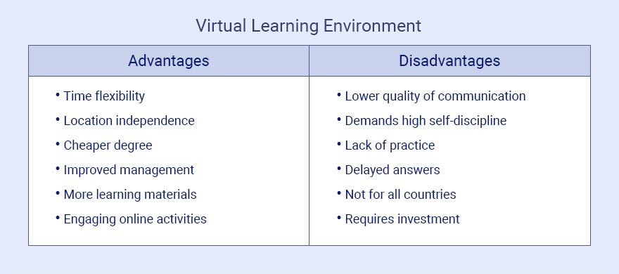
Image source: https://scand.com/company/blog/the-use-of-virtual-learning-environment-in-education/

- Aims and Objectives

The aim and objective of my questionnaire is to gather information given to me by my classmates at the University of Wales Trinity Saint David (London Campus) to make conclusions and infer a few facts based on my primary data and the secondary data from the established patterns Virtual Learning Environment (VLE) shows throughout previous case studies. I want to know if age and gender interfere with the learning process. Know how many times a week students log in Moodle and how many hours they spend studying, and finally find out if VLE is a powerful tool, as well as, user friendly and if students are willing to recommend VLE to family and friends.

- Method

This research was done by me in the form of a questionnaire that was sent out to about 30 of my classmates at the University of Wales Trinity Saint David (London Campus) to be answered at their own pace. My classmates had about 4 weeks to answer 10 questions that were sent via Outlook about VLE. I received 10 answered questionnaires which are 33% of the class. Questions will be processed in an Excel spreadsheet to produce charts and graphs with the collected data. The type of questions that were asked:
Closed End Questions- with a dichotomous choice of answers.
Multiple choice questions- a, b, c
Likert Scale Questions- Strongly disagree (1), Disagree (2), Neutral (3), agree (4) strongly agree (5).
Please note that if a student chooses neutral it has the value of 3. Values 1 and 2 show the degree of disagreement and values 4 and 5 display how much a student agrees on this answer (Barker, Gossman, 2013).
All students were advised in the email I sent them about their rights regarding data protection. That this data wouldn’t be shared nor be seen by anyone but me and my lecturer.
The full questionnaire will be attached in the Appendix section of this report.

- Results
Here are the results of my questionnaire that was sent to my classmates. The results are in 3 tabular tables. All the answers will be discussed and analysed in more depth with Excel charts and graphs.
Table 1
Student number | VLE use? | Gender | Age Group | Hours of VLE Use? * | Times of Moodle Use? *
001 | Yes | Female | 41+ | 4-7 | 4-7
002 | Yes | Male | 41+ | 8+ | 4-7
003 | Yes | Female | 26-40 | 8+ | 8+
004 | Yes | Female | 26-40 | 8+ | 4-7
005 | Yes | Male | 18-25 | 4-7 | 8+
006 | Yes | Female | 18-25 | 4-7 | 4-7
007 | Yes | Female | 26-40 | 4-7 | 4-7
008 | Yes | Male | 26-40 | 4-7 | 4-7
009 | Yes | Female | 41+ | 4-7 | 8+
010 | Yes | Female | 18-25 | 8+ | 4-7
*= Weekly use.
Table 2
Information Easily Retrievable? | Would You Recommend VLE?
Yes | Yes
Yes | Yes
Yes | No
Yes | Yes
Yes | Yes
Yes | Yes
Yes | Yes
Yes | No
Yes | Yes
Yes | Yes

Table 3
Option | Strongly Disagree | Disagree | Neutral | Agree | Strongly Agree
VLE Powerful Tool? |  |  | (2)  20% | (8)  80%
VLE Good Learning Experience? |  |  | (1)  10% | (7)  70% | (2)  20%
Moodle User Friendly? |  |  | (2)  20% | (8)  80%

- Analysis/discussion
All data gathered through my questionnaire was obtained thanks to my classmates. All my classmates were informed that their answers will not be seen, shared, or sold to anyone. I informed them about the data protection act, which states that all information must not cause any harm to the participant nor it will be shared with anyone. My classmates were informed that their identity, as well as their answers, will remain anonymous.
In question (Q1) students were asked if they use VLE, the answer was ‘yes’ is all 10 questionnaires since we are in a pandemic and classes cannot be on campus.
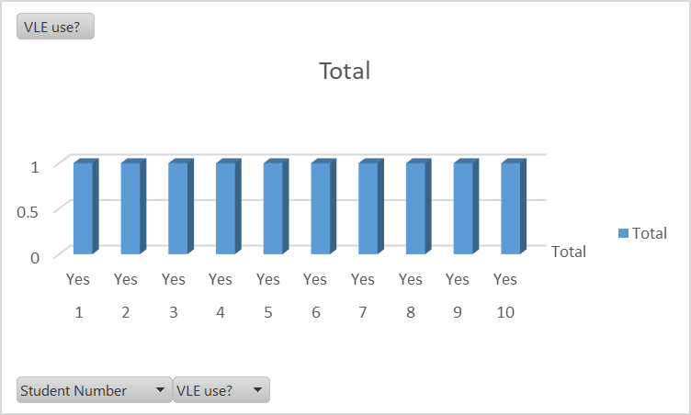
This table shows the impact VLE has on my classmates due to the Covid-19 virus 100% percent use because nobody can attend the University.
Questions 2-5 ask about their gender, age group, hours of VLE use, and times a week they use Moodle.
- Question 2 (Q2) - 70% Female, 30 Male.
- Question 3 (Q3) - 40% 26-40 Years, 30% 41+ Years, 30% 18-25 Years.
- Question 4 (Q4) – 60% 4-7 Hours, 40% 8+ hours.
- Question 5 (Q5) – 60% 4-7 hours, 40% 8+ hours.
In (Q2) the vast majority of my classmates are female, 70% (Q3) of the students that answered are between the ages of 26 years, and 41+ years. The other 30% comprehends from the ages of 18 to 25. As for time spent using VLE (Q4) and Moodle (Q5) to study class materials is the same.
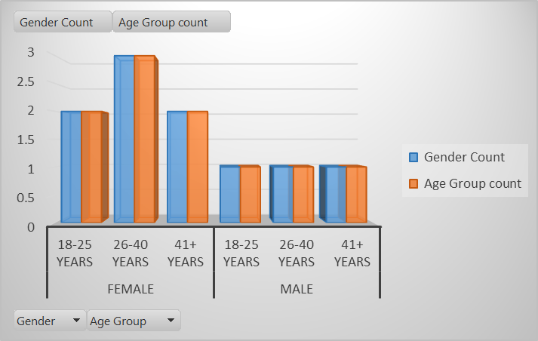
This graph shows the age and number of participants in my questionnaire. The graph shows that University appeals to basically all age groups, especially females from the age of 26-40 age group range.
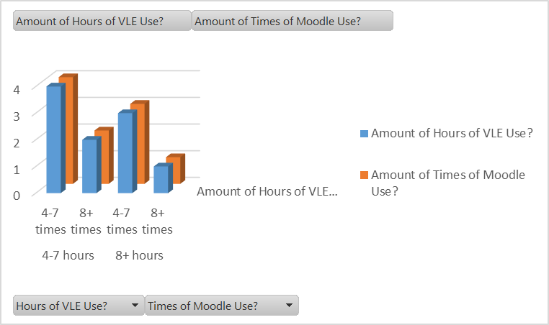
The amount of hours and amount of times students use VLE and Moodle on a weekly basis is quite similar, this means that students spend time and effort to study their lessons in Moodle.

The answers to questions 6 (Q6) and 7 (Q7) regarding if the information is easily retrievable and if they would recommend VLE to family and friends.
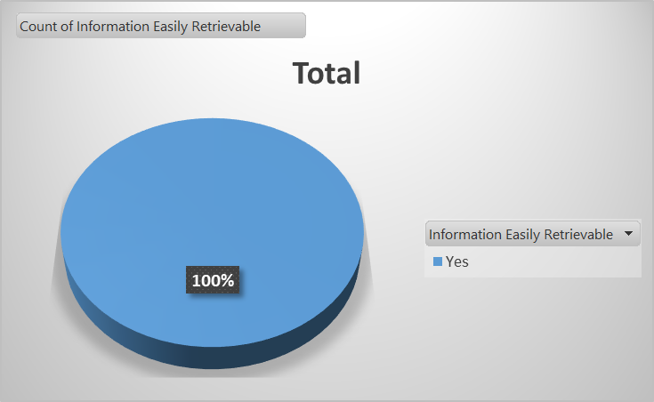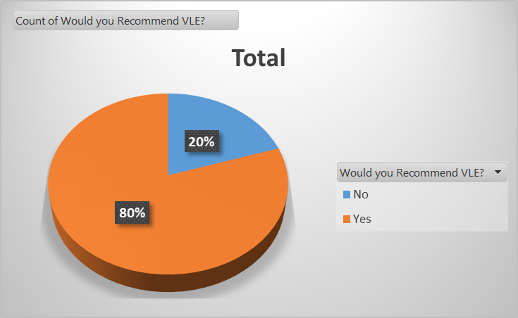

Question 6 (Q6) - 100% information is easily retrievable.
Question 7 (Q7) - 80% would recommend VLE to family and friends.
Question 6 has a unanimous 100% that the information is of easy access, on the other hand (Q7) has an 80% recommendation rate, and 20% would not recommend VLE due to system glitches, mic problems, and poor internet connection.
In the last set of questions (8-10), students were asked to answer from strongly disagree to strongly agree (Likert scale questions).
Question 8 (Q8) asked if VLE is a powerful tool. Question 9 (Q9) asked if VLE was a good learning experience, and finally, question 10 (Q10) asked if Moodle is user friendly. These were the results:
- Question 8 (Q8) – 80% agree, 20% were neutral.
- Question 9 (Q9) – 70% agree, 20% strongly agree and 10% neutral.
- Question 10 (Q10) - 80% agree, 20% neutral.
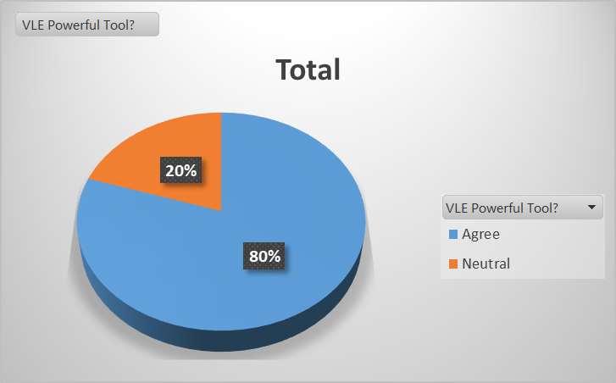
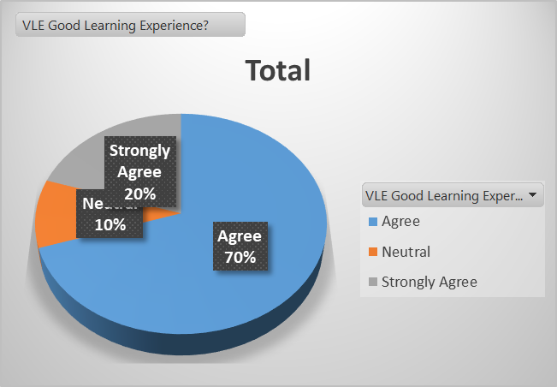
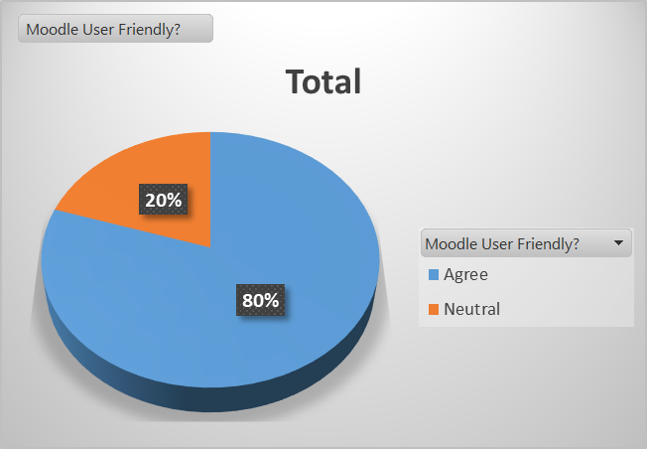
Even though the information given to me by my classmates was useful, the extend of the impact of VLE at The University of Wales Trinity Saint David (London) is inconclusive because the amount of people that answered my questionnaire is minuscule (10), however, I can make a judgement on the impact it has made in my class as I showed their answers in pie charts and graphs.

- Conclusion
The impact of VLE on students at the University of Wales Trinity Saint David I would say it has been positive, however, it has a few drawbacks that I have enlisted in previous paragraphs. The pandemic of Covid-19 has put VLE to the test and the results for the most part have been positive. The University of Wales, as well as the IT team, must work on glitches and mic problems that some of my classmates have endured during this difficult period of our lives.

- References

• Barker, J. and Gossman, P. (2013). The Learning Impact of a Virtual
Learning Environment: Students’ views.
Available at: https://core.ac.uk/download/pdf/29422368.pdf
(Accessed: December 24 2020).
• Demian, P., Morrice, J. (2015). The use of virtual learning environments and their impact on academic performance.
Available at: https://www.tandfonline.com/doi/full/10.11120/ened.2012.07010011
(Accessed: December 24 2020).
• Greenwell, R. Vanoureck, G. The Virtual Revolution.
Available at: https://www.educationnext.org/the-virtual-revolution-understanding-online-schools/
(Accessed: December 24 2020).
• Lyndon, S., Hale, B. (2015). Evaluation of How the Blended Use of a Virtual Learning Environment (VLE) Can Impact on Learning and Teaching in a Specific Module.
Available at: https://www.tandfonline.com/doi/full/10.11120/elss.2014.00019
(Accessed: December 24 2020).
• Moodle, 2020. Statistics.
Available at: https://stats.moodle.org/
(Accessed: December 24 2020).
• The Economic Times, 2020. Definition of ‘E-Learning’.
Available at: https://economictimes.indiatimes.com/definition/e-learning
(Accessed: December 24 2020).
• SC& Scand, (2020). The Use of Virtual Learning Environment In Education.
Available at: https://scand.com/company/blog/the-use-of-virtual-learning-environment-in-education/
(Accessed: December 25 2020).
• Titus, 2020. The history of Moodle – A timeline of key events.
Available at: https://www.tituslearning.com/the-history-of-moodle/
(Accessed: December 24 2020).
• Virtual College, (2020). Virtual learning environments 'benefit students and teachers'.
Available at: https://www.virtual-college.co.uk/resources/2012/05/virtual-learning-environments-benefit-students-and-teachers
(Accessed: December 25 2020).

• https://www.enago.com/academy/what-are-the-ethical-considerations-in-research-design/

9-Appendix

Student Name: ____________________________ Student ID: ____________________
Module Name: Digital Skills and Research Methods Term 2 Group: ____3_________

Questionnaire

1- Do you use a Virtual Learning Environment (VLE)?
a) Yes b) No

2- What is your gender?
a) Male b) Female

3- What is your age group?
a) 18-25 b) 26-40 c) 41+

4- How many hours a week do you use (VLE)?
a) 1-3 Hours b) 4-7 Hours c) 8+ Hours
5- How many times a week do you use Moodle?
a) 1-3 times b) 4-7 times c) 8+ times
6- Is the University information easily retrievable in Moodle?
a) Yes b) No
7- Would you recommend VLE to family and friends?
a) Yes b) No

8- Do you think VLE is a very powerful tool?
a) Strongly disagree b) Disagree c) Neutral
d) Agree e) Strongly agree

9- Is VLE a good learning experience?
a) Strongly disagree b) Disagree c) Neutral
d) Agree e) Strongly agree

10- Is Moodle User friendly?
a) Strongly disagree b) Disagree c) Neutral
d) Agree e) Strongly agree

