January 2023

A detailed lesson plan, resources and rationale supporting a key stage 1 lesson in multiplication.
Curriculum & Assessment Studies – ECES6017
Leonie Mills - 2000637

Curriculum for Wales 2022

Lesson/Session Plan
Age: 6 to 7 | No. of learners: 20 |  | ALN/Meeting learners’ needs: |  |  | Teaching Assistant provided for extra help for ALN learners.
Additional Adults: Teacher and Teaching Assistant |  | Responsibilities of additional adults for this session: Provide extra help where needed, specifically for pupils who may need extra support
Learning objective(s): Commence learning of multiplication in maths and numeracy-based sessions, whilst building upon previous addition and subtraction skills |  |  |  |  | Success criteria: Learners are able to confidently practice addition and subtraction, and also use the two times table effectively.
Links to previous learning: Starter activity assessing pupils’ knowledge on addition and subtraction, practicing familiarity and use of numbers in both Welsh and English.
Curriculum coverage (AoLE/Strand/Descriptions of learning)

Thinking Skills  Asking questions the child may understand, but presenting the question in a different way |  |  |  | Literacy(LNF)  Using a What I Learned ticket at the end of the lesson for each pupil as a means of communicating their thoughts and writing out what they enjoyed or may need extra help with
Numeracy (LNF)  Teaching learners the first steps of multiplication and using various contexts to ask questions based on the topic to show learners various ways to apply the methods. |  |  |  | Digital Competence (DCF)  Using a wheel generator for pupils’ names in a starter activity. Using the internet to participate in a song for learning the two times table.
Y Cwricwlwm Cymreig (the Welsh Dimension)  Asking questions and providing answers in Welsh as well as English |  |  |  | Global Dimension  Use of real-life images and scenarios in questions, encouraging application of skills to real-life contexts

Time | Session activities, organisation and management | Assessment for Learning (strategies and opportunities)
10-15 minutes | Introduction |  | - Observing the child’s thought process to achieving the answer
10-15 minutes | Learners will enter the classroom and take their seats, being introduced by a name generator with the learners’ names on it. Learners will take turns at spinning the wheel, and the individual whose name appears, selected by the wheel, will take their turn to answer an addition or subtraction equation. If additional support is required, they may be able to ask a friend, or receive support through teaching assistants. |  | - Providing help if they struggle to understand the answer
10-15 minutes |  |  | - Extension tasks provided for pupils who finish the task early
10-15 minutes |  |  | - Using the plenary activity to get an understanding of how the learners found the tasks
40-45 minutes | Main activities |  | Resources and Key Vocabulary
40-45 minutes | The main activity of the session requires the class to be split into three groups. Across the main body of this lesson, the learners will participate in three activities. The first being a number block counting exercise, requiring the learners to use the counting blocks to answer the questions displayed on the worksheet. The second exercise requires the use of flashcards to practice the learners’ ability to display a multiplication sequence, based on images on the cards. They will also be able to use dry-wipe markers on the cards to write out the answer alongside their sequence. The third activity the groups will rotate through will be an interactive song about the two times tables. This will encourage some physical movement, such as waving their arms, and requires the learners to listen and sing-along. |  | - Number Blocks
40-45 minutes |  |  | - Dry-wipe pens
40-45 minutes |  |  | - Space for physical movement
40-45 minutes |  |  | - Access to a computer
40-45 minutes |  |  | - Pens and/or pencils
40-45 minutes |  |  | - Tables
40-45 minutes |  |  | - Chairs
10-15 minutes | Plenary (formative assessment)
10-15 minutes | To finish the session, learners will all receive one ‘Exit Ticket’, where they will fill out their name, alongside what they learned through that session, and how they feel regarding the topic of the two times table. The ‘Think, Pair, Share’ method will be used here. These will then be passed to the educator to review and provide further support, or an extension activity if required.

Rationale for Lesson Plan
- Use of a starter activity – Best practice
- Use of a name generator (participation) – Estyn best practice
- Groupwork and independent work – collaborative learning theory – Vygotsky 1978
- Rotating activities: number blocks, flashcards, song – Station rotation model
- Various materials used to encourage development of motor skills (blocks, dry wipe markers, songs with actions) – best practice GOV.UK EYFS
- Feedback on the lesson (pupils get a voice) – Black and Wiliam 1998
- Self-assessment
- Extension activity
Script for presentation
The lesson being carried out is aimed at pupils aged 6 to 7, working at key stage 1 level. This lesson will be a one-off lesson based around beginner multiplication, specifically around the two times table, which will feature a starter activity, which consists of an online wheel name generator where pupils will then take turns in answering either an addition or subtraction question (How to Use a Randomiser in your ESL Classes, 2020), the main activity which contains a variation of three main activities, these being: recreating multiplication questions using number blocks (Twinkl, 2020), using flashcards with real life images and multiplication questions as well as dry-wipe markers for working out the answer (Twinkl, 2022), and also a two times table song with actions (2 Times Table Song - Percy Parker - Wave Your Arms In The Air With Percy, 2019), and finally a plenary activity, which will be an exit ticket, where pupils will fill in their names, as well as what they learned, and circling either a happy, sad, or average face to show how they feel about the topic (Twinkl, 2022).
These activities will link to previous learning of addition and subtraction within the starter activity and will practice familiarity of numbers in English and Welsh throughout the lesson.
The lesson will require a teacher and a learning support assistant (LSA), who will be required to provide help where needed. The LSA will also be expected to provide support to ALN learners, helping them to navigate through the stations and learn how to work with their peers if this is an area of learning that the pupil may struggle with. To carry out an effective and successful lesson, the lesson plan will require a learning objective: to commence learning in multiplication in mathematics and numeracy-based sessions, whilst building upon learners’ previous knowledge of addition and subtraction. A success criterion will also be acknowledged to understand if the lesson was effective. In this instance, this will require learners to be able to confidently practice addition and subtraction and have a good understanding of beginner multiplication.
This lesson has also been planned with consideration towards wider curriculum coverage. Within this lesson plan, the curriculum coverage is broken down into sections, according to the Welsh government guidelines in 2022.
- Thinking Skills – asking questions the learner is familiar with in a way which will encourage problem-solving
- Literacy in line with literacy and numeracy framework – using an Exit Ticket as the plenary which will encourage children to discuss and write down their feedback for the lesson with the educator and peers
- Numeracy in line with literacy and numeracy framework – Teaching the initial steps towards multiplication and using varied approaches in learning to show learners how to apply knowledge using different methods. Also using basic numeracy understanding to boost the learner’s confidence.
- Digital Competency in line with digital competency framework – Using an internet-based wheel generator in the starter activity and using the internet to search for a song that will aid learning the two times table.
- Welsh Dimension to learning – Using Welsh to pose questions, give headings for activities, and provide support or encouragement, e.g., Da Iawn!
- Global Dimension to learning – using a multitude of activities to show how the subject can be applied to real-life contexts and gives the learners some understanding on how multiplication is used in the world around them.
With regards to the new curriculum for Wales, the lesson is heavily focused on the area of mathematics and numeracy. However, there is some aspects of languages, literacy, and communication through groupwork, and an effort towards expressive arts is also made using songs in the lesson (Welsh Government, 2022).
The new curriculum for Wales as stated by the Welsh government holds four purposes: helping learners to become capable and ready to learn through life, ready to play a full part in life and work, become ethical citizens of Wales and the world, and being a confident and fulfilled individual in society (Welsh Government, 2022). Though it is difficult to tell whether all these aims are being reached in a one-off lesson, it is important for the educator to prioritise these points in any way possible. Within this lesson, using a variety of stations will help prepare learners to be adaptable, and will also encourage them to be prepared to use several types of media in their learning to find out the most optimum way for them to learn.
A key factor which is focused upon within this lesson plan is the use of a starter activity. Within this lesson, the starter activity consists of an online randomised name generator and several simple addition and subtraction questions which pupils will be familiar with. Pupils will have the opportunity to spin the wheel to generate a name, then the selected pupil with have a large selection of questions they can answer one of. The opportunity for support from teachers, LSA’s or peers is available during this.
The intention of this starter activity is predominantly to build confidence of pupils which will provide extensive benefits in and out of school life (Estyn, 2016) as addition and subtraction is one of the first mathematics topics taught so it is building upon the familiarity and confidence of the learners’ knowledge. The use of the starter activity in this instance is to provide clarity to what topic will be studied for this lesson and will set the tone to the lesson ahead (Gershon, 2011).
As previously mentioned, the starter activity features an online name generator, which will be used to encourage pupil participation, which is the key to engagement and is important in the new curriculum for Wales (Estyn, 2016). There are also great benefits to prioritising pupil participation for the learners’ social skills such as listening, communicating, and working with others through turn-taking (Estyn, 2016). It also encourages digital competency, as it is implementing the idea of turn-taking and participation, as well as using ICT skills. This is in line with the digital competency framework and improves ICT confidence in both learners and staff (Edwards, 2019).
Groupwork is also encouraged in the main activities of this lesson. In line with Vygotsky’s collaborative learning theory, learners will be encouraged to communicate and listen to peers and to educators during their work, as opposed to working independently (Vygotsky, 1978). In connection with this, Vygotsky’s Zone of Proximal Development can be acknowledged, as this will highlight the learner’s skill development and what they can learn alone compared to from peers and the ‘more knowledgeable other’ (1978).
The main activities in the lesson include a rotation of three separate tasks: Number counting blocks, flashcards with images alongside multiplication questions, and a song to help pupils retain information. The station rotation model is a method of blended learning which is commonly used to engage students and create a more dynamic classroom environment (Hitt, 2017). It can also allow learners to receive a wider understanding of a topic using varied resources through the classroom, some of which they may not often get the chance to use (Truitt & Ku, 2018).
The lesson will also feature the opportunity for learners to develop motor skills, such as using number blocks, songs with actions, and using dry wipe markers alongside flashcards. Development of motor skills can help a child’s confidence and coordination when navigating the world and can also improve their physicality (Gov.UK, 2022). This can also help the class remain engaged, in line with best practice from Estyn (2016).
Following on from looking at the main activity, this lesson is concluded with an Exit Ticket. This is a formative assessment method used by the teacher to see how the class felt about the topic and provides them with the opportunity to understand what aspects of the lesson may need revisiting (Black & Wiliam, 1998). From this, the teacher is gaining adequate feedback from learners, and understanding what went well, and what did not. Because the class are writing their names on the ticket, the teacher is also able to identify what learners may need specialised support without having to announce this to the entire class. This builds trust between pupil and teacher and allows the pupil to receive the support they need.
Self-assessment will also be used in this plenary activity, as it requires the pupil to reflect upon what they had learned and how they felt about the topic. It will provide the pupil the opportunity to share their understanding by writing it down and set their own targets towards better improving their understanding. It will allow the learner to extend their zone of proximal development (Vygotsky, 1978), meaning what they are able to learn and teach themselves will broaden.
Extension activities are also used within this lesson plan, as an opportunity for more able and talented pupils to further their learning. Extension activities provide the opportunity to give the topic a further explanation and provides learners with the opportunity to practice using the materials (Oxford University Press ELT, 2017). Additionally, an extension activity can be used as a method of informal formative assessment (Black & Wiliam, 1998). Alongside the use of the Exit ticket, an extension activity will allow the educator to gauge the understanding of the class, along with who may need further support and therefore improving engagement and prioritising wellbeing of pupils (Estyn, 2016).
These key elements of the lesson plan put together will provide a successful learning experience for pupils and will cover a large amount of the Welsh curriculum. This will also remain in line with Estyn guidelines to provide optimum education for pupils at this age. Within the submission of this document will be a full lesson plan, along with resources provided.
Link for presentation:
https://uowtsd.sharepoint.com/teams/AstudiaethauCwricwlwmacAsesuCurriculumandAssessmentStudi_GRP-LeonieMills/Shared%20Documents/Recordings/Leonie%20Mills-20230127_163604-Meeting%20Recording.mp4?web=1

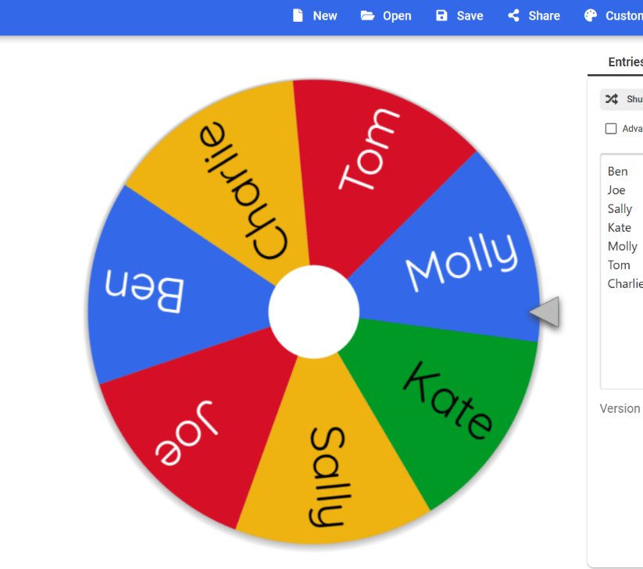
Starter
2 + 3 = ? | 3 – 1 = ?
5 + 2 = ? | 4 – 2 = ?
4 + 1 = ? | 6 – 4 = ?
6 + 2 = ? | 4 – 3 = ?
3 + 7 = ? | 2 – 1 = ?
4 + 3 = ? | 5 – 3 = ?
1 + 9 = ? | 2 – 2 = ?
2 + 2 = ? | 10 – 3 = ?

(How to Use a Randomiser in your ESL Classes, 2020)

Main activity 1: Group work using number blocks

Present the answers using number blocks!
Cyflwynwch yr atebion gan ddefnyddio blociau rhif!
2 x 1 = ____
2 x 2 = ____
2 x 3 = ____
2 x 4 = ____
2 x 5 = ____
2 x 6 = ____

2 x 7 = ____
2 x 8 = ____
2 x 9 = ____
2 x 10 = ____
2 x 11 = ____
2 x 12 = ____
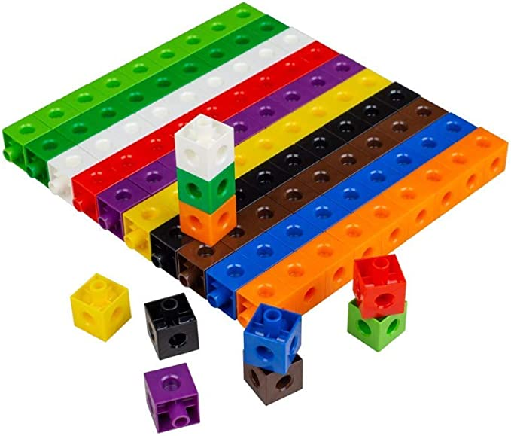

(Twinkl, 2020)

Main Activity 2: Flashcards (Two times tables from 1 to 12)
(Twinkl, 2022)


Three rows of two spiders...
What does this multiplication sequence look like?
Two rows of two airplanes...
What does this multiplication sequence look like?



Five rows of two aliens...
What does this multiplication sequence look like?
Four rows of two cakes...
What does this multiplication sequence look like?

2 x 5

2 x 3

2 x 4

2 x 2
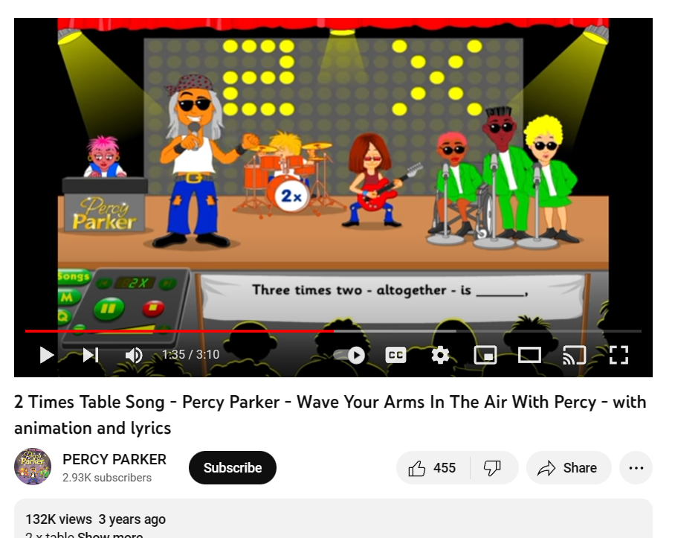
Main activity 3: Learners will listen and sing along to a two times tables song. An example of this is the Percy Parker Times Table Songs.
(2 Times Table Song - Percy Parker - Wave Your Arms In The Air With Percy, 2019)
Plenary
Exit Ticket/Tocyn Gadael
NAME/ENW: ________________
What I learned today/Yr hyn a ddysgais heddiw…
_________________________________________
_________________________________________
_________________________________________
I feel/Rydw i’n Teimlo…

About multiplication/Ynglŷn â lluosi!

(Twinkl, 2022)

References
2 Times Table Song - Percy Parker - Wave Your Arms In The Air With Percy. 2019. [Film] United Kingdom: Percy Parker.
Black, P. & Wiliam, D., 1998. Inside the Black Box: Raising Standards Through Classroom Assessment. [Online]
Available at: http://electronicportfolios.org/afl/InsideBlackBox.pdf
[Accessed 19 January 2023].
Edwards, A., 2019. Digital Competence: Improving pupils' digital skills. [Online]
Available at: https://www.estyn.gov.wales/blog/digital-competence-improving-pupils-digital-skills
[Accessed 19 January 2023].
Estyn, 2016. Improving pupil wellbeing through pupil engagement. [Online]
Available at: https://www.estyn.gov.wales/effective-practice/improving-pupil-wellbeing-through-pupil-engagement
[Accessed 19 January 2023].
Estyn, 2016. Pupil participation: a best practice guide, Cardiff: Estyn.
Gershon, M., 2011. The Guardian: Our expert's guide to the perfect starter. [Online]
Available at: https://www.theguardian.com/teacher-network/2011/oct/17/guide-perfect-starter-teaching
[Accessed 19 January 2023].
Gov.UK, 2022. Physical development: fine motor skills. [Online]
Available at: https://help-for-early-years-providers.education.gov.uk/physical-development/fine-motor-skills
[Accessed 19 January 2023].
Hitt, S., 2017. Blended Learning: The Station Rotation Model. [Online]
Available at: https://achievethecore.org/peersandpedagogy/blended-learning-the-station-rotation-model/
[Accessed 19 January 2023].
How to Use a Randomiser in your ESL Classes. 2020. [Film] United Kingdom: Twinkl ESL.
Oxford University Press ELT, 2017. Creating Extension Activities. [Online]
Available at: https://oupeltglobalblog.com/2017/12/29/creating-extension-activities/#:~:text=Creating%20Extension%20Activities%201%201.%20Personalise%20it%20An,8%208.%20Turn%20it%20into%20a%20project%20
[Accessed 21 January 2023].
Truitt, A. A. & Ku, H.-Y., 2018. A case study of third grade students' perceptions of the station rotation blended learning model in the United States. Educational media international, 55(2), pp. 153-169.
Twinkl, 2020. Year 2 Building bricks multiplication activity. [Online]
Available at: https://www.twinkl.co.uk/resource/year-2-building-bricks-multiplication-activity-sheet-t-n-7464
[Accessed 4 January 2023].
Twinkl, 2022. General Exit Tickets. [Online]
Available at: https://www.twinkl.co.uk/resource/us2-pa-1-general-exit-slip-question-cards
[Accessed 4 January 2023].
Twinkl, 2022. Twos, Fives and Tens - Picture Array. [Online]
Available at: https://www.twinkl.co.uk/resource/twos-fives-and-tens-picture-arrays-au-n-2548832
[Accessed 4 January 2023].
Vygotsky, L., 1978. Mind in society: The development of higher psychological processes. 1st ed. Cambridge, MA: Harvard University Press.
Welsh Government, 2022. Curriculum for Wales. [Online]
Available at: https://hwb.gov.wales/curriculum-for-wales/
[Accessed 21 January 2023].

