Based on your visit to the National Museum of Wales, consider how the museum promotes public understanding of the archaeological record

In the introduction to the edited volume “The Educational Role of the Museum”, Eilean Hooper-Greenhill states that “one of the main functions of museums and galleries is education”. She then goes on to explain how this concept has evolved and grown from simply “provision for school children” to encompass “services for a much broader range of audiences, both in the museum and in the community.” During our visit to the National Museum of Wales in Cardiff, I was able to observe first-hand the role that this museum played in the education and promotion of understanding of the archaeological record. In particular, I observed a school group of primary-school children, and several university students. This led me to consider the different ways that the museum is involved in promoting learning and education. Therefore, I will be focussing on how the museum promoted the understanding of the archaeological record through its connection to the education sector.

I will first discuss the observations I made of several exhibit visitors, as per Figs. 1 and 6. Fig. 1 is a diagram of the movements of three different visitor groups to the ‘Evolution of Wales’ exhibit. For the purposes of this essay I will be discounting the “couple” and the “mother with a young son”. As can be seen in Fig. 1, upon entering the ‘Origins of Wales’ phase of the exhibit the school group dispersed in different directions, although most of them stopped at the fossil and rock display (see Fig. 2). This exhibit showed how the earth was formed. The tactile nature of this section of the exhibit seemed to appeal to the school children, in particular the ammonite fossils shown in Fig. 3. Going back to Hooper-Greenhill’s commentary mentioned above, the ability to touch this exhibit engages with the children, which I feel ties in particularly well with the role of the museum as “increasing motivation to learn… to discover and develop new passions… [by] making a previously mundane set of facts suddenly come alive and become meaningful.”
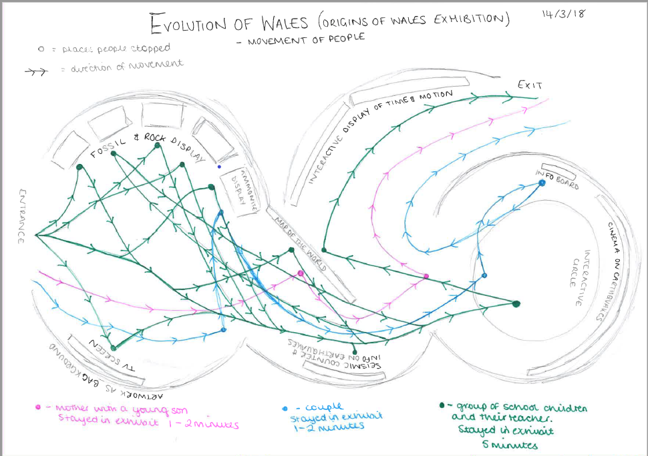
Figure 1. Origins of Wales Exhibition - Movement of People. © Rosie Nye. 13 March 2018. Cardiff
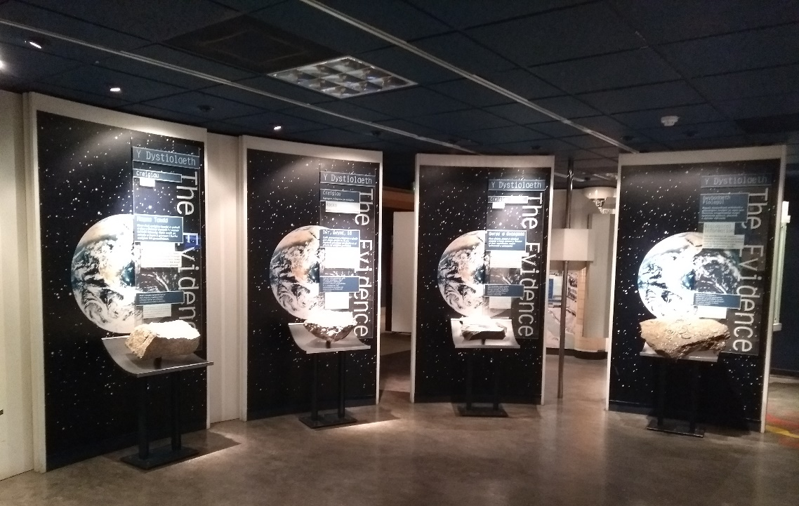
Figure 2. Fossil and Rock Display. © Vikki Hare. 13 March 2018. Cardiff.
On the information boards surrounding this section of the exhibit was information explaining how each fossil and rock provided the researchers with data about the past. An example of this can best be seen in Fig.3, where the board can clearly be read:
“Fossil animals and plants give similar information about ancient environments. They also provide data about the age of rocks and the course of biological evolution.”
By having this particular display at the very entrance to the exhibit, the museum has ensured that its visitors are immediately engaged and interested in the archaeological artefacts in the exhibit and are informed as to how the archaeological record can be interpreted and understood. I observed that this particularly motivated the children to want to learn more, as I overheard them telling each other how “cool” and “awesome” the fossils were.
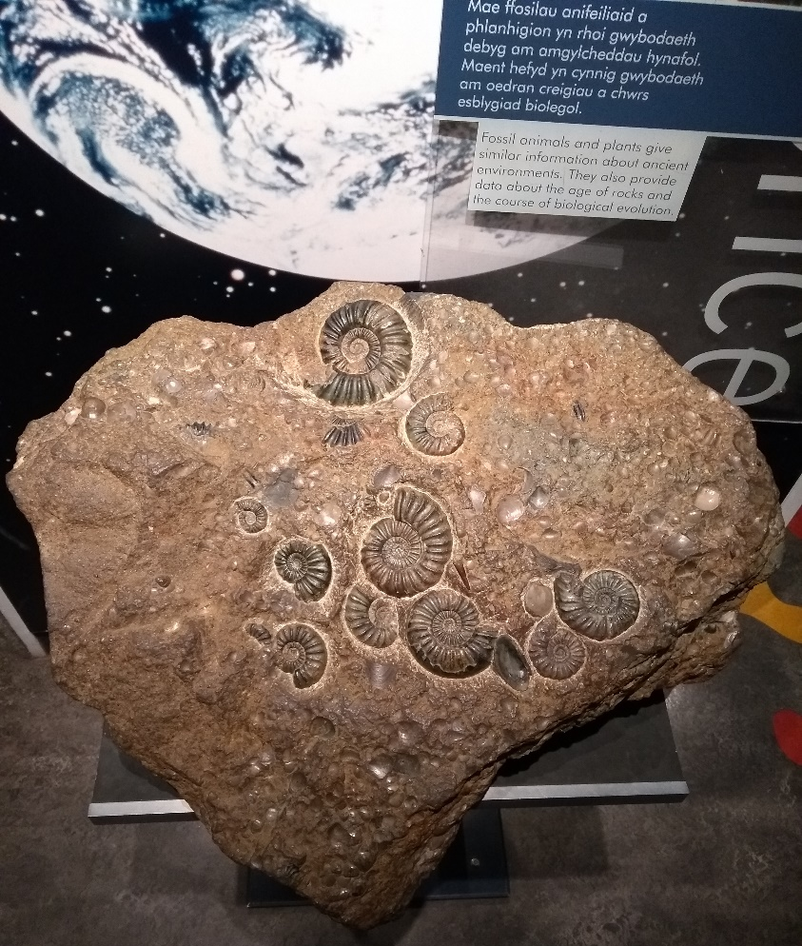
Figure 3. Ammonite Fossils in Rock. © Vikki Hare. 13 March 2018. Cardiff

From the fossils, the school group moved on through the exhibit, congregating at the “interactive circle”, which caused a simulated earthquake on the screen on the wall. The school children seemed to particularly enjoy this, as the interactive element was highly engaging. The circle itself was a diagram of the makeup of the earth, with the different layers down to the core (see Fig. 4). Though it is debatable as to whether this could be considered as part of the ‘archaeological record’, this interactive display continues the museum’s theme of engaging its visitors to aid understanding through physical interaction with the exhibit.
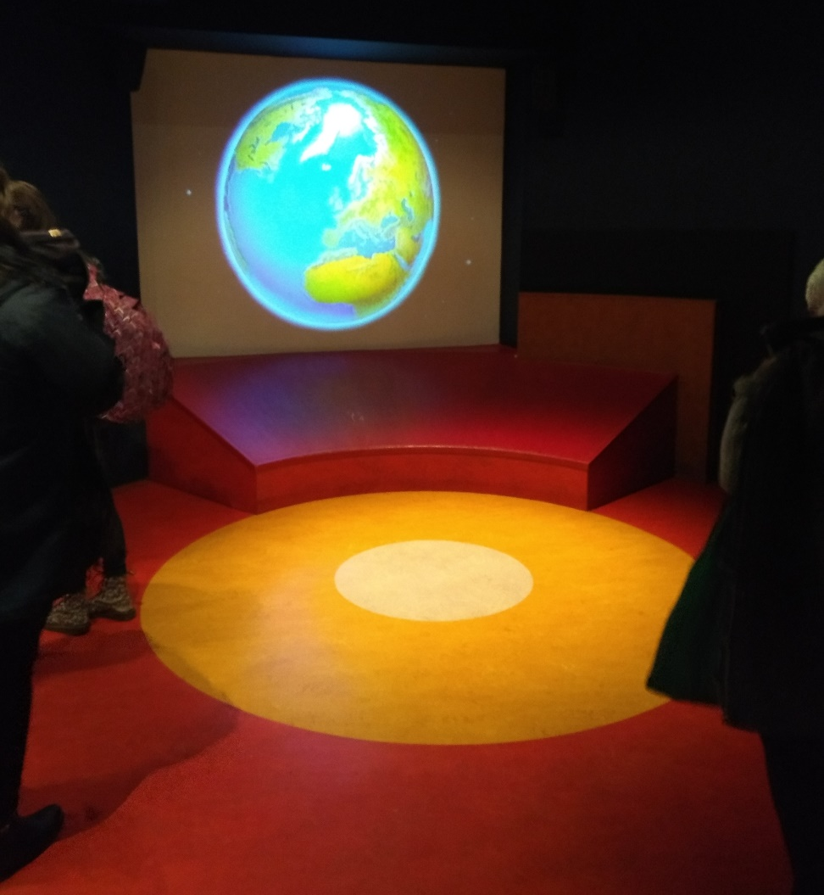
Figure 4. Interactive Circle. © Vikki Hare. 13 March 2018. Cardiff
From here, the school group moved on to the exit of this exhibit, which led into an enclosed circular room with three screens and a limited easting area. This room had been designed to resemble the night sky, and had been lit accordingly with small lights to represent stars. The group stopped here and sat to watch a video about the origins of the universe and our planet (see Fig. 5). The video was shown twice, once in English and once in Welsh, which I feel is a further demonstration of the way that the museum engages with its visitors through multi-lingual means. At this point I stopped observing the school group and began observing smaller cluster of university students as they moved through the next phases of the exhibit, in order to determine whether there was a notable difference in the way they engaged with the exhibit.
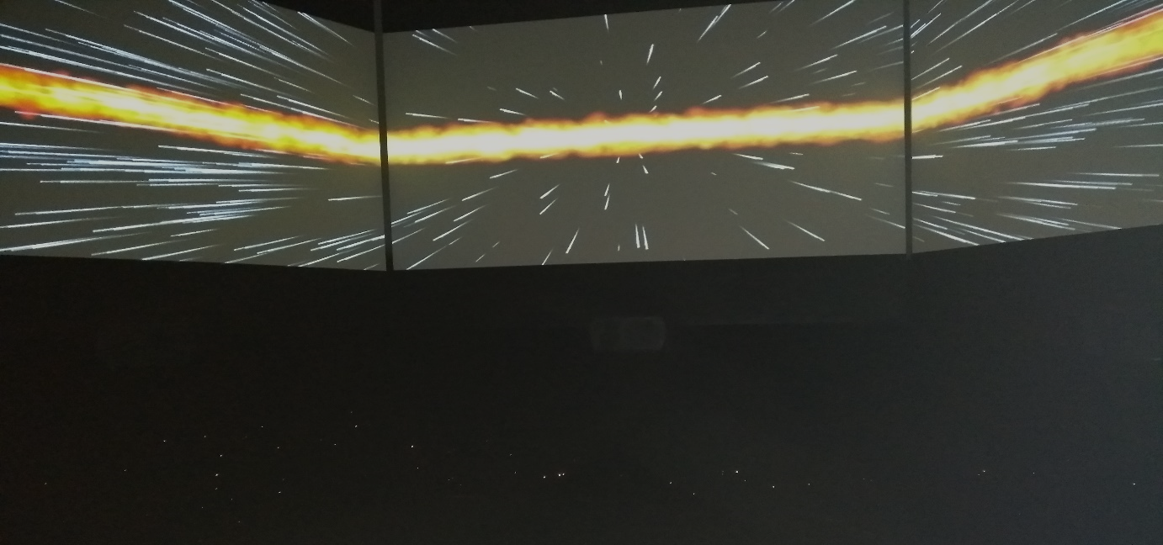
Figure 5. Planetarium. © Vikki Hare. 13 March 2018. Cardiff
The university groups were less haphazard in their perusal of the exhibit. Fig. 6 shows their progress through the “Dinosaur Exhibition”, and clearly shows a more structured movement as they spent time reading about each object, unlike the school children, who simply enjoyed the interactive portions of the exhibit.

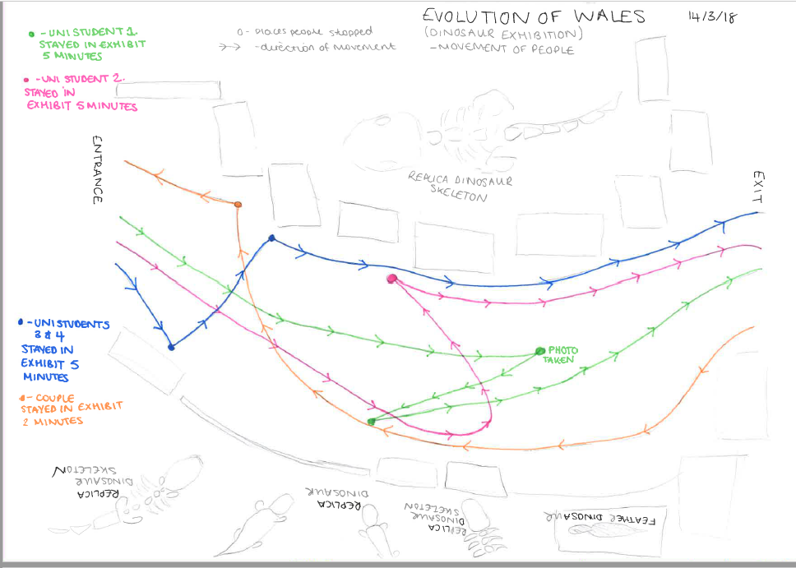
Figure 6. Dinosaur Exhibit - Movement of People. © Rosie Nye.13 March 2018. Cardiff
At the entrance to this exhibit are a number of replicas of dinosaurs or their skeletons (see Fig. 7). All of the university students stopped to look at these, as well as reading the information boards next to them. The coloured circles in Fig. 6 show where the students stopped for a short while, and these indicate that the museum has been successful in engaging with students of this age group, as they are compelled to read the information, not just look at the replicas. As can be seen in Fig. 7, the display cases in front of the replicas also contained objects. These were mostly fossils, but also some genuine dinosaur bones were displayed here, not replicas like the upright models.

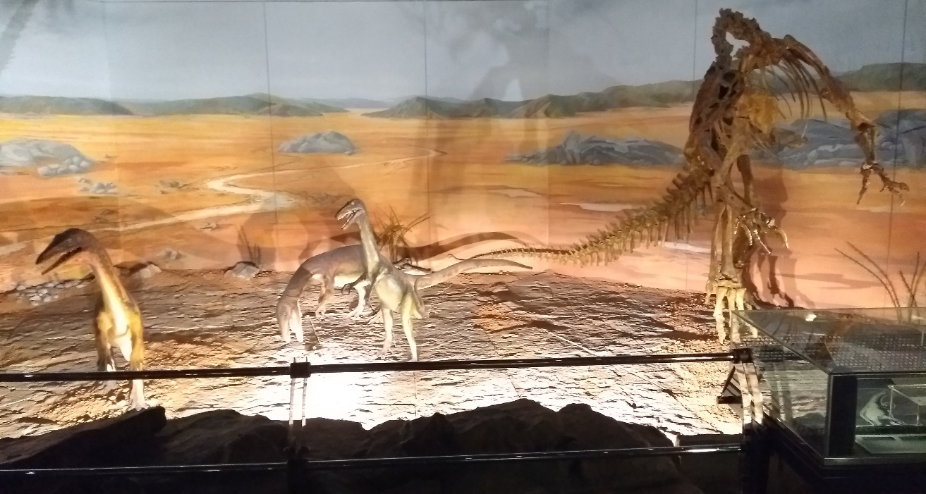
Figure 7. Dinosaur Replicas. © Vikki Hare. 13 March 2018. Cardiff
On the other side of the room from Fig. 7 was displayed the leg bone (Fig. 8) and replica skeleton of a much larger dinosaur, which garnered a lot of interest from the students. The inclusion of this in the exhibit seems to have been a deliberate attempt by the museum to impress those who come to visit. By ‘wow-ing’ the visitors, it again links back to Hooper-Greenhill’s ideas of how a museum should engage with those it is trying to educate.
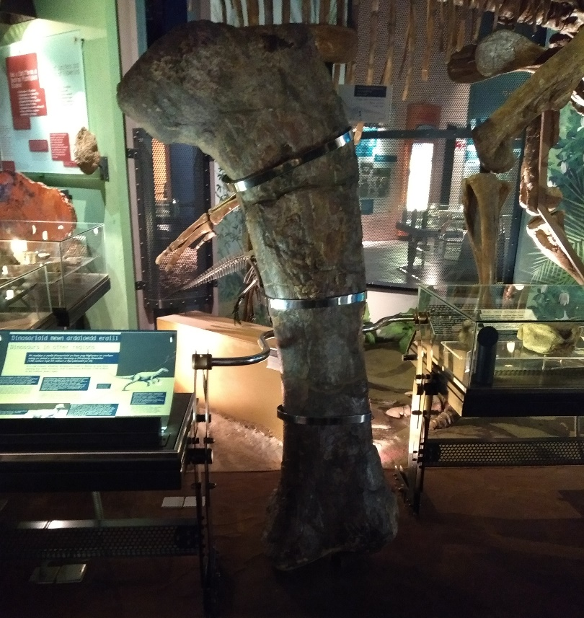
Figure 8. Dinosaur Leg Bone. © Vikki Hare. 13 March 2018. Cardiff
The museum also made sure that the information boards are highly prominent in the exhibits, as can be seen in Fig. 9, which shows a large information board about the ‘Dracoraptor’. The museum also takes great pains to stay true to its Welsh Heritage, by showing the information in both Welsh and English, which I believe helps to further the understanding of the archaeological record to non-English speakers.
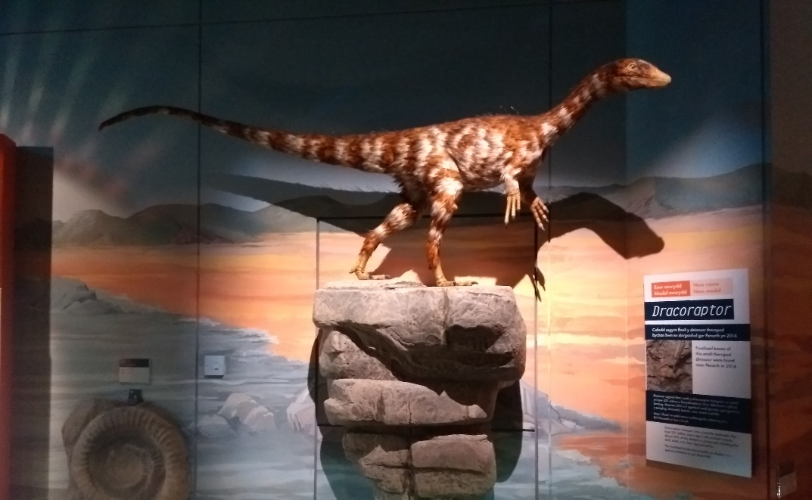
Figure 9. Dracoraptor. © Vikki Hare. 13 March 2018. Cardiff
From my observations, I noticed that there were a few key differences in the way that the different levels of students interacted and engaged with the exhibits. The younger school group were less interested in reading what the information boards had to say and were more excited by the tactile sections of the exhibit. In contrast, the university students stopped and read what was written on the boards and were interested in the theory and archaeology behind what was on display.

During our visit, we were lucky enough to be granted a behind-the-scenes tour with one of the curators, Elizabeth Walker. She was able to show us some of the storage of artefacts not on display, as well as a brief tour of one of the conservation labs, where we learnt about how the objects found in the archaeological record were preserved and studied. One of the objects we were shown was a Viking Sword that was currently being studied by specialists (see Fig. 10). By allowing us to see and learn about this object, it was another way that the museum provides education and understanding of the way the archaeological record could be interpreted.
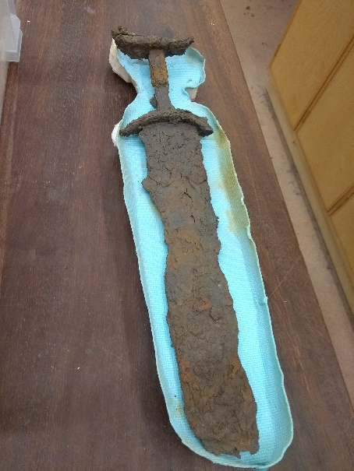
Figure 10. Viking Sword. © Vikki Hare. 13 March 2018. Cardiff
I have also done some research beyond what I experienced through my observations, by looking through the National Museum’s website to find out what else they offer on the education front in terms of informing the public about archaeology. They offer educational sessions to those of all ages and educational levels, from Foundation Phase to Adult Learners. To fit in with the observations made above, I chose to investigate further what options were available to ‘Key Stage 2’ and ‘Post-16 Education’.

The Key Stage Two section offered several resources to aid teachers in the classroom or during self-guided visits, as well as full workshops in the museum itself, led by museum staff. These varied from dinosaur-themed workshops, where the children could handle dinosaur bones, experience digging up a fossil, and compare the teeth of different dinosaurs, to workshops involving learning about how a museum is run and how the displays are put together. All of these sessions are designed to help the students understand how the archaeological record can be discovered, interpreted and displayed to educate others. The Post-16 Education section was less hands-on and included behind-the-scenes tours of the museum, although there are many resources that can be adapted for use in a university setting from the ‘Teachers’ section of the website. The museum also has a ‘Learning Blog’, which is constantly kept up-to-date with different information to help education about the subjects the museum has collections of, including the archaeological record.

Through a combination of my own observations and a thorough perusal of their website, I have been able to build a picture of the different ways that the National Museum of Wales aims to promote and education its visitors about the archaeological record. Through a combination of engaging displays, tactile objects, interactive exhibits and prominent multi-lingual information boards, the museum has managed to capture both the interest and the imagination of those who enter through its doors. They even go a step further to reach out to the public, by running workshops and talks about the objects housed in the museum, and to demonstrate how the archaeological record can be interpreted to learn about the history of our planet. Overall, I would say that this museum definitely lives up to its role as an educator, and more than meets the high standards laid out by Eilean Hooper-Greenhill.

Bibliography

•Hooper-Greenhill, E. (ed) 1994. The Educational Role of the Museum. London: Routledge

•National Museum Cardiff 'Learning' n.d. a https://museum.wales/cardiff/learning/ [Accessed 31st March 2018]

•National Museum Cardiff 'Key Stage 2' n.d b https://museum.wales/cardiff/learning/ks2/ [Accessed 31st March 2018]

•National Museum Cardiff 'Post-16 Education' n.d. c https://museum.wales/cardiff/learning/post_16/ [Accessed 31st March 2018]

•National Museum Cardiff 'Teachers' n.d d https://museum.wales/cardiff/learning/teachers/ [Accessed 31st March 2018]

•National Museum Cardiff 'Learning Blog' 2018 https://museum.wales/blog/?cat=407 [Accessed 31st March 2018]

Hooper-Greenhill 1994: 1
Hooper-Greenhill 1994:1
Hooper-Greenhill 1994:1
Hooper-Greenhill 1994:1
National Museum Cardiff n.d. a
National Museum Cardiff n.d. b
National Museum Cardiff n.d. b
National Museum Cardiff n.d. b
National Museum Cardiff n.d. b
National Museum Cardiff n.d. c
National Museum Cardiff n.d. d
National Museum Cardiff 2018

