

AI Governance and Predictive Risk Analytics in Banking Cybersecurity: A Supervised Machine-Learning Decision-Support System Using the UNSW-NB15 Dataset.

By
Jervis. A Payne
Supervisor: Dr Nouh Elmitwally
Second Marker: NAME HERE

Project submitted as part of the requirements for the award of MSc Data and Artificial Intelligence

August 2026

Declaration form and form of consent
DECLARATION
I, .... Jervis Alexis Payne……declare that I am the sole author of this Project; that all references cited have been consulted; that I have conducted all work of which this is a record; and that the finished work lies within the prescribed word limits.

This work has not previously been accepted as part of any other degree submission.

Signed: Jervis Alexis Payne......

Date: 27/08/2026.......

FORM OF CONSENT

I ____Jervis Alexis Payne___hereby consent that my Project, submitted in candidature for the MSc Data and Artificial Intelligence, if successful, may be made available for inter-library loan or photocopying (subject to the law of copyright), and that the title and abstract may be made available to outside organisations.

Signed _Jervis Alexis Payne__

Date __27/08/2026___

Abstract
A prototype cybersecurity risk decision support system was developed for a banking use case using the UNSW-NB15 intrusion-detection dataset. Exploring opportunities to apply supervised machine-learning approaches and AI governance principles to support transparent, auditable cyber-risk classification with human oversight. Highlighting the problem financial institutions face in addressing cybersecurity threats, using AI in security decision-making requires attention to explainability, accountability, auditability, traceability, and human oversight. [1].
A research and development method was used. The dataset was checked, cleaned, and processed to classify network traffic as normal or attack traffic using a binary classification approach. The implementation was done in Python using Google Colab, scikit-learn, and Streamlit. Three supervised machine-learning models were developed and evaluated: Logistic Regression, Decision Tree, and Random Forest. I used several metrics, including accuracy, precision, recall, F1 score, ROC-AUC, and confusion matrix analysis, to evaluate model performance. A threshold analysis was performed to assess the trade-off between false positives and false negatives and then tested explanations using feature-importance analysis and SHAP outputs.
A working Streamlit dashboard that provides cyber risk predictions, attack outcomes, risk levels, evidence of model performance, threshold analysis, explainability outputs, persistent audit logging, audit analytics, evidence of dashboard testing, and AI governance notes. Findings indicated that supervised machine learning (SML) can help classify cyber risk with appropriate governance controls. In the paper, the Decision Tree showed balanced performance, but Random Forest was chosen for the dashboard based on its best attack recall and ROC-AUC.
In conclusion, evaluating AI in cybersecurity based on predictive accuracy is a flawed approach. For banking cybersecurity, the effectiveness of an AI decision support system should also be evaluated for transparency, explainability, auditability and traceability, as well as human review. The final recommendation is to test the prototype further with larger, more recent datasets and to test the dashboard with cybersecurity or risk professionals before real deployment.

Table of Contents
1 Introduction 9
1.1 Background and Context: 9
1.2 Problem Statement: 10
1.3 Project Motivation and Rationale: 10
1.4 Project Aim: 11
1.5 Project Objectives: 11
1.6 Research Question: 11
1.7 Scope of the Project: 12
1.8 Report Structure: 12
2 Literature Review 13
2.1 Banking Cybersecurity and AI-Enabled Risk Context: 13
2.2 Intrusion Detection and Machine Learning: 14
2.3 Benchmark Datasets and UNSW-NB15: 14
2.4 Supervised Models and Evaluation Metrics: 15
2.5 Explainable AI & SHAP: 16
2.6 AI Governance, Auditability and Human Oversight: 17
2.7 Critical Synthesis and Positioning of Project: 17
2.8 Implications for Project Methodology: 18
2.9 Gaps in existing work: 19
2.10 Chapter Summary: 20
3 Research, Development and Methodology 21
3.1 Chapter Introduction: 21
3.2 Research Methodology: 21
3.3 Development Methodology: 22
3.4 Materials, Tools and Hardware: 22
3.5 Experimental Design: 22
3.6 Evaluation Criteria: 23
3.7 Validity, Reliability and Generalisability: 23
3.8 Chapter Summary: 23
4 Design and Implementation 24
4.1 Chapter Introduction: 24
4.2 Requirements and Design Logic: 24
4.3 System Architecture: 25
4.4 Machine-Learning Pipeline Design: 27
4.5 Development Environment and Tools: 28
4.6 Streamlit Dashboard Design: 28
4.7 AI Governance Layer Design: 31
4.8 Implementation Process: 33
4.9 Testing and Evidence Strategy: 34
4.10 Chapter Summary: 34
5 Design/Data collection 35
5.1 Chapter Introduction: 35
5.2 Dataset Selection: 35
5.3 Initial Dataset Inspection: 36
5.4 Feature Selection and Target Definition: 37
5.5 Categorical and Numerical Preprocessing: 37
5.6 Chapter Summary: 38
6 Data Analysis & Model Evaluation 39
6.1 Chapter Introduction: 39
6.2 Model Evaluation Strategy: 39
6.3 Model Performance Results: 40
6.4 Confusion Matrix Analysis: 41
6.5 Threshold Analysis: 42
6.6 Explainability Results: 43
6.7 Dashboard Integration of Evaluation Outputs: 45
6.8 Chapter Summary: 45
7 Results and Discussion 46
7.1 Chapter Introduction: 46
7.2 Analysis of Model Performance: 46
7.3 Threshold Behaviours and Risk Appetite: 47
7.4 Explainability and Transparency: 47
7.5 Dashboard and Decision-support Value: 48
7.6 AI Governance Contribution: 49
7.7 Project Objectives Achievements: 50
7.8 Limitations of Results: 51
7.9 Chapter Summary: 51
8 Conclusions and Recommendations 52
8.1 Chapter Introduction: 52
8.2 Project Achievement Summary: 52
8.3 Response to Research Question: 53
8.4 Conclusions from the Results: 53
8.5 Recommendations: 54
8.6 Future Work: 55
8.7 Conclusion: 55
9 Reflection 56
9.1 Technical Reflection: 56
9.2 Problem Solving and Development Reflection: 56
9.3 Governance and Professional Learning: 57
9.4 Final Reflection: 57
10 References 58
11 Appendices 68
11.1 Appendix A – Logbook: 68
11.2 Appendix B - Dataset Inspection Evidence: 70
11.3 Appendix C - Model Evaluation Evidence: 74
11.4 Appendix D - Explainability and SHAP Evidence: 79
11.5 Appendix E - Streamlit Dashboard Screenshots: 86
11.6 Appendix F - Audit Log and Audit Analytics Evidence: 92
11.7 Appendix G - Packaging and Reproducibility Evidence: 97

Table of Figures
Figure 1: Overall System Architecture. 26
Figure 2: Machine-Learning Pipeline and Preprocessing Workflow. 27
Figure 3: Streamlit Dashboard Project Overview. 29
Figure 4: Cyber-Risk Prediction Interface: Low. 30
Figure 5: Cyber-Risk Prediction Interface: Critical 30
Figure 6: Persistent Audit Log and Audit Analytics Evidence. 32
Figure 7: Label Distribution in Training and Testing Sets. 36
Figure 8: Model Performance Comparison. 40
Figure 9: Random Forest Threshold Trade-Off 42
Figure 10: Random Forest Feature Importance. 43
Figure 11: SHAP Global Feature Importance. 44

List of Tables
Table 1: Functional and Non-Functional Requirements 25
Table 2: Software Tools and Justification. 28
Table 3: Dashboard Sections and Contribution. 29
Table 4: Dashboard Version Development Summary. 33
Table 5: Dataset Summary 35
Table 6: Preprocessing Decisions. 38
Table 7: Model Performance Summary. 40
Table 8: Confusion Matrix Comparison 41
Table 9: Random Forest Threshold Analysis 42
Table 10: Project Objectives and Achievement 50

List of Abbreviations
Abbreviation | Full Meaning
AI | Artificial Intelligence
AI RMF | Artificial Intelligence Risk Management Framework
API | Application Programming Interface
CSV | Comma-Separated Values
CRISP-DM | Cross-Industry Standard Process for Data Mining
DBS | Disclose and Barring Service
DoS | Denial of Service
DSR | Design Science Research
EBA | European Banking Authority
F1-score | Harmonic mean of precision and recall
GRC | Governance, Risk and Compliance
IDS | Intrusion Detection System
ISO | International Organisation for Standardisation
NIST | National Institute of Standards and Technology
OHE | One-Hot Encoding
README | Project documentation file
ROC-AUC | Receiver Operating Characteristic – Area Under the Curve
SHAP | SHapley Additive exPlanations
SOC | Security Operations Centre
TCP | Transmission Control Protocol
UNSW-NB15 | University of New South Wales Network Benchmark 2015 dataset
ZIP | Compressed archive file

Introduction

Background and Context:
As more organisations rely on digital infrastructure and resources, cybersecurity has become a major concern, especially for banking and financial service organisations. Banks handle vital monetary information, run payment servers, manage customer accounts, and face rigorous security compliance requirements. A serious cyber incident can disrupt operations, erode customer trust, destabilise finances, and trigger regulatory penalties. [2]. At the same time, cybersecurity threats are becoming more complex, driving growing interest in using Artificial Intelligence and Machine Learning to detect cyber risk faster [3].
Machine learning has been used in a wide range of applications, such as intrusion detection. A traditional rule-based approach can match known patterns, but this can be problematic if attacks evolve or do not match existing patterns. Supervised machine learning models can be trained on labelled network traffic and then classify network traffic as malicious or normal [4]. In this way, public datasets like UNSW-NB15 can be utilised for academic research, as models can be developed, compared and evaluated in a controlled setting [5].
But in a high-risk industry, such as banking, powerful predictive performance is not enough. Even a highly accurate model can lead to operational risk if it fails to detect significant attacks, produces too many false positives, or its results are incomprehensible to analysts. Classification alone isn't sufficient for banking cybersecurity. It must be transparent, explainable, auditable, traceable and human-centric [6].
The juxtaposition of cybersecurity risk, AI, and supervised machine learning governance inspired this project. The project direction was shaped by the requirement for a Master of Science in Data and Artificial Intelligence dissertation based on a practical programme developed during the course. Banking was chosen because it is a relevant setting for responsible AI decision support and has also been affected by cyber fraud on a few occasions, which has impacted many people and remains a major concern for financial institutions given the technology's rapid development and increasing adoption of digital services [7].

Problem Statement:
This project targets a major challenge: machine learning cybersecurity systems are evaluated primarily on technical metrics, with less focus on how the system's outputs can be explained, governed, recorded, and later reviewed. This is a major drawback in banking cybersecurity. A hypothesis that a network event is an attack makes sense only if the system provides the means to interpret or prioritise risks, audit data, and escalate to human involvement [8].
Past research shows that machine learning models can assist with intrusion detection [9]. But a disconnect remains between model development and governed decision support. Though a classifier can distinguish between normal traffic and attacks, evidence of why it decided to make a prediction, how risky its prediction might be, and that it could be revisited is necessary for a banking context.
Beyond model performance, this project aimed to create a dashboard that brings together prediction, explanation, threshold-based risk classification, persistent audit logging, and human-review support [10].
Despite the partial solutions, the problem still must be completely resolved due to the continuous evolution of cyber threats and the difficulty of interpreting AI models. Further, risk appetite shapes cybersecurity decisions.
Lower thresholds let more attacks through but also produce more false positives, while higher thresholds block more attacks but are less likely to produce false positives. This shows that cyber risk classification encompasses both technical and governance issues [11].

Project Motivation and Rationale:
This project's rationale is that AI-driven cybersecurity tools should complement, not supplant, human judgment. In banking, accountability and reviewability of risk decisions must be maintained. The project brings together some of the governance elements of explainability, audit logging, risk levels, recommendations and human-review status with machine-learning classification, and this will ensure the artefact aligns with Responsible AI Practices [12].
This project partly responds to the growing importance of AI governance in high-risk settings. As AI systems are increasingly used in the Cyber Security and Risk Management domain, organisations need ways to ensure results are easily understood, traceable, and appropriate for review. The project illustrates how to embed predictive analytics in a dashboard prototype under governance [13].

Project Aim:
This project aims to create and test an AI-based automated cybersecurity risk decision-support prototype, based on the UNSW-NB15 intrusion detection dataset, using supervised machine learning models and AI governance principles in a banking context.

Project Objectives:
The project aims to review the literature on cybersecurity risk, IDS, machine learning, explainable AI, and AI governance; inspect and prepare the UNSW-NB15 dataset for binary classification; and develop and compare Logistic Regression, Decision Tree, and Random Forest models.
To evaluate the models using accuracy, precision, recall, F1-score, ROC-AUC and confusion-matrix analysis; perform threshold analysis to analyse the False Positive (FP) vs False Negative (FN) trade-off; perform feature importance and SHAP explainability analysis; design and implement the Streamlit dashboard to present the prediction, probability of attack, level of risk, explanation of the model, audit logging, audit analytics and governance notes; and assess the prototype dashboard regarding value, limitations and future development needs.

Research Question:
The main research question is: How can AI governance principles and supervised machine-learning techniques be combined to create a banking cybersecurity decision-support system using the UNSW-NB15 intrusion-detection dataset?
This question is relevant to both the technical and governance aspects of the project. It raises how prediction outputs can be transparent, explainable, auditable, and fit for human-led decision support.

Scope of the Project:
The project will be an academic prototype only. It uses the public UNSW-NB15 dataset and does not use any live, active banking data, customer data, employee data, or private data from any organisation's network traffic. It targets binary classification, which categorises traffic as "benign" or "attack".
The system is not claimed to be a banking cybersecurity solution ready for production use. It is not a real-time deployment, analyst testing, penetration testing, security hardening or integration with operational banking systems. It provides a Proof of Concept that incorporates machine learning classification with governance controls.

Report Structure:
Chapter 2 provides a literature review covering banking cyber-risk, intrusion detection, machine learning, explainable AI (XAI), and AI governance. Chapter 3 describes the methodology used for the research and development.
Chapter 4 covers the system design and implementation, including the machine-learning pipeline, Streamlit dashboard, risk-threshold logic, and audit log/governance framework. Chapters 5 and 6 discuss dataset selection and dataset preprocessing.
Chapter 6 provides model evaluation results, threshold analysis, and explainability results. Chapter 7 covers results from a performance, governance, and decision-support perspective. Chapter 8 gives conclusions and recommendations. Chapter 9 summarises the development process, the technical learning area, and the area of professional relevance.

Literature Review
This chapter reviews literature on an AI-enabled cybersecurity risk decision-support prototype for banking. It's based on six themes: banking cyber-risk, intrusion detection, benchmark datasets, supervised machine-learning models, explainable AI and AI governance. The review will focus on its relevance to the project, not as a general tutorial. It reviews what has been achieved, by whom, what results have been reported, and how those findings justify the adopted methodology.

Banking Cybersecurity and AI-Enabled Risk Context:
The banking industry is a high-risk digital environment because it processes sensitive personal data, payment transactions, account information, and authentication records. Digital-banking adoption and confidence have repeatedly been affected by identity theft, malware, phishing, and vishing, as found in Cele's systematic review [14]. Other researchers also noted that banking information security can have technical, human, and organisational weaknesses and that phishing, Distributed Denial of Service (DDoS), and malware are recurring threats. These studies are relevant to the project, as cybersecurity problems in the financial sector can erode trust and continuity, along with regulatory confidence [15].
Financial-sector cybersecurity also falls under the umbrella of operating resilience. In its guidance, CPMI-IOSCO considers Cyber-resilience part of governance, risk management, and the continuity of critical financial-market services [16]. The European Banking Authority has also identified ICT & security risk management as part of overall institutional governance, rather than only a technical problem [17]. This is relevant to the dissertation because it suggests that a banking cybersecurity artefact is not just about identifying attacks; it should present risk evidence in a way that enables review and governance.
The banking sector faces additional opportunities and risks with the advent of AI. In financial services, AI techniques are becoming increasingly prevalent, including risk analytics, fraud detection, and decision support, as reported in other studies [18], [19]. However, barriers related to explainability, skills, data quality, accountability, and oversight may arise when using AI in cybersecurity. This implies that a project can't be judged solely by whether a model predicts an attack. It should also demonstrate explanations, logging, and human review of predictions [20].

Intrusion Detection and Machine Learning:
Intrusion Detection Systems (IDS) monitor and identify malicious behaviour within a network or on a system. Signature-based systems are effective against known attacks but ineffective if attacks evolve or are not defined in the rules. Surveys found that machine learning and data mining are significant techniques for cyber intrusion detection, including classification, clustering, feature selection, and ensemble approaches [21].
Other researchers stress the fact that the selection of the datasets, how to represent attacks, and how to design the evaluation of the attacks have a strong impact on intrusion-detection results [22]. Labelled data is available, so supervised learning is appropriate. For this project, the UNSW-NB15 data set contains labels for the normal and attack traffic that can be learned and evaluated. Logistic Regression, Decision Tree, Random Forest, Support Vector Machine, Naïve Bayes and deep-learning models are all applied in the classification process, as shown in the previous IDS research [23].
However, higher complexity does not necessarily mean a model is more suitable. As good as deep-learning techniques can be, they could require more computational power and be less interpretable [24].
Classical supervised models are thus defensible for a governance-focused MSc development project, as they enable performance comparisons and are easy to understand and implement in a dashboard prototype.

Benchmark Datasets and UNSW-NB15:
The literature attests to the centrality and challenges of IDS datasets. A common benchmark was KDD Cup 99, but previous studies have identified redundancy and distribution issues that could affect evaluation [25]. NSL-KDD reduced has some vulnerabilities, but it still represents older traffic patterns [26]. Later datasets like UNSW-NB15, CICIDS2017, and BoT-IoT sought to introduce up-to-date traffic, more features and extensive attack scenarios [14] – [16], [27].
UNSW-NB15 was chosen due to its being a well-known academic testbed for network intrusion detection. Moustafa and Slay built it using the IXIA PerfectStorm tool in the UNSW Canberra Cyber Range Lab, based on both real and synthetic network traffic. Their subsequent statistical analysis suggested that UNSW-NB15 is more complex than KDD99 and suitable for assessing anomaly-detection systems [28]. In addition, studies state that modern flow-based datasets are valuable for machine learning-based IDS because they offer reproducibility and support comparative testing [29].
However, one should use care in dealing with dataset literature. Public datasets enable repeatability but are less representative of live banking network traffic. They may include synthetic attacks, behaviour, and/or distributions from dated sources that do not reflect operational reality [30]. This accordingly affected the dissertation's scope. The artefact is an academic prototype and proof of concept, not a production banking security system. This limitation should be clearly stated in the methodology, evaluation and conclusion.

Supervised Models and Evaluation Metrics:
The project compares Logistic Regression, Decision Trees, and Random Forest, as they offer different levels of simplicity, interpretability, and predictive capacity. Although Logistic Regression is efficient and can serve as a baseline, it can struggle with nonlinear relationships in network traffic [31]. Decision Trees can easily model nonlinear decision rules and are more interpretable but may not be sufficiently controlled to prevent overfitting [32]. Random Forest builds several trees, can be more robust, has less variance, and provides feature-importance outputs [33].
Tree-based and ensemble methods often yield good results in the IDS studies. The Random Forest approach proposed by Breimann remains influential because ensemble aggregation can yield strong classification performance [34]. In addition, recent IDS studies indicate that a wide variety of complex classifiers frequently compete favourably with simpler ones [35]. But accuracy should not be the only factor when picking a model. In cybersecurity, a false negative can indicate missed attacks, and false positives may increase analyst workload and alert fatigue [36].
Thus, for this purpose, accuracy, precision, recall, F1 score, ROC-AUC and confusion-matrix analysis have been employed in the dissertation. In imbalanced datasets, evaluation measures must be chosen carefully, as demonstrated by Saito and Rehmsmeier [37]. Chicco and Jurman argue that confusion-matrix performance measures provide more insight than accuracy alone [38]. Threshold analysis is also relevant because it links model outputs to the organisation's risk appetite. Lowering the threshold can increase recall at the risk of more "false alarms"; raising it will have the opposite effect. This justifies the project's decision to incorporate threshold analysis as a technical and a governance feature [39].

Explainable AI & SHAP:
Explainability is crucial as cybersecurity analysts must interpret the rationale behind a model marking an event as either normal or malicious. Findings describe explainable AI as a crucial component of responsible AI, particularly when human users need to interpret or question model-generated outputs [40]. Doshi-Velez and Kim also suggest that interpretability must be addressed as an evaluation issue rather than an optional add-on [41].
SHAP is applied especially to this project. Lundberg and Lee proposed SHAP, a common framework to interpret predictions based on Shapley values. SHAP can be used to provide explanations for the entire model, indicating which variables are generally driving the model, and for individual records, indicating why such a record was classified in such a way. This is useful for IDS as it may be necessary to determine if a prediction was affected by packet counts, connection state, a volume of bytes, timing behaviour or some other characteristic of the service [42].
This inclusion is supported by the Cybersecurity XAI research. An explanation method is employed by Warnecke et al. to reveal weaknesses and assumptions of security classifiers [43]. Heron and other XAI-IDS research suggests that explanations may help analyst trust and model debugging, but also cautions that, if taken on faith, explanations may become unstable and be misunderstood [44], [45]. This literature view inspired the project's use of feature importance and SHAP as evidence of governance, rather than evidence alone [46]. SHAP sample-size stability checking is another tool used in the project that enhances the credibility of the explanation pattern in the final evaluation.

AI Governance, Auditability and Human Oversight:
The literature on AI governance plays a prominent role in the dissertation, as one research question is how machine learning can be fused with governance principles. NIST's AI Risk Management Framework defines AI trustworthiness as a socio-technical governance, risk mappings, risk measurements and risk management problem [47]. The European Commission's guidelines list human oversight, transparency, technical robustness, privacy, accountability and data governance as essential prerequisites for Trustworthy AI [48]. The OECD principles also stress human-centred and transparent AI, as well as robust and accountable AI [49].
These frameworks support the Streamlit dashboard design. A cybersecurity prediction shouldn't be a stand-alone term. It should contain: Probability, Risk level, Explanation, Recommendation, Timestamp, Audit Record, Human-review Status. According to researchers, AI accountability should rely on auditing processes, not on any fuzzy notion of responsibility [50]. Other studies also show that systems based on algorithmic decisions should have records and governance arrangements that allow later inspection. [51]. This helps the project's ongoing audit log and audit analytics page.
In cybersecurity, a major focus in financial institutions, human oversight is particularly crucial. Automated escalations without context can be seen as operational or governance risk – especially for high-risk/critical model input/outputs, human analysts should be involved in the review process. This dissertation thus conceptualises the dashboard as a decision support system, rather than as a system for making autonomous decisions. It isn't a single governance layer, but part of the artefact's contribution. [52].

Critical Synthesis and Positioning of Project:
The literature reviewed supported the project and revealed some of its limitations. IDS research also reveals that supervised machine learning has effectively classified network traffic; however, results are also influenced by factors such as the design of the dataset, the selection of the metric(s), and the class distribution of the classification problem. While dataset research indicates that UNSW-NB15 is valid for academic purposes, it is not an immediate measure of live banking readiness. While XAI can aid feature importance and SHAP, explanations should not be accepted on faith. While AI governance frameworks argue for auditability and human oversight, they provide no definitive how-to guidance [53].
The project's contribution is therefore integrative, not algorithmically new. These are known methods: Logistic Regression, Decision Tree, Random Forest, and SHAP. The originality lies in combining them in one Streamlit artefact geared toward banking use, with features including prediction, probability, risk classification based on thresholds, explainability, persistent audit logging, audit analytics, and governance notes. This fills a gap in most IDS analysis papers, which typically compare models but don't show how a prediction contributes to a governed decision-making process [54].
The literature on methodological direction also supports this. The project should compare models on multiple measures, justify the selected dashboard model based on recall, ROC-AUC, and overall performance, discuss trade-offs between models around FP & FN, and make it explicit that the system is still an academic prototype. Consider both governance value and technical performance. Overall, the literature shows that the chosen approach is valid, as it uses recognised intrusion-detection techniques alongside AI design features that promote responsibility. This will make the methodology, implementation, and results chapters that follow clearer by clarifying the methodology's foundation [55].

Implications for Project Methodology:
Several implications for methodology in the literature bear directly on the methodology employed in this dissertation. Firstly, it supports an applied research and development approach rather than an exclusively theoretical review. The problem is practical; the project requires creating and testing a functioning artefact. The artefact must be based on recognised computing methods that involve data inspection, preprocessing, model training/computation, model evaluation, and reproducibility. For this reason, the project follows a structured Python pipeline development process. It breaks the overall process into distinct stages: constructing the datasets, deploying models, and creating explainability models and dashboards.
Second, the literature suggests considering several models rather than choosing one algorithm in advance. Therefore, the performance of intrusion detection systems depends on the datasets, attack types and distribution, and feature structure [56], [57]. Thus, comparing Logistic Regression, Decision Tree, and Random Forest provides more evidence than a single classifier. It also makes the final model selection more transparent. Justification for selecting Random Forest for the dashboard should be based on measured performance and the cyber risk context, not preference.
Third, the literature needs to address target leakage and preprocessing properly. Because UNSW-NB15 has a binary label and attack category, the project should avoid using fields that reveal the answer during model training. This supports validity, as the model must learn from network features rather than target-derived variables. Likewise, categorical encoding and numerical scaling are required to ensure the chosen models can handle mixed feature types consistently [58]. These steps relate directly to the dataset and methodology chapters.
Fourth, the literature advocates using a dashboard as a research deliverable. Our question is about governed decision support, and simply model metrics aren't enough to answer it. The Streamlit dashboard is thus not an additional visualisation layer; it's the artefact that embodies prediction, explanation, thresholding, audit logging and human review. This means the assessment must be based not only on predictive performance but also on governance functionality [59].

Gaps in existing work:
The IDS literature is also vast, but several gaps remain that are pertinent to this project. Although many studies focus mainly on improving accuracy or comparing algorithms, few show how a model's output could be used in a governed workflow from a human reviewer's perspective [60]. This provides a narrow sense of value, as a banking cybersecurity environment requires evidence, escalation, and accountability; it's not simply about classification.
The second gap is the disconnect between XAI and governance. Often, XAI studies focus on explaining model predictions, but that doesn't necessarily provide auditability [61]. A SHAP chart can help interpret a prediction, but it does not necessarily show who reviewed the outcome, when, the risk level, or the recommendation. On the other hand, governance arrangements assert principles of accountability and oversight, and only occasionally illustrate how to realise them within a small operating IDS prototype. This dissertation aims to fill that gap by incorporating explanations and audit areas into the dashboard.
The third is related to contextualisation. UNSW-15 is a widely used dataset; however, much of the literature refers to it in general terms of network intrusion [62]. This project is not about the bank data for UNSW-NB15. Instead, it adopts banking as the decision-support environment for interpreting cyber-risk outputs. That distinction matters because it helps prevent the project from becoming ‘mission creep’ while ensuring it is also applied to financial-sector risk, governance, and resilience.
Lastly, there's a divide between classroom experimentation and packaging reproducible artefacts. A model notebook will yield results, but may not be easy to rerun, review or explain. These are saved model artefacts, requirements files, a readme, persistent audit logs and a packaged dashboard folder for the project. These are not just administrative products; they provide evidence for reproducibility and professional development.

Chapter Summary:
This is the case in the project, with respect to the computing research in this review. When financial institutions consult the cybersecurity press, they will find high cyber risk and cyber-governance pressure. IDS literature shows that supervised machine learning suits labelled traffic classification, and dataset studies show that UNSW-NB15 is suitable for educational use but has definite limitations. The model-evaluation literature recommends using multiple measures and threshold analysis in addition to accuracy [63], [64].
For feature importance and SHAP, the XAI literature and human oversight and traceability in AI governance frameworks support audit logging [65]. The main takeaway is that the dissertation isn't a project to train a model. Its importance lies at the intersection of model development and governed decision-making. The literature therefore fits into a dual assessment: a technical assessment of model performance and a governance contribution. This foundation is followed by the next chapter, which discusses the methodology for researching and developing the prototype, including its building, testing, and evaluation.

Research, Development and Methodology

Chapter Introduction:
This chapter outlines the methodology used to design, develop, and evaluate the cybersecurity risk decision-support prototype. The project involved applied research, supervised machine-learning experiments, and the development of software artefacts. The idea was to create a reproducible prototype that can classify network traffic and provide evidence and examples of AI governance controls.

Research Methodology:
The project used the design science research approach, as the primary product was a computing artefact designed to solve a practical problem [66]. When research seeks to develop, test, and validate an artefact in the context of an information-system or computing situation, design science is appropriate. The project has also broadly adopted the four phases of a project suggested by Peffers et al.: problem identification, objective definition, design and development, demonstration, evaluation, and communication [67].
The research identified a lack of explainability, auditability, traceability, and human oversight in machine-learning intrusion-detection systems, which are typically evaluated primarily with predictive metrics. The goal was therefore to build a prototype based on supervised cyber-risk classification and AI governance features. The design phase included building the machine-learning pipeline, exporting machine-learning artefacts, and creating the Streamlit dashboard. These testing predictions, audit logging and audit analytics/governance outputs were tested at the demonstration and evaluation stage [68].
Principles derived from the CRISP-DM method were also applied, particularly in data understanding and data preparation, modelling and evaluation. This was appropriate because the UNSW-NB15 dataset needed systematic inspection and preparation before model training.

Development Methodology:
An iterative development approach was employed, as it required multiple iterations to experiment with the dashboard and test and refine it. The Streamlit interface and model loading were initially generated in version 1. Persistent Audit logging (version 2). Version 3 added audit analytics features. Version 4 enhanced testing evidence, governance notes, and the presentation, resulting in the final dashboard. Version 5 focused on packaging, documentation, requirements files, and reproducibility evidence.
This approach ensured each version was tested before adding more functionality. The major drawback was the risk of confusing versions. This was mitigated by retaining 'backup' copies for each major version and monitoring the project logbook.

Materials, Tools and Hardware:
Python was chosen because it is widely used for machine learning applications, data processing, and dashboard creation. For model development using Google Colaboratory Notebooks, an appropriate platform for executing Python programs was imperative, and Google Colab provided it. Data manipulation was done with Pandas, data preprocessing with scikit-learn, and data analysis and classification with NumPy and scikit-learn.
To achieve explainability, SHAP was used because it offers global and local explanations of model behaviour. A data application was created directly in Python using Streamlit, chosen for its ability to create interactive data applications. Local testing was conducted on a Windows laptop using Anaconda. A Conda environment was set up, and the scikit-learn version was fixed to 1.6.1, replicated from the model-export environment.

Experimental Design:
This experiment was run on the UNSW-NB15 training and test sets. The class attribute used to isolate the variable to construct was the binary label field, with 0 denoting normal traffic and 1 denoting attack traffic. I did not use the attack_cat field as a model input because it is attack-category data that is close to the target label, which can lead to leakage.
Three supervised models were developed: Logistic Regression, Decision Tree, and Random Forest. They were chosen to compare a linear baseline model, an easy-to-understand tree model, and an ensemble model. The performance was evaluated using accuracy, precision, recall, F1-score, and ROC-AUC, along with the confusion matrix. These metrics were chosen because they are less prone to misleading results in an imbalanced classification problem, as discussed in [69]. Also examining false-positive and false-negative trade-offs.

Evaluation Criteria:
Evaluation had two components: technical model evaluation, where performance was measured using standard classification metrics across the three classifiers. Recall was especially critical, as it reflects missed attacks, and precision was important because false positives increase analysts' workload. Discrimination analysis was conducted for different threshold values using ROC-AUC. Second, artefact evaluation assessed the dashboard's usefulness as a prototype decision-support system. Functionality testing assessed model loading, record selection for prediction, prediction generation, risk-level assignment, visualisation, explainability outputs, persistent audit logging, and audit analytics. In the context of the responsible AI guidance, governance evaluation considered explainability, traceability, auditability, transparency, and human oversight.

Validity, Reliability and Generalisability:
Several tests were carried out to validate the dataset: testing on a recognised public dataset, training and testing set separation, exclusion of leakage-prone fields, and the use of various testing metrics. Support includes the saved model artefacts, a dashboard backup, requirements files, audit logs, screenshots, and a README file. As UNSW-NB15 is not live banking data and testing was not conducted in a security operations centre, generalisability is limited. Thus, the results show an academic proof of concept, not a production-ready solution.

Chapter Summary:
This chapter discussed the research and development methodology for constructing and evaluating the prototype. The project included design science research, CRISP-DM principles, supervised experimentation with machine learning algorithms, and iterative dashboard development. The next chapter elaborates on the system design and implementation.

Design and Implementation

Chapter Introduction:
This chapter introduces the design and implementation of the prototype system for risk assessment and decision-making in cybersecurity. It explains the principal engineering decisions, the rationale for these decisions, and how the project outcomes and final artefact meet the project goals.
It comprises a supervised machine learning pipeline built in Python and Google Colab, including the model and evidence files, and a Streamlit dashboard with predictions, model performance, threshold analysis, explainability, persistent audit logging, audit analytics, and AI Governance output.
The chapter is written as a development-based project. It is therefore relatively detailed and explains the rationale behind certain design decisions. Naturally, the artefact was not designed as a fully-fledged banking cybersecurity system for production.
Rather, it is conceived as an academic proof of concept to showcase the integration of machine-learning classification and transparent decision support, supported by human review and approximation in compliance with auditing.

Requirements and Design Logic:
The initial requirement was to develop a functional software product that could classify Network traffic and demonstrate AI governance in a banking cybersecurity environment. Thus, the system needed components beyond a trained model.
It had to provide prediction outputs, probability scores, risk-level interpretation, explain the evidence, maintain audit records, and include a clear mechanism for human monitoring. This directly connected to the research question: How can supervised machine learning and AI governance principles be integrated into a cybersecurity decision-support system?

Table 1: Functional and Non-Functional Requirements
Requirement Type | Requirement | Design Response
Functional | Classify selected traffic records | Random Forest pipeline loaded into Streamlit
Functional | Display attack probability | Model probability shown as dashboard metric
Functional | Assign risk level | Probability mapped to Low, Medium, High or Critical
Functional | Support explainability | Feature importance and SHAP evidence included
Functional | Record predictions | Persistent CSV audit log implemented
Functional | Support human review | Analyst review status and note fields added
Non - Functional | Reproducibility | README, requirements files and backups created
Non - Functional | Usability | Sidebar navigation and section-based layout used
Non - Functional | Auditability | Timestamped prediction records retained
Non - Functional | Scope control | Dashboard labelled as academic decision-support prototype
This table summarises the main system requirements and explains how the dashboard design addressed them. It links the project objectives to specific design decisions.
The design deliberately excluded live banking deployment, real-time traffic capturing, and integration with operational security tools. Those would have required extra work with private banking data and production infrastructure, as well as security hardening and professional validation by analysts. Instead, the decision was to focus on developing a prototype, as it was controlled, reproducible, and aligned with ethical requirements.

System Architecture:
The system architecture was staged, starting with dataset preparation and ending with governed dashboard output. The first phase used the UNSW-NB15 dataset. Training and testing files were uploaded, examined, and pre-processed for binary classification. Public IDS Datasets can be used to reproduce research but do not necessarily reflect actual traffic in organisations [70], [71].
The second step was to develop the machine-learning pipeline. The design differentiated between categorical and numerical inputs. One-hot encoding was used for categorical fields, and numerical fields were processed uniformly. This was done by leveraging the scikit-learn `preprocessing` and `pipeline` utilities, which allow different transformations for different types of features. The input variables into the model were all minus id, label and attack_cat. ID was removed since it didn't have any predictive value. Labels were removed to separate the target from the inputs. With attack_cat removed, no attack-category information in the field that was near the target class (attack_cat field) no longer leaked, thus preventing the occurrence of target leakage.
The third phase was model development and evaluation. Three classifiers, Logistic Regression, Decision Tree and Random Forest, were trained, and differences between the performance of these classifiers were compared. They then exported the results into CSV evidence files containing summary-level metrics, confusion-matrix components, threshold-analysis results, feature-importance values, and SHAP explanation outputs. The Random Forest model was then exported as a joblib pipeline to be used as the main model in the dashboard.
The fourth stage was implementing the dashboard. Streamlit was chosen because it enables rapid development of interactive Python applications, including displaying dataframes and generating visual charts from the data. Plotly was used to contextualise dashboard visualisations because it provides interactive charts for bar charts, pie charts, and performance summaries. This meant that it was not necessary to create a complete webapp, but still an artefact that looked professional for the users.
Figure 1: Overall System Architecture.
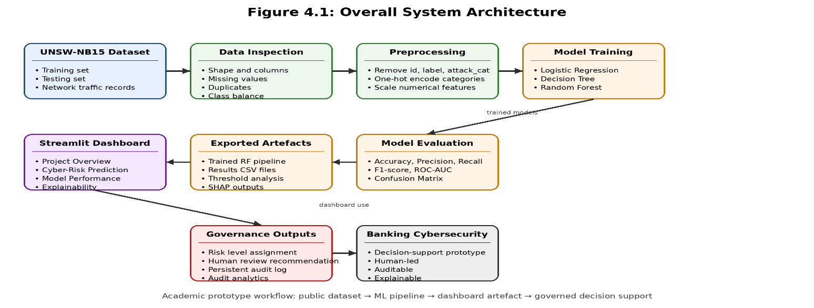
This figure represents the project's information flow, from UNSW material data to model development, assessment, and exporting artefacts to the Streamlit dashboard. It also shows how the dashboard generates governance outputs to support human-driven cybersecurity decision-making.

Machine-Learning Pipeline Design:
The pipeline was designed for validity and repeatability. The binary label field was targeted: 0 is normal traffic, and 1 is attack traffic. The model input features were created from the remaining network-traffic variables, with leakage-prone or non-predictive variables removed.
Three supervised models were chosen, with Logistic Regression providing a simple baseline. A nonlinear classifier was obtained from a Decision Tree, which was interpretable. Random Forest implemented an ensemble model that could generalise better and allow feature-importance analysis. This model set was designed to be classic and not U-Net-style deep-learning-based. Deep learning would have been possible, but it would have complicated implementation and reduced transparency. This project focused on governance, explainability, and dashboard-based decision support; classical supervised models fit the scope better.
The last dashboard used Random Forest because it had the highest Attack Recall in the model-comparison phase and the highest ROC-AUC. This was critical because, in cybersecurity, it's typically more important to miss attacks than to generate too many false alarms. The report discusses the Decision Tree even though it had good fidelity, since it performed well. This shows that model selection was based on the risk context, not just the model's accuracy.
Figure 2: Machine-Learning Pipeline and Preprocessing Workflow.
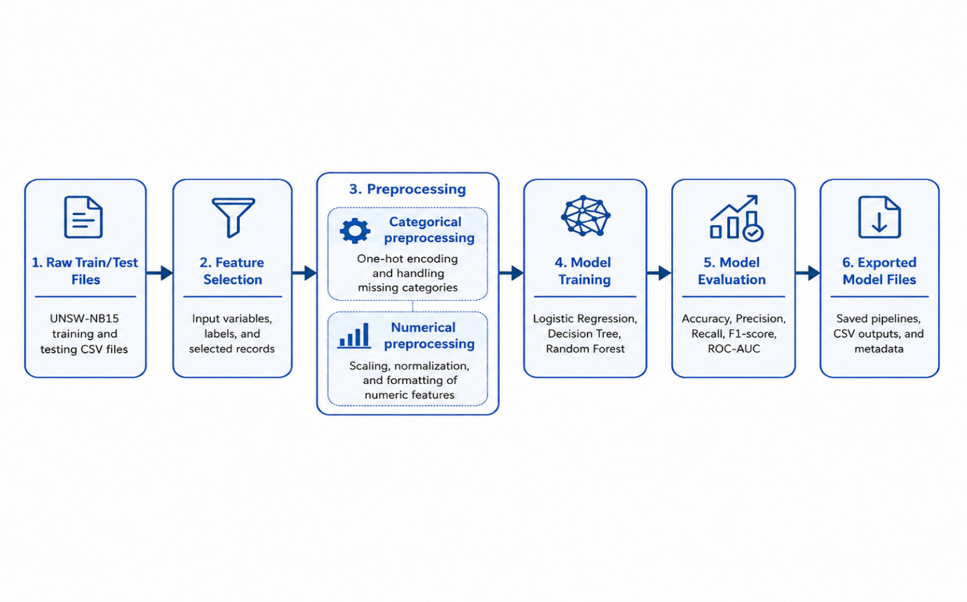
This demonstrates how the data was manipulated before modelling, including feature selection, removing leakage-prone fields, categorical encoding, and numeric manipulation. It shows the data passed to the supervised learning models.

Development Environment and Tools:
The development environment was developed to support experimentation, reproducibility and practical dashboard delivery.
Table 2: Software Tools and Justification.
Tool | Purpose | Justification
Python | Main development language | Suitable for ML, data processing and dashboards
Google Colab | Model development | Notebook-based enjoyment for experimentation
Pandas/NumPy | Data handling | Supported inspection, cleaning and numerical processing
Scikit-learn | ML pipeline and evaluation | Provided preprocessing, classifiers and metrics
SHAP | Explainability | Supported global and local model interpretation
Streamlit | Dashboard interface | Enabled interactive Python dashboard development
Plotly | Visualisation | Produced interactive charts for results and audit analytics
Anaconda | Local environment | Supported package and environment control
Joblib | Model export | Stored trained model pipeline for reuse.
The main tools used to build the prototype and explain why each tool was appropriate. This supports reproducibility and the technical justification of the implementation.
One key implementation lesson was maintaining environment consistency. While testing the exported Random Forest model locally, it would not load because the locally installed scikit-learn version did not match the version used when the model was exported. This was addressed by creating a separate Anaconda environment and pinning scikit-learn to version 1.6.1. This decision enhanced replicability and motivated the creation of the requirement.txt and requirement_full.txt files.

Streamlit Dashboard Design:
The dashboard was structured in individual pages instead of one overloaded page. The sidebar navigation had Project Overview, Cyber-Risk Prediction, Model Performance, Threshold Analysis, Explainability, Audit Log, Audit Analytics, Dashboard Testing Summary and Governance Notes. This structure facilitated testing, explanation, and evidence review for this artefact in the final report.

Table 3: Dashboard Sections and Contribution.
Dashboard section | Contribution
Project Overview | Explains purpose, model choice and governance position
Cyber-Risk Prediction | Runs prediction on selected sample records
Model Performance | Shows model-comparison evidence
Threshold Analysis | Shows false-positive and false-negative trade-offs
Explainability | Presents feature importance and SHAP outputs
Audit Log | Stores and displays persistent prediction records
Audit Analytics | Summaries logged predictions using metrics and charts
Dashboard Testing Summary | Records functional testing evidence
Governance Notes | Explains limitations and responsible AI controls
This table provides an overview of the dashboard sections and each section's contribution. This table details the purpose of each dashboard page and how each section supports the artefact. It illustrates the dashboard's organised approach to Prediction, Evaluation, Explainability, and Governance.
The primary interactive page was the Cyber-Risk Prediction page. It enabled the user to select a sample record, run the Random Forest model, display the prediction result, display the original record, and add an analyst review status and note. Prediction label, attack probability, risk level, correct label, attack label, correct or not. This design was selected since a class label alone would not be sufficient for decision support.
Figure 3: Streamlit Dashboard Project Overview.
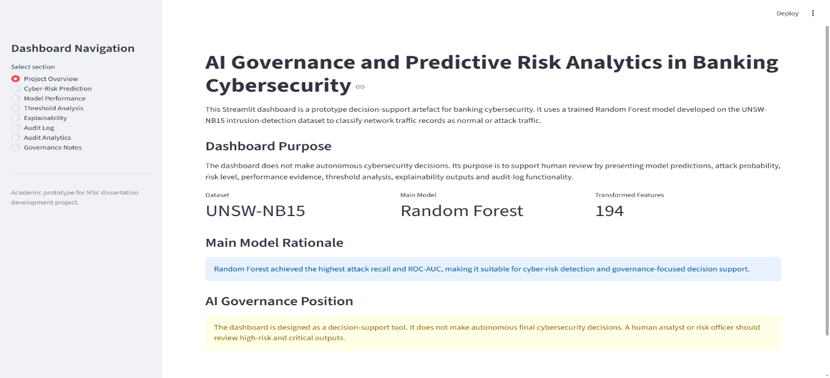
This screenshot shows the top level of the dashboard, which includes the artefact purpose, the chosen model, and a notification that the required files loaded successfully. It provides evidence of the dashboard design as a working prototype decision support system.
Figure 4: Cyber-Risk Prediction Interface: Low.
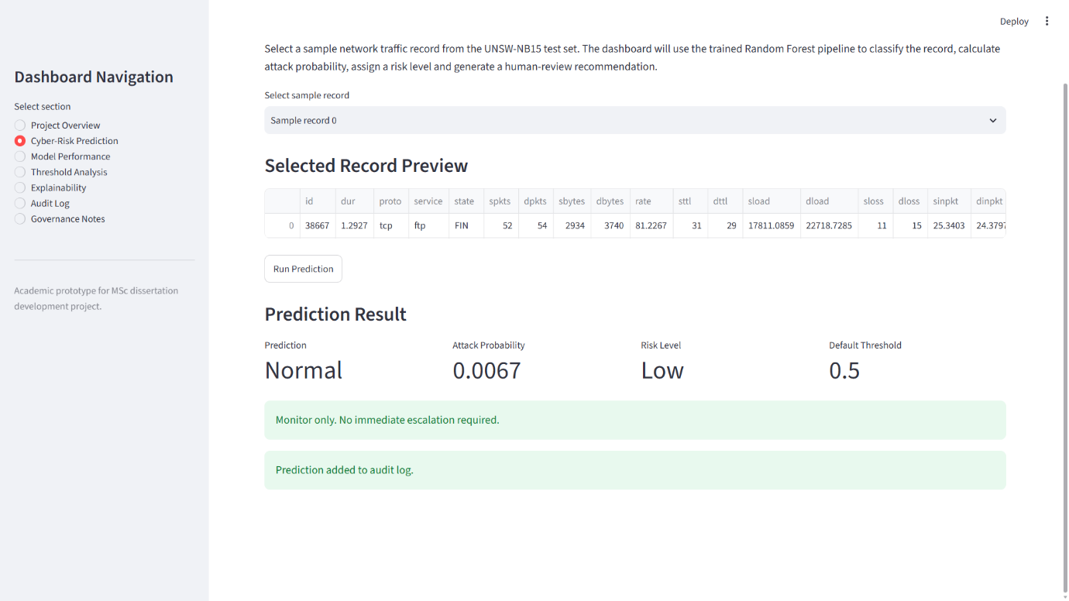
The following screen shows a selected test record sorted as a normal test but with a low attack probability. It shows the dashboard's potential to provide outputs that are not high risk for human evaluation and review.
Figure 5: Cyber-Risk Prediction Interface: Critical
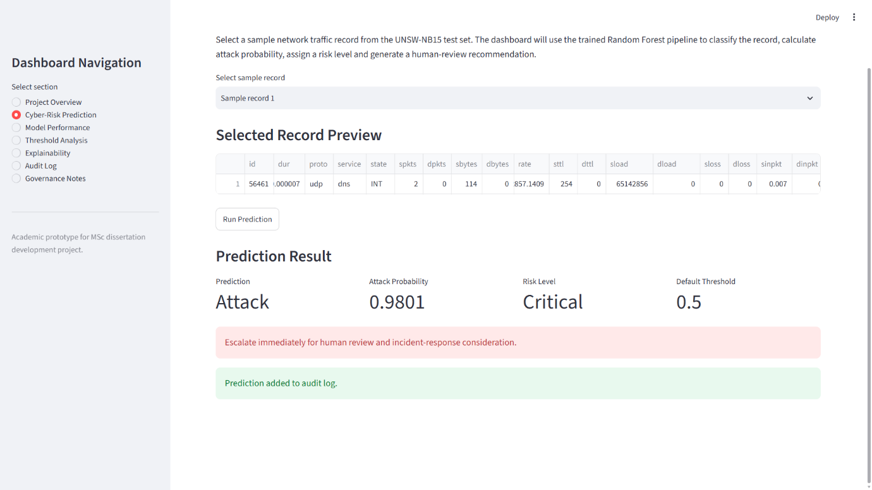
In this screenshot, you can see a selected test record marked as an attack, with a critical risk value. It shows how the dashboard can escalate high-risk predictions with probability, risk level, and recommendations.

AI Governance Layer Design:
The technical artefact will be tailored to the research question in the governance layer. NIST's AI Risk Management Framework views AI risk management as a lifecycle process comprising four stages: governance, risk mapping, measurability, and risk management [72]. Human oversight, transparency and accountability are also key elements of the European Trustworthy AI guidance. These principles guided the dashboard design [73].
The first type of governance characteristic is risk-threshold logic. The dashboard was adapted to 4 attack-probability levels: Low, Medium, High, and Critical. This facilitated interpretation of model output and strengthened the link between models' technical forecasts and cyber-risk prioritisation. This is shown on the Threshold Analysis page, which shows how different classification thresholds affect precision, recall, false positives, and false negatives. This was particularly significant because the threshold decision was not technical. In cyber security, it depends on the organisation's risk appetite and the trade-off between missed attacks and generated alerts.
The second governance aspect was explainability. Random Forest feature importance and SHAP evidence were added to the dashboard. Lundberg et al. demonstrate how to link individual prediction explanations to a more general understanding of the model using tree-based tasks [74]. The literature on explainable IDS also notes that explanations can aid the analyst's interpretation, but careful human judgement is still needed. For this reason, SHAP supported the decision rather than dictating it [75].
The third governance measure was logging persistent audit trails. The attributes for each prediction were relatively straightforward, including time (timestamp), sample record, model name, prediction, p (attack probability), risk level, true label, attack category, correctness status, recommendation, human-review status, and analyst note. This gave them a traceable record for dashboard use. These were then summarised on the Audit Analytics page as metrics and charts. This ensured auditability, as the prediction events remain recorded and can be consulted afterwards.
The fourth construct of governance was called explicit decision-support framing. The dashboard said it was an academic prototype and shouldn't be adopted for real-life banking security solution decisions until further research. This brought banking-sector expectations of governance, control, and documentation processes to manage ICT and security risks in line with those of the banking sector.
Figure 6: Persistent Audit Log and Audit Analytics Evidence.
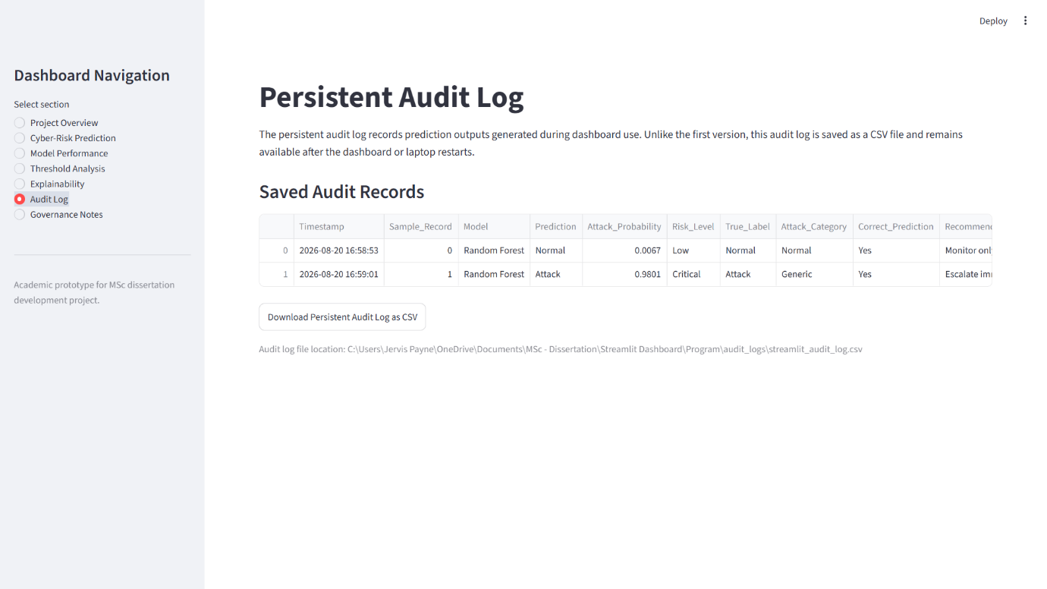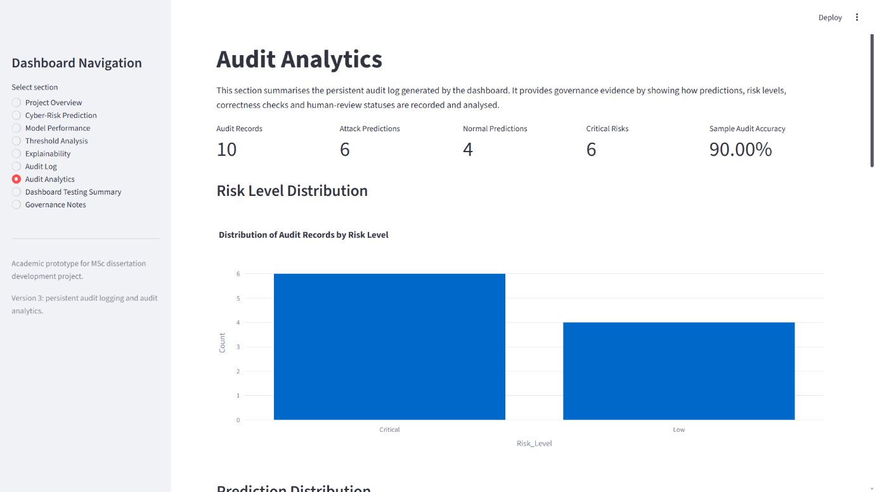
These screenshots show the persistent audit log that stores prediction records after dashboard use. It offers proof of auditability, traceability and record retention.

Implementation Process:
There were five versions of the dashboard to implement. Version 1 set up the basic Streamlit UI, read the Random Forest model, and showed dashboard sections of interest. It enabled predictions, but it saved audited events only in Streamlit session state. This caused records to be lost when the application restarted.
Persistent Audit logging was added in version 2. A separate audit logs folder was set up, and prediction records were added to streamlit_audit_log.csv. This enhanced the artefact, as records would remain after restarting the dashboard/laptop. I also added human review status and analyst notes, further strengthening the human-in-the-loop design.
Version 3 introduced Audit Analytics features. This page provided total audit records, attack predictions, normal predictions, critical risks, and audit-sample accuracy. It also showed graphs of risk-level distribution, Prediction distribution, Correctness distribution, and Traffic/Attack-category distribution. The term audit-sample accuracy was used deliberately because it refers only to the accuracy of manually tested dashboard records, not model accuracy.
Version 4 added the finishing touch to the dashboard. It included the Dashboard Testing Summary page, enhanced the Governance Notes page, incorporated a Risk-Policy table and noted the prototype limitations. Version 5 focused on final packaging and the possibility of repeating the process. It included a README, a clean requirements.txt, a full requirements.txt, backup files for each major version, and a final zipped dashboard package.
Table 4: Dashboard Version Development Summary.
Version | Main development completed | Evidence produced
Version 1 | Initial Streamlit dashboard and model loading | Working interface and prediction screenshots
Version 2 | Persistent CSV audit logging | Audit log retained after restart
Version 3 | Audit analytics page | Metrics and charts from logged records
Version 4 | Testing summary and governance polished
Version 5 | Final packaging and reproducibility | README, requirement files and ZIP package
Here is a table summarising the progress made in development from Version 1 to Version 5. It provides concise evidence of iterative development, testing, fine-tuning, and end-to-end packaging.
Multiple implementation issues have been addressed. This was because Windows PowerShell did not initially recognise Python, so the Anaconda Prompt was used. Before installing, users had to agree to Conda's terms of service. The local environment was modified to match the exported environment to avoid a model-loading problem caused by a scikit-learn version mismatch. We decided not to remove these issues from the project evidence because they illustrate replicable, realistic development and debugging practice.

Testing and Evidence Strategy:
Testing involved observing the dashboard in operation as a complete academic artefact. The final functional test verified correct loading of all pages, production of predictions with the Random Forest model, case creation as Low/Normal classes and Critical/Attack classes, audit persistence, and updating of audit analytics from audit persistence.
A screening approach was used. Wherever possible, include only the clearest screenshots in the main report, with the full evidence series in the appendices. This prevents overloading the chapter and ensures evidence is available for assessment.

Chapter Summary:
This chapter explained the design and implementation of the cyber security decision support (CSDS) prototype. The design included a structured Streamlit dashboard, an AI governance layer, and a replicable machine-learning pipeline. Key design decisions supported prediction, explainability, and human auditability. Five controlled versions led to a stable packaged artefact during implementation. This chapter describes the dataset selection and data preprocessing in more detail.

Design/Data collection

Chapter Introduction:
This chapter describes the choices, steps and actions taken in the dataset selection and preprocessing section of the project. This phase aimed to prepare the UNSW-NB15 intrusion detection dataset for supervised binary classification. This was required to ensure consistent inputs for the ML models and a well-defined output variable, along with safeguards against inappropriate training data (target leakage).

Dataset Selection:
The UNSW-NB15 dataset was chosen because it is a recognised dataset used in network intrusion detection research. It contains labelled network traffic records that illustrate normal network traffic and attack behaviours. Benchmark intrusion-detection datasets support academic projects by enabling reproducibility, model comparison, and controlled evaluation. However, the data is not real bank data. It was therefore primarily an academic representation of cyber-risk classification and did not indicate production readiness [76].
The dataset was appropriate for the project because it included separate training and test files, a binary label field, and network-flow features. These attributes suited supervised machine learning, so Logistic Regression, Decision Tree, and Random Forest models were developed and evaluated. Another benefit of using a publicly available dataset was avoiding ethical or confidentiality concerns that would arise if real banking network traffic were used.
Table 5: Dataset Summary
Dataset Element | Project Value
Training records | 175,341
Testing records | 82,332
Original columns | 45
Target field | Label
Binary classes | Normal = 0, Attack = 1
Attack category field | attack_cat
Missing values | 0
Duplicate records | 0
Table 5 summarises the essential aspects of the training and testing UNSW-NB15 datasets used in the project. Indicates the number of records in the dataset, the target field, the field to be used for class labels, and the field for attack-category data, as well as initial data-quality tests.

Figure 7: Label Distribution in Training and Testing Sets.
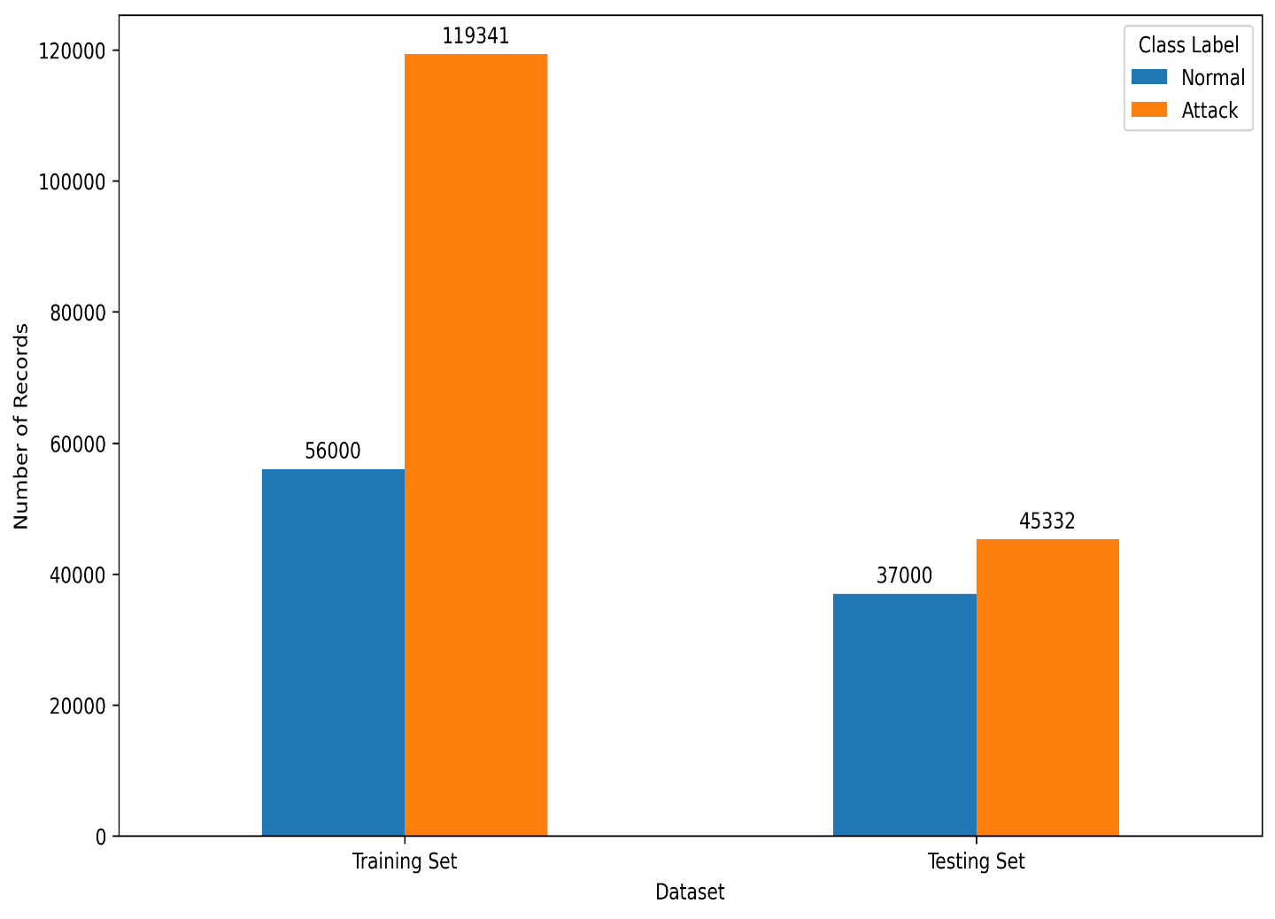
The figure above compares the distributions of normal and attack records in the UNSW-NB15 training and testing sets, respectively. It shows class imbalances and enables evaluation based on precision, recall, F1 score, and confusion-matrix analysis rather than accuracy.

Initial Dataset Inspection:
First, I previewed the training and test sets in Google Colab. This involved verifying the shape, names, and column data types; the class distribution; and the presence of missing values and duplicate records in the dataset. The inspection confirmed that both datasets imported successfully and that each had 45 columns. The training dataset had 175,341 records, and the testing dataset had 82,332.
During inspection, there were no missing data or duplicate entries. This minimised the need for imputation and/or duplicate-removal procedures. However, attention was still needed for class distribution, as the training set had more attack records than normal records. Because of this, it became imperative to evaluate models with metrics other than accuracy, since in an imbalanced classification problem, accuracy alone does not always reflect model performance [77].

Feature Selection and Target Definition:
The test field was the binary label field. If the value was 0, it was not attack traffic (normal traffic); if the value was 1, it was attack traffic. The model input data did not include id, label and attack_cat. The id field was not retained because it was merely a record identifier and had no meaningful predictive value.
The feature set was reduced by the label field since it was the target of prediction. The attack_cat field was also dropped because attack-category information is like the target field and could result in target leakage.
This is crucial for the experimental validity. Including attack_cat during model training would give the model information it otherwise wouldn't receive in a real prediction scenario. The leakage-free fields ensured the models learnt from network traffic features, not from information that came off the target.

Categorical and Numerical Preprocessing:
Following feature selection, the resulting input features were split into categorical and numerical features. The categorical variables were proto, service and state. These were then one-hot encoded so that they could be used with scikit-learn models. One-hot encoding was suitable because it represents categorical values by creating indicator columns for each value, without imposing an artificial order.
The numerical features were processed individually. To create a pipeline that applies different preprocessing techniques to different columns, a scikit-learn ColumnTransformer was used. This approach improved train-test cohesion by applying the same preprocessing logic to training and testing. The transformed feature space after preprocessing had 194 features for modelling.
Table 6: Preprocessing Decisions.
Preprocessing Decision | Reason
Removed id | Non-predictive record identifier
Removed label | Target variable
Removed attack_cat | Prevented target leakage
One-hot encoded categorical variables | Converted text categories into model-ready features
Scaled numerical variables | Supported consistent model processing
Used provided train/test files | Preserved original evaluation structure

Table 6 lists the key preprocessing choices made before training the model. It justifies the fields discarded and explains how the categorical and numerical fields were converted before using a supervised machine learning algorithm.

Chapter Summary:
This chapter explained how the UNSW-NB15 dataset was selected, inspected, and prepared for supervised machine learning. The preprocessing stage ensured the data was ready for binary prediction, prevented target leakage, and standardised features for model input. The next chapter presents the model development, analysis, and evaluation results.

Data Analysis & Model Evaluation

Chapter Introduction:
This chapter presents the data analysis and model evaluation results from the project's supervised machine-learning stage. The objective is to compare the performance of three models, namely Logistic Regression, Decision Tree and Random Forest and finally choose the best model to be used in the Streamlit dashboard.
The chapter also provides threshold analysis and explainability outputs, as these are vital because cybersecurity evaluation must be not only correct but also comprehensible. False negatives in intrusion detection mean missed attacks, and false positives can lead to analyst fatigue and increased workload [78].

Model Evaluation Strategy:
Model evaluations used data from the UNSW-NB15 testing set. The binary label field was taken as the target variable, with 0 denoting normal traffic and 1 denoting attack traffic. The evaluation used accuracy, precision, recall, F1 score, ROC-AUC, and confusion matrix analysis.
Overall correct classification was used for accuracy. Precision assessed the accuracy of the predicted attack labels. Recall determined how many real attacks were identified. An F1 score provided a precision/recall balance, and ROC-AUC assessed the model's ability to distinguish normal from attack traffic across thresholds.
Indicators like these were needed because the dataset wasn't perfectly balanced, and cybersecurity has asymmetric error costs. Failing to detect an attack can be more serious than dropping a false alarm, but too many false positives can reduce the corollary's usefulness. As such, the dashboard model was chosen, taking both technical considerations and cybersecurity risk context into account.

Model Performance Results:
Table 7: Model Performance Summary.
Model | Accuracy | Precision | Recall | F1-score | ROC-AUC
Logistic Regression | 0.8354 | 0.8023 | 0.9303 | 0.8616 | 0.9558
Decision Tree | 0.9211 | 0.9043 | 0.9581 | 0.9304 | 0.9756
Random Forest | 0.9006 | 0.8636 | 0.9733 | 0.9151 | 0.9845
Table 7 shows the performance of the three supervised models in terms of accuracy, precision, recall, F1-score, and ROC-AUC. This provides a primary basis for comparing the models' suitability.
Figure 8: Model Performance Comparison.
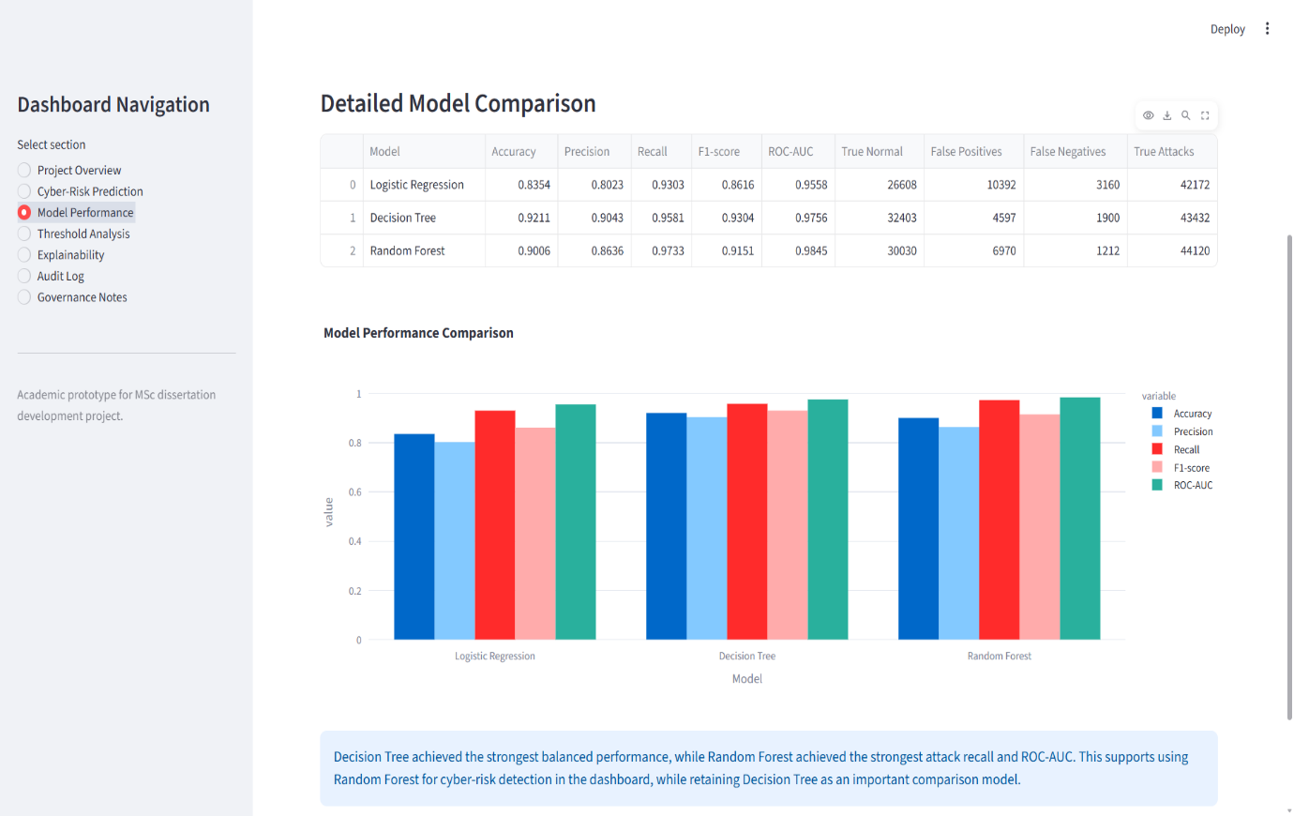
Logistic Regression showed an accuracy of 0.86, precision of 0.89, recall of 0.87, F1 score of 0.87 and ROC AUC of 0.92 when compared to the Decision Tree and Random Forest in terms of accuracy, precision, recall, F1 score and ROC AUC, as shown in Figure 8. This shows that the Decision Tree had the best-balanced performance, while the Random Forest had the highest recall and ROC-AUC.

All three models demonstrate useful classification performance. Logistic regression provided a strong baseline, achieving 83.54% accuracy and 93.03% recall. This indicated that even in this simple linear model, it could identify a substantial number of attack records. However, it performed the worst overall on the trees.
The Decision Tree achieved the best accuracy, precision, and F1-score. Its accuracy was 92.11%, precision was 90.43%, and F1-score was 93.04%. This made it the best model overall. The Random Forest achieved the best recall and ROC-AUC. It had a recall rate of 97.33% and a ROC-AUC of 0.9845, which indicated that it discriminates well between normal and attack flows. It was less accurate and less well-rounded than the Decision Tree. Still, it had better attack detection capabilities and was therefore a more appropriate model for this dashboard, which aimed to report risks.

Confusion Matrix Analysis:
Table 8: Confusion Matrix Comparison
Model | True Normal | False Positives | False Negatives | True Attacks
Logistic Regression | 26,608 | 10,392 | 3,160 | 42,172
Decision Tree | 32,403 | 4,597 | 1,900 | 43,432
Random Forest | 30,030 | 6,970 | 1,212 | 44,120
Table 8 shows the differences between true normal records, false positives, false negatives, and true attacks across the three models. It chooses the best kind, "Random Forest", because it has the fewest missed attacks among these kinds.
The confusion matrix results clearly illustrate the model's behaviour. Logistic Regression had 3,160 false negatives and 10,392 false positives. This corroborated its baseline performance but showed it is not as strong as the tree-based models.
All three models significantly reduced false negatives, but Decision Tree had the fewest false positives, with just 1,900. This supported its strong balanced performance. Random Forest had the fewest false negatives (only 1,212 missed attacks). This was the primary reason it was chosen for the dashboard. One of the most important challenges of cybersecurity decision support is minimising false negatives, since they might indicate ongoing malicious activity.

Threshold Analysis:
To assess how varying decision thresholds affect classification results, we performed a threshold analysis for the Random Forest model.
Table 9: Random Forest Threshold Analysis
Threshold | Accuracy | Precision | Recall | F1-score | False Positives | False Negatives
0.30 | 0.8374 | 0.7734 | 0.9966 | 0.8709 | 13,236 | 154
0.40 | 0.8725 | 0.8180 | 0.9883 | 0.8951 | 9,969 | 529
0.50 | 0.9006 | 0.8636 | 0.9733 | 0.9151 | 6,970 | 1,212
0.60 | 0.9178 | 0.9029 | 0.9533 | 0.9274 | 4,648 | 2,119
0.70 | 0.9271 | 0.9431 | 0.9233 | 0.9331 | 2,525 | 3,479
Table 9 shows different classification thresholds and their impact on precision, recall, false positives, and false negatives, highlighting the trade-off between attack detection and false-alert reduction.
Figure 9: Random Forest Threshold Trade-Off
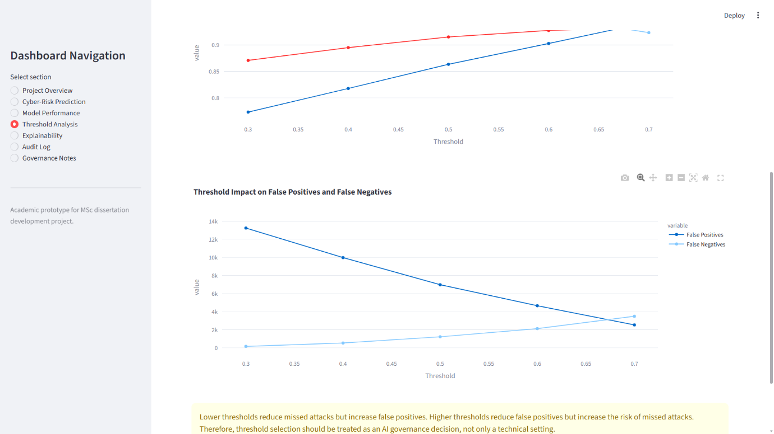
As shown in Figure 9, false positives (FP) and false negatives (FN) vary with the Random Forest classification threshold. This shows that the threshold setting is not just a technical setting, but also a governance and risk-appetite decision.
The threshold analysis depicts the trade-off between attack detection and false alerts. With a threshold of 0.30, the system missed 154 attacks but generated many false positives (13,236). With a threshold of 0.70, the number of false positives was reduced to 2,525, but the number of attacks missed rose to 3,479. This confirms that threshold selection is a technical setting, not just a governance and risk-appetite decision. It is also a governance and risk-appetite choice. For this reason, the dashboard was not intended to provide a binary output, but rather risk levels and recommendations.

Explainability Results:
Adding explainability enabled transparency and governance. According to the Random Forest feature importance results, sttl, ct_state_ttl, sload, rate, dload, dttl, dbytes, dinpkt, ct_srv_dst, and sbytes had a significant impact on the results. These features relate to traffic behaviour, the number of bytes transferred, packet characteristics, and connection and flow state.
Figure 10: Random Forest Feature Importance.
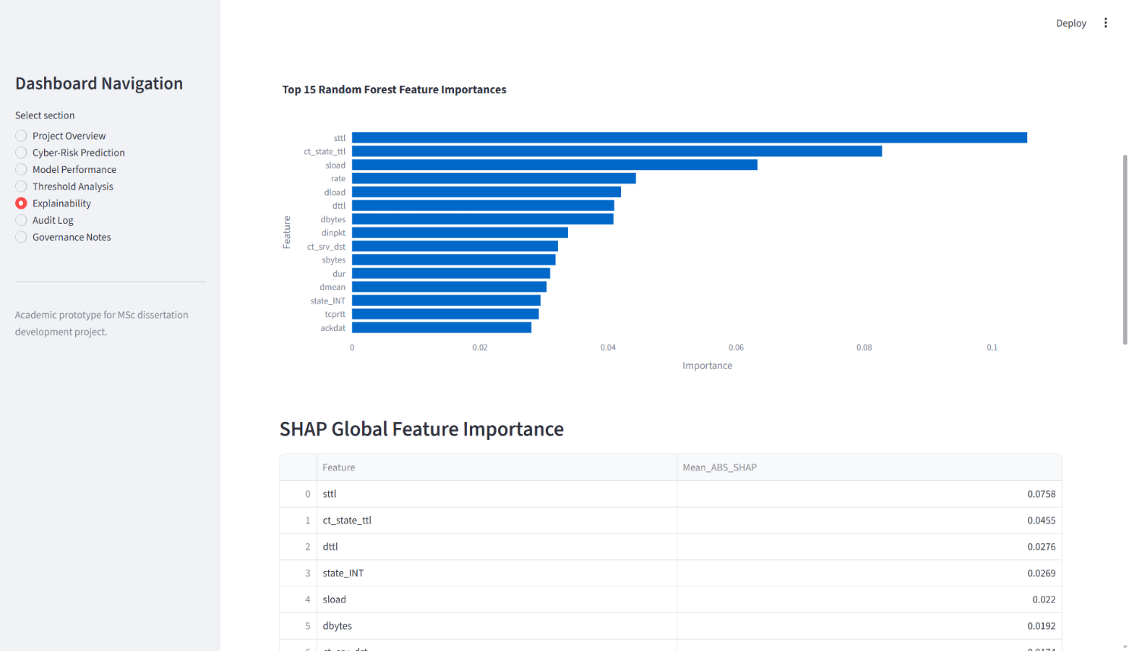
Figure 10 shows the most important features used by the Random Forest model. It shows that traffic-related features (like sttl, ct_state_ttl, and sload) had a significant effect on classification.

SHAP analysis provided additional explanatory evidence. For the global SHAP results, sttl and ct_state_ttl were the two most influential features. SHAP was run both on the 500-record sample and then run again on the 1000-record sample. The top 15 features were the same in both samples, with 100% overlap in the top 15 SHAP values. This increased confidence that the explanation pattern did not rely on a single sample of size 3.
Figure 11: SHAP Global Feature Importance.
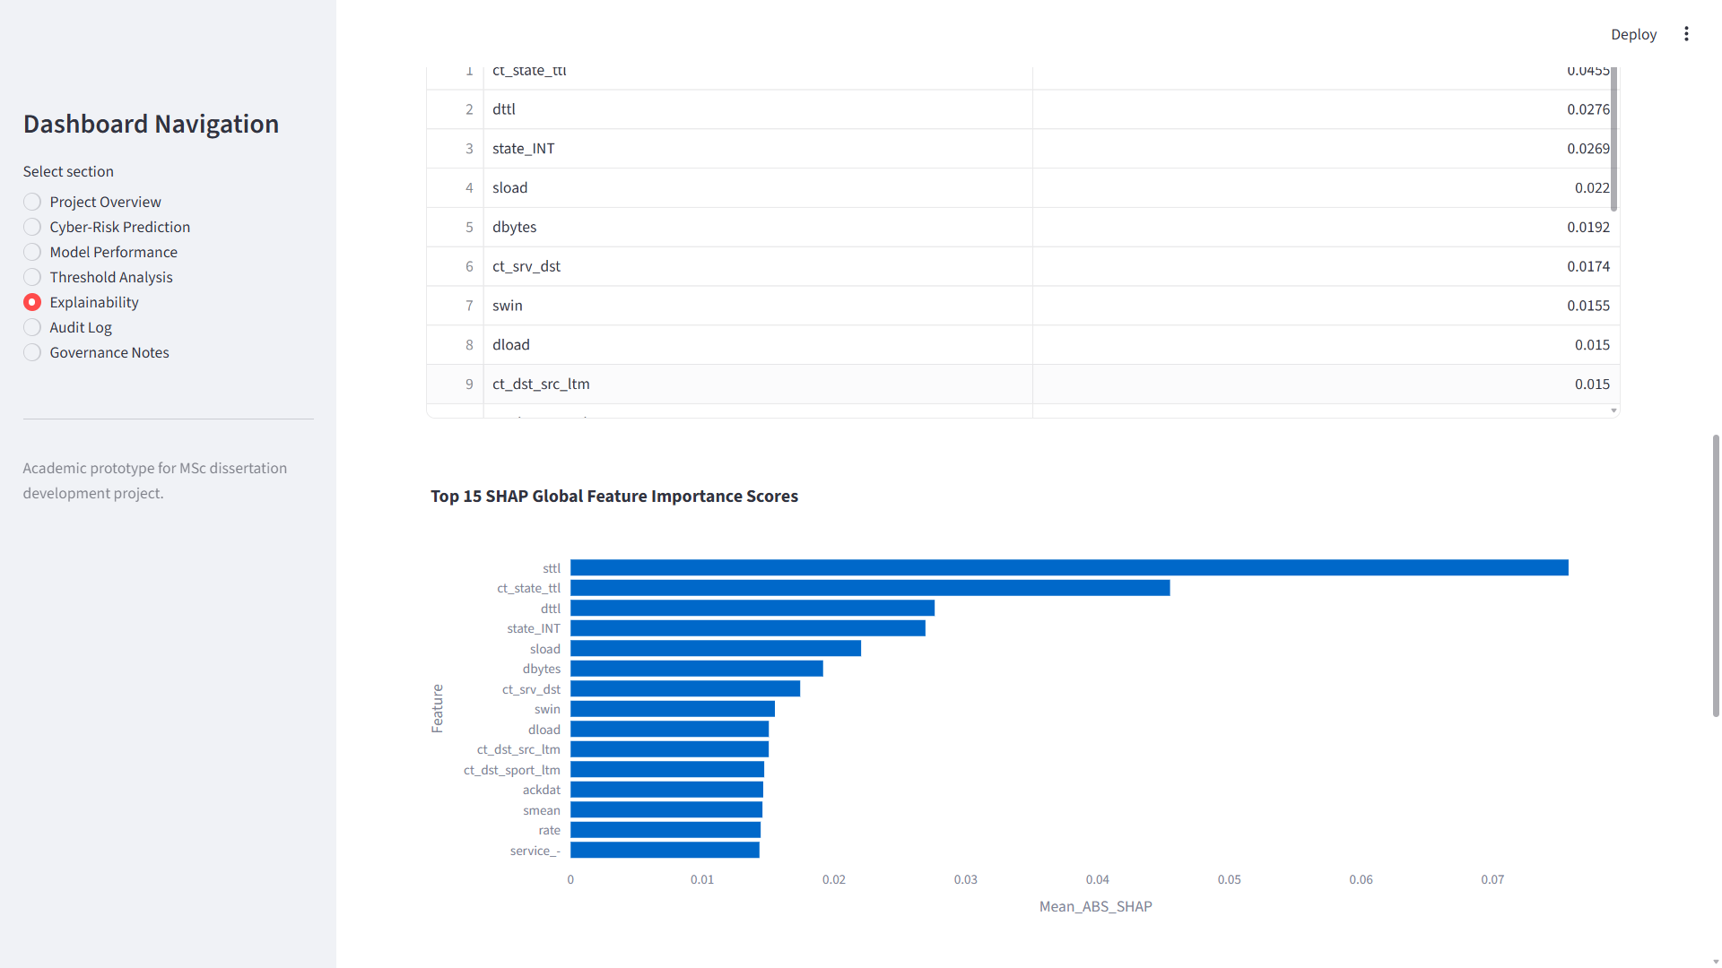
The global SHAP feature-importance results of the Random Forest model are given in Figure 11. This helps explainability by showing the features most influential at the highest level of model predictions.
An example of a local SHAP was also generated for the prediction of a high-risk user. The selected record had a true label of attack, was predicted as attack and had an attack probability of 1.0. Main participants on the local side were mainly sttl, sload, ct_state_ttl, state_INT, dbytes, ct_dst_sport_ltm, dinpkt, rate, smean and dur. This helped the dashboard meet the governance objective of interpreting the meaning of a single high-risk prediction.

Dashboard Integration of Evaluation Outputs:
The model assessment outcomes were exported and combined with the Streamlit dashboard. The dashboard displayed tables and outcomes from model-performance and threshold analysis, as well as evidence and SHAP outputs for feature importance. This was significant as the evaluation did not stop in the notebook space. It was transformed into an artefact accessible to the user, which enabled review, auditability, and decision support.
The dashboard also classified sample records using a Random Forest model. All the predictions showed the class label, attack probability, risk level, true label, attack category, correctness status and recommendation. The output of these was then stored in the persistent audit log and summarised by audit analytics. This supported a more comprehensive design of the artefact's governance.

Chapter Summary:
This chapter examined the three supervised models that were used in this project. The Decision Tree was the most balanced; Random Forest had the highest Recall, ROC-AUC, and the fewest false negatives. Random Forest was ultimately chosen as the dashboard model because its behaviour matched the risk-perceptive nature of cybersecurity decision support.
Threshold analysis showed that false-positive and false-negative trade-offs require governance expertise. Explainability was achieved through feature importance and SHAP analysis, revealing which traffic features influenced the model's behaviour. The next chapter discusses these results in the context of the research question, literature review, and project objectives.

Results and Discussion

Chapter Introduction:
This chapter discusses the findings from the model evaluation, dashboard implementation and AI governance design. This chapter discusses the technical results in Chapter 6 in relation to the research question, project objectives, and literature review. Key discussion on model performance, threshold behaviour, explainability, value for the dashboard, and governance contribution/limitations.
The research question is: How can AI governance principles and supervised machine-learning techniques be integrated to develop a banking cybersecurity decision-support system for the UNSW-NB15 dataset? The results suggest this is possible through a structured workflow, including dataset preprocessing, model comparison, risk-based predictions, explainability, persistent audit logging, audit analytics, and human validation.

Analysis of Model Performance:
From the evaluation outcomes, all test classifiers, namely Logistic Regression, Decision Tree and Random Forest classifiers, were able to classify normal and attack traffic in the UNSW-NB15 dataset. This reinforces the general intrusion-detection research that supervised machine learning is a convenient method for well-defined network-traffic classification. However, each model's performance varied, validating the need to compare multiple classifiers [79], [80].
The Decision Tree achieved the best accuracy, precision, and F1-score, with balanced performance. This demonstrated its effectiveness in attack detection and in controlling false positives. Despite this, the random forest achieved the best recall and ROC-AUC, with minimal false negatives. This was the key reason for selecting it as the dashboard model. In cybersecurity, a false negative can be worse than a false alarm because it indicates a missed attack [81]. Therefore, the model-selection decision was based on risk, not accuracy alone.

This result confirms literature stating that a single criterion should not measure classification performance [82]. While accuracy is useful, it can obscure critical gains in false positives and false negatives, particularly in imbalanced and risk-sensitive classification problems. Hence, for a more complete analysis, this project used accuracy, precision, recall, F1-score, ROC-AUC, and confusion-matrix analysis.

Threshold Behaviours and Risk Appetite:
One of the most significant results is the relationship between model behaviour and risk appetite as displayed in the threshold analysis. Random Forest had more successes in identifying attacks and fewer FNs at a lower threshold, but it also had more FPs. That is, as the threshold increased, false positives decreased, but attacks missed increased. This showed that choosing the threshold is not just a technical decision. It's a governance decision too.
The cost of a failed cyber-attack is very high in a banking environment, as it can affect customer data, service continuity, financial loss, and regulatory confidence. Where an attack failure cannot be allowed, it may be appropriate to set a lower threshold. But if the system produces too many false positives, it can swamp analysts and reduce its value. The specific cut-off will vary based on the organisation's risk tolerance, business landscape and review capacity [83].
This metric has been reflected in the dashboard with the four levels of Low, Medium, High and Critical risk based on the attack probability. This design decision made the model results easier to understand and better suited to decision support. It also tied technical evaluation to governance, as the user received not only a prediction but also a risk category and a review recommendation.

Explainability and Transparency:
The explainability experiments reinforced the artefact by showing which features affected the Random Forest model. The importance plot showed variable importance, and the SHAP plots summarised the importance of variables like sttl, ct_state_ttl, sload, rate, dload, dbytes, and flow-related variables. This suggests the model relied on network traffic characteristics rather than leakage-prone fields; this will be addressed later in this report.
This matters because explainability is crucial to responsible AI. Arrieta et al. argue for explainable AI, as human users should be able to understand AI-produced outputs and decide whether to accept or reject them [84]. Lundberg et al. further show that SHAP can generate explanations in tree-based models, linking individual predictions to overall model behaviour. In this project, SHAP provided both global and local interpretations [85]. The local SHAP example showed why the local high-risk record was deemed an attack, and the global SHAP outputs indicated the most influential features across sampled records during classification.
The SHAP stability check for the explanation evidence increased the trustworthiness of the explanations. SHAP's top 15 features stayed the same as we increased our sample size from 500 to 1000 records. This does not necessarily mean the model is fully explainable, but it does mean the explanation pattern did not rely on a small sample. This aligns with explainable intrusion-detection research, where explanations are desired to support XAI but must be carefully interpreted by humans [86].

Dashboard and Decision-support Value:
The predominant development artefact was the Streamlit dashboard, which proved the project was not simply about model development. Many intrusion-detection investigations compare and report the results of different algorithms but don't demonstrate the systems through which an ID model's output would be applied in a real-life review process [87]. This project filled this gap by building a dashboard to display model outputs in an interactive format.
The dashboard supported decision-making in several ways. The Cyber-Risk Prediction page displayed the prediction, attack probability, risk level, true label, attack category, correctness status, and recommendation. The Model Performance page evaluated comparative evidence of performance. Biases (namely false-positive and false-negative) were observed on the Threshold Analysis page. The "Explainability" page displayed feature importance and SHAP outputs. The Audit Log and Audit Analytics pages logged predictions, which were saved and summarised.
This design transformed the artefact from a mere classifier into a decision-support system. It evolved into a prototype decision-support system that integrated technical, explanatory, and governance evidence in one system. The dashboard did not replace the human assessor. Instead, it supported human-led interpretation and escalation. This fits a banking cybersecurity scenario, where risk decisions should be accountable and reviewable.

AI Governance Contribution:
One of the project's most successful aspects was creating the AI governance layer. NIST's AI Risk Management Framework illustrates AI risk management as a lifecycle process that includes governance, mapping, measurement, and management [88]. Human oversight, transparency, accountability and technical robustness are also key aspects of the European Trustworthy AI guidance [89]. These principles informed the dashboard design.
Supporting transparency: representation of model scenarios, probabilities, performance measures and threshold results. Feature importance and SHAP explained the features. CSVAuditLog was used for Auditability and persisted over time. Traceability was enabled because each prediction record includes the timestamp, sample record, model prediction, attack probability, risk level, true label, attack category, correctness state, recommendation, and analyst check status and analyst note. Analyst review fields and the dashboard framing for decision support led to human oversight.
This matters because governance principles often address issues at the policy level and don't necessarily show up in small technical artefacts. In this project, we extended the idea of governance by incorporating it into the working system. The audit log and audit analytics page provided concrete proof that predictions were being generated from that information and documented and stored for future analysis.
This directly addressed the research question and showed how supervised machine learning and AI governance can be correlated in a prototype charting cybersecurity in a banking environment. The design also aligns with banking-sector expectations that ICT and security risks be properly controlled and managed through documented governance and control processes [90].

Project Objectives Achievements:
Overall, the project's main goals have been accomplished. The literature review focused on Cybersecurity Risk, ID, supervised ML, Explainable AI and AI governance. UNSW-NB15 dataset was chosen, explored and processed for binary classification. Logistic Regression, Decision Tree, and Random Forest were built and compared, then compared with logistic regression.
Multiple model metrics were used for evaluation, including confusion matrices and threshold analysis. Explainability was achieved using feature importance and SHAP. A working Streamlit dashboard was developed, tested and packaged. Governance controls were incorporated through risk levels, audit logging, audit analytics, and human review.
Table 10: Project Objectives and Achievement
Objective area | Outcome
Literate review | Completed and used to justify model, dataset and governance choices.
Dataset preparation | UNSW-NB15 inspected, cleaned and prepared for binary classification
Model development | Trained and compared Logistic Regression, Decision Tree, and Random Forest.
Evaluation | Multiple metrics, confusion matrices and threshold analysis completed
Explainability | Feature importance and SHAP evidence produced.
Dashboard artefact | Streamlit prototype implemented and tested.
Governance | Audit logging, audit analytics, risk levels and human review included.
Final packaging | README, requirements files, backups and ZIP package created.
Table 10 summarises how each project objective was fulfilled in the literature review, data set preparation, model development, evaluation, explainability, dashboard development, governance controls, and final packaging. Explain clearly the extent to which the project aims and objectives have been met (in the context of an academic prototype).
The overall objective was thus achieved. The project resulted in a functional academic prototype which demonstrates a hybrid approach of supervised machine learning with a set of AI governance controls. However, this achievement is limited to the project scope. The system is a proof of concept and not a banking cybersecurity tool ready for market.

Limitations of Results:
The project has several limitations. First, UNSW-NB15 is a public reference benchmark dataset, not real bank network traffic. It supports reproducibility in academic evaluation, but it can't validate whether it works in a real banking environment. Second, the developer tested the dashboard, not professional cybersecurity analysts. The evaluation could be made into a structured user test, although this was outside the scope of this project.
Third, the model struggled with binary classification, not multi-class attack classification. Attack_cat was shown only as context and was not used for training. Fourth, SHAP analysis was performed on samples, not the full testing dataset, because the dataset was unnecessarily large. Fifth, the dashboard was not security-hardened, was not deployed as a production application, and was run locally. This does not detract from the project's academic value. Rather, it provides the correct definition. The project shows how such an artefact to support cybersecurity decision-making in the ADR can be designed, implemented and evaluated, and illustrates that additional validation would be required before deployment.

Chapter Summary:
This chapter presented the project findings based on the research question, objectives, and literature. The results showed that supervised learning algorithms can aid cyber-risk classification with appropriate measures. Random Forest had the highest recall and the lowest false negatives and ROC-AUC, so it was chosen for the dashboard; Decision Tree had the best-balanced performance. Threshold analysis indicated that prediction settings needed adjustment based on risk appetite.
Explainability supported transparency, ongoing audit logging, and audit analytics with governance. Overall, the project results showed that machine-learning classification and AI governance principles can be interwoven into a working prototype of cybersecurity decision support in the banking sector.

Conclusions and Recommendations

Chapter Introduction:
Finally, this chapter summarises the project developments, answers the research question, and outlines recommendations for future development. This project aimed to create a prototype risk decision-support system for cybersecurity in a banking environment, using supervised machine-learning models and the UNSW-NB15 intrusion detection dataset, while following AI governance principles. The product was a functional Streamlit dashboard app with prediction, model evaluation, explainability, classification based on a risk threshold, persistent audit log, audit analytics and HRC.

Project Achievement Summary:
Within the scope of an academic development project, the project was completed and met the overall aim. The UNSW-NB15 dataset was selected, validated, and pre-processed for binary classification. During preprocessing, non-predictive, leakage-prone fields were removed; categorical and numerical fields were separated; and suitable transformations and features were created for the model. This provided a solid basis for a supervised machine learning experiment.
Three models were created and tested: Logistic Regression, Decision Tree, and Random Forest. The models were compared based on accuracy, precision, recall, F1 score, ROC-AUC, and confusion matrix analysis. Random Forest had the highest recall and ROC-AUC, while the Decision Tree performed best overall and had the fewest false negatives. Random Forest was thus chosen as the dashboard's default model because its positive behaviour matches the risk sensitivity of cybersecurity decision support.
The project also met its governance target. The model output was not only provided as a prediction Label in the Dashboard. It included features such as attack probability, risk level, recommendation, model-performance evidence, threshold analysis, explainability outputs, persistent audit records and audit analytics. These features showed how machine-learning predictions could be more explainable, traceable, reviewable, and transparent.

Response to Research Question:
The research question is: What are the principles of AI governance, and how can they be used, along with supervised machine learning techniques, to develop a cybersecurity decision-support system for a banking environment based on the UNSW-NB15 intrusion-detection dataset?
The project addressed this question by producing an end-to-end case study, from dataset preprocessing to supervised learning model training, evaluation, explainability, and governance through dashboards. To classify network traffic as normal or attack traffic, the project used a supervised machine learning approach. AI governance principles were integrated through risk-level thresholds, feature importance and SHAP explanations, persistent audit logging, analyst review fields, audit analytics, dashboard testing evidence, and explicit limitations.
The key takeaway is that the team successfully melded supervised machine learning with AI governance by treating the model as one part of a broader decision-support framework. The model produces both classification and probability outputs within the governance layer, which explains the outputs, supports record-keeping, and reviews and interprets outputs through risk levels. This is far more suitable for a banking cybersecurity setting than a standalone classifier; in finance, risk decisions must be accountable, evidence-based, and overseen by humans.

Conclusions from the Results:
Three principal conclusions emerge from the results. First, a supervised machine-learning model can be used in intrusion-detection classification by training and testing it using appropriate labelled data. Both models performed well, but performance varied among the three models. This validated the point that model choice should not be the only criterion in the model selection process but should be based on the purpose of the artefact.
Second, the Random Forest model was appropriate for the dashboard because it had the highest attack recall and the fewest false negatives. False Negatives in Cybersecurity can be extremely significant, as they could indicate a missed attack. The Decision Tree results were also significant, with the highest accuracy, precision, and F1-score. This illustrates one principle: no single perfect engineering model (solution) exists; the right approach depends on the risk priority.
Third, governance added value to the technical system. Threshold analysis indicated that these predictions/setting levels represent levels of risk appetite. Explainability supported transparency. Permanent audit trails enabled traceability and subsequent audit checks. Audit Support took saved predictions and turned them into "governance evidence. The results also highlight the importance of considering the responsibility of interpreting, recording and controlling AI-driven cybersecurity outputs, in addition to their predictive performance.

Recommendations:
The first recommendation is: AI cybersecurity tools should not be built as decision-making tools, but as decision-support tools, particularly in high-risk areas such as banking. Where model outputs could affect escalation, investigation, and/or operational response, human review should remain central.
The second is to evaluate a model through a combination of metrics. Intrusion Detection relies not only on accuracy but also on other factors. Precision, recall, F1-score, and ROC-AUC, along with confusion-matrix analyses, reveal a more realistic picture of model performance, particularly when false-positive and false-negative error rates differ.
The third recommendation is to build explainability and auditability into the artefact from the start. Features like importance, evidence, risk thresholds, audit logs, and human-review fields are not optional extras. These play a crucial role in transparent and accountable AI governance.
The fourth suggestion is for banking cybersecurity prototypes to undergo cybersecurity, risk and/or governance professional evaluation in the future. Structured user feedback could evaluate the Understandability of the dashboard outputs and their usefulness and applicability to actual decision-support workflows.

Future Work:
Future work can expand the prototype in several ways. First, evaluate the system on new and diverse intrusion-detection datasets to determine whether the model's behaviour holds beyond UNSW-NB15's scope. Second, extend the classification to multi-class, enabling the system to go beyond whether traffic is malicious and to predict which type of attack is being used.
Third, the dashboard options could be better developed with users such as cybersecurity analysts or risk practitioners. Fourth, the governance framework could be extended to align dashboards' output with established security governance frameworks like ISO 27001 or financial-sector ICT risk guidance, or other recognised AI governance frameworks, such as NIST's AI RMF [91]. A future version might also cover secure deployments, user authentication, audit logging with a database, and integration with simulated security-operations workflows.

Conclusion:
The project successfully built a prototype for an AI-based cybersecurity risk decision-support solution. It proved that supervised machine learning can successfully classify intrusion-detection records; however, it also highlighted that supervised machine learning cannot be used directly in banking cybersecurity due to its limited performance.
The project's main contribution is integrating model explanations and predictions with risk-threshold logic, persistent audit logging, audit analytics, and human review, consolidated into a single governed dashboard artefact. Although the system is still an academic research proof-of-concept, it provides a solid basis for future system development, professional evaluation, and further research.

Reflection

Technical Reflection:
This project helped solidify my knowledge of the transition from experimentation to a functioning software artefact of a machine-learning solution. In the early stages, I inspected and pre-processed the data, then trained and evaluated the model on Google Colab. The project then became more complete by transferring the trained model, evaluation outputs, and evidence of government approval into the Streamlit dashboard. This showed that not only high model metrics but also output usability, explainability, auditability, and appropriateness for review were key to a successful applied AI project.
One main technical take-home was the need for the following experimental validity. Excluding attack_cat from the model inputs was important to avoid leakage and ensure the models used network-traffic features rather than target labels. This improved the credibility of the model evaluation and strengthened the project's academic quality.

Problem Solving and Development Reflection:
The development process involved several practical problems. Setting up on-site was difficult, mainly because PowerShell does not support Python and because I had to install and configure Anaconda to create the environment. Another problem was that the exported Random Forest model could not load because the scikit-learn versions mismatched between Google Colab and the local system. To fix this, A new Anaconda environment was created, and scikit-learn was updated to 1.6.1.
These challenges improved the project and made the need for reproducibility, environment control, version management, and proper documentation clear. This directly influenced Requirements.txt, requirements_full.txt, the README.md documentation, version backups, and the final zipped dashboard package. The debugging process also produced a final artefact that provides stronger evidence of realistic software development practice.

Governance and Professional Learning:
The project also helped me build my knowledge about AI governance. Initially, they just wanted to create a model which would identify attack traffic. During development, it became clear that prediction alone is not adequate for cybersecurity in the banking sector. The dashboard must show probability, risk level, explanations, audit records, and analyst review status/limitations. This transformed the project from a mere classifier into a Governed Decision-Support (GDS) prototype. I find these interests professionally significant in cybersecurity, data governance, risk, compliance, and financial-sector technology. The project gave me clear insights into how technical AI systems can be linked to accountability, auditability, transparency, and human control. This is crucial for future research in cybersecurity governance and AI assurance, as well as for future postgraduate study.
For research, structure and proofreading, Generative AI was also used appropriately during the Project. It helped me align the dissertation argument, improve chapter headings, and verify the grammar and clarity of explanations. It also supported the data analysis workflow, though I encountered issues when implementing it. However, the project decisions, dataset preparation, model development, dashboard implementation, evidence testing, result interpretation, and academic judgement were my own. The significance for my learning was that it demonstrated that AI could support academic and technical tasks without excluding essential thinking, ownership, or the development of independent projects.

Final Reflection:
The project was a challenging endeavour, but it was successful. It involved research, technical development, and debugging, as well as documentation, evaluation, and critical reflection. After some hurdles, a final artefact was created that fulfilled the original aim through the integration of supervised machine learning and implemented AI governance controls in one working Streamlit dashboard.
I would add more feedback from people in cybersecurity/risk and try out the system with more datasets. The project, in the realm of academic subjects, however, demonstrated a high level of technical skill and sophistication, problem-solving, sensitivity to governance issues, and an appetite for further postgraduate study.

References

[1] | S. a. W. D. a. V. M. a. F. A. a. N. B. a. C. P. a. S. J. a. I. S. a. B. P. N. a. I. K. a. o. Amershi, “Guidelines for human-AI interaction,” in Proceedings of the 2019 CHI Conference on Human Factors in Computing Systems, Glasgow, CHI 2019 Paper, 2019, pp. 1- 13.
[2] | F. A. E. I. A. G. T. A. J. N. A. K. M. T. A. M. A. A. S. N. A. W. C. Adelmann, Cyber risk and financial stability: It’sa small world after all, International Monetary Fund, 2020.
[3] | M. A. A. E. A. A. O. A. K. S. A. I. T. A. S. I. A. B. I. Ozkan-Okay, “A comprehensive survey: Evaluating the efficiency of artificial intelligence and machine learning techniques on cyber security solutions,” IEEE Access, vol. 12, pp. 12229- 12256, 2024.
[4] | I. H. a. F. M. H. a. N. R. Sarker, “AI-driven cybersecurity: an overview, security intelligence modelling and research directions,” SN Computer Science, vol. 2, no. 3, p. 170, 2021.
[5] | N. a. Z. F. a. L. F. a. Z. H. Elmrabit, “Evaluation of machine learning algorithms for anomaly detection,” in 2020 International Conference on Cyber Security and Protection of Digital Services (Cyber Security), IEEE, 2020, pp. 1- 8.
[6] | D. A. A. Z. A. S. S. Dasgupta, “Machine learning in cybersecurity: a comprehensive survey,” The Journal of Defence Modelling and Simulation, vol. 19, no. 1, pp. 57- 106, 2022.
[7] | M. A. T. A. Asmar, “Integrating machine learning for sustaining cybersecurity in digital banks,” Heliyon, vol. 10, no. 17, 2024.
[8] | G. A. B. J. A. W. O. A. A. M. R. A. S. A. A. C. R. A. O. H. A. M. A. Rjoub, “A survey on explainable artificial intelligence for cybersecurity,” IEEE Transactions on Network and Service Management, vol. 20, no. 4, pp. 5115- 5140, 2023.
[9] | S. a. F. U. a. A. A. a. A. R. M. a. G. T. M. a. S. S. Muneer, “A critical review of artificial intelligence-based approaches in intrusion detection: A comprehensive analysis,” Journal of Engineering, vol. 1, no. 3909173, pp. 1 - 16, 2024.
[10] | U. Peters, “Explainable AI lacks regulative reasons: why AI and human decision-making are not equally opaque,” AI and Ethics, vol. 3, no. 3, pp. 963- 974, 2023.
[11] | A. A. a. A. A. A. a. A. T. M. a. A. A. M. a. A. S. M. a. E. S. A. Darem, “Cyber threats classifications and countermeasures in banking and financial sector,” IEEE Access, vol. 11, pp. 125138- 125158, 2023.
[12] | H. F. Abdul-Rasheed Olatunji Ottun, Trustworthy AI in practice: A comprehensive review of human oversight and human-in-the-loop approaches, TechRxiv, 2025.
[13] | A. K. Z. a. H. M. Holzinger, “Is human oversight of AI systems still possible?” New Biotechnology, vol. 85, pp. 59 - 62, 2025.
[14] | N. N. A. K. S. Cele, “Do cybersecurity threats and risks have an impact on the adoption of digital banking? A systematic literature review,” Journal of Financial Crime, vol. 32, no. 1, pp. 31- 48, 2025.
[15] | A. L. V. Y. G. B. J. A. B. A. L. A.-A. a. R. S. B.-G. Vasquez Ubaldo, “Information security in the banking sector: A systematic literature review on current trends, issues, and challenges,” International Journal of Safety and Security Engineering, vol. 13, no. 1, pp. 97- 106, 2023.
[16] | B. Dupont, “The cyber-resilience of financial institutions: significance and applicability,” Journal of Cybersecurity, vol. 5, no. 1, p. tyz013, 2019.
[17] | P. S. K. a. J.-P. Brauchle, The European Union, cybersecurity, and the financial sector: A primer, Washington, DC: Carnegie Endowment for International Peace, 2021.
[18] | Y. K. a. H. L. a. I. E. a. A. G. a. C. C. a. C. T. a. D. Y. a. D. R. a. E. J. a. E. A. a. o. Dwivedi, “Multidisciplinary perspectives on emerging challenges, opportunities, and agenda for research, practice and policy,” International Journal of Information Management,” International journal of information management, vol. 57, p. 101994, 2021.
[19] | T. A. M. J. G. A. R. P. A. C. M. Lynn, Disrupting finance: FinTech and strategy in the 21st century, Dublin: Springer Nature, 2019.
[20] | N. I. P. K. K. a. A. B. Polemi, “Challenges and efforts in managing AI trustworthiness risks: a state of knowledge,” Frontiers in Big Data, vol. 7, p. 1381163, 2024.
[21] | D. T. Y. A. G. a. F. S. Gümüşbaş, “A comprehensive survey of databases and deep learning methods for cybersecurity and intrusion detection systems,” IEEE Systems Journal, vol. 15, no. 2, pp. 1717 - 1731, 2020.
[22] | A. a. G. I. a. V. P. a. K. J. Khraisat, “Survey of intrusion detection systems: techniques, datasets and challenges,” Cybersecurity, vol. 2, no. 1, p. 20, 2019.
[23] | M. L. A. T. K. A. S. S. A. D. J. A. D. D. Ali, “Deep learning vs machine learning for intrusion detection in computer networks: A comparative study,” Applied Sciences, vol. 15, no. 4, p. 1903, 2025.
[24] | R. A. A. M. A. S. K. P. A. P. P. A.-N. A. A. V. S. Vinayakumar, “Deep learning approach for intelligent intrusion detection system,” IEEE Access, vol. 7, pp. 41525- 41550, 2019.
[25] | S. a. K. N. Choudhary, “Analysis of KDD-Cup’99, NSL-KDD and UNSW-NB15 datasets using deep learning in IoT,” Procedia Computer Science, vol. 167, pp. 1561 - 1573, 2020.
[26] | Y. Sahli, “A comparison of the NSL-KDD dataset and its predecessor, the KDD Cup’99 dataset,” International Journal of Scientific Research and Management (IJSRM), vol. 10, no. 4, pp. 832- 839, 2022.
[27] | A. a. H. J. a. Z. N. a. W. A. a. M. X. a. U. F. a. Q. S. a. P. M. S. Nazir, “Advancing IoT security: A systematic review of machine learning approaches for the detection of IoT botnets,” Journal of King Saud University Computer and Information Sciences, vol. 35, no. 10, p. 101820, 2023.
[28] | M. A. G. G. A. A. F. A. A. R. A. O. S. Ghurab, “A detailed analysis of benchmark datasets for network intrusion detection system,” Asian Journal of Research in Computer Science, vol. 7, no. 4, pp. 14- 33, 2021.
[29] | M. A. L. S. A. M. N. A. P. M. Sarhan, “Netflow datasets for machine learning-based network intrusion detection systems,” in International Conference on Big Data Technologies and Applications, Brisbane, Springer, 2020, pp. 117- 135.
[30] | “A scheme for generating a dataset for anomalous activity detection in IoT networks,” in Canadian Conference on Artificial Intelligence, Springer, 2020, pp. 508- 520.
[31] | N. A. Z. F. A. L. F. A. Z. H. Elmrabit, “Evaluation of machine learning algorithms for anomaly detection,” in 2020 International Conference on Cyber Security and Protection of Digital Services (Cyber Security), IEEE, 2020, pp. 1- 8.
[32] | I. H. A. A. Y. B. A. A. F. A. K. A. I. Sarker, “Intrudtree: a machine learning-based cyber security intrusion detection model,” Symmetry, vol. 12, no. 5, p. 754, 2020.
[33] | H. A. A. K. A. S. A. Salman, “Random forest algorithm overview,” Babylonian Journal of Machine Learning, vol. 2024, pp. 69- 79, 2024.
[34] | G. A. N. M. A. A.-K. O. Nassreddine, “Ensemble learning for network intrusion detection based on correlation and embedded feature selection techniques,” Computers, vol. 14, no. 3, p. 82, 2025.
[35] | M. A. S. R. A. A. Ö. A. G. D. Ozkan-Okay, “A Comprehensive Systematic Literature Review on Intrusion Detection Systems,” IEEE Access, vol. 9, pp. 157727- 157760, 2021.
[36] | I. I. A. B. I. I. A. B. A. D. R. A. D. R. Noora Zidan Khalaf, “Development of real-time threat detection systems with AI-driven cybersecurity in,” Mesopotamian Journal of Cybersecurity, vol. 5, no. 2, p. 501–513, 2025.
[37] | M. A. J. M. A. B. A. A. H. R. Imani, “Why ROC-AUC Is Misleading for Highly Imbalanced Data: In-Depth Evaluation of MCC, F2-Score, H-Measure, and AUC-Based Metrics Across Diverse Classifiers,” Technologies, vol. 14, no. 1, 2026.
[38] | D. A. G. J. Chicco, “The advantages of the Matthews correlation coefficient (MCC) over F1 score and accuracy in binary classification evaluation,” BMC Genomics, vol. 21, no. 1, pp. 1- 13, 2020.
[39] | J. A. W. Z. Miao, “Precision–recall curve (PRC) classification trees,” Evolutionary Intelligence, vol. 15, no. 3, pp. 1545- 1569, 2022.
[40] | N. D.-R. J. D. S. A. B. S. T. A. B. S. G. S. G.-L. D. M. R. B. R. C. a. F. H. Alejandro Barredo Arrieta, “Explainable Artificial Intelligence (XAI): Concepts, Taxonomies,” Information Fusion, vol. 58, pp. 82- 115, 2020.
[41] | R. R. H. W. C. A. E. G. K. Shane T. Mueller, “Explanation in Human-AI Systems: A Literature Meta-Review, Synopsis of Key Ideas and Publications, and Bibliography for Explainable AI,” arXiv, vol. 1902.01876, pp. 1- 204, 2019.
[42] | S. M. G. E. H. C. A. D. J. M. P. B. N. R. K. J. H. N. B. a. S.-I. L. Lundberg, “From local explanations to global understanding with explainable AI for trees,” Nature Machine Intelligence, vol. 2, no. 1, pp. 1 - 27, 2020.
[43] | A. D. A. C. W. a. K. R. Warnecke, “Evaluating explanation methods for deep learning in security,” in 2020 IEEE European Symposium on Security and Privacy (EuroS&P), Genoa, IEEE, 2020, pp. 158- 174.
[44] | S. J. A. W. A. S. M. S. R. I. B. a. M. S. Neupane, “Explainable Intrusion Detection Systems (X-IDS): A Survey of Current Methods, Challenges, and Opportunities,” IEEE Access, vol. 10, pp. 112392- 112415, 2022.
[45] | V. Z. M. A. I. C. Obagbuwa, “Evaluating machine learning-based intrusion detection systems with explainable AI: enhancing transparency and interpretability,” Frontiers in Computer Science, vol. 7, pp. 1 - 23, 2025.
[46] | S. M. G. E. H. C. A. D. J. M. P. B. N. R. K. J. H. N. B. a. S.-I. L. Lundberg, “From local explanations to global understanding with explainable AI for trees,” Nature Machine Intelligence, vol. 2, no. 1, p. 56–67, 2020.
[47] | N. AI, “Artificial intelligence risk management framework (AI RMF 1.0),” URL: https://nvlpubs. nist. gov/nistpubs/ai/nist. ai, vol. 1, no. 0, pp. 1-48, 2023.
[48] | A. Hleg, “High-level expert group on artificial intelligence,” Ethics guidelines for trustworthy AI, vol. 6, no. 15.3, pp. 1 - 9, 2019.
[49] | O. Legal, “Recommendation of the Council on artificial intelligence,” Organisation for Economic Cooperation and Development, pp. 1- 9, 2019.
[50] | I. D. a. S. A. a. W. R. N. a. M. M. a. G. T. a. H. B. a. S.-L. J. a. T. D. a. B. P. Raji, “Closing the AI accountability gap: Defining an end-to-end framework for internal algorithmic auditing,” in Proceedings of the 2020 conference on fairness, accountability, and transparency, Barcelona, ACM, New York, 2020, pp. 33- 44.
[51] | M. S. A. L. J. S. Jennifer Cobbe, “Reviewable automated decision-making: A framework for accountable algorithmic systems,” in Proceedings of the 2021 ACM Conference on Fairness, Accountability, and Transparency, ACM, New York, 2021, pp. 598- 609.
[52] | K. M. J. P. A. V. E. ALAN F. WINFIELD, “Machine ethics: The design and governance of ethical AI and autonomous systems,” Proceedings of the IEEE, vol. 107, no. 3, pp. 509- 517, 2019.
[53] | M. I. H. M. A. A. A. T. Shweta More, “Enhanced intrusion detection systems performance with UNSW-NB15 data analysis,” Algorithms, vol. 17, no. 2, p. 64, 2024.
[54] | K. A. L. S. A. V. V. A. H. I. A. A. X. M. Shaukat, “A survey on machine learning techniques for cyber security in the last decade,” IEEE Access, vol. 8, pp. 222310- 222354, 2020.
[55] | T. A. K. N. Talaei Khoei, “A comparative analysis of supervised and unsupervised models for detecting attacks on the intrusion detection systems,” Information, vol. 14, no. 2, p. 103, 2023.
[56] | A. T. & R. Lohiya, “A survey on intrusion detection system: feature selection, model, performance measures, application perspective, challenges, and future research directions,” Artificial Intelligence Review, vol. 55, no. 1, pp. 453- 563, 2022.
[57] | P. Uwe, “Explainable AI lacks regulative reasons: why AI and human decision-making are not equally opaque,” AI and Ethics, vol. 3, no. 3, pp. 963- 974, 2023.
[58] | S. M. K. A. Y. Sun, “Performance Analysis of Intrusion Detection,” Journal of Big Data, vol. 7, no. 1, pp. 1- 20, 2020.
[59] | D. A. J. M. Chou, “A survey on data-driven network intrusion detection,” ACM Computing Surveys, vol. 54, no. 9, pp. 1- 36, 2021.
[60] | M. A. W. S. A. S. D. A. L. D. A. H. A. Ring, “A survey of network-based intrusion detection data sets,” Computers & Security, vol. 86, pp. 147- 167, 2019.
[61] | Q. V. a. G. D. a. M. S. Liao, “Questioning the AI: informing design practices for explainable AI user experiences,” in Proceedings of the 2020 CHI conference on human factors in computing systems, New York, Association for Computing Machinery, 2020, pp. 1- 15.
[62] | S. M. A. S. Y. Kasongo, “Performance analysis of intrusion detection systems using a feature selection method on the UNSW-NB15 dataset,” Journal of Big Data, vol. 7, no. 1, p. 105, 2020.
[63] | S. M. A. S. Y. Kasongo, “Performance analysis of intrusion detection systems using a feature selection method on the UNSW-NB15 dataset,” Kasongo, Sydney M and Sun, Yanxia, vol. 7, no. 1, p. 105, 2020.
[64] | K. A. L. S. A. V. V. A. H. I. A. A. X. M. Shaukat, “A survey on machine learning techniques for cyber security in the last decade,” IEEE Access, vol. 8, pp. 222310- 222354, 2020.
[65] | Q. V. a. G. D. a. M. S. Liao, “Questioning the AI: informing design practices for explainable AI user experiences,” in Proceedings of the 2020 CHI conference on human factors in computing systems, New York, Association for Computing Machinery, 2020, pp. 1- 15.
[66] | J. A. H. A. M. A. Vom Brocke, “Introduction to design science research,” in Design science research. Cases, Switzerland: Springer, 2020, pp. 1-13.
[67] | P. A. P. E. Johannesson, “A method framework for design science research,” in An introduction to design science, Springer, 2021, pp. 77- 93.
[68] | K. A. L. S. A. V. V. A. H. I. A. A. X. M. Shaukat, “A survey on machine learning techniques for cyber security in the last decade,” IEEE Access, vol. 8, pp. 222310- 222354, 2020.
[69] | M. A. A. A. A. M. T.-H. Altalhan, “Imbalanced data problem in machine learning: A review,” IEEE Access, vol. 13, pp. 13686- 13699, 2025.
[70] | M. A. W. S. A. S. D. A. L. D. A. H. A. Ring, “A survey of network-based intrusion detection data sets,” Computers & Security, vol. 86, pp. 147- 167, 2019.
[71] | M. A. a. M. L. a. M. S. a. J. H. Ferrag, “Deep learning for cyber security intrusion detection: Approaches, datasets, and comparative study,” Journal of Information Security and Applications, vol. 50, pp. 1- 20, 2020.
[72] | N. AI, “Artificial intelligence risk management framework (AI RMF 1.0),” URL: https://nvlpubs. nist. gov/nistpubs/ai/nist. ai}, vol. 1, no. 0, pp. 1 - 48, 2023.
[73] | E. Union, “Proposal for a regulation of the European Parliament and of the Council laying down harmonised rules on artificial intelligence (artificial intelligence act) and amending certain Union legislative acts,” COM/2021/206final, pp. 1 - 107, 2021.
[74] | S. M. a. E. G. a. C. H. a. D. A. a. P. J. M. a. N. B. a. K. R. a. H. J. a. B. N. a. L. S.-I. Lundberg, “From local explanations to global understanding with explainable AI for trees,” Nature Machine Intelligence, vol. 2, no. 1, pp. 56- 67, 2020.
[75] | S. a. V. V. a. M. S. M. a. S. A. a. A. N. a. S. O. a. K. S. a. S. K. a. K. K. Patil, “Explainable artificial intelligence for intrusion detection system,” Electronics, vol. 11, no. 19, p. 3079, 2022.
[76] | S. M. A. S. Y. Kasongo, “Performance analysis of intrusion detection systems using a feature selection method on the UNSW-NB15 dataset,” Journal of Big Data, vol. 7, no. 1, p. 105, 2020.
[77] | A. Tharwat, “Classification Assessment Methods,” Applied Computing and Informatics, vol. 17, no. 1, pp. 168- 192, 2021.
[78] | A. a. G. I. a. V. P. a. K. J. Khraisat, “Survey of intrusion detection systems: techniques, datasets and challenges,” Cybersecurity, vol. 2, no. 1, pp. 1- 22, 2019.
[79] | A. a. G. I. a. V. P. a. K. J. Khraisat, “Survey of intrusion detection systems: techniques, datasets and challenges,” Cybersecurity, vol. 2, no. 1, pp. 1- 20, 2019.
[80] | M. A. L. S. A. M. N. A. P. M. Sarhan, “Netflow datasets for machine learning-based network intrusion detection systems,” in International Conference on Big Data Technologies and Applications, Springer, 2020, pp. 117- 135.
[81] | A. A. G. I. A. V. P. A. K. J. Khraisat, “Survey of intrusion detection systems: techniques, datasets and challenges,” Cybersecurity, vol. 2, no. 1, pp. 1- 22, 2019.
[82] | D. A. J. G. Chicco, “The advantages of the Matthews correlation coefficient (MCC) over F1 score and accuracy in binary classification evaluation,” BMC Genomics, vol. 21, no. 1, pp. 1- 13, 2020.
[83] | S. a. G. L. a. L. T. a. L. B. a. W. D. Doerr, Cyber risk in central banking, Bank for International Settlements, Monetary and Economic Department, 2022.
[84] | A. B. a. D.-R. N. a. D. S. J. a. B. A. a. T. S. a. B. A. a. G. S. a. G.-L. S. a. M. D. a. B. R. a. o. Arrieta, “Explainable Artificial Intelligence (XAI): Concepts, taxonomies, opportunities and challenges toward responsible AI,” Information Fusion, vol. 58, pp. 82- 115, 2020.
[85] | S. M. a. E. G. a. C. H. a. D. A. a. P. J. M. a. N. B. a. K. R. a. H. J. a. B. N. a. L. S.-I. Lundberg, “From local explanations to global understanding with explainable AI for trees,” Nature Machine Intelligence, vol. 2, no. 1, pp. 56- 67, 2020.
[86] | S. A. A. J. A. A. W. A. M. S. A. R. S. A. B. I. A. S. M. Neupane, “Explainable intrusion detection systems (x-ids): A survey of current methods, challenges, and opportunities,” IEEE Access, vol. 10, pp. 112392- 112415, 2022.
[87] | D. a. K. H. a. K. J. a. S. S. C. a. K. I. a. K. K. J. Kwon, “A survey of deep learning-based network anomaly detection,” Cluster Computing, vol. 22, no. 1, pp. 949 - 961, 2019.
[88] | N. AI, “Artificial intelligence risk management framework (AI RMF 1.0),” URL: https://nvlpubs. nist. gov/nistpubs/ai/nist. ai, vol. 1, no. 0, pp. 0-1, 2023.
[89] | H. Ai, “High-level expert group on artificial intelligence,” Ethics guidelines for trustworthy AI, vol. 6, no. 15.3, pp. 1 - 9, 2019.
[90] | P. S. K. A. J.-P. Brauchle, The European Union, cybersecurity, and the financial sector: A primer, Washington: Carnegie Endowment for International Peace, 2021.
[91] | N. AI, “Artificial intelligence risk management framework (AI RMF 1.0),” URL: https://nvlpubs. nist. gov/nistpubs/ai/nist. ai, vol. 1, no. 0, pp. 0-1, 2023.

Appendices

Appendix A – Logbook:
The logbook focuses on substantive academic and technical milestones. Screenshot evidence is referenced where available in the report appendices.
No. | Date | Activity | Work completed | Evidence produced | Issue/risk | Action/outcome
1 | 11 May 2026 | Project start and requirements review | Reviewed dissertation requirements, project expectations and the need to produce a research report plus a practical artefact. | Project notes and initial planning evidence. | Needed to define a suitable topic that matched the MSc Data and AI programme. | Narrow the project toward AI, cybersecurity and governance.
2 | 20 May 2026 | Topic confirmation | Confirmed the working project focus: AI governance and predictive risk analytics in enterprise/banking cybersecurity. | Confirmed project title and dissertation planning notes. | Scope needed to be specific enough for a 16-week MSc project. | Use banking cybersecurity as the application context and supervised ML as the technical method.
3 | 22 May 2026 approx. | Proposal drafting | Prepared the proposal structure, including aim, objectives, research question, rationale and proposed development approach. | Proposal draft sections and project outline. | Needed to align the work with supervisor guidance and assessment expectations. | Develop a full proposal with clear methodology and deliverables.
4 | Late May 2026 approx. | Literature review planning | Identified key areas for review: banking cybersecurity, intrusion detection, supervised machine learning, explainable AI and AI governance. | Literature search notes and draft reference list. | Needed recent, credible sources, while keeping older sources only as foundational. | Build a focused literature review that supports the final artefact.
5 | 03 Jun 2026 approx. | Supervisor guidance and scope refinement | Reviewed guidance on project suitability, dataset scale, AI use and the need for a clear human contribution. | Supervisor contact/screenshot evidence and proposal notes. | Needed to show that the project was not only automated model generation. | Emphasise dataset preparation, pipeline design, governance rules, dashboard implementation and interpretation.
6 | Early Jun 2026 approx. | Ethics and risk planning | Prepared ethics-related content, including risks, confidentiality, dataset choice and the decision not to use live banking/customer data. | Ethics form notes for Sections H and I. | Needed to avoid personal, confidential or operational banking data. | Use a public benchmark dataset and clearly state the academic proof-of-concept scope.
7 | 12 Jun 2026 | Proposal completion stage | Finalised the proposal for the extended deadline, covering topic rationale, methodology, expected artefact and limitations. | Completed proposal document and planning evidence. | Needed to keep proposal within the requested structure and word range. | Move from proposal stage into dataset preparation and implementation.
8 | 22 Jun 2026 | Dataset files confirmed | Confirmed that the UNSW-NB15 training and testing files were stored in the project folder and ready for analysis. | Screenshot of training/testing files in folder. | Needed to confirm file availability before modelling. | Loaded the files in Google Colab and inspected the structure.
9 | 22 Jun 2026 | Dataset loading and shape inspection | Loaded the training and testing datasets and confirmed their dimensions: 175,341 training records and 82,332 testing records. | Screenshot of loading code and dataset shapes. | Needed to verify that both files loaded correctly. | Inspect columns, data types and sample rows.
10 | 22 Jun 2026 | Dataset preview and quality checks | Inspected the dataset preview, missing values and duplicate records to assess initial data quality. | Screenshots of dataset head, missing values and duplicate checks. | Needed to confirm whether imputation or duplicate removal was required. | Proceeded because no missing values or duplicates were identified.
11 | 22 Jun 2026 | Class distribution analysis | Calculated and visualised the distribution of normal and attack records in the training and testing datasets. | Label distribution counts and training class distribution chart. | Class imbalance meant accuracy alone could be misleading. | Used precision, recall, F1-score, ROC-AUC and confusion matrices during evaluation.
12 | 22 Jun 2026 | Attack-category context analysis | Inspected attack-category distribution for contextual understanding while keeping binary label prediction as the modelling task. | Attack category distribution screenshot. | Needed to avoid using attack category as a leakage-prone input. | Retain attack_cat only for post-prediction context, not model training.
13 | 22 Jun 2026 | Preprocessing design | Defined the target variable, removed id, label and attack_cat from model inputs, and separated categorical and numerical features. | Preprocessing code and feature-schema evidence. | Needed to prevent target leakage and maintain consistent preprocessing. | Use a scikit-learn ColumnTransformer and one-hot encoding for categorical features.
14 | 23 Jun 2026 | Logistic Regression baseline | Trained and evaluated Logistic Regression as the linear baseline model. | Confusion matrix, ROC curve and metrics table screenshots. | Needed a simple baseline for comparison. | Compare baseline results with tree-based models.
15 | 23 Jun 2026 | Decision Tree model | Trained and evaluated the Decision Tree model, which achieved strong balanced performance. | Decision Tree confusion matrix, ROC curve and metrics table. | Needed to assess whether an interpretable tree model could perform well. | Compare Decision Tree with Random Forest.
16 | 23 Jun 2026 | Random Forest model | Trained and evaluated Random Forest, which achieved the strongest attack recall and ROC-AUC. | Random Forest confusion matrix, ROC curve and metrics table. | Training time was higher than simpler models. | Selected Random Forest for the dashboard due to low false-negative behaviour.
17 | 23 Jun 2026 | Model comparison and threshold analysis | Produced a detailed model comparison and tested Random Forest thresholds from 0.3 to 0.7. | Model comparison table and threshold analysis screenshots. | Needed to justify model selection and show risk trade-offs. | Use threshold analysis to support the governance discussion.
18 | 24 Jun 2026 | Feature-importance analysis | Generated Decision Tree and Random Forest feature-importance outputs to support model interpretation. | Feature-importance tables and charts. | Needed explainability evidence beyond performance metrics. | Use feature importance in the report and dashboard explainability page.
19 | 24 Jun 2026 | SHAP global explainability sample 500 | Generated SHAP explanations on a 500-record sample to identify globally important features. | SHAP top features, bar chart and beeswarm plot. | SHAP was computationally heavier than standard feature importance. | Use sample-based SHAP and make the limitation explicit.
20 | 24 Jun 2026 | Local SHAP explanation | Created a local SHAP explanation for a high-risk attack prediction to show individual prediction reasoning. | Local SHAP table and explanation chart. | Needed evidence of both global and local explainability. | Include local SHAP as evidence that individual predictions can be reviewed.
21 | 24 Jun 2026 | SHAP stability check | Repeated SHAP analysis using a 1,000-record sample and compared it with the 500-record sample. | SHAP 1,000-sample outputs and stability comparison table. | Needed to show that explanation patterns were not dependent on one small sample. | Use stability evidence in Chapter 6 and Chapter 7.
22 | 15 Jul 2026 | Dashboard artefact preparation | Prepared exported artefacts, sample records, metadata and local folder structure for the Streamlit dashboard. | Folder and code screenshots from the July implementation stage. | Needed to move from Colab experimentation to a local dashboard artefact. | Build the first Streamlit dashboard version.
23 | 15 Jul 2026 | Local setup and debugging | Tested the local Streamlit environment, resolved Python/Anaconda setup issues and identified model-loading/environment problems. | Anaconda/terminal screenshots and error evidence. | PowerShell did not recognise Python, and package versions initially caused loading problems. | Use Anaconda and align scikit-learn versions between environments.
24 | 20 Aug 2026 | Dashboard Version 1 | Built and tested the initial dashboard with model file checks, project overview, cyber-risk prediction, model performance, threshold analysis and explainability pages. | Screenshots of model file check, project overview and dashboard pages. | Needed to confirm all artefacts loaded correctly. | Add persistent audit logging and human-review fields.
25 | 20 Aug 2026 | Dashboard Version 2 | Added persistent audit logging, analyst review status and analyst notes to strengthen traceability and human oversight. | Audit log and human review screenshots. | Session-only logs were not enough for governance evidence. | Save audit records to a CSV file and test persistence after restart.
26 | 20 Aug 2026 | Dashboard Version 3 | Added audit analytics to summarise saved predictions, risk levels, correctness and attack-category distribution. | Audit analytics screenshots. | Needed governance evidence beyond individual prediction records. | Use analytics to support auditability and review.
27 | 20 Aug 2026 | Dashboard Version 4 final polish | Added dashboard testing summary, governance principles, risk policy and limitation statements. | Testing summary, governance notes and risk policy screenshots. | Needed to show that the artefact was tested and appropriately limited. | Back up Version 4 as the stable final dashboard code.
28 | 21 Aug 2026 | Dashboard Version 5 packaging | Created README, requirements files, full environment file, final folder structure and zipped dashboard package. | Program folder, model_files folder, README and requirements screenshots. | Needed to demonstrate reproducibility for the submitted artefact. | Prepare final report evidence and appendices.
29 | 26 Aug 2026 | Final report completion | Completed and polished all report chapters from abstract to reflection, reaching a final word count of 11,127. | Final Word document, updated contents, references and chapter checks. | Needed to remain within the 10% word-count allowance and keep content concise. | Complete appendices, abbreviation list and final logbook.
30 | 27 Aug 2026 | Appendix evidence and logbook completion | Labelled appendix screenshots, finalised evidence structure and completed the Word and Excel logbook versions. | Appendix screenshot labels, work logbook document and Excel workbook. | Needed clear evidence organisation for the examiner. | Carry out final submission checks and prepare for viva revision.

Appendix B - Dataset Inspection Evidence:
  - Appendix B1 - Dataset Training and Testing Files.
This screenshot represents the UNSW-NB15 training/testing files before they are loaded into the project folder.
  - Appendix B2 - Dataset Shape and Column Inspection
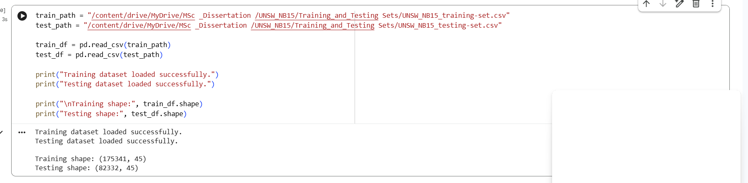
The screenshot of the dataset loading code and shapes shows the dimensions of the training and testing datasets.
Appendix B3 - Dataset Shape and Column Inspection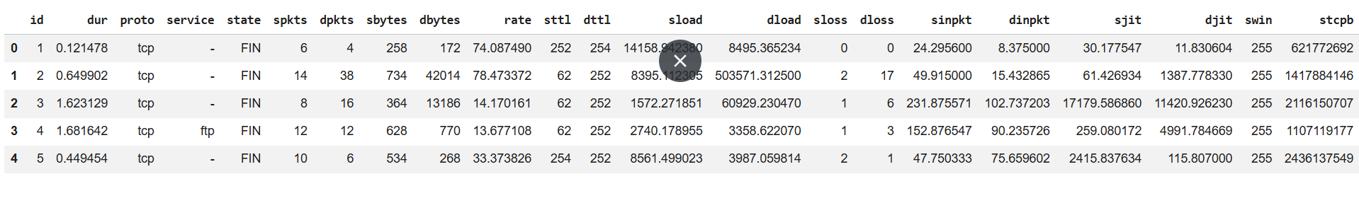
This screenshot shows the first few rows of the dataset to confirm the data loaded correctly and includes the expected columns.

  - Appendix B4 - Missing Values Check
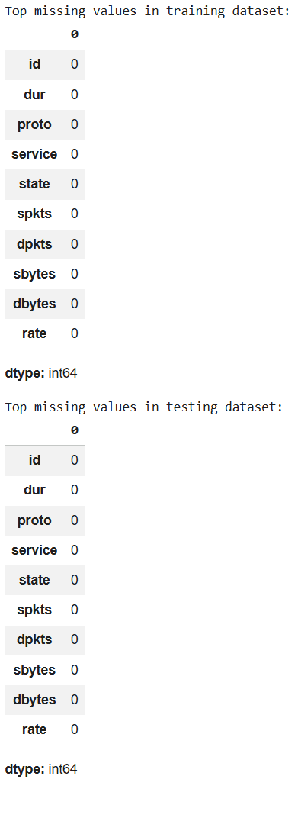
This missing-values-check screen shows how this was inspected to ensure nothing needed imputation.

  - Appendix B5 - Duplicate Check
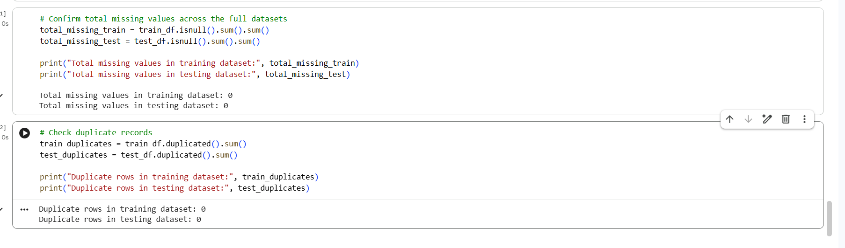
This screenshot illustrates the duplicate record check used to ensure no duplicate records existed before removing a record.
  - Appendix B6 - Label Distribution Counts
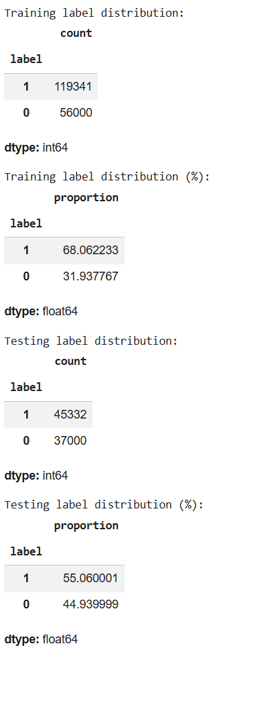
This screenshot shows the count of normal and attack records in the training and testing datasets.
  - Appendix B7 - Training Class Distribution Chart
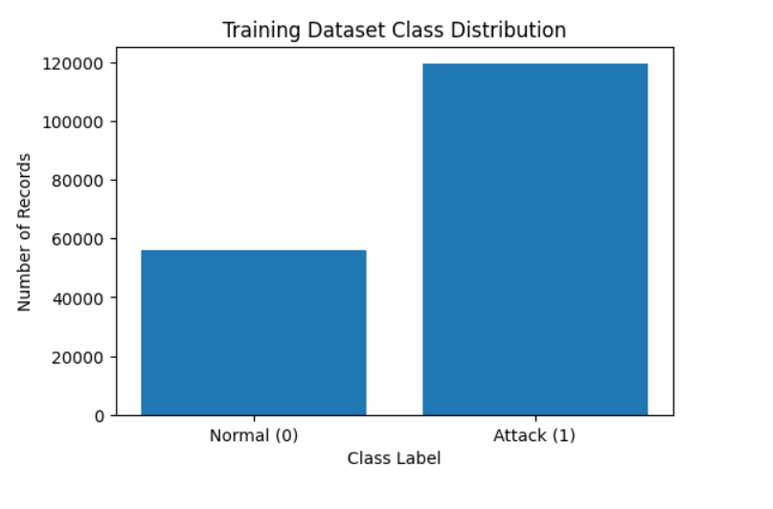
This bar chart visualises the training-set class distribution between normal and attack records.
  - Appendix B8 - Attack Category Distribution
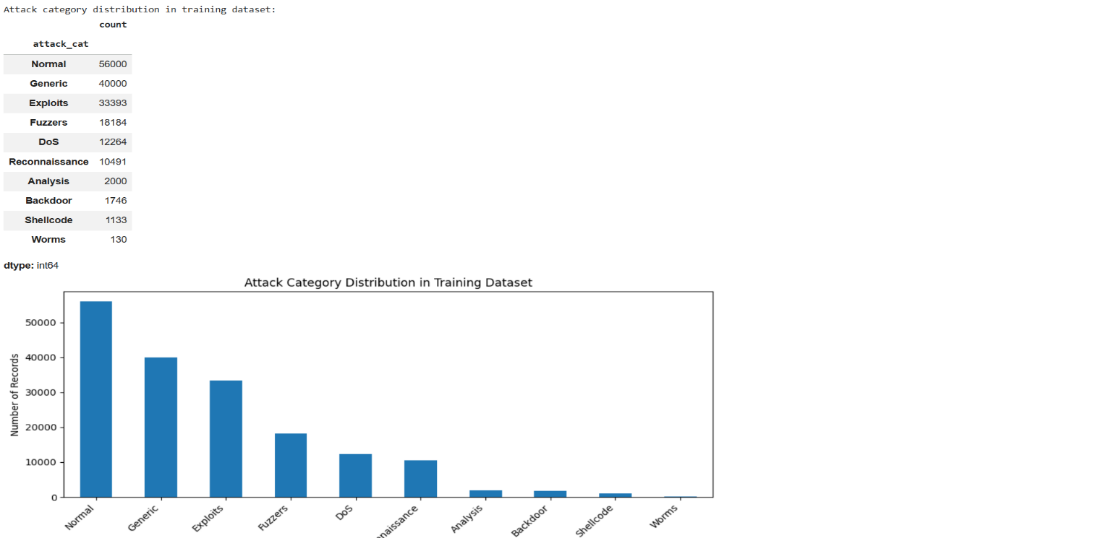
This screenshot shows the distribution of attack categories in the UNSW-NB15 dataset for contextual analysis.

Appendix C - Model Evaluation Evidence:
  - Appendix C1 - Logistic Regression Confusion Matrix
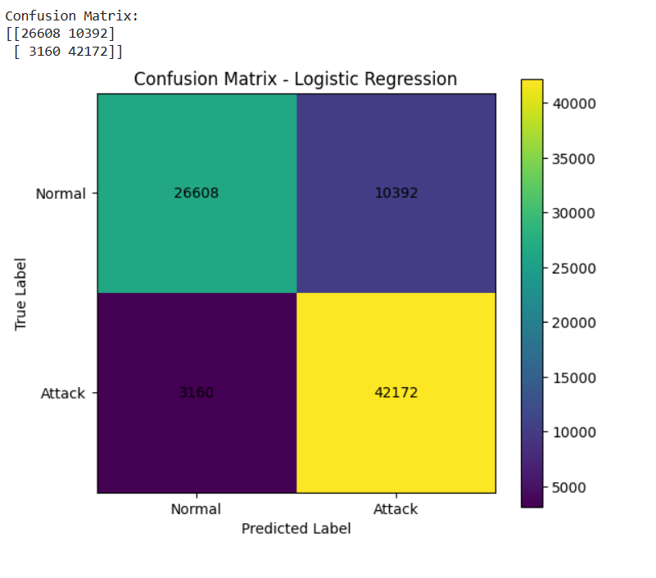
This screenshot shows the Logistic Regression confusion matrix, including true normal, false positive, false negative, and true attacks.
  - Appendix C2 - Logistic Regression ROC Curve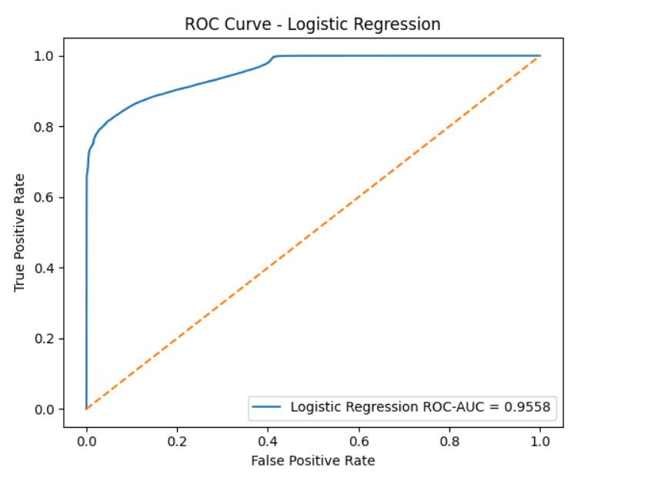
This is the logistic regression ROC curve used to test the model's ability to differentiate between normal and attack traffic.

  - Appendix C3 - Logistic Regression Metrics Table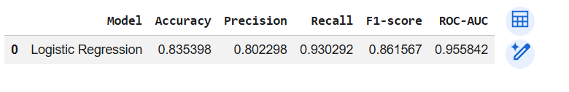
As shown in this screenshot, the model accuracy, precision, recall, F1-score, and ROC-AUC for Logistic Regression are displayed.
  - Appendix C4 - Decision Tree Confusion Matrix
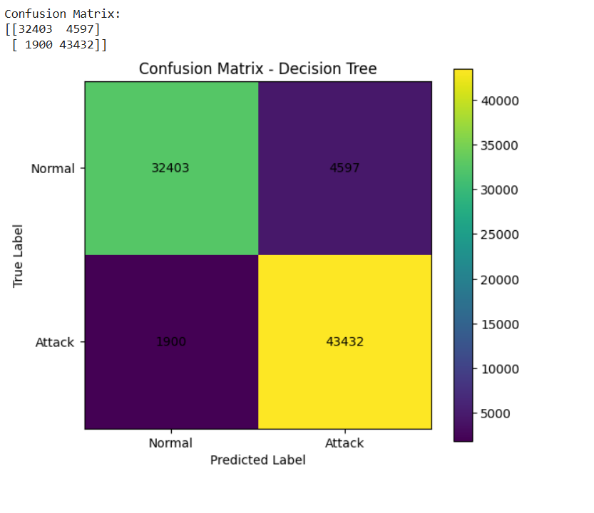
This screenshot shows the Decision Tree confusion matrix, which evaluates the Decision Tree's classification behaviour on test data.
  - Appendix C5 - Decision Tree ROC Curve
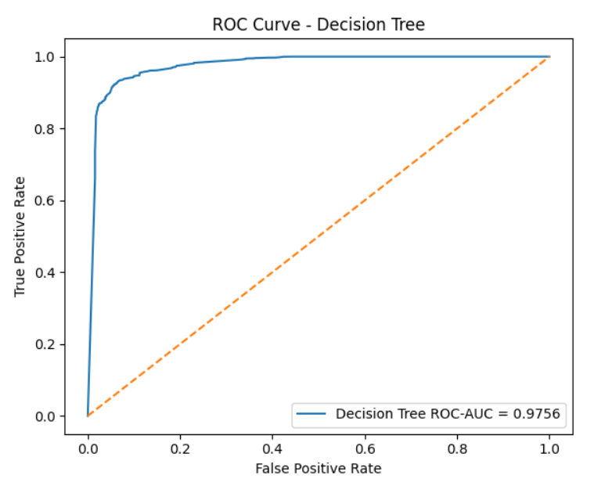
Decision Tree ROC curve for determining the performance of discrimination over different classification thresholds.
  - Appendix C6 - Decision Tree Metrics Table
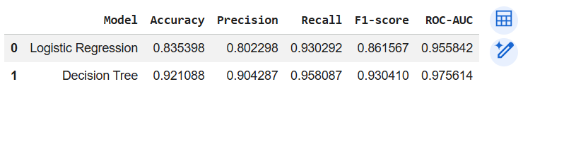
This screen shows the Decision Tree performance metrics for comparison with Logistic Regression and Random Forest.
  - Appendix C7 - Random Forest Confusion Matrix
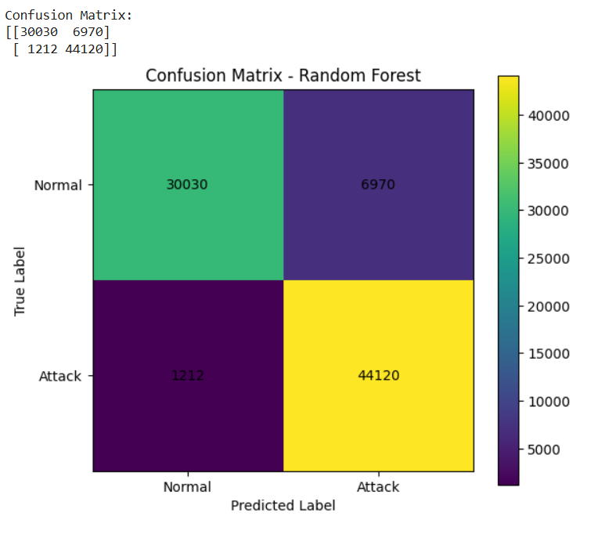
This screenshot displays the Random Forest confusion matrix and its low number of false negatives.
  - Appendix C8 - Random Forest ROC Curve
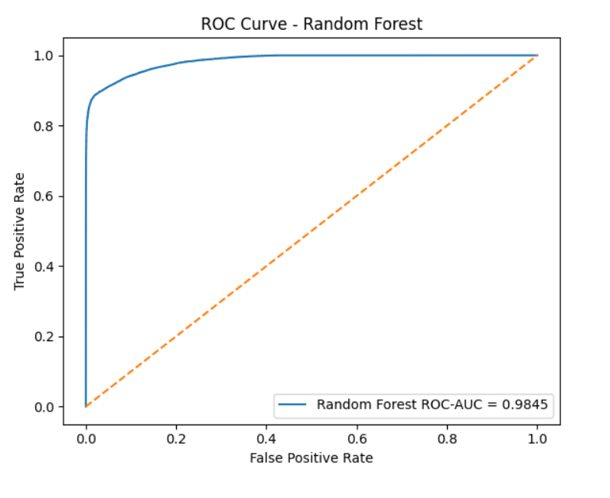
Screenshots have been produced, with the first showing the single-run Random Forest ROC curve to evaluate its overall class-discrimination performance.
  - Appendix C9 - Random Forest Metrics Table
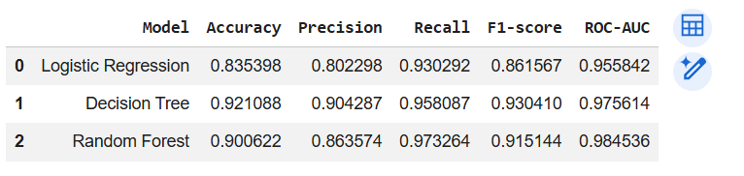
This is a screenshot of the accuracy, precision, recall, F1-score, and ROC-AUC results for the Random Forest.
  - Appendix C10 - Detailed Model Comparison Table
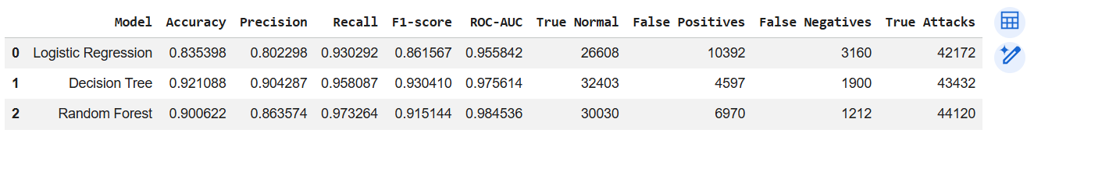
This screen displays a side-by-side comparison of all three models based on metrics aggregated across performance and confusion-matrix outputs.
  - Appendix C11 - Threshold Analysis Table
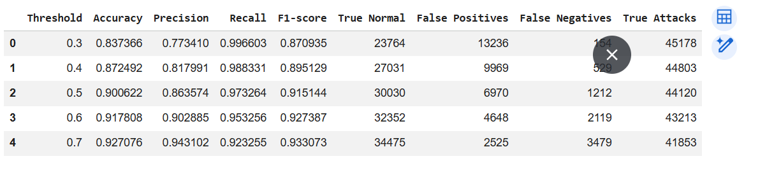This screenshot illustrates the impact of different Random Forest classification thresholds on accuracy, precision, recall, F1-score, false positives, and false negatives.
  - Appendix C12 - Threshold Precision/Recall/F1 Chart
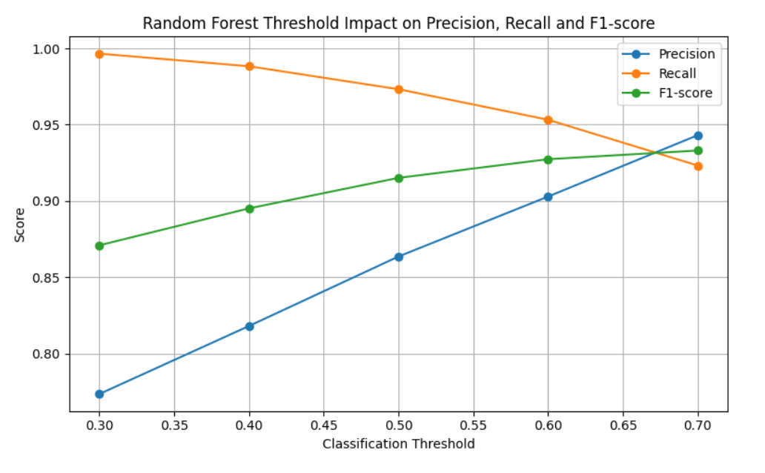
Screenshot that visualised the varied precision, recall and F1 score along different Random Forest thresholds
  - Appendix C13 - Threshold False Positives/False Negatives Chart
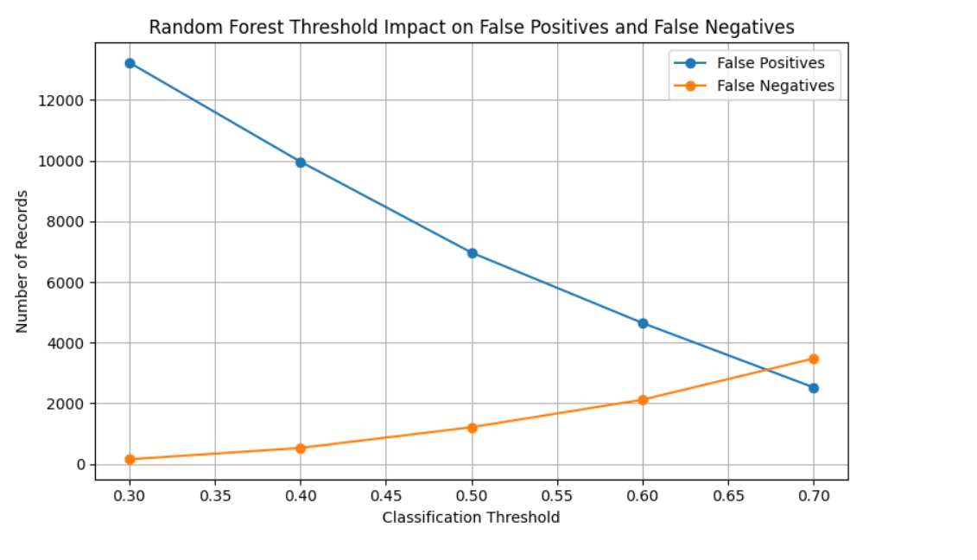This screenshot shows the trade-off between false positives and false negatives between thresholds on the Random Forest model.

Appendix D - Explainability and SHAP Evidence:
  - Appendix D1 - Feature Importance Milestone/Code
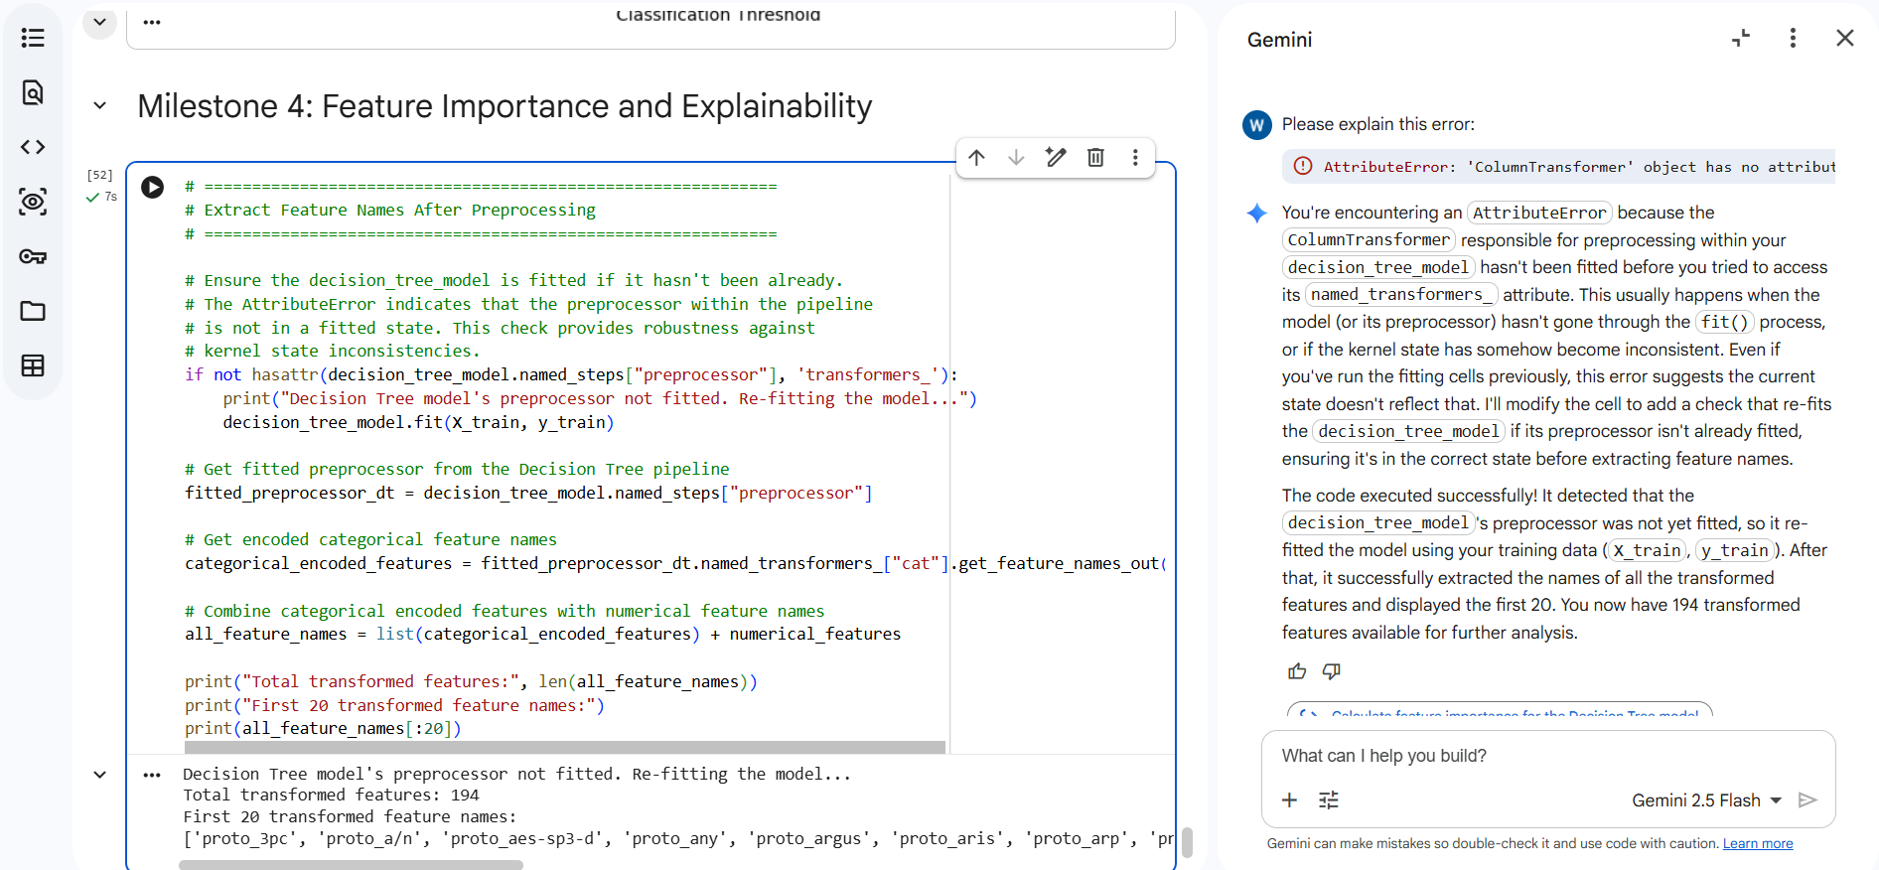
The screenshot shows the model feature-importance output generated for explainability analysis.
  - Appendix D2 - Decision Tree Feature Importance Table
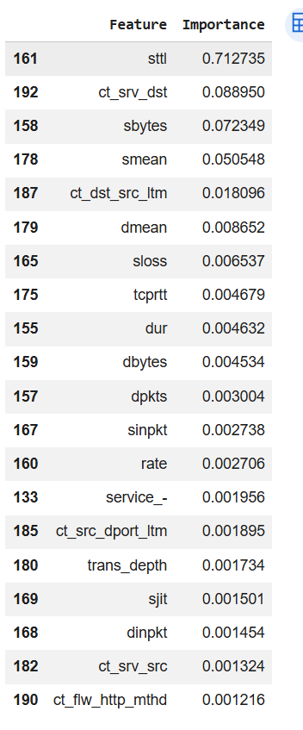
This screenshot shows the most important features identified by the Decision Tree model.
  - Appendix D3 - Decision Tree Feature Importance Chart
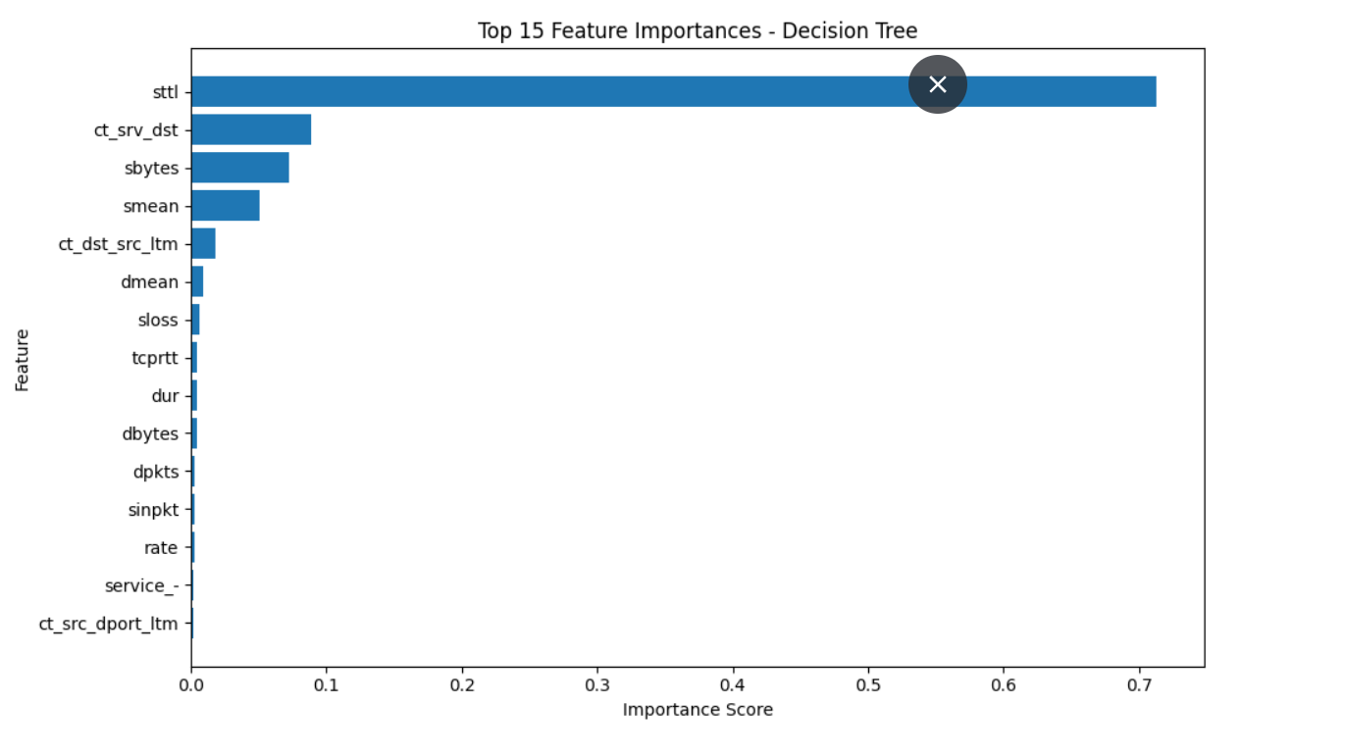This screenshot shows the top feature-importance scores for the Decision Tree.
  - Appendix D4 - Random Forest Feature Importance Table
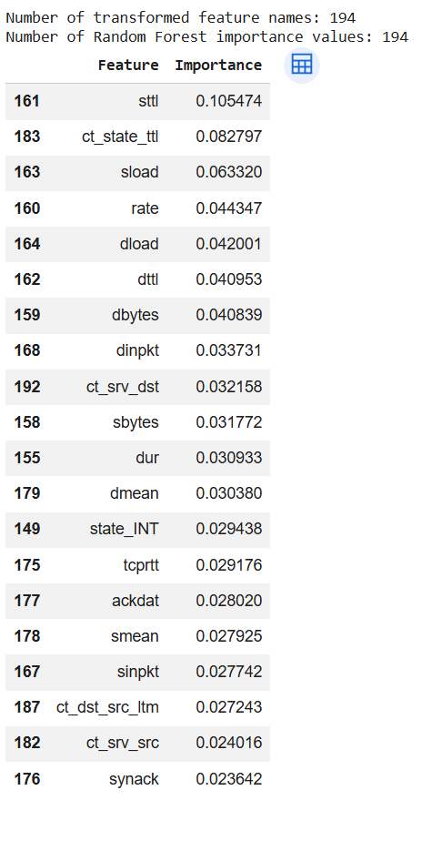
This screenshot displays the top features based on the Random Forest model.
  - Appendix D5 - Random Forest Feature Importance Chart
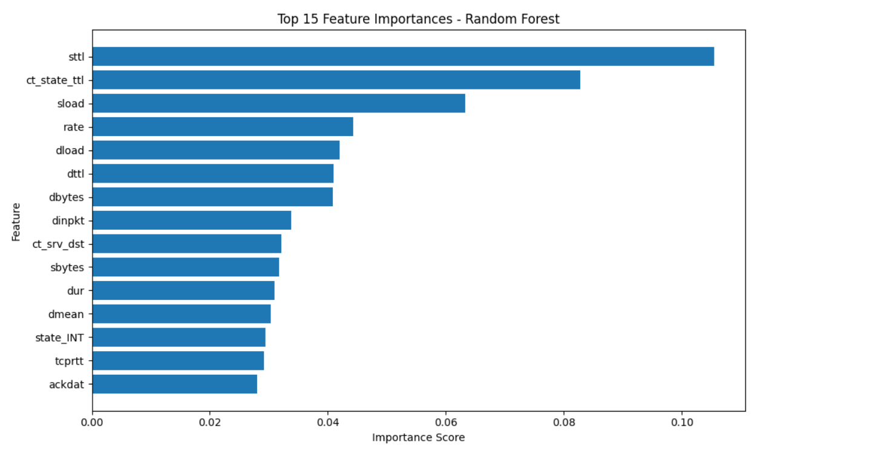This screenshot visualises the highest feature scores calculated by Random Forest, which can be used to interpret the model.
  - Appendix D6 - SHAP Top Features, 500 Samples
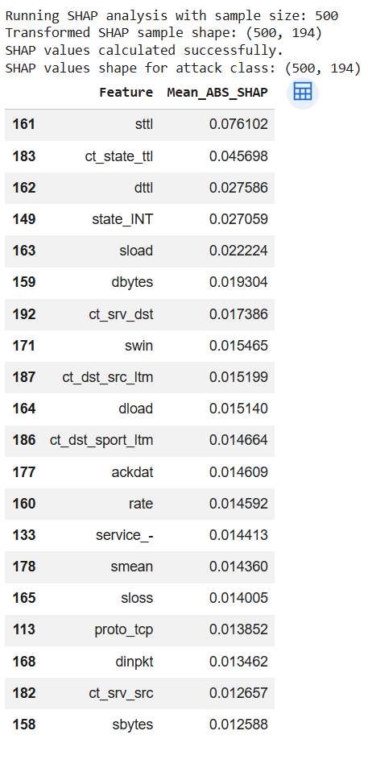
This is a screenshot of the global SHAP feature-importance results, obtained from a sample of 500 records.
  - Appendix D7 - SHAP Bar Chart, 500 Samples
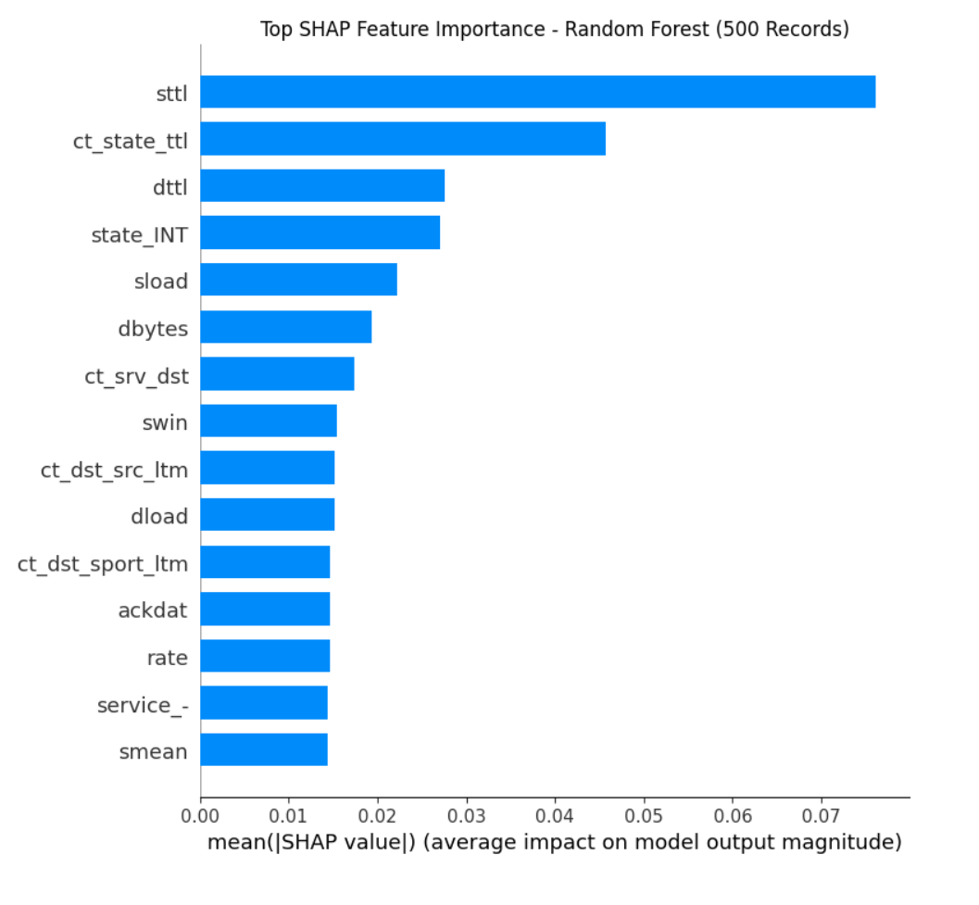
This screenshot visualises the top SHAP features from the 500-record sample.
  - Appendix D8 - SHAP Beeswarm/Summary Plot, 500 Samples
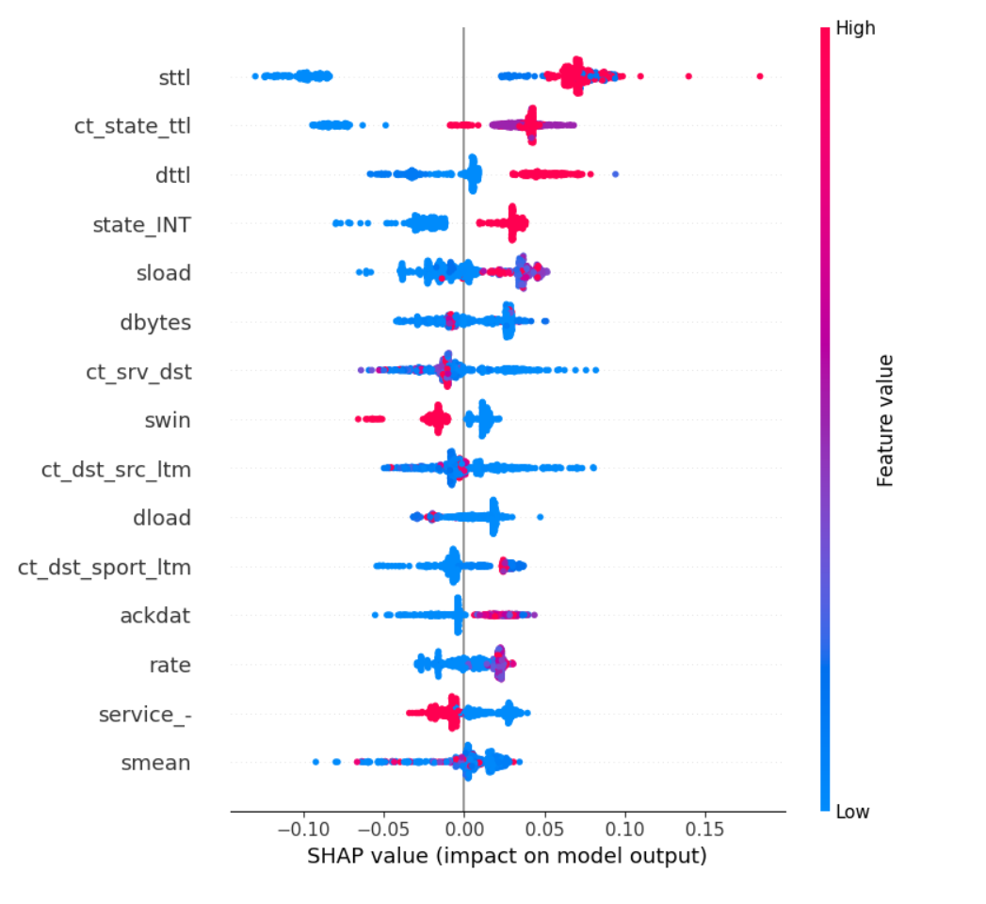
This image displays the beeswarm/summary plot created by SHAP to help explain feature impact across the sampled predictions.
  - Appendix D9 - Local SHAP High-Risk Prediction Table
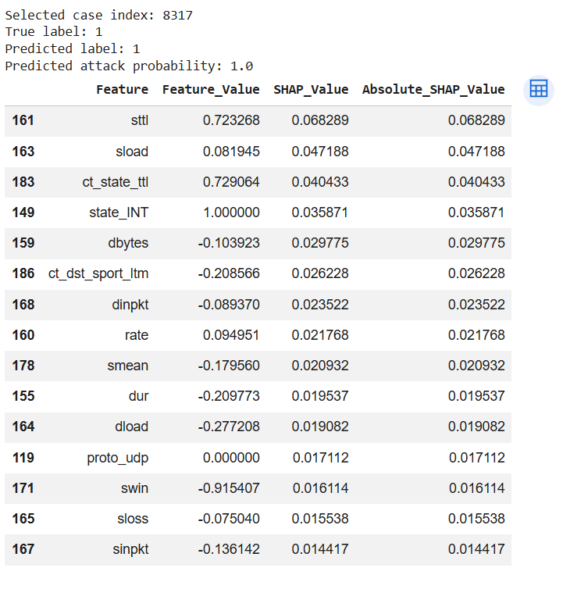
This screenshot shows the value calculated by the local model SHAP for a high-risk prediction selected for local interpretation.
  - Appendix D10 - Local SHAP Explanation Chart
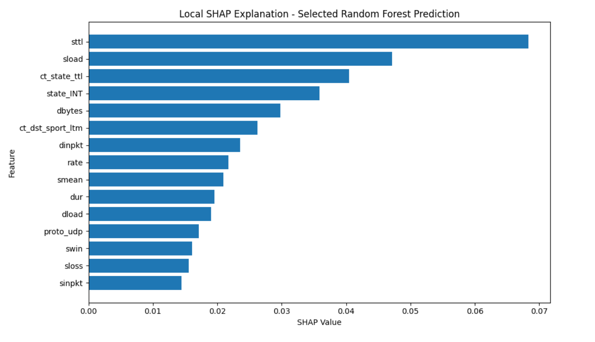
This screenshot shows the explanation chart, which visualises the key features driving an individual high-risk attack prediction.
  - Appendix D11 - SHAP Top Features, 1000 Samples
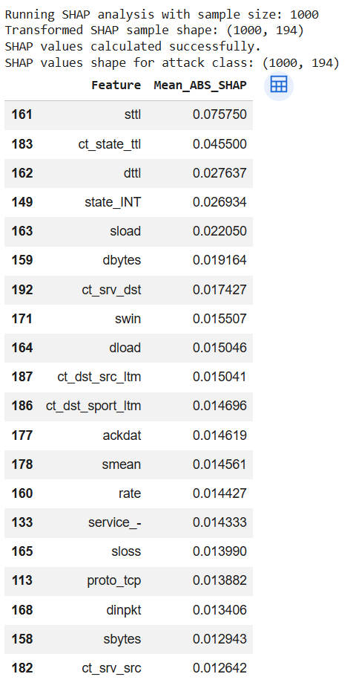
Screenshot of the top features in the world based on a larger sample of 1,000 records.
  - Appendix D12 - SHAP Bar Chart, 1000 Samples
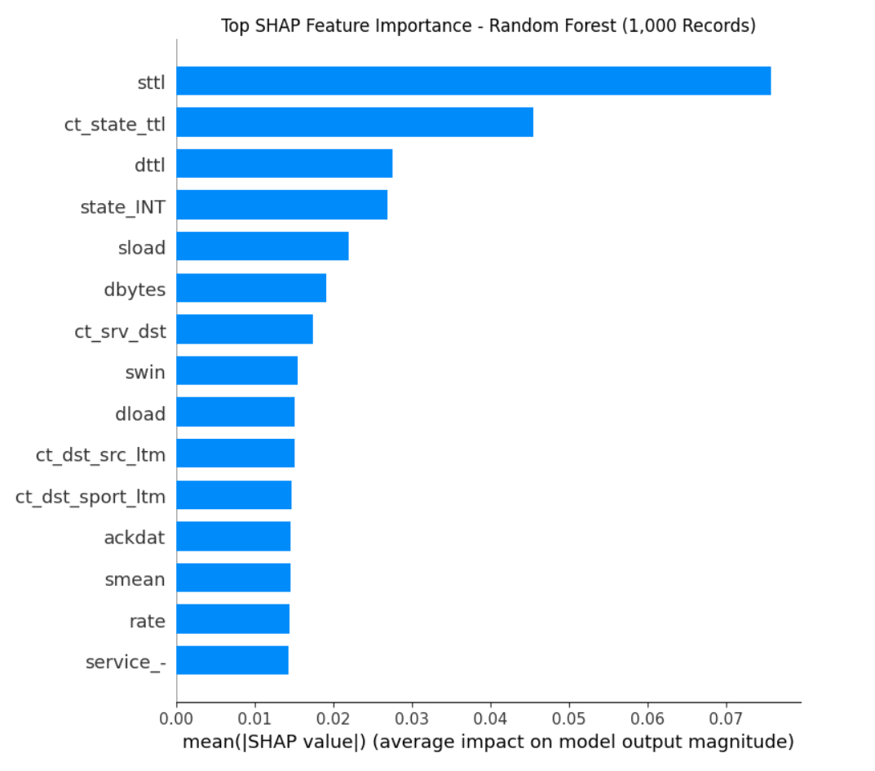
This screenshot shows the top SHAP features from the 1,000-record sample.

  - Appendix D13 - SHAP Beeswarm/Summary Plot, 1000 Sample
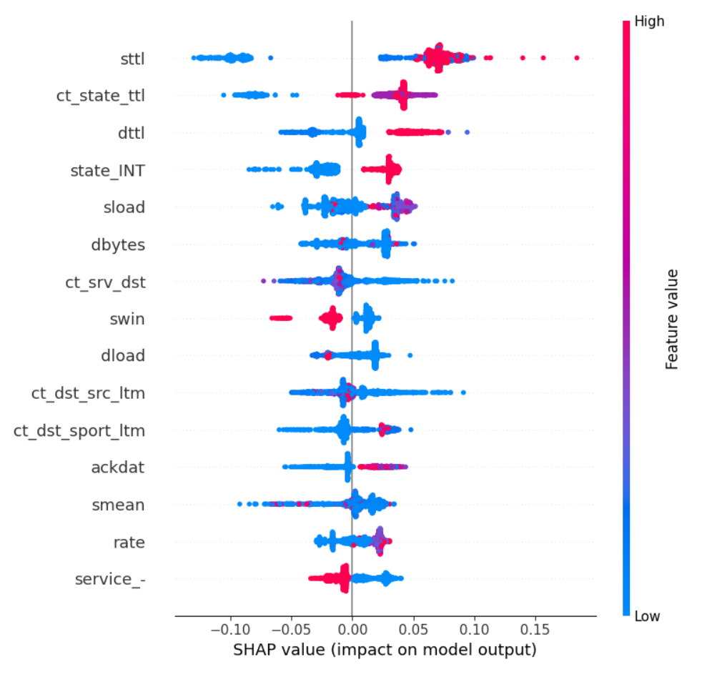
This screenshot is the SHAP beeswarm/summary plot for the 1,000-record sample.
  - Appendix D14 - SHAP Stability Comparison Table
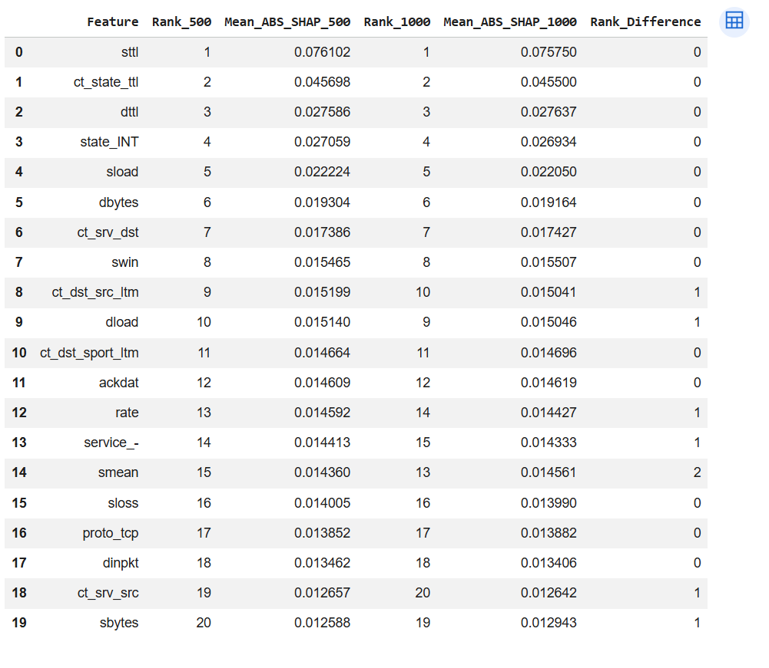
This screenshot compares the top features from the 500-sample and 1,000-sample SHAP results to show stability.

Appendix E - Streamlit Dashboard Screenshots:
  - Appendix E1 - Model File Check
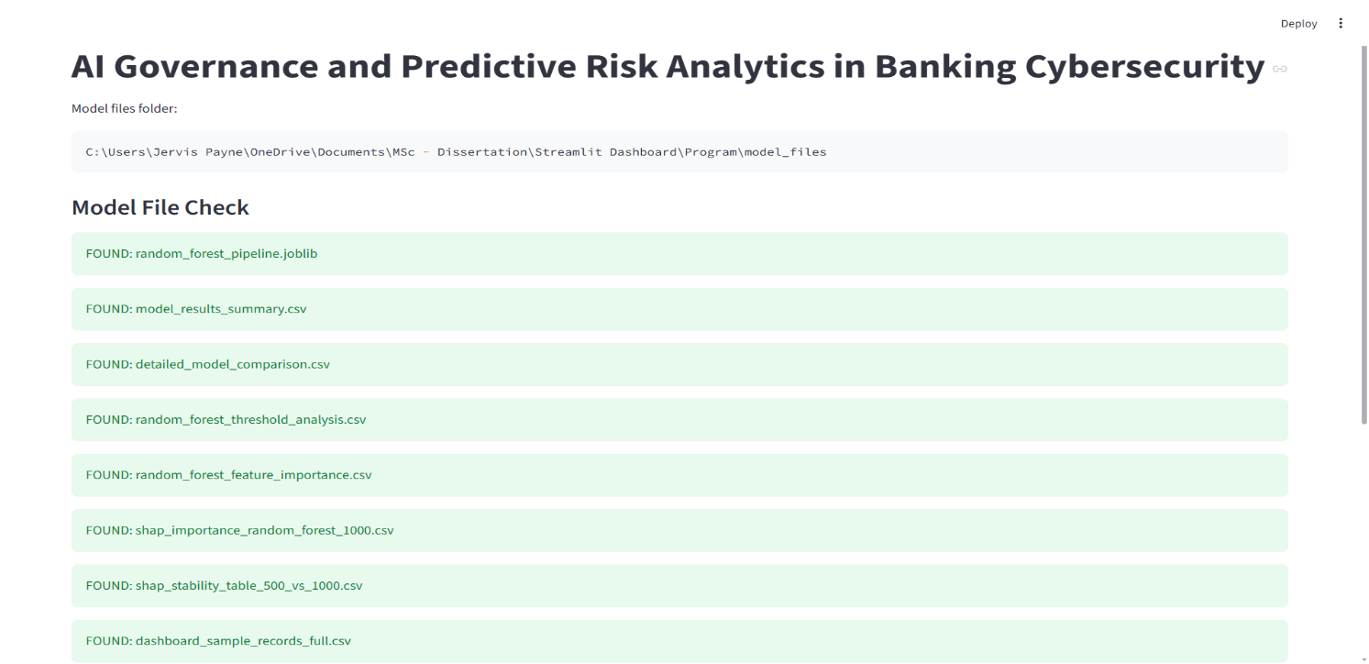
This screenshot shows the model file has been located and includes supporting artefact files on the dashboard.
  - Appendix E2 - Project Overview
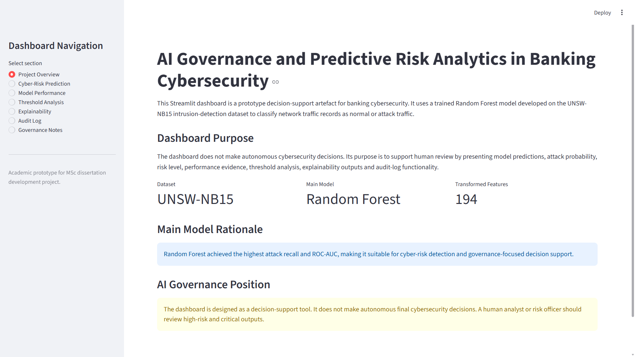
This screenshot displays the dashboard overview page, including the project purpose, selected model, and governance position.
  - Appendix E3 - Model Performance Page
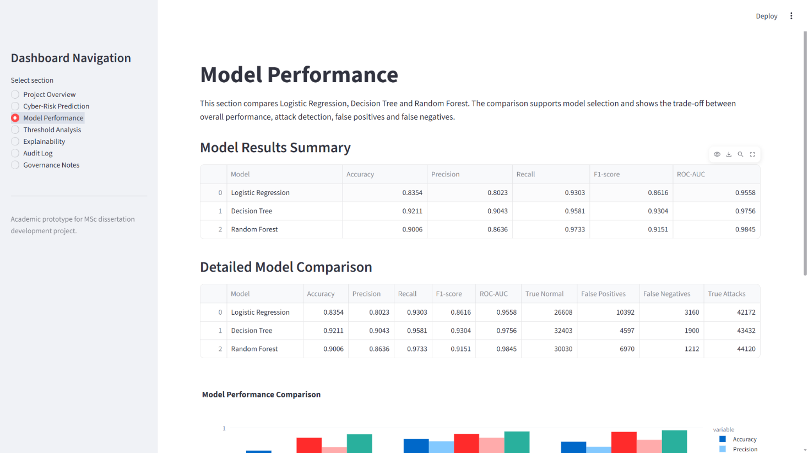
The image above shows the model comparison results on the dashboard.
  - Appendix E4 - Model Performance Chart
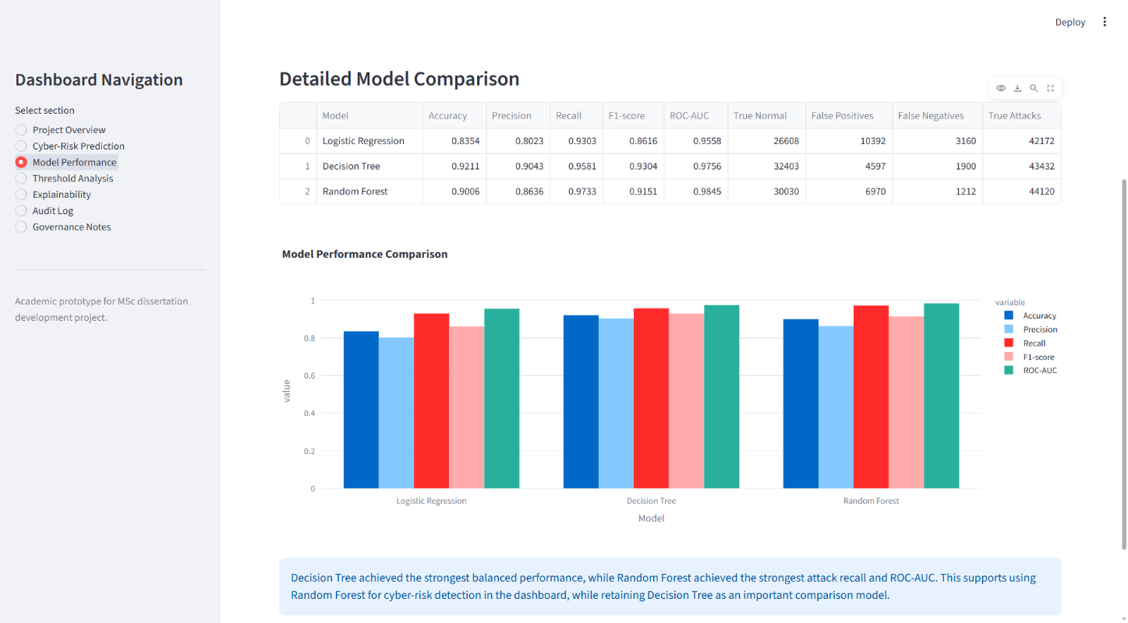
This screenshot depicts the Comparison of Logistic Regression vs Decision Tree vs Random Forest for the key evaluation metrics.
  - Appendix E5 - Threshold Analysis Page
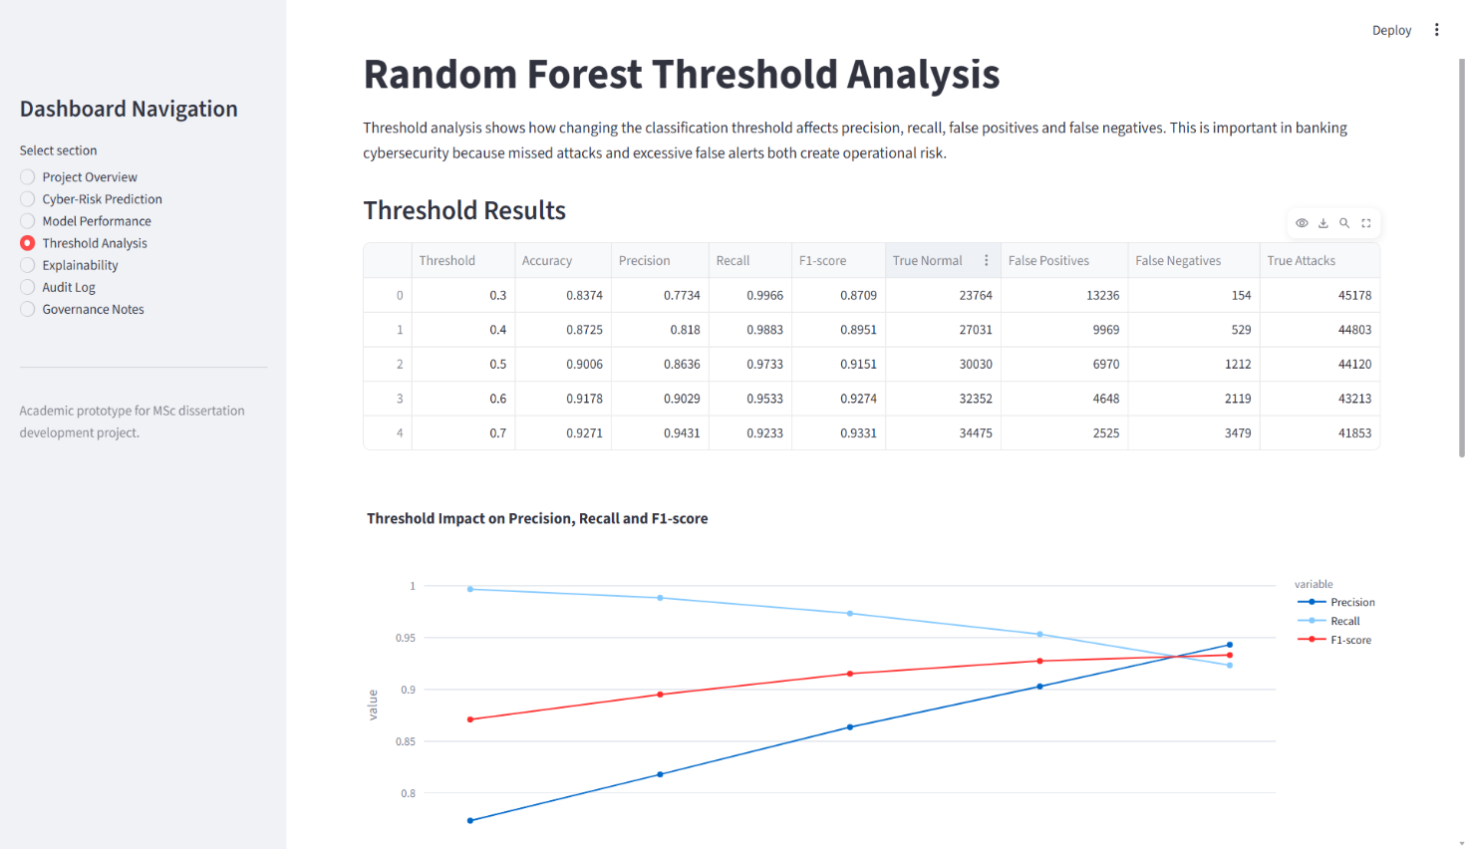
This image shows the part of the dashboard used to display Random Forest threshold-analysis outcomes.
  - Appendix E6 - Threshold Analysis Chart
This is a screenshot visualisation of Random Forest performance across various classification thresholds.
  - Appendix E7 - Explainability Page
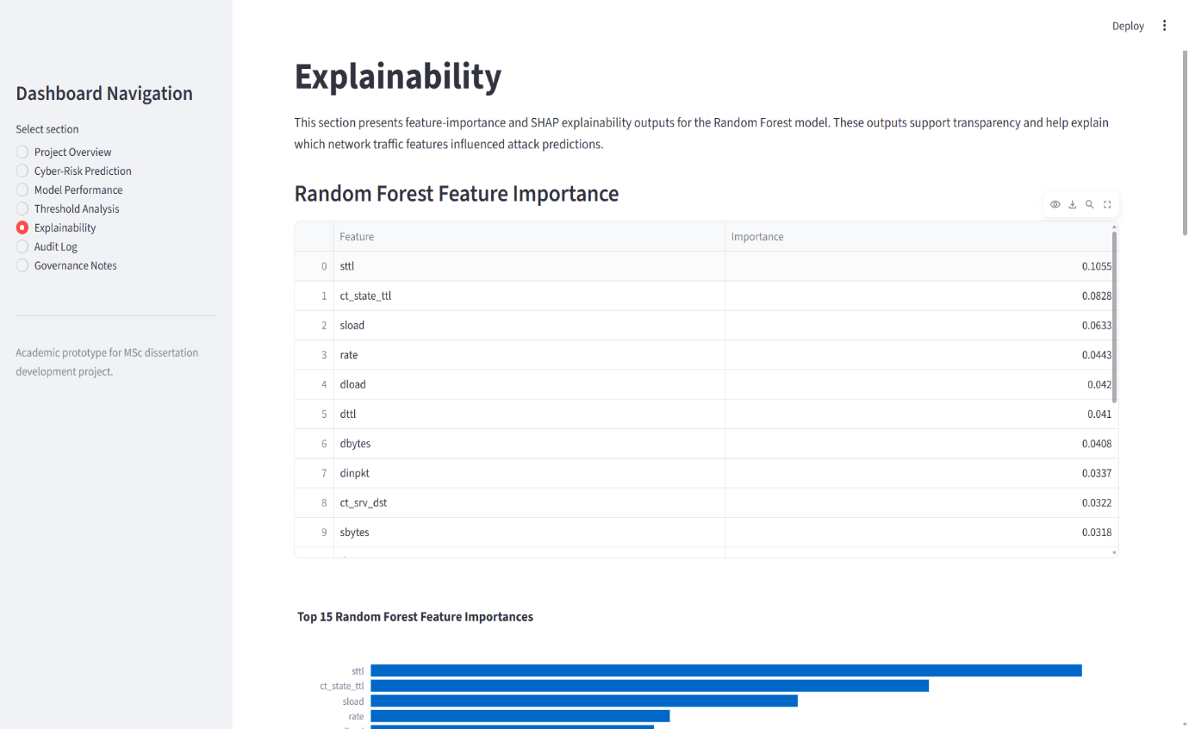
This screenshot shows the dashboard page used to display feature importance and SHAP explainability evidence.
  - Appendix E8 - Feature Importance / SHAP Dashboard Chart
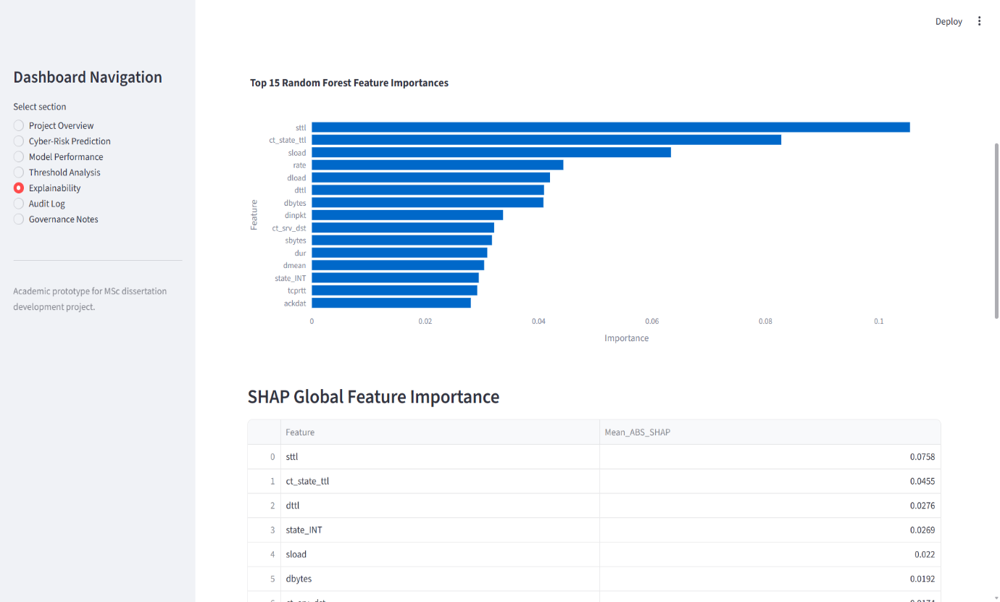 This screenshot captures the key model features used to interpret the Random Forest model's behaviour.
  - Appendix E9 - SHAP Global Feature Importance
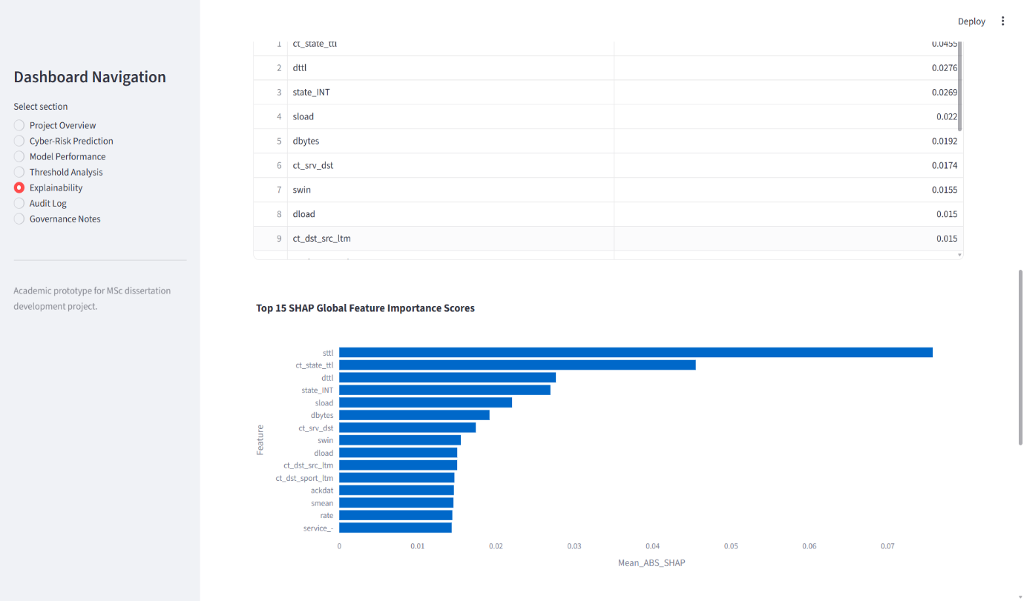
This screenshot shows the SHAP global feature-importance results in the dashboard.
  - Appendix E10 - SHAP Stability Dashboard
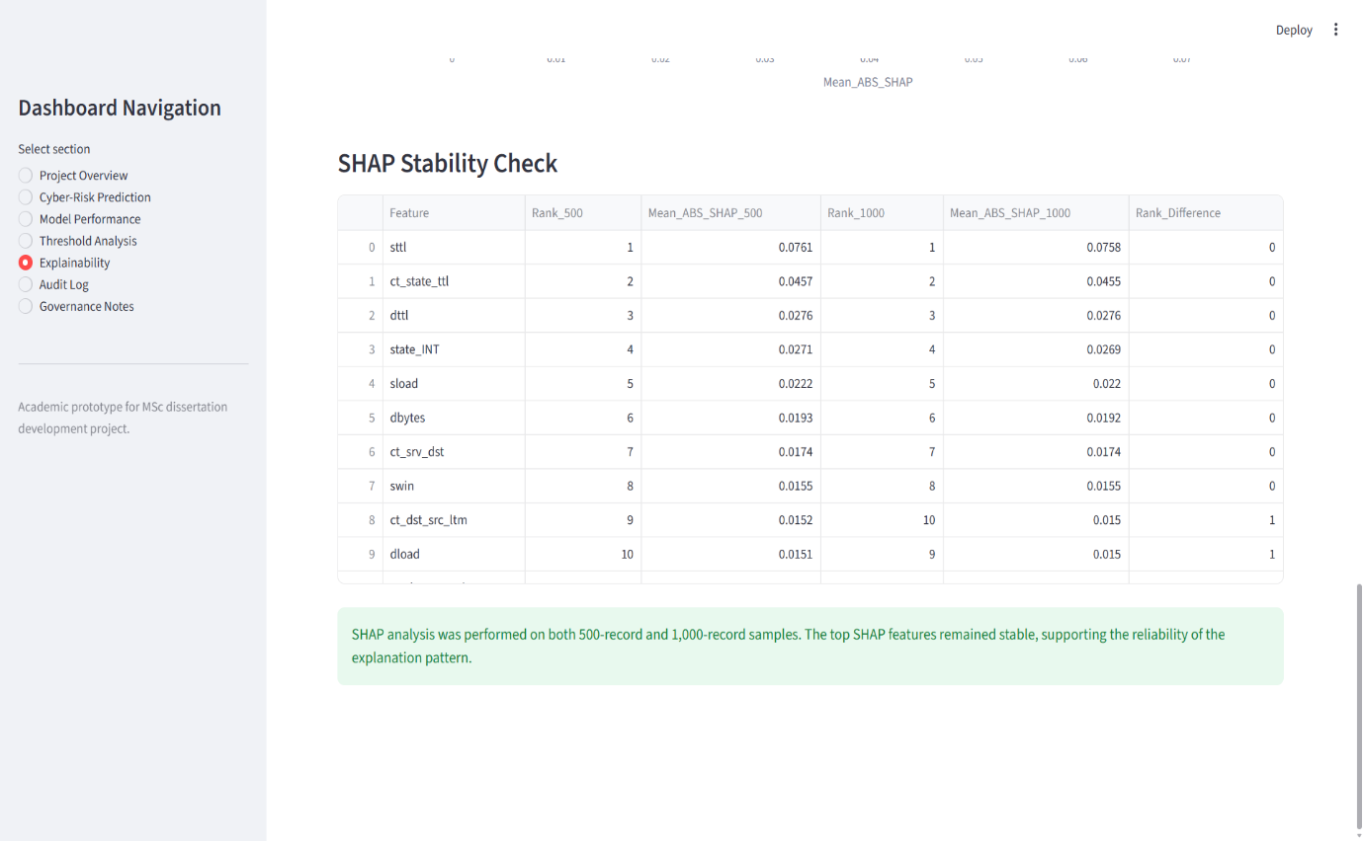
This screen shows dashboard evidence comparing SHAP outputs across different sample sizes.
  - Appendix E11 - Governance Notes Page
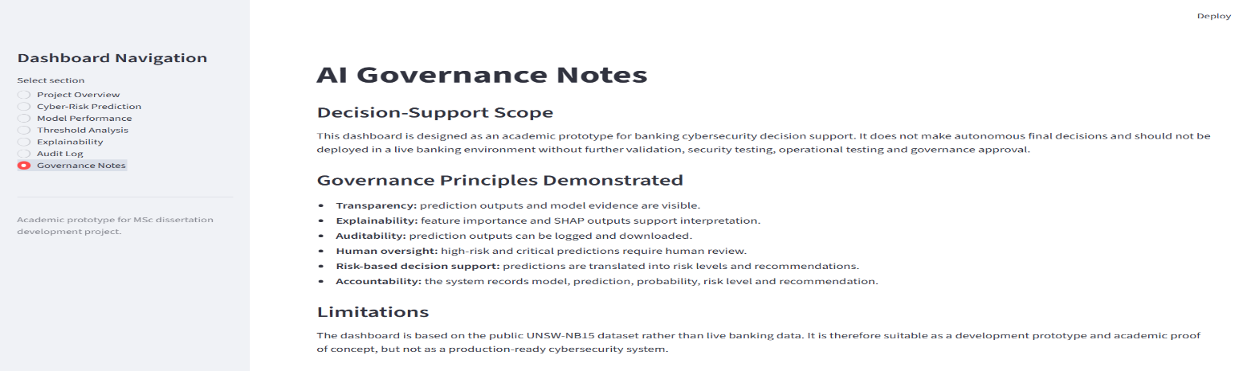
The AI governance notes page of the dashboard, covering transparency, auditability, human oversight, and limitations.
  - Appendix E12 - Low/Normal Prediction Example
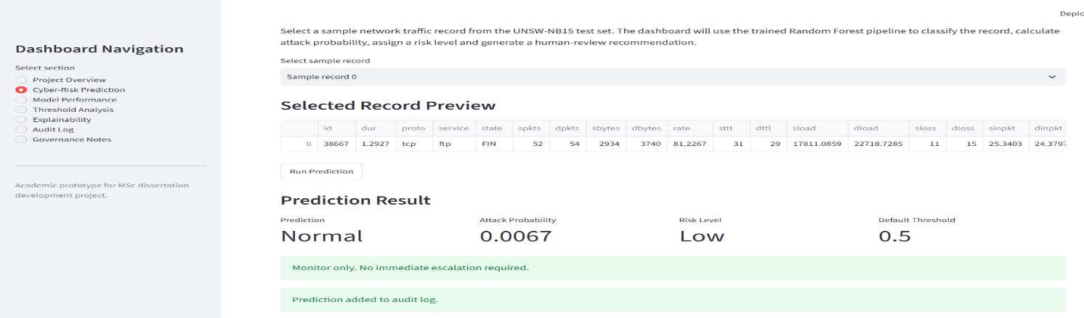
This shows a selected record with a low attack probability; no issues are present, so it is classified as normal.
  - Appendix E13 - Critical/Attack Prediction Example
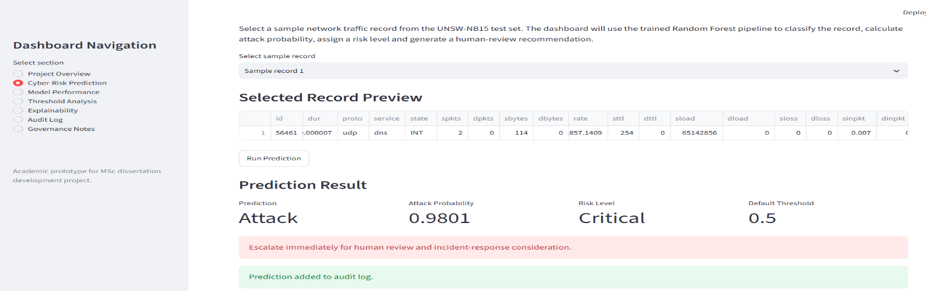
An example of a selected record with a critical risk level and an escalation recommendation (shown as an attack).

Appendix F - Audit Log and Audit Analytics Evidence:
  - Appendix F1 - Audit Log with multiple saved records
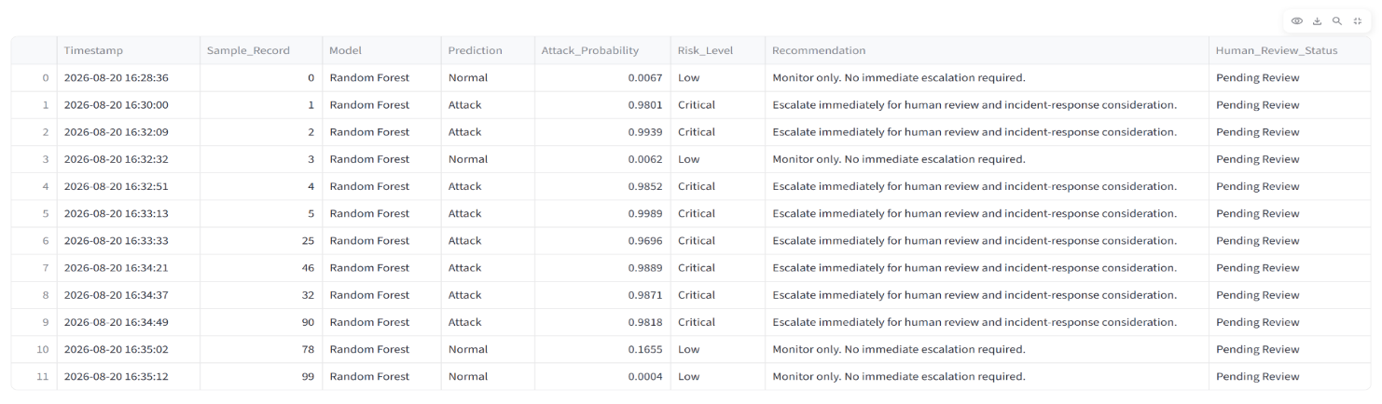
This screenshot shows multiple saved prediction records in the persistent audit log.
  - Appendix F2 - Human Review input page
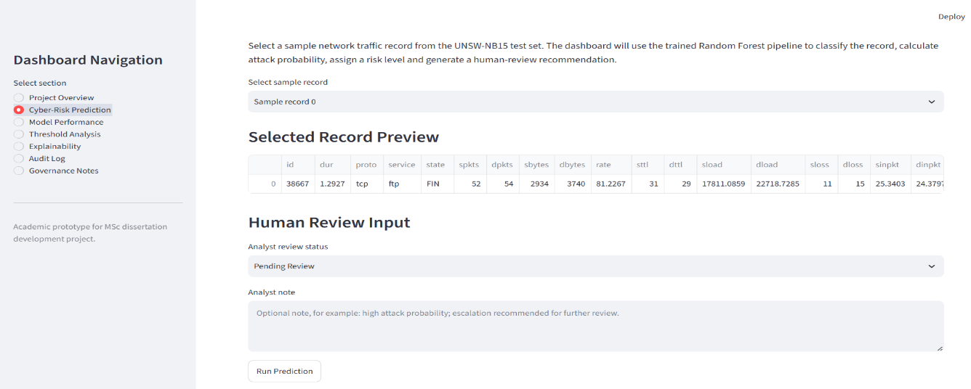
Sample of the human review input page with an indication of the analyst review status and the use of notes.
  - Appendix F3 - Persistent Audit Log after restart
This screenshot verifies audit records persisted after the dashboard restarted.
  - Appendix F4 - Audit Analytics summary metrics
This screenshot shows the Audit Analytics summary, including metrics like normal predictions, total records, attack predictions, and critical risks.
  - Appendix F5 - Prediction Distribution
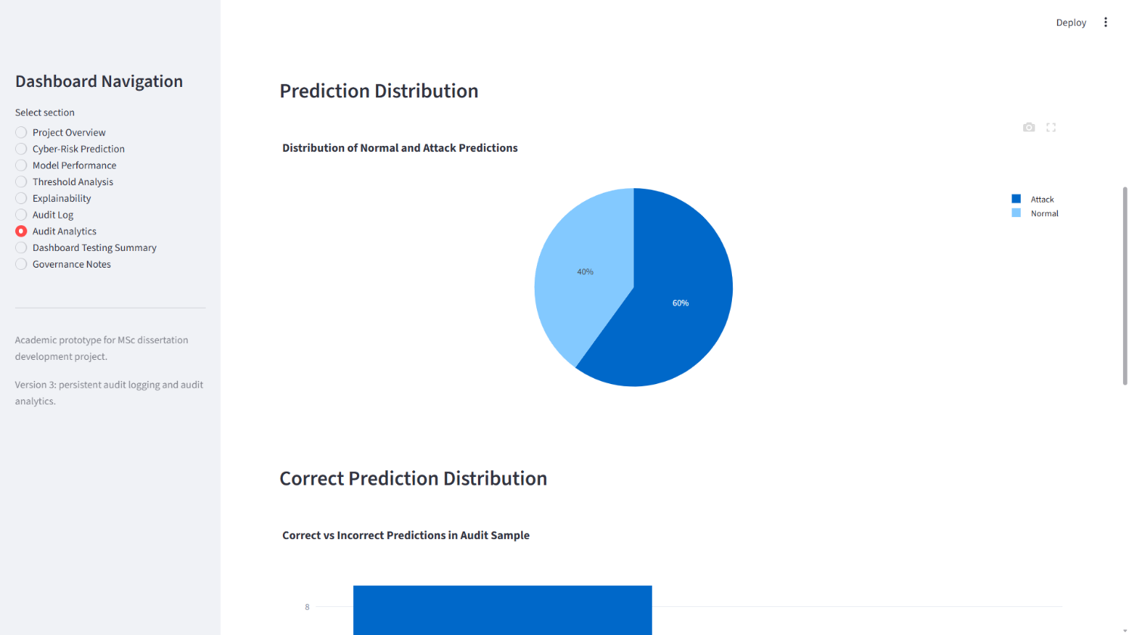
This screenshot shows the audit log distribution of saved normal and attack predictions.
  - Appendix F6 - Correct Prediction Distribution
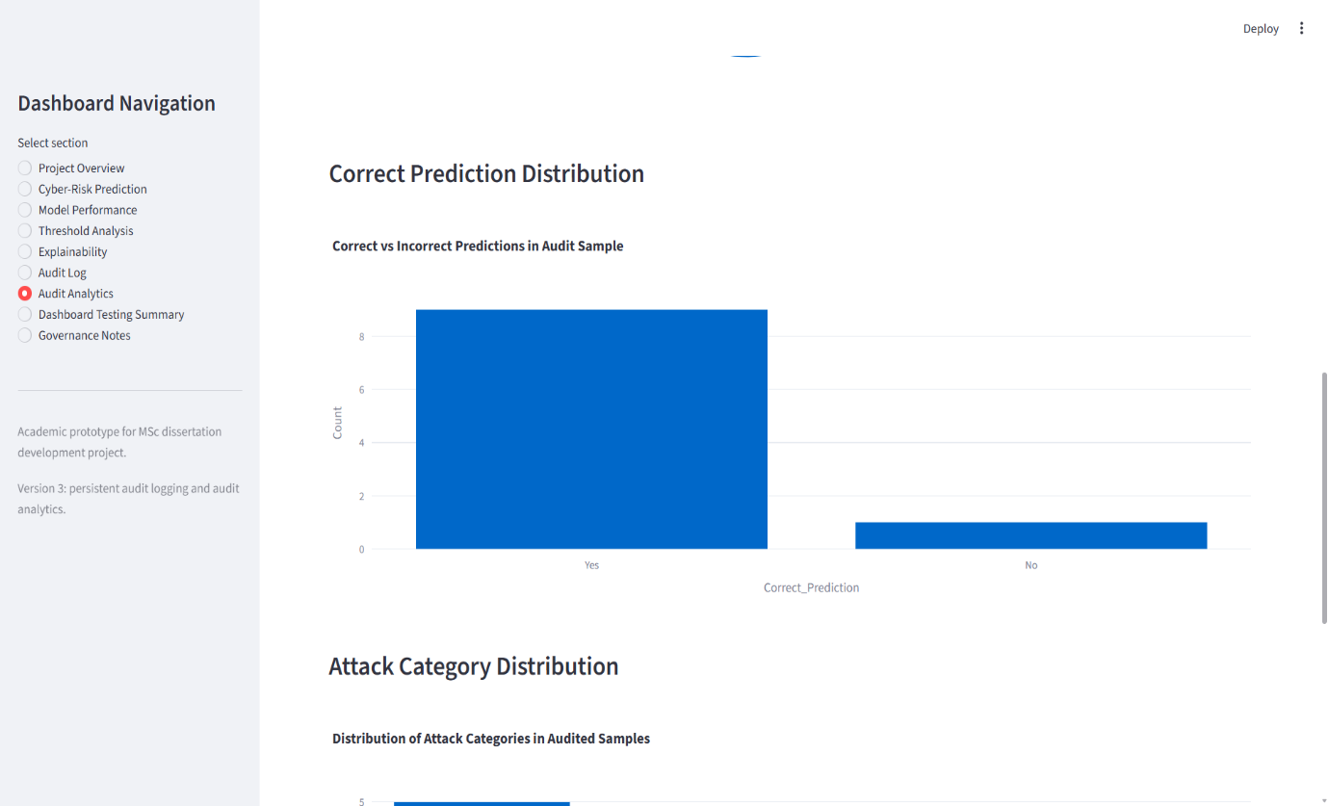
This screen shows the proper distribution of correctly and incorrectly predicted results in the saved audit history.
  - Appendix F7 - Attack Category Distribution
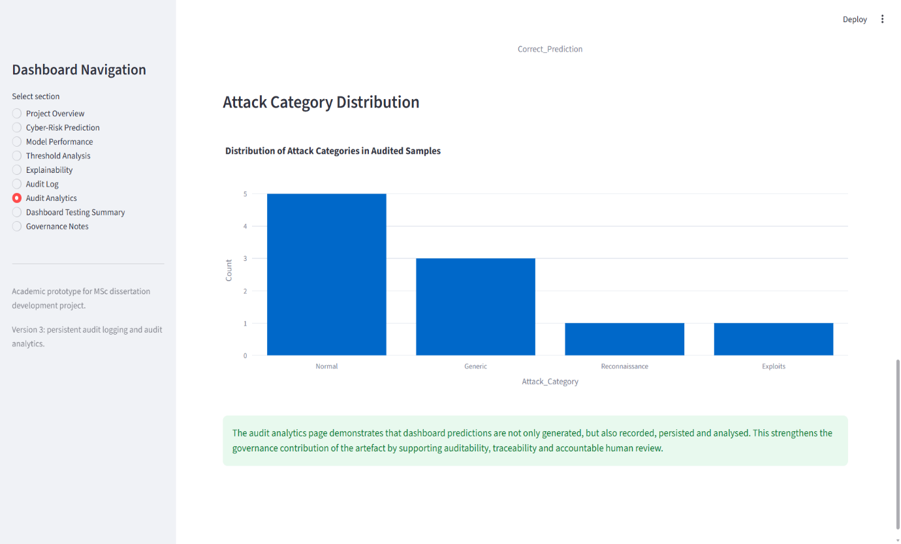
This screen displays the attack-category distribution that was captured in audit analytics.
  - Appendix F8 - Dashboard Testing Summary
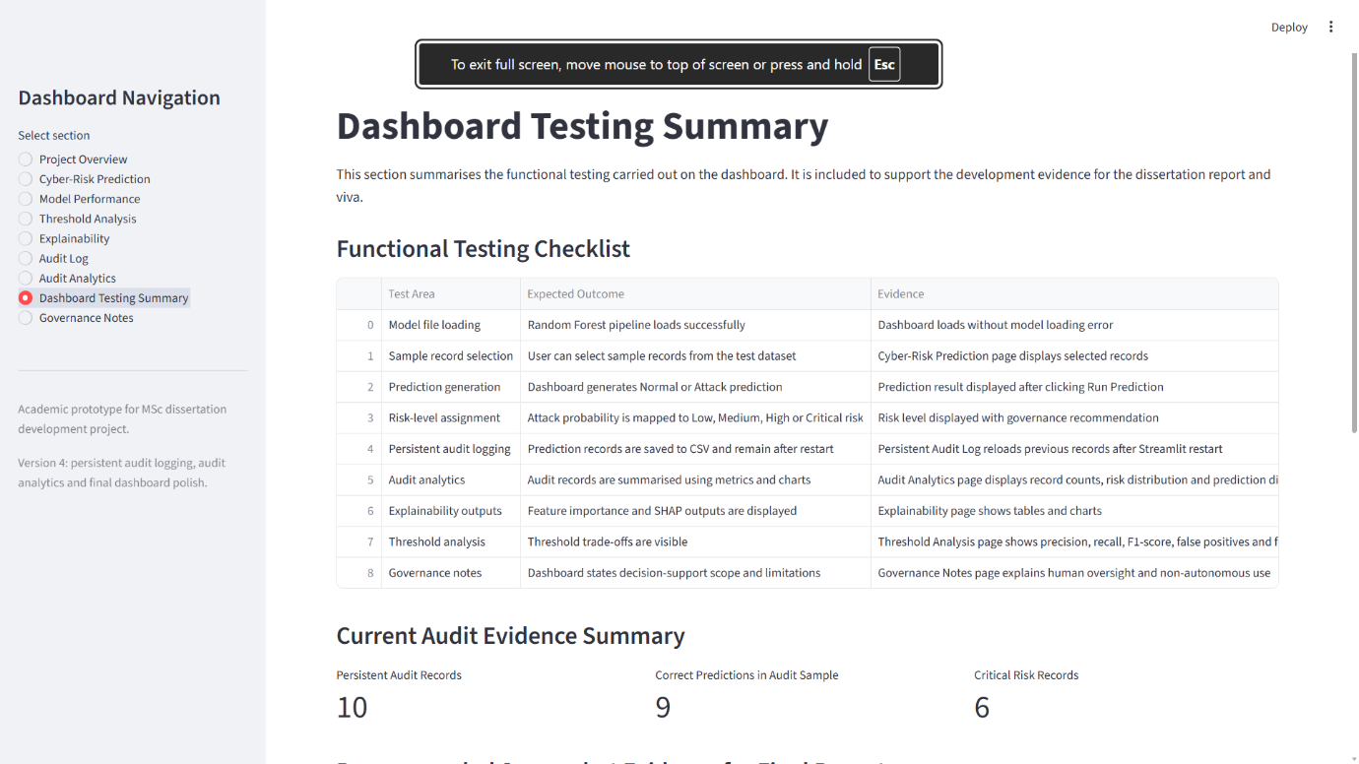
This screenshot shows the dashboard testing summary and provides evidence of the prototype's functional testing.
  - Appendix F9 - Dashboard Testing Summary Evidence checklist
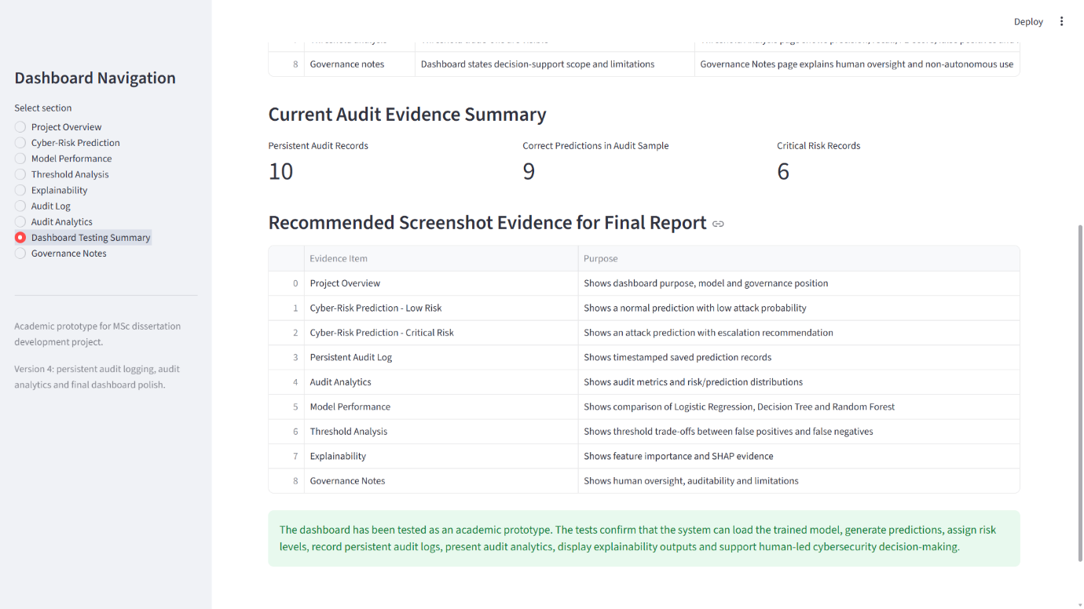
This image displays the dashboard functions evidence checklist with the evidence checked off using an image of the dashboard.
  - Appendix F10 - Governance Principles table
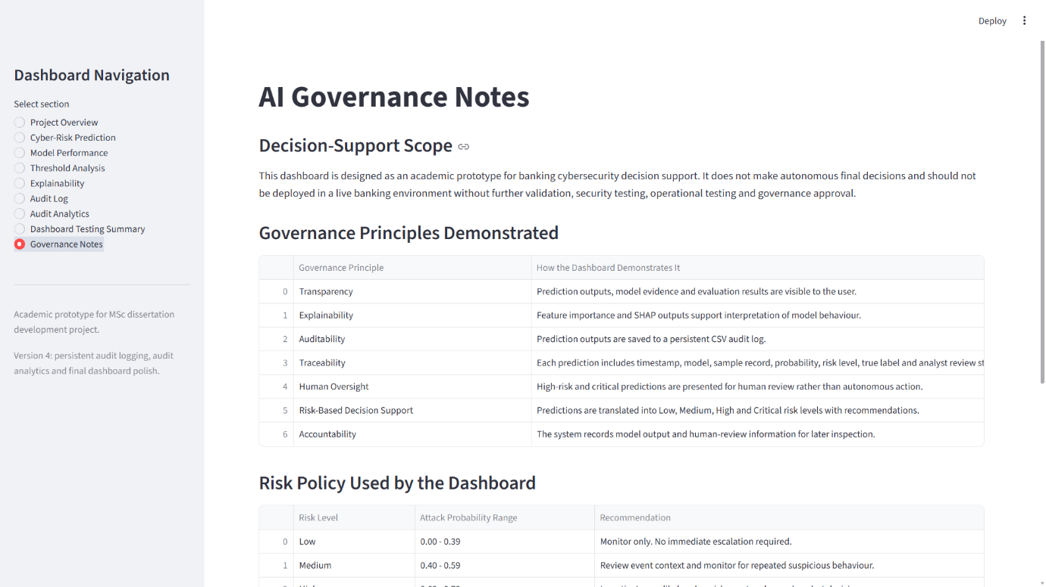
This screenshot shows how the dashboard features map to AI governance principles such as transparency, auditability and human oversight.
  - Appendix F11 - Risk Policy and Limitations
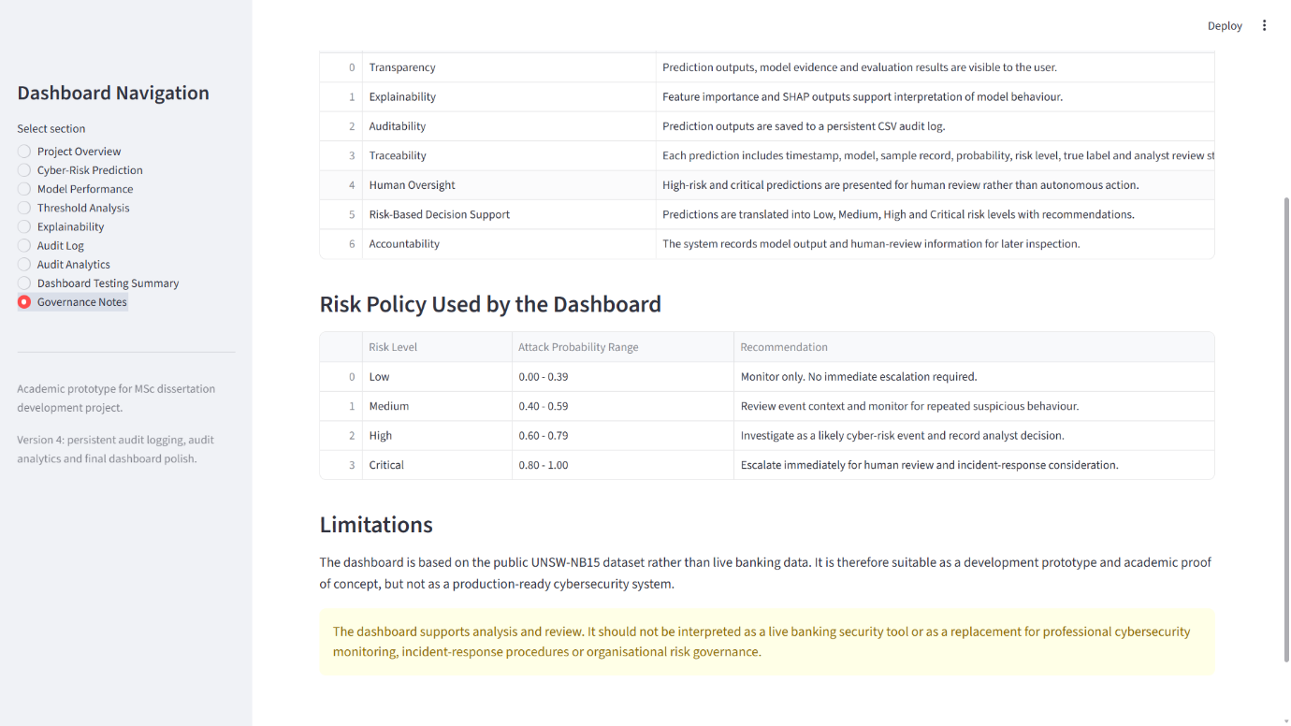
The screenshot, Risk Policy and Limitations, shows the dashboard's risk-level policy and the limitations of the academic prototype.

Appendix G - Packaging and Reproducibility Evidence:
  - Appendix G1 - Anaconda Warning/Version Environment evidence
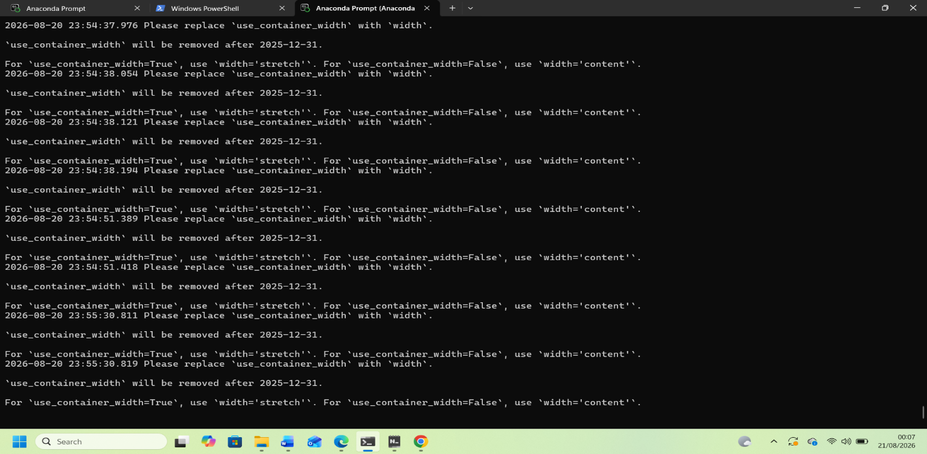
This is a screenshot of the local Python/Anaconda environment evidence utilised for dashboard setup / to test dashboard reproducibility.
  - Appendix G2 - Final model_files folder
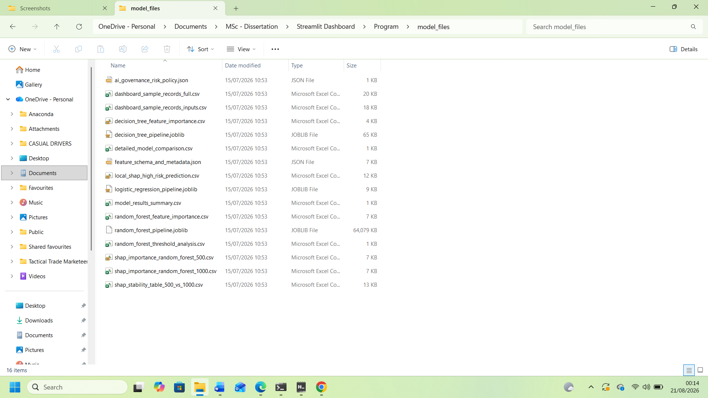
These are the evaluation, SHAP, threshold, and metadata files for the exported model, used by the Streamlit dashboard.
  - Appendix G3 - Final Program folder with README and Requirements
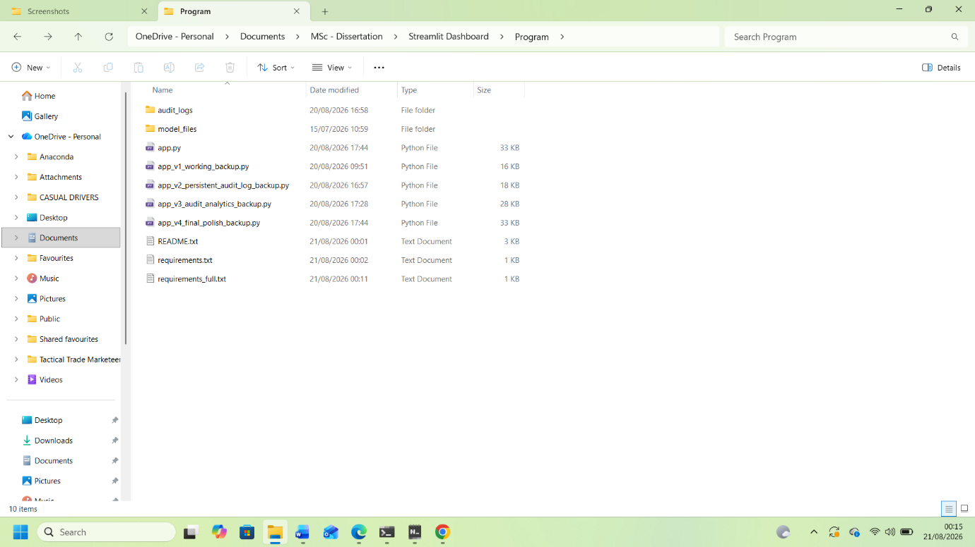
This screenshot presents the final dashboard folder structure, which contains all required application files, documentation and dependency files to recreate the prototype.

