Destination Management: The Tower of London

Student name: Shazzad Miah
Module title: Sustainable Hospitality & Tourism Management
Module code: BMIH5006
Lecturer’s name: Dr Huw Thomas
Table of Contents
Introduction 1
Sustainable tourism 2
Environmental sustainability 2
Socio-economic sustainability 2
Cultural Sustainability 3
Benefits and drawbacks of sustainable tourism 4
Countries that benefit 4
Countries that suffered 5
Butler’s lifecycle model 6
What should London Tower do? 9
Doxey’s Irridex model 10
Demographics of Respondents 10
Conclusion 12
References 13

Introduction
The Tower of London has become a symbol of British heritage in modern times. Its primary purpose, however, is to serve as a tourist attraction, given that it is a representation of the power and authority of the British monarchy. Visitors get the opportunity to acquire knowledge not only about England but also about the history of the Tower of London (Maitland & Newman, 2014). London attracts approximately 30 million international visitors annually. Since 2002, London has seen a rise in its tourist population, which resulted in more than 19 million visitors in 2016. According to the National Office of Statistics, tourists stayed a total of 111 million nights and contributed over £11.9 billion to the economy. In this report, we will analyse The Tower of London's development management plan closely to see how well it adheres to sustainable tourism standards.

Sustainable tourism

Environmental sustainability
Reducing negative impacts on the environment is a primary goal of environmental sustainability. Transportation alternatives like biking and public transit, garbage management, and a general reverence for the natural world and its inhabitants all help (Maxim, 2020).
London's first eco-friendly shopping mall, Buck Street Market was constructed from eighty-eight repurposed shipping containers. Green and ethically sourced coffee are just two of the many products for sale at local shops. The market is proud of its zero-plastic policy and in-house composting program for edible scraps. It's a short trip of about 30 minutes to the Tower of London.
Vehicle use inside the central business district has been deterred by implementing a Congestion Charge Zone. The accumulation of freesheets on buses and trains during the day is a major environmental nuisance. These days, you may recycle paper at the exit of most train stations.

Socio-economic sustainability
Sustainable tourism places a strong emphasis on minimizing negative social impacts. It's usually connected to long-term financial health. Businesses in the tourist industry should prioritize providing their employees with reasonable working conditions, including a secure workplace, competitive pay, and reasonable hours. In an ideal world, corporations would invest in local initiatives, raise money for local causes, sponsor events in the community, and provide educational scholarships to employees and their children (Dias & Cardoso, 2017).
Bicycles available for rent by the public may be found all across town, making quick work of the tower's shorter distances. This means that sightseers may explore the area without negatively impacting the local environment.

Cultural Sustainability
Since the palaces within the tower provide tourists enlightenment regarding British history and cultural roots, it’s also preserving the cultural heritage without letting it be forgotten. Tourists get to see Bloody Tower, and The Gunpowder Plot and marvel at the crown jewels. Since it allows the tower to earn money via tickets and visits, it will ensure jobs for the people around and revenue for the country as a whole (Janusz & Bajdor,2013).

Benefits and drawbacks of sustainable tourism
Advantages  - Environmental Protection  - Links with the local community  - Reduced Energy consumption  - Reducing Waste  - Cost saving  - Competitive Edge and Image | Disadvantages  - May limit what you can do  - People can be limited in what they can do  - Cost a lot of money  - May not be effective in some places

Countries that benefit
Among the world's happiest nations is Bhutan, which may be found to the east of the Himalayas. The lack of significant colonial influence in the nation has allowed the locals to preserve their traditional, environmentally friendly way of life (LY, 2018).
"High value, low impact" is the guiding idea of Bhutan's tourist industry. This resulted from the implementation of stringent admission criteria and a daily tourist charge. However, a sizable percentage of the tariff goes towards improving and preserving the country's infrastructure, as well as funding Bhutan's universally free health and educational systems.
UK-based Responsible Travel promotes more ethical vacation planning by providing informative internet information and arranging eco-friendly and socially conscious vacation packages. The option to "join a team of local environmentalists" is advertised to passing sightseers. In order to guarantee that volunteer work is conducted in a way that does not harm the people, animals, or environment, volunteers are subjected to a thorough screening process and given a volunteer guide before they leave (Vargas-Sánchez et al, 2015).

Countries that suffered
Barcelona, Spain: Some of the most well-known places that have been overrun by tourists are in Barcelona. Barcelona attracts 32 million visitors annually despite having a very small population of only 1.6 million (Fan, et al). Because of the skyrocketing cost of real estate, city dwellers are being forced to leave their houses and make way for hotels and other tourist infrastructure. High levels of privatization have also led to a decrease in the number of communitarian regions. In addition to this, it has led to a decline in the standard of living and health among the local population (Carr et al, 2016).

Butler’s lifecycle model
Butler put out a simple, linear model of the life cycle of a tourist destination. The different phases of tourism development are shown on a graph, with the y-axis representing the number of tourists and the x-axis representing the years. Butler's model fits here, showing the six tiers of the industry's evolution.

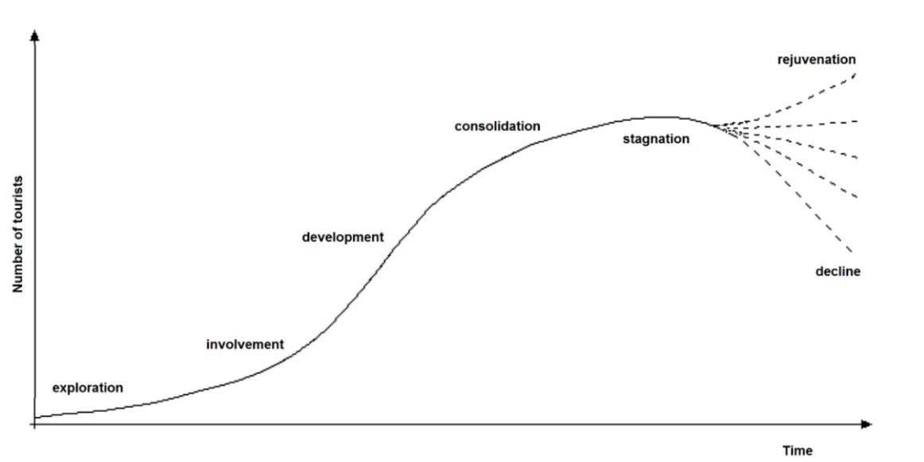
Figure 1: Butler’s lifecycle model
Source: (Budeanu et al, 2016)
Exploration: Benefits to society and the economy are little. Natural or cultural sights are more likely to draw visitors. At this point, governments and residents are only starting to consider the tourist business and the possibilities it presents. At this point, preparations for a tourist adventure can officially begin (Budeanu et al, 2016).
Involvement: There may be calls for governments to invest in airports, transportation networks, and healthcare services to better serve their citizens. Seasonality in tourism may begin to appear at the participation stage.
Development: Lots of construction and preparation will be placed throughout the development phase. There is potential for the development of new transportation infrastructure including highways, railways, and airfields. It is possible that by this time, there will be more tourists than locals.
Consolidation: The consolidation phase is marked by a decline in tourist numbers. It is possible that this is on design, with the goal of preserving a certain amount of exclusivity in the travel market, or it might be a simple mistake. When this happens, locals may start showing signs of displeasure. One of the societal costs of tourism is this.
Stagnation: Stagnation is the first stage of a tourist downturn. At this point, the number of visitors may have peaked, and facilities may be at or near capacity.
Deterioration or revival: The result will be determined by the choices and efforts of those involved in the tourist development project in question.
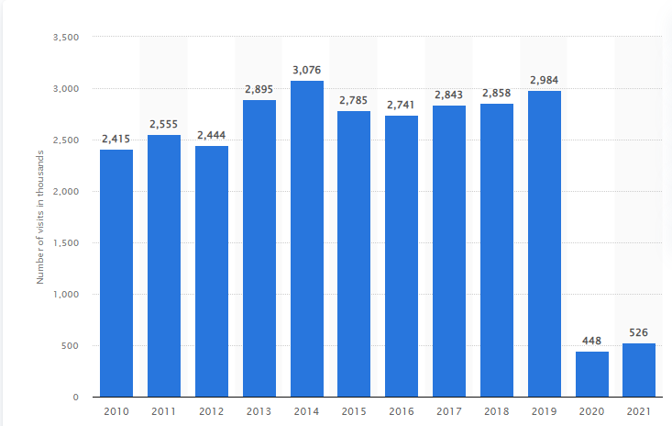
Figure 2: From 2010 to 2021, total visitors to England's Tower of London (in 1,000s)
Source: (Astawa et al., 2022)
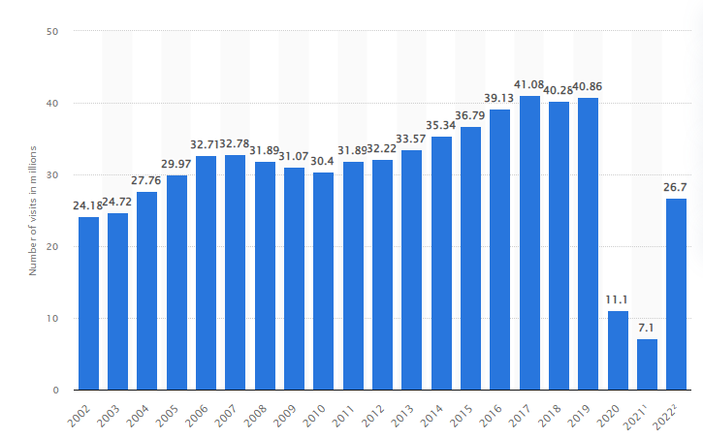
Figure 3: Number of international tourists visiting the UK from 2002 through 2021, including projections for 2022 (in millions)
Source: (Astawa et al., 2022)
Because of the pandemic caused by the coronavirus (COVID-19), the number of people who went to the Tower of London in England in 2020 and 2021 was significantly fewer than it had been in prior years. Although there were about three million people who went to the tourist site in 2019, that number fell precipitously to 448 thousand in 2020 and then slowly started to creep back up to 526 thousand in 2021.
Therefore, as seen from the table information, the number of visits has been fairly constant at London Tower for the past decade. Hence, this tourist location is currently in a stagnation period. The growth in the number of visits has slowed in rate and almost become constant (Harris et al, 2012). Visitor numbers have reached their peak. Due to competition from other resorts and shops in the vicinity, rowdiness and a loss of the original things I liked about London Tower will arise. If not taken care of properly, this can lead to a decline after a few years.

What should London Tower do?
Recent research has looked at the tourist industry's low level of integration and the possibility of using the idea of clusters, in which enterprises and allied institutions build links that increase competitiveness and innovation. In order to develop a successful tourist cluster, it is essential to provide visitors with a wide range of unique activities and attractions that set the location apart from others.
Better industry integration may be achieved more reliably and sustainably through the formation of clusters that bring together tourism-related businesses, government authorities, and auxiliary institutions (Kolmakov et al, 2019).
The tourist industry in Hawaii is the most developed in the Pacific. Planning, legislation, and regulation may help stabilise visitor numbers and make popular tourist spots more long-term viable.

Doxey’s Irridex model
Doxey's Irritation Index (also known as "Irridex") postulates that locals' feelings and behaviours change in predictable ways as the number of tourists visiting their town rises. Four primary phases, from "euphoria" to "antagonism," were recognized by him in the interaction between the host community and the guest.
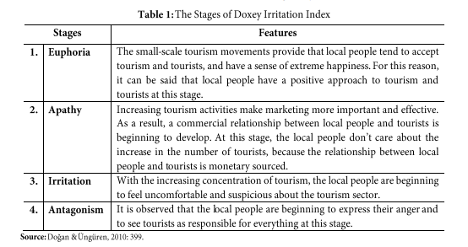
As the detrimental effect of tourism on a region's carrying capacity grows, so does the number of complaints from its residents.
A survey has been conducted to analyse the attitude of residents in long, to understand their attitude regarding the tourist, hence visiting London tower, which is the most popular tourist destination of d London.

Demographics of Respondents
The Google Forms survey was completed by forty-two individuals, exactly half of whom were male and the other half of whom were female. The ages of the respondents ranged from 18 to 66 years old, and about equal representation was found across all age categories. There were 45% of respondents were between the ages of 18 and 30, and there were 55% of respondents were between the ages of 30 and 66.
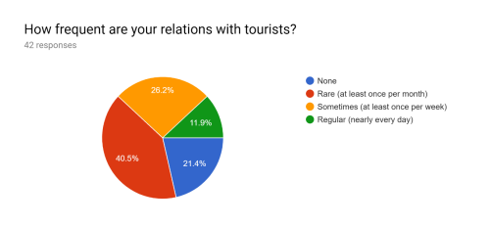
Results: Ten statements were presented to respondents, and they were asked to indicate their level of agreement. About 40% of those who participated in the survey agreed or strongly agreed that increased tourism opens up new opportunities for the local community. Some people agreed with the notion that "Tourism positively improves community life," while others strongly disagreed. Yet, most of the time, respondents were ambivalent. The majority (i.e., 25 respondents) (strongly) agreed that "Overall, London has improved owing to the tourism sector." Even still, five people strongly disagreed with the assertion. The majority of responders (36 out of 37) either agreed or strongly agreed that the tourist sector had increased employment opportunities for locals. Respondents mostly agreed with the statement that they take pride in their own culture. Two of them, though, either didn't agree or strongly disagreed with this remark.
Apathy permeates London, including the neighbourhood around London Tower. Financial gain from tourism that does not significantly alter their way of life is a welcome side effect. On the one hand, most Londoners know that tourism has a favourable effect on the city's economy. The increased number of visitors does not make them feel less secure. Moreover, they generally agree that the tourist industry has been beneficial to London by creating new jobs and that the city is better off as a result.

Conclusion
Both the benefits and cons of sustainable tourism have been covered, London tower being the focus. Since it’s the most popular destination amongst tourists, the tourist trend can be perceived as proportional to the number of tower visits. The historical artefacts have led to rising in economic activity in the region. Though tourism has reached a stagnant life cycle since it has monetary value for the residents, they still maintain an apathetic attitude regarding it.

References
Astawa, I.P., Triyuni, N.N. and Santosa, I.D.M.C., 2022. Sustainable tourism and harmonious culture: a case study of the cultic model at village tourism. In Journal of Physics: Conference Series (Vol. 953, No. 1, p. 012057). IOP Publishing.
Budeanu, A., Miller, G., Moscardo, G. and Ooi, C.S., 2016. Sustainable tourism, progress, challenges and opportunities: an introduction. Journal of Cleaner Production, 111, pp.285-294.
Carr, A., Ruhanen, L. and Whitford, M., 2016. Indigenous peoples and tourism: the challenges and opportunities for sustainable tourism. Journal of Sustainable Tourism, 24(8-9), pp.1067-1079.
Dias, F. and Cardoso, L., 2017. How can brand equity for tourism destinations be used to preview tourists’ destination choice? An overview from the top of Tower of Babel. Tourism & Management Studies, 13(2), pp.13-23.
Fan, D.X., Liu, A. and Qiu, R.T., 2019. Revisiting the relationship between host attitudes and tourism development: A utility maximization approach. Tourism Economics, 25(2), pp.171-188.
García-Palomares, J.C., Gutiérrez, J. and Mínguez, C., 2015. Identification of tourist hot spots based on social networks: A comparative analysis of European metropolises using photo-sharing services and GIS. Applied Geography, 63, pp.408-417.
Harris, R., Williams, P. and Griffin, T. eds., 2012. Sustainable tourism. Routledge.
Holmes, K. and Ali-Knight, J., 2017. The event and festival life cycle–developing a new model for a new context. International Journal of Contemporary Hospitality Management.
Janusz, G.K. and Bajdor, P., 2013. Towards to sustainable tourism–framework, activities and dimensions. Procedia economics and finance, 6, pp.523-529.
Khan, Y.H. and Hossain, A., 2018. The effect of ICT application on the tourism and hospitality industries in London. SocioEconomic Challenges, (2, Iss. 4), pp.60-68.
Koens, K., Postma, A. and Papp, B., 2018. Is overtourism overused? Understanding the impact of tourism in a city context. Sustainability, 10(12), p.4384.
Kolmakov, V.V., Polyakova, A.G., Karpova, S.V. and Golovina, A.N., 2019. Cluster development based on competitive specialization of regions. Ekonomika Regiona= Economy of Regions, (1), p.270.
LY, M.B., 2018. An application of Butler’s (1980) tourist area life cycle to Saly (Senegal). International Journal for Innovation Education and Research, 6(1), pp.47-56.
Maitland, R. and Newman, P., 2014. London: tourism moving East?. In World Tourism Cities (pp. 80-100). Routledge.
Maxim, C., 2020. Challenges of world tourism cities: London, Singapore and Dubai. In Routledge Handbook of Tourism Cities (pp. 19-30). Routledge.
Vargas-Sánchez, A., do Valle, P.O., da Costa Mendes, J. and Silva, J.A., 2015. Residents' attitude and level of destination development: An international comparison. Tourism Management, 48, pp.199-210.

