Cameron Rees

Computer architechture and networks -assignment 2

Table of Contents
Introduction 2
Scenario 1 2
Scenario 2 3
Additional storage for Scenario 2 4
References 6

Introduction
In this report I will be choosing parts for a computer will be building and I have two scenarios that I must adapt the computer too.
With the first scenario, I have to build a computer that is low cost and is for an elderly person that just need the computer to browse the web and check e-mails and for the computer to be able to handle word processing and also he needs it to be able to handle YouTube content and also skype calls with people from abroad . he also wants the computer to be low form factor and for it to have a full-sized keyboard and a decent sized monitor.
The second scenario, we have a graduate to is going to be self-employed and they want to start their own company so we need to have a powerful computer and has given me a spending limit of £2500, he will want to be able to produce and edit 4K video content using software that will be using CPU and GPU power so we will need powerful ones of that and speed and productivity is very important we will also have to take into account about all of the film and editing equipment and if it compatible with the computer. I also have to think about storage because when editing and production 4K footage you will need a lot of storage and he wants to have a NAS drive with 8TB but needs to be able to expandable up to 56TB and I also need to think about RAID mechanism.

Scenario 1
Name | Component | Brand | numbers | price
Ryzen 3 3200G Quad-Core Processor | CPU | AMD | 3.6GHz | £75.00
B450M-HDV R4.0 Micro ATX AM4 Motherboard | Motherboard | ASRock | N/A | £55.25
Crucial DDR4-2400 Memory | RAM | Crucial | 8GB (2x4GB) | £33.47
Seagate BarraCuda 7200RMP Internal Hard Drive | Hard Disk Drive | Seagate | 1TB 3.5” | £34.60
Deepcool SMARTER MicroATX Mini Tower Case | Case | Deepcool | N/A | £27.06
be quiet! Pure Power 11 80+ Gold Certified | Power Supply | be quiet! | 400W | £56.99
AOC E2270SWHN 1920x1080 | Monitor | AOC | 21.5” 60Hz | £73.98
Microsoft ANB-00006 Wired Slim Keyboard | Keyboard | Microsoft | N/A | £8.49
 |  |  | Total | £330.24

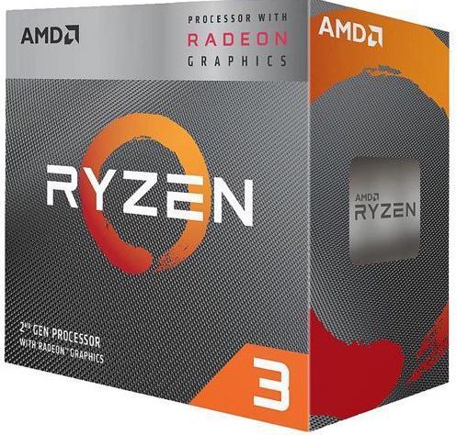
These are the parts that I chose and what I think would be a great daily driver when using a computer day to day and I will be going though all of the parts and I will be talking about why I chose these parts. First, we have the CPU and I chose this CPU because first the cost it is a very cheap CPU and at great value as it’s a quad-core processor with 3.6GHz but it also has integrated Radeon Vega 6 graphics so you’re getting a budget CPU and a GPU all in one little chip and as scenario 1 will only be using it for browsing the web, checking E-mails and doing some word processing with some YouTube and skype calls this CPU will be able to do all of that with ease. Secondly, we have the motherboard and I chose this mother board because it was cheap, it was a B450M which is compatible with Ryzen CPU’s and it Micro-ATX which is perfect for that small form factor. Thirdly, I chose the RAM and I chose DDR4-2400 which a budget friendly kit with 2x4GB which is 8GB in the system and I could of gone for just a stick $GB but I thought having more than you need wouldn’t hurt and it was only £33.60 so it was expensive either. Next, we have the storage and I went with the Seagate BarraCuda because it’s a 1TB hard disk drive which is prefect for a low budget system and it more than enough memory for a while as it will only be used to create word documents which don’t take up a lot of memory and under £35 it’s a bargain. Next, we have the case and I only this for two reasons it is a MicroATX which is a low form factor and the price at £27.06 its hard not to chose and Deepcool is a reliable case manufacturer. Have the power supply next and I chose a 80+ gold rated power supply because the person in scenario 1 will not know how to replace the power supply so I needed a high rated PSU and with a 80+ gold rated PSU it wont be breaking or need changing for years. Next I have the monitor and I chose this monitor because it was a standard size at 21.5” and the price is good for a monitor at this size and also it is compatible with the computer as you can use VGA which the computer has so everything should work as normal there and lastly I chose a standard Microsoft keyboard as it was £8.49 it was the cheapest keyboard I could find that was reliable. So that was my computer for scenario 1 now I will be talking about scenario 2. [1]

Scenario 2
Name | Component | Brand | Numbers | Price
Threadripper 2950x 16-core Processor | CPU | AMD | 3.5GHz | £619.40
Cooler Master MasterLiquid ML3060P Sliver Edition ARGB 45 CFM | Liquid CPU Cooler | Cooler Master | N/A | £203.40
Asus PRIME X399-A EATX sTR4 | Motherboard | Asus | N/A | £259.40
Corsair Vengeance RGB Pro DDR4-3200 CL16 | RAM | Corsair | 128GB (8x16GB) | £509.86
Gigabyte GeForce RTX 2070 SUPER | Graphics Card | Gigabyte | 8GB | £582.95
Phenteks PH-ES614PC_BK ATX Full Tower | Case | Phenteks | N/A | £84.97
Super Flower Leadex III Gold 80+ Gold | Power Supply | Super Flower | 850W | £112.99
Seagate BarraCuda Pro 7200RMP Internal Hard Drive | Storage | Seagate | 6TB | £175.00
 |  |  | Total | £2628.97

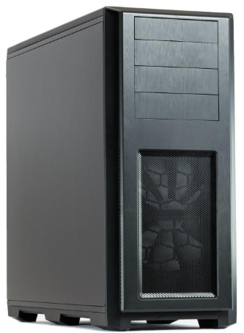
Now I will talk about scenario and as they wanted a computer that was powerful and can handle 4K footage, so these are the components I chose. First, the CPU and I went with the Threadripper 2950x 16-core processor and I went with this one because it is the cheaper of the Threadripper and I think 16 cores is plenty for these tasks that scenario wants to do and its from AMD which is leading the CPU industry at the moment and at 3.5GHz you know it will be fast and it can be overclocking to 4GHz if you are into to overclocking. Secondly, I have the cooling system and I included a cooling system because the Threadripper requires you to have on as it’s a big CPU and need a lot of cooling and as a liquid cooler they are some of the best cooling solutions. Thirdly, I have the motherboard and I didn’t want to spend to much on the motherboard but it w]has 8 USB ports which most thing are UBS compatible and it has a USB-Type C port as more modern things are moving to Type C and it can support the all the RAM that being 128GB and there is ports for sounds cards to be pugged into the motherboard and Asus is one of the biggest names in the industry so it will be reliable. Next, I have the RAM and I chose this RAM because I know that Corsair Vengeance RAM is a good set of RAM and that having 128GB would be enough for some the have 4K footage on their computer and to render the footage it will be able to handle that task load but it does come at a price and I thought it would be worth it. Next I chose the graphics card and I chose the this card because it a GeForce which is one of the biggest Graphics in the industry but it’s a part of the RTX line up with this being the RTX 2070 SUPER which is a very powerful card and it is sitting at a 8GB this card will defiantly be able to take the tasks of the 4K footage. Next, I also chose for Storage a Seagate Hard Disk Drive because I know they are reliable to do, and the drive is 6TB which is plenty of internal storage for a computer even at 4K footage. Next I have the case which was easy to choose because it is a more expensive but it is full ATX but the reason I got it is because there is 8 bays for any extra Hard Disk Drives that being 1 internal 2.5” bay, 6 internal 3.5” bays and 3 external 5.25” bays so that is a lot of extra storage you can have and that is mostly internal but I think storage is very important in this scenario because of what the computer is being used for. Next I have the power supply and I chose a 80+ gold rated like the last one but it’s a 850W so it is much more powerful power supply which is going to be need given that there is a lot of horsepower going into this computer. [2]

Additional storage for Scenario 2
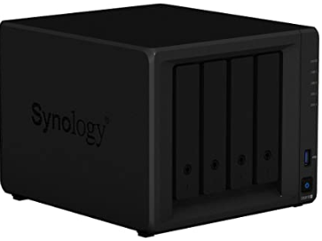
For additional storage I have gone for a NAS drive and I have gone with the Synology DS918+ with 4 bays so if you put 4 8TB drives then you will be sitting at 32TB but you can also purchase a expansion kit which will add 9 more drives which will be plenty of drives to be on your NAS system and if we are talking speeds it reads 225MB/s and writes 221MB/s which is fast in modern times which the public can buy I also has 2 M.2 NVMe SSD slots on the bottom of the system and this is for system cache support, it also has 4GB of DDR3L-1866 memory but it can be expanded to 8GB if you wanted that but the only downfall is that is currently £519.98 which is a lot for a NAS drive but its in good reason because it has all the security you will need in a NAS system, it has a Security Advisor which will help you too analyse the systems settings, strengthen passwords and you will be able to change your network preferences and you are able to remove any malware on the system. Also, it has something called AppArmor which will have enhancements which will block malicious programs from accessing unauthorized systems resources, it also has AES 256-bit encryption and it will encrypt shared folders and network data transmission to avoid unauthorized data access to keep all of the unwanted data out. It also has 2 step verification which will keep the bad people out and will send you a six-digit one time password when you want to access the drives and lastly it also backs all of your storage on the cloud and will upload the data every night so you don’t lose anything if something happened to the NAS drive itself. Now I will have to use RAID on this NAS system so I have chose RAID 6 and here is why, with RAID 6 its like RAID 5 but better which it uses parity data which is written to two drives which means it require 4 drives which is good because that is what we have and it can handle 2 drives dying simultaneously but the chances of that is very sim but if that was the case with RAID 5 you would have to replace the dead drives with new ones which could take a day if you don’t have any drives on hand and if a another drive dies then you have lose all of the data and but with RAID 6 the system will be able to survive a second failure, I thought this would be the most cost effective and the redundancy wouldn’t be big that why I did chose RAID 1+0 because the redundancy would be expensive and RAID 1 and RAID 0 wouldn’t be as effective and RAID 5 is good but RAID is better. [3]

References

[1] | C. Rees, “PC Part Picker,” [Online]. Available: https://uk.pcpartpicker.com/list/WbYTTC.
[2] | C. Rees, “PC Part Picker,” [Online]. Available: https://uk.pcpartpicker.com/list/pv2TTC.
[3] | A. UK, “Amazon.co.uk,” [Online]. Available: https://www.amazon.co.uk/dp/B075DDZ894?tag=georiot-trd-21&th=1&ascsubtag=t3-9800976932675054000-21.

