Computer Architecture & Operating Systems
Declan Shipley
2303938 – 02/04/2024
Computer Architecture & Operating Systems
Computer Architecture & Operating Systems


Contents
Introduction to the Report 3
General Operating Systems 3
Use of Windows OS CLI Commands 5
PC Name Command 5
Directory Command 5
IPConfig Command 6
Folder Creation Command 6
File Creation Command 7
Date Retrieval Command 7
Time Command 7
Ping Command 8
Browser Start Command 8
Color Change Command 8
Use of Linux OS CLI Commands 9
PC Name Command 9
Current Directory Command 9
Directory Content Command 9
Date & Time Retrieval Command 9
Picture Directory Command 9
File Creation Command 10
Rename File Command 10
Delete Directory Command 10
Disk Usage Command 10
History Command 10
Use of bat Scripts - Windows 11
Introduction Script 11
Addition Sum Script 12
Number Guess Script 12
Loop Script 13
Grade Storage Script 14
Use of bash Scripts - Linux 15
Introduction Bash Script 15
Addition Bash Script 15
Number Guessing Bash Script 16
Loop Bash Script 17
Conclusion 18

Introduction to the Report
This report is to identify, detail and demonstrate key functions and commands within different operating systems. The two operating systems I will be showcasing will be Windows and Linux, as these are both the most popular operating systems used, and both differ drastically in their capabilities and ease of use, which is detailed on this site [1]. The commands used will include both batch (.bat) and bash, as these are simple, usable, and effective, which are perfect for the purpose of showcasing.

General Operating Systems
An operating system’s main function is to allow users to seamlessly navigate the system, performing complex functions, accessing applications, and a vast array of other uses, which is discussed on this site [2]. In order for an operating system to perform at a good level, there needs to be some hardware to take advantage of, such as computer memory/RAM and CPU [3], so that functions are completed at incredible paces and the use/maintenance of the system through the use of this hardware. The more memory a system has access to, the more data a system can store at a time, allowing for more intensive applications to run. The better the CPU, the faster a system can process instructions and functions, meaning for faster performance and higher system potential. Because of the reliance on memory, it’s imperative that an operating system has a good memory management system, as this will constantly keep track of how much memory is being used, where it’s being used, and how much you have left, and how much it can allocate to other applications/processes, Task Manager is typically used for this [4].
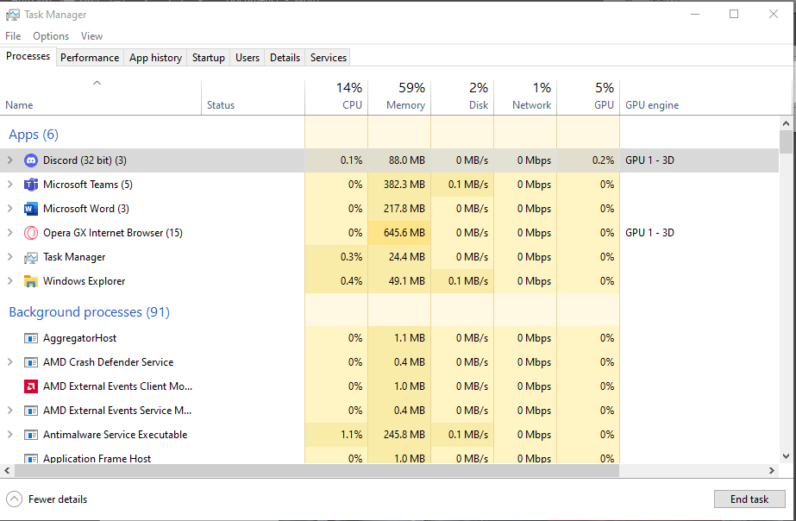
Figure 1: Task Manager

It’s imperative that the operating system and the memory management system work in tandem, ensuring there are no unnecessary expenditures of memory throughout the system, however, this isn’t always the case, and this can cause something called “deadlocks”, which is when multiple applications compete over memory. “memory leaks” can also occur, which causes an application to use increasing amounts of memory over time, causing issues across the system.
Alongside the aforementioned, an operating system also contains an file management system, as shown below.

Figure 2: File Explorer
This file management system’s purpose is to collect and store most information which is stored in the system memory, and then manipulate these files, storing them in specific format, predetermined locations and without causing corruptions [5]. This is widely used by users to store files in preferred locations, so that they may be found and accessed easily, as well as edited or deleted. When a new file or date piece is created on the operating system, the file manager will then place and store them where told, ensuring it’s stored correctly, and no unnecessary actions are performed, such as copied or replaced files, this is imperative for data credibility, as discussed in this book [6] . Through the use of commands, the directories of the file management system can be accessed, as shown later in this report.
Another key function of an operating system is device management, which details to the operating system which hardware is connected to the system itself, in order to make it more accessible and functional, which is critical for ease of access [7]. The hardware connected could consist of both input and output hardware, such as monitors, keyboards, mice, and switches, which will in turn communicate with the operating system. It’s important that the communication between these devices and the operating system is constant and stable, and it will be monitored constantly.
Finally, there is the security management system, which is imperative to ensuring the user has a safe and secure environment to perform their tasks [8], for example, Windows comes with Windows Defender, and a number of other security features, as shown below.
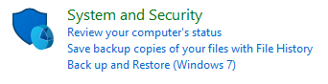
Figure 3: Security Features

Use of Windows OS CLI Commands
Commands are used on almost every operating system, and Windows is no exception. As previously mentioned, the operating system is simply an interface and application that allows for the execution of an entered command. These commands are mostly automated and simplified for the ease of access this brings, however a user can manually perform these commands through the command prompt [9], and in this case, its through the use of batch files. Through the use of commands, users can perform efficient and complex functions, or troubleshoot issues within the system. Shown below are a plethora of examples of the use of commands, to show simple functions they can perform.

PC Name Command
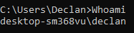
A user can retreive the name of the system, through the use of a command. By typing in “Whoami”, the system is prompted to retrieve the “name” of the system, which could be used in a plethora of ways, such as for networking purposes.

Directory Command
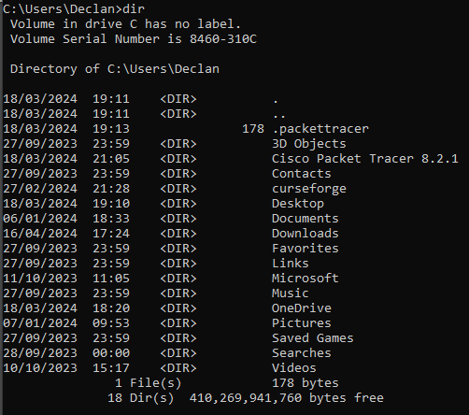
This is the directory command, which is used to retrieve and identify all directories on the system, which is useful for data retrieval or for data management purposes.

IPConfig Command
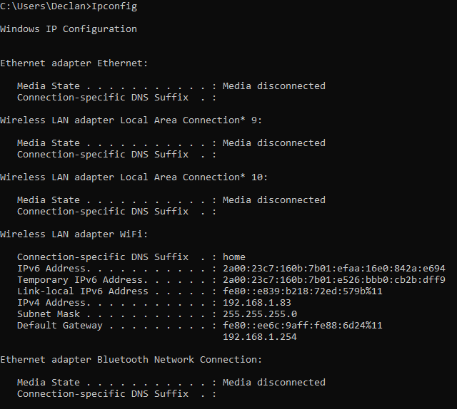
Shown above is the “Ipconfig” command, which when a user types in “Ipconfig”, the system retrieves the IP of said system. Again, this is an important yet simple command which is used for networking purposes [10].

Folder Creation Command
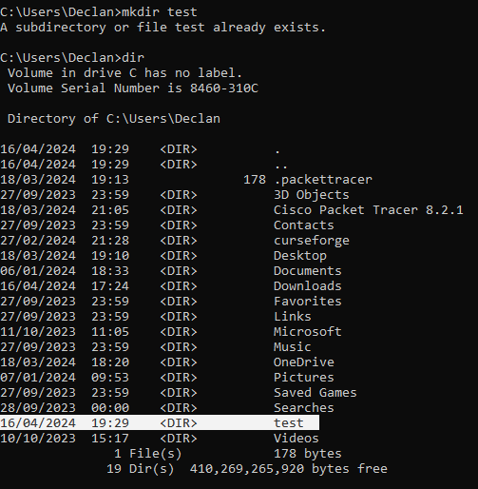
By typing in the command “mkdir test”, a user is able to make a new directory on the system. Users are able to name this directory within the command, and its created instantly. This command is used across computing, but mostly within the website development industry, as a quick way to make new directories for websites.

File Creation Command
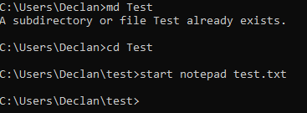
Through the use of these commands, a new folder and text file is created. The “md Test” command, a directory is made, then the “cd Test” command makes a new folder, in this instance called Test. Finally, “start notepad test.txt” opens a new text file, which is then saved within this new folder and directory created within the same command.

Date Retrieval Command
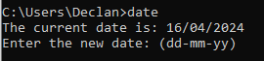
The date retrieval command is a very simple command, which is accomplished through typing “date” in the command prompt. This is not a very useful command, as most OS’s show the data on the home screen, so there is no need for this command in day-to-day use.

Time Command
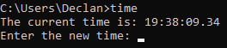
Again, this command isn’t widely used, as its application isn’t very broad. By typing “time”, a detailed time is reported back to the user.

Ping Command
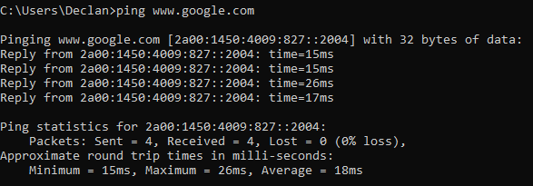
By typing in the command “ping www.google.com”, the system pings the website, then reports the time it took for that ping arrive at the website, this is used to test latency between a system and a website. As well as this, it also reports if any pings didn’t arrive at the destination, and shows the average latency of the ping. This command could be used to troubleshoot networking issues, as detailed in this [11] book, or test communication speeds of the system.

Browser Start Command
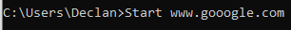
This command allows a user to open up a specified website through the command prompt, and in this case, its google. There are minimal uses for this command, and is not widely used by users.

Color Change Command
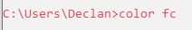
This command is used to change the colour of the command prompt, which could be used for accessibility purposes, which is important for users.

Use of Linux OS CLI Commands
Like Windows, we can again use CLI commands in Linux, and these again can be used for a variety of functions, the functions shown below are relatively simple functions but for the purpose of this report, serve well to highlight some capabilities.

PC Name Command
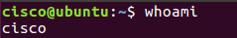
This command is used to retrieve the system name. When you enter "whoami," the system is asked to retrieve the "name" of the system. This information can be used for a variety of purposes, including networking.

Current Directory Command

By typing in the command “pwd”, the current directory is displayed to the user

Directory Content Command
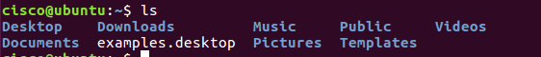
Entering the command “ls”, a user is able to retrieve all of the directories on the system, again, used for data management and general maintainance of the system.

Date & Time Retrieval Command

By entering the command “date” I was able to display the date and time, and again, is not widely used as these values are displayed on the home page of Linux systems.

Picture Directory Command

By entering the command “cd Pictures”, a user can switch to their “Pictures” directory, and the value of “Pictures can be any named directory on the system. This is used to quickly access specific directories on the system.

File Creation Command
By typing in the command “cat > filename”, a new file is made.

Rename File Command
By typing in the command “mv file.txt newfile.txt”, the specified file was renamed, and this could be used to quickly rename a plethora of files.

Delete Directory Command
Through the use of the command “rm filename”, the “filename” directory was deleted. It can be used to quickly delete a directory, and is used in data management.

Disk Usage Command
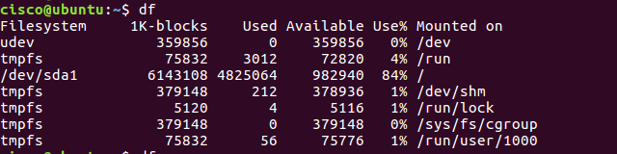
Typing in the command “df”, the system details disk usage on the system, and could be used to troubleshoot memory management on a Linux system.

History Command
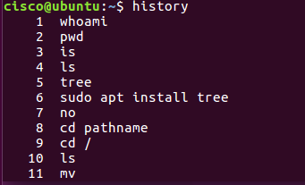
Typing in the command “history”, a user is able to see previously entered commands, useful for debugging and logging of what commands have been used on the system.

Use of bat Scripts - Windows

Introduction Script
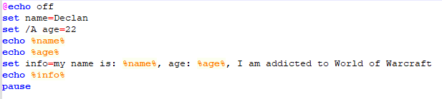
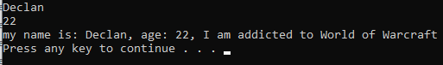
This batch script is created through Notepad++, and then runs through the command prompt. This specific script is a simple introduction to me, and simply relays some prewritten text. It could be used to automate introductions or messages when users log in to the system, and much more, as detailed in this [12] book.

Addition Sum Script
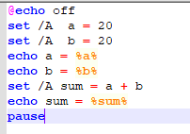
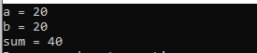
This is a simple addition batch script, and again, through the use of functions within the code, the script will add two predetermined numbers together and output the total. This is a very simple showcase of a mathematics script, and these are very useful scripts.

Number Guess Script
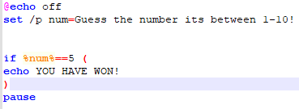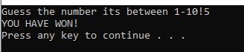
This script showcases the use of an “if” statement, this function allows for a plethora of actions and can determine the flow of scripts, in this example, it’s use is to determine if the user’s input is the same as the input value, a winning message is displayed to the user, if the value input is not correct, no message is displayed, this is referred to as branching within the code [13].

Loop Script
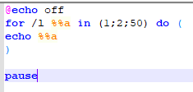
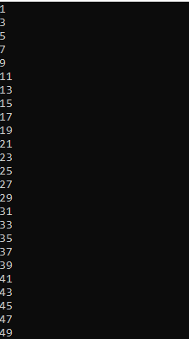
This script simply adds 2 to the total until it reaches the specified number, or cannot increase anymore without going past it, and in this case, it’s the number 50. Whilst not a complex script, it showcases the use of a loop. A loop function makes it so a function or process repeats itself, either for a specified amount of time, or until a condition(s) is met, which is vital for large scale batch file operations, as they often need to perform the same operation on multiple files/directories.

Grade Storage Script
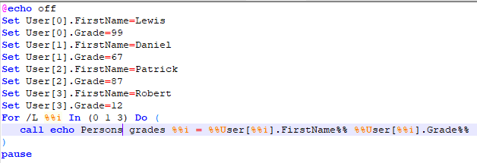
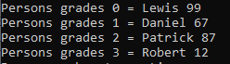
This is a simple array/list function, which stores values and then retrieves these values when asked, which is critical for data management purposes. It can also be used to contain complex functions or snippets of code, which can then be applied later in the code without retyping the entire code section.

Use of bash Scripts - Linux

Introduction Bash Script
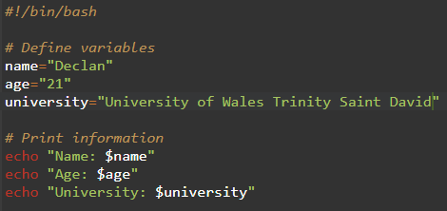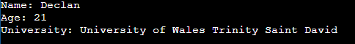
This is another simple but useful [14] introduction file, but this time coded for a bash command. Like the windows version, it’s a very simple example of simple value storage and text displaying, through the use of bash commands.

Addition Bash Script
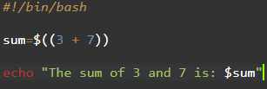
Shown here is a simple addition bash script, which adds 2 values together and outputs the result.

Number Guessing Bash Script
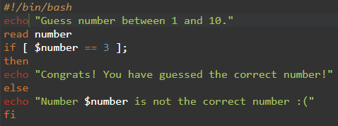
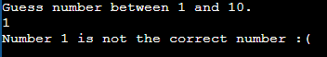
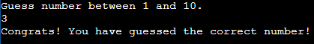
This bash script showcases the use of an if statement, which again allows for branching of code, making it more complex and allowing for more freedom of use. This script is a very simple example and allows for a massive variety of possibilities within the code, so long as the outcomes or possibilities are coded in.

Loop Bash Script
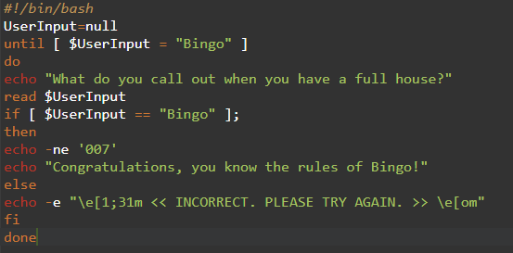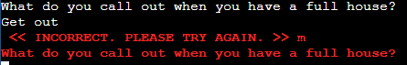
Again, a loop function is displayed, but this time in the bash script. It asks the user to input an answer, and if correct, displays a winners message. However, if the wrong answer is input, then the script loops and starts back at square one, asking the user the initial question again, prompting them for another attempt, this allows for easy automation of scripts, and allows for the implementation of fucntions like authentication and security [15].

Conclusion
In conclusion, the value and importance of commands, batch and bash scripts cannot be understated in relation to operating systems, and this report details very simple examples, in order to show the reader that although some scripts or commands are simple, they are effective and can be expanded upon to make a user’s experience using the OS more comfortable and enjoyable. Most of the commands on OS’s are automated and very rarely does the average user need to manually enter commands using their respective programs, however, for expert or specialised use, they are incredibly useful and important.

References

[1] | C.-M. Ramon and G. Pankaj, “Dynamic Mixed Duopoly: A Model Motivated by Linux vs. Windows,” Management Science, vol. 52, no. 7, pp. 1072-1084, 2006.
[2] | S. Amaninder, “Functions of operating system,” GeeksforGeeks, 17 Febuary 2019. [Online]. Available: https://www.geeksforgeeks.org/functions-of-operating-system/.
[3] | D. Milica, “Memory Management in Operating Systems Explained,” phoenixNAP, 22 September 2023. [Online]. Available: https://phoenixnap.com/kb/memory-management.
[4] | A. I. Martyshkin, “TASK MANAGER FOR GENERAL-PURPOSE OPERATING SYSTEMS,” Revista Turismo Estudos e Práticas - RTEP/UERN, no. 5, p. 1–15, 202.
[5] | C. Wan and H. Dai, “Research on embedded file management system based on Forth virtual machine,” Journal of Physics: Conference Series, vol. 1486, no. 7, 2020.
[6] | P. Laura, Data Credibility: Why It Matters in Data Visualization, Astrato, 2022.
[7] | Fortinet, “What Is Mobile Device Management (MDM)? Why is it Important?,” Fortinet, 2024. [Online]. Available: https://www.fortinet.com/uk/resources/cyberglossary/mobile-device-management.
[8] | Z. Fu, Y. Cao, J. Wang and l. Yang, “Reference-based importance assessment model of identity information,” Personal and Ubiquitous Computing, vol. 17, no. 5, pp. 875-882, 2013.
[9] | Techquickie, Why Do Command Lines Still Exist?, Linus Media Group, 2022.
[10] | G. Jason, “ipconfig,” Microsoft, [Online]. Available: https://learn.microsoft.com/en-us/windows-server/administration/windows-commands/ipconfig.
[11] | J. D. Sloan, Network Troubleshooting Tools: Help for Network Administrators, O'Reilly Media, Inc., 2001.
[12] | D. Nerendra, Batch Script Porgramming, Nerendra Dwivedi, 2022.
[13] | B. Samer, “If statements: Do you really need them in your code,” Pluralsight, 22 September 2015. [Online]. Available: https://www.pluralsight.com/blog/it-ops/if-statements#:~:text=An%20if%20statement%20lets%20your.
[14] | E. Mokhtar and M. Andrew, Mastering Linux Shell Scripting,: A practical guide to Linux command-line, Bash scripting, and Shell programming, 2nd Edition, Packt Publishing Ltd, 2018.
[15] | A. R. Mayer and D. M. Ritchie, “The complexity of loop programs,” ACM '67: Proceedings of the 1967 22nd national conference, pp. 456-469, 1967.

