Module Code: BMHP5019

Module Name: Introduction to Independent Research Skills

Assignment Title: Component 1: (Research Proposal: Autism in Children)

Student Name: Shabana Nasreen

Student ID: 2330540
Table of Contents

a) Topic, review question, and objectives 3
b) Rationale and importance of the topic 3
c) Methods for data collection and analysis 4
d) Ethical considerations 5
References 6

a) Topic, review question, and objectives
Autism Spectrum Disorder (ASD) is a neurodevelopmental condition characterised by difficulties with social communication, and restricted repetitive behaviours predominantly noticed in early childhood. In this secondary research focus is on the prevalence of autism in children 0–12 years. The scoping review question proposed was: What is the current evidence of early detection, intervention and support for children with Autism Spectrum Disorder?
The objectives of this scoping review are to:
1. Chart the existing peer-reviewed literature on early diagnosis and interventions for children with ASD
2. Recognise themes gaps and trends in emerging research and
3. Consider the implications for health, social care and digital health professionals working in paediatric autism support (Daniolou, 2022).
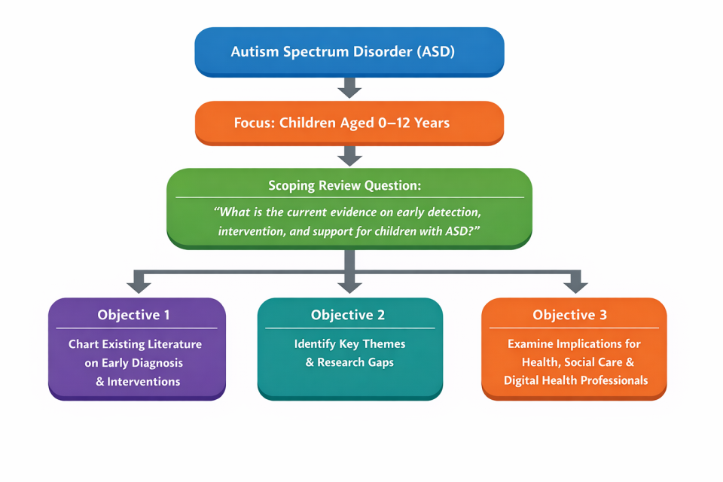

b) Rationale and importance of the topic
Autism has become more common worldwide; around one in 100 children in the UK is estimated to be autistic (National Autistic Society, 2023). When diagnosed and properly treated it leads to better developmental outcomes, lower costs in long term care and better family situations (Al-Beltagi, 2024).
For health and social care professionals, autism has a range of complex challenges including access to services, co-ordination across health and social care services and long waiting times for assessment and support. A range of digital health approaches such as telehealth assessment and assistive technologies are now being used to fill gaps in services. The present evidence base is therefore of strategic importance for policy and practice development and research in child health and social care (Lord, 2020).

c) Methods for data collection and analysis
All the articles from the screening project will be reviewed in accordance with the scoping review methodology developed by Arksey and O'Malley, who provided guidance from the Joanna Briggs Institute. A search in the electronic database PubMed will be carried out using systematic searches of publications from EPUB, Scopus, CINAHL and PsycINFO. The content about the latest’ published in English and ‘the most recent' of these studies will be covered. The selected articles will then be extracted from the dataset and grouped into key themes which will then be used to summarise the evidence in this field. Key gaps will then be identified (Peters, 2022).

d) Ethical considerations
This study uses previously published material, for which no formal ethical approval is necessary, and ethics principles will be respected:
- Maintaining transparency in reporting methods
- Accurately citing all sources
- Minimising bias in the selection and interpretation of studies

References

Al-Beltagi, M. (2024). Pre-autism: Advancing early identification and intervention in autism. World Journal of Clinical Cases, 12(34), 6748. https://pmc.ncbi.nlm.nih.gov/articles/PMC11514348/.
Daniolou, S. P. (2022). The efficacy of early interventions for children with autism spectrum disorders: A systematic review and meta-analysis. Journal of Clinical Medicine, 11(17), 5100. https://pubmed.ncbi.nlm.nih.gov/36079029/.
Lord, C. E.-V. (2020). Autism spectrum disorder. The Lancet, 392(10146), 508–520. https://scholar.google.com/scholar?q=Lord+Elsabbagh+Baird+Veenstra+VanderWeele+2020.
National Autistic Society. (2023). Autism facts and history. https://scholar.google.com/scholar?q=National+Autistic+Society+autism+prevalence+UK.
Peters, M. D. (2022). Best practice guidance and reporting items for the development of scoping review protocols. JBI evidence synthesis, 20(4), 953-968.

