DATA ANALYSIS AND VISUALIZATION

STUDENT NAME: George Nitulescu
STUDENT ID: 2123688
Table of contents
Part 1: 3
Introduction 3
Data analysis and result 3
Conclusion 7
Part 2: 8
1. Male and female students 8
2. Number of student qualifies and does not qualify for reduced/free lunch 8
3. Mean and median of students who qualifies and does not qualify for reduced/free lunch 8
4. Mean and median differences of students’ pre-test and post-test scores 8
5. Clustering example (K-Means Clustering) 9
6. Data mining and text mining methods used in contemporary business 12
7. Advantages and disadvantage of using SPSS and Excel 15
Reference list 17

Part 1:

Introduction
The whole 2017–2021 hotel reservation dataset was thoroughly analyzed using Microsoft Excel. This program helped with data preparation, processing, and visualization. Over the last half-decade, typical lodging expenses changed. Excel's data management and calculations made it easy to estimate average prices and identify patterns in this large dataset.
Microsoft Excel became an essential resource in data analysis, allowing data analysts to get comprehensive understanding into the temporal changes of average hotel booking expenses. The analysis revealed a range of price fluctuations, focusing on their connection to the COVID-19 pandemic. The findings could potentially assist hotel sector decision-makers anticipate obstacles and identify new possibilities.

Data analysis and result
Sum of Average price |  | Booking status
Market_type | Arrival_year | Canceled | Not_Canceled | Grand Total
Aviation | 2018 | 3783 | 8805 | 12588
Aviation Total |  | 3783 | 8805 | 12588
Complementary | 2017 |  | 340.93 | 340.93
 | 2018 |  | 887.5 | 887.5
Complementary Total |  |  | 1228.43 | 1228.43
Corporate | 2017 | 3623.4 | 34798.74 | 38422.14
 | 2018 | 17386.59 | 111357.25 | 128743.84
 | 2019 |  | 67 | 67
Corporate Total |  | 21009.99 | 146222.99 | 167232.98
Offline | 2017 | 40533.3 | 217872.96 | 258406.26
 | 2018 | 277497.18 | 428591.4 | 706088.58
 | 2019 |  | 139 | 139
 | 2020 |  | 75 | 75
Offline Total |  | 318030.48 | 646678.36 | 964708.84
Online | 2017 | 45764.59 | 243161.98 | 288926.57
 | 2018 | 925736.36 | 1390481.32 | 2316217.68
 | 2019 | 37.33 | 182.45 | 219.78
 | 2020 |  | 250.6 | 250.6
 | 2021 |  | 316 | 316
Online Total |  | 971538.28 | 1634392.35 | 2605930.63
Grand Total |  | 1314361.75 | 2437327.13 | 3751688.88
Table 1: Pivot table for average reservation price during 2017-2021
(Source: MS Excel)
The tabular representation shows the cumulative aggregation of average hotel reservation fees based on booking statuses, “canceled” and “not canceled,” from 2017 to 2021. These statistics are further divided into “complementary,” “corporate,” “offline,” and “online” market divisions. The "Grand Total" row contains the combined mean prices for every year and booking status.
In 2017, the average accommodation reservation price in the “Online” sector reached $288,926.57. “Offline” is second with $258,406.26. The “Corporate” market segment has a mean reservation price of $38,422.14, whereas the “Complementary” sector has lowest prices at $340.93. In 2018, average accommodation reservation costs rose in all marketplace groups. “Online” earns $2,316,217.68, followed by “Offline” at $706,088.58. “Corporate” has the highest mean price at $128,743.84, while "Complementary" has the lowest at $887.5.
In 2019, only “Corporate” & “Offline” market classes have average pricing. “Online” has an average amount of $219.78, whereas “Corporate” is the least expensive at $67. 2020 shows just “Offline” and “Online” market statistics. The former averages $250.6 per hotel reservation, while the alternative is $75. Finally, in 2021, data is just from the “Online” market segment. The average reservation fee this year is $316. These findings explain how average hotel reservation costs changed across different market typologies over five years.
Overall Summary:
Average hotel booking prices increased gradually from 2017 to 2021. In 2021, the typical room reservation price reached $316. This statistical study shows that the “Online” market category had the highest average hotel reservation costs, totaling $2,437,327.13. After then, the “Offline” market segment contributed $1,314,361.75, making it the second largest. The “Corporate” market sector totaled $840,986.39. “Complementary” had the lowest mean value at $1,628.43.
In some market categories, 2019 and 2020 data are insufficient. Thus, the analysis for these years may be imprecise and incomplete. This restriction necessitates care when making inferences from the above results. This table depicts past patterns in average hotel reservation expenses, highlighting market categorization differences. Clearly, the “Online” market sector dominates the overall mean price scene for the specified timeframe. To provide a thorough and scientifically valid evaluation, data inconsistencies from 2019 and 2020 must be carefully examined. A comprehensive analytical framework also includes cyclic changes, economic transformation, and specialized advertising strategies that may affect hotel booking rates (Okagbue et al. 2021).
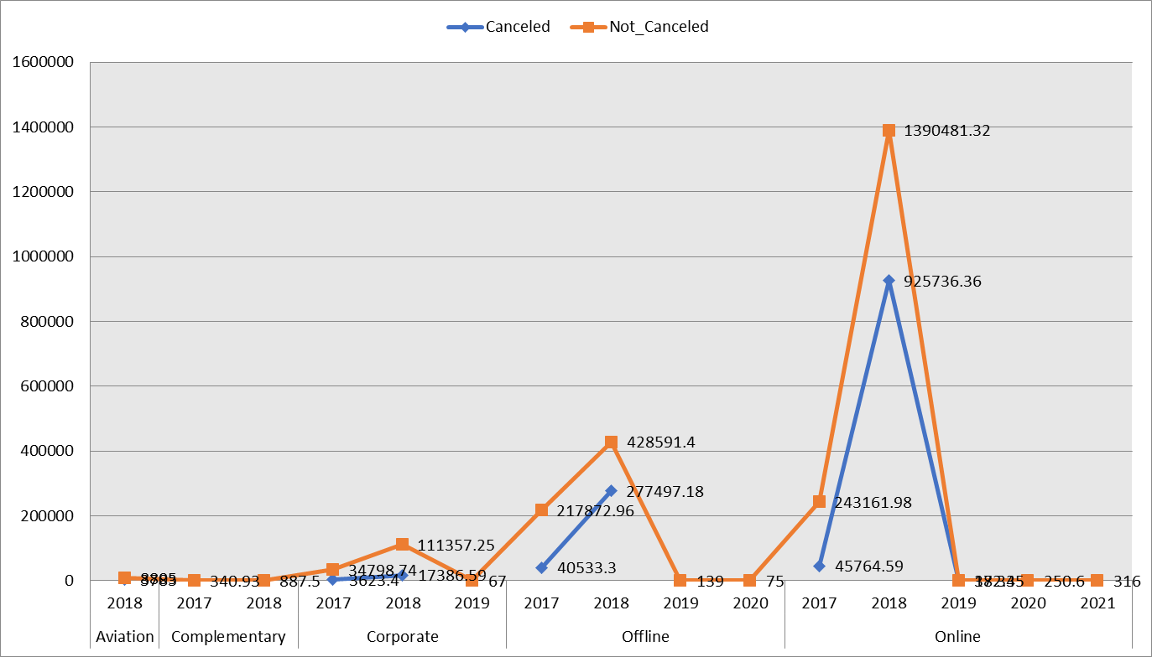
Figure: Hotel reservation pattern from 2017 to 2021
(Source: MS Excel)
During 2017-2021, average hotel reservation costs fluctuate. Prices climbed sharply in 2018, then fell in 2019 and 2020. The COVID-19 pandemic disrupted hotel pricing dynamics, causing a price drop during this period. The epidemic caused average prices to plummet in 2020. In 2021, prices overall increased, suggesting a rebound. These complicated price trends, tightly linked with the pandemic's effects, were efficiently clarified using graphical representations in Microsoft Excel, providing an in-depth overview of pandemic-induced hotel industry changes.
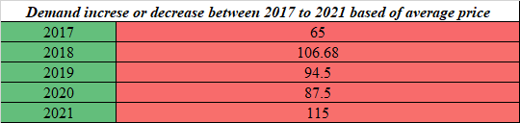
Table 2: Demand increase or decrease during 2017 to 2021 based on average price (VLOOKUP function)
(Source: MS Excel)
The demand curve, as seen through the perspective of mean price, showed clear oscillations during 2017-2021. During 2017, the first year of operation, demand reached an all-time high of 65 units. The following year experienced a significant increase, with a peak of 107 units reached. This significant increase in demand in 2018 may be traced back to a number of different factors, including a stronger economy, rising customer trust, and effective marketing efforts of relevant businesses.
Despite this increase, 2019 saw a slight slowdown in demand, with registrations decreased by 95 units from the year previously. A mix of market volatility and external factors may be to blame for this moderate slowdown (Watkins, 2021). Emerging as a pivotal force having great power over worldwide economic configurations and consumer comportment, the COVID-19 pandemic arose around the latter half of 2019 and the beginning of 2020.
The next year, in 2020's disaster, demand dropped further, to an overall of 88 units, clearly showing a drop from the prior year's levels. COVID-19 pandemic directly contributed to the sudden drop in demand, with far-reaching consequences including extensive lockdowns, travel prohibitions, and the establishment of regulations dictating social demarcation. Hospitality, tourism, and entertainment sectors suffered particularly heavy hits, and as a result, both demand patterns along with subsequent mean prices reduced dramatically.
Demand, however, recovered to a quantitative peak of 115 units in 2021, which appeared as an arena of resurrection and characterized by an evident recovery. Several factors contributed to the uptick, including the gradual easing of incarceration regulations, careful preparation of vaccination drives, and the careful planning of federal efforts geared toward boosting economic recovery and consumer spending (Cleff, 2019). As the world learned to live with the outbreak and adopted steps to reduce its impact, consumers recovered faith in the market and started spending again on specific products and services.

Conclusion
In conclusion, the onset and development of the COVID-19 pandemic might provide some explanation for the fluctuations seen in the demand trend, as defined by the mean price, throughout the period from 2017 to 2021. During the specified years, the pandemic clearly had diverse impacts on consumers and other companies, causing a variety of demand. Notably is the apparent rise in demand in 2018; in contrast, both the years 2019 and 2020 saw decreases, with 2020 seeing a particularly obvious decrease owing to the widespread effects of the pandemic. Nevertheless, this demand surge begins becoming visible in 2021 as evidence of global adjustment to the new environment and the beginning of the path to financial restoration.

Part 2:

Male and female students
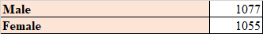
(Source: MS Excel)
The presented data highlights the breakdown of the community by gender. Specifically, there are 1077 men and 1055 women in the data set.

Number of student qualifies and does not qualify for reduced/free lunch
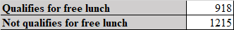
(Source: MS Excel)
The dataset quantifies individuals as “Eligible for Free Lunch” or “Ineligible for Free Lunch.” The dataset records 918 free lunch events and 1215 non-free lunch times.

Mean and median of students who qualifies and does not qualify for reduced/free lunch
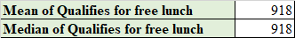
(Source: MS Excel)
In the data set provided, the mean and median values for the “Qualifies for free lunch” metric are both specified as 918.
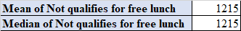
(Source: MS Excel)
The presented dataset furnishes both the mean and median outcomes for the variable “Not Qualifies for Free Lunch” at a value of 1215.

Mean and median differences of students’ pre-test and post-test scores
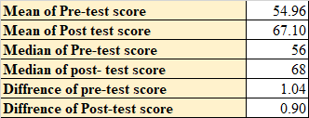
(Source: MS Excel)
Students' academic success is shown in the dataset's pre- and post-test scores. The mean score pre-treatment is 54.9559. The post-test shows a mean value of 67.1022, indicating the cohort's typical accomplishment following therapy. The post-test mean is higher than the pre-test means, indicating that treatment improved students' competence. In increasing order, the pre- and post-test medians are 56 and 68, correspondingly. After the procedure, the post-test median was higher than the pre-test median. Particularly, those median values match their means, supporting observed patterns.
Pre-test to post-test score variations show progress. Pre-test scores average 1.04407 higher after intervention. Similarly, the post-test score difference is 0.8978, showing a score increase. Though this variation is less evident than the pre-test, it however shows the intervention's effectiveness in improving student performance (Lemenkova, 2019). The intervention's effectiveness is shown by the increase in the median and mean values from pre-test towards post-test. These persuasive score patterns demonstrate a significant increase in students' academic achievement after the treatment. A thorough evaluation of the study design, sample size, and possible confounding factors is needed to strengthen these results.

Clustering example (K-Means Clustering)
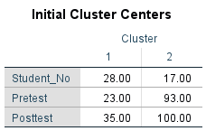
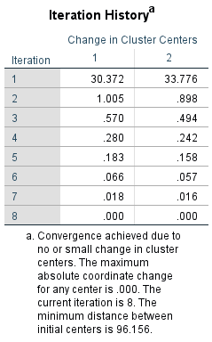
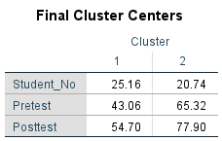
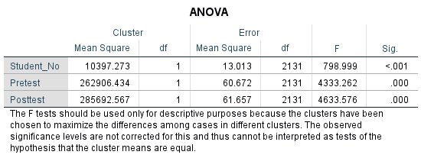
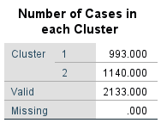
Figure: K-means cluster analysis
(Source: IBM SPSS)
A thorough clustering research used “Pretest” and “Posttest” characteristics to divide two groups. This study's repetition record thoroughly tracks the cluster centers' dynamic development. Significantly, the investigation begins with initial clusters for each variable, assuring the validity of future analyses.
Notably, these cluster centers were determined after a careful study of their relative geographical layout, which deepens the analytical structure (Rahman and Muktadir, 2021). The research also sheds insight into case allocation within clusters, helping explain group dynamics. A detailed investigation of variance, a statistical approach that allows for substantial cluster variations, adds to the study's analytical integrity. The research's diverse strategy improves the study's resilience and dependability, increasing its academic relevance.
Explanation:
There were a total of 2133 eligible cases for study, 993 from Cluster 1, and 1140 from Cluster 2. For Cluster 1, initially core values were (Pretest: 23.00, Posttest: 35.00), while for Cluster 2, it was (Pretest: 93.00, Posttest: 100.00). After several passes, the central values for Cluster 1 stabilized at (Pretest: 43.06, Posttest: 54.70) and for Cluster 2, they settled at (Pretest: 65.32, Posttest: 77.90). Inter-cluster distances of 32.454 units are consistent throughout both Cluster 1 & Cluster 2. In a nutshell, it's a measure of how different the two groups are from one another.
The “analysis of variance” (ANOVA) shows significant differences between the groups on all three measures (Student_No, Pretest, and Posttest). The resulting F-values are rather large, and their associated p-values are statistically insignificant (p < 0.001). These findings provide strong evidence that the differences between the clusters in those factors are statistically significant.
Result interpretation:
Clustering analysis divided the dataset into two groups using "Pretest" and "Posttest" variables. The resulting cluster centroids show that Cluster 1 students performed poorer on both the "Pretest" and "Posttest" than Cluster 2 students. The ANOVA results confirm the clusters' difference and show significant heterogeneity in the variables.
The clustering technique reveals the dataset's intricacies and allows it to identify various subpopulations depending on test results. In academic or research settings, patterns of data may influence decision-making and analysis (Mustika et al. 2022).

Data mining and text mining methods used in contemporary business
Data Mining Methods:
I. Clustering:
Clustering, a fundamental technique within the domain of data mining, entails the conglomeration of disparate data points into discernible groups predicated upon shared intrinsic attributes. This method finds utility in multifarious applications such as client segmentation, anomaly discernment, and product categorization, wherein latent patterns within raw data are unveiled (Sylvia and Terhaar, 2023).
In the realm of retail, clustering can be deployed to amalgamate clients manifesting akin purchasing proclivities. Subsequently, this collated data may be harnessed to optimize inventory allocation and engineer targeted marketing endeavors.
II. Classification:
Classification, a pivotal data mining process, encompasses the assignment of categorical designations or classes to novel data instances. Its salience is manifest in diverse arenas, including electronic mail filtering, affective analysis, and anti-fraud mechanisms.
A practical instantiation of classification resides in the realm of customer service, wherein incoming support entreaties are classified into distinct thematic categories such as payment discrepancies, technical quandaries, or product inquiries.
III. Association Rule Mining:
The pursuit of mining association rules engenders the revelation of hitherto concealed relationships or patterns within voluminous datasets (Kafle, 2019). Predominantly wielded within market basket analysis, this technique serves to identify co-occurring acquisitions of diverse commodities.
A pertinent illustration materializes in the retail sphere, wherein association rule mining might unveil a correlative affinity between the purchase of cereals and the acquisition of milk. This discernment could be operationalized to strategically situate merchandise, fostering opportunities for efficacious cross-selling endeavors.
IV. Regression Analysis:
A statistical modality, regression analysis, is harnessed to prognosticate numerical outcomes predicated upon the discernment of prevailing patterns. Its utility spans an array of domains such as sales projection, consumer interest estimation, and the judicious apportionment of scarce resources.
Within the domain of gastronomy, regression analysis might be deployed to optimize workforce scheduling and inventory management by delving into the interplay of variables encompassing meteorological conditions, temporal considerations, and promotional incentives on daily sales figures.
V. Anomaly Detection:
Anomaly detection, an instrumental facet of the data mining paradigm, facilitates the identification of aberrant data patterns or outliers (McDonald et al. 2020). Its instantiation is found within domains such as fraud detection, intrusion surveillance, and prognostication of machinery malfunctions.
An exemplar application of anomaly detection resides in the realm of cybersecurity, wherein anomalous network comportment is flagged, thereby signifying potential impending cyber assaults, and thus enabling preemptive countermeasures.
Text Mining Methods:
i. Sentiment Analysis:
Sentiment analysis, a prominent text mining technique, seeks to discern the polarity of sentiments within textual content, categorizing them as positive, negative, or neutral. Its utility spans diverse domains including web monitoring, online reputation management for businesses, and consumer sentiment analysis.
An illustrative instance of sentiment analysis lies in its application within the hospitality industry, where a hotel chain could effectively gauge and evaluate customer satisfaction levels, thereby identifying specific areas for service enhancement.
ii. Topic Modeling:
Topic modeling serves as a strategic endeavor within text mining, focused on discerning overarching thematic constructs inherent within a corpus of textual data. This methodology is instrumental in tasks encompassing content organization, personalized recommendations, and the discernment of latent patterns.
An illustrative implementation of topic modeling is conspicuous in the operations of a content dissemination platform, wherein it could be effectively harnessed to autonomously categorize articles into pertinent genres or subjects, thereby enhancing content discoverability and user experience.
iii. “Named Entity Recognition” (NER):
“Named Entity Recognition” (NER) constitutes a pivotal text mining methodology aimed at identifying and classifying named entities such as individuals, locations, and entities with proper names. This technique is pivotal for information extraction, content categorization, and the creation of succinct document summaries (Rode and Ringel, 2019).
A portrayal of NER finds resonance in the realm of news aggregation, wherein an automated system could proficiently delineate crucial entities from news headlines, empowering readers to efficiently access targeted information pertaining to individuals, corporations, or geographical locales.
iv. Text Summarization:
Text summarization, a strategic facet of text mining, entails the distillation of salient information from protracted textual narratives, encapsulating them into concise and coherent summaries. Its pertinence is evident in contexts such as document synthesis, news aggregation, and information retrieval.
The deployment of text summarization is manifest in modern news applications, wherein it facilitates the dissemination of abridged yet comprehensive synopses of news articles, enabling users to expeditiously assimilate core insights sans the necessity of perusing the entire textual content.
v. Text Classification:
Text classification, a fundamental technique, entails the systematic classification of textual content into predefined categories or classes. Its applicability spans diverse domains, encompassing endeavors like spam filtering, language identification, and content labeling.
A pertinent use-case of text classification materializes in the domain of e-commerce, wherein an online retail entity could leverage this technique to automatically channelize customer service inquiries into distinct categories, such as sales queries, return requests, or technical support issues.
In the contemporary settings, the strategic assimilation of data mining and text mining techniques imparts significant advantages to enterprises, manifesting applicability across a diverse spectrum of pragmatic real-world scenarios.

Advantages and disadvantage of using SPSS and Excel
Aspect | SPSS | Excel
Advantages
Statistical Analysis | Specialized for complex analyses (e.g., ANOVA, regression) | Basic statistical functions (mean, median, etc.) for simple analyses
Data Visualization | Customizable charts and graphs for analysis and presentation (Roni and Djajadikerta, 2021). | Various chart options, less specialized than SPSS
Data Management | Robust features for data cleaning, handling missing values, variable transformations | Basic data management tasks (filtering, sorting)
Syntax and Automation | Syntax scripting for automation and reproducibility | Automation with “Visual Basic for Applications” (VBA)
Disadvantages
Cost | Commercial software, can be expensive for individuals/small organizations | Often included in Microsoft Office, more cost-effective for basic tasks
Learning Curve | Steeper learning curve, especially for non-statistical users | Widely used and familiar, accessible for basic tasks (Simanjuntak, 2020)
Scalability | Handles large datasets, performance slowdown with complexity (Pallant, 2020). | Struggles with very large datasets, potential data issues
Practical Examples
Example 1: Multivariate Analysis | Researcher studies age, income, education's impact on job satisfaction using SPSS | Small business owner compares monthly sales with Excel
Example 2: Data Visualization | Analyst visualizes survey data using stacked bar charts in SPSS | Excel user generates website traffic trend line graph
Example 3: Data Preprocessing | Research team uses SPSS for cleaning, preprocessing, handling missing values | Student employs Excel for sorting, filtering, and basic analysis
Example 4: Automation and Reproducibility | Analyst uses SPSS syntax files for transparent and reproducible analysis | Office manager creates budget report using Excel

Reference list
Cleff, T., 2019. Applied statistics and multivariate data analysis for business and economics (pp. 433-441). Cham, Switzerland: Springer International Publishing. https://link.springer.com/content/pdf/10.1007/978-3-030-17767-6.pdf
Kafle, S.C., 2019. Correlation and regression analysis using SPSS. Management, Technology & Social Sciences, 126. https://journal.oxfordcollege.edu.np/file/1681898552journal-1.pdf#page=126
Lemenkova, P., 2019. Numerical data modelling and classification in marine geology by the SPSS statistics. International Journal of Engineering Technologies IJET, 5(2), pp.90-99. https://dergipark.org.tr/en/download/article-file/751483
McDonald, S., Vieira, R. and Johnston, D.W., 2020. Analysing N-of-1 observational data in health psychology and behavioural medicine: a 10-step SPSS tutorial for beginners. Health psychology and behavioral medicine, 8(1), pp.32-54. https://www.tandfonline.com/doi/pdf/10.1080/21642850.2019.1711096
Mustika, I., Nabella, S.D. and Mulyadi, M., 2022. DATA-PROCESSING TRAINING USES A SPSS APPLICATION FOR IBNU SINA UNIVERSITY MANAGEMENT STUDENTS. International Journal of Engagement and Empowerment, 2(2), pp.179-183. https://ije2.esc-id.org/index.php/home/article/download/68/68
Okagbue, H.I., Oguntunde, P.E., Obasi, E.C. and Akhmetshin, E.M., 2021. Trends and usage pattern of SPSS and Minitab Software in Scientific research. In Journal of Physics: Conference Series (Vol. 1734, No. 1, p. 012017). IOP Publishing. https://iopscience.iop.org/article/10.1088/1742-6596/1734/1/012017/pdf
Pallant, J., 2020. SPSS survival manual: A step by step guide to data analysis using IBM SPSS. McGraw-hill education (UK). https://books.google.com/books?hl=en&lr=&id=CxUsEAAAQBAJ&oi=fnd&pg=PP1&dq=data+analysis+through+excel+and+SPSS&ots=n39zAJCb4Z&sig=Fl_oKsFrx18GLfFGHESMbZOAm_w
Rahman, A. and Muktadir, M.G., 2021. SPSS: An imperative quantitative data analysis tool for social science research. International Journal of Research and Innovation in Social Science, 5(10), pp.300-302. https://www.academia.edu/download/79116055/300-302.pdf
Rode, J.B. and Ringel, M.M., 2019. Statistical software output in the classroom: A comparison of R and SPSS. Teaching of Psychology, 46(4), pp.319-327. https://journals.sagepub.com/doi/abs/10.1177/0098628319872605
Roni, S.M. and Djajadikerta, H.G., 2021. Data analysis with SPSS for survey-based research. Singapore: Springer. https://link.springer.com/content/pdf/10.1007/978-981-16-0193-4.pdf
Simanjuntak, S.D., 2020. Statistik Penelitian Pendidikan dengan Aplikasi Ms. Excel dan SPSS. Jakad Media Publishing. https://books.google.com/books?hl=en&lr=&id=O4LRDwAAQBAJ&oi=fnd&pg=PP1&dq=data+analysis+through+excel+and+SPSS&ots=BWLf-N8vrv&sig=tnZ9Bd3KKXpu4bv033_M_SHCtf0
Sylvia, M.L. and Terhaar, M.F. eds., 2023. Clinical analytics and data management for the DNP. Springer Publishing Company. https://books.google.com/books?hl=en&lr=&id=ZKucEAAAQBAJ&oi=fnd&pg=PP1&dq=data+analysis+through+excel+and+SPSS&ots=KwM-WUTELy&sig=3rKIPUwWYSFnXkqnREg7Yyx7qt4
Watkins, M.W., 2021. A step-by-step guide to exploratory factor analysis with SPSS. Routledge. https://scholar.archive.org/work/gfor7wfsfzcjfle7ge4uicdmoe/access/wayback/https://s3-euw1-ap-pe-ws4-capi2-distribution-p.s3-eu-west-1.amazonaws.com

