DS 1 Template

My Screenshots/Photos
- Please add 4–6 screenshots or photos of your digital life.
- You can use your phone or laptop.
- For each screenshot, write one or two sentences explaining what it shows.

Screenshot/Photo 1
[Insert Photo/Screenshot below]
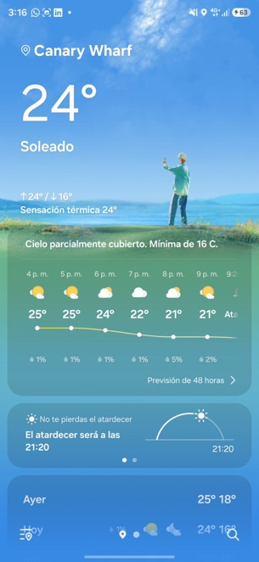
I check the weather in my app frequently

Screenshot/Photo 2
[Insert Photo/Screenshot below]
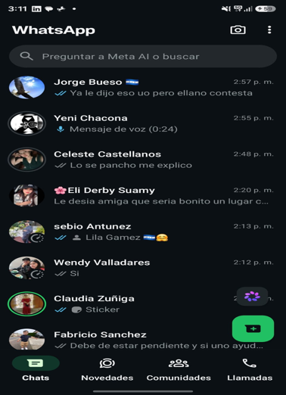
I usually use my WhatsApp to talk with my family friends.

Screenshot/Photo 3
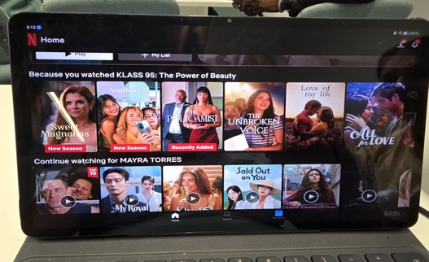
[Insert Photo/Screenshot below]

I like to watch my series in Netflix

Screenshot/Photo 4
[Insert Photo/Screenshot below]
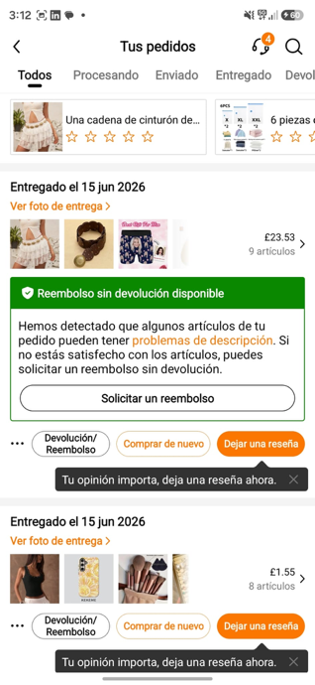
I enjoy my time buying some stuffs online in Temu

Screenshot/Photo 5
[Insert Photo/Screenshot below]
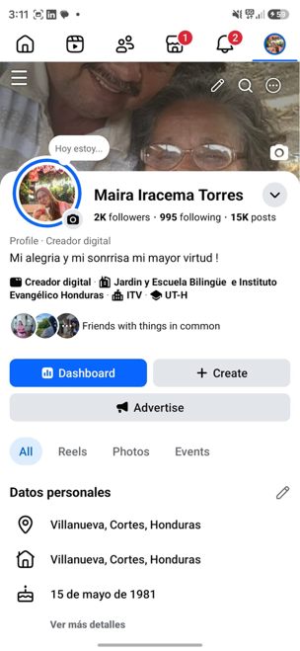
I enjoy my time to checking news stories about my contacts in my fb.

Screenshot/Photo 6
[Insert Photo/Screenshot below]
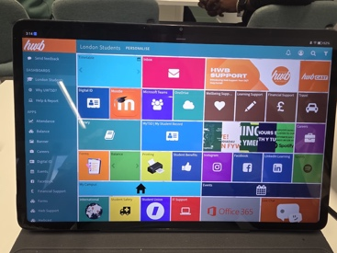
I use this app to get knowledge and develop my skills.

My Short Reflection
- Write 5–8 simple sentences about your digital life.
- You can use the sentence starters below if helpful.
I use digital tools to improve my skills.
I feel confident when I learnt something new that I can do it.
I want to improve my skills in IT
I often use these tools to do my task and the assignment
I sometimes feel nervous about new things that I have to put in practice.

Sentence starters
- I use digital tools to …
- I feel confident when I …
- I want to improve …
- I often use these tools: …
- I sometimes feel nervous about …
- I hope this module will help me …
- Digital skills are important for me because …
You can write more if you want.

Submission Checklist
Before you submit, please check:
​​​ ☐ I added 4–6 screenshots
☐ I wrote short sentences for each screenshot
☐ I wrote my short reflection
☐ My work is my own
☐ My file opens correctly
​​☐ My file opens correctly

