Investigating the Perceptions of Year 7 and Year 10 on Positive Reinforcement as Strategy for Behaviour Management and Class Motivation
Student Number: 0851389
Word Count: 4826

Aim, focus and purpose of the research/Research Context
This academic research involves designing, conducting and critically evaluating a close-to-practice professional enquiry focusing on the model of the transformative teacher in teaching practices that has a positive impact on the student. This research project will “influence the ongoing learning of the student-teacher and is developmental in prompting further professional growth” (Welsh Government, 2017).
The aim of this research essay is to achieve a better understanding of learners’ perceptions of positive reinforcement as a strategy for behaviour management and class motivation. Promoting positive learning habits and behaviours is a statutory requirement within the professional standards for teaching and leadership (WG, 2017). Skinner (1953) implies that positive reinforcement involves the addition of a reinforcing stimulus following a behaviour to increase the likelihood or probability that the behaviour will occur. Positive reinforcement strategy is employed in alignment with School X’s Behaviour Policy. By implementing this strategy during placement, differing behaviours were observed from different groups of students, which spurred interest in wider research. It is widely recognized that considering students' perspectives in educational programs is crucial. Teachers can gain valuable insights by examining how students perceive positive reinforcement as a means of behaviour management and motivation. By adjusting the teaching style based on this information, teachers are better equipped to address the needs and expectations of their students.
Research was undertaken in a city secondary school of 904 pupils. School X has a very high percentage (39.5%) of pupils with Additional Learning Needs (ALN) compared with the 3-year average (Estyn, 2023). Similarly, the percentage of pupils (33.8%) eligible for free school meals is also significantly high (Estyn, 2023). According to United Kingdom Parliament (2010), “Poor nutrition and, frequently, problematic behaviour affect disadvantaged pupils most of all. Conversely, good school food has been shown to improve attendance, concentration and behaviour and therefore to increase pupils’ motivation and ability to learn.” Downing (1991) advised addressing misbehaviour before teaching would be appropriate.
The context of the classes relating to the research consisted of two Year 7 classes of high and low attainment groups as well as a Year 10 group.

Literature Review
Classroom management and class motivation are crucial in shaping students’ academic differences. Effective classroom management creates an orderly and productive environment while class motivation drives students’ engagement and enthusiasm for learning (Sieberer-Nagler, 2016, Dorn et al., 2017). As a student-teacher, it is essential to promote “positive learning habits and behaviours” (WG, 2017). Awang (2013) reinforces this view and encourages praising behaviour. Skinner (1953) believed that positive reinforcement as a key component of his operant conditioning theory included an introduction of a desirable stimulus following a behaviour to increase the likelihood or probability that this behaviour would be repeated. Ferlazzo (2012) highlighted the analogy between farmers and educators: just as farmers can’t force crops to grow, educators can’t compel intrinsic motivation in students. Intrinsic motivation referring to the desire of learning originating from inside the learner. However, they can create a conducive classroom environment where intrinsic drive is more likely to flourish. Ryan and Deci (2020) suggest that rewarding a pupil for specific behaviours, such as completing assignments on time or actively participating in discussions, can lead to these behaviours becoming internalised. As a result, students are more likely to be intrinsically motivated (Ferlazzo, 2012) to engage in class activities and maintain positive academic habits. According to Morin (2017) and Hattie (2009), verbal praise is one of the most effective forms of positive reinforcement for promoting desirable behaviours and outcomes in students. The research indicates that regular and specific verbal recommendations can greatly improve students’ engagement and overall behaviour in the classroom by reinforcing positive actions and encouraging repeated behaviors. Burnett and Mandel (2010) advocate this view; however, they emphasise that the effectiveness of praise largely depends on its nature, with specific and targeted praise eliciting favourable reactions from students as compared to general praise.
Rewarding students, with social rewards such as praise, a smile, nod of approval, high fives or tangible rewards such as a phone call or postcard home or hot drink with the headmaster, when they perform well or meet standards will encourage a repeat behaviour (School X, 2024). Recognising students’ work in public may encourage other students to emulate the rewarded behaviour (Diedrich, 2010). Building a strong relationship and getting to know students’ strengths and limitations are critical for teachers to use positive reinforcement most effectively (Sterret, 2012). Cushing, Horner, and Barrier (2003) suggest that positive behaviour is connected to positive social surroundings in the school environment, and that there is a correlation between well-behaved children and good child-parent relationship.
Motivation, reward, classroom management and punishment are all variables which relate to positive reinforcement. Research has consistently shown that teachers use positive feedback at a bare minimum (Scott et al., 2017). It is widely recognised that feedback is the most efficient and consistent strategy that teachers utilise (Hattie, 2012). Its limited use can result in missed opportunities to reinforce good behaviour and academic effort. Granting children recognition for their diligent efforts and progress serves as a potent motivator, fostering resilience (Curriculum for Wales, 2022)in the face of future challenges. In contrast Morin (2017) and Burnett and Mandel (2010), emphasis the effectiveness of specific and targeted praise in promoting positive student outcomes. The gap between research and practice suggests that teachers may need more training and support to effectively use positive reinforcement. Addressing this issue can enhance students’ behaviour and academic performance by making better use of positive feedback.
Kubanek, Snyder, Abrams (2015) research indicates that punishments can be more effective than rewards in guiding behaviour. This is because punishments offer immediate feedback, while rewards require more time to establish the desired behaviour, implying it is easier to punish than to reward when both options are available. This is often the case because the effect is immediate, for example, sending a misbehaved pupil to stand outside the classroom rather than “conditioning” (Skinner, 1953) as this may be time consuming.
The evidence indicates that positive reinforcement is a useful technique and an essential component of education (Cook et al., 2017). The straightforward process of reinforcement is still disregarded in education as an antiquated, damaging, and ineffectual approach despite logic and evidence as opposed to the findings of Cameron et al., (2001) and Kohn (2018). Kohn (2018) believes that extrinsic motivation, enticing students’ interests through grades, points, prizes, gold stars or even threats of detention and negative calls home are short-lived as students tend to place more focus on the rewards rather than the task itself.
This literature is relevant to the case study undertaken in School X as it gives an overview of the current understanding and literature available for this investigative research (Chigbu et al., 2023), based on the research question “What are the pupils’ perceptions of positive reinforcement as a strategy for behaviour management and class motivation?” Engaging in a wide range of literature will enable scholars to identify knowledge gaps, identify targeted inquiries thus contributing to the progress and development (Creswell, 2012). The wealth of information and research conducted on positive reinforcement all highlighting the effectiveness of modifying behaviour and seeing positive outcomes (Skinner, 1930; Wheatley, et al., 2009). Although opinions are divided on the benefits of positive reinforcement, alternative viewpoints will be considered when evaluating the data.
Explanation of Case Study
Swanborn (2010) defines a case study as an investigation of a social phenomenon that is supported by various data sources including observations, interviews and document analysis. Swanborn (2010) highlights the exact steps that must be taken, all the while staying inside the boundaries of social system that includes people, groups, organizations, local communities and nation states. Its goal is to examine and to deduce data to derive widely generalisable conclusions and thus fill in knowledge gaps, question prevailing understanding and to uncover hidden dimensions (Creswell, 2012). Among qualitative research methods, a case study relies on a variety of data sources, including documents, artifacts, interviews and observations which then allows researchers to create a detailed and nuanced picture of the topic under investigation. The objective being is to unveil minute details offer a complete understanding of the subject matter (Baxter and Jack, 2008). Researchers define the parameters of the case, set boundaries, and analyse data using various techniques. Case studies can be descriptive (to describe the phenomenon), explanatory (to explain how or why something occurred), or exploratory (to identify research questions for subsequent studies) (Yin, 2017). They are inherently multimodal or mixed methods, combining methods, combining both qualitative and quantitative data sources (Clark, 2005). This approach allows a deep examination of a specific subject or phenomenon within its real-life context when unearthing a rare or distinctive phenomena for a complete analysis of the subject enquiry (Yin, 2017). It is research based, evidence based and methodologically flexible (Simons, 2009). As well as having assurances on reliability and validity theory in the initial stage would be having a well-researched, well-defined question with relevance to the case study and its connection to the literature world which should possess a conceptual framework that integrates with the current paradigm of data processing and interpretation (Yin, 2017).
Participants
The subject groups are Year 7 and Year 10 pupils involving all to complete a questionnaire and two focussed interview groups gathering pupils’ perceptions of positive reinforcement. Upon which the researcher will analyse data to code and identify themes, patterns, differing responses before finally drawing conclusions and making interpretations. The significance of the case study enables a thorough investigation and aids in locating any gaps, abnormalities or additional experiences or events that might have an impact on attitudes and behaviours (Yin, 2014). According to Hamm (2018), teachers can employ positive reinforcement as an effective method to increase students’ motivation and to promote desirable behaviours in the classroom.
The participants involved will be of different sampling groups: Year 10 (set 2), Year 7 (Set 1 and Set 5). The research design data will be collected for this quantitative research project to investigate the relationship between positive reinforcement and students' behaviour and motivation in the classroom. The researcher hopes to understand if different sampling groups can benefit more from this reinforcement strategy. This could make it easier for educators to understand the perspectives and experiences of their pupils and help educators create successful teaching methods. Farrell (2010) states that children with emotional behavioural disorders (EBD) had a highest impact benefitting from positive reinforcement. There are many variables to consider as positive reinforcement does not stand alone, such as the learning environment, the relationship between the teacher and pupil, students’ attitude towards learning, the rewards and the length of the condition and the environment. This descriptive case study can shed further light on the phenomenon and help understand the effects of this classroom management technique. It can also support previously published research, to help researchers easily formulate and replicate hypothesis and provide a direction for further studies. However, it is noteworthy that the case study is subjective, biased and may lack rigour; criticisms of case study is that all research findings and interpretations of data rely heavily on the researcher’s interpretations who may be funded and influenced by personal views, preferences and opinions, hence, there may be restricted prediction values for a given example, distorted data and a lack of probability sampling (Yin, 2017). Moreover, according to Stake (1995), researchers exercise prudence when generalizing findings from a solitary case study and consider the specific contextual factors that influenced the study. By exploring the students’ perceptions of positive reinforcement, this research study contributes and supports the literature theory of effective strategies of managing classroom haviour and class motivation aligned with the curriculum goals.

Research Methods
The aim of this research study is to address knowledge gaps in the literature, challenge current understanding and to contribute to the progress and development (Creswell, 2012). By investigating on the research question: “What are the pupils’ perceptions in positive reinforcement as a strategy for behaviour management and class motivation”, this would put theory into practice and add strength to current literature using data drawn from the mixed methodologies. The current literature suggests the underutilisation of positive reinforcement; highlights the effectiveness of modifying behaviour and seeing positive outcomes (Skinner, 1953; Wheatley, et al., 2009). By conducting this investigative study, the researcher hopes to contribute to the support of this underutilized practice in education.
One way to make the research process more apparent is through methodology, which may also be used to describe the exploratory approach, the course of action, the method, or framework that guided the strategic planning and strategies(Silverman, 2005). In this research activity, the research methods used were a mixture of qualitative and quantitative approaches.
Qualitative Approach (Focussed Group Interviews)
An interview was used as part of a qualitative approach to obtain a range of perspectives based on a set of semi- structured questions on two focussed groups: 2 Year 7. The set of semi-structured questions asked would have the pliancy in the order the questions were asked and thus would allow the interviewer to expand their answers (Walker and Solvason, 2014). This qualitative method had the advantage of involving fewer participants, thus less time spent on transcription (from audiotape) and then the data scrutinised (Naughton and Blatchford, 2010). The pupils in the group were involved in an informal group interview seated in a round table so pupils could talk naturally and interact with each other at ease with a live audio recording of the activity. The semi-structured questions were prepared in advance and written on a page, the researcher reassured the interviewees of their rights, anonymity and confidentiality. This method of data collection from the perspective of teaching and learning has the advantage of providing an in-depth understanding of the participants’ beliefs, perspectives and experiences (Braun & Clarke 2006). The focussed group interview was chosen because it was informal and allowed participants to speak on their own terms for data gathering on participants ‘behaviour and setting (Bruce, Louis, and McCall, 2015). It also had the advantage of exploring and understanding pupils’ perceptions, ideas or feelings as it captured feelings and opinion, subjective in nature. However, qualitative methods, being subjective, might open to sub-conscious bias when interpreting participants’ responses (NFER, 2013). It had been criticised for being time consuming, which involved making sense of complex narratives and hard to provide general statistics (NFER, 2013). When conducting the interview, it would dig deep into the ‘Why’, ‘how’ (Yin, 2017) aspects of things, taking on a more holistic understanding, being able to adapt questions to answers as well as facial expressions, intonation, observations for data collection.
QUANTITATIVE APPROACH (QUESTIONNAIRE)
A questionnaire is a tool and is a popular choice which enabled the researcher to gather data efficiently within a limited time span (Creswell, 2012). In this case study, a set of both open and closed-ended questions were incorporated which allowed the collection of qualitative and quantitative data to be extracted (Creswell, 2012). Administering questionnaires had the advantage of including a large cohort within the study simultaneously to gather data from a large sample (Brace, 2018). All the subject groups had the standardised questionnaires, it was reported by their maths teacher that the low attainment group comprised mostly of pupils ALN and EBD and that comprehending the information may be a challenge. For this reason, the data collected from Group B was discarded as they would encounter difficulties interpreting the questions in this research project (Creswell, 2012). Likert scales was used as a rating scale which is a common tool to measure attitudes, opinions and perceptions in questionnaires and surveys (Adelson and McCoach, 2010). As there were only 5 choices in each question, each choice, for example ‘Highly Agree’ has a rating of 5, ‘Agree’ has a rating of 4, ‘Neutral (I don’t know)’ rating of 3, ’Disagree’ has a rating of 2 and ‘Strongly Disagree’ has a rating of 1, from then an average of the total score was calculated for all questions.
By utilising the strengths of quantitative and qualitative research (Braun and Clarke, 2006), this mosaic approach of integrating extracted data and analysis techniques allowed the exploration of perceptions, opinions, behaviours in detail capturing responses in different groups.
To eliminate any potential unconscious bias, reflections were to be conducted using Brookfield's Lenses (Brookfield, 1998), which are intended to inspire the practitioner to reflect from several perspectives. The reflecting method proposed by Gibbs (1988) would then be applied to each lens to give each one of Brookfield's lenses additional structures. The researcher used Thematic analysis (TA) which is a popular method to analyse data in social, behaviour, sciences and beyond. It involves identifying recurring themes, patterns, and underlying meanings within qualitative data sets. Researchers use various techniques, such as coding, thematic analysis, and content analysis, to explore and interpret the richness of qualitative information. By examining textual, visual, or audio data, researchers gain insights into the complexities of human experiences, behaviours, and social phenomena (Braun & Clarke, 2006). There are many rigorous stages in using TA: initially reading and gaining an impression of the transcripts line by line; then labelling relevant words, phrases, after which the researcher has to code the most important opinions, sentences, surprises and create categories by bringing several codes together, the labelled categories are then sorted into the most relevant and how they are connected to each other; these categories are placed in order of hierarchy (Braun and Clarke, 2006).

Data Presentation and Analysis Methods
The qualitative data collected from the interviews were placed in order of hierarchy using the Thematic Analysis methods. The rigorous steps of content analysis were used to allow classification and categorisation of common themes and patterns (Braun and Clark, 2006) to gain an insight in the perceptions of positive reinforcement from the pupils’ viewpoints. See Fig, 3.1 and Fig, 3.2
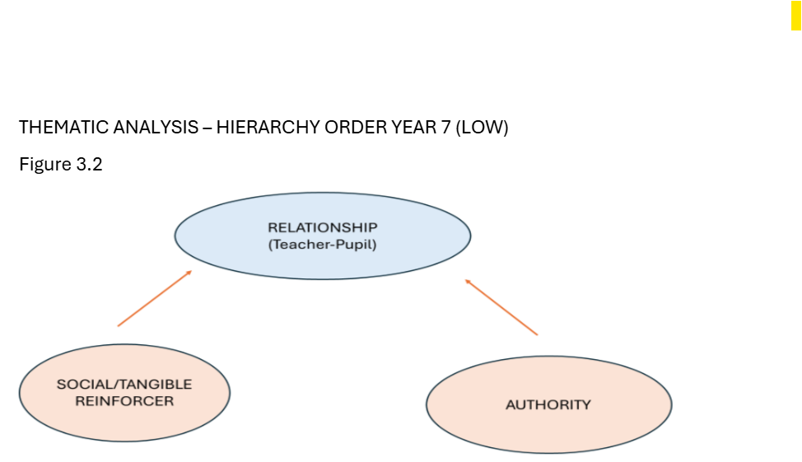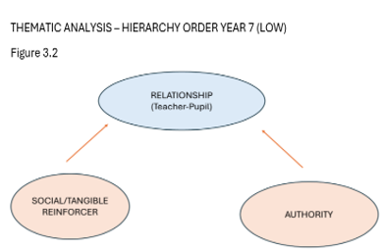
The quantative data collected from the questionnaires were manually transferred to Excel spreadsheet. Using the Likert scale, the ratings of each group (Year 7 and Year 10) would give an average scale. The average rating of each question was compared to the upper and lower quartile on the Likert scale of each class groups. This approach would allow the researcher to compare and interpret data effectively into the pupils’ understanding of positive reinforcement as outlined in School X’s Behaviour Policy Handbook. Moreover, this qualitative analysis allowed for a deep exploration of the perceptions of rewards and class motivation.
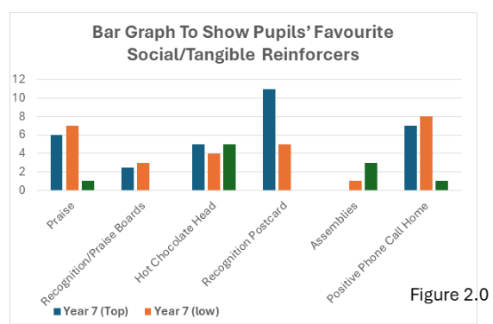

The versatility and accessibility of the thematic approach to identify themes and patterns (Braun and Clark, 2006) enabled the researcher to gain a better insight of the pupils’ perceptions when positive reinforcement is applied. Therefore, by applying the mosaic approach which involves combining qualitative and quantitative data as well as multiple perspectives would allow the researcher to gain a more nuanced understanding of the pupils’ overall opinions and exposure to positive reinforcement (Clark and Moss, 2011). Since quantitative research methods such as questionnaires would offer anonymity and understood respondents’ sentiments, so instead of a binary answer such as a ‘yes’ or a ‘no’, it could offer a more nuanced insight. This would add credibility and reliability to the case study being outlined by comparing information (Patton, 2014) gained from the mixed methodologies approach, called data triangulation. The triangulation method would add an in-depth understanding of the students’ perceptions from extrapolated data derived from both the interviews and questionnaire. To ensure trustworthiness of this research, as in the collection of the qualitative data, the interviews conducted were recorded and carefully transcribed. This detailed analysis trail gave rise to dependability, transparency and replicability of this research (Lincoln and Guba, 1985).

Ethical Considerations
Ethical considerations are crucial when undertaking any research especially when young participants are involved. According to BERA (2024) ethical guidelines for educational research are shaped by five key ethical principles: “inclusivity, respect, democratic society, responsibilities and global impact”. These guidelines shape the research processes from the beginning of orchestrating and designing, down to the latter stages of data extraction, data analysis and compilation of the research findings (BERA, 2024).
It is essential for all research students to consider the moral standards, the anonymity and confidentiality of the participants are adhered to, and that the researcher adheres to UWTSD’s Research Ethics & Integrity Code of Practice, UWTSD Research Data Management Policy when the research project is carried out (BERA, 2024).
Prior to the research project, an Ethics Form was filled out and had to be approved before any research activity was undertaken (see Appendix 3) from UWTSD. Once Ethical approval was gained the researcher sent an email to both Head of Year 7 and 10 to seek consent for the two activities as well as 14 pupils’ names in Year 7 were forwarded. On behalf of the researcher, School X directly sent off emails to the relevant participants’ guardian for consent. Once consent had been given then the participants were assured of anonymity, confidentiality, the researcher reiterated that they were not obligated to state their names on the questionnaires. And if at any time they did not wish to participate in the questionnaire or interview they had the option to not participating so they so wish, and their questionnaire destroyed. The researcher gained assent from all participants in both the interview and questionnaire participants and re-iterated that if the participants felt uncomfortable with the interview before, during and after, they have the right to leave at any point in time (BERA, 2024). It was made known to the pupils that the interview would be recorded, and assurances given to protect the identity in the research such as participants’ names, year group or any other information that could lead to the identification of the participants. The data information would only be accessable by the researcher. Positionality refers to a person's perspective on the world as well as the stance they take regarding a research project and its social and political environment (Foot and Bartel, 2011).

Results/Analysis of Results/Discussion
The researcher carried out a focussed group interview of 6 students from each two year 7 classes and administered questionnaires to two year 7s and a year 10 class. The research design protocol was followed as was mentioned in the Ethical Form, the data collected from the interviews and questionnaires were on 02/05/2024 and the raw data were then translated using different research methods.

Year 7 (Group A) Interview Data: High Attainment Group
The pupils had a good perception of positive reinforcement, there was a chorus of ‘yeahs’ when asked about their perceptions of positive reinforcement, the participants were able to give examples of token reinforcers such as gift cards at the end of year, social reinforcers such as ‘being noticed for doing good work’. When the participants were asked about positive reinforcement having an influence on positive behaviour, Group A participants were quick to answer they were ‘here to learn’ and that they would work hard to achieve the grades which linked to question 4 to motivation. One participant stated that depending on what the reward would be for her to be really motivated. Others believed that they would work hard even if there were no reinforcements. There were two participants who remained quiet. One participant was pro-active.

Year 7 (Group B) Interview Data: Low Attainment Group
All pupils stated they had a good perception of positive reinforcement. The participants unanimously agreed that they would be motivated with social influencer, such as praise or acknowledgement from the teacher. Participant A stating that he would work hard only for certain teachers. He stated that he enjoyed Maths and would work hard for Mr X and Mrs Y. Participant B stated that she would work hard for all teachers regardless of which subject and to be ‘fair’ to all. One participant did not say a word throughout. Two participants were vocal.

From the thematic analysis (Braun and Clark, 2006), Figure 3.1, it could be concluded that Group A responded well to positive reinforcement and were motivated especially if it was their preferred reinforcer, they had a strong work ethics and would work hard regardless of whether they are positively reinforced, that was at the top of the hierarchy branch they were intrinsically motivated. Group B could be positively reinforced, something small such as praise, or high fives, they had respect for teachers, someone influential and what was identified in the interview was that they would be strongly influenced and motivated if they had a good rapport with the educator
Questionnaire Results: Year 7 (Group A) and Year 10
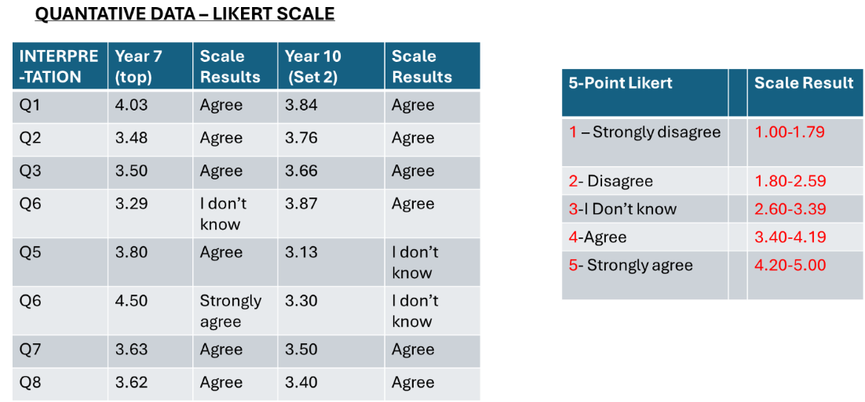
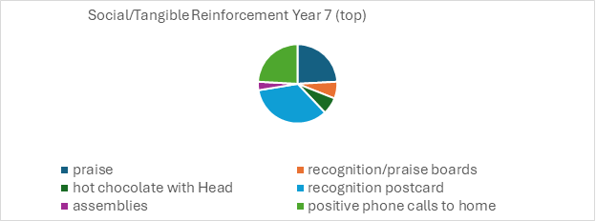
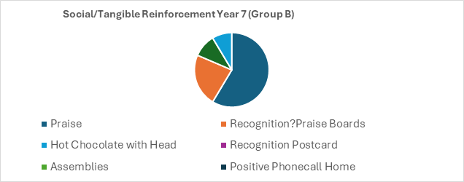
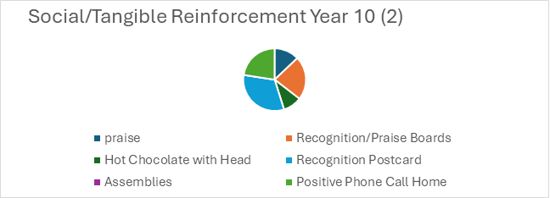
A set of quantitative data was extrapolated using the Likert Scale. The results from the raw data were then calculated using Excel. The average of the scores were compared to the upper and lower quartiles range. It was found that most of the participants had a good perception of positive reinforcement. There was a surprising anomaly shown in Group A and that the top75% of the respondents strongly agreed in question 6. The quantitative results showed in Group A that positive reinforcement was a motivator and could impact their self-esteem. This was in stark contrast to Year 10, where 50% of the respondents remained neutral/unsure. In Figure 1, the pie graph showed Group A’s preferred reinforcer was having a postcard sent to home, second was positive phone call to home followed by praise in classroom. Group B’s preferred reinforcer was hot chocolate with the Head, 50%, assemblies, praise. Year 10 (2) voted positive phone call to call followed closely with praise and postcard. Group A was motivated with or without reinforcement, being intrinsically motivated, the biggest motivator being what the reward was. Group B was motivated by social reinforcement, simple praise or words of encouragement, but their biggest motivator was their teacher. Although Year 10 acknowledged positive reinforcement, 50% of the participants remained neutral about motivation. Their responses with regards to the reinforcers were impartial, there were no desired rewards.

Discussion
The researcher had taken great lengths to ensure that the results were as accurate and credible, transferable and information gathered as ethical, complying with BERA guidelines.
The qualitative data from the interview identified patterns, themes, exploring areas to offer an insight into the phenomenon. The follow up was the quantitative data from the questionnaires, which provided a framework for assessing respondents’ sentiments and opinions. With the two combined methods, this research activity. It is widely recognised that understanding students’ perspectives is paramount during the implementation of educational initiatives (Collins et al., 2022).
Teachers prefer punishment which produce a rapid, temporary suppression to the behaviour, Maag (1999). Therefore, rather than reinforcing negative behaviours, wouldn’t it be best to train and educate practitioners to plan the implementation of positive reinforcement, the universal principle?

Conclusions and Recommendations
This research study undertaken, investigating the perceptions of positive reinforcement as a strategy to classroom behaviour and motivation supported the findings by Skinner (1950), Wheatley et al. (2009) emphasising the effectiveness of modifying behaviour and seeing positive outcomes. The mosaic technique by combining the quantitative data from questionnaire and the qualitative data from the interviews met the aims of the research and be ‘fit for purpose’ (Cohen et al., 2011), making the hypothesis true: the pupils have a perception of positive reinforcement. This tied in with what many educators already know and, that is, when positive reinforcement is used effectively it promotes “positive learning habits and behaviours” (WG, 2017). The data triangulation method used assured dependability, reliability and trustworthy as this approach enabled a comprehensive understanding of the case study undertaken (Creswell, 2012). However, it should be noted that the focussed interviews were a small cohort and there was a dominating speaker. The whole research was rather subjective, so ironically it would be hard to eliminate unconscious bias. A different researcher looking at the results would conclude with the same hypothesis, that is, the pupils have some perception of positive reinforcement in relation to class motivation and behaviour. From the results, it can be concluded all participants have a good perception of positive reinforcement where they have had some form of reinforcers whether they are social (praise, high fives, smiles, nod of approval), tangible (positive phone call to home, hot chocolate with headmaster, name on billboard) or token reinforcer (gift vouchers)
Recommendations include:
- Collecting observational data, this approach may give an immediate insight into the effectiveness and their impact on class behaviour and participation
- Collaboration with student teachers and share ideas to further explore the topic and its implications.
- Explore negative reinforcements, the focus is to increase the occurrence of a behaviour by removing or avoiding an aversive stimulus.
As part of continuous professional development, it is inherent to address misbehaviour before teaching (Downing, 1991) to ensure more time is spent learning rather than dealing with behaviour management. An important finding from this research highlighted the importance of building a teacher-student relationship (Hamre and Pianta, 2006) such as a simple smile and high fives and words of encouragement, postcards sent to home are positive reinforcers to modify behaviour and encourage class motivation and participation.

Reference List
Adelson, J.L. and McCoach, D.B. (2010) 'Measuring the Mathematical Attitudes of Elementary Students: The Effects of a 4-Point or 5-Point Likert-Type Scale', Educational and Psychological Measurement, 70(5)
Awang, M.M (2013) ‘Effective teaching strategies to encourage learning behaviour’ IOSR Journal of Humanities and Social Science https://doi.org/10.9790/0837-0823540 10.9790/0837-0823540
British Educational Research Association [BERA] (2018) Ethical Guidelines for Educational Research, fourth edition, London. https://www.bera.ac.uk/researchers-resources/publications/ethical guidelines-for-educational-research-2018
British Educational Research Association (BERA) (2024) Ethical guidelines for educational research. 4th edn. Available at: https://www.bera.ac.uk/publication/ethical-guidelines-for-educational-research-fifth-edition-2024 (Accessed:10July 2024)
Brace, I. (2018) Questionnaire Design. 4th edn. London: Kogan Page.
Bear, G.G. et al. (2017) ‘Rewards, praise, and punitive consequences: Relations with intrinsic and extrinsic motivation’, Teaching and teacher education, 65, pp. 10–20. Available at: https://doi.org/10.1016/j.tate.2017.03.001.
Braun, V. and Clarke, V. (2006) 'Using thematic analysis in psychology', Qualitative Research in Psychology, 3(2)
Bruce, T., Louis, S. and McCall, G. (2015) Observing Young Children. 55 City Road, London: SAGE Publications Ltd. https://doi.org/10.4135/9781473910225.
Burnett, P.C. and Mandel, V., 2010. Praise and Feedback in the Primary Classroom: Teachers' and Students' Perspectives. Australian Journal of Educational & Developmental Psychology, 10.
Cameron, J. and Pierce, W.D., 1994. Reinforcement, reward, and intrinsic motivation: A meta-analysis. Review of Educational research, 64(3).
Cherry, K., 2018. Attitudes and behavior in psychology. Verywell mind.
Chigbu, U., Atiku, S., & du Plessis, C. (2023). The Science of Literature Reviews: Searching, Identifying, Selecting, and Synthesising. Publications, 11(1), 2. https://doi.org/10.3390/publications11010002
Clark, A. (2005) 'Listening to and involving young children: a review of research and practice', Early Child Development and Care, 175(6), pp. 489-505. https://doi.org/10.1080/03004430500131288
Clark, A. and Moss, P. (2011) Listening to young children: The mosaic approach. 2nd edn. London: National Children's Bureau.
Cohen, L., Manion, L., & Morrison, K. (2000). Research Methods in Education (5th ed.). Routledge. https://doi.org/10.4324/9780203224342
Creswell, J.W. (2012). Educational research: Planning, conducting, and evaluating quantitative and qualitative research (4th ed.). Boston, MA: Pearson.
Cook, C.R., Coco, S., Zhang, Y., Fiat, A.E., Duong, M.T., Renshaw, T.L., Long, A.C. and Frank, S., 2018. Cultivating positive teacher–student relationships: Preliminary evaluation of the establish–maintain–restore (EMR) method. School Psychology Review, 47(3).
Cushing, L.S., Horner, R.H. and Barrier, H., 2003. Validation and congruent validity of a direct observation tool to assess student social climate. Journal of Positive Behavior Interventions, 5(4).
Diedrich, J.L., 2010. Motivating students using positive reinforcement (Doctoral dissertation, SUNY College at Brockport).
Doimer, N., Dando, M., Fox, C.C. and Dorn, J., Schools and Motivation.
Downing, J. A., Moran, M. R., Myles, B. S., & Ormsbee, C. K. (1991). Using Reinforcement in the Classroom. Intervention in School and Clinic, 27(2), 85-90. https://doi.org/10.1177/105345129102700205
Downing, John., Keating, Tedd., Bennett, Carl. (2005). Effective Reinforcement Techniques in Elementary Physical Education: The Key to Behaviour Management. The Physical Educator. 114-122.

Estyn 2023 Latest inspection reports | Estyn (gov.wales) Available at:https://www.estyn.gov.wales/system/files/2023-11/Inspection%20report%20XXX%20XXXXX%20School%202023_0.pdf Accessed: 5 March 2024
Farrell, M. (2010). The Effective Teacher’s Guide to Behavioural and Emotional Disorders: Disruptive Behaviour Disorders, Anxiety Disorders, Depressive Disorders, and Attention Deficit Hyperactivity Disorder (2nd ed.). Routledge.
Ferlazzo, L. (2012). Self-Driven Learning: Teaching Strategies for Student Motivation (1st ed.). Routledge. https://doi.org/10.4324/9781315853413
George, G., Bear, J. C., Slaughter, L., Mantz, S. and Farley-Ripple, E. (2017) ‘Rewards, praise, and punitive consequences: Relations with intrinsic and extrinsic motivation’, Teaching and Teacher Education, 65, pp. 10-20. Available at: https://doi.org/10.1016/j.tate.2017.03.001
Hamre, B.K. and Pianta, R.C., 2007. Learning opportunities in preschool and early elementary classrooms.
Hattie, J., 2012. Visible learning for teachers: Maximizing impact on learning. Routledge.
Kubanek, J., Snyder, L.H. and Abrams, R.A. (2015) ‘Reward and punishment act as distinct factors in guiding behavior’, Cognition, 139, pp. 154–167. Available at: https://doi.org/10.1016/j.cognition.2015.03.005.
Kohn 2018
Kubanek, J., Snyder, L.H. and Abrams, R.A., 2015. Reward and punishment act as distinct factors in guiding behavior. Cognition, 139, pp.154-167.
Maag, John W. (2001). Rewarded by Punishment: Reflections on the Disuse of Positive Reinforcement in Schools. 173-186.
Martin, G. and Pear, J.J., 2019. Behavior modification: What it is and how to do it. Routledge.
Morin, D. (2017). The Effects of Inclusion and Positive Reinforcement Within the Classroom. Honors Program Contracts. 4. http://scholarworks.merrimack.edu/honors_component/4
Naughton and Blatchford 2010
NFER 2013
Lincoln and Guba 1985
Patton, M.Q. (2014) Qualitative research & evaluation methods: Integrating theory and practice. 4th edn. Thousand Oaks, CA: Sage Publications.
Ryan, R.M. and Deci, E.L., 2020. Intrinsic and extrinsic motivation from a self-determination theory perspective: Definitions, theory, practices, and future directions. Contemporary educational psychology, 61, p.101860.
Savolainen, R. (1996) ‘The art of case study research: Stake, Robert E. Thousand Oaks, CA: Sage Publications, 1995. 175 pp. $23.50 (paperback). (ISBN 0-8039-5767-X)’, Library and Information Science Research. Elsevier Inc, pp. 291–293. Available at: https://doi.org/10.1016/S0740-8188(96)90053-5.
Schieltz, K.M. et al. (2020) ‘Evaluating the Effects of Positive Reinforcement, Instructional Strategies, and Negative Reinforcement on Problem Behavior and Academic Performance: an Experimental Analysis’, Journal of developmental and physical disabilities, 32(2), pp. 339–363. Available at: https://doi.org/10.1007/s10882-019-09696-y.
Sieberer-Nagler, K., 2016. Effective classroom-management & positive teaching. English language teaching, 9(1)
Silverman, D., 2005, September. Instances or sequences? Improving the state of the art of qualitative research. In Forum Qualitative Sozialforschung/Forum: Qualitative Social Research (Vol. 6, No. 3).

Skinner, B.F., 1953. Skinner-Operant Conditioning.
School X, Behaviour Policy Handbook
Miskovic, M. (2011) ‘Welcome to the old world: a review of Peter Swanborn’s case study research: what, why and how?’, Qualitative report, 16(2)
UK Parliament (2010) Behaviour and Discipline in Schools. Food for Life Partnership Memorandum. Available at: https://publications.parliament.uk/pa/cm201011/cmselect/cmeduc/writev/behaviour/we23.htm (Accessed: 10 July 2024).
Walker, H.M. and Buckley, N.K., 1968. The use of positive reinforcement in conditioning attending behavior 1. Journal of Applied Behavior Analysis, 1(3), pp.245-250.
Walker, R. and Solvason, C., 2014. Success with your early years research project.
Welsh Government (2017) Curriculum for Wales guidance. Available at://hwb.gov.wales/curriculum-for-wales/introduction-to-curriculum-for-wales-guidance/(accessed: 10 July 2024).
Wheatley, R. K., West, R. P., Charlton, C. T., Sanders, R. B., Smith, T. G., & Taylor, M. J. (2009). Improving Behavior through Differential Reinforcement: A Praise Note System for Elementary School Students. Education & Treatment of Children, 32(4), 551–571. https://doi.org/10.1353/etc.0.0071
Yin, R. K. (2017). Case Study Research and Applications: Design and Methods (6th ed.). Thousand Oaks, CA: SAGE Publications.

APPENDICES
SECTION A Interview Questions

- Have you seen any examples of positive reinforcement in the classroom? How do you feel about it?
- Do you think it has an effect on motivating you to perform better academically?
- Have you ever received rewards and incentives to encourage student engagement and participation? If so, what were they?
- Would you say that positive reinforcement may have an impact on student behavior in the classroom? What about yourself?
- Do you think positive reinforcement can have a positive effect on peer interactions and relationships?
- How important do you think it is for teachers to use positive reinforcement to recognize and acknowledge student achievements?
- Can you provide any examples of how positive reinforcement has influenced your own motivation and engagement in school?
- What do you know about positive reinforcement in creating a positive and supporting classroom environment?
- How do you think positive reinforcement can contribute to a sense of belonging and inclusion among students?
- Do you believe that positive reinforcement is an effective strategy for promoting positive attitudes towards learning and academic success? Why?

FIGURE1.1

Figure 1.2
Figure 1.3

FIGURE 2
Figure 2.0

FIGURE 3.1

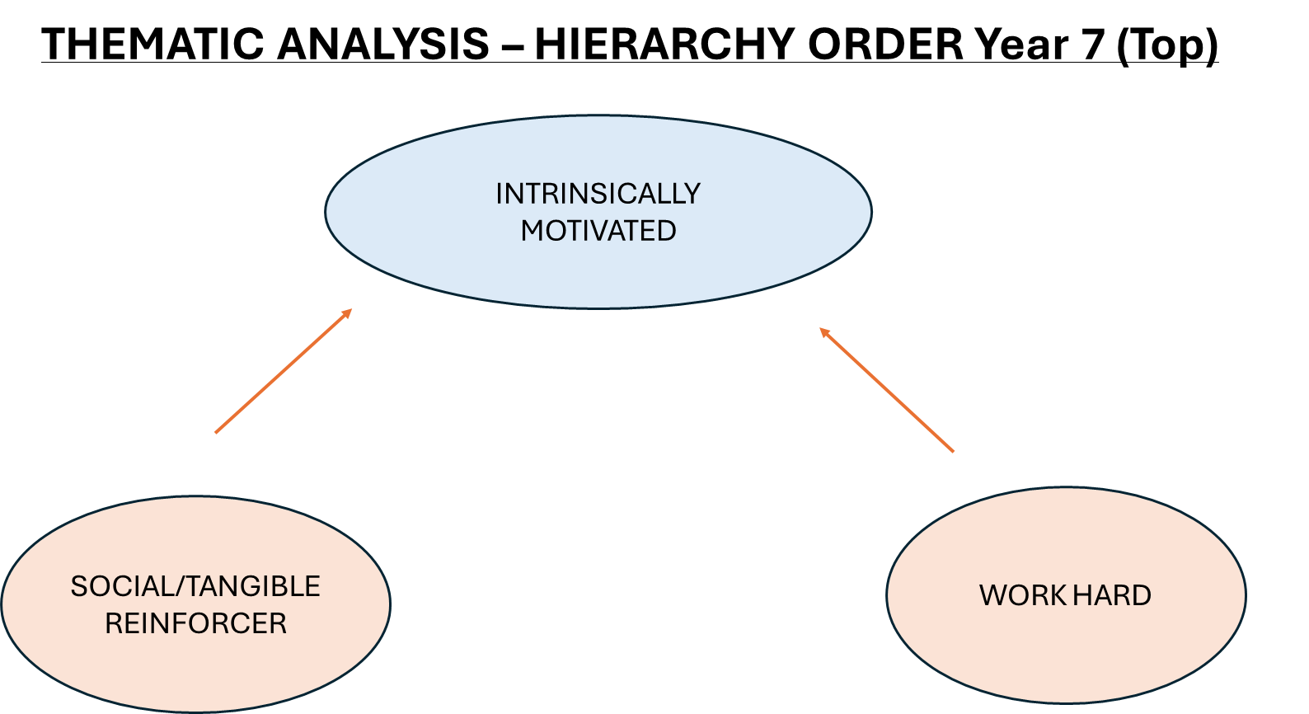
THEMATIC ANALYSIS – HIERARCHY ORDER YEAR 7 (LOW)
Figure 3.2
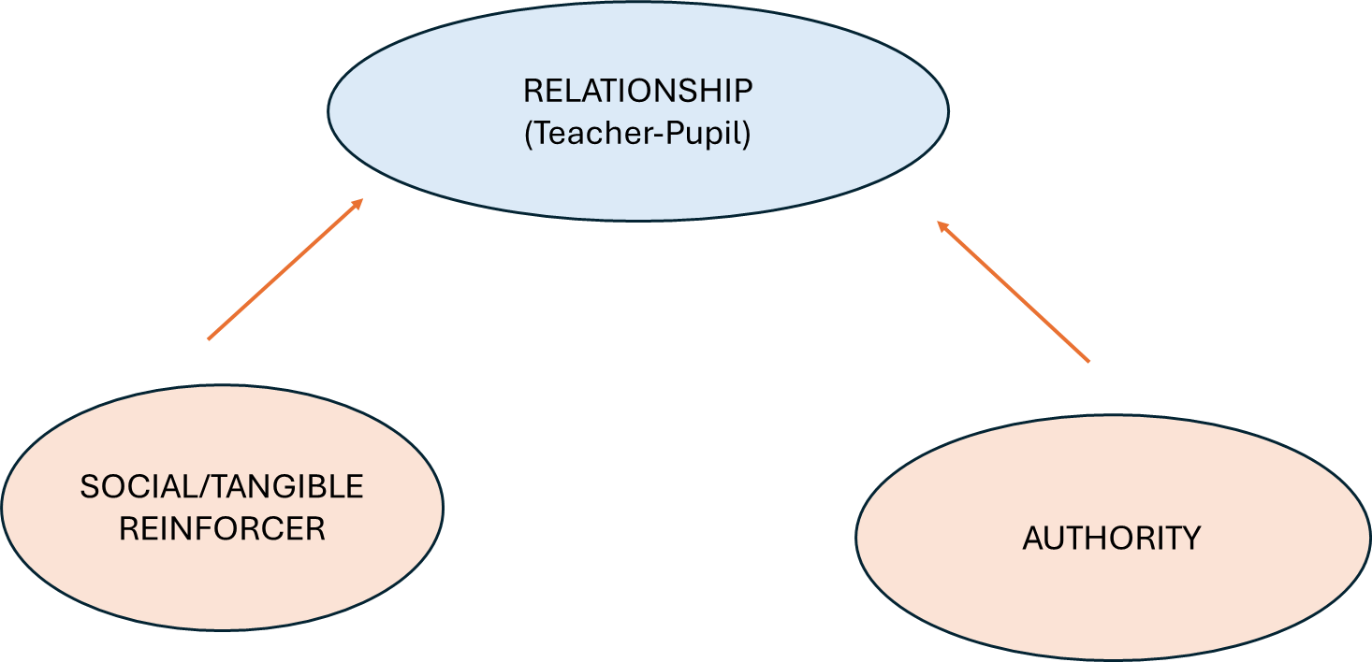
SECTION B QUESTIONNAIRE
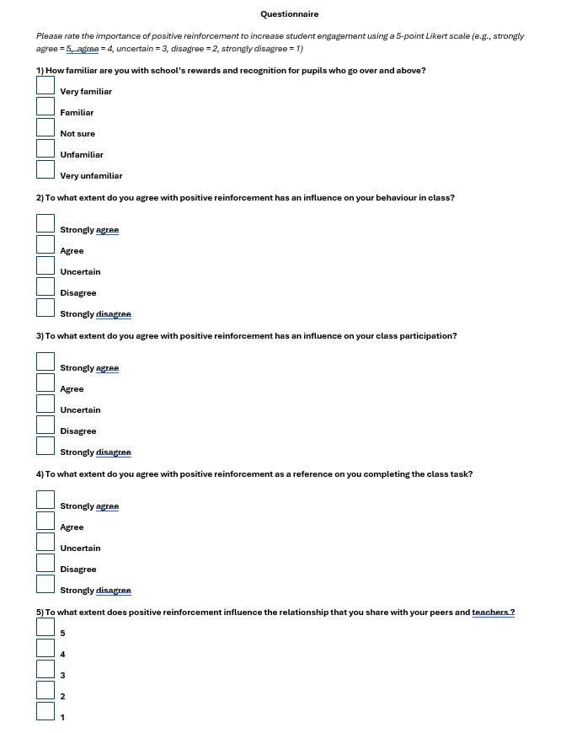
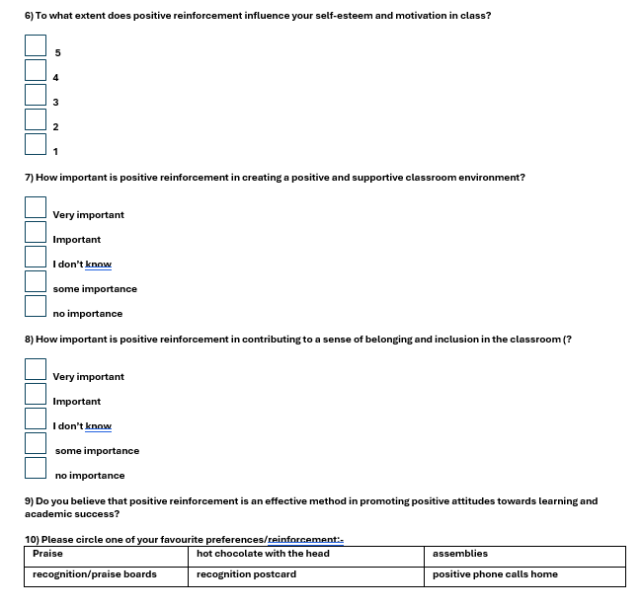
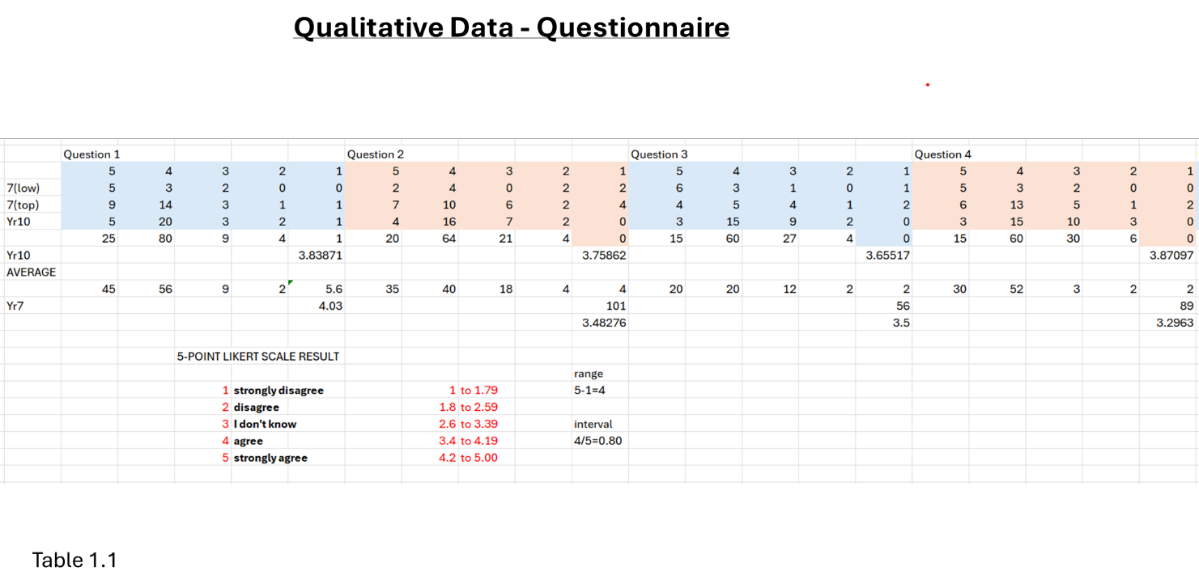
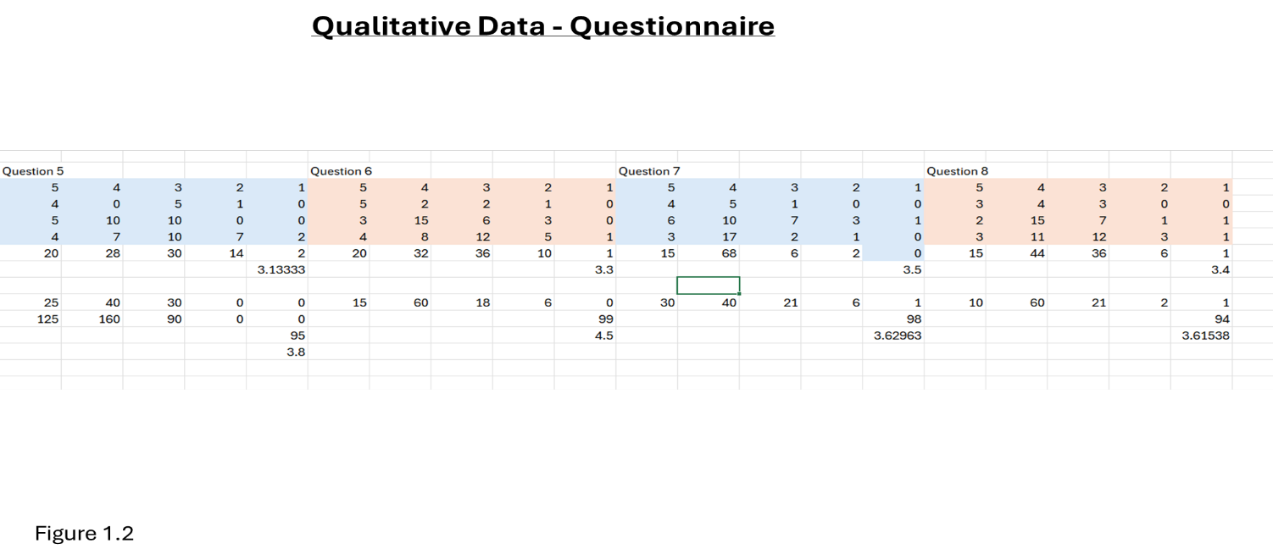
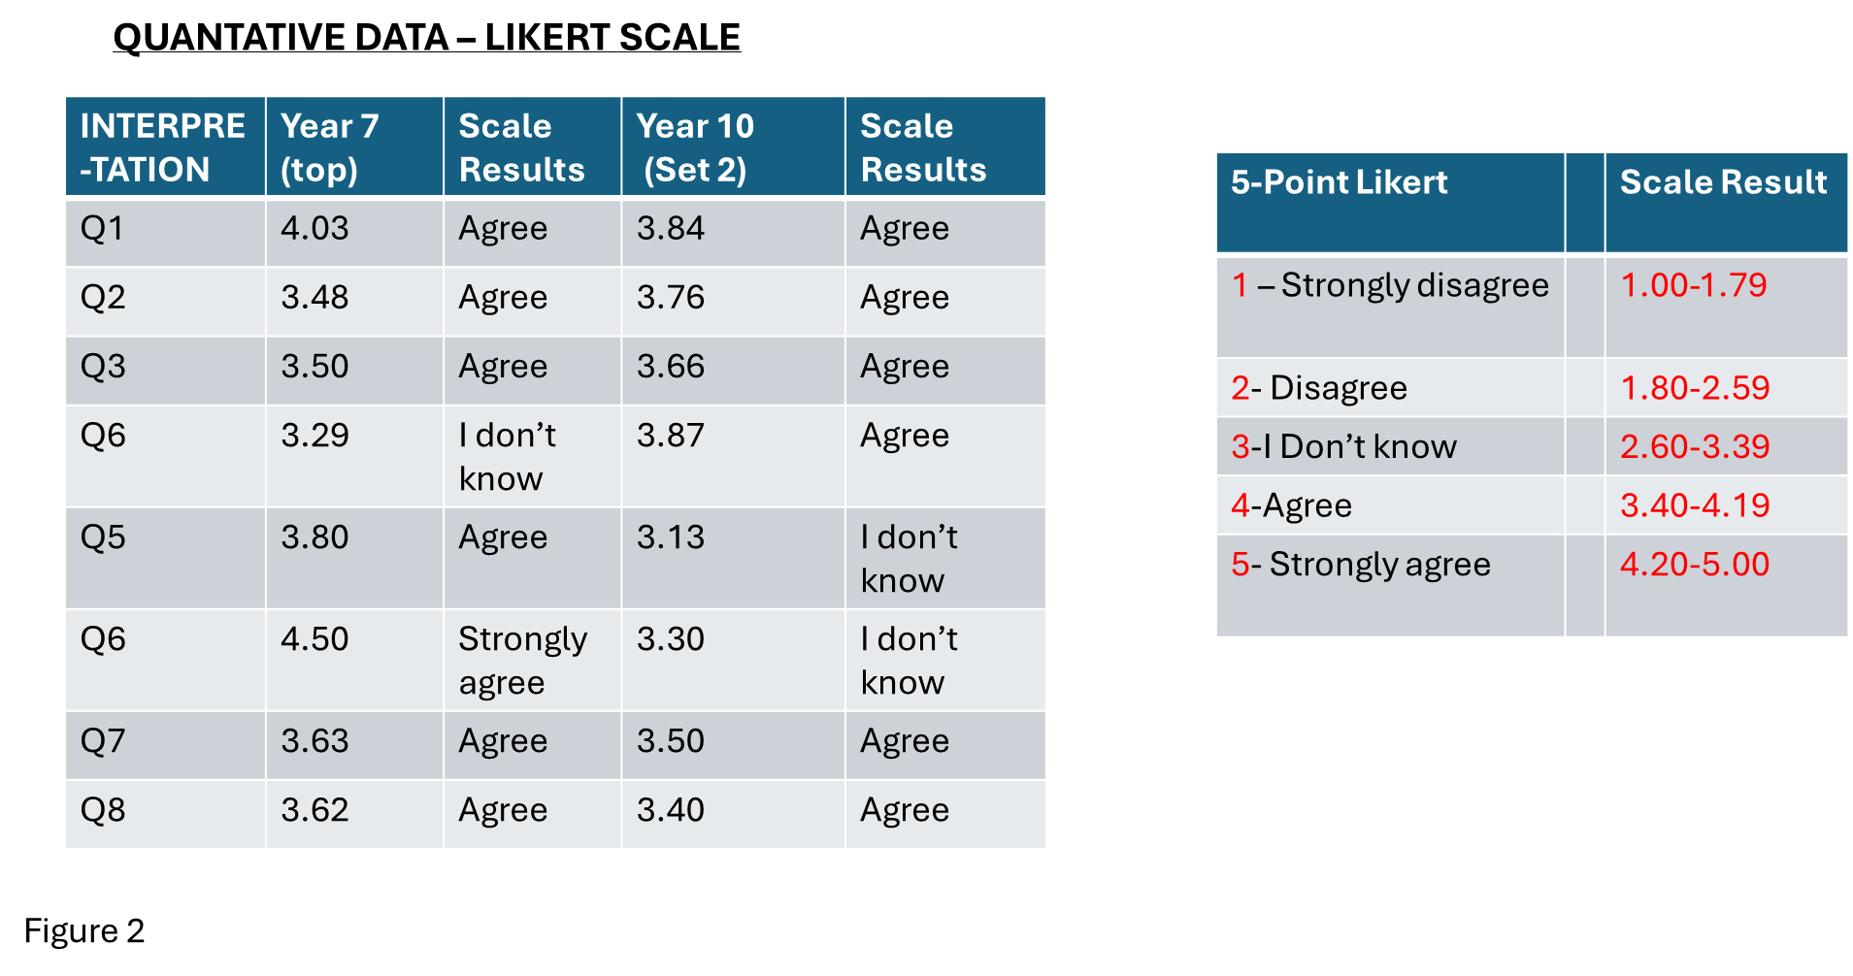
Appemdix 2 – Consent Form



Appendix 3 – Ethics Form
APPLICATION FOR ETHICAL APPROVAL

RESEARCH STUDENTS
This form is to be completed by the student within SIX months for full-time students and TWELVE months for part time students, after the commencement of the research degree or following progression to Part Two of your course.

Once complete, submit this form via the MyTSD Doctoral College Portal at (https://mytsd.uwtsd.ac.uk).

This document is also available in Welsh.

RESEARCH STAFF ONLY
All communications relating to this application during its processing must be in writing and emailed to pgresearch@uwtsd.ac.uk , with the title ‘Ethical Approval’ followed by your name.

STUDENTS ON UNDERGRADUATE OR TAUGHT MASTERS PROGRAMMES should submit this form (and receive the outcome) via systems explained to you by the supervisor/module leader.

In order for research to result in benefit and minimise risk of harm, it must be conducted ethically. A researcher may not be covered by the University’s insurance if ethical approval has not been obtained prior to commencement.

The University follows the OECD Frascati manual definition of research activity: “creative work undertaken on a systematic basis in order to increase the stock of knowledge, including knowledge of man, culture and society, and the use of this stock of knowledge to devise new applications”. As such this covers activities undertaken by members of staff, postgraduate research students, and both taught postgraduate and undergraduate students working on dissertations/projects.

The individual undertaking the research activity is known as the “principal researcher”.

Ethical approval is not required for routine audits, performance reviews, quality assurance studies, testing within normal educational requirements, and literary or artistic criticism.

Please read the notes for guidance before completing ALL sections of the form.

This form must be completed and approved prior to undertaking any research activity. Please see Checklist for details of process for different categories of application.

SECTION A: About You (Principal Researcher)
1 | Full Name: |  | Tai Foon Lam
2 | Tick all boxes that apply: |  | Member of staff: | ☐ | Honorary research fellow: | ☐
 | Undergraduate Student | ☐ | Taught Postgraduate Student | ☒ | Postgraduate Research Student | ☐

3 | Institute/Academic Discipline/Centre: | UWTSD
4 | Campus: | Swansea
5 | E-mail address: | 0851389@student.uwtsd.ac.uk
6 | Contact Telephone Number: | 07863479309
 | For students:
7 | Student Number: | 0851389
8 | Programme of Study: | PGCE Secondary (Mathematics)
9 | Director of Studies/Supervisor: | Catherine Morgan

SECTION B: Approval for Research Activity
1 | Has the research activity received approval in principle?  (please check the Guidance Notes as to the appropriate approval process for different levels of research by different categories of individual) |  | YES | ☒ | NO | ☐
 |  |  |  |  | Date
2 | If Yes, please indicate source of approval (and date where known): Approval in principle must be obtained from the relevant source prior to seeking ethical approval | Research Degrees Committee |  | ☐
2 |  | Institute Research Committee |  | ☐
2 |  | Catherine Morgan |  | ☒ | 14/03/2024

SECTION C: Internal and External Ethical Guidance Materials
 | Please list the core ethical guidance documents that have been referred to during the completion of this form (including any discipline-specific codes of research ethics, location-specific codes of research ethics, and also any specific ethical guidance relating to the proposed methodology). Please tick to confirm that your research proposal adheres to these codes and guidelines. You may add rows to this table if needed.
1 | UWTSD Research Ethics & Integrity Code of Practice | ☒
2 | UWTSD Research Data Management Policy | ☒
3 | BERA (2018) Ethical guidelines for educational research. 4th edn. | ☒

SECTION D: External Collaborative Research Activity
If there are external collaborators then you should gain consent from the contact persons to share their personal data with the university. If there are no external collaborators then leave this section blank and continue to section E.
1 | Institution
2 | Contact person name
3 | Contact person e-mail address
4 | Is your research externally funded? |  | YES | ☐ | NO |  | ☐
5 | Are you in receipt of a KESS scholarship? |  | YES | ☐ | NO |  | ☐
6 | Are you specifically employed to undertake this research in either a paid or voluntary capacity? | Voluntary | YES | ☐ | NO | ☐
7 |  | Employed | YES | ☐ | NO | ☐
8 | Is the research being undertaken within an existing UWTSD Athrofa Professional Learning Partnership (APLP)? | If YES then the permission question below does not need to be answered. | YES | ☐ | NO |  | ☐
9 | Has permission to undertake the research has been provided by the partner organisation? | (If YES attach copy)  If NO the application cannot continue | YES | ☐ | NO |  | ☐

Where research activity is carried out in collaboration with an external organisation
10 | Does this organisation have its own ethics approval system? | YES | ☐ | NO | ☐
 | If Yes, please attach a copy of any final approval (or interim approval) from the organisation (this may be a copy of an email if appropriate).

SECTION E: Details of Research Activity
1 | Indicative title: | What are pupils’ perceptions of positive reinforcement as a strategy for classroom behaviour and class motivation?
2 | Proposed start date: | 14/03/2024 | Proposed end date: | 31/07/2024
Introduction to the Research (maximum 300 words per section)

Demonstrate, briefly, how Existing Research has informed the proposed activity and explain
- What the research activity will add to the body of knowledge
- How it addresses an area of importance.
3 | Purpose of Research Activity  The purpose of this assignment is to find out pupils’ perceptions of a classroom management strategy, such as positive reinforcement may have an impact on their behaviour, positively.
4 | Research Question  What are pupils’ perceptions of positive reinforcement as a strategy to classroom management?  (this box should expand as you type)
5 | Aims of Research Activity  The aim of this research is to achieve a better understanding of learners on the use of positive reinforcement as a strategy of classroom management. I want to gain a better understanding of using positive reinforcement techniques, such as praise, rewards and certificates may or may not have an effect in managing classroom behaviour and if so, does it improve pupils’ engagement and learning outcomes from pupils’ points of views?
6 | Objectives of Research Activity  - To examine students’ perceptions of positive reinforcement, in the form of praise, rewards, certificates.  - To offer an insight from students’ perspectives an impact, if any, on motivation and engagement.  - To offer an insight from students’ perspectives, the effectiveness of using positive reinforcement techniques in reducing disruptive behaviour in a classroom environment.  - To inform my future practices the implementation of this strategy for behaviour management – to add to my repertoire of teaching toolkit.  (this box should expand as you type)
Proposed methods (maximum 600 words)
Provide a brief summary of all the methods that may be used in the research activity, making it clear what specific techniques may be used. If methods other than those listed in this section are deemed appropriate later, additional ethical approval for those methods will be needed. You do not need to justify the methods here, but should instead describe how you intend to collect the data necessary for you to complete your project.
7 | Interviews of Year Groups (recorded)  A small group of 5-8 pupils will be interviewed in a private room sitting within the school. The interview will be recorded with consent sought prior to interview. The interview is semi-structured, targeted to allow freedom of speech and thoughts. The interviewing time will not be longer than an hour with the data collected and stored in personal laptop.  Questionnaire – 10 – 20 (Year 7, 8, 9, 10) A set of 10-20 structured questions which are easy to understand, complete with instructions will be distributed to all pupils in each year group in person after lesson to collect quantitative data on pupils’ perceptions on positive reinforcement such as praise, rewards, certificates. The questionnaires will be collected within a week. As well as handouts pupils will have the option of doing the questionnaire online.  Observations - Observations undertaken will be in the presence of a subject mentor, systematically noting the frequency of behaviour, teacher-pupil interactions. No video or audio recording equipments will be used.  After all of the above data collected, they will be reviewed and analysed with existing analysis from previous studies using the thematic analysis approach.  (this box should expand as you type)
Location of research activity
Identify all locations where research activity will take place.
8 | Secondary School, in Swansea.
Research activity outside of the UK
If research activity will take place overseas, you are responsible for ensuring that local ethical considerations are complied with and that the relevant permissions are sought. Specify any local guidelines (e.g. from local professional associations/learned societies/universities) that exist and whether these involve any ethical stipulations beyond those usual in the UK (provide details of any licenses or permissions required). Also specify whether there are any specific ethical issues raised by the local context in which the research activity is taking place, for example, particular cultural and/or legal sensitivities or vulnerabilities of participants. If you live in the country where you will do the research then please state this.
9 | N/a  (this box should expand as you type)

10 | Use of documentation not in the public domain: Are any documents NOT publicly available? | NO | ☒
10 |  | YES | ☐
11 | If Yes, please provide details here of how you will gain access to specific documentation that is not in the public domain and that this is in accordance with the current data protection law of the country in question and that of England and Wales.  (this box should expand as you type)

 | Does your research relate to one or more of the seven aims of the Well-being of Future Generations (Wales) Act 2015? | YES | NO
12 | A prosperous Wales | ☐ | ☒
13 | A resilient Wales | ☐ | ☒
14 | A healthier Wales | ☐ | ☒
15 | A more equal Wales | ☒ | ☐
16 | A Wales of cohesive communities | ☐ | ☒
17 | A Wales of vibrant culture and thriving Welsh language | ☐ | ☒
18 | A globally responsible Wales | ☐ | ☒
19 | If YES to any of the above, please give details:
These are aligned to the seven aims of the well-being of Future Generations (Wales) Act 2015.

(this box should expand as you type)

SECTION F: Scope of Research Activity
 | Will the research activity include: | YES | NO
1 | Use of a questionnaire or similar research instrument? | ☒ | ☐
2 | Use of interviews? | ☒ | ☐
3 | Use of focus groups? | ☒ | ☐
4 | Use of participant diaries? | ☐ | ☒
5 | Use of video or audio recording? | ☒ | ☐
6 | Use of computer-generated log files? | ☐ | ☒
7 | Participant observation with their knowledge? | ☒ | ☐
8 | Participant observation without their knowledge? | ☐ | ☒
9 | Access to personal or confidential information without the participants’ specific consent? | ☐ | ☒
10 | Administration of any questions, test stimuli, presentation that may be experienced as physically, mentally or emotionally harmful / offensive? | ☐ | ☒
11 | Performance of any acts which may cause embarrassment or affect self-esteem? | ☐ | ☒
12 | Investigation of participants involved in illegal activities? | ☐ | ☒
13 | Use of procedures that involve deception? | ☐ | ☒
14 | Administration of any substance, agent or placebo? | ☐ | ☒
15 | Working with live vertebrate animals? | ☐ | ☒
16 | Procedures that may have a negative impact on the environment? | ☐ | ☒
17 | Other primary data collection methods. Please indicate the type of data collection method(s) below. | ☐ | ☒
 | Details of any other primary data collection method:  (this box should expand as you type) | ☐ | ☒
If NO to every question, then the research activity is (ethically) low risk and may be exempt from some of the following sections (please refer to Guidance Notes).

If YES to any question, then no research activity should be undertaken until full ethical approval has been obtained.

SECTION G: Intended Participants
If there are no participants then do not complete this section, but go directly to section H.

 | Who are the intended participants: | YES | NO
1 | Students or staff at the University? | ☐ | ☒
2 | Adults (over the age of 18 and competent to give consent)? | ☐ | ☒
3 | Vulnerable adults? | ☐ | ☒
4 | Children and Young People under the age of 18? (Consent from Parent, Carer or Guardian will be required) | ☒ | ☐
5 | Prisoners? | ☐ | ☒
6 | Young offenders? | ☐ | ☒
7 | Those who could be considered to have a particularly dependent relationship with the investigator or a gatekeeper? | ☐ | ☒
8 | People engaged in illegal activities? | ☐ | ☒
9 | Others. Please indicate the participants below, and specifically any group who may be unable to give consent. | ☐ | ☐
 | Details of any other participant groups:  Proposed Year groups: 7, 8, 9, 10  (this box should expand as you type) | ☐ | ☐

Participant numbers and source
Provide an estimate of the expected number of participants. How will you identify participants and how will they be recruited?

10 | How many participants are expected? | Interviews : maximum of 16  Hoping to have 2 small group sessions of 5-8 of Year 7, top set and bottom set in Maths. Although they are already in sets, I will still differentiate them in abilities. I will take up suggestions from my subject mentor.  Questionnaires: maximum of 120  Class observations: maximum of 120  (this box should expand as you type)
11 | Who will the participants be? | Pupils that I will be teaching in PTE2 Year 7,8,9,10  (this box should expand as you type)
12 | How will you identify the participants? | These participants will be pupils I will be teaching in PTE2, I will speak to them first to find out interested parties and then offer an informal briefing of the research activity and their right to withdraw from the research if they find it uncomfortable. I will carefully select 5-8 pupils from top set Year 7 and bottom set (5-8 pupils) also. So two individual interviews.  I will email an invitation to participate in the research focussed groups an email with the briefing will be sent that clearly explain the ethical aspects and purposes of the research, seeking involved consent and providing information expectations of professional contact for focused discussions.  To form the staff group, an email will be sent to key staff in specific roles to invite them to focus group. This group will include between 4 to 6 participants within specific roles.  (this box should expand as you type)

 | Information for participants: | YES | NO | N/A
13 | Will you describe the main research procedures to participants in advance, so that they are informed about what to expect? | ☒ | ☐ | ☐
14 | Will you tell participants that their participation is voluntary? | ☒ | ☐ | ☐
15 | Will you obtain written consent for participation? | ☒ | ☐ | ☐
16 | Will you explain to participants that refusal to participate in the research will not affect their treatment or education (if relevant)? | ☒ | ☐ | ☐
17 | If the research is observational, will you ask participants for their consent to being observed? | ☒ | ☐ | ☐
18 | Will you tell participants that they may withdraw from the research at any time and for any reason? | ☒ | ☐ | ☐
19 | With questionnaires, will you give participants the option of omitting questions they do not want to answer? | ☒ | ☐ | ☐
20 | Will you tell participants that their data will be treated with full confidentiality and that, if published, it will not be identifiable as theirs? | ☒ | ☐ | ☐
21 | Will you debrief participants at the end of their participation, in a way appropriate to the type of research undertaken? | ☐ | ☒ | ☐
22 | If NO to any of above questions, please give an explanation
My email address will be given to participants should they need further information.

(this box should expand as you type)

 | Information for participants: | YES | NO | N/A
24 | Will participants be paid? | ☐ | ☒ | ☐
25 | Is specialist electrical or other equipment to be used with participants? | ☐ | ☒ | ☐
26 | Are there any financial or other interests to the investigator or University arising from this study? | ☐ | ☒ | ☐
27 | Will the research activity involve deliberately misleading participants in any way, or the partial or full concealment of the specific study aims? | ☐ | ☒ | ☐
28 | If YES to any question, please provide full details
 | (this box should expand as you type)

SECTION H: Anticipated Risks

Outline any anticipated risks that may adversely affect any of the participants, the researchers and/or the University, and the steps that will be taken to address them.

If you have completed a full risk assessment (for example as required by a laboratory, or external research collaborator) you may append that to this form.
1 | Full risk assessment completed and appended? |  | Yes | ☐
1 |  |  | No | ☒
2 | Risks to participants  For example: sector-specific health & safety, emotional distress, financial disclosure, physical harm, transfer of personal data, sensitive organisational information
 | Risk to participants:  (this box should expand as you type) | How you will mitigate the risk to participants:  (this box should expand as you type)
3 | If research activity may include sensitive, embarrassing or upsetting topics (e.g. sexual activity, drug use) or issues likely to disclose information requiring further action (e.g. criminal activity), give details of the procedures to deal with these issues, including any support/advice (e.g. helpline numbers) to be offered to participants. Note that where applicable, consent procedures should make it clear that if something potentially or actually illegal is discovered in the course of a project, it may need to be disclosed to the proper authorities
 | (this box should expand as you type)
4 | Risks to the investigator  For example: personal health & safety, physical harm, emotional distress, risk of accusation of harm/impropriety, conflict of interest
 | Risk to the investigator:  (this box should expand as you type) | How you will mitigate the risk to the investigator:  (this box should expand as you type)
5 | University/institutional risks  For example: adverse publicity, financial loss, data protection
 | Risk to the University:  (this box should expand as you type) | How you will mitigate the risk to the University:  (this box should expand as you type)
6 | Environmental risks  For example: accidental spillage of pollutants, damage to local ecosystems
 | Risk to the environment:  - Use of paper  - Travel - Carbon footprint  (this box should expand as you type) | How you will mitigate the risk to environment:  This research activity will mostly use electronic systems, reducing the need for bleached paper and need for travel.  (this box should expand as you type)

 | Disclosure and Barring Service
 | If the research activity involves children or vulnerable adults, a Disclosure and Barring Service (DBS) certificate must be obtained before any contact with such participants. | YES | NO | N/A
7 | Does your research require you to hold a current DBS Certificate? | ☒ | ☐ | ☐
8 | If YES, please give the certificate number. If the certificate number is not available please write “Pending”; in this case any ethical approval will be subject to providing the appropriate certificate number. | 001847474827

SECTION I: Feedback, Consent and Confidentiality

1 | Feedback  What de-briefing and feedback will be provided to participants, how will this be done and when?
An email address is provided so participants are able to contact for further details or results or withdraw from the research activity.

(this box should expand as you type)
2 | Informed consent  Describe the arrangements to inform potential participants, before providing consent, of what is involved in participating. Describe the arrangements for participants to provide full consent before data collection begins. If gaining consent in this way is inappropriate, explain how consent will be obtained and recorded in accordance with prevailing data protection legislation.
Paper questionnaire & observation = Participants sign a consent form (parental consent), two parts of a consent form.
Focussed interview groups = participants sign a consent form and an assent form.
Online questionnaire = screen before the question, start the access, the consent form, informing participants that by clicking on the next button they are providing consent.
(this box should expand as you type)
3 | Confidentiality / Anonymity  Set out how anonymity of participants and confidentiality will be ensured in any outputs. If anonymity is not being offered, explain why this is the case.
The researcher will not disclose participants’ personal details or information to a third-party. The interview information will be treated with the strictest confidence and will not be disclosed to any third party members, stored in my laptop. The research activity will be aligned with BERA (2018) guidelines.

(this box should expand as you type)

SECTION J: Data Protection and Storage

 | Does the research activity involve personal data (as defined by the General Data Protection Regulation 2016 “GDPR” and the Data Protection Act 2018 “DPA”)? | YES | NO
1 | “Personal data” means any information relating to an identified or identifiable natural person (‘data subject’). An identifiable natural person is one who can be identified, directly or indirectly, in particular by reference to an identifier such as a name, an identification number, location data, an online identifier or to one or more factors specific to the physical, physiological, genetic, mental, economic, cultural or social identity of that natural person. Any video or audio recordings of participants is considered to be personal data. | ☐ | X
 | If YES, provide a description of the data and explain why this data needs to be collected:
2 | (this box should expand as you type)
 | Does it involve special category data (as defined by the GDPR)? | YES | NO
3 | “Special category data” means sensitive personal data consisting of information as to the data subjects’ –  (a) racial or ethnic origin,  (b) political opinions,  (c ) religious beliefs or other beliefs of a similar nature,  (d) membership of a trade union (within the meaning of the Trade Union and Labour Relations (Consolidation) Act 1992),  (e) physical or mental health or condition,  (f) sexual life,  (g) genetics,  (h) biometric data (as used for ID purposes), | ☐ | X
 | If YES, provide a description of the special category data and explain why this data needs to be collected:
4 | (this box should expand as you type)

 | Will data from the research activity (collected data, drafts of the thesis, or materials for publication) be stored in any of the following ways? | YES | NO
5 | Manual files (i.e. in paper form)? | ☒ | ☐
6 | University computers? | ☐ | ☒
7 | Private company computers? | ☐ | ☒
8 | Home or other personal computers? | ☒ | ☐
9 | Laptop computers/ CDs/ Portable disk-drives/ memory sticks? | ☒ | ☐
10 | “Cloud” storage or websites? | ☐ | ☒
11 | Other – specify: | ☐ | ☒
12 | For all stored data, explain the measures in place to ensure the security of the data collected, data confidentiality, including details of backup procedures, password protection, encryption, anonymisation and pseudonymisation:
All data will be kept in password, protected, personal computer. All participants will be given a unique identify to ensure confidentiality in this list will be kept securely in the past protected folder. If any cloud storages needed, the University Office 365 system will be used, which will be encrypted and a date and the cloud is anonymized. The data will be stored until receipt of the dissertation result and then deleted. Participants will have the right to ask to see what data is held relating to them, and these state will be deleted immediately. If the participants requests this, in which case the data will not be used in the project.

(this box should expand as you type)

 | Data Protection
 | Will the research activity involve any of the following activities: | YES | NO
13 | Electronic transfer of data in any form? | ☒ | ☐
14 | Sharing of data with others at the University outside of the immediate research team? | ☐ | ☒
15 | Sharing of data with other organisations? | ☐ | ☒
16 | Export of data outside the UK or importing of data from outside the UK? | ☐ | ☒
17 | Use of personal addresses, postcodes, faxes, emails or telephone numbers? | ☐ | ☒
18 | Publication of data that might allow identification of individuals? | ☐ | ☒
19 | Use of data management system? | ☐ | ☒
20 | Data archiving? | ☒ | ☐
21 | If YES to any question, please provide full details, explaining how this will be conducted in accordance with the GDPR and Data Protection Act (2018) (and any international equivalents, where appropriate):
Each participants electronic consent form and data from interviews, class, observation, and questionnaire will be stored in the secure place in a password, protected, personal computer or the university office, 365 system which will be encrypted. All personal identification information will be removed or anonymized during transcription.

(this box should expand as you type)
22 | List all who will have access to the data generated by the research activity:
The researcher,Tai Lam and UWTSD staff members.

(this box should expand as you type)
23 | List who will have control of, and act as custodian(s) for, data generated by the research activity:
The researcher, Tai Lam.

(this box should expand as you type)
24 | Give details of data storage arrangements, including security measures in place to protect the data, where data will be stored, how long for, and in what form. Will data be archived – if so how and if not why not.
Signed, informed, consent forms in paper form will be kept in a loft file cabinet and will be unavailable to anyone except the researcher. I’m receiving the feedback and mark for this piece of work, the signed informed, consent forms will be destroyed and audio-and/or videotaped data will be deleted.

(this box should expand as you type)
25 | Please indicate if your data will be stored in the UWTSD Research Data Repository (see https://researchdata.uwtsd.ac.uk/ ). If so please explain. (Most relevant to academic staff)
No.

(this box should expand as you type)
26 | Confirm that you have read the UWTSD guidance on data management (see https://www.uwtsd.ac.uk/library/research-data-management/) | YES | ☒
27 | Confirm that you are aware that you need to keep all data until after your research has completed or the end of your funding | YES | ☒

SECTION K: Declaration
The information which I have provided is correct and complete to the best of my knowledge. I have attempted to identify any risks and issues related to the research activity and acknowledge my obligations and the rights of the participants.

In submitting this application I hereby confirm that I undertake to ensure that the above named research activity will meet the University’s Research Ethics and Integrity Code of Practice which is published on the website: https://www.uwtsd.ac.uk/research/research-ethics/
1 | Signature of applicant: |  | Date:  14/03/2024

For STUDENT Submissions:
2 | Director of Studies/Supervisor: |  | Date:
3 | Signature: |  | Date:

For STAFF Submissions:
4 | Academic Director/ Assistant Dean: |  | Date:
5 | Signature: |  | Date:

Checklist: Please complete the checklist below to ensure that you have completed the form according to the guidelines and attached any required documentation:
☒ | I have read the guidance notes supplied before completing the form.
☒ | I have completed ALL RELEVANT sections of the form in full.
☒ | I confirm that the research activity has received approval in principle
☒ | I have attached a copy of final/interim approval from external organisation (where appropriate)
☐ | I have attached a full risk assessment (where appropriate) ONLY TICK IF YOU HAVE ATTACHED A FULL RISK ASSESSMENT
☒ | I understand that it is my responsibility to ensure that the above named research activity will meet the University’s Research Ethics and Integrity Code of Practice.
☒ | I understand that before commencing data collection all documents aimed at respondents (including information sheets, consent forms, questionnaires, interview schedules etc.) must be confirmed by the DoS/Supervisor, module tutor or Academic Director.

RESEARCH STUDENTS ONLY
Once complete, submit this form via the MyTSD Doctoral College Portal at (https://mytsd.uwtsd.ac.uk).

RESEARCH STAFF ONLY
All communications relating to this application during its processing must be in writing and emailed to pgresearch@uwtsd.ac.uk , with the title ‘Ethical Approval’ followed by your name.

STUDENTS ON UNDERGRADUATE OR TAUGHT MASTERS PROGRAMMES should submit this form (and receive the outcome) via systems explained to you by the supervisor/module leader.

