The Sun and The Moon and Their Portrayal in Cultures and Art
Vynn Rixon
The sun and the moon have appeared in art for centuries, whether occurring in stories of old cultures, in art themselves as depictions and what humans see, or in music to tell love. I shall talk about how the Sun and Moon are showcased and their possible meanings in each of these medias. I will discuss Welsh Celtic and Norse Cultures, Michelangelo and Christianity, Caspar David Friedrich, Joesph Mallord William Turner, Wojciech Weiss, Claude Monet, the Flag of Argentina, and the singers Pequeno Cisadao and The Crane Wives.

In many cultures, the sun and moon have a story to go with them. Two examples I shall explore are Norse and Celtic Culture. In Celtic Culture, the sun and moon are influential in beliefs. They are seen as deities and cosmic forces; they are seen in many ways because of how many variations of Celts exist. However, despite so many beliefs, there were ideals relating to the sun and moon that were the same or near it. The sun and moon allowed the Celts to listen to the Earth and live by its cycles. In Celtic mythology, the sun is viewed as a powerful life force. It was associated with warmth, light, and growth. Its cycle helped farmers with their agriculture and seasonal patterns, letting them know when to plant their crops. Sun gods and goddesses had many names depending on which celts you talked to; in Welsh mythology, the sun deity is the goddess and Welsh flower Olwen. In her stories, a man set out to marry her but must first complete the 39 tasks set out by her father, Yspaddaden Penkawer (Giant Hawthorn Tree), a giant chief doomed to die if his daughter were to marry. The man completed the tasks, and the marriage happened on May Day, the beginning of Celtic summer, halfway through the year. Yspaddaden died, and the year ends as the Giant Hawthorne tree drips blood (red berries of a Hawthorne). On the other hand, the moon is affiliated with feminine energies, more cycles, fertility, and mystery. Once again, the moon held power over the farmers when it came to their crops, but it also held a connection to their practices. The Welsh moon and stars goddess Arianrhod was a part of femininity the cycles of life, death, and rebirth. She was also the power of arts, magic, and manifestation. She is known to hold a silver wheel, and with it, she spins the tapestry of life.
Meanwhile, in Norse paganism, the sun and moon are objects, and their story makes them meaningful. They are pulled on chariots by the sister and brother Sol and Mani, with Sol pulling the Sun and Mani the moon. The gods chose them for the jobs after the sun and moon were created, possibly as punishment. The siblings must drive their chariots to avoid being devoured along with the celestial objects by the wolves Skoll and Hati, giants born of Fenrir. In Norse paganism, the wolves will eventually devour the sun and moon, which would signify Ragnarök; a battle between gods, giants, good and evil. It is also the end of the world. The sun and moon are seen as objects to worship the gods, but they are also used to warn of the end of days, instilling a sense of dread when they disappear.
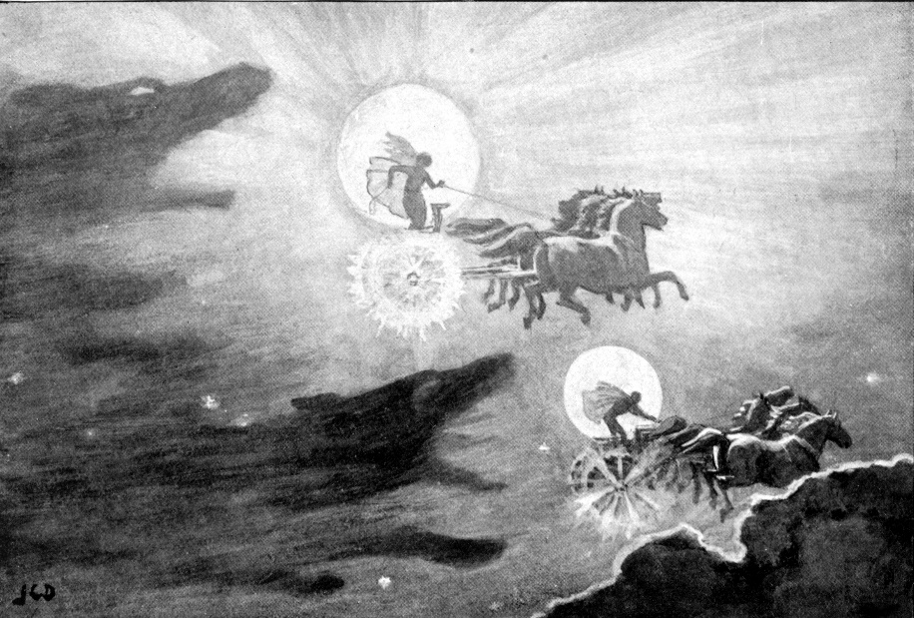
Fig 1. Dollman John Charles, (1909), The Wolves Pursuing Sol and Mani

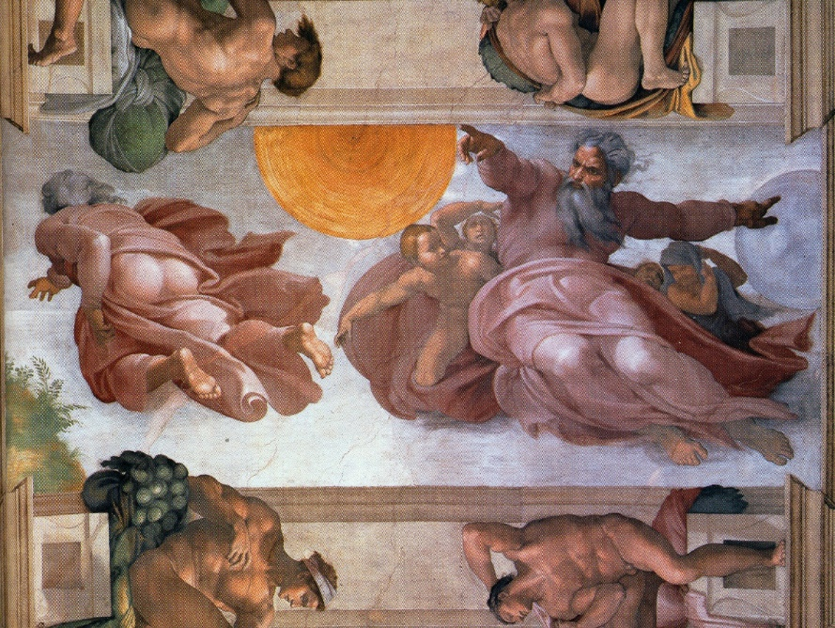
Fig 2. Michelangelo, (1511), The Creation of the Sun, the Moon and The Plants.
The Creation of the Sun, Moon, and Plants is a fresco painting by Michelangelo in the Sistine Chapel in Rome, alongside a collection of similar Christian works. God is creating the sun, moon, and vegetation in this painting. The painting displays God's power in making such things, but it also pays unfair attention to the sun, with the Sun being the front and top center of the painting, displaying its importance with its position. The sun was the first thing that allowed humans to see at all, thus making it more critical. In the Christian faith, the sun represents hope as it symbolizes Jesus’ resurrection.
Paintings of the moon: This painting was done by Caspar David Friedrich and is about him and his friend August Heinrich observing the moon.
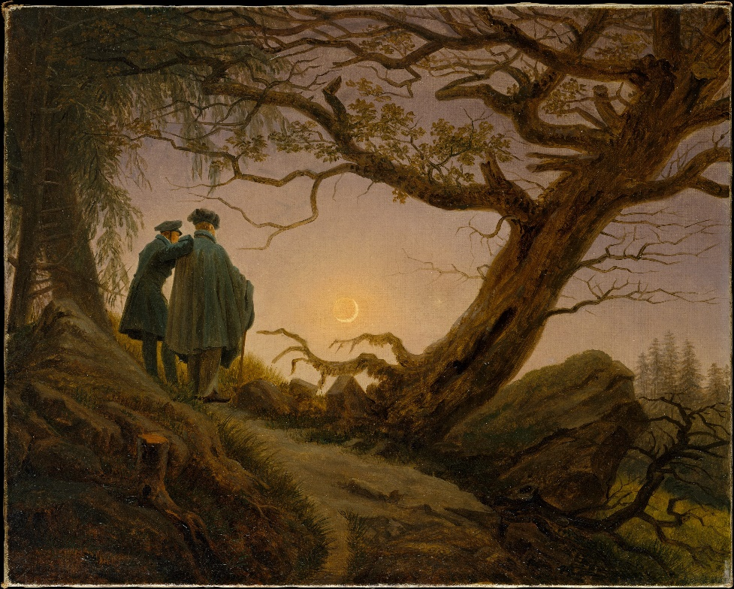
Fig 3. Friedrich Caspar David, (1819), Two Men Contemplating the Moon
The neutral colours used in the painting could represent that this is a domestic scene of life. Two humans admire the beauty of something bigger than themselves; however, the moon's placement could symbolize how they think of themselves above it. They look down on it, although it lights up the night sky in a way they could never. The painting shows the moon as a thing to be mesmerized by.
On the other hand, Fishermen at Sea by Joesph Mallord Williams Turner gives an opposite effect with dramatic light and dark contrast, giving a sense of eeriness. Two men fishing in the dark may send a sense of unease to most, as the ocean is an unexplored habitat with many creatures. To this day, only 5% has been explored. This bottomless pit, mixed with the light in the sky, gives a sense of danger. However, the sea and the moon are beautiful, with songs, poems, and stories about them, which connects Two Men Contemplating the Moon and Fishermen at Sea. It seems it is a common theme for humanity to portray the moon with beauty. Perhaps something about the bright ball of light in the dark enchants them.
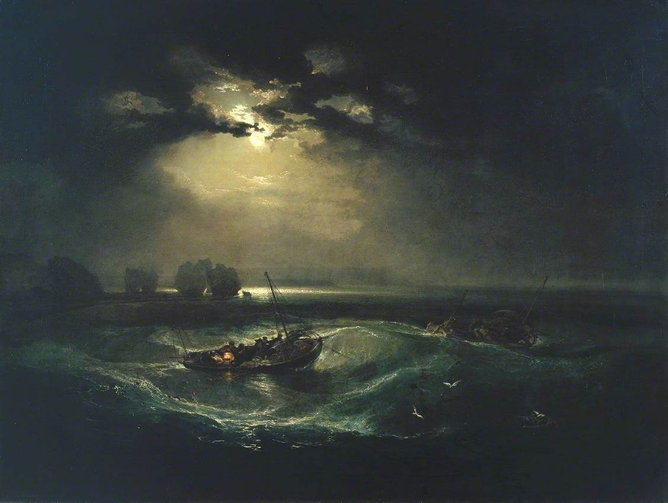
Fig 4. Turner Joesph Mallord Williams, (1796), Fishermen at Sea
Onto a painting of the sun is called A Beaming Sunset and was done by the Polish artist Wojciech Weiss.
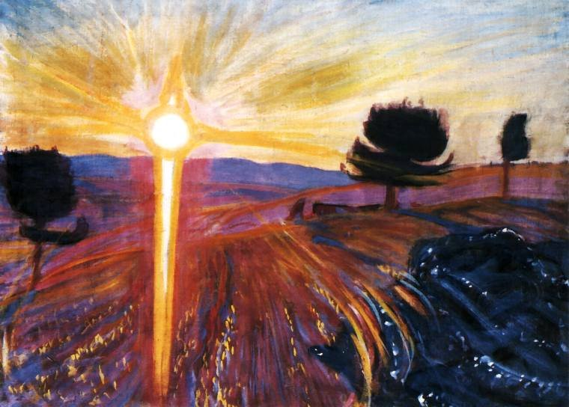
Fig 5. Weiss Wojciech, (1901-1902), A Beaming Sunset
This painting is done in bright, bold colours and strokes, which could show hope and joy. The sun in this gives a sense of wonder and optimism. Everything is going to be okay. The harsh sun rays are reaching out to the view, pulling the viewer into a new day as a sunset does. Similarly, Claude Monet’s Impression Sunrise holds the same ideals as Weiss’s A Beaming Sunset. The painting captures the rise of the sun as men boat across a lake, possibly signifying the beginning of a working day. The world starts back up after a nap; before the rush, life is tranquil. In this painting, the sun’s bright orange stands out against the surrounding landscape's blues, greens, and greys. This could indicate the incoming chaos of the day or hope or danger for the workers in their future.
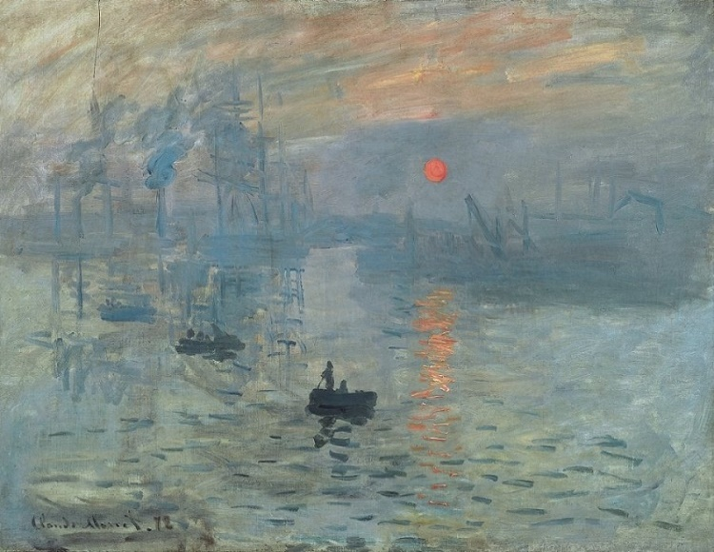
Fig 6. Monet Claude, (1872), Impression Sunrise
Paintings and Stories from Culture and religion aren’t the only things that have the sun and/or moon in them. Other arts that contain them are music and flags. For example, The Argentina flag is a blue and white horizontal striped flag with the sun in the middle.

Fig 7. (1861), Flag of Argentina
The colours reflect the skies and snow of Andes. The sun on the flag is Sol De Mayo, which translates to May Sun. It celebrates the appearance of the sun in cloudy May 5th, 1810, skies. This was when the first mass demonstration for Argentina's independence took place. For the country, it represents their fighting spirit, hope for their future, and freedom.
The sun and moon often pop up in music, commonly used to display love for each other or in place of people in love stories. One of these songs is O Sol e a Lua, a Portuguese love song by artist Pequeno Cisadao, released in 2009. In the music, the sun has been deeply in love with the moon since the reaction of time and proposes but is rejected by the moon, who is unsure and does not want to belong to anyone. The lyrics “O Sol pediu a Lua em casamento. E a Lua disse: “Nao Sei, nao sei, nao sei, me da um tempo” (Translating to: The Sun asked the Moon in marriage. And the Moon said: “I don’t know, I don’t know, I don’t know, give me a break”) and “Pois meu coracao nao pertence a ninguem, sou a inspiracao de todos os casais” (Translating to: Because my heart doesn’t belong to anyone, I am the inspiration of all couples.) tell us this. The song may represent the unrequited love between two people. It is, at its core, a sad love song. The sun will love the moon but will never have her. This is similar and different to the song The Moon Will Sing by The Crane Wives, released in 2015. This song, once more, is about the sun loving the moon the way one person loves another. While O Sol e a Lua is about confessed unrequited love, The Moon Will Sing says, “The Moon will sing a song for me I loved you like the sun, bore the shadows you made with no light of my own” and “I shine only with the light you give me” about loving someone without admitting it and feeling as if they give you purpose even if they will never be together. Still, they love them and will do anything to make their moon happy.

A common theme in the sun and moon showcased in this essay is that the sun represents hope and reemergence; meanwhile, the moon represents beauty and curiosity. Together, they show forms of love, whether the sibling love between Sol and Mani or a romantic attachment to be sung about. I think my research into the sun and moon will lead me into not only researching further celestial bodies but also looking at the cycles of life, nature, and love in art and the world around me.

Bibliography
Britannica. (2023), Flag of Argentina. Available at: https://www.britannica.com/topic/flag-of-Argentina (Accessed: 16th November 2023)
Claud-Monet. (2010), Impressionism Sunset by Claude Monet. Available at: https://www.claude-monet.com/impression-sunrise.jsp (Accessed: 15th November 2023)
Feminism and Religion. (2013), Arianhod, Celtic Star Goddess. Available at: https://feminismandreligion.com/2013/02/23/arianrhod-celtic-star-goddess-2/ (Accessed: 20th November 2023)
Feminism and Religion. (2016), Olwen, Welsh Flower and Sun Goddess by Judith Shaw. Available at: https://feminismandreligion.com/2016/06/22/olwen-welsh-flower-and-sun-goddess-by-judith-shaw/ (Accessed: 20th November 2023)
Flicker. (2011) Radiant Sunset. Available at: https://www.flickr.com/photos/32357038@N08/6270522642/in/photostream/ (Accessed: 15th November 2023)
Genius. (2009), Pequeno Cidadao O Sol E A Lua. Available at: https://genius.com/Pequeno-cidadao-o-sol-e-a-lua-lyrics (Accessed 23rd November 2023)
Genius. (2015), The Moon Will Sing. Available at: https://genius.com/The-crane-wives-the-moon-will-sing-lyrics (Accessed: 24th November)
Lyrics Translate. (2023), Pequeno Cidadao O Sol E A Lua English Translation. Available at: https://lyricstranslate.com/en/o-sol-e-lua-sun-and-moon.html-0 (Accessed: 23rd November 2023)
Michelangelo. (2010), Creation of the Sun, the Moon and the Plants By Michelangelo. Available at: https://www.michelangelo.org/creation-of-the-sun-moon-and-plants.jsp#google_vignette (Accessed 14th November 2023)
Norse Mythology for smart people. (2019), Skoll and Hati. Available at: https://norse-mythology.org/skoll-hati/ (Accessed:13th November 2023)
Otway Crystals. (2023), An Introduction to Celtic Mythology. Available at: https://www.otwaycrystals.com.au/blogs/otwaycrystals-blog/celtic-mythology%23:~:text=In%2520Celtic%2520mythology%2520and%2520beliefs,across%2520much%2520of%2520Western%2520Europe. (Accessed: 19th November 2023)
Pantheon Mythology. (2022), Skoll and Hati – Eaters of the Sun and Moon | Pantheon Mythology. Available at: https://m.youtube.com/watch?v=5b34QfW-Elg&pp=ygUPc2tvbGwgYW5kIGhhdGkg (Accessed: 13th November 2023)
Tate. (2000), Joesph Mallord Williams Turner Fishermen at Sea exhibited 1796. Available at: https://www.tate.org.uk/art/artworks/turner-fishermen-at-sea-t01585 (Accessed: 16th November 2023)
The Met. (2023), Two Men Contemplating the Moon. Available at: https://www.metmuseum.org/art/collection/search/438417 (Accessed: 13th November 2023)

Figure 1: Dollman John Charles, (1909), The Wolves Pursuing Sol and Mani [Available at: https://norse-mythology.org/skoll-hati/ ]
Figure 2: Michelangelo, (1511), The Creation of the Sun, the Moon and The Plants. [Available at: https://www.wikiart.org/en/michelangelo/sistine-chapel-ceiling-creation-of-the-sun-and-moon-1512 ]
Figure 3: Friedrich Caspar David, (1819), Two Men Contemplating the Moon [Available at: https://www.metmuseum.org/art/collection/search/438417 ]
Figure 4: Turner Joesph Mallord Williams, (1796), Fishermen at Sea [Available at: https://artuk.org/discover/artworks/fishermen-at-sea-117749 ]
Figure 5: Weiss Wojciech, (1901-1902), A Beaming Sunset [Available at: https://www.flickr.com/photos/32357038@N08/6270522642 ]
Figure 6: Monet Claude, (1872), Impression Sunrise [Available at: https://www.impressionists.org/impression-sunrise.jsp ]
Figure 7: (1861), Flag of Argentina [Available at: https://www.britannica.com/topic/flag-of-Argentina ]

