University of Wales Trinity Saint David

Wales Institute of Science & Art


BEng Manufacturing Systems Engineering

Module: Engineering Design (ACMA4008)

Assignment Title: Engineering Problem

Name: Mathew Soroka
Student ID: 2406846
Date: January 2025
Table of Contents
Table of Tables…………………………………………………………………………………………………………………………………………2
Table of Figures 3
1. Introduction 4
1.1 Interpretation of the Client Brief 4
2. Legislation considerations 7
3. Specification 8
4. Project Timeline 10
5. Idea Generation 12
5.1 SCAMPER Brainstorming 12
5.2 Market Research 13
5.2.1 Automation and Modified Tank Lid 13
5.2.2 Mechanical Advantage 14
5.2.3 Lid Material selection 14
6. Design Concepts 15
6.1 Proposal 1 – Linear Rail 15
6.2 Proposal 2 – Gas Struts 16
6.3 Proposal 3 – Pneumatic Cylinders 17
6.4 Proposal 4 – Lever Arm 18
6.5 Idea Evaluation 19
7. Documentation and Prototype 20
7.1 Bill of Materials 20
7.2 Technical Drawings and Manufacturing Methods 21
7.2.1 BOM Level 1 and 2– Tank Shelf and Shelf gusset 21
7.2.2 BOM Level 3 – Tank lid 22
7.2.3 BOM Level 4 and 5 – Tank Lid shaft and Lever arm 23
7.2.4 BOM Level 6 – Lid arm 24
7.2.5 Final CAD Assembly 25
7.2.6 Bearing Choice 26
8 Testing and Implementation 27
9 Conclusion 31
10. Bibliography 32
Table of Tables
Table 1- Material performance tests from Assignment brief (2024) 5
Table 2 - Project Specification 8
Table 3 - Decision Matrix 19
Table 4 - Bill of materials (BOM). Bill of Materials Template. (2024) 20

Table of Figures
Figure 1 - Illustration of the Anodising Tank and Lid from Assignment brief (2024) 4
Figure 2 - Gantt Chart of the Project Planning, research and Design and Protyping phase (2024) 10
Figure 3 - Gantt Chart of the Project Implementation and Validation phase (2024) 11
Figure 4 - The SCAMPER model 12
Figure 5 - Automation and Lid modification Idea. Source (KCH Services, 2023) 13
Figure 6- Mechanical Advantage Idea Generation. Source (Li, M. and Automations, F., 2023) 14
Figure 7 - Granta Material Chart Cost vs Density (Ansys, 2025) 14
Figure 8- Sketched Linear rail Solution 15
Figure 9 - Sketched proposal 2 - Gas struts 16
Figure 10 - Sketched proposal 3 - Pneumatic cylinders 17
Figure 11 - Sketched proposal 4 – Lever arm with locking pin 18
Figure 12 - Technical drawing - Tank shelf and gusset 21
Figure 13 - Technical drawing - Tank lid 22
Figure 14 - Technical drawing - Tank lid shaft and lever 23
Figure 15- Technical drawing - Tank lid arm 24
Figure 16 - Final CAD Design 25
Figure 17 - SKF Bearing Characteristics. Source (SKF, 2025) 26
Figure 18 - Bearing specification. Source (SKF, 2025) 26
Figure 19 - FAT Testing. Page 1/4. Source (Safety Culture , 2025) 27
Figure 20 - FAT Testing. Page 2/4. Source (Safety Culture , 2025) 28
Figure 21 - FAT Testing. Page 3/4. Source (Safety Culture , 2025) 29
Figure 22- FAT Testing - Page 4/4. Source (Safety Culture , 2025) 30

Introduction
Working as a Design Engineer within an automotive OEM company, innovation and design are essential, with a strong emphasis on safety. Each component manufactured on-site undergoes several manufacturing processes, including anodisation for both aesthetic appeal and corrosion resistance.
This assignment, given by line management, focuses on analysing the tank lid removal and fitment in the anodisation process. Concerns have been raised by operators and the Health and Safety Manager regarding the manual handling of the tank lid. The goal is to identify the root cause and implement an effective solution.

1.1 Interpretation of the Client Brief
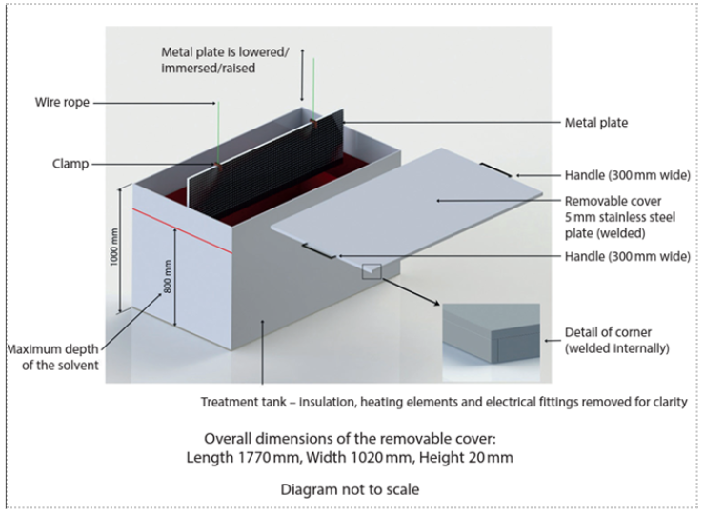
The anodising system consists of a tank, lid, and hoisting system. The tank is filled with temperature-controlled acid (80% capacity), into which metal parts are dipped for anodising. The detachable lid is applied when not in use and removed before hoisting parts as shown in Figure 1.

Figure 1 - Illustration of the Anodising Tank and Lid from Assignment brief (2024)
The problem lies in the movement of the tank lid. While the lid serves a safety purpose, it creates secondary hazards. Currently, the lid is lifted by two people using handles on either side. The primary risks are related to manual handling. The stainless-steel lid could cause injury if the handle shears, leading to a loss of control. The presence of liquid also poses slip, trip, and fall hazards. Additionally, the corrosive sulfuric acid (30%) raises concerns regarding COSHH and exposure limits. As shown in Table 1, the data shows the following material performance when exposed to sulfuric acid.
Table 1- Material performance tests from Assignment brief (2024)

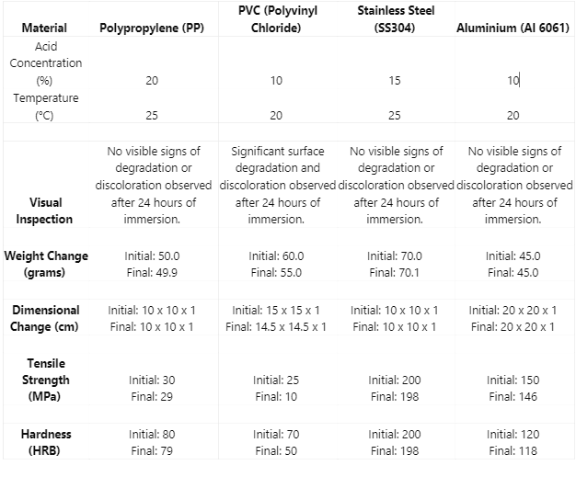

By analysing the data, it can be summarised that:
- PVC performs the worst, showing significant degradation in all categories, making it unsuitable.
- Polypropylene (PP) performs well under high acid concentration and temperature but experiences weight loss/shrinkage, which could affect component assembly and tolerances.
- Metals are the best performers, with only slight reductions in hardness and tensile strength, but no significant weight loss.
The project goal is to improve the safety on the tank lid removal and fitting, transitioning from a two-person to a single-person operation. Opportunities include modifying the tank and lid, with constraints on maintaining the tank’s dimensions and materials. The solution must be safe, allow sufficient clearance for hoisting, and be scalable for low-volume production (low hundreds). The final design must be practical and feasible within these parameters.

Legislation considerations
This project involves equipment modifications that must comply with relevant occupational legislation to ensure personnel safety, maintain legal compliance, and prevent any compromise to existing safety systems. The key relevant legislations that will be adhered to include:
- The Health and Safety at Work etc. Act 1974 (HASAWA): The Health and Safety Executive (HSE) states, “It shall be the duty of every employer to ensure, so far as is reasonably practicable, the health, safety, and welfare at work of all his employees” (1974). This is the overarching legislation designed to protect workers' health and safety.
- The Provision and Use of Work Equipment Regulations 1998 (PUWER): The HSE states, “Every employer shall ensure that all persons who use work equipment have received adequate training for purposes of health and safety, including training in the methods which may be adopted when using the work equipment, any risks which such use may entail, and precautions to be taken” (1998, p. 31).
- Additionally, the HSE states, “Your risk assessment carried out under regulation 3 of the Management Regulations should identify hazards presented by machinery” (1998, p. 38).
- The HSE further states, “In most cases, the objective of risk reduction measures is to prevent contact of part of the body or clothing with any dangerous part of the machine, for example, guarding” (1998, p. 38).
With the legal compliance detailed above the final solution must be safe to use, undergo a thorough risk assessment prior to use, be adequately guarded, and ensure operators are properly trained.

Specification

This aspect of the project focuses on defining the project requirements and deliverables. It outlines the aims and objectives while also serving as a template for the conclusion, where the project's success is evaluated. As shown in Table 2, a wide range of parameters are covered to ensure all expectations are clearly defined.
Table 2 - Project Specification
Timescale | 3 months from start of design to completion.
Target Market​ | This is an In-house project for multiple anodising tanks. There are sister sites facing the same issue, and the solution may be scalable to these locations.
Function​ | Safely allow the opening and closing of the anodising treatment tank lid by a single person.
Design constraints​ | Modifications can be made to the tank and lid, but the materials and dimensions of the tank must be unchanged.  Clearance above is required for safe hoisting of parts by one person.
Size​ | The tank lid must fully cover the tank when closed, with dimensions of 1760mm length and 1000mm width. Its weight must be supported by all components.
Aesthetics (looks) | The solution will be in a corrosive environment, so it will be functional, aesthetically pleasing, and professional, while aligning with its surroundings.
Durability​ | The system is expected to last 10+ years with correct maintenance, supported by a critical spares package for reactive replacements.
Materials | Corrosive resistant, strong and durable for its environment.
Safety​ | Risk assessment compliant with Health & Safety at Work Act, method statement, and on-site permit for project work and operation. Guarding on moveable components to prevent entrapment. All components fit for purpose and structurally sound. Emergency stop included if automated. Operator training and safe use SOP provided.
Cost​ | Financially viable. First prototype circa £10,000, with three quotes for outsourcing to ensure cost efficiency. Subsequent systems will cost around £4,000 each.
Environmental Issues​ | To ensure energy efficiency, long-lasting, 100% recyclable materials will be used. All build waste will be disposed of properly, and components and outsourced work will be sourced locally to reduce the carbon footprint.
Manufacture​ | Fabrication and machining will finalise the prototype. Prime and supplementary movers will be catalogue items. Batch processing (e.g., castings) can be used for complex parts once the concept is proven.
Testing | Prototype, functional, failure, and safety testing, along with:  - Immersion Testing: New materials require a Sulphuric Acid Immersion test if not previously tested.  - Maintenance Testing: Confirm serviceability and servicing time.  - Site Acceptance Testing (SAT): Verify system functionality before project sign-off.

Project Timeline

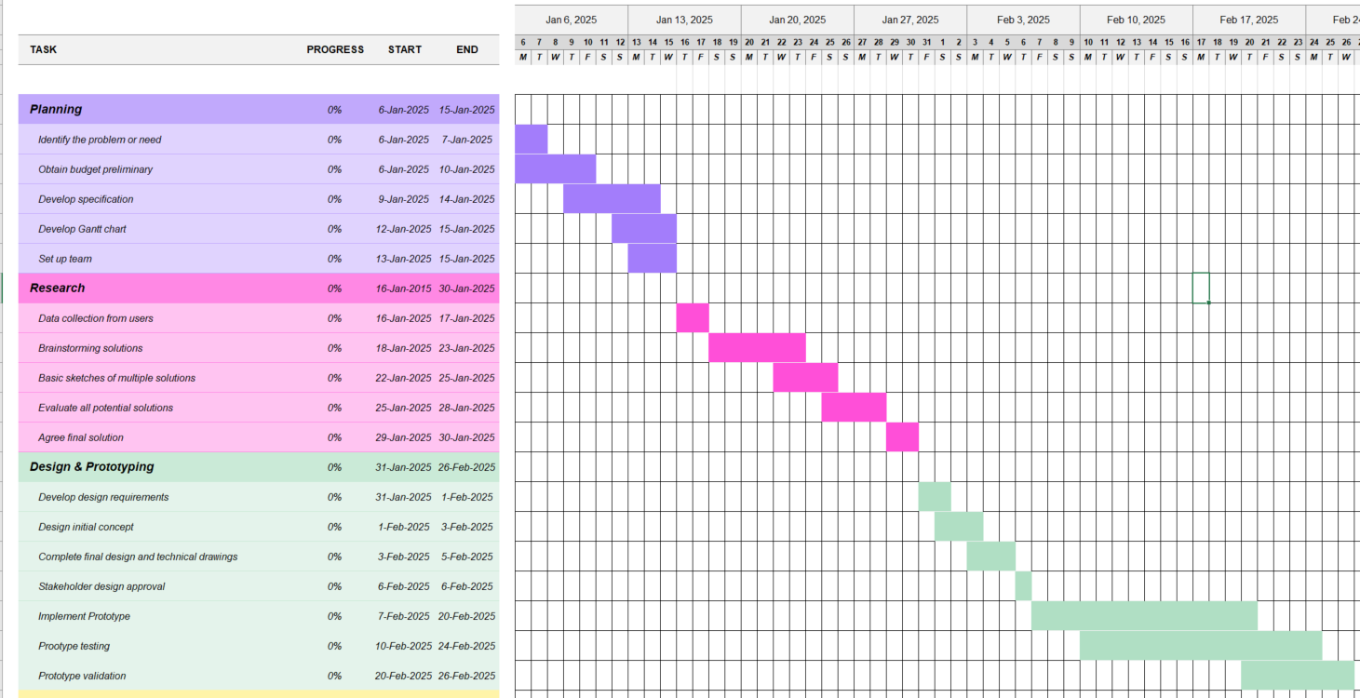
To support this section, a Gantt chart has been created to provide a visual representation of the process flow for each step. This chart serves as a communication tool for stakeholders to understand the process and as a validation piece to ensure the project is completed on time. The project is set up over eleven weeks, allowing adequate time for each step while also establishing clear timescales. As shown in Figure 2, the Planning through to the Design & Prototyping phases 7are displayed.
Figure 2 - Gantt Chart of the Project Planning, research and Design and Protyping phase (2024)

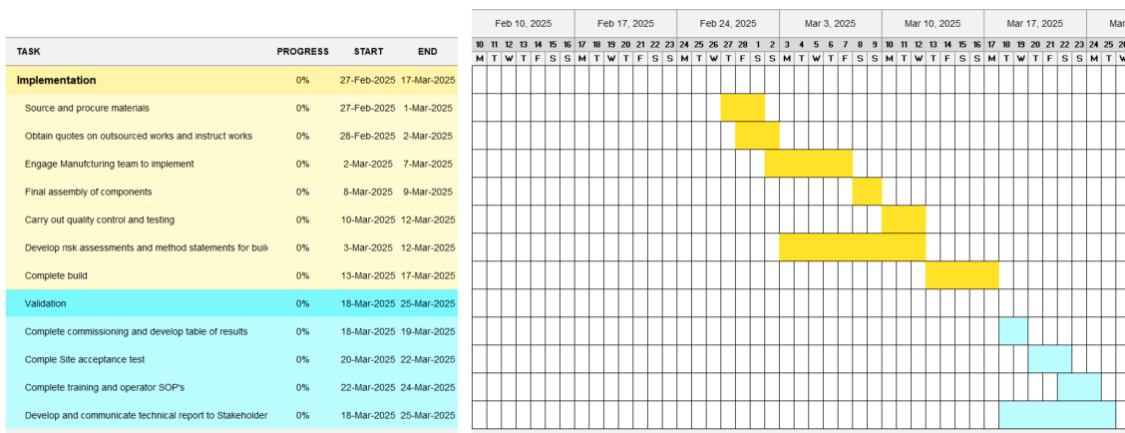
As shown in Figure3, the implementation and Validation phases are detailed.
Figure 3 - Gantt Chart of the Project Implementation and Validation phase (2024)

Idea Generation

SCAMPER Brainstorming

To support this section, a brainstorming methodology can be implemented to get ideas flowing. One methodology is known as SCAMPER and according to Parsons (2024), SCAMPER focuses on modifying existing models rather than generating entirely new products.
As shown in Figure 4, seven questions are posed to eliminate the assumption that existing systems need a complete overhaul, and instead focus on what can be improved rather than what cannot.
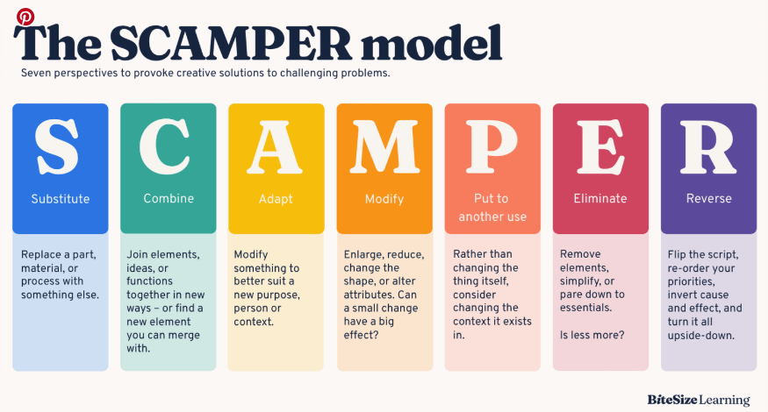
Figure 4 - The SCAMPER model. Source (G parsons, 2024)
Applying this model to the tank lid problem, it was determined that...
Substitute – The lid can be replaced with a lower mass alternative.
Combine – Potential combination of a mechanical advantage (adapt) and a modified two section lid (modify).
Adapt – The introduction of mechanical advantage to transition to a single person lift.
Modify – The lid has scope to be modified potentially splitting the lid in two sections as it opens up options.
Put to another use – Replacing the Tank does not seem a feasible solution.
Eliminate – No components to eliminate as a two-part system.
Reverse – Not applicable in this context.

From this brainstorming, it was derived that a possible solution may involve:
- Automation
- Mechanical advantage
- Lighter weight lid
- Tank lid modified into two sections

Market Research

Automation and Modified Tank Lid
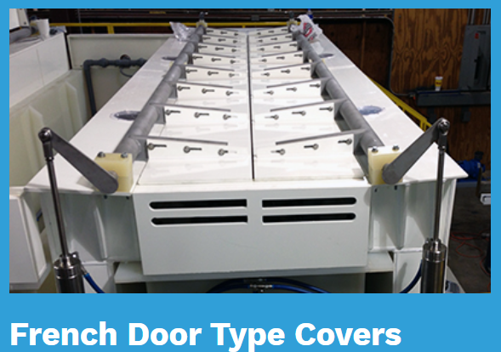
As shown in Figure 5, a possible method of involving automation would be Pneumatic cylinders to control the tank. With this idea it has also detailed that splitting the tank lid is a viable option too.

Figure 5 - Automation and Lid modification Idea. Source (KCH Services, 2023)

Mechanical Advantage
As shown in Figure 6, there are a number of methods in which Mechanical advantage can be obtained.
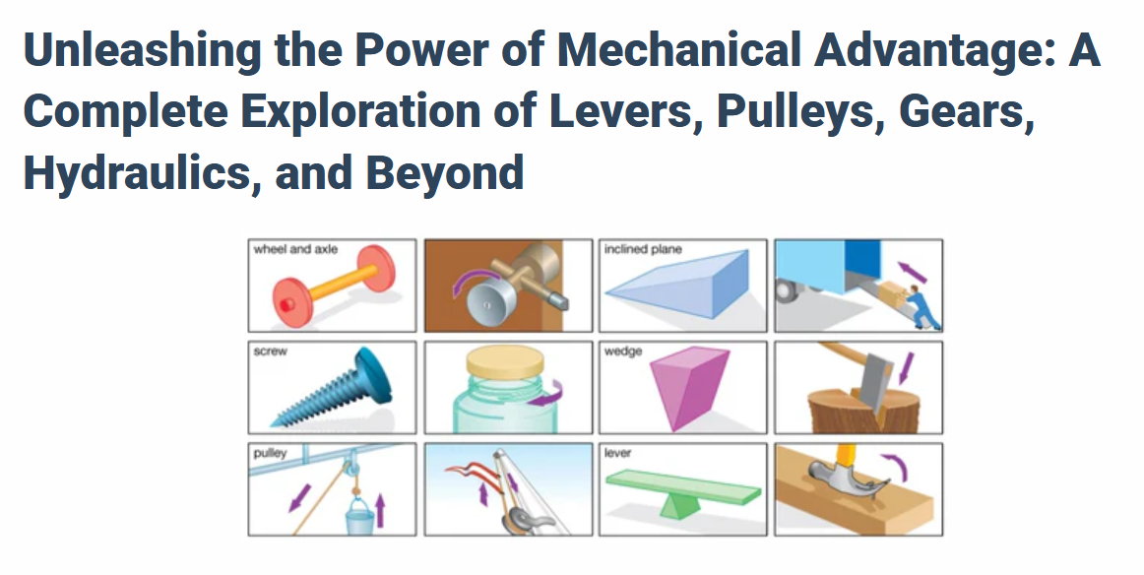
Figure 6- Mechanical Advantage Idea Generation. Source (Li, M. and Automations, F., 2023)

Lid Material selection
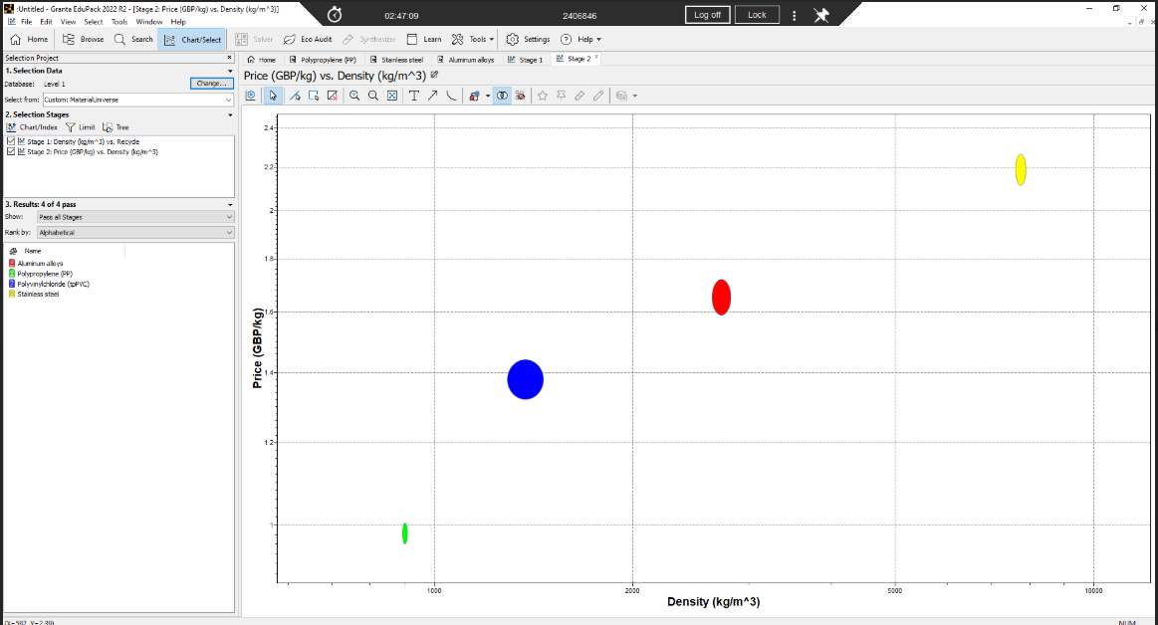
As shown in Figure 7, Stainless Steel is the most expensive material and the heaviest. Polypropylene’s has a significant reduction in cost and density meaning this may have a place in the final solution.

Figure 7 - Granta Material Chart Cost vs Density (Ansys, 2025)

Design Concepts

Four design ideas have been developed through the relevant research and the SCAMPER brainstorming method. It is essential to assess both the advantages and disadvantages of each solution before conducting an overall evaluation to determine the most suitable option.

Proposal 1 – Linear Rail

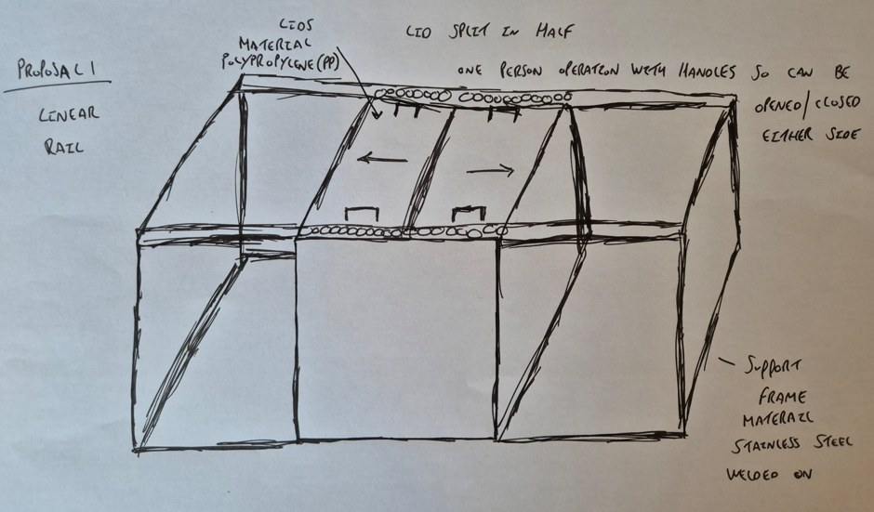
As show in Figure 8, the lid is divided into two sections and a linear guide rail is implemented. To accommodate this solution, a box frame is required to support the mechanical linear movements.
Figure 8- Sketched Linear rail Solution

Advantages
- Can be operated by single person from either side.
- Polypropylene lids resulting in lower cost and overall mass.
- Low maintenance and high load capacity.
Disadvantages
- Support frame requires a larger footprint which may not be practical when the project scales out to other sites.
- Albeit there will be PPE supplied for operators, when operating this proposal, operators are exposed to the side of the open tank of Acid

Proposal 2 – Gas Struts

In Figure 9, the lid is divided into two sections, with hinges and handles allowing it to be opened and closed. Gas struts are implemented to provide mechanical assistance.
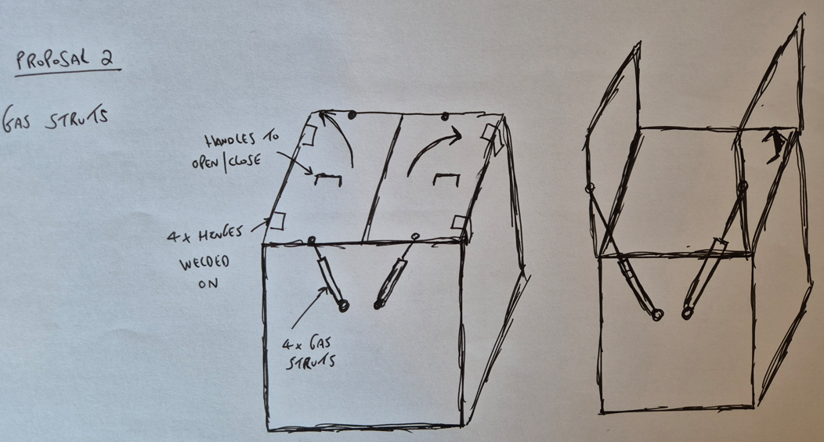
Figure 9 - Sketched proposal 2 - Gas struts
Advantages
- Can be operated by single person from either side.
- Simplistic design that requires the least modifications so the turnaround time will be significantly less to implement the proposal
Disadvantages
- Gas struts have a weight limitation, for a heavy lid these may not be a feasible option.
- Gas struts require an initial force to be applied, which could potentially cause cracking of the polypropylene handle or gas strut attachments. Additionally, using stainless steel for the lid in this solution would increase both the cost and weight.

Proposal 3 – Pneumatic Cylinders

In Figure 10, the lid is divided into two sections, with rotational movement facilitated by a shaft and roller bearing setup. Four pneumatic cylinders control this movement through a dedicated linkage arm.
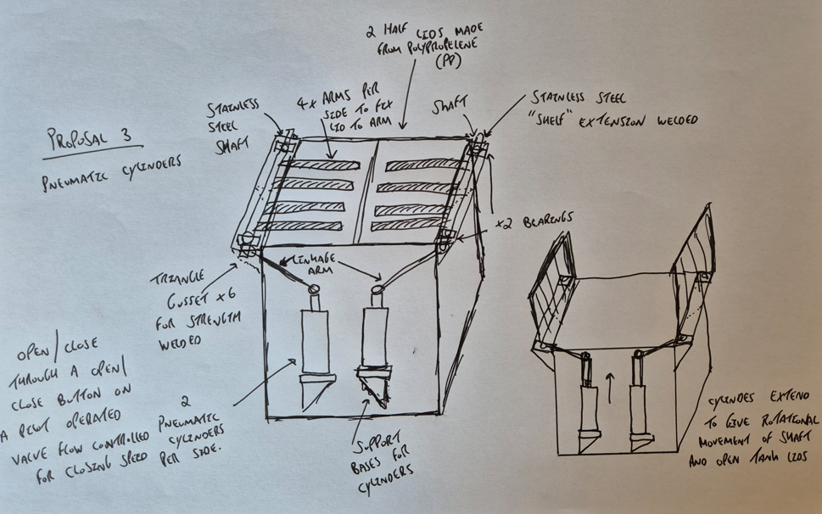
Figure 10 - Sketched proposal 3 - Pneumatic cylinders
Advantages
- Does not require the operator to be hands on to open and close the tank lids
- Minimal additional footprint required for the shelf extension
- It is an automated solution that requires no mechanical force from the operator reducing any potential of Repetitive strain injuries.

Disadvantages
- The cost of this solution is the highest due to the shaft assembly and pneumatics involvement
- Additional mechanical parts that will require servicing and potential cause of failure e.g. pneumatic pump, cylinders and valves
- Increased workplace noise with pneumatics

Proposal 4 – Lever Arm

In Figure 11, the lid is divided into two sections, with rotational movement enabled by a shaft and roller bearing setup. A lever arm is placed midway on the shaft on each side, providing the operator with a mechanical advantage to open and close the tank lid. A concentric hole is then incorporated into the lever and tank shelf, allowing a retaining pin securing the tank in an open position.
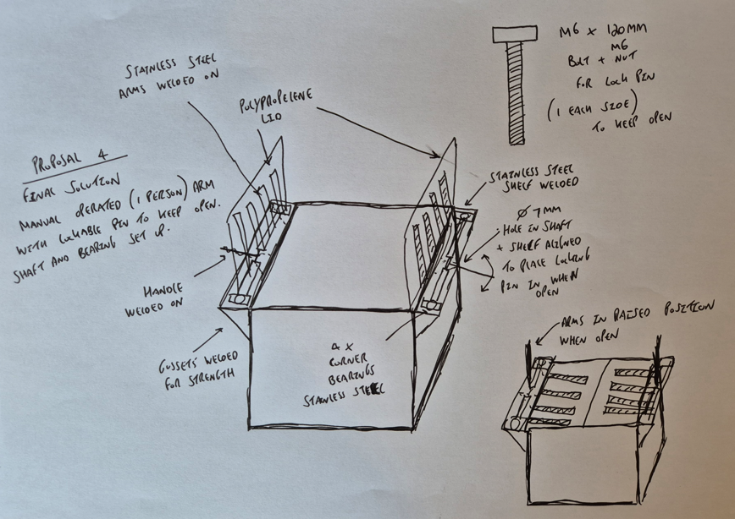
Figure 11 - Sketched proposal 4 – Lever arm with locking pin
Advantages
- Minimal additional footprint required for the shelf extension
- Mechanical advantage on mechanical lever to open and close the lid
- Polypropylene (PP) lids reducing the overall weight
- Built with future proofing in mind if the customer wanted to move to the Pneumatic cylinder option if budget was allowed for the scaling of the product.

Disadvantages
- Although this has moved to a singular person operation and mechanical advantage with the lever it still requires mechanical force to open and close. It is not an automated solution.
- Moving parts which will require maintenance
- Limited force output with a lever arm and additional footprint around tank required for this proposal.

Idea Evaluation

After individually evaluating the four solutions, the next step is to assess them collectively and choose the final solution to move forward with. According to Malsam (2023), biasing and emotion can influence decision-making when evaluating project solutions, potentially leading to undesired outcomes. Therefore, using a decision matrix introduces a data-driven approach with a weighted scoring system.
As shown in Table 3, the five key criteria selected for the decision matrix are safety and risk, cost, sustainability, feasibility, and how well the solution aligns with the initial specification. Based on the scoring, the lever arm solution was selected as the final solution, as it scored the highest across all criteria, demonstrating the best balance of these factors.
Table 3 - Decision Matrix
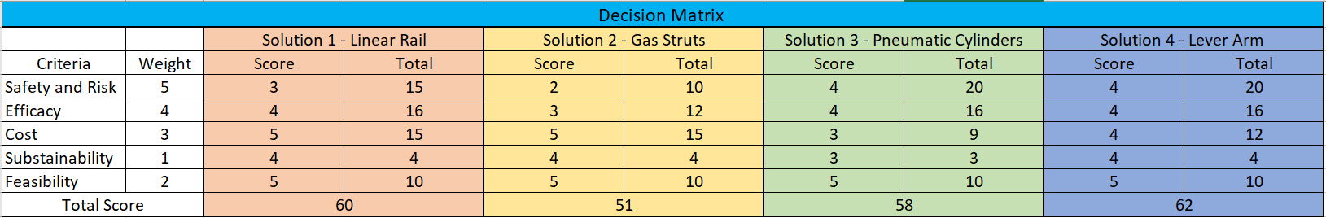

Documentation and Prototype

This phase of the project includes formal technical drawings, CAD designs, the bill of materials, and technical information related to the build components.

Bill of Materials

According to Tristancho (2024) the bill of materials forms the foundation of any project by providing a definitive list of components, while also serving as a tool for planning and costing. With all the necessary information, it enables accurate material costing and helps determine the timescales and lead times for components, ensuring the project is completed on schedule. As shown in Table 4, the material costs are calculated at £3321.56.
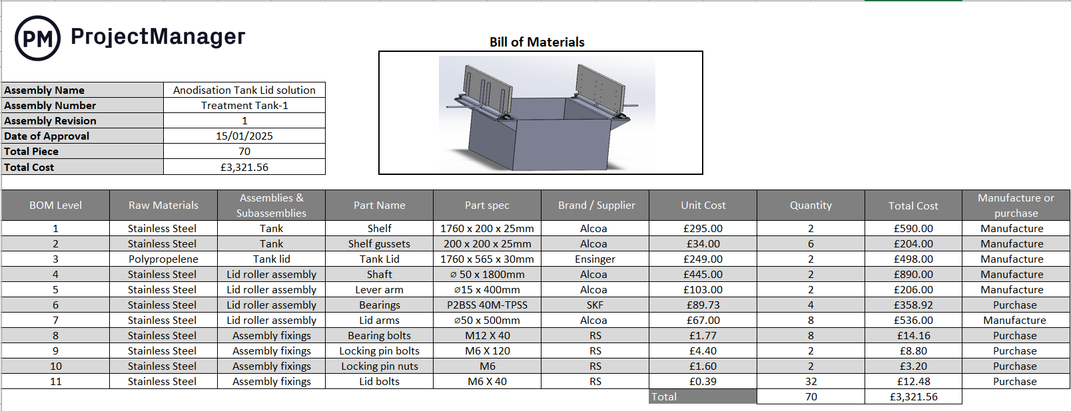

Table 4 - Bill of materials (BOM). Bill of Materials Template. (2024)

Technical Drawings and Manufacturing Methods

From the Bill of Materials, it has been determined that out of the eleven components, six will be manufactured and five will be procured. The material selections of Stainless Steel and Polypropylene are derived from Table 1 in the Assignment brief. According to the brief (2024), the mechanical properties of these materials ensure that they can withstand the Caustic environments but also consider mass where possible such as the tank lid.
The following section outlines the manufacturing methods for each component, along with their corresponding technical drawings.

BOM Level 1 and 2– Tank Shelf and Shelf gusset
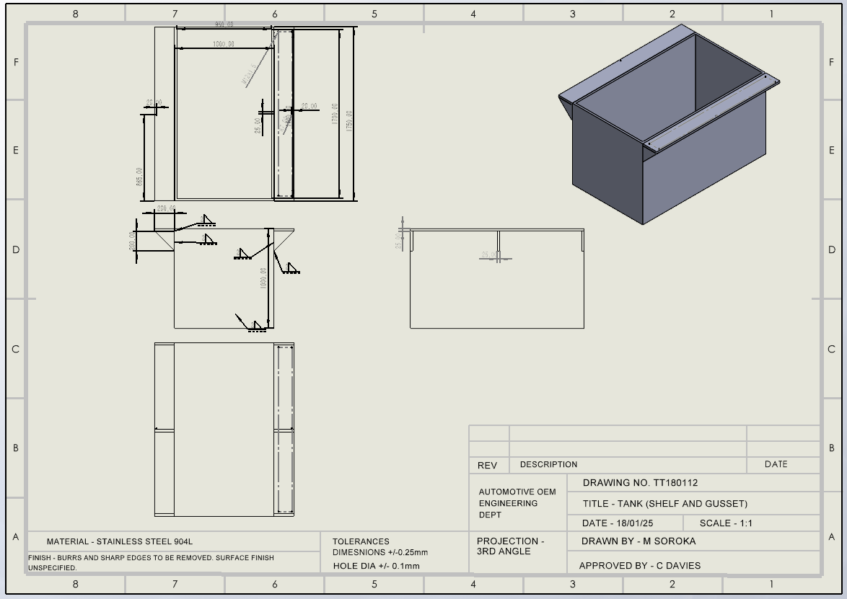
Figure 12 - Technical drawing - Tank shelf and gusset
As shown in Figure 12, there is a shelf extension on each side of the existing tank. This shelf serves as the structural base for the tank lid roller assembly. To provide additional support, three gussets are added on each side, ensuring stability. Steel Supply, L.P states that “Joints and connections are vulnerable points where stresses concentrate in any structure. Steel gusset’s help alleviate these stress concentrations by providing additional support and reinforcement”. (2024, p. Steel Gussets: Enhancing Structural Stability).
The tank shelf and gusset are made from Stainless Steel 904L and manufactured through hot rolling, which reduces the material to the desired billet dimensions. Plasma cutting is then used to shape the components to the final specifications. Once dimensioned, the shelf is pillar drilled and tapped to accommodate the shaft bearings, and the shelf and gussets are TIG welded onto the tank.

BOM Level 3 – Tank lid
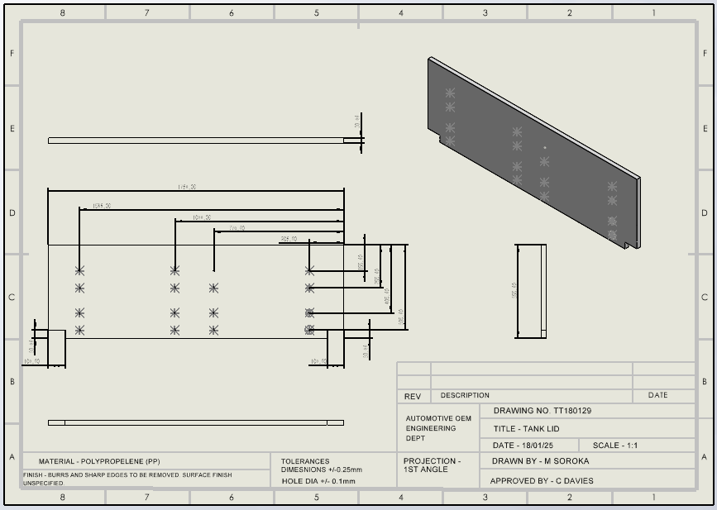
Figure 13 - Technical drawing - Tank lid
As shown in Figure 13, the tank lid is a critical component that protects the user by covering the tank when it is not in use.
The material selected is Polypropylene (PP), produced through plastic casting, where liquid plastic is poured into a mold to form the billet. A machine router is then used to shape the billet to its final dimensions, with clearance holes manually drilled. Finally, the component is de-burred to remove any sharp edges.

BOM Level 4 and 5 – Tank Lid shaft and Lever arm

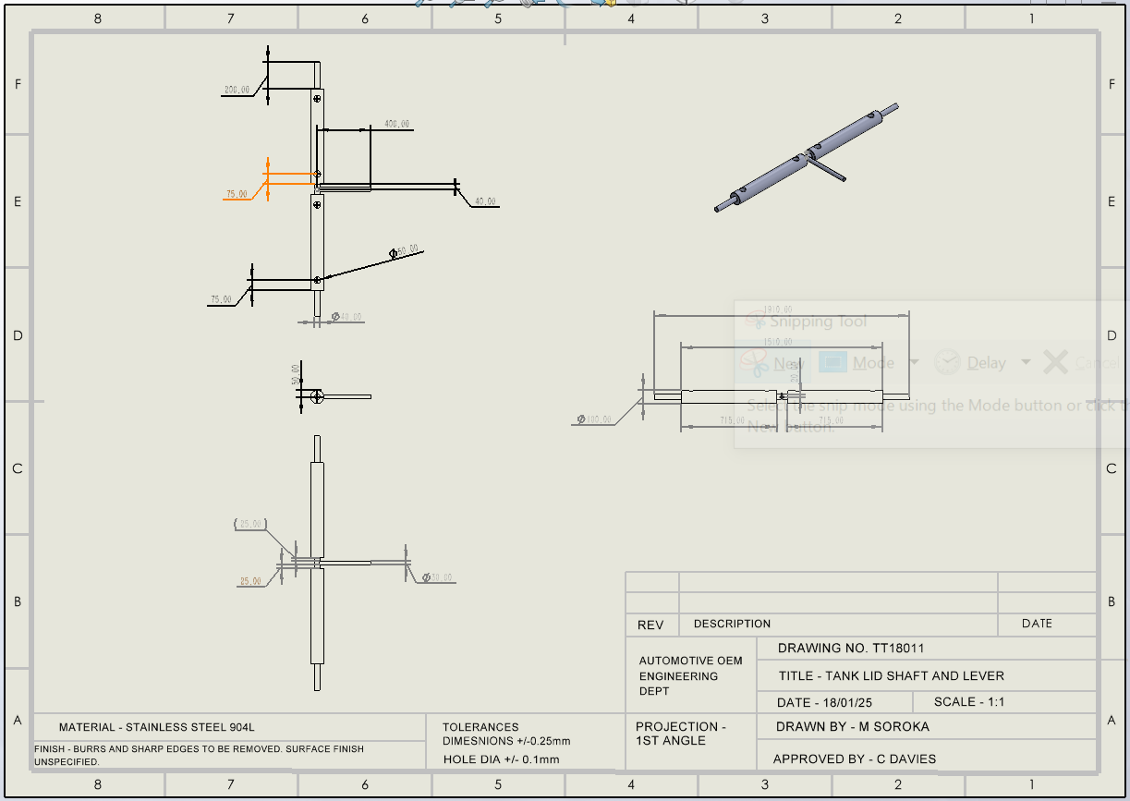
Figure 14 - Technical drawing - Tank lid shaft and lever
As shown in Figure 14, the lid shaft and bearings enable rotational movement, allowing the lid to open and close. The lever mechanism provides additional mechanical advantage to assist with this motion.
The lid shaft, roller, and lever are made from Stainless Steel 904L, produced via continuous casting to form a round profile. The shaft is turned on a lathe to the correct diameter, then milled for holes to fit the lever and tank lid arms. The lever is lathe-turned and end-milled flat for TIG welding onto the shaft.

BOM Level 6 – Lid arm
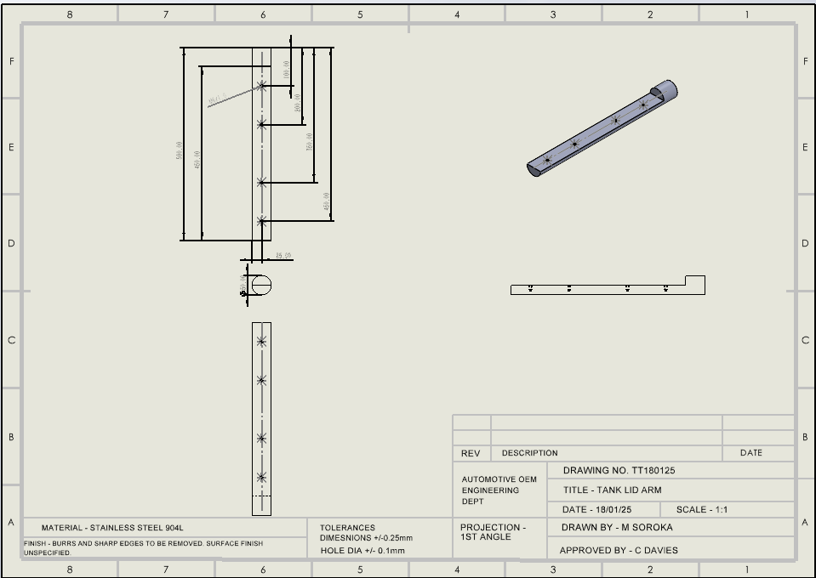
Figure 15- Technical drawing - Tank lid arm
As shown in Figure 15, the lid arms allow the lid to be attached to the final assembly. The arms are TIG welded into the milled holes in the lid shaft component for secure fitment.
The tank lid arm is made from Stainless Steel 904L, again is produced by continuous casting to form a round profile. The bar is lathe-turned to the correct diameter, milled to create a flat face, and drilled with an end drill. The holes are tapped, where the component is ready for assembly.

Final CAD Assembly
As shown in Figure 16, the final CAD assembly is represented.
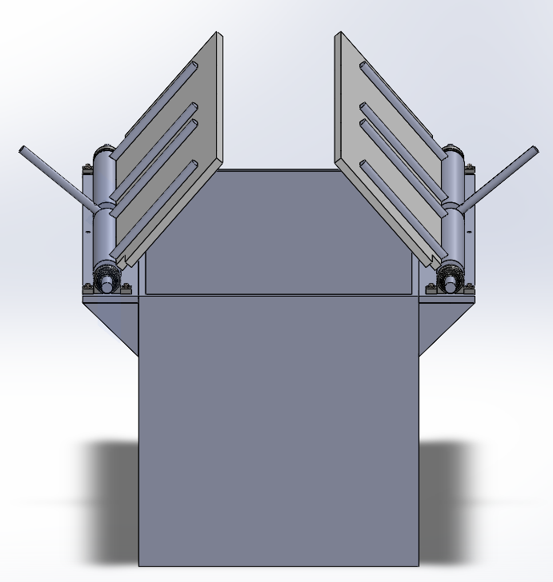
Figure 16 - Final CAD Design

Bearing Choice
Due to the corrosive environments, a Stainless-steel bearing was selected in a pillow block set up to withstand any environmental challenges, as shown in Figure 17. According to SKF (2025), this bearing is suitable for alternating directions of rotation and upholds good corrosion resistance.
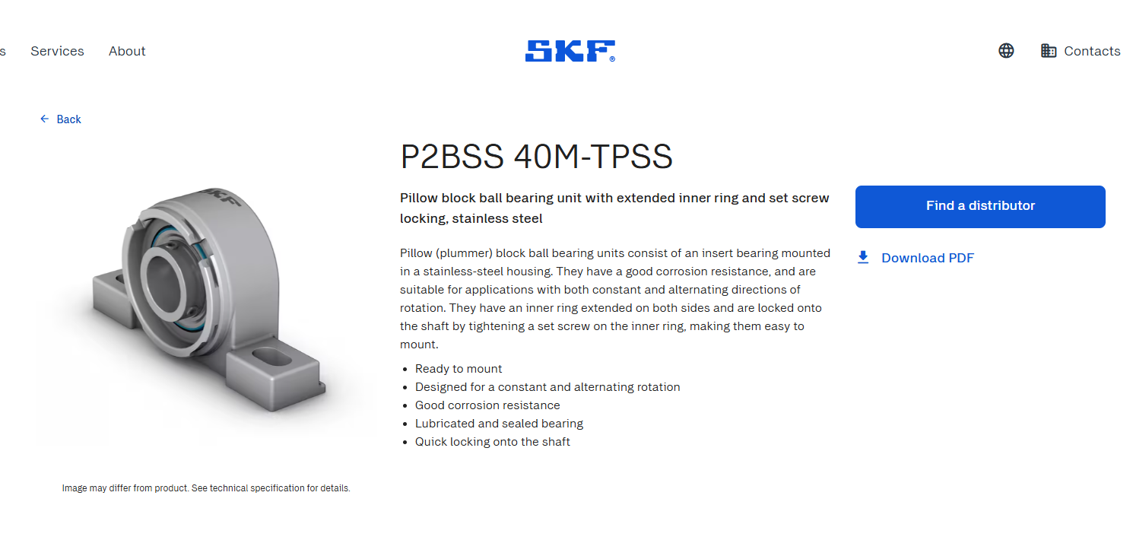
Figure 17 - SKF Bearing Characteristics. Source (SKF, 2025)

As shown in Figure 18, the specification aligns with the requirements for the project.
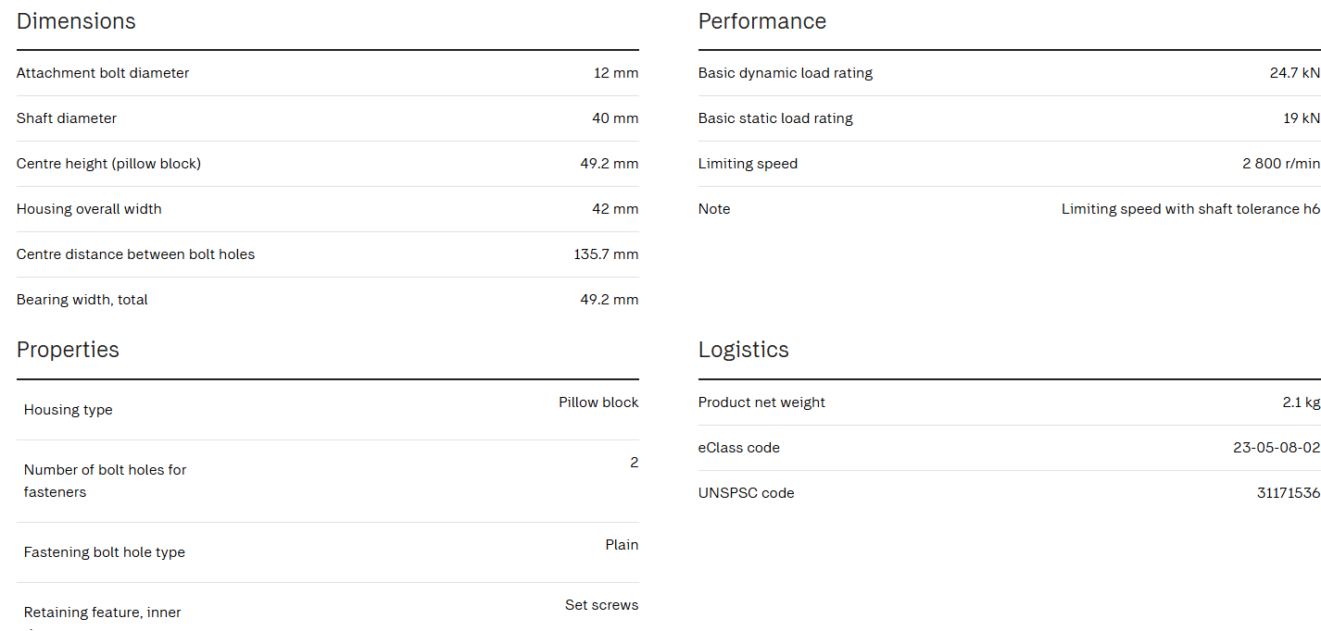
Figure 18 - Bearing specification. Source (SKF, 2025)

Testing and Implementation

As shown in Figures 19-22, the next step is to carry out the implementation and Factory Acceptance Testing to ensure all Stakeholders are aligned on the Project before deploying it in operation.

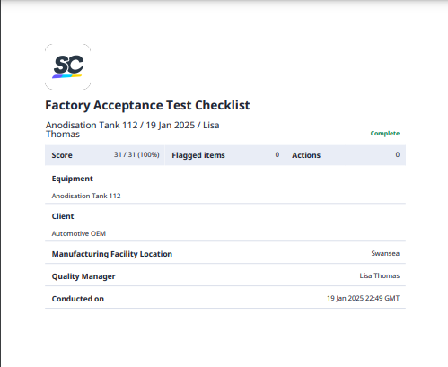
Figure 19 - FAT Testing. Page 1/4. Source (Safety Culture , 2025)

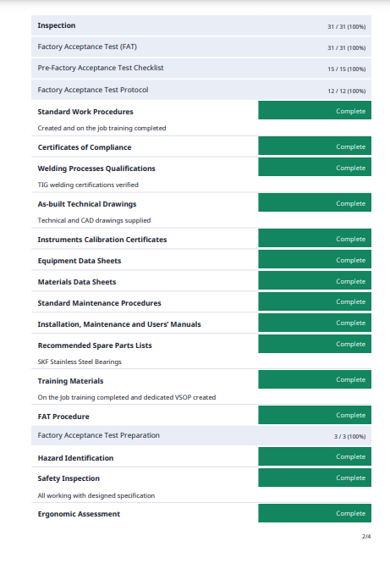
Figure 20 - FAT Testing. Page 2/4. Source (Safety Culture , 2025)
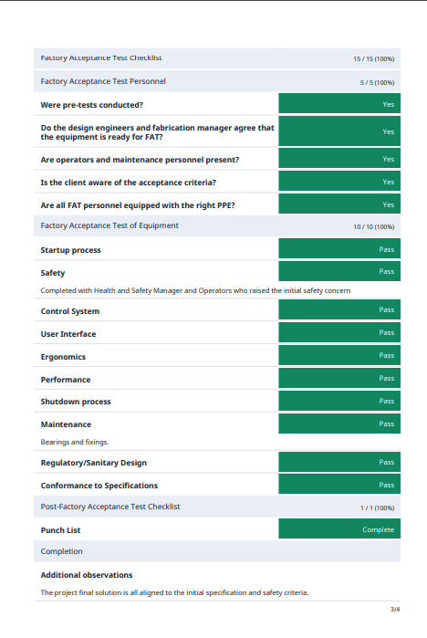
Figure 21 - FAT Testing. Page 3/4. Source (Safety Culture , 2025)

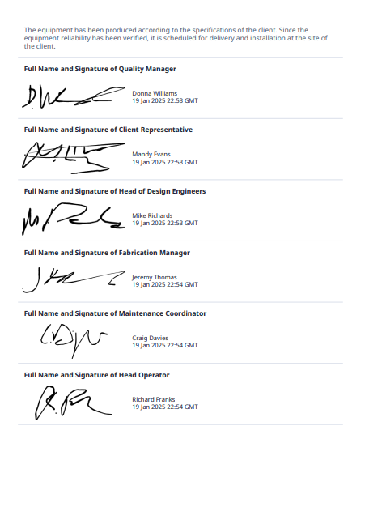
Figure 22- FAT Testing - Page 4/4. Source (Safety Culture , 2025)

This now ensures that all parties are satisfied and the solution can be deployed into use.

Conclusion

In conclusion, it can be confirmed that the project deliverables have been achieved as outlined in the initial scope and specification, such that:
- The system is safe to operate.
- The system can be operated by a single person.
- The tank dimensions and materials have remained the same whilst modifications have been implemented.
- The tank lid has been amended as necessary.
- There is clearance from above, allowing the parts to be hoisted in and out of the tank.
Through thorough testing and validation, the solution has been confirmed successful and stakeholder feedback has been positive.
Moving forward, if the budget allows, this solution has been designed with future-proofing in mind, incorporating the potential for implementing a pneumatically controlled option as per proposal 3. This solution would remove any operator hand on interaction but the final solution has balanced safety, cost, feasibility and reduced the risks as low as reasonably practicable and adheres with safety regulations.

10.Bibliography
Ansys, 2025. Material selection Chart. s.l.:Granta.
Camilo Tristancho, 2024. https://www.projectmanager.com/blog/bill-of-materials. [Online]
Available at: https://www.projectmanager.com/blog/bill-of-materials
[Accessed 18 January 2025].
G parsons, 2024. SCAMPER model of creativity, explained. [Online]
Available at: https://www.bitesizelearning.co.uk/resources/scamper-model-creativ
[Accessed 19 January 2025].
HSE - Legislation.gov.uk, 1974. Health and Safety at Work etc. Act. [Online]
Available at: https://www.legislation.gov.uk/ukpga/1974/37/section/2
[Accessed 31 December 2024].
HSE, 1998. Safe use of work equipment (PUWER). Forth ed. s.l.:HSE.
HSE, 1998. Safe use of work equipment (PUWER). Fourth ed. s.l.:HSE.
KCH Services, 2023. Tank Cover. [Online]
Available at: https://kchservices.com/products/process-tanks/tank-covers/
[Accessed 02 January 2025].
Kevin Rogers, 2024. ACMA4008 - Engineering problem. Swansea: UWTSD .
Li, M. and Automations, F., 2023. Mechanical advantage guide. [Online]
Available at: https://www.scribbr.co.uk/referencing/generator/folders/77SOsAFi5JfcIEy9n4MWcq/lists/3mmhEKsgwZmaVKEjgGnx4M/
[Accessed 04 January 2025].
Microsoft , 2024. Gantt Chart Template. [Online]
Available at: https://create.microsoft.com/en-us/template/simple-gantt-chart-4bf6b793-490f-4623-84ca-c9c6251a91fc
[Accessed 03 December 2024].
Safety Culture , 2025. Factory Acceptance Testing, Swansea: Mathew Soroka.
SKF, 2025. Bearing Product ID. [Online]
Available at: https://www.skf.com/il/productinfo/productid-P2BSS%2040M-TPSS
[Accessed 19 January 2025].
Steel Supply, L.P, 2024. https://www.steelsupplylp.com/blog/steel-gussets?srsltid=AfmBOorF_J0l3P88Qr6ugEz8u8cAB1XmHt-D-glm0eR6h79gDbhtwVxE. [Online]
Available at: https://www.steelsupplylp.com/blog/steel-gussets?srsltid=AfmBOorF_J0l3P88Qr6ugEz8u8cAB1XmHt-D-glm0eR6h79gDbhtwVxE
[Accessed 19 Januray 2025].
William Malsam, 2023. https://www.projectmanager.com/blog/decision-matrix.. [Online]
Available at: https://www.projectmanager.com/blog/decision-matrix.
[Accessed 18 January 2025].

