MODULE CODE: ACBA5010
ASSIGNMENT TITLE: CLIENT LETTER AND DRAFT BEP
NAME: MUSTAFA OMAR
2015656

DRAFT

MUST-DESIGN
121 MAIN STREET
SWANSEA
SA1 5JU
07305255416 MUST-DESIGN@HOTMAIL.CO.UK
March 29, 2022

MR GAVIN TRAYLOR
SWANSEA COUNCIL
100 BROADWAY STREET
SA1 2LC

Dear Mr Traylor
On behalf of the MUST-DESIGN team I would like to take this opportunity to highlights the key areas of BIM information when and how information should be created, shared, and managed and adopt all aspects of level 2 BIM.
Building Information Modelling (BIM) changing the way that we design all types of infrastructure and improved the safety, costs, and optimize schedules during construction. BIM is intended to help construction industry professionals, clients, asset owners and suppliers to understand and adopt all aspects of the BIM level 2.

Building Information Modelling (BIM) model is shared through an online space known as a common data environment (CDE). That provides centralized storage such as sharing and access of all the data and can be exported into an open-source file format, such as Industry Foundation Class (IFC). However, using Industry Foundation Class (IFC) file will allow a large construction project that involves many stakeholders from different countries that is working with different BIM software packages to share the building information stored in a CDE without losing data or having to remodel the building. on the other hand, BIM process in a project does not mean that all the stakeholders should use a similar software package. instead, a team that is working with Revit can past the file to another team that is working with any other BIM packages using open-source file format such as IFC.

Advantages of CDE
- Accuracy
shared information reduces any misunderstandings, mistakes and avoiding unnecessary delays.
- Accountability
Any party that is involved knows who is responsible for and what their job is to prevents any misunderstanding.
- Faster and efficient processes
- Reduced on-site waste
- Avoidance of rework costs

International BIM Standards
The UK government produced a strategy to embed the use of building information modelling (BIM) level 2, this means for those who work in design, construction and management should meet the standards of BIM level 2 package.
However, the UK is now recognized as the leading nation in the use of building information modelling (BIM). BIM standard ISO 19650 is a series of international BIM standard, created by international organization for standardization, are guidelines codes of standard that are fast developed process which helps the UK construction industry. BIM is also recognized as the key driving economic growth in both domestic and international market.

BIM MATURITY LEVEL 2
These various levels of BIM can be achieved for several types of projects (known as BIM Maturity Levels) BIM levels starts with level 0 to level 3 and above. The purpose of these levels is to measures how useful or at the same time to see how information is being shared throughout the process.
Before we continue the BIM levels, it is important to know the basics of dimensions in which they operate. Diagram below explains each dimension and how they work.
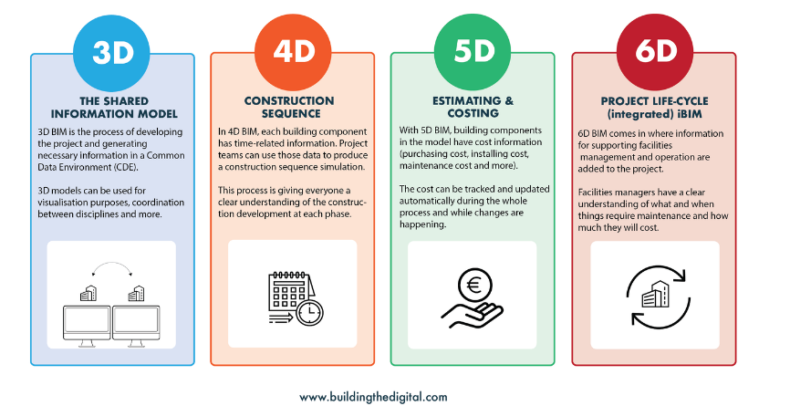Fig 1
2-Dimension
2D dimensions is the most basic type of construction model, it usually is a simple x-axis and Y-axis. These are made by hand or using CAD drawings.
3-Dimension
3D BIM shows structures 3-dimensionally and is the most popular BIM dimension using the X-Y and Z-axis where the 2D only uses X and Y-axis. On the other hand, the benefits of the 3 dimensional improves the visualisation as well as better co-ordination and better communication among different parties.
4-Dimension
4D BIM it is a process that can add a lot of value to design and saving both time and money in construction, these includes:
- Construction planning
- Virtual construction
- Scheduling time lining
- Deliveries equipment’s
Those are all included in the 4-dimension of the BIM process.
5-Dimension
5D contains cost data into BIM process this includes
- Accurate cost estimation
- Quantity extractions
- Fabrication model
- material take-off
6-Dimension
6D gather the energy use and sustainability, using 6-dimension can assess the buildings in numerous energy rating system.

BIM LEVELS
Now that you have a better understanding of BIM-Dimensions, the diagram below shows and explains each BIM levels and how you can identify the level on which you are working.

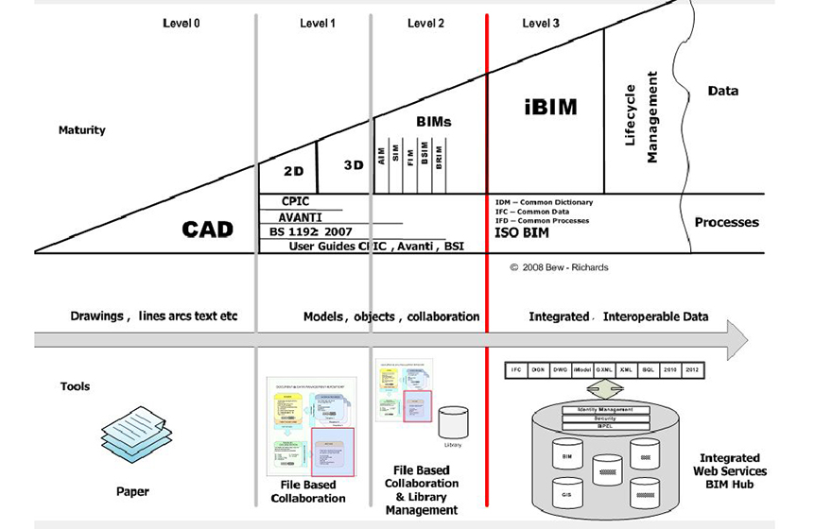 Fig 2

Level 0
This level is the basic using of 2D CAD drafting or even hand drawing with paper or electronic print information exchange.

Level 1
This Level 1 is containing a mixture of both 3D-CAD and the 2D for drafting backed by an electronic sharing of data conducted from common data environment (CDM). CAD standards are required to meet British Standards 1192:2007+A2:2016.
Level 2
Level 2 BIM is distinguished by collaborative working across disciplines with all parties using 3D models. each party must be capable of exporting to one of the common file formats either Information Foundation Exchange (IFC) or COBie (Construction Operations Building Information Exchange).

Level 3

Level 3 there is complete and Fully collaboration in the planning construction and the operational life cycle of any built asset. The data is shared, collected and stored using a single source of data.

BIM Execution Plan (BEP)

PROJECT TITLE: YSGOL BAE ABERTAWE
PROJECT ADDRESS: SWANSEA COUNCIL
100 BROADWAY STREET
PROJECT NUMBER: 5010
DATE: 29/03/2022

Contents
PROJECT INFORMATION 8
MANAGEMENT 8
ROLES, RESPONSIBILITIES, AND AUTHORITIES 8
PROJECT MILESTONES 9
PLANNING AND DOCUMENTATION 9
REVISED PROJECT INFORMATION PLAN (PIP) 9
AGREED MATRIX OF RESPONSIBILITIES ACROSS THE SUPPLY CHAIN 9
STANDARD METHOD AND PROCEDURE 11
VOLUME STRATEGY 11
FILE NAMING CONVENTION 11
PROJECT INFORMATION MODEL (PIM) 11
LAYER NAMING CONVENTION 11
DISCIPLINE 12
METADATA 12
THE IT SOLUTIONS 13
SOFTWARE VERSIONS 13
EXCHANGE FORMATS 13
Reference 14

PROJECT INFORMATION
Table 1 – Project information
Project Name | YSGOL BAE ABERTAWE
Project Address | SWANSEA COUNCIL
Project Number (Clients Project Number or reference) | 5010
Project Design Start Date | April 4, 2019
Project Construction Start Date | March 20, 2021
Project Completion and Handover Date | March 29, 2022
Project Description | 1 form entry infant school for 90 pupils, with 48 PT nursery provision. “The Project is a joint funded venture with the Welsh Government, under the 21st Century schools programme”
Project Brief and CDM

MANAGEMENT
This section of the BEP covers the requirements of BS EN ISO 19650

ROLES, RESPONSIBILITIES, AND AUTHORITIES
Table 2: Start of the project, it is important to identify the roles and responsibilities of the design teams.
Role Company | Name | Email and Telephone number
Lead Designer Company | Mike Dean (Must-Design company) | Must-Design@hotmail.co.uk  07305254516
Project Delivery Manager Company | Amir Omar (Must-Design company) | Must-Design@hotmail.co.uk  07925053215
Project Information Manager Company | John lee | Johnlee@hotmail.co.uk  07750535722
Construction Manager | Williams jones | Johnlee@hotmail.co.uk  07986342451
Task Team Manager | Mustafa Omar | mustomar12@hotmail.co.uk  07303500251
Task Team Information Manager | Mustafa Omar | mustomar12@hotmail.co.uk  07303500251
Task Team Interface Manager | Mustafa Omar | mustomar12@hotmail.co.uk  07303500251
Task Team BIM Authors | Mike Dean | Dean_Mike@hotmail.co.uk  07925053215

Table 3: Roles and responsibilities
Role | Authority
Lead Designer | Halen Foster
Project Information Manager | Amir Omar
Task Team Manager | Mustafa Omar
Interface Manager | Mustafa Omar
Information Manager | Mustafa Omar
Coordinator | Mike Dean

PROJECT MILESTONES
Project Phase/Milestone | Estimated Start Date | Estimated completion date
Concept design | N/A
Pre-design | N/A
Preliminary design | Jun 5, 2019 | Oct 10, 2019
Developed design | Dec 20, 2019 | Feb 3, 2020
Detailed design | April 4, 2019 | Jun 7, 2020
Construction | March 20, 2021 | March 20, 2022
Handover |  | March 29, 2022

PLANNING AND DOCUMENTATION
This section of the BEP covers the requirements of BS EN ISO 19650

REVISED PROJECT INFORMATION PLAN (PIP)
Discipline | Resource numbers | Levels of competence | Years of Experience | Names of individuals
Qualified Architect | 1 | RIBA, CAD/BIM, | 10 | Halen Foster
Qualified Structural Engineer | 2 | Istructe | 17 | Ayah Omar
Architectural Technologist  (CIAT) | 4 | CAD, BIM, CIAT, Trained | 11 | Spike Lee
Architectural Technician | 2 | CAD or Model Certificate | 7 | Johnathan David

AGREED MATRIX OF RESPONSIBILITIES ACROSS THE SUPPLY CHAIN
Model Authoring | Example software | Native (F) | Exchange  (F) | 1 Brief | 2 Concept | 3 Definition | 4 Design | 5 Build and commission | 6 Handover and Closeout | 7 Operation
Space Planning
Architectural Model
HVAC Design Model
Site and Existing Buildings
Site, Urban Design Context
Structural Design Model
Road and Civil Design
Building Services MEP Design
Lighting Design Model
Electrical Design Model
HVAC Fabrication Model
Interior Layouts and Design Model
Curtain Wall Fabrication Model
Hydraulics Design Model
Structural Steel Fabrication Model
Landscaping and External Works Options
Renovation and Refurbishment
Facility Management Model
Construction Model
Model Analysis
Brief Development
Model Clash Detection Rendition
LCA Analysis
Sustainability Analysis
Thermal Simulation
Sun and Shadow Studies
Alternative Design Options Analysis
Construction Scheduling/ 4D
Design Performance Analysis
Structural Analysis
Cost Planning and Control
Animation Security
Code Checking and Regulatory Compliance

STANDARD METHOD AND PROCEDURE
This section of the BEP covers the requirements of BS EN ISO 19650
VOLUME STRATEGY
See Section 5.3 for a list of additional resources:

FILE NAMING CONVENTION
The code | Project | Originator | Functional Breakdown | Spatial Breakdown | Form | Discipline | Number | Description | Status | Revision
 | 4005 | UWTSD | XX | ZZ | D | A | 1001 | GEO MOD | S1 | A

PROJECT INFORMATION MODEL (PIM)
Record of information model origin and orientation
Point | Grid intersection notation | Easting (m) | Northing (m) | Elevation or site Datum
Site local grid origin
Grid origin Bottom Left Intersection
Grid Intersection Bottom Right
Grid Intersection Top Left

LAYER NAMING CONVENTION
This list should be published to all members of the project team for information
Field | Discipline | Classification | Presentation | Description
Name | A | G23 | M2 | Stairs
Example | Architect | AA | Model graphics

DISCIPLINE
Discipline or role codes as recommended in BS EN ISO 19650
(see BS EN ISO 19650) Code Discipline
Code | Discipline
A | Architect
B | Building Surveyor
C | Civil Engineer
D | Drainage, Highways Engineer
E | Electrical Engineer
F | Facilities Manager
G | Geographical Information System Engineers and Land Surveyor
H | Heating and Ventilation Designer
I | Interior Designer
K | Client
L | Landscape Architect
M | Mechanical Engineer
P | Public Health Engineer
Q | Quantity Surveyor
S | Structural Engineer
T | Town and Country Planner
W | Contractor
X | Sub-Contractor
Y | Specialist Designer
Z | General (non-disciplinary)

METADATA
Extend the standard Metadata status codes as required for the project, the codes in the BS EN ISO 19650
Status | Description
S0 | Initial status or WIP Master document index of file identifiers uploaded into the extranet.
S1 | Suitable for Co-ordination The file is available to be „shared‟ and used by other disciplines as a background for their information.
S2 | Suitable for Information
S3 | Suitable for Internal Review & Comment
S4 | Suitable for Construction Approval
S5 | Suitable for Manufacture
S6 | Suitable for PIM Authorization (Information Exchanges 1-3)
S7 | Suitable for AIM Authorization (Information Exchange 6)
D1 | Suitable for Costing
D2 | Suitable for Tender
D3 | Suitable for Contractor Design
D4 | Suitable for Manufacture/Procurement
AM | As Maintained
A  B | Suitable for Construction  Partially signed-off: For Construction with minor comments from the Client. All minor comments should be indicated by the insertion of a cloud and a statement of “in abeyance” until the comment is resolved, then resubmitted for full authorization.
AB | As-Built Handover documentation, PDF, native models, COBie etc.

THE IT SOLUTIONS

SOFTWARE VERSIONS
The CAD software
User | Database | CAD software | Version | Format | Comments
Architect |  | Revit
Interior |  | Revit
Structural |  | Revit
Electrical |  | Revit
During the Project new versions of application software may become available. Upgrading of models or project data to never versions should be reviewed with all team members to ensure compatibility. If the team decides an upgrade is beneficial to the project a protocol will be developed.

EXCHANGE FORMATS
Exchange | Deliverable | Means | IFC | Other
Collaboration Between design team | CAD | PDF Sets  BIM 360 design |  | Refer to progress phase/milestone table for schedule
Team architect | Revit | PDF sets
Milestone submissions by design to client | Revit |  |  | Refer to progress phase/milestone table for schedule
Cost Estimate from x/y

Reference

https://www.buildingthedigital.com/
https://www.designingbuildings.co.uk/wiki/Level_of_detail_for_BIM
https://www.designingbuildings.co.uk/wiki/BIM_level_2
https://ukbimframework.org/wp-content/uploads/2019/11/ISO-19650-Guidance-Part-2-Single-Page-Print.pdf
file:///C:/Users/44730/Downloads/UK%20BIM%20Introduction%20Guide.pdf
https://ukbimframework.org/wp-content/uploads/2019/11/ISO-19650-Guidance-Part-2-Single-Page-Print.pdf

