UWTSD
WISA



Engine Characteristics
Motorsport Technology ACHA4012

Tristan Short
2306302
(Paper Date 03/2025}
Contents
1 Introduction 3
2 Background 3
3 Discussion 3
4 Conclusions 3
5 References 3

Introduction
The aim of this assignment was to run dyno test on an engine, review the result and to calculate power, torque and compare.

Testing

Equipment
- Dynamometer.
- Engine.
- Sensor recorder modules.
- Exhaust extraction system.
- Fuel supply board.
- Computer with relevant programming installed to read and record the data.

Method

- Turn on the systems and start the engine.
- Two dials, Dynanometer and Engine. Engine controls RPM
- Dynanometer controls the electrical current to the Dyno to make it produce torque.
- Set Dyno mode to “torque” and Throttle to “direct”.
- Using the throttle dial causes the engine to rev at a higher RPM. The Dyno dial creates torque in the dyno to slow down the engine. Then you can measure the load output of the engine.

Data

Raw Data
Load | Dyno Speed | Fuel Flow Rate | Lambda
Newtons | rpm | l/min | Lambda
102.275 | 1000 | 0.0704 | 1.2658
102.756 | 1050 | 0.0724 | 1.26783
103.689 | 1100 | 0.0737 | 1.27344
104.209 | 1150 | 0.0728 | 1.28476
105.811 | 1200 | 0.0744 | 1.29181
107.51 | 1250 | 0.07895 | 1.29729
109.488 | 1300 | 0.079 | 1.29895
111.797 | 1350 | 0.0796 | 1.29469
114.268 | 1400 | 0.0835 | 1.2855
115.783 | 1450 | 0.0847 | 1.27818
116.985 | 1500 | 0.08865 | 1.2795
117.788 | 1550 | 0.0932 | 1.27766
118.471 | 1600 | 0.0959 | 1.28235
118.772 | 1650 | 0.09875 | 1.29028
118.656 | 1700 | 0.10005 | 1.29942
118.861 | 1750 | 0.10305 | 1.31053
119.584 | 1800 | 0.1093 | 1.3149
119.934 | 1850 | 0.11415 | 1.31849
120.176 | 1900 | 0.11745 | 1.31892
120.948 | 1950 | 0.12055 | 1.31484
122.157 | 2000 | 0.12555 | 1.31653
122.845 | 2050 | 0.12785 | 1.32098
123.796 | 2100 | 0.1309 | 1.32287
124.794 | 2150 | 0.13435 | 1.32164
125.137 | 2200 | 0.1377 | 1.31652
126.028 | 2250 | 0.14105 | 1.30465
126.66 | 2300 | 0.14495 | 1.29646
126.822 | 2350 | 0.14985 | 1.28229
126.69 | 2400 | 0.1537 | 1.27304
126.552 | 2450 | 0.15565 | 1.26984
126.438 | 2500 | 0.1596 | 1.27446
126.239 | 2550 | 0.1626 | 1.27876
126.161 | 2600 | 0.16805 | 1.27634
125.847 | 2650 | 0.17145 | 1.28027
124.911 | 2700 | 0.17465 | 1.28371
123.927 | 2750 | 0.1784 | 1.2812
Load | Dyno Speed | Fuel Flow Rate | Lambda
Newtons | rpm | l/min | Lambda
123.389 | 2850 | 0.1831 | 1.26036
122.519 | 2900 | 0.1879 | 1.2531
121.837 | 2950 | 0.19255 | 1.23943
121.709 | 3000 | 0.199 | 1.22735
121.123 | 3050 | 0.20605 | 1.2193
121.124 | 3100 | 0.21005 | 1.20692
120.851 | 3150 | 0.21605 | 1.19274
120.596 | 3200 | 0.21795 | 1.18481
120.84 | 3250 | 0.22305 | 1.17378
121.633 | 3300 | 0.2255 | 1.16118
122.181 | 3350 | 0.2285 | 1.15104
122.933 | 3400 | 0.2342 | 1.14117
123.475 | 3450 | 0.23605 | 1.12669
123.428 | 3500 | 0.24195 | 1.11975
124.205 | 3550 | 0.24545 | 1.10622
124.066 | 3600 | 0.25505 | 1.09697
123.967 | 3650 | 0.25755 | 1.09401
123.815 | 3700 | 0.26445 | 1.09659
123.767 | 3750 | 0.2651 | 1.09808
123.509 | 3800 | 0.2693 | 1.09907
122.672 | 3850 | 0.27375 | 1.10533
122.157 | 3900 | 0.2759 | 1.11704
121.184 | 3950 | 0.28285 | 1.12259
120.004 | 4000 | 0.28455 | 1.12461
118.734 | 4050 | 0.2871 | 1.1222
117.442 | 4100 | 0.28895 | 1.12394
116.5 | 4150 | 0.29305 | 1.12233
115.931 | 4200 | 0.2949 | 1.12179
115.034 | 4250 | 0.29715 | 1.12456
114.391 | 4300 | 0.3022 | 1.12278
114.016 | 4350 | 0.30605 | 1.11943
113.871 | 4400 | 0.3092 | 1.11986
113.985 | 4450 | 0.3099 | 1.11873
113.306 | 4500 | 0.31445 | 1.11563
113.074 | 4550 | 0.3171 | 1.10953
112.195 | 4600 | 0.3194 | 1.10569
111.061 | 4650 | 0.32055 | 1.09782
109.973 | 4700 | 0.3207 | 1.09558
108.654 | 4750 | 0.32485 | 1.08827
Load | Dyno Speed | Fuel Flow Rate | Lambda
Newtons | rpm | l/min | Lambda
105.24 | 4850 | 0.3257 | 1.08221
103.632 | 4900 | 0.3277 | 1.0846
102.335 | 4950 | 0.32845 | 1.08823
101.106 | 5000 | 0.3287 | 1.08687
99.3149 | 5050 | 0.32985 | 1.0891
97.5815 | 5100 | 0.3297 | 1.09185
95.8486 | 5150 | 0.33095 | 1.09407
94.8033 | 5200 | 0.3338 | 1.09346
93.0976 | 5250 | 0.3313 | 1.08804
91.7886 | 5300 | 0.3324 | 1.08339
90.5938 | 5350 | 0.3308 | 1.08007
89.6374 | 5400 | 0.3388 | 1.07895
88.9256 | 5450 | 0.3438 | 1.07923
88.6474 | 5500 | 0.3488 | 1.08366

Calculated Data
Load | Torque |  | Power
Ftlb | Nm | Ftlb | BHP | KW
22.99234048 | 83.4334904 | 18.75659954 | 11.71703627 | 8.737406053
23.1004736 | 83.82587866 | 18.84481195 | 12.36074864 | 9.217423038
23.3102204 | 84.58699766 | 19.01591836 | 13.06693279 | 9.744025283
23.42712108 | 85.01120118 | 19.11128313 | 13.72939357 | 10.23802297
23.7872651 | 86.31807434 | 19.40507997 | 14.54656161 | 10.84738603
24.16921559 | 87.70407776 | 19.71666602 | 15.39597371 | 11.48079351
24.61388779 | 89.31768269 | 20.07941893 | 16.30640261 | 12.15970128
25.13297177 | 91.20130947 | 20.50287518 | 17.29068521 | 12.89368183
25.68847481 | 93.21709197 | 20.95604123 | 18.32740376 | 13.66676393
26.02906045 | 94.45299261 | 21.23388282 | 19.23362243 | 14.34253213
26.29928087 | 95.43355536 | 21.45432215 | 20.10340974 | 14.99113342
26.47980249 | 96.08862349 | 21.60158736 | 20.91611552 | 15.59716896
26.63334704 | 96.6457985 | 21.72684531 | 21.7160245 | 16.19366191
26.70101455 | 96.89134707 | 21.78204684 | 22.45154849 | 16.74214291
26.6749367 | 96.79671706 | 21.76077316 | 23.10930642 | 17.23263368
26.72102255 | 96.96395114 | 21.79836889 | 23.83009174 | 17.77012404
26.88355946 | 97.55375718 | 21.9309626 | 24.66004514 | 18.38902115
26.96224261 | 97.83927878 | 21.99515042 | 25.4192266 | 18.95514355
27.01664638 | 98.03669658 | 22.03953172 | 26.15890927 | 19.50672568
27.19019893 | 98.66647565 | 22.18111172 | 27.01976631 | 20.14866766
Load | Torque |  | Power
Ftlb | Nm | Ftlb | BHP | KW
27.61666161 | 100.2140027 | 22.52900974 | 28.85091768 | 21.51415913
27.83045496 | 100.9898057 | 22.70341723 | 29.78339443 | 22.20950801
28.05481435 | 101.8039501 | 22.88644423 | 30.73834291 | 22.92161408
28.13192383 | 102.0837613 | 22.9493483 | 31.53963811 | 23.51914074
28.33222865 | 102.8106177 | 23.11275216 | 32.48612031 | 24.22493349
28.47430794 | 103.3261882 | 23.22865703 | 33.37456437 | 24.88744714
28.510727 | 103.4583439 | 23.25836683 | 34.1437129 | 25.461002
28.48105221 | 103.3506614 | 23.23415885 | 34.83388099 | 25.97566106
28.45002857 | 103.2380844 | 23.20885051 | 35.52085275 | 26.48793661
28.42440034 | 103.1450859 | 23.18794361 | 36.21311736 | 27.00415904
28.37966335 | 102.9827465 | 23.15144825 | 36.87924419 | 27.50089051
28.36212825 | 102.9191159 | 23.13714353 | 37.57913304 | 28.02279835
28.29153822 | 102.6629623 | 23.07955789 | 38.20647995 | 28.49061158
28.081117 | 101.8993959 | 22.9079013 | 38.63783071 | 28.81227029
27.85990494 | 101.0966724 | 22.72744181 | 39.04333582 | 29.11465588
27.8064004 | 100.9025177 | 22.68379409 | 39.67686919 | 29.58708236
27.7389577 | 100.6577849 | 22.62877596 | 40.28743246 | 30.04238003
27.54337387 | 99.94805974 | 22.46922336 | 40.70518447 | 30.35389813
27.39005413 | 99.39170051 | 22.3441488 | 41.17650662 | 30.70536355
27.36127858 | 99.28728118 | 22.3206744 | 41.83042093 | 31.19298812
27.22954051 | 98.80923645 | 22.21320564 | 42.32283432 | 31.56018129
27.22976532 | 98.81005222 | 22.21338903 | 43.01700642 | 32.07782615
27.16839246 | 98.58734538 | 22.16332253 | 43.61230977 | 32.52174447
27.11106616 | 98.3793225 | 22.11655711 | 44.2110844 | 32.96825133
27.16591956 | 98.57837184 | 22.16130519 | 44.99273187 | 33.55112666
27.3441931 | 99.22528221 | 22.30673647 | 45.98473036 | 34.29086096
27.46738843 | 99.67232746 | 22.40723626 | 46.89178535 | 34.9672528
27.6364448 | 100.285791 | 22.54514839 | 47.88458006 | 35.70758084
27.75829128 | 100.7279416 | 22.64454782 | 48.80298834 | 36.39243884
27.74772525 | 100.6896001 | 22.63592832 | 49.49143224 | 36.90581217
27.92240185 | 101.3234581 | 22.77842529 | 50.5144604 | 37.66868533
27.89115339 | 101.2100652 | 22.75293355 | 51.16860383 | 38.15648076
27.8688973 | 101.1293034 | 22.73477757 | 51.83788117 | 38.65556156
27.83472634 | 101.0053054 | 22.70690171 | 52.48355832 | 39.13704368
27.8239355 | 100.9661482 | 22.69809881 | 53.17217407 | 39.65054516
27.76593478 | 100.755678 | 22.65078321 | 53.76881781 | 40.09546302
27.57776965 | 100.0728735 | 22.49728261 | 54.1071254 | 40.34773933
27.46199301 | 99.65274883 | 22.40283481 | 54.57971348 | 40.70014875
27.24325386 | 98.85899878 | 22.22439266 | 54.83914373 | 40.89360616
26.97797924 | 97.8963831 | 22.00798799 | 54.99256788 | 41.0080147
Load | Torque |  | Power
Ftlb | Nm | Ftlb | BHP | KW
26.40201858 | 95.80636499 | 21.53813311 | 55.16397858 | 41.13583584
26.1902485 | 95.037904 | 21.36537616 | 55.38884486 | 41.30351886
26.06233218 | 94.57372746 | 21.2610251 | 55.78239522 | 41.59698977
25.86067851 | 93.84197638 | 21.09652087 | 56.00972463 | 41.76650954
25.71612632 | 93.31743242 | 20.97859866 | 56.35190448 | 42.02167341
25.63182294 | 93.01151642 | 20.90982599 | 56.8202766 | 42.37093899
25.59922564 | 92.8932289 | 20.88323389 | 57.40029138 | 42.80345661
25.62485387 | 92.98622736 | 20.90414079 | 58.11068575 | 43.33319842
25.47220855 | 92.43231546 | 20.77961641 | 58.41356441 | 43.55905535
25.42005287 | 92.24305542 | 20.73706905 | 58.94167022 | 43.9528644
25.22244576 | 91.52598832 | 20.57586591 | 59.12615268 | 44.09043316
24.96751235 | 90.60089834 | 20.36789735 | 59.16472066 | 44.11919335
24.72292016 | 89.71333405 | 20.16836491 | 59.21506582 | 44.15673579
24.42639709 | 88.6373255 | 19.92646851 | 59.12724104 | 44.09124475
24.07164848 | 87.35003098 | 19.63707311 | 58.88187925 | 43.90827822
23.65889916 | 85.85226624 | 19.30036212 | 58.47508529 | 43.60493154
23.29740629 | 84.54049843 | 19.00546491 | 58.17524831 | 43.38134279
23.00582902 | 83.48243696 | 18.76760317 | 58.03335503 | 43.27553283
22.72953875 | 82.47984826 | 18.54221221 | 57.91555457 | 43.1876889
22.32688335 | 81.01871186 | 18.2137356 | 57.45847215 | 42.84684207
21.93719943 | 79.60464574 | 17.89584081 | 57.01458293 | 42.51583342
21.54762792 | 78.19098751 | 17.57803771 | 56.55113018 | 42.17023622
21.31263507 | 77.33825686 | 17.38633619 | 56.47745061 | 42.1152933
20.92917836 | 75.94678774 | 17.0735214 | 55.99459072 | 41.75522417
20.63490338 | 74.87893695 | 16.83345894 | 55.73306166 | 41.56020168
20.36630158 | 73.90424779 | 16.61434004 | 55.52653135 | 41.40619182
20.15129426 | 73.12403962 | 16.43894222 | 55.45379809 | 41.35195455
19.99127521 | 72.54337027 | 16.30840253 | 55.52282979 | 41.40343156
19.92873335 | 72.31642138 | 16.25738237 | 55.85691912 | 41.65256232

Corrected Data
Corrected |  | BMEP | BSFC
BHP | KW | bar | kg/kWh
11.14172978 | 8.308399416 | 1044.537167 | 0.008057311
11.75383588 | 8.764847567 | 1101.922114 | 3.080036566
12.42534639 | 9.265593642 | 1164.876224 | 2.913580289
13.05528034 | 9.735336044 | 1223.932532 | 2.772996317
13.83232544 | 10.31477938 | 1296.78051 | 2.6172204
14.6400314 | 10.91708655 | 1372.502944 | 2.472825592
Corrected |  | BMEP | BSFC
BHP | KW | bar | kg/kWh
17.42752824 | 12.99572582 | 1633.830772 | 2.07730229
18.28925157 | 13.6383138 | 1714.617335 | 1.979427325
19.11633232 | 14.25506877 | 1792.156155 | 1.893786094
19.88913425 | 14.83134796 | 1864.606336 | 1.820202119
20.64976769 | 15.39855311 | 1935.915721 | 1.75315504
21.34917746 | 15.9201037 | 2001.485387 | 1.695720802
21.97463947 | 16.38651136 | 2060.12245 | 1.647455666
22.66003424 | 16.89761095 | 2124.37821 | 1.597625314
23.44923692 | 17.48612021 | 2198.365961 | 1.543855966
24.17114258 | 18.024446 | 2266.044617 | 1.497746505
24.87450682 | 18.54894545 | 2331.985015 | 1.45539546
25.69309578 | 19.15936808 | 2408.72773 | 1.409026169
26.61530746 | 19.84706228 | 2495.185074 | 1.360203874
27.43433762 | 20.45781392 | 2571.969152 | 1.319596077
28.32102976 | 21.11902116 | 2655.09654 | 1.278281355
29.22909027 | 21.79616282 | 2740.227213 | 1.238568973
29.99104188 | 22.36435093 | 2811.660176 | 1.207101923
30.8910518 | 23.03548925 | 2896.036106 | 1.171933042
31.73587326 | 23.66547349 | 2975.238118 | 1.140735723
32.4672566 | 24.2108668 | 3043.805306 | 1.115038599
33.12353744 | 24.7002561 | 3105.331635 | 1.092946198
33.77677888 | 25.18737892 | 3166.57302 | 1.071808666
34.4350533 | 25.67825484 | 3228.286247 | 1.051319538
35.0684733 | 26.15059679 | 3287.669372 | 1.032330207
35.73399761 | 26.64687895 | 3350.062276 | 1.013103675
36.33054178 | 27.09172256 | 3405.988292 | 0.996468606
36.74071322 | 27.39758782 | 3444.441864 | 0.985344081
37.12630804 | 27.68512627 | 3480.591378 | 0.975110272
37.72873491 | 28.13435662 | 3537.068898 | 0.959540372
38.30931953 | 28.56729917 | 3591.498706 | 0.944998365
38.70655991 | 28.86352173 | 3628.739992 | 0.93529997
39.15474015 | 29.1977302 | 3670.756889 | 0.924594166
39.77654726 | 29.6614124 | 3729.051306 | 0.910140442
40.24478315 | 30.01057639 | 3772.948421 | 0.899551233
40.90487141 | 30.50280488 | 3834.831694 | 0.885035035
41.47094536 | 30.92492682 | 3887.901127 | 0.872954402
42.04032016 | 31.34951019 | 3941.280015 | 0.861131508
42.78358874 | 31.90376634 | 4010.961444 | 0.846171286
43.7268801 | 32.60717968 | 4099.395009 | 0.827917387
Corrected |  | BMEP | BSFC
BHP | KW | bar | kg/kWh
45.53344718 | 33.95433862 | 4268.760673 | 0.795069264
46.40676161 | 34.6055701 | 4350.633901 | 0.780107102
47.06140292 | 35.0937368 | 4412.006524 | 0.769255527
48.03420039 | 35.81915288 | 4503.206287 | 0.753676423
48.65622538 | 36.28299755 | 4561.521129 | 0.744041364
49.2926412 | 36.75757349 | 4621.185113 | 0.734435068
49.90661561 | 37.21541484 | 4678.745213 | 0.725399706
50.56142032 | 37.70370339 | 4740.133155 | 0.716005288
51.12876886 | 38.12677578 | 4793.322081 | 0.708060161
51.45046554 | 38.36666533 | 4823.481144 | 0.703632978
51.89984955 | 38.70177145 | 4865.610895 | 0.697540448
52.14654177 | 38.8857301 | 4888.738291 | 0.694240559
52.2924328 | 38.99452118 | 4902.415575 | 0.692303692
52.38576078 | 39.06411596 | 4911.165073 | 0.691070317
52.45542723 | 39.1160663 | 4917.696303 | 0.690152501
52.66925258 | 39.27551608 | 4937.742429 | 0.687350637
53.04347962 | 39.55457757 | 4972.826214 | 0.68250131
53.25964715 | 39.71577393 | 4993.09192 | 0.679731208
53.58502597 | 39.95840925 | 5023.596184 | 0.675603747
54.03040102 | 40.29052589 | 5065.350096 | 0.670034714
54.58193707 | 40.70180689 | 5117.056601 | 0.663264191
55.25745108 | 41.20553838 | 5180.386039 | 0.655155886
55.5454584 | 41.42030573 | 5207.386725 | 0.651758854
56.04763421 | 41.79477876 | 5254.465707 | 0.645919222
56.22305858 | 41.92559289 | 5270.911742 | 0.643903858
56.25973288 | 41.95294095 | 5274.349957 | 0.643484113
56.30760609 | 41.98864006 | 5278.838071 | 0.642937017
56.2240935 | 41.92636464 | 5271.008766 | 0.643892005
55.99077898 | 41.75238176 | 5249.13553 | 0.646575114
55.6039586 | 41.4639294 | 5212.871119 | 0.651073147
55.31884362 | 41.25131886 | 5186.141589 | 0.654428798
55.1839173 | 41.15070416 | 5173.492247 | 0.656028895
55.07190084 | 41.06717337 | 5162.990703 | 0.657363261
54.63726117 | 40.74306212 | 5122.243234 | 0.662592589
54.21516691 | 40.428306 | 5082.671897 | 0.667751229
53.77446969 | 40.09967762 | 5041.356533 | 0.673223642
53.70440779 | 40.04743239 | 5034.78823 | 0.674101918
53.24525632 | 39.70504267 | 4991.74278 | 0.679914922
52.99656833 | 39.51959578 | 4968.428281 | 0.683105443
52.80017866 | 39.3731478 | 4950.01675 | 0.685646246
Corrected |  | BMEP | BSFC
BHP | KW | bar | kg/kWh
53.11434439 | 39.60742151 | 4979.469787 | 0.681590721

Graphs
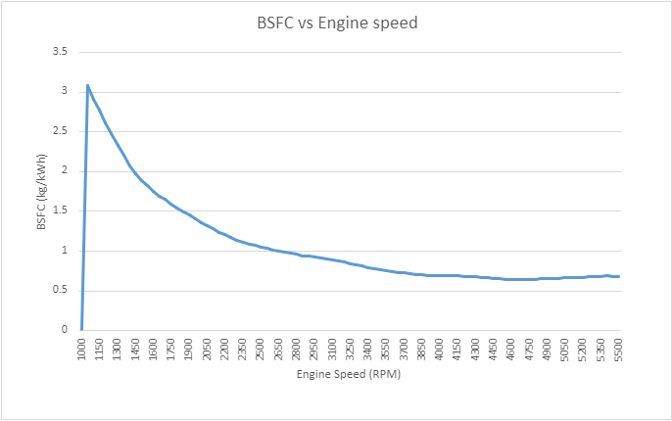
Figure 4-1Graph 1
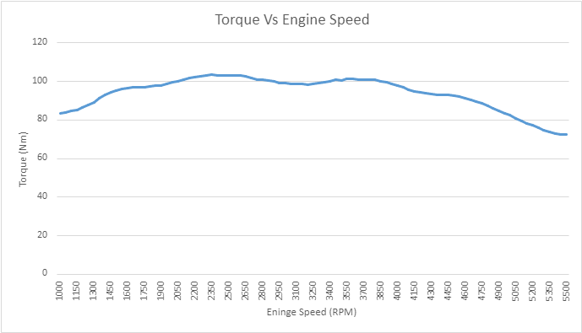
Figure 4-2 Graph 2
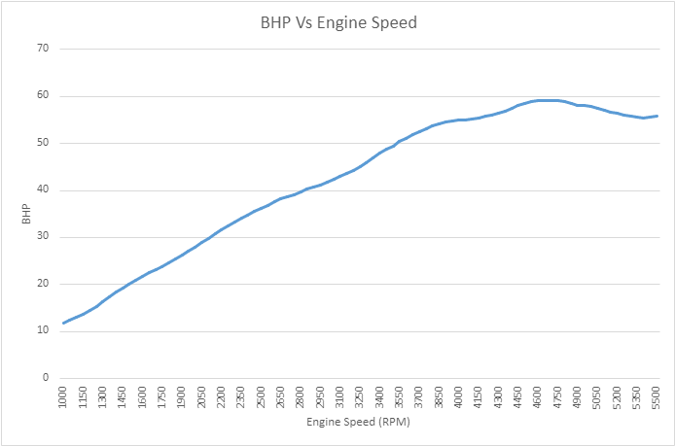
Figure 4-3 Graph 3

Conclusions
As shown in Figure 4-1, the RPM increases there is more efficient fuel consumption at 4700 RPM with a BSFC (Brake-Specific Fuel Consumption) of 0.643 kg/kWh. As it requires less fuel to generate power, the engine having a lower BSFC number is more efficient at that RPM.
As shown in figure 4-2, At Low RPM (Idle to Mid RPM) because the air-fuel mixture has less time to fully ignite at low engine speeds, the engine fails to produce as much power. However, because of the engine's capacity to generate pressure and effectively use low-speed features, the torque is comparatively higher in this range.
At High RPM (High-Speed Running): The air-fuel mixture must be more precisely regulated as engine speed rises. At increasing RPMs, the engine's ability to burn the mixture entirely decreases, causing torque to begin decreasing. This is because when engine speed increases and the intake and exhaust valves move more quickly, combustion becomes less efficient.
As shown in Figure 4-3, Brake power varies the same as torque where the low RPM range the fuel-air mixture has less to fully ignite so the BHP (Brake Horse Power) is low. Then going up to a higher RPM the fuel-air mixture the BHP is higher as the full can ignite more efficiently.

Evaluation
The test could have been improved if there had been a working dyno. Unfortunately, as there wasn’t I was given previously collected raw data to form calculations.

