
Skills for the Workplace
Module Assignment Submission
Student Name: | Ceri Edwina Jones
Student Number: | 1911551
Module No: | BMSK4003
Module Title: | Digital Skills and Research Methods

Statement of Confirmation of Authenticity
By the act of making this submission, the student declares that this is the work of the student named above. The work has not, in whole or in part, been knowingly presented elsewhere for assessment, or where assessment has been built on a previous assessment, this has been identified. Where materials have been used from other sources it has been properly acknowledged. If this statement is untrue, the student acknowledges that an assessment offence has been committed.
Attention is drawn to the plagiarism and unfair practice policies of both the University and of ILM.
Permission for ILM to use this script
ILM uses learners’ submissions – on an anonymous basis – for assessment standardisation. By submitting, both the centre and the learner agree that ILM may use this script on condition that identifying information is removed. However, if you are unwilling to allow ILM use this script, please refuse by ticking the box: □

Table of Contents
What has been the impact of 21st Century Technologies on the modern workplace? 3
Part 1 3
An Overview of the 21st Century Workplace 3
An in-depth look at technologies used in own workplace 3
Part 2 4
An exploration of the use of social media in the workplace generally 4
An in-depth look at the use of social media in own workplace 4
The use of social media to enhance networking and career prospects 4
LinkedIn Profile 4
Conclusion 5
References 6
Appendix 1 7
Appendix 2 8

What has been the impact of 21st Century Technologies on the modern workplace?

Technology today is a force to be reckon with in the workplace today, changing and altering the way things are being implemented in the world today. It’s indivisible component of the modern workplace and its quite problematic to think of businesses or workplaces that don’t rely on basic technology today. Helps businesses understand their money and conserves precious resources such as time and considerable space. A lot of workspaces have the resources like Wi-Fi, mobile phones, the cloud to help businesses connect, store data to be able to keep important files altogether, also be able to keep up to date with tasks. Technology has a big impact on how the workplace functions, no matter how minor or well-built the company is technology has both palpable and imperceptible benefits that will help you be prosper and create the best results for customers. Business advances like PCs, tablets, interpersonal organizations, virtual gathering programming, bookkeeping programming, client the executives applications, thus considerably more have evacuated working environment limits and they have likewise encouraged in the development of data at the working environment which quickens snappy basic leadership at your work environment. Innovation can be utilized to mechanize different assignments at work, this computerization will ensure proficiency and will likewise increment on generation at work. The utilization of PCs to achieve explicit undertakings at work makes room of making amendments on moment and it additionally decreases on human mistakes. Utilizing databases to catch and store data can encourage brisk basic leadership at work. Representatives can without much of a stretch access business data by means of one single database; this data can be altered and put something aside for later use. Utilization of inner systems at the working environment can help in sharing of devices like printers and scanners, so representatives don't need to move to various divisions to share mechanical devices. Transmitting on computer database and cloud to store peoples work and keep important information altogether can be very terrifying if you don’t take the right procedures and don’t have the right data to back up files to keep them safe. There are many software safety databases you can purchase to keep your data safe and stop your company files from being hacked. Problems that have occurred thanks to technology, being fastened to emails interrupts productivity working from home, has its benefits but its moreover comes with its disadvantages not being able to switch off from work, lack of sleep, leads to burn out and exertions presentation. It's a given that the greatest advantage of being a cloud office is that the cloud is consistently on. Workers can get to their documents, preparing, devices, information and whatever else they must carry out their responsibility from anyplace on the planet at any hour of the day or night. This not just liberates representatives from potential limitations of a conventional office condition, yet it permits the entirety of your workers all around to get to a similar data. Distributed computing enables your association to stay aware of everchanging innovation. With cloud innovation, you're ready to refresh any product or stage as new forms are discharged. It doesn't require any framework upgrades to raise workers to an acceptable level. It evens the odds for organizations, from new businesses to Fortune 500 by giving them all entrance to similar advances. It additionally says a great deal regarding your association and your ability to contend in an inexorably worldwide market for clients and ability. Innovation moves at a pace that can without much of a stretch surpass moral norms encompassing its utilization. The impacts of innovation on hard working attitudes move at a comparative pace with businesses moving to build up moral limits that appear to encroach on worker protection rights and confine correspondence capacities. A representative possessing organization hardware, including a mobile phone or PC, may regard the gear as his very own property as a result of the psychological proprietorship he creates through restrictive use. Moral issues emerge when a representative decides to utilize these bits of hardware for non-business-related reasons, including scanning for a new position or tolerating individual calls. A business must build up a reasonable approach on utilizing organization hardware credited to a worker for business purposes. This permits a business to set the moral standard regarding the operation of innovation.

Part 1

An Overview of the 21st Century Workplace

I would say technology has changed the way our workplaces function in many ways. Workplaces today have taken on a lot of different tools like internet, word, excel, power point, graphs/charts etc. Another tool that we use to communicate is email, text message, WhatsApp and Skype are just a few. Technology is used in numerous ways in a workplace, for example knowledge organisation, data disturbing, data guard, sudden choice making and communicating within the company. I would say we use technology in workplaces today because it helps keep businesses completely prearranged, companies use a lot of different software systems to help constructing, assigning, studying all tasks. Managers can oversee workplace behaviours on sites that are keeping them off track from completing tasks. Their such a significant number of ways innovation can occupy representatives at work. The utilization of informal organizations at work can cause such a lot of interruption and it influences the profitability of representatives. A few organizations have chosen to square access to explicit sites like Facebook, Twitter and YouTube, on account of the boundless interruption they cause. Different business innovations which cause interruption at work incorporate cell phones, PCs and virtual gathering applications like Skype. It is expensive to buy technology, but it is also costly to maintain it. It is costly to purchase innovation; however, it is additionally expensive to look after it. Numerous independent ventures cannot manage the cost of the expense of enlisting a full-time specialized individual, so they resort to month to month tech temporary workers who charge them for work done. If business innovation instruments like PCs are not very much kept up, their exhibition will diminish and the way toward purchasing new PCs or some other business innovation can even be increasingly costly. Since most undertakings are computerized by innovation, numerous representatives become languid at work, innovation murders their inventiveness and abilities. Straightforward assignments like ascertaining deals and following stock are being finished with PCs, so you will find that representatives don't put their cerebrums at work, they can't take care of top of the line business issues in light of the fact that a PC or programming will do it with no test. Technology can affect work relationships, conversing ng mobile phones, text messages, email or computer-generated video conferencing tools. This type of communication technology eliminates face-to-face communication. Interpersonal communications are important in building workplace relationships because employees will get a chance to know each other in person, occasionally they can even share non-work connected information, this type of interaction is killed by communication technology tools. Employees become more reserved and self-focussed; they get supressed into their work which can be of great damage to a business.

Benefits of Digital Workplaces

https://www.dizzion.com/resource/blog/27-stats-about-digital-workplace-transformations/

I found figures of businesses using technology to their advantage.

An in-depth look at technologies used in own workplace

Working as administrative assistant for RT Electrical company, we use a lot of excel and Microsoft word to store date for the company more or less every day we create graphs, tables and pie charts to explain are finding and to write down our documents, our jobs we get in through email we use excel to store our information. RT has a lot of different technology devises from computers to tablets, we use mobile phones, the internet, the cloud to store everything. Using various databases to store work, like the cloud and using the internet to connect with customers, having a website for customers to find out more about the company has really helped the business involve into such a big company, being in the industry for over 20 years and being well known. We use tablets to connect to the engineers to find out what work needs to be completed and needs to be done. We are very technical company where if we need to store information and data, we have all the right technology to help us. Business has been using paper for a while but since many businesses around us are implicating different technology we thought it was best for the engineers and us to go into tablets because it is much more efficient. My workplace connects to employees using WhatsApp, facetime, text messaging and emails, which is really good way to communicate with others. When one of us has a problem or issue with customer or job we can help each other by not just communicating face to face but by phoning each other or sending message on group chat. I know all our data is safe and stored in the right place because we have procedures in place to keep everything safe because we relay on computers and data so much as a company, without that where cant process jobs through or run a business. Using the cloud in work we are all able to access work outside of work and able to check where the engineers are, we check the use of the internet in work to see if everyone is getting on work. We have trackers to be able to access when we need to, so we need to check why engineer is late for occupation, where able to know if they’ve stopped or if there stuck in traffic. Were able to retrieve our work emails on our phones and video chat if we are on sick or on holiday and we need to discuss matters about the business we can do so on our mobile phones.

Part 2

An exploration of the use of social media in the workplace generally

Social media in workplace can be a big factor in workplace. Web based life can profit an organization in an assortment of ways including publicizing and advertising and discovering potential representatives. Promoting and advertising are two tremendous pieces of an effective organization. Organizations can utilize online networking for promoting another item or thought with expectations of it contacting a bigger crowd Internet based life is a simple method to support correspondence among representatives and help to share thoughts and increment commitment both while at work and at home. Its where most companionships can keep an eye on the competition, having Facebook, Instagram, twitter, websites and other social media platforms to use to promote your business can have their advantages and disadvantages. web based life has additionally gotten significant for clients who need to impart their encounters to an item or brand, regardless of whether it's to contact the business or just to impart to different shoppers. That is the reason it is essential to develop and sustain your web-based social networking bolster technique with the goal that clients' inadmissible surveys of your image on social stages don't go unnoticed. If you don't make it right, an ever-increasing number of web-based life clients will see these harming posts that can influence the general assessment of your image. Today marketing customers use social media because they have a better occurrence, the situation found that 53% of clienteles want faster answers and genuine responses. Representatives utilizing online life for work are even more frequently presented to other openings for work and have higher profiles among enrolment specialists, making them potential focuses for poaching. Online networking can be a ground-breaking specialized instrument for workers, helping them to team up, share thoughts and take care of issues. Representatives applying web for work are even more frequently presented to other openings for work and have higher profiles among enrolment specialists, making them potential focuses for poaching. Internet based life can be an incredible specialized device for representatives, helping them to team up, share thoughts and take care of issues. Employees using social media for work are more often exposed to other job opportunities and have higher profiles among recruiters, making them potential targets for poaching. Social media can be a powerful communication tool for employees, helping them to collaborate, share ideas and solve problems. Employees using social media for work are more often exposed to other job opportunities and have higher profiles among recruiters, making them potential targets for poaching. Social media can be a powerful communication tool for employees, helping them to collaborate, share ideas and solve problems. There are numerous advantages to consuming the internet in the work environment. A couple incorporate improved correspondence inside the organization, advancement of the organization brand, enlisting ability, and better client care. Permitting your staff to be using social networking at work can help spirit and really improve worker commitment for various reasons. It shows that you confide in them. It will cause them to feel esteemed and acknowledged. Internet based life can help representatives when managing a troublesome work issue. On the off chance that a worker has an issue they can't fathom, online life might be the appropriate response. Offering a conversation starter via web-based networking media is a basic and brisk approach to get a few potential arrangements. Regardless of whether none of the appropriate responses are utilized to take care of the issue, the data they give may start to another arrangement. Some of the time an outside viewpoint is required and using social media websites is a way to increase numerous new points of view, rapidly, effectively, and for nothing. Representatives can exploit online networking as a type of correspondence to find and convey work related data. Online networking in the work environment is another road for laborers to discover data that is applicable to the activity or find new data they can apply while on their activity. It is likewise a path for your workers to spread data about your organization. This transmission of data can help with brand mindfulness and open new enrolling and business openings.

An in-depth look at the use of social media in own workplace

Company doesn’t like to use social media, as it has a lot of negatives to having people view and comment on the business, RT is a very private company when it comes to the business. We have website where you can find all the information and data needed.

The use of social media to enhance networking and career prospects

I have used my LinkedIn profile in the past to find job, LinkedIn can be an important instrument in your pursuit of employment as organizations, spotters and head-trackers will utilize LinkedIn to look for contender for specific occupations and afterward approach them legitimately. On the off chance that you are effectively work looking through it is fundamental that you have a modern LinkedIn profile. Your LinkedIn profile is really like composing an online CV. Be that as it may, the computerized innovation parts of LinkedIn, offers some other helpful highlights including Endorsements. Organizations regularly utilize positive criticism from clients to convince other potential purchasers. LinkedIn takes this thought and permits you to incorporate individual tributes. Ask individuals you know, regardless of whether it is your administrator, partners, clients, providers or companions to compose a couple of positive words about your work abilities on your LinkedIn page. You can make recommendations for the sort of thing you might want them to compose. In any case, the way that another individual has set aside the effort to compose positive things for and about you will be seen by others as a sign of believability. LinkedIn isn't a substitution for a regular CV, yet it has gotten a helpful, if not fundamental, supplement to it. On the off chance that you are, or seek to be, in an expert job then you should join, as spotters who get your CV will verify whether you are likewise on LinkedIn.

LinkedIn Profile
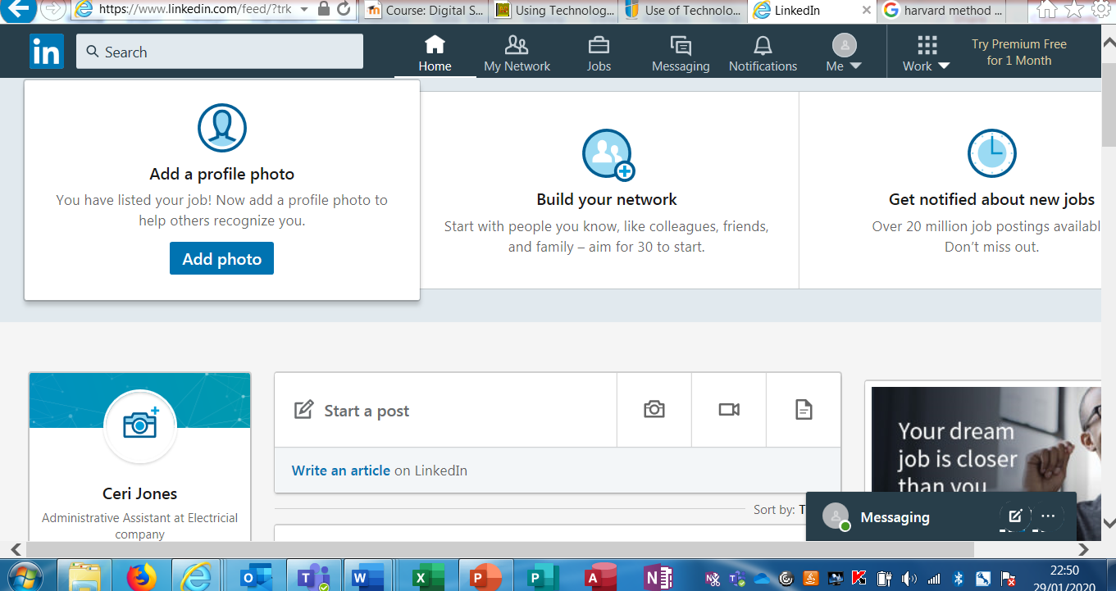
This is my LinkedIn

Conclusion

I’ve concluded from my research on technology in workplace, how I use technology in workplace is that you can only succeed in a business by having the basic technology these days, technology has evolved in todays market. Even small businesses relay on basic laptop, computer, tablets or iPads to communicate and store their work, its like what it used to be back in the day writing down information and data on piece of paper. Technology helps you to be able to have all the resources you need to run a small or large business, my workplace used to have one computer now it has over 5 computers and engineers used to write down all their job descriptions on a piece of paper, now they use tablets that get sent straight to use so we are able to store the information into our files. I would say technology has a lot of huge benefits but at the same time it does have its negatives as well, not being able to switch off from work, eyes straining from looking at a computer screen all day, being able to take your work home can have its pros or cons, you can finish your work at home so you don’t have to do it tomorrow in the office but then your not switching off from work mode. I find that we do have the tools to help use get our work out on time, having the internet there to research ideas and help when your stuck with work problems. Found a lot of articles and figures to help me find the right information and research.

References

https://scholarship.richmond.edu/cgi/viewcontent.cgi?article=1753&context=masters-theses/

https://smallbusiness.chron.com/effects-technology-work-ethics-18716/

https://freshdesk.com/customer-support/social-media-customer-service-blog/

https://www.dizzion.com/resource/blog/27-stats-about-digital-workplace-transformations/
https://hbr.org/2018/05/employees-who-use-social-media-for-work-are-more-engaged-but-also-more-likely-to-leave-their-jobs

http://www.egroupengage.com/blog/the-pros-and-cons-of-social-media-in-the-workplace
https://www.shrm.org/resourcesandtools/tools-and samples/toolkits/pages/managingsocialmedia.aspx

Appendix 1

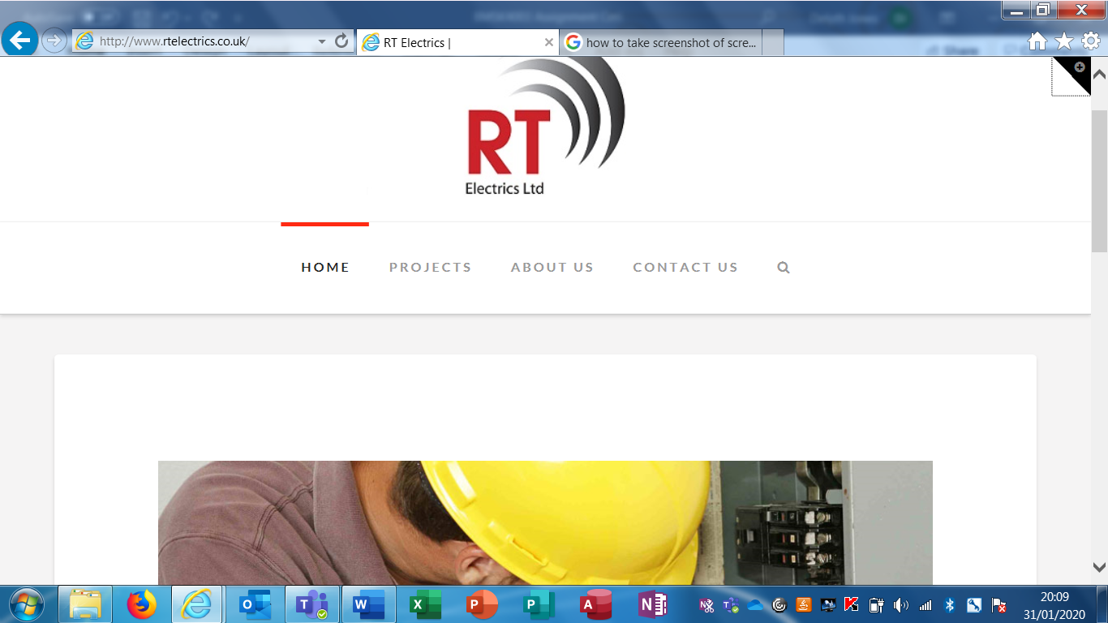

Appendix 2

