

Student name: Meneouan Keoua Sandrine Yo Ep Kouame
Student ID: 2336790

Module name: Changemakers: Building your Personal Brand for Sustainable Employment
Module code: BMHP5015
Lecturer name: Christopher Mafuva

Introduction (150-200 Words)
The module “The Changemakers: Building Your Brand for Sustainable Employment” has played a significant role in developing my personal and professional skills. It strengthened my understanding of how a clear career plan supports long-term growth and helped me recognise the value of self-awareness in shaping my professional identity. Through exploring emotional intelligence, I gained insight into how strong leadership, self-management, and reflective practice contribute to effective performance in the workplace. I also engaged with concepts such as ambition, success, and motivation, which encouraged me to think critically about what drives my career aspirations. Learning about the gig economy expanded my awareness of how modern employment is changing, offering greater flexibility and autonomy but also requiring adaptability and continuous learning. The module further highlighted the importance of hierarchy in health and social care, particularly in supporting clear communication and collaborative decision-making. This understanding helped me evaluate my own employability skills by identifying both strengths and areas for improvement. Additionally, studying networking techniques emphasised how building professional relationships enhances communication and supports ongoing development. Overall, the module’s focus on personal branding, boundaryless careers, networking, and emotional intelligence has encouraged meaningful self-development and provided practical strategies for shaping a sustainable career path (Prisniakova et al., 2023)

Reflection on Unit 1: Brand You (Approx. 400 Words)
Self‑awareness means checking in with yourself to see whether your thoughts, feelings, and actions match the kind of person you want to be (Ashley and Reiter‑Palmon, 2012). It is basically comparing who I am right now with who I want to be. Developing self‑awareness strengthens emotional intelligence and supports personal growth by helping individuals understand their limits, weaknesses, and patterns of interaction. In professional environments, people who lack self‑awareness may struggle to integrate into teams, misinterpret feedback, or make poor decisions that negatively affect their organisation. In contrast, individuals who cultivate self‑awareness tend to lead with empathy, communicate more effectively, and build strong relationships with colleagues and stakeholders (Carden, Jones and Passmore, 2022).
Evaluating myself is essential for my career development and long‑term success. Every reaction and thought becomes an opportunity for learning. In high‑pressure situations, it is important to remember that colleagues observe and learn from our behaviour. Self‑awareness also nurtures qualities such as empathy, honesty, calmness, transparency, and confidence. It enables employees to align their behaviour with organisational expectations and supports continuous learning from oneself and others. Ultimately, self‑awareness is an ongoing process of assessing and improving emotional skills. It is a form of self‑education that helps me understand the importance of teamwork, develop leadership abilities, solve problems, and make informed decisions. It also allows me to recognise the impact positive or negative of my actions in the workplace. According to Carden, Jones and Passmore (2022) self‑awareness is seen as one of the most important skills for becoming a good leader and building a successful career. Because of this, it has become a key part of leadership training and management education.
During classroom group activities, we explored topics related to building a personal brand, including ambition, motivation, and the gig economy. Each participant shared their understanding and experiences, which helped broaden my perspective. I learned that ambition, motivation, and clear career goals are essential for building a strong professional identity. We also discussed the concept of boundaryless careers, where individuals move across distinct roles or sectors throughout their working lives. This type of career development involves drawing validation from external networks, challenging traditional hierarchical structures, and making personal choices that may reject conventional career paths (Arthur, 2014). For example, my own journey from sales assistant to petrol station manager, to carer, and now a learner in Health and Social Care Level 5 illustrates a boundaryless career shaped by diverse experiences and continuous growth. Overall, Unit 1 has deepened my understanding of self‑awareness, career development, and the evolving nature of work, helping me build a clearer and more confident professional identity.

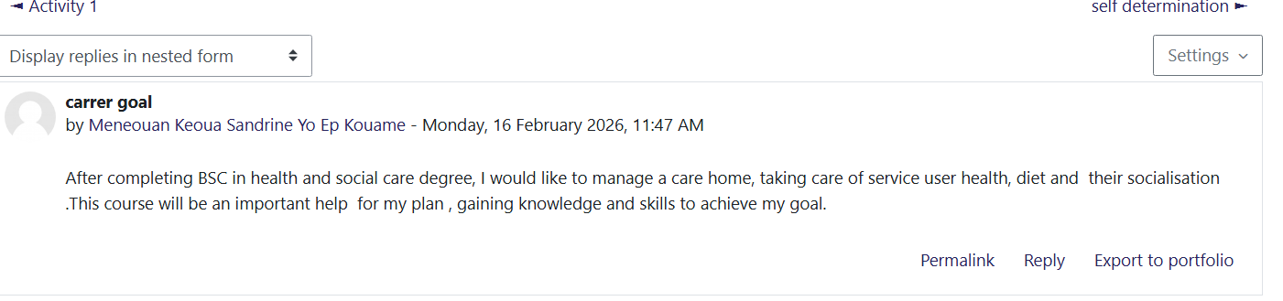

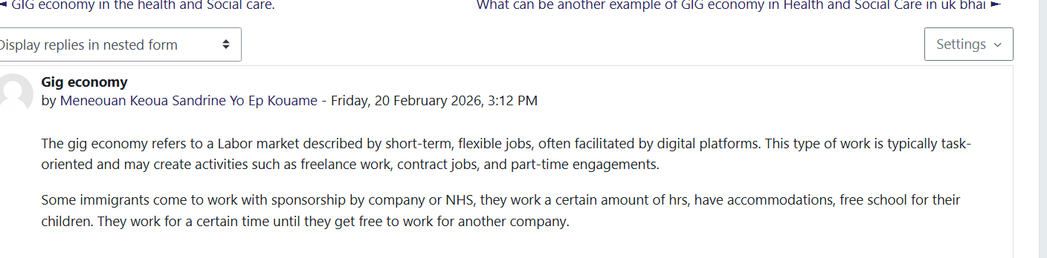

Reflection on Unit 2: It’s a Small World (Approx. 400 Words)
Networking is essential because it connects people, enables the exchange of knowledge, and supports personal and professional development. The purpose of networking is to build meaningful connections that help individuals achieve their goals. Evaluation in networking refers to assessing whether our connections are effective, relevant, and supportive of our objectives. Suarez‑Varela et al. (2023) discuss the opportunities of graph neural networks in communication. Networking is a powerful communication system made up of interconnected strategies that allow information to be exchanged easily. It links people across different contexts and locations, enabling interaction based on shared interests. Effective networking depends on the quality of relationships, opportunities created, knowledge shared, and the extent to which goals are achieved. It strengthens communication and supports teamwork, making it a vital component of professional practice.
Diversity within networking is particularly valuable because it encourages growth, innovation, and creativity. Collaborating with people from diverse backgrounds provides a variety of viewpoints and experiences. Kirby, Pascual and Hildebrand (2025) highlight that diversity in networks allows individuals to collaborate with others who have contrasting cultural perspectives. The Oxford University Press (2022) defines diversity as a range of many people or things that differ from one another. Understanding diversity is important for my career goals. It requires being open to collaborating with people who have different experiences and cultural backgrounds. Diversity encourages stepping outside of one’s comfort zone to exchange knowledge and ideas, which enhances creativity and broadens thinking. Building connections with people from various places and professions enriches skills and promotes open‑mindedness. In diverse networks, everyone is valued equally regardless of background, education, gender, or sexual orientation. People connect to share, learn, and communicate, making the world feel smaller and more interconnected. In health and social care, diversity means working with and caring for individuals with a wide range of needs, cultures, and conditions. It also involves adapting services to meet the needs of service users. High‑quality care requires strong collaboration between professionals such as GPs, community nurses, social workers, advocates, councils, care home managers, nurses, and carers. This professional network ensures safety, continuity, and person‑centred care. Diversity and inclusion promote equal opportunities and strengthen healthcare delivery across communities.

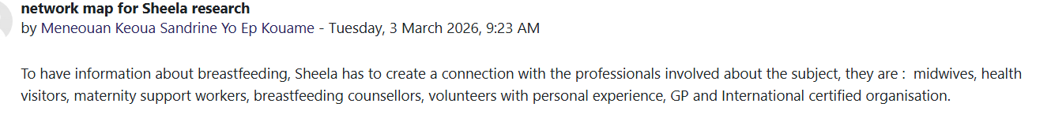
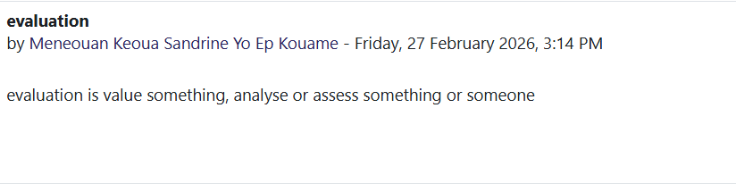


Reflection on Unit 3: Opportunity Knocks (Approx. 400 Words

Changing perspectives in health and social care allows professionals to observe several aspects of a situation and understand service users more holistically. This approach supports person‑centred care by improving the quality of support provided and strengthening teamwork. When professionals consider multiple viewpoints, both service users and staff benefit. Health and social care workers develop new skills by recognising opportunities through different perceptions, and service users receive more tailored and effective support. This contributes to a positive and collaborative workplace environment. We also explored the concept of “spotting opportunities,” which is an important skill for professional growth and success. From an information‑processing perspective, opportunity recognition involves using instructions, strategies, and problem‑solving methods to identify and construct opportunities based on existing information (Vaghely and Julien, 2010). In health and social care, this means recognising gaps, anticipating needs, and using available knowledge to improve practice.
During the session, we discussed the difference between success and luck. Although they may appear similar, they are distinct: success develops through competence, communication, empathy, and understanding, while luck often emerges from actively seeking opportunities. In professional practice, it is essential to work effectively, respect hierarchy, maintain confidentiality, and uphold service user dignity. Setting goals is a key strategy for achieving success, as it helps individuals manage challenges and stay motivated. As Waites (2023) suggests, achieving long‑term goals requires effort, persistence, and a strong commitment to personal development.
The group activity highlighted that individuals perceive situations differently, and this diversity of perspectives is valuable. I realised that I am ready to recognise opportunities, build success, and create my own luck. This unit was particularly meaningful because it helped me understand how to organise my goals and strengthen my career plan. Using the SMART framework, I developed the following goal: Specific: I want to work for myself by creating my own company and supporting people in need, particularly children.
Measurable: I am currently studying Health and Social Care and have access to relevant resources.
Achievable: I am completing my Level 5 qualification this term, and I already have experience as a carer and volunteer nurse.
Relevant: Working for myself will give me flexibility and allow me to manage my schedule around my son.
Time‑bound: I aim to achieve this goal within two years, giving me time to finish my degree and gain further specialisation.
Overall, this unit has strengthened my understanding of opportunity, success, and career planning, helping me build a clearer and more confident professional direction.


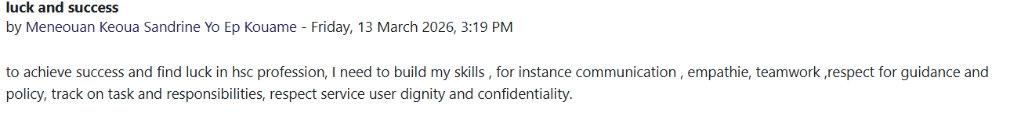

Reflection on Unit 4: The Pursuit of Happiness (Approx. 400 Words)

Wellbeing can be understood in several ways. It is often linked to financial stability, medical or physical health, and socio‑psychological factors such as the fulfilment of needs or overall happiness (Dluzewska, 2016). In health and social care, wellbeing is supported through person‑centred care planning tools, which strengthen communication, goal setting, and shared decision‑making between service users and professionals (Lawless et al., 2024). Overall, wellbeing involves being able to engage in activities that bring peace, satisfaction, and good health.
The unit also explored, resilience, which I now understand as the ability to transform negative experiences into positive outcomes. It involves staying firm in one’s decisions, avoiding unhelpful influences, and refusing to limit oneself. Resilience means continuously improving, maintaining hope, and finding solutions even in challenging situations. It requires a positive mindset and the belief that growth is always possible, regardless of age, background, or perceived limitations. According to Nguyẽ̂n (2024), resilience refers to the capacity to withstand change, instability, or adversity, making it a key survival skill in both personal and professional contexts.
Another important topic was, work life balance, which refers to maintaining an equal distribution of time, energy, and commitment between work responsibilities and personal life. Achieving balance supports wellbeing, reduces stress, and improves performance in both areas.
This course has helped me understand how resilience influences my personal and professional development. It has challenged my beliefs, strengthened my confidence, and improved my ability to cope with difficulties. I now trust myself more and recognise that I can achieve goals I once believed were impossible. For example, when I began this programme, I doubted my ability to complete the first year because balancing work, family, and study felt overwhelming. However, by organising my time and staying committed, I succeeded and am now completing Level 5. If I had allowed fear to stop me, I would not have reached this stage.
The course also introduced the PERMA model, a scientific framework for wellbeing developed by Dr Martin Seligman, a pioneer of positive psychology (Madeson, 2017). Understanding this model has shown me how positive emotion, engagement, relationships, meaning, and accomplishment contribute to a fulfilling and successful life. Overall, this unit has deepened my understanding of wellbeing, resilience, and balance, helping me build a stronger foundation for my future career.

See below a diagram of PERMA model.

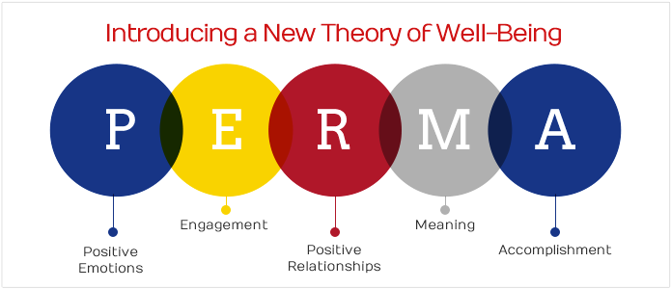
(Creative Common, 2023)

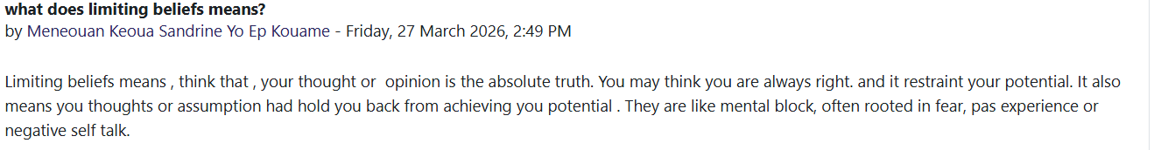

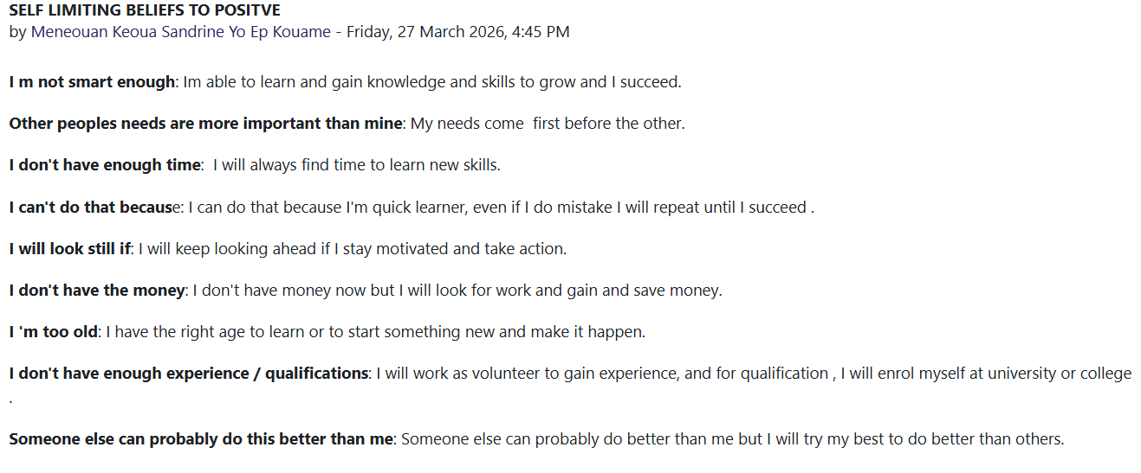

Conclusion (Approx. 150-200 Words)

In conclusion, the module “The Changemakers: Building Your Brand for Sustainable Employment” has been highly valuable in supporting both my personal and professional development. It has strengthened my understanding of career planning, personal branding, emotional intelligence, networking, and self‑awareness key elements for building a successful career in health and social care. Throughout the module, I learned the importance of ambition, motivation, clear goal setting, communication, leadership, teamwork, and adaptability. I also gained insight into the gig economy, boundaryless careers, diversity, and effective networking as pathways for creating opportunities and supporting long‑term growth. The module encouraged me to reflect critically on my strengths and weaknesses, improve my professional behaviour, and think more intentionally about my future. It has increased my confidence, resilience, and determination to achieve my goals while maintaining a healthy work life balance and overall wellbeing. I now feel more prepared to navigate challenges, recognise opportunities, and take initiative-taking steps toward my career aspirations. Overall, this course has inspired me to continue developing my skills, broaden my perspective, and move forward with a positive and motivated mindset.
References
Ashley, G. C. and Reiter-Palmon, R. (2012). ‘Self-awareness and the evolution of leaders: The need for a better measure of self-awareness’, Journal of Behavioral and Applied Management, 14(1), 2. Available at: https://doi.org/10.21818/001c.17902

Arthur, M.B. (2014) ‘The boundaryless career at 20: where do we stand, and where can we go?’, Career Development International, 19(6), pp. 627–640. Available at: https://doi.org/10.1108/CDI-05-2014-0068.

Carden, J., Jones, R. J. and Passmore, J. (2022). ‘Defining self-awareness in the context of adult development: A Systematic Literature review’. Journal of Management Education, 46(1), pp.140–177.Available at: https://doi.org/10.1177/1052562921990065

Creative Commons (2013) Attribution‑Non-commercial‑No Derives 3.0 Unported (CC BY‑NC‑ND 3.0). Available at: https://creativecommons.org/licenses/by-nc-nd/3.0/. (Accessible on 01/04/2026).

Dluzewska, A. (2016) ‘Wellbeing – conceptual background and research practices’, Društvena Istraživanja, 25(4), 547–567. Available at: https://doi.org/10.5559/di.25.4.06.

Kirby, T. A., Pascual, N.R and Hildebrand, L.K. (2025). ‘The dilution of diversity: Ironic effects of broadening diversity,’ Personality & Social Psychology Bulletin, 51(2), 268–283. Available at:
https://doi.org/10.1177/01461672231184925

Lawless, M.T., Archibald, M.M., Ambagtsheer, R.C., Pinero de Plaza, M.A. and Kitson, A.L. (2024) ‘My Wellbeing Journal: Development of a communication and goal‐setting tool to improve care for older adults with chronic conditions and multimorbidity’, Health Expectations: An International Journal of Public Participation in Health Care and Health Policy, 27(1), pp. e13890-n/a. Available at: https://doi.org/10.1111/hex.13890

Madeson, M. (2017) Seligman’s PERMA+ model explained: A theory of wellbeing. Available at: https://positivepsychology.com/perma-model/ (Accessible on 11 April 2026).

Nguyẽ̂n, V. (2024) Lived refuge: Gratitude, resentment, resilience. 1st edn. University of California Press. Available at: https://doi.org/10.1525/9780520397279

Oxford University Press (2022) Oxford English Dictionary: diversity. Available at: https://www.oed.com/ (Accessed: 11 April 2026).

Prisniakova, L., Aharkov, O., Samoilov, O., Nesprava, M. and Varakuta, M. (2023) ‘Psychology of self-development: Strategies and factors of effective personal growth’, Revista de Gestão e Secretariado, 14(10), pp. 19106-19122.

Suarez-Varela, J., Almasan, P., Ferriol-Galmes, M., Rusek, K., Geyer, F., Cheng, X., Shi, X., Xiao, S., Scarselli, F., Cabellos-Aparicio, A. and Barlet-Ros, P. (2023)’ Graph Neural Networks for communication networks: Context, use cases and opportunities’, IEEE Network, 37(3), pp.146–153.Available at: https://doi.org/10.1109/MNET.123.2100773.

Vaghely, I.P. and Julien, P.-A. (2010) ‘Are opportunities recognized or constructed? An information perspective on entrepreneurial opportunity identification,’ Journal of Business Venturing, 25(1), pp. 73–86. Available at: https://doi.org/10.1016/j.jbusvent.2008.06.004

Waites, M. (2023) Transition to success: A self-esteem and confidence workbook for trans People. 1st edn. Jessica Kingsley Publishers. Available at: https://doi.org/10.5040/9781805016526

