University of Wales Trinity Saint David
Wales Institute of Science and Art


Materials Testing and Sustainability of Composites for Motorsport and Automotive Industries
Automotive Materials and Sustainability
ACHA6012
Scott Holden
2200027
April 2026

Contents
1. Introduction 1
2 Literature Review 2
2.1 Composites Overview 2
2.2 Types of Composites 3
2.3 Structure Property Relationships 3
2.4 Mechanical Properties 3
2.5 Manufacturing Process 4
3 Sustainability Analysis 4
4 Experiment Results and discussion 6
5 Conclusion 8
6 References 10
7 Appendices 12

1. Introduction
The aim of this report is to investigate and assess the mechanical properties of selected composite materials through experimental testing and evaluate these against data found through an in-depth literature review in order to assess their suitability for application into the motorsport and automotive industries. Composites are becoming an increasingly popular material to be used in motorsport and automotive industries, this can be attributed to their high strength-to-weight characteristics (Fardin Khan, 2025) Typical applications can include but aren’t necessarily limited to: Bodywork, Engine Covers, Diffusers and Spoilers. Since their introduction into automotive and motorsport, their use has increased exponentially, with a mainstream use being the 1981 Mclaren MP4/1 monocoque chassis proving its ability to provide significant weight reductions and also increase structural rigidity. (Technologies, 2025). Key advantages of Composites are their significant reduction in weight compared to their alternatives, with a reduction of thermal conductivity these materials provide an enormous increase of performance in material properties but at a cost to material, and manufacturing costs. Composites are used due to their high strength and stiffness paired with their low density; this is excellent for automotive applications as a decrease in weight can yield a higher overall efficiency as the propulsion system isn’t working as hard to propel the smaller mass (Mehran Bahari, 2022). An issue that surrounds composites are the sustainability of the material, implications such as wastage through material cutoffs, the initial energy demands and greenhouse emissions that are created through the manufacturing process.

2 Literature Review

2.1 Composites Overview
Composites can be classified as a material where two or more chemically different components have been manufactured together in order to produce a new material (Chinta, 2017). Primary composites used in motorsport can consist of Carbon Fibre Reinforced polymers (CFRP), Glass Fibre Reinforced polymers (GFRP), aramid composites similar to the Kevlar used in body armour for military applications. Additional composites used in motorsport can include Polyethylene Filaments, and Zylon, these are applied across the chassis, bodywork and the aerodynamic components (Savage, 2008). Besides their use in the Mclaren MP4/1, a major achievement was when Williams FW14B won the 1992 World Championship with its fully Carbon Fibre chassis proving the useful application into the sport. Carbon fibre has steadily been more utilised in traditional automotive applications for numerous reasons, from being an aesthetic choice due to consumers assuming it has a higher value and/or performance to additional weigh savings compared to their tradition metal counterparts (Tang, 2025).

2.2 Types of Composites
Several variations of composites exist and are utilised in automotive and motorsport applications, as stated above common types include, CFRP and GFRC, but variations in the materials used in these materials also exist. With Epoxy Resin being the most common matrix material used, it has several inherent weaknesses in its use, the weak interfacial bonding between the resin and carbon fibres can be attributed to the smooth bonding surfaces on the fibres paired with the chemical inertness (Boshi Yu, 2025) Carbon-Carbon (CC) composites are another type of composite used today with both fibre reinforcement and matrix material are both carbon based. Commonly used in braking systems such as brake disks due their advantages compared to traditional steel brakes. CC brake disks retain their mechanical properties at extremely high temps experienced under heavy braking (Aleksander Yevtushenko, 2020).

2.3 Structure Property Relationships
The fibres in the composites are the main load bearing component providing the strength and stiffness while the matrix offers the path of the stresses through to the fibres. The effectiveness of the composite depends on the properties and their responses to applied stresses (Anna Wiśniewska, 2019), the interface between the fibre and the matrix is essential in the short and long-term performance of the composites due to the transfer of stresses between the materials. A poor interface between the fibres and the polymer matrix can lead to premature debonding between these components and also a reduced structural performance (Silu Huang, 2021). A Major difference between these composites and their counterparts is unlike metals and their isotropic properties, composites are generally anisotropic material where the strength is direction dependent to mitigate this, the fibres are usually constructed as laminates and stacked atop one another (B. Schläpfer, 2014).

2.4 Mechanical Properties
The mechanical properties observed in composite materials are imperative to their applications, especially within motorsport and automotive uses. Unlike Metallics, which are usually isotropic and can be characterised by a set of properties; composite materials can be engineered to match the demands of the component (Chris Worrall, 2020), through direction dependent properties and laminate structures, the specific needs of the component can lead to a tailoring of the composite used. A common advantage of CFRP is their specific strength and stiffness (strength/stiffness per unit mass) this is more relevant to vehicle performance than the absolute strength and stiffness characteristics as every kilo of mass has a cost in vehicle performance in terms of acceleration, braking and cornering grip (Wallentowitz, 2004). Vehicle structures are continuously subjected to loading of different types, from suspension inputs, powertrain vibration and road irregularities, due to this, fatigue can be a critical issue that materials need to overcome (M.A. Adam, 2025). Although CFRP demonstrates good fatigue resistance as the carbon fibre’s high tensile strength and stiffness allow the material to absorb and effectively distribute the cyclic loads effectively, however, fatigue in Composites can be more complex than metals due to multiple damage mechanisms interacting with one another, such as delamination, debonding between the matrix and the fibres and fibre failure being among the many failure mechanisms the composites can experience (Anurag Sharma, 2023).

Manufacturing Process
The most common method for the manufacture of Carbon Fibre in motorsport is the use of Pre-Preg materials, this is where the layers of fibre are already infused with a specific amount of resin usually epoxy (Nigel Keen, 2023). Prepreg requires, pressure, heat and time in an autoclave in order to cure the resin used within the matrix. The component is shaped using several pre-cut prepreg pieces placed within a negative mould. An autoclave is a high-pressure oven that uses pressure around 6 Bar and temperatures between 120° and 180° (Stefano Cassola, 2022). Due to the mould requiring the ability to perform under the same conditions as the composite through curing while matching the thermal expansion properties, these moulds are often made from the same materials as the component desired (Biao Wang, 2023)

3 Sustainability Analysis
As the motorsport and automotive industries continue to face increasing regulatory and environmental pressure, the sustainability of materials used within these sectors has become a major consideration. Composite materials, particularly carbon fibre reinforced polymers (CFRP), present a complex challenge when assessed from a sustainability perspective. While they offer significant performance advantages, their environmental impact across the full lifecycle must be carefully evaluated.
A common method used to assess this impact is Life Cycle Assessment (LCA), which considers all stages of a material’s life, including raw material extraction, manufacturing, use phase, and end-of-life disposal. This approach highlights a key paradox associated with CFRP: although the material enables weight reduction and improved efficiency during use, it carries a high environmental cost during production.
The manufacturing stage is one of the most environmentally intensive phases of composite materials. Carbon fibre production typically begins with a petroleum-based precursor such as polyacrylonitrile (PAN), requiring high energy input during stabilisation and carbonisation processes. These stages operate at elevated temperatures and contribute significantly to greenhouse gas emissions. In addition, the use of thermosetting resins such as epoxy further increases the environmental burden, as these materials are derived from non-renewable resources and are not easily recyclable.
Composite manufacturing processes, particularly those used in motorsport such as prepreg layup and autoclave curing, also contribute to sustainability concerns. These processes require high pressure and temperature, resulting in further energy consumption. Additionally, due to the complex geometries of automotive components, a large amount of material waste is generated through trimming and cutting of prepreg sheets. As highlighted in the report, these offcuts are often discarded, representing both an environmental and economic inefficiency.
End-of-life disposal is another significant issue. Unlike metals, which can be melted and reused with relatively low degradation in properties, thermoset composites cannot be remelted. This makes recycling difficult, and many composite components are currently sent to landfill or incinerated. Although some recycling methods such as pyrolysis and mechanical grinding exist, they are not yet widely implemented at an industrial scale and often result in reduced material performance.
Despite these drawbacks, the use-phase benefits of composite materials can offset their initial environmental impact. The lightweight nature of CFRP leads to reduced vehicle mass, which directly improves fuel efficiency in internal combustion engine vehicles and extends range in electric vehicles. Over the lifetime of a vehicle, this reduction in energy consumption can lead to a net decrease in overall carbon emissions. As noted, studies have shown that incorporating CFRP into vehicle structures can result in significant CO₂ savings over a typical service life, demonstrating that the material can be environmentally beneficial when considered holistically.
In recent years, efforts have been made to improve the sustainability of composite materials. One approach is the development of bio-based resins, which aim to replace petroleum-derived matrices with renewable alternatives. Similarly, natural fibres such as flax are being explored as replacements for synthetic fibres in certain applications. These materials generally have a lower environmental impact during production, although they often come with reduced mechanical performance compared to carbon fibre.
Another area of development is recycling and circular economy strategies. Research into reclaiming carbon fibres from end-of-life composites is ongoing, with the aim of reusing fibres in secondary applications. While recycled fibres typically have lower mechanical properties, they can still be suitable for non-critical components, reducing the demand for virgin material.
Overall, while composite materials present clear sustainability challenges, particularly in manufacturing and disposal, their benefits during the use phase cannot be overlooked. The future of sustainable composites will likely depend on improvements in manufacturing efficiency, increased use of bio-based materials, and the development of effective recycling technologies. A balanced lifecycle approach is therefore essential when assessing their true environmental impact.

4 Experiment Results and discussion
The average mechanical properties obtained from the tensile testing (based on four specimens per material) are shown in Table 1. The results highlight clear differences in behaviour across the seven materials tested, which can be linked back to the fibre type, fibre arrangement and matrix material discussed earlier in the literature review.
Table 1 shows the generated values for each material.
The aluminium samples produced a mean ultimate tensile strength (UTS) of 117.0 MPa, a 0.2% proof stress of 105.4 MPa and a Young’s modulus of 56.1 GPa. The break stress of 38.1 MPa is much lower than the UTS, which is expected for a ductile material like aluminium. This is because the material undergoes significant plastic deformation and necking before fracture, reducing the cross-sectional area at the point of failure. The modulus value is also slightly lower than the typical value of around 69 GPa, which could be due to the specific alloy used or the small sample size.
The non-woven carbon fibre with a bio-resin matrix produced a mean UTS of 162.8 MPa and a modulus of 12.3 GPa. The relatively low stiffness compared to woven carbon fibre is likely due to the random fibre orientation, which reduces the efficiency of load transfer in any one direction. The relatively high break stress compared to its UTS suggests a more gradual failure rather than a sudden brittle fracture.
The woven carbon fibre with bio-resin matrix showed extremely high values of 2041.3 MPa for UTS and 297.8 GPa for modulus. These values are far higher than what would normally be expected for a cured composite laminate and are more in line with raw carbon fibre properties. This suggests there may have been an error in measuring or recording the cross-sectional area, as stress calculations are directly dependent on this value. As a result, these values are likely inaccurate and should be treated with caution, and are not considered reliable for comparison with the other materials.
The woven carbon fibre with epoxy matrix produced a mean UTS of 348.5 MPa, a 0.2% proof stress of 264.5 MPa and a Young’s modulus of 48.9 GPa. These values are much more in line with expected properties for a woven CFRP laminate and can be used as a realistic benchmark. The break stress of 337.6 MPa is very close to the UTS, which indicates a brittle failure mode, where the material fails suddenly with very little plastic deformation.
The non-woven flax with bio-resin matrix produced a mean UTS of 46.0 MPa and a break stress of 40.9 MPa. The proof stress and modulus were not obtained, most likely due to the gradual and non-linear elastic behaviour typically seen in natural fibre composites, which makes these values harder to extract accurately. However, the UTS value aligns reasonably well with the datasheet range of 37–44 MPa, giving some confidence in the result.
The woven flax with bio-resin matrix produced a mean UTS of 90.8 MPa, a proof stress of 72.6 MPa and a modulus of 1.9 GPa. The UTS is higher than the datasheet value of 58–61 MPa, while the modulus is significantly lower than the expected 6–7 GPa. This could suggest a lower fibre volume fraction in the test samples, or that the bio-resin matrix had a greater influence on the stiffness at lower strains.
Finally, the woven Kevlar with bio-resin matrix produced the second highest UTS of 1132.3 MPa and a modulus of 51.0 GPa. This reflects the well-known high strength of aramid fibres. The large difference between the UTS and the 0.2% proof stress (677.3 MPa) indicates that the material undergoes a noticeable amount of deformation before failure, which is consistent with Kevlar’s high toughness and energy absorption capability.

5 Conclusion
This report has investigated the mechanical properties of seven composite and metallic materials through experimental tensile testing, supported by a literature review covering composite types, structure-property relationships, mechanical properties, manufacturing processes, and sustainability considerations. The experimental programme tested four specimens per material, producing quantitative data for UTS, 0.2% proof stress, Young's modulus, and break stress, which were compared against manufacturer datasheet values where available.
The woven carbon fibre with epoxy matrix produced the highest reliable UTS of 348.5 MPa and a Young's modulus of 48.9 GPa among the conventionally tested materials, confirming its position as the industry-standard composite benchmark for structural motorsport applications. The woven Kevlar with bio-resin system produced an exceptionally high UTS of 1132.3 MPa, reflecting the outstanding tensile strength of aramid fibres documented in the literature, alongside a significant plastic strain range consistent with the energy-absorbing characteristics that make Kevlar particularly suited to impact and safety-critical structures in motorsport.
The non-woven carbon fibre with bio-resin system produced a UTS of 162.8 MPa and a Young's modulus of 12.3 GPa, demonstrating that the random fibre architecture of the non-woven mat significantly reduces directional mechanical efficiency compared to woven systems, consistent with the structure-property relationships established in the literature review. The woven and non-woven flax bio-resin systems produced UTS values of 90.8 MPa and 46.0 MPa respectively, which are broadly consistent with their datasheet values and demonstrate that natural fibre composites represent viable materials for lower-load structural and semi-structural applications where sustainability is a priority.
The woven carbon fibre with bio-resin specimens produced anomalously high values of 2041.3 MPa UTS and 297.8 GPa modulus, which are inconsistent with expected cured laminate properties and are attributed to a likely error in the recorded cross-sectional area of the specimens. These results have been noted as unreliable and excluded from direct comparative analysis, representing a limitation of the experimental programme that would benefit from further investigation with corrected specimen geometry data.
The sustainability analysis conducted in this report demonstrates that whilst CFRP carries a substantial environmental burden at the manufacturing stage — requiring approximately 20 tonnes of CO₂ per tonne of carbon fibre produced — the lifecycle benefits of weight reduction can more than offset this cost over a vehicle's service life. The bio-resin systems tested in this study offer a meaningful step towards reducing the environmental impact of composite manufacture, with the IB2 bio-resin containing approximately 31% plant-based content without compromising the mechanical performance of the resulting composite relative to conventional epoxy systems. The flax fibre composites similarly demonstrate that natural fibre reinforcements can deliver competitive mechanical properties for appropriate applications while significantly reducing the embodied carbon of the material.
Based on the findings of this study, the following recommendations are made for the use of composite materials in motorsport and automotive applications. Woven carbon fibre with epoxy matrix remains the most appropriate choice for primary structural components where maximum stiffness and strength are required. Woven Kevlar with bio-resin is recommended for impact-critical and energy-absorbing structures given its exceptional tensile strength and plastic deformation capacity. For secondary structural and bodywork applications where sustainability is a design priority, woven flax with bio-resin represents a viable alternative to synthetic composites, offering a significantly reduced lifecycle carbon footprint at acceptable mechanical performance levels. The adoption of bio-resin matrix systems across all fibre types is recommended as a straightforward substitution that reduces environmental impact without meaningful mechanical penalty.
Future research should focus on fatigue testing of the bio-resin composite systems to characterise their durability under the cyclic loading conditions experienced in motorsport, determination of actual fibre volume fractions in the manufactured specimens to allow more direct comparison with datasheet values, and investigation of end-of-life recyclability of bio-resin matrix composites through solvolysis routes, which may offer improved recovery rates relative to conventional thermoset epoxy systems.

6 References
Aleksander Yevtushenko, M. K. K. T., 2020. Frictional Heating during Braking of the C/C Composite Disc. Materials, Volume 13, pp. 26-91.
Anna Wiśniewska, S. H. A. L.-K. H. E., 2019. Effective properties of composite material based on total strain energy equivalence. Composites Part B: Engineering, 166(1), pp. 213-220.
Anurag Sharma, S. C. J., 2023. Enhancement in fatigue performance of FRP composites with various fillers: A review. Composite Structures, 309(1), pp. 116-724.
B. Schläpfer, A. B. G. K., 2014. Optimal design and testing of laminated light-weight composite structures with local reinforcements considering strength constraints: Part II: Testing. Composites Part A: Applied Science and Manufacturing, Volume 61, pp. 279-287.
Biao Wang, S. F. J. C. W. Y. W. L. Y. L., 2023. A review on prediction and control of curing process-induced deformation of continuous fiber-reinforced thermosetting composite structures. Composites Part A: Applied Science and Manufacturing, Volume 165, pp. 107-321.
Boshi Yu, Y. Z. Y. L. Y. J. Y. S. M. P., 2025. Enhancing the mechanical properties of carbon fiber/epoxy resin laminates through a combination of carbon fiber coating and matrix reinforcement with an aminated para-polyamide. Composites Part A: Applied Science and Manufacturing, Volume 191.
Chinta, J. P., 2017. Coinage metal nanoparticles based colorimetric assays for natural amino acids: A review of recent developments. Sensors and Actuators B: Chemical, pp. 733-752.
Chris Worrall, E. K. C. V., 2020. JOINING OF FIBRE-REINFORCED POYMER COMPOSITES, s.l.: Composites UK Ltd.
D. May, C. G. K. F., 2021. Multifunctionality of polymer composites based on recycled carbon fibers: A review. Advanced Industrial and Engineering Polymer Research, 4(2), pp. 70-81.
Fakirov, S., 2026. On the drastic discrepancy between the mechanical characteristics of polymer nanocomposites as observed and as predicted: Justifications and workable fixes. Advanced Industrial and Engineering Polymer Research, 9(2), pp. 179-188.
Fardin Khan, N. H. J. J. M. S. M. R. M. J. I. M. B. M. A. C., 2025. Advances of composite materials in automobile applications – A review. Journal of Engineering Research, 13(2), pp. 1001-1023.
Hao Chen, H. P. L. A. A. O. Z. C. M. M. W. I. M. C.-D., 2025. A critical review and meta-analysis of energy demand, carbon footprint, and other environmental impacts from carbon fiber manufacturing. Resources, Conservation and Recycling, 219(1), pp. 108-302.
M.A. Adam, S. S. S. A. M. J., 2025. Bayesian approach in fatigue reliability characterization for stochastic-induced road load conditions. Results in Engineering, Volume 25, pp. 104-505.
Mehran Bahari, M. R. A. E. S. G. M. E., 2022. Performance evaluation and multi-objective optimization of a novel UAV propulsion system based on PEM fuel cell. Fuel, 311(1), pp. 122-554.
Nigel Keen, R. B. S. J., 2023. MOULD TOOLING FOR FIBRE-REINFORCED POLYMER COMPOSITES, s.l.: Composites UK Ltd.
Oh, E. &. G. M. &. N. T. &. K. B. &. T. T. T. &. S. J., 2024. Sustainable green composite materials in the next-generation mobility industry: review and prospective. Advanced Composite Materials, 33(10), pp. 1-52.
Savage, G., 2008. Composite Materials Technology in Formula 1 Motor Racing , s.l.: Honda Racing F1.
Silu Huang, Q. F. L. Y. B. K., 2021. Characterization of interfacial properties between fibre and polymer matrix in composite materials – A critical review. Journal of Materials Research and Technology, Volume 13, pp. 1441-1484.
Stefano Cassola, M. D. T. S. D. M., 2022. Machine learning for polymer composites process simulation – a review. Composites Part B: Engineering, Volume 246, pp. 110-208.
Tang, H., 2025. Research Progress of Carbon Fiber Composite Materials in Automobile Body Lightweight, s.l.: EDP Sciences .
Technologies, P., 2025. History of Carbon Fibre in Motorsports. [Online]
Available at: https://pfafftechnologies.com/a-history-of-carbon-fibre-and-motorsports/
[Accessed April 2026].
Toray, 2023. Life Cycle Assessment. [Online]
Available at: https://www.cf-composites.toray/aboutus/sustainability/Life%20Cycle%20Assessmentci.html
[Accessed 01 05 2026].
Wallentowitz, D. I. H., 2004. Automotive Engineering II: Vertical Vehicle Dynamics, s.l.: Institute For Motor Vehicle Engineering .
Yu Han, Q. X. Y.-Q. W. H. G., 2026. Bionic CFRP for extreme applications: from natural structures to high-performance manufacturing. Composites Part B: Engineering, 311(15), pp. 113-193.
Zabihi, O. &. Z. P. &. Y. R. &. W. Y. &. L. M. &. P. E. &. A. M. &. L. Q. &. H. S. &. N. M., 2025. The sustainability spectrum of carbon fibre: balancing high performance CFRP composites with environmental responsibility. Advanced Composites and Hybrid Materials, Volume 10.

7 Appendices
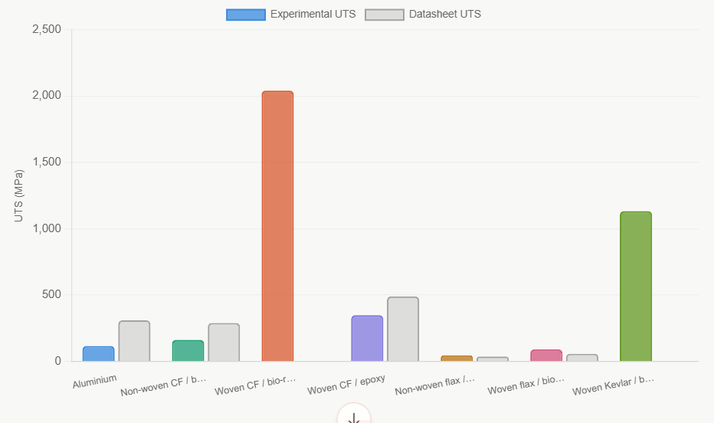
Figure 1 shows the calculated uts values against data sheets.
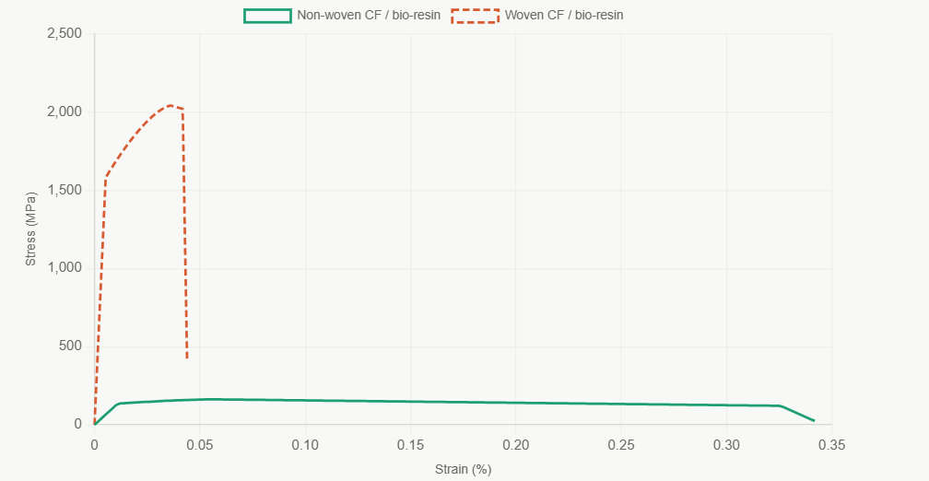
Figure 2 shows the stress strain graph for non-woven carbon fibre compared to woven carbon fibre.

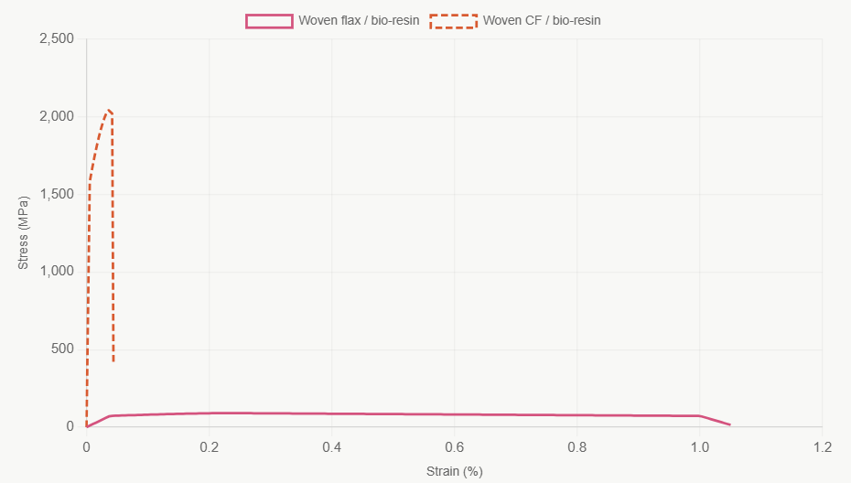
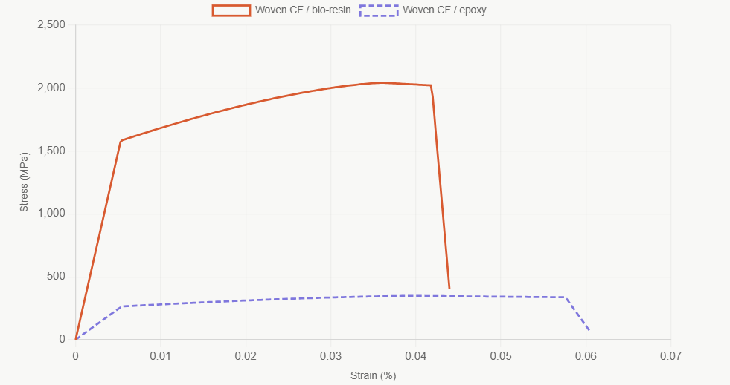
Figure 4 shows the stress strain for woven flax against woven carbon fibre.
Figure 3 shows the stress strain for woven cf using an epoxy resin and a bio resin.

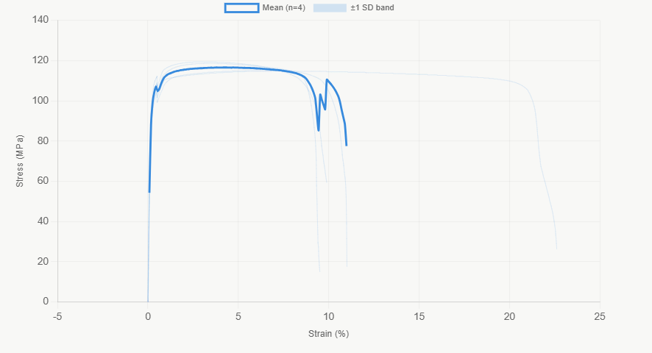
Figure 5 shows the stress strain for the four aluminium samples.

