LCBB5013-Portfolio - 6 elements

TASK 1-Business Plan Development

Element 1: Business Idea, Products/Services, Objectives & USP

1.1. Business Idea and Overview of Products/Services
The chosen business idea, NutriFork Kitchen, is a planned healthy meal preparation and delivery company that addresses consumer needs for healthy, nutritional, and convenient food options. Many people are constrained by their time for planning meals and preparing those meals in a healthier way in today's busy lifestyles and opt for buying unhealthy quick food or processed foods (Núñez Rivas et al. 2025). The issue is overcome with the introduction of nutritious and well-balanced meals that are prepared and ready to eat, which reduces the time and effort customers need to spend preparing healthy meals. The business will start in a commercial kitchen, cook and prepare meals every day, and will deliver them directly to the local area residential addresses, places of work and learning.
It caters to various dietary needs and preferences, providing customisable meal solutions that align with health objectives. It is not about single items on a menu as it is about customising the meals to accommodate different dietary preferences and nutritional goals. It offers subscription meal plans, personal nutrition programs and plans per specifications for individuals, families and businesses. There are different meal plans available for customers depending on their health goals, like weight maintenance, muscle enlargement, vegetarian meal plans, vegan meal plans, or plans for allergy-conscious people (Amiri et al. 2023). Food is prepared from quality, fresh ingredients from known local suppliers wherever viable, nutrition, food safety, and consistency of quality are in focus at every meal.
Meal preparation and delivery is not the only assisting tool that NutriFork Kitchen customarily offers. This will play a role by offering nutritional guidance for portion-controlled meal planning, as well as nutritional education with the aim of adopting positive lifestyle changes (Alyafei and Daley, 2025). The company also has a website and offers sales by phone and social media platforms, allowing consumers to have a convenient ordering experience. With a focus on providing healthy meal solutions, NutriFork Kitchen aims to be a trusted source for health-conscious consumers who prioritise convenience, reliability, and the enjoyment of delicious, nutritious meals.

1.2. Business Objectives
NutriFork Kitchen has identified both short-term and long-term goals to help sustain long-term business growth and secure a competitive position within the healthy food delivery market. For its first year in operation, the business plans to build a customer base by providing a consistent quality of meals and reliability with respect to customer service (Nakajima and Sekiguchi, 2025). The company plans to appeal to customers with low prices on subscriptions, offers and a tie-up with local gyms, fitness centres, universities and offices. The second short-term goal is to become effective and efficient in the operation, with the expectation of meeting high food safety standards and minimising food waste due to inventory control, with the aim of reaching a stable monthly sales volume that will provide positive cash flow.
In the long term, NutriFork Kitchen plans to reach more cities with its delivery services and ramp up manufacturing to move to a larger market. The company is set to expand its product range with some specialisation of the meal programme for children, the elderly and medical special dietary requirements (Chereches et al. 2023). It also aims to forge links with corporate bodies to ensure the provision of healthy workplace meals and enhance its brand awareness through robust digital marketing and customer loyalty initiatives. In the end, the business is designed to be a healthful meal delivery option recognised for quality, price, sustainability and customer satisfaction and ultimately, profitable and sustainable in the long-term.

1.3. Unique Selling Point (USP)
The main Unique Selling Point of NutriFork Kitchen is its ability to deliver balanced meals that are freshly prepared, affordable, customisable, and environmentally friendly, all in a single service. NutriFork Kitchen sets itself apart from other traditional take-outs that are just focused on tasting good and being delivered quickly by using fresh ingredients, nutritionally balanced portions, methods of tastier and healthier cooking, and preparing meals that are concerned with the customers' long-term health. As per (Srivastava et al. 2025), such a strategy allows for healthier eating choices while keeping the convenience and quality of shopping the same.
One of the company's USP's is that they can offer flexible meal subscription options that can be tailored to each person's dietary, lifestyle and health needs. There are meal plans available for those who want to lose weight, build muscles, have a vegetarian or vegan diet, or follow a diet based on allergies (Haider and Abbas, 2025). The company improves its competitiveness by utilising environmentally friendly packaging materials and choosing ingredients from local suppliers as far as possible, which can help save the environment and promote local businesses.
In addition, NutriFork Kitchen maximises customer value through reliable home delivery and workplace orders, trusted nutritional details and customer support. This holistic strategy feels next to personal in its customer service and elevates healthy lifestyles beyond just meal delivery. With dedication to quality, convenience, sustainability, and customer satisfaction, NutriFork Kitchen creates a unique market identity which is hard to mimic for the traditional takeout service.

Element 2: Business Environment & Competitor Analysis

2.1. SWOT analysis
Strengths:
Fresh, customised healthy meals: NutriFork Kitchen presents fresh, nutritionally balanced meals designed to suit various dietary requirements, such as weight reduction, vegetarian and vegan options, and high-protein meals. This tailored method distinguishes the company from the normal takeaway providers. As per AHDB (2024), there is continued growth in the desire for healthier food as 70% of UK consumers actively strive to eat healthily and to avoid ultra-processed foods. These people favour healthy meal delivery companies.
Subscription-based business model: Exclusive meal subscription options help steady business flow and increase customer retention and production planning (Medium, 2017). Customer lifetime value and revenue stability have consistently correlated with subscription businesses rather than traditional retail businesses.
Weakness:
Higher operational expenses: Unlike traditional food delivery services, there are additional operational costs. This includes skilled chefs to prepare fresh meals on a daily basis, commercial kitchen facilities, refrigerator/freezers for holding the food, and temperature-controlled delivery services (Drummond and Brefere, 2026). UK hospitality firms release cost of labour and food continue to pose a threat.
Low brand awareness: NutriFork Kitchen is a fresh brand in this market, meaning that it is not known to as many customers as the competition. Early business expansion will require a lot of investment in digital marketing and customer acquisition (Durand, 2025).
Opportunities:
Growing healthy market for meals: Demand for convenient and healthy meals is only gaining momentum, due to the rising health consciousness and hectic lifestyle. The UK meal kit market valued at 1.79 billion in the year of 2025 and expected to reach 3.80 billion USD by the year of 2034 with a CAGR 8.71% (Market Data Forecast, 2025). This shows that there is significant commercial value in healthy meal providers in the UK.
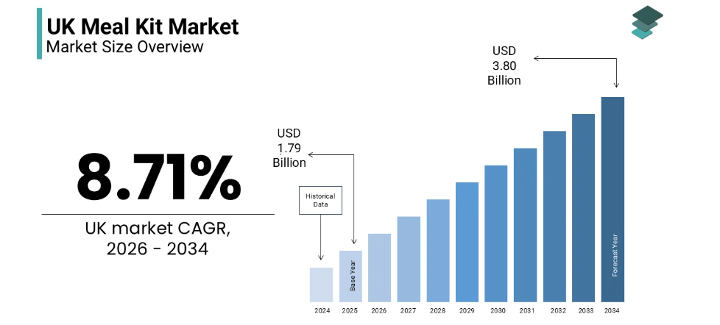
Figure 1: UK Meak Kit Market
Source: (Market Data Forecast, 2025)
Growth of digital food ordering: Social and cultural changes influence consumer choice of digital ordering, which provides greater opportunities to target more people. As per Dana et al. (2021), UK Consumers continue to expand on meal delivery services, with more than 28% engaged in online meal ordering at least once in the previous month.
Threats:
Strong competition: There are established kitchen brands available like HelloFresh or Gousto, which offer similar services. Around 368,000 branded searches are generated by HelloFresh per month, compared with approximately 165,000 for Gousto (Salience, 2026). This illustrates brand recognition and customer loyalty.
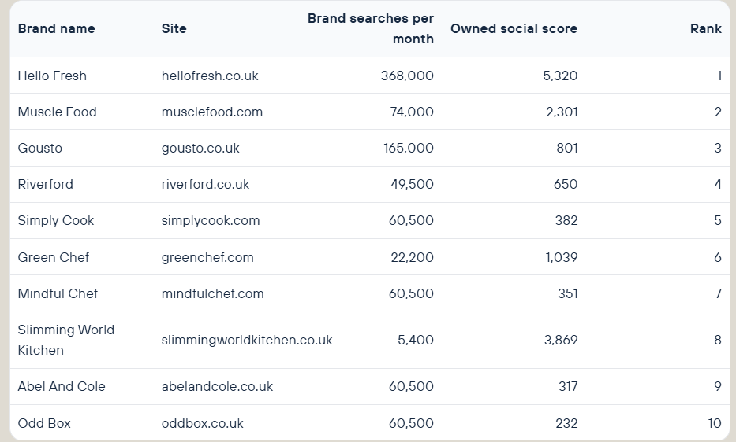
Figure 2: Particular brand searches and relevant details
Source: (Salience, 2026)
Economic and supply chain pressures: Food prices, transportation costs, and inflation could affect consumer spending on higher-ticket meal subscriptions and the cost of doing business. Moreover, the UK generates 10.7 million tonnes of food waste per year (House of Commons Library, 2024). This makes the implementation of proper inventory management crucial to reduce waste and stay profitable.

2.2. Competitor Analysis
The direct and indirect competitors for NutriFork Kitchen will be all the competition in the UK healthy meal delivery service sector.
Direct Competitor 1: HelloFresh
HelloFresh is the UK's biggest meal-kit service and provides recipe boxes with fresh ingredients and how-to-prepare instructions. The company has the brand name on the radar for 368,000 monthly searches online in the UK with a 5320 owned social score (Salience, 2026). This shows a testament to the company's brand awareness and market penetration. Economies of scale, vast menus and distribution throughout the country are advantages of HelloFresh.
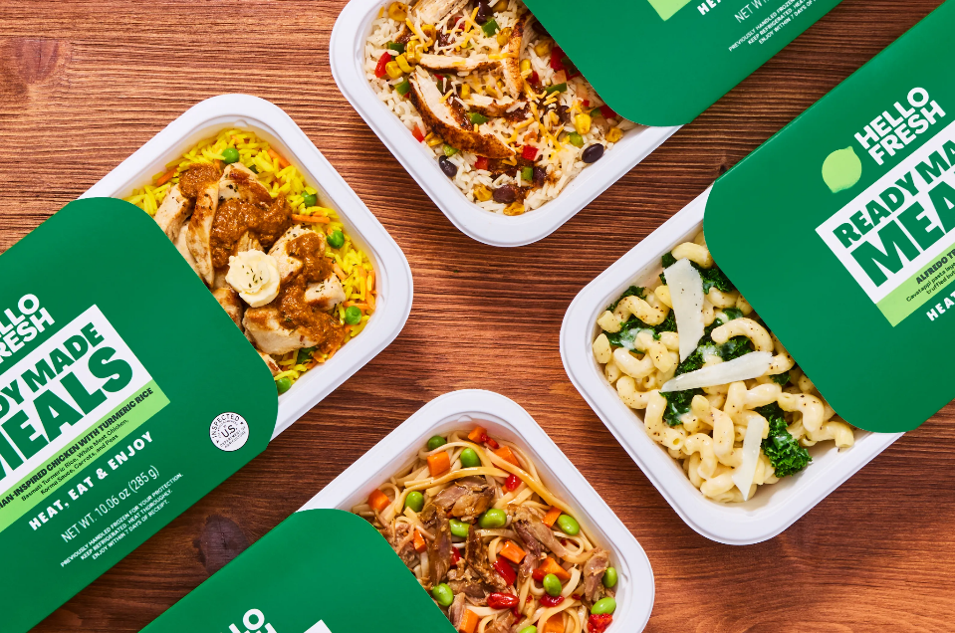
Figure 3: HelloFresh prepared meals
Source: (HelloFresh, 2026)
Direct Competitor 2: Mindful Chef
Mindful Chef focuses on delivering top-quality healthy boxes, and offers recipe boxes for consumers who want healthy, gluten-free, high-protein meal options (Mindful chef, 2026). In addition, the Company holds an Outstanding Independent Irish rating for its health attributes and is recognised for its sustainable sourcing practices.
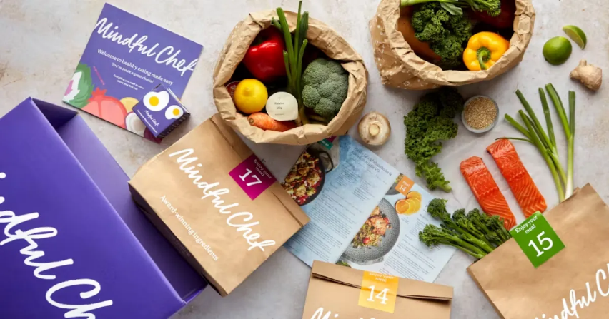
Figure 4: Mindful Chef recipe boxes and meals
Source: (Mindful Chef, 2026)
Indirect Competitor 1: Tesco
Tesco competes indirectly as they provide ready meals, fresh grocery products and meal deals at low prices and have a vast network of stores throughout the UK and earned £63.6bn in group sales in 2024-2025 (Tesco, 2025). It is competitively priced, and there are budget-conscious consumers that may opt for supermarket meals over meal subscriptions.
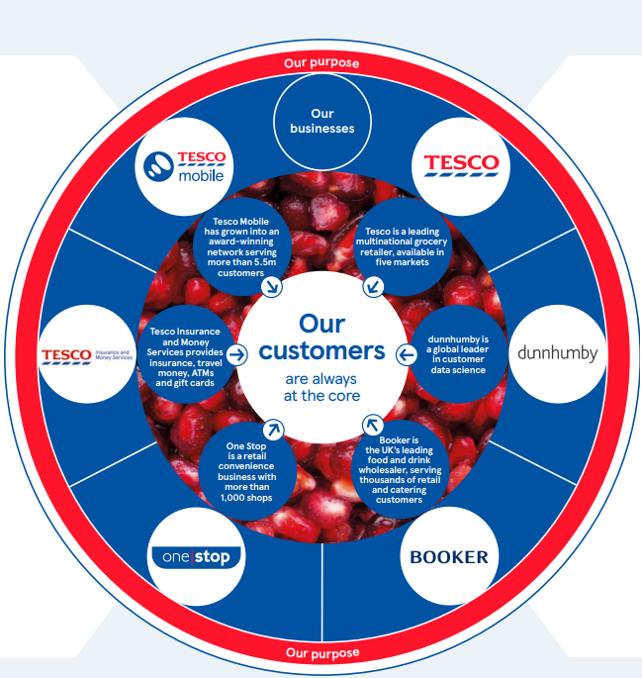
Figure 5: Tesco values
Source: (Tesco, 2025)
Indirect Competitor 2: Deliveroo
A digital service connects customers with thousands of restaurants across the local area with ease and convenience. Deliveroo offers convenient access to 172,000 restaurants on a single app platform (Business of Apps, 2026). Although its primary product line is not healthy meal delivery but restaurant delivery, consumers can easily call for meals whenever they want, which will give restaurant delivery companies more competition in the healthy meal delivery business.
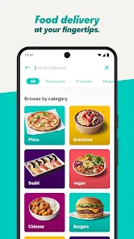
Figure 6: Deliveroo application
Source: (Deliveroo, 2026)

Element 3: 4Ps, Market Segmentation & Marketing Strategies

3.1. Company’s market segmentation and target customers
Market Segmentation: NutriFork Kitchen will use a multi-segment targeting approach using customer demographic, geographic, psychographic and behavioural segments across the UK. The target market for the business is adults aged 20-45 with middle to upper-middle income, who appreciate convenience and healthy foods. The company will initially operate in urban regions like London, Manchester and Birmingham, where the demand for food delivery services is on the rise owing to the hectic lifestyle of people. Psychographically, it targets health-conscious consumers, who have emphasised nutrition, fitness, sustainability and work-life balance (FasterCapital, 2026). Behaviourally, the target market comprises individuals who are looking for convenience, meal subscription and custom-built meal plans. This segmentation allows NutriFork Kitchen to customise their products and promotions based on consumers' preferences. FasterCapital (2026) found that the demand for nutritious meal services is high, with 63% of UK adults actively trying to make healthier food choices.
Target Customers: The NutriFork Kitchen brand is for people who don't have much time on their hands for preparing a nutritious meal, such as busy business professionals, students at universities, young families and anyone who practices fitness. The typical consumers are people with fixed incomes, often buying online, who value time-saving and healthy living services. The business also caters to employers looking for a better meal solution for their staff as part of an employee wellbeing program. The younger consumer is of special interest, not only for their buying power, but also their digital purchasing habits. UK adults aged between 16 and 44 years were primarily digital customers, with over 99% of them using the internet every day (Office for National Statistics, 2021). This shows that digital ordering and online communication are highly effective for this segment of the population.

Consumer Persona | Emily Carter
Age | 31 years
Occupation | Marketing Executive
Location | Manchester, UK
Income | £38,000 per year
Lifestyle | Busy professional, health-conscious, regular gym user
Goals | Save time, eat healthy, maintain fitness, convenient meals
Pain Points | Limited cooking time, unhealthy takeaway options, meal planning difficulties
Buying Motivation | Fresh, nutritious meals with flexible subscription and home delivery
Common Objections | Price, freshness, subscription flexibility
Preferred Channels | Website, Instagram, Facebook, Google Search
Buying Behaviour | Orders food online weekly, values reviews, quality, and convenience
Table 1: Consumer Persona
Source: (Created by author)

3.2. Application of the 4Ps of Marketing to the company
Product: NutriFork Kitchen offers freshly prepared meals with good nutrition and allows them to be ordered as a one-time order or subscribed to on a flexible basis. Through customisable meal plans for diets which are specialised for weight management, vegetarian, vegan, high protein and allergenic, it establishes itself as different (Amiri et al. 2023). Fresh ingredients are used to prepare meals which are labelled with nutritional facts and packaged in environmentally friendly containers. The value proposition is about product quality, convenience, and nutritional transparency.
Price: The company will adopt value pricing. Price will be based on the basis of the premium quality of the products offered by the company, making it affordable for people. Customers can order single dinners or could even be able to get lower weekly rates and month-to-month subscription dinners, meaning they can get dinners over and over again within the week, increasing their lifetime value (Cho et al. 2020). New customer uptake and encouraging of referrals will be enhanced by promotional discounts and incentives, all whilst keeping prices competitive with existing meal delivery companies.
Place: NutriFork Kitchen will cook at a central commercial kitchen and deliver directly to the consumer via an online ordering system. Firstly, delivery will be concentrated on the main cities within the UK before then gradually expanding in number through to geographical areas (Chen et al. 2026). The company will accept orders via the online platform and social media networks, which will be followed by a well-designed distribution system with proper local delivery services to ensure food freshness and quality. Market Data Forecast (2026) reported that 98% of UK households are now prefer ordering everything online, making online ordering an effective distribution method for food.

Promotion: Promotion will primarily be targeted to digital, but in addition, local partnerships will play a role. The company will use Search Engine Optimisation (SEO), Google Ads, social media ads, working with influencers, email marketing, referrals and customer retention goodies (Morgan, 2025). Collaborations will continue to enhance the business's visibility with gyms, fitness centres, healthcare professionals, and corporate organisations. Convenience, nutrition, sustainability and the option for flexible subscriptions will be the focus of promotional activities. Kemp (2025) highlighted that the UK had around 54.8 million social media users, which is around 79% of the country's population, and offered ample scope for digital customers.

3.3. Online Marketing Strategies
NutriFork Kitchen will work towards developing a comprehensive digital marketing strategy that is going to bring new customers to the table and will also ensure the company can cultivate relationships with its customers on a long-term basis. Keywords such as healthy meal delivery UK and fresh meal subscription will gain increased visibility with Search Engine Optimisation (SEO), driving more organic traffic to the website (Morgan, 2025). Google Search and Performance Max campaigns will reach active users who are actively searching for easy ways to healthy meals.
Instagram advertising will feature a mix of meal solutions, customer suggestions, nutritional information, and the way things are made and simple routines, aiming to build brand reputation and interaction. Nutrition posts, customer reviews, and how it's made clips will all be featured on social media marketing platforms, such as Instagram, Facebook, TikTok, and LinkedIn, with the objective of building brand trust and engagement. Email marketing will help retain customers with more personalised food ideas, special offers, abandoned cart reminders, and subscription renewal incentives (Jacob, 2023). Ongoing customers will be more motivated to repeat business, and customer advocacy is likely when they see loyalty points to earn and referral discounts.
Additionally, the business will team up with other fitness influencers and nutritionists as a way to boost trust among consumers. Email marketing continues to be one of the most profitable customer retention marketing strategies, averaging at around a US$36 return on every US$1 invested (Carson, 2025). Moreover, Jayden (2026) showed that 85% of businesses find online reviews to be important. These help businesses build a healthy reputation and help new customers discover them.

Element 4: Financial Planning

4.1. Projected Financial Figures
The financial forecasts show a cost of £50,000 being required to fund the set-up of a commercial kitchen, website development and other start-up costs, which includes licences, initial marketing and working capital. Monthly running costs include £18,000 for food ingredients, salaries and wages, rental payments, utilities, packaging costs and delivery charges. During the first six months, the total revenue is projected as £125,000, as they build their customer base and also focus on creating awareness about their product. In the first 2 months, the business incurs losses as sales pull in less than operating costs (£18,000 per month), but improves in the following month such that monthly revenue (£18,000) equals operating costs (£18,000) where operating break-even is achieved with an operational profit of £0 in Month 3. After Month 6, NutriFork Kitchen expects to make an operating profit of £17,000. The full investment required, £50,000, will be retrieved in about 12-15 months, depending on the growth of the customer base and subscription rates.

Financial Projection
Financial Item | Estimated Amount (£)
Start-up Costs
Kitchen equipment & appliances | 18,000
Commercial kitchen deposit & setup | 8,000
Website & online ordering system | 4,500
Licences, insurance & registration | 2,500
Initial marketing | 5,000
Initial inventory & working capital | 12,000
Total Start-up Cost | 50,000
Monthly Operating Costs | 18,000
Table 2: Financial projection
Source: (Created by author)

Revenue Forecast
Month | Revenue (£) | Operating Cost (£) | Monthly Profit/Loss (£)
Month 1 | 12,000 | 18,000 | -6,000
Month 2 | 15,000 | 18,000 | -3,000
Month 3 | 18,000 | 18,000 | 0
Month 4 | 22,000 | 18,000 | +4,000
Month 5 | 27,000 | 18,000 | +9,000
Month 6 | 31,000 | 18,000 | +13,000
Total | 125,000 | 108,000 | +17,000
Table 3: Revenue analysis
Source: (Created by author)
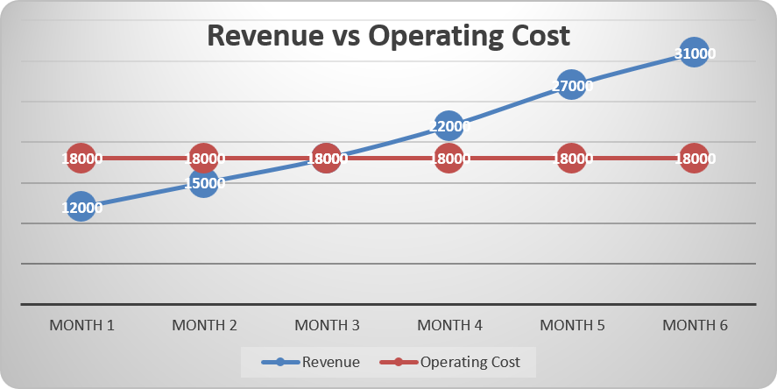
Figure 7: Revenue vs operation cost graphical analysis
Source: (Created by author)

4.2. Funding Sources
To help capitalise the startup and minimise financial risk, NutriFork Kitchen will have a mixed funding approach, with the necessary £50,000 raised from other sources as well as from this campaign. This will showcase the owner's financial commitment and confidence in the business as a whole, with him or her putting in £20,000 through personal savings. As per (Amimakmur et al. 2026), it is also a credentialing measure if the company needs finance from an outside party because lenders will be more likely to give credit to owners who are prepared to take risks with their money. The main funding source will be the UK Government-supported Start Up Loans Scheme to which the business will apply for £25,000. This scheme is ideal for start-up ventures owing to its fixed interest rate, fixed repayment period and free mentoring support provided. This will improve the skills of financial planning and business management within the start-up venture.
The remaining £5,000 will be funded by a small commercial bank loan, so that the unexpected operating expenditure can be met in the first few months, and to support working capital requirements. This multi-stream funding strategy helps diversify the funding sources and provides sufficient liquidity so the business can be stabilised at profitability levels (Xie et al. 2022). This is a funding mechanism with a number of hazards. The owner or family will risk losing their personal investment if the organisation fails to meet expectations. Loan repayments will need to be made even when there are monthly profits, and it's estimated that the business will start to pay off around 12-15 months. NutriFork Kitchen will thus closely observe and manage cash flow, manage operating expenses and keep our contingency reserve small to reduce financial risk while promoting sustainable long-term development.

References for Task 1

AHDB (2024) A natural opportunity for health, AHDB. Available at: https://ahdb.org.uk/news/consumer-insight-a-natural-opportunity-for-health (Accessed: 05 August 2026).
Alyafei, A., and Daley, S. F. (2025). The role of dietary lifestyle modification in chronic disease prevention and management. In StatPearls [Internet]. StatPearls Publishing.
Amimakmur, S. A., T, S., Rahman, A. F., and Atmini, S. (2026). The Influence of Operational Efficiency (SFA Modeling), Credit Risk, and Third-Party Funds on Stock Prices with Financial Performance as a Mediating Variable. International Journal of Financial Studies, 14(5), 108.
Amiri, M., Li, J., and Hasan, W. (2023). Personalized Flexible Meal Planning for Individuals With Diet-Related Health Concerns: System Design and Feasibility Validation Study. JMIR formative research, 7, e46434. https://doi.org/10.2196/46434
Business of Apps (2026) Deliveroo revenue and usage statistics (2026) , Business of Apps. Available at: https://www.businessofapps.com/data/deliveroo-statistics/ (Accessed: 05 August 2026).
Carson, R. (2025) 2023 Email marketing for beginners. Vero. Available at: https://www.getvero.com/resources/2023-email-marketing-for-beginners/ (Accessed: 5 August 2026).
Chen, L., Han, H., Yan, W., and Yang, Y. (2026). How Online Food Delivery Services Are Reshaping the Urban Food Environment: Evidence from Hangzhou, China. Foods, 15(14), 2481. https://doi.org/10.3390/foods15142481
Chereches, M. C., Finta, H., Popa, C. O., Stefanescu, D., and Muntean, D. L. (2023). Qualitative study on the factors influencing the utilisation of products labelled “food for special medicinal use”(FSMP). Nutrients, 15(11), 2582.
Cho, M., Bonn, M. A., Moon, S., and Chang, H. (2020). Home chef meal kits: Product attributes, perceived value and repurchasing intentions the moderating effects of household configuration. Journal of Hospitality and Tourism Management, 45, 192–202. https://doi.org/10.1016/j.jhtm.2020.08.011
Dana, L. M., Hart, E., McAleese, A., Bastable, A., and Pettigrew, S. (2021). Factors associated with ordering food via online meal ordering services. Public health nutrition, 24(17), 5704–5709. https://doi.org/10.1017/S1368980021001294
Deliveroo (2026) Deliveroo-Restaurants, takeaways, supermarkets and shops. Delivered, Deliveroo. Available at: https://deliveroo.co.uk/ (Accessed: 05 August 2026).
Drummond, K. E., and Brefere, L. M. (2026). Nutrition for Foodservice and Culinary Professionals, with eBook Access Code. John Wiley & Sons.
Durand, B. (2025). Digital Marketing Innovation and Its Effect on Customer Acquisition and Retention in Small Businesses.
FasterCapital (2026) Healthy meal kit: Targeting the right audience: Marketing your healthy meal kit to health conscious consumers , FasterCapital. Available at: https://fastercapital.com/content/Healthy-meal-kit--Targeting-the-Right-Audience--Marketing-Your-Healthy-Meal-Kit-to-Health-Conscious-Consumers.html (Accessed: 05 August 2026).
Haider, R., and Abbas, H. (2025). Protein is an Effective Food for Weight Loss and Maintaining Body Composition. J. Biomed. Res. Clin. Rev., 10(5), 1-11.
HelloFresh (2026) HelloFresh® Meal Kits: Free Breakfast for Life + 10 free meals, HelloFresh. Available at: https://www.hellofresh.com/ (Accessed: 05 August 2026).
House of Commons Library (2024) Food waste in the UK , House of Commons Library. Available at: https://commonslibrary.parliament.uk/research-briefings/cbp-7552/ (Accessed: 05 August 2026).
Jacob, L. (2023). Personalization as an important email marketing tactic.
Jayden, S. (2026) How online reviews influence consumer buying behavior across industries globally – Insights from GoodFirms. GoodFirms. Available at: https://www.goodfirms.co/resources/online-reviews-consumer-buying-behavior-global-insights (Accessed: 5 August 2026).
Kemp, S. (2025) Digital 2025: The United Kingdom. DataReportal. Available at: https://datareportal.com/reports/digital-2025-united-kingdom (Accessed: 5 August 2026).
Market Data Forecast (2025) UK meal kit market size, share, trends and analysis, 2034, Market Data Forecast. Available at: https://www.marketdataforecast.com/market-reports/united-kingdom-meal-kit-market (Accessed: 05 August 2026).
Market Data Forecast (2026) UK food delivery market size, share, Growth & Trends, 2034, Market Data Forecast. Available at: https://www.marketdataforecast.com/market-reports/united-kingdom-food-delivery-market (Accessed: 05 August 2026).
Medium (2017) Meal-kit companies and their retention challenges , Medium. Available at: https://medium.com/@vaishnavirajendran/meal-kit-companies-and-their-retention-challenges-f7c286a8e3d3 (Accessed: 05 August 2026).
Mindful chef (2026) Healthy recipe boxes & meal kits delivered UK , Mindful chef. Available at: https://www.mindfulchef.com/ (Accessed: 05 August 2026).
Morgan, C. L. (2025). Social Media Marketing for Your Business. BuilderBooks.
Nakajima, H., and Sekiguchi, T. (2025). Is Business Planning Useful for Entrepreneurs? A Review and Recommendations. Businesses, 5(1), 10. https://doi.org/10.3390/businesses5010010
Núñez Rivas, H. P., Holst Schumacher, I., Roselló Araya, M., and Blanco Metzler, A. (2025). Food literacy and caregivers' perceptions related to healthy eating and salt/sodium reduction in children and adolescents: A qualitative study in Costa Rica.
Office for National Statistics (2021) Internet users, UK: 2020, Office for National Statistics. Available at: https://www.ons.gov.uk/businessindustryandtrade/itandinternetindustry/bulletins/internetusers/2020 (Accessed: 05 August 2026).
Salience (2026) 2025 free meal delivery industry report, Salience. Available at: https://salience.co.uk/report/meal-delivery-market-report (Accessed: 05 August 2026).
Srivastava, P. K., Sharma, A., Whig, V., Malaviya, S., and Kumar, N. (2025). Review Of Transforming Grocery Shopping with Artificial Intelligent: A New Era of Convenience. Advances in Consumer Research, 2(2), 665-675.
Tesco (2025) Tesco PLC Annual Report and financial statements, Tesco . Available at: https://www.tescoplc.com/media/ky0bfwpo/tesco_ar25_interactive.pdf (Accessed: 05 August 2026).
Xie, Z., Liu, X., Najam, H., Fu, Q., Abbas, J., Comite, U., Cismas, L. M., and Miculescu, A. (2022). Achieving Financial Sustainability through Revenue Diversification: A Green Pathway for Financial Institutions in Asia. Sustainability, 14(6), 3512. https://doi.org/10.3390/su14063512

